Changing Work and Work-related Travel and the impact of Covid-19

Kiron Chatterjee and Fiona Crawford (University of the West of England)
Abstract: The nature of work was undergoing dramatic change before the pandemic as the digital age continued to transform all sectors of our society. In this paper we describe pre-pandemic trends in types of work, the workforce and working arrangements in the UK. We show how these changes were having gradual yet significant impacts on commuting and other work-related travel which were apparent in national travel data series. Key features of these impacts were increasing diversification and flexibilities in work travel. We bring together findings on how working practices and travel have been altered by the pandemic and report expectations and opinions on longer-term legacies of the pandemic. The pandemic has accelerated pre-pandemic trends and led to a shift in how work is performed for almost all sectors of the economy – but grasping the opportunity for this to contribute to deep carbon reductions from transport and to improve equity and health outcomes will require carefully directed policy interventions.

Introduction
Work is a pillar of how societies are organised and how individuals lead their lives and find meaning from them. Cities provide economies of scale to support large numbers of people and the employment located in cities is the dominant driving force of modern economies. The nature of this employment and its distribution shapes where people live and the infrastructure and services provided to serve the population. The travel associated with work has major implications for quality of life and liveability in the city.
This paper is concerned with the impacts of Covid-19 on work and work-related travel. It primarily focuses on the UK, but the trends and issues discussed in this paper will apply to many other countries. The paper first examines pre-pandemic trends in types of work, the workforce and working arrangements before turning to trends in work-related travel. It then focuses on effects of the pandemic on work and work-related travel and discusses how these relate to pre-pandemic trends. The paper finishes by putting forward thoughts on what the future might hold and how government policies and other actions can shape the future in a desirable direction.

Pre-pandemic trends

Trends in work
The Chartered Institute of Personnel and Development (CIPD) identified three themes to examine trends in work and working lives in the UK which for the purpose of this paper we will refer to as types of work, the workforce and working arrangements (CIPD, 2013).

Types of work
The UK has experienced a long-term trend towards a services-led economy and services are estimated to account for 83.6% of employment in 2016 (ONS, 2019a). Notable changes seen between 1980-1999 and 2000-2016 have been an increase in employment in professional, scientific and technical services from 21.4% to 27.2%, an increase in employment in miscellaneous services (including hotels and catering) from 16.6% to 21.2% and a decrease in employment in manufacturing from 17.4% to 9.5% (ONS, 2019a). There has therefore been growth in both the high-skilled end of the service sector and the low-skilled end.
Furlong (2015) has highlighted that young people are particularly likely to be employed in the hospitality and leisure sectors which have absorbed large numbers of overqualified graduates and migrants. Also, higher skilled knowledge-economy jobs are increasingly concentrated in cities, along the main transport corridors and in city centres, while lower skilled service jobs are dispersing out of city centres (Tochterman and Clayton, 2011).
Information and communication technologies (ICTs) have transformed the world of work as with other spheres of our lives. Along with liberalisation of trade arrangements and cheaper transport costs, they have facilitated global business by reducing the costs of transport, communication and exchange (CIPD, 2013). This has created new business models and job roles, including technologically-mediated self-employment for example as a consultant or a delivery person. It has also led to out-sourcing of some types of work to other parts of the world with cheaper labour.

The workforce
The total number of people in employment aged 16 and over in the UK grew to an unprecedented figure of 33.1 million at the start of 2020, an increase of nearly 6 million over the figure of 27.3 million in 2000 (ONS, 2021a). The long-term growth in employment in the UK was partly a consequence of growth in the population but employment rates also increased to a rate of 76.6% of those aged 16 to 64 at the start of 2020 (having been 72.2% in 2000) (ONS, 2021a). This growth in employment rate is largely due to more women working.
The age profile of the working population has got older with the employment rate of those aged 65 and over rising from 5.3% at the start of 2000 to 11.5% at the start of 2020, whilst the employment rate for those aged 18 to 24 fell from 67.8% in 2000 to 63.8% in 2020 (ONS, 2021a). Ageing of the workforce has been mitigated to some extent by in-migration to the UK which has supplied younger workers and helped to fill a shortage of workers in lower skilled occupations.
An average of 9% of the workforce changed jobs every year between 2000 and 2018 with this ranging from a post-recession low of around 5.7% in 2010 to a high of around 10.9% in both 2017 and 2018 (ONS, 2019b). The likelihood of changing job is much greater for younger workers with one in four (26%) 21-24 year olds changing job each year compared to one in 20 (6%) 50-64 year olds.

Working arrangements
There has been a trend towards greater self-employment with 5.0 million self-employed workers (15.2% of the workforce) at the start of 2020 compared with 3.3 million (12.0%) in 2000 (ONS, 2021b). One likely contribution to this trend has been the arrival of the ‘gig economy’, whereby technology platforms have made it easier for people to work on a self-employed basis.
The percentage of the labour force reporting that they are part-time employed has been relatively stable over the last 20 years with 26.0% (8.6 million people) indicating this at the start of 2020 compared with 25.2% (6.9 million people) at the start of 2000 (ONS, 2021b). One in ten part-time workers (10.5%) reported not being able to find a full-time job at the start of 2020 before the pandemic, a decrease from a post-recession high of 18.4% in 2013. When looking at average hours worked per week this has not changed very much at 31.8 hours at the start of 2020 compared to 32.6 hours at the start of 2000 (ONS, 2021c).
Trends in flexible working were examined by CIPD in 2019 with their definition covering a range of working arrangements such as part-time work, flexitime, working from home and zero-hours contracts (CIPD, 2019). Most forms of flexible working had not seen major changes in prevalence between 2005 and 2017 with the main exception being those forms of flexibility associated with the location where work takes place. Results from the Annual Population Survey show that there was an increase in those reporting mainly working from home from 3.6% to 5.0% between 2011 and 2019 (ONS, 2021d). Those reporting that they recently worked from home increased from 5.3% to 7.9% between 2011 and 2019, while those reporting occasional work from home decreased from 15.0% to 13.7% between 2011 and 2019. This demonstrates a gradual shift was occurring towards more intensive working from home before the pandemic.
Felstead (2012) remarked on the slow apparent pace of change in 2012 but added ‘office work can now, with the help of ICT and the mobile phone and laptop in particular, be carried out in a variety of different places – in the home, in an assortment of locations within the office, in clients’ premises and in ‘third places’ such as the train, the car and the plane’. Felstead anticipated an increasing number of employers moving away from providing personal office space towards alternative arrangements such as ‘hot-desking’.
The trend towards more frequent working from home was also evidenced in research by the CIPD which found one in three workers (33%) reported they had worked at or from home in 2018 compared to 16% in 2011, suggesting working from home had become more prevalent as an occasional, if not every-day, practice prior to the pandemic. It was more likely for women and for those with children.

Summarising trends in work
In summary, work had been undergoing fairly gradual yet transformational changes in the UK in the 20 years or so prior to the pandemic. Changes in the industrial composition of jobs and the demographics of workers, along with developments in ICT, were driving changes in what represents a typical job and a typical workplace.

Trends in work-related travel
Trends in different aspects of work-related travel are examined in this section. The statistics generally apply to England only, as data on work-related travel is not collected in a consistent manner across all nations of the UK.

Number of trips
In the 2011 Census, 23.8 million out of 25.2 million employed people aged between 16 and 74 in England reported a method of travel to work with 1.3 million people reporting that they work mainly at or from home (QS701EW in ONS, 2021e). With the growth in the workforce mentioned in the previous section, it would be expected that more and more people in England will have been sharing the commuting experience. However, Figure 1 shows there has been a trend for workers to travel to their workplace less often with 335 commuting trips per year (6.4 per week) on average for those employed in England in 2002 and 277 in 2019 (5.3 per week)(NTS0411 at DfT, 2020a). This decreasing trend has been seen also in other industrialised countries (Le Vine et al., 2017).
The reduction in commuting trips applies to both full-time and part-time workers but is particularly striking for self-employed workers (who can be full-time or part-time) with a decrease from 230 commuting trips per year to 126 trips - this could be a consequence of more self-employed workers working mainly from home and/or more self-employed workers travelling to diverse work locations rather than one usual place of work.
[Figure 1 here]
The scale of reduction in commuting trips per worker more than offsets the increase in the number of workers and it has been estimated that there has been an overall reduction in commuting trips from 8.5 billion journeys per year to 7.9 billion between 1995 and 2014 (Le Vine et al., 2017).
At the same time as commuting trips have been decreasing, the average number of business trips has also been decreasing in England with an average of 36 trips per year in 2002 per person and 28 trips per year in 2019 (NTS0403 at DfT, 2020a). In total, work-related travel - the sum of commuting and business trips - decreased from 200 trips per person per year in 2002 to 168 trips per year in 2019. Trip rates for other travel purposes have also decreased so the decrease in work-related trips as a percentage of all trips has been more modest with a decrease from 18.6% to 17.6%.
Le Vine et al. (2017) analysed National Travel Survey one-week diary data to seek explanation for the declining number of commuting trips. They found it was a consequence of both more workers making no work trips (although not working from home) and more workers making work trips on one-four days of the week rather than five days or more.

Commuting distances
The long-term trend of lengthening commuting distances has continued with the average commute 9.0 miles in England in 2018/2019 compared to 8.5 miles in 2002/2003 (NTS9912 at DfT, 2020a). Census data shows that almost 774,000 workers (3.1%) in England commuted at least 60 kms to work in 2011 compared to 608,000 (2.7%) in 2001 (UV035 and QS702EW in ONS, 2021e).
Although the length of the average commute has increased, the average number of miles travelled per worker per year for commuting and business travel has decreased from 2,892 miles in 2002 to 2,541 miles in 2019, as a result of the fewer commute trips per person mentioned previously (NTS0411 at DfT, 2020a). Work-related travel has decreased as a percentage of all distance travelled from 29.2% in 2002 to 28.2% in 2019. Commuting has maintained a 20% share of total distance travelled between 2002 and 2019.
Between 2002 and 2019 the one-way mean commute time in England has increased from 26 minutes to 30 minutes (TSGB0110 at DfT, 2020b). In 2019, 14% of employees had a one-way commute journey of at least 60 minutes whereas this was only the case for 11% of employees in 2002. Evidence exists that long commutes are a substitute for moving home and these are made possible by better transport connections (making longer journeys less burdensome) and more flexible working schedules (not requiring employees to be at the workplace at fixed times) and motivated by preferences to maintain social ties near home locations (Green, 1999).

Commuting modes
The car dominates commuting in England with 67% of commuters reporting the car as their usual main method of transport in 2019 compared to 12% by rail, 9% on foot, 7% by bus and 3% by bicycle (TSGB0108 at DfT, 2020b). London is an exception with only 27% of commuters reporting the car as their usual main transport mode. Car use has decreased slightly since 2002 when 70% of commuters reported the car as their usual main method of transport with rail the main beneficiary with an increase from 7%.
An analysis of change in commuting mode share between 2001 and 2011 based on Census data showed a shift from car to public transport was only evident in London and not other settlement types (Melia et al., 2018). However, when looking specifically at young workers aged 25 to 34 a shift was apparent across all settlement types in England. The analysis showed that more young adults were living in highly urbanised areas and they were increasingly tending to use public transport (an expected outcome given lower driving licence rates among this generation of young adults than previous generations).

Time of travel and trip chaining
While commuting has reduced overall since the turn of the millennium, it remains a key concern for transport planning as it is concentrated in certain hours of the day on weekdays. That has not changed substantially, although it has been found commuting trips have shifted a few minutes earlier in the morning and a few minutes later in the afternoon (reflecting slightly longer working days on average) (Le Vine et al., 2017).
An increase has been observed in intermediate trips associated with the trip to and from work during both the morning and evening peak periods, particularly escort to education trips in the morning peak (Le Vine et al., 2017). This implies a greater complexity in work-related travel for a section of the population – this travel may be more easily managed by using a car.

Diversity and flexibility in work-related travel
Crawford (2020) identified four distinct types of work travel patterns (‘clusters’) amongst the working population in England based on National Travel Survey seven-day diaries for 1998-2016:
- Regular work travellers tend to go to their usual workplace five days a week at the same times of day (63% prevalence in 1998, 59% prevalence in 2016)
- Temporally variable work travellers tend to go to their usual workplace five days a week but at different times of day (16% in 1998, 9% in 2016)
- Spatially variable work travellers tend to travel to their usual workplace less than once per week and travel to other places for work on four days per week (5% in 1998, 10% in 2016)
- Infrequent work travellers tend to travel to their usual workplace less than once per week and have little travel to other workplaces (16% in 1998, 22% in 2016)
The infrequent and spatially variable clusters have both grown in importance with their combined size rising from 21% in 1998 to 32% in 2016. These finding are consistent with the results reported in the previous section on flexible working arrangements being increasingly available and taken up in terms of the location of work.
Crawford (2019) has shown for the same data set that 83% of commuters used the same main method of transport to travel to/from work in a week’s worth of travel, whilst 17% used at least two main modes. In contrast to the trend towards increasing diversity in commuting patterns based on frequency of travel and locations visited, there has been a trend towards more single mode commuters between 1998 and 2016. The percentage of single mode commuters who were car drivers decreased from 74% in 1998 to 67% in 2016, whilst the percentage who were public transport users increased from 9% to 17%. Commuters were more likely to use the same mode if they were older or self-employed and these groups have been increasing in prevalence over time.
Looking at commuting behaviour over a longer time frame, Clark et al. (2016) found for a representative sample of 15,000 English workers in 2009/10 that one in five (20%) changed their main method of getting to work a year later with this less likely for car commuters (9%) and more likely for users of other modes (e.g. bus 34%). This shows the challenge of achieving modal shift from car commuting. Commute mode changes are more likely when workers change job or move home (which occurred for 11% and 7% of the population respectively).

Commuting satisfaction
International research shows commuters using active travel modes report the highest levels of commute satisfaction, followed by car users with public transport users reporting the lowest levels of commute satisfaction (Chatterjee et al., 2020). Nevertheless, most public transport users in Great Britain report being satisfied with the journeys they take – 82% of rail passengers reported being satisfied with their journeys for the most recent data available at the start of 2020 (TSGB0608 at DfT, 2020c) and the figure is 89% for bus passengers in England (outside London) (Transport Focus, 2020).
An analysis of panel data for 26,000 employed people living in England between 2009/10 and 2014/15 found that longer commute times were associated with lower job and leisure time satisfaction, increased strain and poorer mental health (Clark et al., 2020). Despite these negative associations, longer commute times were not associated with lower overall life satisfaction. Workers in England appear to be successful in balancing the negative aspects of commuting against the wider benefits, e.g. access to employment, earnings and housing. The absence of the commute, via working from home, was, however, associated with increased job satisfaction and leisure time satisfaction.

Impacts of working from home on other travel
Findings from analysis of the Swiss Mobility and Transport Microcensus suggest working from home increases travel due to teleworkers living further away from the workplace than other workers and making more journeys for other purposes than other workers (Ravalet and Rérat, 2019). They use a fairly broad definition of teleworking which includes people who sometimes or often work from home, or in other locations such as on a train, in cafes or in co-working spaces, rather than travelling to their usual workplace.
Similarly, Zhu et al. (2018) found in the United States that working from home is associated with longer commute trip distances, more daily work trips and more daily non-work trips. This can be interpreted as teleworkers choosing residential and job locations which require more travel than non-teleworkers. However, if these location choices would be made anyway (regardless of opportunity to work from home) then travelling less frequently to the workplace could lead to decreased travel. A Dutch study has estimated the aggregate impact on car kilometres travelled in the Netherlands of increasing prevalence of different types of flexible working over the period 2000-2016 (Van der Loop, 2019). It estimated a 2% reduction in car kilometres on working days and a 7% reduction during peak hours. The reduction in peak hour car travel was contributed to more by shifting working hours than by working from home.

Summary of trends in work-related travel
Overall, the trends in work-related travel prior to the pandemic reflect the trends in work discussed previously. People were commuting on fewer days per week and travelling further to work. An increased complexity was observed in travel to and from a workplace due to trip chaining, probably connected to demographic changes in the working population and in particular the growth in female participation in the labour market. Changes were visible but their effect was still relatively small, with most workers still travelling to a usual workplace on around five days per week, the car remaining dominant as the main commute mode and commuting consistently contributing 20% of the distance travelled in England.

Impacts of the Covid-19 pandemic
Since March 2020, workers in England and many other countries around the world have had to make substantial adjustments to their lives and daily routines. The first national lockdown came into force in England on 26th March 2020. The lockdown rules included a limited number of reasons for which someone could leave their home and travelling to work was only possible ‘where this is absolutely necessary and cannot be done from home’. This was followed by a relaxation of the rules over the summer of 2020 and then a series of local lockdowns and tightening of restrictions from September 2020. A second national lockdown began in England on 5th November 2020. This lasted for four weeks and was followed by a more strict tiered system of restrictions. The third national lockdown began on 6th January 2021. Between March 2021 and the time of writing this paper, restrictions have been gradually eased as the vaccination rate increases. The pandemic is not over, however, nor are its impacts on working lives. The impacts during the pandemic so far have been far-reaching but also varying in intensity and it is not the purpose of this paper to provide a comprehensive record of these. What is covered next is an overview of different impacts experienced with a focus on those that may have enduring impacts beyond the pandemic.

Impacts on work and workers
The total number of people in employment aged 16 and over in the UK decreased by one million from 33.1 million at the start of 2020 to 32.1 million by the end of 2020. The employment rate decreased from 76.6% of those aged 16 to 64 at the start of 2020 to 74.7% at the start of 2021 with the unemployment rate rising from 4.0% to 5.1% and inactivity rate rising from 20.2% to 21.2% (ONS, 2021a). Young people aged 16 to 24 years saw particularly large increases in unemployment and economic inactivity rates. In terms of sectors affected by the pandemic in the UK, retail has seen the most job losses followed by aviation and hospitality. Hours worked decreased by 20% in the first wave of the pandemic in 2020 and were still 7% lower than the start of 2020 in mid-2021 (ONS, 2021f). Partial or furlough leave has been most common in the arts, entertainment and recreation and transportation and storage sectors (ONS, 2021g).
The proportion of people working from home to any extent increased from 27% in 2019 to 37% in 2020 and the latest data for May 2021 shows 26% of workers exclusively working from home, 50% travelling to work only and 11% doing a combination (ONS, 2021h). The extent of working from home has varied considerably by industry sector as illustrated in Figure 2 which shows differences in working from home among 12 industry sectors employing more than one million workers. This shows a divide in working from home between higher skilled service jobs (such as in the information and communication sector) and lower skilled service jobs (such as in accommodation and food services).
[Figure 2 here]
Felstead and Reuschke (2020) were able to track working from home during the first national lockdown in 2020 based on the UK Household Longitudinal Study which initiated a Covid-19 Study tracking about 7,000 participants every month at the start of the pandemic. Participants in the first wave in April 2020 were asked to report working from home prior to the pandemic in January/February 2020 with 5.7% of workers saying they always worked at home, 6.1% often worked at home and 17.7% sometimes worked at home. The percentage always working from home increased dramatically to 43.1% in April 2020 and was still at 36.5% in June 2020.
Given the longitudinal nature of the data, transitions in work location were able to be analysed and results are shown in Figure 3. They show about one third of workers (35.5%) were identified as ‘new home-centred workers’ while one in ten (10.7%) were ‘established home-centred workers’. The shift to working from home varied considerably amongst the working population but was ‘experienced most strongly by the highest paid, the better qualified, the higher skilled and those living in London and the South East’ (p14).
[Figure 3 here]
It was found that those always working at home during the three months of the first national lockdown had significantly lower levels of mental health than those who did not work at home at all, but reported getting more work done. This should be considered in context, however, as working from home during a pandemic, when other activities were limited and at times schools were closed, is very different from working from home in more ‘normal’ times.

Changes in work-related travel
Visits to and time spent in workplaces in the UK were recorded by Google and compared against the pre-pandemic baseline of January-February 2020 (Google, nd). Weekday data excluding public holidays is shown in Figure 4 and it can be seen that during the first national lockdown in England, workplace presence was 70% below the baseline and during May and June of 2021 it remained around a third lower than the baseline. With regard to overall travel activity, the use of all forms of public transport remained greatly reduced in July 2021 at about 50% of pre-pandemic levels with use of the car at about 90% pre-pandemic levels and cycling at similar levels to pre-pandemic (DfT, 2021a). Use of light goods vehicles was slightly higher than pre-pandemic levels, reflecting greater demand for home deliveries.
[Figure 4 here]
The UK Department for Transport (DfT) commissioned a UK-wide longitudinal panel to specifically capture travel behaviour during the pandemic (Marshall et al., 2021). The online survey has been repeated four times between May 2020 and March 2021 with about 4,000 adults taking part in the first survey wave. Only a quarter of UK adults (26%) said they travelled to a place of work in February/March 2021 with 66% of these driving a car, 15% travelling as a car passenger, 15% walking, 12% travelling by bus, 6% travelling by train and 3% cycling. When asked about travel during the last four weeks, 29% reported working from home all the time and 13% some of the time.
The impact of the lockdown on road transportation resulted in a fall of almost 20% in the CO₂ emissions from transport in 2020 compared to 2019 (BEIS, 2021). Levels of air pollutants at roadsides decreased around the time of the first national lockdown with NO, NO₂ and NO_{x} decreasing by between 32% and 50% on average (Ropkins and Tate, 2020). Between April and July 2020, however, roadside levels of NO, NO₂ and NO_{x} gradually began to increase.

Expectations for the future
There are expectations of increased hybrid working (working both from home and at a workplace) in the UK after the pandemic from national surveys of employees and employers in April/May 2021 (ONS, 2021g). The Business Insights and Conditions Survey found that 24% of businesses intended to use increased working from home as a permanent business model with this more likely for businesses that had adjusted in this way during the pandemic. At the same time, 38% of businesses expected three-quarters or more of their workforce to be at their normal place of work in the future, while 16% of businesses expected between one half and three-quarters of their workforce to be at their normal place of work. Employers cited improved staff wellbeing as the main reason for adopting increased working from home as a permanent business model. The Opinions and Lifestyle Survey found 85% of employees working from home expected to share their time between their usual workplace and remote working in the future. Working from home was perceived positively in terms of work-life balance and getting work done but negatively with respect to collaborating with others. Older workers were generally more positive about working from home than younger workers.
Whilst there are differences between the expectations of businesses and the expectations of workers, the surveys found that both businesses and individuals favoured a hybrid approach where employees work in an office some of the time and from home the rest of the time.

National interventions
The UK Government has sought to protect the economy and employment during the pandemic with a combination of measures, including the Coronavirus Job Retention Scheme (better known as furlough scheme), the Self-Employment Income Support Scheme, business loan schemes, business rate reductions, business grants and the Kickstart Scheme providing work placements for those aged 16-24 at risk of long-term unemployment (Harari and Keep, 2021). The easing of restrictions between March and July of 2021 included the reopening of schools, non-essential retail and other businesses. The furlough scheme is due to continue until the end of September 2021.
During the pandemic, the UK Government has provided emergency funding to public transport operators to maintain the running of what are seen as vital services. DfT introduced the Active Travel Fund in England to make cycling and walking safer and facilitate more trips via active modes at a time when public transport capacity is reduced due to social distancing, pavements may not be wide enough to provide sufficient space for pedestrians and roads are at risk of congestion if significant numbers of people switch their commuting mode to cars from public transport (DfT, 2021b). It initially invited applications from local authorities in June 2020 for the installation of temporary projects and, although there were objections from residents and local politicians to temporary schemes in some areas (Guardian, 2020), it then invited applications in November 2020 for the creation of longer-term projects. In July 2020 the DfT legislated to enable 12-month e-scooter trials to take place in England and invited local authorities to come forward with proposals. Trials are taking place in 32 areas as of 19 April 2021 (DfT, 2021c).
[Figure 5 here]
There have also been longer term policy and strategy developments during the pandemic. The ‘Gear Change’ white paper, published in July 2020, sets out a vision to achieve a half of all journeys in towns and cities on foot or bicycle (DfT, 2021d). A national bus strategy for England was announced in March 2021 which aims to reform how services are planned and delivered to enable bus patronage to first return to pre-pandemic levels and then increase beyond this (DfT, 2021e). In May 2021, the ‘Williams-Shapps Plan for Rail’ white paper was published (DfT, 2021f). The Plan involves a return to the rail network being publicly run. The Plan notes that prior to the pandemic commuters made up 47% of all rail passengers and business travellers 10% and it suggests much of this demand will return but not all of it. The Plan aims to make purchasing tickets easier with flexible season tickets introduced which recognise that people do not travel to work five days a week.
On 15 July 2021 the Government published its Transport Decarbonisation Plan which has a major focus on electrifying road transport but also recognises the importance of more journeys by public transport, cycling and walking. Grant Shapps (Secretary of State for Transport) says in the Foreword (p6) that ‘We want to reduce urban road traffic overall. Improvements to public transport, walking and cycling, promoting ridesharing and higher car occupancy, and the changes in commuting, shopping and business travel accelerated by the pandemic, also offer the opportunity for a reduction or at least a stabilisation, in traffic more widely’. The Plan does not include specific policies with respect to work travel except it does include a commitment to work with large employers in both the public and private sectors on measuring, reporting and reducing commuting emissions from their employees’ travel journeys through a ‘Commute Zero’ programme.

Summary of pandemic impacts
For many employees, the primary impact of the pandemic has been the sudden shift to working from home, either all of the time or more frequently than previously. For others, particularly those working in retail or the service sector, the pandemic has removed their commutes either due to furlough leave or unemployment. Those who have continued to travel to a workplace are likely to have experienced quieter roads and public transport. The Active Travel Fund, amongst other initiatives, was introduced to capitalise on the increased interest in walking and cycling during the first national lockdown, particularly due to the reluctance by many to use public transport.

Future outlook
Looking to the future what can we expect in the medium to long term given the trends in work and work-related travel prior to the pandemic and the impacts of the pandemic? This is a challenging question to answer whilst the pandemic is still ongoing and with no sense of a ‘new normal’ on the horizon.

Future scenarios for work
The UK Commission for Employment and Skills looked at the future of work, jobs and skills in 2014 and identified ten potential disruptions that could radically alter the future of work (UKCES, 2014). They included global spreading of centres of excellence, zero-hours contracts becoming the norm and artificial intelligence and robots automating jobs. Four alternative scenarios for the future of work in 2030 were identified. Common themes across the scenarios were technology pervading all work environments, a greater emphasis on interconnectivity and collaboration, increased individual responsibility for career development and a two-tiered labour market with high-skilled workers in demand.
This highlights that before the pandemic there was an expectation that more and more jobs and tasks could be done away from a fixed work site and that workers need to be agile in being able to collaborate with others. This implies for high-skilled work that fewer routine work trips might be required than previously seen but occasional longer distance trips might be required. As discussed in Section 3, the pandemic has normalised working from home and the replacement of face-to-face contact with online activities. This has not just been the case for employees and employers, but also for customers or clients as online meetings have become more acceptable for some medical appointments, interviews and client engagement, for example. It is possible, however, that in some industries there may be a further push towards automation, given the impact of the pandemic on productivity and the risk of future global pandemics.
Kramer and Kramer (2020) have suggested the pandemic will change the perceived status of occupations (such as a positive change in status for jobs in healthcare), increase the acceptability of working from home (from both the employer and employee perspective) and widen the divide between good jobs and bad jobs. They concluded ‘that overall, while some occupational groups might benefit from the pandemic, its overall impact will increase and broaden income, gender, racial, and ethnic inequality’.
Such increases in inequality have been observed as a result of the pandemic itself and the recession experienced in 2020. It remains to be seen how quickly the UK economy will recover and what permanent damage will have been caused to different sectors of the economy. Medium- to long-term changes in work which may increase inequality yet further are therefore concerning. Transport impacts could include higher paid workers having lower commuting costs as they are more likely to be able to work from home, and/or job accessibility for low paid workers decreasing due to rising costs of car ownership and use and poorer public transport provision as the sustainability of public transport services falls due to decreased commuting.

Affordable and safe alternatives to car use
Both the pre-pandemic work by UKCES and the opinions of Kramer and Kramer (2020) point to a future where low-skilled workers will struggle to obtain stable, well-paid work. Low-skilled workers contain a disproportionate number of young people aged 16-24, single parents, people from some BME groups (e.g. Bangladeshi, Pakistani, Black African), women and disabled people. These are also groups in society with lower car access (Chatterjee et al., 2019). It is important that transport does not act as a barrier for gaining skills and training and applying for and taking up jobs. The availability of affordable and frequent public transport is particularly important in this respect, as highlighted by a study showing that longer public transport times to employment are associated with lower employment rates (Johnson et al., 2017).
We have shown how prior to the pandemic an increasing proportion of the working population (about one third in 2016) did not travel much for their work or worked in multiple locations with the self-employed particularly highly represented in these groups. At the same time, those workers who usually travel to their work have seen a trend towards greater public transport use with this a particularly notable phenomenon in London and amongst younger workers.
During the pandemic the UK Government has introduced policies to encourage the use of alternatives to the car in urban areas but car use has almost returned to pre-pandemic levels (even with widespread working from home) while public transport use is markedly lower. There remains concern amongst sections of the population about using public transport while the Covid-19 virus is still in circulation. Also, Marsden and Docherty (2021) found in their interviews with senior stakeholders in the transport industry that there was concern about the longer term impact of the UK Government’s ‘avoid public transport’ messaging during the pandemic. It is currently unclear how trust in public transport can be re-established to prevent short-term shifts to car use becoming entrenched behaviours. Nevertheless, policies and measures to advantage active travel, e-scooters and public transport have been introduced in England during the ‘window of opportunity’ provided by the pandemic and this offers some optimism that promising pre-pandemic trends might be maintained.

Working from home policies
Prior to the pandemic, studies on the impacts of working from home tended to find a neutral effect or it increased distance travelled, particularly as a result of it being selectively taken up by workers living distant from their workplace. The pandemic has led to working from home being imposed almost instantaneously on staff without this selection effect and if a broader range of people continue to work from home (partially or fully) then a more positive impact on travel distance might arise. The UK Government has not introduced any specific policies to consolidate the increase in working from home seen during the pandemic, presumably sensitive to the wish of many employers to get their staff back to their workplace. Workers have had the right to request flexible working since 2014 and hence the Government may not see the need to introduce new policies, legislation or guidance. It is no doubt waiting to see what will happen and hoping that hybrid working practices will be introduced in the industries where this does not compromise productivity.
As discussed in Section 3.3, there is heterogeneity in business expectations relating to working from home, with many businesses still unsure what will happen post-pandemic. Already, a quarter of businesses plan to increase homeworking on a permanent basis and as many businesses struggle with economic conditions over the coming years, it is likely that financial implications will play a substantial role in determining organisational strategies. As discussed in Marsden and Docherty (2021), other influential actors such as commercial property owners may also play a role in shaping how work locations evolve. Increasing the availability of co-working hubs for people who do not have suitable facilities at home might be one way to encourage employers and employees to embrace greater remote working, which need not be working from home.
[Figure 6 here]
It was found prior to the pandemic that remote working can lead to more time spent working and an inability to switch off (Felstead and Henseke, 2017) and during the pandemic that levels of mental health were lower for those that were fully working from home (Felstead and Reuschke, 2020). Workers therefore will look for a balance to be struck where they are given the opportunity to work with colleagues at the workplace but also to work from home where appropriate. The extent to which employees will have control over the choice to work from home in the future remains to be seen and there is a risk that higher earners may have more autonomy over their work location.

Urban planning
The pandemic has heightened people’s awareness of the need to manage their health to reduce risks from viruses and other diseases. If people are undertaking more activities online, including work, then they may get less incidental exercise from travelling to work. It is important for both physical and mental health that people have the opportunity to go outside and get exercise and connect with the wider world. A future with increased working from home requires the built environment where people live to enable them to get exercise locally and have access to local amenities and greenspace. The vision for providing environments suitable for walking and cycling in the ‘Gear Change’ white paper and the concept of a 20-minute neighbourhood (TCPA, 2021) are in line with this requirement.
There is a need for more housing supply in the UK. A future with greater levels of working from home and increased desires from some of the working population to live in the countryside will lead to pressure for house building outside of urban areas. It has been seen that house prices increased more in rural areas than urban areas from March 2020 and houses had higher price growth than flats (ONS, 2021j). It is important that new communities outside of existing urban areas are located, planned and designed in a way to minimise the need to travel, especially by car. Past efforts have been widely criticised in this respect with research by Transport for New Homes finding that plans for Garden Communities are likely to lead to their residents being forced into car-dependent lifestyles (Transport for New Homes, 2020). The Transport Decarbonisation Plan has a commitment to embed transport decarbonisation principles in spatial planning but the practical steps to achieve this await to be seen.
With workers wanting larger homes to facilitate working from home there is also a need for responding to this need within urban areas. One opportunity is to re-purpose space and buildings no longer needed as workplaces such as office blocks. In doing this, there is a need to learn from the positive and negative experiences of urban regeneration in recent decades (see Tallon, 2020). The need for housing to be suitably designed to accommodate working from home is discussed in more detail in Hollis (2021) in this issue.

Concluding points
This paper has synthesised a broad range of evidence on pre-pandemic trends in work and work-related travel in England and the UK. It has summarised impacts of the pandemic and the latest policy developments in transport and used this as the basis for putting forward suggestions on what the future might hold and how policies can shape the future in a desirable direction. It is apparent that the trend towards flexibility in where work is carried out mainly applies to those with high paid jobs in the knowledge economy and there is the risk that working practices will become less equitable and work travel less sustainable (for example, more reliant on car use). Peak period congestion may become a less severe issue than in the past but this may be at the expense of increased travel at other times and the withdrawal of public transport services during the peak period which are essential for low-waged workers. Another risk is that, left to the market, businesses and property developers will not supply workplaces and housing in locations and designs that support low carbon mobility patterns and equity.
On the other hand, the pandemic has led to a big shift in acceptability and normalisation of working from home and online access to goods and services. Systems have been rapidly developed to facilitate remote working and access. There are indications of more people being happy with the areas where they live and believing their neighbourhood pulls together (DCMS, 2021). It is implausible that we will return to pre-pandemic ways of working. The pandemic has accelerated pre-pandemic trends and led to a shift in how work is performed for almost all sectors of the economy – but grasping the opportunity for this to contribute to deep carbon reductions from transport and to improve equity and health outcomes will require carefully directed policy interventions.

References
BEIS (2021) 2020 UK greenhouse gas emissions, provisional figures. Department for Business, Energy and Industrial Strategy. Available at https://data.gov.uk/dataset/9a1e58e5-d1b6-457d-a414-335ca546d52c/provisional-uk-greenhouse-gas-emissions-national-statistics
Chatterjee, K., Chng, S., Clark, B., Davis, A., De Vos, J., Ettema, D., Handy, S., Martin, A. and Reardon, L. (2020) Commuting and wellbeing: a critical overview of the literature with implications for policy and future research. Transport Reviews, 40(1), pp. 5-34.
Chatterjee, K., Clark, B., Nguyen, A., Wishart, R., Gallop, K., Smith, N., and Tipping, S. (2019) Access to Transport and Life Opportunities. Report for Department for Transport. Available at https://www.gov.uk/government/publications/access-to-transport-and-life-opportunities
CIPD (2013) Megatrends: The trends shaping work and working lives. London: Chartered Institute of Personnel and Development. Available at https://www.cipd.co.uk/knowledge/work/trends/megatrends/trends-shaping-working-lives
CIPD (2019) Megatrends: Flexible Working. London: Chartered Institute of Personnel and Development. Available at https://www.cipd.co.uk/knowledge/work/trends/megatrends/flexible-working#gref
Clark, B., Chatterjee, K. and Melia, S. (2016) Changes to commute mode: The role of life events, spatial context and environmental attitude. Transportation Research Part A, 89, pp. 89-105.
Clark, B., Chatterjee, K., Martin, A. and Davis, A. (2020) How commuting affects subjective wellbeing. Transportation, 47(6), pp. 2777-2805.
Crawford, F. (2019) Variability in commuting mode in England, in DfT (2019) Analyses from the National Travel Survey. Department for Transport. Available at https://www.gov.uk/government/statistics/national-travel-survey-2017
Crawford, F. (2020) Segmenting travellers based on day-to-day variability in work-related travel behaviour. Journal of Transport Geography, 86, 102765.
DCMS (2021) Official Statistics: Community Life Survey 2020/21 - Neighbourhood and Community. UK: Department for Digital, Culture, Media & Sport. Available at https://www.gov.uk/government/statistics/community-life-survey-202021-neighbourhood-and-community
DfT (2020a) Statistical data set: Purpose of travel. Department for Transport. Available at https://www.gov.uk/government/statistical-data-sets/nts04-purpose-of-trips
DfT (2020b) Statistical data set: Modal comparisons (TSGB01). Department for Transport. Available at https://www.gov.uk/government/statistical-data-sets/tsgb01-modal-comparisons
DfT (2020c) Statistical data set: Public transport (TSGB06). Department for Transport. Available at https://www.gov.uk/government/statistical-data-sets/tsgb06#buses-and-concessionary-travel
DfT (2021a) Transport use during the coronavirus (COVID-19) pandemic. Department for Transport. Available at https://www.gov.uk/government/statistics/transport-use-during-the-coronavirus-covid-19-pandemic
DfT (2021b) Active travel fund: local transport authority allocations. Department for Transport. Available at https://www.gov.uk/government/publications/emergency-active-travel-fund-local-transport-authority-allocations
DfT (2021c) E-scooter trials: guidance for users. Department for Transport. Available at https://www.gov.uk/guidance/e-scooter-trials-guidance-for-users
DfT (2021d) Gear change: A bold vision for cycling and walking. Department for Transport. Available at https://www.gov.uk/government/publications/cycling-and-walking-plan-for-england
DfT (2021e) Bus Back Better: National bus strategy for England. Department for Transport. Available at https://www.gov.uk/government/publications/bus-back-better
DfT (2021f) Great British Railways: The Williams-Shapps Plan for Rail. Department for Transport. Available at https://www.gov.uk/government/publications/great-british-railways-williams-shapps-plan-for-rail
DfT (2021g) Decarbonising transport: A better, greener Britain. Department for Transport. Available at https://www.gov.uk/government/publications/transport-decarbonisation-plan
Felstead, A. and Henseke, G. (2017) Assessing the growth of remote working and its consequences for effort, well-being and work-life balance. New Technology, Work and Employment, 32(3), pp. 195–212.
Felstead, A. and Reuschke, D. (2020) Homeworking in the UK: Before and During the 2020 Lockdown. WISERD Report, Cardiff: Wales Institute of Social and Economic Research. Available at https://wiserd.ac.uk/publications/homeworking-uk-and-during-2020-lockdown
Furlong, A. (2015) Unemployment, insecurity, and poor work: young adults in the new economy, in Wyn, J. and Cahill, H. (eds.) Handbook of Children and Youth Studies. Singapore: Springer, pp. 531-542.
Google (nd) Covid-19 Community Mobility Reports. Available at https://www.google.com/covid19/mobility
Green, A.E., Hogarth, T. and Shackleton, R.E. (1999) Longer distance commuting as a substitute for migration in Britain: A review of trends, issues and implications. International Journal of Population Geography, 5, pp. 49-67.
Guardian (2020). English councils backpedal on cycling schemes after Tory backlash. Available at https://www.theguardian.com/world/2020/jul/15/english-councils-backpedal-on-cycling-schemes-after-tory-backlash
Harari, D. and Keep, M. (2021) Coronavirus: Economic impact. House of Commons Briefing Paper Number 8866, 1 June 2021. Available at https://commonslibrary.parliament.uk/research-briefings/cbp-8866/
Hollis, F. (2021) Working from home. Built Environment.
Johnson, D., Ecrolani, M. and Mackie, P. (2017) Econometric analysis of the link between public transport accessibility and employment. Transport Policy, 60, pp. 1-9.
Kramer, A., and Kramer, K. Z. (2020). The potential impact of the Covid-19 pandemic on occupational status, work from home, and occupational mobility. Journal of Vocational Behavior, 119, 103442.
Le Vine, S., Polak, J. and Humphrey, A. (2017) Commuting trends in England 1988 – 2015. Report for Department for Transport. Available at https://www.gov.uk/government/publications/commuting-trends-in-england-1988-to-2015
Marsden, G. and Docherty, I. (2021) Mega-disruptions and policy change: Lessons from the mobility sector in response to the Covid-19 pandemic in the UK. Transport Policy, 110, pp. 86-97.
Marshall, D., Bizgan, L. and Gottfried, G. (2021) All change? Travel tracker - Wave 4 report. Report for Department for Transport. Available at https://www.gov.uk/government/publications/covid-19-travel-behaviour-during-the-lockdown
Melia, S., Chatterjee, K. and Stokes, G. (2018) Is the urbanisation of young adults reducing their driving? Transportation Research Part A, 118, pp. 444-456.
ONS (2019a) Long-term trends in UK employment: 1861 to 2018. Office for National Statistics. Available at https://www.ons.gov.uk/economy/nationalaccounts/uksectoraccounts/compendium/economicreview/april2019/longtermtrendsinukemployment1861to2018
ONS (2019b) Analysis of job changers and stayers. Office for National Statistics. Available at https://www.ons.gov.uk/economy/nationalaccounts/uksectoraccounts/compendium/economicreview/april2019/analysisofjobchangersandstayers
ONS (2021a) Dataset A05 SA: Employment, unemployment and economic inactivity by age group (seasonally adjusted). Office for National Statistics. Available at https://www.ons.gov.uk/employmentandlabourmarket/peopleinwork/employmentandemployeetypes/datasets/employmentunemploymentandeconomicinactivitybyagegroupseasonallyadjusteda05sa
ONS (2021b) Dataset EMP01 SA: Full-time, part-time and temporary workers (seasonally adjusted). Office for National Statistics. Available at https://www.ons.gov.uk/employmentandlabourmarket/peopleinwork/employmentandemployeetypes/datasets/fulltimeparttimeandtemporaryworkersseasonallyadjustedemp01sa
ONS (2021c) Dataset HOUR01 SA: Actual weekly hours worked (seasonally adjusted). Office for National Statistics. Available at https://www.ons.gov.uk/employmentandlabourmarket/peopleinwork/earningsandworkinghours/datasets/actualweeklyhoursworkedseasonallyadjustedhour01sa
ONS (2021d) Homeworking hours, rewards and opportunities in the UK: 2011 to 2020. Office for National Statistics. Available at https://www.ons.gov.uk/employmentandlabourmarket/peopleinwork/labourproductivity/articles/homeworkinghoursrewardsandopportunitiesintheuk2011to2020/2021-04-19
ONS (2021e) NOMIS Official Labour Market Statistics. Office for National Statistics. Available at https://www.nomisweb.co.uk/default.asp
ONS (2021f) Employment in the UK: July 2021. Office for National Statistics. Available at https://www.ons.gov.uk/employmentandlabourmarket/peopleinwork/employmentandemployeetypes/bulletins/employmentintheuk/latest
ONS (2021g) Business insights and impact on the UK economy: 29th July 2021. Office for National Statistics. Available at https://www.ons.gov.uk/businessindustryandtrade/business/businessservices/bulletins/businessinsightsandimpactontheukeconomy/29thjuly2021
ONS (2021h) Business and individual attitudes towards the future of homeworking, UK: April to May 2021. Office for National Statistics. Available at https://www.ons.gov.uk/employmentandlabourmarket/peopleinwork/employmentandemployeetypes/articles/businessandindividualattitudestowardsthefutureofhomeworkinguk/apriltomay2021#current-homeworking-practices
ONS (2021i) Dataset: Homeworking in the UK labour market. Office for National Statistics. Available at https://www.ons.gov.uk/employmentandlabourmarket/peopleinwork/employmentandemployeetypes/datasets/homeworkingintheuklabourmarket
ONS (2021j) Recent trends in the housing market: January 2021. Office for National Statistics. Available at https://www.ons.gov.uk/economy/inflationandpriceindices/articles/priceseconomicanalysisquarterly/january2021
Ravalet, E. and Rérat, P. (2019) Teleworking: decreasing mobility or increasing tolerance of commuting distances? Built Environment, 45(4), pp. 582-602.
Ropkins, K. and Tate, J.E. (2021) Early observations on the impact of the COVID-19 lockdown on air quality trends across the UK. Science of the Total Environment, 754, 142374.
Tallon, A. (2020) Urban Regeneration in the UK. 3rd edition. Abingdon: Routledge.
TCPA (2021) The 20-minute neighbourhood. The Town & Country Planning Association. Available at https://www.tcpa.org.uk/the-20-minute-neighbourhood
Tochtermann, L. and Clayton, N. (2011) Moving On Up, Moving On Out? Overcoming the Jobs-skills Mismatch. London: Centre for Cities. Available at https://www.centreforcities.org/publication/moving-on-up-moving-on-out/
Transport Focus (2020) Bus Passenger Survey Autumn 2019 report. London: Transport Focus Available at https://www.transportfocus.org.uk/publication/bus-passenger-survey-autumn-2019-report/
Transport for New Homes (2020) Garden Villages and Garden Towns: Visions and Reality. Transport for New Homes. Available at https://www.transportfornewhomes.org.uk/the-project/garden-villages-and-garden-towns/
UKCES (2014) The future of work: Jobs and skills in 2030. Evidence Report 84, Rotherham: UK Commission for Employment and Skills. Available at https://www.gov.uk/government/publications/jobs-and-skills-in-2030
van der Loop, H., Haaijer, R. and Willigers, J. (2019) The impact of various forms of flexible working on mobility and congestion estimated empirically, in Coppola, P. and Esztergár-Kiss, D. (eds.) Autonomous Vehicles and Future Mobility. Amsterdam: Elsevier, pp. 125-139.
Zhu, P., Wang, L., Jiang, Y., and Zhou, J. (2018) Metropolitan size and the impacts of telecommuting on personal travel. Transportation, 45(2), pp. 385–414.

Figures

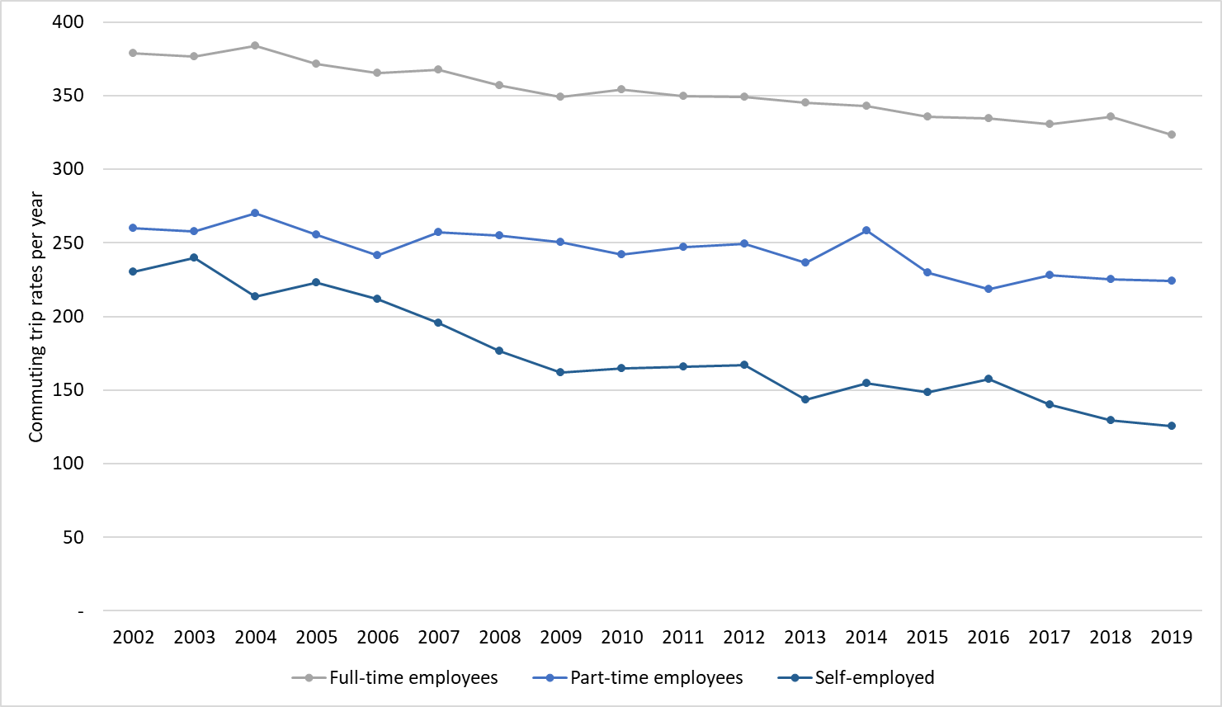
Figure 1: Commuting trip rates per year in England (data from NTS0411 at DfT, 2020a)
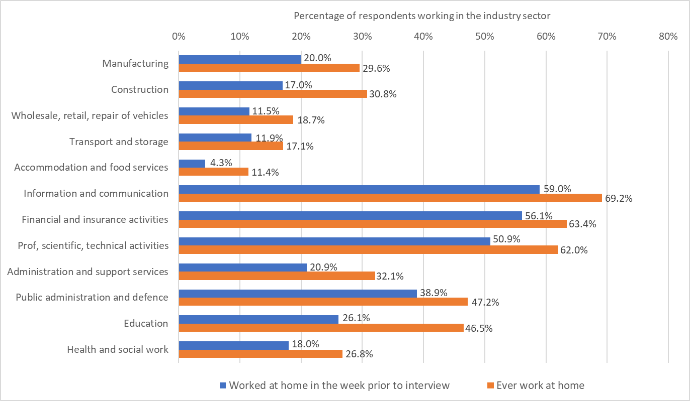
Figure 2: Working from home by industry sector in the UK January to December 2020 (data from Table 3 at ONS, 2021i)
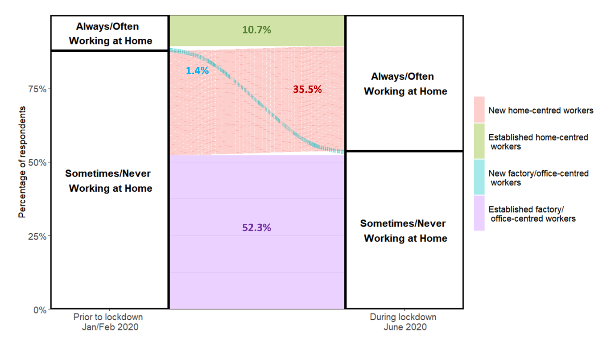
Figure 3: Transitions in work location from before first national lockdown to June 2020 (based on results reported in Felstead and Reuschke (2020))
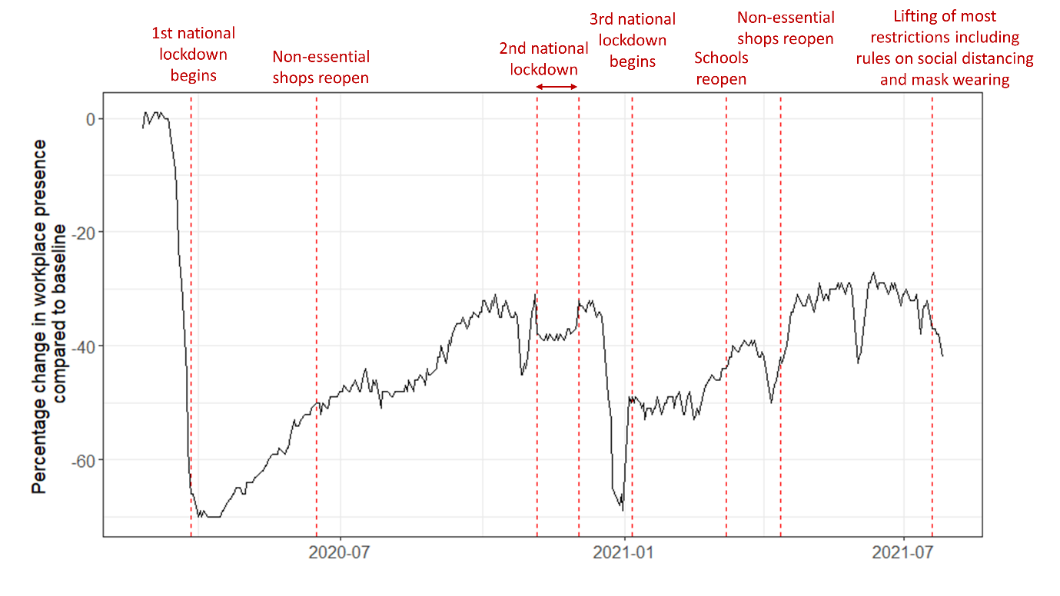
Figure 4: Change in weekday workplace presence in the UK during the pandemic (data from Google Covid-19 Community Mobility Reports (Google, nd))
Figure 5: Pop-up cycle lane in London
Figure 6: Co-working hub and e-scooter in Bristol

Statistics on work-related travel are reported for England only since different data collection methodologies are used across England, Northern Ireland, Scotland and Wales and it is not feasible to report statistics for all four nations.
In the National Travel Survey commuting trips are defined as trips to ‘a usual place of work’ from home or from ‘a usual place of work’ to home. Business trips are defined as trips involving an ‘in course of work’ location. A usual place of work is defined as the location where the respondent works on at least two consecutive days per week. Commuting trips do not include travel to or from work involving non-trivial stops, for example, to drop off a child at school or to buy groceries. See Crawford (2020) for further details.

