

REINVESTMENT PROJECT FINAL REPORT

South West Allied Health Professions e-Newsletter

Jim Petter
September 2010
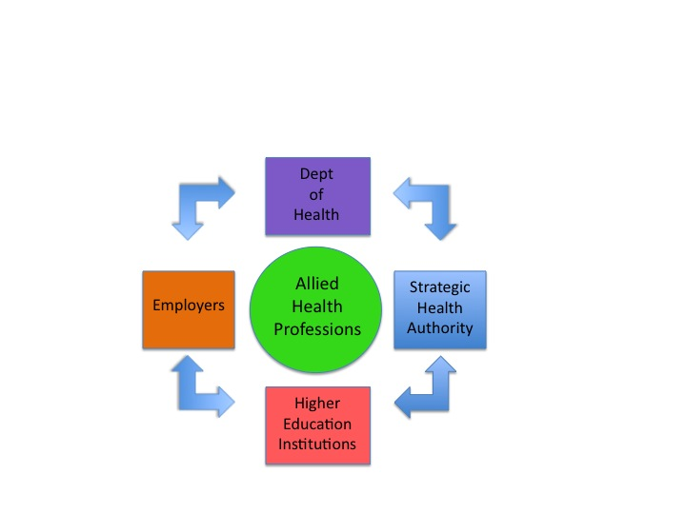

Contents

1 Executive Summary………………………………………………………….5

2. Background…………………………………………………………………..9

3. Project Activity……………………………………………………………….12

4. Project Findings..............................……………………………………….16

5. Sustainability Appraisal.................………………………………………..18

6. Project Outcomes................. …………………………………...21
7. References ………………………………………………………….22

8. Appendix 1: South West SHA Allied Health Professionals

Workforce Statistics………………………………………………………...23

1. Executive Summary

1.1 Allied Health Professionals (AHPs) are defined by the Deprtment of health (DH) as first-contact practitioners and share common attributes. The role of AHPs has become increasingly relevant to DH plans for modernisation, as indicated by their inclusion as a generic NHS workforce group that have been included in a number of important publications over recent years.

  - They are, in the main, first-contact practitioners;

They perform essential diagnostic and therapeutic roles.

They work across a wide range of locations and sectors within acute, primary and community care

They perform functions of assessment, diagnosis, treatment and discharge throughout the care pathway – from primary prevention through to specialist disease management and rehabilitation.

These include the following professions:

Art therapists Chiropodists/Podiatrists

Diagnostic Radiographers Dieticians

Dramatherapists Music therapists

Occupational Therapists Orthoptists

Paramedics Physiotherapists.

Prosthetists and Orthotists Speech and language therapists

Therapeutic Radiographers

1.2 The South West Strategic Health Authority (SWSHA) has recognised the increasing role that AHPs have to play in delivering heath care and in particular, some key drivers for modernisation.

- A desire to improve quality of patient care.
- A growing and ageing population with long term and potentially complex needs.
- A desire to provide equality of access to care and treatments for all.
- An acknowledgement of the valuable contribution of AHPs to the strategic planning and delivery of patient services in all sectors.

1.3 The SHA-Funded Reinvestment Projects were a joint South West Strategic Health Authority (SW SHA) and University of the West of England (UWE) initiative, consisting of twelve distinct projects and launched in 2009. Three members of UWE staff worked on one of the projects, named “Modernising AHP Careers”, which included objectives agreed between UWE and SW SHA as supportive of the SHA’s: Strategic Framework for Improving Health in the South West (2008/09 to 2010/1)

1.4 The three project team members focussed on three specific project aims, these being:

i) To enhance communications with and between AHPs
ii) To examine and improve Continued Professional Development (CPD) access and delivery
iii) The production of an AHP Resource Pack for publication which supported the QIPP (Quality, Innovation, Productivity and Prevention) agenda.

1.5 This document deals with the communications strand of the project. After consideration of the potential methods and the resources available, it was agreed that the most cost effective method of enhancing communications amongst and around AHPs was to produce a regular (quarterly) newsletter in electronic format, which could be distributed via email to AHPs in the region, using both direct and indirect methods. Consequently the electronic newsletter: “South West AHP News” was first produced during December of 2009

1.6 Following the decision in December 2009 to reject the option of an additional web-based presence solely for the communications project strand, a decision was made by the project lead (JP) to produce subsequent editions in a two-monthly cycle, rather than quarterly.

1.7 On 3rd March 2010, the South West AHP Conference provided a valuable opportunity to further advertise the newsletter and to gain feedback on its style and content.

1.8 During spring of 2010, publication was hampered by a period of “purdah” around the general election. During the purdah period, DH and SHA staff were unable to contribute news items or comment on existing information.

1.9 Since December 2009, the newsletter has been well received and the initial database of AHPs has been continually expanded to include requests from individual subscribers. There now exists a substantial database of AHPs in the South West region, which could be used to further develop direct communications with this group of AHPs or for other reasons, such as targeted marketing, news and information.

1.10 The newsletter has sought to underpin existing lines of communication, notably the work of the AHP Networks in the South West region, which are supported by the SW SHA. These are:

- The Avon Gloucestershire and Wiltshire AHP Forum
- The Dorset and Somerset AHP Forum
- The Peninsular AHP Forum

2. Background

Background to the need to enhance communication with AHPs

2.1 The principles of ‘modernisation’ stem from a drive to provide more patient-focussed services which better meet the changing needs of the patient population and are delivered by a skilled and knowledgeable AHP workforce.
2.2 Several DH reports have been published which scope the involvement of AHPs in delivering high quality, accessible services in health and social care settings. These include High quality care for all: NHS Next Stage Review (Department of Health 2008) and Modernising Allied Health Professions (MAHPC) Careers (Department of Health 2008).
2.3 In practical terms these reports have been designed to deliver the following key aims:
- AHPs to be given the opportunity to be involved in leadership and strategic planning of services.
- AHPs to be supported to gather data in order to measure and document best practice through a variety of frameworks and methods
- AHPs will be expected to foster greater involvement of patients and carers in strategic and operational matters in order to ensure what they plan and deliver meets patient needs appropriately.
- AHPs to contribute to improving access to services for patients and carers.

2.4 The first two elements above are particulary relevant to the communications strand of this project, which seeks to increase awareness of good practice and of the ongoing leadership agenda, for example the National Leadership Challenge. The South West Strategic Health Authority (SW SHA) is committed to the principles of modernisation enshrined in the DH and their own strategy documents, such as: Ambitions for the South West. (NHS South West, 2008) This commitment was one of the reasons for the creation of the Reinvestment Project and of the: “Modernising AHP Careers (MAHPC)” sub-project, in partnership with UWE. The partnership sought to explore AHP workforce modernisation within the South West region, for the benefit of its patients and workforce.

2.5 Project Aims

Specifically, the brief of the communications strand of the MAHPC project was to:

- Identify and circulate examples of existing good practice and innovation

- Support knowledge of SHA strategic aims and key messages

- Improve communication between AHPs in the SW SHA region

- Publicise events and information of interest to AHPs

- Support the development of AHP business skills and leadership initiatives

- Signpost access to resources and information, in order to promote good practice.

- Support the other two MAHPC project strands.

(Note that the creation of a database of AHPs was not an aim of the project but has developed as an unintended benefit.)

2.6 The SW AHP e-newsletter was originally sent direct as an email attachment to the regional AHP Networks (mentioned 1.10 above), as well as to individuals, AHP professional bodies and employers (NHS Trusts). However, this method was adapted so that an email containing a simple web-link could be sent, thereby reducing size of email traffic.

2.7 Initially the newsletter was held on a SW SHA server as part of the workforce modernisation web page set. This led to problems, as the site was obscure and necessitated a cumbersome web address. To resolve this problem, hosting was switched to the new “Day in the Life” website www.dayinthelife.org.uk which provided much easier access.

2.8 An added advantage was that the new website also facilitated the hosting of other large items which could be held at the same Internet location, for example the AHP Resource Pack: http://www.dayinthelife.org.uk/Data/Sites/7/docs/developing/innovationinpracticecopy.pdf

2.9 The project team consisted of one 0.5 WTE equivalent member of staff. Jim Petter (JP)

Project date: June 2009 - August 2010

3. Project Activity

Publishing Options
3.1 Electronic publishing provides ease of access across a large geographical area with relatively low cost. Initially the SW AHP Newsletter was sent by e-mail as a PDF file directly to AHPs, but with the arrival of the “Day in the Life” web site this policy was changed, so as to reduce the size of data sent and instead an email containing a link to the web page was sent.

3.2 As well as an electronic newsletter, the further option of a dedicated web page was discussed and investigated. The potential for developing a specific website using UWE information technology and expertise were investigated and appraised. However this option was rejected because it was felt that the dis-benefits outweighed the benefits (see table below) especially given the fixed-term nature of the project and the lack of a firm commitment to fund beyond the project end date.

Benefits | Dis-benefits
Convenient platform for e-newsletter and further communicative tools, e.g. forums, interactive discussions, CPD opportunities | Cost of domain and server access (£100 p.a.)
Effective control of media platform | Cost of IT specialist support for website development and ongoing support  £1000-2000 start up plus approx £500 p.a.
24/7 access to information | Long term commitment
Long term provision requirements | Easy availability of alternatives

Readership demographics
3.3 The SW AHP e-newsletter link was circulated primarily by means of cascading the webpage link to the newsletter to the following groups. The groups listed below were then asked to ciculate the link in turn, to their AHP contacts.

- Individual AHPs
- AHP Network Chairs (for further circulation via the existing networks)
- AHP professional bodies
- NHS employers

3.4 As well as the cascade method used, a separate database of individual subscribers is held, which now contains approximately 420 individual contacts, including name, profession and contact email/phone numbers. This list currently represents approximately 5.2% of all AHPs in the South West region (total number 7,795 by headcount, June 2009) according to SW SHA workforce figures (see Appendix 1).

3.5 It should be noted that most AHPs receive the newsletter via the third party organisations listed above, than directly to the subscriber databse. Consequently, although the exact reader numbers are difficult to establish, the total number of readers is thought to be considerably more than the number of individual subscribers. The individual subsciber database is owned by UWE and the SW SHA.

3.6 AHPs in the private and third sectors were not specifically targeted. Whilst there is no deliberate exclusion of private sector AHPs, there has not been sufficient resource to expand this sector database. Although there are a few private and third sector members of the database, and non-NHS areas of excellence have received page-space, it is acknowledged that low numbers of non-NHS AHP interest has been a challenge for the project.

3.7 The pie chart below (Figure 1), demonstrates individual subscriber numbers by profession. Professions that are poorly represented include the arts therapies and paramedics. Both professions are scarce on the individual subscriber list but may receive the e-newsletter via the third party organisations above. The reasons for such a low take up by Arts Therapists may be reflected by the low numbers in the South West region, (110 according to SHA figures). Paramedics are a bigger group by numbers but are an embryonic profession in that their professional body is less than ten years old and their professional awareness as generic AHPs is low in comparison to the other professions.

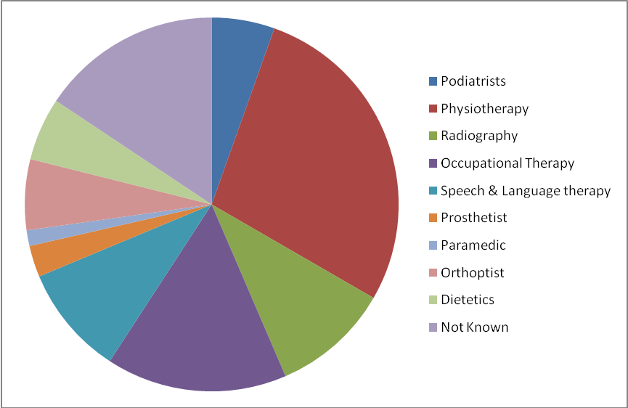
Figure 1. Individual subscribers by profession (total 420)

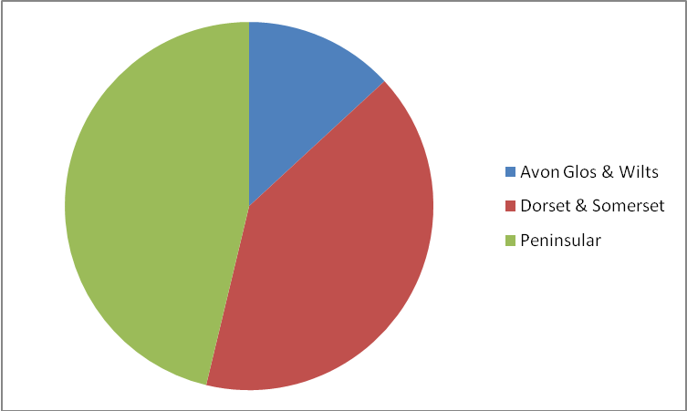
Figure 2. Individual subscribers by AHP Network area (total 420)

Subject Themes
3.8 Newsletter subject themes have been diverse, taking account of both generic and profession-specific items of interest. They have included contact information on the AHP networks, CPD opportunities, including short courses, conferences and study days plus general news articles of interest to AHPs. There have also been several articles about areas of best practice and implementation, plus updates on the MAHPC work at the DH and the SHA. The National Leadership Awards: http://www.nhsleadershipawards.nhs.uk/
have also been heavily featured.

3.9 The major project activity was centred on production of the SW AHP e- newsletter. However other activities included:

- Creation and management of the subscriber database
- Participation in the organisation SW AHP Conference, March 2010. (Included workshop facilitation role)
- Participation in the provision of the AHP Celebration Event (December 2009)
- Presentation and networking with various stakeholder groups
- Support of aims of the two other MAHPC Project strands.
- Liaison with other Reinvestment Project Leads

4. Project Findings

The project identified some key issues around communicating with AHPs.

Perspectives on profession-specific versus generic information.
4.1 In dealing with the needs of AHPs, the DH and SW SHA are often obliged to treat them generically. This is largely because of their strategic outlook. Government organisations have a remit to manage the implementation of regional and national agenda. Issues such as modernisation, health strategy, finance, patient care initiatives etc, commonly deal with the health economy as a whole and dialogue is only rarely focussed on specific allied health professions. All of the AHP-relevant publications that support the MAHPC project are designed to be generic to all the AHPs (those professions defined as AHPs by the DH list) The support of AHP Networks by government organisation is designed to encourage dialogue on generic issues and to enhance collaborative working amongst AHPs and between AHPs and the other health professions.

4.2 In producing relevant information for SW AHP e-newsletter readers, it was apparent that the content had to contain both profession-specific and generic information in order to remain relevant. A bias towards either generic or profession specific content was listed as being disliked by delegates to the SW AHP Conference.

Profession-specific exposure within the AHP community
4.3 Further to the point at 4.1.above, it is the case that some allied health professions have a higher profile in the health economy than others. In terms of numbers, physiotherapists, occupational therapists and radiographers have more members, more powerful and active professional bodies and a better developed public relations output than the other smaller professions, consequently they are better able to feed news into various media outlets. This disparity makes it necessary to search more thoroughly for items of interest to the smaller professions and to take a more supportive role to highlight activity, as compared to the more high-profile groups.

Professional boundaries
4.4 The project lead (JP) is in agreement with the DH and SHA that AHPs have much to offer the health economy and that the role of AHPs in healthcare is increasingly relevant to modernisation. During the life of this project the new coalition government has announced radical plans to change the NHS, in the form of the White Paper: Equity and Excellence: Liberating the NHS, (DH 2010) which includes radical plans to change commissioning.

4.5 It is apparent that if AHPs are to position themselves for maximum input into a changed NHS, they must be able to present their strengths as effectively as possible, setting aside professional differences in favour of a stronger, generic approach. The principles behind the MAHPC project are designed to support AHP development within the health economy. Further publication of the AHP e-newsletter would continue to support the overall AHP agenda and underpin the AHP networks, which currently provide much needed momentum for such an approach.

Quality, Innovation, Productivity and Prevention (QIPP)
4.6 Quality, Innovation, Prevention and Productivity (QIPP) is now very much part of the NHS cost-savings agenda and consequently is highly relevant to AHP working. http://www.improvement.nhs.uk/QIPP/tabid/61/Default.aspx
In the new climate of austerity within the NHS, AHPs have received support to prove their effectiveness from the DH AHP team at the centre and from regional initiatives such as the MAHPC projects. Outputs from these projects such as the AHP Resource Pack, and Experts Register, have been publicised by the e-newsletter

5. Sustainability Appraisal

5.1 Two questions were raised about continuity. The first was whether the newsletter had succeeded in its aims and therefore added value to the regional AHP agenda. The second, (dependant on the first) was whether resources could be found to enable continuation of the publication, so as to maintain support for the strategic principles set out by the DH and SW SHA.

5.2 As key stakeholders, the AHP Network members were canvassed by email for their opinions, during September 2010. The following feedback was received.

“I don’t think we have built up a ‘demand’ for the newsletter – which is probably nothing to do with its content and purpose, but more about it being ‘separate’ to other forms of information. I also wonder whether there would be more interest if it was more ‘local’ rather than regional – but that is pure conjecture”

“It was a good newsletter and enjoyed seeing what was going on in the SW”

“The SW AHP Newsletter reaches me through via a service lead in Devon, who sends it to Therapy Manager in Cornwall and Isles of Scilly PCT, who then sends it on to her Therapy Leads. I wanted to let you know that I find it very helpful and informative, and often use the links to, for example government developed tools”

“I think that the newsletter has been very interesting and has enabled us to feel less isolated as practioners working often outside a multidisciplinary situation”.

“It has contained useful advice and I have been able to pass it on to other colleagues”.

“Having a newsletter is ‘nice to have’, but represents nothing more tangible than that”

5.3 In addition, a short survey (consisting of two questions only), was placed on the Day in the Life website. The survey was deliberately concise so as to be accessible and was designed to canvas the views of those AHPs unconnected with the AHP Networks. The questions were:

Has the SW AHP e-newsletter been of value to you in your practice as an AHP? Yes/No

Would you like to see the SW AHP e-newsletter continue in its current format? Yes/No

The response rate to this online survey was disappointing in that only two responses were received. Both answered yes to both questions.

  - The feedback received was overwhelmingly positive about the value of the newsletter and of the benefits to communication that it provided. However the feedback received did not appear to provide a firm case for continuity. In particular no resources were identified which would have provided for continued publication.
This document provides options for the future of the project.

5.5 The options are:
- Discontinue the publication from September 2010.
- Seek funding for the AHP Networks to continue publication
- Invite the regional HEIs to continue to resource the publication

5.6 In the face of financial austerity, it is unlikely that resource to continue publication will be found within the public sector. SW SHA have also confirmed that there is no funding currently identified for such purposes.

In addition, the response from AHP Network Chairs, members and from AHPs themselves has confirmed that there are currently inadequate resources to maintain publication.

These factors indicate that there is no strong will or resources available continue with publication.

5.7 An unintended benefit of the project has been the creation of a database of specific allied health professionals in the South West region. This database may have value for further specific targeted information and following data cleansing to comply with statutory requirements (Data Protection Act) could be shared with the SW SHA (as commisioners of the project) so as to be included in information with which they can continue to inform the region’s AHPs.

6. Project Outcomes

  - The e-newsletter was successful in acting as a catalyst for communications, bringing together AHPs in the South West region. Together with the other MAHPC projects it has provided a positive legacy, leaving AHPs more empowered and more professionally self-aware. These have been important steps in maximising the AHP contribution to healthcare.

  - Production of the e-newsletter prompted many individual AHPs to ask to be included as subscribers. This has led to the creation of a database of professionals from a range of AHP backgrounds which will now be used to enable further communications beyond the end of this project and represents a further positive outcome of the dialogue undertaken.

References

AHP resource Pack http://www.dayinthelife.org.uk/Data/Sites/7/docs/developing/innovationinpracticecopy.pdf

Day in the Life website http://www.dayinthelife.org.uk/

Dept of Health (2010) Equity and Excellence: Liberating the NHS
London: Dept of Health

Dept of Health (2000) Modernising Allied Health Professions (AHP) Careers.
London: Dept of Health

Dept of Health (2008) Framing the contribution of allied health professionals: delivering high-quality healthcare London: Dept of Health

Dept of Health (2008b) A high quality workforce: NHS Next Stage review London: Dept of Health

Dept of Health (2009) High Quality Care for All: Our journey so far London: Dept of Health

Dept of Health (2009b) Transforming Community Services: Enabling new patterns of provision London: Dept of Health

Dept of Health (2009c) Transforming Community Services Quality Framework: Guidance for Community Services London: Dept of Health

NHS South West (2008) Ambitions for the South West - A summary version of The Strategic Framework for Improving Health in the South West 2008/09 to 2010/11 Taunton: NHS South West

Jenkins F and NHS South West (2009) Implementing Framing the Contribution of Allied Health Professionals: Delivering high-quality healthcare in the South West. Taunton: NHS South West

7. Appendix
Appendix 1: Total registered AHP staff by headcount 7,975
(South West Strategic health Authority workforce statistics, June 2009.

Chiropody/Podiatry |  | Head
SAA | Consultant Therapist / Scientist | 2
S0A | Manager | 13
S1A | Therapist | 338

Dietetics |  | Head
SAB | Consultant Therapist / Scientist
S0B | Manager | 20
S1B | Therapist | 320

Occupational Therapy |  | Head
SAC | Consultant Therapist / Scientist | 2
S0C | Manager | 73
S1C | Therapist | 1,841

Orthoptics/Optics |  | Head
SAD | Consultant Therapist / Scientist
S0D | Manager | 12
S1D | Therapist | 84

Physiotherapy |  | Head
SAE | Consultant Therapist / Scientist | 8
S0E | Manager | 81
S1E | Therapist | 2,433

Radiography (Diagnostic) |  | Head
SAF | Consultant Therapist / Scientist | 2
S0F | Manager | 33
S1F | Therapist | 1,450

Radiography (Therapeutic) |  | Head
SAG | Consultant Therapist / Scientist
S0G | Manager | 12
S1G | Therapist | 219

Art/Music/Drama Therapy |  | Head
SAH | Consultant Therapist / Scientist
S0H | Manager | 2
S1H | Therapist | 110

Speech & Language Therapy |  | Head
SAJ | Consultant Therapist / Scientist | 3
S0J | Manager | 58
S1J | Therapist | 792

Art/Music/Drama Therapy |  | FTE
SAH | Consultant Therapist / Scientist
S0H | Manager | 1.81
S1H | Therapist | 65.59

