CARFREE, LOW-CAR – WHAT’S THE DIFFERENCE?
Dr Steve Melia, Senior Lecturer in Transport & Planning
University of the West of England

Abstract
This paper aims to propose a definition and typology of carfree development and to assess the benefits and problems associated with it. It aims to contrast these with the concept and practice of ‘low car’ development.
Through a review of the literature and study visits to European carfree areas, 3 types of carfree development were identified: the Vauban model, Limited Access model and pedestrianised city centres with substantial residential populations. Differences in the previous definitions of carfree development reflect two different aspects of the concept: exclusion of vehicles from the residential area, and places where people live without owning cars. The definition proposed here reflects both of these, although neither was absolutely implemented in the examples visited. Although intermediate cases are possible, in practice clear differences are apparent between the carfree and ‘low car’ developments reviewed in the literature and studied in one case, in the UK.
The study visits supported the claims in the literature that carfree developments help to reduce problems created by traffic in urban areas. They facilitate active travel and independent play amongst children. Their main problems relate to the management of parking and vehicular access. Low car developments by contrast can offer similar benefits to policymakers, but fewer benefits to residents.

Introduction
Carfree development is a relatively recent response to long-standing concerns about the effects of motor vehicles on the urban environment. Although the relationship between cause and effect remain contested, and no consensus exists on the appropriate policy responses, the proposition that increasing car ownership and use creates particular problems in urban areas has been largely accepted.
Amongst the many proposals advanced to address these problems some have advocated carfree development (Reutter, 1996, Crawford, 2000), several examples of which have been built across Europe in recent years, although it has occupied a relatively marginal place in this debate so far.
This article begins by reviewing the different types of carfree development found in the literature and visited during the course of this study. From this, three types of carfree development are proposed, leading to a definition in Section 4. Section 5 briefly reviews some examples of ‘low car’ development leading to a proposed definition. Section 6 considers the main benefits claimed for carfree developments and the evidence for these, along with some problems. Section 7 reviews evidence on the benefits and problems of low car development.
All of the developments described as ‘carfree’ involve some degree of compromise with pressures for vehicular access and parking. Thus the distinction between ‘carfree’ and ‘low car’ involves a judgement. Nevertheless, there are important differences between the two concepts relating to the immediate environment and benefits to residents.
The article concludes with a discussion of implications for transport policy in urban areas, and gaps in the knowledge base, where more research is needed.

Carfree Development in Europe and Elsewhere
There are many areas of the world where people have always lived without cars, because no road access is possible, or none has been provided. The term carfree development implies a physical change: either new building or changes to an existing built area. There have been some recent attempts to define carfree development (see, for example: Morris et al, 2009), following practice around Europe. These attempts at definition have generated some problems. Morris et al include ‘low car’ as a form of carfree development, which would appear to be a contradiction in terms, although the distinction between the two is far from clear.
In UK planning policies (e.g. DETR, 2001) the term ‘car free’ usually refers solely to the absence of parking. Some London boroughs (e.g. Camden LB, 2009) with extensive Controlled Parking Zones, define car free housing by a planning condition precluding occupants from applying for a residents’ parking permit. Over time, the growing proportion of such housing has served to constrain levels of car ownership within these zones.
Underlying the various definitions are two different aspects of carfree developments i.e.:
- residential (or mixed use) areas from which vehicles are excluded, and/or
- housing where people live without owning a car
The UK definition ignores the first aspect and assumes that parking restrictions will achieve the latter. Most of the continental European examples exhibit some element of both, and in seeking a definition, this article will focus on developments which exhibit both, although neither has been absolutely implemented in any of the examples.
The broadest study of European carfree developments was conducted by Scheurer (2001). His thesis refers to six recently built carfree developments (and some others which would not be considered carfree as defined here) of which four were sufficiently advanced to include in his survey: Vauban (Freiburg), GWL Terrein (Amsterdam), Autofreie Musterseidlung Florisdorf (Vienna) and Slateford Green (Edinburgh). Two other planned developments mentioned by Scheurer have since been built: Saarlandstrasse (Hamburg) and Stellwerk 60 (Cologne). Four of these developments were visited during the course of this study.
Many cities in Europe and elsewhere have pedestrianised city, town and district centres. The vast majority are mainly commercial in nature, although some include some residential properties. Most research on pedestrianisation has focussed on commercial centres and travel to them; relatively little attention has been paid to the extent of, and potential for, residential populations within pedestrianised centres. The literature (Tsubohara, 2007, Ligtermoet, 2006) did suggest, however, that Groningen in the Netherlands contains one of the largest examples of a city centre with a residential population, from which through traffic has been removed.

Typology and Examples
To explore and compare the different types of carfree development, study visits were arranged to: Groningen and five carfree new developments: Vauban (Freiburg), GWL Terrein (Amsterdam), Saarlandstrasse and Kornweg (Hamburg) and Stellwerk 60 (Cologne). These six examples were chosen to provide a range of differing sizes, contexts, and approaches to the carfree concept. In each case, stakeholders including municipal planners and organisations representing residents were interviewed. Observations were made of access arrangements, travel behaviour, social interactions and children’s travel and play.
These examples suggested three types of carfree development described below:

- Vauban model
- Limited Access model
- Pedestrianised centres with residential population

The Vauban Model
Vauban, with a population of just over 5,000, unlike the other examples discussed here, has no physical barriers to the penetration of motor vehicles into the residential areas. Although the term autofrei (carfree) is sometimes used in connection with Vauban, this is not how most residents would describe it. The City Council prefers the term stellplatzfrei, to describe the majority of streets where this rule applies. Vehicles are allowed down these streets at walking pace to pick up and deliver but not to park, although there are frequent infractions. Residents of the stellplatzfrei ‘areas must sign an annual declaration stating whether they own a car or not. Car owners must purchase a place in one of the multi-storey car parks on the periphery, run by a council-owned company. The cost of these spaces – € 17,500 in 2006, plus a monthly fee – acts as a disincentive to car ownership.
The planned parking capacity – 0.5 per dwelling – was higher than the other examples described below. At early stages of its construction, Scheurer (2001) and Nobis (2003) found just over half of households owned a car, but today, many of the parking spaces are unused. There have been no more recent surveys but parking levels suggest a substantial majority of households do not own cars there today.
Although vehicles are physically able to drive down the residential streets, and the no-parking rules are not effectively enforced, in practice, vehicles are rarely seen moving on the stellplatzfrei streets. Signs emphasise that children are allowed to play everywhere, and in the absence of moving traffic, children are more evident (Figure 1) than in the more conventional home zones and traffic-calmed streets common elsewhere in Freiburg.

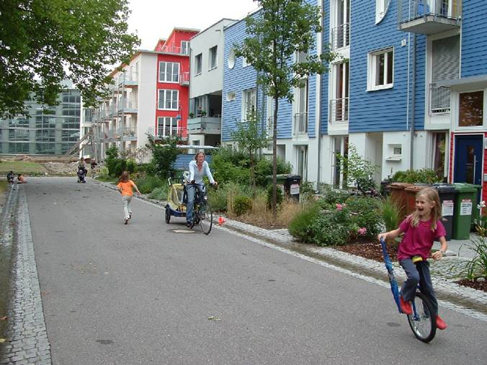 | 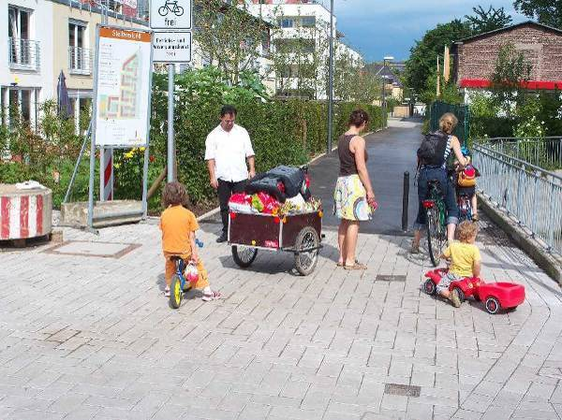
Figure 1 stellplatzfrei street, Vauban, Freiburg | Figure 2 Access to Stellwerk 60, Cologne

The Limited Access Model
Unlike Vauban, in GWL Terrein, Stellwerk 60, Saarlandstrasse and Kornweg, as well as several others described in the literature, various arrangements physically restrict the access of motor vehicles to the residential areas. These more common arrangements may be described as the Limited Access Model.
Saarlandstrasse and Kornweg are relatively small, with 111 and 64 dwellings respectively. In these cases, a few parking spaces (ratios 0.15 and 0.2) intended for visitors and deliveries are close to the housing, surrounded by semi-private space where vehicles cannot penetrate. These small developments are able to provide a traffic-free environment because of their particular situations – the Saarlandstrasse site is partly surrounded by water and Kornweg is effectively a traffic-free cul-de-sac.
GWL Terrein and Stellwerk 60 are both larger: around 600 and 400 dwellings respectively. Stellwerk 60 includes some houses as well as apartment blocks, with pedestrianised streets between them. Removable bollards restrict access to the core of the site. A residents’ organisation controls these bollards which are removed for a limited range of vehicles such as removal vans and emergency vehicles, but not for general deliveries, which are done by hand, sometimes using trolleys or cycle trailers (Figure 2). In the case of GWL Terrein, the blocks of up to 8 storeys high have been built around semi-private space where vehicles cannot penetrate (Figure 3). Entrances to the blocks are all fairly close to the perimeter, where some time-limited parking is available. Peripheral parking, mainly in multi-storey blocks is provided at a ratio of around 0.2 in both sites, allocated by ballot in GWL Terrein, and separately sold in Stellwerk 60.

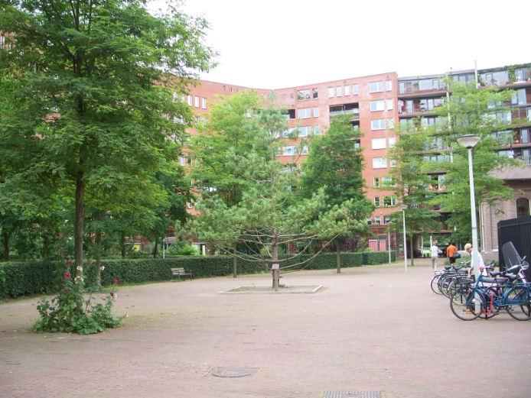
Figure 3 GWL Terrein, Amsterdam | Figure 4 Groningen Inner Ring road

Pedestrianised Centres
Whereas the first two models apply to newly-built carfree developments, most pedestrianised city, town and district centres have been retro-fitted. Pedestrianised centres may be considered carfree developments where they include a significant number of residents, mostly without cars, due to new residential development within them, or because they already included dwellings when they were pedestrianised.
Groningen is a city in the North of the Netherlands with a population of 181,000, including about 46,000 students (City of Groningen 2007, cited in: Pucher and Buelher, 2007). Its city centre, an area of roughly a square kilometre, is partially pedestrianised and entirely closed to through motor traffic: there are several car parks accessible on an ‘in and out’ basis. Groningen is unusual because of the size of the residential population within this largely traffic-free centre: 16,551, a population which has been growing in recent years (Gemeente Groningen, 2008).
The original decision to restrict through traffic was implemented in 1977 (Tsubohara, 2007). Since then, the process has continued incrementally, with nearly half of the streets now pedestrianised (some of them allowing bicycles). These are mainly shopping streets although there are a few apartments above or behind the shops. Some of the other streets are open to general traffic only at certain times of the day. An Inner Ringroad encircles the centre, providing a fairly slow bypass for general traffic (Figure 4). Priority in its design has been given to cycling and public transport.
Parking for non-residents has been progressively restricted to car parks towards the edge of the centre. A total of 2,340 parking spaces (900 on-road) are reserved for the residents, amongst whom car ownership (28.7 per 100 households) was roughly half the city average and a third of the national average (Gemeente Groningen, 2008). Although no separate statistics were available, the concentration of students, who generally have lower levels of car ownership, is believed to be higher in the centre than elsewhere in the city.

Definition of Carfree Development
In proposing the above typology and a definition a degree of circularity is unavoidable. The developments studied were chosen because they have been described as carfree, or partially carfree. Based on absolute criteria, none of them would be described as entirely carfree. Their defining factors may be identified as follows:

Definition of Carfree Development
Carfree developments are residential or mixed use developments which:

- Normally provide a traffic free immediate environment, and:
- Offer no parking or limited parking separated from the residence, and:
- Are designed to enable residents to live without owning a car.

Though none of these is unique in itself, and each requires a judgement, their combination encompasses all three types and distinguishes them from other forms of development. Each of these is discussed in turn.
The phrase ‘normally’ in the first criterion implies the need for a judgement. Clearly vehicles are not excluded from the streets of Vauban, nor are they always excluded from pedestrianised centres but the traffic-free environment which obtains most of the time is a factor common to all three.
Similarly for the second criterion on parking: none of the examples visited, nor any of those reviewed in the literature had achieved zero car ownership. In most cases some limited parking for residents (ratios between 0.15 and 0.5 per dwelling) explicitly allowed a minority of them to own cars.
The third criterion reflects the observation that all the European examples were designed with a range of sustainability objectives including measures to facilitate living without owning a car. These measures varied according to the scale and location of the development, from cycle storage facilities in all cases, car club vehicles in the larger ones, to the extension of the tram network along the main street of Vauban. ‘Design’ in this context may also include the choice of location: for the smaller developments, proximity to the existing public transport networks was always an important factor.

Definition of Low Car Development
As with carfree development there is no agreed definition of low car development. Morris et al (2009) state that reduced parking standards are the defining feature, although they do not explain how “reduced” should be interpreted.
Six developments which may be considered ‘low car’ were reviewed in a study for the UK’s Department for Transport (DfT, 2005). The parking ratios were considerably higher than the carfree developments described in Section 3 – varying from 0.7 to 1.5 spaces per dwelling. 1.5 was the national maximum parking standard in the UK at that time (DETR, 2000), although the national standards were not uniformly applied, and were subsequently abandoned (CLG, 2006). The developments in the DfT study combined these parking standards with residential travel plans, designed to encourage modal shift amongst the residents.
Following the approach in the previous section, low car development may be defined as follows:

Definition of Low Car Development
Low car developments are residential or mixed use developments which:

- Offer limited parking, and:
- Are designed to reduce car use by residents.

As with the definition of carfree development, the term ‘limited’ requires a judgement, which will vary according to the context. The principle is that the combination of parking provision and parking controls constrains the level of car ownership: if more parking were available, higher levels of car ownership, more typical of the surrounding area, would result.

Benefits and Problems of Carfree Developments
Although the literature on European carfree developments is limited, it does provide some fairly strong evidence that they reduce car use and increase walking and cycling. The literature also suggests some other potential benefits, which this section will review.
Scheurer’s (2001) surveys found levels of car ownership varying between 8% of households in Vienna Florisdorf to 54% of households in Vauban, which was at an early stage in its development. Scheurer’s method of measuring modal share was rather unusual, asking respondents to fill in the frequency of trips per month under seven specific categories with no ‘other’ category, so comparisons with all-purpose modal share statistics may not be precise. Nevertheless, a clear pattern of very low car use (5% - 16% of journeys) and high levels of walking and cycling (38% - 73%) emerges from his surveys.
Another survey of Vauban was conducted two years later when nearly half of the planned housing was occupied. Nobis (2003) found a similar proportion of carfree households (“over 40 %”) and using different questions from Scheurer confirmed the low level of car use: cycling was the most frequent mode for commuting, shopping and leisure. Both of these studies were conducted before the extension of the tram system to Vauban in 2006, which may have influenced both car ownership levels and travel patterns.

Social and Health Benefits
The studies of European carfree development have mainly concentrated on the mobility aspects, but they contain some evidence of other benefits.
Ornetzeder et al (2008) explored questions of social cohesion and social contacts in Vienna’s Florisdorf carfree development. 85% - 87% of respondents agreed that there were “good neighbourly relationships”, “solidarity within the settlement” and that people helped each other. They found that residents of the carfree project had more friends within the settlement than those of the slightly larger reference settlement (average 16 versus 7). They also knew more people by sight (101 versus 62). The authors ascribe these differences to the carfree nature of Florisdorf, although there were also differences in the extent of resident involvement in the planning of the two developments.
Scheurer also comments on the favourable environment for children in Vauban, where household sizes were particularly high. Nützel (1993) found that children were allowed to play out on the carfree streets of Nuremberg-Langwasser at a younger age (average 3.8) than on conventional streets nearby (average 5.6). The observations made during this study would support these findings. There was considerable evidence of young children playing and cycling without direct supervision in several of the developments visited.
No specific research has been found on the health impacts of carfree development, although some benefits could be deduced from the observations about travel patterns and traffic generation.

Does Carfree Development Address the Problems Caused by Urban Car Use?
It may be considered self-evident that a policy which reduces car ownership and use would help to alleviate the problems caused by car use in urban areas. There are, however, a number of complicating factors.
The analysis so far suggests that the two aspects of carfree development outlined in Section 2 have a number of direct and indirect effects, as illustrated in Figure 5.

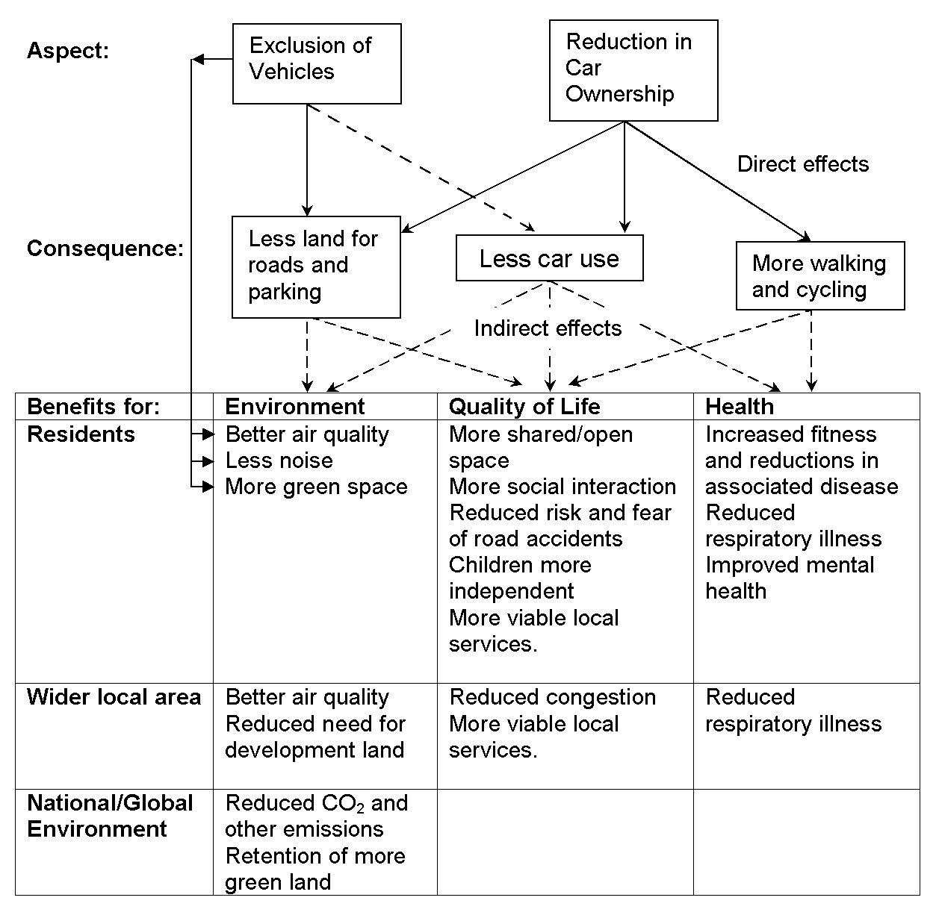Figure 5 Benefits of Carfree Development

The indirect relationship shown between Exclusion of Vehicles and Less Car Use illustrates the effects of making parking less convenient and increasing the advantages of walking for short distances.
The European studies provide fairly strong evidence for the three intermediate consequences. Ornetzder et al (2008) found evidence to support two of the ultimate benefits: sociability, as discussed above, and reductions in CO₂ emissions: residents of the carfree area had a carbon footprint lower than a more conventional reference development nearby, and considerably lower than the national average.
The benefits for residents, from carfree developments in general, may be inferred with a reasonable degree of confidence, although their extent would depend upon the individual circumstances of each development. The benefits to the wider local area and the global environment are more problematic. Whether they will be achieved in practice would depend upon a number of other factors, including other policy or design issues.
The land-related benefits would depend on how the land saved from parking and roads was re-allocated, between gardens, open space and increased density of dwellings (which might reduce building on undeveloped land elsewhere). Reduced congestion would depend upon wider policy and practice in the city and immediate area surrounding the carfree development. Some of the benefits shown would depend upon behavioural change amongst residents, on which there is some evidence from the European studies. Carfree developments could reduce driving and increase active travel for two reasons:
- They attract residents predisposed towards non-car travel
- They change the behaviour of residents (compared to conventional developments)
If the lower car use in carfree developments were solely due to the former, then the national and global benefits would not be achieved, and the benefits to the wider local area might be achieved at the expense of other areas.
The evidence from the European studies suggests that carfree developments do indeed change the behaviour of residents. Nobis found that 81% of the carfree households in Vauban had previously owned a car; 57% gave up their cars after moving there. Scheurer found proportions varying from 10% (in GWL Terrein) to 62% (in Florisdorf) of households had reduced their car ownership since moving to the carfree developments. In Florisdorf Ornetzeder et al (2008) found only one car owner (who was violating the rules of occupation) amongst the 50% of male and 30% of female residents had previously owned a car. 41% of respondents said they were “using the bicycle much more than before”.

Problems: Parking and Vehicular Access
The main problems of carfree developments relate to parking and the control of vehicular access. Scheurer found dissatisfaction amongst 39% of residents with the arrangements in Vauban. Carfree households were unhappy that some car owners were flouting the rules by parking on the stellplatzfrei streets. Some car owners were unhappy about the inconvenience of parking separated from the housing. Nobis found, overall carfree households were more satisfied with the arrangements than car owners. This finding is consistent with Borgers (2008) who found that car owners in the Netherlands preferred parking to be adjacent rather than separated from their housing (there was no mention of any carfree housing in the sample).
Overspill parking can also be a problem. The Vauban system of annual declarations and expensive parking spaces has given some residents an incentive to cheat, by registering cars in other names and parking them nearby. Freiburg City Council had taken legal action against two persistent offenders. The suburban location of Vauban made parking enforcement more difficult. There were no parking controls in the adjoining district of Merzhausen, and statutory enforcement of parking rules within Vauban itself was rare. Vehicles were often parked on the stellplatzfrei streets in contravention of the rules, although this did not significantly detract from the traffic-free nature of these streets, as there were very few vehicle movements.
The Limited Access model avoids the latter problem, although overspill parking in the surrounding area was sometimes an issue. Most of the examples were in more urban locations than Vauban. In GWL Terrein, parking in the surrounding areas was already controlled, so the development did not significantly change the parking situation there. In Stellwerk 60 some complaints had been made about overspill parking, which was addressed by the extension of controls in the surrounding area.
The criteria for exceptional vehicular access to Stellwerk 60 had caused differences of opinion amongst the residents. One contested issue was whether older or disabled residents should be allowed to drive into the interior of the site. The rules adopted by the residents’ association allowed minibuses for older and disabled residents, but not private cars, inside the site.

Benefits and Problems of Low Car Developments
Comparing the potential benefits of low car development to those shown in Figure 5, the benefits related to the exclusion of vehicles would not normally apply. Those related to reductions in car ownership could be expected to apply to a lesser extent than in carfree developments. Although there might be some minor benefits from lower car ownership, the environmental and quality of life benefits for residents would depend on the exclusion of vehicles.
The UK DfT (2005) study mentioned earlier focussed on the process of developing residential travel plans; most of the case studies had yet to begin construction at that time. As part of a wider study (Melia, 2010b) one of these – Poole Quarter in Dorset – was surveyed during 2007. The findings support the view that low car developments well sited in respect to public transport and local services can reduce car use and increase active travel compared to conventional developments, but there was little evidence of the improvements to the local environment observed in the European carfree developments.
Poole Quarter was a new development of low-rise flats and town houses near the centre of a town with a population of 139,000. The dwellings completed at the time of the survey each had one parking space. The travel plan aimed to promote sustainable movement through information and incentives such as discounts on public transport. Of the 97 households (43%) who returned questionnaires, 81% owned a car, but only 15% owned more than one – considerably lower than the surrounding area. 26 had reduced their car ownership on moving there, mainly from two cars to one, and 32 reported lower car use. 57 reported walking more and 19 reported cycling more. These changes were partly explained by proximity to the town centre, bus and rail stations but the parking limitations also contributed. Telephone interviews revealed some evidence of self-selection: some people who moved there were seeking greater accessibility. Others moved there for other reasons, but still reported a change in their travel behaviour. Several reported that their attitudes towards travel by alternatives to the car had become more positive following their moves, consistent with the evidence from the European carfree developments.
The site had been developed at higher than usual densities for that area (108 dwellings/hectare). This meant that even with the lower than usual parking ratios the area between the housing was largely filled with parked cars. An area designated as a home zone (Figure 6) was rarely used, as intended, for children’s play; a lack of green spaces or play areas was cited as a problem by 31% of respondents. The most frequently cited problem, by 57%, was lack of parking. Conflict between neighbours over limited parking spaces was mentioned by several interviewees. When residents were asked why they moved to Poole Quarter, most mentioned the accessibility of the site, but none mentioned anything relating to the low car concept or the travel plan – this was a notable difference from the European carfree developments.
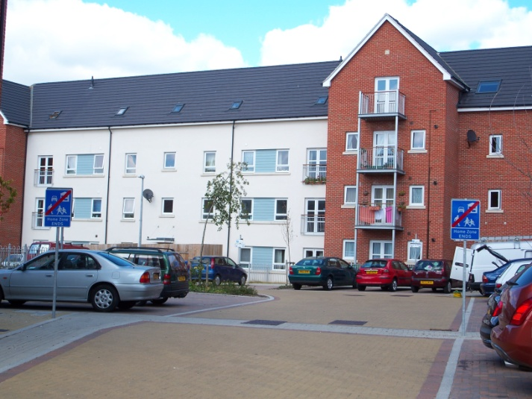
Figure 6 Poole Quarter ‘home zone’

Returning to Figure 5, the benefits of low car developments such as Poole Quarter flow entirely from a reduction in car ownership; these are benefits to the wider area or the global environment, but not for residents. A similar point may be made about the UK concept of ‘car free housing’.

Potential Demand and Feasible locations for Carfree Development
All of the analysis of benefits presupposes a potential market for housing with reduced car ownership. In the European cities where carfree developments have been built, such a market clearly exists, and anecdotal evidence suggests that property values may be higher in such developments (Melia, 2010b), although there has been no specific study on this as yet. There is some evidence that car owners tend to prefer parking adjacent to their homes, although environmental improvements and accessibility to public transport routes may compensate for this to at least some extent (Borgers et al, 2008).
Melia (2010b, 2010a) has studied the potential demand for housing in carfree developments in the UK. Two surveys were conducted: a national online survey of members of cycling and environmental groups and a postal survey of the Bloomsbury and Kings Cross areas of Inner London, where car ownership is particularly low. The questionnaires were followed up by in-depth telephone interviews with some of the respondents. This study found that potential demand exists for owner occupied and rented accommodation, mainly amongst Carfree Choosers – people who live without a car by choice. These people have higher incomes than other non owners of cars. They tend to be younger than average and are more likely to live alone. They are particularly concentrated in the inner areas of larger cities and their preferences for neighbourhoods and housing types tend to favour urban high density living.
A substantial minority amongst them would prefer to live in smaller settlements or less urban locations but their transport needs mean that in practice, most such locations are not suitable. Many of these people acquire a car, often reluctantly at first, following such a move. For the small minority of Carfree Choosers who live outside large cities proximity to good rail services is often a prerequisite, although more research is needed to establish the specific factors which enable people to choose carfree living in different locations.
This study also explored, through interviews with developers and a senior civil servant, why very few carfree developments – none of any size – have been built in the UK so far. The reasons related partly to the innate conservatism of the UK housing industry (Ball, 1999), partly to the lifestyles and attitudes of developers and partly to a belief that parking exerts a strong positive influence on property values. This belief is based mainly on comparisons between similar properties with and without parking. The effects of traffic and traffic-removal on property values are not generally considered, as there is little evidence on this from within the UK.

Conclusions: Differences between Carfree and Low Car Development
Although the proposed definitions allow for hybrids and intermediate cases, the evidence reviewed here suggests some important differences in concept and outcomes between carfree and low car developments. The three defining criteria of carfree developments: the traffic-free environment, limited separated parking and design to support carfree living all contribute to the range of benefits illustrated in Figure 5. Low car developments constrain car ownership but do not provide a traffic-free environment, nor do they necessarily support carfree living: the aim at Poole Quarter was more limited: to reduce car ownership to one per household. This approach leads to less traffic generation with benefits for the wider local area and the global environment but brings very limited benefits to the residents of the development.
The traffic-free environment is generally valued by the residents of European carfree areas, and this may increase property values, although more research is needed to quantify this. As this does not apply to low car developments, it may be argued that they offer ‘the worst of both worlds’ to their residents: with no tangible benefits to offset the disadvantage of limited parking. It may be possible to design low car developments in ways which bring greater benefits to the residents. To the extent that this involves separating or removing traffic, this would lead to a hybrid or intermediate case.
The main problems of carfree development relate to parking management within the development and/or surrounding areas. These problems are not confined to carfree developments: any development where parking is constrained is likely to encounter challenges in this respect. Although the availability of parking is generally much lower in carfree developments, car ownership also tends to be lower.
The evidence reviewed in this article suggests that where feasible, carfree developments offer significant benefits to policymakers – a wider range of benefits than low car developments. This is particularly true in circumstances where minimal traffic generation is required. As these are often in high density urban areas, these are also the areas where potential demand is concentrated and where the benefits to residents of a traffic-free environment are also likely to be greatest.

Figures (all photographs taken by Steve Melia)

- Children in Vauban
- Stellwerk 60, Cologne – Bollards not Removed for Normal Deliveries
- Interior of GWL Terrein
- Groningen Inner Ringroad
- Benefits of carfree development
- Poole Quarter ‘home zone’

Bibliography:
Ball, M. (1999) Chasing a Snail: Innovation and Housebuilding Firms' Strategies. Housing Studies14 (1), 9.
Borgers, A., Snellen, D., Poelman, J. and Timmermans, H. (2008) Preferences for Car-restrained Residential Areas. Journal of Urban Design13 (2), 257.
Camden LB (2009) Carfree Housing [online] [Accessed August 2009].
CLG (2006) Planning Policy Statement 3 (PPS3): Housing London: Department of Communities and Local Government.
Crawford, J.H. (2000) Carfree cities. Utrecht; Charlbury: International Books; Jon Carpenter distributor.
DETR (2001) Planning Policy Guidance Note 13: Transport. London: The Stationery Office.
DETR (2000) Planning Policy Guidance Note 3: Housing. London: The Stationery Office.
DfT (2005) Making Residential Travel Plans Work: Good practice guidelines for new development. [Online]: www.dft.gov.uk: Dept for Transport, Transport 2000 Trust.
Gemeente Groningen, (2008) Statistisch Jaarboek. [online]. [Online]: http://gemeente.groningen.nl: .
Ligtermoet, D., (2006) Continuous and Integral: The Cycling Policies of Groningen and Other European Cities. Rotterdam: Fiets Beraad. (7).
Melia, S. (2010a) Potential for Carfree Development in the UK. In: Anon. 42nd Universities Transport Study Group Conference, Plymouth January.
Melia, S. (2010b) Potential for Carfree Development in the UKPhD, University of the West of England. Available online: www.stevemelia.co.uk.
Morris, D., Enoch, M., Pitfield, D. and Ison, S. (2009) Car-free development through UK community travel plans. Urban Design and Planning162 (1), 19-27.
Nobis, C. (2003) The Impact of Car-Free Housing Districts on Mobility Behaviour – Case Study. In: E. Beriatos, C.A. Brebbia, H. Coccossis and A. Kungolos, eds. International Conference on Sustainable Planning and Development, Skiathos Island, Greece Southampton: WIT, pp 701-720.
Nützel, M., (1993) Nutzung und Bewertung des Wohnumfeldes in Großwohngebieten am Beispiel der Nachbarschaften U und P in Nürnberg-Langwasser. Bayreuth: Universitat Bayreuth. (119).
Ornetzeder, M., Hertwich, E.G., Hubacek, K., Korytarova, K. and Haas, W. (2008) The environmental effect of car-free housing: A case in Vienna. Ecological Economics65 (3), 516-530.
Pucher, J. and Buelher, R. (2007) At the Frontiers of Cycling: Policy Innovations in the Netherlands, Denmark and Germany. World Transport Policy & Practice13 (13), .
Reutter, U. (1996) Car-free households: who lives without an automobile today? World Transport Policy & Practice2 (4), 32.
Scheurer, J. (2001) Urban Ecology, Innovations in Housing Policy and the Future of Cities: Towards Sustainability in Neighbourhood CommunitiesThesis (PhD), Murdoch University Institute of Sustainable Transport.
Tsubohara, S., (2007) The effect and modification of the Traffic Circulation Plan (VCP)-traffic plannign in Groningen in the 1980s. Groningen: Urban and Regional Studies Institute. (317).

Although the spelling of the terms is often inconsistent, UK documents tend to separate (car free) or hyphenate (car-free) the adjective. Apart from quotations, ‘car free’ will be used to distinguish the UK definition from the European-derived definition proposed in this study.

