**Determination of Urban Sustainability Compliance with National Indicators**

L. Mahdjoubi, M. Horswell and R. Akplotsyi

*Faculty of Environment and Technology*

*University of the West of England, U.K.*

**Abstract**

Improvements in methodologies for measuring and capturing data for the UK’s sustainability indicators (social, economic and environmental) means there is now a wealth of accurate and reliable approaches to assess sustainability levels. However the majority of these indicators focus on one aspect of sustainability at a time. An understanding of these issues in a unified approach is required. This research draws on the power of geographical information systems to investigate the multiple sustainability indictor datasets. It pulls together the datasets into a unified interactive system, which enabled the examination of the complex interconnectedness between urban physical characteristics, growing diversity of lifestyles and NI, across scales. At a smaller scale, the research demonstrated that successful places work as system of interconnected sets of activities. The larger scale analysis consisted of an examination of the relationship between active travel and road network, as well as three measures of centrality (straightness, closeness and betweeness). The findings revealed that activity networks are more complex than is depicted in traditional spatial planning networks. These results have important implications on determining natural strategies of urban planning and design.

Keywords: Sustainable environments, National Indicators, GIS, centrality, lifestyles.

# Background

What needs to be done to ensure that current and future urban environments are better planned and designed to meet the requirements of the three pillars of sustainability; social, economic and environmental. This issue remains one of the biggest challenges facing urban designers, planners, city developers, and policy makers in the 21st century [1]. This research proposes transformational changes to the way we measure the performance of cities against the national indicators of sustainable; a subset of 15 ‘headline’ indicators, used to summarise the achievement and to determine the ‘quality of life for everyone, now and for future generations to come’ [2].

A radical new approach is proposed, which uses expertise and methods at the forefront of thinking in geographical information systems (GIS) to analyse communities’ changing and diverse lifestyle trends in relation to mobility, land-use patterns and structures, density, safety, and amenities and facilities. Lifestyles are understood as sets of individual responses to the physical and social environment [3]. This study develops a modelling framework and tools within which the contribution of lifestyle trends and patterns to urban sustainability is assessed. The aim is to provide an informed basis for planning urban environments that are socially, economically and environmentally more sustainable. These issues are of critical importance to the Government's strategy and long-term programme of action for delivering sustainable urban environments agenda, especially in the context of Eco-towns, World class places, Retrofitting existing urban environments, Healthy towns, and Sustainable communities: Building for the future [4].

It is increasingly widely recognised that there are essential ‘ingredients’ missing from modern urban environments, leading to the production of areas that meet the basic requirements for shelter, work and leisure, but are generally dull, as well as socially, economically, and environmentally unsustainable. These problems could affect the Communities and Local Government’s ideal ‘to foster prosperous and cohesive communities, offering a safe, healthy and sustainable environment for all’ [5]. To address these challenges, city developers have sought to determine the ‘essential principles’ and their expression in the forms and structures of modern urban environments. The solutions have been heavily inspired from historical urban environments, and largely consist of a compact, higher density urban fabric, and mixed uses with shops; businesses and other facilities that are intermingled with dwellings.

The move towards sustainable development in the UK (and Europe and USA) is predominantly focused around the creation of more compact, higher density, mixed use urban environments [6]. At the urban level, much of this policy is currently focused on promoting vibrant, walkable, high density neighbourhoods. The assumption being that through enabling multi-functionality through integration of land uses, walkable access to local facilities such as schools, shops, and employment, there would be a reduction in car use and hence climate change emissions. The increase in walking would promote healthier lifestyles, reducing obesity and health problems, and the increase vibrancy of local areas helps with social capital, reduces isolation and helps with a number mental illnesses.

Despite these efforts, modern developments that have been planned and designed, following ‘sustainability principles’, are still failing to match the liveliness and economic vitality of historic environments. A criticism of prevailing urban planning and design approaches is that they have considered cities as an artefact, so even if planned environments are designed for growth and change, it is often assumed that each phase as a rationally planned unit, taking place, within a predetermined timescale, within the ordering framework of the large city system. This approach has often meant that the nature, size and location of amenities and facilities often comply with concepts of rationally organised communities, and a hierarchically ordered relationship within a city system. However, emerging evidence confirms that the notion that the patterns of resource use and standards of liveability are not only determined by a neighbourhood's catchment area, geographical location, and the level of social cohesion and self-governance experienced within the community. It seems that there are variables at work that transcend the reach of physical and social planning.

In the quest to discover the properties of old towns, which gave them life, some sought to rediscover the hidden order that supports the formation of `spontaneous' and organic cities [8]. Christopher Alexander [9] challenged the simplistic modern conception of cities as tree structures, which made hindered interconnection between the social, economic and physical components of city life. Instead, he proposed the principle of semi-lattice, which consists of complex overlapping sets. It is the overlap between social and economic activities, and the physical spaces that support them that provide city vitality.

Consequently, blueprint models often do not fully reflect communities’ behavioural patterns within the community and with other communities, travel demand, as well as attitudinal responses to the provision of resources or infrastructure [10], [11], [12]. The sustainability issue is not fully understood as a result of individual and collective human behaviour. Another limitation of the current approach is that city plans are often devised independently of other key stakeholders that actually build, manage, or use them. This represents a challenge in its own right as it leads to unsustainable solutions because the essential learning process has not been understood.

At present there is much rhetoric towards sustainable development, yet it has been difficult to provide ‘evidence’ of its sustainable performance against sustainability indicators. The creation and refinement of a rigorous and objective examination of development will be a powerful medium for those involved with procuring sustainable development.

[](http://www.google.co.uk/imgres?q=christopher+alexander+the+city+is+not+a+tree+diagram&hl=en&rlz=1T4WZPA_enGB439GB439&biw=1024&bih=470&tbm=isch&tbnid=30N-8DaUoC02CM:&imgrefurl=http://dmedia.ucsc.edu/FDM171d/Winter2005/alexander-tree1.html&docid=zNR6Wu9DBYxdQM&w=300&h=560&ei=dHNXTujbCNO38gOE67mgDA&zoom=1)[](http://www.google.co.uk/imgres?q=christopher+alexander+the+city+is+not+a+tree+diagram&hl=en&rlz=1T4WZPA_enGB439GB439&biw=1024&bih=470&tbm=isch&tbnid=no3V7O66C_uvIM:&imgrefurl=http://dmedia.ucsc.edu/FDM171d/Winter2005/alexander-tree1.html&docid=zNR6Wu9DBYxdQM&w=150&h=260&ei=dHNXTujbCNO38gOE67mgDA&zoom=1)

Figure 1: The City is not a tree [9]

Recent research efforts have concentrated on determining natural strategies of urban planning beyond the modernistic heritage [13]. Concepts such as centrality were proposed as key to explaining how urban environments work and cities develop. It was claimed that central places have the necessary properties that allow them to attract more customers and have a greater potential to become social hubs [13].

**1.1 Aims and objectives**

The focus of the research is to address the limitations of prevailing planning and urban design methods and instruments, and develop instead new ways of examining the congruence between the planning and design of urban environments, and patterns of urban living in order to elaborate appropriate solutions to support sustainability practices. This understanding should be based on the social, economic and physical realities of the communities and the environment in which they live, as well as the interaction with other communities, and the city as a whole. The contention of this study is that an improved understanding of the interaction between urban spaces and activities and lifestyles provides a better insight into the essence of urban sustainability.

Harnessing the power of GIS, this research proposes a paradigm shift in the process of understanding cities away from fixed blueprints towards complex systems of interactive networks that work at different scales. This project seeks to push forward the state of the art in the measurement of urban sustainability against NI, by meeting the following objectives:

1. evaluate evidence on the association between lifestyles and urban environments;
2. produce analysis tools, which integrate lifestyle trends and urban environment characteristics;
3. develop evidence based approach for determining urban sustainability compliance with NI;
4. validate the proposed approach in real-life situations.

# Methodology

The three pillars of social, economic and environmental sustainability have recently attracted a great deal of research, and have, as a result, become better understood. Improvements in methodologies for measuring and capturing data for the UK’s sustainability indicators means there is now a wealth of accurate and reliable approaches to assess sustainability levels. However the majority of these indicators focus on one aspect of sustainability at a time, for example transport, energy use or carbon emissions. An understanding of these issues in a unified approach is required. This has proven difficult to achieve in practice, as many researchers might be experts in their field, but not all of the different fields. These sustainability systems are too complex to be understood by individual professionals. Clearly, decision making in situations of a considerable complexity is often difficult to make by a single mental act. This raises the problem of planners and urban designers’ ability to solve the intricacies of communities’ lifestyles and urban environments interactions by intuitive means or conventional instruments.

One of the key objectives of the research is to evaluate and co-ordinate the multiple sustainability indicators into a unified and transparent system for assessing sustainability. The research proposes a series of analytical methods and tools to shed light on how activities and lifestyle trends and patterns manifest in urban sustainability. The approach is demonstrated through two study areas at smaller and larger scales. At a larger scale, the ancient town of Thornbury provides an example of a variety of communities’ lifestyle and models of land-use patterns and structures, which evolved over long period of time. This small market town is situated about 11 miles north of Bristol. It is home to around 12,000 residents.

The analysis consists of an examination of the relationship between active travel and road network, as well as three measures of centrality. Network straightness was the first measure of centrality used to measure how closely a route between two points approximates a hypothetical straight line between the same two points. Derivation of all the network metrics presented is based on the work presented by Porta et al. (2009) [3]. Closeness is probably the most intuitive centrality measure. Closeness is the inverse of the average distance from a node to all other nodes in a network. The higher the value of closeness is the more accessible the road segment and adjacent facilities. The third measure of centrality is betweenness. This measure shows the importance of an arc in moving through the network. The higher the score the more times the arc is traversed across the shortest distance paths from all nodes to all other nodes in the network. The data was analysed by ESRI ArcGIS. Hengrove leisure park cinema case study demonstrates how, at a smaller scale, several units of activity can work together to form a thriving interconnected system.

# Results

This section presents the results and discussion in relation to active travel and road network, measures of centrality, and system of activities.

**3.1 Road network and active travel**

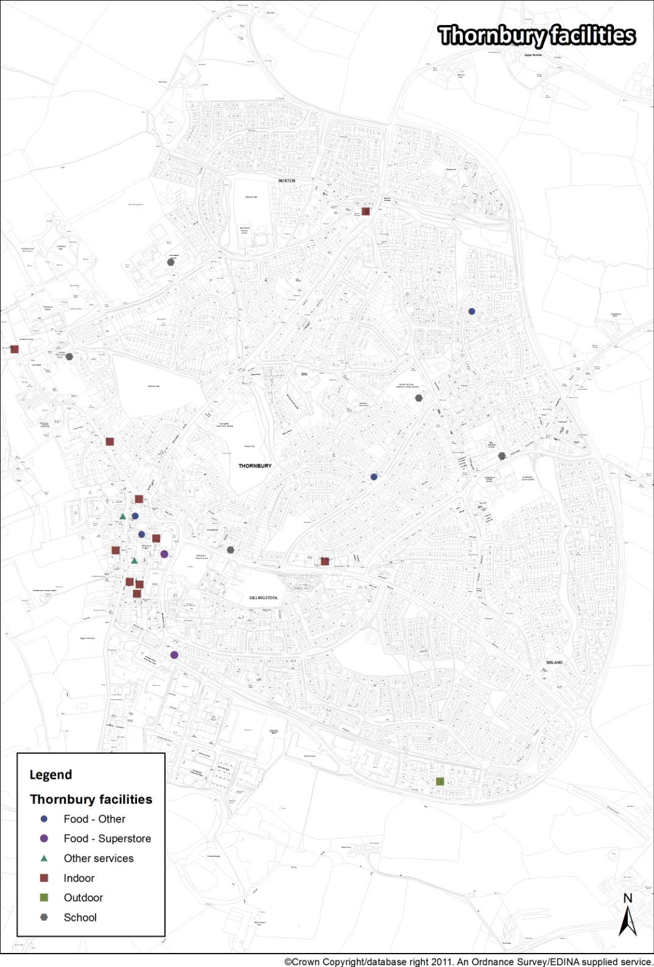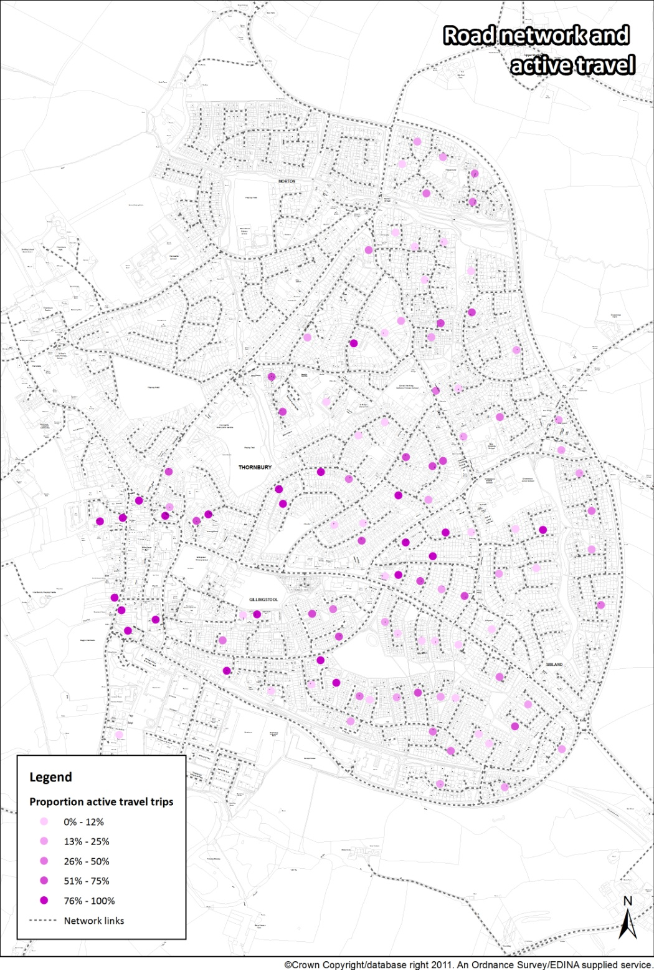 

Figure 2: Road network & active travel Figure 3: distribution of the facilities

Figure 2 shows the proportion of trips from all respondent origins that were undertaken using active travel modes (walking and cycling). Figure 3 illustrates the distribution of facilities visited by respondents. It is worth noting that although the pattern appears quite dispersed, the values exhibit a very high degree of spatial autocorrelation (with a probability < 0.01 that the pattern arose by random chance). The data represents a total of 1382 trips. Outliers have been removed from the view and the analysis (respondents outside of the town urbanised extent).

**3.2 Network straightness**

Figure 4 shows the scatterplot of the proportion of active travel and the straightness score (normalised to 100) of the road segment on which the trips in question started. A trend line has been included.

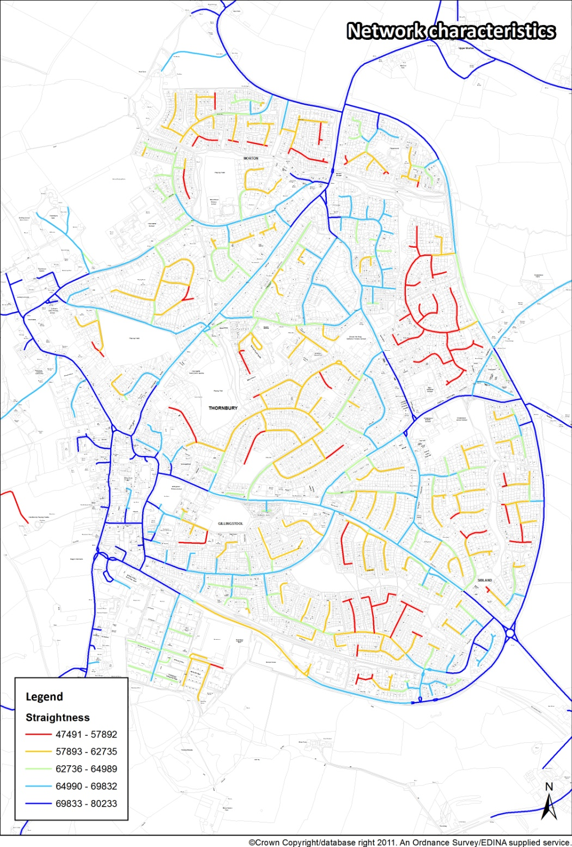

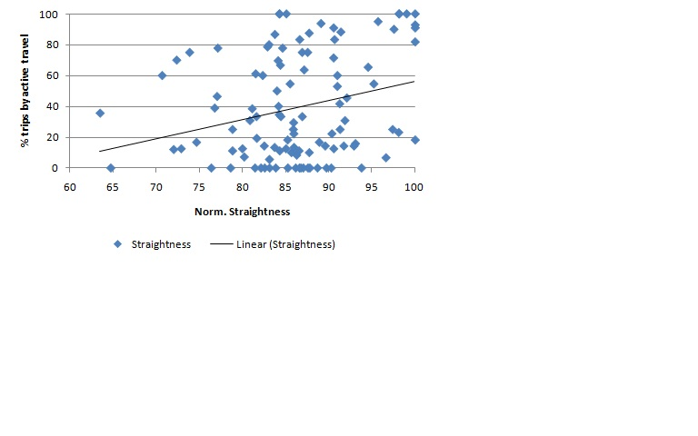



Figure 4: Network straightness

**3.3 Network closeness**

Figure 5 shows the scatterplot of proportion of active travel trips and the closeness score of the roads on which they started.

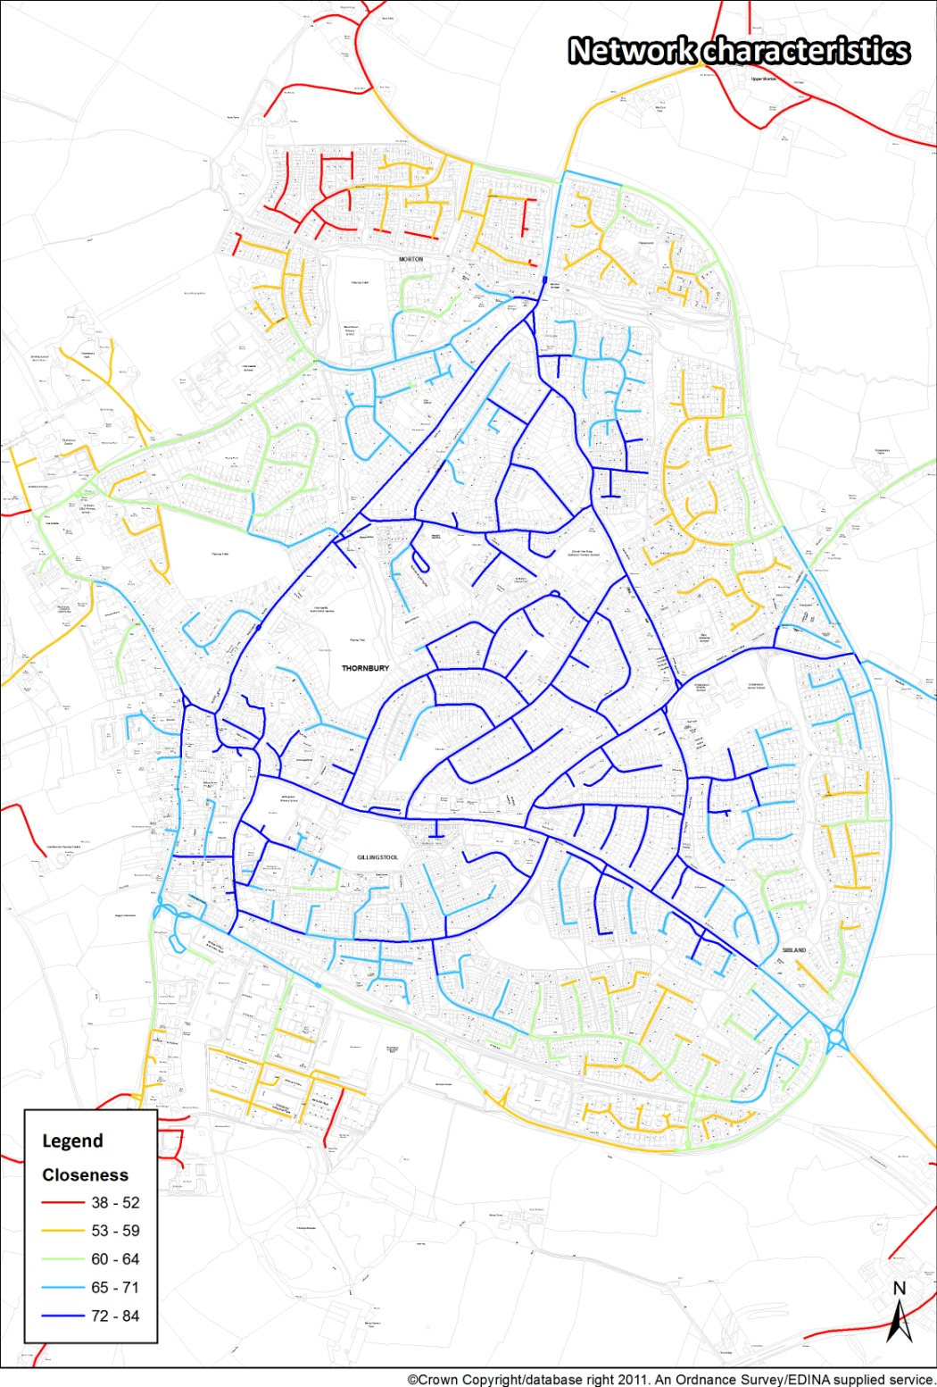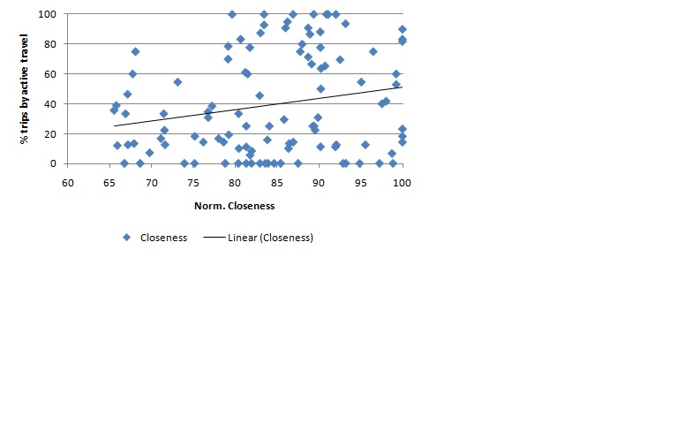 Figure 5: Network closeness

# Analysis of results

Table 1: Relationship between active travel characteristics of network

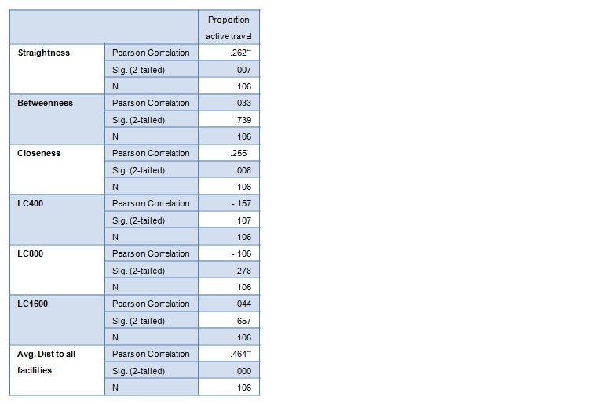

Table 1 confirms the correlation between the proportion of active travel and the characteristics of the network segment on which they start (essentially the street location of the respondent).

Three of the factors investigated show statistically significant relationships (** = correlation is significant at the 0.01 level [2-tailed]). These are straightness, in other words, trips originating from a place relatively ‘directly’ accessible to other locations, and closeness, being centrally located in an intuitive (distance based) sense of the word – not too far away from everywhere else. These measures consider the respondent location and the network characteristics only– not the relationship between the locations of respondents and the facilities they use. The closer and more directly accessible a trip origin is to other places, the greater the proportion of trips undertaken using active travel modes.

The third significant relationship is to the average distance from origins and all facilities. This was added as a specific measure beyond the network characteristics, and considers the spatial arrangement of respondents and facilities specifically. The closer a trip origin to a set of destination facilities, the greater the proportion of active travel trips originating from that origin. As with a lot of pedestrian related analyses, there are a few caveats related to the results. The pedestrian mobility network is a richer, more extensive network than is depicted in traditional transport networks – which have until recently overlooked active travel routes. The quality of the walking environment is also not adequately represented. This map shows the pavement and pedestrian path network in Thornbury, which would be useful inclusions in analysis such as this, and would go someway to addressing the problem.

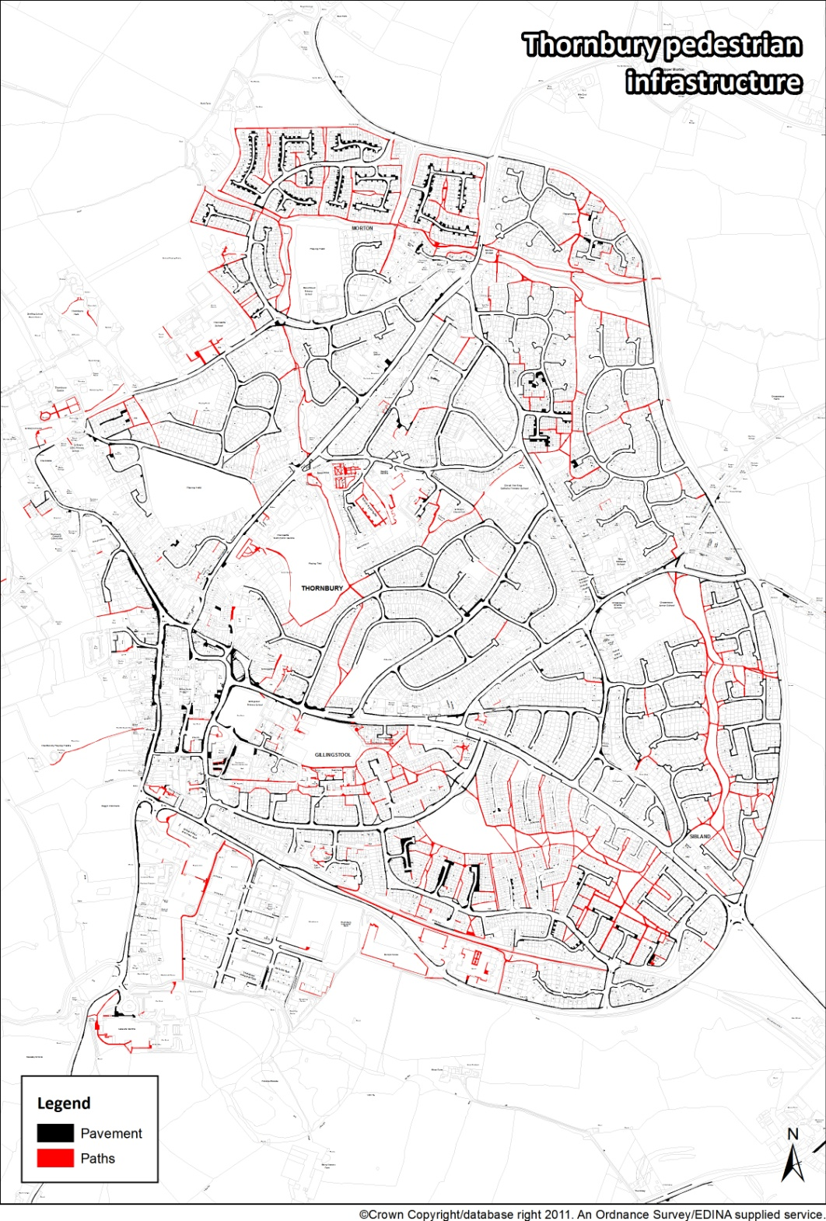

Figure 6: Pedestrian network

Unfortunately, there it is not in a ‘network friendly format’ and is difficult to include at the moment. The other assumption is that pedestrians are distance rationalists, and will always take the shortest route (Figure 6).

**4.1 Activity sets as a system**

At a smaller scale, the connection between nodes could be illustrated by Hengrove leisure park cinema. This leisure park consists of Cineworld cinema, a variety of restaurants, and a play park. Hengrove Play Park include; 12 metre high dome housing a jungle play experience, Sand and water play for younger children, Large wheels park for skateboarders, in-line skaters and BMX riders, distinct zones with activity equipment, large central grassed space for, café, toilets and seating.

The integration between the cinema complex, restaurants and the play areas is central to the success of the place as a support for intergeneration mixed uses. For instance, older children come to see a film on their own or accompanied by adults at Cineworld, then lunch in the local restaurants. This is often followed by play in the park, while adults enjoy teas and coffees from the cafe. From the cafe adults can keep an eye on their children, while socialising with friends and relatives (Figure 8). The cinema complex, the cafe and the playground work as an integrated system. This system attracts a variety of users, which not only contributes to the economic viability of the leisure park, but also makes it a thriving social hub.

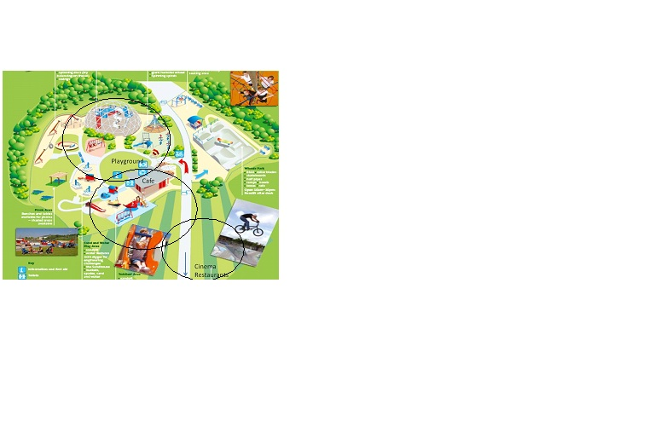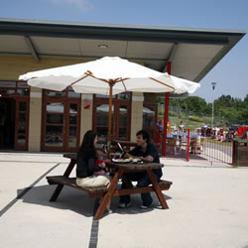

Figure 7: Hengrove leisure park cinema Figure 8: Café overlooking the play area

# Conclusion

This research sought to determine aspects of the essence of sustainable urban environments. It developed a modelling framework within which the interactions and overlap between trends in communities’ lifestyles and behaviours in cities are assessed. A number of computational models have been presented with which to study and/or exploit aggregate behaviour and self-organisation from a number of interacting components. The relationship between lifestyle patterns and spatial characteristics has been analysed, at a larger scale level, using measures such as closeness, betweenness, and straightness. The findings revealed that the complexity of activity patterns is not fully represented in traditional spatial networks. For instance, pedestrian mobility network is more complex than is depicted in traditional transport networks. At a smaller scale, the analysis showed that successful places work as systems made of overlapping sets of activities.

The novelty of the proposed research lies in the following:

* Making explicit and integrating substantive knowledge, and decision-making procedures, from various sources and across scales, help to shed light on new paths to urban sustainability.
* Using methods and tools, which are commonly used for modelling complex systems, to break down a city into small, organic and interactive parts, and analyse the interaction between these parts in the context of the whole city.
* Examining the complex interconnectedness between urban physical characteristics, growing diversity of lifestyles and NI, across scales, will generate a new understanding of priorities for future urban sustainability trends, and their implications on decision-making and policymaking.

# References

1. Adams, W. M. (2006) ["The Future of Sustainability: Re-thinking Environment and Development in the 21st Century."](http://cmsdata.iucn.org/downloads/iucn_future_of_sustanability.pdf) Report of the IUCN Renowned Thinkers Meeting, 29–31/01/2006. Retrieved on: 16-02-2010
2. Valentin, A., and Spangenberg, J. H. (2000) A guide to community sustainability indicators, Environmental Impact Assess. Review 20 381–392
3. Christensen, P. (1997) Different Lifestyles and Their Impact on the Environment. Sustainable Development, Vol 5, pp. 30-35
4. Communities and Local Government, (2003) Sustainable Communities: Building for the Future, 5 February 2003, Online <http://www.communities.gov.uk/publications/communities/sustainablecommunitiesbuilding>. Retrieved on: 20-06-2011.
5. Communities and Local Government. (2008) [Thames Gateway Eco-region: a prospectus](http://www.communities.gov.uk/publications/thamesgateway/ecoregion). Online Retrieved on: 16-06-2011 http://www.communities.gov.uk/documents/regeneration/pdf/1074037.pdf,
6. Jenks, M., Burton, E. and Williams, K. (Eds.), (1996) The Compact City: A Sustainable Urban Form?, Spon Press
7. Jacobs, J. (1961) The Death and Life of Great American Cities. Random House, New York.
8. Alexander, C. (1966). A city is not a tree. In Legates, R. and Stout, F. (Eds.). The City Reader . London: Routledge. pp. 118-131.
9. Jones, P., Marshall, S. and Boujenko, N. (2008) Creating more people-friendly urban streets through ‘Link and Place’, Journal of the International Association of Traffic and Safety Sciences, 32 (1) 14–25.
10. Gehl J, Gemzøe L. (1996) Public Spaces Public Life. Copenhagen, Denmark
11. Lennard, S. and Lennard, H. (1987). Livable Cities - People and Places: Social and Design Principles for the Future of the City. Southampton: Gondolier Press
12. Porta, S. et al. (2009) Street centrality and densities of retail and services in Bologna. Environment and Planning B: Planning and Design, 36, pp. 450-465.