The Study and Information Needs of Researchers at the University of the West of England

# Background

To support the University’s research aspirations, UWE Library Services are investigating the particular information needs of the University’s research community. Funding from the Faculty of Health and Life Sciences (HLS) enabled Library staff to conduct a pilot survey of HLS researchers. Following an evaluation of the pilot study, the survey was extended to researchers across the university, and the results of this are presented in the next section of this paper. Findings from the survey will inform Library Services’ strategy to support the information needs of researchers. This paper briefly outlines the process and key findings of the university wide survey

# Methodology and responses

The original questionnaire was reviewed, and adjustments made to several questions to improve their clarity and to focus responses. The number of questions remained the same: twenty questions relating to researchers’ use of information resources and services provided by UWE Library Services. Respondents were able to add free text comments to the majority of the questions. The questionnaire was available online between April 12th and May 13th 2011. One hundred and five responses were received from staff and post graduate researchers. The spread of these between the Faculties is shown below.

|  |  |
| --- | --- |
| Business and Law | 22 |
| Creative Arts, Humanities and Education | 38 |
| Environment and Technology | 29 |
| Health and Life Sciences | 8 |
| Cross Faculty | 9 |
| Total  (Eight respondents did not provide this information) | 97 |

Ninety three of the respondents provided information about their research role. Of these, twenty three were PhD researchers, with a further 4 undertaking professional doctorates. Fifty one (54.8%) described themselves as ‘lecturer and researcher’, and two as career researchers. The remaining 13 respondents who provided information were research fellows.

# Key Findings

## 3.1 Access to full text of journal articles, inter-library loans, Store and Stack

Overall there was a high level of satisfaction with accessing the full text of journal articles (93% rated adequate or good the level of available titles and 86% rated adequate or good the access to available back issues). When the full text was not available, 76% of respondents had made use of the Inter-library loan (ILL) service. Some researchers made use of contacts at other institutions, personal subscriptions or contacted authors directly to obtain articles they needed. Embargo restrictions on electronic access to current research papers, and confusion over the titles that the Library subscribes to (e.g. Nature, Cell) were the main sources of frustration. Despite some dissatisfaction in terms of speed of delivery of ILLs, and restrictions around the use of electronically delivered documents, respondents who use it mostly consider the ILL service good or adequate. However, there were a number of respondents who indicated that they do not use the service, and more qualitative work needs to be done to establish why this is. The majority of Frenchay researchers found access to items in the Store and Stack (closed access areas in the Frenchay Campus Library) good or adequate, although 7% of respondents were dissatisfied in terms of the process, and communication from the library, and 3% were dissatisfied in terms of speed of delivery. However, there are no free text comments to explain what the cause of dissatisfaction is.

## 3.2 Support, Guidance and Skills

Sixty percent of respondents had contacted their Librarian to assist with accessing a specific information resource. With one exception, all comments revealed a high level of satisfaction with the help they had received from Librarians. One question investigated what Researchers would be interested to learn more about from the library: citation impact/(journal) impact factors (89% very or moderately interested in learning more), accessing materials from other libraries (83%), accessing research with a similar methodology (85%) and accessing research in the same subject area (82%) were the most highly rated areas of interest. Specific mention was made of a need to learn more about data management and curation, and also of literature searching using specific interfaces.

Asked about avenues of **communication** useful during the research cycle, the vast majority of respondents (94% agree or strongly agree) rated conversations with colleagues/peers as a useful forum for discussion of their work. Conversations (73%) and e-mail correspondence (66%) with UWE Librarians were also deemed useful as were participation in professional networks (46%). Researchers seem indifferent towards promotional emails from the Library (50% neither agree nor disagree) and web2.0 applications (60%).

Regarding **specific guidance,** over 70% of respondents agreed or strongly agreed that they would benefit from guidance in finding and using conference papers and official publications, while guidance on “grey literature” would be welcomed by 68%. Guidance on finding and using newspaper articles (58%), audio-visual materials (48%) and legal information (38%) were also desired.

Respondents were interested to develop their **skills** in using Refworks (64% agreed or strongly agreed), searching databases and e-journal packages (61%) and developing search strategies (51%). It was, however, unclear whether researchers who disagreed that they would like to improve their skills, stated so because they were already confident rather than due to a lack of interest.

Researchers would like to be able to arrange **workshops** or meetings with librarians on request. It was widely considered to be a good idea for Post Graduate Research students to meet with a librarian at the beginning of their research project.

## The Library Website

Respondents were asked to rate a range of features of the Library’s website for ease of use. Although the majority (86%) found finding information using the site easy or manageable, over 35% found finding out about services for researchers difficult – less than 10% rated the web pages easy to use for finding services for researchers. Use of the eLibrary to locate relevant journal articles and accessing online resources (databases) were generally rated easy or manageable on and off campus, however, off campus access was more problematic with over 20% rating this difficult. Researchers were asked what we could usefully include on our web pages. Requests were made to simplify the design of the site, make links to Refworks, training events and services for researchers more prominent and to improve on and off campus access to e-journals and databases.

If you have any comments regarding the research, or the work of UWE Research and Knowledge Exchange Librarians, please contact us at [lib.rke@uwe.ac.uk](mailto:lib.rke@uwe.ac.uk).

Analysis of UWE researchers information needs analysis Questionnaire responses

# Availability of full text information resources

**1. How would you rate UWE Libraries' level of access to full text journal articles.**

In terms of relevant titles: 93% Good or Adequate.  
In terms of available back issues: 86% Good or Adequate.

The statistics indicate a high level of overall satisfaction with levels of access to journals. However, around a quarter (28/105) of respondents qualified their response with a text comment. There are some positive aspects to these, but negative comments fall into several categories. They reveal frustrations stemming from difficulties accessing specific titles, for example

*Some major finance journals are not available, e.g. Review or Financial Studies, Journal of Financial Economics. I had to purchase personal subscription.*

Second, is researchers’ assessment that journal titles in their area are not available:

*A wider range of journals in my field would be much appreciated.*

*Many journals are not available electronically*

*About half of the cross-disciplinary stuff I want to look at is not available.*

Third, comments reveal frustration with non-availability of back files in print, or online, depending on subject discipline:

*Beacuse my research is interdisciplinary, I often need to access back copies of journals in order to understand the trajectory of debates within an unfamiliar discipline, or school of thought within a discipline. Sadly, the removal from the library of non digitised back copies is complicating access.*

*Even electronic subs do not go far back enough*

The particular difficulties of interdisciplinary research were raised by several respondents.

A few comments indicated that some researchers have difficulties with searching in general, and would appreciate further support in developing search and enquiry skills. For example

*Main issue is knowing how best to use the system - advanced enquiry skills needed.*

*The range of subjects is quite exhausting, in the search boxes perhaps along with the 'and/or' option there should be a 'not' option*

Comments confirmed that the provenance of data sources is not significant to researchers. For instance there is an absence of appreciation of the difference between resources purchased by the University, and freely available sources such as Google Scholar.

*Sometimes full text articles seem to be only available by going via the library website. Others are available directly (e.g. via Google Scholar).*

*Really good, especially through google scholar.*

Other comments indicate that advice and information from the Library is needed on an ongoing basis to ensure that researchers are working with the correct information about the availability of particular sources. For example, the following comment was made although subscriptions are held to both the resources mentioned:

*“I work in an area at the boundary of engineering and materials science / chemistry. I can easily get hold of the IEEE journals I need, but as UWE doesn't have a subscription to the RSC or Elsever [sic] I have trouble getting the journals I need.”*

**2. When you cannot access the full text of an item, which of the following do you make use of:**

Inter-library loans: 76%  
Other libraries: 54%  
Personal subscriptions to journals/databases: 23%  
Individual purchase of journal articles: 15%

Text comments from seventeen respondents indicate that researchers often make use of colleagues and contacts at other institutions, or by communicating with the author directly to obtain articles. Others simply make do with the articles available and from reading the abstracts of articles, although this is not always seen negatively.

*Sometimes access to the abstract is sufficient*

Some researchers seek alternative routes to the same information, and are inventive in their routes to what they need

*I usually don’t bother, read whatever abstract is available, try Google Scholar or other papers by the same author(s) that might contain the info I want.*

*[I] scour the internet for a free copy first*.

*scouring the net for random copies of papers;* *being handed copies of papers by the authors; reading supplementary information and abstract to guess what's in the paper; dealing in a grey market of copied papers. For books: Procuring scanned copies of books from nefarious corners of the net; using google books to read a few, hopefully useful pages of books;*

**3. Approximately how many times in the last six months have you had to use the following services to obtain full text resources not available from the UWE Libraries.**

|  |  |  |  |  |  |  |  |  |  |  |  |
| --- | --- | --- | --- | --- | --- | --- | --- | --- | --- | --- | --- |
|  | 0 | 1 | 2 | 3 | 4 | 5 | 6 | 7 | 8 | 9 | More |
| ILLs | **38.3%**  **(36)** | 16%  (15) | 16%  (15) | 8.5%  (8) | 4.3%  (4) | 5.3%  (5) | 3.2%  (3) | 0% | 1.1%  (1) | 0% | 7.4%  (7) |
| Other libraries | **42.7%**  **(35)** | 14.6%  (12) | 11%  (9) | 7.3%  (6) | 3.7%  (3) | 2.4%  (2) | 1.2%  (1) | 2.4%  (2) | 0% | 1.2%  (1) | 13.4%  (11) |
| Personal subs | **66.2%**  **(43)** | 9.2%  (6) | 3.1%  (2) | 6.2%  (4) | 3.1%  (2) | 3.1%  (2) | 3.1%  (2) | 0% | 0% | 0% | 6.2%  (4) |
| Purchase of articles | **78.7%**  **(48)** | 13.1%  (8) | 3.3%  (2) | 0% | 1.6%  (1) | 1.6%  (1) | 0% | 0% | 0% | 0% | 1.6%  (1) |

**Number of times services have been used to obtain full text resources not available at UWE.**

Free text responses indicate similar strategies for obtaining articles to the previous question, i.e. contacting colleagues and authors or doing without due to time constraints. Just over 20% of respondents had purchased articles – but the survey did not reveal whether these were personal payments, or being taken from available funding.

Responses to this question also indicate that further work is needed to optimise effective use of the inter-library loan (ILL) service by researchers. Comments revealed a frustration with the ILL limit, especially for post doctoral researchers undertaking wide ranging or in depth literature reviews. A need for advice on managing ILLs was indicated, for example for lecturer researchers working under severe time pressures who found that their ILL had “expired” before they had opportunity to open and print the article.

**4. Have you ever contacted your Librarian to assist with access to a full text information resource (e.g. the full text of an article, book or electronic resource) that was not available via the UWE Libraries?**

Yes 48.5%  
No 51.5%

There was some variation depending on the faculty – more CAHE and FET researchers stated ‘No’ (56.8% and 64.3% respectively) whilst more FBL and HLS researchers stated ‘Yes’ (59.1% and 60%). Text comments also painted a varied picture with some stating that they didn’t need help because the process was straightforward whilst other comments indicated a lack of awareness that librarians could help with access to resources. Positive statements mentioned the helpfulness of staff relating to help with obtaining materials from other libraries, and dealing with problems using electronic journals databases.

**5. How would you rate the Inter-library loans service provided by UWE Libraries?**

While 36 respondents (c38%) had not made use of the ILL service in the last six months, responses to this question indicate that 20 respondents had never used the ILL service at UWE at all. Of those who had used the service, the majority are satisfied in terms of the procedure, delivery times and communication. Only one respondent considered the service poor in terms of procedure, ten in terms of speed of delivery and three in terms of communication. A quarter of the respondents also added a text comment, which taken together highlight some of the main concerns:

*Difficulties with the Acrobat files received – they do not work on Linux, opening the files can be tricky and the limited lifespan of the files meant that one researcher had to resubmit requests*.

*This has become more complicated with electronic delivery and the software to open materials - the time period for accessing is too short as sometimes I'm unable to read them before they expire.*

*The online ILL form is overly time consuming to fill out. One ought to be able to simply enter the doi of a journal article, for example, and have the details found automatically.*

One response mentioned that the ILLs allowance was restrictive.

The survey has revealed that work is needed to improve the Inter Library Loan service in relation to mix ups resulting from working across campuses with ILLs going to the wrong campus.

There is also a need for greater promotion and education about ILLs: some researchers had never heard of the service whilst all of the problems mentioned in comments could be managed if researchers were sufficiently informed.

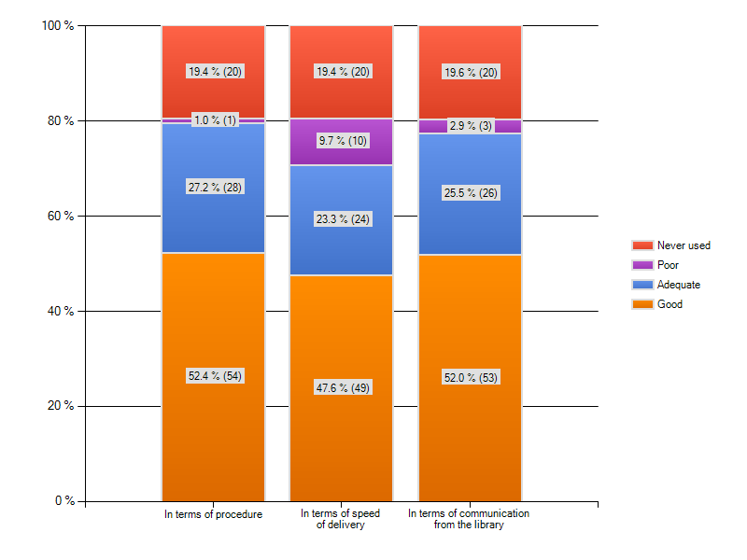

**Figure: Ratings for Inter-library loan service at UWE.**

**6. (For Frenchay Library users) How would you rate the accessibility to texts kept in the Store and Stack?**

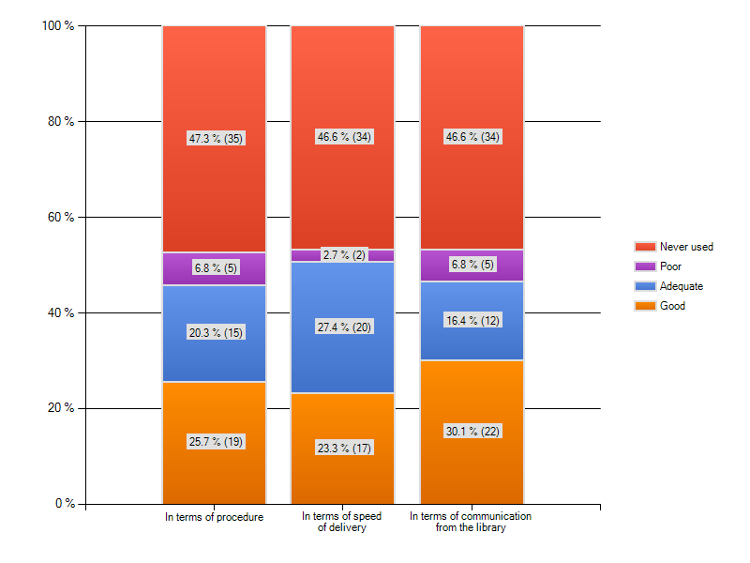

**Figure: Store and Stack ratings at UWE.**

The majority of respondents never use the Store and Stack – in one way this is not surprising as items in these areas are there because they are rarely used, but from another perspective reveals that perhaps the policy of keeping texts “just in case” they are needed for research, or as “classic texts” should be reassessed. Levels of satisfaction from those who had retrieved items from these areas were acceptable. Researchers’ reliance on e-access to information may also account for the lack of usage of store and stack items.

# Library support in the life cycle of research

Q7 I would be interested to learn more about:

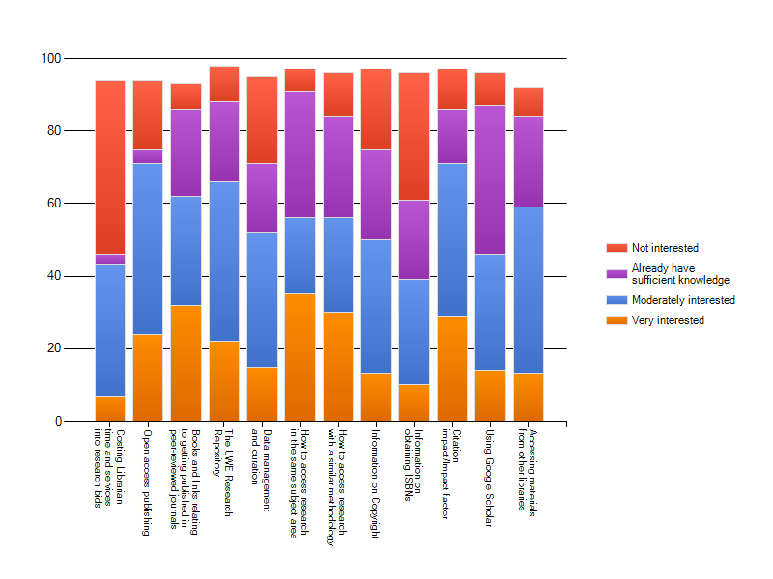

**Figure: Topics that researchers would be interested to learn more about.**

The two major areas of interest here werecitation impact/impact factor (75% - 71 respondents) and open access publishing (76% - 81 respondents). In the context of the Research Excellence Framework, the first of these might be predicted. The level of interest in open access publishing is perhaps more surprising as we are aware that there are some disciplines who view open access publishing with great scepticism.

Sixty two respondents indicated that they were very or moderately interested in books and links relating to getting published in peer-reviewed journals (67%), with similar numbers being interested in the Research Repository (67%), and accessing materials from other libraries (64% 59 people).

Post Graduate/PhD researchers were very interested in accessing other research in the same area or research using the same methodology (63.6% and 68.2% very interested). This group were also very interested to learn more about information relating to getting published in peer-reviewed journals, whereas Lecturer and Researcher responses for these questions indicated that they were less interested, or already had sufficient knowledge.

Accessing research in a similar subject area, or with a similar methodology was of interest to 58% of respondents, as was a wish to find out more about using Google Scholar more effectively. An interest in data curation was expressed by 54% of respondents, although 25% said they were not interested in this area. Other areas of interest were rated as follows:

Information on copyright (52%)

Costing librarian time and services into research bids (46%)

Obtaining ISBNs (41%)

Additional free text comments not covered above indicated specific interest in:

Current awareness tools, secondary research using online sources of official and survey data; Refworks, and analysis software such as nVivo.

**Q8** **Do you think UWE Libraries should provide a space or room specifically for researchers to use?**

52% of respondents said no. Reasons included the view that researchers should ”fit in with other users”, and that faculties should provide space for researchers. Another person commented that

*The library already provides 'study rooms' and in view [sic] all other users 'carry out research' in the library.*

Of the 48% who said yes, the key requirement was a quiet place, distinct from undergraduate study spaces and the associated human and electronic noises. One respondent commented:

*absolutely! too much chatter & snacking & running around by students makes it next to impossible to concentrate*

Some people suggested a variety of seating environments, and others a research meeting room. Other comments include plentiful space for spreading resources (print and IT) and access to equipment including PCs, a scanner, and photocopier. A safe place to leave personal belongings when taking a break was also highlighted.

# Sources of information that assist with your research

**Q9 The following are useful in the course of my research:**

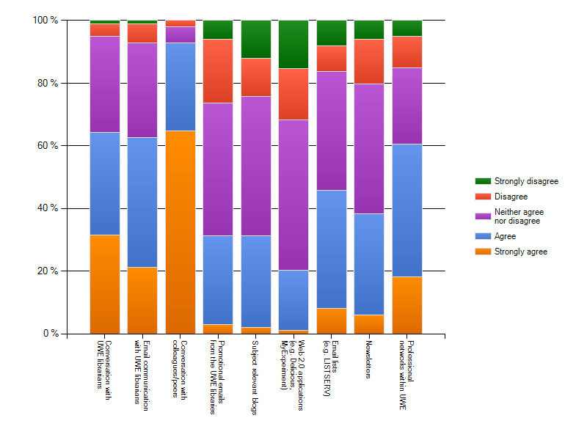

**Figure: Useful communications channels in research.**

For the vast majority of researchers (93%) conversations with colleagues/peers are a useful forum for discussion of their work, with lecturers and researchers seemingly more likely to make use of this than postgraduates or PhD researchers. Conversations or email communications with UWE librarians were also identified as important by a large number of respondents (65% and 63% respectively); this time it is postgraduates and PhD researchers who are more likely to seek advice from this source. Professional networks were considered useful by 61% of respondents.

Researchers seemed quite indifferent to promotional emails from the library, and did not make much use of subject based blogs or other Web 2.0 technologies. Text comments indicate that there is a general lack of understanding about what Web 2.0 is, but perhaps surprisingly it is lecturers and researchers, rather than postgraduate and PhD students, who are more likely to make use of these resources.

# Finding out about stuff..! (Guidance and information skills)

**Q10 My research would benefit from guidance in finding and using:**

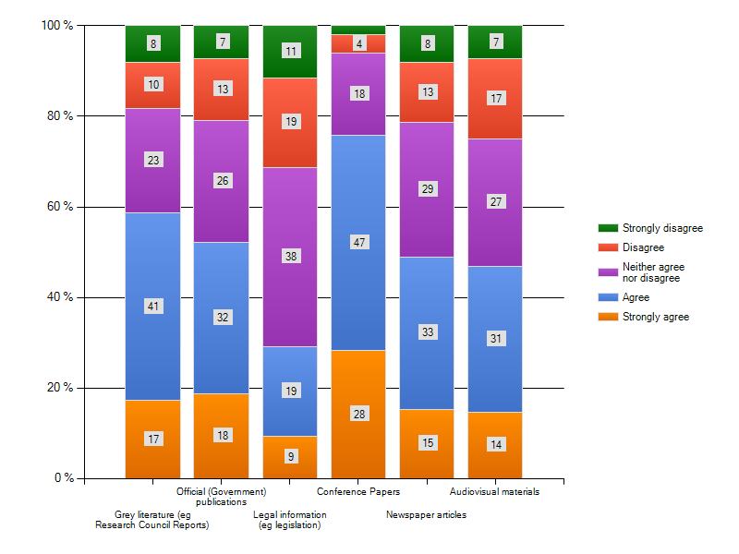

**Figure: Information areas in which researchers would like guidance.**

A large number (79%) of respondents felt that they would benefit from guidance in finding and using conference papers, with grey literature and official publications also being identified as areas requiring support. It is not surprising that these should figure strongly in the responses as publications of this nature can be extremely difficult to locate. There was little difference in the needs of early career reseachers, compared with more established researchers when looking at the results fot these publications.

Free text comments include wanting guidance on finding visual research, census and other survey data, website evaluation and a/v materials. One respondent felt that the library should be making more of its “fantastic” audio-visual collection by providing better cross referencing of resources.

**Q11 I would like to improve my skills in using:**

The most requested area was skills for searching databases and e-journal packages (65%), followed by managing references using Refworks or other reference management software (59%), using keyword searching (44%), and citation searching (37%). Interestingly, it was the more established researchers who strongly agreed that they needed to improve skills in these areas, although the overall picture showed strong similarities between early career and established researchers.

Free text comments not already covered above included a desire to be able to use the UWE website for storing references and information sources thematically, especially when working across a range of subject areas. There was also a comment on the importance of the timing of information sharing:

*“I would appreacite help with all the above, but not during term time when I just don't have time to attend or practice the new skills.”*

**Q12 I would like support with:**

This question is related to the knowledge and skills needed to evaluate information resources in and around a researcher’s field of interest. The responses indicate quite a high level of need in some skills:

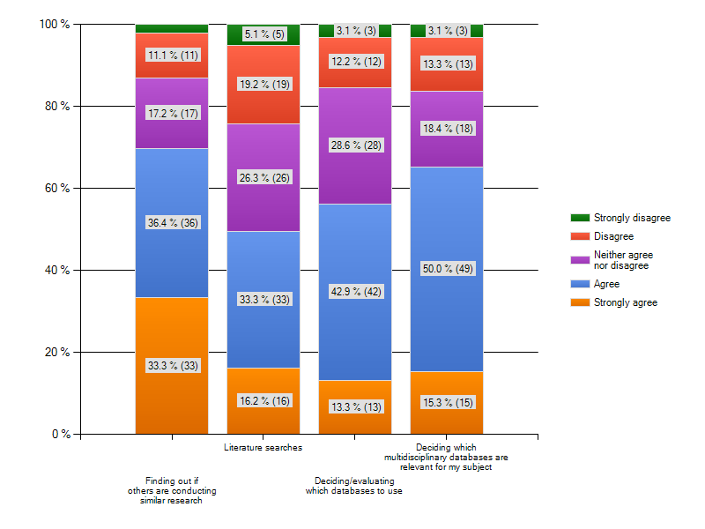

**Figure: Support in finding and using.**

The strongest need for support came from early career researchers, who indicated that they felt less confident in most of these areas than their more established colleagues. The most notable difference was in finding out if others are conducting research in a similar area: 77% of post graduate or PhD researchers agreed or strongly agreed that they would like support with this, as opposed to 60% of lecturer/researchers. Other results between these two groups were closer, with the next biggest difference being shown in carrying out literature searches; 56% of PGRs or PhD students would appreciate support here, as opposed to 48% of lecturer/researcher colleagues.

Free text comments indicated a desire for short cuts to finding relevant market reports, industry commentary, government reports, published industry reports or academic articles, plus assessing which journals to submit to, and information about the upcoming REF. There was also one comment on the timing of information delivery:

*“have answered this as I am now writing up, could have done with more support at the earlier stages of my research”*

**Q13 When would be the optimum time for workshops or meetings with librarians?**

Unsurprisingly, most respondents said this should be “on request” (54%). 15% suggested meetings with librarians should be during inductions. There was some interest in meeting with librarians at the beginning of a research project and then smaller responses to the options for “once a year” and “during the ADP” (Academic Development Programme).

**Q14 Please rate the following features of the library’s website:**

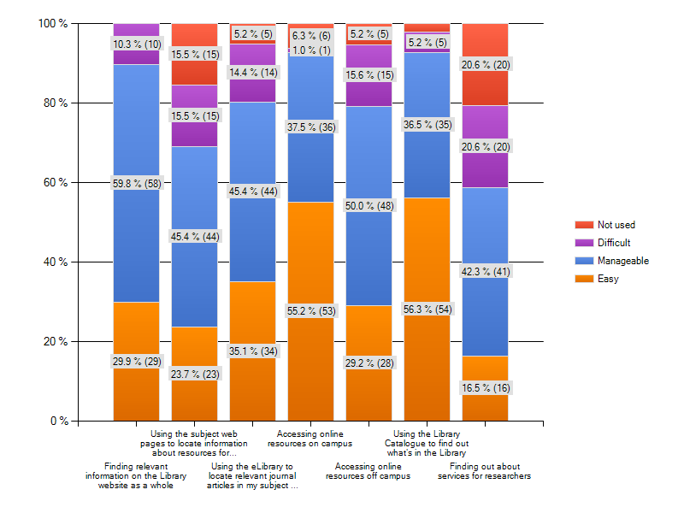

Figure: Task ratings using the UWE Library website.

Respondents were asked to rate a range of features of the Library’s web site for ease of use. Over 89% said that finding relevant information on the web site as a whole is easy or manageable. Ten respondents found the web site difficult to use overall.

Researchers found **the Library Catalogue** the easiest part of the web site with just over 56% rating this as easy and a further 36% finding it manageable. Two respondents said they had never used the library catalogue to find out what was in the library.

**Finding out about services for researchers** was rated as the least satisfactory aspect of the web pages, with 20 (20.6%) respondents rating this as difficult, and a further 20 having never used the web pages for this purpose. Sixteen researchers (16.5%) rated the web pages easy to use for finding services for researchers.

Using the subject web pages to locate information about resources for research was rated as easy or manageable by over 69% of respondents, but fifteen people (over 15% ) rated this aspect as difficult, and a further fifteen people had not used the web pages for this purpose.

**Using the eLibrary to locate relevant journal articles in my subject:**

Over 80% of respondents rated this aspect as easy or manageable, but over 14% found it difficult, and the final 5.2% (5 people) had not made use of the eLibrary for this purpose.

The two final features of the web site related to the **accessing of journal articles on campus, and from outside the University.** In the first of these, nearly 93% of respondents found the web site easy or manageable to use, and for off campus access this figure was over 79%. Six people (6%) rated on campus access as difficult, but fifteen (15.6%) thought that accessing journals off campus was difficult.

**Q15 What information for researchers could we usefully include on our web pages?**

Ten respondents made suggestions here. One stated that the web pages were, “an excellent guide to services”, but the other comments had a range of suggestions for how the web pages could be improved. Two people suggested that there should be more obvious contact details for subject specialist librarians or for help when resources cannot be found.

Several comments indicated that more guidance and signposting is needed to the resources that are available. These included a suggestion for “plain English flowcharts” for how to access resources, guidance on where to find newspapers, official data and other grey literature, and links to other repositories and annotated bibliographical sources. There was a request for a more integrated approach to data and services in the web pages.

One respondent suggested that web pages for researchers should be arranged to reflect the interdisciplinary nature of research activity, rather than being tied into the undergraduate subject areas and Departments. In a similar vein, it was suggested that a facility for a personalised area and/or a “personal bookshelf” would be supportive.

Finally, a respondent suggested that guidance on which resources might be appropriate at different stages of the research process would be helpful.

# Recommendations

Based on the findings from this survey, recommendations for future action and developments can be made under the headings:

* Publicity/Marketing of Services
* Guidance
* Access to services from the Library Web pages
* E-resource training

## Publicity/marketing of services

Promote and enable access to the following through the revised web pages

* + Refworks
  + The Research Repository
  + Services such as inter library loans. Ensure clarity of supporting information.
  + Easy booking for workshops and individual support

## Guidance

Re-asses/fully publicise the available guidance for service users in the light of feedback for (in order of priority):

* + Conference papers, grey literature, official publications
  + Newspapers/articles
  + AV/digital materials
  + Census and other survey materials

Develop a variety of supporting materials, utilising or building on existing tools such as the *i*SkillZone, MySkills and BLIS, for

* + Providing clarity on the services and resources that are provided by UWE, to include subscribed services that initially appear to be provided from elsewhere (e.g. Google Scholar searches linking to UWE subscribed e-journal articles when searched for on-campus)
  + Particular types of resource and information, for example conference papers, official publications
  + Particular skills, for example citation searching
  + REF related activities, for example measuring impact factors, H-index
  + Open access publishing
  + The Research Repository

## Access to services from the Library Web pages

As far as possible, web pages for reseachers should aim to bring together access to data, and relevant services. This can be achieved through the appropriate use of “Related links” within the CMS.

Reflection throughout the research process has also raised additional considerations:

* Work with RBI to integrate resources as developed with the Researcher Development Framework
* Continue to investigate, at University level, the opportunities for data management and curation. Once finalised, offer guidance through appropriate means such as the researchers’ web pages, or via the RDF.

## E-resource training

Work with subject colleagues to clarify responsibilities for designing and delivering training for subject based databases and e-journal packages.

Judith Stewart, Jenni Crossley, David Hewish

UWE Library Services

August 2011.