**Supplementary File**

*“Influence of Orographic Precipitation on Coevolving Landforms*

*and Vegetation in Semi-arid Ecosystems”*

**Content of this file**

**Figure S1, S2, S3, S4, and S5**

**Introduction**

This supporting material includes five figures (S1-S5). Figure S1 shows the precipitation distributions (which is a function of precipitation) plotted against distance in the domain for three different precipitation settings. Figure S2 shows the three dimensional view of spatial patterns of simulated vegetation cover fraction (for the different precipitation and solar radiation scenarios. Figure S3 illustrates the aspect distribution for all the precipitation settings. Figure S4 represents the modelled simulated divide migration map from CHILD, and Figure S5 shows discharge plots for the orographic bare soil and orographic vegetative soil for a particular time of the year.

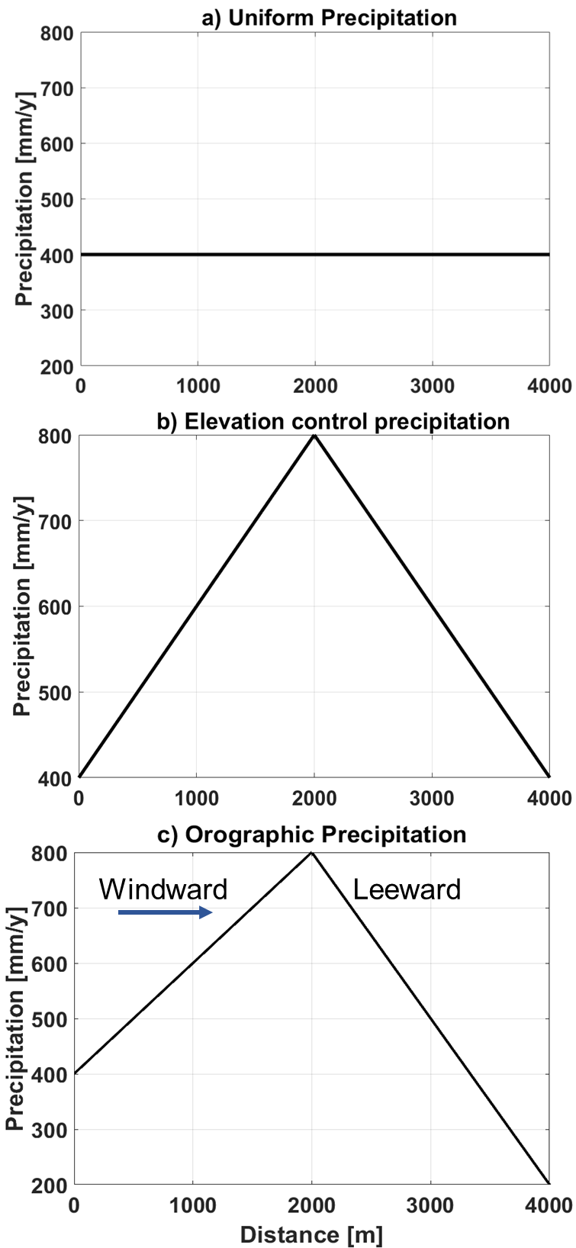

**Figure S1:** Schematic showing of precipitation distributions (which is a function of precipitation) plotted against distance in the domain for a) uniform precipitation, b) elevation controlled precipitation, and c) orographic precipitation. The direction of the arrow in subfigure c shows the windward side of the synthetic domain, while the opposite side represents the leeward side.

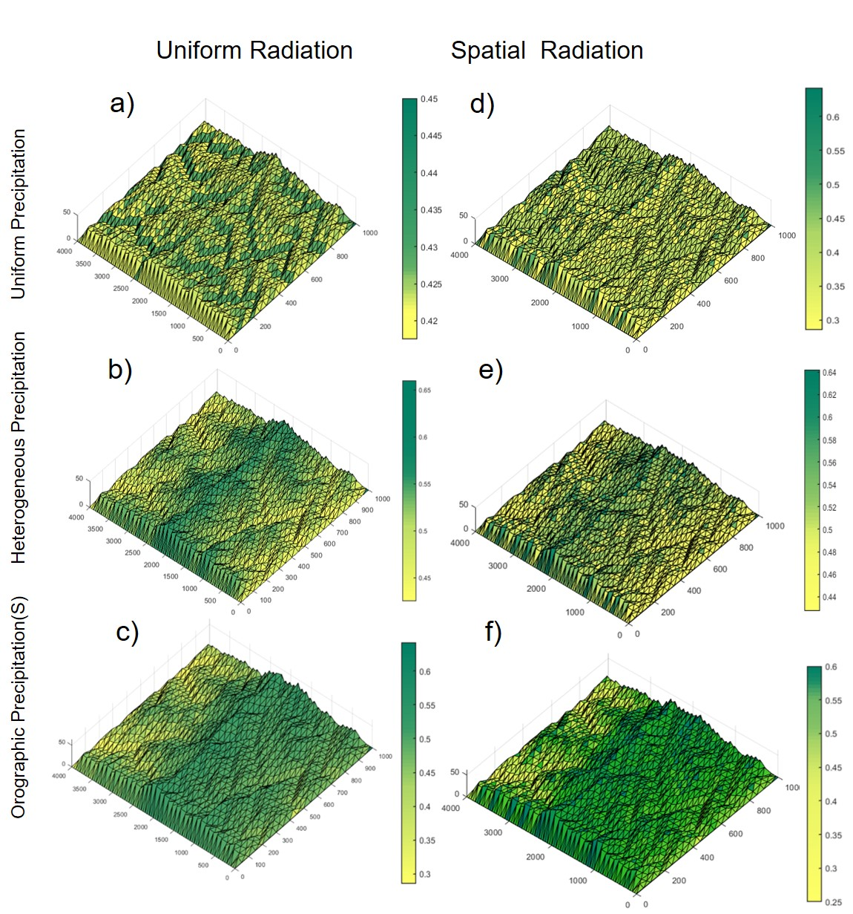

**Figure S2:** Three dimensional view of spatial patterns of simulated vegetation cover fraction (mean values over the last 100 years) for the different precipitation and solar radiation scenarios. The left panel (first column) shows the results for the uniform solar radiation scenario for a) uniform precipitation; b) elevation control precipitation; and c) orographic precipitation. The right panel (second column) shows the spatially varied solar radiation scenario for the three precipitation patterns. Note that the range of values (colour bands) varies for different scenarios, which was needed for pattern visualization.

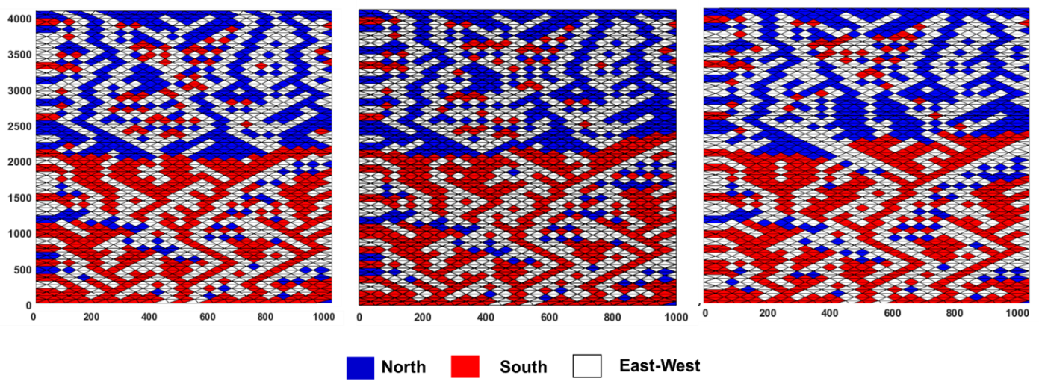

**a)**

**c)**

**b)**

**Figure S3:** Aspect distribution shown for a) uniform precipitation; b) elevation control precipitation; and c) orographic precipitation.

E:\OROGRAPHY\Z_MATCODE\Oro_mat_figures\Orography\BARE SOIL\3dplots\Or82311BS.tif

**Figure S4:** Modelled simulated divide migration map from CHILD model for orographic precipitation and spatially varied solar radiation case for bare soil condition.

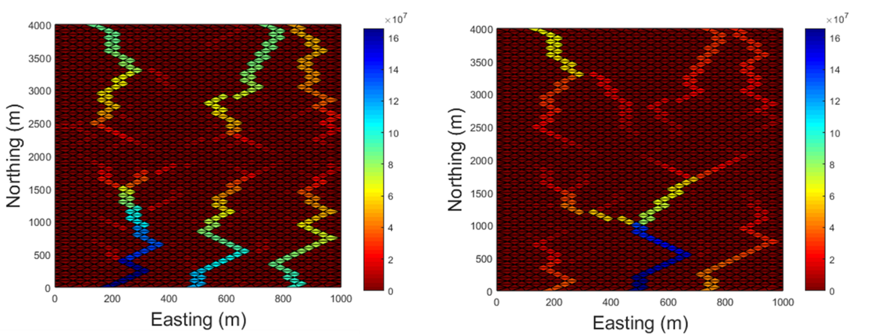

**b)**

**a)**

**Figure S5:** Discharge plots for the a) orographic bare soil and b) orographic vegetative soil for a particular time of the year.