## Abstract

Topography affects the amount and spatial distribution of precipitation due to orographic lift mechanisms and, in turn, influences the prevailing climate and vegetation distribution. Previous studies have predominantly focused on orographic precipitation on landform evolution for mountain chains alongside oceans. However, research on the effect of changes in precipitation regimes induced by elevation gradients (particularly in aspect-controlled semi-arid ecosystems) and its consequences for coevolving vegetation and landform patterns are limited. In this study, the Channel-Hillslope Integrated Landscape Development (CHILD) landscape evolution model (LEM) coupled with the vegetation dynamics Bucket Grassland Model (BGM) was used to analyse the coevolution of semi-arid landform-vegetation ecosystems. The CHILD+BGM model was run under different combinations of precipitation and solar radiation settings. The three precipitation settings considered were uniform, elevation control, and orographic control precipitation; while the two radiation settings used were spatially uniform and spatially varied radiation. Based on these different precipitation and solar radiation settings, drainage network, aspect, and elevation control were identified as the major drivers of the distribution of vegetation cover on the landscapes. Further, the combination of orographic precipitation and spatially varied solar radiation created the highest divide migration due to the gentler windward side slopes than the leeward side of the domain. This suggests the erosive power of increasing runoff under orographic precipitation dominates the effect of vegetation protection on erosion on the windward side of the domain. The modelling outcomes from this study suggest that slope control radiation in combination with orographic precipitation plays a key role in the generation of topographic asymmetry in semi-arid ecosystems.

**Keywords:** Orographic precipitation, landscape evolution, topographic asymmetry, vegetation, semi-arid ecosystems

## Introduction

Precipitation patterns in mountain ranges are strongly controlled by topography due to orographic lift mechanisms; and are also highly variable in space and persistent over long timescales (Anders et al., 2008; Houze et al., 2012). The phenomenon of orographic precipitation is usually more pronounced in mountain ranges at midlatitudes, where the prevailing winds are perpendicular to the mountains (Roe et al., 2002, 2003; Roe, 2005; Chaboureau et al., 2008; Kirshbaum and Smith, 2008; Minder, 2010; Colberg and Anders, 2014; Shi and Durran, 2015). Semi-arid regions are highly dependent on mountain water flow for their freshwater supply, as a large proportion of the available runoff is due to precipitation from high-elevation areas (Viviroli et al., 2007; Scaff et al., 2017). Henceforth, understanding the influence of precipitation-topography relationships in semi-arid ecosystems is critical towards quantifying the sensitivity of landscapes to changes in climate and vegetation cover.

Due to the effect of orographic precipitation, a wetter climate prevails on the windward side of a mountain flank compared to the leeward side of the mountain flank, as it receives less precipitation than the windward flank. Additionally, elevation also controls precipitation and enhances differences in microclimatic conditions, as the mean annual precipitation rate increases with elevation (Roe et al., 2002, 2003; Anders et al., 2006; Colberg and Anders, 2014; Garreaud et al., 2016) across a mountain range. Many researchers have studied the phenomenon of orographic precipitation across various study sites worldwide. For example, studies have been conducted on the Cherrapunji in the Khasi Hills, India’s Himalayan range (Murata et al., 2007); the high central valley of Atacama Desert, Chile (Houston and Hartley, 2003); the Mauna Loa and Mauna Kea ranges over Hawaii (Carbone et al., 1998); in semi-arid northern New Mexico (Guan et al., 2005); the Southern Alps in New Zealand (Wratt et al., 1996); and across the Pacific Northwest in the United States (Luce et al., 2013).

The impacts of orographic precipitation on various earth surface processes and landscape evolution have been explored in previous studies using both observational data on natural landscapes (Ferrier et al., 2013; Goren et al., 2014; Han et al., 2014) and numerical experiments (Tucker and Slingerland, 1997; Whipple et al., 1999; Roe et al., 2002; Gasparini et al., 2008). Thiede et al. (2004) showed that orographic precipitation strongly influences erosion rates, affecting the long term evolution of topography in the Himalayas. Similar findings were reported by Clift et al. (2008), who found a clear correlation between Himalayan denudation rates and Asian monsoonal patterns. Anders et al. (2008) and Han et al. (2015) also reported that river network and elevation distribution are affected by the orographic influence of precipitation. Numerical simulations conducted by Goren et al. (2015) further showed orographic controls on landform evolution under the constant uplift and no vegetation component, revealing that windward slopes are longer and gentler than the leeward ones, due to the more runoff production which leads to enhanced erosion. A key aspect missing from these previous landscape evolution studies, however, is the effect of coevolving vegetation patterns under orographic precipitation conditions. It is essential to understand how vegetation-climate interactions can affect the landform asymmetry (Zavala et al., 2020; Smith and Bookhagen, 2021).

Vegetation plays a key role in landscape evolution, as it modulates geomorphic processes such as erosion and sediment transport (Langbein and Schumm, 1958; Wilson, 1973; Summerfield and Hulton, 1994; Moglen et al., 1998; Collins et al., 2004; Dietrich and Perron, 2006; Saco et al., 2007; Collins and Bras, 2008; Willgoose, 2018; Yetemen et al., 2015a, 2019). Early on, Langbein and Schumn (1958) quantified the non-linear relationship between precipitation and sediment yield using their landscape evolution model (LEM). They demonstrated that vegetation and precipitation exert competing effects, where precipitation increases erosion and vegetation inhibits erosion. Moglen et al. (1998) extended this study by developing empirical relationships concerning erosion, vegetation, and climate to investigate the influence of climate change on drainage density. Using these empirical relationships they illustrated that, as the climate becomes wetter, vegetation becomes denser, offsetting the increase in erosion rates which could potentially result from increased runoff. Further work incorporating the effect of vegetation into LEMs has revealed an increase in dynamic equilibrium slopes with increased vegetation, which is due to an increase in resistance to sediment transport and erosion (Roering et al., 2003).

The effect of spatially heterogeneous vegetation patterns can be of particular importance when attempting to understand the effect of vegetation cover on erosion. An important example of heterogeneous patterns due to aspect-controlled vegetation differences are frequently observed on opposing hillslopes, and these can create variations in water-stress patterns across slopes, particularly in semi-arid regions (Gutiérrez-Jurado et al., 2013; Zhou et al., 2013; Yetemen et al., 2015a; Bass et al., 2017; Kumari et al., 2020). The dense vegetation cover on north-facing slopes (NFS) provides a more erosion-resistant surface, which minimises the effect of runoff. On the other hand, south-facing slopes (SFS) with sparser vegetation are prone to higher erosion (Istanbulluoglu et al., 2008). Such aspect-controlled vegetation differences have a pronounced influence on landscape morphology at the hillslope scale and can lead to differences in the way topography evolves over time (Carson and Kirkby, 1972; McMahon, 1998; Istanbulluoglu et al., 2008; Yetemen et al., 2015; Srivastava et al., 2021).

Several modelling studies (Collins et al., 2004; Istanbulluoglu and Bras, 2005; Collin and Bras, 2008; Collins and Bras, 2010; Yetemen et al., 2015a, b) have been conducted in which the vegetation-erosion coupling in LEMs was included. Collins et al. (2004) coupled the Channel-Hillslope Integrated Landscape Development (CHILD) LEM with vegetation-erosion dynamics and found that incorporating the dynamic vegetation component improved the representation of the co-evolution of landforms. Istanbulluoglu and Bras (2005) used CHILD coupled with dynamic vegetation and found that a landscape simulated with dynamic vegetation closely resembles a natural landscape. Additional results from Collin and Bras (2008) using CHILD suggest an asymmetry in vegetation recovery. Vegetation growth rates for drier climates, were slower than for wetter climates, due to limited by water availability. Yetemen et al. (2015a, b) improved the LEM framework developed by Istanbulluoglu and Bras (2005) and Collins and Bras (2010), by incorporating the effect of spatial varied solar radiation, and showed that solar radiation is a major driver of topographic asymmetry in semi-arid landforms.

Despite the significant progress that has been made in relating earth surface processes and vegetation patterns to hillslope aspect and climate, the understanding of feedback mechanisms between vegetation and erosion in LEMs remain limited. For example, all of the studies modelling landform evolution under orographic precipitation were performed under the assumption of bare-soil conditions (e.g., Goren et al., 2014; Han et al., 2015; Zavala et al., 2020). As mentioned in previous paragraphs, topographic asymmetry in these studies was triggered by variations in precipitation between the windward and leeward sides of the mountain (i.e., in bare-soil conditions). However, predictions around topographic asymmetry can be complex and affected by the presence of vegetation cover. This is because there will be competition between shear stress due to increased runoff and vegetation protection on both the windward and leeward sides of the mountain that might affect topographic asymmetry (Willgoose, 2018). This type of effect can only be analysed in modelling studies by incorporating an aspect-controlled vegetation framework into LEMs and enabling the coevolution of landforms and vegetation under the effect of orographic precipitation.

This study constitutes the first attempt to better understand the role of orographic precipitation on the coevolution of landforms and aspect-controlled vegetation in semi-arid ecosystems. To achieve this goal, the modelling framework of the CHILD LEM (Tucker et al., 2001) coupled with the vegetation dynamics component was modified to incorporate modules for orographic and elevation control on precipitation patterns, as well as solar radiation patterns on vegetation and landscape evolution. To elucidate the role of solar radiation and different precipitation, several combinations of precipitation and solar radiation were used, which are discussed in the methodology section of this paper.

## Detailed Model Structure

The CHILD LEM coupled with a vegetation dynamics component (i.e., the Bucket Grassland Model [BGM], which explicitly simulates above- and below-ground biomass) was used in this study. A detailed description of the geomorphic process, vegetation dynamics, and climate forcing are provided in the following sub-sections.

### 2.1 Geomorphic dynamics

Geomorphic processes are responsible for moving sediment across the basin. The continuity equation for sediment gives the rate of change in elevation after considering various geomorphic processes such as uplift, hillslope diffusion, and fluvial erosion (Tucker et al., 2001), as follows:

 (Eq. 1)

where *z* [L] is elevation and *t* [T] is time. The first term on the right gives the uplift, *U* [LT-1]; the second term states the divergence of volumetric sediment flux per unit width of hillslope diffusion,  [LT-1]; and the third term, *F* [LT-1], provides the fluvial erosion function. The varies with slope (Roering et al., 1999), as follows:

 (Eq. 2)

where *Kd* is diffusivity [L2T-1] and *Scr* is the critical hillslope gradient. The fluvial process, *F*, is given as

 (Eq. 3)

where  represents net divergence of sediment flux per unit width [LT-1] and *Dc* is the detachment capacity [LT-1], which gives the maximum rate of local erosion. Both detachment (*Dc*) and transport  capacity can be expressed as a power function of shear stress (Nearing et al., 1999; Meyer-Peter and Müller, 1948). The *Dc* andare given via equations 4 and 5, respectively.

 (Eq. 4)

 (Eq. 5)

where *kd* and *dc* are the detachment-limited erodibility coefficient and exponent, respectively (Nearing et al., 1999); *kf* and *fc* represent the transport-limited erodibility coefficient and exponent, respectively (Meyer-Peter and Müller, 1948); (Pa) represents the effective shear stress; is the critical shear stress for sediment transport; and, finally,  is represented by following Equation 6, which is provided by Istanbulluoglu et al. (2002):

 (Eq. 6)

where is the density of water;  is acceleration due to gravity; is a shape constant and taken as 0.36 for parabolic cross-section; *Q* is runoff discharge; and  is local slope, where . can also be approximated with the boundary shear stress  and scaled using the ratio of Manning’s roughness coefficient of vegetation  and bare soil , as outlined by Laursen (1958) and Istanbulluoglu and Bras (2005) in Equation 7:

 (Eq. 7)

Roughness due to particular vegetation (*nv*) is represented as a power function of its reference vegetation cover, = 0.95, which has a roughness coefficient, = 0.5 (Istanbulluoglu and Bras, 2005), as follows:

 (Eq. 8)

where  is the parameter that quantifies the relation between vegetation roughness to surface vegetation cover.

### 2.2 Vegetation dynamics

Ecohydrologic vegetation dynamics in CHILD were simulated in this study for a single plant functional type (i.e., grass) by using the single‐layer BGM. The BGM represents uniform soil moisture within the root zone and spatially distributes using laterally connected elements in the direction of flow. Each model cell was covered by grass (live and dead) and bare soil fractions and updated following every storm event. The net primary productivity (*NPP*) of grass biomass (g/m2) was calculated as a function of interstorm evapotranspiration (*ETa*) and water use efficiency (*WUE*) and then allocated to aboveground and belowground biomass compartments (Swenson and Waring, 2006), as follows:

 (Eq. 9)

where  is the ratio of exchange of CO2 from daytime to night time, is density of water, and  is a conversion factor of CO2 to dry biomass (kg DM/kg CO2). The production of the sum of above-ground and below-ground grass biomass at the ecosystem scale is related linearly with through the use of *WUE* (the ratio of biomass produced by the plants to the amount of water transpired by a plant). According to Fick’s law, *WUE* (kg CO2/kg H2O) can be represented consistent with Farquhar et al. (1989):

 (Eq. 10)

where and are the ambient and intercellular partial pressures of CO2, respectively; andis the change in the water vapour pressure inside the leaf and in the air, respectively.

Biomass (g DM m-2) decays following first‐order reaction kinetics, which is regulated by water stress (Yetemen et al., 2015a). Two separate biomass states (compartments) were tracked: green aboveground and dead biomass. Based on ordinary differential equations, biomass components were modelled consistent with Montaldo et al. (2005), as follows:

 (Eq. 11)

 (Eq. 12)

whereis the allocation coefficient; and represent decay coefficients for green and dead biomass, respectively; is the coefficient for drought-induced foliage loss; is a coefficient for climate influence on dead biomass; and is a water stress function for green biomass. This was determined by following equation Laio et al. (2001).

 (Eq. 13)

where, *s* [-] is degree of soil saturation, *sw* and *s\** are the soil moisture threshold levels for plant wilting point and reduced transpiration under plant water stress, respectively. The adjustment coefficient  for dead biomass and the allocation coefficient  were calculated, respectively, using the equations outlined by Istanbulluoglu et al. (2012):

 (Eq. 14)

 (Eq. 15)

 is PET on the modelled day, and is a constant for dead biomass loss adjustment. The effect of temperature on the decomposition of dead biomass was incorporated via the ratio of  such that rate of decay is higher during warmer days.

In equations 16 and 17,  and  are green and dead LAI, respectively; and  is the maximum LAI for a fully vegetated surface. The LAI values were estimated from the biomass through the linear relationships, consistent with Arora, (2003):

 (Eq. 16)

 (Eq. 17)

where  and  are specific leaf area and the green and dead leaf area index, respectively (Istanbulluoglu et al., 2012). The total leaf area index  was estimated by

 (Eq. 18)

The vegetation cover fraction, [-], for total biomass is represented by an exponential function, as outlined by Lee (1992):

 (Eq. 19)

### 2.3 Rainfall input

The Poisson rectangular pulse (PRP) rainfall model was modified to incorporate into the CHILD model to generate the stochastic rainfall forcing (Eagleson, 1978). Every storm event is considered to have three essential characteristics: storm intensity  [LT-1]; storm duration,  [T]; and interstorm period, [T]. All three characteristics of the PRP model are best described by the exponential distribution given by Eagleson (1978):

 (Eq. 20)

 (Eq. 21)

 (Eq. 22)

where , , and  represent the mean distribution of storm intensity , storm duration , and interstorm period . The mean annual precipitation  is expressed consistent with Collins and Bras (2010):

 (Eq. 23)

where *Ns* [-] is the number of storms in a year and is given by

 (Eq. 24)

## Methodology

The role of different precipitation settings on co-evolving landforms with vegetation cover is outlined in this study. To achieve this goal, the CHILD+BGM model was used, which was previously calibrated and validated using soil moisture, runoff, and satellite-based LAI data for the Sevilleta National Wildlife Refuge (SNWR) in central New Mexico (Yetemen et al., 2015a, b). A brief overview of the synthetic domains and the design of the numerical experiments used in this study is presented below.

### 3.1 Synthetic domain

Figure 1 shows the two-dimensional (2D) synthetic domain used in the CHILD+BGM numerical LEM to explore the role of different rainfall settings on vegetation and landform co-evolution. This domain displays the main channels in the east-west direction in agreement with the general features of the SNWR (Gutiérrez-Jurado et al., 2007, 2013; Yetemen et al., 2015a; 2015b; Bass et al., 2017; Srivastava et al., 2021). The CHILD model was run on a 1000×4000 m triangulated irregular network domain constructed using 50 m regularly spaced nodes such that the fluxes of surface runoff and sediment were permitted through two open boundary downslope edges. As shown in Figure S1 of the supplementary material, the elevation was highest at 2000 m. All model simulations were run for 800,000 years so that the simulated landscapes attained dynamic equilibrium between erosion (*E*) and uplift (*E ≅ U*), driven by *U* = 0.1 mm/year. The last 100-year period of elevation, erosion, and vegetation cover fraction (*Vt*) in each grid cell was used to examine differences in landform, erosion, and vegetation patterns resulting from the different precipitation and insolation settings.

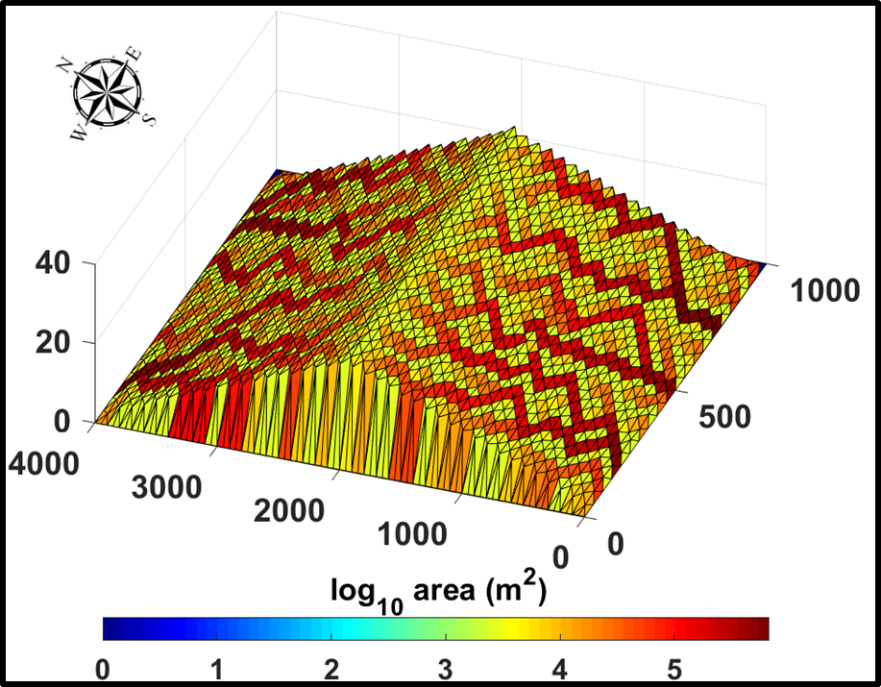

***Figure 1:*** *Two-sided synthetic domain (showing contributing drainage area in m2) used in the design of the numerical experiments in the current study.*

### *3.2 Numerical experimental settings*

Several simulations were conducted using CHILD+BGM on the synthetic domain shown in Figure 1. Notably, in each simulation, soil and vegetation parameters were considered uniform over the entire domain. These simulations were conducted to understand the combined role of solar radiation and different precipitation settings on the co-evolution of vegetation patterns and semi-arid landforms. In total, six different scenarios were designed using a combination of two different solar radiation conditions and three different precipitation settings, as described below.

To elucidate the role of solar radiation on the spatial distribution of vegetation cover, two different scenarios were used: i) uniform radiation and ii) slope control on radiation. For uniform radiation, solar radiation was uniformly distributed as a function of day of the year and latitude throughout the domain. In this scenario, every cell received the same amount of solar radiation corresponding to that of a flat surface on that day. In the spatial radiation case (slope control), solar radiation was spatially varied as a function of day of the year, latitude, aspect, and slope throughout the domain.

To investigate the role of different precipitation settings on the coevolution of vegetation and landform patterns, three different scenarios were designed: i) uniform precipitation, ii) elevation controlled precipitation, and iii) orographic precipitation. Figure 2 shows a schematic diagram for the spatial distribution of precipitation with distance across the synthetic domain for the three scenarios. In the uniform precipitation case, all grid cells recieved the same amount of precipitation, as shown in Figure 2a. In the elevation controlled precipitation case, precipitation was spatially varied as a function of elevation on both sides of the domain (Figure 2b). In the orographic precipitation scenario, the precipitation varied as a function of elevation differently on the windward and leeward sides of the domain. To distribute the precipitation over the landscape (Figure 2c), the precipitation was adjusted for the windward and leeward sides using a linear relation. Linear models for orographic control on precipitation are simple and have previously been used in the literature (Osborn, 1984; Wainwright, 2005; Nearing et al., 2015). The modelled precipitation *Pz* at a cell with elevation (*Zi*) was obtained using the following equation:

 (Eq. 25)

where *P* is the precipitation at *Zo*,  [m-1] is the windward orographic precipitation fraction, and [ m-1] is the leeward orographic precipitation fraction. The precipitation was scaled linearly as a function of the elevation and windward and leeward fractions (= 1 and = 0.5), as shown in Figure 2c.  represents the cell elevation [m], is the initial elevation [m], and is the maximum elevation [m]. is a factor [-], which defines on which side of the mountain range the cell is (i.e., windward or leeward), where *AspF* is



Based on the Equation 25, the distributions of the modelled precipitation cases which were considered in the simulations are shown on the landscapes in Figure 2 and Figure S1 (in the Supplementary material). In this case, where precipitation at the initial elevation was 400 mm, it increased as a function of elevation, leading to a maximum precipitation of 800 mm at the highest elevation.  was found to be lower than the , which indicates that the low elevations on the leeward side received less precipitation (200 mm) compared with those on the windward side. The linear orographic precipitation model provides an idealised representation of the relationship between precipitation and topography and has successfully been used in many climatological studies (Smith et al., 2003; Smith and Barstad, 2004; Anders et al., 2006; Minder, 2010; Lundquist et al., 2010).

The experiments were carried out by combining the three precipitation settings and two solar radiation conditions. To quantify how the landscape would evolve in response to different precipitation patterns only, a set of experiments with uniform solar radiation were run using a) uniform, b) elevation control, and c) orographic precipitation. A set of three experiments were also conducted with slope control on radiation driven by d) uniform, e) elevation control, and f) orographic precipitation. The experiment with slope control on radiation and uniform precipitation was pursued to single out the role of aspect on the coevolving landscape. The results for the six scenarios are outlined in the following section.



***Figure 2:*** *Spatial distribution of three different precipitation settings: a) uniform precipitation, b) elevation controlled precipitation, and c) orographic precipitation at a particular time step of the year.*

## Results

### 4.1 Influence of different precipitation and radiation patterns on the spatial distribution of vegetation cover

The spatial patterns of simulated vegetation cover for the six combinations of precipitation and radiation scenarios are provided in Figure 3(3-dimensional plots of spatial vegetation cover for these settings are provided in Figure S2, in the Supplementary material). The spatial pattern of simulated vegetation cover for the uniform solar radiation and uniform precipitation scenario is shown inFigure 3a. The vegetation cover fraction was found to reach a value of 0.45 in this scenario. The higher values of the vegetation cover fraction occurred in the channels (higher contributing areas). This highlights a dominant network control on vegetation patterns for this scenario, since the incoming solar radiation and precipitation were uniform. Therefore, the only observed spatial variability in vegetation distribution in this case was due to the effect of enhanced soil moisture in areas of flow concentration.

The spatial pattern of the mean simulated vegetation cover fraction for the uniform solar radiation setting in combination with elevation control precipitationis showninFigure 3b. Higher vegetation cover (darker green pixels) can be seen in the middle of the domain (~1500–2500 m) where elevation is high. This shows the elevation control on the vegetation cover pattern, as vegetation cover increased in areas of high precipitation. This is also reflected in the higher amount of vegetation cover fraction which, for this scenario, reached ~0.65 at high elevations. Areas with lower elevations on both sides of the domain, which received comparatively less precipitation, were found to have a lower vegetation cover (i.e., ~0.45). Notably, this pattern of elevation control was found to be so strong that it completely counteracted the effect of the network.

****

***Figure 3:*** *Spatial patterns of the simulated vegetation cover fraction (mean values over the last 100-year period) for the different precipitation and solar radiation scenarios. The left panel (first column) shows the results for the uniform solar radiation scenario for a) uniform precipitation, b) elevation control precipitation, and c) orographic precipitation. The right panel (second column) shows the spatially varied solar radiation scenario for the three precipitation patterns. Note that the range of values (colour bands) varies for different scenarios, which was necessary for pattern visualisation.*

Figure 3c shows the spatial pattern of the mean vegetation cover fraction for simulations with orographic precipitation and uniform solar radiation inputs. Unlike the previous two settings, the amount of vegetation cover was found to be higher on the windward side of the domain (0–2000 m) than in the leeward side (2000–4000 m) due to the orography effect, as there was higher rainfall on the windward side (this is also visible in the 3-dimensional plots, as shown in Figure S1c in the Supplementary material). As in the previous case, the effect of increased vegetation in higher elevation (with higher precipitation) also characterises this pattern.

The spatial pattern of mean simulated vegetation cover for spatially varied solar radiation in combination with uniform precipitation is presented in Figure 3d. A higher range of vegetation cover fraction values (~0.3–0.6) was obtained in this case when compared with those from the uniform solar radiation scenario. The distinct differences between the patterns shown in Figures 3a and 3d suggest that the spatial variability of solar radiation and its associated aspect-driven effects dominated the vegetation response (the aspect distribution is shown in Figure S3 in the Supplementary material). A similar spatial pattern of vegetation was observed in the case of spatially varied solar radiation combined with elevation controlled precipitation, as shown in Figure 3e. However, in this case, the pattern was found to clearly reflect not only the radiation control but also the elevation control on precipitation. The aspect control is reflected by the presence of a higher vegetation cover fraction on the NFS; in this case, however, a higher vegetation cover fraction can be observed at higher elevations. This last observation becomes evident when Figures 3e to 3d are compared.

Lastly,Figure 3f shows the spatial pattern of simulated vegetation cover fraction for the spatially varied solar radiation under orographic precipitation input. In this case, the pattern can be seen to resemble the same features in the two previous cases (Figures 3e and 3d) but with the effect induced by the existence of higher precipitation on the windward side. First, the windward side was found to have higher vegetation cover fraction compared with the leeward side of the domain. Second, the aspect control of solar radiation was also evident in this pattern. Moreover, it can also be observed that the NFS on the windward side has a higher vegetation cover fraction compared with the NFS on the leeward side due to the effect of orographic precipitation. The role of aspect and elevation on the simulated vegetation cover fraction on different precipitation settings is described in more detail in the next sub-section.

### 4.2 Vegetation cover fraction as a function of elevation and aspect

To explore the effect of aspect, the pixels were classified as North = 315°­–360° and 0°­–­45°, East = 45°­–135°, South = 135°­–225°, and West = 225°­–315°. Figure 4 shows scatter plots of the mean total vegetation cover fraction as a function of elevation for the three different precipitation distributions (i.e., uniform, elevation control, and orographic) considering spatial variability in solar radiation.

The mean total vegetation cover as a function of elevation for the NFS and SFS for the scenario with uniform precipitation is presented in Figure 4a. Vegetation cover in this case did not change significantly with elevation as precipitation was uniformly distributed. These trends are produced by the effect of slope angle. As a result of differences in insolation, NFS (which have lower evapotranspiration) were found to have a denser canopy compared with SFS. Upper hillslope areas are usually steeper (as will be discussed in more detail in later sections), which affects insolation. Steep NFS have lower insolation than gentle slopes, while steep SFS have higher insolation than gentle ones which explains the trends observed for higher elevations, as areas with higher insolation have higher evaporation and lower soil moisture, which therefore sustains reduced vegetation cover. Figure 4b shows the mean vegetation cover as a function of elevation under the combined effect of spatially varied radiation and elevation control on precipitation. Similar to the previous scenario, NFS had higher vegetation cover than the SFS, but in this case, vegetation cover increased as a function of elevation. Mean vegetation cover ranged from 0.32 to 0.5 for the NFS, while it ranged from 0.32 to 0.41 for the SFS.

The mean vegetation cover fraction as a function of elevation for the case of orographic precipitation and spatially varied radiation is shown in Figure 4c, which displays differences for the NFS and SFS on the windward and leeward sides of the domain. The highest values for the vegetation cover fraction were found for cells with a north windward (~0.5) position. These values were always above those for cells with the same elevation but located in the north leeward, south windward, and south leeward positions. Unlike the previous two precipitation settings, the relationship between the vegetation cover and elevation was more complex for this scenario due to competition between solar radiation and precipitation on the windward and leeward sides of the domain. The lowest vegetation cover fraction was observed on the SFS at the leeward side of the domain due to soil moisture stress induced by solar radiation and the orographic shade effect. It was also found that the lower elevation of the NFS on the leeward side had a lower vegetation cover fraction, while the SFS on the windward side had a higher vegetation cover fraction. This is due to the effect of orographic precipitation in the case analysed (due to the assumed wind direction). However, at higher elevations (> 30 m), the NFS on the leeward side had a higher vegetation cover fraction than the SFS on the windward side of the domain. This occurred because, at higher elevations, the precipitation was similar on both sides, and the role of solar radiation intensified. Overall, vegetation patterns are strongly affected by rainfall patterns and variability in solar radiation.

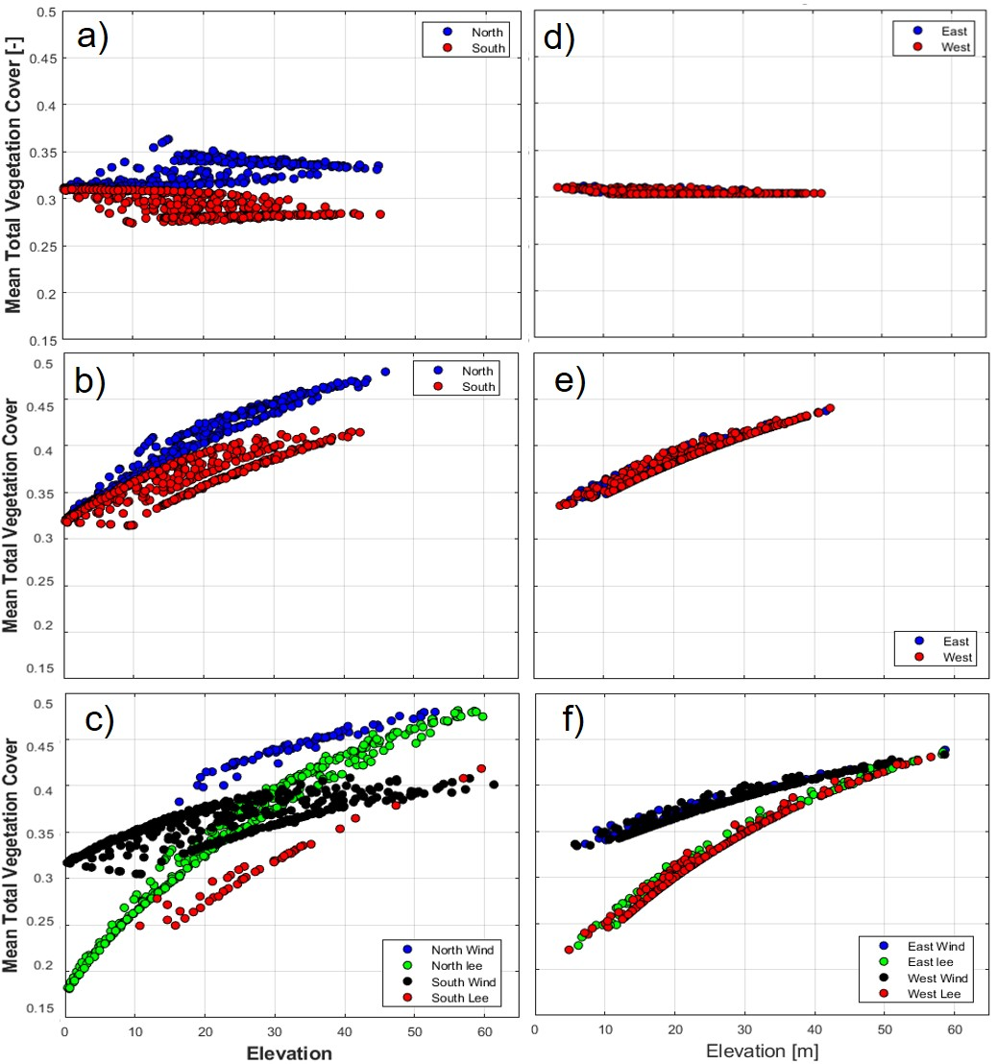

***Figure 4:*** *Simulated mean total vegetation cover as a function of elevation on NFS and SFS (first panel) and EFS and WFS (second panel) for different precipitation settings: a) uniform precipitation, b) elevation control precipitation, c) orographic precipitation. The NFS and SFS on the windward side are represented by ‘North Wind’ and ‘South Wind’, respectively. While the NFS and SFS on the leeward side of the synthetic domain are illustrated by ‘North Lee’ and ‘South Lee’, respectively. The EFS and WFS on the windward side are represented by ‘East Wind’ and ‘West Wind’, respectively, and the EFS and WFS on the leeward side of the synthetic domain are illustrated by ‘East Lee’ and ‘West Lee’, respectively.*

Figure 4d shows the mean vegetation cover as a function of elevation for east-facing slopes (EFS) and west-facing slopes (WFS) for the uniform precipitation and spatially varied solar radiation setting. EFS and WFS had a similar amount of the vegetation cover fraction (~0.31) across the whole elevation range. The role of aspect was not significant on the EFS and WFS and was similar to that for a flat surface. Figure 4e shows the mean vegetation cover fraction plotted as a function of elevation for the elevation control precipitation and spatial varied solar radiation setting, which reflects the increase in rainfall with elevation, but, again, shows no differences in vegetation cover between EFS and WFS at the same elevation. Figure 4f shows that when considering the effect of orographic precipitation, it can be observed that although there was no difference in the vegetation cover at the EFS and WFS within the windward and leeward sides of the domain, vegetation cover increased with elevation. Additionally, EFS and WFS on the windward side were found to support higher vegetation cover than the EFS and WFS on the leeward side of the domain due to the influence of orographic precipitation.

### 4.3 Influence of different precipitation and solar radiation settings on divide migration

Figure 5displays the development of topographic asymmetry over the geologic time scales for all of the study cases. Figure 5a shows the case with uniform precipitation and uniform radiation, where no divide migration is visible, as an almost negligible number of pixels shifted. On the other hand, when precipitation is uniform but solar radiation varies spatially due to the effect of aspect (Figure 5d), it can be seen that a few pixels tend to migrate. This is likely due to the role of differences in radiation which creates differences in vegetation distribution on hillslopes with different aspects. Figures 5b and 5e show a similar pattern for elevation controlled precipitation but with a larger number of pixels shifting. In this case, the role of spatially varied solar radiation intensified (Figure 5e), inducing higher divide migration than in the case of the elevation controlled precipitation with uniform solar radiation (Figure 5b). Figures 5c and 5f show that the divide migration is more pronounced for the orographic precipitation case with both spatial and uniform solar radiation. However, among these last two cases, the divide migration phenomenon was again enhanced when the effect of aspect-controlled solar radiation was considered (Figure 5f). This is due to the combined effect of aspect driven vegetation differences and rain shadow effects. This shows that the aspect influence on topographic asymmetry is more pronounced in combination with the influence of orographic precipitation. The effect of topographic asymmetry presented in Figure 5 is further explored by examining the elevation maps (Figure 6) and slope-area diagrams (Figure 7), as discussed below.

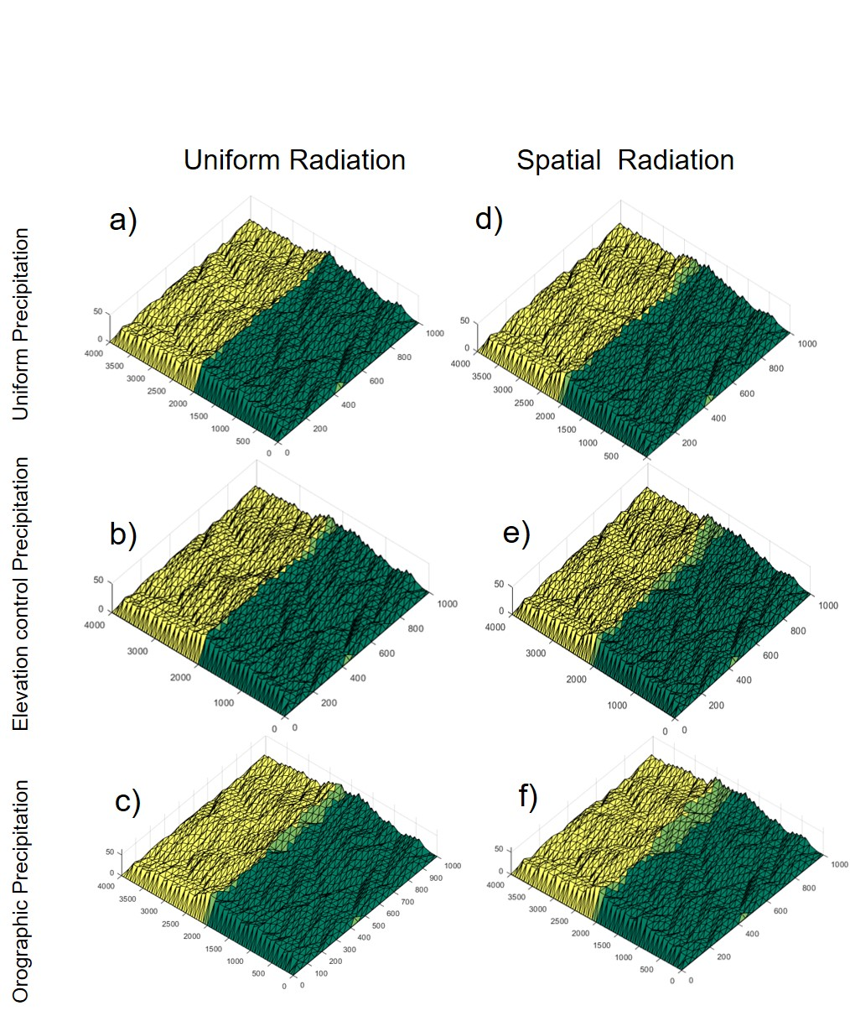

***Figure 5:*** *Modelled divide migration map from CHILD for different precipitation and solar radiation cases. The left column of the diagram shows the uniform solar radiation cases for a) uniform precipitation, b) elevation control precipitation, and c) orographic precipitation. The right column of the diagram shows the spatial radiation cases for d) uniform precipitation, e) elevation control precipitation, and f) orographic precipitation. Green represents the windward side of the domain and yellow represents the leeward side with respect to orographic precipitation. Finally, the light green indicates the migration of the pixels.*

Elevation was found to increase to ~45 m for the cases of uniform and elevation control precipitation with uniform radiation, which were found to have almost no divide migration (Figures 6a and 6b). It can also be observed that there were negligible differences in the mean slopes at both sides of the domain (Figures 7a and 7b) in both of these cases. Though there was minimal difference in the elevation for uniform precipitation and elevation control precipitation for the spatially varied radiation case (Figure 6d–e), Figures 7d and 7e show some subtle differences, with the slopes on the leeward side being slightly steeper than those on the windward side of the domain, particularly for the case that accounts for aspect driven radiation effects (displaying a higher number of migrating pixels in Figure 5). When orographic precipitation was considered (Figures 6c and 6f), the simulated elevations at the divide tended to be higher than those from the other precipitation scenarios, increasing to ~60 m for both simulations with uniform and spatially varied solar radiation. Figures 7c and 7f show that the slopes of the leeward face were steeper than the windward slopes of the domain. Among the two cases of orographic precipitation, the differences on the windward and leeward slopes were found to be more pronounced in the spatially varied solar radiation case.

To capture and compare the trends in divide migration simulated and discussed in previous studies (Goren et al., 2014; Han et al., 2015) with the results obtained in the current study (which accounted for vegetated landscapes), simulations for bare soil conditions were also run. Importantly, the simulations with bare soil, using spatially varied radiation and orographic precipitation settings, displayed less divide migration than the simulations using the same scenario but including dynamic vegetation cover (Figure S4 in the Supplementary material).

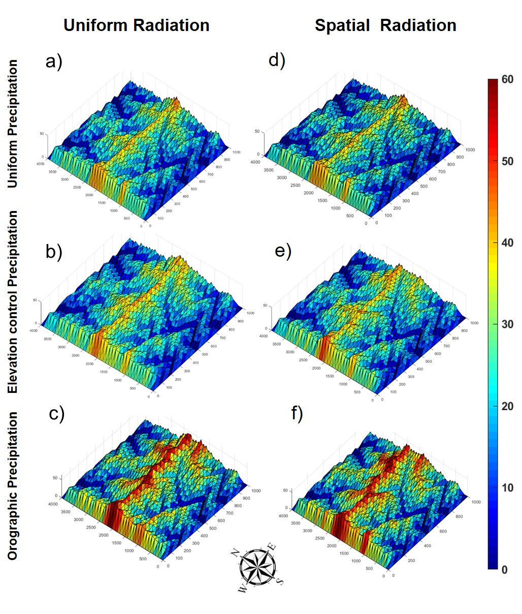

***Figure 6:*** *Three-dimensional views of modelled elevation map from the CHILD model for different precipitation and solar radiation cases. The modelled elevation map is plotted on evolved topography, where the left column of the diagram shows the uniform solar radiation cases for a) uniform precipitation, b) elevation control precipitation, and c) orographic precipitation. The right column of the diagram shows the spatially varied solar radiation cases for d) uniform precipitation, e) elevation control precipitation, and f) orographic precipitation.*

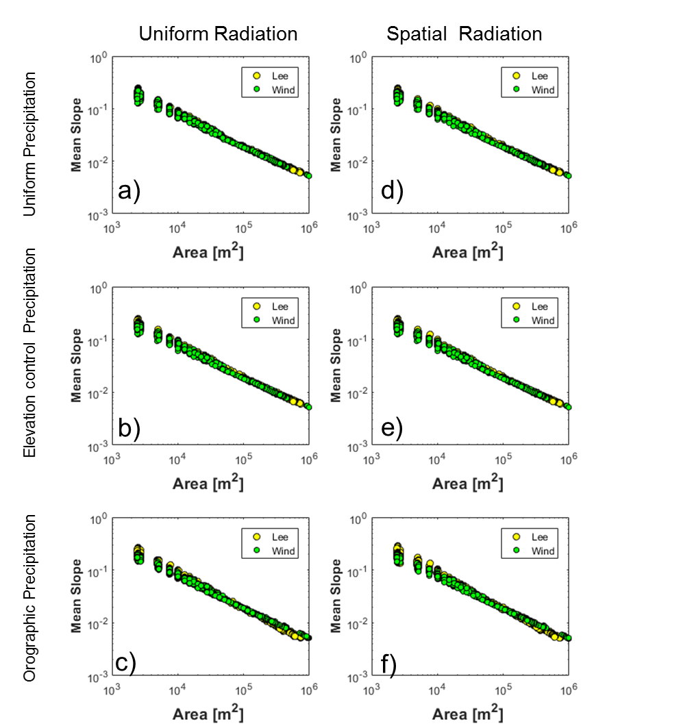

***Figure 7:*** *Slope-area relationship of the modelled landscapes for different precipitation and solar radiation cases. The left column of the diagram shows the uniform solar radiation cases for a) uniform precipitation, b) elevation control precipitation, and c) orographic precipitation. The right column of the diagram shows the spatially varied solar radiation cases for d) uniform precipitation, e) elevation control precipitation, and f) orographic precipitation.*

Figure 8 displays the results for the slope-area diagram for the orographic precipitation and spatially varied solar radiation scenario for both vegetated and bare soil conditions. It was found that the slopes on the windward and leeward sides of the domain with vegetation cover were always higher than the windward and leeward slopes of the bare soil domain. As discussed in previous sections, the leeward slopes for the vegetated domain were steeper than the windward slopes. In a similar fashion, the leeward slopes of the bare soil domain were found to be steeper than those at the windward flank throughout the domain.



***Figure 8:*** *Slope-area plot for orographic precipitation with bare soil and vegetated domains for the windward and leeward slopes. ‘Lee B’ and ‘Wind B’ represent the mean slopes of the bare soil on the leeward and windward sides of the domain, respectively, and ‘Wind V’ and ‘Lee V’ represent the mean slopes of the windward and leeward sides of the domain, respectively.*

Figure 9 shows the discharge for the windward and leeward sides using the orographic precipitation with the spatially varied solar radiation setting for both the vegetated and bare soil domains. The discharge for the windward side of the bare soil domain was found to be higher than the windward side of the vegetated soil domain. Discharge for the leeward side of the bare soil case was higher than the discharge of the leeward side for the vegetated soil case. The discharge was also higher on the windward side for both the bare soil domain and vegetated domain in comparison to their respective leeward sides. From Figure S5 (in the Supplementary material), it can be seen that the windward side of the vegetated domain had a higher contributing area than leeward side, implying that the windward is gentler than leeward for the case of orographic precipitation.

E:\OROGRAPHY\Z_MATCODE\Oro_mat_figures\Discharge\Discharge_08Dec.tif

***Figure 9:*** *Mean discharge-area plot for orographic precipitation with bare soil and vegetated domain. ‘Lee B’ and ‘Wind B’ represent the mean discharge on the leeward and windward sides of the bare soil domain, respectively, and ‘Wind V’ and ‘Lee V’ represent the mean discharge of the windward and leeward sides of the vegetated domain, respectively.*

## Discussion

Based on the simulations presented in previous sections, drainage network, aspect, and elevation controls were identified as the three main drivers of vegetation patterns on the landscape following the use of six different scenarios corresponding to the combination of uniform and spatially varied solar radiation with uniform, elevation control, and orographic precipitation. A higher simulated vegetation cover fraction was obtained for the channels (higher drainage areas) than the hillslopes for the case of uniform solar radiation and uniform precipitation settings. This highlights the strong control of network patterns on vegetation cover due to the flow concentration for this case. Since the incoming solar radiation and precipitation were uniform in this scenario (except for the channels that have higher contributing areas, there was little variation in vegetation cover across the rest of the domain, which is consistent with findings of previous studies (Istanbulluoglu et al., 2008; Yetemen et al., 2010 Yetemen et al., 2015a).

The control of aspect and slope on solar radiation was found to have a significant impact on vegetation cover for all of the precipitation settings (i.e., uniform, elevation control, and orographic precipitation) analysed. Differences in incoming solar radiation on the NFS and SFS led to differences in vegetation cover on these slopes. The strong role of aspect on vegetation pattern differences is consistent with that reported in previous studies showing that incoming solar radiation leads to sparser vegetation cover on the SFS than in the NFS (Broza et al., 2004; Caylor et al., 2004; Zou et al., 2007; Gutiérrez-Jurado et al., 2013; Hinckley et al., 2014; Flores‐Cervantes et al., 2014; Yetemen et al., 2015a; Bass et al., 2017; Kumari et al., 2019; Srivastava et al., 2019).

The elevation and orographic precipitation controls led to higher vegetation cover at higher elevations due to an increase in precipitation with elevation. This is based on the observation that orographic effects on clouds and precipitating often results in greater precipitation at higher elevations, where temperatures are cooler and more precipitable water can accumulate (Roe, 2003; Giambelluca et al., 2011; Houze, 2012). Field and modelling studies have shown this strong orographic effect on precipitation as a function of elevation at various locations (Hay and McCabe, 1998; Hanson, 2001; Dettinger et al., 2004; Girotto et al., 2014; Kirchner et al., 2014; Knowles et al., 2015). For instance, Dettinger et al. (2004) showed that precipitation at higher elevation can be as much as 30 times more than at the base of the range. In this study, the effect of orographic precipitation led to significant differences in vegetation cover, particularly for the case in which slope controlled radiation area was considered. For this case, the NFS and SFS on the windward and leeward slopes displayed highly distinct vegetation cover values as a function of variations in both elevation and aspect, which is consistent with results reported in previous studies (Elder et al., 1991; Winstral et al., 2013; Yetemen et al., 2015a). Our results accounting for orographic rainfall effects that led to higher vegetation cover on the windward side are also consistent with observations in field-based studies (Chen et al., 1997; Giambelluca et al., 2011).

Indeed, the asymmetry caused by insolation was also found to be an effective variable driving the vegetation pattern on the windward and leeward sides (Rozas et al., 2011). The results from this study also highlight that it is very important to understand and recognise the combined effects of slope aspect and predominant wind direction. This study demonstrated that the NFS on the leeward side of the mountain flank hold a lower vegetation cover fraction than the NFS on the windward side. However, denser vegetation cover existed on the SFS of the windward side of the mountain flank—this is due to the direction of wind, which is assumed to come from South direction. The effect of the windward versus leeward location can sometimes be more important than location in terms of aspect, as shown in the studies by Dettinger et al. (2004) and Lundquist et al. (2010) at Sierra Nevada of California.

The results from the bare-soil simulation show that the windward side of the domain was gentler compared with the leeward side, which is consistent with the previous modelling studies in which the influence of orographic precipitation was simulated for bare landscapes (Goren et al., 2014; Han et al., 2015; Zavala et al., 2020; Paik and Kim, 2020). The study conducted by Goren et al. (2014) showed that the windward side was longer than the leeward side of the mountain due to higher rainfall leading to higher erosion rates. Therefore, it was found that windward side of the mountain becomes gentler, whereas the other side (leeward) receives less rainfall, in turn leading to steeper slopes under landform evolution equilibrium conditions (i.e., when erosion equals tectonic uplift).

Further, the current study also compared and contrasted the differences in divide migration for a vegetated domain. Notably, the pattern found from the modelling results for the vegetated domain remained consistent with that for the bare-soil domain, such that the windward side of the domain was found to be gentler. One potential explanation for this pattern is that, though the windward side had denser vegetation cover, the runoff discharge was higher on that side as compared to the leeward side (Figure 9). This can lead to higher shear stress due to increased runoff, with the results suggesting that the effect of higher shear stress dominates those of vegetation protection on the windward side and leads to a decrease in topographic slope, as shown in Figure 8 (Istanbulluoglu and Bras, 2005; Istanbulluoglu et al., 2008; Yetemen et al., 2015a). Higher slopes were observed for the leeward side of the vegetated landscape, whereas lower slopes were observed for the windward side. This topographic asymmetry between the leeward and windward sides was found to be more pronounced for aspect-controlled and orographic-precipitation conditions. This is because the effect of increased runoff dominates that of vegetation protection on erosion on the windward side of the domain.

## Conclusions

In this study, the CHILD LEM coupled with the vegetation dynamic component BGM was used to better understand the role of elevation controlled and orographic precipitation on the coevolution of landforms and aspect-controlled vegetation in semi-arid ecosystems. The results from the simulations showed that for uniform precipitation and uniform solar radiation, the vegetation pattern was controlled by the effect of the drainage network, as higher vegetation was observed in the channels. However, when the effect of aspect on radiation was considered, this effect became dominant. When elevation control on precipitation was considered under the assumption of uniform solar radiation, higher vegetation cover was observed at a higher elevation. However, when elevation control precipitation was combined with the effect of spatially varied solar radiation, the role of aspect was seen in addition to the elevation control phenomenon.

Unlike previous simulations, the results accounting for the orographic effect on precipitation and assuming uniform solar radiation showed denser vegetation cover on the windward than in the leeward side of the domain. On the other hand, when considering the effects of both orographic precipitation and spatially varied solar radiation, a more complex relationship was observed between vegetation and elevation, as there was competition between the effects of slope-controlled solar radiation and orographic precipitation on both sides of the domain. However, at higher elevations, where precipitation was similar on both sides, the slope control solar radiation effect dominated, leading to denser vegetation cover on the NFS on the leeward side compared with the SFS on the windward side of domain.

Differences in the coevolution of landforms under different precipitation and solar radiation settings were also significant and led to various degrees of topographic asymmetry. There was negligible divide migration for the case of uniform precipitation and uniform solar radiation; however, a slight shifting of the divide was seen when accounting for the effect of spatially varied solar radiation. This is due to the fact that aspect drives vegetation differences that lead to topographic asymmetry across the domain. A noticeable amount of shifting in the divide was observed in the case of elevation controlled precipitation with spatially varied solar radiation. Among all of the simulations, the highest divide migration was observed for the orographic precipitation combined with spatially varied solar radiation. This is because the slopes of the windward side of the mountain flank are gentler than the leeward slopes of the mountain flank that leads to highest divide migration. Further, it was found that the divide migration in the vegetated landscapes was consistent with that obtained for bare soil landscapes. This suggests that the effect of vegetation protection on erosion on the windward side is not as important as the erosive power of increasing runoff under orographic precipitation conditions.

The key contribution of this modelling study is the advancement in knowledge of the distribution of the vegetation cover fraction on the windward and leeward sides of the domain under the influence of orographic precipitation in semi-arid ecosystems. This modelling study finds that spatially varied solar radiation and non-uniform precipitation plays a fundamental role in the generation of topographic asymmetry in semi-arid ecosystems.

**Acknowledgments**

This research was funded by the Australian Research Council through grants FT140100610

and DP140104178 (P.M. Saco) and the Scientific and Technological Research Council of

Turkey (TUBITAK) through grant 118C329 (O. Yetemen).

## References

Anders, A.M., Ne, A., Roe, G.H., Montgomery, D.R., 2008. Influence of precipitation phase on the form of mountain ranges. Geology (6), 479–482.

Anders, A.M., Roe, G.H., Durran, D.R., Minder, J.R., 2006. Small-scale spatial gradients in climatological precipitation on the Olympic peninsula. Journal of Hydrometeorology 8, 1068–1081.

Arora, V.K., 2003. Simulating energy and carbon fluxes over winter wheat using coupled land surface and terrestrial ecosystem models. Agricultural and Forest Meteorology 118 (1–2), 21–47.

Bass, B., Cardenas, M.B., Befus, K.M., 2017. Seasonal shifts in soil moisture throughout a semiarid hillslope ecotone during drought: A geoelectrical view. Vadose Zone Journal 16 (2), 1-17.

Broza, M., Poliakov, D., Gruia, M., Bretfeld, G. 2004. Soil collembolan communities on north-and south-facing slopes of an eastern Mediterranean valley. Pedobiologia, 48(5–6), 537–543.

Carbone, R.E., Tuttle, J.D., Cooper, W.A., Grubišić, V., Lee, W. C., 1998. Trade wind rainfall near the windward coast of Hawaii. Monthly weather review 126 (11), 2847–2863.

Carson, M.A., Kirkby, M.J., 1972. Hillslope form and process. Cambridge University Press: Cambridge.

Caylor, K. K., Scanlon, T. M., Rodriguez-Iturbe, I. 2004. Feasible optimality of vegetation patterns in river basins. Geophysical Research Letters, 31, L13502.

Chaboureau, J.-P., 2008. A midlatitude precipitating cloud database validated with satellite observations. Journal of Applied Meteorology and Climatology 47, 1337–1353.

Chen, Z.S., Hsieh, C.F., Jiang, F.Y., Hsieh, T.H., Sun, I.F., 1997. Relations of soil properties to topography and vegetation in a subtropical rain forest in southern Taiwan. Plant Ecology 132 (2), 229–241.

Clift, P.D., Hodges, K.I.P.V, Heslop, D., Hannigan, R., Long, H.V.A.N., Calves, G., 2008. Correlation of Himalayan exhumation rates and Asian monsoon intensity. Nature Geoscience 17, 875–880.

Colberg, J.S., Anders, A.M., 2014. Geomorphology numerical modelling of spatially-variable precipitation and passive margin escarpment evolution. Geomorphology 207, 203–212.

Collins, D. B. G., R. L. Bras, and G. E. Tucker (2004), Modeling the effects of vegetation-erosion coupling on landscape evolution, Journal of Geophysical Research Earth Surface, 109, F03004

Collins, D.B.G., Bras, R.L., 2008. Climatic control of sediment yield in dry lands following climate and land cover change. Water Resour. Res. 44 (June), 1–8.

Collins, D.B.G., Bras, R.L., 2010. Climatic and ecological controls of equilibrium drainage density, relief, and channel concavity in dry lands. Water Resour. Res. 46 (4), 1–18.

Dettinger, M., Redmond, K., Cayan, D., 2004. Winter orographic precipitation ratios in the Sierra Nevada - Large-scale atmospheric circulations and hydrologic consequences. Journal of Hydrometeorology 5(6), 1102–1116.

Dietrich, W.E., Perron, J.T., 2006. The search for a topographic signature of life. Nature 439(7075), 411-418.

Eagleson, P., 1978. Introduction to water balance dynamics. Water Resour. Res. 14 (5), 705–712.

Elder, K., Dozier, J., Michaelsen, J., 1991. Snow accumulation and distribution in an Alpine Watershed. Water Resour. Res. 27 (7), 1541–1552.

Farquhar, G.D., Ehleringer, J.R., Hubick, K.T., 1989. Carbon isotope discrimination and photosynthesis. Annual Review of Plant Physiology and Plant Molecular Biology 40, 503–537.

Ferrier, K.L., Huppert, K.L., Perron, J.T., N.D., 2013. Climatic control of bedrock river incision. Nature, 1–6.

Garreaud, R., Falvey, M., Montecinos, A., 2016. Orographic precipitation in coastal southern Chile: Mean distribution, temporal variability, and linear contribution. Journal of Hydrometeorology 17, 1185–1202.

Gasparini, N.M., Bras, R.L., Tucker, G.E., Rice, S.P., Roy, A.G., Rhoads, B.L., 2008. Numerical predictions of the sensitivity of grain size and channel slope to an increase in precipitation. River confluences, tributaries and the fluvial network. John Wiley & Sons Ltd., New York, NY. 367–394.

Gasparini, N.M., Whipple, K.X., 2014. Diagnosing climatic and tectonic controls on topography: Eastern flank of the northern Bolivian Andes. Lithosphere 6 (4), 230–250.

Giambelluca, T.W., DeLay, J.K., Nullet, M.A., Scholl, M.A., Gingerich, S.B., 2011. Canopy water balance of windward and leeward Hawaiian cloud forests on Haleakalā, Maui, Hawai'i. Hydrological Processes 25 (3), 438–447.

Girotto, M., Cortés, G., Margulis, S.A., Durand, M., 2014. Examining spatial and temporal variability in snow water equivalent using a 27-year reanalysis: Kern River watershed, Sierra Nevada. Water Resour. Res. 50 (8), 6713–6734.

Goren, L., Willett, S.D., Braun, J., 2014. Coupled numerical – Analytical approach to landscape evolution modelling. Earth Surface Processes and Landforms 545 (January), 522–545.

Guan, H., Wilson, J.L., Makhnin, O., 2005. Geostatistical mapping of mountain precipitation incorporating auto searched effects. Journal of Hydrometeorology 6(6), 1018–1031.

Gutiérrez-Jurado, H.A., Vivoni, E.R., Cikoski, C., Harrison, B.J., Bras, R.L., Istanbulluoglu, E., 2013. On the observed ecohydrologic dynamics of a semi-arid basin with aspect-delimited ecosystems. Water Resour. Res. 49 (12), 8263–8284.

Gutiérrez-Jurado, H.A., Vivoni, E.R., Istanbulluoglu, E., Bras, R.L., 2007. Ecohydrological response to a geomorphically significant flood event in a semi-arid catchment with contrasting ecosystems. Geophysical Research Letters 34 (24), 1–7.

Han, J., Gasparini, N.M., Johnson, J.P.L., 2015. Measuring the imprint of orographic rainfall gradients on the morphology of steady-state numerical fluvial landscapes. Earth Surface Processes and Landforms 1350 (March), 1334–1350.

Han, J., Gasparini, N.M., Johnson, J.P.L., Murphy, B.P., 2014. Modeling the influence of rainfall gradients on discharge, bedrock erodibility, and river profile evolution, with application to the Big Island, Hawai'i. Journal of Geophysical Research: Earth Surface, 119(6), 1418-1440.

Hanson, C.L., 2001. Long-term climate database, Reynolds Creek Experimental Watershed, Idaho, United States. Water Resour. Res. 37 (11), 2839–2841.

Hay, L.E., McCabe, G.J., 1998. Verification of the Rhea-Orographic-Precipitation Model. Journal of the American Water Resources Association 34 (1), 103–112.

Hinckley, E. L. S., Ebel, B. A., Barnes, R. T., Anderson, R. S., Williams, M. W., Anderson, S. P. (2014). Aspect control of water movement on hillslopes near the rain-snow transition of the Colorado Front Range. Hydrological Processes, 28(1), 74–85.

Houston, J., Hartley, A.J., 2003. The Central Andean west-slope rainshadow and its potential contribution to the origin of hyper-aridity in the Atacama Desert. International Journal of Climatology: A Journal of the Royal Meteorological Society, 23(12), 1453-1464.

Houze Jr., R.A., 2012. Orographic effects on precipitating clouds. Reviews of Geophysics 50 (2012), 1–47.

Istanbulluoglu, E., Bras, R.L., 2005. Vegetation-modulated landscape evolution: Effects of vegetation on landscape processes, drainage density, and topography. Journal of Geophysical Research Earth Surface 110, 1–19.

Istanbulluoglu, E., Tarboton, D.G., Pack, R.T., Luce, C., 2002. A probabilistic approach for channel initiation. Water Resour. Res. 38 (12), 1325.

Istanbulluoglu, E., Wang, T., Wedin, D.A., 2012. Evaluation of ecohydrologic model parsimony at local and regional scales in a semi-arid grassland ecosystem. Ecohydrology 5 (1), 121–142.

Istanbulluoglu, E., Yetemen, O., Vivoni, E.R., Gutie, H.A., Bras, R.L., 2008. Eco-geomorphic implications of hillslope aspect: Inferences from analysis of landscape morphology in Central New Mexico. Geophysical Research Letters 35 (2), 1–6.

Kirchner, P.B., Bales, R.C., Molotch, N.P., Flanagan, J., Guo, Q., 2014. LiDAR measurement of seasonal snow accumulation along an elevation gradient in the southern Sierra Nevada, California. Hydrology and Earth System Sciences 18 (10), 4261–4275.

Kirshbaum, D.J., Smith, R.B., 2008. Temperature and moist-stability effects on midlatitude orographic precipitation. Quarterly Journal of the Royal Meteorological Society 1199 (July), 1183–1199.

Knowles, J.F., Harpold, A.A., Cowie, R., Zeliff, M., Barnard, H.R., Burns, S.P., et al., 2015. The relative contributions of alpine and subalpine ecosystems to the water balance of a mountainous, headwater catchment. Hydrological Processes 29 (22), 4794–4808.

Kumari, N., Yetemen, O., Srivastava, A., Rodriguez, J.F., and Saco, P.M., 2019. The spatio-temporal NDVI analysis for two different Australian catchments. 23rd International Congress on Modelling and Simulation (MODSIM2019), Canberra, Australia, 958-964.

Kumari, N., Saco, P. M., Rodriguez, J. F., Johnstone, S. A., Srivastava, A., Chun, K. P., Yetemen, O., 2020. The grass is not always greener on the other side: Seasonal reversal of vegetation greenness in aspect‐driven semi-arid ecosystems. Geophysical Research Letters 47(15), e2020GL088918.

Langbein, W.B., Schumm, S., 1958. Yield of sediment in relation to mean annual precipitation. Transactions, American Geophysical Union 39.

Laursen, E.M., 1958. The total sediment load of streams. J. Hydraul. Div. Am. Soc. Civ. Eng. 84 (1530), 1–6.

Lee, T.J., 1992. The impact of vegetation on the atmospheric boundary layer and convective storms, doctoral thesis, Colorado State University, Fort Collins, Colorado.

Luce, C.H., Abatzoglou, J.T., Holden, Z.A., 2013. The missing mountain water: Slower. Science 342 (December), 1360–1365.

Lundquist, J.D., Minder, J.R., Neiman, P.J., Sukovich, E., 2010. Relationships between barrier jet heights, orographic precipitation gradients, and streamflow in the Northern Sierra Nevada. Journal of Hydrometeorology 11 (5), 1141–1156.

McMahon, D.R., 1998. Soil, landscape and vegetation interactions in small semi-arid drainage basin: Sevilleta National Wildlife Refuge, New Mexico, Nmtech, Socorro, N.M.

Meyer-Peter, E., Müller, R., 1948. Formulas for bed-load transport. In IAHSR 2nd meeting, Stockholm, appendix 2. IAHR.

Minder, J.R., Mote, P.W., Lundquist, J.D., 2010. Surface temperature lapse rates over complex terrain: Lessons from the cascade mountains. Journal of Geophysical Research Atmospheres 115, 1–13.

Moglen, G.E., Parsons, R.M., 1998. On the sensitivity of drainage density to climate change. Water Resour. Res. 34 (4), 855–862.

Montaldo, N., Rondena, R., Albertson, J.D., Mancini, M., 2005. Parsimonious modelling of vegetation dynamics for ecohydrologic studies of water-limited ecosystems. Water Resour. Res. 41 (10), 1–16.

Murata, F., Hayashi, Æ.T., Matsumoto, Æ.J., 2007. Rainfall on the Meghalaya Plateau in Northeastern India—one of the rainiest places in the world. Natural Hazards 391–399.

Nearing, M.A., Simanton, J.R., Norton, L.D., Bulygin, S.J., Stone, J., 1999. Soil erosion by surface water flow on a stony, semi-arid hillslope. Earth Surface Processes and Landforms 24 (8), 677–686.

Nearing, M.A., Unkrich, C.L., Goodrich, D.C., Nichols, M.H., Keefer, T.O., 2015. Temporal and elevation trends in rainfall erosivity on a 149 km2 watershed in a semi-arid region of the American Southwest. International Soil and Water Conservation Research 3 (2), 77–85.

Osborn, H.B., 1984. Estimating precipitation in mountainous regions. J. Hydraul. Eng. 110 (12), 1859–1863.

Paik, K., Kim, W. 2020. Simulating the evolution of the topography-climate coupled system. Hydrol. Earth Syst. Sci. Discuss. 1-24 (in review).

Roe, G.H., 2005. Orographic precipitation. Annu. Rev. Earth Planet. Sci. 33, 645–671.

Roe, G.H., Montgomery, D.R., 2002. Steady-state river profiles. Geology (2), 143–146.

Roe, G.H., Montgomery, D.R., Hallet, B., 2003. Orographic precipitation and the relief of mountain ranges. Journal of Geophysical Research Solid Earth 108 (B6).

Roering, J.J., Kirchner, J.W., Dietrich, W.E., 1999. Evidence for nonlinear, diffusive sediment transport on hillslopes and implications for landscape morphology. Water Resour. Res. 35 (3), 853–870,

Roering, J.J., Schmidt, K.M., Stock, J.D., Dietrich, W.E., Montgomery, D.R., 2003. Shallow landsliding, root reinforcement, and the range. Canadian Geotechnical Journal 253, 237–253.

Rozas, V., Pérez-de-Lis, G., García-González, I., Arévalo, J.R., 2011. Contrasting effects of wildfire and climate on radial growth of Pinus canariensis on windward and leeward slopes on Tenerife, Canary Islands. Trees - Structure and Function 25 (5), 895–905.

Saco, P.M., Willgoose, G.R., Hancock, G.R., Saco, P.M., Willgoose, G.R., 2007. Eco-geomorphology of banded vegetation patterns in arid and semi-arid regions. Hydrology and Earth System Sciences Discussions 11, 1717–1730.

Scaff, L., Rutllant, J. A., Rahn, D., Gascoin, S., Rondanelli, R. (2017). Meteorological interpretation of orographic precipitation gradients along an Andes west slope basin at 30° S (Elqui Valley, Chile). Journal of Hydrometeorology, 18(3), 713-727.

Shi, X., Durran, D.R., 2015. Estimating the response of extreme precipitation over midlatitude mountains to global warming. Journal of Climate 28, 4246–4262.

Smith, R.B., 2003. A linear upslope-time-delay model for orographic precipitation. Journal of Hydrology 282 (1–4), 2–9.

Smith, R.B., Barstad, I., 2004. A linear theory of orographic precipitation. Journal of the Atmospheric Sciences 61 (12), 1377–1391.

Smith, T., Bookhagen, B. 2021. Climatic and biotic controls on topographic asymmetry at the global scale. Journal of Geophysical Research: Earth Surface, e2020JF005692.

Srivastava, A., Yetemen, O., Kumari, N., Saco, P.M., 2019. Aspect-controlled spatial and temporal soil moisture patterns across three different latitudes. 23rd International Congress on Modelling and Simulation - Supporting Evidence-Based Decision Making: The Role of Modelling and Simulation, MODSIM 2019 (December), 979–985.

Srivastava, A., Saco, P.M., Rodriguez, J.F., Kumari, N., Chun K.P., Yetemen, O., 2021. The role of landscape morphology on soil moisture variability in semi-arid ecosystems. Hydrological Processes, 35:e13990

Summerfield, M.A., Hulton, N., 1994. Natural controls of fluvial denudation rates in major world drainage basins. Journal of Geophysical Research Solid Earth 99, 871–883.

Swenson, J.J., Waring, R.H., 2006. Modelled photosynthesis predicts woody plant richness at three geographic scales across the north-western United States. Global Ecol. Biogeogr. 15 (5), 470–485

Thiede, R.C., Bookhagen, B., Arrowsmith, J.R., Sobel, E.R., Strecker, M.R., 2004. Climatic control on rapid exhumation along the Southern Himalayan Front. Earth and Planetary Science Letters 222 (3–4), 791–806.

Tucker, G.E., Parsons, R.M., Slingerland, R., 1997. Drainage basin responses to climate change. Water Resour. Res. 33 (8), 2031–2047.

Tucker, G., Lancaster, S., Gasparini, N., Bras, R., 2001. The Channel-Hillslope Integrated Landscape Development Model (CHILD). Boston, MA: Springer.

Viviroli, D., Du, H.H., Messerli, B., Meybeck, M., Weingartner, R., 2007. Mountains of the world, water towers for humanity: Typology, mapping, and global significance. Water Resour. Res. 43, 1–13.

Wainwright, J., 2005. Climate and climatological variations in the Jornada Experimental Range and neighbouring areas of the US Southwest. Adv. Environ. Monit. Model. 2, 39–110

Whipple, K.X., Kirby, E., Brocklehurst, S.H., 1999. Geomorphic limits to climate-induced increases in topographic relief. Nature 401(6748), 39–43.

Willgoose, G.R., 2018. Principles of soilscape and landscape evolution. Cambridge University Press, Cambridge.

Winstral, A., Marks, D., Gurney, R., 2013. Simulating wind-affected snow accumulations at catchment to basin scales. Advances in Water Resources 55, 64–79.

Wratt, D.S., Ridley, R.N., Sinclair, M.R., Larsen, H., Thompson, S.M., Austin, R.H.G.L., et al., 1995. The New Zealand Southern Alps Experiment. Bull. Amer. Meteor. Soc. 77, 683–692.

Yetemen, O., Istanbulluoglu, E., Flores-Cervantes, J.H., Vivoni, E.R., Bras, R.L., 2015a. Ecohydrologic role of solar radiation on landscape evolution. Water Resources Research 51 (2), 1127–1157.

Yetemen, O., Istanbulluoglu, E., Duvall, A.R., 2015b. Solar radiation as a global driver of hillslope asymmetry: Insights from an ecogeomorphic landscape evolution model. Water Resour. Res. 51 (12), 9843–9861.

Yetemen, O., Saco, P.M., Istanbulluoglu, E., 2019. Ecohydrology controls the geomorphic response to climate change geophysical research letters. Geophysical Research Letters 8852–8861.

Zavala, V., Carretier, S., Bonnet, S., 2020. Influence of orographic precipitation on the topographic and erosional evolution of mountain ranges. Basin Research (February), 1–26.

Zou, C.B., Barron-Gafford, G.A., Breshears, D.D., 2007. Effects of topography and woody plant canopy cover on near-ground solar radiation: Relevant energy inputs for ecohydrology and hydropedology. Geophysical Research Letters 34 (24), 1–6.