Accounting for the Needs of Blind and visually impaired people in public realm design

Dr John Parkin, Reader in Transport Engineering and Planning, The University of Bolton, Deane Road, Bolton, BL3 5AB, 01204 903 027, j.parkin@bolton.ac.uk
Miss Nicola Smithies, Engineer, Bolton Council

Abstract
Public realm schemes are being introduced in urban areas without the usual delineation between the footway and carriageway provided by kerb edges. Concern has been expressed about the resulting spaces on behalf of the approximately two million people in the UK who or blind or visually impaired.
This paper presents the results from a questionnaire and in-depth interviews, and observational studies of blind and visually impaired people navigating in urban streets and spaces with and without shared surfaces. They show that blind and visually impaired people can identify many different surface types and delineators, and they use these, along with other features of the urban environment, in creative ways to identify their location and guide themselves. Shared Space schemes need to preserve a safe area for pedestrians, they need to provide a rich physical environment of contrasts in terms of surface tactility, colour contrast, and the enhancement of sound and other sensory clues.

1 Introduction
The public realm within urban areas performs broadly two functions: space to move and space to interact. Design philosophy in the modern era has arguably been dominated by the requirements of movement based on a scientific and technological agenda linked with maximising capacity for traffic while at the same time imposing controls for reasons of safety. The seminal Buchanan Report (Ministry of Transport, 1963) argued for a separation between motor vehicle and pedestrian flows, and policy for the ensuing forty years has focused primarily on the needs of motor vehicles, with the needs of space for interaction being considered of secondary importance.
The primacy of design linked with movement has recently been challenged in a range of urban design thinking (e.g. CABE 2006 and 2007) and a more balanced approach is being pursued in some inner urban and residential areas where there is a high demand for space for interaction. A common method of providing such interaction space has been to ‘share’ space between people and vehicles. Such ‘Shared Space’ is increasingly frequently being designed without a kerb edge between what would otherwise be a carriageway (primarily for vehicles) and a footway (for people). Such ‘Shared Surfaces’ are contentious, particularly for groups which represent those with disabilities, including particularly blind people and people with visual impairment, and the contention is caused by the lack of segregation, limited navigation aids and street furniture which creates obstacles.
The concept of Shared Space replaces the ‘predictability and certainty’, as Hamilton-Baillie (2008) describes it, of the segregation of carriageway from footway with integration which relies on ‘cultural signals and informal social protocols’, most of which rely on eye contact. Clearly, this places those with visual impairment and blindness at a disadvantage. In contrast to some of the positive messages concerning Shared Space, Methorst et al. (2007) note that greater feelings of insecurity result particularly for walkers and cycle users. Commenting on three showcase schemes in The Netherlands, arguably the progenitor of the modern Shared Space ‘movement’, they challenge three underlying assumptions of movement in Shared Space: not all users are able to detect and recognise danger; not all users may respond appropriately; and motor vehicles are no longer the dominating influence in such areas. They conclude that a Shared Spaces should be of short length to reduce the degree of frustration felt on the part of vehicle drivers and should normally only experience vehicle traffic which is originating or destinating in the area, as this will ensure that drivers have some affinity with the area.
A person with visual impairment has reduced visual capability and this may result from illness, retinal problems, trauma, or complications from birth. A blind person has no vision at all. A blind or visually impaired person is taught to navigate using a long cane or guide dog along routes used in their daily routines. Rarely would a blind or visually impaired person enter an area with which they lack familiarity or in which they have received no training.
Approximately 140,000 people in the UK use a white cane (GDBA, 2006), which may be a ‘symbol cane’ (as an indication to others), a ‘guide cane’ (held across the body to afford protection from obstacles) or a ‘long cane’, which is swept from side to side to identify way-finding landmarks, the space available, the surface type and obstacles. As well as tactile clues from the cane and feet, other clues are used including: auditory clues (traffic, sound shadows from, e.g. bus shelters, controlled crossings, sounds from frontage buildings, e.g. shop music, and REACT talking signs developed by the Royal National Institute for the Blind (RNIB, 2009)); visual clues (contrasts, yellow and white lines, colours, the skyline) and olfactory clues (e.g. a florist). There are approximately 5,000 guide dog partnerships in the UK and the guide dog is trained to walk in a straight line, while avoiding obstacles. They are taught to stop at kerbs, find doors and frequently visited locations, but the responsibility for route finding rests with the person and this requires clues for navigation. A long cane user will follow either the inner shore line (building line) or the outer shore line (kerb line) using others clues as appropriate. A guide dog partnership would usually be more remote from either of these shore lines.
The aim of the research presented here is to determine the specific difficulties of blind and visually impaired people in the public realm, particularly when in Shared Spaces, and to develop appropriate interpretations of current design guidance. A tri-partite survey methodology was developed including a questionnaire, in-depth interviews, and observational studies. The results from these surveys was synthesised with an evaluation of current design guidance to produce recommendations to guide practising designers.
Section 2 presents research evidence from the literature on navigation and safety issues in Shared Space. Section 3 summarises current design guidance. Section 4 and 5 presents the method and results of this study. Section 6 discusses the results and Section 7 presents conclusions and recommendations.
2 Research evidence from the literature
There is a good deal of literature dealing with the efficacy of tactile surfaces and this includes work on identifying the problems for visually impaired people (Gallon and Oxley, 1990); identify the number of tactile patterns that may be recognised by visually impaired people (Sharp and Savill, 1998), how people may be trained to understand and learn the clues being provided by tactile paving (Gallon et al., 1992; Savill and Whitney, 2001) and issues connected with real pedestrian environments and problems for other footway users (Gallon and Oxley, 1992; and Gallon, 1992).
Literature of a general nature relating to Shared Space, however, tends to mention issues connected with disability only in tangential and non-specific terms, for example Barnett (2006) merely suggests that streets must be accessible for vulnerable pedestrians, with contrast for visually impaired people and step-free access for wheelchair users. Writing on behalf of the Guide Dogs for the Blind Association, Thomas (2008a) is supportive of ‘some of the ideas behind Shared Space’, but remains concerned about Shared Surfaces and calls on the government to ensure that schemes take into account the needs of disabled users.
Between March and June 2006, the Guide Dogs for the Blind Association (GDBA, 2006) undertook ten focus groups with sixty-seven people with visual impairments and other disabilities who live in UK towns with Shared Surfaces. The focus group participants identified a range of general issues connected with urban walking not specifically linked with Shared Surfaces including: obstructions on footways (such as ‘A’ boards and parked vehicles); cyclists riding on footways and shared paths; lack of suitable controlled crossings for pedestrians; lack of guardrails and barriers; lack of colour contrast; inadequate signage. The main concerns with Shared Surfaces are: a lack of demarcation between footway and carriageway; a lack of clues to help orientation; and difficulty in identifying the boundaries to Shared Surface areas. Participants considered bicycles to be a particular problem because they are more nearly silent than other vehicles.
Even where surfaces are shared, it was noted that people with mobility impairment tend to remain in areas not trafficked by vehicles, and suffer where there is a lack of demarcation of places to ‘cross’ the vehicle trafficked areas. The building line is frequently used for navigation purposes, and it was noted that there is a greater propensity to allow street furniture and equipment, such as café chairs and tables, to be placed in Shared Spaces. This reduces the ability to navigate successfully. Overall, Shared Surfaces reduce the confidence of those with mobility impairment and this leads to them avoiding such areas.
Participants suggested that the boundary of a Shared Surface area should be delineated by signs and tactile information. They also suggested that the boundary within Shared Surface areas should still be demarked between areas where vehicles may travel and ‘safe’ areas using one or more of: a tactile feature audible against a cane; surface area texture contrast; different surface area patterns; and colour or tone contrast; and yellow lines. Other suggestions included: a surface to make vehicles sound louder; reduced obstacles near the building line; colour contrasting of street furniture; good lighting; audible information and talking signs; countable objects such as lampposts to aid navigation.
In a parallel study to understand the nature of the issue in The Netherlands, two focus groups were undertaken: one with a group of blind and visually impaired people and the other with professionals with an interest in street design and Shared Space (GDBA, undated). Blind and visually impaired respondents all reported greater difficulty using Shared Surface areas as compared with traditional street designs. A point emphasised and consistent with the comments from the UK focus groups is that independence would be enabled were there to be consistency in ‘design clues’, both within a town and from one town to another.
The Guide Dogs for the Blind Association commissioned experimental trials under laboratory conditions of seven delineators for demarcating safe areas within Shared Space (GDBA, 2008 also reported in Thomas, 2008b). The delineators, depicted in Figure 1, comprised: ribbed guidance paving to Department for Transport guidance (DETR, 1999), but 400mm wide rather than the recommended 800mm width; 20mm high ‘central delineators’ (used to separate the pedestrian side of a shared use footway from cycle traffic (DETR,1999); three kerbs types of height 30mm with straight, chamfered and bullnose edges; and two slope types of 30mm height with a 1:7 slope and 50mm height with a 1:4 slope.
INSERT FIGURE 1 HERE
The tests involved thirty blind and visually impaired people and fifteen people with mobility impairment and were carried out at the University College London Pedestrian Accessibility Movement Environment Laboratory (PAMELA). The laboratory provides a controlled environment in which the surface condition can be changed using 1.2 m² modules fitted with different surface types and mountable at different heights. Lighting levels were held at 200 lux (a typical luminance for an office environment, and less than the 9,000 lux outside on an overcast day) and background sound was not used. Data were collected by interviewing participants, observing videos of the tests, and recording heart rates. Participants were asked about ease of detection, and feelings of confidence and safety. They were asked to walk forwards intending to find a delineator and their success was recorded, they were separately also asked to use the delineators as guides (with the exception of the slopes which were of insufficient length). Mobility impaired participants were asked to cross each delineator, with the exception of the guidance paving, which they were asked to walk along.
The three types of delineator which did not result in failures in attempt to cross them by the mobility impaired were the guidance paving, the central delineator and the 30mm slope. Owing to its short length, it was not possible to test the slope for guidance purposes. The feelings of confidence and safety for the guidance paving and the central delineator were generally fairly high (the lowest level of confidence was for the guidance paving with twenty-one people being confident). Suggestions for improvements to the delineators included changing the profiles (e.g. only two, but more prominent, ribs on the guidance paving, making the central delineator more rounded and wider (see Savill et al., 1997 for earlier research on this profile), and making the slope wider) and making greater colour contrast between the delineators and the adjacent paving. Contrast is supported by Bates (2008), a retired engineer with late onset blindness, who suggests that creative paving design with panels, lines and strips of paviours with different colours and textures detectable through shoes or a long cane would be adequate as a navigational aid.
It is interesting to note that no traditional kerb height of between 100 mm and 150mm with the usual colour contrasts (black tarmac and white concrete) was tested for guidance purposes. The closest comparison was the straight edge kerb and only ten of the thirty participants were confident with the straight edge kerb when used as guidance from the upper side, a lower number than for the guidance paving and central delineator (no data is available for the 30 mm slope).
The size and layout of the platform confused guide dogs used by participants in the testing. Instead of using their usual dogs, participants were asked to use a different mobility aid and this would have resulted immediately in some different degree of confidence. It is interesting to speculate the extent to which participants might also have been slightly confused by the congested layout on the platform. With the exception of the central delineator, which was either white or grey, colour differences were not explored. Lighting was not varied and wet surface conditions were not investigated. The purpose of a laboratory space such as PAMELA is that controlled experiments can be undertaken in order properly and accurately to measure differences. In vivo, however, there would be many other clues used for navigation purposes, and the physical delineators are only a part of that mix. The experiments conducted as part of these trials do not measure the way on which the clues are ‘added together’ to form a guidance strategy.
3 Design Guidance
The highest authority so far as design guidance is concerned is legislation, and the UK Disability Discrimination Act 1995, incorporating amendments in 2005, states that ‘It is unlawful for a provider of services to discriminate against a disabled person’. Highway authorities come within the purview of the Act as they provide a service by virtue of providing a means of travelling safely. Other types of guidance may include: ‘specifications’, for example for materials and design criteria, which are usually always fulfilled because they are based on technically defined requirements; ‘codes of practice’, which would usually be adhered to and reasonable evidence would be required for abrogation; and ‘manuals’ which may provide suggested options and have varying levels of adherence depending on the circumstance. Finally, other types of guidance may provide general advice on a topic. There is a growing body of literature providing guidance for designers of public realm schemes and many highway authorities have put into place, or are producing, their own codes of practice and specifications. This section summarises some of the most important guidance.
The Design Manual for Roads and Bridges (DMRB) is used for designing the motorway and trunk road network and routes for non-motorised traffic which may be affected by that network. It states that particular attention should be given to vulnerable road users such as the very young, the elderly and the mobility and visually impaired (Highways Agency, 2005a). Local highway authority engineers have often adopted DMRB’s approach for non-trunk roads. This may be appropriate in many circumstances, but it does not provide useful guidance for designs where pedestrians are an important part of the flow in urban areas.
Recognising a need to bring about change in street design and the creation of sustainable residential environments, the Department for Transport published Manual for Streets (MfS) (DfT, 2007). MfS notes the importance of a kerbed separation between footway and carriageway for navigation by those with a visual impairment and acknowledges that Shared Surfaces require an alternative means for blind people and people with visual impairment to navigate (paragraph 7.2.10) and, resulting from the GDBA consultations described above, suggests space protected by appropriate physical demarcation for those unable or unwilling to ‘negotiate’ their space with motor vehicles (paragraph 7.2.12).
So far as inclusive mobility is concerned, Department for Transport (DfT, 2002) guidance specifies a width requirement of 1100mm for a long cane or guide dog user, identifies street works as a particular threat, and recommends a 150mm high tapping rail for any street furniture. The guide highlights the importance of illuminating features such as street furniture to help provide a visual contrast. It falls short, however, of materials specification in terms of colour and contrast. Guidance on the use of tactile paving (DfT, 1999) provides direction on the appropriate use of tactile and guidance paving, however, it is clear that much of the guidance is not complied with by local highway authorities.
4 Methodology
Data were collected from blind and visually impaired people in Bolton, North West England, using a questionnaire, interviews and observations of participants. The questionnaire provided an initial overview of the nature and scope of participant’s views and concerns, while the interviews allowed for greater exploration of the questionnaire responses. The observations provided a rich source of data on use of facilities in vivo.
The tri-partite methodology was preceded by an initial fact finding observation of a blind person being instructed by a trainer on how to navigate the route from her workplace to her new home. The observation enabled more relevant questions to be developed for the questionnaire.
The questionnaire was issued via email to Bolton members of The Action for Blind group. It comprised ten questions which covered issues of longevity of blindness, whether a cane or a dog is used for navigation, whether the footway median line or a building ‘shore line’ is usually used as a reference, particular difficulties of navigating in shared use areas and possible demarcation options and other means for effective navigation in such spaces, interpretation of tactile paving, and the types of surfaces which are found difficult to identify.
One-to-one home based hour long interviews following up on questionnaire responses were arranged with four blind and three visually impaired people. Detailed discussions ensued regarding beneficial and difficult issues linked to shared use areas, and general difficulties faced by blind and visually impaired people in urban environments.
Observations were arranged with willing participants from the questionnaire and interview stages. Participants were asked if they would be willing to be observed in a Shared Space and if they were unwilling, they were observed using a familiar route. Participants were viewed using their preferred navigation aid and were encouraged to talk unprompted about how they were navigating. This reduced so far as possible the level of bias as a result of being ‘led’ by questioning from the observer. With the participants’ approval, photographs were taken during the observation. This allowed for a smoother flow through the area being navigated, overcoming the need to stop the participant frequently, which may have resulted in him or her becoming disorientated.
Once the observation was complete the observer produced a written account of the event detailing the general facts concerning the observation (name of participant, route, date and time, weather, navigation aid used). It also estimated the walking speed and described problems encountered and suggestions for improvements by the participant.
The majority of data obtained from the questionnaire survey were qualitative in nature. Interview responses were recorded in narrative form and detailed accounts of the observations were written by the observer. The analysis of this qualitative data was accomplished with the assistance of MAXQDA software which allows for a rigorous and exhaustive analysis of textual data based on a coding system linked to the occurrences of words and phrases. The analysis aimed to identify commonalities and patterns in the responses and accounts in order to provide a rich and deep understanding of the issues faced by blind and visually impaired people. The results also summarise the participants’ views and knowledge on mobility aid use and navigation in Shared Spaces.
Using a triangulation method, by gathering data through questionnaires, interviews and observations, enabled comparisons to be made within the data collection and allowed for a greater assurance that views and suggestions expressed, were corroborated by observational evidence.
5 Results
The Initial Observation
A Guide Dogs for the Blind Trainer was observed instructing Person X to navigate a new route she will regularly use. Problems identified during the observations included:
- Gullies place in the centre of dropped crossings
- Tactile paving incorrectly located on the footway
- Narrow footways or footpaths (less than 1 metre in places)
- Sudden ending of footways
- Poles for street signs and street furniture not being aligned consistently at a certain distance from either the kerb line or the back of footway, i.e. being apparently randomly located
- Poles for pedestrian push button units at pedestrian crossings being located on both sides a crossing point, rather than the usual one side.
- A Closed Circuit Television column located inappropriately on a pedestrian refuge island
- Damaged statutory undertakers equipment boxes in the footway
- Overhanging trees
- ‘Overspills’ from shop frontages (signs, equipment or items for sale which shop keepers place in the footway)
Items 1 to 4 are concerned with the original civil engineering design and construction of the highway. Items 5 to 7 are concerned with inappropriate location of equipment placed by agencies concerned with the management of the highway and public realm. Item 8 and 9 are concerned with maintenance issues on the part of statutory undertakers and the highway authority. The final item results from possible illegal activity.
Pedestrian push button units and their poles used to be installed on the closest side to the oncoming traffic. Recently installed controlled crossings have two push button units either side of the crossing, as shown in Figure 2. This was disorientating to Person X, who had been taught to locate the push button unit by the noise of oncoming traffic.
INSERT FIGURE 2 HERE
It became clear observing Person X and her trainer that the interpretation of tactile paving by blind people differs from that of a highway designer. To a designer, tactile paving alerts and directs a person to a crossing point, with red tactile paving being generally used at controlled crossings and buff coloured paving at uncontrolled crossings. A blind person is taught that tactile paving may indicate the presence of a gap in the footway for a side road and that it does not necessarily indicate the safest place for a blind person to cross a road.
Using a cane, Person X was taught to walk along the back of the footway sweeping the cane from side to side, just extending past her hip width. In locations where a dropped crossing with tactile paving appeared in the road, particularly at uncontrolled crossings, Person X often missed locating the crossing because tactile paving is not required to extend to the back of the footway, as shown in Figure 3.
INSERT FIGURE 3 HERE

The Questionnaires
Nineteen responses were received to the questionnaire survey. Two respondents were blind, with one using a cane to navigate, and the other a guide dog. Seventeen of the participants were visually impaired. Fifteen used a cane to navigate, one used either a guide dog or a cane, and one used an indicator light, but in bad weather only. Six of the visually impaired people navigate down the centre of a footpath or pedestrian area with six staying close to buildings when walking. They use their canes or guide dogs to locate and follow demarcation lines such as buildings or other ‘shore lines’ to identify their location. Only one of the fifteen responses mentioned kerb lines as his demarcation aid.
Only three of the responses highlighted tactile paving as helpful, with the suggestion that they present a safe place to cross the road. Four of the participants do not like tactile paving, commenting on its discomfort underfoot. One respondent had never come across a tactile surface, and another had no training on what a tactile surface represented. Both blind participants suggested that tactile paving denoted a controlled crossing point, but only one participant suggested it was useful. The remainder of answers suggested that tactile paving was installed to denote the presence of a signal controlled crossing.
So far as surfaces are concerned, tarmac (actually, bitumen macadam) was identified as the easiest surface to identify by five respondents, with four participants highlighting paving flags as easily recognisable due to their unevenness. Three of the responses were not able to tell the difference between surface material types. Tarmac was noted as being the smoothest surface and most comfortable to walk on. Participants who noted tarmac as being easily identifiable stated that paving flags were uncomfortable to walk on. Only one negative comment was received about tarmac from the visually impaired responses. Paving flags were identified as being easily identifiable, with one participant stating all surface types were acceptable. Block paving was suggested as posing problems while using a guide cane. Suggested accessibility improvements within Shared Spaces included a walkway specifically for pedestrians, installing street furniture closer to the shops, and the fitting of street lighting brackets to buildings.
A number of participants commented both negatively and positively about trench reinstatements, that is locations where statutory undertakers have repaired a surface after having undertaken work in the ground. Some suggested that these reinstatements provided a useful navigation aid for the visually impaired person, as they often run in straight lines along the centre of the footway. Contrariwise, these reinstatements can often be uneven and prove confusing for some visually impaired people. Colour differences between the original footway surfacing and the any reinstatement were seen as potentially useful but also possibly confusing.
Obstacles were identified as being a major concern while navigating Shared Spaces including street furniture such as bollards and shop advertising boards. Visually impaired participants found black bollards particularly difficult to identify due to the lack of colour contrast with the surrounding environment. The presence of cyclists and skate boarders was also noted as problematic.
Inconsistent positioning of street furniture was highlighted as a difficulty, not only in Shared Spaces but for highway design in general. Cars parking on the footway and thereby restricting the footway width were noted as a hazard, particularly the propensity to walk into door mirrors. A number of participants regarded other pedestrians as a concern when within Shared Spaces due to their lack of awareness in a visually impaired person’s presence.
Suggestions made by participants to improve accessibility in Shared Spaces included enforcement where vehicles park on the footway and a reduction in the number of obstacles, i.e. street furniture, within the Shared Space. Blind participants emphasised the use of their other senses to help locate demarcation aids, for example their hearing for locating the direction of traffic.

The Interviews
Four interviews were undertaken with blind people. Two interviewees used guide dogs to navigate, and two were able to use either a guide cane or a dog. Participants who used a guide dog walked in the centre of the footway, while cane users walked near the building shore line as this provided a tapping point for the cane. All participants commented on the use of hearing to identify gaps between the shore lines, that is where a side street may be present.
In Shared Spaces interviewees kept to the building line or a channel line (such as a drainage feature or other linear feature within the area) if one was present. Contrasts in texture between different surface types, as shown in Figure 4 were also used for navigation purposes. Unlike those who are visually impaired, who can distinguish to some extent between red and buff tactile paving, blind people noted that its presence may cause them to attempt to find a controlled crossing push button unit, only for one not to be there. Respondents suggested that tactile paving is not necessary at side roads because listening can allow for the sense that there is less traffic noise, providing the clue as to it being a side road.
INSERT FIGURE 4 HERE
It was also noted that no identification method exists that allows a blind person to know whether a crossing point has a refuge island in the middle of the carriageway. When they reach a refuge island they do not instantly know whether or not they are in the middle of the carriageway or safely across the whole carriageway. Blind participants were unaware that different layouts of tactile paving denoted different situations such as a controlled or uncontrolled crossing.
All interviewees thought tactile and guidance paving was easily identifiable. Participants confirmed questionnaire feedback that statutory undertakers’ trench reinstatements provide useful lines to follow along a footway. Further discussion centred on strips of blocked paving or channel drains as useful delineators.
Difficulties encountered when navigating shared use areas were described as follows: absence of kerb line causes problems as guide dogs are taught to walk in a line parallel to the kerb; sharing with motor vehicles is frightening, especially when a car is heard approaching; direction of traffic is difficult to detect through hearing; dogs find it confusing when too many obstacles are in the way; the change in environment is difficult to adjust to; shop ‘overspills’ and street furniture are in less predictable locations; cyclists are not easily able to identify a blind person.
The following were outlined as effective ways of navigating Shared Spaces: street lighting columns and strategically placed bollards; surface material changes; changes in level, i.e. deliberate dips and kerbs; alleyways, as they create a different background acoustic; building shorelines; gullies or channel drains as these can be used as a demarcation aid; other senses, i.e. noise and smells; effective use of a guide dog.
Improvements suggested for Shared Spaces include: installation of pedestrian crossings at all tactile paving locations; placing street furniture at the back of the footway; introducing a demarcation aid around all obstacles, for example paving of different surface texture; monitor scaffolding and road works and informing organisations representing blind and visually impaired people of these locations; constructing better demarcations; using motion sensors that speak to blind or visually impaired people; keeping a kerb edge, even if only of minimal height; pedestrian crossing beepers and cones under the push button unit; some form of guidance or tactile paving installed around obstacles such as post boxes, allowing blind and visually impaired people to identify them more readily.
The Observations
Person A is blind, uses a long cane to navigate, walks with a fast confident stride and was observed in dry weather. He identified his location in the street in which he lives by counting the number of driveways he had walked past. When crossing the street, a rumble strip constructed from setts not only alerted him to passing traffic (due to the different noise), but also allowed him to identify his position in the road using his cane, as shown in Figure 5.
INSERT FIGURE 5 HERE
Person A kept to the back of the footway at all times, using his cane to tap against the change in surface, for example an edging or the bottom of a building wall. He preferred to walk at the back of the footpath even when obstructions such as trees were present, as shown in Figure 6. He said he felt safer knowing he was away from the carriageway, and not in the way of other pedestrians. On approaching pedestrian crossings, Person A used his cane to identify the tactile paving at the back of the footway, and then followed it to locate the push button unit.
INSERT FIGURE 6 HERE
Person B is visually impaired, uses neither a cane nor a dog to navigate, walks confidently at a fast pace, and was observed in light rain. Person B chose not to use a particular pedestrian crossing, but felt safer crossing further along the road where visibility of oncoming traffic is better.
Person C is visually impaired, uses neither a cane nor a dog to navigate, walked at average pace, and was observed in dry weather. Generally, Person C walked close, but not adjacent to the building line, he explained that this would avoid more benches, bollards and other street furniture. Person C specifically commented on overspills from shop frontages such as newsagents’ signs, and explained the difficulties they pose for him and other visually impaired and blind people. Person C noted the useful colour contrast between setts in the carriageway and sandstone paving flags in the footway which provide, for all concerned, an indication of the different functions of the surface type, as shown in Figure 7.
INSERT FIGURE 7 HERE
Person D is visually impaired, uses a long cane as a navigation aid, walked confidently at a constant pace, and was observed during dry weather. She keeps close to the shore lines, in order to use her cane against buildings and walls positioned at the back of the footway, which helps her define her location. Person D identified every controlled pedestrian crossing by locating the tactile paving at the back of the footway and following it to the push button unit. She used the rotating cones underneath the push button unit to tell her when the invitation to cross period had begun (i.e. when the ‘green man’ was being displayed). She used her cane to follow a rubber strip forming part of a bridge joint to guide her through the train station forecourt and bus station, as shown in Figure 8. Person D also made use of pavement surface variations, such as the up-lighting installed within a block paving strip, or drains situated in a straight line.
INSERT FIGURE 8 HERE
Person E is visually impaired, uses a small white cane held at chest height, walked confidently at a steady pace and was observed in dry weather. As shown in Figure 9, Person E found it difficult to identify her location due to sunlight reflecting off the surface: contrast between surface types was hard to identify, as was the presence of street furniture, particularly as there was little or no colour variation within the surroundings. Other difficulties identified while observing Person E included black bollards situated throughout the Town Centre. She explained that the colour of the bollards does not stand out against its surroundings, and as a result she often walks into them.
INSERT FIGURE 9 HERE
6 Discussion
The generally fast pace of each participant was not expected, however it appeared that participants wanted to reach their destinations quickly to reach safety. It is apparent that blind people and people with visual impairment only navigate routes with which they are familiar: each participant knew what to head for and what to steer clear of. This may be another reason for the confident pace of each participant. Blind people only navigate routes they have been trained to use. In many cases routes were used that were not the most direct, but the ones which avoided or minimised conflict.
A particularly significant and recurring issue is the use and understanding of tactile paving. Highway designers generally place tactile paving at the junction of side roads. Trainers however, instruct a blind or visually impaired person to walk some way along a side road away from the main road before crossing. This provides a better chance of hearing turning vehicles, and improves driver visibility when turning into a side road if a blind or visually impaired person is waiting to cross.
Visually impaired people observed in shared use areas walked close to the buildings or other shore lines. These areas provide some degree of safety from vehicles which may enter the area, and provide a means of navigating through the area. By contrast, guide dogs are taught to walk in a central position, avoiding obstacles. Very frequently, participants made good use of channel drains, block paving features and other strips of surface materials as demarcation aids. These provided a different surface texture and a path the cane could follow. These demarcation aids appear to be highlighted to visually impaired people by their trainers. Outcomes from the literature review stress the importance of level differences within Shared Spaces as an aid to blind and visually impaired people. Only a small number of the participants highlighted this as a demarcation aid, other demarcation aids, such as guidance paving appeared to be equally, if not more, important and effective.
Overall, data collected from the three types of survey did not identify any distinctly negative views from blind and visually impaired participants with respect to Shared Space. This is unexpected as the view of user representatives clearly and consistently highlights objections to the concept of Shared Space. It may reflect the fact that there are a limited number of Shared Spaces in the centre of Bolton carry higher volumes of pedestrian than vehicle traffic. Navigation techniques and interpretations of shared use public realm areas differ depending on the sociability of the participants. Many members of the Guide Dogs for the Blind Association have a more negative view on shared areas than other participants.
Participants who were blind did not complain about certain surface types, such as cobbles or tactile paving as being uncomfortable to walk on. Blind participants saw benefit in having this distinct surface underfoot as it aided them in identifying their location and reassured them they were safe. However, visually impaired participants, who could see the uncomfortable surface type, were more predisposed to complain about its lack of comfort.
The two blind participants interviewed and observed appeared to be adaptable to change, providing they were consulted and taught how to use the new routes and areas effectively. This means variations of shared use areas could be introduced, providing consideration is given to blind people, people with visual impairment and other vulnerable road users.
7 Conclusions and recommendations
The use of questionnaires, interviews, and observations has made the data available in this research a rich resource. The results show that there are issues surrounding the use and interpretation of tactile paving, blind and visually impaired people use many tactile and sensory clues to help them locate themselves and navigate, and obstacles within the public realm pose particular problems.
Discrete features, such as gaps in the frontage to a road and countable objects such as street lighting columns, and also linear features, including serendipitously located features not specifically designed for navigation purposes, are essential requirements for blind and visually impaired people. Shared Spaces should not be a uniform material but there should be distinct areas and boundaries within the space to create a physical geography easily identifiable and understandable to blind and visually impaired people. In addition, colour contrast, accentuation of clues based on sound, and an absence of obstacles is desirable. The space needs therefore to be interesting not just to look at, but also to navigate through. We have found evidence which supports the views of Methorst et al. (2007), who suggest that the boundaries of the Shared Space should be clearly marked to drivers and there should be safe areas within Shared Space which still remain reserved for pedestrians.
Demarcations for safe areas must be identifiable by means of a cane and change in feeling underfoot (i.e. different surface types). While the PAMELA trials (GDBA, 2008) provided some information on detection and ease of use rates of delineators, the evidence from this research suggests that further work should link such laboratory based and controlled experiments with complementary field data which accounts for the many and varied additional stimuli and navigational aids which go to make up the tool kit of resources used for navigation. A particularly important area which has not been fully researched is the exact nature of differences in degree of tactility of areas (wider than simply delineators) and degree of contrast.
References
Barnett, S. (2006) Creating walkable urban environments, Proceedings of the Institution of Civil Engineers: engineering sustainability, 159 (3), pp. 91-97.
Bates, D.M. (2008) User perspective: blind people and shared surface developments, Proceedings of the Institution of Civil Engineers: Urban design and planning, 161 (2), pp. 49-50.
Buchanan, C. (1963) Traffic in Towns (London, Her Majesty’s Stationery Office).
CABE (2006) Streets for People: How Highways and Transportation Professionals can Help make Better Places (London, Commission for architecture and the built environment, Institution of Highways and Transportation and English Heritage).
CABE (2007) This way to better streets: ten case studies (London, Commission for architecture and the built environment).
DETR (1999) Guidance on the use of Tactile Paving (London, Department of Environment Transport and the Regions and The Scottish Office Mobility Unit).
DfT (2002) Inclusive Mobility: a guide to best practice on access to pedestrian and transport infrastructure (London, Department for Transport).
DfT (2007) Manual For Streets (London, Thomas Telford)
Gallon, C. (1992) Tactile surfaces in the pedestrian environment: experiments in Wolverhampton: Transport Research Laboratory report CR317 (Crowthorne, Transport Research Laboratory).
Gallon, C., Fowkes, A. and Simms, B. (1992) The development of training methods to enable visually impaired pedestrians to use tactile surfaces (Cranfield, Centre for logistics and transport, Cranfield Institute of Technology).
Gallon, C. and Oxley, P. (1990) Tactile surfaces experiment. Proceedings of Seminar F, PTRC 18th Summer Annual meeting, 10th-14th September, University of Sussex.
Gallon, C. and Oxley P. (1992) Tactile surfaces for visually impaired pedestrians. Comotred 92, Mobility and transport for elderly and disabled persons, Volume 1, Proceedings of the 6th international conference, May 31st-June 3rd, Eurexpo-Lyon.
GDBA (undated) Shared Surface Street Design: Report of focus groups held in Holland (Reading, Guide Dogs for the Blind Association, www.guidedogs.org.uk).
GDBA (2006) Shared Surface Street Design Research Project The Issues: Report of Focus Groups (Reading, Guide Dogs for the Blind Association, www.guidedogs.org.uk).
GDBA (2008) Testing Proposed Delineators to Demarcate Pedestrian Paths in a Shared Space Environment, Report of design trials conducted at the University College London Pedestrian Accessibility Movement Environment Laboratory (PAMELA). (Reading, Guide Dogs for the Blind Association, www.guidedogs.org.uk).
Hamilton-Baillie (2008) Towards shared space, Urban design international, 13, pp. 130-138.
Methorst, R., Gerlach, J., Boenke, D. and Leven, J. (2007) Shared space: safe or dangerous? A contribution to objectification of a popular design philosophy: discussion paper on Shared Space, WALK21 conference, 1st-3rd October 2007, Toronto.
Highways Agency (2005) TA 91/05 Provision for non-motorised users, Design Manual for Roads and Bridges, Volume 5, Section 2, Part 4 (London: Highways Agency, www.standardsforhighways.co.uk)
Savill, T.A., Gallon, C. and McHardy, G. (1997) Delineation for cyclists and visually impaired pedestrians on segregated, shared routes, TRL Report 287 (Crowthorne, Transport Research Laboratory).
Savill, T.A. and Whitney, G. (2001) Elderly people and tactile surfaces (Crowthorne, Transport Research Laboratory).
Sharp, S. and Savill, T. (1998) The pedestrian environment – user friendly or ‘no-go’ for blind and partially sighted people? 8th International conference on transport and mobility for elderly and disabled people, Perth, Western Australia, September, Vol 1, pp. 267-72.
RNIB (2009) RNIB React, Royal National Institute for the Blind, www.rnib.org.uk [Accessed 14th October 2009]
Thomas, C. (2008a) Discussion: shared space – safe space? Proceedings of Institution of Civil Engineers Municipal Engineer, 161 (2), pp. 59-60.
Thomas, C. (2008b) Guide Dogs announces results of shared surfaces research. Proceedings of Institution of Civil Engineers Municipal Engineer, 161 (2), pp. 77-79.
List of Figures
Figure 1 Delineators tested under laboratory conditions (Source: GDBA, 2008)
Figure 2 Push button facilities both sides of a crossing, and poorly located poles
Figure 3 Tactile paving not extending to back of the footway
Figure 4 Different surfacing types allow confirmation of location in shared area
Figure 5 Rumble strip in carriageway
Figure 6 Keeping to the back of the footway despite obstacles
Figure 7 Colour contrast is useful to denote different surface function
Figure 8 Using a serendipitously present expansion joint as a navigation guide
Figure 9 Reflection on light coloured surface materials

Figure 1 Delineators tested under laboratory conditions (Source: GDBA, 2008)
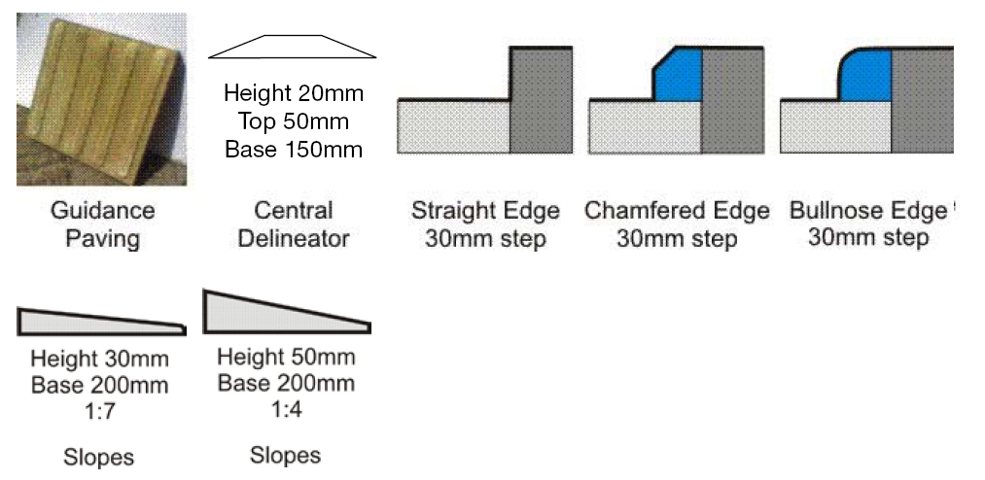
Figure 2 Push button facilities both sides of a crossing, and poorly located poles
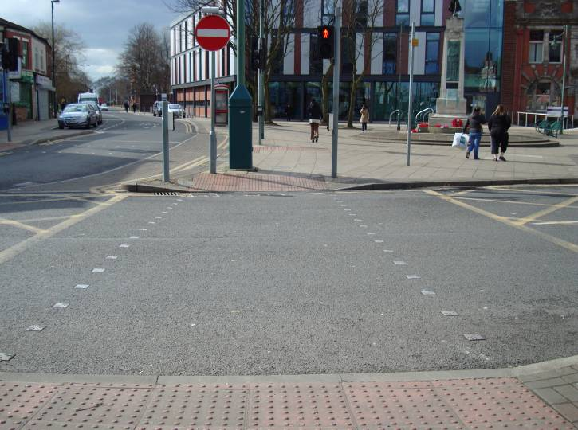
Figure 3 Tactile paving not extending to back of the footway
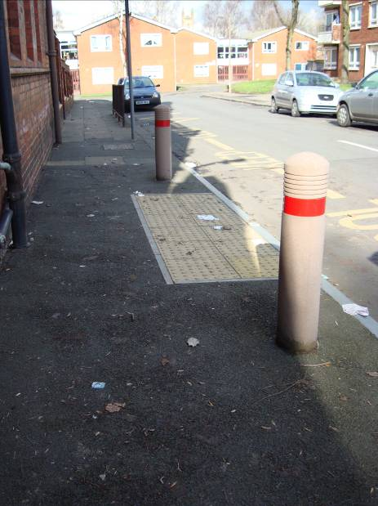
Figure 4 Different surfacing types allow confirmation of location in shared area
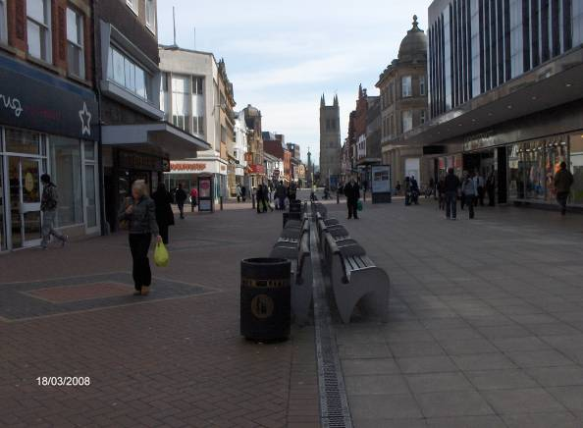
Figure 5 Rumble strip in carriageway
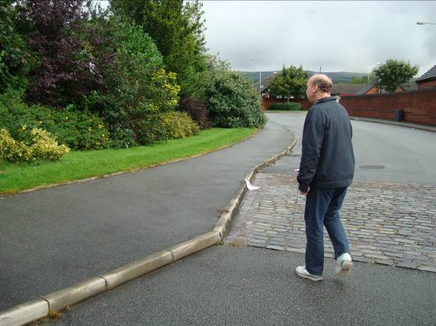
Figure 6 Keeping to the back of the footway despite obstacles
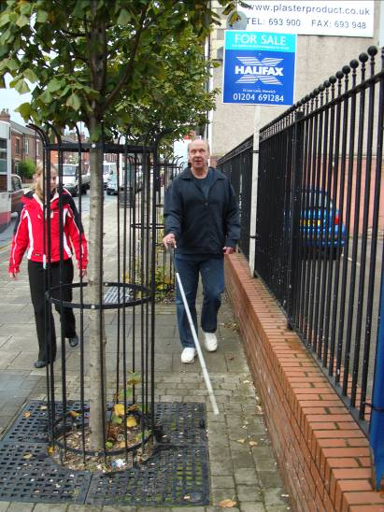
Figure 7 Colour contrast is useful to denote different surface function
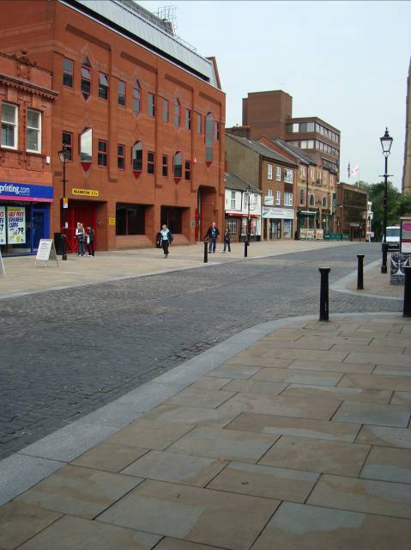
Figure 8 Using a serendipitously present expansion joint as a navigation guide
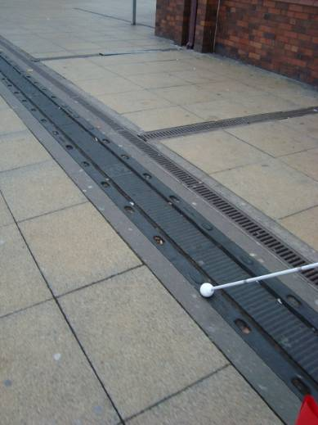
Figure 9 Reflection on light coloured surface materials
