**DOCUMENTARY MADE SUSTAINABLE : THE BRISTOL BIKE PROJECT, FROM GRASSROOTS WORKSHOP TO GLOBALISED AUDIENCE (PPT1)**

**PART 1 / CONTEXT (5-6 minutes)**

Teach documentary production at UWE in Bristol but also a film maker, increasingly specializing in Documentary & Sustainability

Want to start by just giving a bit of background context

I’ll be launching the new Year 2 documentary module on Tuesday : will probably start by showing them this

**WORLDOMETERS (PPT2)**

Asking students to engage with / interpret / represent the world around them : this year specifically asking them to deal with themes that reflect the current zeitgeist

http://www.worldometers.info/

Shocking reality that we face :

Particularly on oil & global population

Kind of like shock tactics but actually maybe it’s just too much to take in :

They’ll look in horror before they pitch their ideas about skateboarding and Big Issue sellers.

Shock impact but actually in some ways it doesn’t really work : just presenting the facts and figures

But for me it is tangible evidence of a truly shocking state of affairs.

**SHEFFIELD DOCUMENTARY FESTIVAL : PANEL ON CLIMATE CHANGE ON DOCUMENTARY (PPT3)**

Why isn’t climate change sexy ??

Another significant indicator of how my thinking has developed on this : Sheffield Documentary festival in June

Unsettling spectacle of Chris Rapley ( Director of Science museum & director of British Antarctic Survey ) clearly stating that 97% of the scientific community in the UK believe that climate change is a reality and yet being harangued by a couple of television executives for not communicating the message of climate change clearly enough.

Kim Shillingshaw, BBC commissioning editor for Natural History & Science saying it’s an old story ….. 20 years old and the story doesn’t really change very much

Just gave an insight into how television executives think about climate change :

And over the summer, just been keeping an eye on how this is reported on

television : just had the wettest summer for 100 years, there have been dramatic crop failures in the Amercian grain belt, the Polar ice caps are at their lowest ever levels, 65% of Manilla was submerged underwater and yet they still can’t bring themselves to name this as climate change.

**BROADCAST TV SCHEDULE (PPT4)**

Take just a glance at the TV SCHEDULE for a day : 350 television channels and you’ll be hard pushed to find a single one dealing with these issues in any meaningful way.

<http://www.tvguideuk.co.uk/tvlistings/index-time.php?column1=bbc1&align=1&column2=bbc2&column4=ch4&day=minus_five>

I’d even suggest that we all know about climate change, global warming and so on in spite of the mainstream media.

97% science community think climate change is a reality and yet the media insist on framing it as a debate.

**SO ALL OF THAT GIVES SOME CONTEXT TO MY OWN POSITION, TEACHING DOCUMENTARY PRODUCTION IN HIGHER EDUCATION**

Basically, I’m amazed at the broadcasting industry’s willful indifference to the most important issues of our time.

I also think the tradition of documentary has a fine tradition in trying to reveal the essential truth of its time.

So, in the reinvigoration of my own film making practice, I have found myself increasingly drawn to issues of sustainability

Trying to make a short film each year, in the intersices of teaching and all the other responsibilities of lecturing

Operating outside the parameters of research

Started three years ago, with

**THE BRISTOL BIKE PROJECT (PPT5)**

**BONNINGTON SQUARE**

**INVISIBLE AIRS**

**GARDENS OF ST GEORGE / ASYLUM SEEKERS GARDEN**

Short documentary films : all feed back into teaching and learning, though it would be disingenuous to suggest that’s why I make them : more about my own creative drive

Not trying to ‘change the world’ but maybe imperceptibly shift the consciousness of anyone who is engaged by watching

Also suggest that HE is an ideal opportunity for production, free of the constraints of commissioning editors / commercialism : personally I prefer to also work free of the research agenda.

**PART 2 / THE BRISTOL BIKE PROJECT**

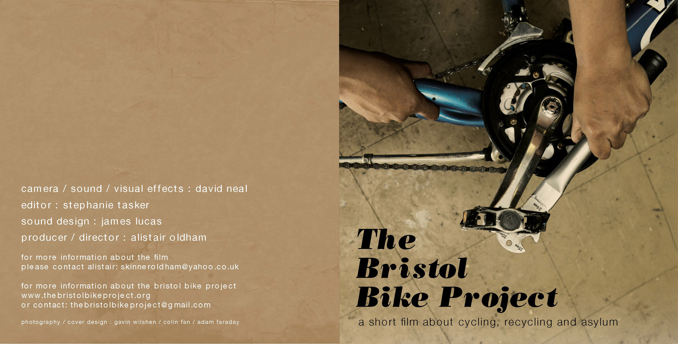

Tagged as a short film about cycling, recycling and political asylum

A budget of approx £600

Dave Neal / Steph Tasker / James Lucas

Produced in the summer of 2010 : shot ten hours of footage late June / early July, edited in August and picked up again in October

Without beating about the bush, it’s done very well in terms of audience & distribution

**FROM GRASSROOTS WORKSHOP TO GLOBALISED AUDIENCE (PPT6)**

**AUDIENCE & DISTRIBUTION**

**Show FESTIVALS listings :** [**http://vimeo.com/36598320**](http://vimeo.com/36598320)

The film and internet distribution has enabled the film and the ideas of the project to reach out to a globally diverse audience

Translated into fourteen languages

Over forty film festivals around the world

Seoul Platoonkunsthalle : global reach but also appropriate that it ends up being screened in a Korean cinema with a German name, constructed out of 32 recycled shipping cargo units, to symbolize the globalised movements of culture.

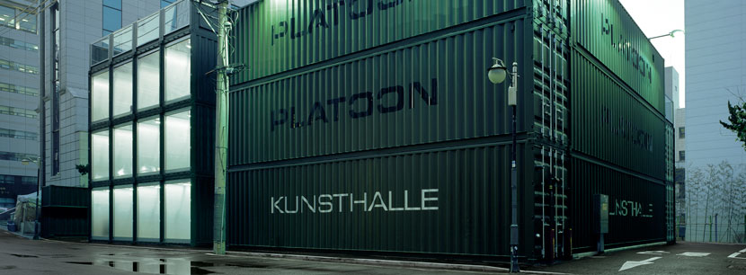

**PLATOON KUNSTHALLE** **(PPT7)**

is built of 28 iso cargo containers. as icons of a flexible architecture in a globalized culture, the stacked containers form a unique construction that can be rebuilt anywhere else any time.

Shown in every other school in the Czech Republic ( People in Need and One World in Schools programmes)

Estonia, Georgia , Romania (24 high schools in 17 cities), Armenia, Slovakia

The audience in the Czech republic were particularly interested in the notion of civic participation.

The Americans are obsessed with cycling.

The Georgians are not interested at all in cycling, but are really interested in issues around refugees and asylum.

Bristol Bike Project won the Observer Grassroots Award

So already brings up some quite interesting dynamics in terms of audience & distribution.

Again, very different to a television audience : rather than just selling the rights of the film to a television broadcast company where it will be shown one night only, it’s actually there for people to watch

In some ways this indicates new ways of making documentary practice sustainable,

although evidently this is only possible in a non-commercial context.

**SO ALL THE EVIDENCE SUGGESTS IT DOES WORK, IT DOES ENGAGE :**

**HOW ?**

WHAT IS THE NATURE OF THAT AUDIENCE ENGAGEMENT ?

How does it work ? How does it actually engage its audience ?

**AUDIENCE ENGAGEMENT / CRITICAL REFLECTION (PPT8)**

(detaiiing the three act structure & the three stages of production)

When I say critical reflection, I have to admit that I’m coming mainly from my critical refection as a film maker : there might be critical analysis, there’ll certainly be reflection on production, but just much less contextual critical theory.

Also seems appropriate to an artefact that has evolved from a three act production process (or modes of production)

**POLANSKI QUOTE (PPT9)**

DESCRIBES FILM AS ‘A DIALOGUE WITH THE UNCONSCIOUS’

So how does that dialogue work ?

I’m not a scientist : I’m interested in the relationship between politics and aesthetics, how you can represent political realities to an audience in a palatable way.

I deal with stuff like dreams, the unconscious, creativity, writing, images, and I use French words like mise en scene and montage. Instinctive.

**PRODUCTION PROCESS (PPT10)**

I was reading the critical evaluation of one of my MA students the other day and she said that she feels as though she has made the film three times : once in research & writing the treatment, once in the filming and again in the edit (and paper edit).

That methodology can be expressed as

PREPRODUCTION PRODUCTION POSTPRODUCTION

The three fundamental stages which I think underlie the principles of documentary production

Research and preproduction to me is actually the bedrock or foundation of narrative documentary : story of meeting Daahir & Aziz

Research & creative development

Meeting Daahir & Aziz / hanging out in the workshop

Haven’t got time to show detail of proposal / treatment

The writing or scripting of the film is an essential element of its success.

So there came a point through the research when the potential for a narrative began to present itself : mainly through talking to characters about their situation. From that was able to write a basic premise.

Correspondingly, this process found its organization through the narrative development of a three act structure which was uncovered through the process of research and preproduction : in fact I would define that period of preproduction more closely by saying it is first of all research and only then is it creative development. 6.00

**WRITING / THREE ACT STRUCTURE (PPT11)**

Not in any crudely formalized way but rather just as an underpinning narrative structure …. At its most basic Introduction / Development / Resolution

And it was basically to collect the bicycles and introduce the characters / introduce and set out the workshop / leave the workshop on the bicycle and to use the movement away from the workshop as a narrative device for telling the backstory of the main characters.

When if you like, the local starts to move away into the global.

Treatment written after having met Daahir and Aziz but before filming or interviewing them.

Knew enough to know that they would offer an explanation of their motivation for leaving Somalia / Afghanistan.

Also knew that they had both assented to this process and that they both had a clear understanding of the political dynamics that had led to this situation : ie the colonization, exploitation and destabilization of their own respective countries, Somalia and Afghanistan.

In the writing / research phase that this relationship between the bicycle, the workshop and the back story began to reveal itself through the organizing principles of narrative

And going back to Alba’s ‘making the film three times’, I rewrote the film all over again, this time as a paper edit based on eight hours worth of rushes and interview transcripts.

Again you can see the possibilities of a film, somewhere between your imagination and the sea of post it notes in front of you.

But don’t want to get too bogged down in the chronology of process.

It’s the moment when the film transitions from the purely local (the grassroots bicycle recycling workshop), to the recounting of individualized narratives of real life migration

Mixing the observational action of the bicycle workshop with directed action, stills, testimony and music. Had no real idea if it would work until the editing stage.

That critical point in the narrative is actually constructed through artifice, through the telescoping of images researched through the internet, which are then set against Daahir and Aziz’s personal testimonies, which in themselves are enhanced emotionally by the use of an atmospherically constructed soundtrack ( which incidentally is itself built up from the recorded sounds of bicycles in the workshop).

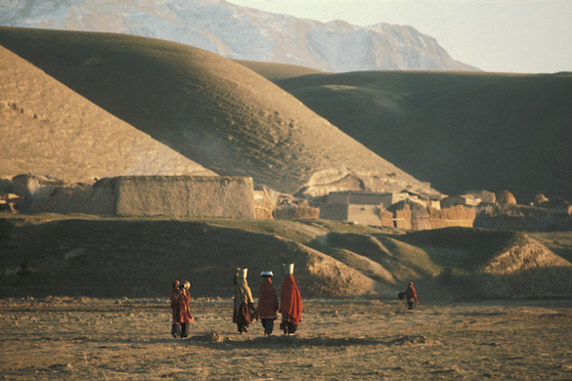

So, interestingly, this is actually all a form of assemblage, of recycled and reconstituted parts, put together to form a coherent critical whole.

Assemblage : montage as the crucial process by which field footage becomes a film.

There does come a breakthrough point in the edit where you suddenly realize you have a film

When juxtapositions rhythms relationships reach a point of compression where they begin to seep and merge into each other, suddenly becoming much more than their constituent elements.

Materiality of film as a text that raises questions : the fascinating part, a kind of alchemy or synthesis of narrative.

**NARRATIVE STORYTELLING (PPT12)**

But of course even more fundamentally than that it is about storytelling.

The stories of individual bodies and their migration : interweaves the visual present with oral testimony of the past.

Narrative storytelling based on solid research (or harrowing experience)

What they both say : harrowing stories. Daahir went home to find that his family had been massacred and Aziz was kidnapped by the Taliban and threatened with beheading.

The relationship of the visual present tense of the bicycle being driven through the streets of Bristol is then set against the aural past, in the testimony that each character gives of their perilous journey away from danger.

There’s an interesting sense in which the stories that Daahir and Aziz are told in research, again in the interview (which at points is repeated and directed), and then reordered and reshaped in the paper edit : so what you see and hear in the finished film is actually a kind of recycled version of events that has been remediated through the process of the film’s production.

Not sure there’s anything new or staggeringly innovative in this, but I do know that it is an important story to tell at many levels, and also that it’s much easier said than done.

Therefore the three act structure and relatively conventional production methodologies provide a solid template for production. They combine to create a filmic experience.

Also know that there is a narrative device that combines the movement of the bicycle, walking and the story of the bodies in migration : that’s the narrative dynamic of the film.

**PART 3 : CONCLUSIONS**

**CONCLUSION 1 / CONNECTING TO YOUR AUDIENCE : SHOW NOT TELL (PPT13)**

WHAT A GOOD FILM SHOULD DO IS ASK QUESTIONS OF YOUR AUDIENCE : NOT GIVE THEM ANSWERS, DON’T PREACH OR LECTURE

SHOW NOT TELL

Half of it is told through images and visual storytelling : it’s not a rational discourse that sets out to tell an audience what is right and what is wrong.

As much about getting an audience to feel, to engage their emotion as much as their intellect

To me a successful film should leave an audience asking questions, rather than simply giving them answers.

For example, is there a relationship between cycling and recycling ?

How does the combination of cycling, recycling and political asylum work ?

Has it got anything to do with ‘Documentary & the Environment’ ?

I’d suggest that the alchemy of film can suggest some of these connections through its interpretation of reality (which is where the director comes in)

Is there any relationship between the reality of being a political refugee and climate change ?

**CONCLUSION 2 / ASK QUESTIONS OF YOUR AUDIENCE (PPT14)**

It can be about cycling, recycling and political asylum because actually they are all interrelated.

Could take it further and say there is an interconnection between the larger paradigms that underlie the film’s narrative.

Both Daahir and Aziz talk about the mineral exploitation of their countries by imperialism.

The imperial west invades Afghanistan and Somalia to extract mineral wealth and to destabilize those countries, which creates economic and political turmoil, which creates instability and increasing danger, which makes those places impossible to live in. Which creates the motivation for migration.

**CONCLUSION 3 / POLITICAL ASYLUM (PPT13)**

One of the film’s more sobering real life postscripts 16.00

First conclusion is that since the end of the film’s production, one of its central characters Aziz, came to me asking for a reference. Two weeks later he was taken to Campsfield Immigration Removal Centre and a month later he was put back on a plane to Kabul. The narrative goes on ….. where is he now ?

In the process of trying to help him, I discovered that there is a flight chartered by British Midlands International every Tuesday night that leaves the cargo area of Stansted airport with a plane load of terrified Afghan refugees aboard.

I also read the report of the Austrian Red Cross in Afghanistan about the treatment of the Hazara minority in Ghazni province.

“Hazaras are facing dire threats in Afghanistan's central provinces. Disturbingly, just 11 weeks after the government's suspension, the decapitated corpses of 11 Hazara males were discovered in the Khas Oruzgan district of Oruzgan province on 25 June 2010. Police official Mohammed Gulab Wardak reported they were killed by the Taliban 'because they were ethnic Hazaras and Shiite Muslims'.” (Phillips, Denise/UNE, August 2010)

It’s also quite a handy way of moving a narrative forward.

Put it another way, Western industrialization has created the conditions for climate change : and climate change (or more specifically rising sea levels) will create approximately 200 million refugees over the next fifty years. These issues are not going to go away.

**CONCLUSION 4 / THE SUSTAINABILITY OF DOCUMENTARY (PPT15)**

My critical reflection is that the film works as a compression of ideas : that it works as a text from which different audience responses can evolve.

Actually it works by never telling people what to think, by resisting a purely rational discourse, and by creating some kind of poetics through the synthesis of its narrative and its imagery. A creative treatment of actuality.

Some parting thoughts on documentary

To reassert that documentary is a vital and expressive medium. It is one of the most fundamental ways of interpreting the increasingly volatile world that we live in.

Personally I feel that narrative film making / good storytelling / the primacy of content are the most important factors.

These are what make ‘cinematic’ documentary :

Unfortunately a lot of what passes for documentary on our television screens is presenter led, formulaic, commercially driven and ultimately trivial.

Maybe an object lesson in keeping it simple and it’s also about the psychology of presenting solutions

The only problem is that we don’t have very much time and there are too many people whose conservatism makes them simply oblivious.