CRAFTING THE COLLABORATIVE STUDIO

Elena Marco, ARB, RIBA, Associate Head of Department for Architecture

Mike Devereux, MCD FRGS MRTPI, Senior Lecturer in Urban Planning

John Comparelli, ARB, RIBA, Senior Lecturer in Architecture

University of the West of England

The teaching of architecture, structural engineering and planning in higher education has, for the last sixty years or so, been strongly governed by the requirements of professional bodies who have set relatively strict guidelines on approach to curriculum content and method of delivery. The result has been that these disciplines have ploughed their own furrow and developed independently of each other. From the point of view of the architect, environmental engineering has become seen as something of a technical fix and planning a bureaucratic process, both sitting at arm’s length from the ‘real’ business of the design studio – to the detriment of all.
This paper argues that this traditional approach can, and should, be challenged. It examines the criteria of the professional accrediting bodies and presents a case study of an alternative approach in which all three disciplines have been brought together in a single year-long specialist studio that is taken by students studying for degrees in architecture & planning as well as architecture & environmental engineering. The paper draws upon the experience of the authors and others at the University of the West of England (UWE) in setting up and running such a studio and, more importantly, of the students who have participated in it. At the core of the approach is an interpretation of the relevant ARB-RIBA criteria as requiring a design-centred studio focus (GC1) for all, but also allowing a leaning towards the structural and engineering criteria (GC8&9) for some, whilst others concentrate on the more social and urban criteria (GC4&5). The authors contend that the key to integrating these two approaches in one studio lies in how students work with each other on a single brief and in the outputs required of students – to the advantage of all.

Setting the Scene
Back in 1970s Professor Sir Edmund (Ted) Happold ‘broke the barriers between engineering and design, by proposing a truly innovative educational model in building design where two complementary disciplines were integrated to achieve better design solutions. By studying and working together, students gain an understanding for each others’ disciplines and master a common language. However Happold’s educational model did not survive nor has been replicated elsewhere due to a lack of understanding by the students of the potential benefits to their career paths.
Boyer and Mitgang indentified design studio teaching as an educational paradigm where integrated teaching could take place. They pointed out that the most important challenge confronting the architectural programmes is ‘making the connections, both within the architectural curriculum and between architecture and other disciplines’.
In 2011 the Royal Institute of British Architects (RIBA) think tank ‘Building Futures’ published the report 'The Future for Architects?' and set a radical vision of the future of architecture by examining how the demands of a global economy and economic recession have transformed business practice and how the architectural profession could look radically different in 2025. It also concluded that a more interdisciplinary concept of architectural practice is being sought by the new generation of architects. This raises the question of how our educational models might need to adapt in the near future to face this reality.
Furthermore in October 2012, the Engineering Environmental Architecture Conference at Bath brought together 300 built environment professionals for a discussion about why Ted’s model didn’t survive. A consensus emerged that whilst professionals understand the need for collaborative working, the educational system doesn’t. It was also suggested that integrated educational practices are an oddity not the norm, and general acknowledgement of the need for more integrated educational modelsError: Reference source not found.

Part I Architecture at UWE
UWE had a clear goal when it was decided in 1996 to re-establish architectural education in Bristol, which was to create a unique route to an architectural education through the creation of a holistic multidisciplinary dual-qualification route. The main objective was to equip students with a more complete formation without the need to invest in two different degrees, and at the same time to offer our graduates a much wider spectrum of employment possibilities, thanks to the specialisation in two areas that complement each other.

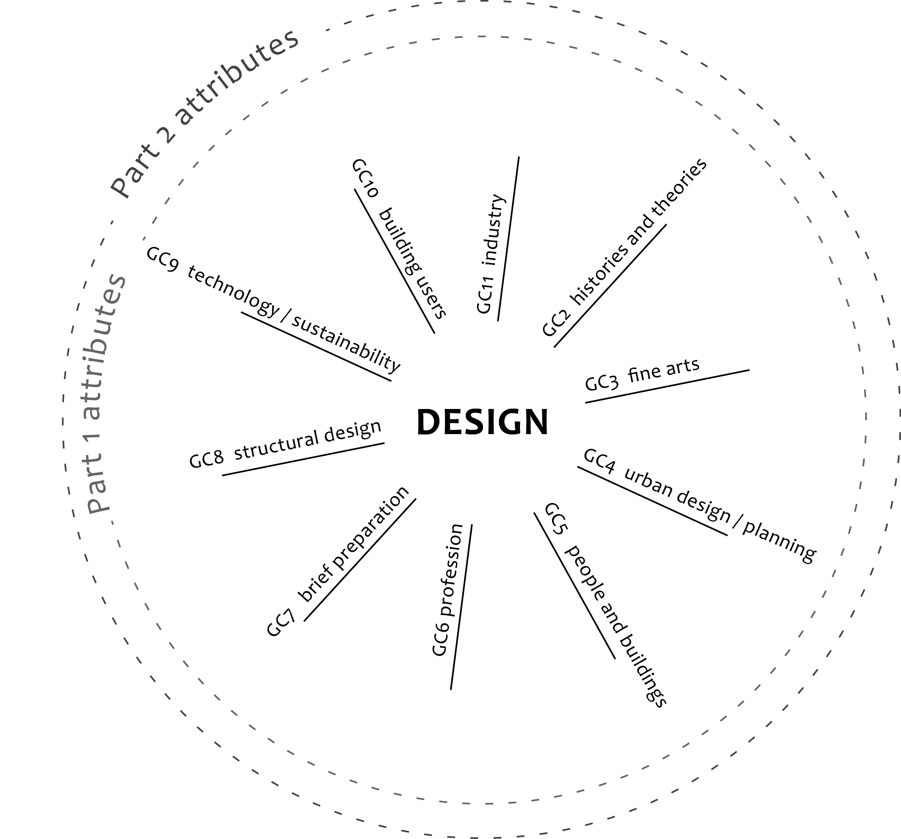
Fig. 1. ARB/RIBA criteria ©Richard Parnaby and Elena Marco
The first implementation of these ideas was through the joint BA(Hons) in Architecture & Planning (hereafter referred to as AP). A traditional single qualification to become an architect needs the knowledge and skills in the context of the general criteria and graduate attributes (see figure 1) contained in the RIBA/ARB criteria for validation/prescription,. UWE’s AP programme is also designed to meet the requirements of RTPI Policy Statement on Initial Planning Education. On the face of it, combining two three-year degrees with traditionally disparate methods of teaching, into one four-year course presents a huge challenge if all of these professional bodies’ criteria are still to be met. However they are two complementary professions and there is sufficient alignment of the learning outcomes for this to be not only achievable but also hugely successful. The architectural offer was later developed further with a BEng(Hons) in Architecture & Environmental Engineering (hereafter referred to as AEE). The programme is designed to meet the requirements of UK standard for Professional Engineering Competence: ECuk and CIBSE,. Whilst both awards have design-centred studio as the heart (GC1), the AEE award leans towards the structural and engineering criteria (GC8&9), whilst the AP award concentrates on the more social and urban criteria (GC4&5), ensuring compliance with ARB/RIBA and CIBSE and RTPI.

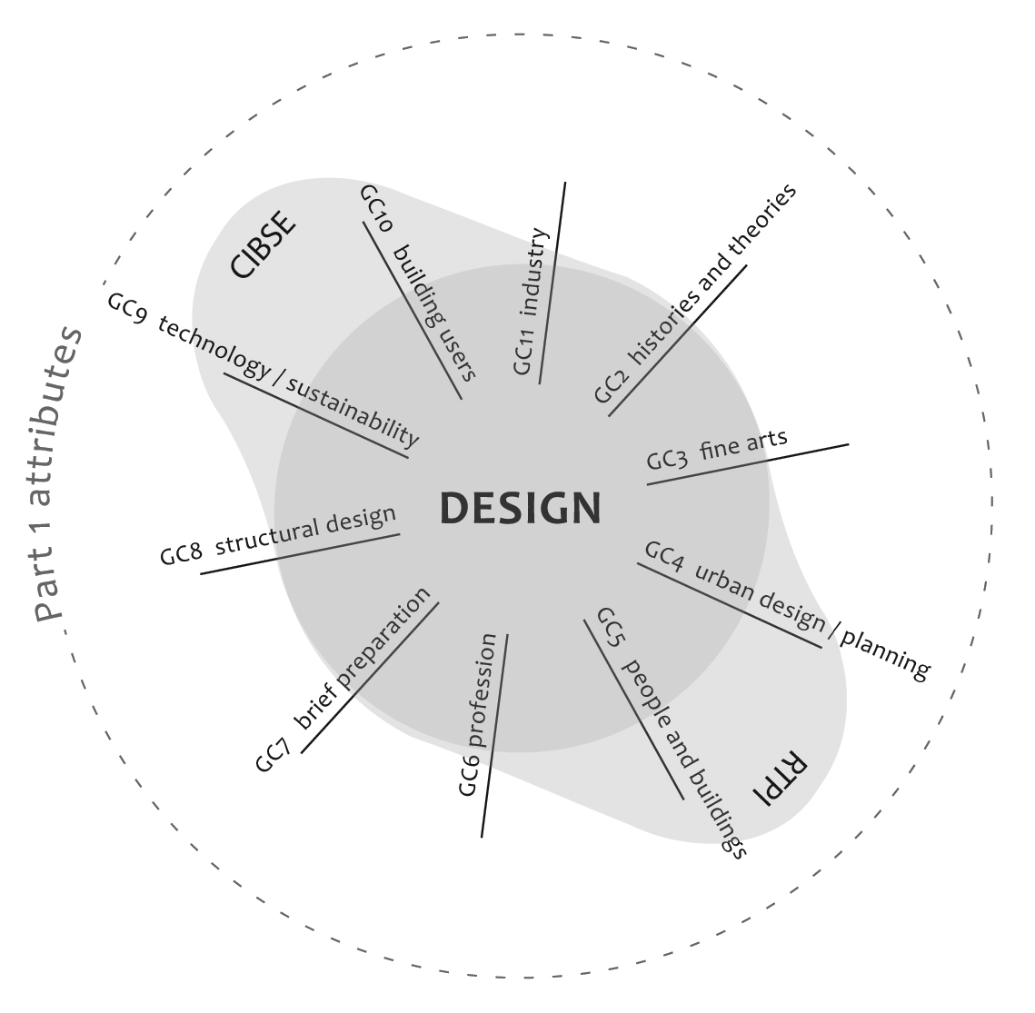
Fig. 2. Mapping of ARB/RIBA criteria for AEE and AP courses ©Richard Parnaby and Elena Marco
The strength and attractiveness of these architecture-based courses lies in their integrated educational model of collaborative working which goes back to Happold’s proposal in the 1970s. It provides students with the essential skills of two disciplines, and creates a new type of graduate with the core knowledge and skills of both professions from the outset, just what the built environment profession has recently identified as being crucial for future success.

The Specialist Studio
This paper presents the case study of a ‘specialist’ holistic multidisciplinary studio where the graduating years of the BA(Hons) Architecture and Planning (AP) and the BEng(Hons) Architecture Environmental Engineering (AEE) students share a common site, design brief and RIBA Part 1 output requirements. The students have different requirements for their planning (RTPI) and environmental engineering (CIBSE) outputs, but with an expectation that they will share areas of specialist knowledge with their peers to create what the design tutors call a are truly gesamtkunstwerks portfolio. The studio aims to provide the ultimate integrated opportunity to utilise and test all the students’ architectural, planning and environmental engineering skills. It also creates a multi-disciplinary studio where collaboration and the contribution of others increase individual motivation to learn.
The studio runs throughout the whole academic year with two full days of staff-student contact per week and at the end of the year students are assessed through a portfolio of work.
As part of the studio ethos, students are specifically asked not to create iconic building proposals nor overly grand urban gestures. Rather to develop design proposals that are ‘civic minded’ and focus on the repair of city fabric by the careful insertion of an appropriate sustainable master plan, buildings and well considered public spaces.
The studio has three clear phases with a theoretical underpinning based on sound pedagogic research. Starting with Research & Reflection, the students move on to Develop their briefs finish by Crafting their design proposals.
Research and Reflection
In Phase 1 the students are asked to understand the site and to create a well conceived masterplan that will help them to build a framework within which to propose a suitable programme and masterplan. During this phase the students assess the strengths and weakness of the proposed site through its physical form and function, considering a wide variety of issues such as planning policy, social inclusion and community, movement, climatic data, the food chain, waste or energy generation. From this analysis emerge a number of strong themes of particular relevance to the site which are then turned into a masterplan.
Developing the Brief
During Phase 2 the students are asked to develop a building proposal informed by the masterplan where the appropriate urban and environmental strategies are integral to the design development and inform the fabric of the building.
At this stage the architect-planners also undertake a ‘Planning & Managing Development’ module, dealing with the mechanics of planning permission, such as how to apply for permission, how to argue that planning permission should be granted, how applications are determined, etc. This module gives them the skills to understand what makes a good planning application and the considerations a local planning authority take into account in making a decision.. The module requires them to create a full planning application and so students use their design studio project as their case study.
While architect-planners are finalising their planning applications based on their studio work, the architect-engineers draft the Technical Research element of their work. This piece of research is also based on their studio work, and forms the basis of the individual investigative project required by CIBSE. The two groups carry out their own specialist learning using the common design studio project as a case study (see Figure 3).
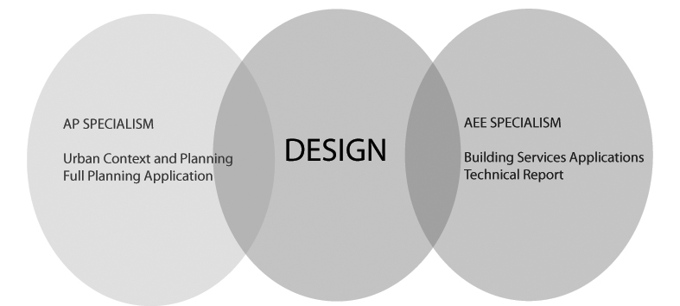
Fig. 3. Diagram showing the Design element in relation to the AP and AEE Specialisms © Elena Marco

Fig. 4. Year overview for AP and AEE

Crafting
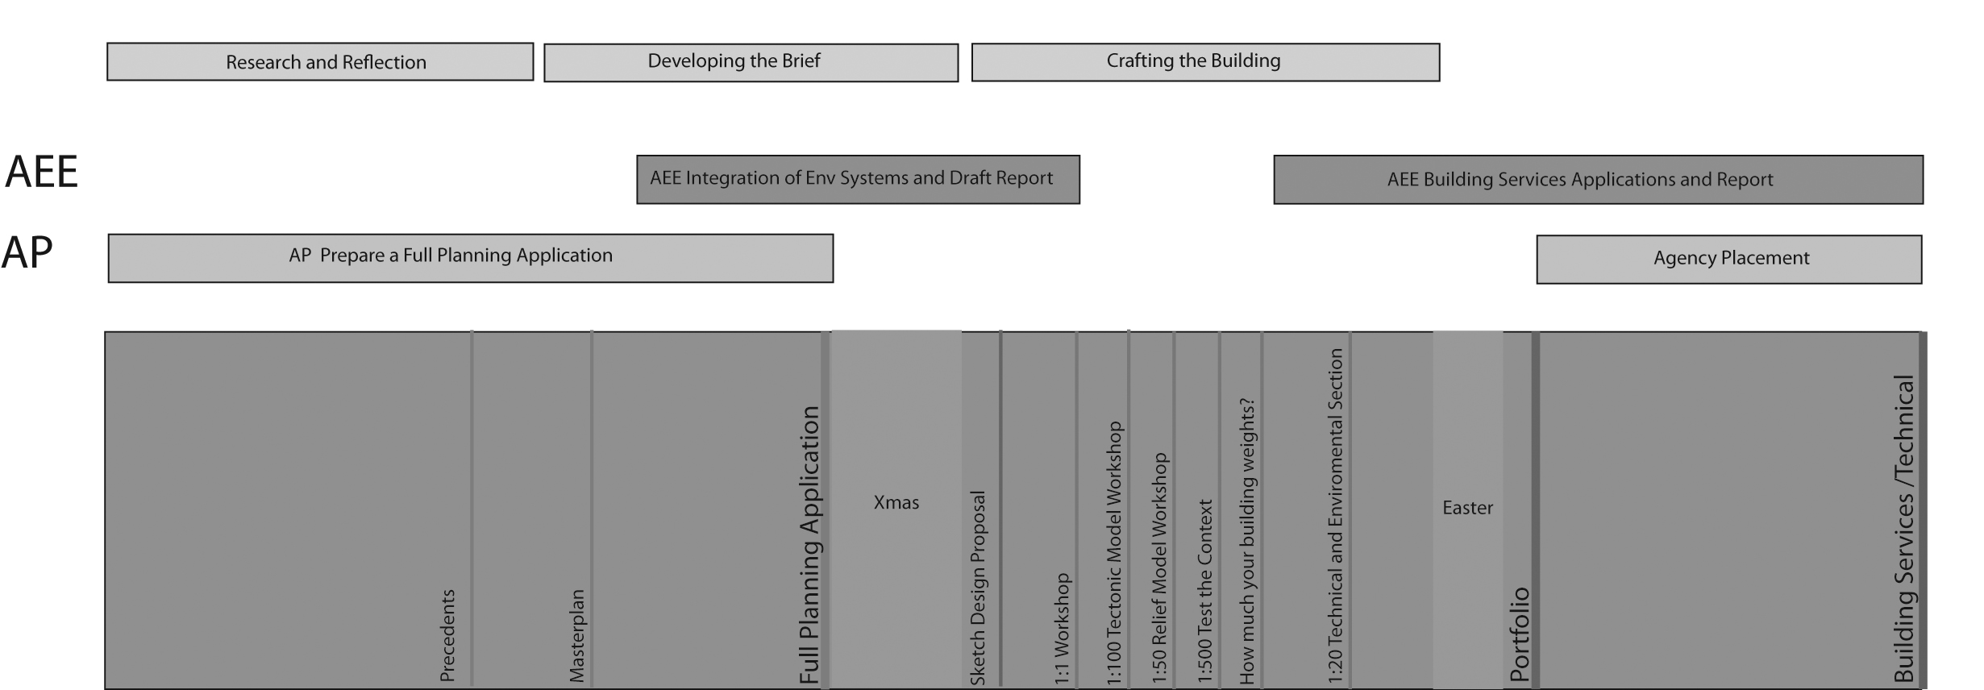
Finally the students craft their design proposals in a non-progressive manner (see Figure 4). They are encouraged to break away from the ‘normal’ hierarchical process of working from the whole down to a detail. Through a series of workshops the students are encouraged to think at different scales. For example when consolidating their building proposals they are asked to design a piece of their building at 1:1 scale. This helps the students to think about issues of materiality and ergonomics and ensures that their buildings are the manifestation of their overriding concept rather than the assemblage of generic and inappropriate details. In parallel they also look at large-scale building sections to test and apply materiality. They are then asked to test the tectonics by building a physical 1:100 model of their scheme to help locate the most important interior space. This is followed by a Relief Modelling and Elevation Composition workshop, where the students test their scheme against the site context (1:500) through a series of draft iterations that will culminate in the final model.
Almost at the end of this Crafting phase the students are asked to quantify their building proposal through a workshop called ‘How much does your building weigh?’, as Buckminster Fuller’s famously asked Norman Foster back in the 70s, a sentiment echoed by Cedric Price. Fuller proposed the question at the birth of ‘high tech’ architecture when it was a challenge to the industry to embrace the science of materials and structures of the 20th century. In the 21st century we have another, more pressing concern, that of sustainability. Therefore, through this workshop the students re-think their choice of materials, and the implicit structural and environmental strategies they are using, by scheduling their quantities, weight and embodied energy so that they can fully understand the proprieties of the materials and their impact on the environment. The crafting of the building phase finishes with a 1:20 technical model, which the students use to test their building’s atmosphere and materiality.
After the end of the third phase the architect-planners go on an agency placement for 6 weeks, whilst the architect-engineers finalise their building design and specialist technical report. Their Building Services brief asks them to finalise the materials assessment and specification with a view to demonstrating the environmental performance of building through a thermal model and to carry out cooling and heating calculations as well as designing and sizing the mechanical ventilation for a part of their building. They also finalise the design of the electrical distribution and lighting systems and demonstrate a fully integrated proposal through the careful co-ordination of services, structure and architecture.
This syncopated process of design keeps the students from falling back into preconceived notions and ensures they are continually testing, integrating and refining the design strategies to achieve an ultimately coherent and fully integrated project in line with the interdisciplinary nature of their degrees.

Discussion
The creation of this ‘specialist’ holistic multidisciplinary studio has proved a challenge, not only for the students but also to the educators who have to deliver the learning as a process of collaboration with planners, architects and engineers working together to provide the students with a holistic learning experience.
Students were initially sceptical about joining the two cohorts into a single studio. They came with preconceived ideas about how they were architect-planners (or architect-engineers) and did not need to know about the other discipline. In a group discussion, the tutors used the diagrams mapping the professional bodies’ criteria (Figure 2) to demonstrate to the students that they did indeed need an appreciation of engineering (or planning) and that sharing a studio was a good way of sharing knowledge and scaffolding this learning.
As the course now draws to a close, a significant majority of the students across both programmes have agreed that the experience has been beneficial and they are glad they were given this opportunity. The tutors can see the students have embraced the collaborative nature of the studio, which has motivated them to learn the language of a complementary discipline.
Interestingly, the uncommon nature of dual degree qualifications means that relatively few of the tutors are qualified in AP or AEE themselves. This has also broken the typical relationship between the architect-tutor and the student, since the students now have to take onboard comments from very different professionals with very different points of view. This is not necessarily a new experience for architecture students, who may have experienced conflicting opinions from different tutors in the past. But it is much harder to identify and reconcile contradictions if they come from different disciplines. This can even lead to conflict between the tutors themselves, and in addition to having diverse views on design, they can also have very different approaches to teaching. To mitigate this, tutors debrief after each studio session where conflicting advice is identified and reconciled amicably before clarification is given to the students. However the experience of dealing with conflicting advice is a useful learning tool for the students and helps build relevant skills for collaborative practice. The engineer-tutor, the planner-tutor and the architect-tutor inject a new array of perspectives to shape each student’s understanding and all these cross-professional experiences are given equal value.
The authors believe that the educational model at UWE has for many years helped the students to produce better integrated design solutions that shape a new type of graduate with the core knowledge and skills of two professions, as was intended when this unique route to an architectural education was established. However, the recent innovation of combining the final year design studios of two dual-discipline degrees also allows the students to have a better understating of a third profession (planning or engineering). This has helped them to further broaden their knowledge, and has resulted in even broader integrated design solutions. The architect-planners have been able to embed environmental design strategies into their work, rather than adding them as an afterthought as had sometimes been seen in previous years. Similarly, the architect-engineers have demonstrated a much better understanding of the planning system, as demonstrated through their masterplans and discussions of urban context. The design studio has resulted in some truly gesamtkunstwerk portfolios, exactly as the tutors had hoped.
The industry will benefit enormously from these graduates. Whilst this studio is not a practice-based experience, it is clear that it is a much closer fit to the reality of the way different professions must work together to produce more integrated solutions. And as Ted Happold said, ‘A world which sees art and engineering as divided is not seeing the world as a whole’. Had he been able to witness the joint degree programmes at UWE he may well have included planning.

Acknowledgements
The authors would like to acknowledge the valuable diagrams initially designed by Richard Parnaby as well as Paul Kirby, Senior Lecturer in Environmental Engineering. Finally, I would like to thank the students from both the AEE and AP awards for their invaluable contributions.

Hagan, S.K. “The environment and the studio: integrating the quantitative and the qualitative”, The Oxford Conference 2008: Resetting the Agenda for Architectural Education, Oxford, 2008.
Sharp D. “Obituary: Professor Sir Edmund Happold”, The Independent Newspaper, Jan 18, 1996, Available from: http://www.independent.co.uk/news/people/obituary-professor-sir-edmund-happold-1324558.html, [Accessed 10 March 2013].
Finch, P. “Why did Ted Happold’s combined course in architecture and engineering fail?”, Architects Journal, October 2012, Available from: http://www.architectsjournal.co.uk/comment/why-did-ted-happolds-combined-course-in-architecture-and-engineering-fail/8637644.article [Accessed 2 March 2013].
Hartman, H., “Engineering Environmental Architecture at Bath”, Architects Journal, October, 2012, Available from: http://www.architectsjournal.co.uk/footprint/footprint-blog/engineering-environmental-architecture-at-bath/8637448.article , [Accessed 2 March 2013].
Boyer, Ernest, L. and Mitgang, L. “Building Community: A New Future for Architectural Education and Practice”, Princeton, N.J.: Carnegie Foundation for the Advancement of Teaching, 1996.
Robinson, D. Jamieson, C. Worthington J. & Cole C. ‘The Future for Architects?’ Building Futures, 2011, Available from: http://www.buildingfutures.org.uk/assets/downloads/The_Future_for_Architects_Full_Report_2.pdf , [Accessed 2 March 2013].
Royal Institute of British Architects, “RIBA Validation Criteria at Part 1 and Part 2”, 2010, Available from: http://www.architecture.com/Files/RIBAProfessionalServices/Education/Validation/RIBAValidationCriteriafromSeptember2011Parts1,23.pdf, [Accessed 2 March 2013]
Architects Registration Board, “Prescription of qualifications: ARB Criteria at Parts 1, 2 and 3”, January 2010, Available from: http://www.arb.org.uk/Scripts/wysiwyg/ckeditor/ckfinder/userfiles/Images/images/files/ARB_Criteria.pdf , [Accessed 2 March 2013]
Royal Town Planning Institute, “Policy Statement on Initial Planning Education, Revised 2012”, Available from: http://www.rtpi.org.uk/media/1403721/microsoft_word_-_policy_statement_on_initial_planning_education_2012.pdf, [Accessed 2 March 2013].
Engineering Council Uk , “The Accreditation of higher Education Programmes; UK Standards for Professional Engineering Competence”, January 2013, Available from: http://www.engc.org.uk/ecukdocuments/internet/document%20library/AHEP%20Brochure.pdf , [Accessed 2 March 2013]
CIBSE, “Guidance Notes on the Submission of Documentation for Accreditation of Academic Programmers.” Available from: http://www.cibse.org/content/membership/universities/Guidance%20on%20Academic%20Programmes%20November%202010%20Final.pdf , [Accessed 2 March 2013].
Fisher, A. ‘Retrospective Perceptions of Architectural Education; a study of how two groups of diploma graduates perceived the value of their education from the perspective of employment’, RIBA Trust Research Awards and distributed via e-mail in April 2000.
Sara, R., ‘Between Studio and Street: The Role of the Live Project in Architectural Education’, PhD Thesis, University of Sheffield, 2004.
“How much does your building weigh, Mr. Foster?” Directed by Lopez Amado, N. & Carcas, C., Spain, Art Commissioners, 2010.
Cedric Price: Works II, Architectural Association, 1984 republished as Cedric Price: The Square Book, Wiley-Academy, 2003
Cuff ,D. “Architecture: the story of practice” ,Cambridge, Mass: MIT Press, 1991.
Addis, B. & Walker, D., ‘Happold: The Confidence to Build’, Taylor and Francis, 2005.

