# Lay summary

Sharing social information through recruitment can alter the outcome of collective decisions. We show that when ants share social information through recruitment, colonies consistently choose a nest site that fluctuates between being good and bad over a constantly mediocre alternative, even when the latter is only good for 25% of the time. This choice contrasts with previous results showing colonies can accurately assess nest sites that fluctuate in quality when recruitment is infrequent.

**The effect of social information on the collective choices of ant colonies**

**Abstract**

In collective decision-making, groups collate social information to inform their decisions. Indeed, societies can gather more information than individuals- so social information can be more reliable than private information. Colonies of *Temnothorax albipennis* can estimate the average quality of fluctuating nest sites when the sharing of social information through recruitment is rare. However, collective decisions in *T. albipennis* are often reached with the use of recruitment. We use a new experimental set-up to test how colonies react to fluctuating nest sites when they use recruitment to reach a decision. When recruitment is used colonies consistently choose nest sites that fluctuate between being ‘good’ and ‘poor’ over constantly ‘mediocre’ alternatives. Moreover, they do so even if the fluctuating option is only ‘good’ for 25% of the time. The ants’ preference for fluctuating nest sites appears to be due to tandem running. Even if a nest site is only briefly ‘good’, scouts that experience it when it is ‘good’ are likely to perform tandem runs to it. However, a constantly ‘mediocre’ nest site is unlikely to ever provoke tandem runs. Consequently, the fluctuating nest sites attracted more tandem runs, even when they were only ‘good’ for a short time. This led to quorum attainment in fluctuating nest sites rather than in constant ‘mediocre’ nest sites. The results of this experiment demonstrate how sharing of social information through recruitment can change the outcome of collective decisions.

**Background**

Through social means individuals can obtain information that they might not be able to collect themselves. Social information is also useful as it may be more accurate than private information (e.g. Surowiecki, 2004). Furthermore, individuals are known to perform better in certain tasks when they have access to social information. For example, in a difficult and uncertain task Wolf et al. (2013) observed that human participants made fewer false positives and more true positives when they had access to social information, than when they acted independently. However, in some cases social information may be poor and groups can be led to bad decisions (Rieucau and Giraldeau, 2011). For example, groups of guppies (*Poecilia reticulate*) that are initially trained to follow a long route to a food source take longer than individuals that forage independently to identify a shorter route (Laland and Williams, 1998). Similarly humans often use inaccurate social information (Rieucau and Giraldeau, 2011), which can lead to disastrous information cascades (Bikhchandani et al., 1998). For example, Helbing et al. (2000) found that in an evacuation individuals attempt to exit using the same route as other people, even when other options are available. This can have disastrous effects as exits become overcrowded (Helbing et al., 2000). Similarly, in elections certain individuals use social information to determine which party they vote for, which can influence election results (McAllister and Studlar, 1991).

A recent review by Grűter and Leadbeater (2014) emphasised how information sharing in social insects can have both good and bad effects, depending on the situation. Here we investigate the effect of information sharing, through tandem running, on the outcome of collective decisions in nest site choice in the rock ant (*Temnothorax albipennis*). *T. albipennis* is an excellent model system for the study of cooperative decision-making as they are easily collected, easy to keep in the laboratory, amenable to experimentation and demonstrate complex cooperative behaviors.

Individual *T. albipennis* antsmeasure the quality of potential nest-sites by incorporating information from various factors such as entrance width, floor area and light level (Franks et al., 2003b). If the nest site is deemed to be suitable scouts recruit others to it through tandem running, which increases the rate of accumulation in the new nest (Möglich, 1978; Mallon et al., 2001; Franks and Richardson, 2006). In a tandem run an informed scout leads a naïve follower to a particular resource by secreting a pheromone that signals to the recruit to follow the leader (Möglich, 1978; Mallon et al., 2001; Franks and Richardson, 2006). The recruited ant may subsequently become a recruiter and through this process the number of individuals in the new nest site increases. When the number of ants reaches a certain threshold, known as the quorum, ants switch from tandem running to carrying nest mates to the new nest site (Pratt et al., 2002). As numerous factors are considered in nest site choice, colonies often migrate to a cavity that is good for certain attributes, but bad for others (Franks et al., 2003b).

Colonies that make collective decisions are able to estimate resource quality through the integration of information from a number of scouts (Robinson et al., 2009). Individuals that encounter a nest site either reject it and continue searching or accept it and recruit (Pratt, 2005). It has been hypothesised that there is variation among individuals acceptance thresholds above which they decide to recruit to a site (Robinson et al., 2009; Robinson et al., 2011). Therefore, higher quality nest sites should meet the approval of more scouts, attract higher rates of recruitment and, thus, be more likely to draw a quorum (Robinson et al., 2009; Robinson et al., 2011). This explains how colonies are able to make accurate decisions without the need for all individuals to assess all nest sites (Robinson et al., 2009; Robinson et al., 2011).

When presented with nest cavities of fluctuating quality, house-hunting colonies of *T. albipennis* should choose nests that are predominantly the better option, assuming rationality (Edwards and Pratt, 2009; Sasaki and Pratt, 2011) and that fluctuations are not inherently costly (Franks et al., 2015). This prediction has been validated by recent work that found that colonies generally chose to migrate to nests that were predominantly the better option (Franks et al., 2015). This study showed the ants’ ability to account for fluctuations in quality when measuring the attributes of a potential nest cavity and demonstrated that ant colonies are able to estimate resource quality using a system that is consistent with homogenization theory, which posits that fluctuations can be safely averaged to estimate the quality of a certain resource (Pavliotis and Stuart, 2008; Franks et al., 2015). However, the experimental design used in Franks et al. (2015) meant that tandem running was rare so positive feedback did not play a role in the accumulation of ants in the new nest sites. Tandem runs rarely occur when a potential new nest site is close and there are many scouts; instead a quorum is achieved by scouts that independently find the cavity (Langridge et al., 2004; Franks et al., 2015). Instead, the ability of colonies to choose nests that were predominantly better in Franks et al. (2015) appears to have been the result of scouts spending longer in such nests. Consequently, a quorum threshold was reached in higher quality nests through accumulation of ants that had found the new nest site independently (Franks et al., 2015).

Recruitment is likely to have an influence on decision-making in *T. albipennis* as it is often used to reach decisions (Dornhaus et al., 2004; Franks and Richardson, 2006). Furthermore, there are other examples of cases where recruitment has affected colony decisions. Social insect colonies often need to choose between different food sources and recruitment to such resources is common (Von Frisch, 1967; Hölldobler et al., 1974; Deneubourg et al., 1987; Gottlieb et al., 2013). Recruitment to food sources appears to have a strong effect on food site choice. For example, ant colonies that use trail pheromones typically do not utilise two resources of equal quality in a symmetrical way; instead most individuals will forage from only one of the resources (Deneubourg et al., 1986; Pasteels and Deneubourg, 1987). This occurs as a consequence of one pheromone trail becoming stronger causing most individuals to choose to follow the same trail (Deneubourg et al., 1986; Pasteels and Deneubourg, 1987). Similarly, once a pheromone trail is established to a resource of a particular quality certain colonies are often unable to switch to a higher quality resource as the original trail is too strong (Pasteels and Deneubourg, 1987; Detrain and Deneubourg, 2006). Numerous other examples in which recruitment or positive feedback affect group decisions have been observed in humans (e.g. Kirman, 1993; Hirshleifer and Teoh, 2003).

Clearly recruitment plays an important role in collective decision-making in many systems. Therefore, it seems likely that recruitment would have an influence on the decisions that ant colonies make. The earlier finding of accurate assessment of fluctuating resources in the absence of tandem running, in Franks et al. (2015), provides an interesting possibility for comparisons between decisions that have been influenced by tandem running and those that have not*.* In this study we test the hypothesis that tandem running influences the outcome of collective decisions made by colonies of *T. albipennis* when faced with fluctuating nest sites. The reason that we suggest that this is a possibility is that the mechanism used by individuals to determine whether they should contribute to a quorum by spending more time in a nest or contribute to a quorum by tandem running may be different. Such differences may result in a quorum being reached in different nest sites depending on whether tandem running is used or not. Consequently, recruitment may influence the outcome of collective decisions in certain situations.

**Methods**

**Collection and housing of ant colonies**

Thirty colonies of *T. albipennis* were collected from Dorset, UK on 27th September 2014. Colonies contained between 23 and 235 adults (mean = 116, s.d. = 57.4) and a roughly equal number of brood and adults (Franks et al., 2006a). Most, but not all, colonies contained a queen; this is not unusual for *T. albipennis* and queenless colonies have often been used for decision-making experiments (Partridge et al., 1997; Franks et al., 2006b).

Following collection colonies were housed in artificial nests (dark; cavity dimensions: 60 x 35 x 1mm; nest entrance: 4mm) and fed according to standard protocols from the day they were collected (Franks et al., 2003a). One week prior to its first trial each colony was induced to migrate into a holding nest (dark; cavity dimensions: 55 x 35 x 1.6mm; nest entrance: 4mm) with a detachable wall (Figure 1) by removing the upper nest cover of their original nest. This method of inducing emigration was used to remain consistent with the methodology of Franks et al. (2015).

**Experimental design**

The experimental design was identical to that in Franks et al. (2015) except for the use of larger and more complex arenas, which were employed to stimulate more tandem runs. Franks et al. (2015) did not observe many tandem runs in their experiment. This appears to be because a quorum was reached before tandem runs were performed due to the high level of independent nest-site discovery by scouts as a consequence of the small arenas used (Mallon et al., 2001; Franks et al., 2015). This is typical for experiments using small arenas and ‘emergency migrations’ (e.g. Langridge et al., 2004). By creating a larger arena we limited the possibility of a quorum being reached by independent scouts, which allowed time for individuals to perform tandem runs to the nests.

In each trial, colonies were provided with a choice between two potential nest sites. One of the nest sites remained constantly ‘mediocre’ as it had a narrow (1mm wide) nest entrance, but was light. In contrast, the other nest site had a wide (4mm) nest entrance and fluctuated between being better or worse than the constant nest through the removal and replacement of a dark red filter (Table 1). Disturbance caused by the removal and replacement of the dark filter was controlled for, by removal and replacement of a transparent filter over the constant nest at the same time. The experiment used three conditions of fluctuating nest (Table 2).

The experimental set-up consisted of three arenas (23 x 23 x 1.7cm) connected by acetate bridges (7 x 4.5cm). At the start of each trial the detachable wall was removed from the holding nest. The holding nest was then placed in the central arena and the new nest sites were placed in each of the peripheral arenas (Figure 2).

Each trial was run for 5h with the number of ants at each new nest site recorded every 10min. Throughout the trial, the occurrence and times of tandem runs and social carrying of brood and workers to each nest site were recorded. Both the time and the number of ants in each new nest site were recorded when the quorum threshold was reached. A quorum was said to have been reached when the first ant or brood item was carried to either of the new nests. The quorum threshold was estimated by recording the number of individuals in the nest site to which social carrying was directed at the time it began. This method was used to be consistent with the method used by Franks et al. (2015). Following the attainment of a quorum, the number of carriers to each nest was recorded at 10-min intervals until the end of 5h.

Sixty trials were performed, with each of the 30 colonies used in two of the three conditions to trade off the requirements of a balanced design with minimizing the interval between trials. There was an interval of 14 days between each of the two trials for all colonies. The effects of this design were accounted for in a mixed model analysis (see Statistical methods).

**Statistical methods**

Analyses were performed with R (version 3.1.1) (R Core Team, 2014) and IBM SPSS 21 (IBM Corp, 2012). We used the Generalized Linear Mixed Model tool in IBM SPSS 21 to test for effects in our data (IBM Corp, 2012). Graphs were produced using the R package ggplot2 (Wickham, 2009).

***Nest choice***

We fitted a mixed binary logistic regression model with a logit link to all trials included in the analysis (see Results for inclusion criteria). The response was the type of nest chosen (fluctuating or constant). The fixed effects of the original model were condition as a factor, colony size as a covariate and the interaction between condition and colony size. The random effect built into the model was colony identity. None of the fixed predictors had a significant effect (see SI, Section 1).

***Nest population dynamics***

We fitted a mixed model with a Poisson-distributed error structure and a log link to the nest dynamics data (number of ants in each nest every 10min) for both fluctuating and constant nests for the 41 trials included in the analysis (see Results for inclusion criteria). The predictors in the model were the fixed factors condition and nest type, the covariate time and all two-way and three-way interactions between them. Order was also included as a fixed factor predictor. The random factor predictor in the model was colony identity.

***Tandem runs, quorum numbers and quorum times***

All tests on the effect of condition and order of presentation of the conditions on the number of tandem runs, quorum number and time of quorum were performed on data from the trials in which a colony chose either of the two nests and used tandem runs before reaching a quorum in either of the nest sites. To test for any effect of different conditions and trial orders on quorum times a linear mixed model with an identity link was fitted to the data as the residuals were compatible with a normal distribution (Shapiro-Wilk normality test: W = 0.9726, p = 0.4184). To test for any effect of different conditions and trial orders on quorum number and number of tandem runs, mixed models with poisson distributed error structures and log links were fitted to the data. The initial models used condition, order, colony size and all possible interaction terms as fixed factors. We then removed colony size and all interactions as none had a significant effect on either response variable. Consequently, each model included the predictors condition and order as fixed factors, colony identity as a random factor and the respectivevariable (number of tandem runs, quorum number or time of quorum attainment) as the response.

An additional mixed model with a negative binomial error structure and a log link was fitted to the data for the number of tandem runs to each nest type before a quorum was reached. The model included nest type (mediocre or fluctuating) as a fixed factor, colony identity and trial identity were used as random factors and the number of tandem runs was set as the response.

**Results**

**Nest choice**

In 41 of the 60 trials colonies migrated to one of the nest sites and performed tandem runs before reaching a quorum (choices made in all trials are detailed in Table S1). Remarkably, in 40 of the 41 trials included in the analysis, the colonies chose to migrate to the fluctuating nest (Figure 3).

**Nest population dynamics**

The preference for fluctuating nests over constant nests is further exemplified by the rate of accumulation of scouts in each of the nest sites (Figure 4). Scouts accumulated at a significantly higher rate in fluctuating nests over constant nests when the fluctuating nest was ‘good’ for 75% of the time (GLMM: p<0.01) and when the fluctuating nest was ‘good’ for 50% of the time (GLMM: p<0.01), but not when the fluctuating nest was ‘good’ for 25% of the time (GLMM: p>0.05). There was no significant difference in the rate of accumulation between the constant nests for the different conditions (GLMM: p>0.05), but there was a lower rate of accumulation in the fluctuating nests when they were ‘good’ for 25% of the time than when they were ‘good’ for 50% or 75% of the time (GLMM: p<0.05). Full model results are detailed in Section 3 of the Supplementary Information.

**Tandem runs, quorum numbers and quorum times**

The number of tandem runs performed before a quorum was reached did not differ between conditions (GLMM: F2,37 = 0.485, p = 0.619; Figure 5a) or between first and second trials (GLMM: F1,37 = 0.038, p = 0.846; Figure 5b). However, there were significantly more tandem runs to fluctuating nests (median = 5, I.Q.R. = 6) before quorum attainment than to constant nests (median = 0, I.Q.R. = 0) (GLMM: F1,65 = 82.062 p < 0.001). Average quorum numbers did not differ between conditions (GLMM: F2,37 = 2.331, p = 0.111; Figure 6a) or between first and second trials (GLMM: F1,37 = 0.941, p = 0.338; Figure 6b). Additionally, the average time taken to reach a quorum was not significantly different between conditions (LMM: F2,37 = 12.644, p = 0.121; Figure 7a). Additionally, there was a significant difference between the first (median = 210min, I.Q.R. = 95min) and second (median = 125min, I.Q.R. = 102.5min) trials (LMM: F1,37 = 12.644, p < 0.005; Figure 7b). Furthermore, the number of tandem runs in the first hour of the trial was significantly higher (Wilcoxon: W = 82.5, n = 43, p < 0.0001) and the time of the first tandem run was significantly earlier (Wilcoxon: W = 369, n = 43, p < 0.0001) in the second trials compared to the first trials. This did not appear to have an effect on choice as almost all colonies chose the fluctuating nest.

**Discussion**

Our results indicate a strong and consistent preference for nest sites that are at least occasionally ‘good’, when tandem runs were used to reach a quorum. Interestingly, even when a fluctuating nest site was ‘poor’ for longer than it was ‘good’ colonies still chose it over a constantly ‘mediocre’, alternative. Franks et al. (2015) found that when tandem runs were not used colonies were able to choose nests that were predominantly the best option. The contrast between the findings here and those of Franks et al. (2015) is interesting as the key difference between the experiments is the presence (in this study) or the absence (in Franks et al. 2015) of tandem running.

We propose that the reason that ants chose the fluctuating nest in the present experiment is determined by the acceptance threshold used by ants to decide whether to perform a tandem run or not. The threshold above which an individual ant will perform a tandem run is thought to vary among individuals in a colony (Robinson et al., 2009; Robinson et al., 2011). Some individuals are predicted to perform tandem runs to low quality nests, whilst others are predicted to only perform tandem runs to very high quality nests. Such a distribution of thresholds may allow colonies to discriminate between nests of different quality (Robinson et al., 2009; Robinson et al., 2011). In this experiment when a nest is ‘poor’ or ‘mediocre’ it appears that it is below the tandem running threshold for most ants. In contrast, when a nest is ‘good’ a high proportion of ants perform a tandem run to it. Therefore, even if a nest is only ‘good’ for a short period of time it still induces certain individuals to recruit to it. Meanwhile, a ‘mediocre’ nest is unlikely to evoke many tandem runs as it is probably only above the tandem running threshold for few individuals. This hypothesis is supported by the observed number of tandem runs performed to each nest type; in most trials there were no tandem runs to constant nests before a quorum was reached (median = 0, I.Q.R. = 0), whereas fluctuating nests attracted multiple tandem runs (median = 5, I.Q.R. = 6).

The most interesting finding of our experiments is that recruitment through tandem running strongly influences the outcome of the collective decision made by the ants. This clearly indicates a difference between the mechanisms used by scouts to determine whether to tandem run to a nest and the mechanism they use to determine whether they should spend a certain length of time in a nest. The ability of colonies to migrate to nests that were predominantly the best option in the experiment performed in Franks et al. (2015) may have been a consequence of an alternative method of assessment used when tandem running is not used. It seems possible that individuals in Franks et al. (2015) spent longer in nests of higher quality, resulting in colonies being able to make accurate decisions without the need for recruitment. Seemingly one of the causes for a difference between the results of Franks et al. (2015) and those in this paper are a consequence of the rating systems in each being of differing levels of continuity. The mechanism proposed by Franks et al. (2015) is continuous, whereby the length of time an individual spends in a nest is a linear function of nest quality. In contrast, the mechanism that we propose the ants use in this experiment is discrete, whereby individuals perform a tandem run when they observe a ‘good’ nest, but not when they observe a ‘poor’ or ‘mediocre’ nest. Consequently, colonies in this experiment were not able to discriminate between ‘mediocre’ and ‘poor’ nests, whereas in Franks et al. (2015) they were.

It appears that the information transmitted by tandem leaders resulted in colonies always selecting a nest that was occasionally ‘good’, over one that was consistently ‘mediocre’. Examples of recruitment altering colony behaviors have been observed in both social insects (Deneubourg et al., 1986; Pasteels and Deneubourg, 1987; Detrain and Deneubourg, 2006; Sasaki et al., 2013) and humans (Kirman, 1993; Hirshleifer and Teoh, 2003). However, the difference between this case and others is that the extent of positive feedback observed in this experiment was small with an average of only 5 tandem runs per trial (median = 5, I.Q.R. = 6). This demonstrates the influence that a few important events can have on collective decisions and shows how even low levels of positive feedback can alter decision accuracy.

Negative feedback mechanisms are important in preventing positive feedback causing incorrect choices in collective decision-making systems (Camazine et al., 2003). However, in certain systems the occurrence of uncontrolled positive feedback is generally observed in experimental scenarios that are presumably rare in nature (e.g. Deneubourg et al., 1986; Pasteels and Deneubourg, 1987; Detrain and Deneubourg, 2006). Negative feedback mechanisms have been identified in *Temnothorax* species (e.g. Sasaki et al. 2014; Stroeymeyt et al. 2014). Furthermore, there is evidence for negative feedback mechanisms to prevent mistaken recruitment in honey-bees (Kietzman and Visscher 2015). However there is no known negative feedback mechanism that acts against misdirected tandem running. This appears to be the case in this experiment as extreme fluctuations in light levels are probably not common in the rock crevices *T. albipennis* generally inhabit. This could be the reason that *T. albipennis* has not adapted to avoid the effects of positive feedback through tandem running. Never the less, experiments that present subjects with such manipulations are a useful method for investigating how mechanisms of behavior work as they allow researchers to examine such mechanisms in detail..

The reason that the ants behave in this way may give us an indication of the conditions under which colonies live in the wild. Colonies of this species are found at high densities in the wild (Partridge et al., 1997) and competition between colonies for living space is probably important. Therefore, responding to the discovery of a good potential nest site quickly by tandem running could be essential to a colony finding somewhere to live.

The results of this experiment show improvement in emigration speed over time (Figure 7b). Langridge et al. (2004) found that colonies are able to increase migration efficiency with experience, but only when the previous migration was within the past 6 days. In this experiment there was an interval of 14 days between trials and there were still signs of improvement (Figure 7b). One possible cause for this difference might be the presence of tandem running; which rarely occurred in Langridge et al. (2004) because the use of small arenas and ‘emergency’ migrations, in which the current nest is made uninhabitable. Here, faster decision-making seems to be the result of earlier tandem running in subsequent trials; tandem runs were observed earlier and more frequently in the first hour in subsequent trials. Individuals that performed tandem runs in the first experiment may be better at retaining information regarding the layout of the arena or scenario, which could have prompted them to tandem run earlier. Alternatively, colonies that have previously migrated in a ‘move-to-improve’ scenario, as in the present experiment, could be able to improve migration efficiency over longer time periods than those that have migrated in an ‘emergency’ scenario, as in Langridge et al. (2004). Regardless of the mechanism, this result indicates that the findings of Langridge et al. (2004) may be restricted to certain situations. However, further investigation of this effect is required before a full conclusion can be drawn.

This study shows a strong effect of tandem running on the way that colonies make decisions. The high standard of nest required to induce tandem running is probably important in preventing wasteful recruitment to poor quality nests. However, in this scenario it led colonies to migrate to a nest that was poorer than an alternative nest for the majority of the time. This demonstrates how influential social information can be in collective decision-making systems. These results also show the power of tandem running in influencing colony decisions and the mechanisms by which ant colonies are able to respond to a high quality nest site rapidly.

**Data accessibility**

All data are available from XXXX

**References**

Bikhchandani S, Hirshleifer D, Welch I, 1998. Learning from the behavior of others: Conformity, fads, and informational cascades. Journal of Economic Perspectives 12:151-170.

Camazine S, Deneubourg J-L, Franks NR, Sneyd J, Theraulaz G, Bonabeau E, 2003. How self-organization works. Self-organization in biological systems NJ, USA: Princeton University Press.

Deneubourg J-L, Aron S, Goss S, Pasteels JM, 1987. Error, communication and learning in ant societies. European Journal of Operational Research 30:168-172. doi: 10.1016/0377-2217(87)90093-2.

Deneubourg J-L, Aron S, Goss S, Pasteels JM, Duerinck G, 1986. Random behaviour, amplification processes and number of participants: How they contribute to the foraging properties of ants. Physica D-Nonlinear Phenomena 22:176-186. doi: 10.1016/0167-2789(86)90239-3.

Detrain C, Deneubourg J-L, 2006. Self-organized structures in a superorganism: do ants "behave" like molecules? Physics of Life Reviews 3:162-187. doi: 10.1016/j.plrev.2006.07.001.

Dornhaus A, Franks NR, Hawkins RM, Shere HNS, 2004. Ants move to improve: colonies of Leptothorax albipennis emigrate whenever they find a superior nest site. Animal Behaviour 67:959-963. doi: 10.1016/j.anbehav.2003.09.004.

Edwards SC, Pratt SC, 2009. Rationality in collective decision-making by ant colonies. Proceedings of the Royal Society B-Biological Sciences 276:3655-3661. doi: 10.1098/rspb.2009.0981.

Franks NR, Dornhaus A, Best CS, Jones EL, 2006a. Decision making by small and large house-hunting ant colonies: one size fits all. Animal Behaviour 72:611-616. doi: 10.1016/j.anbehav.2005.11.019.

Franks NR, Dornhaus A, Fitzsimmons JP, Stevens M, 2003a. Speed versus accuracy in collective decision making. Proceedings of the Royal Society B-Biological Sciences 270:2457-2463. doi: 10.1098/rspb.2003.2527.

Franks NR, Dornhaus A, Metherell BG, Nelson TR, Lanfear SAJ, Symes WS, 2006b. Not everything that counts can be counted: ants use multiple metrics for a single nest trait. Proceedings of the Royal Society B-Biological Sciences 273:165-169. doi: 10.1098/rspb.2005.3312.

Franks NR, Mallon EB, Bray HE, Hamilton MJ, Mischler TC, 2003b. Strategies for choosing between alternatives with different attributes: exemplified by house-hunting ants. Animal Behaviour 65:215-223. doi: 10.1006/anbe.2002.2032.

Franks NR, Richardson T, 2006. Teaching in tandem-running ants. Nature 439:153-153. doi: 10.1038/439153a.

Franks NR, Stuttard JP, Doran C, Esposito JC, Master MC, Sendova-Franks AB, Masuda N, Britton NF, 2015. How ants use quorum sensing to estimate the average quality of a fluctuating resource. Scientific Reports. Advance online publication. doi: 10.1038/srep11890.

Gottlieb D, Phillips BB, Sendova-Franks AB, Franks NR, 2013. Individual and social information gathering are fine-tuned to the internal state of the group. Animal Behaviour 85:1479-1484. doi: 10.1016/j.anbehav.2013.03.046.

Gruter C, Leadbeater E, 2014. Insights from insects about adaptive social information use. Trends in Ecology & Evolution 29:177-184. doi: 10.1016/j.tree.2014.01.004.

Helbing D, Farkas I, Vicsek T, 2000. Simulating dynamical features of escape panic. Nature 407:487-490. doi: 10.1038/35035023.

Hirshleifer D, Teoh SH, 2003. Herd behaviour and cascading in capital markets: A review and synthesis. European Financial Management 9:25-66. doi: 10.1111/1468-036X.00207.

Hölldobler B, Möglich M, Maschwitz U, 1974. Communication by tandem running in the ant *Camponotus sericeus*. Journal of Comparative Physiology 90:105-127. doi: 10.1007/BF00694481.

Kietzman PM, Visscher PK, 2015. The anti-waggle dance: use of the stop signal as negative feedback. Frontiers in Ecology and Evolution. 3: 14. doi: 10.3389/fevo.2015.00014.

Kirman A, 1993. Ants, rationality, and recruitment. Quarterly Journal of Economics 108:137-156. doi: 10.2307/2118498.

Laland KN, Williams K, 1998. Social transmission of maladaptive information in the guppy. Behavioral Ecology 9:493-499. doi: 10.1093/beheco/9.5.493.

Langridge EA, Franks NR, Sendova-Franks AB, 2004. Improvement in collective performance with experience in ants. Behavioral Ecology and Sociobiology 56:523-529. doi: 10.1007/s00265-004-0824-3.

Mallon EB, Pratt SC, Franks NR, 2001. Individual and collective decision-making during nest site selection by the ant Leptothorax albipennis. Behavioral Ecology and Sociobiology 50:352-359. doi: 10.1007/s002650100377.

Mallon EB, Pratt SC, Franks NR, 2001. Individual and collective decision-making during nest site selection by the ant Leptothorax albipennis. Behavioral Ecology and Sociobiology 50:352-359. doi: 10.1007/s002650100377.

McAllister I, Studlar DT, 1991. Bandwagon, underdog, or projection - opinion polls and electoral choice in Britain, 1979-1987 Journal of Politics 53:720-741. doi: 10.2307/2131577.

Möglich M, 1978. Social-organization of nest emigration in Leptothorax (Hym form). Insectes Sociaux 25:205-225. doi: 10.1007/bf02224742.

Partridge LW, Partridge KA, Franks NR, 1997. Field survey of a monogynous leptothoracine ant (Hymenoptera, Formicidae): Evidence of seasonal polydomy? Insectes Sociaux 44:75-83. doi: 10.1007/s000400050031.

Partridge LW, Partridge KA, Franks NR, 1997. Field survey of a monogynous leptothoracine ant (Hymenoptera, Formicidae): Evidence of seasonal polydomy? Insectes Sociaux 44:75-83. doi: 10.1007/s000400050031.

Pasteels JM, Deneubourg J-L, 1987. Self-Organization Mechanisms in Ant Societies (I) Trail Recruitment to Newly Discovered Food Sources. In: Pasteels JMD, J.-L., editor. From Individual to Collective Behaviour in Social Insects Basel: Birkhauser. p. 155-175.

Pavliotis G, Stuart A, 2008. *Multiscale Methods: Averaging and Homogenization.* Springer

Pratt SC, 2005. Quorum sensing by encounter rates in the ant Temnothorax albipennis. Behavioral Ecology 16:488-496. doi: 10.1093/beheco/ari020.

Pratt SC, Mallon EB, Sumpter DJT, Franks NR, 2002. Quorum sensing, recruitment, and collective decision-making during colony emigration by the ant Leptothorax albipennis. Behavioral Ecology and Sociobiology 52:117-127. doi: 10.1007/s00265-002-0487-x.

R Core Team 2014. R: A language and environment for statistical computing. Vienna: R Foundation for Statistical Computing

Rieucau G, Giraldeau L-A, 2011. Exploring the costs and benefits of social information use: an appraisal of current experimental evidence. Philosophical Transactions of the Royal Society B-Biological Sciences 366:949-957. doi: 10.1098/rstb.2010.0325.

Robinson EJH, Franks NR, Ellis S, Okuda S, Marshall JAR, 2011. A simple threshold rule is sufficient to explain sophisticated collective decision-making. Plos One 6. doi: 10.1371/journal.pone.0019981.

Robinson EJH, Smith FD, Sullivan KME, Franks NR, 2009. Do ants make direct comparisons? Proceedings of the Royal Society B-Biological Sciences 276:2635-2641. doi: 10.1098/rspb.2009.0350.

Sasaki T, Granovskiy B, Mann RP, Sumpter DJT, Pratt SC, 2013. Ant colonies outperform individuals when a sensory discrimination task is difficult but not when it is easy. Proceedings of the National Academy of Sciences of the United States of America 110:13769-13773. doi: 10.1073/pnas.1304917110.

Sasaki T, Hölldobler, Millar JG, Pratt SC, 2014. A context-dependent alarm signal in the ant Temnothorax rugatulus. Journal of Experimental Biology 217: 3229-3236. 10.1242/jeb.106849

Sasaki T, Pratt SC, 2011. Emergence of group rationality from irrational individuals. Behavioral Ecology 22:276-281. doi: 10.1093/beheco/arq198.

Stroeymeyt N, Jordan C, Mayer G, Hovsepian S, Giurfa M, Franks NR, 2014. Seasonality in communication and collective decision-making in ants. Proceedings of the Royal Society B-Biological Sciences 281: 20133108. doi: 10.1098/rspb.2013.3108

Surowiecki J, 2004. The wisdom of crowds. New York: Doubleday.

Von Frisch K, 1967. The dance language and orientation of bees. Harvard: Harvard University Press.

Wickham H, 2009 ggplot2: elegant graphics for data analysis. Springer New York,

Wolf M, Kurvers RHJM, Ward AJW, Krause S, Krause J, 2013. Accurate decisions in an uncertain world: collective cognition increases true positives while decreasing false positives. Proceedings of the Royal Society B-Biological Sciences 280. doi: 10.1098/rspb.2012.2777.

**Figure legends**

**Figure 1.** Holding nest before (left) and after the removable wall has been detached at the start of the experiment (right)

**Figure 2.** Experimental set up used in all trials.

**Figure 3.** Choices between the fluctuating and constant nest for trials in which colonies performed tandem runs before reaching a quorum. The percentage of time a nest was good corresponds to 10 min periods of fluctuations (i.e. 25% good was good for 2.5min and bad for 7.5min in every 10 min for the duration of the experiment).

**Figure 4.** Changes over time in the number of ants in each potential nest until a quorum was reached. Colonies which did not migrate, split or did not perform tandem runs were excluded. Each colour represents a colony for both fluctuating and mediocre nests in each condition. The percentage of time a nest was good corresponds to 10 min periods of fluctuations (i.e. 25% good was ‘good’ for 2.5 min and ‘poor’ for 7.5 min for the duration of the experiment).

**Figure 5.** A: Number of tandem runs before a decision was reached for different conditions B: Number of tandem runs before a decision was reached for first and second trials. The percentage of time a nest was good corresponds to 10 min periods of fluctuations (i.e. 25% good was ‘good’ for 2.5 min and ‘poor’ for 7.5 min for the duration of the experiment).

**Figure 6.** A: Quorum number for each condition B: Quorum number for first and second trials. The percentage of time a nest was good corresponds to 10 min periods of fluctuations (i.e. 25% good was ‘good’ for 2.5 min and ‘poor’ for 7.5 min for the duration of the experiment).

**Figure 7.** A: Time taken to reach a quorum for each condition; B: Time taken to reach a quorum for first and second trials. The percentage of time a nest was good corresponds to 10 min periods of fluctuations (i.e. 25% good was ‘good’ for 2.5 min and ‘poor’ for 7.5 min for the duration of the experiment).

**Tables**

**Table 1.** Parameters of nests of different quality. All nests had an inner cavity with the dimensions 55mm x 30mm x 1.6mm

|  |  |  |
| --- | --- | --- |
| Nest quality | Nest entrance width (mm) | Light level |
| Poor | 4 | Light |
| Mediocre | 1 | Light |
| Good | 4 | Dark |

**Table 2.** Quality of each nest type over 10min periods for each of the conditions

|  |  |  |
| --- | --- | --- |
| Condition | Constant nest | Fluctuating nest |
| 75% good | Mediocre | Good for 7.5min/ bad for 2.5min |
| 50% good | Mediocre | Good for 5min/ bad for 5min |
| 25% good | Mediocre | Good for 2.5min/ bad for 7.5min |

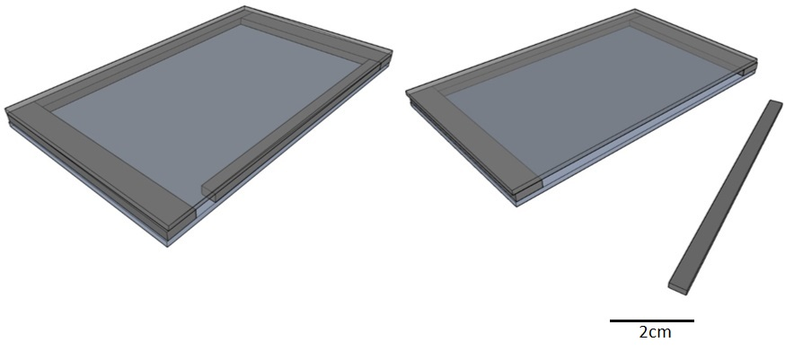

Fig 1

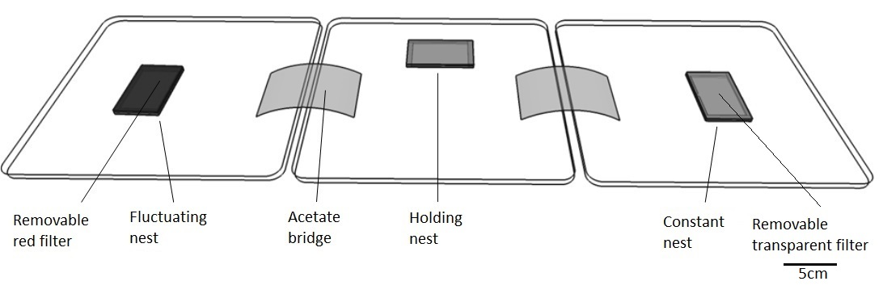

Fig 2

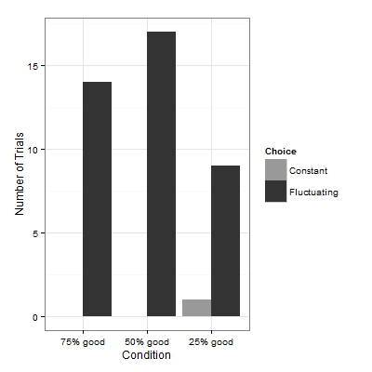

Fig 3

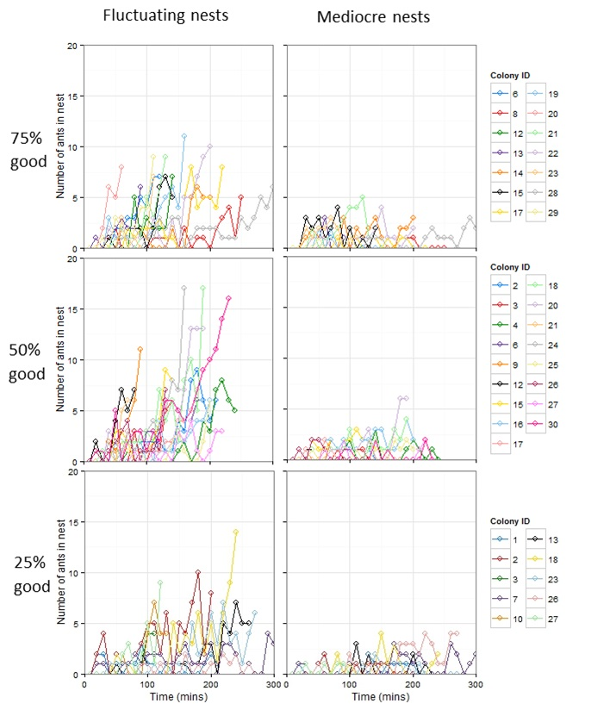

Fig 4

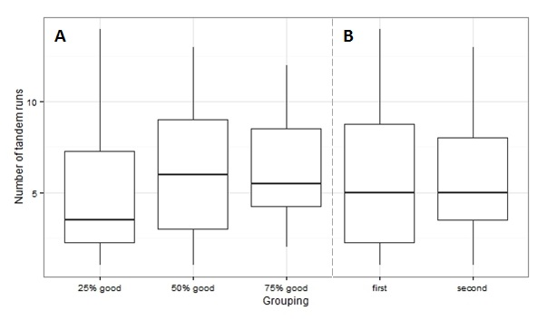

Fig 5

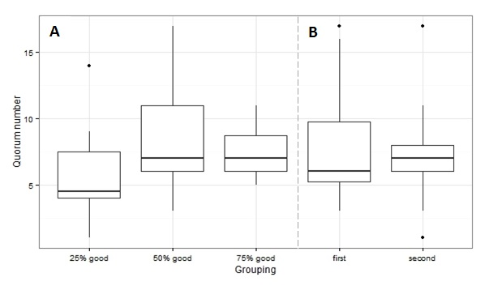

Fig 6

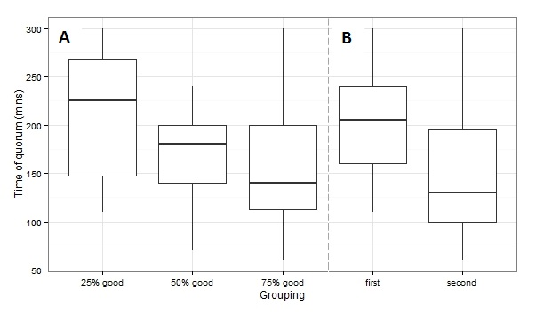Fig 7