


Using the Bristol City Council Quality of Life Survey (2011-2013) to support the Bristol Health Partners Health Integration Team ‘Active People: Promoting Healthy Life Expectancy’ – Preliminary Analysis and Recommendations for Further Analyses
Beth Bennett-Britton, Janet Mundy & Issy Bray
Summary
The purpose of this report is to explore the utility of the Bristol Quality of Life Survey for measuring levels of physical activity in Bristol to support the 'Active People: Promoting Healthy Life Expectancy' Health Integration Team (HIT). Key issues for consideration are sample size, response rates, and variables available to measure levels of physical activity, to understand potential enablers and barriers to older people being active, and to measure important health outcomes that are associated with physical activity.
Based on pooled data from the three surveys 2011-13, there were 7,078 respondents of age 55 and above. 84% of men and women age 55-59 years exercise at least once a week. 39% of men and 35% of women age 55-59 exercise at least 5 times a week. 32% of men and 36% of women age 55-59 play sport at least once a week. Levels of physical activity decline with age, and tend to decline more rapidly amongst women than men. The percentage who exercise at least once per week and who play sport at least once per week are highest in the Bristol North and West (Inner) sub-locality of Bristol. Generally, black and minority ethnic (BME) respondents have lower levels of physical activity than non-BME respondents. Older people who reported that something prevented them from leaving the house (particularly poor health or disability) were less likely to be physically active. General health in the past 12 months was positively associated with levels of physical activity, while having a limiting long-term illness, having had an accidental fall in the last 12 months and being overweight or obese were all associated with lower levels of physical activity.
We conclude that the large sample size and wide range of variables available make this a useful data source for monitoring the HIT. We note that the data are self-reported, and that the low response rate is a concern. These potential sources of bias do not detract from the usefulness of the data in monitoring trends over time and assessing the effect of interventions.
Background
According to the ONS mid-year population estimates for 2013, the population of Bristol is estimated to be approximately 437,500. Bristol’s 97,900 older people (aged 55 and over) make up 22% of the total population. The proportion of older people is lower than in England and Wales as a whole (29%). There are more than 9,000 people living in Bristol aged 85 and over, and the population continues to age gradually. The over 85 age group has increased by 1,700 people (22.3%) between 2001 and 2012. One person in five over the age of 85 is likely to have dementia.
Despite the general city-wide improvement, there are clear and persistent health and wellbeing inequalities across the city, including a persistent inequality in life expectancy between the most and least deprived areas (with an estimated gap of up to 10 years for men and 6 years for women). Bristol has concentrated geographical pockets of deprivation (particularly in the south, inner city and north of the city) and affluence (particularly in the west) (see Figure 1).
Figure 1. Index of multiple deprivation 2010 by lower layer super ouput area of Bristol, Office of National Statistics¹
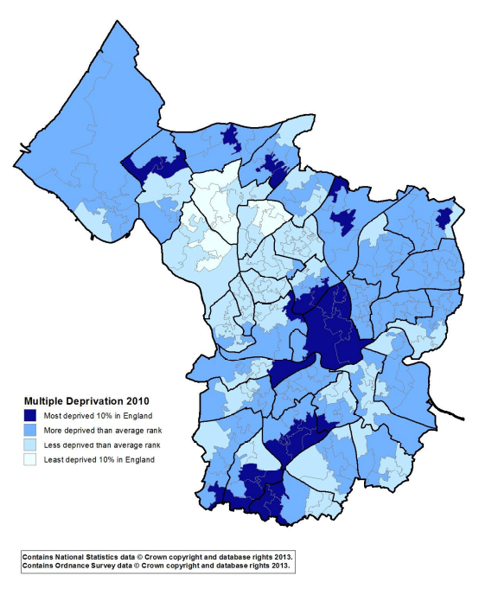

Many of the important health issues for Bristol mirror national challenges, with cancer still the biggest killer of people under 75 years of age, followed by heart disease and stroke. Obesity and physical inactivity are major contributing factors to poor health outcomes, along with smoking and alcohol.
Regular physical activity is associated with healthy ageing. The Bristol Health Partners HIT 'Active People: Promoting Healthy Life Expectancy' has been set up to address the trend towards more sedentary behaviour in people over 55 years, and in particular to reduce the disproportionate burden of inactivity seen in groups of low socio-economic status, and in the oldest age groups. Key to the success of the HIT are tools for measuring physical activity in the Bristol population, enabling us to describe baseline levels and examine differences between different demographic groups, to monitor trends over time and assess the effect of interventions.
Several national surveys collect data on physical activity, exercise and sport. These physical activity data sources have been described by the National Obesity Observatory. Some collect information only about specific aspects of physical activity (e.g. travel to work or sport). Few report results by Local Authority and, even were this data available, the numbers of respondents of age 55 or greater in the Local Authorities of interest are not likely to allow for breakdown by age group and gender. The English Longitudinal Study of Ageing (ELSA) includes a measure of physical inactivity, which is reported (i) by age and gender (ii) by age and wealth, over successive waves (2002/3, 2004/5, 2006/7, 2008/9, 2010/11, 2012/13). This provides useful statistics for comparative purposes, but since it includes only 1,218 respondents in the South West region, this study does not provide a reliable source of age- and gender-specific rates for the local Bristol population. By contrast, the Active People survey is the largest survey of its kind. The sample of 169,800 adults (age 14 and over) allows analysis by demographic factors such as gender, social class, ethnicity and age, with comparative data going back to 2005/6. The survey measures participation in sport and specific recreational activities - recreational cycling, recreational walking, walking for active travel purposes, cycling for active travel purposes, dance and gardening. A summary outcome measure (participation in sport, at moderate intensity, for at least 30 minutes on at least four days out of the last four weeks, equivalent to 30 minutes on one or more day a week) is calculated based on these activities, but occupational activity or work in the home is not included. Participants are not asked directly about their total moderate intensity activity per day or per week, which is how the government guidelines for older people are framed. Nevertheless, it is used by Local Authorities to benchmark levels of physical activity in the local population. Other work specific to the Bristol area includes Project OPAL (Older People and Active Living) - a prospective study of older people sampled from areas of low, middle and high areas of deprivation in the city. This study found that time spent doing moderate to vigorous physical activity per day was associated with subsequent health care usage (prescriptions and unplanned hospital admissions), but the sample size (213) was too small to estimate levels of physical activity by age group, ward and gender and the focus was on later old age (mean age 78 years). There is therefore a need for a data source with a larger sample size to allow for more detailed demographic analyses.

The Bristol City Council Quality of Life Survey
The Bristol Quality of Life Survey has been administered since 2001 by Bristol City Council. Residents are randomly selected from the Electoral Register every September and the survey is voluntary. Participants can complete the questionnaire by post or online. Each year approximately 4-5,000 people responded. The purpose of the survey is to collect information from residents of Bristol about a wide range of factors related to quality of life. These include many questions about health, activities and sport. The questions used in the survey have evolved over time. Some are based on validated national questionnaires, for example the short Warwick-Edinburgh Mental Wellbeing Score, the Local Government Best Value Survey (no longer in use) and the General Household Survey (general health and limiting long-term illness questions). The question about physical activity is “How often do you take moderate exercise? (e.g. brisk walk, leisure activity, heavy gardening, heavy housework or DIY)”.
A wide range of other variables are available from this survey. Demographic variables include age, gender, index of multiple deprivation (2010), ethnicity and highest educational level. Geographical information is recorded as one of 35 wards. A survey report is produced each year and a detailed analysis of each question is available, by ward and other variables of interest, for monitoring inequalities. The report based on findings for 2013 showed that while some health-related indicators for the city are very good or improving (less people driving and more people cycling to work, good quality green spaces, fewer people smoking), others are poor or deteriorating (exercise, obesity, support for carers). In particular, there are widening gaps between deprived areas and the rest of the city in terms of obesity. The percentage of respondents taking moderate exercise at least 5 times a week has decreased from 39% in 2006 to 34% in 2013. Differences in the proportions of people taking moderate exercise in deprived and non-deprived areas are narrowing. No analysis by age is presented, but the 2013 survey report highlights that the proportion of respondents who are overweight or obese is higher for older people (57%) than overall (51%). Obesity is reported to increase with age and peak just before retirement, at 23% for people aged 55-64 years.
In this report we use data from three recent years (2011-2013) to present an analysis of physical activity levels amongst people over 55 years, by five-year age bands, gender, BME status and sub-locality. The 35 wards of Bristol have been divided into five (CCG) sub-localities (Figure 2), which provide a meaningful categorisation in terms of geography and socio-economic context.
Figure 2. Clinical Commissioning Group sub-localities and constituent wards
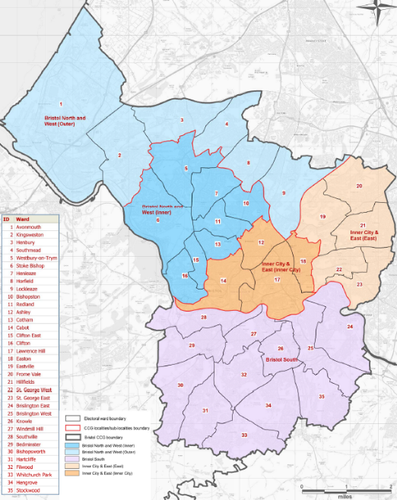

Response rates to questionnaire
The overall response rates were 23% in 2011, 20% in 2012 and 19% in 2013. The relatively low response rate means that the survey results may not be representative of the Bristol population. Bristol City Council acknowledge that people who have particularly strong views about aspects of living in Bristol or services provided by the Council may be more likely to respond to the survey.
Response rates are likely to vary with age, and may well be higher in the over 55s. Since response rates are not available by age or gender, we have compared the age distribution of the responses received (2011-2013) with the estimated age distribution of the Bristol population for 2012. Figure 3 confirms that all age groups from 45-49 to 85-89 are over-represented in the sample; in other words response rates are higher than in the younger age groups.
Figure 3. The percentage of responses by age band (2011-2013), compared with the adult age distribution of the Bristol population (2012)
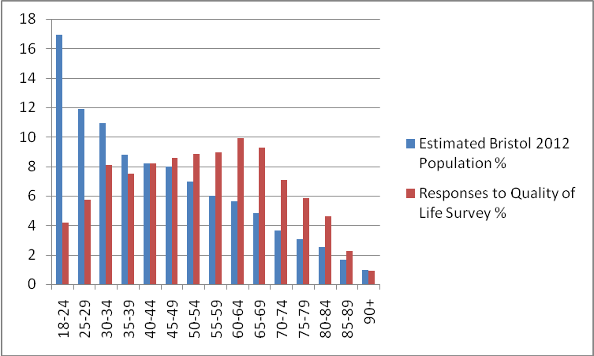

Number of responses by demographic variables
It is important to consider the total number of responses received in the age group of interest (55 years and older), as this will determine how far the results can be broken down while retaining a reasonable level of precision. Table 1 shows the total numbers of responses by age and gender, while Table 2 shows the total number of responses by sub-locality and year, for those aged 55 years or more. Please note that gender was missing for 25 cases so the total number for analyses involving age group is 7,053.
Table 1. Number of responses by age group (55+ years) and gender (2011-2013)
Age | Male | Female | Total
55 – 59 | 574 | 721 | 1,295
60 – 64 | 633 | 798 | 1,431
65 – 69 | 646 | 692 | 1,338
70 – 74 | 482 | 540 | 1,022
75 – 79 | 386 | 455 | 841
80 – 84 | 321 | 348 | 669
85 – 89 | 154 | 173 | 327
90 - 94 | 40 | 69 | 109
95 - 99 | 6 | 14 | 20
100+ | 1 | 0 | 1
Total | 3,243 | 3,810 | 7,053

Table 2. Number of responses (55+ years) by sub-locality and year (2011-2013)
 | Year of Survey
Sub-locality | 2011 | 2012 | 2013 | Total
Bristol South | 998 | 834 | 722 | 2,554
Bristol North and West (Outer) | 506 | 372 | 382 | 1,260
Bristol North and West (Inner) | 573 | 479 | 535 | 1,587
Inner City & East (Inner City) | 270 | 232 | 226 | 728
Inner City & East (East) | 270 | 291 | 310 | 949
Total | 2,695 | 2,208 | 2,175 | 7,078

Individual questions and response rates
We have identified the following questions as being useful in monitoring the current prevalence, and trends over time, in both physical activity amongst older people in the Bristol area, and possible outcomes that may be associated with physical activity (Table 3). The percentage of respondents for whom this data is missing (because they did not complete the question, or answered ‘does not apply’) is also given. The full wording of the questions as they appear in the questionnaire can be found in Appendix 1.

Table 3. Questions measuring physical activity and outcomes that may be associated with physical activity
 | Concept | Questions | % Missing | Data Type
Measures of physical activity | Frequency of physical activity | Exercise at least 5 times a week  Exercise at least once per week  Sport at least once per week | 1.34  1.34  3.04 | Binary  Binary  Binary
Outcomes that may be associated with physical activity | General health  Falls  Weight | General health in past 12 months  Limiting long-term illness  Accidental fall in the last 12 months  Body Mass Index category | 1.23  0.52  2.22  9.99 | Categorical  Binary  Binary  Categorical

Table 4. Questions measuring factors that may influence levels of physical activity.
Concept | Questions | % Missing | Data Type
Deprivation  Social interaction  Barriers to getting out and about  Enablers to getting out and about  Connectedness with neighbourhood | Index of Multiple deprivation (2010)  Meet family and friends  Talk to family and friends  Live alone  Safety outdoors after dark  Safety outdoors during day  Something prevents me from leaving the house (the following can be specified):  Fear of crime  Lack of confidence  Inaccessible public transport  Lack of support and assistance  Financial circumstances  Disability  Poor health  Caring responsibilities  Quality of parks and green spaces  Range/quality outdoor events  Satisfaction with neighbourhood  I belong to my neighbourhood | 1.94  1.60  1.81  4.31  5.65  5.52  3.19  10.17  2.32  2.14  4.40 | Continuous  Categorical  Categorical  Binary  Categorical  Categorical  Binary  Categorical  Categorical  Categorical  Categorical

Preliminary analyses
Describing levels of physical activity
Based on pooled data for 2011-2013, we present headline figures for the key variables identified above. Figure 4 shows the percentage of males and females in each age band who report that they exercise at least once a week. For younger ages (55-69 years) the percentage is close to 85% for both men and women (peaking at 87% at age 60-64 in both cases). The percentage exercising at least once per week then drops off more steeply amongst women than men, so that by age 90+, 69% of women but only 55% of men are not achieving this level of exercise. Figure 5 shows the percentage of respondents who report exercising at least once a week by sub-locality and ethnicity (BME/non-BME). In some sub-localities (Bristol South - 76%, Bristol North and West (Inner) - 88%, Inner City and East (East) – 79%), there is very little difference in this outcome between BME and non-BME respondents. In others (Bristol North & West (Outer), Inner City & East (Inner City)), BME groups are less likely to be exercising at least once a week but we note that the numbers of BME respondents in some sub-localities is quite small (<50), so the results should be interpreted with caution.
Figure 4. Percentage of respondents who exercise at least once a week, by age group and gender (actual numbers shown in Appendix 2)
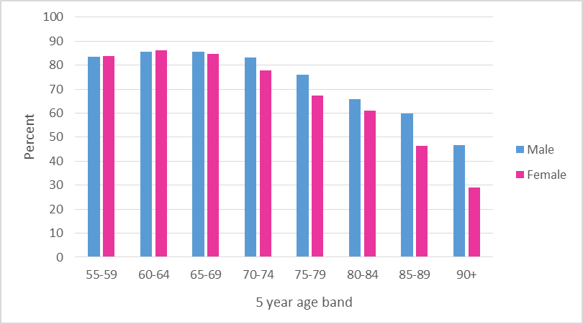

Figure 5. Percentage of respondents who exercise at least once a week, by sub-locality and ethnicity (actual numbers shown in Appendix 2)
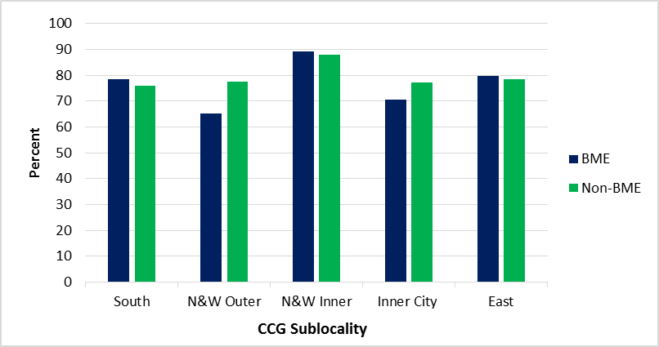
Similar graphs are shown for the percentage of respondents who exercise at least 5 times a week (the government guideline). Figure 6 shows slightly higher levels of exercise amongst males, with a clearly decreasing trend with age amongst men. The pattern with age is less clear for women, with exercise levels peaking at age 65-74 years (37% of women in this 10-year age band are exercising at least 5 times a week). This may suggest a positive effect for women of retirement on the opportunity to take exercise, or possibly some other cohort effect. Generally, however, the percentage not achieving exercise at least 5 times a week increases from 61% (men) and 65% (women) at age 55-59 years to 80% by age 90+.
Figure 6. Percentage of respondents who exercise at least 5 times a week, by age group and gender (actual numbers shown in Appendix 2)
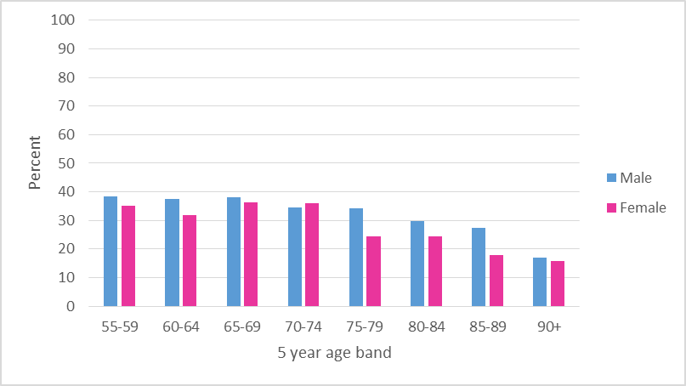

Figure 7 shows the percentage of respondents who exercise at least 5 times a week by sub-locality and whether they are BME or non-BME. This shows than non-BME respondents are more likely to meet the government's target for exercise than BME respondents. Amongst BME groups, exercise levels are lowest in the Eastern area of the 'Inner City and East' sub-locality (81% not achieving government target), while among non-BME groups, exercise levels are lowest in South Bristol (68% not achieving government target).
Figure 7. Percentage of respondents who exercise at least 5 times a week, by sub-locality and ethnicity (actual numbers shown in Appendix 2)
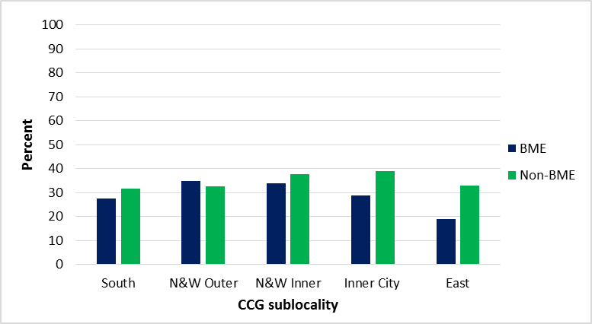

The final measure of physical activity that we consider is the percentage that report that they play sport at least once a week (Figures 8 and 9). Overall levels are similar amongst males and females, but there is evidence that women aged 55-64 are more likely to play a sport regularly than men of the same age, while above age 75 years the opposite is true. The decline in regular sport with age is greater than that for regular exercise. The pattern for sport also differs according to sub-locality, with highest levels in Bristol North and West (Inner) and lowest levels in Bristol South. In these areas, approximately 80% of respondents play sport less frequently than once a week. Overall, a slightly greater percentage of non-BME than BME respondents play sport at least once a week, but in most areas the difference is not great, while in Bristol North and West (Outer) a substantially greater proportion of BME (28%) than non-BME (20%) respondents play sport regularly. However, we note the low number of non-BME respondents and possible bias in this sample.
Figure 8. Percentage of respondents who play sport at least once a week, by age group and gender (actual numbers shown in Appendix 2)
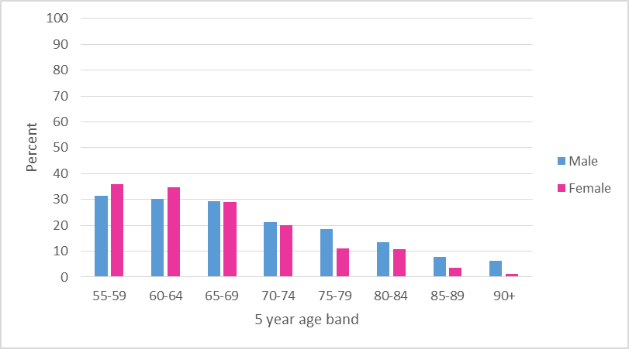

Figure 9. Percentage of respondents who play sport at least once a week, by sub-locality and ethnicity (actual numbers shown in Appendix 2)
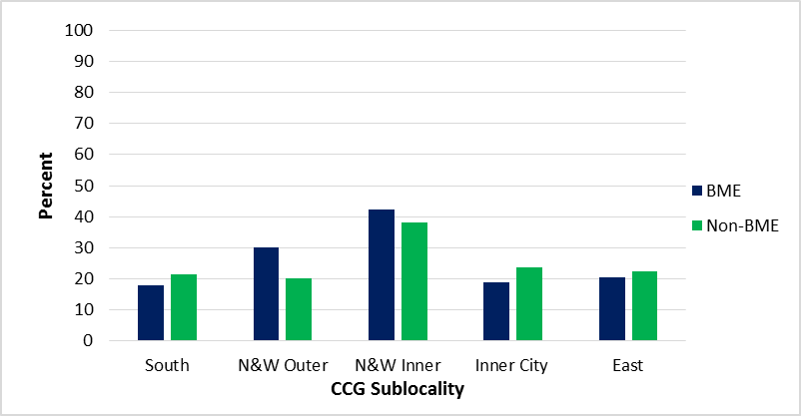

Describing associations between 'Exercise at least 5 times a week' and health outcomes
We identified several health outcomes in Table 3 that are recorded in the survey and may be associated with levels of physical activity. Here we explore the cross-sectional associations between these outcomes and exercising at least 5 times a week (this measure is chosen as it reflects the government guidelines on physical activity for older adults). Table 5 shows odds ratios for univariate logistic regression analyses. Exercising at least 5 times a week was strongly positively associated with ‘General health in past 12 months’ and negatively associated with the other health outcomes considered – reporting a limiting long-term illness, having had an accidental fall in the previous 12 months, and being overweight or obese.
Table 5. Univariate associations between exercising at least 5 times a week and selected health outcomes
 | Association with “Exercise at least 5 times per week”
Variable | Number included in the analysis | Odds ratio (95% confidence interval) | p-value
General health in past 12 months (1=good/fairly good; 0=not good) | 6,902 | 2.357 (2.04 – 2.72) | 0.000
Limiting long-term illness (1=yes; 0=no) | 6,949 | 0.484 (0.44 – 0.54) | 0.000
Accidental fall last in last 12 months (1=yes; 0=0) | 6,839 | 0.698 (0.62 – 0.79) | 0.000
Overweight or obese (1=yes; 0=no) | 6,303 | 0.575 (0.52 – 0.64) | 0.000
Obese (1=yes; 0=no) | 6,303 | 0.495 (0.43 – 0.57) | 0.000

Table 6 presents these associations adjusted for age, gender, BME status, sub-locality and deprivation. The results are similar to the univariate analyses shown in Table 5, slightly attenuated in all cases except for the association with weight, which is stronger after adjustment. Those who exercised at least 5 times a week were more than twice as likely than those who didn’t to describe their health as ‘fairly good’ or ‘good’. They were also half as likely to describe themselves as having a limiting long-term illness, about 30% less likely to have had an accidental fall in the previous 12 months, more than 40% less likely to be overweight or obese, and more than 50% less likely to be obese.
Table 6: Adjusted associations* between exercising at least 5 times per week and health outcomes
 | Association with “Exercise at least 5 times per week”
Variable | Number included in the analysis | Odds ratio (95% confidence interval) | p-value
General health in past 12 months (1=good/fairly good; 0=not good) | 6,690 | 2.301 (1.98 – 2.67) | 0.000
Limiting long-term illness (1=yes; 0=no) | 6,740 | 0.507 (0.45 – 0.57) | 0.000
Accidental fall last in last 12 months (1=yes; 0=0) | 6,633 | 0.734 (0.65 – 0.83) | 0.000
Overweight or obese (1=yes; 0=no) | 6,119 | 0.559 (0.50 – 0.62) | 0.000
Obese (1=yes; 0=no) | 6,119 | 0.474 (0.41 – 0.55) | 0.000
* adjusted for age, gender, BME status, sub-locality and deprivation
Describing associations between 'Exercise at least 5 times a week' and potential explanatory factors
We were also interested to explore the association between exercising at least 5 times a week and a number of variables that could potentially explain levels of physical activity reported by individuals. Odds ratios for univariate tests of association are shown in Table 7. Of the 11 variables considered, all except 'living alone' and ‘neighbourhood satisfaction’ had an association with exercising at least 5 times a week (p-value<0.05). As expected, there is a negative association between deprivation and physical activity, and meeting family and friends has a stronger relationship than talking to family and friends with levels of exercise. Reporting that 'something prevents me from leaving the house' is associated with decreased levels of physical activity, while positive perceptions of safety (during the day and after dark), satisfaction with parks/green spaces and outdoor events, and a sense of belonging to the neighbourhood, were all associated with increased levels of exercise.
Respondents who stated that something prevented them from leaving the house could select from a number of possible reasons. These are listed in Table 8 below, along with results of univariate tests of association with physical activity levels. As you would expect, those who cite disability and poor health as a barrier to leaving the house are much less likely to exercise at least 5 times a week. Lack of confidence as a barrier to leaving the house is also associated with reduced levels of exercise. Those who report that they do not leave the house due to a fear of crime actually report higher levels of physical activity than others. We investigated this counter-intuitive finding further by correlating this variable with reporting of feeling safe (during the day and after dark). These comparisons suggest that the reporting of fear of crime in this question (about factors preventing respondents from leaving the house) is not reliable. Accessibility of public transport, lack of support and assistance, financial circumstances and caring responsibilities do not appear to be associated with exercising at least 5 times a week.
Table 7. Univariate associations between exercising at least 5 times a week and potential explanatory factors
 | Association with “Exercise at least 5 times per week”
Variable | Number included in the analysis | Odds ratio (95% confidence interval) | p-value
Index of Multiple Deprivation (2010) (continuous) | 6,850 | 0.995 (0.99 – 0.998) | 0.001
Meet family and friends (1=often, 0=rarely) | 6,877 | 1.269 (1.10 – 1.47) | 0.001
Talk to family and friends (1=often, 0=rarely) | 6,865 | 1.175 (1.01 – 1.37) | 0.037
Live alone (1=yes; 0=no) | 6,694 | 1.006 (0.90 – 1.12) | 0.919
Safety outdoors after dark (1= safe; 0=neither/nor or unsafe) | 6,607 | 1.314 (1.18 – 1.46) | 0.000
Safety outdoors during day (1= safe; 0=neither/nor or unsafe) | 6,611 | 1.412 (1.18 – 1.69) | 0.000
Something prevents me leaving the house (1=yes; 0=no) | 6,801 | 0.419 (0.37 – 0.47) | 0.000
Quality of parks & green spaces (1=satisfied, 0=neither/unsatisfied) | 6,302 | 1.346 (1.17 – 1.55) | 0.000
Range/quality outdoor events (1=satisfied, 0=neither/unsatisfied) | 6,853 | 1.439 (1.27 – 1.64) | 0.000
Neighbourhood satisfaction (1=satisfied, 0=neither/unsatisfied) | 6,835 | 1.046 (0.91 – 1.20) | 0.524
I belong to my neighbourhood (1=agree, 0= disagree) | 6,693 | 1.176 (1.05 – 1.32) | 0.005

Table 8. Factors that prevent respondents from leaving the house, and univariate associations with exercising at least 5 times a week (n=6,801)
 | Association with “Exercise at least 5 times per week”
Variable | Odds ratio (95% confidence interval) | p-value
Disability (1=yes; 0=no) | 0.235 (0.19 – 0.29) | 0.000
Poor health (1=yes; 0=no) | 0.257 (0.21 – 0.32) | 0.000
Inaccessible public transport (1=yes; 0=no) | 0.831 (0.63 – 1.09) | 0.185
Lack of support and assistance (1=yes; 0=no) | 0.820 (0.52 – 1.30) | 0.398
Financial circumstances (1=yes; 0=no) | 0.858 (0.67 – 1.10) | 0.228
Lack of confidence (1=yes; 0=no) | 0.446 (0.32 – 0.62) | 0.000
Fear of crime (1=yes; 0=no) | 1.346 (1.07 – 1.68) | 0.013
Caring responsibilities (1=yes; 0=no) | 0.826 (0.63 – 1.08) | 0.163

A multivariate analysis was carried out including those factors in Tables 7 and 8 with p-value<0.1, along with the demographic variables age, gender, BME status, sub-locality and deprivation. Only variables with missing data <5% (Table 4) were included. A final model of those variables, which remained significant (p<0.1) in the multivariate model, is presented in Table 9 (all demographic variables were retained).
Table 9: Adjusted associations* between exercising at least 5 times per week and potential explanatory variables (n = 6,216)
 |  | Association with “Exercise at least 5 times per week”
Demographic variables |  | Odds ratio (95% confidence interval) | p-value
age (continuous) |  | 0.991 (0.99 – 1.00) | 0.007
gender (m=0, f=1) |  | 0.867 (0.78 – 0.97) | 0.010
Black and Minority Ethnic (BME=1, non-BME=0) |  | 0.667 (0.50 – 0.88) | 0.004
Sub-locality | South | - | -
Sub-locality | North Outer | 1.126 (0.96 – 1.32) | 0.148
Sub-locality | North Inner | 1.230 (1.04 – 1.45) | 0.014
Sub-locality | Inner City | 1.481 (1.21 – 1.82) | 0.000
Sub-locality | East | 1.064 (0.89 – 1.27) | 0.482
Index of Multiple Deprivation 2010 (continuous) |  | 1.000 (1.00 – 1.01) | 0.641
Other variables associated with physical activity
Meet family and friends (1=often, 0=rarely) |  | 1.171 (1.00 – 1.38) | 0.057
Range/quality outdoor events (1= satisfied; 0=neither/dissatisfied) |  | 1.242 (1.08 - 1.43) | 0.003
I belong to my neighbourhood (1= belong; 0 = neither/do not belong/does not apply) |  | 1.167 (1.03 – 1.32) | 0.017
Does anything prevent you from leaving the house? | Disability | 0.313 (0.24 - 0.40) | 0.000
Does anything prevent you from leaving the house? | Poor health | 0.352 (0.28 - 0.45) | 0.000
Does anything prevent you from leaving the house? | Lack of confidence | 0.595 (0.41 -0.87) | 0.007
Does anything prevent you from leaving the house? | Fear of crime | 1.684 (1.29 – 2.20) | 0.000
*adjusted for age, gender, BME status, sub-locality, deprivation and the other variables in the table
For the demographic variables, this analysis confirms that levels of physical activity amongst older people in the Bristol area reduce with age, are higher amongst men than women (on average men are 13% more likely to achieve exercise at least 5 times a week) and are higher amongst non-BME than BME groups (on average people from a non-BME background are 33% more likely to achieve exercise at least 5 times a week). These variables seem to be more important in explaining levels of physical activity than deprivation. There is no evidence that levels of physical activity differ between the South sub-locality (baseline) and the North Outer or East sub-localities. There are significantly higher levels of physical activity for those in the North Inner sub-locality and the Inner City sub-locality. This suggests that physical activity levels are higher closer to the centre of Bristol, where amenities are within easier walking/cycling distance. Those who are satisfied with the range of outdoor events are 24% more likely to report exercising at least 5 times a week, and those who meet family and friends regularly are 17% more likely to do so. The findings for disability, poor health and lack of confidence as reasons for not leaving the house confirm those of the univariate analyses (a strong association with reduced levels of physical activity, by 69%, 65% and 40% respectively).
Discussion
We have carried out a preliminary analysis of data in the Bristol City Council Quality of Life survey relating to levels of physical activity in older people in the city. Our estimates of levels of physical inactivity in Bristol by age and gender can be compared with those for England from the ELSA study. Physical inactivity in the ELSA study is classified as no moderate or vigorous physical activity on a weekly basis. Table 10 compares our findings for exercise at least once per week with those of the ELSA study for the highest (75-79) and lowest (55-59) 5-year age bands considered by both analyses. The percentage of both samples classified as ‘inactive’ or ‘not exercising at least once per week’ are remarkably similar for 55-59 year olds but diverge for older ages (75-79 years), with the ELSA estimates being higher for both men and women. Possible reasons for this are beyond the scope of this report, but nevertheless this comparison suggests a certain degree of comparability between the two studies.
Table 10: Comparison of levels of physical inactivity in the ELSA study and the percentage who do not exercise at least once per week in the current analysis of BCC QoL survey data
Age band | ELSA (% inactive) | BCC QoL survey (% who do not exercise at least once per week)
55 – 59
Males | 14% | 16%
Females | 15% | 16%
75-79
Males | 34% | 23%
Females | 51% | 31%

Although response rates of around 20% to the survey overall are a major concern in terms of potential bias (because respondents are self-selected and therefore not representative), we have shown that response rates are higher in the age groups of interest (55+ years). By way of comparison, the response rate to the 2011/12 Active People Survey was 27.3%, while that of the most recent wave of the ELSA study was 36%. We should also acknowledge that self-reported physical activity is likely to over-estimate actual physical activity. A study comparing the results of a self-administered physical activity questionnaire with accelerometer measurements in a large national survey in Norway found that the differences were greatest in men with less education and those over 65 years of age. In that study, the higher levels of moderate to vigorous physical activity reported by men compared with women were not reflected in the objectively-measured levels, which were similar.
While we should be cautious in generalising the findings about frequency of physical activity to the wider population, we have demonstrated that this data source has value for monitoring trends over time and assessing the effects of any intervention. A major strength is the large sample size, which means that even when looking at subgroups of the population (e.g. by area or age group) there are sufficient numbers to carry out statistical analyses. The detailed breakdown of exercise levels by age group, gender, sub-locality and ethnicity can be used to identify groups with particularly low levels of physical activity. This will be important in planning interventions to increase levels of physical activity amongst older people.
We have identified several health outcomes recorded in the survey and a range of variables that may help us to understand why older people do or do not take regular physical activity. This is a very rich data source, allowing the association between exercise levels and many other variables to be described, with adjustment for potential confounders. We note that a limitation of this approach is that some of the questions have high levels of non-response, reducing the sample size in multivariate analyses.
Our analysis confirmed the importance of age, gender, ethnicity and sub-locality within the city in understanding variations in levels of physical activity. Deprivation, based on postcode, was not independently associated with exercising at least 5 times a week. This may in part be because it is measured at a small area level (rather than individual level) but also could suggest that the other demographic variables included (age, gender, ethnicity and sub-locality) are more important than deprivation in explaining levels of physical activity. Other variables found to be positively associated with exercising at least 5 times a week were meeting family and friends regularly and being satisfied with the range/quality of outdoor events. Those who reported that they were prevented from leaving the house due to lack of confidence, poor health or disability were less likely to exercise at least 5 times a week. Due to the cross-sectional nature of the data, these associations cannot be interpreted as causal, but they do help in identifying modifiable factors that may help improve levels of physical activity amongst older people.
Future Analyses
Retrospective longitudinal analysis will allow description of annual trends from 2005 to present. The increase in sample size due to pooling of data from 2005 to 2013 will allow additional analyses to be carried out, highlighting socio-economic and geographical inequalities. For example, an analysis by quintiles of deprivation, by the 14 neighbourhood areas used by Local Authorities and even by individual ward would be possible. A more detailed breakdown of ethnicity would also be informative.
It would also be useful to repeat analyses looking at potential explanatory factors for different sub-groups of the population i.e. the reasons for not exercising may be very different for older women in an affluent locality than for BME men in a more deprived area. If we can identify the different barriers to exercise in each group, this will inform the planning of interventions and changes to policy to improve levels of physical activity amongst older people.
In this report we have demonstrated associations between physical activity and a range of health outcomes (general health, limiting long-term illness, accidental falls and weight). We plan to extend this work to look at associations between physical activity and mental health (the Short Warwick-Edinburgh Mental Well-Being Scale was added to the questionnaire in 2013). The survey also collects information on 'life satisfaction' but the question was changed in 2013 to allow comparison with national surveys, meaning comparability with previous years is lost. However, a longitudinal analysis of physical activity and life satisfaction will be carried out using data from 2005-2012.

Appendix 1: Survey questions (Bristol City Council Quality of Life Survey)
Question reference | Original question
Satisfaction with neighbourhood | How satisfied are you with your local area as a place to live? (tick one box) (very satisfied; fairly satisfied; neither satisfied nor dissatisfied; fairly dissatisfied; very dissatisfied)
Safety outdoors after dark  Safety outdoors during day | How safe or unsafe do you feel in your neighbourhood: (please tick one box in each case)  - Outdoors after dark (very safe; fairly safe; neither safe nor unsafe; fairly unsafe; very unsafe; does not apply)  - Outdoors during the day (very safe; fairly safe; neither safe nor unsafe; fairly unsafe; very unsafe; does not apply)
Meet family and friends | How often do you meet friends and family? (tick one box) (most days; every week; every month; a few times a year; never)
Talk to family and friends | How often do you talk to, text or email friends and family (tick one box) (most days; every week; every month; a few times a year; never)
I belong to my neighbourhood | Do you agree or disagree with the following statements? (please tick one box in each case)  - “I feel I belong to my neighbourhood” (strongly agree; tend to agree; neither/nor; disagree; strongly disagree)
Quality of parks and green spaces | How satisfied or dissatisfied are you with the following? (please tick one box in each case)  - Quality of parks and green spaces (very satisfied; fairly satisfied; neither/ nor; fairly dissatisfied; very dissatisfied; does not apply)
Exercise at least 5 times a week  Exercise at least once per week | How often do you take moderate exercise? (e.g. brisk walk, leisure activity, heavy gardening, heavy housework or DIY) (please tick one box) (5 times a week or more; 3-4 times a week; 1-2 times a week; about once a month; within the last 6 months; over a year ago/never; never, due to health reasons)
Sport at least once per week | How often do you take part in active sport (when you are active for 30 minutes or more)? (e.g. football, running, swimming) (please tick one box) (5 times a week or more; 3-4 times a week; 1-2 times a week; about once a month; within the last 6 months; over a year ago/never; never, due to health reasons)
Something prevents me from leaving the house (the following can be specified)  Disability  Poor health  Inaccessible public transport  Lack of support and assistance  Financial circumstances  Disability  Lack of confidence  Fear of crime  Caring responsibilities | Does anything prevent you from leaving the home when you want to or need to? (please tick any that apply) (nothing/never; disability; poor health; inaccessible public transport; lack of support and assistance; financial circumstances; lack of confidence; fear of crime; caring responsibilities; fear of losing parking space)
Range/quality outdoor events | How satisfied are you with the range and quality of outdoor events in Bristol? (e.g. Bristol Harbour Festival, Bristol Balloon Fiesta, Bristol’s Biggest Bike Ride, and events in local parks) (tick one box only) (very satisfied; fairly satisfied; neither/ nor; fairly dissatisfied; very dissatisfied; does not apply)
Life satisfaction | Overall, how satisfied are you with your life nowadays? (4=high; 3=high; 2=medium; 1=low satisfaction)
Live alone | Including yourself how many people live in your home? (if you live by yourself write 1 in the box)
General health in past 12 months | In the last 12 months, how would you say your health has been on the whole? (please tick one box) (good; fairly good; not good)
Limiting long-term illness | Do you have any long-term illness, health problem or disability, which limits your daily activities or work you can do? (include problems which are due to old age) (yes; no)
Accidental fall last in last 12 months | Have you accidentally fallen in the last 12 months? (yes; no)
Overweight or obese | Weight is a current health concern. (if you are able to weigh yourself or measure your height, please do so wearing light clothing and without shoes)  - What is your weight (you can use stone & pounds or kilograms)  - What is your height (you can use feet and inches or meters)  - Are you pregnant (yes; no; not applicable)
Gender | Are you? (male; female)
Age | What age are you?
BME | How would you describe your ethnic origin? (please tick 1 box) (white or white British; black or black British; Asian or Asian British; mixed background (please describe); other ethnic group (please describe))

Appendix 2: Tables corresponding to figures

Figure 4. Proportion (n/N) and percentage of respondents who exercise at least once a week, by age group and gender
 | Males |  | Females
Age band | n/N | % who exercise at least once a week | n/N | % who exercise at least once a week
55 – 59 | 480/572 | 83.92 | 605/719 | 84.14
60 – 64 | 541/624 | 86.70 | 688/792 | 86.87
65 – 69 | 553/644 | 85.87 | 586/684 | 85.67
70 – 74 | 401/475 | 84.42 | 421/532 | 79.14
75 – 79 | 293/381 | 76.90 | 307/446 | 68.83
80 – 84 | 211/315 | 66.98 | 212/334 | 63.47
85 – 89 | 92/152 | 60.53 | 80/165 | 48.48
90 + | 22/47 | 46.81 | 24/78 | 30.77
Total | 2593/3210 | 80.78 | 2923/3750 | 77.95

Figure 5. Proportion (n/N) and percentage of respondents who exercise at least once a week, by sub-locality and ethnicity
 | BME |  | Non-BME
Sub-locality | n/N | % exercise at least once per week | n/N | % exercise at least once per week
Bristol South | 40/51 | 78.43 | 1871/2,461 | 76.03
Bristol North & West (Outer) | 28/43 | 65.12 | 918/1,186 | 77.40
Bristol North & West (Inner) | 42/47 | 89.36 | 1326/1,508 | 87.93
Inner City & East (Inner City) | 91/129 | 70.54 | 435/564 | 77.13
Inner City & East (East) | 55/69 | 79.71 | 678/865 | 78.38
Total | 256/339 | 75.52 | 5228/6,584 | 79.40

Figure 6: Proportion (n/N) and percentage of respondents who exercise at least 5 times a week, by age group and gender
 | Males |  | Females
Age band | n/N | % who exercise at least 5 times a week | n/N | % who exercise at least 5 times a week
55 – 59 | 221/572 | 38.64 | 254/719 | 35.33
60 – 64 | 237/624 | 37.98 | 254/792 | 32.07
65 – 69 | 246/644 | 38.20 | 252/684 | 36.84
70 – 74 | 166/475 | 34.95 | 195/532 | 36.65
75 – 79 | 132/381 | 34.65 | 111/446 | 24.89
80 – 84 | 96/315 | 30.48 | 85/334 | 25.45
85 – 89 | 42/152 | 27.63 | 31/165 | 18.79
90 + | 8/47 | 20.00 | 13/78 | 19.40
Total | 1148/3210 | 35.76 | 1195/3750 | 31.87

Appendix 2: Tables corresponding to figures (continued)

Figure 7. Proportion (n/N) and percentage of respondents who exercise at least 5 times a week, by sub-locality and ethnicity
 | BME |  | Non-BME
Sub-locality | n/N | % exercise at least 5 times per week | n/N | % exercise at least 5 times per week
Bristol South | 14/51 | 27.45 | 779/2,461 | 31.65
Bristol North & West (Outer) | 15/43 | 34.88 | 386/1,186 | 32.55
Bristol North &West (Inner) | 16/47 | 34.04 | 571/1,508 | 37.86
Inner City & East (Inner City) | 37/129 | 28.68 | 219/564 | 38.83
Inner City & East (East) | 13/69 | 18.84 | 285/865 | 32.95
Total | 95/339 | 28.02 | 2,240/6,584 | 34.02

Figure 8. Proportion (n/N) and percentage of respondents who play sport at least once a week, by age group and gender
 | Males |  | Females
Age band | n/N | % who play sport at least once a week | n/N | % who play sport at least once a week
55 – 59 | 181/570 | 31.75 | 258/710 | 36.34
60 – 64 | 191/619 | 30.86 | 278/781 | 35.60
65 – 69 | 189/637 | 29.67 | 201/668 | 30.09
70 – 74 | 102/468 | 21.79 | 108/519 | 20.81
75 – 79 | 72/375 | 19.20 | 50/430 | 11.63
80 – 84 | 43/313 | 13.74 | 37/317 | 11.67
85 – 89 | 12/149 | 8.05 | 6/165 | 3.64
90 + | 3/45 | 6.67 | 1/74 | 1.35
Total | 793/3,176 | 24.97 | 939/3,664 | 25.63

Figure 9. Proportion (n/N) and percentage of respondents who play sport at least once a week, by sub-locality and ethnicity
 | BME |  | Non-BME
Sub-locality | n/N | % who play sport at least once per week | n/N | % who play sport at least once per week
Bristol South | 9/50 | 18.00 | 516/2,416 | 21.36
Bristol North & West (Outer) | 12/40 | 30.00 | 236/1,168 | 20.21
Bristol North & West (Inner) | 19/45 | 42.22 | 567/1,493 | 37.98
Inner City & East (Inner City) | 23/123 | 18.70 | 130/553 | 23.51
Inner City & East (East) | 14/69 | 20.29 | 190/849 | 22.38
Total | 77/327 | 23.55 | 1,696/6,479 | 25.30

Bristol City Council’s State of the City Report, 2013 (https://bristolresearchnetwork.wordpress.com/2013/11/19/bristol-state-of-the-city-report/)
Hamer M, Lavoie KL, Bacon SL, 2014. Taking up physical activity in later life and healthy ageing: the English longitudinal study of ageing. Br J Sports Med, 48(3), pp 239-243
Physical activity surveillance in England: what is measured and where are the gaps? (www.noo.org.uk/securefiles/151203_1121//Physical_activity_surveillance_in_England_revised300709.pdf)
Physical activity guidelines for older adults (65+ years), Department of Health Factsheet 5 (www.nhs.uk/Livewell/fitness/Documents/older-adults-65-years.pdf)
e.g. Bath and North East Somerset (www.bathnes.gov.uk/services/your-council-and-democracy/local-research-and-statistics/wiki/physical-activity)
www.bristol.gov.uk/page/council-and-democracy/quality-life-bristol
e.g. Angus VC, Entwistle VA, Emslie MJ, Walker KA, Andrew JE, 2003. The requirement for prior consent to participate on survey response rates: a population-based survey in Grampian. BMC Health Services Research, 3, p21
the mid-point is chosen as the best estimate of population for this period
We hypothesize that the way the question is presented encourages respondents to select the most important barriers to leaving the house. In other words, respondents would consider selecting ‘fear of crime’ as a reason for not leaving the house in the absence of poor health/disability/lack of confidence preventing them leaving the house.
Active People Survey 5-7 Technical Report, 2014. UK Data Archive SN7493 (http://doc.ukdataservice.ac.uk/doc/7493/mrdoc/pdf/7493_aps_7_technical_report.pdf)
Cheshire H, Ofstedal MB, Scholes S, Schroeder M, 2011. A comparison of response rates in the English Longitudinal Study of Aging and the Health and Retirement Study. Longitudinal and Life Course Studies, 2(2), pp 127-144
Dyrstad SM, Hansen BH, Holme IM, Anderssen SA, 2013. Comparison of self-reported versus accelerometer-measured physical activity, Medicine and Science in Sports and Exercise, 46(1), pp 99-106
Though the survey started in 2001, data from before 2005 are excluded for reasons of data access and quality

