Chitinase 3-like 1 expression by human (MG63) osteoblasts in response to lysophosphatidic acid and 1,25-Dihydroxyvitamin D3
J.P. Mansell*, M. Cooke, M. Read, H. Rudd, A.I. Shiel, K. Wilkins, M. Manso
Department of Biological, Biomedical & Analytical Sciences, University of the West of England, Frenchay Campus, Coldharbour Lane, Bristol, BS16 1QY.

*Corresponding author
Dr. Jason Peter Mansell
Senior Lecturer in Bone Biology
Department of Biological, Biomedical & Analytical Sciences
University of the West of England
Frenchay Campus
Coldharbour Lane
Bristol
BS16 1QY, UK.

Tel: +44 117 323 5966
Email: j.p.mansell@bris.ac.uk

Abstract
Chitinase 3-like 1, otherwise known as YKL-40, is a secreted glycoprotein purported to have a role in extracellular matrix metabolism. The first mammalian cell type found to express YKL-40 was the human osteosarcoma-derived osteoblast, MG63. In that first study the active vitamin D3 metabolite, 1,25-dihydroxycholecalciferol (1,25D), stimulated YKL-40 expression, thereby indicating that a vital factor for skeletal health promoted YKL-40 synthesis by bone forming cells. However, when these MG63 cells were exposed to 1,25D they were also exposed to serum, a rich source of the pleiotropic lipid mediator, lysophosphatidic acid (LPA). Given that 1,25D is now known to co-operate with selected growth factors, including LPA, to influence human osteoblast differentiation we hypothesised that 1,25D and LPA may work together to stimulate osteoblast YKL-40 expression. Herein we report that 1,25D and LPA synergistically promote YKL-40 expression by MG63 cells. Inhibitors targeting AP1, MEK, Sp1 and STAT3 blunted the expression of both alkaline phosphatase and YKL-40 by MG63 cells in response to co-stimulation with 1,25D and LPA. Other ligands of the vitamin D receptor also co-operated with LPA in driving YKL-40 mobilisation. Collectively our findings highlight another important role of 1,25D and LPA in the regulation of human osteoblast function.
Key words: Osteoblasts; active vitamin D; lysophosphatidic acid; differentiation; alkaline phosphatase; YKL-40.

1. Introduction
Located on the long arm end of chromosome 1, 1q31-q32, is CHI3L1, the gene encoding YKL-40 [1,2], otherwise known as chitinase 3-like 1 (CHI3L1), breast regression protein 39 (BRP-39, murine analog) or human cartilage glycoprotein 39 (HC-gp39). Originally identified in the whey fraction of non-lactating cows [3] it is a secreted glycoprotein of the 18-glycosyl-hydrolase family. The term YKL-40 is attributed to its apparent molecular mass of 40kDa and the N-terminal amino acids tyrosine (Y), lysine (K) and leucine (L). Although chitinase-like, YKL-40 does not exhibit glycohydrolase activity because an essential active site glutamate and juxtaposed aspartate residue are replaced with a leucine and alanine residue respectively. Devoid of chitinase activity the glycoprotein is still able to bind chitin and chitooligosaccharides with high affinity because a hydrophobic substrate binding cleft is present [3-5]. To date the precise biological function(s) of YKL-40 remains elusive but it is thought to have a connection with extracellular matrix (ECM) remodelling in both health and disease [6,7]. Indeed, there are instances of raised YKL-40 production where there is tissue damage, inflammation and ECM pathology, for example, liver fibrosis, rheumatoid arthritis, osteoarthritis and sarcoidosis [8,9].
The discovery that YKL-40 binds to fibrillar collagens I-III and can influence collagen fibril formation could indeed support a role of YKL-40 in connective tissue formation and/or turnover. The first mammalian cell type found to mobilise YKL-40 was the human immature osteoblast cell line, MG63 [10]. Since then it has emerged that YKL-40 is expressed by human osteoblasts and osteocytes at both endochondral and intramembranous sites of ossification [11,12] perhaps lending credence to a role of YKL-40 in bone development. In the context of bone metabolism in disease are the (compelling) reports of raised YKL-40 in the serum and synovial fluid from patients presenting with osteoarthritis [13-15], a crippling affliction of which bone composition and turnover are often markedly affected [16-19]. Connor and colleagues [11] initially postulated that raised YKL-40 expression in the serum and synovial fluid from patients with osteoarthritis may be a feature of heightened bone formation in affected joints. Bone tissue is a composite of highly tensile type I collagen fibers impregnated with hydroxyapatite imparting material stiffness. Osteoblasts are responsible for the provision of this matrix, an activity under the regulation of multiple local and systemic soluble factors. How these agents influence osteoblast YKL-40 is largely unknown. However there is an indication that the active metabolite of vitamin D3, 1α,25-dihydroxycholecalciferol (1,25D), might stimulate YKL-40 production following the finding of the glycoprotein in the conditioned media of cultured MG63 cells exposed to 1,25D [10]. Interestingly in their study, Johansen and colleagues [10] treated MG63 cells with 1,25D in growth medium supplemented with foetal calf serum, a rich source of the pleiotropic growth factor, lysophosphatidic acid (LPA), as bound to the albumin fraction [20,21]. In the context of human osteoblast biology we now know LPA to cooperate synergistically with 1,25D in stimulating increased production of tissue nonspecific alkaline phosphatase (TNSALP) [22-25], an enzyme essential for bone collagen mineralisation [26] and a marker of the mature osteoblast phenotype [27].
There is a growing interest in LPA in skeletal biology [23] but whether it has a role in the expression of YKL-40 in bone cells has not been forthcoming. Indeed at the time of this particular study there were no published works reporting on YKL-40 expression in response to LPA/related analogues for any mammalian cell type. Given that LPA, like YKL-40, is implicated in tissue repair, remodelling and fibrosis [28-30] we sought to investigate if LPA could stimulate human osteoblast YKL-40 expression and how 1,25D might influence this. Herein we provide evidence that LPA can stimulate YKL-40 production. Importantly the co-stimulation of osteoblasts with LPA and 1,25D culminated in a synergistic increase in YKL-40 mobilisation. Our findings offer new insights into the molecular control of osteoblast YKL-40 in the context of 1,25D and LPA-induced cellular differentiation.

2. Materials & Methods

2.1. General
Unless stated otherwise, all reagents were of analytical grade from Sigma-Aldrich (Poole, UK). Stocks of LPA (10mM, Enzo Life Sciences, Exeter, UK) were prepared in 1:1 ethanol:tissue culture grade water and stored at -20 °C. Likewise, 100 μM stocks of 1,25D and 24,25D (both epimers) were prepared in ethanol and stored at -20 °C. The vitamin D receptor (VDR) ligands delphinidin chloride (Del) and lithocholic acid acetate methyl ester (LCA Ac Ome, Steraloids, INc. Rhode Island, US) were reconstituted to 10 and 5mM respectively in ethanol and curcumin (CM, Tocris, Bristol, UK) stocks (10mM) prepared using DMSO. The LPA1/3 receptor antagonist, Ki16425, was reconstituted to 20mM in DMSO and stored at -20 °C. The specificity protein 1 (Sp1) inhibitor, mithramycin A, was prepared as a 500μM stock in ethanol; the activator protein-1 (AP-1) inhibitor, SR11301 (Tocris, Bristol, UK) was reconstituted to 10mM in ethanol, as were inhibitors to both MEK (UO126, Merck Serono Ltd, Feltham, UK) and Stat3 (S31-201, Merck Serono Ltd, Feltham, UK). The protein kinase C activator, phorbol 12-myristate 13-acetate (PMA) was supplied by Tocris (Bristol, UK) and prepared as a 50μg/ml stock in ethanol. In each case all reagent stocks were aliquoted and stored at -20 °C.

2.2. Human osteoblasts
Human osteoblast-like cells (MG63) were cultured in conventional tissue culture flasks (250 mL, Greiner, Frickenhausen, Germany) in a humidified atmosphere at 37 °C and 5 % CO2. Although osteosarcoma-derived, MG63 cells exhibit features in common with human osteoblast precursors or poorly differentiated osteoblasts. Specifically, these cells produce type I collagen with no or low basal osteocalcin (OC) and alkaline phosphatase (ALP). However, when MG63 s are treated with 1,25D, OC expression increases [31,32] and, when the same cells are co-treated with 1,25D and selected growth factors, e.g. LPA, the levels of ALP markedly increase [22], a feature of the mature osteoblast phenotype. Consequently, the application of these cells to assess the potential pro-maturation effects of selected factors is entirely appropriate. Cells were grown to confluence in Dulbecco’s modified Eagle medium (DMEM)/F12 nutrient mix (Gibco, Paisley, Scotland) supplemented with sodium pyruvate (1 mM final concentration), L-glutamine (4 mM), streptomycin (100 ng/mL), penicillin (0.1 units/mL) and 10 % v/v foetal calf serum (Gibco, Paisley, Scotland). The growth media (500 mL final volume) was also supplemented with 5 mL of a 100x stock of non-essential amino acids. Once confluent, MG63s were subsequently dispensed into blank 24-well plates (Greiner, Frickenhausen, Germany). In each case, wells were seeded with 1 mL of a 2 x 10⁴ cells/mL suspension (as assessed by haemocytometry). Cells were then cultured for 3 days, the media removed and replaced with serum-free DMEM/F12 (SFCM) to starve the cells overnight. Osteoblasts were subsequently treated with 1,25D (100nM), LPA (1.25-10μM) or a combination of these factors in the presence and absence of selected inhibitory compounds. An examination of LPA (10μM) in combination with either DC, CM (10μM) or LCA Ac Ome (5 μM) was also investigated. Similarly the influence of PMA (50ng/ml) in combination with 1,25D (100nM) on YKL-40 expression was also ascertained. In each instance MG63 cells were treated with phenol red-free serum free culture medium to eliminate any interference with the assays described below. After the desired time point (24-72hr) the conditioned media were processed for YKL-40 quantification (see below) and the remaining monolayers processed for cell number and total ALP activity to ascertain the extent of cellular growth and maturation respectively.

2.3. Chitinase 3-like 1 (YKL-40) quantification in conditioned media
The quantification of YKL-40 in cell culture media was performed using a proprietary ELISA (R&D systems, Abingdon) in accordance with the manufacturer’s instructions. Prior to analysis all conditioned media samples underwent an initial 10-fold dilution in SFCM. All further dilutions were made using the diluent buffer provided in the ELISA kit. Briefly, samples of media, standards and controls (50μl) were dispensed into wells already coated with an anti-YKL-40 antibody. Once dispensed the plate was left to incubate at room temperature for 2 hours. Wells were subsequently aspirated and washed three times before treating with 200μl/well of an antibody conjugate. The plate was then left to incubate for a further two hours, the wells aspirated, washed three times and then treated with 200μl/well of substrate. After 30 minutes the reaction was terminated and the absorbances read at 450nm. The data are expressed as the mean concentration (ng/ml) of YKL-40 per 100k cells ± the standard deviation.

2.4. Cell number
An assessment of cell number was performed using a combination of the tetrazolium compound 3-(4,5-dimethylthiazol-2-yl)-5-(3-carboxymethoxy-phenyl)-2-(4-sulfophenyl)-2H-tetrazolium, innersalt (MTS, Promega, UK) and the electron-coupling reagent phenazine methosulphate (PMS). Each compound was prepared separately in pre-warmed (37 °C) phenol red-free DMEM/F12, allowed to dissolve, and then combined so that 1 mL of a 1 mg/mL solution of PMS was combined to 19 mL of a 2 mg/mL solution of MTS. A stock suspension of MG63s (1 x 10⁶ cells/mL) was serially diluted in growth medium to give a series of known cell concentrations down to 25 x 10³ cells/mL. Each sample (0.5 mL in a microcentrifuge tube) was spiked with 0.1 mL of the MTS/PMS reagent mixture and left for 45 min within a tissue culture cabinet. Once incubated, the samples were centrifuged at 900 rpm to pellet the cells and 0.1 mL of the supernatants dispensed onto a 96-well microtitre plate and the absorbances read at 492 nm using a multiplate reader. Plotting the absorbances against known cell number, as assessed initially using haemocytometry, enabled extrapolation of cell numbers for the experiments described herein.

2.5. Total ALP activity
An assessment of ALP activity is reliably measured by the generation of p-nitrophenol (p-NP) from p-nitrophenylphosphate (p-NPP) under alkaline conditions. The treatment of cells to quantify ALP activity was similar to that described by us recently . Briefly, the MTS/PMS reagent was removed and the monolayers incubated for a further 5 min in fresh phenol red-free DMEM/ F12 to remove the residual formazan. Following this incubation period, the medium was removed and the monolayers lysed with 0.1 mL of 25 mM sodium carbonate (pH 10.3), 0.1 % (v/v) Triton X-100. After 2 min, each well was treated with 0.2 mL of 15 mM p-NPP (di-Tris salt, Sigma, UK) in 250 mM sodium carbonate (pH 10.3), 1 mM MgCl₂. Lysates were then left under conventional cell culturing conditions for 1 h. After the incubation period, 0.1 mL aliquots were transferred to 96-well microtitre plates and the absorbance read at 405 nm. An ascending series of p-NP (50-500 μM) prepared in the incubation buffer enabled quantification of product formation. Unless stated otherwise, total ALP activity is expressed as the mean micromolar concentration of p-NP per 100k cells, as extrapolated from the MTS/PMS assay described above.
2.6 Expression of YKL-40 via quantitative PCR
MG63 cells were seeded into T25 flasks, 8ml of a 5 x 10⁴ cells/mL suspension per flask, and the cells left for three days under conventional culturing conditions. After which the media were removed and replaced with SFCM and the cells starved for 24 hours. Flasks were subsequently divided so that some received SFCM alone or SFCM either supplemented with 1,25D (100nM), LPA (10μM) or a combination of these stimuli. Cells were left for 6, 24 and 48 hours prior to processing for RNA extraction and an assessment of YKL-40 mRNA expression via quantitative PCR. Briefly, after each of the treatment times the culture medium was aspirated, the monolayers rinsed in SFCM and treated with 1.5ml trypsin/EDTA and recovered cells combined to an equal volume of complete medium and centrifuged. Resultant cell pellets were lysed and total RNA prepared using SV total RNA isolation kit (Promega, Southampton) in accordance with the manufacturers’ instructions. Total RNA was subsequently DNase treated using RQ1 RNase-Free DNase kit (Promega, Southampton).
Following DNase treatment, samples were reverse transcribed into cDNA. Briefly, as per 30 μl of reaction mixture, the sample RNA (up to 5 μg/reaction) was combined with 2 μl oligo(dT) primer (0.5 μg/reaction) and nuclease-free water to a final volume of 10 μl and the sample tubes were placed in a preheated (70 °C) heating block for 5 minutes. The samples were subsequently cooled on ice for 1 minute before the addition of master mix containing 4 μl of GoScript™ 5X Reaction Buffer, 2 μl of MgCl2 (final concentration 1.5–5.0 mM), 1 μl of PCR Nucleotide Mix (final concentration 0.5 mM each dNTP), 1 ul (20 units) of Recombinant RNasin® Ribonuclease Inhibitor, 1 μl of GoScript™ reverse transcriptase and nuclease-free water to a final volume of 20 μl. In each instance samples were incubated in a preheated heating block for 5 minutes at 25 °C, 42 °C for 1 hr and 70 °C for 15 minutes followed by cooling. These samples were subsequently processed to ascertain YKL-40 expression using qPCR. Primers for quantitative PCR were designed using Primer3Plus design (Primer3Plus, Boston, USA) and manufactured by Invitrogen (MA, USA). The sequences of the oligonucleotides used as PCR primers were as follows, for YKL-40 gene upstream primer: 5ʹ-GATTTTCATGGAGCCTGGCG-3ʹ and downstream primer: 5ʹ- CCCCACAGCATAGTCAGTGT-3ʹ; for GAPDH gene upstream primer: 5ʹ- GAAGGTGAAGGTCGGAGTC -3ʹ and downstream primer: 5ʹ-GAAGATGGTGATGGGATTTC – 3 ʹ. Briefly, the reaction volume (16 µL) included 8 µL SensiFASTTM SYBR® Hi-ROX master mix (Bioline, UK), 2.4 µL diluted cDNA, 4.6 µL of ddH₂O and 0.5 µL each of forward and reverse primers. After initial denaturation at 94 °C for 2 min, the target genes were amplified with 40 cycles of denaturation at 95 °C for 5 s and annealing at 60 °C for 30 s. Gene expression levels were normalised to GAPDH and expressed as the mean fold induction + SD. Real-time PCR reactions were carried out in duplicate by an Applied Biosystems® StepOnePlus™ System (ThermoFisher).

2.7. Statistical analysis
Unless stated otherwise, all the cell culture experiments described above were performed three times and all data were subject to a one-way analysis of variance (ANOVA) to test for statistical significance as we have reported previously [33]. When a p value of < 0.05 was found, a Tukey multiple comparisons post-test was performed between all groups. All data are expressed as the mean together with the standard deviation.

3. Results

3.1. Co-treating MG63 cells with LPA and 1,25D stimulates a synergistic increase in YKL-40 expression.
As reported by us previously the application of 1,25D (100nM) resulted in a modest decrease in MG63 cell number (p<0.01) which is in keeping with a pro-differentiating effect of this secosteroid. In contrast treating these cells with LPA (10μM) led to the expected increase in cell growth (p<0.01) when compared to medium controls (Fig. 1A). Co-treating MG63 cells with LPA and 1,25D led to the expected differentiation response as supported by a clear, synergistic increase in total ALP activity (p<0.001) compared to all other groups (Fig. 1B). The conditioned medium harvested from co-stimulated cells was found to have markedly elevated levels (66 ± 10 ng/ml per 100k cells, p<0.01) of YKL-40 (Fig. 1C) compared to cells exposed to either medium alone (5 ± 0.4 ng/ml per 100k cells), 1,25D (8 ± ng/ml per 100k cells) or LPA alone (3 ± 0.2 ng/ml per 100k cells). Collectively the findings indicate co-expression of both ALP and YKL-40 as the cells move towards a more mature phenotype. We subsequently found that the expression of both YKL-40 and ALP could be significantly inhibited/attenuated when co-treated MG63’s were exposed to small inhibitors targeting MEK, Sp1, Stat3 and AP-1 (Table 1).
Next, we examined the ability of varying concentrations of LPA (1.25 - 10μM) to co-operate with 100nM 1,25D in stimulating YKL-40 production by MG63 cells between 24 and 72hr of culture. The data depicted (Fig. 2A) provide evidence for temporal changes in YKL-40 expression over the culture period with maximal levels reached after 72hr for cells co-treated with 1,25D and 5μM LPA. The concentration of YKL-40 (ng/ml per 100k cells) expressed by vehicle controls (5 ± 0.4), 100nM 1,25D alone (8 ± 0.4) or 10μM LPA alone (3 ± 0.3) after a 72 hour culture were all significantly less (p<0.005) when compared to co-stimulating cells with 1.25μM LPA and 1,25D (35 ± 7) for the same duration.
To complement the findings gleaned for the temporal YKL-40 ELISA data, cells were treated for up to 48 hours and an assessment of YKL-40 gene expression performed via qPCR (Fig. 2B). Suffice it to say maximal gene expression was evident for all groups after the two day period; there were very modest changes for vehicle-treated controls at approximately 5-fold compared to 31 and 76-fold for LPA (10μM) and 1,25D (100nM) exposures respectively. In keeping with the quantification of YKL-40 in conditioned media there was a striking, synergistic increase in gene expression of approximately 1000-fold for MG63 cells co-stimulated with 1,25D and LPA.
In a previous study we found that Ki16425 (10μM), an inhibitor of LPA1/LPA3 receptors, blunted the expression of ALP from cells co-stimulated with LPA and 1,25D [22]. Herein we find that the same inhibitor markedly supressed (~ 8 fold, p<0.001) the expression of YKL-40 for co-treated cells; 234.5 ± 20.8 versus 28.9 ± 2.3 ng/ml per 100k cells (Fig. 3A). As anticipated the application of Ki16425 inhibited expression of ALP from co-treated cells (Fig. 3B).

3.2. The VDR ligands 24,25D and LCA Ac Ome also co-operate with LPA to enhance YKL-40 expression by MG63 cells.
In addition to 1,25D we found that another dihydroxylated metabolite of vitamin D3, namely 24,25D (100nM), co-operated with LPA (10μM) in stimulating YKL-40 production by cultured MG63 cells (Fig. 4A). Both epimers were functional with 24R,25D being modestly more potent (**p<0.01) than 24S,25D. Another bone fide agonist of the VDR, LCA Ac Ome, also converged with LPA to increase the levels (*p<0.001 compared to agents in isolation) of YKL-40 in the conditioned media (Fig. 4B). With regard to the purported VDR ligands, CM and Del, both compounds were found not to act with LPA in promoting YKL-40 expression (data not shown).
3.3. The phorbol ester PMA converges with 1,25D in stimulating MG63 YKL-40 production.
We previously found that the protein kinase C activator, PMA, co-operated with 1,25D to bolster MG63 ALP activity [34] but whether this agent pairing might also influence YKL-40 production was not explored. In isolation both PMA and 1,25D had little, if any, effect on YKL-40 expression but when administered together there was a stark, synergistic, increase (*p<0.001) in the levels of YKL-40 in the conditioned media following three days of culture (Fig. 5).

4. Discussion
Following the discovery of YKL-40 in the conditioned medium of cultured (MG63) osteoblasts [10] studies began focussing on YKL-40 expression in the context of degenerative joint disease. It soon emerged that the levels of this glycoprotein were substantially elevated in the synovial fluid and serum from patients with either osteoarthritis or rheumatoid arthritis [13-15]. These findings suggested that YKL-40 might be a valuable marker and/or prognostic for degenerative joint disease. Since then there has been a rapid expansion of studies examining YKL-40 amongst a plethora of anomalies ranging from Alzheimer’s disease [35] to ulcerative colitis [36]. Throughout this time, and despite the wealth of studies being reported, how YKL-40 expression might be regulated by local and systemic factors has received scant attention. Indeed this was raised recently by Bhardwaj and co-workers [37] wherein the authors state: “Despite the numerous reports documenting elevated expression of YKL-40, relatively little is known about the inflammatory mediators and specific molecular mechanisms that control its expression.”
In the context of 1,25D-induced osteoblast maturation it was of notable interest to see that MG63 cells exposed to this steroid produced greater quantities of YKL-40 into the surrounding growth medium [10]. These initial findings support the possibility that YKL-40 may in some way be linked to the provision of a mature mineralised bone matrix given that 1,25D deficiency results in childhood rickets and osteomalacia in adults [26]. With regard to the range of effects of 1,25D for cultured human osteoblasts it is becoming clear that 1,25D needs to converge with other signalling networks elicited by certain growth factors [38, 39]. In our hands we consistently find that 1,25D per se enhances osteocalcin expression and an accompanying attenuation of cell growth, findings which would be expected for a pro-differentiating stimulus. However with regard to ALP, 1,25D has to act in concert with other stimuli, e.g., TGFβ [40], epidermal growth factor [34] and LPA [22] to promote enzyme expression. The initial studies of Johanssen and colleagues [10] inspired us to examine whether 1,25D and LPA might co-operate to enhance YKL-40 production by MG63 cells. The impetus for this emerged from the culturing conditions utilised by Johanssen and colleagues in that first study [10]; cells were treated with 1,25D in a medium supplemented with serum, a rich source of LPA, chiefly associated with the albumin fraction [20,21]. It is clear from our studies that 1,25D and LPA do indeed converge to synergistically enhance YKL-40 mobilisation into the surrounding growth medium. Our findings go to help explain how 1,25D promotes osteoblast YKL-40 expression when these cells are exposed to a medium containing LPA. As has been alluded to already, little is known pertaining to the molecular control of YKL-40 expression. Using our model we therefore turned our attention to those intracellular mediators central to controlling osteoblast differentiation and fate and found that the expression of YKL-40 was sensitive to inhibitors targeting MEK, AP-1, Sp1 and STAT3.
In a previous study we reported that the expression of ALP in response to MG63 cells co-stimulated with LPA and 1,25D could be prevented using UO126, an inhibitor of MEK and therefore Erk phosphorylation/activation [22]. Similar results were obtained for cells co-treated with 1,25D and EGF [34] and 1,25D and colchicine [41]. Herein we now find that UO126 can inhibit the production of YKL-40 when MG63 cells are co-treated with 1,25D and LPA. How LPA (MEK activation) and 1,25D act to increase YKL-40 could be via MEK-dependent stimulation of AP-1. It is well known that the AP-1 family of transcription factors plays an important role in the development and maturation of osteoblasts [42, 43]. Herein we report that inhibiting AP-1 with SR11301 significantly attenuates the large increases for both ALP and YKL-40 for cells co-stimulated with LPA and 1,25D. These findings are therefore in keeping with the role of AP-1 in the development of the mature osteoblast phenotype.
During the late stages of human macrophage differentiation, Rehli and colleagues [44] found YKL-40 to be markedly enhanced. In ascertaining the transcriptional regulation of YKL-40 Rehli et al. [44] conducted a series of comprehensive deletion and mutational analyses of the YKL-40 promoter. Suffice it to say the ubiquitous transcription factor Sp1 played a key role in YKL-40 gene expression. Similarly phorbol ester (PMA)-induced differentiation of THP-1 cells was accompanied by increased YKL-40 expression and that this was also attributed to an Sp1 element in the YKL-40 promoter [44]. Herein we also find that as human osteoblasts progress to a more mature phenotype the mobilisation of YKL-40 in to the culture medium increases. We subsequently found that YKL-40 expression, consequent to co-treatment with LPA and 1,25D could be inhibited using Mithramycin A which prevents Sp1 promoter binding [45]. A key component for osteoblastogenesis is RUNX2, indeed mice nullizgous for Runx2 have defective osteoblast development [46]. Using murine MC3T3-E1 osteoblasts it has since been found that Sp1 expression is coupled to increased Runx2 gene expression whereas siRNA depletion of Sp1 reduces Runx2 expression and ALP [47]. How 1,25D and LPA converge in driving Sp1-dependent YKL-40 expression will necessitate further study but it is worth highlighting a report by Huang et al. [48] for how 1,25D might act; the VDR has been reported to activate P27^{kip1} by physically binding to Sp1. Although the molecular mechanism by which VDR enhances Sp1-mediated transactivation remains to be resolved it is suggested that the VDR may increase the stability of Sp1-GC rich DNA interaction and resultant stimulation of target genes (which could include YKL-40 and ALP) via an Sp1 transactivation domain. Credence is given to this possibility given that both YKL-40 and ALP genes have Sp1 binding sites in their promoters [44, 49].
In a previous study we also discovered that PMA and 1,25D co-operated to enhance MG63 osteoblast maturation, as supported by elevated ALP activity [34]. It has been known for over a quarter of a century, that the activation of PKC, by PMA, promotes osteoblast proliferation [50]. Interestingly, in our hands, when pro-mitogenic stimuli are combined with 1,25D, cell growth is attenuated and there is a concomitant enhancement of ALP production. The models we have utilised are representative of signal transduction “cross-coupling” wherein a pro-mitogenic stimulus, e.g., PMA, converges with a pro-differentiating steroid hormone [51], which, in this particular case, is 1,25D. As with THP-1 cells [44] we now report that PMA and 1,25D synergistically increase YKL-40 production by MG63 cells. We consistently find that MG63 maturation is accompanied by elevated expression of both ALP and that this now extends to YKL-40. To date these are the only two proteins known to be synergistically expressed consequent to co-treatment with 1,25D and selected growth factors and/or physical stimuli for any mammalian cell type.
Signal transducers and activators of transcription 3 (STAT3) are essential in mediating cell proliferation, differentiation and survival. Mutations in STAT3 result in Job syndrome characterised by skeletal and craniofacial anomalies [52]. Furthermore, the ability of autologous serum, a rich source of LPA, to promote osteoblast formation from human mesenchymal cells was found to be accompanied by enhanced STAT3 expression/phosphorylation/activation [53]. There is good evidence supporting an important role of STAT3 in YKL-40 expression in the context of IL-1, IL-6 and oncostatin M-stimulated human and murine astrocytes [37, 54]. We therefore set out to investigate whether the pharmacological inhibition of STAT3 might result in reduced YKL-40 production for MG63 cells co-stimulated with LPA and 1,25D. Suffice it to say the application of S31-201 to LPA and 1,25D co-treated MG63 cells led to clear reductions in the expression of both ALP and YKL-40.
In addition to 1,25D, the VDR ligands 24,25D and LCA Ac Ome have previously been found to co-operate with LPA/LPA analogs to enhance ALP expression [33, 55]. Likewise for ALP, both 24,25D and LCA Ac Ome converged with LPA to synergistically increase YKL-40 mobilisation from MG63 cells. Purportedly CM and Del are agonists of the VDR [56, 57] yet these agents were unable to stimulate YKL-40 expression by MG63 osteoblasts. A major polyphenol of turmeric (Curcuma longa), CM has been found to bind the VDR with concomitant recruitment of the VDR co-receptor, RXR, and resultant transcription of the VDR-target gene CYP3A4 in colon (Caco-2) cancer cells [56]. Although activation of the VDR by CM requires micromolar concentrations compared to nanomolar levels for 1,25D and 24,25D, we found that 10μM CM did not couple with LPA to enhance YKL-40 production. It is possible that this lack of effect of CM and LPA on YKL-40 expression is linked to CM’s reported inhibition of some key signalling pathways and transcription factors that regulate osteoblast growth and differentiation. This possibility is supported by our finding that the inclusion of CM attenuated (~1.7 fold) the ability of LPA and 1,25D to enhance total ALP (data not shown).
It is becoming clear that CM can down-regulate multiple transcription factors including AP-1 and Stat3 [58 and references therein]. Importantly, in our hands, we find that inhibiting AP-1 and Stat3 with SR11301 and S31-201 respectively, led to a clear suppression of YKL-40 expression when osteoblasts were co-stimulated with LPA and 1,25D. In addition CM inhibits ERK phosphorylation [58 and references therein] which is of further significance since the application of the MEK inhibitor, UO126, blunted the ability of MG63 cells to produce YKL-40 following treatment with both 1,25D and LPA. We previously reported a similar effect of UO126 on ALP expression for co-treated cells [22]. It is quite possible that CM serves to inhibit key transcription factors and signalling networks that are important to securing osteoblast maturation in the context of 1,25D and LPA cross-coupling.
The purple, fruit-derived anthocyanidin, Del, has been found to be a low affinity VDR ligand reported to up-regulate multiple , VDR-inducible, late cornified envelope genes , in primary human keratinocytes [57]. However, like CM, Del failed to co-operate with LPA to induce both ALP and YKL-40 production by MG63 cells. The finding that Del, like CM, can inhibit ERK phosphorylation, for example in airway epithelial cells [59], could indicate a potential antagonistic effect of Del on LPA signalling. Like CM, when Del was co-administered to cells stimulated with LPA and 1,25D there was a clear attenuation (~2.8 fold) of total ALP expression (data not shown).
In summary we are the first to report that LPA co-operates with 1,25D to increase the production of YKL-40 by cultured human (MG63) osteoblasts. In addition to ALP it would seem that YKL-40 represents another 1,25D-regulated protein whose expression increases as these cells move towards a more differentiated phenotype. Given the importance of 1,25D for bone health and the links between LPA, tissue repair and the discovery that YKL-40 can bind type I collagen, it is conceivable that YKL-40 is a feature of bone matrix metabolism. Monitoring local YKL-40 expression during fracture healing or at bone implant sites may offer some valuable insight with respect to this possibility.
Acknowledgements
The authors hereby acknowledge support from the University of the West of England and to the National Institute for Health Research (II-LA-0315-20004) for their research funding. The authors report no conflict of interest.

References
[1] B.E. Hakala, C. White, A.D. Recklies, Human cartilage gp-39, a major secretory product of articular chondrocytes and synovial cells, is a mammalian member of a chitinase protein family, J. Biol. Chem. 268 (1993) 25803-25810.

[2] J.S. Johansen, B.V. Jensen, A. Roslind, D. Nielsen, P.A. Price, Serum YKL-40, a new prognostic biomarker in cancer patients?, Cancer Epidemiology, Biomarkers & Prevention 15 (2006) 194-202.

[3] J.J. Rejman, W.L. Hurley, Isolation and characterization of a novel 39 kilodalton whey protein from bovine mammary secretions collected during the nonlactating period, Biochem. Biophys. Res. Commun. 150 (1988) 329–34.

[4] F. Fusetti, T. Pijning, K.H. Kalk, E. Bos, B.W. Dijkstra, Crystal Structure and Carbohydrate-binding Properties of the Human Cartilage Glycoprotein-39, J. Biol. Chem. 278 (2003) 37753–37760.

[5] D.R. Houston, A.D. Recklies, J.C. Krupa, D.M.F. van Aalten, Structure and Ligand-induced Conformational Change of the 39-kDa Glycoprotein from Human Articular Chondrocytes, J. Biol. Chem. 278 (2003) 30206–30212.

[6] J.S. Johansen, Studies on serum YKL-40 as a biomarker in diseases with inflammation, tissue remodelling, fibroses and cancer, Dan. Med. Bul. 53 (2006) 172–209.

[7] C. Nordenbaek, J.S. Johansen, P. Junker, N. Borregaard, O. Sorensen, P.A. Price, YKL-40, a matrix protein of specific granules in neutrophils, is elevated in serum of patients with community-acquired pneumonia requiring hospitalization, J. Infect. Dis. 180 (1999) 1722–1726.

[8] H. Tao, J-J. Yang, K-H. Shi, C. Huang, L. Zhang, X-W. Lv, et al., The significance of YKL-40 protein in liver fibrosis, Inflam. Res. 63 (2014) 249–254.

[9] J. Kzyhshkowska, A. Gratchev, S. Goerdt, Human chitinases and chitinase-like proteins as indicators for inflammation and cancer, Biomarker Insights 2 (2007) 128–146.

[10] J.S. Johansen, M.K. Williamson, J.S. Rice, P.A. Price, Identification of proteins
secreted by human osteoblastic cells in culture, J. Bone Miner. Res. 7 (1992) 501 – 512.

[11] J.R. Connor, R.A. Dodds, J.G. Emery, R.B. Kirkpatrick, M. Rosenburg, M. Gowen, Human cartilage glycoprotein 39 (HC gp-39) mRNA expression in adult and fetal chondrocytes, osteoblasts and osteocytes by in-situ hybridization, Osteoarthritis and Cartilage 8 (2000) 87-95.

[12] J.S. Johansen, P.E. Høyer, L.A. Larsen, P.A. Price, K. Møllgard, YKL-40 protein wxpression in the early developing human musculoskeletal System, J. Histo. Cytochem. 55 (2007) 1213-1228.

[13] J.S. Johansen, J. Hvolris, M. Hansen, V. Backer, I. Lorenzen, P.A. Price, Serum
YKL-40 levels in healthy children and adults. Comparison with serum and synovial fluid levels of YKL-40 in patients with osteoarthritis or trauma of the knee joint, Br. J. Rheumatol. 35 (1996) 553 – 559.

[14] T.C. Register, C.S. Carlson, M.R. Adams, Serum YKL-40 is associated with
osteoarthritis and atherosclerosis in nonhuman primates, Clin. Chem. 47 (2001) 2159 – 2161.

[15] B. Volck, J.S. Johansen, M. Stoltenberg, C. Garbarsch, P.A. Price, M. Ostergaard, et al., Studies on YKL-40 in knee joints of patients with rheumatoid arthritis and osteoarthritis. Involvement of YKL-40 in the joint pathology, Osteoarthritis & Cartilage 9 (2001) 203 – 214.

[16] A.J. Bailey, J.P. Mansell, Do subchondral bone changes exacerbate or precede articular cartilage destruction in ostoarthritis of the elderly, Gerontology 43 (1997) 296-304.

[17] J.P. Mansell, J.F. Tarlton, A.J. Bailey, Biochemical evidence for altered subchondral bone collagen metabolism and osteoarthritis of the hip, Br. J. Rheumatol. 37 (1997) 16-19.

[18] J.P. Mansell, A.J. Bailey, Abnormal cancellous bone collagen metabolism in osteoarthritis, J. Clin. Invest. 101 (1998) 1596-1603.

[19] S.A. Hardcastle, P. Dieppe, C.L. Gregson, N.K. Arden, T.D. Spector, D.J. Hart, et al., Individuals with high bone mass have an increased prevalence of radiographic knee osteoarthritis, Bone 71 (2015) 171-179.

[20] G. Tigyi, R. Miledi, Lysophosphatidates bound to serum albumin activate membrane currents in Xenopus oocytes and neurite retraction in PC12 phaechromocytoma cells, J. Biol. Chem. 267 (1992) 21360–21367.

[21] A.E. Thumser, J.E. Voysey, D.C. Wilton, The binding of lysophospholipids to rat liver fatty acid-binding protein and albumin. Biochem. J. 301 (1994) 801–806.

[22] J. Gidley, S. Openshaw, E.T. Pring, S. Sale, J.P. Mansell, Lysophosphatidic acid cooperates with 1alpha, 25 (OH) 2D3 in stimulating human MG63 osteoblast maturation, Prost. other Lipid Med. 80 (2006) 46-61.

[23] J. Blackburn, J. P. Mansell, The emerging role of lysophosphatidic acid (LPA) in skeletal biology, Bone 50 (2012) 756–762.

[24] J.P. Mansell, J. Blackburn, Lysophosphatidic acid, human osteoblast formation, maturation and the role of 1α, 25-Dihydroxyvitamin D3 (calcitriol), Biochim. Biophys. Acta. 1 (2013, Mol. Cell Biol. Lipids) 105-108.

[25] S. Lancaster, J.P. Mansell, The role of lysophosphatidic acid on human osteoblast formation, maturation and the implications for bone health and disease, Clin. Lipidol. 8 (2013) 1-13.

[26] M.P. Whyte, Physiological role of alkaline phosphatase explored in hypophosphatasia, Ann. N Y Acad. Sci. 1192 (2010)190-200.

[27] A. Neve, A Corrado, F.P. Cantatore, Osteoblast physiology in normal and pathological conditions, Cell Tissue Res. 343 (2011) 289-302.

[28] W.H. Moolenaar, L.A. van Meeteren, B.N.G. Giepmans, The ins and outs of lysophosphatidic acid signaling, BioEssays 26 (2004) 870–881.

[29] J.W. Choi, D.R. Herr, K. Noguchi, Y.C. Yung, C.W. Lee, T. Mutoh, et al., LPA receptors: subtypes and biological actions, Annu. Rev. Pharmacol. Toxicol. 50 (2010) 157–186.

[30] N.C. Stoddard, J. Chun, Promising pharmacological directions in the World of lysophosphatidic acid signaling, Biomol. Therap. 23 (2015) 1-11.

[31] J. Clover, M. Gowen, Are MG-63 and HOS TE85 human osteosarcoma cell lines representative models of the osteoblastic phenotype?, Bone 15 (1994) 585–91.

[32] E.M. Czekanska, M.J. Stoddart, R.G. Richards, J.S. Hayes, In search of an osteoblast model for in vitro research, Eur. Cells. Mater. 24 (2012) 1-17.

[33] S.T. Lancaster, J. Blackburn, A. Blom, M. Makishima, M. Ishizawa, J.P. Mansell, 24,25-Dihydroxyvitamin D3 cooperates with a stable, fluoromethylene LPA receptor agonist to secure human (MG63) osteoblast maturation, Steroids 83 (2014) 52–61.

[34] S.J. Yarram, C.Tasman, J. Gidley, M. Clare, J.R. Sandy, J.P. Mansell, Epidermal growth factor and calcitriol synergistically induce osteoblast maturation, Mol. Cell. Endocrinol. 220 (2004) 9–20.

[35] C. Rosen, C-H. Andersson, U. Andreasson, J.L. Molinuevo, M. Bjerke, L. Rami, et al., Increased Levels of Chitotriosidase and YKL-40 in Cerebrospinal Fluid from Patients with Alzheimer’s Disease, Dement. Geriatr. Cogn. Disord. Extra 4 (2014) 297–304.

[36] C-C. Chen, J. Pekow, V. Llado, M. Kanneganti, C.W. Lau, A. Mizoguchi, et al., Chitinase 3-Like-1 Expression in Colonic Epithelial Cells as a Potentially Novel Marker for Colitis-Associated Neoplasia, Am. J. Pathol. 179 (2011) 1494–1503.

[37] R. Bhardwaj, J.W. Yester, S.K. Singh, D.D. Biswas, M.J. Surace, M.R. Waters, et al., RelB/p50 complexes regulate cytokine-induced YKL-40 expression, J. Imm. 194 (2015) 2862-2870.

[38] J.P. Mansell, Convergence of vitaminD and lysophosphatidic acid signaling in stimulating human osteoblast maturation, Front. Physiol. 5 (2014) article 263.

[39] J. Van de Peppel, J. P.T.M. van Leeuwen, Vitamin D and gene networks in human osteoblasts, Front. Physiol. 5 (2014) article 137.

[40] L.F. Bonewald, M.B. Kester, Z. Schwartz, L.D. Swain, A. Khare, T.L. Johnson, et al., Effects of combining transforming growth factor beta and 1,25 dihydroxyvitaminD3 on differentiation of a human osteosarcoma (MG-63), J. Biol.Chem. 267(1992) 8943–8949.

[41] J.P. Mansell, D. Farrar, S. Jones, M. Nowghani, Cytoskeletal reorganisation, 1α,25-dihydroxy vitamin D3 and human MG63 osteoblast maturation, Mol. Cell. Endo. 305 (2009a) 38–46.

[42] P.J. Marie, Transcription factors controlling osteoblastogenesis, Arch. Biochem.
Biophys. 473 (2008) 98–105.

[43] E.F. Wagner, Functions of AP1 (Fos/Jun) in bone development, Ann. Rheum.
Dis. 61 (Suppl. Ii, 2002) 40–42.

[44] M. Rehli, H-H Niller, C. Ammon, S. Langmann, L. Schwarzfischer, R. Andreesen, et al., Transcriptional Regulation of CHI3L1, a Marker Gene for Late Stages of Macrophage Differentiation, J. Biol. Chem. 278 (2003) 44058–44067.

[45] S.W. Blume, R.C. Snyder, R. Ray, S. Thomas, C.A. Koller, D.M. Miller, Mithramycin Inhibits SP1 Binding and Selectively Inhibits Transcriptional Activity
of the Dihydrofolate Reductase Gene In Vitro and In Vivo, J. Clin. Invest. 88 (1991) 1613-1621.

[46] F. Otto, A.P. Thornell, T. Crompton, A. Denzel, K.C. Gilmour, I.R. Rosewell, et al., Cbfa1, a Candidate Gene for Cleidocranial Dysplasia Syndrome, Is Essential for Osteoblast
Differentiation and Bone Development, Cell 89 (1997) 765–771.

[47] Y. Zhang, M.Q. Hassan, R-L. Xie, J.R. Hawse, T.C. Spelsberg, M. Montecino, et al., Co-stimulation of the Bone-related Runx2 P1 Promoter in Mesenchymal Cells by SP1 and ETS Transcription Factors at Polymorphic Purine-rich DNA Sequences (Y-repeats), J. Biol. Chem. 284 (2009) 3125-3135.

[48] Y-C. Huang, J-Y. Chen, W-C. Hung, Vitamin D3 receptor/Sp1 complex is required for the induction of p27Kip1 expression by vitamin D3, Oncogene 23 (2004) 4856-4861.

[49] H. Orimo, The mechanism of mineralisation and the role of alkaline phosphatase in health and disease, J. Nippon. Med. Sch. 77 (2010) 4-12.

[50] O. Kozawa, K. Takatsuki, K. Kotake, M. Yoneda, Y. Oiso, H. Saito, Possible involvement of protein kinase C in proliferation and differentiation of osteoblast-like cells, FEBS Letters. 243 (1989) 183-185.

[51] R. Schule, R. M. Evans, Cross-coupling of signal transductionpathways:zinc finger meets
leucine zipper, Trends.Genet. 7 (1991) 377–381, doi:10. 1016/0168-9525(91)90259-S.

[52] H. Zhou, A.B. Newnum, J.R. Martin, P. Li, M.T. Nelson, A. Moh, et al., Osteoblast/osteocyte-specific inactivation of Stat3 decreases load-driven bone
formation and accumulates reactive oxygen species, Bone 49 (2011) 404–411.

[53] S.J. Roberts, H.C. Owen, W.L. Tam, T. Solie, S.J. van Cromphaut, G. van den Berghe, et al., Humanized Culture of Periosteal Progenitors in Allogeneic Serum Enhances Osteogenic Differentiation and In Vivo Bone Formation, Stem Cells Trans. Med. 3 (2014) 218-228.
[54] S.K. Singh, R. Bhardwaj, K.M. Wilczynska, C.I. Dumur, T. Kordula, A compex of nuclear factor I-X3 and STAT3 regulates astrocyte and glioma migration through the secreted glycoprotein YKL-40, J. Biol. Chem. 286 (2011) 39893-39903.

[55] J.P. Mansell , D. Shorez, D. Farrar, M. Nowghani, Lithocholate—A promising non-calcaemic calcitriol surrogate for promoting human osteoblast maturation upon biomaterials, Steroids 74 (2009b) 963-970.

[56] L. Bartik, G.K. Whitfield, M. Kaczmarska, C.L. Lowmiller, E.W. Moffet, J.K. Furmick, et al., Curcumin: A Novel Nutritionally-Derived Ligand of the Vitamin D Receptor with Implications for Colon Cancer Chemoprevention, J. Nutr. Biochem. 21 (2010) 1153-1161.

[57] E. Hoss, H.R. Austin, S.F. Batie, P.W. Jurutka, M.R. Haussler, G.K. Whitfield, Control of late cornified envelope genes relevant to psoriasis risk: upregulation by 1,25-dihydroxyvitamin D3 and plant-derived delphinidin, Arch. Dermatol. Res. 305 (2013) 867-878.
[58] M.K. Shanmugam, G. Rane, M.M. Kanchi, F. Arfuso, A. Chinnathambi, M.E. Zayed, et al., The multifaceted role of curcumin in cancer prevention and treatment, Molecules 20 (2015) 2728-2769.
[59] G.H. Bae, B.S. Jeon, Y.S. Choi, S-Y. Song, Y-D. Kim, Y-D, Delphinidin Inhibits LPS-Induced MUC8 and MUC5B Expression Through Toll-like Receptor 4-Mediated ERK1/2 and p38 MAPK in Human Airway Epithelial Cells, Clin. Exp. Otorhino. 47 (2014) 198-204.
Figure & table legends
Figure 1. Co-treating human (MG63) osteoblasts with LPA and 1,25D synergistically enhances YKL-40 expression - A. MG63 osteoblasts were treated with 1,25D (100nM), LPA (10μM) or a combination of these agents and left for three days under conventional cell culturing conditions prior to an assessment of cell growth. As anticipated for the pro-differentiating effects of 1,25D, there were fewer cells (*p<0.01 1,25D versus control) at the end of the culture period. In contrast the application of LPA led to a significant increase in cell numbers (**p<0.01 16:0 LPA versus control). B. Alkaline phosphatase (ALP) is expressed in greater abundance as osteoblasts progress from an immature to a more differentiated phenotype. Enzyme activity is reliably monitored via the hydrolysis of p-nitrophenyl phosphate to p-nitrophenol (p-NP). As anticipated from previously published works, the co-stimulation of MG63 cells with 100nM 1,25D and 10μM LPA yielded significant increases in total ALP activity by 72 h (*p < 0.001 versus agents in isolation). C. Co-stimulated osteoblasts also expressed demonstrably greater quantities of YKL-40 (*p<0.01 versus all other groups) with clear evidence of synergy. In each case the data shown are the mean + SD of 4 replicate samples and are a representative of three independent experiments.

Figure 2. Time and dose response profile for MG63 YKL-40 expression in response to 1,25D and LPA – A. Depicted evidence for temporal changes in osteoblast YKL-40 mobilisation following co-stimulation with varying concentrations of LPA (1.25 – 10μM) and 100nM 1,25D. At 24 hours the concentration of YKL-40 was similar for all groups at around 2ng/ml per 100k cells. After 48 hours there was a clear increase in glycoprotein expression for all groups (**p<0.01) compared with 24hours of treatment. Over the next 24 hours the concentration of YKL-40 continued to rise, the levels being statistically significant for all groups (*p<0.05) when compared to 2 days of culture. The co-treatment of MG63 cells with 5μM LPA and 100nM 1,25D appeared to be the most effective combination for enhancing YKL-40 expression following a 48 hour culture period; p<0.01 versus 1.25μM LPA; p<0.05 versus 2.5 μM LPA; p<0.005 versus 10μM LPA. A similar trend for 5μM LPA and 1,25D was observed following three days of culture wherein p<0.01 on comparison with 1.25μM LPA and p<0.05 versus 2.5μM LPA. The difference observed between 5μM LPA and 1,25D and 10μM LPA with 1,25D did not achieve statistical significance (p=0.11) after 72 hours of culture. B. In keeping with these temporal ELISA data a clear indication of demonstrable YKL-40 gene expression (~1000 fold normalised to GAPDH), as determined via qPCR, for MG63 cells co-exposed to 1,25D (100nM) and LPA (10μM) for 48 hours.
**

Figure 3. The LPA receptor antagonist, Ki16425, inhibits both ALP and YKL-40 expression when osteoblasts are co-stimulated with LPA and 1,25D – The anticipated increase for both YKL-40 (3A) and total ALP (3B) for osteoblasts co-treated with 1,25D (100nM) and LPA (10μM) were markedly reduced (*p<0.001) when the LPA receptor antagonist, Ki16425 (Ki, 10μM), was applied throughout the three day culture period. The data are the mean + SD of 4 replicate samples.

Figure 4. Other ligands of the VDR interact with LPA to enhance MG63 YKL-40 production – A. MG63 osteoblasts were stimulated with LPA (10μM) alone or in combination with either 24R,25D or 25S,25D (both at 100nM) for 3 days prior to quantification of YKL-40 in the conditioned medium. From the data presented it is clear that co-treated cells consistently mobilise greater quantities of YKL-40 (*p<0.01 in each case) but with variable potency; 24R,25D and LPA promoted a greater increase (~ 1.3 fold, **p<0.01) compared to co-treating cells with 24S,25D and LPA. B. Another known agonist of the VDR, LCA Ac Ome (5μM) also converged with LPA (10μM) in stimulating a synergistic increase (*p<0.01) of YKL-40 in the conditioned media of cultured cells.

Figure 5. The phorbol ester, PMA, synergistically co-operates with LPA in stimulating MG63 YKL-40 expression – The potent protein kinase C activator, PMA, was administered to MG63 osteoblasts either alone or in combination with 1,25D for 72hrs under serum-free conditions. It is clear that a combination of PMA and 1,25D result in a demonstrable (*p<0.001), synergistic increase (>10 fold) in YKL-40 production compared to either agent used in isolation.

Table 1. Expression of YKL-40 and alkaline phosphatase in response to LPA and 1,25D is sensitive to inhibitors targeting AP-1, MEK, Sp1 and Stat3 – The ability of 1,25D (100nM) and LPA (10μM) to synergistically enhance YKL-40 production by MG63 osteoblasts could be significantly inhibited (ªp<0.01 in each instance) when co-stimulated cells were exposed to inhibitory agents targeting AP-1 (SR11301, 10μM), MEK (UO126, 10μM), Sp1 (Mithramycin A, 500nM) and Stat3 (S31-201, 10μM). Similarly these same inhibitors reduced (^{b}p<0.01 in each instance) total alkaline phosphatase activity ([p-NP]) and therefore the extent of cellular maturation.

Table 1

Treatment | YKL-40 ng/ml/100k cells ± SD | Fold inhibition | [p-NP] μM/100k cells ± SD | Fold inhibition
LPA & 1,25D | 167 ± 28 |  | 425 ± 25
LPA, 1,25D & Mithramycin A | 5 ± 0.6 | 33.4ª | 122 ± 52 | 3.4^{b}
LPA, 1,25D & UO126 | 20 ± 3 | 8.3ª | 105 ± 37 | 4.0^{b}
LPA, 1,25D & SR11301 | 21 ± 5 | 7.9ª | 102 ± 32 | 4.1^{b}
LPA, 1,25D & S31-201 | 68 ± 14 | 2.4ª | 100 ± 23 | 4.2^{b}

Figure 1
A
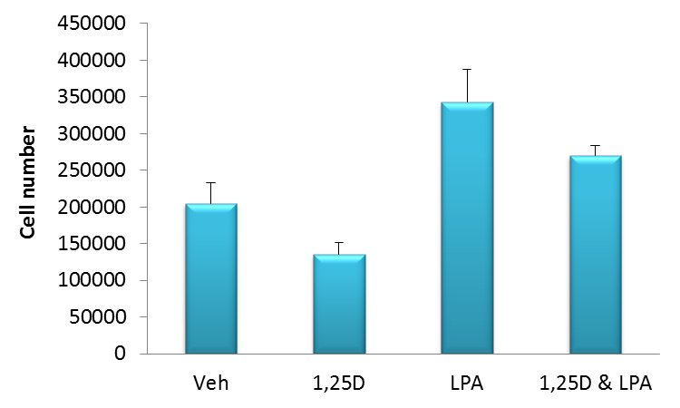
**
*
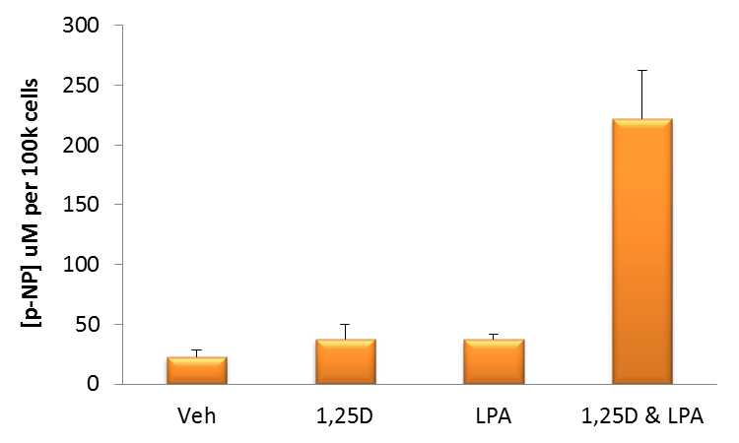
B
*
*

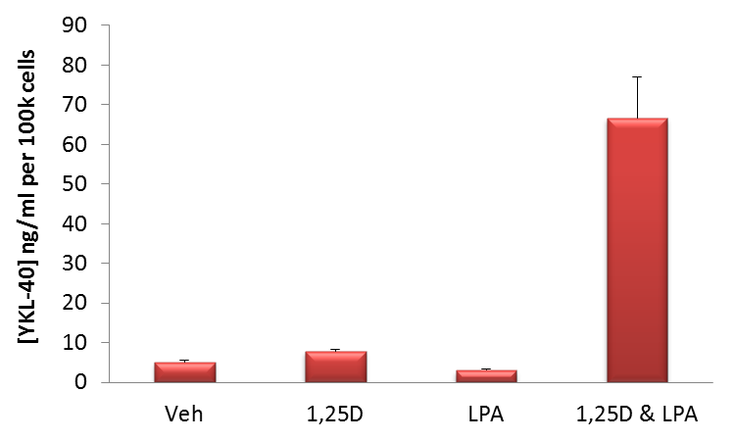
C
*

Figure 2
A
*

**

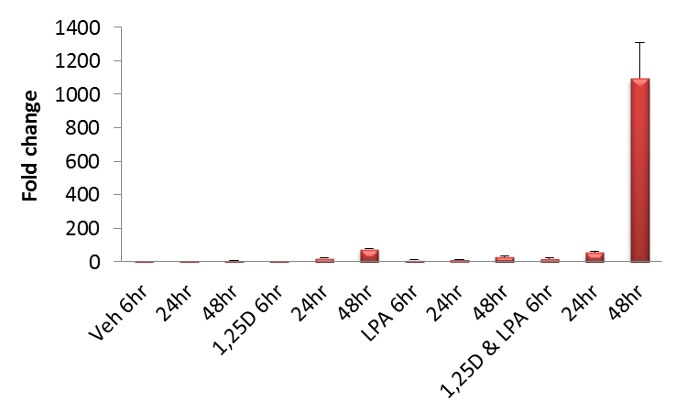
B

Figure 3
A
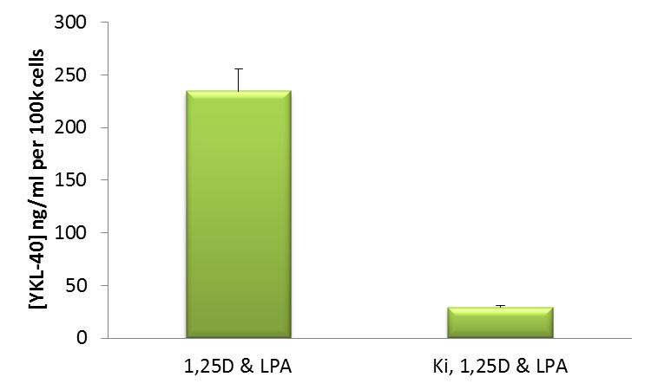

*

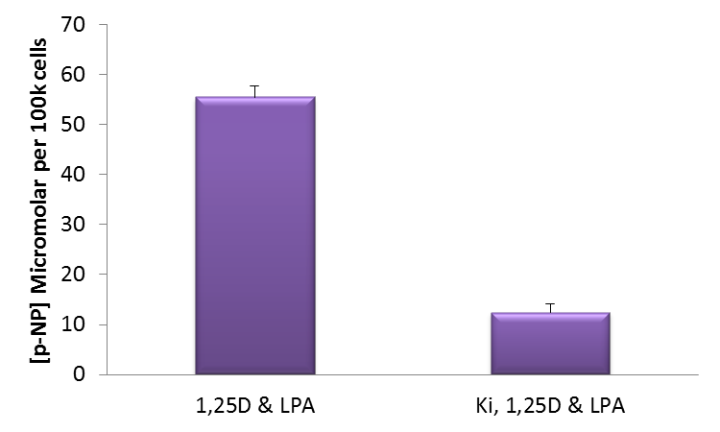
B

*

Figure 4

A
**
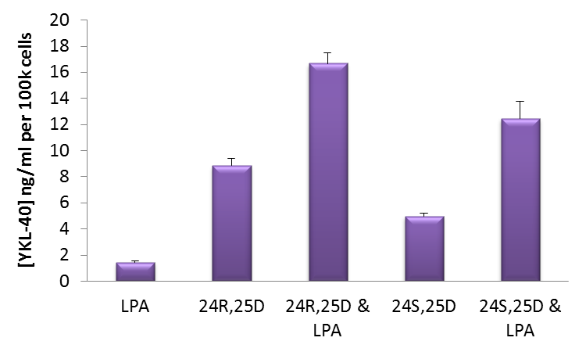
*

*

B
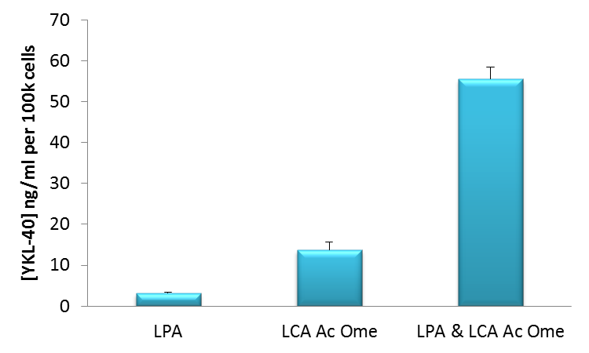
*

Figure 5

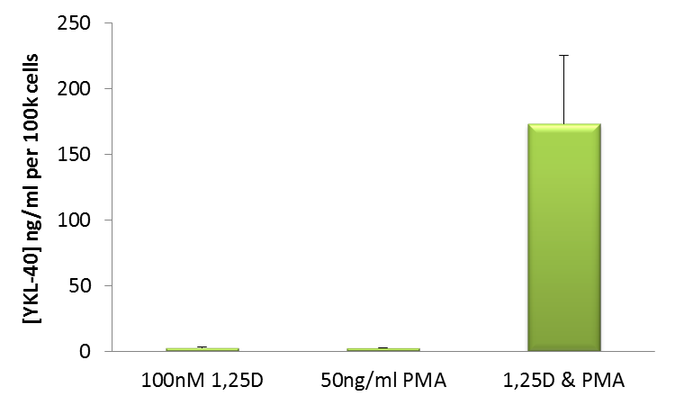
*

Figure & table legends
Figure 1. Co-treating human (MG63) osteoblasts with LPA and 1,25D synergistically enhances YKL-40 expression - A. MG63 osteoblasts were treated with 1,25D (100nM), LPA (10μM) or a combination of these agents and left for three days under conventional cell culturing conditions prior to an assessment of cell growth. As anticipated for the pro-differentiating effects of 1,25D, there were fewer cells (*p<0.01 1,25D versus control) at the end of the culture period. In contrast the application of LPA led to a significant increase in cell numbers (**p<0.01 16:0 LPA versus control). B. Alkaline phosphatase (ALP) is expressed in greater abundance as osteoblasts progress from an immature to a more differentiated phenotype. Enzyme activity is reliably monitored via the hydrolysis of p-nitrophenyl phosphate to p-nitrophenol (p-NP). As anticipated from previously published works, the co-stimulation of MG63 cells with 100nM 1,25D and 10μM LPA yielded significant increases in total ALP activity by 72 h (*p < 0.001 versus agents in isolation). C. Co-stimulated osteoblasts also expressed demonstrably greater quantities of YKL-40 (*p<0.01 versus all other groups) with clear evidence of synergy. In each case the data shown are the mean + SD of 4 replicate samples and are a representative of three independent experiments.

Figure 2. Time and dose response profile for MG63 YKL-40 expression in response to 1,25D and LPA – A. Depicted evidence for temporal changes in osteoblast YKL-40 mobilisation following co-stimulation with varying concentrations of LPA (1.25 – 10μM) and 100nM 1,25D. At 24 hours the concentration of YKL-40 was similar for all groups at around 2ng/ml per 100k cells. After 48 hours there was a clear increase in glycoprotein expression for all groups (**p<0.01) compared with 24hours of treatment. Over the next 24 hours the concentration of YKL-40 continued to rise, the levels being statistically significant for all groups (*p<0.05) when compared to 2 days of culture. The co-treatment of MG63 cells with 5μM LPA and 100nM 1,25D appeared to be the most effective combination for enhancing YKL-40 expression following a 48 hour culture period; p<0.01 versus 1.25μM LPA; p<0.05 versus 2.5 μM LPA; p<0.005 versus 10μM LPA. A similar trend for 5μM LPA and 1,25D was observed following three days of culture wherein p<0.01 on comparison with 1.25μM LPA and p<0.05 versus 2.5μM LPA. The difference observed between 5μM LPA and 1,25D and 10μM LPA with 1,25D did not achieve statistical significance (p=0.11) after 72 hours of culture. B. In keeping with these temporal ELISA data a clear indication of demonstrable YKL-40 gene expression (~1000 fold normalised to GAPDH), as determined via qPCR, for MG63 cells co-exposed to 1,25D (100nM) and LPA (10μM) for 48 hours.
**

Figure 3. The LPA receptor antagonist, Ki16425, inhibits both ALP and YKL-40 expression when osteoblasts are co-stimulated with LPA and 1,25D – The anticipated increase for both YKL-40 (3A) and total ALP (3B) for osteoblasts co-treated with 1,25D (100nM) and LPA (10μM) were markedly reduced (*p<0.001) when the LPA receptor antagonist, Ki16425 (Ki, 10μM), was applied throughout the three day culture period. The data are the mean + SD of 4 replicate samples.
Figure 4. Other ligands of the VDR interact with LPA to enhance MG63 YKL-40 production – A. MG63 osteoblasts were stimulated with LPA (10μM) alone or in combination with either 24R,25D or 25S,25D (both at 100nM) for 3 days prior to quantification of YKL-40 in the conditioned medium. From the data presented it is clear that co-treated cells consistently mobilise greater quantities of YKL-40 (*p<0.01 in each case) but with variable potency; 24R,25D and LPA promoted a greater increase (~ 1.3 fold, **p<0.01) compared to co-treating cells with 24S,25D and LPA. B. Another known agonist of the VDR, LCA Ac Ome (5μM) also converged with LPA (10μM) in stimulating a synergistic increase (*p<0.01) of YKL-40 in the conditioned media of cultured cells.
Figure 5. The phorbol ester, PMA, synergistically co-operates with LPA in stimulating MG63 YKL-40 expression – The potent protein kinase C activator, PMA, was administered to MG63 osteoblasts either alone or in combination with 1,25D for 72hrs under serum-free conditions. It is clear that a combination of PMA and 1,25D result in a demonstrable (*p<0.001), synergistic increase (>10 fold) in YKL-40 production compared to either agent used in isolation.
Table 1. Expression of YKL-40 and alkaline phosphatase in response to LPA and 1,25D is sensitive to inhibitors targeting AP-1, MEK, Sp1 and Stat3 – The ability of 1,25D (100nM) and LPA (10μM) to synergistically enhance YKL-40 production by MG63 osteoblasts could be significantly inhibited (ªp<0.01 in each instance) when co-stimulated cells were exposed to inhibitory agents targeting AP-1 (SR11301, 10μM), MEK (UO126, 10μM), Sp1 (Mithramycin A, 500nM) and Stat3 (S31-201, 10μM). Similarly these same inhibitors reduced (^{b}p<0.01 in each instance) total alkaline phosphatase activity ([p-NP]) and therefore the extent of cellular maturation.

