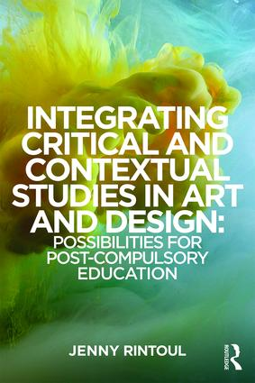

Description

*Integrating Critical and Contextual Studies in Art and Design* examines the relationship between two aspects of art education that appear at times inseparable or even indistinguishable, and at others isolated and in conflict: Critical and Contextual Studies (CCS) and studio practice. Underpinned by international contexts, this book is rooted in British art and design education and draws upon contemporary case studies of teaching and learning in post-compulsory settings in order to analyse and illustrate identities and practices of CCS and its integration.

The chapters in this book are divided into three sections that build on one another: ‘Discourse and debate’; ‘Models, types and tensions’; and ‘Proposals and recommendations’. Key issues include:

* knowledge hierarchies and subject histories and identities;
* constructions of ‘theory’ and the symbiotic relationship between theory and practice;
* models and practices of CCS within current post-compulsory British art and design education;
* the reification of ubiquitous terms in the fields of art and design and of education: *intuition*and *integration*;
* approaches to curriculum integration, including design and management; and
* suggestions for integrating CCS in art and design courses, including implications for pedagogy and assessment.

*Integrating Critical and Contextual Studies in Art and Design* offers a comprehensive analysis of the current drive towards integration within art education, and elucidates what we understand by the theory and practice of integration. It explores the history, theory, teaching and student experience of CCS, and will be of interest to lecturers, teachers and pedagogues involved in art and design as well as researchers and students of art education.

Table of Contents

**1.** CCS in a changing landscape: What is CCS, where has it come from and why be concerned about it in an art and design curriculum? **2.** Theory/Practice: tales of turbulence **3.** The meaning of, and possibilities for, integration **4.** Case study examples: Introducing elements of the research process **5.**Locating theory: the lecture theatre and the studio **6.**Types of ‘Theory’ and Points of Tension: issues of form and content **7.**Subject and staff identities and cultures **8.**Approaches to integrating CCS: Where does integration reside? **9.** Concluding considerations and recommendations

About the Author

**Jenny Rintoul** is a senior lecturer in Visual Culture at the Faculty of Arts, Creative Industries and Education, University of the West of England, UK. She has previously worked as a dancer, a gallery educator and a Further Education (FE) teacher of Art and Design and History of Art. She has taught Critical and Contextual Studies across a range of FE and Higher Education (HE) programmes within Performing Arts, Musical Theatre and Art and Design.