**TITLE PAGE**

**Title:** Development and initial validation of the Bristol Impact of Hypermobility (BIoH) questionnaire

**Authors:** Palmer Sa, Cramp Fa, Lewis Rb, Gould Gc, Clark EMc

**Author affiliations:** aDepartment of Allied Health Professions, University of the West of England, Bristol, UK. [Shea.Palmer@uwe.ac.uk](mailto:Shea.Palmer@uwe.ac.uk), [Fiona.Cramp@uwe.ac.uk](mailto:Fiona.Cramp@uwe.ac.uk)

bDepartment of Physiotherapy, North Bristol NHS Trust, Bristol, UK. [Rachel.Lewis@nbt.nhs.uk](mailto:Rachel.Lewis@nbt.nhs.uk)

cMusculoskeletal Research Unit, University of Bristol, Bristol, UK. [Gin.Gould@googlemail.com](mailto:Gin.Gould@googlemail.com), [Emma.Clark@bristol.ac.uk](mailto:Emma.Clark@bristol.ac.uk)

**Corresponding author:** Professor Shea Palmer, Department of Allied Health Professions, University of the West of England, Blackberry Hill, Bristol, BS16 1DD, UK. Tel. +44 117 3288919, [Shea.Palmer@uwe.ac.uk](mailto:Shea.Palmer@uwe.ac.uk)

**Word count:** 3 303

**ABSTRACT**

**Objectives:** Stage 1: Identify the impact of Joint Hypermobility Syndrome (JHS) on adults; Stage 2: Develop a questionnaire to assess the impact of JHS; Stage 3: Undertake item reduction and establish the questionnaire’s concurrent validity.

**Design:** A mixed methods study, employing qualitative focus groups and interviews (Stage 1); a working group of patients, clinicians and researchers, and ‘think aloud’ interviews (Stage 2); and quantitative analysis of questionnaire responses (Stage 3).

**Setting:** Stages 1 and 2 took place in one secondary care hospital in the United Kingdom (UK). Stage 3 recruited members of a UK-wide patient organisation.

**Participants:** A total of n=15, n=4, and n=615 participants took part in Stages 1, 2 and 3 respectively. Inclusion criteria were: ≥18 years; a diagnosis of JHS; no other conditions affecting physical function; able to give informed consent; and able to understand and communicate in English.

**Interventions:** None.

**Main outcome measures:** The development of a questionnaire to assess the impact of JHS.

**Results:** Stage 1: A wide range of impairments, activity limitations and participation restrictions were identified. Stage 2: A draft questionnaire was developed and refined following ‘think aloud’ analysis, leaving 94 scored items. Stage 3: Items were removed on the basis of low severity and/or high correlation with other items. The final ‘Bristol Impact of Hypermobility’ (BIoH) questionnaire has 55 scored items and correlated well with the Physical Component Score of the Short Form 36 health questionnaire (r=-0.725).

**Conclusions:** The BIoH questionnaire demonstrated good concurrent validity. Further psychometric properties need to be established.

**Key words:** Hypermobility, joint; Joint laxity, familial; Questionnaires; Interview; Focus Groups; Validity of results.

**MANUSCRIPT**

**TITLE**

Development and initial validation of the Bristol Impact of Hypermobility (BIoH) questionnaire

**INTRODUCTION**

Joint Hypermobility Syndrome (JHS) is a heritable connective tissue disorder characterised by excessive joint range of motion and pain [1]. It has been reported to affect up to 5% of women and 0.6% of men [2], although there is a lack of good-quality epidemiological evidence for the true prevalence of JHS in the general population. The prevalence in musculoskeletal practice contexts is likely to be very high, however, with 30% of those referred to a Musculoskeletal Triage Clinic in the United Kingdom (UK) meeting the Brighton diagnostic criteria [3,4].

JHS is associated with a wide range of problems including pain, fatigue, proprioception deficits and repeated cycles of injury, anxiety and catastrophizing [5]. It may also be associated with a range of autonomic and gastrointestinal symptoms, and functional difficulties indicative of developmental coordination disorder/dyspraxia [6]. Empirical data has shown that, when compared with healthy controls, JHS has a significant impact on outcomes such as exercise endurance, gait, pain, proprioception, strength, function and quality of life both in children [7,8,9,10] and adults [11,12,13,14]. A recent systematic review and meta-analysis confirmed the impact of JHS on a range of psychological variables such as fear, agoraphobia, anxiety, depression and panic disorders [15].

Physiotherapy, particularly exercise, is a mainstay of treatment for JHS, although recent systematic reviews highlighted the lack of research evidence [16,17]. The trials in adults included in those reviews used a range of patient reported outcome measures (PROMs), including the Short-Form 36 (SF-36) [18], the Arthritis Impact Measurement Scales 2 (AIMS-2) [13] and a questionnaire developed by Barton and Bird [19]. Of those, only the SF-36 captured improvements following exercise [18]. Only one of the five AIMS-2 subscales changed with exercise [13] and there were no changes evident in Barton and Bird’s questionnaire [19]. So, if exercise is effective (which has yet to be convincingly demonstrated [16]), only the SF-36 seemed to demonstrate sufficient measurement sensitivity. Closer inspections of these PROMs identify a lack of face, content and construct validity [20] for many issues reported by people with JHS [5]. For example Barton and Bird’s questionnaire [19] focused on lower limb activity (such as going up and down stairs, squatting, standing up and walking), failing to reflect upper limb functional difficulties. Neither the process of development nor the psychometric properties of the questionnaire were reported. A recent survey of physiotherapy practice in the UK [21] highlighted a lack of congruence between the aims of physiotherapy management for JHS and the tools used to assess the effectiveness of management. There is therefore a need to develop a condition-specific, psychometrically sound, outcome measure to underpin future research and clinical practice in this area.

This project had a number of related aims. Stage 1: To identify the impact of JHS on adults with the condition to inform initial patient-specific questionnaire items; Stage 2: To develop a questionnaire to assess the personal impact of JHS; Stage 3: To reduce the number of questionnaire items and establish the concurrent validity of the new questionnaire against the SF-36.

**METHOD**

Ethical approval was obtained from the South West 5 NHS Research Ethics Committee (10/H0107/46). The research was conducted in three stages as follows.

* Stage 1 – Identification of questionnaire items. Methods: focus groups and telephone interviews with people with JHS.
* Stage 2 – Development of the initial questionnaire. Methods: working group of patient research partners and researchers; ‘think aloud’ evaluation.
* Stage 3 – Item reduction and validation of the questionnaire. Methods: administration of the initial questionnaire and SF-36 to members of the Hypermobility Syndromes Association (HMSA), a UK-based patient organisation; item removal; assessment of the concurrent validity of the final questionnaire items against the SF-36; production of the final questionnaire.

**Participants**

Inclusion criteria (Stages 1-3): Diagnosed with JHS; ≥18 years old; no other formally diagnosed conditions affecting physical function (such as inflammatory arthritis, osteoarthritis or neurological conditions); able to give informed consent; able to understand and communicate in English. Stage 2 also recruited all five members of the research team.

The sources of recruitment at each stage were as follows.

Stages 1-2: Patients who met the Brighton criteria [3] for JHS (confirmed by a physiotherapist) who had been seen by the physiotherapy service at North Bristol NHS Trust in the previous two years were sent an invitation letter, participant information sheet and a reply slip. All participants completed informed signed consent. Two patient research partners (people with JHS who advised on the design and conduct of all aspects of the research, including the wording of patient information sheets and consent forms, and sat as equal members of a study steering group), and one further person with JHS who contributed to the working group during Stage 2 were recruited from the same cohort.

Stage 3: Adult members of the HMSA were sent an invitation letter, participant information sheet and a copy of the questionnaires. Diagnosis of JHS was self-declared. Completion and return of the questionnaires was taken as implied consent.

**Procedure**

***Stage 1***

Two focus groups with people with JHS were conducted to explore the impact of the condition. An option to undertake a telephone interview was provided for those who were unable or unwilling to attend a focus group. A loose topic guide was used to steer the focus group and interview discussions. The same researcher (GG) conducted all focus groups and interviews, with another researcher (SP) taking notes during the focus groups to aid transcription. Focus groups and interviews were audio-recorded, transcribed verbatim and anonymised. Open coding of the transcripts was used to identify individual questionnaire items, and codes were discussed in detail and verified by two researchers (GG and SP). Thematic analysis of the data did not progress beyond this first level of coding as the aim was limited to identification of individual items.

***Stage 2***

A working group was convened to develop the initial questionnaire. The group comprised three people with JHS (including two patient research partners) and five researchers. The researchers included clinical and academic expertise in physiotherapy and medical rheumatology and expertise in outcome measure development. Meetings were supplemented by e-mail and telephone correspondence and two researchers (GG and SP) took the lead in developing and revising draft questionnaires between meetings based on working group feedback and discussion. The working group initially discussed in detail the items developed from Stage 1 and agreed the specific wording of individual questions and response options, and the overall design of a first draft questionnaire. The three Bristol Rheumatoid Arthritis Fatigue Numerical Rating Scales (BRAF-NRS) [22,23] were included with permission. The BRAF-NRS assess intensity of, effect of and coping with fatigue and, although developed for Rheumatoid Arthritis, have generic wording. This first draft questionnaire was then subjected to ‘think aloud’ analysis (also known as cognitive interviewing [24]) where people with JHS were asked to verbalise their thoughts whilst completing the questionnaire. This method was used to explore patients’ understanding of the questions and their responses to them. Interviews were audio-recorded, transcribed and anonymised. The transcriptions were analysed question by question to identify any salient points and a report was produced for the working group. Further refinements were then made and the initial JHS questionnaire agreed with the working group.

***Stage 3***

An invitation letter, participant information sheet, a copy of the questionnaires (the initial JHS questionnaire, SF-36 and a demographics questionnaire) and a pre-paid return envelope were distributed by mail to all 1 502 adult members of the HMSA (identified by the membership secretary). No reminders were sent. Completed questionnaires were systematically entered into an IBM SPSS Statistics spreadsheet by a research associate employed on the project. Data accuracy was audited and verified by the lead author (SP). SF-36 scoring software v4.5 (Optum Insight) was used to calculate SF-36 component and subscale scores. Descriptive statistics and Kolmogorov-Smirnov tests for normality of data distributions were calculated for all items. A correlation matrix using Spearman’s Rank Correlation coefficients was produced to investigate the relationships between all scored items on the JHS questionnaire. Two criteria were then employed to inform decisions on whether to remove or retain individual items (although the BRAF-NRS were retained unaltered).

1. Median score ≤40% severity. This criterion helped to identify items that were considered relatively less important.
2. Strong correlations (r≥0.7) between individual items. This criterion helped to identify items that were potentially redundant (i.e. multiple items may have been measuring similar things). The wording of strongly correlated items were looked at closely and an iterative process was used to inform which questions should be retained and which should be removed.

The scores for the final JHS questionnaire items were then added to give a total score and this was correlated against the component and subscale scores of the SF-36 to test concurrent validity.

Given the pragmatic design of the questionnaire, including incorporation of the BRAF-NRS and the range of different response categories employed, it was considered inappropriate to try to identify separate domains within the JHS questionnaire using exploratory factor analysis.

**RESULTS**

**Stage 1**

Stage 1 recruited 15 people with JHS and they contributed to two focus groups (both n=6/15) and telephone interviews (n=3/15). 13/15 (86.7%) were women. 2/15 (13.3%) were aged 18-25 years, 7/15 (46.7%) 26-35 years, and 6/15 (40.0%) 36-45 years. A wide range of issues related to the impact of JHS were raised, encompassing impairment, activity limitations and participation restrictions [25]. The issues identified included items common to many other long term musculoskeletal conditions, such as pain and fatigue and difficulties with standing, walking and negotiating stairs. However there were other more specific issues identified such as balance and coordination problems, unexpected pain, joints giving way and weakness. It was also clear that participants commented on both the intensity and frequency of issues.

**Stage 2**

The working group devised a draft questionnaire relatively easily, using a mixture of numerical rating scales (similar to the BRAF-NRS) and Likert scales. It was decided that questions with common response options should be grouped together to facilitate navigation and completion and that larger scores should equate to greater impact. Four participants (all women, aged 19-40 years) took part in the think aloud analysis and the draft questionnaire was generally very well received, with the questions and response options generally clear. Participants stated that there was some repetition, with similar questions asked in slightly different ways, but the working group decided to keep all questions as part of Stage 3 was designed to identify closely correlated questions. The findings of the think aloud analysis informed a few minor changes to wording but was otherwise useful in confirming the face validity of the draft questionnaire. The individual questionnaire items and response options are evident from the final ‘Bristol Impact of Hypermobility’ (BIoH) questionnaire (supplemental material) and from Table 3 (those items that were later excluded). The resultant draft questionnaire contained 94 scored items (and a further 10 identifying area of pain).

***Stage 3***

A total of 636/1 502 responses were received (42.3% response rate), of which 21 were excluded (reasons for exclusion: 12 aged <18 years; 9 omitted at least one section of the JHS questionnaire meaning that a total score could not be calculated). The remaining 615 were included in analysis.

Kolmogorov-Smirnov tests revealed that the data for age, individual JHS questionnaire items and the majority of SF-36 subscales deviated from normality (all p<0.001). The only exception was the SF-36 Physical Component Score (p=0.200). Non-parametric analyses were therefore employed throughout.

The median (IQR) age of participants was 39 (17) years. 81/599 (13.5%) were aged 18-25 years, 156/599 (26.0%) 26-35 years, 186/599 (31.1%) 36-45 years, 100/599 (16.7%) 46-55 years, 56/599 (9.3%) 56-65 years, 18/599 (3.0%) 66-75 years, and 2/599 (0.3%) 76-85 years. Other participant characteristics are presented in Table 1. The majority were women (582/614, 94.8%) of white ethnicity (602/614, 98.0%). Participants were generally well educated (292/519, 56.3% had a university degree or equivalent) and a slight majority were in paid employment (339/600, 56.5%).

**Insert Table 1 here.**

Participants complained of pain in a wide range of painful areas (Table 2). Figure 1 illustrates the total number of painful areas reported by participants. The median (IQR, range) number of painful areas was 8.0 (3.0, 0-10).

**Insert Table 2 here.**

**Insert Figure 1 here.**

A total of 39 questions were removed on the basis of a median score ≤40% and/or a strong correlation with other questions (r≥0.7) (supplemental information 1).

The remaining 55 questionnaire items comprised the final ‘Bristol Impact of Hypermobility’ (BIoH) questionnaire and gave a single composite score of 360, with higher scores representing more severe impact (please see supplemental information 2 and 3). It takes approximately 10 minutes to complete. The median (IQR, range) BIoH score was 234 (81, 55-355). The total BIoH scores were correlated against the SF-36 scores to investigate concurrent validity and the results are presented in Table 3.

**Insert Table 3 here.**

The BIoH questionnaire correlated most closely with the Physical Component Score (PCS) (r=-0.725), reflecting less the Mental Component Score (MCS) (r=-0.447). This was also reflected in the subscales, with high correlation coefficients (r≥-0.7) for physical function, role physical and bodily pain. The only MCS subscale that had a strong correlation with the BIoH questionnaire values was social functioning. 88% (541/615) and 52% (320/615) of the cohort were below general population norms for the SF36 PCS and MCS respectively. There was no correlation between age and total BIoH score (Spearman’s Rank Correlation Coefficient r=-0.070, p=0.085).

The median (IQR) BRAF-NRS scores for severity, effect and coping were 7.0 (2.0), 7.0 (4.0) and 4.0 (4.0) respectively, indicating that people with JHS experience a high level of fatigue, it has a strong effect on their lives, but that they cope with fatigue relatively well. The mean (SD) values were 6.8 (2.1), 6.6 (2.6) and 4.1 (2.4) respectively.

**DISCUSSION**

The new BIoH questionnaire is the first condition-specific tool validated for JHS. It was developed in close collaboration with people with JHS and seems comprehensive in reflecting items of importance. Scores correlate strongly with the PCS of the SF-36, with the strongest relationship being evident with Bodily Pain (BP) domain scores. Correlation with the MCS of the SF-36 was much more modest. This suggests that the BIoH questionnaire predominantly captures information about physical function rather than psychological function. Given the predominance of physical function items identified by focus group and interview participants, this seems an appropriate finding. It may be that further one-to-one interviews may have elicited further participation-level outcomes of importance to individuals, as such issues may be more difficult to discuss in a focus group context.

There was a very high prevalence of pain in a wide range of body areas, many of which are not reflected in the current Brighton diagnostic criteria [3], such as the shoulders and neck. It should be noted that the wording of the BIoH questionnaire does not distinguish between unilateral and bilateral pain and therefore the actual number of areas is likely to be higher than reported here. However there was a clear trend towards participants reporting a high number of affected body areas, with the highest reported prevalence being of pain in all ten areas. Self-reported tender joint counts are used in other conditions such as rheumatoid arthritis (RA) and have been found to correlate well with clinician assessment [26]. It is difficult to directly compare data due to differing methodologies but Scott and Scott [27] reported that only 25% of consecutive people with RA (n=307) reported 6 or more tender joints out of 28 joints assessed. This threshold equates to just over 20% of the joints assessed. By way of comparison, 99.2% (609/614) respondents in the current study reported pain in 20% (two or more) of the 10 body areas assessed. In fibromyalgia the mean ‘tender point’ count has been reported as 14.7 out of 18 [28], although these no longer form part of the diagnostic criteria and they include a mixture of joint and muscle points. Nevertheless the prevalence is akin to that identified for JHS in the present study. Clark et al [6] identified that 19% of people with JHS reported a concomitant diagnosis of fibromyalgia and therefore some overlap is to be expected. What is clear is that pain in multiple body areas seems to be a very significant issue in the JHS population described here.

Terry et al [5] identified fatigue as one of the major factors associated with JHS. The BIoH questionnaire therefore included the three BRAF-NRS questions which assess fatigue severity, effect and coping. In RA the mean (SD) BRAF-NRS scores have been reported as follows (n=229): severity 6.8 (1.8), effect 6.5 (2.2), and coping 5.7 (2.3) [22]. The present study has found that people with JHS seem to experience fatigue levels that are very similar to people with RA, certainly in terms of severity and effect. Interestingly, the coping with fatigue question is reverse scored, with patients choosing a lower score to represent worse coping. Many respondents in the present study seem to have scored this question inappropriately, choosing a high score when they had also chosen a high score for severity and effect (and vice-versa). Our addition of a note on how to score this item may have caused some confusion for respondents. For the purpose of analysis the scores for this item were calculated as described by the developers [22] but there is a question mark over the appropriateness of some responses. The very small contribution of this one item to the overall BIoH score is unlikely to have affected the findings.

Although the results of the initial validation of the BIoH questionnaire are promising, it should be noted that other psychometric properties such as test-retest reliability, sensitivity to change and the minimum clinically important difference have yet to be established. Given its condition-specific focus, it is anticipated that the BIoH questionnaire will be sensitive to changes in physical function which is a key aim of physiotherapy management [21]. However this requires future verification.

**Limitations and strengths**

The response rate in Stage 3 (636/1 502, 42.3%) might have been improved through strategies such as sending reminders or providing an online response option. Respondents to Stage 3 included a slightly older age range than those who contributed to the Stage 1 development of the questionnaire items, although 71% were in the same 18-45 year age range (423/599) and no relationship was observed between age and total BIoH score. The proportion of women was largely similar between Stage 1 and Stage 3. Validation has therefore been conducted on a generally similar group to that which generated the questionnaire items. Members of the HMSA who responded to the questionnaire self-declared a diagnosis of JHS and this was not confirmed clinically. It should therefore be acknowledged that some respondents might have had other conditions. The questionnaire was not subjected to factor analysis to inform item reduction and questionnaire structure. The pragmatic design of the questionnaire, including the use of a range of different response options and adoption of the BRAF-NRS questions, complicated the effective use of factor analysis for these purposes. In hindsight, a more standardised approach to response options might have facilitated further refinement of the questionnaire. The range of response options has also resulted in some items that attract a maximum score of 5 and others a maximum score of 10. The appropriateness of the relative weighting of questions is currently unknown, although the median total BIoH scores were almost identical when these items were scored out of 10 (median score 234/360, 65.0%) as opposed to out of 5 (180.5/275, 65.6%). This is therefore unlikely to be a significant issue unless those items were to be affected differentially by an improvement or deterioration in the condition and this would need to be determined in future research. On a positive note, a very inclusive development process was employed which worked well. Initial validation has also been conducted on a very large sample size (n=615), although it should be noted that the sample lacked diversity with regards ethnicity, gender and educational attainment.

**Conclusion and future directions**

The new BIoH questionnaire has demonstrated initial potential to inform future research and clinical practice in this under-recognised and poorly managed condition. Future research needs to be conducted to determine other psychometric properties such as test-retest reliability, sensitivity to change, the minimum clinically important difference, and other aspects of validity, including Rasch analysis.

**Ethical Approval:** Ethical approval was obtained from the South West 5 NHS Research Ethics Committee (10/H0107/46).

**Funding:** This work was supported by funding from the North Bristol NHS Trust Flexibility & Sustainability Fund and from the University of the West of England, Faculty of Health & Life Sciences.

**Conflict of Interest:** None declared.

**Acknowledgements:** We would like to acknowledge the assistance of the Hypermobility Syndromes Association in recruiting people with JHS and to thank all of the participants for taking part in the research. Thank you to our patient research partners Alison Cossons and Jennifer Elvin. Thank you to Shahid Muhammad for completing questionnaire data entry. The Short-Form 36 questionnaire was used under license from OptumInsight (license number QM013824).

**REFERENCES**

[1] Grahame R. Hypermobility and hypermobility syndrome. In: Keer R, Grahame R, editors. Hypermobility syndrome. Recognition and management for physiotherapists. Edinburgh: Butterworth-Heinemann; 2003.

[2] Simpson MR. Benign joint hypermobility syndrome: evaluation, diagnosis and management. J Am Osteopath Assoc Clin Pract 2006;106(9):531-6.

[3] Grahame R, Bird HA, Child A. The revised (Brighton 1998) criteria for the diagnosis of benign joint hypermobility syndrome (BJHS). J Rheumatol 2000; 27:1777-9.

[4] Connelly E, Hakim A, Davenport HS, Simmonds JV. A study exploring the prevalence of joint hypermobility syndrome in patients attending a musculoskeletal triage clinic. Physiother Pract Res 2015;36(1):43-53.

[5] Terry R, Palmer S, Rimes K, Clark C, Simmonds J, Horwood J. Living with joint hypermobility syndrome: Patient experiences of diagnosis, referral and self-care. Fam Pract 2015;32(3):354-8.

[6] Clark C, Khattab A, Carr E. Chronic widespread pain and neurophysiological symptoms in joint hypermobility syndrome (JHS). Int J Ther Rehabil 2014;21(2):60-7.

[7] Engelbert RH, van Bergen M, Henneken T, Helders PJ, Takken T. Exercise tolerance in children and adolescents with musculoskeletal pain in joint hypermobility and joint hypomobility syndrome. Pediatrics 2006;118:e690-6.

[8] Fatoye F, Palmer S, Macmillan F, Rowe P, van der Linden M. Proprioception and muscle torque deficits in children with hypermobility syndrome. Rheumatology 2009;48:152-7.

[9] Fatoye F, Palmer S, Macmillan F, Rowe P, van der Linden M. Gait kinematics and passive knee joint range of motion in children with hypermobility syndrome. Gait Posture 2011;33:447-51.

[10] Fatoye F, Palmer S, Macmillan F, Rowe P, van der Linden M. Pain intensity and quality of life perception in children with hypermobility syndrome. Rheumatol Int 2012;32(5):1277-84.

[11] Mallik AK, Ferrell WR, McDonald A. Impaired proprioceptive acuity at the proximal interphalangeal joint in patients with the hypermobility syndrome. Brit J Rheumatol 1994;33:631-7.

[12] Hall MG, Ferrell WR, Sturrock RD, Hamblen DL, Baxendale RH. The effect of the hypermobility syndrome on knee joint proprioception. Br J Rheumatol 1995;34:121-5.

[13] Sahin N, Baskent A, Cakmak A, Salli A, Ugurlu H, Berker E. Evaluation of knee proprioception and effects of proprioception exercise in patients with benign joint hypermobility syndrome. Rheumatol Int 2008;28:995-1000.

[14] Sahin N, Baskent A, Ugurlu H, Berker E. Isokinetic evaluation of knee extensor/flexor muscle strength in patients with hypermobility syndrome. Rheumatol Int 2008;28:643-8.

[15] Smith T, Easton V, Bacon H, Jerman E, Armon K, Poland F, et al. The relationship between benign joint hypermobility syndrome and psychological distress: a systematic review and meta-analysis. Rheumatology 2014;53:114-22.

[16] Palmer S, Bailey S, Barker L, Barney L, Elliott A. The effectiveness of therapeutic exercise for joint hypermobility syndrome: a systematic review. Physiotherapy 2014;100:220-7.

[17] Smith TO, Bacon H, Jerman E, Easton V, Armon K, Poland F, et al. Physiotherapy and occupational therapy interventions for people with benign joint hypermobility syndrome: a systematic review of clinical trials. Disabil Rehabil 2014;36(10):797-803.

[18] Ferrell WR, Tennant N, Sturrock RD, Ashton L, Creed G, Brydson G, et al. Amelioration of symptoms by enhancement of proprioception in patients with joint hypermobility syndrome. Arthritis Rheum 2004;50:3323-8.

[19] Barton LM, Bird HA. Improving pain by the stabilization of hyperlax joints. J Orthop Rheumatol 1996;9:46-51.

[20] Keszei AP, Novak M, Streiner DL. Introduction to health measurement scales. J Psychosom Res 2010;68(4):319-23.

[21] Palmer S, Cramp F, Lewis R, Muhammad S, Clark E. Diagnosis, management and assessment of adults with joint hypermobility syndrome: a UK-wide survey of physiotherapy practice. Musculoskelet Care 2015;13(2):101-11

[22] Nicklin J, Cramp F, Kirwan J, Greenwood R, Urban M, Hewlett S. Measuring fatigue in rheumatoid arthritis: A cross-sectional study to evaluate the Bristol Rheumatoid Arthritis Fatigue Multi-Dimensional questionnaire, visual analog scales, and numerical rating scales. Arthrit Care Res 2010;62:1559-68.

[23] Dures EK, Hewlett SE, Cramp FA, Greenwood R, Nicklin JK, Urban M, et al. Reliability and sensitivity to change of the Bristol Rheumatoid Arthritis Fatigue scales. Rheumatology 2013;52(10):1832-9.

[24] Drennan J. Cognitive interviewing: verbal data in the design and pretesting of questionnaires. J Adv Nurs 2003;42(1):57-63.

[25] World Health Organization. Towards a common language for functioning, disability and health: ICF (The International Classification of Functioning, Disability and Health). Geneva: World Health Organization; 2002.

[26] Radner H, Grisar J, Smolen JS, Stamm T, Aletaha D. Value of self-performed joint counts in rheumatoid arthritis patients near remission. Arthritis Res Ther 2012;14:R61.

[27] Scott IC, Scott DL. Joint counts in inflammatory arthritis. Clin Exp Rheumatol 2014;32(Suppl. 85):S7-S12.

[28] Lindell L, Bergman S, Petersson IF, Jacobsson LTH, Herrström P. Prevalence of fibromyalgia and chronic widespread pain. Scand J Prim Health Care, 2000;18(3):149-53.

**FIGURE CAPTION**

**Figure 1. The total number of painful areas reported by individuals (n=614 valid responses).** Participants were asked “During the past 7 days, have you had pain in any of the following areas?” and were given response options of ‘yes’ or ‘no’ to 10 areas.

|  |  |  |
| --- | --- | --- |
| Characteristic  (number of valid responses) | Response  (number of responses) | % of valid responses |
| Sex (614) | Women (582) | 94.8 |
| Men (32) | 5.2 |
| Ethnicity (614) | White (602) | 98.0 |
| Mixed (5) | 0.8 |
| Asian (2) | 0.3 |
| Black (1) | 0.2 |
| Chinese (1) | 0.2 |
| Other (3) | 0.5 |
| Relationship status (612) | Single (177) | 28.9 |
| Married/partner (378) | 61.8 |
| Divorced/separated (48) | 7.8 |
| Widowed (7) | 1.1 |
| Other (2) | 0.3 |
| Living arrangements (595) | Alone (96) | 16.1 |
| With husband/ wife/ partner (356) | 59.8 |
| With somebody else (143) | 24.0 |
| Education* | College diploma or equivalent (302/482) | 62.7 |
| University degree or equivalent (292/519) | 56.3 |
| Postgraduate degree (e.g. PhD) (76/392) | 19.4 |
| Currently in paid employment (600) | Yes (339) | 56.5 |
| No (261) | 43.5 |
| Hours of paid employment (324) | Part-time (160) | 49.4 |
| Full-time (159) | 49.1 |
| Not applicable (5) | 1.5 |
| Employment status (302) | Self-employed (49) | 16.2 |
| Employee (248) | 82.1 |
| Self-employed and employee (1) | 0.3 |
| Not applicable (4) | 1.3 |

**Table 1. Characteristics of responders to Stage 3.** * More than one response could be selected so total n not reported and total % may be more than 100%.

|  |  |
| --- | --- |
| *“During the past 7 days, have you had pain in any of the following areas?”* (number of valid responses) | Number responding ‘Yes’ (% of valid responses) |
| Back (613) | 550 (89.7) |
| Knees (611) | 524 (85.8) |
| Shoulders (611) | 513 (84.0) |
| Hips (610) | 506 (83.0) |
| Neck (601) | 480 (79.9) |
| Hands (605) | 477 (78.8) |
| Wrists (604) | 470 (77.8) |
| Feet (606) | 439 (72.4) |
| Ankles (603) | 400 (66.3) |
| Elbows (596) | 292 (49.0) |

**Table 2. Site of pain.** Results are presented in order of frequency.

|  |  |  |
| --- | --- | --- |
| Question | Reason for removal | |
| **Median score**  **≤40%** | **Correlation**  **≥0.7** |
| C. Please tick the box which best describes how much, during the past 7 days, hypermobility has affected… | | |
| the clothing you have worn | ✓ | 🗶 |
| D. How often… | | |
| have your hands seized up during the past 7 days? | ✓ | 🗶 |
| have you had difficulty getting comfortable in bed during the past 7 days? | 🗶 | ✓ |
| have you had trouble sleeping due to hypermobility during the past 7 days? | 🗶 | ✓ |
| has hypermobility kept you from your usual activities during the past 7 days? | 🗶 | ✓ |
| have you had difficulty walking a distance that would usually be OK for you during the past 7 days? | ✓ | 🗶 |
| has it been difficult to do your usual work activities (including unpaid work such as housework) during the past 7 days? | 🗶 | ✓ |
| has it been difficult to do your usual hobbies during the past 7 days? | 🗶 | ✓ |
| E. How much difficulty have you had with the following tasks during the past 7 days due to hypermobility? | | |
| Holding a mug or cup | ✓ | 🗶 |
| Doing up buttons | ✓ | ✓ |
| Picking up a coin | ✓ | ✓ |
| Washing dishes | ✓ | 🗶 |
| Using a door handle or lever | ✓ | 🗶 |
| Putting on socks | ✓ | ✓ |
| Getting out of a car | ✓ | 🗶 |
| Making sharp turns while walking or running | 🗶 | ✓ |
| Pushing a shopping trolley or pushchair | ✓ | 🗶 |
| Getting dressed | ✓ | ✓ |
| Raising your hands above your head repeatedly, e.g. to straighten hair or change a light bulb | 🗶 | ✓ |
| Turning over in bed | ✓ | 🗶 |
| Brushing or combing hair | ✓ | 🗶 |
| Pulling a light switch cord | ✓ | 🗶 |
| Holding a frying pan | 🗶 | ✓ |
| Using a computer mouse or keyboard | ✓ | 🗶 |
| Getting out of bed without assistance | ✓ | ✓ |
| F. How much discomfort would you have had after the following activities during the past 7 days? | | |
| Climbing one flight of stairs | 🗶 | ✓ |
| Going down one flight of stairs | ✓ | ✓ |
| Going up or down a flight of stairs without a handrail | 🗶 | ✓ |
| Walking at your own pace for 5 minutes | ✓ | ✓ |
| Walking briskly for 5 minutes | 🗶 | ✓ |
| G. Please circle the number which best indicates… | | |
| how able you have felt to cope with pain during the past 7 days | 🗶 | ✓ |
| thinking about what you are usually able to do, how much you have felt in control of your ability to do your usual activities during the past 7 days | 🗶 | ✓ |
| how much pain has interfered with your ability to take part in social or family activities during the past 7 days | 🗶 | ✓ |
| H. Please tick the box which best indicates your agreement with the following statements. | | |
| I am concerned about tripping or falling over when I am out and about | 🗶 | ✓ |
| I feel unsteady on my feet | 🗶 | ✓ |
| I feel anxious about falling or tripping | 🗶 | ✓ |
| I can control the position of my limbs | 🗶 | ✓ |
| I am able to cope with my pain | 🗶 | ✓ |
| I am able to manage my pain | 🗶 | ✓ |

**Supplemental information 1. Details of the removed questionnaire items and reasons for their exclusion.** ✓ = Met this criterion and used to inform removal of this item. 🗶 = Did not meet this criterion.

|  |  |  |  |
| --- | --- | --- | --- |
| SF36 Domains | | Median (IQR) | Spearman’s Rank Correlation Coefficient (r) |
| Physical Component Score (PCS) | | 31.9 (14.5) | -0.725* |
|  | Physical Functioning (PF) | 40.0 (45.0) | -0.779* |
| Role Physical (RP) | 34.4 (43.8) | -0.756* |
| Bodily Pain (BP) | 31.0 (29.0) | -0.787* |
| General Health (GH) | 27.0 (30.0) | -0.567* |
| Mental Component Score (MCS) | | 44.1 (17.6) | -0.447* |
|  | Vitality (VT) | 25.0 (25.0) | -0.624* |
| Social Functioning (SF) | 50.0 (50.0) | -0.717* |
| Role Emotional (RE) | 75.0 (50.0) | -0.476* |
| Mental Health (MH) | 65.0 (30.0) | -0.455* |

**Table 3. Median SF-36 component scores and correlation against the total BIoH score.** * All p<0.001.

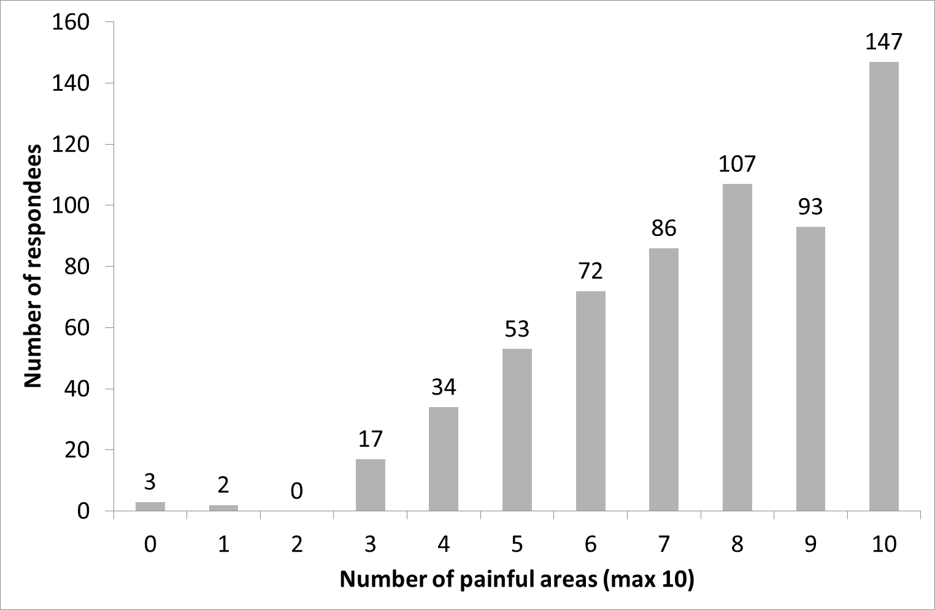

**Figure 1.**

**Supplemental information 2. The Bristol Impact of Hypermobility (BIoH) questionnaire.**

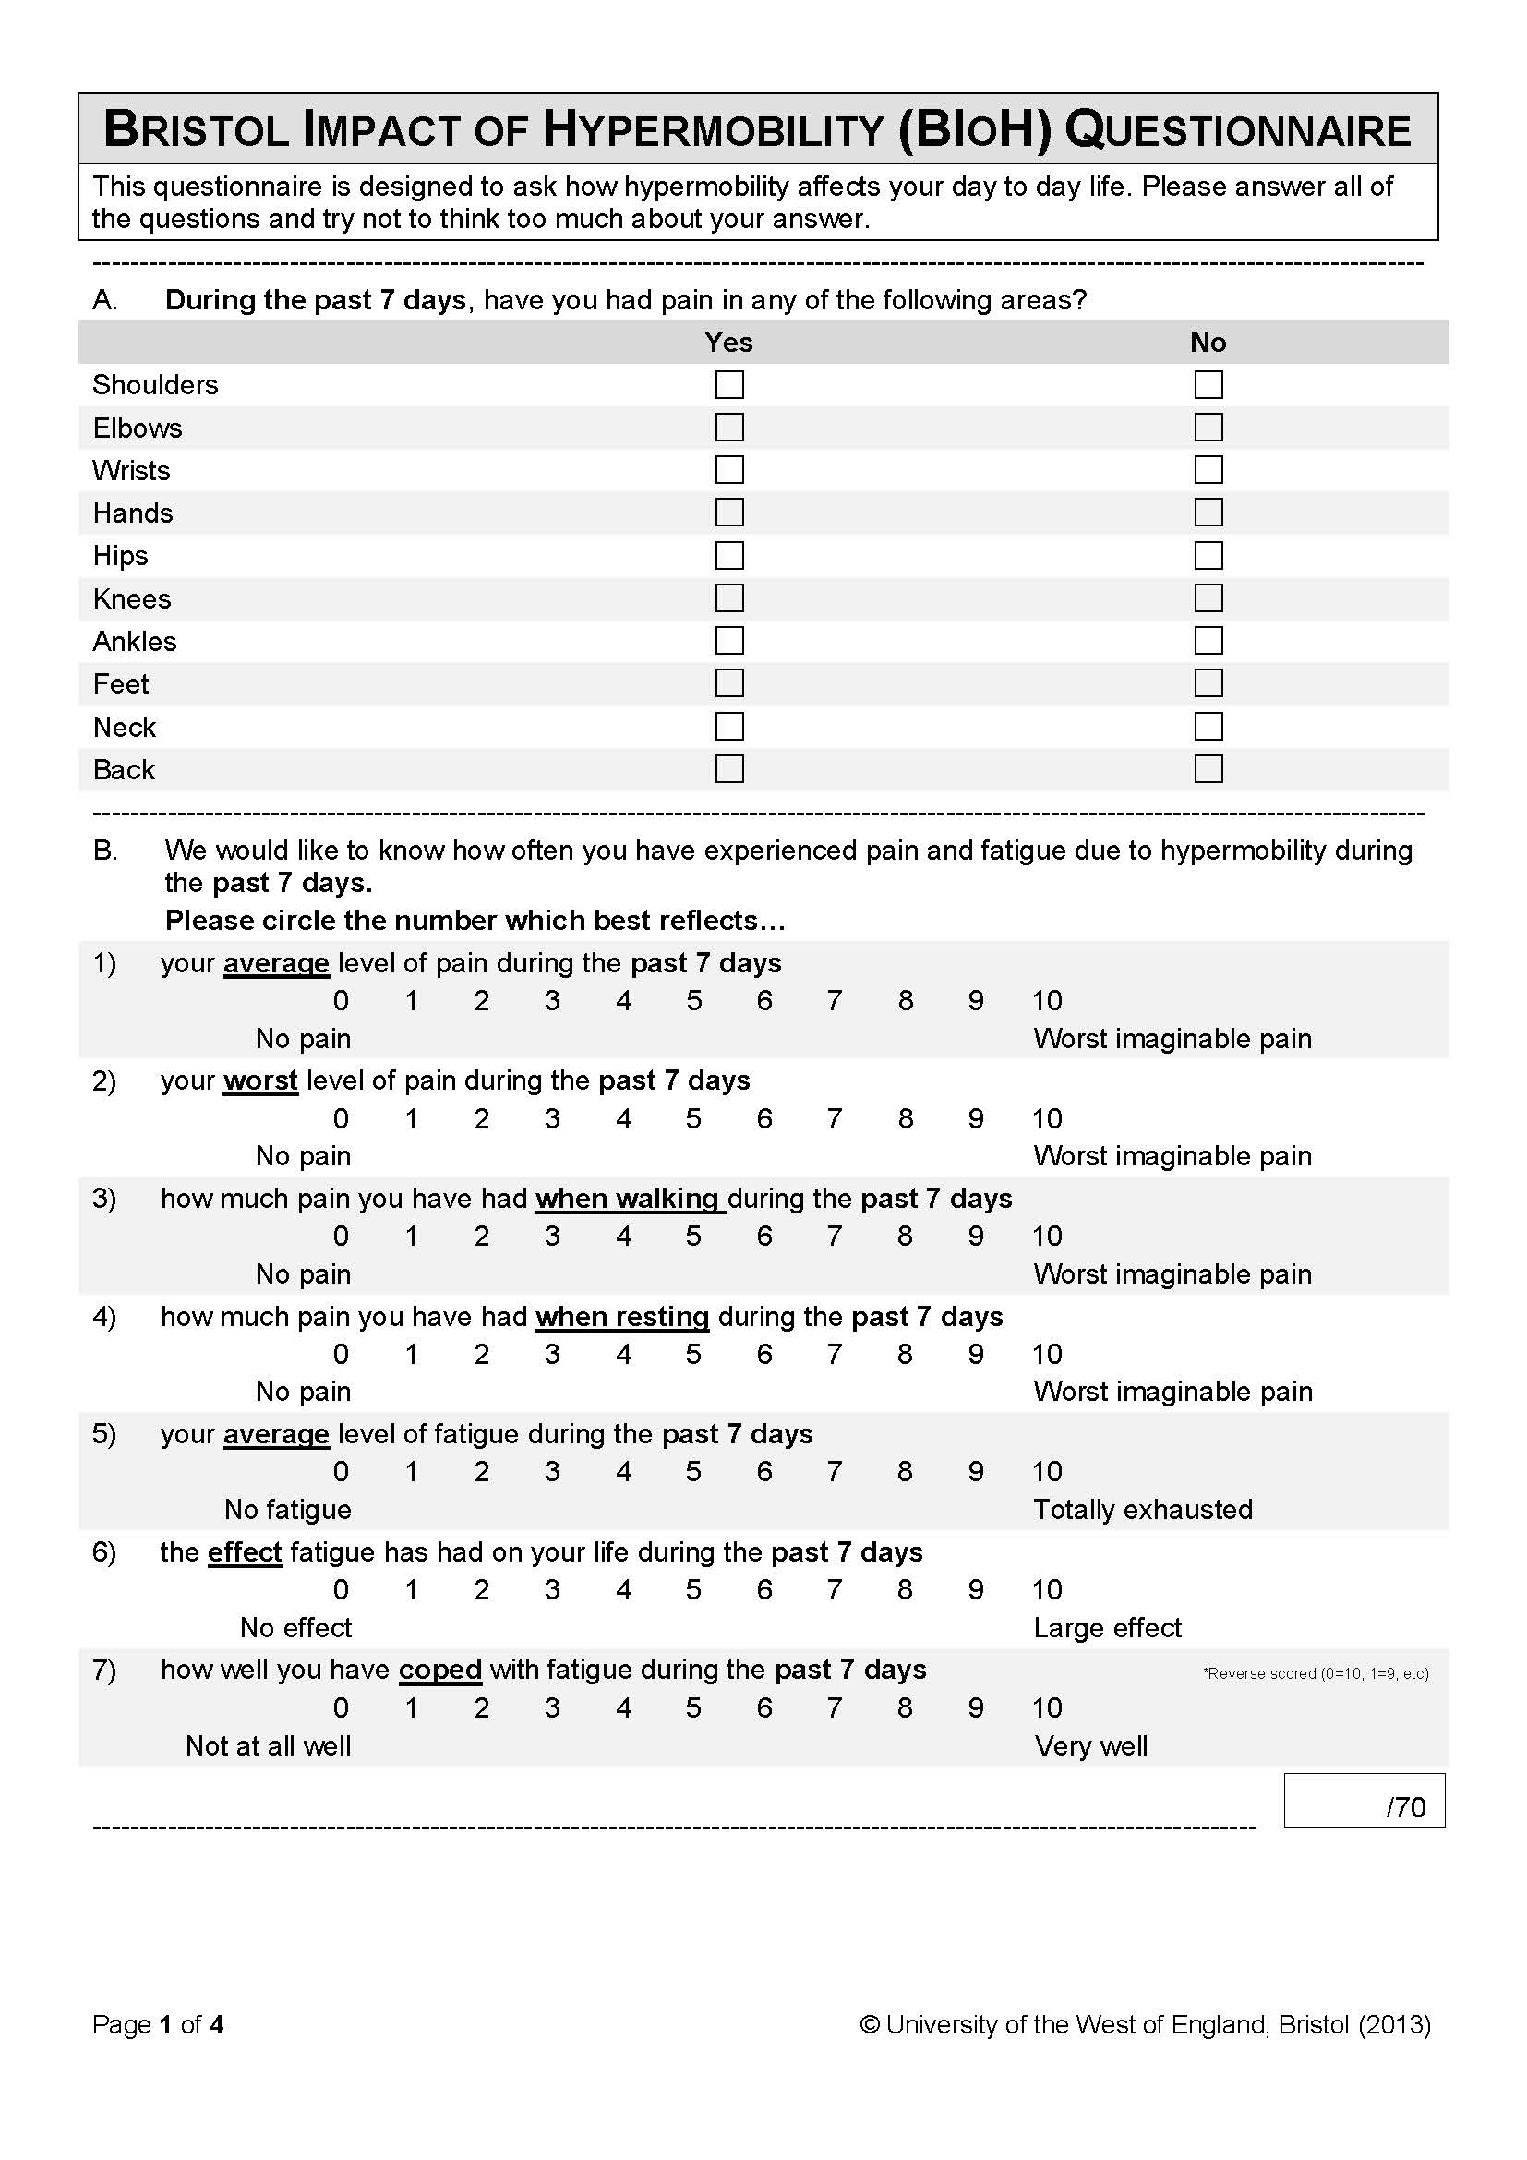

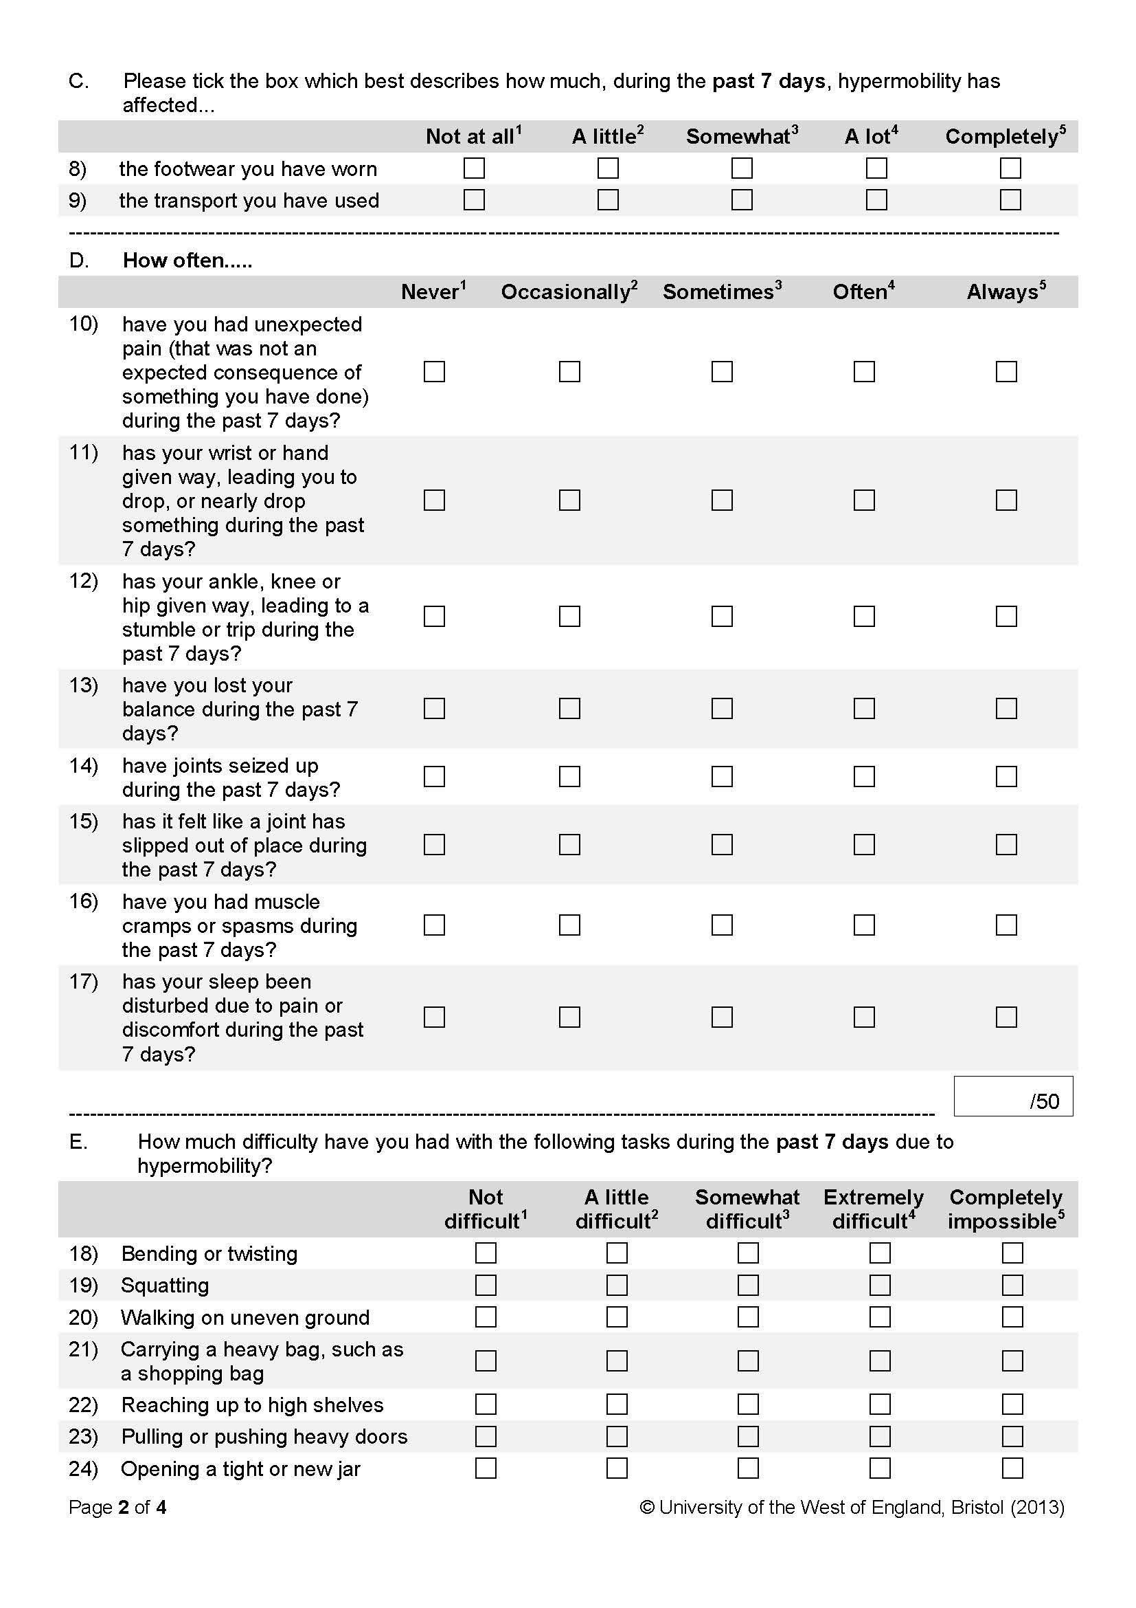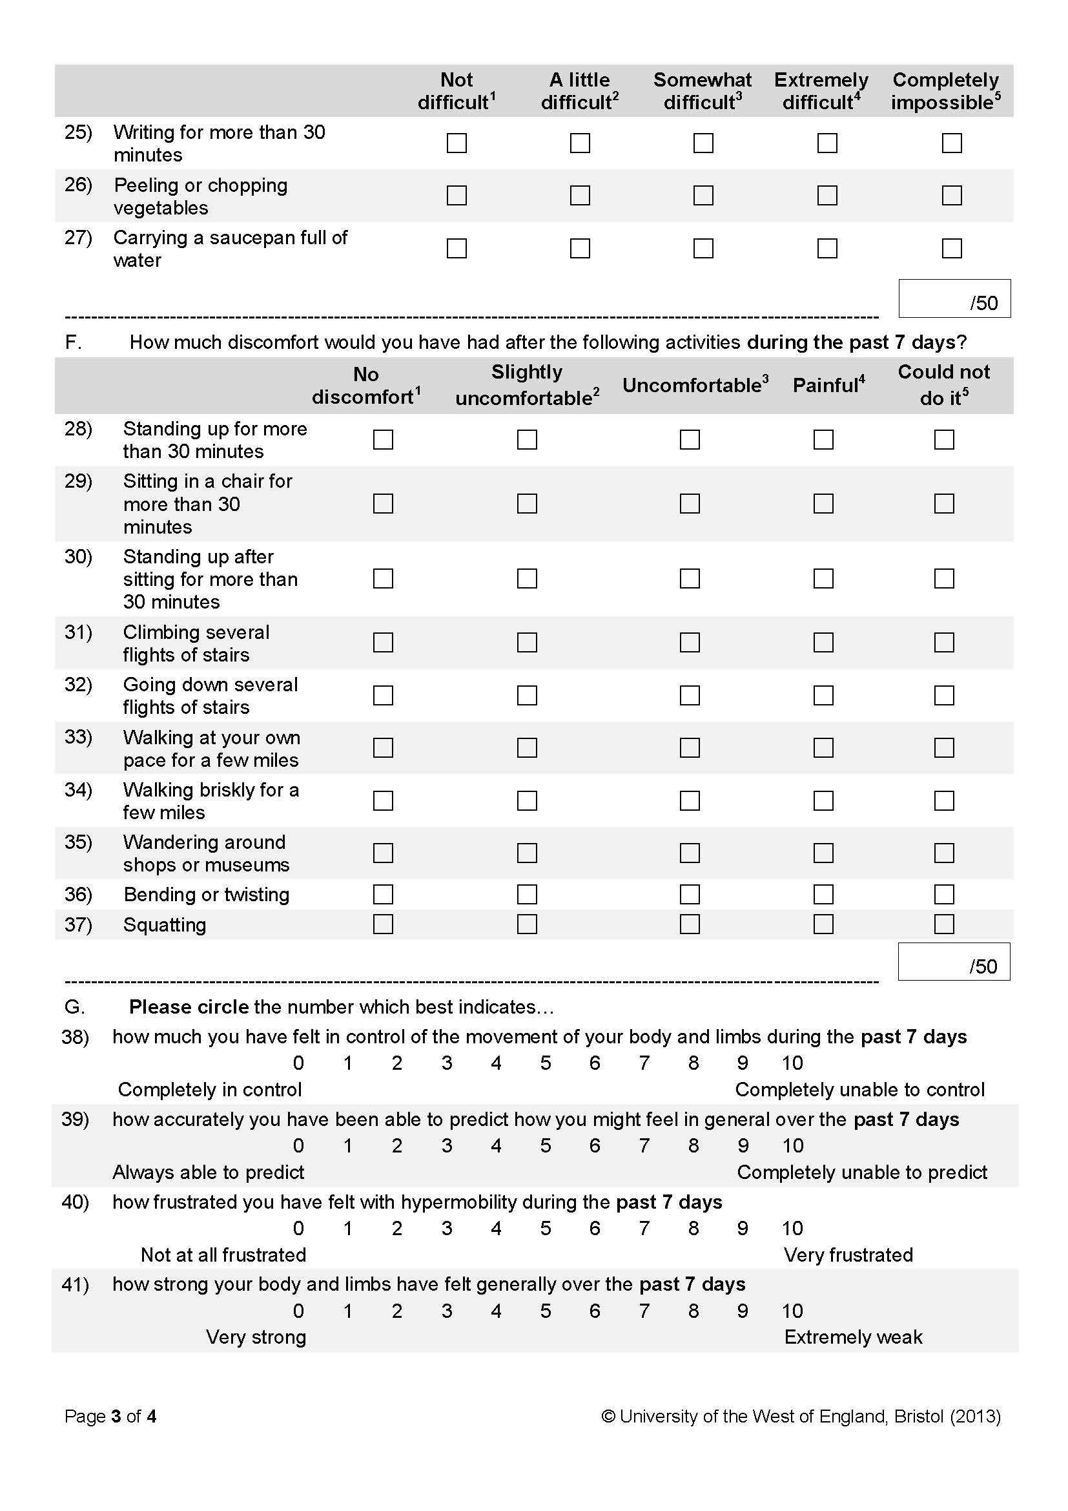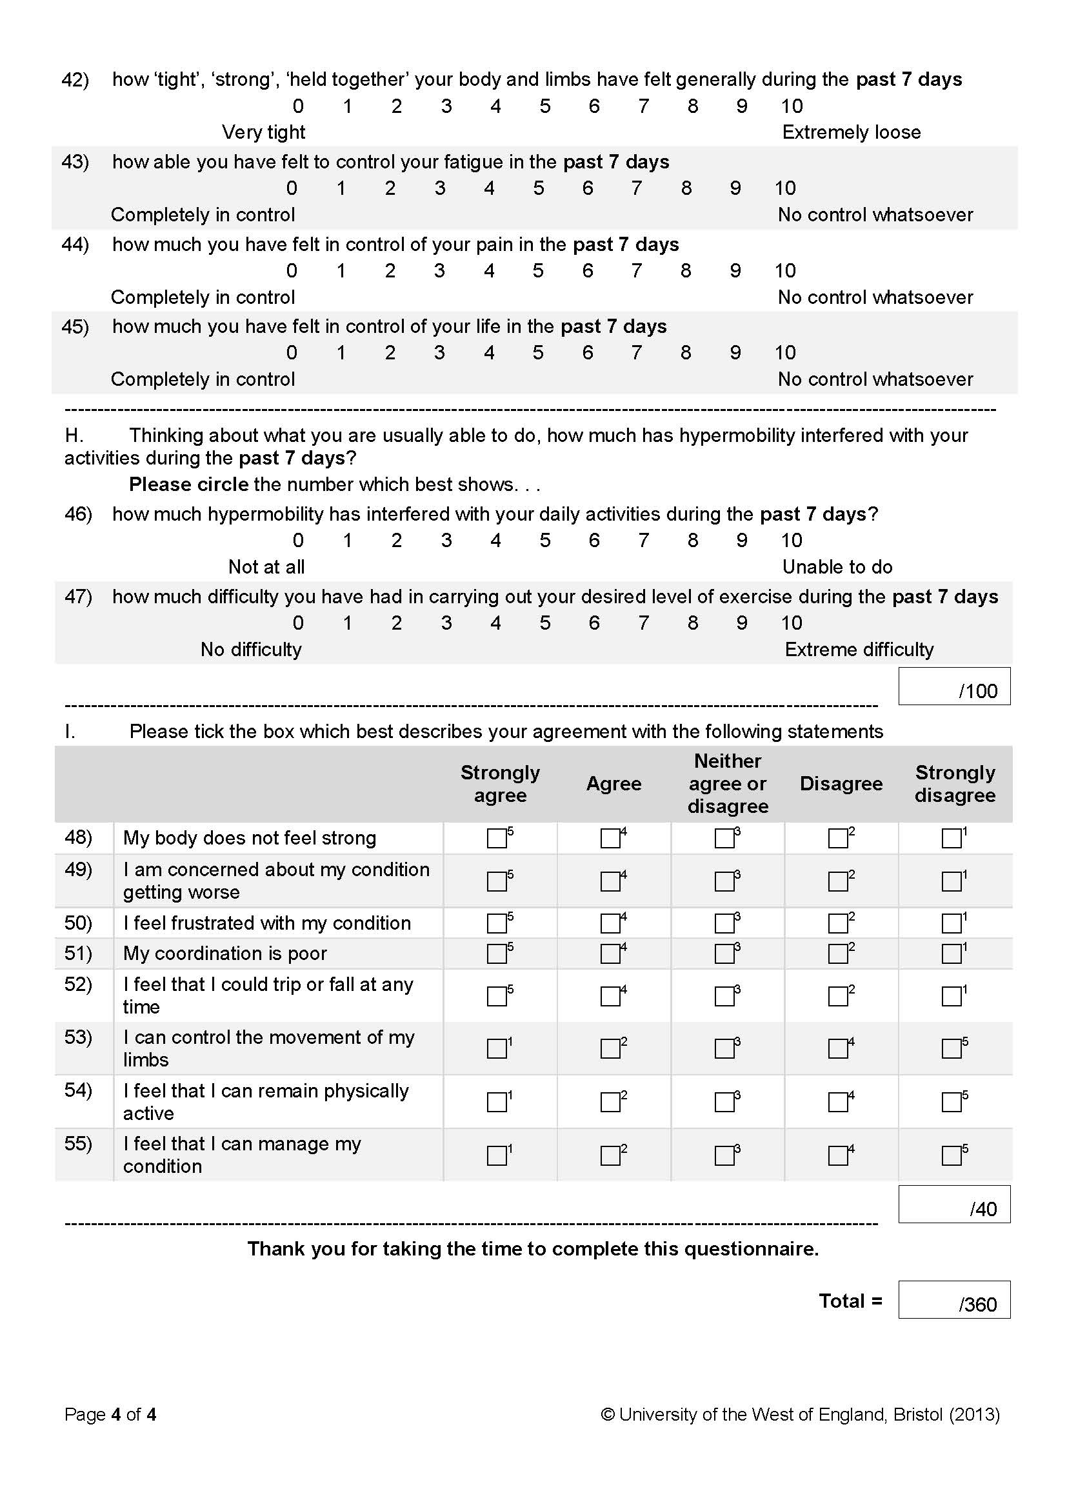

**Supplemental information 3. The Bristol Impact of Hypermobility (BIoH) questionnaire scoring guidance.**

