 | Abstract Template
Abstract Title:

Mathematical analysis on Urine Flow Traces for Non-invasive Diagnosis of Detrusor Underactivity in Men

Abstract Text:

Hypothesis / aims of study
Detrusor underactivity (DU) is still largely under researched and can only be diagnosed by invasive pressure flow studies (PFS). Theoretically, the flow shape of DU is different from bladder outlet obstruction (BOO), but in practice PFS is the only gold standard for diagnosing DU. It is suggested that detrusor muscle contraction and abdominal squeezing act in total different frequencies, 0.1Hz and 1Hz respectively, which could be an indicator for differentiating DU and BOO [1]. However, this hypothesis has not been quantitatively validated. Therefore, continuing last year’s research [2], we have conducted a novel study on validating frequencies of abdominal and detrusor muscle activity as reflected in urine flow, and propose a potential indicator for diagnosing DU.

Study design, materials and methods
Urine flow data of 114 adult male patients who had undergone PFS were analysed. Based on their PFS record, these patients were divided into three groups: 46 BOO, 44 DU, and 24 normal (DU and BOO disease free). A free urine flow rate was performed before each PFS, and the shape of those flows analysed. The starting and ending voiding point was selected by the threshold value of 0.5ml/s. Then a third order Butterworth filter was applied on the urine flow rate curve with different cut-off frequencies (1Hz, 0.8Hz, 0.6Hz, 0.5Hz, 0.3Hz and 0.1Hz), to count the peak numbers in each raw curve and filtered curve. The ratio of the number of peaks in the raw curve and the filtered curves was calculated for statistical analysis to find the best sensitivity/specificity for diagnosing DU. An example plot of raw curve and 1Hz filtered curve is presented in figure 1.
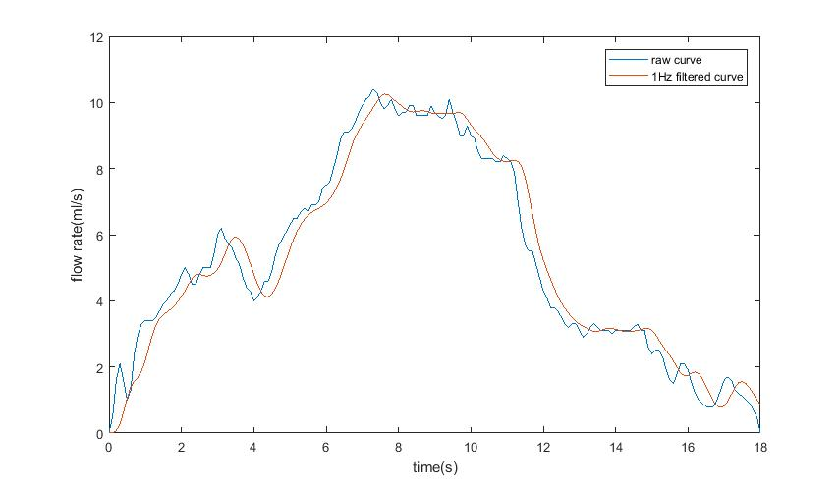
Figure 1 Raw urine flow rate curve and 1Hz filtered curve

All statistical analysis was performed in SPSS version 23, Mann-Whitney U test and T-student test were performed as appropriate. A statistically significant difference was considered as P value<0.05.

Results
We found the best statistically significant difference (P<0.002) on DU/BOO in ratio of peak numbers of 1Hz filtered curve against 0.1Hz filtered curve, followed by raw curve against 0.1Hz filtered curve with P value of 0.002 and 0.8Hz against 0.1Hz with P value of 0.002. Further receiver operating characteristic (ROC) analysis was performed on these three peak ratios in DU against with BOO and disease free group. The plot of ROC is presented as in figure 2.
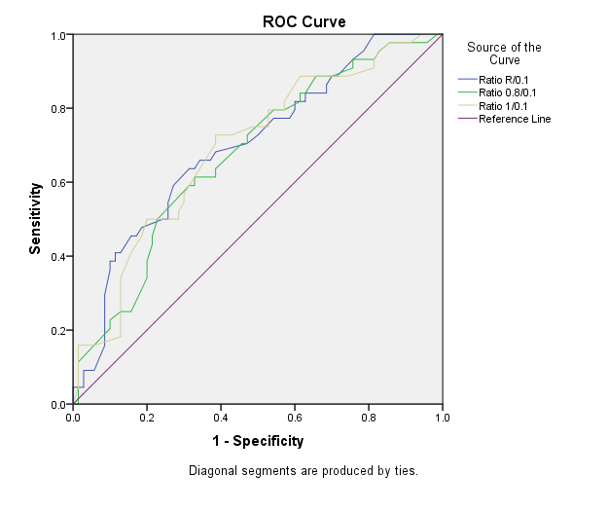
Figure 2 ROC analysis on ratio of peak numbers in raw curve/0.1Hz filtered curve, 0.8Hz/0.1Hz filtered curve and 1Hz/0.1Hz filtered curve

The ratio of peak numbers in 1Hz filtered curve against 0.1Hz filtered curve has the largest area under the curve of 0.691. With cut-off value of 8.37, the best sensitivity and specificity for diagnosing DU are 73% and 61% respectively.

Interpretation of results
It is suggested in urine flow rate data, an averaging should be taken in a 2 second window for reducing drops and artefacts [3], which equates to a 1Hz filter for a 10Hz sampling rate urodynamic equipment. In this research, we found the best diagnosing power for DU is the ratio of peak numbers in 1Hz filtered against 0.1Hz filtered curve. As DU patients have relativity lower detrusor contractility than BOO patients, they may have more abdominal straining for voiding out the urine. Therefore, we found the ratio of peak numbers in before and after filtering abdominal squeezing curve has significant statistical difference between DU group and BOO group. This result also verifies the hypothesis of frequencies for abdominal and detrusor squeezing are around 1Hz and 0.1Hz respectively.

Concluding message
This study shows promising non-invasive indicator for diagnosing DU in men by comparing the number of peaks in 1Hz filtered curve against the 0.1Hz filtered curve. It has also made suggestions on possible frequencies of abdominal squeezing and detrusor straining. Further research will follow on more frequency analytical methods, such as Fourier analysis and wavelet theory, to achieve a decent diagnosing power on non-invasively diagnosing DU and by combining multiple clinical parameters.

