A framework to evaluate the accessibility, visibility, and intelligibility of green-blue spaces (GBSs) related to pedestrian movement

Abstract
The planning of green-blue spaces (GBSs) requires considering the pedestrian needs in their walking routes for improving the walking experience. Incorporating the quantitative spatial characteristics of pedestrian movement is essential for the pedestrian-friendly urban planning, which however received insufficient attention. Based on the space syntax theory, this study provided three indicators – accessibility, visibility, and intelligibility – to demonstrate the needs of physical access, visual access, and spatial cognition, respectively, in pedestrian movement. Measuring these three indicators, this study exemplified the planning of pedestrian-friendly GBSs using Guangzhou, China as a case study. Spatial design network analysis was used to quantify heterogeneous values of accessibility, visibility, and intelligibility of each GBS throughout the city. Moreover, we used principal component analysis to identify the leading indicators based on their weightings and then to calculate the scores to compare these three aspects of GBSs. The measurements of accessibility, visibility, and intelligibility of each GBS were then averaged across urban administrative districts for evaluating city-scale GBSs. The findings showed that GBSs in central districts were most accessible and visible but least intelligible. In contrast, the overall intelligibility of GBSs throughout the city was the greatest but the visibility was the least. Furthermore, intelligibility, as a more important factor than accessibility and visibility, should be particularly emphasized in future planning of pedestrian-friendly GBSs. Pedestrians from the central districts of Guangzhou city were most satisfied with the walking experience, in terms of accessing to, viewing, and cognizing the GBSs. ‘Yuexiu’, ‘Huadu’, and ‘Nansha’ districts were found as the key places where improved accessibility, visibility, and intelligibility were particularly needed to improve the GBS pedestrian-friendliness throught the city. In summary, this study not only demonstrated a human-scale GBS evaluation framework for improving human walking experience but also provided empirical evidence for building pedestrian-friendly green-blue spaces at the city scale.

Keywords: Accessibility; Visibility; Intelligibility; Space syntax; Green-blue spaces

AVI: Accessibility, visibility, and intelligibility
GBSs: Green-blue spaces
LConn: Line Connectivity
NQPDA: Network Quantity Penalized by Distance in Radius Angular
OSM: Open Street Map
PCA: Principal component analysis
PC: Principal component
sDNA: Spatial design network analysis
TPBtA: Two Phase Betweenness Angular

1. Introduction
The planning of urban green and blue spaces should take the pedestrian demands into account for enhancing the walking experience and thereby human well-being. Incorporating the spatial patterns of pedestrian movements contributes to building more pedestrian-friendly urban green and blue spaces. Green and blue spaces can provide significant ecological and social benefits, including climate regulation (Brown et al., 2015) and mental relaxation (Beyer et al., 2014), therefore conservation of GBSs has been encouraged by the governments. For example, the Chinese Government established a ‘minimum standard’ for the areas of green spaces in urban residential areas, requiring at least a 30% greening ratio and 0.5m² green spaces per capita in residences (http://www.mohurd.gov.cn/). However, with the increased areas of green and blue spaces, an underappreciated concern is whether these planned green and blue spaces can meet the human demands in their movement. Because of no universally accepted definition of green and blue spaces in academia (WHO, 2016; Roy et al., 2012), this study uses the term ‘green-blue spaces (GBSs)’ to define all green and blue natural elements within a city. Quantifications of the spatial characteristics of pedestrian movement are necessary for planning the proper locations of GBSs, in such a human-centered urban planning context.
The pedestrian movement is the social response to the existing urban spatial configurations, based on the interactions between the physical built environment and human moving behaviors (Paul, 2015; Aditjandra et al., 2012; Liu et al., 2021). Therefore, the spatial pattern of pedestrian movement can be explained by the configurational properties of spaces (Hillier & Hanson, 1984; Koohsari et al., 2014). The predictions of spatial configuration about pedestrian movement flows can reach over 60% (Jiang, 2009). Jiang and Jia (2011) even found that the movement flow can be directly shaped by the spatial configuration, with little effect of subjective choice in individual movement behavior. In other words, it is reliable to indicate pedestrian movement using configurational measures. The GBSs planning considering the needs in pedestrian movement is thereby translated to the issue of identifying spatial configurations of the GBSs in the urban networks quantitatively.
To characterize spatial configuration, space syntax has been a well-developed theory, allowing us to understand urban configuration from physical and social dimensions (Lerman et al., 2014; Hillier, 1996). Specifically, space syntax explores the relationships between people and spaces (Bafna, 2003), that is, the relationships of spatially-linked urban systems and socially-interacted human activities (Hillier & Vaughan, 2007). In space syntax context, the interaction between physical spatial configuration and movement flow is generalized and identified by a term of ‘natural movement’, which demonstrates the extent to which the pedestrian movement is determined by the spatial configuration (Hillier et al., 1993). Urban configuration affects land use patterns by affecting natural movement (Koohsari et al., 2019), which means that the GBSs should have desirable locations in the given spatial configuration and natural movement pattern. The placement of GBSs is identified by two aspects of natural movement – to-movement and through-movement. To-movement relates to the selection of GBSs in pedestrian walking. Through-movement is related to the selection of routes passed through for reaching GBSs (Hillier & Iida, 2005). Accessibility is a pedestrian need in the to-movement (Cooper, 2015). The more accessible GBSs are preferred as the destination due to the ease of using GBSs. Also, visual accessibility is another pedestrian need in the through-movement. The spaces with high through-movement potentials have more movement flows (Hillier et al., 2012), so that the GBSs located in the frequently traversed spaces provide more benefits of visual accessibility. A cognitive aspect in pedestrian movement, however, is still limited investigated. Interpreted by the space syntax, the spatial cognition of GBSs is not directly determined by to- and through-movement. It is a mental need in pedestrian walking affected by the overall impressions under the patterns of natural movement.
To plan and design the GBSs for accommodating the needs of pedestrian movement, we develop a multi-indicator framework to evaluate the current GBSs through integrating the investigations of physical access, visual access, and spatial cognition. Three indicators of accessibility, visibility, and intelligibility are emphasized and quantified as empirical values to demonstrate three aspects of GBSs’ pedestrian-friendliness. Furthermore, these three indicators are then upscaled to district and city levels for ease of guidance statements in urban GBS planning (Stein et al., 2001). This upscaling has been adopted in GBS evaluations. For example, Tan et al. (2019) assessed the equity of urban green spaces and then upscaled the results from 150 m spatial resolution to block scale to provide planners with the geospatial information on GBS locations. Van De Voorde (2017) characterized the urban green space proximity from building scale to city scale for city-level planning target. Guangzhou, a well-developed city in southern China, is used as an example, to exemplify the planning of accessible, visible, and cognizable GBSs. Overall, based on the Guangzhou case, this study aims to show the AVI framework to 1) measure the multi-indicators of physical access, visual access, and spatial cognition of GBSs as well as those in urban districts; 2) identify the most important factor in our evaluation framework of GBSs; 3) recommend the principles for the GBSs planning associated with pedestrian needs.

2. Accessibility, visibility, and intelligibility of GBSs: an AVI evaluation framework
Based on the space syntax and natural movement theories, we proposed a conceptual framework to examine whether the existing GBSs planning has considered the pedestrian needs (Figure 1). A core premise of our framework is the interactions between urban configuration in a physical space and pedestrian movement in a social space. Corresponding to the needs of physical access, visual access, and spatial cognition in pedestrian movement, three indicators are included in the GBSs evaluation, including accessibility (A), visibility (V), and intelligibility (I). Space syntax provides theoretical supports for GBSs planning with a perspective of pedestrian movement. At the same time, space syntax also provides a set of techniques to measure the properties of spatial structures (Hillier et al., 1984; Hillier & Hanson, 1984). Three basic syntactical measures in space syntax are integration, choice, and connectivity, which can be used to frame AVI indicators associated with physical access, visual access, and spatial cognition respectively (Pafka et al., 2020). Pedestrian-friendly GBSs are the ones that have greater accessibility, visibility, and intelligibility, which address more pedestrian access, vision, and cognition demands for a better walking experience in GBSs.

2.1 Accessibility
Accessibility is a basic walking need for pedestrians showing the relationships between urban configuration, moving behavior, and GBSs planning (Ruben & Julio, 2015). Accessibility demonstrates the need for easy access to GBSs in to-movement, by defining the ability of people to reach their targeted GBSs (Weibull, 1980; Miller, 2005). In more integrated spaces, the GBSs are spatially closer to other areas in the urban system, resulting in a higher possibility of people presence because people feel easy to access with fewer turns in their walking path (Peponis & Wineman, 2002). Therefore, the integration in space syntax is a commonly proxy of spatial accessibility, indicating the degree of one space close to others (Hillier, 2012). According to the positive relationships between spatial integration and movement flows (Nes, 2021), accessibility analysis based on the integration in space syntax (Tannous et al., 2020; Ye et al., 2019; Hillier & Iida, 2005) has been widely conducted to elucidate how people select their destination in their movement and thereby the use efficiency of GBSs.

2.2 Visibility
Visibility, here, is regarded as an indication of the need for visual access to GBSs in through-movement. Visual integration is another impact on the patterns of pedestrian movement (Hajrasouliha & Yin, 2015). Choice measure of space syntax is used as the proxy of visibility, indicating the possibility of a space to be passed through within the connected spatial networks (Hillier et al., 1987). Spaces with a high choice value play important roles in the urban system with more traversable transportation, in which more pedestrians are passed through in their daily movement (Hillier & Iida, 2005). Hence, the visibility indicator is developed based on an assumption that the GBSs in frequently passed-through places provide pedestrians with additional visual functions.

2.3 Intelligibility
Intelligibility is proposed to address the need for spatial cognition in pedestrian movement, which is linked to mental perception in both to- and through-movement. An intelligible space should be easily understandable, well connected, and highly integrated, in which people can perceive large-scale spaces outside their view-shed through cognizing GBSs in their visibility field (Peponis & Wineman, 2002; Liao et al., 2019). Intelligibility is identified by the shape of the scatter diagram between integration and connectivity of space syntax. Connectivity is quantified by the number of neighboring spaces directly connecting to a given space (Hillier & Hanson, 1984), which captures the spatial configurations within a neighboring distance instead of the whole urban system. Spaces with highly synchronous connectivity and integration are more intelligible due to stronger correlations between what we can perceive and what we cannot perceive, which provide more cognitive images for people. Improving the intelligibility of the GBSs can facilitate the pedestrians who are unfamiliar with the urban spaces forming mental ‘big picture’ of GBSs based on a succession of visibility fields in their navigation (Hillier, 2012).

3. Data and methods

3.1 Study areas
Guangzhou is a well-developed city of Guangdong Province in South China (Figure 2(a)) with strong socioeconomic development and a dense population. Rapid urbanization has resulted in a compact urban structure and limited physical spaces for natural environment planning. Guangdong is regarded as the first-tier province to focus on the ecological improvement by constructing various forms of green spaces (Peng et al., 2017). However, with ongoing extensive urban development, better planning of urban natural components, such as GBSs, has emerged as a new challenge, particularly as human-centered urban planning is being prioritized. Apart from quantity, the quality of GBSs for people usage is put on the agenda. Since 2009, Guangzhou and other 8 cities of Guangdong Province, as well as the Hong Kong and Macau have been included in the Guangdong-Hong Kong-Macau Greater Bay Area (GBA) which was an initiative issued by the Chinese Government (The State Council of the PRC, 2019). Aiming to intensify the regional integration and socio-economic co-development in the GBA, Guangzhou is expected to experience greater variations in urban spatial structure. The perspective of pedestrian walking is necessary for GBSs planning for the city and even regional well-being. Guangzhou contains 11 administrative districts having uneven socio-economic conditions. The city centers are old urban districts including ‘Baiyun’, ‘Huangpu’, ‘Panyu’, ‘Yuexiu’, ‘Tianhe’, ‘Haizhu’, and ‘Liwan’ districts. They are evolved from long-term variations in spatial configurations and urban functions, which are greatly influenced by and at the same time shape pedestrian moving behaviors. In detail, ‘Yuexiu’, ‘Liwan’, ‘Haizhu’, and ‘Tianhe’ districts are regarded as the economic cores of the city. Outer districts are new, including ‘Conghua’, ‘Huadu’, ‘Zengcheng’ and ‘Nansha’ districts，which are not merged into the Guangzhou city until 2000. Changed urban structure in the city and heterogeneous urban configuration among districts influence the patterns of human movement in the urban system. Moreover, unevenly distributed green-spaces (Figure 2(b)) and blue-spaces (Figure 2(c)) can be observed. Particularly, the distribution of green-spaces has distinct spatial clusters in some administrative districts, which implies different relationships between GBSs and human movement among districts. Thus, a challenge in Guangzhou is how to adjust GBSs planning to better fit the human daily movement for social benefit delivery. To have a more intuitive understanding of GBSs in various urban spatial networks, a more detailed table has been provided (Table 1). The GBSs in Guangzhou city are characterized as five categories based on different urban components (Lynch, 1960), including GBSs close to streets, GBSs as spatial edges (e.g., rivers), GBSs as districts (e.g., large-scale wetland), GBSs close to urban nodes (e.g., green spaces attached to commercial areas), and GBSs close to landmarks (e.g., green spaces around the tower). The functions of various categories of GBSs and their potential accessibility, visibility, and intelligibility are also described in Table 1.

3.2 Analyzing AVI indicators of GBSs

3.2.1 AVI Measurements using spatial design network analysis
Spatial design network analysis (sDNA) (https://sdna.cardiff.ac.uk/sdna/) was used for spatial network analysis in terms of accessibility, visibility, and intelligibility (AVI) in urban spaces. sDNA and space syntax share a similar principle through characterizing spatial configurations into the graphs consisting of points and linear features (Volchenkov & Blanchard, 2007). In other words, sDNA can measure the AVI framework developed based on space syntax theory. Moreover, one of the distinctions of sDNA is that it can model localized configurational characteristics within the user-specified radius (Sarkar et al., 2015), in the platforms of ArcGIS/QGIS/AutoCAD as well as Python/command line (Cooper & Chiaradia, 2020). Using different radii, two-scale measurements can be achieved in sDNA, including local and city scales. City-scale analyses identified spatial configurations over the urban system in the whole city, while local-scale analyses focused on the sub-areas with a given radius (Önder & Gigi, 2010). For this study, we defined local scale based on an initiative of the ‘15-min walkable neighborhoods’ advocated by a Chinese national standard (The Standard for urban residential area planning and design (GB 50180–2018)). This initiative aims to improve community GBSs for human usage. Based on average walking speed, an empirical value corresponding to 15-min walking distance is 1200 meters (Xia et al., 2018). Hence, the 1200-meter distance was decided as the radius for local-scale measurements.
To perform the sDNA, vector data of GBSs and street networks representing urban spatial configurations were extracted from Open Street Map (OSM) in Quantum GIS (QGIS). OSM is a crowdsourced platform providing geo-referenced information of pedestrian data (Bolten et al., 2017). Each street segment was defined as the origin of human movement, represented as a road centerline between two road turns in this study. The destinations at the city level were all street segments in the city excluding those that were not connected. While, at the local level, the destinations were all street segments within a radial distance of 1.2 km from the origin. In sDNA technique, integration is commonly quantified by Network Quantity Penalized by Distance in Radius Angular (NQPDA), and choice is mostly defined by Two Phase Betweenness Angular (TPBtA). Angular distance, instead of only metric Euclidean distance, was used in this study to accounts for directional changes in human movement. Additionally, Line Connectivity (LConn) was used to indicate connectivity. Based on the measures of integration, choice, and connectivity, accessibility (A) and visibility (V) indicators were described by the values of local NQPDA and local TPBtA within a 1200 m radius, respectively. Moreover, intelligibility (I) values were the Pearson correlations (R²) of LConn and NQPDA values over the whole city. A perfect correlation (R² =1) will be shown as a 45° straight line in the correlation diagram, which, for example, can be interpreted as the exactly synchronous changes between LConn and city NQPDA. Higher correlation (R²) indicates higher levels of intelligibility. The measurements of AVI indicators were summarized in Table 2. Consequently, each street segment had a set of AVI values. The polygon data of GBSs were then combined with the street network data. The AVI values of street segments were affixed to the GBSs in the closest geographical locations. It means that the AVI measurements of the street segment closest to the GBS’s boundary were used to assess the pedestrian-friendliness of each GBS. These AVI measurements of each GBS polygon were taken on a pedestrian movement scale, which were suggested to be upscaled to city level by averaging local measurements for urban planning and GBS management (Liang et al., 2022; Browning et al., 2022). Therefore, this study averaged AVI results of each GBS according to the administrative districts across the city to assess the heterogeneous pedestrian-friendliness of GBSs. These approaches allowed for converting the spatial configurations of street networks to the evaluations of GBSs by quantifying the accessibility, visibility, and intelligibility aspects of pedestrian-friendly GBSs for people walking experiences. Also, AVI-based GBS evaluations can be a potential tool for pedestrian-friendly urban planning.

3.2.2 AVI characterization using principal component analysis
To examine whether there is a redundant indicator in the AVI framework, the correlations between accessibility, visibility, and intelligibility were analyzed. The results (Appendix A, Figure A) show that these three indicators were statistically correlated with each other in ‘Nansha’, the southern district of the city, which demonstrated the data redundancy in the AVI framework. Hence, principal component analysis (PCA) (Jolliffe, 2002) was used here, which has been a common tool to remove the redundant information and identify the most representative one in multi-indicator evaluations (e.g., Ye & Qiu, 2021). The data characteristics of AVI of GBSs were extracted and stored in several uncorrelated principal components (PCs). The first PC generally stores the most distinct information. For each PC, a property is the ‘loading’ that refers to the contribution of each variable on overall data characteristics in that PC. In other words, the indicators of the AVI framework with higher absolute loading values (either positive or negative) should be assigned greater weightings in GBSs evaluation. The indicator having the largest absolute loading value is defined as the ‘winning variable’ that plays a leading role in GBSs evaluation in that PC. Furthermore, apart from ‘loading’, ‘contribution’ is further used to provide more comprehensive quantifications in terms of the importance of each variable in GBSs evaluation in the combined PC1 and PC2, which is measured by (Kassambara, 2017):
Contributions = ${\left[\left(\frac{{Weightings (i1)}^{2} ×100}{\sum{{Weightings (j1)}^{2}}}×Eig 1\right)+\left(\frac{{Weightings (i2)}^{2} ×100}{\sum{{Weightings (j2)}^{2}}}×Eig 2\right)\right]}/{\left(Eig 1+Eig 2\right)}$
where $Weightings (i1)$ is the loading value of $i$ indicator in PC1 and $\sum{{Weightings (j1)}^{2}}$ means the sum of loading values of all indicators in PC1; $Weightings (i2)$ and $\sum{{Weightings (j2)}^{2}}$ indicate the corresponding results in PC2; $Eig 1$ and $Eig 2$ refer to the proportion of variance explained by PC1 and PC2, respectively.
Moreover, another output of PCA is the ‘score’ that is, in essence, a new measurement projected into PC dimensions combining all features of original data. The score in this study can be representations to compare the accessibility, visibility, and intelligibility of GBSs. It is measured by:
Score = ${\left(Xi-Mean (Xi)\right)}/{SD \left(Xi\right)*weightings (i)}$
where $i$ refers to one of AVI indicators; $Xi$ is the values of $i$ indicator based on space syntax measurements; $Mean (Xi)$ is the averaged values of $Xi$; $SD$is the standard deviation; and $weightings$ is the loading values of $i$ indicator based on PCA analysis.
Based on ‘loading’, ‘contribution’, and ‘score’ of PCA, the AVI framework can be characterized and simplified for providing comparable information in PC dimension for GBSs evaluations among different locations and to develop strategies for GBSs improvements to include pedestrian movement.

3.3.3 Analytical AVI framework for GBSs
Figure 3 presented the analytical framework to evaluate AVI indicators of GBSs in the Guangzhou city. Based on the space syntax theory and sDNA technique, accessibility, visibility, and intelligibility of GBSs were measured. PCA was adopted to characterize the AVI framework through defining their respective weightings on GBSs evaluation and generating standardized and comparable values of AVI indicators and the overall AVI-weighted evaluation scores. Three main outcomes of AVI-weighted evaluation are to 1) identify the indicator with the largest weighting in GBSs evaluation; 2) compare the accessibility, visibility, and intelligibility of GBSs as well as the overall AVI-weighted GBSs among districts; and 3) suggest the empirical principles and strategies for GBSs improvement in terms of the considerations of pedestrian movement.

4. Results

4.1 Spatial heterogeneities in AVI measurements of GBSs
To quantify the accessibility, visibility, and intelligibility of GBSs in the city, the measures of NQPDA, TPBtA, and LConn were required according to Table 2. The integrated (high NQPDA values), frequently-traversed (high TPBtA values), and well-connected (high LConn values) spaces were mainly clustered in the middle districts of the city (Figure 4). Compared to spatial integration across the city (Figure 4(a)), the local integration was substantially lower and spaces with high local integration were even more concentrated (Figure 4(b)). It means that, within neighboring walking scope, urban spaces were less integrated and less accessible. In this urban system, the unique values of NQPDA, TPBtA, and LConn in each geographical location can be used to calculate the accessibility, visibility, and intelligibility of each GBS, allowing people to evaluate the pedestrian-friendliness of GBSs while moving.
The values of accessibility, visibility, and intelligibility varied by GBSs. GBSs in the city center, generally, were more accessible (Figure 5(a)) and visible (Figure 5(b)) in pedestrian movement, than those in the surrounding areas. Accessibility and visibility of GBSs were similar throughout the city except for the southernmost areas where GBSs had the greatest accessibility but rather low visibility. Moreover, two regions with the distinct low intelligibility of GBSs were the northwestern and south-central parts (Figure 5(c)). Based on averaged AVI values, the overall pedestrian-friendliness of GBSs was more similar to accessibility spatial patterns (Figure 5(d)). The AVI measurements of individual GBSs were then averaged across administrative districts of the city to provide empirical guidelines for GBS planning in districts and cities. Similar to the spatially explicit AVI of individual GBSs, accessibility and visibility of GBSs in each district shared a similar pattern (Figure 6(a)(b)). GBSs in central areas of the city were more accessible and visible than those in the suburbs, which therefore were easier to access in to-movement and view in through-movement. The greatest accessible and visible GBSs were located at the ‘Yuexiu’ district which is the socioeconomic core of the Guangzhou city. On the other hand, the central districts of the city had few intelligible GBSs, while GBSs in ‘Nansha’ and ‘Huangpu’ districts had the highest intelligibility making them easier to be perceived by pedestrians (Figure 6(c)). According to the averaged values of AVI (Figure 6(d)), the GBSs in the central districts of the city, particularly in the ‘Yuexiu’ district, were more pedestrian-friendly through accommodating the pedestrian needs of access, view, and cognition. This averaged AVI-based evaluations of GBSs’ pedestrian friendliness were consistent with socioeconomic patterns among districts.

4.2 The diverse contributions of AVI to GBSs evaluation
To evaluate AVI-weighted GBSs, the diverse contributions of AVI indicators to GBSs were needed, which were shown in the form of loading values. The characteristics of GBSs in Guangzhou city can be represented by the first two principal components (PCs) that explained 91.6% variance of AVI values (Table 3). In detail, the first PC (PC1) already stored the 60% data characteristics of AVI values, in which accessibility and visibility dominated the GBSs with the positive weightings of 0.688 and 0.68, respectively. In other words, GBSs can meet 60% of pedestrian needs for ease of access and viewing in to- and through-movement. On the other hand, intelligibility was the most leading influence on GBSs evaluation in PC2 with the negative weighting of -0.967. It implied that intelligibility related to the mental perception of pedestrians can describe around 31.6% pedestrian-friendliness of GBSs. Moreover, combining the weightings of AVI in both PCs, we found that accessibility and visibility of GBSs were highly correlated, which means that urban spatial configurations had similar effects on the amount to which GBSs could be accessed and viewed (Figure 7). While intelligibility can provide distinctly different GBSs information, compared to accessibility and visibility, with the greatest contributions to GBSs evaluation in the whole city, which can be a significant aspect in planning pedestrian-friendly GBSs (Figure 7).

4.3 AVI-weighted evaluations of GBSs

4.3.1 Compare AVI scores of GBSs
The PCA contributed to transforming the values of AVI indicators into new representation scores that were comparable in the PC dimension. The accessibility, visibility, and intelligibility of individual GBSs were represented by three uncorrelated PCs. PC1 representing 60% of AVI features dominates the accessibility and visibility aspects of physical functions of GBSs. The scores of accessibility, visibility, and intelligibility in PC1 were shown in Figure 8 (a1)~(a3), which had similar spatial patterns to original AVI values derived from sDNA (Figure 5(a)~(c)). Integrating accessibility, visibility, and intelligibility, the spatial distributions of AVI-weighted scores of GBSs (Figure 8(a4)) were also similar to AVI-averaged ones (Figure 5(d)). Furthermore, in PC2 with an additional 31.6% of data features of AVI (Table 3), the spatial patterns of accessibility and visibility (Figure 8(b1)(b2)) were almost the same as those in PC1 (Figure 8(a1)(a2)). Differently, the spatial pattern of GBSs in PC2 (Figure 8(b3)), in part, was opposite to that in PC1 (Figure 8(a3)), which, however, was similar to the patterns of AVI-weighted GBSs scores (Figure 8(b4)). Therefore, we claimed that the original individual values of AVI indicators as well as AVI-averaged values, derived from sDNA technique, can predict approximately 60% of GBSs’ pedestrian friendliness in the PC dimension. Additional about 31.6% of AVI features of GBSs can be almost presented by intelligibility that was as a function of spatial cognition in the GBSs.
When averaged to district scale, PCA-based AVI scores, which have been standardized and comparable, therefore, can be used as instruments for the communications between stakeholders in GBS planning (Daniels et al., 2017). In PC1, the more central districts had greater accessibility and visibility of GBSs (Figure 9(a1)(a2)). Contrarily, the intelligibility values of GBSs were higher in non-central districts with the highest in the southernmost district (Figure 9(a3)). Comparing the values of AVI indicators in each district, four clusters can be observed (Figure 9(a5)). GBSs in peripheral districts had the greatest intelligibility but the least visibility, while GBSs in more central districts had the lowest accessibility. GBSs had the lowest intelligibility consistently across the most central districts ('Yuexiu', 'Liwan', 'Haizhu', and 'Tianhe' districts), among which, ‘Yuexiu’ and ‘Liwan’ districts had the most accessible GBSs, while another two districts had the greatest visible GBSs. Using the averaged PCA-based AVI scores across districts, GBSs had the best intelligibility but the worst visibility throughout the city, consistent with those in the cluster of peripheral districts. Moreover, AVI-weighted scores of GBSs indicated that GBSs in the central districts, such as ‘Yuexiu’ and ‘Haizhu’ districts, were more pedestrian-friendly weighted by accessibility, visibility, and intelligibility and then provided a better walking experience for pedestrians. In general, the AVI-weighted patterns of GBSs among districts were greatly similar to the patterns of accessibility and visibility that were two dominant indicators in PC1 (Table 3). The districts of ‘Yuexiu’, ‘Haizhu’, and ‘Liwan’ were rated as having the most pedestrian-friendly GBSs and the best walking experience in GBSs with 68.4% confidence. On the other hand, in PC2, the highest intelligibility of GBSs was shown in “Huadu” (Figure 9(b3)) instead of “Nansha” district in PC1 (Figure 9(a3)). Similar to PC1, there were also four spatial clusters of the AVI scores in PC2 (Figure 9(b5)). The entire city still had the greatest intelligibility but the least visibility of GBSs on average in PC2. Moreover, the AVI-weighted scores of GBSs in PC2 demonstrated similar patterns to intelligibility (Figure 9(b4)) which is the dominant indicator of GBSs evaluations in PC2 (Table 3). GBSs in ‘Huadu’, ‘Panyu’, and ‘Haizhu’ districts were the most pedestrian-friendly and met the most walking needs in pedestrian movement with 31.6% possibility.
We concentrated on the combined first two PCs that represent 99.7% of the AVI results. Central districts always showed more accessible and visible GBSs than surrounding districts. Comparing scores of individual AVI indicators, the highest average score for the city was intelligibility, indicating that the spatial cognition demand in the pedestrian movement had been largely accommodated in GBSs. However, the visibility always showed the lowest values suggesting a need for improvement. The GBSs throughout the city demonstrated an overall trend of the highest intelligibility but the lowest visibility, which was more consistent with the peripheral districts (i.e., ‘Huadu’, ‘Conghua’, ‘Zengcheng’, and ‘Panyu’ districts). AVI-weighted scores of GBSs were greatly dominated by the leading factors with the highest loading values in respective PC. GBSs in peripheral districts were generally less pedestrian-friendly than those in central districts.

4.3.2 Compare the contributions of districts to AVI-weighted GBSs over the city
After illustrating the AVI scores in each district of the city in the first two PCs, we investigated how districts contributed to GBSs improvement across the Guangzhou city by promoting accessibility, visibility, and intelligibility (Figure 10). In the districts with higher contribution values, the enhancement of AVI had a greater possibility of improving the GBS pedestrian-friendliness over the whole city. Our findings demonstrated that ‘Yuexiu’, ‘Huadu’, and ‘Nansha’ districts had higher contributions to city GBSs improvements, compared to other districts (Figure 10). Thus, these highly contributed districts should be defined as the priority places for developing pedestrian-friendly GBSs via the AVI framework in the Guangzhou city. This result is also in accord with the Chinese official issues. For instance, the urban development strategies have emphasized the importance of GBSs in the ‘Huadu’ district of the Guangzhou city (Huang et al., 2009). Also, the ‘Nansha’ district has been defined as a new key district for rapid development in the ‘Overall Plan of Nansha New District of Guangzhou (2012-2025)’, so that the GBSs should be improved in the ‘Nansha’ district for potential social well-being.

5. Discussion
To create pedestrian-friendly GBSs for social well-being, the GBSs planning should identify the pedestrian needs in terms of access, view, and cognition. The empirical measurements of accessibility, visibility, and intelligibility based on our AVI framework provide information for suggesting the principle and specific strategies for future GBSs planning. The AVI framework has been shown that it not only helps evaluate the accessibility, visibility, and intelligibility of individual GBSs in the context of pedestrian movement but also provides an empirical approach for improving the pedestrian friendliness of GBSs in each district at the city scale.

5.1 Implications of AVI framework for GBSs planning
To examine the extent to which pedestrian needs are included in the GBSs planning, an AVI framework has been developed in this study, which integrates accessibility (A), visibility (V), and intelligibility (I) factors. The AVI indicators of an urban system demonstrate the pedestrian needs of physical access, visual access, and spatial cognition respectively in their daily movement. This AVI framework can support the emerging target of pedestrian-friendly GBSs planning – facilitating people-oriented urban spaces for easy and pleased human usability (Leyden & Lipps, 2018). Compared to conventional GBSs planning primarily with the consideration of physical space, the patterns of pedestrian movement flows are combined and translated to the empirical assessments of physical spatial configurations in our AVI framework, contributing to improving the pedestrian walking experience in GBSs.
The space syntax is used in this study, which allows for the incorporation of human perspective into the GBSs planning based on the associations between social responses and spatial structure. In other words, the configurational measurements in the urban system can represent pedestrian needs in to- and through-movement. Compared to precise coordinates and Euclidean distance, space syntax-based measurements provide more configurational information on how urban spaces are spatially linked for the GBSs placement. Hence, the application of space syntax provides both theoretical and technical supports for evaluating GBSs related to pedestrian movement. Firstly, to measure accessibility (A), the shortest distance between the origins and the destinations is a conventional approach (Witten et al., 2008; Le Texier et al., 2018). However, pedestrians may not choose the shortest-distance paths in to-movement, instead, the shortest ways topologically with the least directional changes are more preferable (Dettlaff, 2014). Thus, topological measurement, as one of the distinctions of space syntax, is emerging in assessing spatial accessibility (Borzacchiello et al., 2010; Borzacchiello et al., 2009), by counting the numbers of turns needed on the walking route (Hillier & Iida, 2005). Secondly, visual access to GBSs is also characterized by syntactic measurements based on space syntax. Most of the visibility measurements adopt traditional eye-level approaches based on the self-collected picture and innovative street-level methods based on Google Street View (GSV) data (e.g., Ye et al., 2019). However, these approaches are generally at local scales (Larkin & Hystad, 2019; Labib et al., 2021) and do not consider dynamic moving behavior and its influence on spatial visibility. Space syntax-based visibility measurements have the potentials to demonstrate the varied visibility of GBSs in the through-movement at urban scales. Space syntax-based measurements, furthermore, indicate the identity of GBSs, which is affected by city images formed in people walking routes (Asfarilla & Agustiananda, 2020). The concept of city image is firstly proposed in the book ‘The Image Of The City’ by Lynch (1960) who proposed urban physical configurations will determine city image and resultant urban legibility. This interpretation of legibility is similar to the term of ‘intelligibility’ – an indicator of our AVI framework – their interactions can be found in some studies (Long & Baran, 2012; Dalton, 2002; Dalton & Bafna, 2003). Our PCA results also show that intelligibility indicator can reveal additional different information than accessibility and visibility (Figure 7). Thus, following Lynch’s work, it is necessary to include the intelligibility indicator into the GBSs evaluation, for spatial cognition requirements of pedestrians in future GBSs planning.
Overall, theoretically, the AVI framework based on space syntax in our study provides insights into human and social dimensions of physical planning of GBSs through quantifying the accessibility, visibility, and intelligibility of GBSs. In practice, by averaging empirical AVI results of each GBS into those in various urban districts, the comparisons among GBS pedestrian friendliness based on our AVI framework are instrumental in decision-making for informed city-scale GBS planning for improving the walking experience and social well-being.

5.2 Intelligibility requires more attention in GBSs planning
Comparing AVI-averaged and AVI-weighted evaluations of GBSs, their different scores in each district reveal the distinct contributions of accessibility, visibility, and intelligibility to overall GBSs in the city. Weighting determinations for AVI indicators using PCA enable planners to identify more important indicators for GBSs improvement. In PC1 with 60% GBSs characteristics, accessibility and visibility are the main influences of pedestrian-friendly GBSs (Table 3). This observation is similar to previous studies that emphasize the importance of accessible and visible spaces in cities (e.g., Bahrini et al., 2017; Wu et al., 2020). Moreover, the accessibility and visibility are closely interconnected (Figure 7), because they are walking needs in the to-movement and through-movement respectively affected by the configurational structures in the spatial network. The physical and visual access cannot be isolated in the given urban spaces. However, compared with accessibility and visibility, intelligibility indicates an additional walking need on the mental dimension, which is not directly tied to either to- or through-movement, but rather the mental image of a pedestrian in the context of general natural movement patterns. Our result also demonstrates the dominance of intelligibility in pedestrian-friendly GBSs planning (Figure 7). Therefore, we recommend focusing more on enhancing GBSs intelligibility by adjusting connectivity and integration of urban spaces for improved spatial cognition of GBSs. Conventionally, some studies have explored how people perceive the urban space using insufficiently objective approaches, such as the 5-point Likert scale (Chen et al., 2018) and rating scores (Wang et al., 2021). These surveys of spatial intelligibility heavily depend on the judgment of subjects and are affected by several uncontrollable social and human factors, which isolate the linkages between space and people. These limitations can be addressed by using the space syntax approach that provides objective measures of GBSs to help people read the urban spaces (Önder & Gigi, 2010). Our space-syntax measures of intelligibility, combined with PCA, illustrate the importance of intelligibility consideration in pedestrian-friendly GBSs planning through comparing the various weightings of AVI indicators in GBSs evaluations. To improve spatial intelligibility, local connectivity and integration across the city should be improved synchronically, their higher correspondence is the premise of intelligible GBSs. In other words, the main principle of improving the GBSs intelligibility in the Guangzhou city is creating not only well-connected but also well-integrated urban spaces (Hillier, 1996).

5.3 Heterogeneous GBSs evaluations in old and new urban districts
The districts in the central city generally have more pedestrian-friendly GBSs, regardless of AVI-averaged and AVI-weighted evaluations (Figure 6(d) and 9(a4)(b4)). This result can be explained by the different urban patterns between old and new districts of the city. Old districts are more central and have been created earlier. In general, their spatial configurations are closely related to movement patterns socially and thereby are more pedestrian friendly (Wang et al., 2021). Some facts also support our results. For example, the ‘Haizhu’ district has a rich green infrastructure for social interaction (Zhu et al., 2019; Liu et al., 2018). The ‘Yuexiu’ district has diverse transportation systems for easy using and experiencing GBSs within well-connected and well-integrated urban spaces (Deng et al., 2021). On the other hand, new districts in the city periphery are built more recently, so that their spatial configurations may not well suit pedestrian movement patterns due to their looser linkages to municipal urban planning (Xu & Yeh, 2003). Therefore, it is understandable that less pedestrian-friendly GBSs are more clustered in the new districts (Figure 6(d) and 9(a4)(b4)).
For specific AVI indicators, the spatial patterns of GBSs intelligibility do not reveal clear distinctions between old and new districts (Figure 6(c) and 9(a3)(b3)). Some old districts even had rather low intelligibility of GBSs, such as ‘Huadu’, ‘Baiyun’, and ‘Panyu’ districts, while GBSs in some new districts are highly intelligible, such as the ‘Nansha’ district. We explain these situations from the socioeconomic aspects. In ‘Huadu’ and ‘Panyu’ districts, relocated industrial facilities (Lin, 2004) require more green buffers that cannot be perceived in the walking paths. Similarly, the green buffers surrounding the large-scale international airport in the ‘Baiyun’ district (Xu & Yeh, 2003) also limit pedestrian cognition capacity. Furthermore, the great intelligible GBSs in the ‘Nansha’ district benefit from its national-level strategic position as a major junction for stronger collaboration between the Guangdong province, Hong Kong, and Macau in China (Cheng et al., 2017). Overall, based on the heterogeneous GBSs evaluation results between old and new urban districts, we suggest improving the accessibility in to-movement routes and visibility in through-movement routes in new districts for more pedestrian-friendly GBSs and better walking experience of pedestrians. Whereas, old districts may need an emphasis on improving intelligibility of GBSs and the ease of spatial cognition through increasing connected and integrated spaces synchronically.

6. Conclusion
To incorporate the pedestrian needs in their daily movement into physical GBSs planning for better walking experience in GBSs, this research provides the AVI framework to evaluate the accessibility (A), visibility (V), and intelligibility (I) of GBSs, which measures how GBSs meet the pedestrian needs of physical access, visual access, and spatial cognition, respectively. Space syntax is a key to translate the patterns of pedestrian movement into the configurational measurements of GBSs.
Both the AVI measurements of individual GBSs as well as the averaged AVI indicators of GBSs in urban districts have been illustrated, revealing similar spatial patterns. The findings show that GBSs in the central part of the city are more accessible and visible than those in other places, according to the AVI measures, although this trend is not discernible for intelligibility. Based on averaged AVI, the overall GBSs in the city centers are more pedestrian-friendly than the outer districts. Moreover, using PCA, intelligibility is defined as the most dominant influence of pedestrian-friendly GBSs, which can provide additional cognitive information compared with accessibility and visibility. Assigning diverse weightings of AVI indicators, accessibility, visibility, and intelligibility of GBSs among districts can be comparable. Intelligibility of GBSs has the highest score, while visibility needs to be improved throughout the city. However, these observations at city level are not entirely consistent with the AVI values in different districts. With the AVI weightings, the overall GBSs in the city centers are still more pedestrian-friendly than others, similar to the patterns based on the AVI-averaged evaluation results. Additionally, ‘Yuexiu’, ‘Huadu’, and ‘Nansha’ districts are regarded as the priority areas for GBSs improvement in Guangzhou by adjusting AVI indicators.
Despite the lack of human and social survey data, the space syntax-based measurements in our study provide more objective evidence to decipher the linkages between movement flows and GBSs planning, compared to the conventional survey-based evaluations. Intangible moving behavior patterns therefore can be transformed to the empirical results of GBSs evaluation. Also, our empirical evidence can be used to verify survey results and provide planners with comprehensive information. Additionally, the pedestrian walking behavior around the GBSs is the focus of this study, without the consideration of rail networks. As a result, one future direction could be to investigate the effects of highway developments or rapid rail transit on the human utilization of GBSs at larger scales. The quality of GBSs as public spaces, such as the safety of people who use them, also needs to be investigated in future work. In conclusion, this study demonstrates insights into pedestrian-friendly GBSs planning through developing a multi-indictor framework to examine whether the GBSs accommodate the requirements of access, view, and cognition in pedestrian movement. We suggest the intelligibility related to mental cognition in movement as a focus in future GBSs planning. At the same time, the visibility of GBSs needs to be improved particularly in the peripheral districts.

Acknowledgement
This research was supported by the Hong Kong Baptist University Faculty Research Grant (No. FRG1/17-18/044 and No. FRG1/16-17/034), the Research Impact Fund (No. R2002-20F) from the Hong Kong Research Grant Council (RGC), and the 2232 International Fellowship for Outstanding Researchers Program of the Scientific and Technological Research Council of Turkey (TUBITAK) through grant 118C329. This research was conducted using the resources of the High Performance Cluster Computing Centre, Hong Kong Baptist University, which receives funding from Research Grant Council, University Grant Committee of the HKSAR and Hong Kong Baptist University.

References
Aditjandra, P. T., Cao, X. (Jason), & Mulley, C. (2012). Understanding neighbourhood design impact on travel behaviour: An application of structural equations model to a British metropolitan data. Transportation Research Part A: Policy and Practice, 46(1), 22–32. https://doi.org/10.1016/j.tra.2011.09.001
Asfarilla, V., & Agustiananda, P. A. P. (2020). The influence of “sense of place” on the formation of the city image of the riverside historic urban district (Case study of Kampung Bandar, Senapelan, Pekanbaru). IOP Conference Series: Earth and Environmental Science, 447, 012045. https://doi.org/10.1088/1755-1315/447/1/012045
Bafna, S. (2003). Space syntax: A brief introduction to its logic and analytical techniques. Environment and Behavior, 35(1), 17–29. https://doi.org/10.1177/0013916502238863
Bahrini, F., Bell, S., & Mokhtarzadeh, S. (2017). The relationship between the distribution and use patterns of parks and their spatial accessibility at the city level: A case study from Tehran, Iran. Urban Forestry and Urban Greening, 27(July), 332–342. https://doi.org/10.1016/j.ufug.2017.05.018
Beyer, K. M. M., Kaltenbach, A., Szabo, A., Bogar, S., Javier Nieto, F., & Malecki, K. M. (2014). Exposure to neighborhood green space and mental health: Evidence from the survey of the health of wisconsin. International Journal of Environmental Research and Public Health, 11(3), 3453–3472. https://doi.org/10.3390/ijerph110303453
Bolten, N., Mukherjee, S., Sipeeva, V., Tanweer, A., & Caspi, A. (2017). A pedestrian-centered data approach for equitable access to urban infrastructure environments. IBM Journal of Research and Development, 61(6), 10:1-10:12. https://doi.org/10.1147/JRD.2017.2736279
Borzacchiello, M. T., Nijkamp, P., & Koomen, E. (2010). Accessibility and Urban Development: A Grid-Based Comparative Statistical Analysis of Dutch Cities. Environment and Planning B: Planning and Design, 37(1), 148–169. https://doi.org/10.1068/b34126
Borzacchiello, M. T., Nijkamp, P., & Scholten, H. J. (2009). A logistic regression model for explaining urban development on the basis of accessibility: A case study of Naples. International Journal of Environment and Sustainable Development, 8(3–4), 300–313. https://doi.org/10.1504/ijesd.2009.024633
Brown, R. D., Vanos, J., Kenny, N., & Lenzholzer, S. (2015). Designing urban parks that ameliorate the effects of climate change. Landscape and Urban Planning, 138, 118–131. https://doi.org/10.1016/j.landurbplan.2015.02.006
Browning, M. H. E. M., Rigolon, A., McAnirlin, O., & Yoon, H. (Violet). (2022). Where greenspace matters most: A systematic review of urbanicity, greenspace, and physical health. Landscape and Urban Planning, 217, 104233. https://doi.org/10.1016/J.LANDURBPLAN.2021.104233
Chen, H., Qiu, L., & Gao, T. (2018). Application of the eight perceived sensory dimensions as a tool for urban green space assessment and planning in China. Urban Forestry & Urban Greening, 40, 224–235. https://doi.org/10.1016/j.ufug.2018.10.001
Cheng, H., Liu, Y., He, S., & Shaw, D. (2017). From development zones to edge urban areas in China: A case study of Nansha, Guangzhou City. Cities, 71, 110–122. https://doi.org/10.1016/j.cities.2017.07.015
Cooper, C. H. V., & Chiaradia, A. J. F. (2020). sDNA: 3-d spatial network analysis for GIS, CAD, Command Line & Python. SoftwareX, 12, 100525. https://doi.org/10.1016/j.softx.2020.100525
Cooper, C. H. V. (2015). Spatial localization of closeness and betweenness measures: a self-contradictory but useful form of network analysis. International Journal of Geographical Information Science, 29(8), 1293–1309. https://doi.org/10.1080/13658816.2015.1018834
Dalton, R. C. (2002). Is Spatial Intelligibility Critical to the Design of Large-scale Virtual Environments? International Journal of Design Computing, 4.
Dalton, R. C., & Bafna, S. (2003). The syntactical image of the city: A reciprocal definition of spatial elements and spatial syntaxes. 4th International Space Syntax Symposium. Retrieved from http://nrl.northumbria.ac.uk/3909/
Daniels, B., Zaunbrecher, B. S., Paas, B., Ottermanns, R., Ziefle, M., & Roß-Nickoll, M. (2017). Assessment of urban green space structures and their quality from a multidimensional perspective. Science of the Total Environment, 615, 1364–1378. https://doi.org/10.1016/j.scitotenv.2017.09.167
Deng, Z., Chen, D., Qin, X., & Wang, S. (2021). Comprehensive assessment to residents’ perceptions to historic urban center in megacity: a case study of Yuexiu District, Guangzhou, China. Journal of Asian Architecture and Building Engineering. https://doi.org/10.1080/13467581.2021.1942000
Dettlaff, W. (2014). Space syntax analysis-methodology of understanding the space. PhD Interdisciplinary Journal, 283–291.
Hajrasouliha, A., & Yin, L. (2015). The impact of street network connectivity on pedestrian volume. Urban Studies, 52(13), 2483–2497. https://doi.org/10.1177/0042098014544763
Hillier, B., Penn, A., Hanson, J., Grajewski, T., & Xu, J. (1993). Natural movement: or, configuration and attraction in urban pedestrian movement. Environment & Planning B: Planning & Design, 20(1), 29–66. https://doi.org/10.1068/b200029
Hillier, Bi11, Hanson, J., & Peponis, J. (1984). What do we mean by building function? In Designing for building utilisation (pp. 61–72). E & F.N. Spon Ltd: London, UK.
Hillier, Bill. (1996). Space is the machine: a configurational theory of architecture. Cambridge: Cambridge University Press.
Hillier, Bill. (2012). The city as a socio-technical system: A spatial reformulation in the light of the levels problem and the parallel problem. In Digital Urban Modeling and Simulation (pp. 24–48). Retrieved from www.spacesyntax.org
Hillier, Bill, Burdeau, R., Peponis, J., & Penn, A. (1987). Creating life: or, does architecture determine anything? Architecture et Comportement/Architecture and Behaviour, 3(3), 233–250.
Hillier, Bill, & Hanson, J. (1984). The Social Logic of Space. Cambridge University Press.
Hillier, Bill, & Iida, S. (2005). Network and psychological effects in urban movement. International Conference on Spatial Information Theory, 475–490. Retrieved from papers2://publication/uuid/51712050-C088-4BAE-B7A0-6A4372B28C46
Hillier, Bill, & Vaughan, L. (2007). The City as One Thing. Progress in Planning, 67(3), 205–230.
Hillier, Bill, Yang, T., & Turner, A. (2012). Normalising least angle choice in Depthmap and how it opens up new perspectives on the global and local analysis of city space. The Journal of Space Syntax, 3(2), 155–193. Retrieved from http://www.journalofspacesyntax.org/
Huang, D., Lu, C., & Wang, G. (2009). Integrated management of urban green space - The case in Guangzhou China. 45th ISOCARP Congress., 1–18.
Jiang, B. (2009). Ranking spaces for predicting human movement in an urban environment. International Journal of Geographical Information Science, 23(7), 823–837. https://doi.org/10.1080/13658810802022822
Jiang, B., & Jia, T. (2011). Agent-based Simulation of Human Movement Shaped by the Underlying Street Structure. International Journal of Geographical Information Science, 25(1), 51–64. Retrieved from http://eprints.ucl.ac.uk/1398/.
Jolliffe, I. T. (2002). Principal Component Analysis. Springer.
Kassambara, A. (2017). Multivariate analysis II: Practical Guide To Principal Component Methods in R: PCA, M (CA), FAMD, MFA, HCPC, factoextra. Retrieved from http://www.analyticsvidhya.com/blog/2016/03/practical-guide-principal-component-analysis-python/
Koohsari, M. J., Kaczynski, A. T., Mcormack, G. R., & Sugiyama, T. (2014). Using Space Syntax to Assess the Built Environment for Physical Activity: Applications to Research on Parks and Public Open Spaces. Leisure Sciences, 36(2), 206–216. https://doi.org/10.1080/01490400.2013.856722
Koohsari, M. J., Oka, K., Owen, N., & Sugiyama, T. (2019). Natural movement: A space syntax theory linking urban form and function with walking for transport. Health and Place, 58(January), 102072. https://doi.org/10.1016/j.healthplace.2019.01.002
Labib, S. M., Huck, J. J., & Lindley, S. (2021). Modelling and mapping eye-level greenness visibility exposure using multi-source data at high spatial resolutions. Science of the Total Environment, 755, 143050. https://doi.org/10.1016/j.scitotenv.2020.143050
Larkin, A., & Hystad, P. (2019). Evaluating street view exposure measures of visible green space for health research. Journal of Exposure Science and Environmental Epidemiology, 29(4), 447–456. https://doi.org/10.1038/s41370-018-0017-1
Le Texier, M., Schiel, K., & Caruso, G. (2018). The provision of urban green space and its accessibility: Spatial data effects in Brussels. PloS One, 13(10), e0204684. https://doi.org/10.1371/journal.pone.0204684
Lerman, Y., Rofè, Y., & Omer, I. (2014). Using Space Syntax to Model Pedestrian Movement in Urban Transportation Planning. Geographical Analysis, 46(4), 392–410. https://doi.org/10.1111/gean.12063
Leyden, K., & Lipps, B. (2018). Creating people-friendly cities in a data rich world : towards smarter and more liveable places. The Journal of Public Space, 3(3), 103–120. https://doi.org/10.32891/jps.v3i3.312
Liang, X., Lu, T., & Yishake, G. (2022). How to promote residents’ use of green space: An empirically grounded agent-based modeling approach. Urban Forestry & Urban Greening, 67, 127435. https://doi.org/10.1016/J.UFUG.2021.127435
Liao, P., Gu, N., Brisbin, C., Rofe, M., & Soltani, S. (2019). Computationally Mapping Spatial Properties of Chinese Historic Towns using Space Syntax. Proceedings of CAADRIA 2019, 361–370.
Lin, G. C. S. (2004). Toward a Post-Socialist City? Economic Tertiarization and Urban Reformation in the Guangzhou Metropolis, China. Eurasian Geography and Economics, 45(1), 18–44. https://doi.org/10.2747/1538-7216.45.1.18
Liu, Xintao, Wu, J., Huang, J., Zhang, J., Chen, B. Y., & Chen, A. (2021). Spatial-interaction network analysis of built environmental influence on daily public transport demand. Journal of Transport Geography, 92, 102991. https://doi.org/10.1016/j.jtrangeo.2021.102991
Liu, Xuan, Zhu, Z., Jin, L., Wang, L., & Huang, C. (2018). Measuring patterns and mechanism of greenway use – A case from Guangzhou, China. Urban Forestry and Urban Greening, 34(135), 55–63. https://doi.org/10.1016/j.ufug.2018.06.003
Long, Y., & Baran, P. K. (2012). Does Intelligibility Affect Place Legibility? Understanding the Relationship Between Objective and Subjective Evaluations of the Urban Environment. Environment and Behavior, 44(5), 616–640. https://doi.org/10.1177/0013916511402059
Lynch, K. (1960). The image of the city. MIT press.
Miller, H. J. (2005). Place-Based Versus People-Based Accessibility. In Access to Destinations (pp. 63–89). https://doi.org/10.1108/9780080460550-004
Nes, A. van. (2021). Spatial configurations and walkability potentials. Measuring urban compactness with space syntax. Sustainability, 13(11), 5785. https://doi.org/10.3390/SU13115785
Önder, D. E., & Gigi, Y. (2010). Reading urban spaces by the space-syntax method: A proposal for the South Haliç Region. Cities, 27(4), 260–271. https://doi.org/10.1016/j.cities.2009.12.006
Pafka, E., Dovey, K., & Aschwanden, G. D. P. A. (2020). Limits of space syntax for urban design: Axiality, scale and sinuosity. Environment and Planning B: Urban Analytics and City Science, 47(3), 508–522. https://doi.org/10.1177/2399808318786512
Paul, A. (2015). Human city and physical city: connecting the two by generating syntax-based urban configurations. Environment Systems and Decisions, 35(3), 317–322. https://doi.org/10.1007/s10669-015-9547-4
Peng, J., Zhao, H., & Liu, Y. xu. (2017). Urban ecological corridors construction: A review. Acta Ecologica Sinica, 37(1), 23–30. https://doi.org/10.1016/j.chnaes.2016.12.002
Peponis, J., & Wineman, J. (2002). Spatial structucture of envrionment behavior. In Handbook of enviromental phycology (pp. 271–291).
Roy, S., Byrne, J., & Pickering, C. (2012). A systematic quantitative review of urban tree benefits, costs, and assessment methods across cities in different climatic zones. Urban Forestry & Urban Greening, 11, 351–363. https://doi.org/10.1016/j.ufug.2012.06.006
Ruben, T.-G., & Julio, A. S.-L. (2015). Q-PLOS, developing an alternative walking index. A method based on urban design quality. Cities, 45, 7–17. https://doi.org/10.1016/j.cities.2015.03.003
Sarkar, C., Webster, C., Pryor, M., Tang, D., Melbourne, S., Zhang, X., & Jianzheng, L. (2015). Exploring associations between urban green, street design and walking: Results from the Greater London boroughs. Landscape and Urban Planning, 143, 112–125. https://doi.org/10.1016/j.landurbplan.2015.06.013
Stein, A., Riley, J., & Halberg, N. (2001). Issues of scale for environmental indicators. Agriculture, Ecosystems and Environment, 87, 215–232. Retrieved from http://orgprints.org/15537
Tan, C., Tang, Y., & Wu, X. (2019). Evaluation of the Equity of Urban Park Green Space Based on Population Data Spatialization: A Case Study of a Central Area of Wuhan, China. Sensors, 19(13), 2929. https://doi.org/10.3390/s19132929
Tannous, H. O., Major, M. D., & Furlan, R. (2020). Accessibility of green spaces in a metropolitan network using space syntax to objectively evaluate the spatial locations of parks and promenades in Doha, State of Qatar. Urban Forestry and Urban Greening, (October), 126892. https://doi.org/10.1016/j.ufug.2020.126892
The State Council of the PRC. (2019). Outline Development Plan for the Guangdong-Hong Kong-Macao Greater Bay Area.
Van De Voorde, T. (2017). Spatially explicit urban green indicators for characterizing vegetation cover and public green space proximity: a case study on Brussels, Belgium. International Journal of Digital Earth, 10(8), 798–813. https://doi.org/10.1080/17538947.2016.1252434
Volchenkov, D., & Blanchard, P. (2007). City Space Syntax as a Complex Network. Phys Soc, ArXiv, 1–24.
Wang, R., Feng, Z., Pearce, J., Yao, Y., Li, X., & Liu, Y. (2021). The distribution of greenspace quantity and quality and their association with neighbourhood socioeconomic conditions in Guangzhou, China: A new approach using deep learning method and street view images. Sustainable Cities and Society, 66, 102664. https://doi.org/10.1016/j.scs.2020.102664
Weibull, J. W. (1980). On the numerical measurement of accessibility. Environment and Planning A, 12(1), 53–67.
WHO. (2016). Urban green spaces and health: A review of evidence.
Witten, K., Hiscock, R., Pearce, J., & Blakely, T. (2008). Neighbourhood access to open spaces and the physical activity of residents: A national study. Preventive Medicine, 47(3), 299–303. https://doi.org/10.1016/j.ypmed.2008.04.010
Wu, C., Peng, N., Ma, X., Li, S., & Rao, J. (2020). Assessing multiscale visual appearance characteristics of neighbourhoods using geographically weighted principal component analysis in Shenzhen, China. Computers, Environment and Urban Systems, 84, 101547. https://doi.org/10.1016/j.compenvurbsys.2020.101547
Xia, Z., Li, H., & Chen, Y. (2018). Assessing neighborhood walkability based on usage characteristics of Amenities under Chinese metropolises context. Sustainability (Switzerland), 10(11), 3879. https://doi.org/10.3390/su10113879
Xu, J., & Yeh, A. G. O. (2003). City profile. Cities, 20(5), 361–374. https://doi.org/10.1016/S0264-2751(03)00056-8
Ye, Yang, & Qiu, H. (2021). Using urban landscape pattern to understand and evaluate infectious disease risk. Urban Forestry & Urban Greening, 62, 127126. https://doi.org/10.1016/J.UFUG.2021.127126
Ye, Yu, Richards, D., Lu, Y., Song, X., Zhuang, Y., Zeng, W., & Zhong, T. (2019). Measuring daily accessed street greenery: A human-scale approach for informing better urban planning practices. Landscape and Urban Planning, 191(July 2017). https://doi.org/10.1016/j.landurbplan.2018.08.028
Zhu, Z., Ren, J., & Liu, X. (2019). Green infrastructure provision for environmental justice: Application of the equity index in Guangzhou, China. Urban Forestry & Urban Greening, 46, 126443. https://doi.org/10.1016/j.ufug.2019.126443

List of figures
Figure 1. A conceptual AVI framework to assess the GBSs related to pedestrian movement
Figure 2. The location of Guangzhou city in China and its administrative districts are presented in (a). The spatial distributions of green and blue spaces in Guangzhou are shown in (b) and (c), respectively.
Figure 3. The analytical framework for GBSs evaluation based on the AVI framework
Figure 4. Measurements of urban spatial configurations based on sDNA tool. Spaces with darker colors have higher values of NQPDA over the whole city (a), local NQPDA (b), local TPBtA (c), and LConn (d).
Figure 5. Accessibility, visibility, and intelligibility of each GBS are depicted in (a), (b), and (c), respectively. Also, the averaged values of three indicators in each GBS are shown in (d).
Figure 6.Three indicators of GBSs evaluation in each district of Guangzhou city ((a)~(c)). Districts with deeper color have higher values of accessibility, visibility, intelligibility. Also, the averaged values of three indicators in districts are shown in (d), which illustrate the AVI-averaged evaluations of GBSs. The names of each administrative district can be found in (e).
Figure 7.The contributions of accessibility, visibility, and intelligibility to GBSs evaluation in both PC1 and PC2.
Figure 8. Accessibility, visibility, and intelligibility scores of GBSs in PC1 and PC2 are shown in (a1)~(a3) and (b1)~(b3), respectively. AVI-weighted scores of GBSs illustrate the overall GBSs’ pedestrian friendliness in PC1 (a4) and P
Figure 9. AVI-weighted evaluations of GBSs in Guangzhou city based on PCA analysis. Accessibility, visibility, and intelligibility scores of GBSs in PC1 and PC2 are shown in (a1)~(a3) and (b1)~(b3), respectively. AVI comparisons show similar spatial patterns of AVI between PC1 (a5) and PC2 (b5). Integrating AVI indicators, AVI-weighted scores of GBSs illustrate the overall GBSs quality in PC1 (a4) and PC2 (b4). The names of each administrative district can be found in (c).
Figure 10. The contributions of each district to AVI-weighted GBSs over the city in the first two PCs. The red dashed line indicates the expected averaged contributions if the contribution of each district is uniform.

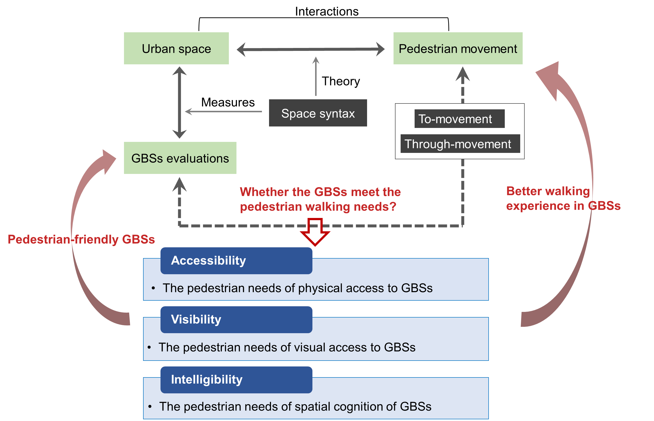
Figure 1. A conceptual AVI framework to assess the GBSs related to pedestrian movement

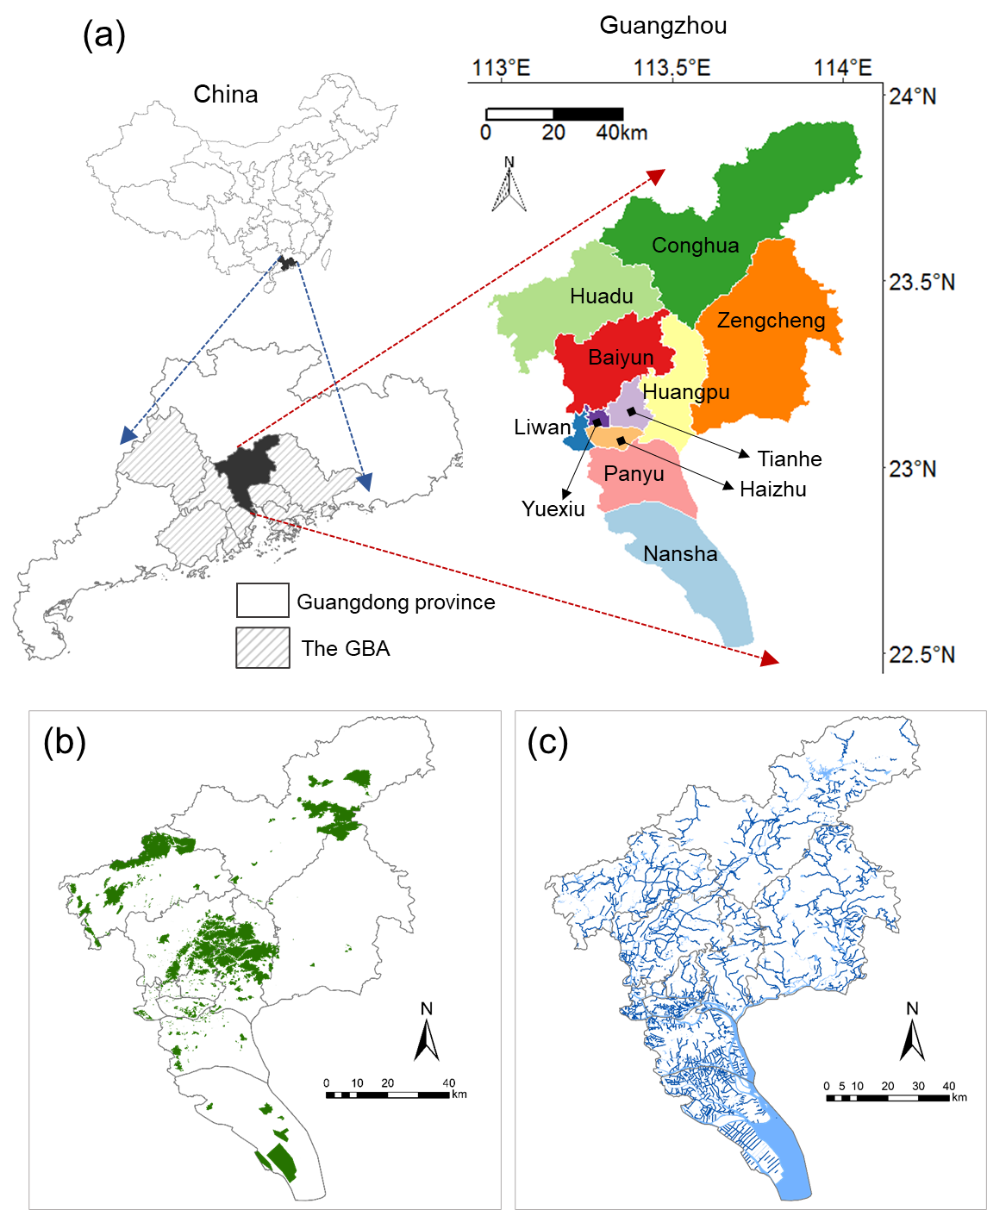
Figure 2. The location of Guangzhou city in China and its administrative districts are presented in (a). The spatial distributions of green and blue spaces in Guangzhou are shown in (b) and (c), respectively.

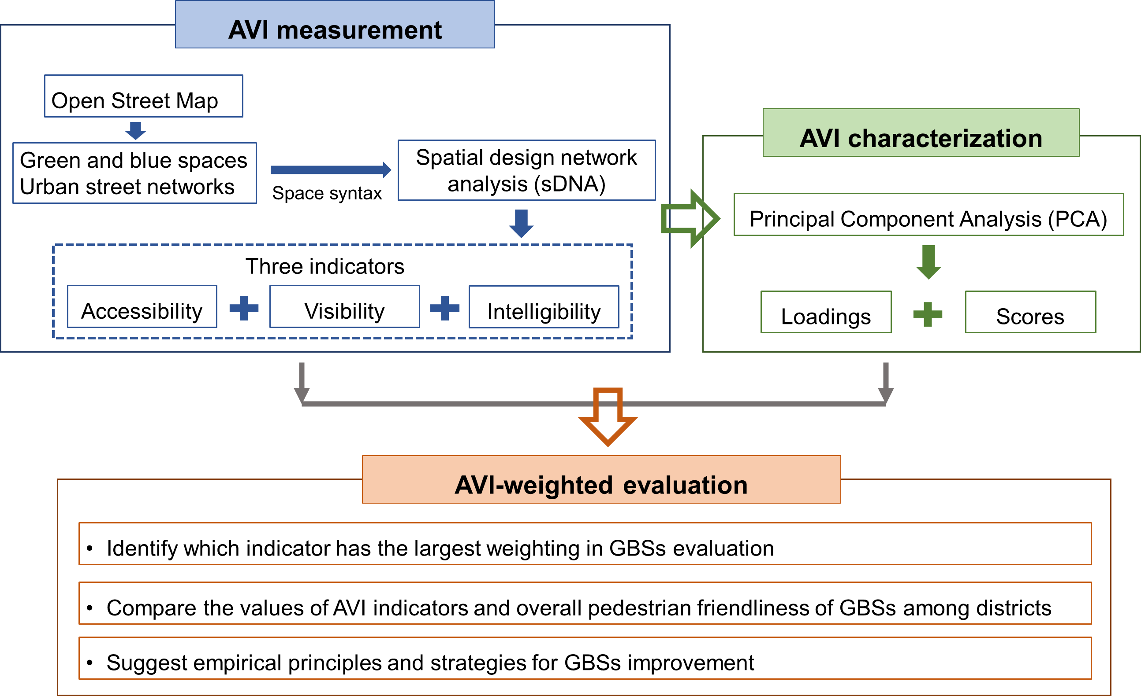
Figure 3. The analytical framework for GBSs evaluation based on the AVI framework

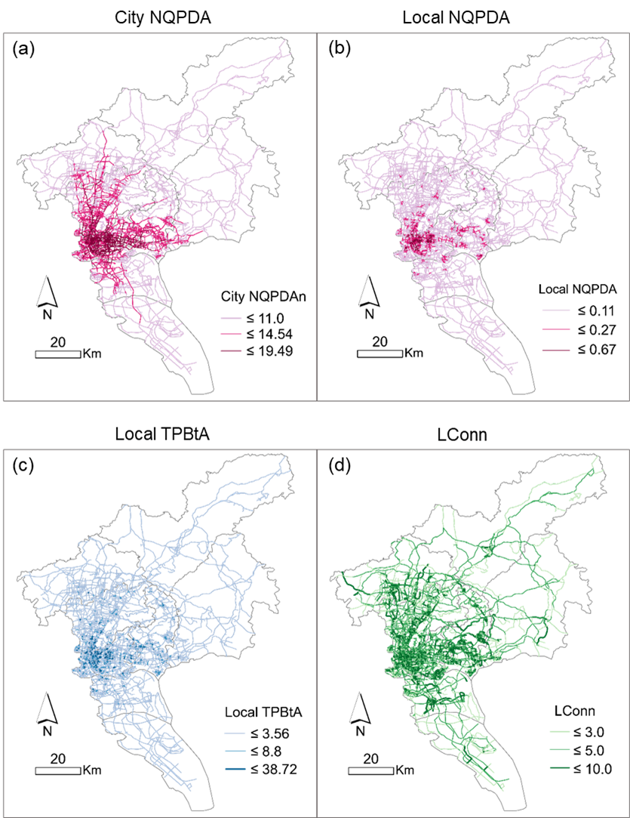
Figure 4. Measurements of urban spatial configurations based on sDNA tool. Spaces with darker colors have higher values of NQPDA over the whole city (a), local NQPDA (b), local TPBtA (c), and LConn (d).

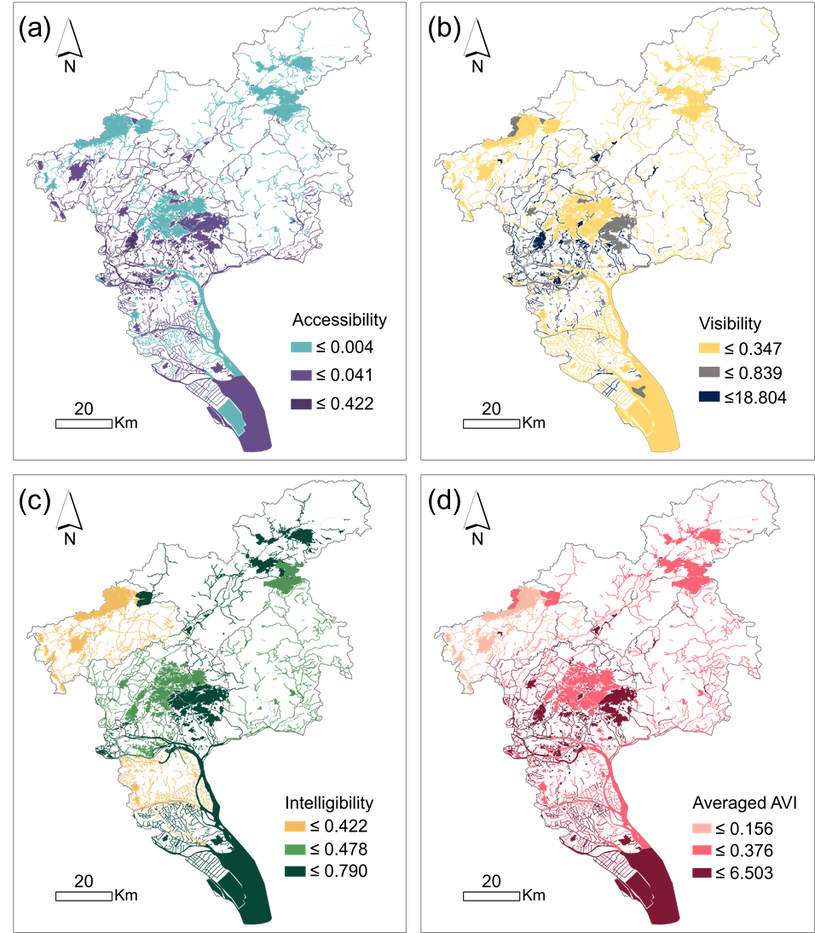
Figure 5. Accessibility, visibility, and intelligibility of each GBS are depicted in (a), (b), and (c), respectively. Also, the averaged values of three indicators in each GBS are shown in (d).
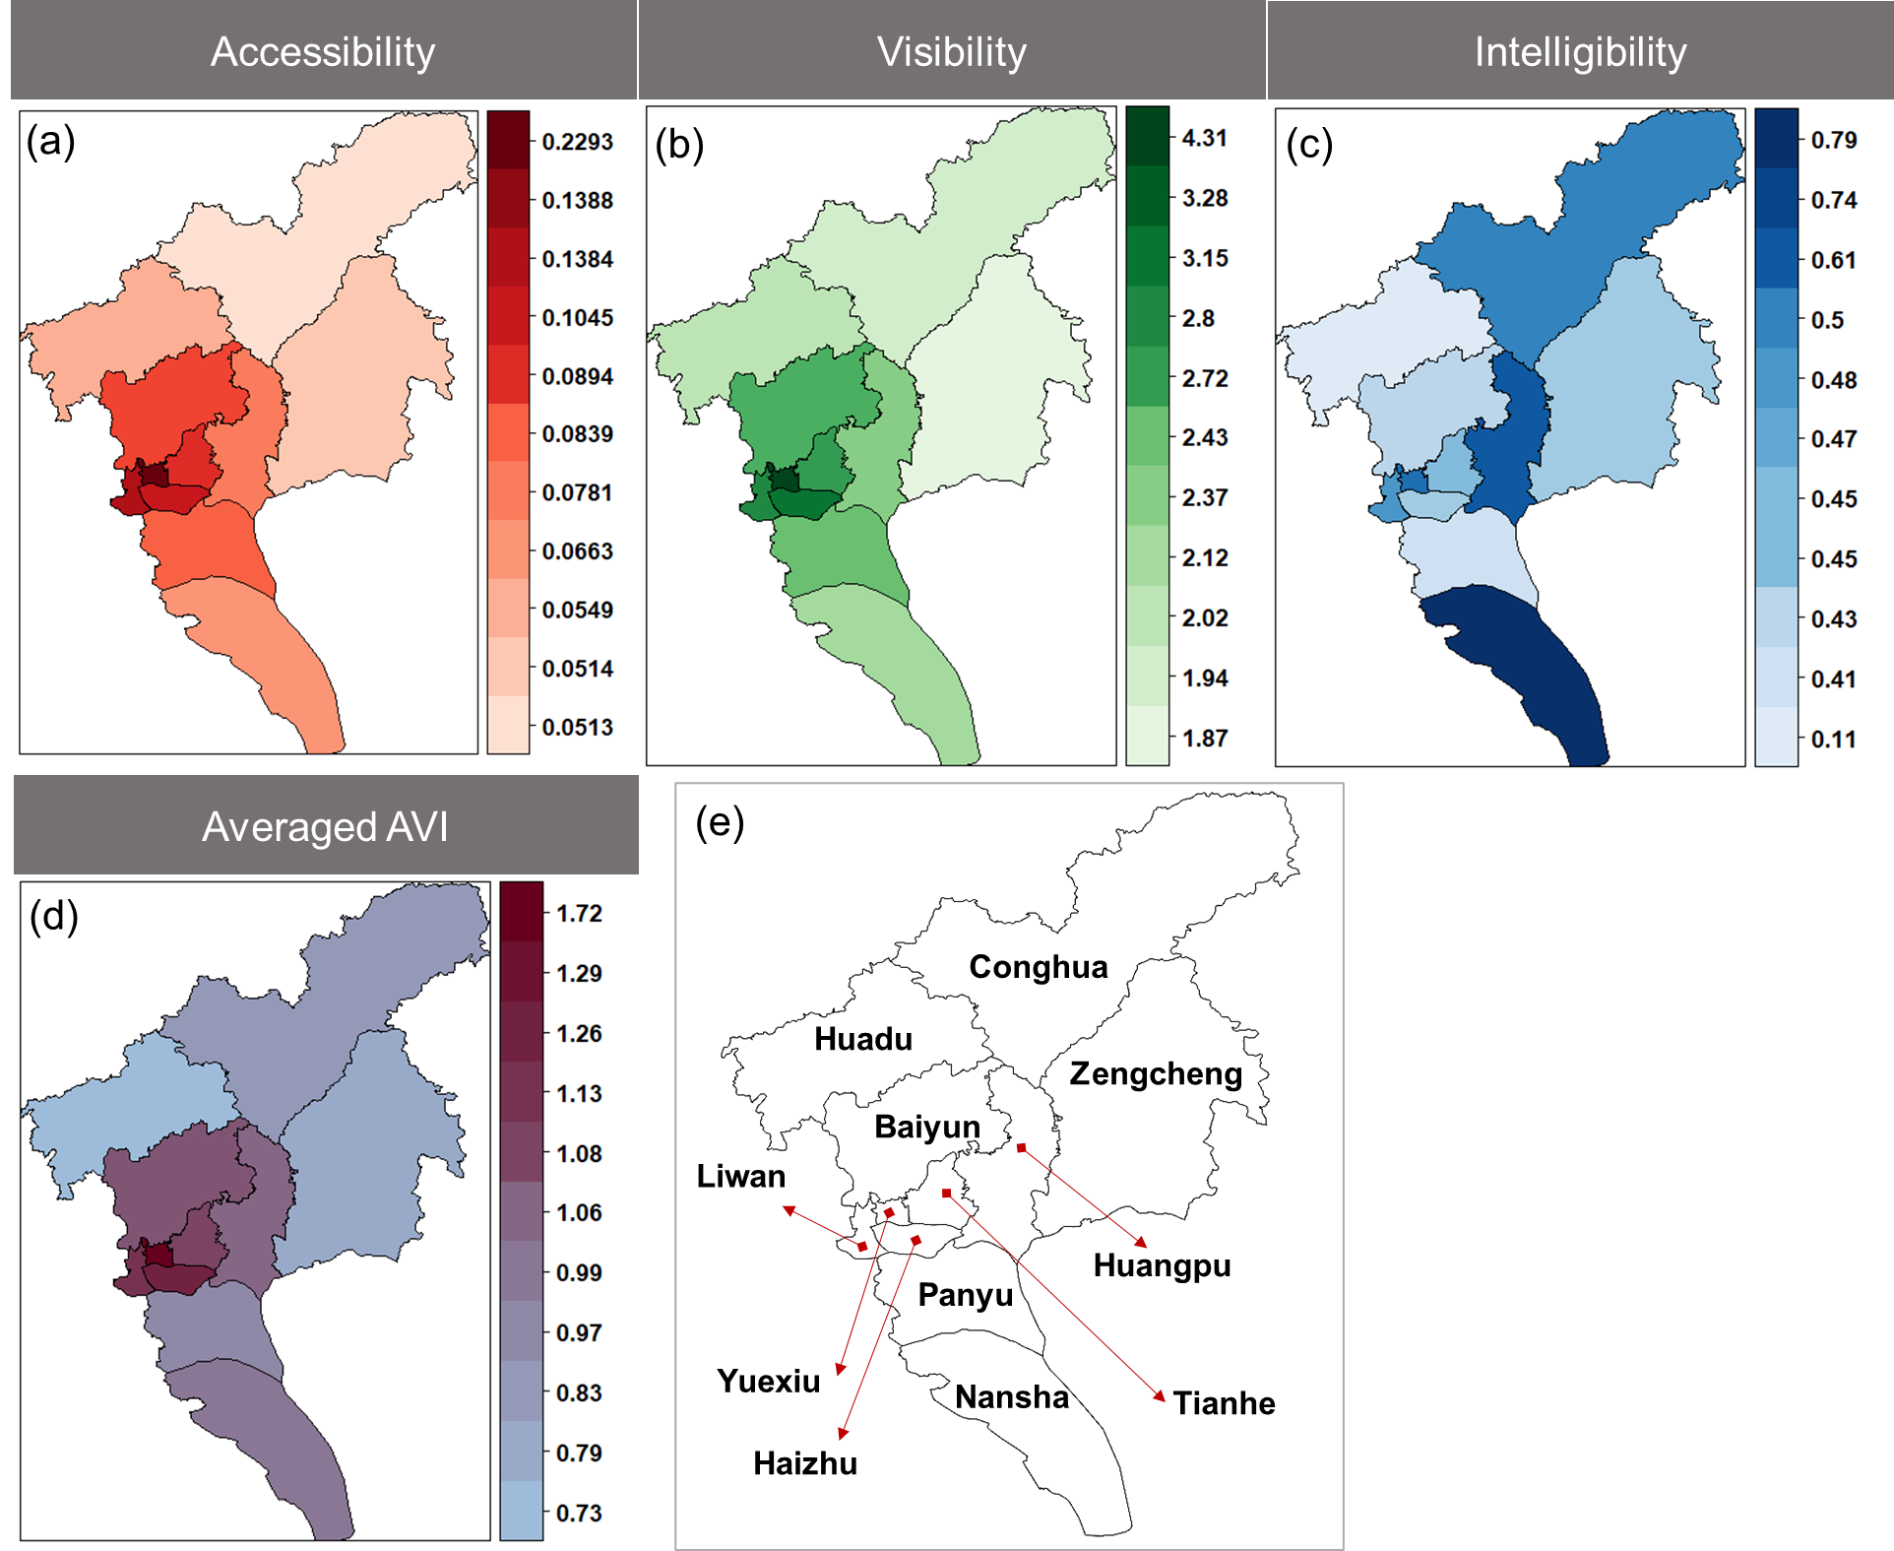
Figure 6. Three indicators of GBSs evaluation in each district of Guangzhou city ((a)~(c)). Districts with deeper color have higher values of accessibility, visibility, intelligibility. Also, the averaged values of three indicators in districts are shown in (d), which illustrate the AVI-averaged evaluations of GBSs. The names of each administrative district can be found in (e).

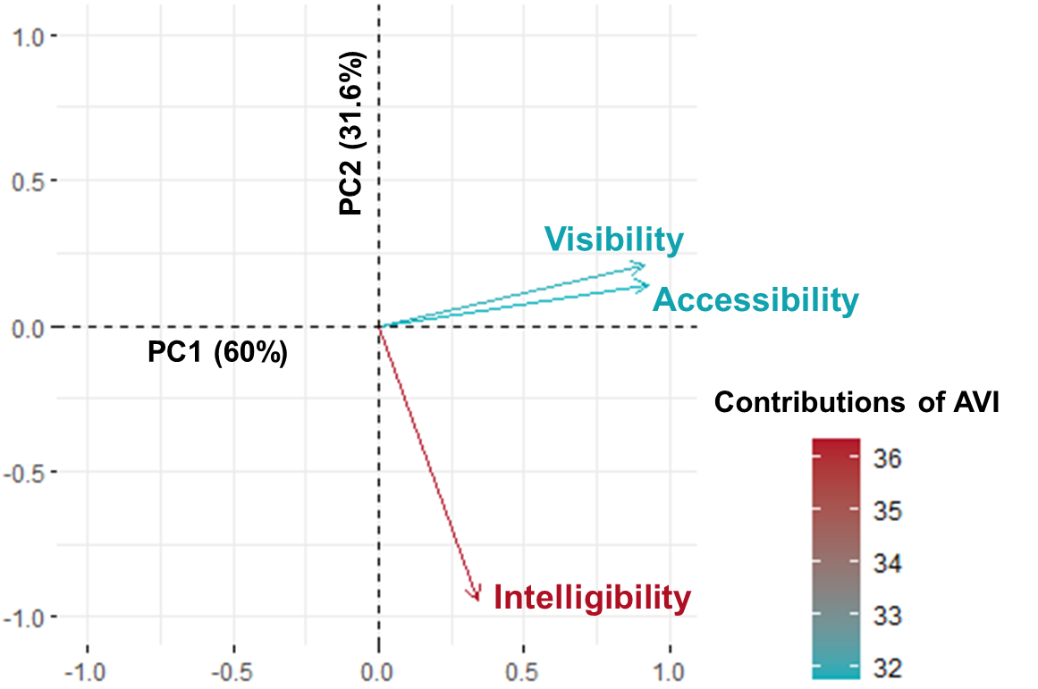
Figure 7. The contributions of accessibility, visibility, and intelligibility to GBSs evaluation in both PC1 and PC2.
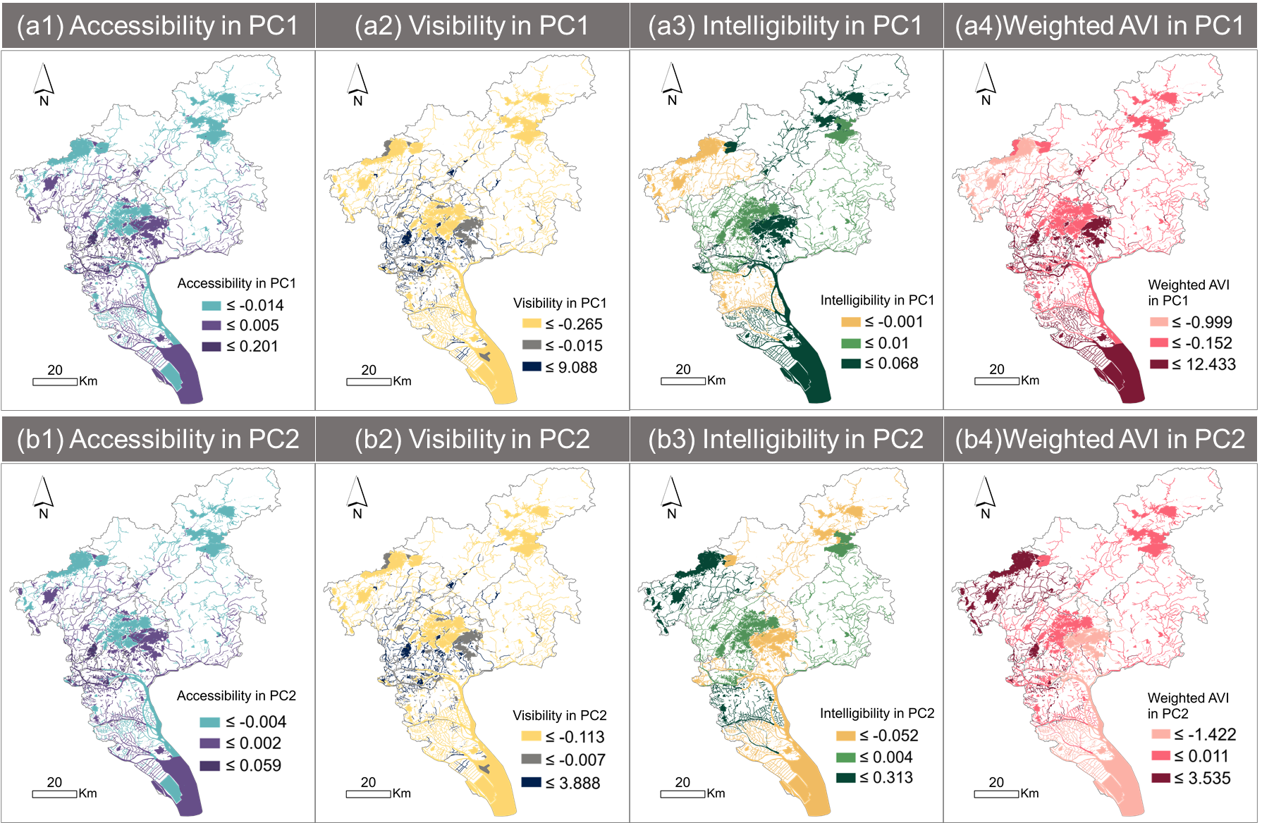
Figure 8. Accessibility, visibility, and intelligibility scores of GBSs in PC1 and PC2 are shown in (a1)~(a3) and (b1)~(b3), respectively. AVI-weighted scores of GBSs illustrate the overall GBSs’ pedestrian friendliness in PC1 (a4) and PC2 (b4).

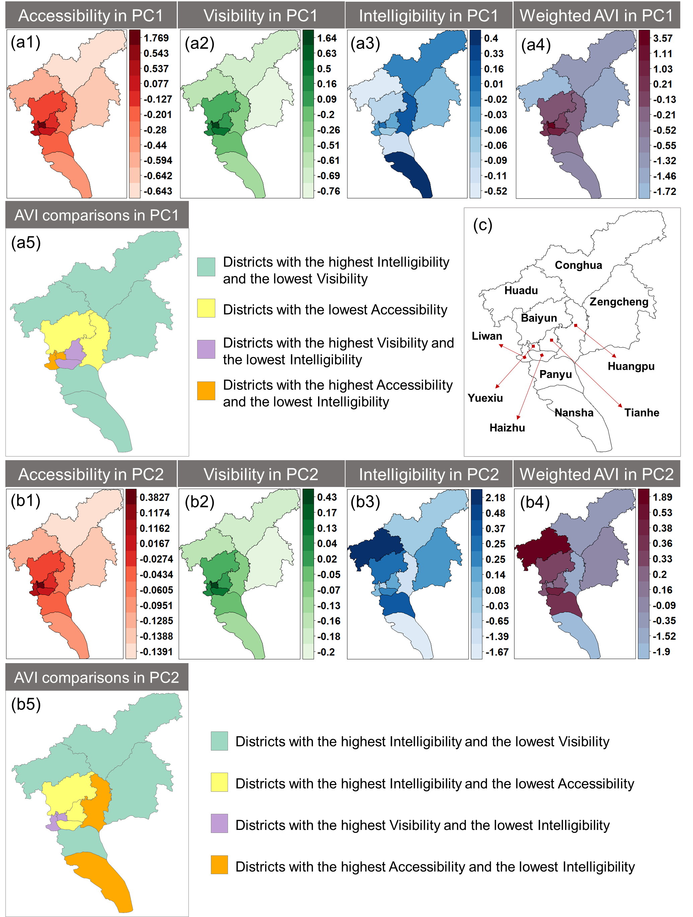Figure 9. AVI-weighted evaluations of GBSs in Guangzhou city based on PCA analysis. Accessibility, visibility, and intelligibility scores of GBSs in PC1 and PC2 are shown in (a1)~(a3) and (b1)~(b3), respectively. AVI comparisons show similar spatial patterns of AVI between PC1 (a5) and PC2 (b5). Integrating AVI indicators, AVI-weighted scores of GBSs illustrate the overall GBSs quality in PC1 (a4) and PC2 (b4). The names of each administrative district can be found in (c).

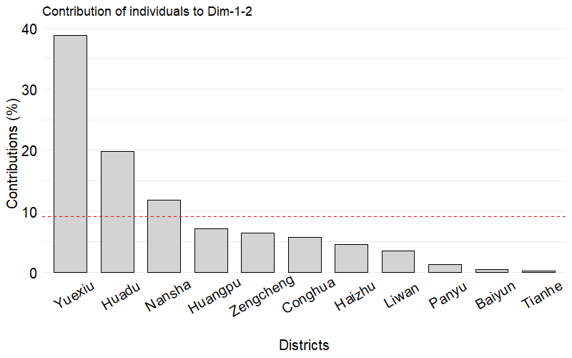
Figure 10. The contributions of each district to AVI-weighted GBSs over the city in the first two PCs. The red dashed line indicates the expected averaged contributions if the contribution of each district is uniform.

List of tables
Table 1. The potential AVI of various spatial characteristics of GBSs
Table 2. AVI measurements of GBSs
Table 3. The PCA results of AVI values

Table 1. The potential AVI of various spatial characteristics of GBSs
Spatial networks of GBSs |  | Potential impacts on AVI | Photographic examples  (By authors)
Distributions | Functions
1. Close to streets | Aesthetic; landscaping; buffering | These green spaces near to streets have high accessibility, visibility, and intelligibility, because they show a similar spatial network to the streets that are easily reached, viewed, and perceived with large human flows. | 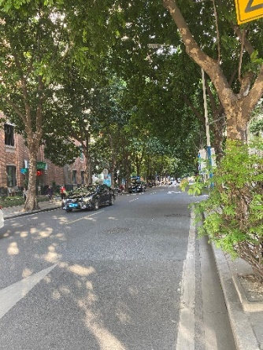
2. As spatial edge (e.g., rivers) | Environmental protection; buffering | The river as an edge for spatial isolation has low accessibility, low visibility, and low intelligibility, because the river, as a natural setting, mainly aims for environmental improvement rather than social activities due to low human flows and distant location. The river is not closely connected to the spatial networks for human daily movement. | 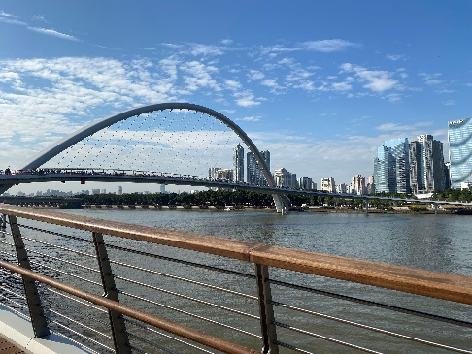
3.1 As district (e.g., wetland, ecological park) | Environmental protection | Both large-scale wetlands for environmental protection and nursery for production have low accessibility, low visibility, and low intelligibility, because they are generally located in the suburban areas with low-density street networks and only serve the particular individuals. These districts will be accessed or walked through in human routine movement. | 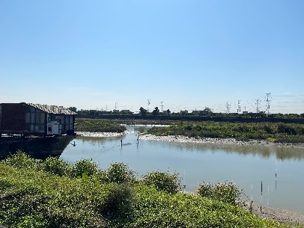
3.2 As district (e.g., transplant nursery) | Production |  | 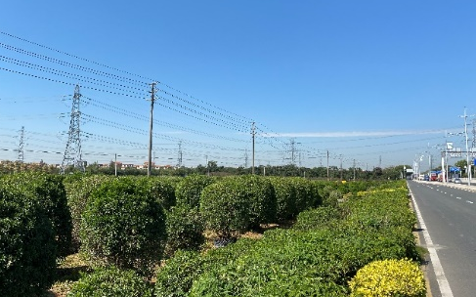
4.1 Close to urban nodes (e.g., attached to residential and commercial areas) | Entertainment; recovery; aesthetic; social cohesion | The GBSs attached to residential areas have high accessibility because most residential areas are easy to reach; but low visibility and intelligibility because these GBSs are usually semi-public and difficult for people moving through public street networks to see and recognize.  The GBSs attached to commercial areas have high accessibility, high visibility, and high intelligibility, because commercial areas as an important urban function in a well-connected spatial network should be easy to reach, view, and perceive throughout the city. | 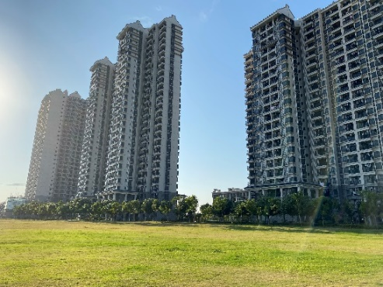
4.2 Close to urban nodes (e.g., attached to industrial areas) | Environmental protection; buffering | The GBSs attached to industrial areas have low accessibility, low visibility, and low intelligibility, because the industrial areas are in a distant location with an isolated spatial network from the city center. These GBSs play more roles in environmental protection than providing social benefits, which will not be recognized by people in their routine movement. | 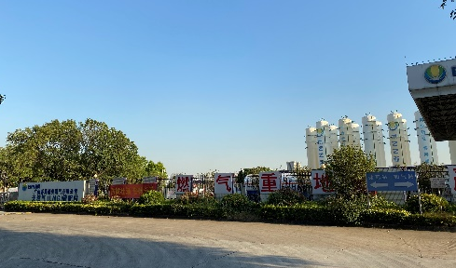
4.3 Close to urban nodes (e.g., public green-blue spaces) | Entertainment; aesthetic; recovery; social cohesion | The public green-blue spaces, such as parks, have high accessibility, high visibility, and high intelligibility, because these public open spaces are usually in well-connected and easy-accessed places, taking the usage efficiency into account. | 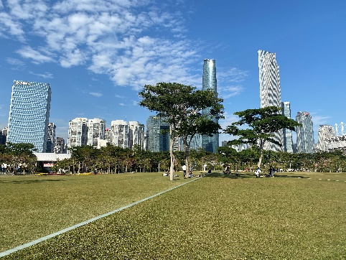
5. Close to landmarks | Aesthetic; entertainment | The GBSs around the landmark have  1) high accessibility and intelligibility, because the surrounding well-developed networks bring the GBSs into the easy-accessed and easy-cognized spatial networks.  2) but low visibility, because these GBSs primarily serve visitors instead of the general public. These GBSs are thus less likely to be viewed if people do not reach the landmark. | 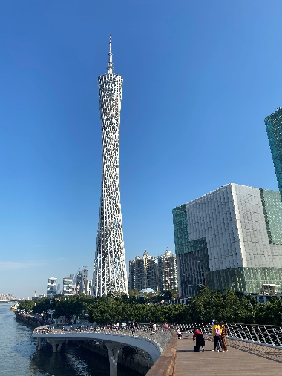

Table 2. AVI measurements of GBSs (Hillier et al., 1987; Hillier, 1996)
Indicators | Measures
Accessibility | Local NQPDA (radius = 1200m)
Visibility | Local TPBtA (radius = 1200m)
Intelligibility | Correlations (R²) between LConn and city NQPDA

Table 3. The PCA results of AVI values
 | PC1 | PC2 | PC3
Proportion of variance (%) | 60 | 31.6 | 8.4
Cumulative proportion (%) | 60 | 91.6 | 100
Loading
Accessibility | 0.688 | 0.146 | 0.711
Visibility | 0.68 | 0.211 | -0.702
Intelligibility | 0.252 | -0.967

