**Nuclear Consulting Group Westminster Seminars**

**The German energy transition and future UK energy policy**

11 September 2017

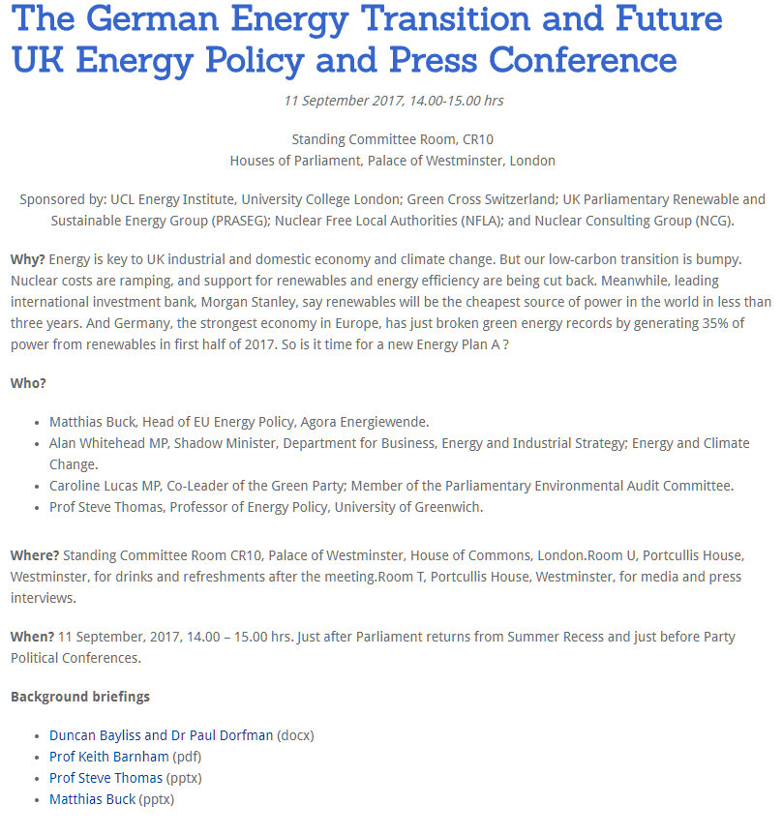

**UK energy policy: late lessons from Chernobyl, early warnings from Fukushima**

28 January 2016

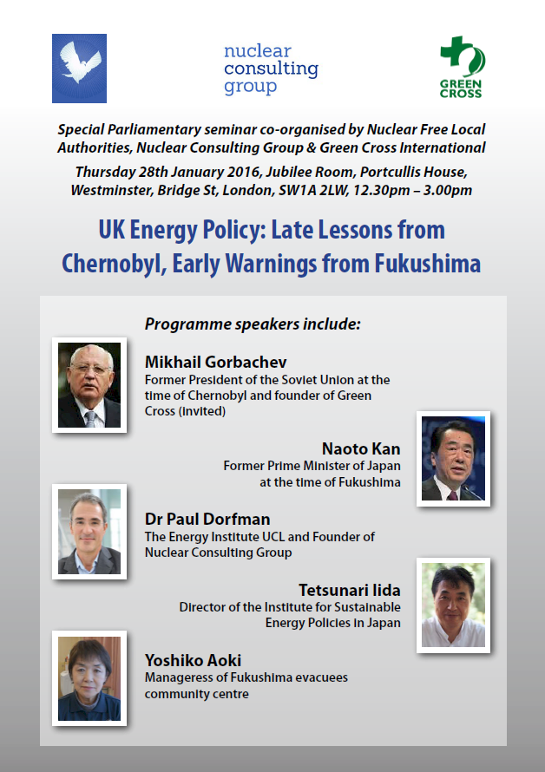

**Fukishima: Lessons learned for UK new nuclear build**

14 June 2011

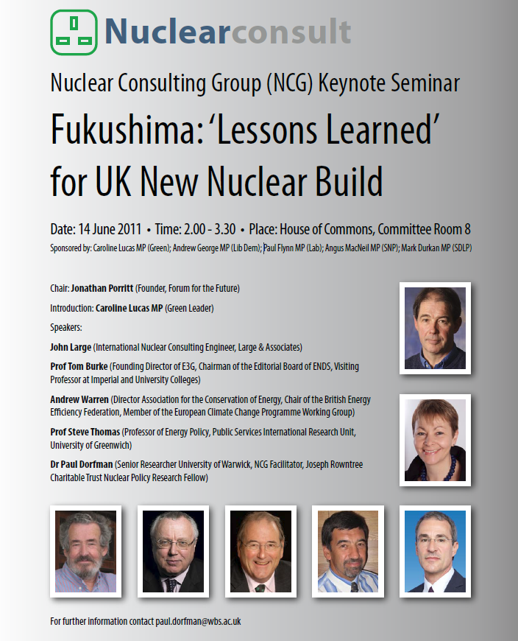

**Nuclear Communities: listen and be heard**

Colston Hall Bristol 9 November 2011

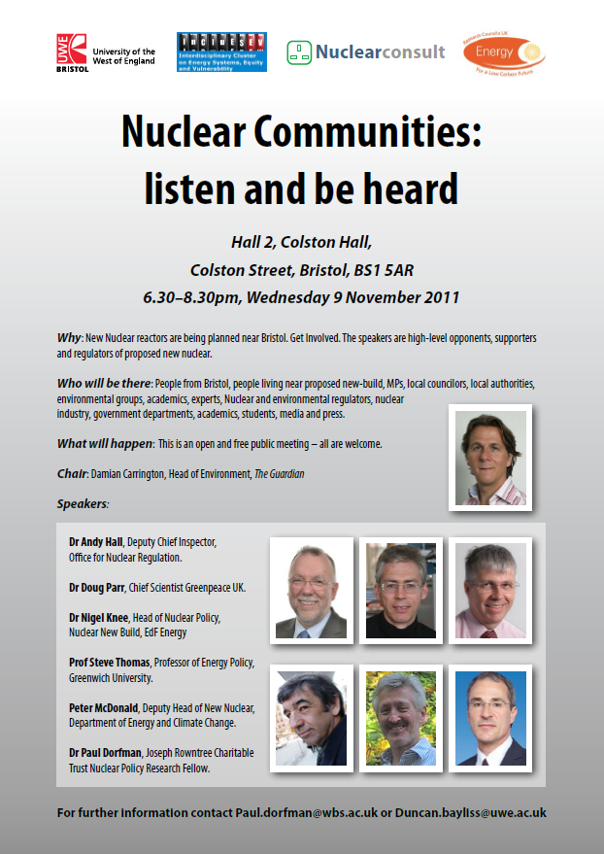

**The Cost of New Nuclear Reactors in UK**

October 19th 2009

