**Reassessing the multiple values of lowland British floodplains**

**Mark Everard**, Pundamilia Ltd, 2 Hollow Street, Great Somerford, Wiltshire SN15 5JD, UK. (E: [mark.everard@uwe.ac.uk](mailto:mark.everard@uwe.ac.uk), M: +44-7747-120019)*

**Peter Bradley**, University of the West of England. (E: [peter.bradley@uwe.ac.uk](mailto:peter.bradley@uwe.ac.uk))

**Wendy** **Ogden**, University of the West of England. (E: [wendyogden@myphone.coop](mailto:wendyogden@myphone.coop))

**Enrica Piscopiello**, University of the West of England. (E: [enrica2.Piscopiello@live.uwe.ac.uk](mailto:Enrica2.Piscopiello@live.uwe.ac.uk))

**Louis Salter**, University of the West of England. (E: [louis2.Salter@live.uwe.ac.uk](mailto:Louis2.Salter@live.uwe.ac.uk))

**Samantha Herbert**, University of the West of England. (E: [samantha2.herbert@live.uwe.ac.uk](mailto:Samantha2.Herbert@live.uwe.ac.uk))

**Rob McInnes**, RM Wetlands and Environment Ltd. (E: [rob@rmwe.co.uk](mailto:Rob@rmwe.co.uk))

*Corresponding author: [mark.everard@uwe.ac.uk](mailto:mark.everard@uwe.ac.uk)

**Abstract**

Ecosystem services provided by lowland British floodplains respectively under semi-natural conditions and converted for intensive maize production were assessed. Floodplains across lowland Britain have been extensively disconnected from river channels, depleting habitat for wildlife and other beneficial ecosystem services. Conservation measures are often regarded as costly constraints on economic and development freedoms whilst, conversely, conversion for intensive agricultural production is rewarded by markets despite many often-overlooked externalities. Maize growing has increased in Britain since the 1970s, initially for feedlot production of livestock and now increasingly for grant-aided biofuel production for anaerobic digestion. Comparative literature-based ecosystem service assessments using the RAWES (Rapid Assessment of Wetland Ecosystem Services) approach reveal that lowland British floodplains in semi-natural condition provide a wider range of provisioning services than those converted for monocultural intensive production of maize, in addition to a diversity of regulating, cultural and supporting service benefits that are lost or transformed into disservices when floodplains are converted for intensive maize growth. Benefits and disbenefits of floodplains managed under the two scenarios (semi-natural versus monocultural maize) are presented graphically as an intuitive means to support decision-makers. Monetisation of benefits would be risky, not merely due to uncertainties but as this may skew conclusions and subsequent decision-making towards maximisation of marketed or near-market services, consequently misrepresenting the diversity of values of whole socioecological floodplain systems. Management solutions protective of the societal values provided by floodplain ecosystem may include buffer zoning as a mitigation measure, but a more strategic solution may be zonation of land use based on suitability not only for crop production but recognising the full spectrum of societally beneficial ecosystem services demonstrated by RAWES assessment. A variety of drivers for a changing approach to floodplain farming – statutory, fiscal and self-beneficial – are highlighted, and are generically applicable beyond Britain with context-specific modification.

**Keywords**

Ecosystem services; value; wetlands; RAWES; energy crops; conservation.

**1. Introduction**

*1.1 Trends in the use and condition of Britain’s lowland floodplains*

River catchments have been heavily modified by human activities across Britain and lowland Europe radically altering the habitats of river corridors (Newson, 2002; Gurnell and Petts, 2011). Disconnection of wetlands degrades habitat, associated species and many ecosystem functions and services. Floodplain area in the British Isles declined from a natural 100-year flood zone extent of 16,577 km2 in around 1950 to 6,940 km2 in 2000, a 58% loss, primarily through construction of flood defence embankments (UK NEA, 2011). The River Habitat Survey (Environment Agency, 2003, cited in Maltby et al., 2013) determined that only 7.1%, of surveyed river stretches retained floodplain on either bank, and that remaining floodplains were heavily modified with embankments close to the watercourse in 13% and embankments set back on the floodplain in 6% of stretches. Maltby et al. (2013) concluded that water is prevented from inundating nearly one-fifth of British semi-natural floodplains. A 2010 survey (Environment Agency, 2010) found that 42% of surveyed river stretches were ‘severely modified’ with a further 20% ‘significantly modified’.

Maltby et al. (2011) determined that freshwater wetlands probably make up around 1% of UK land area, including 300,000 ha of coastal and floodplain grazing marsh. Rothero et al. (2016) identified agricultural intensification as a primary driver of change, accounting for a 97% loss of species-rich grasslands since the 1930s leaving a remnant of only 1,200 ha of species-rich floodplain meadows. Just over one million hectares of English agricultural land lie within floodplains defined by risk of at least 1 in 100-year flood events (Natural England 2011), comprising 9% of total agricultural area and including some of the most fertile and productive areas (accounting for 57% of Grade 1 agricultural land) much of which have been ‘reclaimed’ and ‘improved’ for agricultural purposes since at least the Middle Ages. Intensive agriculture occupied 38% of English floodplains in 1990, expanding to 53% by 2000, 62% in 2007 and 64% by 2015, with wetland areas (fen, marsh, swamp and bog) substantially degraded in both upland and lowland areas with near ubiquitous loss of natural floodplain functioning (Entwistle et al., 2019). Rothero et al. (2016) document important functional floodwater storage, soil and nutrient retention, water purification, natural productivity, drought resilience, pollination, grazing and other roles performed by floodplain meadows. Costs associated with loss of goods and services naturally generated by less intensively modified floodplain ecosystems have yet to be properly assessed (Maltby et al., 2013), a situation far from consistent with stated commitments to sustainable development under which ecosystems are recognised as primary and critical resources.

*1.2 Conversion of lowland British floodplains for the intensive growth of maize*

Though with a long history in Europe, maize cropping has become increasingly significant. British maize has been grown principally as a fodder crop or game cover but, in recent decades, is increasingly grown as a ‘green energy’ crop. UK maize growth has consequently escalated substantially from around 20,000 acres in 1973 to 450,000 acres in 2016 (a 2,250% increase) with continuing growth in cropped area (Drury, 2019). Floodplains are recognised as optimal for growth of maize owing to their level topography and nutrient-rich hydric soils (Rogers, 2018). Dadson et al. (2017) highlighted how floodplain development, including the expansion of crops such as maize, increases soil compaction and exposure of people, property and infrastructure to the costly natural hazard of flooding in the UK particularly under future climate change scenarios. Intensive maize growth also requires high chemical and energy inputs and can leave soil compacted, bare and erosive between autumn forage harvesting and late spring reseeding. Conversion of floodplains for maize, other crops or urban and industrial development overlooks the wide range of ecosystem service benefits provided by their natural processes.

Extensive maize growing for energy production and intensification of dairy farming in the River Axe catchment in east Devon, England, is recognised by the Environment Agency (2019a) as placing the designated Special Area of Conservation (under the EU Habitats Directive) and Special Site of Scientific Interest (SSSI) in the lower reaches of the river in unfavourable and declining condition. In common with many British catchments, floodplain extent, largely indicated by on in 100-year flood risk area, is found mainly in the lower river, which also includes reaches designated for nature conservation and settlements subjected to flood risk and poor water quality (Figure 1). The Axe is seen as particularly problematic on a national scale, the 437 farm units across the 308 km2 catchment, including 125 ‘intensive grazing farms’ (cattle), were subject to a three-year winter time regulatory farm visit programme with infrastructure investments, resulting in modest improvements.

*Figure 1: The Axe catchment, Devon (southern England), illustrating extent of 10% (one in 100-year) flood envelope and locations of settlements including those in the lower catchment at risk of flooding and poor water quality*

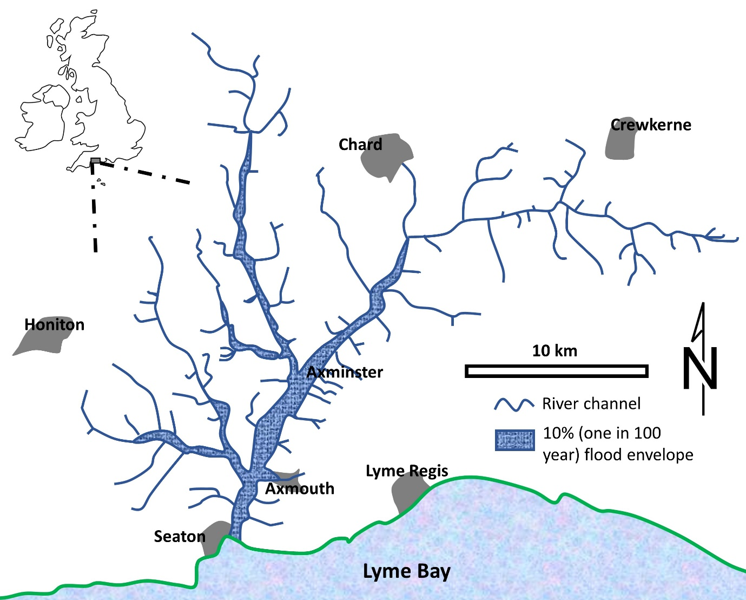

*1.3 Recognition of the benefits and costs of lowland floodplain conversion*

Although profitable in the short term for farming and associated food and energy interests, conversion of lowland floodplains for intensive maize production may be far from benign when externalities for linked ecosystem services are recognised.

Economic assessment of environmental damage from agricultural activities, externalities that are still largely overlooked, can generate significant social and economic costs for current generations and strongly affect future wellbeing (Macháč et al., 2021). Agricultural decision-making tends to focus of profitability related to current commodity markets. Conversely, natural resource and nature conservation initiatives are often expressed in terms of costs (for example Moran et al., 2008), often reliant on conservation philanthropy (for example Larson et al., 2016) or as a constraint on economic freedoms requiring subsidisation. This current skewing of economic assessment positions the sectors of agriculture and nature conservation in opposition (Farkas and Kovács, 2021). In some cases, robust global markets can hasten extinction of wild species as markets and institutional policies fail to value non-market and public benefits (Swarna Nantha and Tisdell, 2009).

A systemic approach is required to assess the net balance of benefits and disbenefits of landscape use, recognising its full potential to generate societally beneficial ecosystem services (Firbank et al., 2011; Schindler et al., 2016) rather than a compromise between two narrow potential outputs of land.

*1.4 The aim of this study*

This study assessesecosystem service benefits and disbenefits consequent from two comparative lowland British floodplain management scenarios: (1) semi-natural including traditional grazing and hay-cutting management; and (2) converted for intensive maize production. These assessments use the RAWES approach to represent the full range of ecosystem service outcomes under each scenario, from which we derive recommendations for land use reforms optimising societal value. Whilst recommendations are drawn in a British context, the findings are generically applicable to floodplain uses in other geographical settings. The methods used in this study can also be adapted to compare contrasting uses of other habitat types.

**2. Methods**

*2.1 Selection of case study scenarios*

The two selected lowland British floodplain management scenarios – semi-natural and converted for intensive maize production – reflect contrasting management regimes.

The semi-natural floodplain scenario, with permanent vegetative cover whether due to low historic impacts or resulting from restoration, was selected in recognition that no British catchment can be considered pristine and un-impacted by human intervention. The substantially evolved ecological assemblages of ‘semi-natural’ habitats have evolved over the long term under traditional human interventions, upon which they depend for retention of their characteristics, but nonetheless are recognised for their high values for biodiversity, retention of important functions and ecosystem services (European Investment Bank, 2018; Lawson et al., 2018).

The comparator case study of generic lowland British floodplains under intensive maize production assumes that no mitigating measures are in place, such as the still uncommon adoption of riparian buffer zones between intensively cropped land and watercourses (Figure 2). Many are also left bare, frequently with application of manure or fertilisers, for up to six months over winter between autumn forage harvesting and late spring sewing of fresh maize (Figure 3).

*Figure 2: Maize growth in lowland British floodplains displaces many of the functions and societal benefits of this riparian habitat when in semi-natural condition, with cropping commonly abutting river edges without buffer zones*

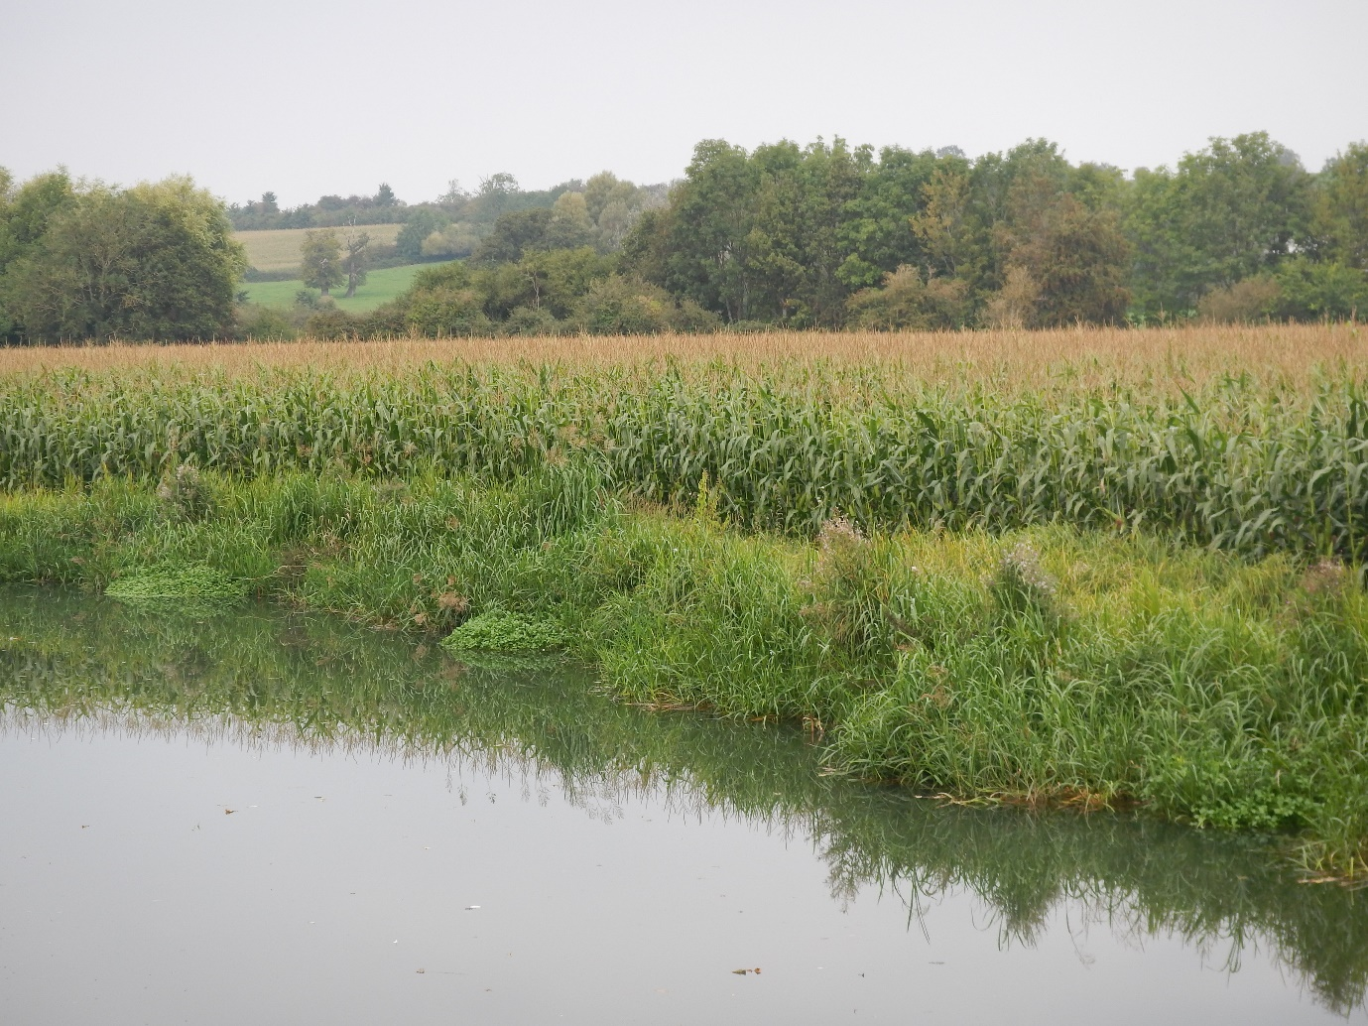

*Figure 3: Soil loss, and run-off from denuded lowland British floodplains after late-autumn forage harvesting of intensive maize, commonly cropped to the river margin with no buffer zone, creates a range of ecosystem service disbenefits*

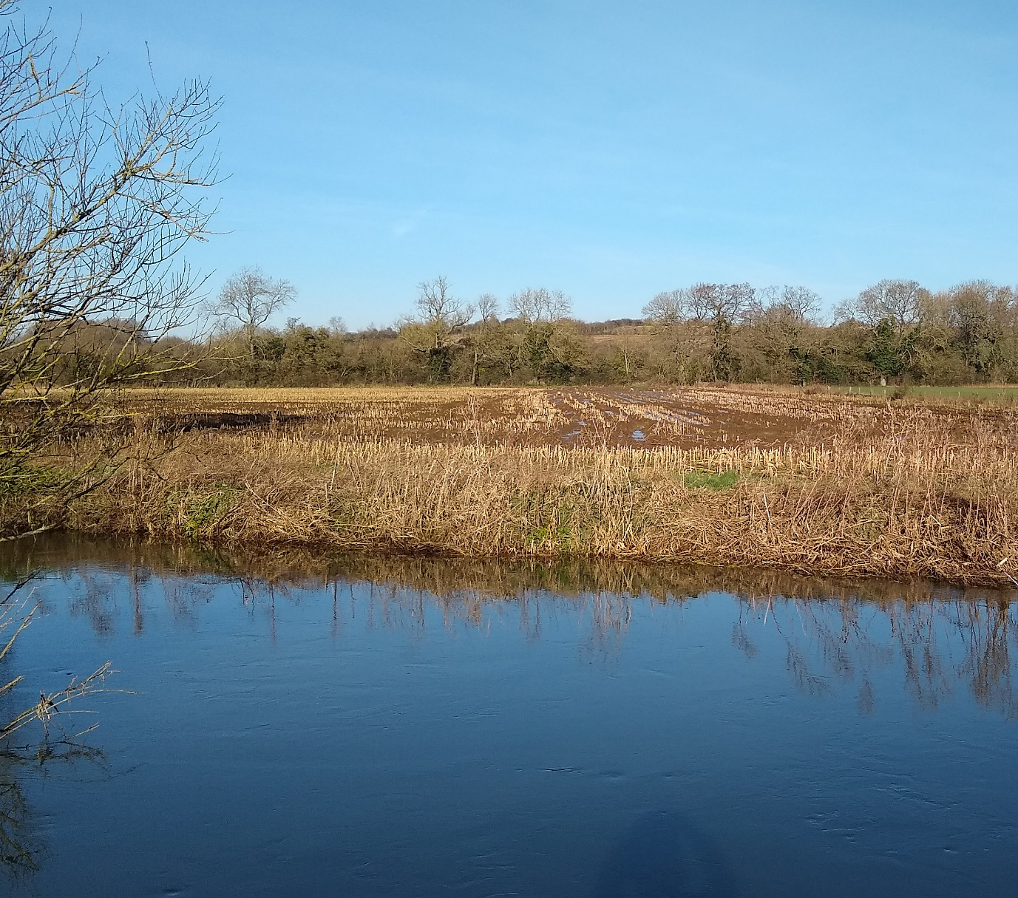

*2.2 RAWES and supporting evidence*

The Rapid Assessment of Wetland Ecosystem Services (RAWES) approach (RRC-EA, 2020) was used to assess likely provision of ecosystem services in the two floodplain scenarios. The RAWES approach was developed to support ecosystem service assessment recognising practical time and resource limitations faced by operational staff, being both rapid and cost-effective and also serving to facilitate the integration of qualitatively differing types of evidence into a systematic semi-quantitative assessment of all ecosystem services across the four Millennium Ecosystem Assessment (2005) categories; provisioning, regulating, cultural and supporting (McInnes and Everard, 2017). RAWES was adopted by a resolution of the Ramsar Convention in October 2018 as a globally standard means for systemic assessment of wetland ecosystem services (Ramsar Convention 2018). Guidance on its application has subsequently been published (RRC-EA 2020). Though specifically developed for wetland assessment, RAWES is adapted from an approach applied to a range of habitat types (Everard, 2009; Everard and Waters, 2012) and can be used across multiple scales from whole landscapes to localised zones of large and complex ecosystems (McInnes and Everard, 2017), as for example by Everard *et al*. (2020) and Everard and West (2021).

RAWES assessments score the each ecosystem service and geographical range over which benefits are realised on a semi-quantitative significance scale following Defra (2011), as outlined in Table 1. Table 1 also describes how RAWES scores are aggregated into ecosystem services index (ESI) scores by summing significance scores within groups of ecosystem services and dividing by the number of contextually relevant services (RRC-EA 2020). Potential ESIs range from +1 to -1, whether calculated for relevant ecosystem services in each of the four categories or for total relevant services across all categories. The same mathematical transformation is used to calculate ESIs for total ecosystem service benefits accruing across the four geographical ranges in the RAWES field assessment sheet (local, catchment, national, global) for relevant ecosystem services; geographically-based ESIs may exceed the limits of +1 or -1 where benefits or disbenefits accrue across multiple scales.

*Table 1: Assignment of RAWES importance scores and their transposition to ESI values*

|  |  |  |  |  |  |  |
| --- | --- | --- | --- | --- | --- | --- |
| **Assigned importance** | **Significantly positive** | **Positive** | **Neutral** | **Negative** | **Significantly negative** | **Unknown** |
| RAWES importance score | ++ | + | 0 | - | -- | ? |
| Numerical value for ESI calculation | 1.0 | 0.5 | 0.0 | -0.5 | -1.0 | Remove from analysis |

Ideally, RAWES assessments would have been conducted directly on case study sites. However, this was not possible due to: (1) pandemic restrictions on travel; (2) resources secured for this study informed by these restrictions; and (3) in the light of a high level of site-specificity, a more generic approach to lowland British floodplains is a more sensible approach if findings are generalised for wider applicability. Consequently, it was necessary to base RAWES assessments on literature review.

*2.3 Literature review*

Literature reviews informing RAWES assessments interrogated both peer-reviewed and ‘grey literature’ (non-refereed government, agency, consultancy, NGO and other) publications. A three-tiered approach was undertaken. The first approach was systematic review. Secondly, ‘snowballing’ reviews followed references in papers identified by systematic review (Sayers, 2007). Thirdly, as few benefits are described in the literature are expressed explicitly as ecosystem services, targeted searches were undertaken (as examples, ‘panning’ and ‘soil compaction’ to address the regulating services of groundwater recharge and erosion, and ‘biodiversity’ to assess the supporting service of habitat for wildlife). There was also a substantial lack of literature addressing pristine or semi-natural floodplains in lowland Britain, necessitating expanded searches to locate literature from similar lowland localities, principally in northern Europe, including restored sites.

The Supplementary Material documents search terms used in the systematic review, snowballing and subsequent targeted searches, and interpretation of literature in RAWES assessments.

*2.4 Valuation*

The values of ecosystem services are inherently plural, as for example reflected in the qualitatively different value systems by which provisioning, regulating, cultural and supporting services are realised (Millennium Ecosystem Assessment, 2005). Historic valuation tended to be undertaken from narrow perspectives, such as maximisation of financial returns (Cornes and Sandler, 1996). For example, the market price of land has been overwhelmingly influenced by agricultural or development potential rather contributions to a diversity of publicly beneficial ecosystem services. The perception of natural capital as a free good, and the undervaluing of the services that it provides, is a principal reason for the progressive degradation of global ecosystems (Barbier, 2011). Valuation of ecosystems and their services requires an inclusive approach considering outcomes for all ecosystem services and their beneficiaries, correcting the current skewing of value systems based on financial/market-driven exchange values.

RAWES takes a semi-quantitative approach, assessing likelihood of impact across all ecosystem services to consider the whole system. The economic concept of ‘disvalue’ (as defined in Bradley et al 2020) can be connected directly to the ecosystem service concept of ‘disbenefits’ (Smith et al., 2013). However, notwithstanding a diversity of approaches seeking to value ecosystem services (for example Everard and Waters, 2013; TEEB, 2010; TESSA, n.d.), conceptual and methodological problems remain for adequate representation of the values of all ecosystem services in monetary terms within a market system principally predicated on profit-making (Everard, 2022). Framing all service benefits in market terms would depend on consciously and commonly held societal appreciation of the benefits or disbenefits of the often-complex emergent properties of ecosystems that underpin their integrity and capacities to underwrite continuing human wellbeing. Whilst significantly positive or negative. or unknown, outcomes identified by semi-quantitative screening using RAWES can, if necessary, be quantified, quantification must not be allowed to dominate decision-making to the exclusion of less inherently quantifiable services that may be nonetheless important culturally and in terms of maintaining continuing ecosystem integrity and functioning (Everard, 2022). Standard valuation approaches are poor at picking up on criticality, and do not always ensure the integrity and resilience of ecosystems for nature and for continuing human benefit, as set out in the ‘dis-value’ concept (Bradley et al., 2020). The RAWES approach seeks to avoid biases such as those introduced by market exchange values, ensuring that important ecosystem services pertaining to support for biodiversity, ecosystem functioning and resilience are not progressively undermined by knowledge gaps and the inability of standard valuation approaches to adequately capture and ensure existing relationships and integrity underwriting prosperity for humans and nature.

**3. Results**

*3.1 The ecosystem services of natural and restored floodplains*

Literature reviews documented in the Supplementary material provide an evidence base that was applied cautiously to make comparative RAWES assessments of lowland British floodplains respectively in semi-natural state and where converted for intensive maize production. The Supplementary material lists references and documents, search parameters and indicative terms used in targeted searches. Table 2 summarises RAWES scores for floodplains under the two management regimes. ESIs for ecosystem service categories are illustrated in Figure 4, with ESIs for geographical scale of benefit realisation in Figure 5.

*Table 2: Summary of RAWES ‘likely impact’ (using ‘traffic lights’ colour coding from ‘++’ = dark green through ‘0’ = amber to ‘--’ = dark red, with ‘?’ and ‘X not relevant’ = white) and geographical scale scores (L = local, C = catchment, N = national, G = global)*

|  |  |  |  |  |  |
| --- | --- | --- | --- | --- | --- |
| **Ecosystem services** | | **Semi-natural floodplain** | | **Intensive maize floodplain** | |
| **Likely impact** | **Scale** | **Likely impact** | **Scale** |
| Provisioning | Fresh water | ++ | L,C | -- | L,C |
| Food production | + | L,C | 0 |  |
| Fibre/fuel production | ++ | L,C | ++ | L,C |
| Genetic resources | ? |  | 0 |  |
| Biochemicals, etc. | ? |  | 0 |  |
| Ornamental resources | + | L,C | 0 |  |
| Harvesting of clay, mineral, aggregates, etc. | Not relevant |  | Not relevant |  |
| Waste disposal | Not relevant |  | 0 |  |
| Energy harvesting from natural flows | Not relevant |  | Not relevant |  |
| Regulating | Air quality | Not relevant |  | - | L |
| Local climate/microclimate | + | L | - | L |
| Global climate | ++ | G | - | G |
| Water regulation/hydrology | ++ | L,C | -- | L,C |
| Natural hazard | 0 |  | 0 |  |
| Pest regulation | + | L | - | L,C |
| Disease - human | 0 |  | 0 |  |
| Disease - livestock | + | L | 0 |  |
| Erosion | + | L | -- | L,C |
| Water purification/waste treatment | ++ | L,C | -- | L,C |
| Pollination | ++ | L,C | -- | L,C,N |
| Salinity | Not relevant |  | Not relevant |  |
| Fire | Not relevant |  | Not relevant |  |
| Noise/visual buffering | Not relevant |  | Not relevant |  |
| Cultural | Cultural heritage | ++ | L,C | 0 |  |
| Recreation/tourism | + | L,C,N | 0 |  |
| Aesthetic value | + | L,C | 0 |  |
| Spiritual/religious value | + | L,C | 0 |  |
| Inspiration of art, folklore, etc. | + | L,C | 0 |  |
| Social relations | + | L,C | 0 |  |
| Educational/research | + | L,C,N | 0 |  |
| Supporting | Soil formation | ++ | L,C | 0 |  |
| Primary production | ++ | L,C | + | L,C |
| Nutrient cycling | + | L,C | -- | L,C,N,G |
| Water recycling | + | L,C | -- | L,C |
| Photosynthesis (O2 production) | + | L | + | L |
| Provision of habitat | ++ | L,C,N,G | - | L,C |

*Figure 4: ESI representation comparing ecosystem service provision from lowland British floodplains in semi-natural state and when converted for intensive maize production*

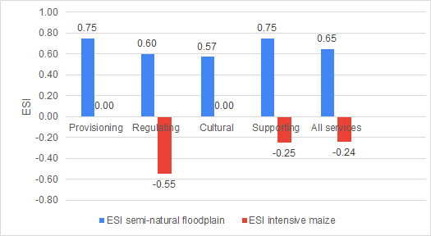

*Figure 5: ESI representation of geographical scales of ecosystem services provision from lowland British floodplains in semi-natural state and when converted for intensive maize production*

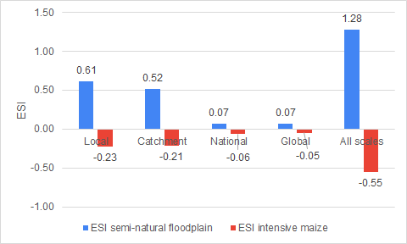

Lowland British floodplains in a semi-natural state provide a wider range of provisioning services (ESI = 0.75) than those converted for monocultural intensive production of maize (ESI = 0.0). The provisioning service ESI value of 0.0 for floodplains converted for maize production may appear counterintuitive, but is explained by the high production of ‘fibre and fuel’ (highly significant, ESI = 1.0) being cancelled out by highly significant impacts on freshwater resources (ESI = -1.0) with other provisioning services assessed as either neutral (ESI = 0.0) or ‘Not relevant’.

Whilst semi-natural floodplain habitats tend to provide a range of regulating services (ESI = 0.60), floodplain converted for intensive maize production tends not merely to erode but to create disbenefits for most regulating services (ESI = -0.55).

Semi-natural floodplains tend to produce a diversity of cultural benefits (ESI = 0.57), though these are lost when floodplains are converted for production of intensive maize crops (ESI = 0.0).

Semi-natural floodplains also produce a diversity of supporting services (ESI = 0.75) but, despite seasonally high photosynthetic production of biomass and oxygen, floodplains converted for intensive maize growth tend to degrade habitat for wildlife and the cycling of nutrients and water (overall ESI = -0.25).

Under both management regimes, the benefits or disbenefits arising from floodplains are predominantly local, though with catchment-scale impacts reflecting water-vectored services. Though lesser, benefits and disbenefits at national and global scales are also significant. The most striking finding is the weight of benefits provided by semi-natural floodplains across all geographical scales combined (ESI = 1.28), yet the uniformly negative benefits (disbenefits) across all ecosystem service categories when floodplains are converted for intensive maize production (overall geographical ESI = -0.55).

*3.2 Representation of values of lowland British floodplains under different management regimes*

An initial intention in this study had been to apply some form of economic valuation to the RAWES assessments. However, despite many interesting theoretical studies (IPBES 2016; Dasgupta, 2021), very little useful methodological progress has been made in the previous decade in robust monetary value of the diverse values of ecosystems relative to the generally illustrative methods documented by Everard and Water (2013). In essence, this reflects that monetary valuation has evolved little, if at all, from framing within a market system principally predicated on profit-making (Everard, 2022). Even ostensibly novel approaches such as Natural Capital Accounting, as for example applied in development of natural capital accounts in the UK (ONS, 2020), remain rooted in exchange values, inherently seeking to fit ecosystems into a largely unreconstructed economy rather than recognising shortfalls in established economic methods and seeking to expand thinking to be more inclusive of the breadth of values reflected by the ecosystem services framework or within the wider framework of intrinsic, instrumental and relational values developed by IPBES (2016).

For this reason, the illustrative representation of values enabled in semi-quantitative terms under the RAWES approach is seen as the most useful and inclusive communications tool to demonstrate to decision-makers and wider stakeholders the distribution of benefits and disbenefits entailed in different floodplain uses. In particular, the representation of ‘likely impact’ through a ‘traffic lights’ colour coding system (Table 2), and of ESIs by ecosystem service category (Figure 4) and across spatial scales (Figure 5), provide intuitive means to communicate relative values on a systemic and distributional basis to inform policy and other decision-making whilst averting market capture.

**4. Discussion**

*4.1 Comparative values of floodplains under contrasting management*

Semi-quantitative representations of ecosystem service values provided by lowland British floodplains under contrasting semi-natural and intensive maize cropping regimes highlight substantial differences between benefit provision at local to catchment, national and global scales. Despite conferring benefits for farming and consumer interests through intensive production of fibre and fuel, conversion of riparian floodplains for intensive maize production yields many public disbenefits that are currently externalised by markets. Even across all provisioning services, benefits from fibre and fuel production under intensive maize cropping are neutralised by degradation of other service outcomes, and regulating and supporting service outcomes turn substantially negative. ADAS and Ricardo Energy and Environment (2016) also conclude that substantial negative impacts arise from conversion of floodplains for intensive energy cropping, endorsing the findings of our comparative study.

All ecosystem services relate to distinct beneficiary stakeholder groups distributed across a range of spatial scales. Furthermore, temporal impacts, in particular intergenerational, arise from services such as global climate regulation, erosion of soil quantity and quality, purification of water resources, regulation of eutrophication, and habitat supporting biodiversity. Consequently, the ‘traffic lights’ colour coding of impacts by ecosystem services (Table 2) and the ESI histograms by service category and spatial scale (Figure 4 and 5) can be read as maps of distributional equities or inequities.

*4.2 Representations of value to support systemic decision-making*

As many or most ecosystem services are inherently incommensurable with monetised values, yet are important culturally, for biodiversity and for the resilience and continued functioning of ecosystems and hence sustainability, representation of their importance to decision-makers is of high importance.

Many of the societal benefits and costs, or disvalues, represented in the comparative RAWES assessments are incommensurable with financial values. As little useful methodological progress has been made in the previous decade with robust monetary valuation of the full diversity of ecosystem services, there are inherent risks in seeking to represent this spectrum of qualitatively different services by synthetic quantification within a largely unreconstructed economy that is substantially based on exchange values. A narrowly framed monetisation approach can inadvertently promote market capture, potentially skewing conclusions and subsequent decision-making by misrepresenting the interconnected socioecological system.

Various ecosystem service valuation tools have been developed over recent years (see examples in Table 3). However, development of the RAWES approach was seen as necessary as these tools, to varying extents, are both data- and resource-intensive, undermining their suitability for routine operational use, and they also focus largely or solely on subsets of readily quantified services (RRC-EA, 2020). RAWES assessment also explicitly recognises the multiple spatial scales of beneficiaries. Promising development of a more inclusive value framework – the ‘intrinsic’, ‘instrumental’ and ‘relational’ values developed by IPBES (2016) – has yet to be translated for ready operational practice. The usefulness of the RAWES approach for ecosystem service assessment on a systemic basis is therefore supported by this comparative study and so, for this reason, we have not progressed valuation beyond the ‘traffic lights’ colour coding system and depiction of ESIs as intuitive and systemic means to communicate relative and interconnected values to decision-makers. In practice, graphic representations of evidenced ‘likelihood of impact’ may be a more practically useful means to inform decision-makers about the full systemic range of impacts than former attempts to derive monetary values of ecosystem services.

*Table 3: Examples of published ecosystem service valuation tools*

|  |
| --- |
| A variety of ecosystem service assessment methods are now available including:   * ARIES (ARtificial Intelligence for Environment & Sustainability) (<https://aries.integratedmodelling.org/>) * Co$ting Nature (<http://www.policysupport.org/costingnature>) * InVEST (Integrated Valuation of Ecosystem Services and Trade-offs) (<https://naturalcapitalproject.stanford.edu/software/invest>) * TESSA (Toolkit for Ecosystem Service Site-based Assessment) (<http://tessa.tools/>). |

*4.3 Broader systemic contexts*

Increasing areas of Britain cropped for maize now increasingly driven by its use as an energy crop (Drury, 2019; Monbiot, 2014) is likely to intensify damage to floodplains if unchecked, giving rise to substantial and diverse sustainability implications. Landscape conversion for biofuel production is further incentivised in Britain by a Green Gas Support Scheme, which includes a biomethane tariff (OFGEM, 2022). ADAS and Ricardo Energy & Environment (2016) estimate that, to achieve UK Government policy aims for energy generation from renewable sources at that time, encouragement of the development of farm-scale AD units had led to 29,000 hectares of maize grown for bioenergy in England (0.6% of total crop area) representing an estimated doubling of the area from 2013, with the area of maize likely to expand by as much as tenfold as more AD units became operational.

In additional to the on-field impacts of intensive maize growth, there are multiple potential secondary implications. These include methane and nitrous oxide emissions from feedlot cattle making significant contributions to climate-active gaseous emissions (Cooprider et al., 2011). Assessments of feedlot emissions generally fail to take a systemic overview, excluding land use and direct land-use change emissions as well as wider downstream impacts (Wiedmann et al., 2015). The increasing volumes of maize now grown in Britain as a fuel for anaerobic digestion (AD) plants also competes with farm resources. Although electricity generation from AD plants can contribute to UK energy security and decarbonisation goals, the UK Bioenergy Strategy (DECC, 2012) acknowledges that net greenhouse gas reduction depends on considering both direct and indirect land use changes, including Government commitment to halt and reverse biodiversity loss and ecosystem degradation. AD digestate is claimed to be a renewable form of fertiliser (AHDB, 2020) allowing recovery of some nutrients (NKP) (Van Cossel et al., 2020) although the proportion of ammonium-N to Organic-N is very substantially higher than other types of agricultural waste spread to land (AHDB, 2020) and maize production is associated with high fluxes of nitrates and phosphates entering water bodies compared with arable-dominated catchments (ADAS and Ricardo Energy and Environment, 2016). Currently, only the largest AD plants are required to consider direct land use changes in areas of high biodiversity value or high carbon stock (including wetlands) in England (DECC, 2012). Also, only AD plants using feedstocks comprising or containing waste require an environmental permit or a relevant exemption, whilst plants taking only non-waste feedstocks require no permits (Environment Agency, 2014). This lack of regulation means that keeping track of AD plants is uncertain though the number of plants is increasing in the UK, Scrivener (2016) documenting that “...the Anaerobic Digestion and Bioresources Association showed that in December 2016 there were 540 UK AD plants in operation, compared with 424 in December 2015” (27% growth in a year). The Anaerobic Digestion and Biogas Association acknowledges the role of an energy crop code of conduct for farmers in combating concerns over negative environmental impacts of purpose-grown crops (ADBA, 2021).

Further research is required to address the wider anaerobic digestion and biofuels system on a fully systemic basis to support more sustainable choices. This includes, for example, determining whether the wider AD market is viable without generation subsidies, that takes account of where or if subsidised energy is used given the lack of energy storage facilities. The broad systemic ‘footprint’ of maize-based biofuel production, digestate disposal or reuse, and carbon-intensive crop transport neds to be brought into this systemic assessment, including implications for climate change, nutrient fluxes and other ecosystem services and their associated beneficiaries.

*4.4 Management solutions for sustainability*

The foundational roles of ecosystems underpinning continuing human security and opportunity is increasingly recognised (for example Costanza et al., 1997 and 2017). Concepts such as ‘wise use’ (sensu Ramsar Convention: see Finlayson et al., 2011) are embedded in international agreements to which the UK is a signatory. Requirements under the Convention on Biological Diversity for signatories to take an ‘ecosystem approach’ across all policy areas (CBD, 2000) necessitate engagement of a broad range of stakeholders at all stages of planning and implementation (Schindler et al., 2016). There is also expanding recognition that achievement of the 17 interconnected Sustainable Development Goals (SDGs) and their 169 subsidiary Targets (UN, 2015) rests substantially on maintaining flows of supportive ecosystem services (Wood et al., 2018; Everard & Longhurst, 2018), even though the ecological roots underpinning the SDGs are still substantially neglected (Reid et al., 2017).

Evidence of the current rewards and restrictions pertaining to floodplain use clearly illustrate that the UK is far distanced from realisation of these noble aspirations and commitments and, with growing trend in maize production, likely to further depart from them. Whilst intensive maximisation of a subset of benefits from floodplain conversion, principally production of fibre and fuel, may be beneficial for a limited constituency of stakeholders, it is likely to result in severe unintended adverse outcomes for other interconnected ecosystem services and their beneficiaries over space and time. Further life cycle research is required to inform decision-makers about the wider livestock and energy systems for which maize growth is currently expanding, taking greater account of the sustainability of the whole socioecological system and not just immediate market rewards for land managers.

As a more localised on-field mitigation measure, if not a systemic solution, riparian buffer zones may be located between sources of diffuse nutrient and other agricultural pollutants and receiving waters. However, buffer zones may be less effective where subsurface drains provide the major flow pathway (Muscutt et al., 1993). Everard and Jevons (2010) undertook an ecosystem services assessment, with illustrative monetisation of quantifiable outcomes, of the benefits accruing from buffer zone installation on the upper Bristol Avon, Wiltshire (UK). Jabłońska et al. (2020) modelled the potential for catchment-scale wetland buffer zones installation to remedy diffuse nutrient pollution in ecologically suitable regions of north-eastern Poland, concluding that this strategy would be cost-effective and “...thus a question of setting policy priorities rather than financial impossibility”. Specifically addressing energy crop production promoted by grants in British floodplains, the Environment Agency (2015) highlighted a lack of understanding of the flood risk impacts of energy crops planted on floodplains and how they are managed, in addition to the current lack of guidance or policy.

A more strategic solution is zonation of land use based on suitability not only for crop production – currently the principal driver of land use – but also recognising other societally beneficial ecosystem services, particularly for habitats such as floodplains and other wetlands that generate a wealth of often formerly overlooked ecosystem services with significant catchment-scale benefits. Such a systemically informed approach can potentially alleviate pressures on floodplains, though care must be taken not simply to displace damage to other important, sensitive habitats falling foul of the law of unintended consequences through ‘diffuse pollution swapping’ (*sensu* Stevens and Quinton, 2009) and impacts on a wider range of ecosystem services. RAWES or other ecosystem service assessment approaches can inform policy and local decisions for optimisation of landscape suitability and use. However, progression towards valuation and safeguarding of the wider societal benefits produced by landscapes may conflict with legacy property rights favouring freedom of use by land owners that, where prioritising private profit-taking over wider values for society and nature, conflict with sustainability goals.

*4.5 Drivers for a changing approach to floodplain farming*

There is an increasingly urgent need to safeguard ecosystems and biodiversity to support human wellbeing, explicitly under the 2021 2030 UN Decade on Ecosystem Restoration (UN, 2021) and in achieving the UN Sustainable Development Goals. Society cannot achieve sustainable development without such a shift in paradigm recognising and reconnecting with its ecological dependencies (Everard et al., 2021), elevating the vision to rebuilding rather than merely reducing pressure on degraded supportive ecosystems (Everard, 2020). This includes moving away from, or at least becoming more sophisticated about, currently narrow monetary valuation as the principal mechanism for assessing progress (Martin and Mazzotta, 2018).

Mace et al. (2015) list British floodplain wetlands as critical natural capital essential for providing the goods and services on which people depend. Britain’s long history of investment in river straightening and land drainage, including the substantial elimination of vast tracts of wetlands (Cocker, 2018; Rotherham, 2010 and 2013) has led to a dearth of functioning floodplains (now occupy only 5% of UK land area and rare internationally) in supporting biodiversity and societally beneficial ecosystem services. Sustainable management of floodplains, such as through traditional, lower-intensity grazing and hay cropping to prevent coarser plant species from becoming dominant, can safeguard their diversity of ecosystem services that otherwise decline or become lost when floodplains are degraded (Rothero et al., 2016; Entwistle et al., 2019).

Highly sensitive indicators such as fish species including burbot (*Lota lota*) (Everard, 2021) as well as wetland birds (Everard and Noble, 2010), amphibians (Beebee, 2014) and other taxa (Everard et al., 2011) have been lost or in serious decline across Britain. In addition to the inherent values of nature, this is significant as increased species richness is linked with greater ecosystem functioning, resilience and provision of ecosystem services (Tilman, 2000; Balvanera et al., 2006; Cardinale et al., 2006; Ives and Carpenter, 2007). RAWES assessments serve to demonstrate the case that conservation initiatives, long regarded as a cost and constraint of freedoms, in fact preserve or regenerate substantial societal values. They also demonstrate that wider wetland protection, restoration and creation programs can regenerate some of the areas and functions within catchments that have been historically degraded by unwise uses. Targeted floodplain restoration would yield substantial savings and gains for society as a whole (Lawson et al., 2018).

Compulsions alone have limited effect in changing thinking and practice around protection of the breadth of societal benefits generated by functional floodplains. This limitation is compounded by the fact that only a low proportion of floodplains are designated for conservation, there is also a tendency for regulations to be targeted at single issues rather than systemic implications, and resources to ensure compliance can thwart their best intentions. However, regulation has important roles to play, such as bringing all AD plants under regulation particularly where installed in vulnerable catchments. Regulation affecting British watercourses needs strengthening substantially; a very current issue (see article by Ranard, 2022).

Self-beneficial reasons may be more compelling for farm businesses not least how legacy problems such as soil loss are likely to affect farm viability, a liability that remains with the landowner whether or not cropping is contracted out. The Environment Agency (2019b, page 1) notes that, in addition to threats to national security, “Soil carbon loss is an act of economic and environmental self-harm” articulating that poor soil quality adversely affects the income and way of life of farmers and that “Some parts of the country such as fenland peats could be only 30 to 60 years away from the fundamental eradication of soil fertility”. The scale of impact both nationally and for farm business is substantial, with 2.9 million tonnes of topsoil lost to erosion annually and soil degradation in England and Wales, estimated to cost £1.2 billion a year in 2010 (Graves et al., 2011). The European Commission (2006) launched a soil protection strategy addressing the benefits provided by soils and risks associated with soil loss, including risks to food security and the food production business.

Additional inducements arise from emerging incentives, including the evolving Environmental Land Management Scheme (ELMS) subsidy scheme introduced in England by the Agriculture Act 2020 on the founding principle of ‘public money for public goods’. Defra (2021) lists principles of what ELMS could pay for, including: clean air and water; thriving plants and wildlife; protection from and mitigation of environmental hazards; beauty, heritage and engagement; and mitigation of and adaptation to climate change. The ELMS principles are aligned with the wider environmental objectives for the UK government *25 Year Plan to Improve the Environment* (HM Government, 2018) that “...aims to deliver cleaner air and water in our cities and rural landscapes, protect threatened species and provide richer wildlife habitats” and that “...calls for an approach to agriculture, forestry, land use and fishing that puts the environment first”. The breadth of ecosystems services provided by semi-natural floodplains demonstrated by RAWES assessment provides a compelling case for support from taxpayer investment to safeguard a diversity of beneficial ‘public goods’ enacting an approach “...that puts the environment first”. Downstream value chains, such as wholesalers and retailers of farmed commodities, can also act to require greater supply chain transparency and responsibility as a reassurance to their customers of more sustainable practice.

The systemic ecosystem services assessment approach undertaken in this study highlights wider environmental impacts that can inform evolving regulations, self-beneficial measures and targeted subsidies.

**5. Conclusions**

Ecosystem services assessment reveals significantly differing benefits and disbenefits generated by British lowland floodplains respectively in a semi-natural condition or converted for intensive maize production. Greater net benefits flow from semi-natural floodplains across all four Millennium Ecosystem Assessment ecosystem service categories, with intensive maize production yielding significantly positive benefits in terms of fibre and fuel but with limited or negative benefits for most other ecosystem services.

The RAWES approach has proven useful for revealing these values in semi-quantified form, integrating different forms of knowledge. It provides a transferable basis for representing values across ecosystem services in an intuitive form, avoiding an overly narrow focus on marketable services skewing assessment away from important though inherently non-market services.

Monetisation of ecosystem services was rejected as a useful approach given current but long-standing methodological limitations, potentially serving only to misrepresent the totality of ecosystem values. Better representations of value influencing decision-making are essential as current market characterisation of conservation of vital natural capital such as lowland floodplains as a cost and constraint, despite them delivering a wealth of societally beneficial services that are lost if converted from a semi-natural state, is a dangerously unsustainable absurdity.

A range of enforcements and inducements, both self-beneficial and subsidised, can help shape farmer perceptions and practices about more sustainable forms of land use, including on floodplains but also across the wider landscapes.

Further study is required to characterise the balance of benefits and disbenefits inherent in the wider livestock feedlot and bioenergy systems, as impacts on floodplain ecosystems form just one component of impacts on the wider socioecological system. Subsidies and omission of key factors, such as carbon mobilisation in maize production, biofuel crop transport and the use of energy, potentially skew current assessments of practices in terms of their overall sustainability and optimisation of benefits to society.

Although this study is undertaken in a lowland British context, the findings are generically applicable to different floodplain uses in other geographical settings. The methods used can also be adapted to address the outcomes of comparative uses of other habitat types.

**6. Acknowledgements**

Senior author Everard was funded by Pundamilia Ltd. Funding for Bradley (PI), Ogden, Piscopiello, Salter and Herbert was provided by the University of the West of England (UWE Bristol). McInnes was funded by RM Wetlands and Environment Ltd.

**7. References**

ADAS and Ricardo Energy and Environment. (2016). *Impacts of bioenergy maize cultivation on agricultural land rental prices and the environment*. Report number SCF0405. Department for Environment, Food and Rural Affairs. [Online.] <http://randd.defra.gov.uk/Default.aspx?Menu=Menu&Module=More&Location=None&Completed=2&ProjectID=19655>, accessed 27 June 2021.

Anaerobic Digestion and Bioresources Association (ADBA). (2021) *Guidance on sustainable bioenergy crops*. [Online.] <https://adbioresources.org/resources/guidance-on-sustainable-bioenergy-crops/>, accessed 8 July 2021.

AHDB. (2020). *Nutrient Management Guide (RB209): Section 2 Organic materials*. Agriculture and Horticulture Development Board (AHDC, 2020), Kenilworth.

Balvanera, P., Pfisterer, A.B., Buchmann, N., He, J-S., Nakashizuka, T., Raffaelli, D., Schmid, B. et al. (2006). Quantifying the evidence for biodiversity effects on ecosystem functioning and services. *Ecology Letters*, 9, 1146-1156. DOI: <https://doi.org/10.1111/j.1461-0248.2006.00963.x>.

Barbier, E.B. (2011). Chapter 1: Ecological scarcity as an economic problem. In: Barbier, E.B. (ed.). *Capitalizing on Nature: Ecosystems as Natural Assets*. Cambridge University Press. Cambridge, UK, p.6.

Beebee, T.J.C. (2014). Amphibian Conservation in Britain: A 40-Year History. *Journal of Herpetology*, 48(1), pp.2-12.

Bradbury, R.B., Butchart, S.H.M., Fisher, B. *et al.* (2021). The economic consequences of conserving or restoring sites for nature. *Nature Sustainability*. DOI: <https://doi.org/10.1038/s41893-021-00692-9>.

Bradley, P., Parry, G., & O'Regan, N. (2020). A framework to explore the functioning and sustainability of business models. *Sustainable Production and Consumption*, 21, pp.57-77.

Cardinale, B., Srivastava, D., Emmett Duffy, J. et al. (2006). Effects of biodiversity on the functioning of trophic groups and ecosystems. *Nature*, 443, pp.989–992. DOI: <https://doi.org/10.1038/nature05202>.

CBD. (2000). *Ecosystem approach*. Decision V/6 of the Conference of Parties to the Convention on Biological Diversity. [Online.] <https://www.cbd.int/decision/cop/?id=7148>, accessed 29 May 2021.

Cocker, M. (2018). *Our Place: Can We Save Britain’s Wildlife Before it is Too Late?* Penguin Random House UK, London.

Cooprider, K.L., Mitloehner, F.M., Famula, T.R., Kebreab, E., Zhao, Y. and Van Eenennaam, A.L. (2011). Feedlot efficiency implications on greenhouse gas emissions and sustainability. *Journal of Animal Science*, 89(8), pp.2643–2656. DOI: <https://doi.org/10.2527/jas.2010-3539>.

Cornes, R. and Sandler, T. (1996). *The Theory of Externalities, Public Goods and Club Goods (2nd edition)*. Cambridge University Press, Cambridge, UK.

Costanza, R., D’Arge, R., de Groot, R., Farber, S., Grasso, M., Hannon, B., Limburg, K., Naeem, S., O’Neill, R., Paruelo, J., Raskin, R.G., Sutton, P. and Van den Belt, M. (1997). The value of the world’s ecosystem services and natural capital. *Nature*, 387, pp.253–260.

Costanza, R., de Groot, R., Braat, L. C., Kubiszewski, I., Fioramonti, L., Sutton, P., Farber, S. & Grasso, M. (2017). Twenty years of ecosystem services: How far have we come and how far do we still need to go? *Ecosystem Services*, 28, 1-16. DOI: https://doi.org/10.1016/j.ecoser.2017.09.008.

Dadson, S.J., Hall, J.W., Murgatroyd, A., Acreman, M., Bates, P., Beven, K., Heathwaite, L., Holden, J., Holman, I.P., Lane, S.N., O'Connell, E., Penning-Rowsell, E., Reynard, N., Sear, D., Thorne, C. and Wilby, R. (2017). A restatement of the natural science evidence concerning catchment-based ‘natural’ flood management in the UK. *Proceedings of the Royal Society A: Mathematical, Physical and Engineering Sciences*, 473(2199). DOI: <https://doi.org/10.1098/rspa.2016.0706>.

Dasgupta, P. (2021). *The Economics of Biodiversity: The Dasgupta Review*. HM Treasury, London. [Online.] <https://www.gov.uk/government/publications/final-report-the-economics-of-biodiversity-the-dasgupta-review>, accessed 14 July 2021.

Defra. (2011). *An introductory guide to valuing ecosystem services*. Department for Environment Food and Rural Affairs (Defra), London. [online]. pp.68. <https://www.gov.uk/government/publications/an-introductory-guide-to-valuing-ecosystem-services>, accessed 07 June 2021.

Defra. (2021). *Environmental land management schemes: payment principles*. Department for Environment Food and Rural Affairs (Defra), London. [online]. <https://www.gov.uk/government/publications/environmental-land-management-schemes-payment-principles>, accessed 15 January 2022.

Defra and Natural England (2020). *Nature Recovery Network*. Department for Environment, Food & Rural Affairs (Defra) and Natural England, 21 October 2020. <https://www.gov.uk/government/publications/nature-recovery-network>, accessed 28 June 2021.

Department for Energy and Climate Change (DECC). (2012) *UK Bioenergy Strategy* [online]. London. Department for Energy and Climate Change. [Online.] <https://www.gov.uk/government/publications/uk-bioenergy-strategy>, accessed 3 Jun 2021.

Drury, L. (2019). The surprising history of maize. *Bright Maize*, 12th June 2019. [Online.] <https://www.brightmaize.com/surprsing-history-maize/#:~:text=Maize%20in%20Britain&text=The%20amount%20of%20maize%20grown,of%20this%20growth%20slowing%20down>, accessed 02 June 2021.

Entwistle, N.S., Heritage, G.L., Schofield, L.A. and Williamson, R.J. (2019). Recent changes to floodplain character and functionality in England. *CATENA*, 174, pp.490-498. DOI: <https://doi.org/10.1016/j.catena.2018.11.018>.

Environment Agency. (2010). *River habitats in England and Wales: current state and changes since 1995-96*. Environment Agency, Bristol.

Environment Agency. (2014). *Briefing note: Crop residues used as feedstocks in anaerobic digestion plants*. Environment Agency, Bristol.

Environment Agency. (2015). *Energy crops and floodplain flows. Evidence Report - SC060092/R2. Environment Agency*, Bristol. [Online.] <https://assets.publishing.service.gov.uk/media/603535d2e90e0740ac3ea1a3/_Energy_crops_and_floodplain_flows_-_report.pdf>, accessed 06 July 2021.

Environment Agency. (2019a). *River Axe N2K Catchment Regulatory Project Report*. Environment Agency, Exeter. [Online.] <https://www.salmon-trout.org/wp-content/uploads/2020/03/Final-Axe-Regulatory-Report.pdf>, accessed 12 January 2022.

Environment Agency. (2019b). *The state of the environment: soil*. Environment Agency, Bristol. [Online.] <https://assets.publishing.service.gov.uk/government/uploads/system/uploads/attachment_data/file/805926/State_of_the_environment_soil_report.pdf>, accessed 28 June 2021.

European Commission. (2006). *Soil protection: The story behind the strategy*. European Commission, Brussels. [Online.] <https://ec.europa.eu/environment/archives/soil/pdf/soillight.pdf>, accessed 28 June 2021.

European Investment Bank. (2018). *Environmental and Social Standards*. European Investment Bank. [Online.] <https://www.eib.org/attachments/strategies/environmental_and_social_practices_handbook_en.pdf>, accessed 06 July 2021.

Everard, M. (2009). *Ecosystem services case studies*. Environment Agency Science report SCHO0409BPVM-E-E. Environment Agency, Bristol. [Online.] <https://www.gov.uk/government/uploads/system/uploads/attachment_data/file/291631/scho0409bpvm-e-e.pdf>, accessed 07 June 2021.

Everard, M. (2020). *Rebuilding the Earth: Regenerating Our Planet’s Life Support Systems for a Sustainable Future*. Palgrave Macmillan.

Everard, M. (2021). *Burbot: Conserving the Enigmatic Freshwater Codfish*. 5M.

Everard, M. (2022). *Ecosystem Services: Key Issues (Second Edition)*. Routledge, London and New York.

Everard, M., Fletcher, M., Powell, A. and Dobson, M. (2011). The feasibility of developing multi-taxa indicators for freshwater wetland systems. *Freshwater Reviews*, 4(1), pp.1-19. DOI: https://doi.org10.1608/FRJ-4.1.129.

Everard, M. and Jevons, S. (2010). *Ecosystem services assessment of buffer zone installation on the upper Bristol Avon, Wiltshire*. Environment Agency, Bristol. [Online.] <https://assets.publishing.service.gov.uk/government/uploads/system/uploads/attachment_data/file/291658/scho0210brxw-e-e.pdf>, accessed 27 June 2021.

Everard, M., Kass, G., Longhurst, J.W.S., zu Ermgassen, S., Girardet, H., Stewart-Evans, J., Wentworth, J., Austin, K., Dwyer, C., Fish, R., Johnston, P., Mantle, G., Staddon, C., Tickner, D., Spode, S., Vale, J., Jarvis, R., Digby, M., Wren, G., Sunderland, T. and Craig, A. (2021). Reconnecting Society with its ecological roots. *Environmental Science and Policy*, 116, pp.8-19. DOI:<https://doi.org/10.1016/j.envsci.2020.11.002>.

Everard, M., Kataria, G., Kumar, S. and Gupta, N. (2019). Assessing livelihood-ecosystem interdependencies and natural resource governance in a tribally controlled region of India’s north-eastern Middle Himalayas. *Environment, Development and Sustainability*, 19, pp.165–177. DOI: <https://doi.org/10.1007/s10668-020-00945-1>.

Everard, M. and Longhurst, J.W.S. (2018). Reasserting the primacy of human needs to reclaim the 'lost half' of sustainable development. *Science of the Total Environment*, 621, 1243-1254. DOI: <https://doi.org/10.1016/j.scitotenv.2017.10.104>.

Everard, M. and Noble, D. (2010). The development of bird indicators for British fresh waters and wetlands. *Aquatic Conservation: Marine and Freshwater Ecosystems*, 20, pp.S117–S124. DOI: <https://doi.org/10.1002/aqc.1074>.

Everard, M. and Waters, R.D. (2013). *Ecosystem services assessment: How to do one in practice*. Institution of Environmental Sciences, London. [Online.] <https://www.the-ies.org/sites/default/files/reports/ecosystem_services.pdf>, accessed 02 June 2021.

Everard, M. and West, H. (2021). Livelihood security enhancement though innovative water management in dryland India. *Water International*, 1874780, pp1-25. DOI: <https://doi.org/10.1080/02508060.2021.1874780>.

Farkas, J.Z. and Kovács, A.D. (2021). Nature conservation versus agriculture in the light of socio-economic changes over the last half-century–Case study from a Hungarian national park. *Land Use Policy*, 101, 105131. DOI: <https://doi.org/10.1016/j.landusepol.2020.105131>.

Finlayson C.M, Davidson N., Pritchard D., Milton G.R. and Mackay H. (2011). The Ramsar convention and ecosystem-based approaches to the wise use and sustainable development of wetlands. *Journal of International Wildlife Law and Policy*, 14, 176–198. DOI: <https://doi.org/10.1080/13880292.2011.626704>.

Firbank, L., Bradbury, R., Jenkins, A., Ragab, R., Goulding, K., et al. (2011). Chapter 7: Enclosed farmland . In: *UK National Ecosystem Assessment. Understanding nature's value to society*. Technical Report. Cambridge, UNEP-WCMC, pp.197-239.

Graves, A. et al.(2011). *The total costs of soils degradation in England and Wales*. Research project by Cranfield University. Final Report to Defra. Project SP1606.

<http://sciencesearch.defra.gov.uk/Document.aspx?Document=10131_SID5_CostofSoilDegradationfinaldraftaug18.docx>, accessed 28 June 2021.

Gurnell, A.M. and Petts, G.E. (2011). *Hydrology and Ecology of River Systems. Treatise on Water Science*, (ed. P. Wilderer) vol. 2, pp. 237–269, Oxford: Academic Press.

HM Government. (2018). *A Green Future: Our 25 Year Plan to Improve the Environment*. HM Government, London. [Online.] <https://assets.publishing.service.gov.uk/government/uploads/system/uploads/attachment_data/file/693158/25-year-environment-plan.pdf>, accessed 28 June 2021.

Homes, N.T.H. and Raven, P.J. (2014). *Rivers: A natural and not-so-natural history*. British Wildlife Publishing Ltd, Oxford.

IPBES. (2016). *Preliminary guide regarding diverse conceptualization of multiple values of nature and its benefits, including biodiversity and ecosystem functions and services (deliverable 3 (d))*. Intergovernmental Science-Policy Platform on Biodiversity and Ecosystem Services, paper IPBES/4/INF/13. [Online.] <https://www.researchgate.net/publication/271529734_Preliminary_guide_regarding_diverse_conceptualization_of_multiple_values_of_nature_and_its_benefits_including_biodiversity_and_ecosystem_functions_and_services>, accessed 25 June 2021.

Ives, A.R. and Carpenter, S.R. (2007). Stability and diversity of ecosystems. *Science*, 317, pp.58-62. DOI: <http://dx.doi.org/10.1126/science.1133258>.

Jabłońska, E., Wiśniewska, M., Marcinkowski, P., Grygoruk, M., Walton, C.R., Zak, D., Hoffmann, C.C., Larsen, S.E., Trepel, M and Kotowski, W. (2020). Catchment-Scale Analysis Reveals High Cost-Effectiveness of Wetland Buffer Zones as a Remedy to Non-Point Nutrient Pollution in North-Eastern Poland. *Water*, 12, 629. DOI: <https://doi.org/10.3390/w12030629>.

Jones, P. and Salter, A. (2013). Modelling the economics of farm-based anaerobic digestion in a UK whole-farm context. *Energy Policy*, 62, pp.215-225. DOI: <https://doi.org/10.1016/j.enpol.2013.06.109>.

Larson, E.R., Howell, S., Kareiva, P. and Armsworth, P.R. (2016). Constraints of philanthropy on determining the distribution of biodiversity conservation funding. *Conservation Biology*, 30(1), pp.206-15. DOI: <http://dx.doi.org/10.1111/cobi.12608>.

Lawson, C., Rothero, E., Gowing, D., Nisbet, T., Barsoum N., Broadmeadow, S. and Skinner, A. (2018). *The natural capital of floodplains: management, protection and restoration to deliver*

*greater benefits*. Valuing Nature Natural Capital Synthesis Report VNP09. (Online.] <https://valuing-nature.net/sites/default/files/documents/Synthesis_reports/VNP09-NatCapSynthesisReport-Floodplains-A4-16pp-144dpi.pdf>, accessed 06 July 2021.

Mace, G.M., Hails, R.S., Cryle, P., Harlow, J. and Clarke, S.J. (2015). Towards a risk register for natural capital. *Journal of Applied Ecology*, 52, pp.641–653. DOI: <https://doi.org/10.1111/1365-2664.12431>.

Macháč, J., Trantinová, M. and Zaňková, L. (2021). Externalities in agriculture: How to include their monetary value in decision-making? *International journal of Environmental Science and Technology*, 18, pp.3–20. DOI: <https://doi.org/10.1007/s13762-020-02752-7>.

Maltby, E., Acreman, M., Blackwell, M.S.A., Everard, M. and Morris, J. (2013). The Challenges and Implications of linking wetland science to policy-experience from the UK National Ecosystem Assessment. *Ecological Engineering*, 56. pp.121-133. ISSN 0925-8574. <http://dx.doi.org/10.1016/j.ecoleng.2012.12.086>.

Maltby, E., Omerod, S., et al. (2011). *Freshwaters-openwaters, Wetlands and Floodplains*. In The UK National Ecosystem Assessment, UNEP-WCMC, Cambridge UK.

Martin, D.M. and Mazzotta, M. (2018). Non-monetary valuation using Multi-Criteria Decision Analysis: Sensitivity of additive aggregation methods to scaling and compensation assumptions. *Ecosystem Services*, 29A, pp.13-22. DOI: <https://doi.org/10.1016/j.ecoser.2017.10.022>.

McInnes, R.J. and Everard, M. (2017). Rapid Assessment of Wetland Ecosystem Services (RAWES): An example from Colombo, Sri Lanka. *Ecosystem Services*, 25, 89-105. DOI: <http://dx.doi.org/10.1016/j.ecoser.2017.03.024>.

Millennium Ecosystem Assessment. (2005). *Ecosystems and Human Well-being: Synthesis*. Washington DC: Island Press.

Monbiot, G. (2014). How a false solution to climate change is damaging the natural world. *The Guardian*, 14 March 2014. [Online.] <https://www.theguardian.com/environment/georgemonbiot/2014/mar/14/uk-ban-maize-biogas>, accessed 26 June 2021.

Moran, E., Cullen, R. and Hughey, K.F.D. (2008). The costs of single species programs and the budget constraint. *Pacific Conservation Biology*, 14(1), pp.108-118.

Muscutt, A.D., Harris, G.L., Bailey, S.W. and Davies, D.B. (1993). Buffer zones to improve water quality: a review of their potential use in UK agriculture. *Agriculture, Ecosystems & Environment*, 45(1-2), pp.59-77. DOI: <https://doi.org/10.1016/0167-8809(93)90059-X>.

Natural England. (2011). *No Charge? Valuing the natural environment*. Natural England, Peterborough.

Newson, M.D. (2002). Geomorphological concepts and tools for sustainable river ecosystem

management. *Aquatic Conservation: Marine and Freshwater Ecosystems*, 12, 365‐379.

OFGEM. (2022). *Green Gas Support Scheme and Green Gas Levy*. Ofgem is the Office of Gas and Electricity Markets (OFGEM). [Online.] <https://www.ofgem.gov.uk/environmental-and-social-schemes/green-gas-support-scheme-and-green-gas-levy>, accessed 15 January 2022.

ONS. (2020). *UK natural capital accounts: 2020 – Estimates of the financial and societal value of natural resources to people in the UK*. Office for National Statistics (ONS). [Online.] <https://www.ons.gov.uk/economy/environmentalaccounts/bulletins/uknaturalcapitalaccounts/2020#main-points>, accessed 25 June 2021.

Rannard J. (2022). 'Chemical cocktail’ polluting English rivers – MPs warn. *BBC News*, 13 January 2022. [Online.] <https://www.bbc.co.uk/news/science-environment-59955624>, accessed 13 January 2022.

Ramsar Convention. (2018). *Resolution XIII.17: Rapidly assessing wetland ecosystem services*. 13th Meeting of the Conference of the Contracting Parties to the Ramsar Convention on Wetlands. [Online.] <https://www.ramsar.org/about/cop13-resolutions>, accessed 02 June 2021.

Reid, A.J., Brooks, J.L., Dolgova, L., Laurich, B., Sullivan, B.G., Szekeres, P., Wood, S.L.R., Bennett, J.R. and Cooke, S.J. (2017). Post-2015 Sustainable Development Goals still neglecting their environmental roots in the Anthropocene. *Environmental Science and Policy*, 77, pp.179-184. DOI: <https://doi.org/10.1016/j.envsci.2017.07.006>.

RRC-EA. (2020). *Rapid assessment of ecosystem services: a practitioner’s guide*. Ramsar Regional Centre – East Asia, Suncheon. [Online.] <http://rrcea.org/wp-content/uploads/2020/07/RAWES-Practitioners-Guide.pdf>, accessed 02 June 2021.

Rogers, C.D. (2018). Crops Grown in Floodplains. *Garden Guides*, 09 January 2018. [Online.] <https://www.gardenguides.com/123003-importance-legumes.html>, accessed 02 June 2021.

Rotherham, I.D. (2010). *Yorkshire's Forgotten Fenlands*. Wharncliffe Books.

Rotherham, I.D. (2013). *The Lost Fens: England's Greatest Ecological Disaster*. The History Press.

Rothero, E., Lake, S. and Gowing, D. (eds) (2016). *Floodplain Meadows – Beauty and Utility. A Technical Handbook*. Milton Keynes, Floodplain Meadows Partnership.

Sayers, A. (2007). Tips and tricks in performing a systematic review. *British Journal of General Practice*, 57(542), 759.

Schindler, S., O’Neill, F.H., Biró, M. et al. (2016). Multifunctional floodplain management and biodiversity effects: a knowledge synthesis for six European countries. *Biodiversity and Conservation*, 25, pp.1349–1382. DOI: <https://doi.org/10.1007/s10531-016-1129-3>.

Schröter, M. and Remme, R.P. (2016). Spatial prioritisation for conserving ecosystem services: comparing hotspots with heuristic optimisation. *Landscape Ecology*, 31, pp.431–450. DOI: <https://doi.org/10.1007/s10980-015-0258-5>

Smith, L.M., Case, J.L., Smith, H.M., Harwell, L.C. and Summers, J.K. (2013). Relating ecosystem services to domains of human well-being: Foundation for a U.S. index. *Ecological Indicators*, 28, pp.79–90. DOI: <https://doi.org/10.1016/j.ecolind.2012.02.0>.

Stevens, C.J. and Quinton, J.N. (2009). Diffuse pollution swapping in arable agricultural systems. *Critical Reviews in Environmental Science and Technology*, 39(6), pp.478-520. DOI: <https://doi.org/10.1080/10643380801910017>.

Swarna Nantha, H. and Tisdell, C. (2009). The orangutan–oil palm conflict: economic constraints and opportunities for conservation. *Biodiversity Conservation*, 18, pp.487–502. DOI: <https://doi.org/10.1007/s10531-008-9512-3>.

TEEB. (2010). *The Economics of Ecosystems and Biodiversity: Mainstreaming the Economics of Nature: A Synthesis*. The Economics of Ecosystems and Biodiversity. [Online.] <http://www.teebweb.org>, accessed 25 June 2021.

TESSA. (n.d.). *Toolkit for Ecosystem Service Site-Based Assessment*. [Online.] <http://tessa.tools/>, accessed 25 June 2021.

Tilman, D. (2000). Causes, consequences and ethics of biodiversity. *Nature*, 405, pp.208-211. DOI: <https://doi.org/10.1038/35012217>.

UK NEA. (2011). *The UK National Ecosystem Assessment: Synthesis of the Key Findings UNEP- WCMC*, Cambridge UK.

UN. (2015). *The 17 Goals*. United Nations. [Online.] <https://sdgs.un.org/goals>, accessed 08 June 2021.

UN. (2021). *Preventing, halting and reversing the degradation of ecosystems worldwide*. United Nations. [online] <https://www.decadeonrestoration.org/>, accessed 06 July 2021.

von Cossel, M., Amarysti, C., Wilhelm, H., Priya, N., Winkler, B. and Hoerner, L. (2020). The replacement of maize (*Zea mays* L.) by cup plant (*Silphium perfoliatum* L.) as biogas substrate and its implications for the energy and material flows of a large biogas plant. *Biofuels, Bioproducts and Biorefining*, 14(2), pp.152-179. DOI: <https://doi.org/10.1002/bbb.2084>.

Wiedemann, S., Davis, R., McGahan, E., Murphy, C. and Redding, M. (2015). Resource use and greenhouse gas emissions from grain-finishing beef cattle in seven Australian feedlots: a life cycle assessment. *Animal Production Science*, 57(6), pp.1149-1162. DOI: <https://doi.org/10.1071/AN15454>.

Wood, S.L.R., Jones, S.K., Johnson, J.A., Brauman, K.A., Chaplin-Kramere, R., Fremier, A. et al. (2018). Distilling the role of ecosystem services in the Sustainable Development Goals. *Ecosystem Services*, 29A, 70-82. DOI: <https://doi.org/10.1016/j.ecoser.2017.10.010>.