Frequency-dependent characteristics of nerve-mediated ATP and acetylcholine release from detrusor smooth muscle.
By Basu Chakrabarty¹, Katie Aitchison¹, Paul White², Carly J McCarthy³, Anthony J Kanai⁴, Christopher H Fry¹.

- School of Physiology, Pharmacology & Neuroscience, University of Bristol, Bristol, UK. 2. Faculty of Engineering, Design & Mathematics, University of the West of England, Bristol, UK. 3. Instituto de Investigaciones en Medicina Traslacional (IIMT), Facultad de Ciencias Biomédicas, Austral University, Buenos Aires, Argentina. 4. Department of Medicine, University of Pittsburgh, Pittsburgh, PA, USA.

Short title: Frequency-dependence of transmitter release to the bladder

Key words: Bladder, detrusor smooth muscle, neurotransmitter, acetylcholine, ATP.

Address for correspondence
CH Fry,
School of Physiology, Pharmacology & Neuroscience,
University of Bristol,
Bristol BS8 1TD, UK
Email: chris.fry@bristol.ac.uk

New Findings. The frequency-dependencies of acetylcholine (ACh) and ATP co-transmitter release are different. ACh release can be modelled to a one-compartment process, whereas ATP release requires a two-compartment model. Nerve-mediated release of ACh and ATP can be independently regulated, for example by the phosphodiesterase-type 5 inhibitor, sildenafil.
What is the central question of this study?
Is the frequency-dependency of co-transmitter release from postganglionic nerve fibres different for each transmitter?
What is the main finding and its importance?
Release of co-transmitters from the parasympathetic supply to detrusor smooth muscle can be independently regulated. This offers a targeted drug model to reduce selectively the release of transmitter associated with human pathologies (ATP) and may also be applicable to other smooth muscle-based disorders of visceral tissues.

Abstract (205 words)
Nerve-mediated contractions of detrusor smooth muscle are mediated by acetylcholine (ACh) and ATP release in most animals. However, with the normal human bladder only ACh is a functional transmitter but in benign pathologies such as overactive bladder (OAB), ATP re-emerges as a secondary transmitter. The selective regulation of ATP release offers a therapeutic approach to manage OAB, in contrast to current primary strategies that target ACh actions. However, the release characteristics of nerve-mediated ACh and ATP are poorly defined. This study aimed to measure the frequency-dependence of ACh and ATP release and determine if selective regulation of ATP or ACh was possible. Experiments were carried out in vitro on mouse detrusor with nerve-mediated ATP and ACh release measured simultaneously with tension recording. ATP was released in two frequency-dependent components, both at lower frequencies (mid-range 0.4 and 5.5 Hz stimulation) compared to a single compartment release of ACh at 14 Hz. Intervention with the phosphodiesterase type-5 inhibitor, sildenafil, attenuated ATP release, equally from both components, but had no effect on ACh release. These data demonstrate that nerve-mediated ACh and ATP release characteristics are distinct and may be separately manipulated. This offers a potential targeted drug model to manage benign lower urinary tract conditions such as OAB.

Introduction
There is considerable evidence for excitatory co-transmission of ATP and acetycholine (ACh) from post-ganglionic parasympathetic nerve fibres to isolated detrusor muscle (Kennedy, 2015, 2021). Contractions generated by trains of short (≤100 µs) pulses and labile to neuroactive agents such as tetrodotoxin or lignocaine are designated as nerve-mediated. They are abolished by the anti-muscarinic agent atropine, plus P2X₁ receptor desensitisation by the metabolically stable ATP analogue, α,β-methylene ATP (ABMA), so the presumed motor transmitters are ACh and ATP (Aronsson et al., 2010). However, the frequency-dependencies of the cholinergic and purinergic components of the contraction are different: the latter more prominent at low stimulation frequencies (Pakzad et al., 2016; Chakrabarty et al., 2019). This raises the possibility that ATP and ACh are differentially released from nerve terminals and so may be separately regulated. This is especially relevant to the translational potential of these observations because in the adult human bladder the purinergic (atropine-resistant) component of detrusor contraction is only present in benign pathologies, including overactive bladder associated with neuropathic, obstructive or idiopathic causes. On the other hand, detrusor contractions from normal human bladders are generated almost completely through muscarinic receptor activation (Bayliss et al., 1999). This differential response can be explained by greater ectoATPase activity in the vicinity of the nerve-muscle junction with tissue from normal adult human bladders and not due to variable ATP release (McCarthy et al. 2019). Furthermore, atropine-resistant contractions are a feature of normal and overactive paediatric human bladders, with those from normal bladders gradually disappearing during childhood development (Johal et al., 2014, 2019).
Current first-line therapies to attenuate bladder overactivity symptoms in humans use antimuscarinic agents that suppress normal, physiological muscarinic pathways. Thus, it would be attractive to develop strategies that suppress selectively the purinergic component of transmitter release as this is associated with human bladder pathologies. Previous work has suggested that differential suppression of low-frequency contractions can be achieved by agents such as adenosine, acting through A1 receptors, or phosphodiesterase type-5 inhibitors (PDE5I) to raise intracellular cGMP levels (Toque et al., 2009; Pakzad et al., 2016; Chakrabarty et al., 2019). The interpretation that nerve-mediated ATP release is thus selectively suppressed is only inferential when using contractions as the experimental variable and more direct evidence would be desirable. Measurement of the frequency-dependence of nerve-mediated ATP and ACh release simultaneously with evoked contractions would provide a more direct test of the ability to differentially modulate release of co-transmitters and the influence this has on contractile function. This may be tested using mouse detrusor that normally has cholinergic and purinergic components to nerve-mediated contractions, by assaying local ATP and ACh concentrations during the generation of contractions. The method to measure quantitatively nerve-mediated transmitter release data was also validated with an alternative method using amperometric ATP-sensitive electrodes. This used guinea-pig detrusor as larger preparations were necessary to accommodate the two required sensing electrodes (see Methods). To determine if nerve-mediated release of ATP and ACh could be separately regulated, as hypothesised from contractile data (Pakzad et al., 2016; Chakrabarty et al., 2019), sildenafil, a phosphodiesterase type-5 inhibitor (PDE5I), was used, as this agent has been shown previously to attenuate nerve-mediated ATP release (Chakrabarty et al., 2019).
Methods
Ethical approval. All animal care and experimental procedures were in compliance with the University of Bristol Ethics Committee approvals (UB/18/010; UB/21/064) and carried out in accordance with the UK Animals (Scientific Procedures) Act 1986 and Amendment Regulations (SI 2012/3039). The study also complies with ethical principles under which Experimental Physiology operates and the principles of United States National Institutes of Health. Animal studies are reported in compliance with ARRIVE guidelines (Percie du Sert et al., 2020). Animals were housed on a 12-hour on-/off-light cycle with free access to food and water.
Animals and tissue preparations. C57BL/6 female mice (12 weeks, Harlan UK Ltd) or Dunkin-Hartley female guinea-pigs (250-350 g, sourced from designated suppliers by the university animal service unit) were euthanised by cervical dislocation. The bladder was removed after a midline laparotomy, the neck and trigone region cut away and the dome laid out as a sheet after an anterior wall incision. Strips (mice, with intact mucosa; 4-5 mm length, 1 mm diam: guinea-pigs, mucosa removed; 5 mm length, 2 mm cross-section) were dissected and tied in a horizontal trough between a fixed hook and an isometric force transducer. Preparations were superfused (3 ml.min⁻¹) at 36°C with Tyrode’s solution. Contractions were generated by electrical field stimulation (EFS; 0.1 ms pulses, 0.5-40 Hz, 3-s trains every 90-s). Agents were added to the superfusate and their effects on nerve-mediated contractions and transmitter release were measured. Tension amplitude was normalised to preparation weight (mN.mg⁻¹).
Acetylcholine (ACh) measurement; mice. Superfusate samples (50 µl) were taken from a fixed location relative to the preparation, 3 mm along the preparation and 1 mm lateral, and immediately stored in ice. Samples were taken before EFS and 2-seconds after its initiation, nerve-mediated release was the difference between these two values. ACh concentration was measured using a choline/acetylcholine fluorometric assay (MAK056, Sigma-Aldrich, USA; 535/587 nm, excitation/emission) per manufacturer’s instructions. Briefly, the superfusate sample was gently mixed at room temperature with 50 µl assay mix, to convert acetylcholine to choline, and an aliquot added to a well of a 96-well plate. The plate was covered with Al-foil and placed on a horizontal shaker for 30-min. Choline standards (0-250 pmol.l⁻¹ in five equal steps) were included and produced linear calibration curves (r²=0.9994±0.0002, n=15).
ATP measurement by luminometry (mice). Superfusate samples (100 µl) were taken as for ACh measurements and stored on ice before analysis with a luciferin-luciferase luminometry assay (FLAAM, Sigma-Aldrich, UK), per manufacturer’s instructions. Luminescence was recorded from a luminometer (Glomax 20/20, Promega), calibrated with ATP standards (0.1-1000 pmol.l⁻¹) – calibrations were linear on a log-log scale across this range, using a blank of Tyrode’s solution.
ATP measurement by amperometric-sensitive electrodes (guinea-pigs). Electrodes (50 µm diam, 2 mm active tip; Sarissa Biomedical Ltd, Coventry, UK) were placed on the preparation surface, parallel to the longitudinal axis. A similar null electrode, lacking the sensing layer was placed about 200 µm away and both were polarised to 0.65 V by carbon fibre potentiostats (MicroC, WPI, UK). Both outputs formed differential inputs to a low common mode rejection amplifier to reduce EFS artefacts and the output was digitised (1 kHz) for recording. Glycerol (2 mM) was added to all superfusates, required as an intermediate for the electrode detection of ATP. Prior to recordings, electrodes was calibrated in situ by adding 0.2-50 µmol.l⁻¹ Na₂ATP to the superfusate – electrodes showed a linear response over this range.
Solutions. Tyrode’s solution contained (mM): NaCl, 118; NaHCO₃, 24; KCl, 4.0; NaH₂PO_{4,} 0.4; MgCl₂, 1.0; CaCl₂, 1.8; glucose, 6.1; Na pyruvate, 5.0; 5%CO₂, 95%O₂, pH 7.4. Sildenafil stock samples (10 mmol.l⁻¹ in DMSO) were added to Tyrode’s solution to obtain a final concentration of 20 µM, a half-maximal concentration to reduce agonist-induced detrusor contractions (Chakrabarty et al., 2019). All chemicals were from Sigma-Aldrich, UK.
Data presentation, statistical methods and curve-fitting. Data are mean±SD and differences between multiple data sets were tested with repeated measures two-way ANOVA and Tukey post hoc tests; the null hypothesis was rejected at p<0.05; n-values refer to the number of animals. Differences between paired data sets were tested with paired t-tests. Statistical and curve-fitting analyses were undertaken with KaleidaGraph (Synergy Software, USA). Frequency-response data were fitted to a one-component (eqn 1) or a linear two-component (eqn 2) function (equivalent to the Hill-Langmuir equation) by a non-linear least-squares Levenberg-Marquardt algorithm (Marquardt, 1963):
$Y(f)={(Y}_{max}*f^{m})/(f_{1/2}^{m}+f^{m})$ 1
$Y(f)={((Y}_{A,max}*f^{m})/(f_{A,1/2}^{m}+f^{m})+{(Y}_{B,max}*f^{m})/(f_{B,1/2}^{m}+f^{m}))$ 2
With eqn 1, Y_{max} is the estimated value of Y (tension (T), ATP or ACh) at the highest frequencies and f_{1/2} the frequency required to achieve Y_{max}/2. m=constant; with tension and ATP data a best fit was obtained with m=2; with ACh data with m=3. With eqn 2 the two components each had a magnitude Y_{A,max} (low frequencies) and Y_{B,max} (high frequencies), each with respective f_{1/2} values (f_{A},_{1/2} and f_{B},_{1/2}).
A two-stage hierarchical regression assessed if the improvement of fit with eqn 2 over eqn 1 was statistically significant at α=0.05 or 0.01. This was tested using tables of the upper significance of the F-distribution, with two and five degrees of freedom, corresponding to the increase in the number of parameters using eqn 2 and the degrees of freedom of the residual mean square error from 10 data values.
Reduction of tension values, T_{redn}, with sildenafil in Figure 5A was fitted by eqn 3.
$T_{redn}\left(f\right)=T_{f0}-((T_{f0-f∞}*f^{m})/(f_{1/2}^{m}+f^{m})$ 3
$T_{f0}=estimated maximum reduction at low frequencies$; $T_{f0-f∞}$difference of reduction at low and high frequencies, m=2 and f_{1/2} is that where frequency-dependent decline was half-maximal.

Results.
Frequency-dependence of nerve-mediated tension and ATP/ACh release; mouse detrusor. Contractions and ATP/ACh release were completely inhibited by tetrodotoxin (1 µM, n=6) or lignocaine (2% final concentration, n=6), demonstrating all phenomena were nerve-mediated. Figure 1 shows the frequency dependence of tension over the range 0.5–40 Hz. Note the frequency axis (abscissa) is plotted on a logarithmic scale. Data were fitted by a single-component function (eqn 1, Methods) or a two-component function (eqn 2). A two-component fit was significantly better than for a one-component fit (F(_{2,5})=175.8; p<0.0001) with the parameters shown in table 1. Thus, the low-frequency component had a mean maximum (Y_{A}) of 0.45±0.19 mN.mg⁻¹, with a frequency for half-maximal generation, f_{A,1/2}, of 0.42±0.26 Hz. Corresponding values for the high-frequency component (Y_{B} and f_{B,1/2}; 1.73±0.49 mN.mg⁻¹ and 5.53 ± 1.42) are also shown in Table 1, as well as the total maximal force attainable (Y_{A}+Y_{B}) and the proportion of total tension from the low-frequency component Y_{A}/(Y_{A}+Y_{B}), 0.21±0.097 (n=12) of the total tension. Overall, a mean stimulation frequency of 4.53±1.71 Hz achieved half-maximal tension. No improvement in goodness-of-fit was obtained with additional components to the model so a two-component model was used for tension and ATP data.
It was also determined if this bifunctional response was reflected in the frequency-dependence of neurotransmitter release. Corresponding data for absolute release of ATP (Figure 2) from the same preparations as used for tension recordings are shown. These data were also better fit by a two-component compared to a one-component model (F(_{2,5})=87.1; p<0.0001). The proportion of ATP release by the low-frequency component, 0.30±0.047 (n=12), was significantly (p=0.0123) greater than the corresponding proportion of the low-frequency tension component. The frequencies for half-maximal release from the two ATP components were not significantly different from corresponding tension values (low frequency tension vs ATP: 0.42±0.26 vs 0.37±0.14 Hz, n=12, p=0.569: high frequency tension vs ATP: 5.53±1.24 vs 7.51±2.71 Hz, n=12, p=0.0763) – see also Table 1.
The frequency-dependence of nerve-mediated ACh release however, showed different frequency-dependent characteristics compared to ATP release, although the maximum quantity released at high frequencies was not significantly different (151.2±22.0 vs 147.9±19.7; p=0.708: ATP vs ACh; n=12,12 – Table 1). Significant release was not measured up to 4 Hz stimulation, the latter frequency corresponding to about 40% of total ATP release. Thereafter, half-maximal release was recorded at 14.0±0.80 Hz, significantly greater (p<0.0001) than the frequencies of half-maximal for either component of ATP release - see table 1. Furthermore, no further advantage was gained by fitting the frequency-dependent ACh release data to a two component model (F(_{2,5})=2.47; p=0.179).
Comparison of superfusate sampling and ATP-sensitive electrode data for ATP release; mouse and guinea-pig detrusor. Nerve-mediated ATP release may also be measured with amperometric electrodes and it was of value to determine if the two methods give similar results, with respect to a two-component release of ATP and their frequency-dependencies. Figure 4A,B shows simultaneous ATP release and isometric tension at two frequencies, 1 and 12 Hz; note the two small spontaneous contractions and associated ATP release in the 1 Hz trace (arrowheads, Figure 4A). The 12 Hz ATP trace shows a biphasic decline of ATP, absent in the 1 Hz trace, and is consistent with two components of release at higher frequencies (Figure 4C, with the two traces superimposed, normalized to their peak values). The integral of the ATP trace was calculated over 30 seconds from initiation of the response and data for the 30-s integral are shown in the final column of Table 1. The f_{1/2} (f_{A,1/2,} f_{B,1/2}) and f_{50%} values, as well as the proportion of the low-frequency component (Y_{A} /(Y_{A} + Y_{B})) were not significantly different between the two methods to measure nerve-mediated release: (note that the units of ATP release by the two methods are different and cannot be compared). Thus, the two methods each demonstrate two similar frequency-dependent components of nerve-mediated ATP release.
Effect of sildenafil intervention; mouse detrusor. Simultaneous sampling of transmitter release with tension recording may provide greater insight into factors determining tension generation and was tested using the PDE5-inhibitor sildenafil. Sildenafil reduced nerve-mediated contractions, compared to control, but the effect was frequency-dependent, greater at lower frequencies and not significant at 40 Hz - Figure 5A. The bar charts of Figure 5B show individual experiments with a significant decrease of force with sildenafil at 4 Hz (0.93±0.47 vs 0.38±0.19 mN.mg⁻¹, n=7, p=0.00283), but none with sildenafil at 40 Hz stimulation (1.83±0.87 vs 1.72±0.82 mN.mg⁻¹, n=7, p=0.259).
The low- and higher-frequency dependent components of nerve-mediated ATP release were both attenuated by sildenafil, and in similar proportions. The low-frequency component was reduced to 51.5±9.8% control (45.8±3.8 vs 28.1±2.3 fmol.µl⁻¹.mg⁻¹; n=7, p=0.000526); the high-frequency component reduced to 51.1±5.1% control (107.9±17.9 vs 57.8±10.4 fmol.µl⁻¹.mg⁻¹; n=7, p=0.00286) - Figure 5C. However, nerve-mediated ACh release was unaffected by sildenafil, e.g. at 20 Hz stimulation 99.4±8.7% control (90.7±3.9 vs 87.2±5.5 fmol.µl⁻¹.mg⁻¹; n=5 p=0.925) - (Figure 5D). Thus, it was possible to attenuate selectively the nerve-mediated release of one neurotransmitter (ATP) supplying detrusor smooth muscle.
Discussion
Nerve-mediated tension and transmitter release in detrusor smooth muscle. Several novel observations were made by this study.
- frequency-dependence of nerve-mediated ACh release can be described by a single component model whereas ATP release requires a two-component model.
- the frequency-ranges over which ATP and ACh release occurred are very different.
- nerve-mediated ATP release can be selectively suppressed over ACh by an agent that raises intracellular cGMP levels.
The different frequency ranges for nerve-mediated ATP and ACh release mean that below 5 Hz ATP will be the dominant excitatory transmitter. Experiments with cat and pig bladder show that the dynamic range of pelvic motor nerve firing is in the range 1-15 Hz (de Groat & Saum, 1976; Schultz-Lampel et al., 1998; Kitney et al, 2021). Together these observations are consistent with the large proportion, about 50%, of mouse detrusor contractions that are atropine-resistant (Chakrabarty et al., 2019). Of interest would be to carry out equivalent measurements in human tissue, especially from adult overactive and paediatric bladders where atropine-resistant, purinergic contractions are also in the range of 20-25% and 50% of the total, respectively (Bayliss et al., 1999; Johal et al, 2019).
ATP and ACh transmitter release. Post-ganglionic parasympathetic motor nerves to detrusor smooth muscle, in common with those to other tissues, consist of small diameter unmyelinated fibres with varicosities up to 1 µm diameter and at intervals as small as 50 nm (Gabella, 2019). These varicosities, that each can make close contact with several smooth muscle cells, contain a large number of different-sized vesicles enclosing transmitters as well as modulatory peptides. Specific criteria have been proposed as to what constitutes a transmitter rather than a broader signalling molecule, including Ca²⁺-dependent exocytosis (Eccles, 1968), and these are fulfilled by both ATP and ACh. The mode of prejunctional Ca²⁺ entry may be through several Ca²⁺ channels, in particular N-type and P/Q-type channels. L-type Ca²⁺ channels also have a role at the postjunctional membrane (Hashitani & Suzuki, 1995; Young et al., 2008) which implies that the release of at least one transmitter (e.g. ATP) has an action on ionotropic receptors. A consensus is that in detrusor smooth muscle Ca²⁺ entry through N-type channels has a major role in regulating ACh release, and entry through P/Q-type channels regulates ATP release (Maggi, 1991; Zygmunt et al., 1993; Frew & Lundy, 1995; Waterman, 1996).
Selective control of transmitter release. Overall, there is compelling evidence that ACh and ATP can be separately released from motor nerves that innervate the bladder, although has not been unequivocally shown if this is due to release from different nerve populations or from different vesicles in the same nerve varicosities. However, such separation of ACh and ATP transmitter release is consistent with their separate frequency-dependencies (Svensson et al., 2019) and its manipulation by an agent such as sildenafil, as shown here. A potential role of cyclic nucleotides and their activation of associated protein kinases is suggested in this selective reduction of purinergic transmission by sildenafil and also in a separate study by adenosine (Pakzad et al., 2016). Sildenafil would be expected to raise local cGMP levels (Hedlund, 2003, whilst adenosine by activation of an A1 receptor would be anticipated to reduce cAMP levels (Yu et al., 2006). cGMP signalling, through activation of protein kinase G or cyclic nucleotide-gated cation channels, or A1 receptor activation have been shown by several studies to modulate transmitter release (Vegetti et al., 2008; Feil & Kleppisch, 2008). What remains is to identify in detrusor parasympathetic varicosities the particular vesicles that store ATP and ACh, and to elucidate the particular pathways that separately regulate transmitter release and the role of cyclic nucleotides.
A further property of ATP release was its efflux in two frequency-dependent components, consistent with two subtypes of vesicular stores. Release of both components was equally modulated by sildenafil suggesting similar pathways to regulate release. We hypothesise that the component elicited by very low frequency stimulation (half-maximal response at 0.4-0.5 Hz and contributing to about 25% of the total releasable pool) is a very labile fraction that contributes to spontaneous ATP release, see Figure 4A and (Young et al., 2008; McCarthy et al.,2019), and potentially to spontaneous contractions. Pathological spontaneous contractile activity is a feature of the human overactive bladder complex (Fry et al., 2012) and so the characterisation of this low-frequency ATP pool deserves particular study.
Limitations
For practical reasons, mucosa was removed from guinea-pig preparations only. Guinea-pig preparations were used to record ATP with amperometric electrodes. Mucosa removal improved the diffusion pathway from release sites in the muscle to the electrode. However, removal of mouse mucosa was more difficult and preliminary experiments indicated some cellular damage as assessed by release of intracellular ATP. However, all ATP measured was inhibited by superfusion with tetrodotoxin or lignocaine and so was designated nerve-mediated.
Female mice only were used for experiments due to a condition in the NIH grant, as some experiments unrelated to this study involve cystometry - a technique easier to perform on female animals. Same sex guinea-pigs were used to avoid a potential confounding effect but the authors are unaware of sex-related differences in neurotransmitter release.

Author Contributions
The study was compiled at the School of Physiology, Pharmacology and Neuroscience, University of Bristol. CHF, AJK and BC conceived and designed the work; BC, KA, PW, CJM and CHF acquired, analysed and interpreted the data; all authors contributed to drafting and critically revising the manuscript. Furthermore, all authors have approved the final version and agree to be accountable for all aspects of the work. Thus, all authors qualify for authorship and all those who qualify for authorship are listed.

Funding
This research was funded by a grant (R01DK098361) from the National Institutes of Health; Section of Diabetes and Digestive & Kidney Diseases (NIDDK)

Data availability statement
Reasonable requests regarding the experimental data may be made to the corresponding author.

References
Aronsson, P., Andersson, M., Ericsson, T. & Giglio D. (2010) Assessment and characterization of purinergic contractions and relaxations in the rat urinary bladder. Basic and Clinical Pharmacology and Toxicology, 107, 603-613. https://doi: 10.1111/j.1742-7843.2010.00554.x.
Bayliss M., Wu, C., Newgreen, D., Mundy, A.R., & Fry, C.H. (1999). A quantitative study of atropine-resistant contractile responses in human detrusor smooth muscle, from stable, unstable and obstructed bladders. Journal of Urology, 162, 1833-1839. PMID: 10524944.
Chakrabarty, B., Ito, H., Ximenes, M., Nishikawa, N., Vahabi, B., Kanai, A.J., Pickering, A.E., Drake, M.J. & Fry, C.H. (2019). Influence of sildenafil on the purinergic components of nerve-mediated and urothelial ATP release from the bladder of normal and spinal cord injured mice. British Journal of Pharmacology, 176, 2227-2237. https://doi: 10.1111/bph.14669.
de Groat, W.C. & Saum, W.R. (1976). Synaptic transmission in parasympathetic ganglia in the urinary bladder of the cat. Journal of Physiology, 256, 137-158. https://doi: 10.1113/jphysiol.1976.sp011316.
Eccles, J.C. (1968). Pathways and synaptic transmitter substances in the central nervous system. In The Physiology of Nerve Cells, Chapter V, pp153-211. The John Hopkins Press, Baltimore, USA.
Feil, R. & Kleppisch, T. (2008). NO/cGMP-dependent modulation of synaptic transmission. Handbook of Experimental Pharmacology, 184, 529-560. https://doi: 10.1007/978-3-540-74805-2_16.
Frew, R. & Lundy, P.M. (1995). A role for Q type Ca²⁺ channels in neurotransmission in the rat urinary bladder. British Journal of Pharmacology, 116, 1595-1598. https://doi: 10.1111/j.1476-5381.1995.tb16378.x.
Fry, C.H., Young, J.S., Jabr, R.I., McCarthy, C., Ikeda, Y. & Kanai, A.J. (2012) Modulation of spontaneous activity in the overactive bladder: the role of P2Y agonists. American Journal of Physiology, Renal Physiology, 302, F1447-F1454. https://doi: 10.1152/ajprenal.00436.2011.
Gabella, G. (2019). Muscle cells, nerves, fibroblasts and vessels in the detrusor of the rat urinary bladder. Journal of Smooth Muscle Research, 55, 34-67. https://doi: 10.1540/jsmr.55.34.
Hashitani, H. & Suzuki, H. (1995). Electrical and mechanical responses produced by nerve stimulation in detrusor smooth muscle of the guinea-pig. European Journal of Pharmacology, 284, 177-183. https://doi: 10.1016/0014-2999(95)00386-y.
Hedlund, P. (2005). Nitric oxide/cGMP-mediated effects in the outflow region of the lower urinary tract – is there a basis for pharmacological targeting of cGMP? World Journal of Urology, 23, 362-367. https://doi: 10.1007/s00345-005-0019-1.
Johal, N., Wood, D.N., Wagg, A.S. & Cuckow, P. & Fry, C.H. (2014). Functional properties and connective tissue content of pediatric human detrusor muscle. American Journal of Physiology, Renal Physiology, 307, F1072-F1079. https://doi: 10.1152/ajprenal.00380.2014
Johal, N.S., Arthurs, C., Cuckow, P., Cao, K., Wood, D.N., Ahmed, A. & Fry, C.H. (2019). Functional, histological and molecular characteristics of human exstrophy detrusor. Journal of Paediatric Urology, 15, 154.e1-154.e9. https://doi: 10.1016/j.jpurol.2018.12.004
Kennedy, C. (2015). ATP as a cotransmitter in the autonomic nervous system. Autonomic Neuroscience, 191, 2-15. https://doi: 10.1016/j.autneu.2015.04.004.
Kennedy, C. (2021). ATP as a cotransmitter in sympathetic and parasympathetic nerves - another Burnstock legacy. Autonomic Neuroscience, 235: 102860. https://doi: 10.1016/ j.autneu.2021.102860
Kitney, D.G., Crook, J., Chakrabarty, B., Kanai A.J., Vahabi, B., Lovick, T.A. & Fry, C.H. (2021). The frequency-dependence of pre- and postganglionic nerve stimulation of pig and rat bladder. International Neurourology Journal, 25, 210-218. https://doi: 10.5213/inj.2142002.001
Maggi, C.A. (1991). Omega conotoxin and prejunctional modulation of the biphasic response of the rat isolated urinary bladder to single pulse electrical field stimulation. Journal of Autonomic Pharmacology, 11, 295-304. https:// doi: 10.1111/j.1474-8673.1991.tb00253.x.
Marquardt, D. (1963). An algorithm for least-squares estimation of nonlinear parameters. SIAM Journal on Applied Mathematics, 11, 431–441.
McCarthy, C.J., Ikeda, Y., Skennerton, D., Chakrabarty, B., Kanai, A.J., Jabr, R.I. & Fry, C.H. (2019). Characterisation of nerve-mediated ATP release from bladder detrusor muscle and its pathological implications. British Journal of Pharmacology, 176, 4720-4730. https://doi: 10.1111/bph.14840.
Pakzad, M., Ikeda, Y., McCarthy, C., Kitney, D.G., Jabr, R.I. & Fry, C.H. (2016) Contractile effects and receptor analysis of adenosine-receptors in human detrusor muscle from stable and neuropathic bladders. Naunyn Schmiedeberg’s Archives of Pharmacolology, 389, 921-929. https://doi: 10.1007/s00210-016-1255-1.
Percie du Sert, N., Ahluwalia, A., Alam, S., Avey, M.T., Baker, M., Browne, W.J., Clark, A., Cuthill, I.C., Dirnagl, U., Emerson, M., Garner, P., Holgate, S.T., Howells, D.W., Hurst, V., Karp, N.A., Lazic, S.E., Lidster, K., MacCallum, C.J., Macleod, M., … Würbel, H. (2000). The ARRIVE guidelines 2.0: Updated guidelines for reporting animal research. PLoS, Biol, 18, e3000410. https://doi.org/10.1371/journal.pbio.3000411.
Schultz‐Lampel, D., Jiang, C., Lindstrom, S., & Thuroff, J.W. (1998). Experimental results on mechanisms of action of electrical neuromodulation in chronic urinary retention. World Journal of Urology, 16, 301-304. https://doi: 10.1007/s003450050071.
Svensson, E., Apergis-Schoute, J., Burnstock, G., Nusbaum, M.P., Parker, D. & Schiöth, H.B. (2019). General principles of neuronal co-transmission: insights from multiple model systems. Frontiers in Neural Circuits, 12, 117. https://doi: 10.3389/fncir.2018.00117.
Toque, H.A., Priviero, F.B., Zemse, S.M., Antunes, E., Teixeira, C.E. & Webb, R.C. (2009). Effect of the phosphodiesterase 5 inhibitors sildenafil, tadalafil and vardenafil on rat anococcygeus muscle: functional and biochemical aspects. Clinical and Experimental Pharmacology and Physiology, 36, 358-366. https://doi: 10.1111/j.1440-1681.2008.05071.x
Veggetti, M., Muchnik, S. & Losavio, A. (2008). Effect of purines on calcium-independent acetylcholine release at the mouse neuromuscular junction. Neuroscience, 154, 1324-1336. https://doi: 10.1152/ajpcell.00025.2006.
Waterman, S.A. (1996). Multiple subtypes of voltage-gated calcium channel mediate transmitter release from parasympathetic neurons in the mouse bladder. Journal of Neuroscience, 16, 4155-4161. https://doi: 10.1523/JNEUROSCI.16-13-04155.1996.
Young, J.S., Meng, E., Cunnane, T.C. & Brain K.L. (2008). Spontaneous purinergic neurotransmission in the mouse urinary bladder. Journal of Physiology, 586, 5743-5755. https:// doi: 10.1113/jphysiol.2008.162040.
Yu, W., Zacaharia, L.C., Jackson E,K. & Apodaca, G. (2006). Adenosine receptor expression and function in bladder uroepithelium. American Journal of Physiology, Cell Physiology, 291, C254-C265. https:// doi: 10.1152/ajpcell.00025.2006
Zygmunt, P.M., Zygmunt, P.K., Högestätt, E.D. & Andersson, K.E. (1993). Effects of omega-conotoxin on adrenergic, cholinergic and NANC neurotransmission in the rabbit urethra and detrusor. British Journal of Pharmacology, 110, 1285-1290. https://doi: 10.1111/j.1476-5381.1993.tb13957.x.

Table 1. Parameter fits for the frequency-dependence of tension and neurotransmitter (ATP and ACh) release. Values are derived from two-component (tension, ATP: eqn 2) and one-component (ACh: eqn 1) fits. Mean data±SD. Y_{A} /(Y_{A} + Y_{B}) is a dimensionless variable.
ACh data are placed in the ‘high-frequency (‘Y_{B}’) rows for convenience. p=0.708: maximum total ATP release (Y_{A} + Y_{B}) compared to maximum total ACh release (Y_{B}). p<0.0001: ACh f_{1/2} values vs both f_{A,1/2} ATP and f_{B,1/2} ATP. See Methods for further explanation of parameter values.
 |  | Analytical Method
 | mouse  (n=12) | Superfusate sampling  mouse  (n=12) |  | ATP electrode guinea-pig (n=10)
Magnitude  parameters | Tension  mN.mg⁻¹ | ATP  fmol.µl⁻¹.mg⁻¹ | ACh  fmol.µl⁻¹.mg⁻¹ | ∫₀³⁰ATP  pmol.s.µl⁻¹.mg⁻¹
Low freq max, Y_{A} | 0.45 ± 0.19 | 45.8 ± 10.5 |  | 1.32 ± 0.95
High freq max, Y_{B} | 1.73 ± 0.49 | 105.4 ± 16.9 | 147.9 ± 19.7 | 4.79 ± 1.91
Y_{A} + Y_{B} | 2.18 ± 0.43 | 151.2 ± 23.0 | (p=0.708) | 6.11 ± 1.60
Y_{A} /(Y_{A} + Y_{B}) | 0.21 ± 0.10 | 0.25 ± 0.13 |  | 0.21 ± 0.09
Frequency  parameters | Tension  Hz | ATP  Hz | ACh  Hz | ATP  Hz
Low freq f_{A,1/2} | 0.42 ± 0.29 | 0.37 ± 0.14 |  | 1.08 ± 0.58
High freq f_{B,1/2} | 5.53 ± 1.42 | 7.51 ± 2.71 | 14.0 ± 0.80 | 6.15 ± 1.60
Freq @ 50% total, f_{50%} | 4.53 ± 1.71 | 5.16 ± 2.15 | (p<0.0001) | 4.83 ± 1.24

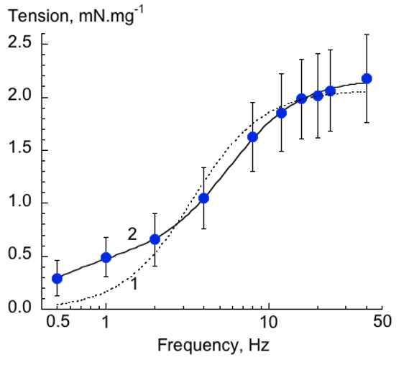
Figure 1. Frequency-dependence of nerve-mediated contraction amplitude; mouse detrusor. Lines are best-fits of a one- (1, dotted line) or a two (2, solid line) component model: see Methods for details. The two-component model shows a significantly better fit (F(_{2,5})=175.8; p<0.0001). Data are mean±SD, n=12 preparations.

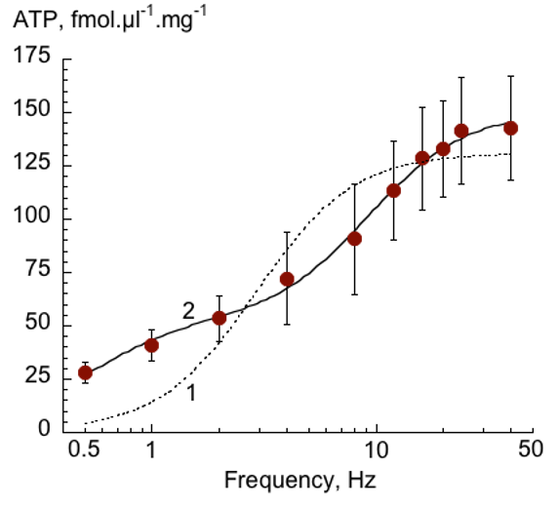
Figure 2. Frequency-dependence of nerve-mediated ATP release; mouse detrusor. Lines are best-fits of a one- (1, dotted line) or a two (2, solid line) component model. The two-component model shows a significantly better fit (F(_{2,5})=87.1; p<0.0001). Data are mean±SD, n=12 preparations.

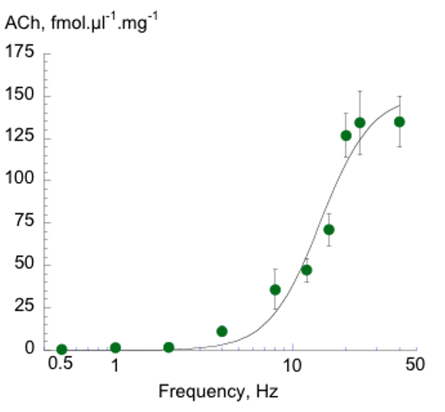
Figure 3. Frequency-dependence of nerve-mediated ACh release; mouse detrusor. The line is a best-fit of a one-component model. A two-component model fit showed no improvement in the goodness-of-fit (F(_{2,5})=2.47; p=0.179). Data are mean ±SD, n=12 preparations.

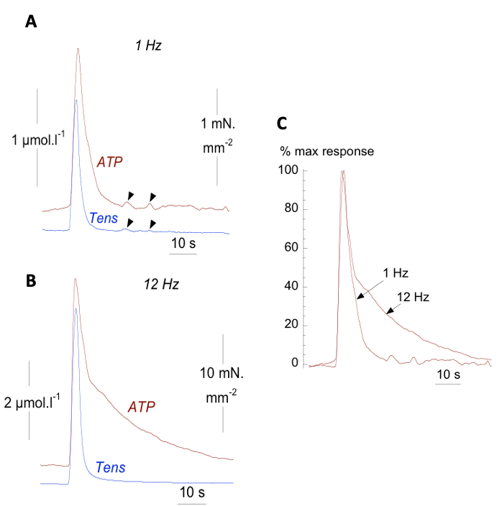
Figure 4. Real-time recording of nerve-mediated tension and ATP release; guinea-pig detrusor. A: ATP and tension recorded with a 3-s train of pulses at 1 Hz frequency. Black arrowheads mark spontaneous ATP and tension transients. B: ATP and tension recorded with a 3-s train of pulses at 12 Hz frequency. C: Superimposition of the ATP transients in parts A and B normalised to their respective maximum values: note the different time courses of the 1 and 12 Hz transients.

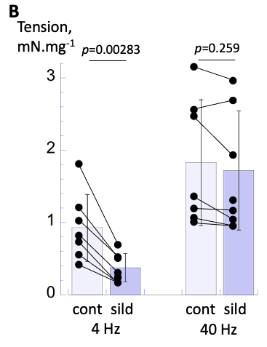
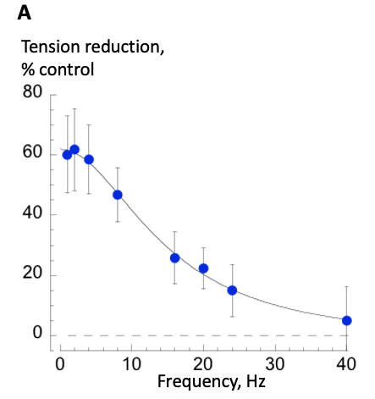

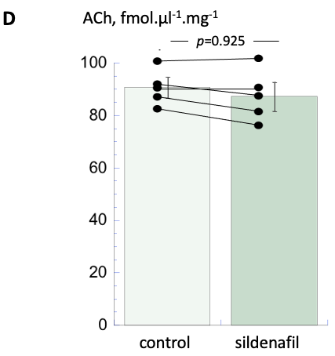
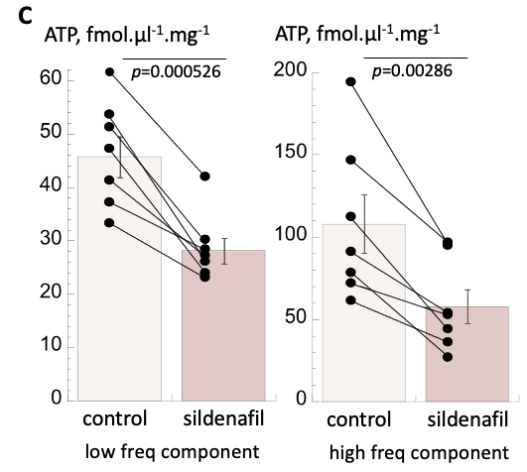

Figure 5. Effect of sildenafil (20 µM) on tension and ATP, ACh release; mouse detrusor. A: Frequency-dependent reduction of nerve-mediated contractions; the line is a fit of eqn 3 (Methods). The dotted line shows the 0% reduction. B: bar chart of tension values in control and with sildenafil during stimulation at 4 Hz (left; **p=0.00283, n=7) and 40 Hz (right; p=0.259, n=7, ANOVA with Tukey post hoc tests). C: Bar charts of nerve-mediated ATP release in control and with sildenafil for the low frequency (left, **p=0.000526, n=7, paired t-test) and high frequency (right; **p=0.00286, n=7, paired t-test) components. D: Bar chart of nerve-mediated ACh release in control and with sildenafil (*p=0.925, n=5, paired t-test). All data mean±SD.
Table 1. Parameter fits for the frequency-dependence of tension and neurotransmitter (ATP and ACh) release. Values are derived from two-component (tension, ATP: eqn 2) and one-component (ACh: eqn 1) fits. Mean data±SD. Y_{A} /(Y_{A} + Y_{B}) is a dimensionless variable.
ACh data are placed in the ‘high-frequency (‘Y_{B}’) rows for convenience. p=0.708: maximum total ATP release (Y_{A} + Y_{B}) compared to maximum total ACh release (Y_{B}). p<0.0001: ACh f_{1/2} values vs both f_{A,1/2} ATP and f_{B,1/2} ATP. See Methods for further explanation of parameter values.
 |  | Analytical Method
 | mouse  (n=12) | Superfusate sampling  mouse  (n=12) |  | ATP electrode guinea-pig (n=10)
Magnitude  parameters | Tension  mN.mg⁻¹ | ATP  fmol.µl⁻¹.mg⁻¹ | ACh  fmol.µl⁻¹.mg⁻¹ | ∫₀³⁰ATP  pmol.s.µl⁻¹.mg⁻¹
Low freq max, Y_{A} | 0.45 ± 0.19 | 45.8 ± 10.5 |  | 1.32 ± 0.95
High freq max, Y_{B} | 1.73 ± 0.49 | 105.4 ± 16.9 | 147.9 ± 19.7 | 4.79 ± 1.91
Y_{A} + Y_{B} | 2.18 ± 0.43 | 151.2 ± 23.0 | (p=0.708) | 6.11 ± 1.60
Y_{A} /(Y_{A} + Y_{B}) | 0.21 ± 0.10 | 0.25 ± 0.13 |  | 0.21 ± 0.09
Frequency  parameters | Tension  Hz | ATP  Hz | ACh  Hz | ATP  Hz
Low freq f_{A,1/2} | 0.42 ± 0.29 | 0.37 ± 0.14 |  | 1.08 ± 0.58
High freq f_{B,1/2} | 5.53 ± 1.42 | 7.51 ± 2.71 | 14.0 ± 0.80 | 6.15 ± 1.60
Freq @ 50% total, f_{50%} | 4.53 ± 1.71 | 5.16 ± 2.15 | (p<0.0001) | 4.83 ± 1.24

