**Ecohydrological Disturbances by Roads: current knowledge, new research needs, and management concerns for the tropics**

Beverley Wemple, University of Vermont, USA, [bwemple@uvm.edu](mailto:bwemple@uvm.edu)

Trevor Browning, Ohio State University, USA, [browning.257@osu.edu](mailto:browning.257@osu.edu)

Alan D. Ziegler, National University of Singapore, Singapore, [geoadz@nus.edu.sg](mailto:geoadz@nus.edu.sg)

Jorge Celi, Universidad Regional Amazónica IKIAM, Ecuador, [jorge.celi@ikiam.edu.ec](mailto:jorge.celi@ikiam.edu.ec)

Kwok Pan (Sun) Chun, Hong Kong Baptist University, Hong Kong, [kpchun@hkbu.edu.hk](mailto:kpchun@hkbu.edu.hk)

Georgia Destouni, Stockholm University, Sweden, [georgia.destouni@natgeo.su.se](mailto:georgia.destouni@natgeo.su.se)

Fernando Jaramillo, Stockholm University, Sweden, [fernando.jaramillo@natgeo.su.se](mailto:fernando.jaramillo@natgeo.su.se)

Nei Leite, Universidade Federal de Santa Catarina, Brazil, [nei.leite@ufsc.br](mailto:nei.leite@ufsc.br)

Mark Johnson, University of British Columbia, Canada, mark.johnson@ubc.ca

Junjiro Negishi, Hokkaido University, Hokkaido, Japan, negishi@ees.hokudai.ac.jp

Ximena Palomeque, University of Cuenca, Ecuador, [ximena.palomeque@ucuenca.edu.ec](mailto:ximena.palomeque@ucuenca.edu.ec)

# **Abstract**

# Roads are a pervasive form of landscape disturbance with known effects on a range of ecosystem processes--but much of what is known about the effects of roads on ecohydrology is drawn from studies conducted in temperate regions. Pressing development pressures (logging, hydropower development, population growth) are resulting in rapid development of road networks in many tropical areas where limited work has been conducted. We review what is known about road impacts on ecohydrological processes, with a focus on aquatic systems, present evidence from several ongoing studies documenting road impacts in settings that represent broader trends in the tropics. We finally propose some recommendations for future research and management.

keywords: tropical ecohydrology, aquatic ecology, erosion and sedimentation, road impacts

**Introduction**

Roads provide important functions for society, facilitating travel, trade, tourism and national defense, supporting resource access and management, and enabling the transport of commodities (Lugo and Gucinski, 2000; Sidle and Ziegler, 2012; Laurance, 2014). Despite these societal benefits, the presence of transportation corridors of all types, ranging from interstate highways to unpaved forest roads and footpaths, have been associated with adverse hydrological and ecological impacts (Forman and Alexander, 1998; Spellerberg, 1998; Trombulak and Frissell, 2000; Seiler, 2001; Coffin, 2007; Andrews and Gibbons, 2008; Ramos-Scharrón and MacDonald, 2005, 2007; Ziegler et al., 2007; Wemple and Jones, 2003; Negishi et al., 2008; Takken, et al., 2008; Thomaz and Peretto, 2016). The opening of new roads has been identified as a key driver of land use change in tropical regions (Geist and Lambin, 2002; Goosem, 2007; Laurance et al. 2009; Freitas et al., 2010; Barber et al., 2014; Laurance et al., 2014; Fearnside, 2015). Arguably, insufficient study has been directed at understanding the realm of impacts of roads in the tropics, particularly to aquatic systems.

Across several scales, the development of road networks has been associated with permanent land-cover conversion, resulting in a range of ecological and hydrological impacts (Chomitz and Gray, 1996; Cropper and Griffiths, 2001). Commonly cited road-related terrestrial ecological impacts include the interference of species mobility or dispersal, habitat fragmentation, mortality by roadkill, noise effects on wildlife populations, and microclimate changes affecting vegetation composition or animal habitat viability (Forman and Alexander, 1998; Spellerberg, 1998; Coffin, 2007). The direct and indirect negative ecohydrological impacts on aquatic ecosystems are diverse (Trombulak and Frissell, 2000). Direct impacts include the obstruction of the movement of fish or other aquatic organisms at road crossings or increased mortality resulting from the discharge of harmful contaminants into streams and the coastal zone from roads. Indirect impacts include stream habitat destruction or disruption of food webs through changes of natural stream runoff response, increased sediment loads resulting from accelerated erosion and/or mass wasting on and adjunct to the road prism (Forman and Alexander, 1998, Forman, et al., 2003, Gucinski, et al., 2001; Coffin, 2007). Increased rainfall instigated by climate change will only serve to exacerbate these issues and further degrade the ecosystem.

Most of what is known about road-related ecohydrological impacts comes from research in developed countries in temperate areas, especially in forested settings where roads alter key aspects of runoff and sediment production, causing deleterious impacts on aquatic ecosystems (National Research Council, 2008). There is a continuing need to study these issues worldwide, particularly in developing tropical nations, which are currently experiencing rapid development of extensive road networks irrespective of potential impacts on hydrologic systems (State of the Tropics, 2014; Sidle and Ziegler, 2012). Extractive industries (e.g., timber extraction, oil production, and mining) and remotely situated infrastructure development, particularly the construction of hydroelectric facilities, have been the primary drivers of extensive road system building in the developing world. Secondary drivers include infrastructure expansion due to growth in tourism and recreation demand in sensitive areas, such as coastal zones and mountains (e.g, Ito, 2011; MacDonald et al., 1997; Brooks et al., 2015) and the opening of international borders (Fox, 2005).

In the face of anticipated climate change and intense development pressure in tropical and/or developing regions, we argue that the vast ecohydrological disturbances caused by roads warrant immediate attention. In this paper, we summarize important negative impacts of roads on ecohydrology, with a focus on land surface hydrology and aquatic ecology. We use a set of cases from our own experiences to first illustrate the diversity of environmental issues associated with road construction and management, then to draw attention to areas for management improvement and for new ecohydrological research.

**Part I. Ecohydrological Impacts of Roads**

**Changes in stream hydro-geomorphological processes**

Road impacts on ecohydrological processes are significant and diverse, spanning spatial scales from plot to landscape. Specifically, roads alter fundamental aspects of water and sediment production their subsequent transport to the stream network and ultimately, the coastal zone. In rural and forested settings, where infiltration rates are otherwise high, compacted surfaces of unpaved roads have low permeability leading to negligible infiltration and the production of overland sheet flow with enhanced suspended sediment concentrations (Luce and Cundy, 1994, Ziegler and Giambelluca, 1997; Luce 2000; Ziegler et al., 2001; Ramos-Scharrón and MacDonald, 2005, 2007; Ziegler et al., 2007). In mountainous terrain, roads act as low permeability geologic layers intercepting and diverting subsurface flow (Megahan and Clayton, 1983; Wemple and Jones, 2003; Negishi et al., 2008). Concentrated surface runoff generated through these mechanisms is typically routed through a network of roadside ditches and diverted to a preexisting channel; if not gully erosion occurs and a new channel is incised and forms, thus increasing the drainage density of the system (Wemple, et al., 1996; Croke and Mockler, 2001; Takken, et al., 2008; Thomaz and Peretto, 2016).

The concentration of water on roads, roadside ditches and discharge points impacts erosion and water quality through various mechanisms such as:

1) The mobilization of fine-grained sediments of the compacted roadbed and roadside margin (Anderson and Potts, 1987; Ziegler et al., 2000; MacDonald, 2005; Ramos-Scharron et al., 2005; Ramos-Scharron, 2012; Araujo et al., 2014),

2) Initiation of gullying at culvert outlets (Wemple, et al., 1996; Croke and Mockler, 2001; Takken, et al., 2008),

3) Shallow landsliding both above and below roads (Montgomery, 1994; MacNamara et al., 2006; Ziegler et al., 2012), and

4) Failure of culverts (and associated sediment mobilization) during extreme rainfall events (Wemple et al., 2001).

Increased erosion and sediment transport from roads leads to higher delivery of associated solutes and nutrients to the stream (Trombulak & Frissell, 2000). Collectively, the mobilization and downstream delivery of sediment and solutes from roads impacts fragile aquatic ecosystems, altering streamwater and seawater chemistry and degrading the quality of benthic habitats (Dodge et al. 1974; Rogers, 1990; Forsyth et al., 2006; Wolanski, et al., 2009; Wasson et al., 2010; Golbuu, et al., 2011; Latrubesse et al., 2009).

### Effects of roads on aquatic systems

The occurrence and types of benthic invertebrates in a river are largely controlled by the grain size of a riverbed, with cobble or pebble substrates supporting both greater diversity and abundance than sand­ or silt ­dominated substrates (Hynes 1970; Minshall 1984; Vouri & Joensuu 1996; Angradi 1999). Excessive deposition of fine sediment from roads can change the physical nature of the substratum, resulting in ecosystem-wide responses (e.g., Rogers, 1990; Mattahei et al. 2006). For example, burial can reduce the availability of permanent and spawning habitats (e.g. seagrass beds, coral reefs, etc.) for fish species seeking cover above or in the benthic interstices within the substratum (Koenig et al., 2000; Rogers, 1990; Richardson 1985). In coastal environments burial of coral reefs causes species diversity and abundance of invertebrates and fish to decrease (Koenig et al., 2000; Friedlander et al. 1998). Heavy metals or other toxic substances in road runoff may also contaminate sediment, thereby reducing substratum suitable for macroinvertebrate colonization (Perdikaki & Mason 1999; Forrow & Maltby 2000). Road-induced changes in sedimentation and runoff patterns may induce taxon­specific responses in drift macroinvertebrates (Rosenberg & Wiens 1978; Richardson 1985; Doeg & Milledge 1991; Shaw & Richardson 2001; Imbert & Perry 2000; Molinos & Donohue 2008), further amplifying change in benthic community structure (Larsen & Ormerod 2010). .

Increases in sediment transport rates and turbidity could also decrease feeding efficiency, decouple food web dynamics, and cause physiological stress for fish (Walde, 1986; Shaw & Richardson 2001; Shofield et al., 2004). Increased sedimentation may mediate food resource quality and quantity for algivorous consumers. Food resource quality of periphyton for macroinvertebrates that feed on them may be reduced by an increasing inorganic content (Graham 1990; Yamada & Nakamura 2002; Suren 2005; Molinos & Donohue 2008), especially when flow is moderate enough to allow particles to settle, and by abrasion of periphyton by coarse sediments (Biggs et al., 1999). Such changes in food quality may affect life history traits of organisms such as ingestion rates (Kent & Stelzer 2008). Altered texture of substratum surfaces may result in changes in retention functioning for organic matter and thus availability of types of food resources for macroinvertebrates (Parker 1989).

Sedimentation of fine­ grained material originating from roads can also affect the dynamics of the hyporheos, a critical zone for various transformations of water chemistry and stream metabolism (Williams & Hynes 1974; Strommer & Smock 1989; Valett et al. 1990; Krause et al., 2011). (). Transformations of water chemistry are dependent on physicochemical environments, depths and residence time of hyporheic-zone exchange (Jones & Holmes 1995) Deposition of sediment substantially reduces the surface­subsurface exchange of water and shortens residence time of water, thus leading to lower dissolved oxygen levels, changes in nutrient retention, and water quality of different chemical composition (Whitman & Clark 1982; Strommer & Smock 1989). Along with surface-­subsurface exchange of water, particle size composition determines community composition of hyporheic invertebrates (Richards and Bacon, 1994; Olsen and Townsend 2003; Packman & Mackay 2003).), Reduced interstitial flow and dissolved oxygen concentration resulting from the filling of hyporheos has been negatively linked to spawning bed quality, in particular those of salmonids (Ringler & Hall 1975; Waters 1995).

Road-related sedimentation in the coastal zone has the ability to both deliver a new food source and bury sessile organisms attached to the substrate (Bégin et al, 2014). Short et al. (2014) found that seagrass meadow cover at several sites in the Western Pacific were in decline because of increased sedimentation and nutrient loading. One site in Palau showed low-level seagrass decline from increased sediment loading due to road construction. Corals gain nutrients through filter feeding, but also need UV radiation to grow. Thus, increased water and sediment flux to the coastal zone increases their food supply while threatening their livelihood.

The construction of roads raised road surfaces surrounded by drainage ditches can also create new habitats for aquatic species in areas where they formerly did not exist. For example, following the construction of a road through pristine tropical lowland rain forest in the Ulu Temburong National Park (Brunei Darussalam) facilitated the immigration of eight new anuran species into the impacted area (Konopik et al., 2014). O’Neill et al (2016) found that communities of crustaceans in artificial waterbodies, including roadside ditches, were indistinguishable from those in naturally formed wetlands­­a result that leads to the assertion that increases in road density facilitates population increases of some species. However, Cairo and Zalbo (2007) found that roads can be considered as having a significant impact on red­bellied toads by augmenting mortality, hindering the mobility of the species and increasing habitat isolation.

**Changes in drainage network structure and connectivity**

In addition to degrading the streambed and riparian zone, road crossings of streams affect the mobility of many types of riverine aquatic species, including fish and macroinvertebrates, by physical alterations to stream network connectivity (Gibson et al., 2005; Ward et al., 2008; Maitland et al., 2016). Maitland et al (2016) recently showed that stream crossings influence abiotic habitat characteristics, restrict biotic connectivity, and impact fish community structure at the whole­stream and within­stream scales (see also Perkin & Gido 2012) . In particular, diadromous species, such as salmonid fish and atyid shrimps, which migrate between upland rivers systems and the sea are vulnerable to obstructions (Brown & Hartman 1988; Resh 2005). Road crossings with culverts may also provide blockages to upstream­skewed flight passages of adult aquatic insects, thereby reducing larval insects in upstream of roads (Blakely et al., 2006).

Continental-scale assessments of road networks show that roads often exist at densities that approach and, in some regions, exceed that of river channel networks, enabling fundamental alterations in the way water and sediment moves through the landscape (Gucinski, et al., 2001; Coffin, 2007). These changes in runoff routing effectively enhances hill slope to channel connectivity (Bracken and Croke, 2007), in turn increasing storm peak flow generation at the watershed scale (Harr et al., 1975; King and Tennyson, 1984; Jones and Grant, 1996; Thomas and Megahan, 1998).

Along higher order rivers in lowland settings, roads alter fundamental river-floodplain interactions with important ecological and economic implications. Transportation networks are commonly built parallel to river corridors, where flat terrain facilitates roadway access. This broad geographical pattern road placement has recently been shown to alter river-floodplain interactions, with important implications for aquatic ecology (Blanton and Marcus, 2009). River avulsion and river bank failures along constrained reaches also undermine road infrastructure and exacerbate property losses during extreme events. (Clarke and Rendell, 2006; Geertsema et al., 2009).

**Alteration of disease ecology**

A handful of studies conducted in recent years have demonstrated the capacity by which roads indirectly affect the ecology of important diseases in tropical areas. The construction of roads in previously inaccessible forested areas can lead to erosion, and stagnant ponds by blocking the flow of streams when the water rises during the rainy season (Patz et al., 2000). One study showed that puddles forming on the road surface were abundant with *Lefionella pheumophila*, the bacteria that are the major cause of community-acquired pneumonia. Larvae of Anopheles gambiae (Savanna form), an important vector for malaria transmission in Burkino Faso were found to be prevalent in small, rain-dependent, ephemeral habitats, such as puddles and road ruts (Pombi 2004).

In Ecuador, Eisenburg et al (2006) found that the construction of roads affected the epidemiology of diarrheal illnesses. In particular, villages closer to a newly constructed road had a higher rates of infection. Although the exact mechanisms causing the increased rates was not articulated, they are probably related to the role of roads channeling contaminated surface water into drinking water resources. Elsewhere, roads have been implicated in the life cycle of malaria. For example, the construction of roads in the Brazilian Amazon were shown to allow anopheline mosquitoes to invade previously inaccessible areas by causing erosion and allowing colonization (Patz et al., 2005). Forest-dwelling Anopheles species either adapted to newly changed environmental conditions or disappeared from the area, offering other anophelines a new ecological niche (Povoa et al. 2001; Patz et al., 2005).

In Asia, Sittithaworn et al. (2012) report how road building and aquaculture have changed the life cycle of *Opisthorchis viverrini*, a water-borne trematode that is a major cause of cholangiocarcinoma around the lower Mekong river in southeast Asia. Following the excavation of soil to build roads, villagers stocked the ponds that formed with fish from nurseries that were infected with the o. parasites. The study found O viverrini infecting at least five species of fish grown for commercial sales in the ponds. The data suggest that infection before stocking is a likely cause of higher prevalence of O viverrini metacercariae found in fish from ponds in Laos than in Thailand, where O.viverrini infection is a recognized critical health issue. Subsequently, Ziegler et al (2016) report how the building roads, dams, and irrigation systems (in support of agriculture intensification and modernized techniques) increases the extent and connectivity of habitats that support the complex O. viverrini ecological cycle (Ziegler et al. 2013; Sithithaworn et al. 2012).

**Part II. Case Studies from the tropics**

The realm of known road-related eco-hydrological impacts, reviewed briefly in Part I, has contributed to the motivation of new calls to improve how road building and road management is conducted globally (Lugo and Gucinski, 2000; Laurance et al., 2014). Implementing eco-friendly strategies in tropical settings requires understanding the distinct context and pressures driving road management and expansion, as well as the potential eco-hydrological impacts in each setting. Below, we present evidence from a few studies conducted by some of the authors that illustrate the range of road impacts on tropical ecosystems.

**Ciénaga Grande de Santa Marta (CGSM), Colombia**

The Ciénaga Grande de Santa Marta (CGSM) is in the delta of the Magdalena River, the largest river in the Colombia, draining an area of over 258,000 km2 (Figure 1).  The basin contains the country’s largest wetland complex on the Colombian Caribbean coast. Between 1950-1960 a main road connecting two major cities of the country was constructed along the wetland’s perimeter, blocking the hydrologic flow between sea and fresh water, required for the natural functioning of the wetland’s ecosystems. The construction phase coincided with a dry period of El Nino/Southern Oscillation (ENSO), enhancing hyper salinity conditions in the CGSM (Blanco et al., 2006) as evidenced by long-term monitoring data (Figure 2). Additional modification and blockage of freshwater inflows from the Magdalena River, due to the construction of a road on the western side of the Cienaga in 1975-1980 and to heavy irrigation systems on the eastern side, have also contributed to degradation of this aquatic ecosystem. Heavy siltation has also blocked many of the channels that usually connected the wetland to the Magdalena River. The combination of both anthropic and natural events resulted in a massive mortality of mangroves at the end of the 20th century which reduced by approximately 50% the area coverage of mangrove species, from an original extension of 511 km2 , as measured in 1956 (Figure 2). This case, a clear example of the impacts of roads on connectivity and aquatic ecosystem function, is now recognized as one of the most important ecological catastrophes of the Americas, having been designated a Ramsar site by the International Convention on Wetlands.

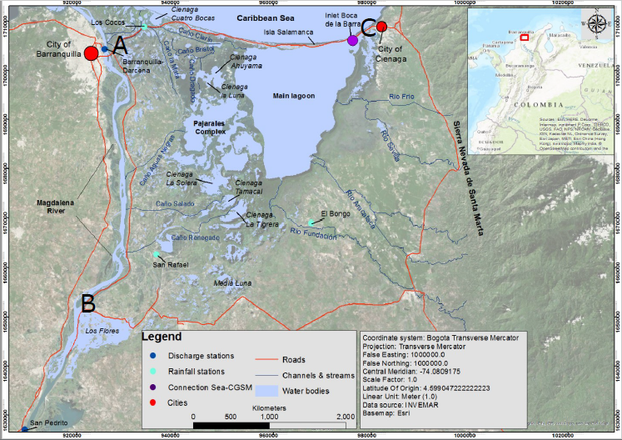

*Figure 1: Road complexes of the Cienaga Grande de Santa Marta, Colombia connecting cities of Barranquila (A) and Cienaga (C) in the 1950’s and along the western shores of the Magdalena River to points south (B) in the 1970’s.*

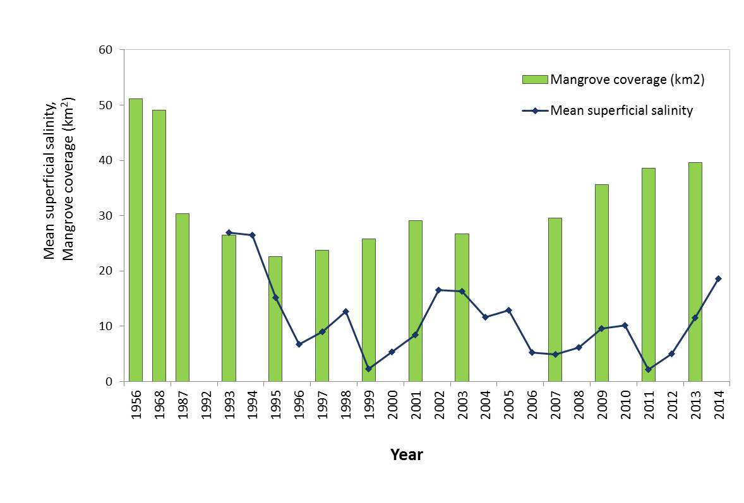

*Figure 2: Mean superficial salinity and mangrove coverage since 1956 for the Cienaga Grande de Santa Marta, Colombia (data from XXX).*

**Pang Khum, Thailand**

Northern Thailand, like many mountainous regions of the tropics, contains dense networks of remote mountain roads, most constructed by hand following historical foot/animal tracks. Regionally, the shift toward the cultivation of marketable crops followed the evolution of road and irrigation infrastructures, the development of urban market demands for agriculture products, and the initiation of crop substitution programs (Ziegler et al., 2009). The road network has subsequently expanded in the mountains to support national security, law enforcement (narcotics, anti-logging), population growth, and agriculture intensification (Ziegler and Giambelluca, 1998; Ziegler et al., 2005). As with many other roads built on steep terrain in the region, sound design and maintenance guidelines were often not implemented to limit potential environmental impacts (Ziegler et al., 2000). Instead, roads are largely left unpaved, designed without effective water drainage systems, and terminated at streams or temporary log bridges. Increased sediments loads in northern Thailand are a concern, but most research and outreach programs addressed accelerated hillslope erosion associated with hilltribe agriculture (Sidle et al., 2004), which was beginning to intensify following the ban on the production of opium–a cash crop that caused exceptionally high erosion on steep hillslopes (Ziegler et al., 2009).

Research in the 94-ha Pang Khum Experimental Watershed, established in 1997, has led to a number of discoveries illustrating how roads in this landscape impact hydroecological processes: (a) roads often produced sediment loads that were disproportional to the area they occupied in the catchment (Ziegler et al., 2005); (b) the erodibility of the native road surface was dynamic, effected by the generation and removal of easily entrained surface material by road surface maintenance activities, vehicular detachment, and overland flow (Ziegler et al., 2001a,b; 2002); (c) road maintenance was intermittent, performed at the end of the wet monsoon period and, when needed, during the wettest part of the rainy season when storms could mobilize mobilize large volumes of fresh sediment made available by the maintenance; (d) roads within heterogeneous landscapes were important in converting substantial amounts of overland flow into elevated stream peak flows (Cuo et al., 2006; 2008); (e) naturally occurring buffers were potentially an economical means of mitigating road-related impacts in upland basins in area when combined with measures limiting sediment and runoff production on contributing road sections (Ziegler et al., 2006); and (f) even the sparse road network in Pang Khum contributed to shallow mass failures where road runoff water was concentrated on the hillslope (McNamara et al., 2006).

Collectively, the findings from northern Thailand highlight the role of roads in accelerating erosion, destabilizing hillslopes, and increasing stream sediment loads (Sidle and Ziegler, 2012). While the long-term consequences of alteration in stream functioning on downstream aquatic environments may have been severe, they were largely unrecognized by officials charged with catchment planning and transportation management. Importantly, the were simply deem acceptable, and inline with the need to improve transportation infrastructure to meet development goals (Sidle and Ziegler, 2012; Ziegler et al., 2009).

**Lower Paute Basin, Ecuador**

Recent road expansion in Ecuador suggests some important and unintended consequences of planned development strategies in rapidly developing tropical regions. The government of Ecuador has recently promoted the generation of hydroelectric power to meet national electrification needs and promote development, promoting the development of dispersed small-scale hydro projects, most without extensive river impoundments and reservoirs in regions where sedimentation behind dams has been an historical challenge (citation). Throughout the country, hydropower projects are developed in high elevation watersheds to harness the potential energy of mountainous terrain, some in the initial stage of operation (Ministerio de Electricidad y Energía Renovable 2016; Ministry of Electricity and Renewable Energy of Ecuador 2016). One such project is the Mazar-Dudas project, initiated in 2005 within the lower region of the Paute River basin (Figure 1). Since 2010 the complex generates around 800 GWh/year to the National Interconnected System (CELEC EP, HIDROPAUTE 2016). This development scheme, and the spatially dispersed nature of the small scale hydro facilities associated with the projects necessitates and extensive network of road development. Empirical observations indicate that road networks in this terrain require extensive slope excavation and are associated with extensive consequences for erosion and sedimentation of receiving waters, including landsliding and debris flows (Sarmiento 2010).

Our analysis of historical imagery for the Mazar and Pindilig catchments of the lower Paute river basin in southern Ecuador illustrates the rapid rate of road development common across the tropics. The Paute basin (5176 km2) is located in the southern Ecuadorian Andes and forms part of the Amazon river basin. Altitudes range from 1991 m asl at the Amazaluza reservoir to 4680 m asl in the upstream areas (Vanacker et al., 2007). The Paute river basin known for high biodiversity of flora and fauna (citation). We obtained historical imagery for 2008 and 2014 and digitized principle highways, secondary roads that provide access to small settlements and project sites, and tertiary roads often constructed for temporary access and excavation or transport of material. Over the period bracketed by this analysis, road development has extended beyond the principle highway that connects the region to larger cities to the southwest and northeast. Most notable is the extensive network of tertiary roads event on recent imagery. Over the period of this analysis, total road length in these two catchments has increased from XX in 2008 to YY in 2014, an increase of XX%.

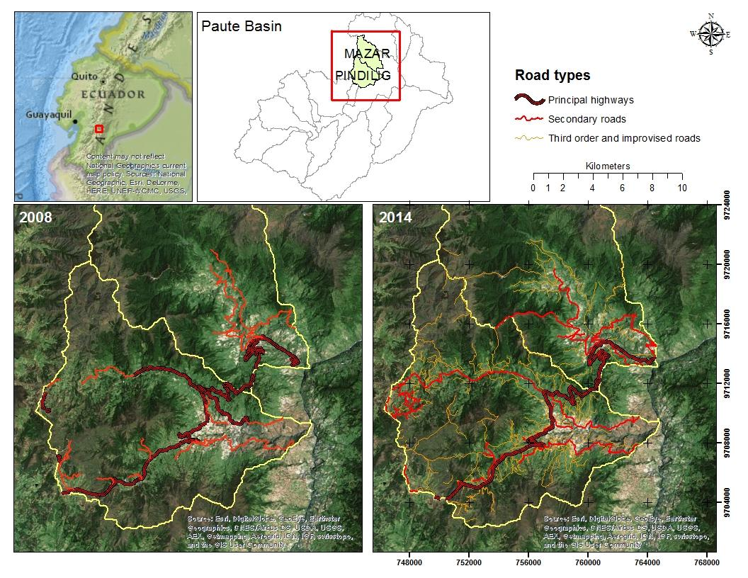

*Figure 3: Road development in the Mazar and Pindilig catchments of the lower Paute basin, Ecuador.*

# **Part III Recommendations**

**Adopting a Tropical Agenda**

The findings of the three case studies reviewed in Part II support the idea that road impacts in developing areas of the tropics can differ from more developed temperate regions of the world. Factors such as political setting, infrastructure, landform stability, climate regime, and ecological systems are the primary drivers of these differences (cf. Robinson and Thagesen, 2004). This unique and understudied situation calls for the development of a “tropical agenda” that recognizes these differences as a fundamental starting point for the development of new land use policies, management strategies, and research. In the tropics many of the ecohydrological impacts of roads reviewed in Part I are driven by the same processes as in temperate regions, regardless of the geography of the site. However, the severity of road impacts is influenced by factors such as climate, anthropogenic disturbance, and biodiversity; factors that, in the tropics, may differ greatly from temperate regions (Robinson and Thagesen, 2004). Thus, a “tropical agenda” focused on those differences should be developed.

Several authors have highlighted tropical-versus-temperate differences in stream ecology, climate, and development trajectories (Boulton et al., 2008; Wohl et al., 2012; (Gallup, Sachs, and Mellinger 1999; Sachs 2001; Easterly and Levine 2003). Boulton et al (2008) stated that despite considerable variability in geological history, flow regime, and geomorphology, streams in the tropics typically receive higher insolation, more intense rainfall, have warmer water and often relatively predictable floods when compared with temperate streams. Beyond more widely known hydrological differences such as greater rainfall and runoff, the tropics have greater energy inputs and faster rates of change, including human-induced change, than temperate regions (Wohl et al., 2012). Future pressures such as human population growth, land use, and climate change will profoundly influence tropical hydrology likely triggering extreme events such as drought and flooding leading to a myriad of issues in aquatic ecosystem productivity (e.g., nutrients, shading, disturbance, and trophic structure). (Wohl et al., 2012; Boulton et al., 2008).

As population grows, additional infrastructure is needed to support basic needs such as water, power, food, healthcare. Meeting these needs generally requires the expansion of road networks. Of particular importance are the construction of roads to support/access remote facilities such as mining, logging, or hydroelectric operations (Caro et al., 2014). Dirt roads are prevalent in the typical emerging economies found in the tropics, especially in rural and mountain areas (Sidle and Ziegler, 2012). Roads in these areas are rarely repaired properly and often go without maintenance completely (Sidle and Ziegler, 2012). Laurance et al. (2015) claim that globally, road proliferation has been chaotic or poorly planned; and the rate of expansion has often overwhelmed the capacity of environmental planners and managers.

Compounding these issues is that some of the fastest and most rapid development is occurring in developing countries where political agendas are often focused on strengthening the economy, improving infrastructure, bolstering national security, achieving self-sufficiency, and increasing citizen well-being, often at the expense of the environment, and particularly with respect to road building (Caro et al., 2014). In time, development typically becomes increasingly environmentally friendly for a range of reasons, but this change may not occur in all cases (Rigg, 2015). For example, the importance of developing roads to support growth in Singapore, one of the most developed countries in the tropics, often supersedes environmental conservation (e.g., the case of redevelopment of Bukit Brown) (Han, 2003). Often the need to channelize streams to reduce flood risks, which arise from aggressive urbanization in cities, outweighs preserving stream ecology, as is the case in Hong Kong (D. Dudgeon, pers. com, Aug 2016). This issue is amplified in cities that are naturally low lying or have experienced subsidence from groundwater pumping, such as the case in Southeast Asia (Phien-wej, Giao, and Nutalaya 2006; Feng et al. 2008).

In many developing countries of the tropics, insufficient attention has been given to mitigating eco-hydrological impacts of roads, both rural and urban (cf. (van der Ree, Smith, and Grilo 2015). Thus, we argue that reducing ecohydrological impacts of roads in the these areas requires an agenda that embraces sound planning, design, and management strategies, as well as research directed at understanding the processes and phenomena that are driving substantive road impacts in the tropics.

**Improving road network management**

Due to the extreme environments and conditions prevalent in tropical areas and the heightened sensitivity of many tropical ecosystems, avoiding the development of fragile and undisturbed areas is the best strategy for preventing road impacts (van der Ree, Smith, & Grilo, 2015). However, given the current trends in road network expansion in the tropics and projected massive increases in human population, road building and expansion will continue to occur, even in sensitive environments (State of the Tropics, 2014; Laurance et al., 2014). Several authors give sound advice with respect to planning, design, construction, and maintenance of roads (e.g., Robinson and Thagesen, 2004; Gunderson et al., 2005; Sessions, 2007; Goosem, 2007). Common themes from the literature that apply to most locales include include:

**a)** Avoid building in wetlands and hillslope hollows;

**b)** Design roads using accepted standards to minimize water accumulation on the road surface, this will reduce erosion both on the road and the adjacent road prism;

**c)** Pay particular attention to the design and placement of bridges and other types of stream crossings to minimize disturbance during construction, limit the discharge of undesirable materials during runoff events, and avoid the obstruction of the movement of aquatic species;

**d)** Perform regular maintenance on native road surfaces to prevent severe erosion and gully formation on native roads;

**e)** Road placement matters, placing roads outside of flood zones will reduce road maintenance, avoid placing roads parallel to streams as it increases peak flow volumes if in the flood zone;

**f)** Note the placement of ephemeral streams or gullies, during the wet season water delivered by these systems can accumulate on the road surface if not properly diverted through drainage culverts;

g) Do not further alter the natural hydrology, as mentioned above when a road is built subsurface flow is diverted, any further attempts to direct flow out of natural pathways will lead to innumerable issues (Quito, EC situation).

Additional insight can be gleaned from the reviewed case studies for tropical settings. For example, the design and planning of roads should be done with consideration for the natural setting, climate conditions, and ecology of the area to minimize impacts during and after construction. For example, management strategies in urban versus rural settings might differ in focus because of unique stressors and different histories of disturbance. Roads that access coastal zones are especially problematic owing to effects of the harsh environment on the road, as well as the sensitivity of coastal ecosystems to inputs of materials that runoff from roads. Countries that do not regulate road building and maintenance may consider implementing programs to prevent ad hoc activities that will impede larger environmental protection objectives. Construction and maintenance should be conducted in dry seasons, rather than the wet seasons in monsoon climates when storms are frequent and occasionally large. Attempts should be made to reduce the hydrological connectivity between the road and stream networks, particularly in areas with high-density road systems (e.g., plantations).

Finally, new evidence is pointing for the need to limit the formation of zones of stagnant pools of water (roadside ditches, fill-dirt excavation ponds) that may create unnatural habitats for unwanted species, including disease pathogens. Again, the building of roads and other infrastructure features (dams, irrigation canals) have little-known effects on the dispersal and ecology of many-waterborne parasites. These common themes and insight are only suggestions from current research as to mitigating the effects of roads on ecohydrological processes. As we have mentioned throughout the full impacts of roads are not completely understood and more research is necessary to adequately manage these areas.

**Research Needs**

Wheeler et al (2005) noted that although highway construction was pervasive and had severe biological consequences, there were few investigations of the impacts of construction on streams, and subsequently, little was known little about the occurrence, loading rates, and biotic responses to specific contaminants in road runoff. They called for an increased understanding of how highway crossings, especially culverts, affect fish populations via constraints on movement and how highway networks alter natural regimes (e.g., streamflow, temperature) (Wheeler et al., 2005). A decade later, this dearth of knowledge is still arguably the case for all types of roads. Much of the work has focused on hydrological and geomorphological processes (see first section of Part I), rather than adverse effects on aquatic ecosystems *per se*. Again, most of the work was been done in temperate areas--but some work has addressed impacts of roads during timber extraction operations in SE Asia (cf Bruinjzeel, 1990; Douglas, 1999; Bonell and Bruijnzeel, 2005).

New research is needed to identify and prioritize the variables for quantifying road effects on ecohydrology. Much research has been accomplished on the negative effects (potential or measured) of increased delivery of pollutants, sediment, and nutrients to aquatic ecosystems (Edmunds and Gray 2014; Edmunds et al. 2014; Bégin et al. 2014; Yates et al. 2014; Muller, Rogers, and van Woesik 2013; Rogers 2009; Rogers 1990; Rogers and Miller 2006; Ellis et al. 2011; Maynard et al. 2015; Riegl et al. 2009; Stork et al. 2009; Newbold et al. 2015). However, monitoring is needed to identify threshold concentrations of these harmful materials that trigger negative ecosystem-wide responses on habitat viability, ecological interaction, mortality, and productivity (e.g., Kaller & Hartman 2004). These responses may be species- or family-specific; and some organisms may emerge as important indicator species for identifying road-related impacts on aquatic environments. Alternatively, mesocosm experiments could identify thresholds of toxicity, for example, of heavy metals or other potentially harmful materials sorbed to road dust (cf. Clements, 1991). Sediment loading research might collaborate with the above sorbing study to investigate if particle size is a factor in ecosystem degradation or it is the elements sorbed to the particles themselves. Research should also examine the effects of nutrient cycling on solute retention and processing rates. Given the sensitivity of coastal ecosystems, one or all of these impacts may be degrading their communities. Overall, more work is needed to link road-induced runoff changes with negative responses in coastal communities, such as coral reefs, mangrove forests, and seagrass beds (Macdonald et al., 1997; Short et al., 2014; Begin et al, 2014). Study is also needed on the effectiveness and feasibility of alternative management or remediation strategies--for example, natural riparian buffers, artificial wetlands, and stormwater retention structures.

Apart from ecohydrological perspectives, trade-offs between livelihoods and environmental concerns related to rural development and road construction should also be further considered (Bonell and Bruijnzeel, 2005). Research studies are important for new road design standards and policies including both local interests and international environmental expectations (cf. Fairhead and Leach, 1995). Compromise solutions may be needed to reconcile development with conservation needs (Caro et al., 2014). Road impacts are also likely affected by social settings, demographics, and levels of development at different scales ranging from countries (e.g. a national road network) to communities (e.g. urban road network), to singular tracks of land (e.g., temporary access road).

Transdisciplinary approaches (e.g. Bring et al., 2015) are useful for reconciling scale differences and investigating environmental issues of great complexity. Databases for road impact investigations can be developed by linking multiple disciplinary datasets. Although remote sensing products can provide spatial land change information, continuous monitoring stations can provide high-resolution ecohydrological data that show temporal changes across important time scales: diurnal, synoptic (in response to a storm event), seasonal, or multi-year. New work should target the space and times scales at which various stressors are important.

Gunderson et al (2005) stress that at national and regional scales, environmental issues associated with road impacts are often treated as a permitting issues to protect particular types of lands (e.g, wetland) or threatened species, rather than dimensions of an overall project design to myriad negative consequences. They argue that governments should (a) provide policy, guidance, and funding for transportation design and decision making that take ecological processes into account; (b) expand the knowledge base for assessing potential effects of transportation activities through nationally funded research projects; and (c) encourage cross-disciplinary dialogue between engineers, ecologists, and other environmental professionals to raise mutual awareness of each other’s expertise, needs, and challenges (Gunderson et al, 2005).

We see the construction of roads--and other major infrastructure projects--as opportunities for builders to work with scientists to gain knowledge about particular ecosystems. For example, if trees are to be removed permanently, the carbon biomass can be measured before by scientists to augment databases needed for climate change investigations (Yuen et al., 2015). Biodiversity surveys should be encouraged before construction to facilitate long-term monitoring, which will ultimately lead to better road building/managing strategies. This “type” of work differs from environmental impact assessments, as it would be implemented after the road project is approved, thereby reducing the conflict between conservation advocates and those championing the road. A road network expansion is inevitable, at least for the time being, we as scientists should maximize the opportunity to study systems that we may not have had access to before and to look for compromise solutions to limit the eco-hydrological impacts (Caro et al., 2014).

Climate change is a prime input we should address in our research on the relationship between road building and aquatic ecosystem. By altering temperature, discharge, erosive flow and number of extreme hydrological event, climate change may add pressure on the already adverse impacts of road building on aquatic lives in the modified urban stream system that we have mentioned in part I of this article. The combined effects of urbanization and climate change on stream biodiversity in the temperate settings are discussed, quantified and forecasted (Meyer et al., 1999; Palmer et al., 2008; Nelson et al., 2009;). Using a biotic model, Nelson et al (2009) demonstrate that the combined effects of urbanization and climate change could give rise to more depressed adult growth of fish species than either climate change or urbanization alone in temperate USA. Yet the mechanism of how changing climate pattern and road building combine to modify tropical stream ecology is still unexplored, given the latter’s climate susceptibility and its role as the key driver converting landscape from natural into concrete.

Despite decades of realization that roads often have a noticeable negative impact on aquatic environments, we have failed to adequately address them in temperate regions and especially within the high pressure developing areas of the tropics. The challenge remains to properly identify the primary drivers and mechanisms of change in these ecosystems and mitigate their ecohydrological impacts. Utilizing the “tropical agenda” idea presented here researchers should impress upon their colleagues to hone their research to attempt to reveal these drivers so that sustainable development and management can occur in these critical and sensitive areas.

References:

Meyer, J. L., Sale, M. J., Mulholland, P. J., & Poff, N. L. (1999). Impacts of Climate Change on Aquatic Ecosystem Functioning and Health1.

Nelson, K. C., Palmer, M. A., Pizzuto, J. E., Moglen, G. E., Angermeier, P. L., Hilderbrand, R. H., ... & Hayhoe, K. (2009). Forecasting the combined effects of urbanization and climate change on stream ecosystems: from impacts to management options. Journal of Applied Ecology, 46(1), 154-163.

Palmer, M. A., Lettenmaier, D. P., Poff, N. L., Postel, S. L., Richter, B., & Warner, R. (2009). Climate change and river ecosystems: protection and adaptation options. Environmental management, 44(6), 1053-1068.