Simple Mappings, Expressive Movement: A Qualitative Investigation into the End-User Mapping Design of Experienced Mid-Air Musicians
*Dom Brown, Chris Nash and Tom Mitchell
Creative Technologies Laboratory, University of the West of England, Bristol UK.
Provide full correspondence details here including e-mail for the *corresponding author
Dom Brown, Creative Technologies Laboratory, University of the West of England, Bristol UK, BS16 1QY dom.brown@uwe.ac.uk
Dr Chris Nash, Creative Technologies Laboratory, University of the West of England, Bristol UK, BS16 1QY chris.nash@uwe.ac.uk
Dr Tom Mitchell, Creative Technologies Laboratory, University of the West of England, Bristol UK, BS16 1QY tom.mitchell@uwe.ac.uk
Provide short biographical notes on all contributors here if the journal requires them.
Dom Brown is currently a PhD candidate at the University of the West of England, looking at end-user mapping design in musical performance with mid-air gestural technology.
Dr Chris Nash is a Senior Lecturer at the University of the West of England, with research interests in music technology and related fields, with a specific goal of improving the user experiences of computer-based composers and musicians.
Dr Tom Mitchell is an Associate Professor of Creative Technologies at the University of the West of England and head of the Creative Technologies Laboratory, with interests in artificial intelligence, audio and music interaction.

Word Count (incl. references): 9283.
Simple Mappings, Expressive Movement: A Qualitative Investigation into the End-User Mapping Design of Experienced Mid-Air Musicians

In a New Interface for Musical Expression (NIME), the design of the relationship between a musician’s actions and the instrument’s sound response is critical in creating instruments that facilitate expressive music performance. A growing body of NIMEs expose this design task to the end performer themselves, leading to the possibility of new insights into NIME mapping design: what can be learned from the mapping design strategies of practicing musicians? This research contributes a qualitative study of four highly experienced users of an end-user mapping instrument to examine their mapping practice. The study reveals that the musicians focus on designing simple, robust mappings that minimise errors, embellishing these control gestures with theatrical ancillary gestures that express metaphors. However, musical expression is hindered by the unintentional triggering of musical events. From these findings, a series of heuristics are presented that can be applied in the future development of NIMEs.
Keywords: Mid-air Interaction; Action–Sound Mapping; Gestural Interaction; Experienced Users; New Interfaces for Musical Expression; Embodied Cognition; Musical Metaphors.

Introduction
The constant improvement of computational systems and sensors used in music technology (McPherson, Jack, and Moro 2016) is enabling the rapid and cheap development of New Interfaces for Musical Expression (NIMEs). A popular interaction technology used in instrument design is gestural mid-air interfaces that use the direct bodily movements of the performer for musical control (Mitchell, Madgwick, and Heap, 2012; Mainsbridge 2018; Otondo 2018), and it is becoming increasingly important to understand how these types of instruments can be designed to effectively facilitate musical expression.
In the NIME literature, one of the most important expression facilitating facets of a NIME is the relationship between the control interface and the sound response, or mapping (Hunt, Wanderley, and Paradis 2003; Rovan et al. 1997), and it is argued that an instrument’s mapping can make the difference between a musical toy and an instrument that supports virtuosic performance (Hunt, Wanderley, and Paradis 2003). In most NIMEs, the mapping is created by its designer and remains a constant feature of the instrument; however, there is a growing body of NIMEs that expose the intricacies of mapping design to the instrument’s players, referred to as “end-user mapping” (Malloch, Sinclair, and Wanderley 2007; Fiebrink, Trueman, and Cook 2009; Brown, Nash, and Mitchell 2018). As well as providing new opportunities for creativity that are unavailable to traditional instrumentalists, this approach leads to new questions about mapping design, namely: what factors influence the design choices of a musician and what can be learnt from their practice to inform the design of new instruments? To explore this question, this research examines the mapping practice of four experienced NIME musicians, who, for several years, have made a mid-air, end-user mapping instrument their primary musical instrument. Studying this group provides insights into the characteristics and processes of expressive mapping design in experienced NIME musicianship.
Previous literature argues that simple mappings do not provide engaging interactions, and that complex mappings, which use combinations of one-to-many, many-to-one, and many-to-many mapping relationships, are needed to facilitate expressive musical interaction (Rovan et al. 1997; Hunt and Kirk 2000; Dobrian and Koppelman 2006; Momeni and Henry 2006). This study explores this argument: the four experienced NIME musicians unanimously select simple rather than complex mapping strategies, enabling them to incorporate theatrical ancillary movements into their performances. The musicians’ mapping practice prioritises the expression of personal aesthetics, utilising visual metaphors to enhance and communicate musical and lyrical meaning. Our findings show that simple mapping strategies can facilitate expressive music performance, and that expressive mappings are not reliant on complexity. These findings inform a series of design heuristics that are presented, which can be applied to the development of future NIMEs.

Background
Mapping Design
Unlike acoustic instruments, NIMEs do not rely on a physical connection between a musician’s actions and an auditory response. As such, the permutations of how a player’s actions generate a musical response are limited only by the affordances of a system’s interface and the constraints of the auditory synthesis to which the interface is connected. This highly-configurable arrangement presents a large sandbox within which instrument designers can work, and the design of mappings remains a focal point of NIME research (Hofmann et al. 2017; Scurto, Bevilacqua, and Françoise 2017; Visi et al. 2017).
Traditionally, mapping design has been considered a series of relationships between action and sound parameters: one-to-one, one-to-many, many-to-one, and combinations of the latter two: many-to-many (Hunt, Wanderley, and Paradis 2003). This conceptualisation has been used to design several NIMEs (Goudeseune 2002; Momeni and Henry 2006; Paine, Stevenson, and Pearce 2007), and it has been argued that more complex mappings lead to more expressive instruments (Rovan et al. 1997; Hunt, Wanderley, and Paradis 2003). Mapping design literature has also focussed on how designers implement mappings: Explicit mapping requires the designer to explicitly define the relationship between action and sound parameters (Hunt and Kirk 2000), while implicit mapping employs machine learning to perform the actual mapping, while the instrument designer provides the algorithm with training examples (Fiebrink, Trueman, and Cook 2009; Francoise 2015). Much of the recent mapping literature has focussed on the use of implicit techniques (Caramiaux et al. 2014; Scurto, Bevilacqua, and Françoise 2017), and it is argued that implicit mapping affords designers more complexity and therefore more expressivity as the specifics of mapping design are abstracted. Fiebrink et al. (2010) argue that implicit systems are better suited to experimental exploration of musical control than designing mappings for a specific purpose, where predictable and reliable responses to a user’s actions are favoured over any serendipity of machine learning misclassifications.
While some mid-air performance systems have drawn from existing gestural disciplines such as Soundpainting (Van Nort 2018), there is a growing body of NIME mapping systems that enable the end-users themselves to define the connections between actions and sound. In such instruments a software interface allows the musician to implement connections between gestural parameters, from human input devices such as cameras, to auditory parameters, typically MIDI or Open Sound Control (OSC). These instruments use either implicit machine learning methods such as the Wekinator (Fiebrink, Trueman, and Cook 2009), or explicit methods such as MyoMapper (Di Donato 2017) or Glover (Brown, Nash, and Mitchell 2018). These systems give musicians the ability to express their personal aesthetics in action-sound relationships (Fischer and Girgensohn 1990).
Musical Expression in NIMEs
The text/act paradigm of musical expression holds that expressive musical performance is achieved through the process of deviating from the given musical “text” in the performance of the musical “act” (Taruskin 1995). Here, the level of control intimacy available plays an important role in determining the expressive potential of a musical instrument, with expressive performance only achievable through virtuosity, which in turn is facilitated by complex mappings (Dobrian and Koppelman 2006).
However, expression cannot be considered only as the level of control intimacy available in an instrument. Musical expression is a process of communication between the performer, their audience, and the composer, situated within a wider cultural and social context (Gurevich and Treviño 2007). As such, an instrument’s expressive potential cannot be considered in and of itself; the context in which the instrument is being played must be considered.
Metaphor in NIME Mapping
Metaphor is an interaction design approach that exploits a user’s existing knowledge of the world to help them learn new technologies. Much research has argued that metaphor should be used in the design of NIME mappings to provide more intuitive, transparent interactions for both audiences and performers (Fels, Gadd, and Mulder 2002; Wessel and Wright 2002).
A typical understanding of metaphor is when one domain, the target, is described through the terminology of another, the source (Blackwell 2006; Lakoff and Johnson 1980), for example, the metaphor TIME IS A RESOURCE gives us the phrase “time is running out”.
The use of metaphor in HCI is widely based in Lakoff and Johnson’s Conceptual Metaphor Theory (Blackwell 2006). Conceptual Metaphor Theory (CMT) argues that our bodily experiences of the world are used to understand all abstract concepts (Lakoff and Johnson 1980). This is evidenced in language, for example, in the metaphor ARGUMENT IS WAR, the abstract concept of arguing is described in the bodily experienced domain of war and conflict: “His claims are indefensible”, “Her position is weak”. Using the phenomenon that language reveals our conceptual metaphors, musical metaphor has been examined through the study of musicians’ language (Wilkie, Holland, and Mulholland 2010), finding metaphorical examples such as HARMONIC PROGRESSION IS MOVEMENT ALONG A PATH, A KEY/CHORD IS A CONTAINER FOR NOTES and MUSICAL SILENCE IS A BLOCKAGE TO MOVEMENT.
Metaphor is also present in gestures, which provide depictions of spatial elements of a source domain. For example, the metaphor FORWARDS AND BACKWARDS IN TIME IS FORWARDS AND BACKWARDS IN SPACE, is present in a forward pushing gesture indicating the postponing of an event: “we can put it off until next week” (Cienki and Müller 2008).

Embodied Cognition
Conceptual Metaphor Theory builds on the philosophy of embodied cognition, which holds that our cognition and understanding of the world are shaped by our bodily interactions within it (Dourish 2004; Leman 2008; Cox 2016), with Lakoff and Johnson arguing that all metaphors are based on source domains related to our bodies. Embodied cognition rejects the Cartesian duality of the mind controlling the body, akin to an automata and its operator, and holds that our bodies, particularly our hands (Pallasmaa 2017; Wilson 1998), are a part of our cognitive processes (Merleau-Ponty 2013).
This cognitive model has been applied to our understanding of music, and how we conceptualise music in terms of movement and our bodies (Cox 2016; Johnson and Larson 2003; Leman 2008). Cox (2016) argues that when we listen to music, we experience an imagined movement, either imagining “what is it like to do the music”, where we imagine the actions are necessary to create the music, drawing on our experiences with musical instruments; or what “is it like to be the music”, imagining the changes in the music (changes in pitch, timbre, rhythm etc.) to be our own movements.
The theory of embodied cognition is used in the HCI field of Embodied Interaction. Embodied Interaction is when embodied cognition concepts such as “being-in-the-world” are used to inform interface design and analysis (van Dijk and Hummels 2017; Jaasma et al. 2017; Klipfel 2017), and has become influential due to its application to tangible interfaces and social computing (Dourish 2004). Embodied Interaction has become particularly pertinent for gestural and wearable performance systems (Mainsbridge 2018; Birringer and Danjoux 2009; Otondo 2018; Klipfel 2017) as the performer’s body becomes the control interface for the system.

Examining NIME Performance
There have been many studies into NIME performances from audience (Otondo 2018; Bin, Bryan-Kinns, and McPherson 2016) and performer perspectives (Jack, Stockman, and McPherson 2017; Tahiroglu, Vasquez, and Kildal 2016). However, it is often the case in performer-perspective studies that the performers solicited are new to the NIME in question. This is due of a lack of experienced users for most NIMEs, due to the novelty of the interface in question: it is difficult to build a community of experienced practitioners around an instrument that has only existed for a few years (McPherson and Kim 2012). This lack of experience can be mitigated by making use of the existing expertise in traditional instruments that is abundant in society, and is useful in cases of augmented instruments, which offer extended performance techniques on top of existing instruments such as pianos or cellos (McPherson, Gierakowski, and Stark 2013; Eldridge and Kiefer 2017; Harrison and McPherson 2017). However, this is not the case for instruments whose intention is to move away from traditional or pre-existing musical interfaces, as is the case for many mid-air instruments. An existing body of experienced musicians cannot be called upon for the study of instruments that are not based on the augmentations of other instruments. Instead, these instruments require entirely new musical expertise to be developed (Brown, Nash, and Mitchell 2018). While there has been much work on the design and development of new gestural performance systems (Otondo 2018; Klipfel 2017), there are very few studies that explore and understand the development of mid-air musical ability (Mainsbridge 2018).
Examining a new user’s experience of technology certainly has its benefits; however, the potential scope of findings becomes limited. A small number of experienced users can be used to effectively study new technology, as their intimate knowledge of the problem domain and current software solutions gives them a knowledge and appreciation of the technology that would elude most novices (Nielsen 1994). Similarly, the skill and expertise of a small number of experienced musicians can be elicited to provide meaningful insights into musical creativity (Johnston 2009; Gelineck and Serafin 2012; Mainsbridge 2018).
NIME research has traditionally drawn from HCI methods (Wanderley and Orio 2002; Kiefer, Collins, and Fitzpatrick 2008), using discrete musical tasks to study musical interaction. Recent work highlights the benefits of using qualitative and observational methods to gain insights into the subjective experiences of NIME musicians (Brown, Nash, and Mitchell 2017; Morreale, De Angeli, and O’Modhrain 2014). These approaches focus on contextually relevant data over quantitative precision (Mackenzie 2013), and allows researchers to explore interaction in the context of the user’s own practice. These methods have been used successfully in the research of compositional and creative processes (Collins 2007; Fiebrink et al. 2010; Gelineck and Serafin 2012), and a move towards context-based, observational research is also being championed in the general HCI discipline (Kuutti and Bannon 2014; Kaye 2009; Bødker 2015).
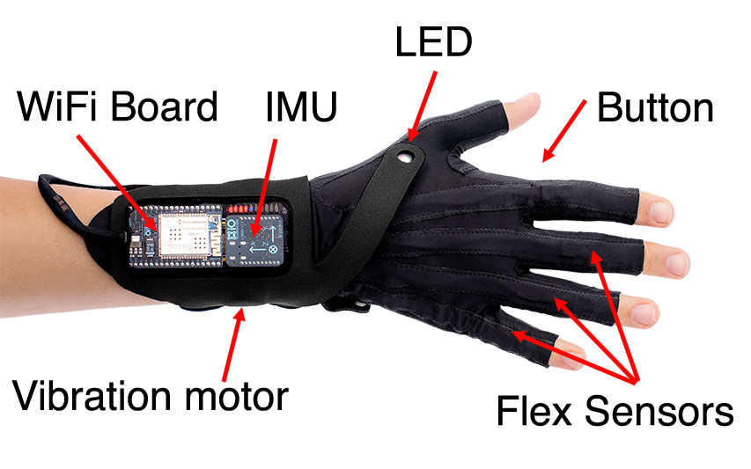
Figure 1: The Glove

The Gloves
The NIME used in this study was a pair of data gloves (Fig. 1) and their dedicated action–sound mapping software (Fig. 2) (T. Mitchell and Heap 2011; T. J. Mitchell, Madgwick, and Heap 2012). The gloves incorporate an array of sensors to detect the orientation (Inertial Measurement Unit on the wrist), flex, and posture (flex sensors down each finger) of a wearer’s hands, which are presented as gestural input parameters in the mapping software. The gloves include a button, placed on the side of the index finger and operated by the thumb, a vibration motor on the wrist and a programmable LED for haptic and visual feedback respectively.
The input parameters from the gloves belong to one of three categories:
- Movements. Continuously streaming parameters such as the pitch, yaw and roll of the hand or the joint angles of the fingers.
- Qualifiers. Parameters that have a binary state behaviour: they can either be occurring or not, such as hand postures (it is either a fist or not-a-fist) or the button press.
- Events. Parameters that represent one-shot trigger controls, usually derived from peaks in sensor readings, such as ‘drum hit’ or ‘wrist flick’.
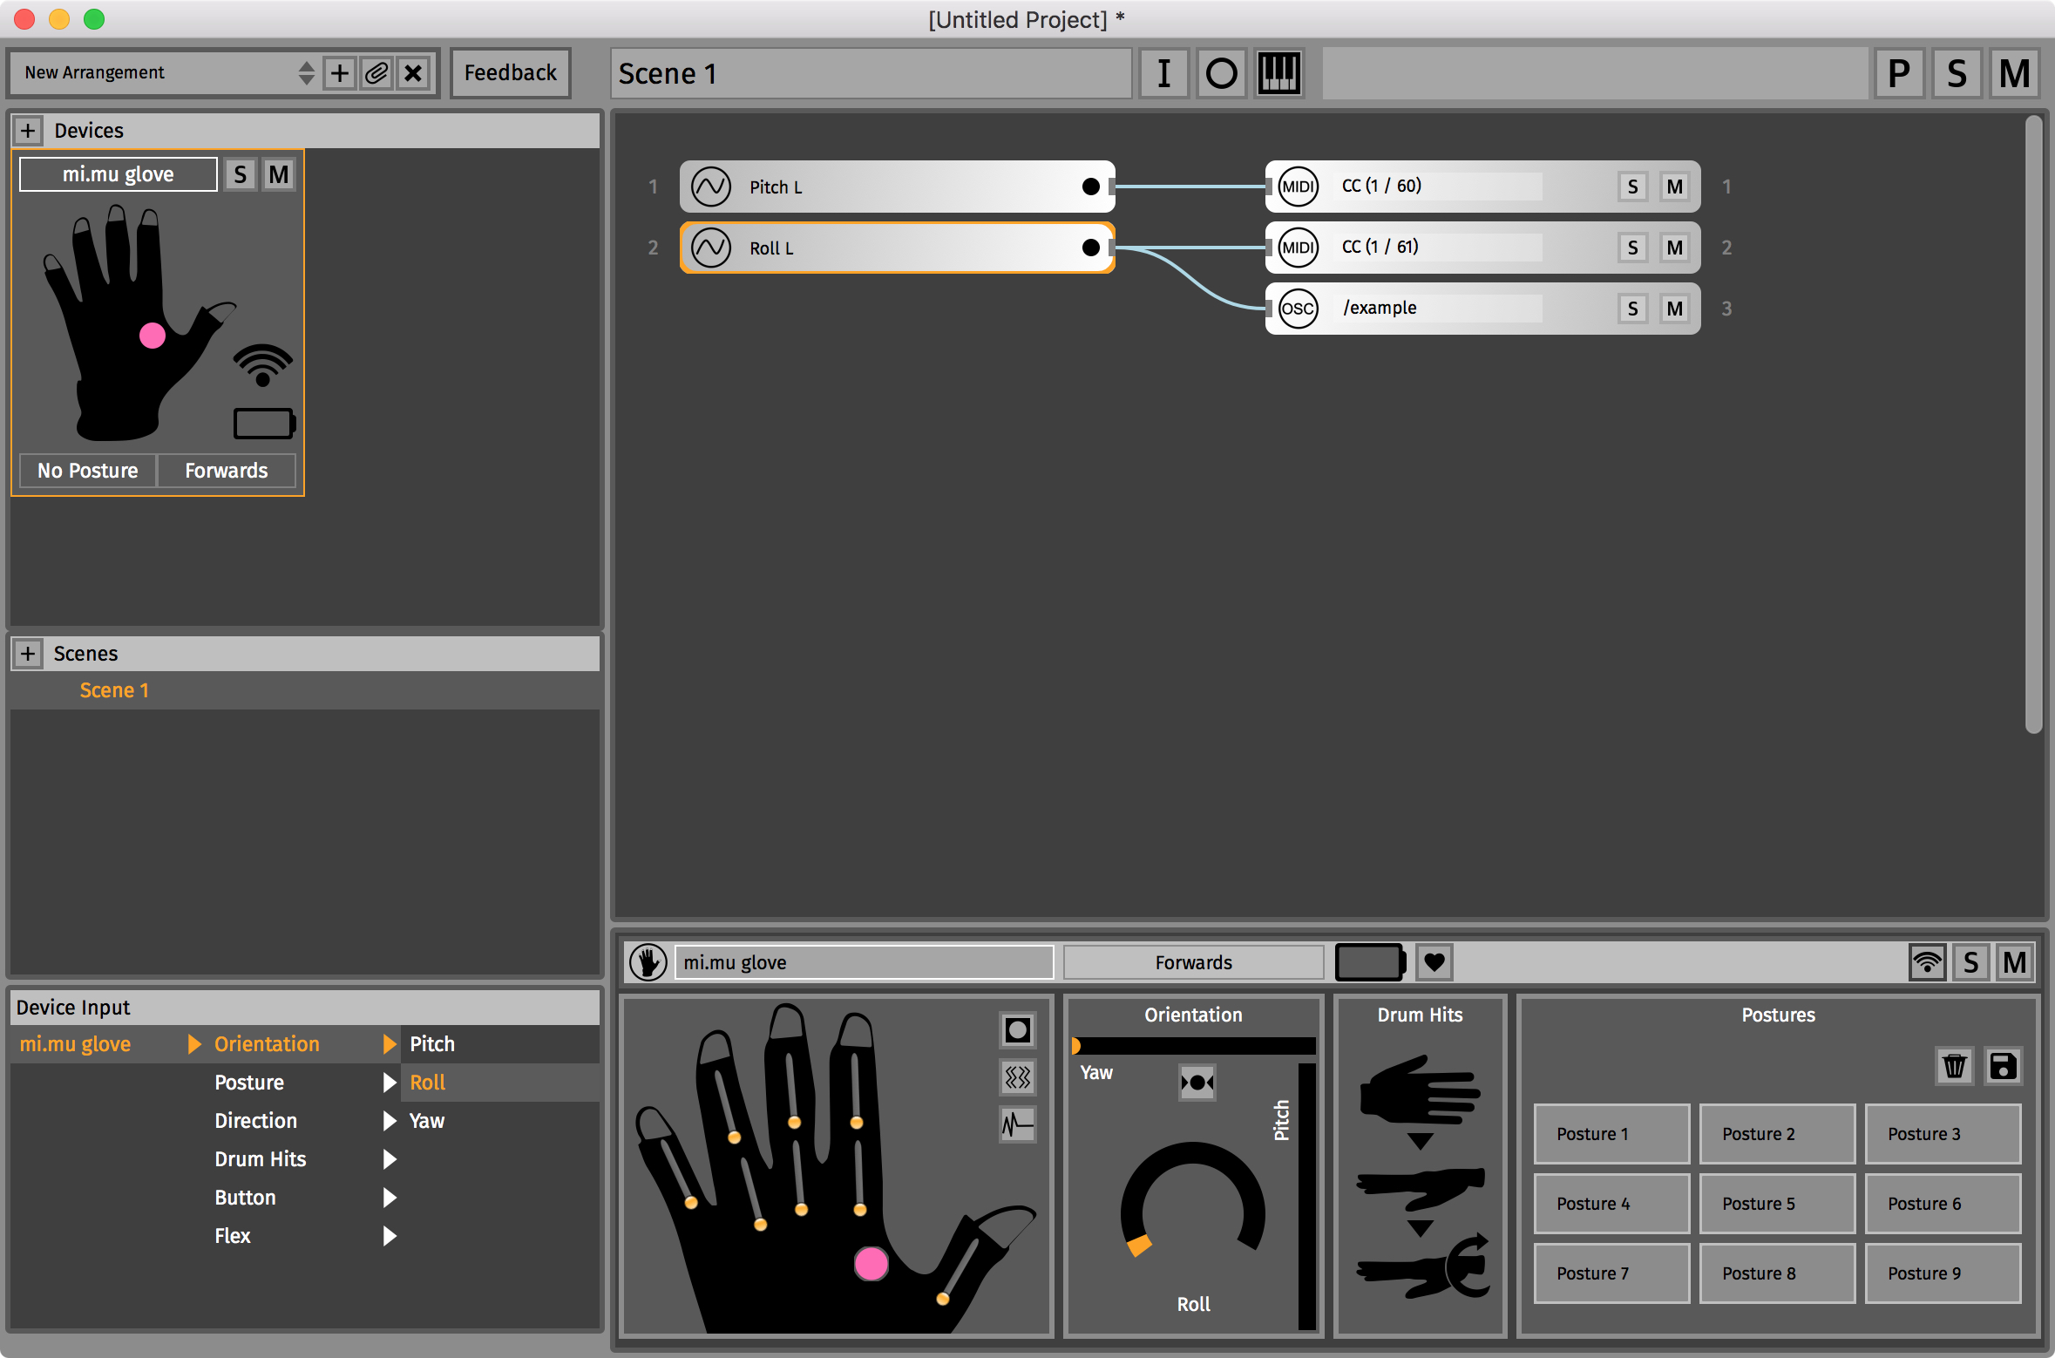
Figure 2: The glove's dedicated action-sound mapping software

Gestural parameters for the gloves are presented in the mapping software organised in the following categories.
- Orientation (Movements). The pitch, yaw and roll of the hand.
- Flex (Movements). The individual flex values of the finger bend sensors.
- Directions (Qualifiers). Directions in which the hand can be pointed (directional lobes): up, down, left, right, forwards, backwards.
- Postures (Qualifiers). Classified from the finger flex sensors using a machine-learning algorithm, trained by the user.
- Button (Qualifiers). Indicating when the button is pressed or released.
- Drum Hits (Events). Rotational peaks on the hand’s three axes: slap, wrist flick and drum hit.
The software employs a machine learning classification algorithm to identify patterns the finger flex sensor data as hand postures, with users able to train the software their own custom posture classes.
The mapping software allows users to connect the gestural parameters to musical MIDI data. The interface uses a patch-cord metaphor (Fig. 3) similar to visual programming languages like Max/MSP or PureData. It also incorporates two mapping ‘instruments’, designed to facilitate and simplify common mapping tasks:
- Chord Machine. This allows users to easily map gestural qualifiers to multiple notes on a piano keyboard interface (Fig. 4a).
- Note Matrix. This splits a given movement parameter into a series of thresholds, which, when crossed, trigger notes (Fig. 4b).
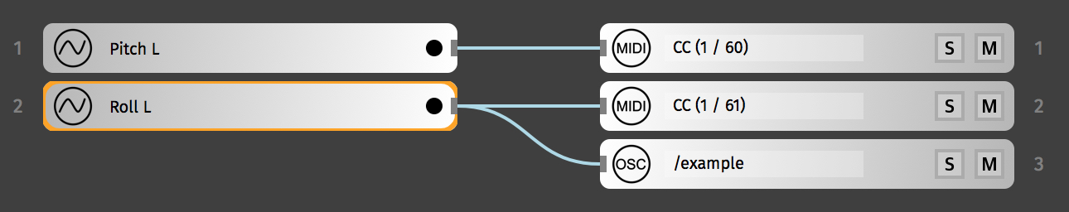
Figure 3: Examples of the patch-cord mapping metaphor

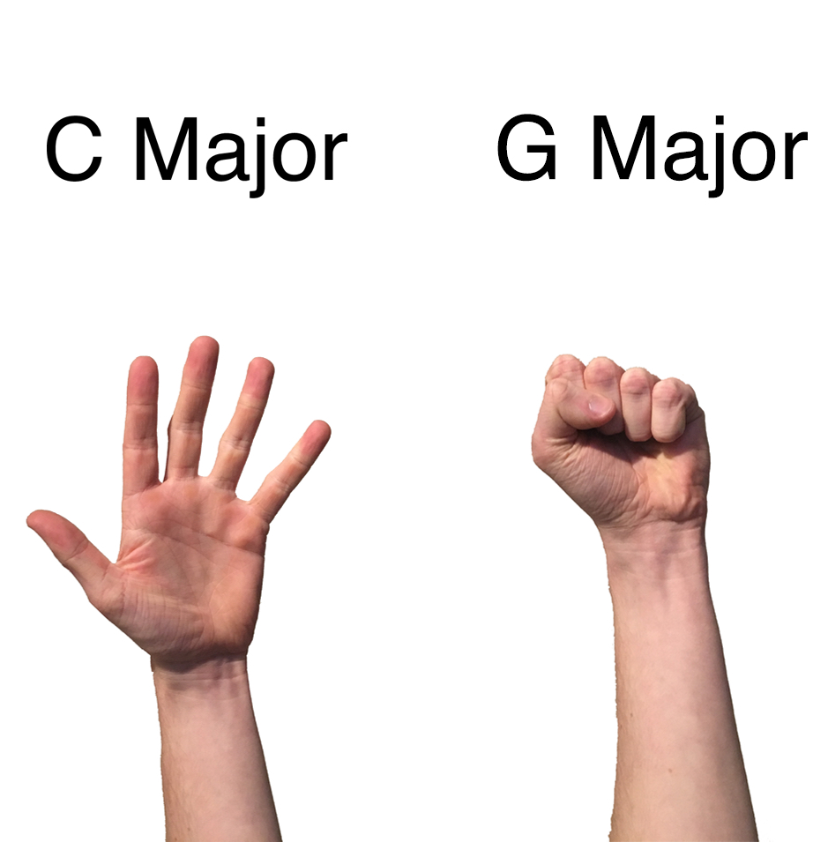 | 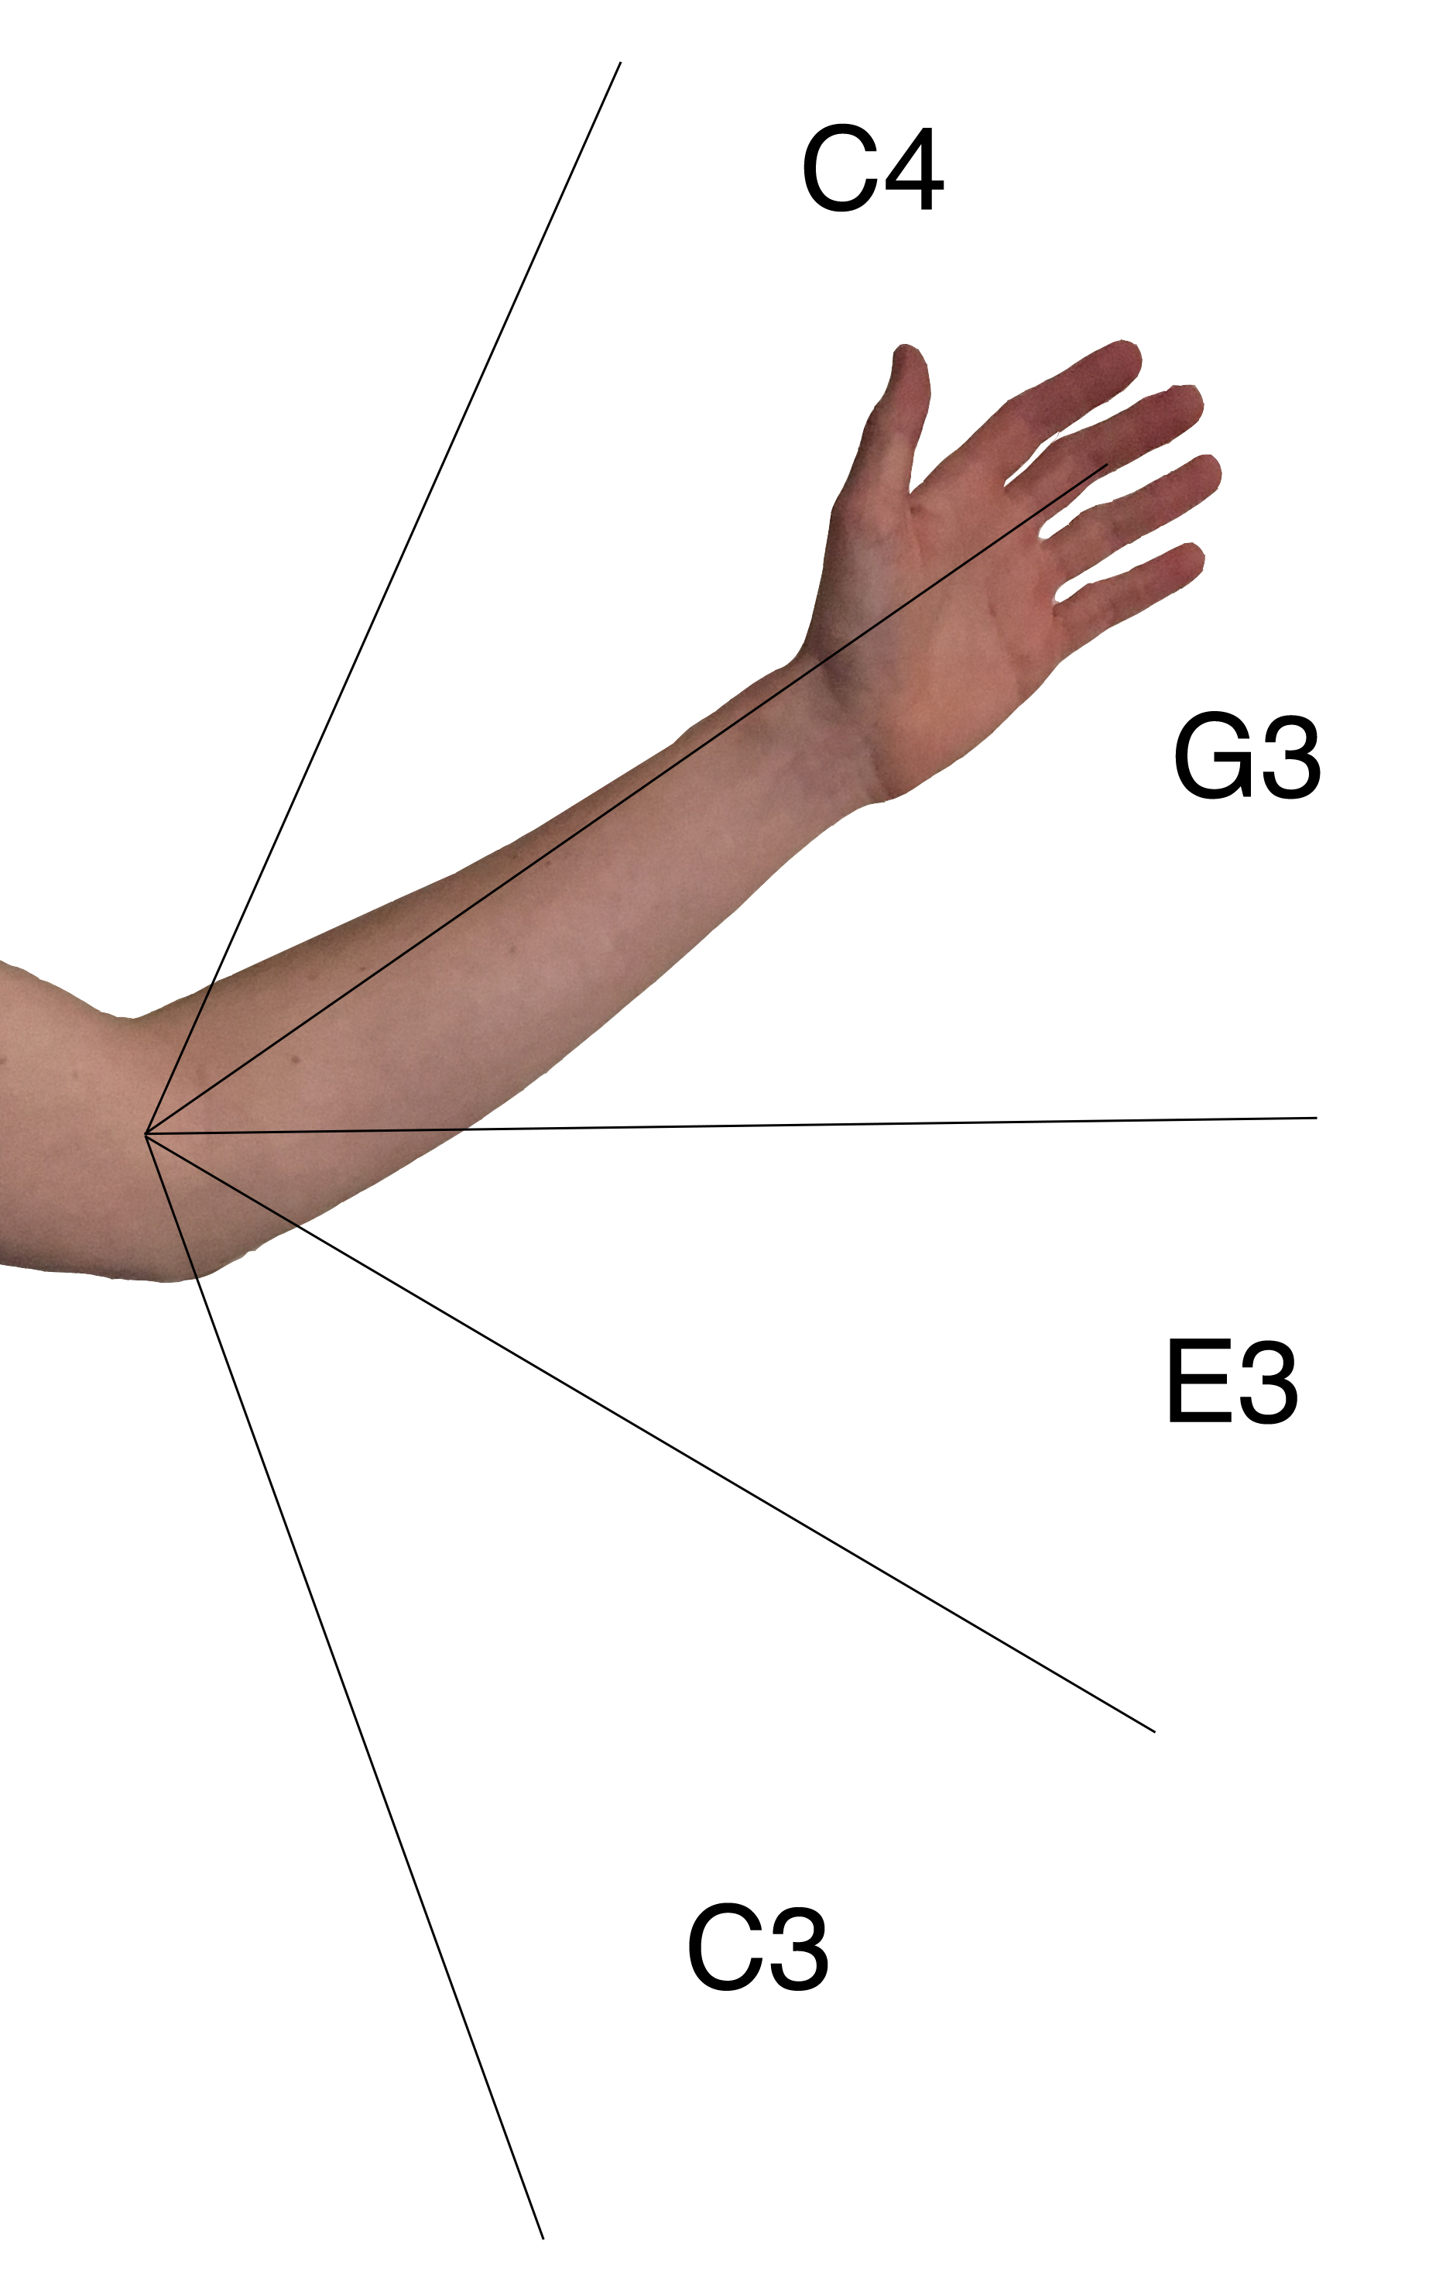

Figure 4: (left) Example Chord Machine mapping: ‘Open Hand’ posture to C major, ‘Fist’ posture to G major. (right) Example Note Matrix mapping: Pitch parameter mapped to a C major chord.

The gloves project began with a single user (and co-creator) Imogen Heap in 2011. Since then, an international community of more than 30 practitioners has grown around the project. Although there is no official pedagogy, established techniques and practices have emerged organically through collaboration (Fig. 5) and the process of introducing and demonstrating the technology to new practitioners. These techniques have their foundations in the early practice of Heap, such as the four postures that are considered as defaults in the posture recognition feature: fist, open hand, puppet hand and one finger point (Fig. 6).
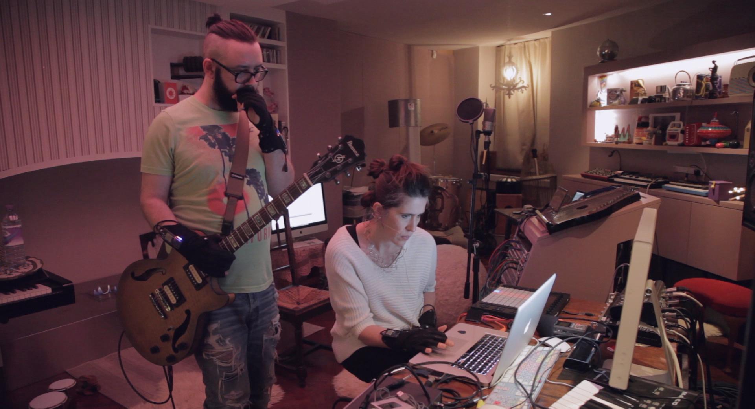
Figure 5: Kris Halpin and Imogen Heap collaborating. Photograph by Lee Cogswell, courtesy of Kris Halpin.
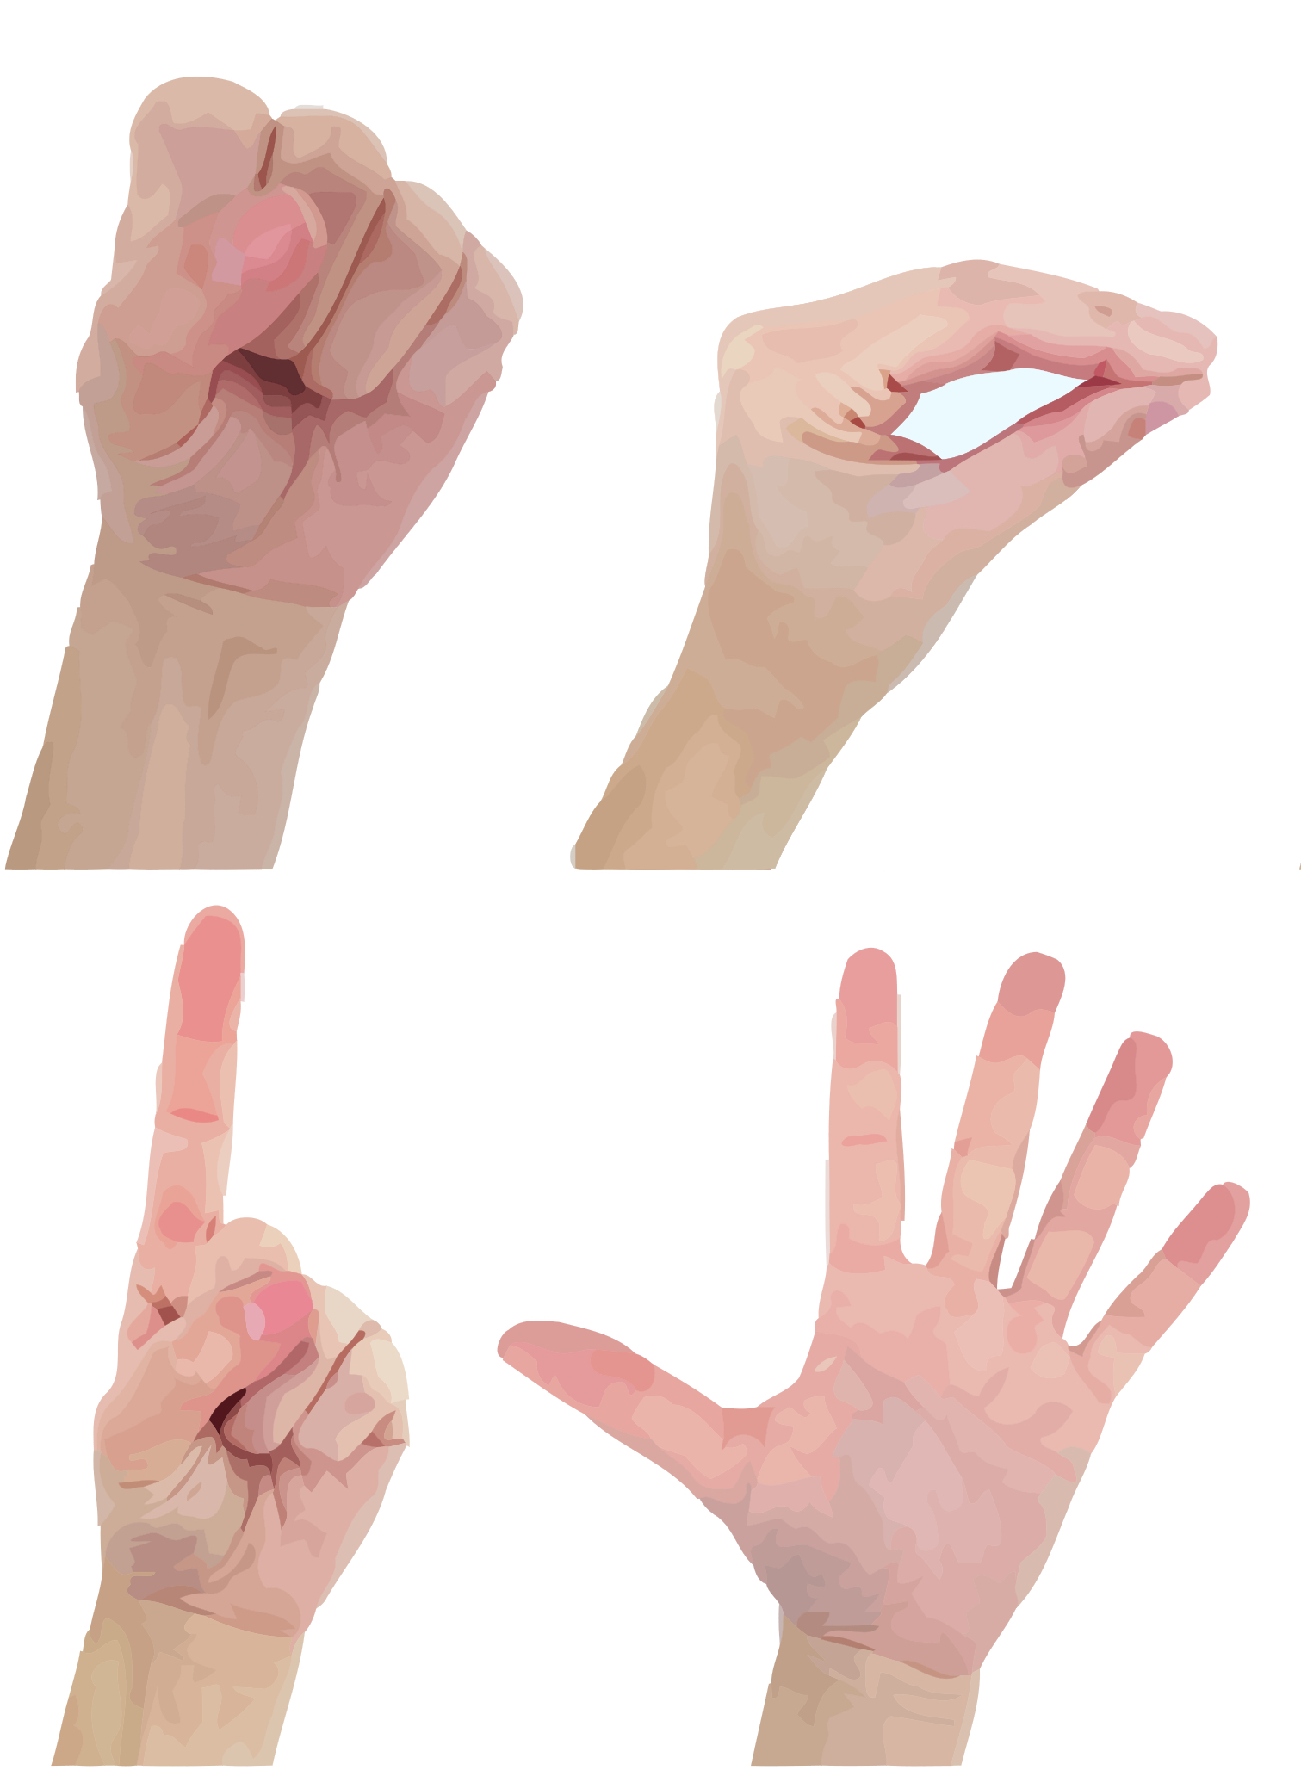
Figure 6: The default postures (clockwise from top left): Fist, Puppet Hand, One Finger Point, Open Hand.

Glove practitioners have used the gloves to perform electronic music in national and international tours, as well as at events such as TED, Ableton Loop and Sonar (Figs. 7 & 8). This community, although small, represents a rare resource in the NIME field, and one apt for studying to gain insights into the musical practice of experienced NIME practitioners.

Figure 7: Chagall performing with the gloves. Photograph by Ben Houdijk, courtesy of Chagall Van Den Berg.

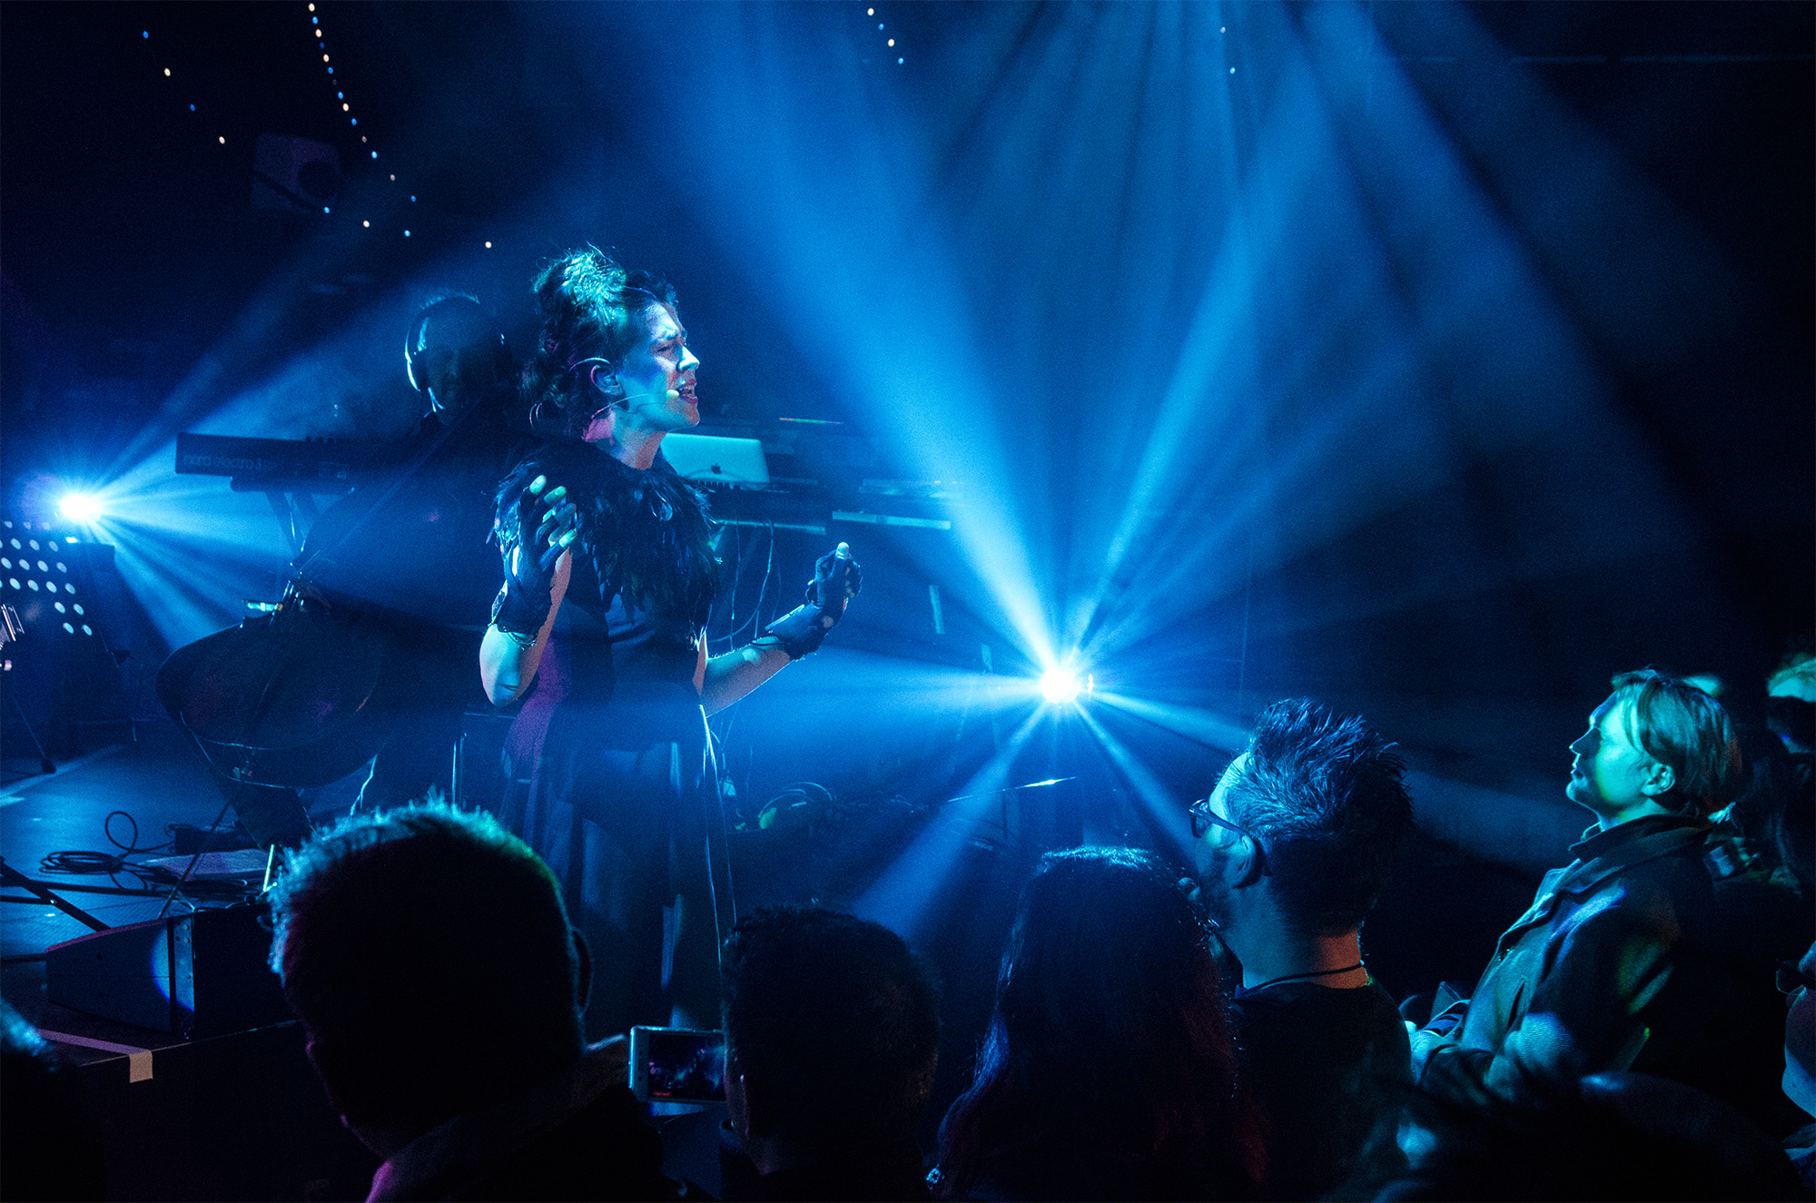
Figure 8: Imogen Heap performing with the gloves. Photograph by Tadej Vindis, courtesy of Imogen Heap.
Method
The method used to examine the musical practice of glove musicians was Grounded Theory (Glaser and Anselm 1967). Four experienced glove musicians took part in an unstructured interview focussing on the factors that affect their mapping design and the use of the gloves in their musical practice. The interview data was concurrently collected and analysed to facilitate theoretical sampling. The four musicians approached were those whose professional practice with the gloves includes live performances for large audiences.
Qualitative research is highly dependent on the interpretations and perspective of the researcher (Elliott, Fischer, and Rennie 1999). The lead researcher is not a practising Glove musician, but does possess intimate knowledge of the associated systems and software, having conducted research on the project for two years. The analysis builds on an understanding of embodied interaction (Dourish 2004), where knowledge is considered to be built from an individuals’ personal bodily experiences in the world. This position has been influenced by HCI and NIME literature, in which embodiment is a common epistemological position (Dourish 2004; Kaye 2009; van Dijk and Hummels 2017; Leman 2008; Cox 2016).

Participants
The four experienced participants have all been using the gloves in their professional performance practice for several years, each performing at national and international tours and events. The group are a strong community, and each musician is well known to the others. They also meet regularly (every six to twelve months) to share their work and provide each other with support and feedback. Throughout the interviews, the musicians referred to each other’s work, so each musician has been assigned a letter: A, B, C and D. In addition to occasional performances with the gloves, Musician C works extensively as a facilitator, designing and developing mappings for others’ performances.
All four musicians have been tied to the development of the gloves and its software to varying degrees, providing at times significant design input and feedback, as well as suggesting and designing mapping features such as the chord machine and note matrix instruments.

Results
Simple Mappings
The musicians were found to use simple, one-to-one and few-to-one mappings that minimise the potential for performer-related errors. Often referred to by the musicians as ‘practical’ mappings, they provide the musicians with control over their musical content that can be mastered with little effort. For instance, Musician A routinely uses combinations of open hand and fist postures, coupled with the directional lobes of movement to quickly facilitate auditory feedback.
‘...practical, make it work quickly, use the different directions and opposite postures so fist and open hand or something... that’s like the quickest way to do a lot of different things.’ – Musician A.
Simple mappings are also used due to the pressures of performing in front of large audiences, where they are used to minimise performer error.
‘I had to figure out a way of mapping everything that I was going to teach them, that was, interesting for people to watch, and then interesting for them to play, but dead simple...it’s not that [name] couldn’t do that if they had the time, they just did not have the time. I literally had 45 minutes to teach them the song and then they performed it in front of 6000 people.’ – Musician C.
Simple mappings are also used to make control relationships obvious to audiences. For instance, Musician B described how they have simplified their mappings as audience members are unable to accurately perceive more complex control relationships. They found there was little point in making mappings overly complex when they could communicate their musical intentions using mappings that are easier to perform.
‘That’s another thing, it’s interesting when tech people think they know how it works, and I’ve had quite a few people think that I’m launching lots of clips, so when I’m doing the violin thing I’m just triggering a sample and then miming to it ... there’s times for having a backup clip that I could launch if I needed to fall back, because sometimes it doesn’t come across, and the audience isn’t part of that conversation, no matter how hard I make it for myself.’ – Musician B.

Expressive Movement
While the musicians use simple excitation mappings, they embellish their excitation movements with theatrical ancillary movement. This ancillary movement has no effect on the sound parameters being controlled, but is used by the musicians to express aesthetic intentions, and to make performances more engaging for their audiences. The incorporation of ancillary movement comes from the performance context of the musicians’ practice, and was often referred to as ‘performance theatrics’. Making their performance movements more visually engaging was a priority for both Musicians A and B, who also discussed their work or desire to work with choreographers.
‘...but also exaggerating certain movements... first of all you’re on a stage so people are looking at you, and before I did anything of the choreography it made me really aware of how I moved on stage and felt not that super comfortable about it, because I’m not a trained dancer and suddenly I had to do movement that I didn’t necessarily like. So thinking more about the choreography and making it more exaggerated and theatrical made me way more confident performing because now at least I knew what I was doing and I was sure it would look cool because we thought about it, you know.’ – Musician A.
This aesthetic consideration in the design of mappings and consequently movement is something that has become more prominent in the musicians’ practice as their Glove performance has developed. Both musicians A and B remarked that in their early mapping practice they would use the ‘next available’ control, and their focus was on creating performable solutions. As their practice with the gloves has developed, they have moved towards considering the visual aesthetics of their performances.
‘There’s a video of me on the day that I came up with it, and I just have one glove and I just go two finger point, fist, two finger point, fist, and just pitch, that’s all, and that works exactly the same way as I do it now but with this and the turning around and putting my hands to the side for no reason’ – Musician A.
‘[T]hings would be quite small, I used to think in terms of […] the next available thing, like if I’m pointing up then I could point forwards.’ – Musician B.
This development reflects the advancement of the musicians’ creative practice, and a move from mapping for functional control to a more abstracted, aesthetically driven approach. Musician A discussed their use of ancillary movements to develop more aesthetically engaging performances. They discuss how in one musical phrase the last gesture has no musical effect, but is performed due to the perceived movement in the music.
‘...there’s one thing that I do that doesn’t trigger a different chord, I do [gestures] this then this, and the two finger point actually doesn’t trigger anything. I don’t know why I do it, but it’s just because in the music it feels like something changes so I feel stupid if I don’t change my posture, but it’s not triggering anything’ – Musician A.
While the musicians’ mappings are simple, the use of theatrical ancillary movement allows them to express their aesthetic intentions and provided engaging performances. Musician C, who believes that something was ‘aesthetically lost’ when mappings were simplified, remarked that Musician A’s use of ancillary gesture added to their performances.
‘Something is aesthetically lost, for sure. That’s why I think it’s so cool what [Musician A] is doing as they’re actually probably doing simple things, but they’re incorporating them into a choreography that makes them seem and look and feel more subtle.’ – Musician C.
Similarly, Musician D remarks how it was the simplicity of Musician B’s performances that provided an engaging performance.
‘When I saw [Musician B] for the first time, they were very specific in the things that they did, and one of the things that really caught me was that I was trying to do too many things, why am I doing so much? I could really par down the pallet and be just as impactful.’ – Musician D.

Metaphors in Mapping
In their expressive movements, the musicians often used visual metaphors of lyrical or musical material. The metaphors would often correlate with established metaphors relating music to spatial properties, such as space being used to conceptualise musical pitch: UP AND DOWN IN PITCH IS UP AND DOWN IN SPACE (Lerdahl 1988; Wilkie, Holland, and Mulholland 2010).
‘This feels to me, terms of pitch, the audience will perceive that the chord does indeed change, it goes down, but it’s not a big change, so you need a bigger gesture to get to the next chord. So, if the interval’s further away you need to make the posture bigger.’ – Musician B.
Other times, gestural metaphors representing lyrical content were used. Musician A designed mappings that reflected the meaning of their lyrics, for example, Musician A used a metaphor of OPENING HANDS IS OPENING EYES.
‘...it’s about my friend waking up from a coma, which actually happened like a year ago, so the chords that I trigger, the first time I trigger the chords I go like this [open hand gesture in front of eyes] because its eye-opening stuff.’ – Musician A
These metaphors aid the musicians in creating visually engaging performances through their simple mapping strategies. Musician D reflected on a performance of Musician B, who incorporated a visual metaphor of RELEASING A FEATHER IS RELEASING A NOTE into a simple mapping.
‘I saw them have five or six chords in a space and it was just a piano sound, and when they opened their hand in a zone it would let out a chord, and it looked like they were letting them off like releasing a feather or something, into the air, and it was so beautiful. I knew that it was just forward, up, left, right but it looked like “I’m going to put it into that wind bit over there, and I’m going to let the feather go over there” and then they were singing with it and it was just really gorgeous.’ – Musician D.
The musicians’ use of metaphor has also developed from being based on the interactions of traditional instruments to more abstract metaphors reflecting the relationship between movement and music (Johnson and Larson 2003; Cox 2016). For instance, Musician B used mappings that used interaction metaphors of existing instruments in their early performances (such as guitars and violins), which afforded both them and their audience transparency (Fels, Gadd, and Mulder 2002). However, they now find this approach to be limiting creatively, and they have moved to thinking more abstractly about how their movements relate to the music itself.
‘I think it would be good to work with a choreographer at some point. For me the mileage had run out [with their previous show]. But it was great for what it was at the time, to go there and play those shows and be like here’s my invisible guitar, here’s my invisible drum kit and whatever, that sets it up as a gestural thing that people can understand. If I started from day one with all this abstract stuff then what is it? Nobody knows, there’s no way in. But that has to evolve. I’m thinking about what is the movement of the music. It’s the first time I’ve gone the other way around and thought “what would it be?”.’ – Musician B.

Accidental Triggering
A hindrance to the musicians use of aesthetic mappings is the prevalence of accidental triggering. For instance, due to the snap-to-nearest-class behaviour of the machine-learning-based posture recogniser, it often mistakes the relaxed hands of the wearer as an ‘open hand’ posture. If the musicians map any controls to an open hand, they can often be triggered unintentionally. The musicians have developed several strategies for dealing with accidental triggering, one being the avoidance of certain controls. For instance, Musician A avoids using ‘open hand’ postures in their mappings, and instead uses another posture they call ‘secret finger’ (Fig. 9), a posture similar but subtly different to an open hand.
‘I do [secret finger] when I don’t want people to pay attention to my posture because it’s almost no posture, and I usually do this one when I kind of want to do it with an open hand but I just need the control.’ – Musician A.

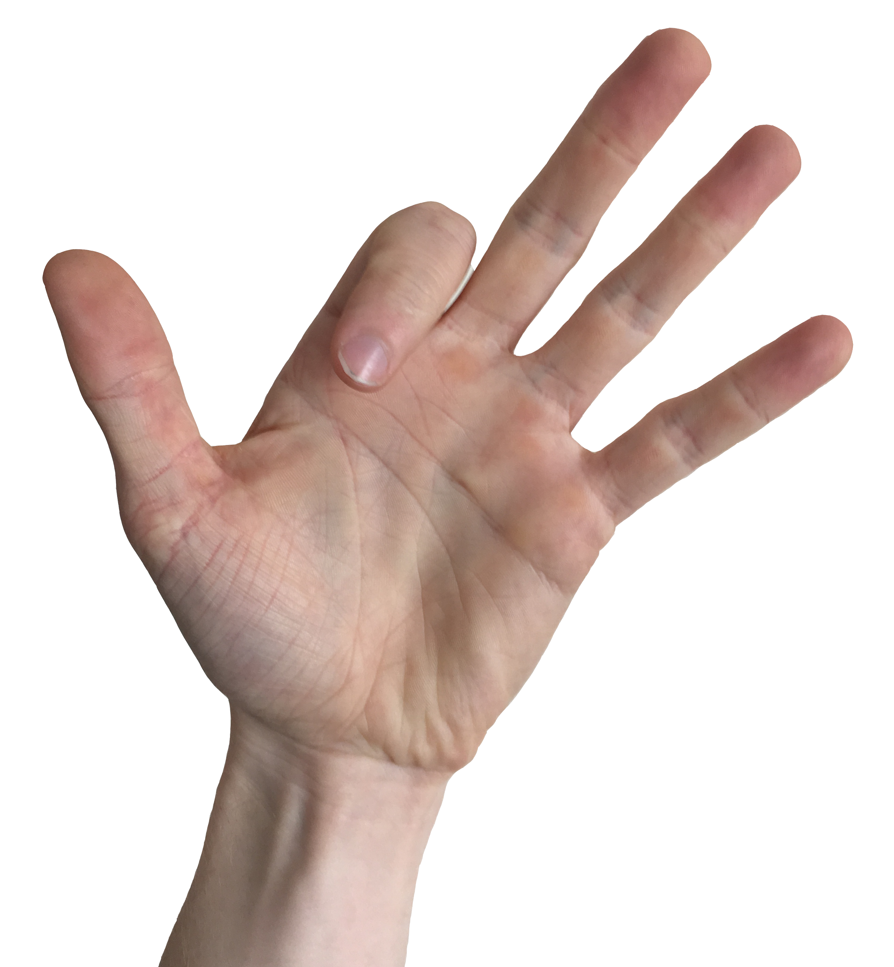
Figure 9: The ‘Secret Finger’ posture.
One strategy that the musicians employ when they wished to use the open hand posture for metaphoric or aesthetic purposes is to use ‘hidden’ controls alongside the open hand posture (with a Boolean AND relationship) to ensure intended control. For instance, Musician B described an instrument using a metaphor of pushing a note between directional lobes. To stop accidental triggering, they use an additional qualifier for each control: the down direction of their other hand. This extra qualifier is considered ‘hidden’ as it does not form part of the performance movement, and the intention is that it goes unnoticed by the audience.
‘When I did the pushing the synth thing there’s a qualifier on the other hand so it’s only active when I’m pointing down.’ – Musician B.
‘So I want to play with open hand, right open hand forwards, which I will map, but that’s going to trigger all the time, so I’m going to have to have a sneaky other thing, like only when my left hand is down or something.’ – Musician A.
Similarly, the name ‘secret finger’, a posture shared by Musician’s A and D, suggests that it is the musicians’ intention that the exact nature of the control is not perceived by the audience. Musician A does use open hand postures when they wish to express a specific aesthetic intent, such as the mapping used to represent a lyric about opening eyes. However, Musician A was acutely aware that this mapping choice is vulnerable to accidental triggering and described how they immediately return to a ‘fist’ posture once the phrase has been performed to minimise risk.
‘I definitely don’t make too much dependent on open hand. In that one with the opening eyes thing I do trigger stuff with open hand but once I’ve done it I immediately go back to fist just to make sure I don’t trigger it again.’ – Musician A.
Reliability in Gestural Controls
The issues with accidental triggering leads to the musicians needing to balance their aesthetic intentions with reliable controls, and influences the way musicians create simple, ‘practical’ mapping strategies. For instance, when Musician A designed mappings that are used to express their aesthetic intentions through metaphors, it is important that the controls not only did this, but could be reliably triggered.
‘I sing “rewired” [gestures bringing hands together] because this is the things that come back together. It works and its practical.’ – Musician A.
This leads to the musicians considering the ‘robustness’ of their mapping choices, which is mostly done when the musicians consider posture controls. The behaviour of the software’s Posture Recognition algorithm causes it to recognise and trigger ‘pass through’ postures: postures that the hand unavoidably ‘passes through’ as it transitions from one posture to another. For example, if a musician is moving from a fist to an open hand posture, if they move in such a way that the index finger starts to extend before the other fingers, the posture recogniser may briefly register a first finger point posture (Fig. 10). This vulnerability causes the musicians to consider the kinematics of their hands and their choice of postures carefully; what they frequently referred to as the ‘robustness’ of their posture choices.
‘Puppet hand isn’t a very stable posture to be doing that with either. It’s not very robust in terms of the likelihood of it happening during other things, you know, when you’re gesticulating, there’s normally a puppet hand in there. You think about hands in a really different way.’ – Musician B.
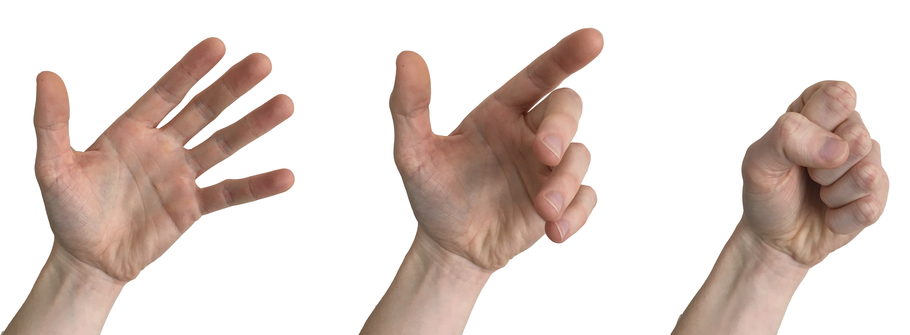
Figure 10: Example of a ‘pass-through’ posture: as the hand moves from ‘Open Hand’ to ‘Fist’, a ‘One Finger Point’ posture is recognised.

While most of the musicians reported that they often change their posture choices to more robust, practical set that minimises these types of errors, Musician C reported that they practise with the posture recogniser to develop the proprioception necessary to master their posture choices. Furthermore, Musician C also added how they can gain reliable control by practising their movements rather changing their posture choices.
‘...and I’ve spent enough time with the software, a lot of time with the software, so I feel like I’ve had a chance and I continually have a chance to build for myself quite subtle and robust posture changes.’ – Musician C.
‘If it’s just me I’ll persevere and I’ll practise and I’ll practise and I’ll practise.’ – Musician C.
This motivation could be due to the nature of Musician C’s personal Glove practice, as they do not perform in front of audiences to the extent that the other musicians do, and therefore they may not have the same motivation to develop mappings that mitigate performance errors.

Personal Aesthetics and Gestural Identity
Mapping design has become a very personal expression of aesthetics for the glove musicians. Enabling musicians to design their own mappings means that choices vary wildly between practitioners.
‘What we’re doing is different enough from each other that we’ve all invented our own standard way of doing things. I inherited a little bit from what we were developing together with [Musician D], but I know [Musician A] does things their way, [Musician B] does things their way, they also inherited things from us, because we taught them initially how to use them, but I’m sure they’ve developed their own workarounds.’ – Musician C.
This lack of shared practice is interesting considering the closeness of the glove community and given that new users are often introduced to the gloves by experienced users demonstrating and sharing elements of their own practice. This suggests that mapping is a very personal creative endeavour for the musicians. For instance, Musician A expressed a reluctance to perform using mappings designed by others, as they saw the design of their mappings as a dimension of their musicianship. Musician C also remarked on the importance of designing one’s own mappings to provide engaging and distinct performances.
‘I feel like playing with the gloves is such an expression of how I see and feel music? So there’s almost no point in copying someone else’s movements or sound–gesture relationships because playing with them is part of the expression, totally, in how you use them.’ – Musician A.
‘I feel like that the ability to spend time with your own mappings, and create your own mappings, is really important for making something that is really engaging visually’ – Musician C.
One exception to the lack of shared mappings is Musician C’s work with a collaborator. The collaborator’s glove musicianship is purely performative, and they do not have the same creative investment in mapping design. The collaborator wanted to perform a cover of Musician D’s material, and expressed a desire to perform it using mappings designed by Musician D.
‘I had kind of figured out how she could start the song, and then [collaborator] decided they wanted to have [Musician D] do it for them’ – Musician C.
While aesthetic mapping practice has become very individual, there has been a development of standard practice around technical aspects of glove mappings, such as using the buttons on the glove to initialise the glove’s orientation parameters, as observed in previous research (Brown, Nash, and Mitchell 2018). As these mappings are related to solving system related issues (for instance, Musician C advocates for a ‘kill all notes’ control on the left-hand button), there is no personal aesthetic investment in the controls, and they are freely shared and copied between musicians.
The desire for personal customisation extends to the hardware interface and the low-level workings of the mapping software. For example, Musician C desires detailed control over the posture training process, such as the ability to remove sensors from the algorithm. In their current practice, Musician C ‘frees’ sensors from the algorithm by providing it with enough varied training examples so that classification result becomes unaffected by the position certain fingers (in this case the thumb).
‘Almost any posture, if I program the postures in a way that the thumb is independent and doesn’t add to the posture, I can move the thumb around.’ – Musician C.
‘I want more degrees of freedom. I want to be able to choose for myself which sensors are the ones that are contributing the postures that can be used as triggers ... if you could say I don’t want that to be in the posture recognition algorithm, because if I move that particular sensor, usually it’s my thumbs, if I move that sensor I don’t want that to mess up my postures, I want to be able to really use my fingers a lot more, in a more nuanced way.’ – Musician C.

Discussion
Traditional mapping literature argues that complex action–sound mapping relationships are needed to facilitate musical expression (Hunt, Wanderley, and Paradis 2003; Rovan et al. 1997; Dobrian and Koppelman 2006). Our findings suggest that glove performers achieve expressive performances using simple one-to-one and few-to-one mappings to minimise the risk of performance error, while embellishing these simple mappings with theatrical ancillary gestures. The musicians use of simple mappings suggests that it is not the complexity of their mappings that facilitates their musical expression, going against the argument that simple mappings lead to musical toys that musicians quickly grow tired of (Hunt, Wanderley, and Paradis 2003). For these musicians, expressive performance can be achieved through simple action–sound mappings that facilitate theatrical movement and their personal ideas and aesthetics of action—sound relationships.
However, the musicians’ ability to express their personal aesthetics is hindered by issues with accidental triggering caused by the snap-to-nearest behaviour of the posture recogniser, with the musicians’ mapping decisions being influenced by the need to consider the robustness of their mapping choices.
An interesting finding in this research is the importance of a musicians’ personal mapping strategies. While it might be expected that mapping practice would be similar between musicians due to their frequent collaborations and sharing of ideas, this research has found that mapping practice is an incredibly personal endeavour, with glove musicians considering mapping design to be an important aspect of their creative practice. Providing musicians with the ability to define their own ideas around action—sound mapping forms an important part of musical expression with the gloves.
Another point of interest is the desire of some of the musicians to work with choreographers to aid them in developing visually sophisticated and expressive movements. This focus on expressive movements was influenced by the musicians’ aim to provide engaging performances for their audiences, and highlights the importance of the performer-audience relationship in mapping design; both the minimisation of performer errors and the use of expressive ancillary gesture come from the desire to provide a good performance, and such factors are more important for musicians in the context of live performance than in other domains, such as composition (Fiebrink et al. 2010). This is particularly highlighted by the personal glove practice of Musician C, who does not have the same error minimisation priority of the other musicians, being more willing to spend time mastering difficult mappings in their personal practice, while in their mapping design for other performers, simplicity and audience engagement remain important factors.
NIME mapping design literature advocates for the use of metaphors in mapping design to facilitate both musician and audience engagement (Fels, Gadd, and Mulder 2002; Hunt, Wanderley, and Paradis 2003). The Glove musicians used metaphors in their mapping design, mainly using metaphors in their ancillary gestures to communicate meaning, for example musician A’s “opening eyes” metaphor. This again was mainly influenced by wanting to provide engaging performances.
The focus on end-user mapping in the context of professional performance reveals mapping design influences that might not be apparent in laboratory-based studies (Caramiaux et al. 2014; Françoise 2013), which find the importance of designing mappings with embodied metaphors, but do not touch upon factors raised in this study around reliability, an important aspect of mapping design for these musicians as they are aware that their mappings are being designed for a live performance.

Conclusion
Through investigating the mapping practice of four experienced musicians who employ end-user mapping in their performance practice, this research has discovered a series of factors that influence their mapping design for music performance. Primarily, the musicians focus on creating simple mappings that reduce the possibility of performer error, focussing on developing expressive, performative ancillary movement, with the underlying aim of these factors being the desire to provide engaging performances for their audiences.
By studying the creative mapping practice of experienced mid-air musicians, an understudied group of NIME practitioners (McPherson and Kim 2012), this research contributes novel insights into expressive NIME mapping design. The findings from this research have informed the following heuristics that can be applied in the design of future NIMEs.
- NIMEs can use simple action–sound mappings to create engaging performances. This research has found that experienced musicians can use simple mapping solutions while providing engaging performances through expressive movement.
- NIMEs should allow end-users to express their personal action–sound aesthetics. This research has found that it is important for NIME mappings to reflect a musician’s personal interpretations and aesthetics of music and movement, and that the mapping design process is an important part of creativity with the gloves. Therefore, NIMEs instruments that permit end-user customisation and mapping personalisation empower musicians to express their own personalised action–sound relationships.
- NIME mapping should use metaphors of music to provide engaging instruments. This research has found that experienced musicians use metaphors in their mapping design to communicate aesthetic intent and to provide engaging performances. The use of metaphor has been advocated in the design of music interaction (Wessel and Wright 2002; Fels, Gadd, and Mulder 2002), which this research supports.
- NIME mappings should mitigate the potential for accidental triggering. This research has found that a major barrier in the musicians’ practice is accidental triggering. The behaviour of the posture recogniser and occurrence of ‘pass-through’ postures force the musicians to move away from expressing their personal aesthetics and focus on the ‘robustness’ of their posture choices. NIMEs could minimise accidental triggering through excitation controls that avoid the need for performers to pass through other body states that trigger excitation controls, and through avoiding controls that rely on gestures that are similar to a musician’s relaxed body state.

Themes emerging from this study suggest directions for future research. The musicians spoke of how their mapping practice has developed over the time with the gloves, such as their move away from functional mappings to theatrical, aesthetic mappings. Tracking the development of mapping practice over a longitudinal study could provide insights into this process. As well as this, future work could examine the extent to which accidental triggering or system related issues affect a performer’s experience with the gloves.
Acknowledgements
This work is supported by the University of the West of England, The Higher Education Innovation Fund (Research England), Innovate UK and European Commission. We thank our anonymous reviewers and study participants for their insightful feedback along with the those involved in the Mimu gloves project: Imogen Heap, Kelly Snook, Seb Madgwick, Hannah Perner-Wilson, Adam Stark, Rachel Freire, Chagall Van Den Berg, Kris Halpin, the gloves collaborators and many others who have helped along the way.

References
Bin, S Astrid, Nick Bryan-Kinns, and Andrew P McPherson. 2016. “Skip the Pre-Concert Demo: How Technical Familiarity and Musical Style Affect Audience Response.” In Proceedings of New Interfaces for Musical Expression (NIME) 2016, 200–205. Brisbane, Australia.
Birringer, Johannes, and Michãšle Danjoux. 2009. “Wearable Performance.” Digital Creativity 20 (1–2): 95–113. https://doi.org/10.1080/14626260902868095.
Blackwell, Alan F. 2006. “The Reification of Metaphor as a Design Tool.” ACM Transactions on Computer-Human Interaction (TOCHI) 13 (4): 490–530.
Bødker, Susanne. 2015. “Third-Wave HCI, 10 Years Later—participation and Sharing.” Interactions 22 (5): 24–31. https://doi.org/10.1145/2804405.
Brown, Dom, Chris Nash, and Tom Mitchell. 2017. “A User Experience Review of Music Interaction Evaluations.” In Proceedings of New Interfaces for Musical Expression (NIME) 2017. Copenhagen, Denmark.
———. 2018. “Understanding User-Defined Mapping Design for Mid-Air Musical Performance.” In Proceedings of the 5th International Conference on Movement and Computing (MOCO). Genoa, Italy: ACM.
Caramiaux, Baptiste, Jules Françoise, Norbert Schnell, and Frédéric Bevilacqua. 2014. “Mapping Through Listening.” Computer Music Journal 38 (3): 34–48.
Cienki, Alan, and Cornelia Müller. 2008. “Metaphor, Gesture, and Thought.” The Cambridge Handbook of Metaphor and Thought, 483–501.
Collins, David. 2007. “Real-Time Tracking of the Creative Music Composition Process.” Digital Creativity 18 (4): 239–256.
Cox, Arnie. 2016. Music and Embodied Cognition. Bloomington, IN, USA: Indiana University Press.
Di Donato, Baladino. 2017. MyoMapper. http://www.balandinodidonato.com/myomapper/.
Dijk, Jelle van, and Caroline Hummels. 2017. “Designing for Embodied Being-in-the-World: Two Cases, Seven Principles and One Framework.” In Proceedings of the Eleventh International Conference on Tangible, Embedded, and Embodied Interaction, 47–56. TEI ’17. New York, NY, USA: ACM. https://doi.org/10.1145/3024969.3025007.
Dobrian, and Daniel Koppelman. 2006. “The `E’ in NIME: Musical Expression with New Computer Interfaces.” In Proceedings of New Interfaces for Musical Expression (NIME) 2006. Paris, France.
Dourish, Paul. 2004. Where the Action Is: The Foundations of Embodied Interaction. MIT Press.
Eldridge, Alice, and Chris Kiefer. 2017. “The Self-Resonating Feedback Cello: Interfacing Gestural and Generative Processes in Improvised Performance.” In Proceedings of New Interfaces for Musical Expression (NIME) 2017, 2017:25–29. Copenhagen, Denmark: Aalborg University Copenhagen. http://sro.sussex.ac.uk/68252/.
Elliott, Robert, Constance T Fischer, and David L Rennie. 1999. “Evolving Guidelines for Publication of Qualitative Research Studies in Psychology and Related Fields.” British Journal of Clinical Psychology 38 (3): 215–229.
Fels, Sidney, Ashley Gadd, and Axel Mulder. 2002. “Mapping Transparency Through Metaphor: Towards More Expressive Musical Instruments.” Organised Sound 7 (2): 109–126.
Fiebrink, Rebecca, Dan Trueman, and Perry R Cook. 2009. “A Meta-Instrument for Interactive, On-the-Fly Machine Learning.” In Proceedings of New Interfaces for Musical Expression (NIME) 2009, 280–285. Pittsburgh, PA, USA.
Fiebrink, Rebecca, Daniel Trueman, N Cameron Britt, Michelle Nagai, Konrad Kaczmarek, Michael Early, MR Daniel, Anne Hege, and Perry R Cook. 2010. “Toward Understanding Human-Computer Interaction In Composing The Instrument.” In Proceedings of the International Computer Music Conference (ICMC) 2010. New York, NY, USA.
Fischer, Gerhard, and Andreas Girgensohn. 1990. “End-User Modifiability in Design Environments.” In Proceedings of the SIGCHI Conference on Human Factors in Computing Systems 1990, 183–192. Seattle, WA, USA: ACM.
Françoise, Jules. 2013. “Gesture–sound Mapping by Demonstration in Interactive Music Systems.” In Proceedings of the 21st ACM International Conference on Multimedia, 1051–1054. Barcelona, Spain: ACM.
Francoise, Jules. 2015. “Motion-Sound Mapping By Demonstration.” PhD, McGill University.
Gelineck, Steven, and Stefania Serafin. 2012. “Longitudinal Evaluation of the Integration of Digital Musical Instruments into Existing Compositional Work Processes.” Journal of New Music Research 41 (3): 259–276.
Glaser, Barney G., and L. Strauss Anselm. 1967. The Discovery of Grounded Theory: Strategies for Qualitative Research. Hawthorne, NY, USA: Aldine Publishing Company.
Goudeseune, Camille. 2002. “Interpolated Mappings for Musical Instruments.” Organised Sound 7 (2): 85–96.
Gurevich, Michael, and Jeffrey Treviño. 2007. “Expression and Its Discontents: Toward an Ecology of Musical Creation.” In Proceedings of New Interfaces for Musical Expression (NIME) 2007, 106–111. New York, NY, USA: ACM.
Harrison, Jacob, and Andrew McPherson. 2017. “An Adapted Bass Guitar for One-Handed Playing.” In Proceedings of New Interfaces for Musical Expression (NIME) 2017, 507–508. Copenhagen, Denmark: Aalborg University Copenhagen. http://www.nime.org/proceedings/2017/ nime2017_paper0102.pdf.
Hofmann, Alex, Bernt Isak Waerstad, Saranya Balasubramanian, and Kristoffer E. Koch. 2017. “From Interface Design to the Software Instrument - Mapping as an Approach to FX-Instrument Building.” In Proceedings of New Interfaces for Musical Expression (NIME) 2017, 133–138. Copenhagen, Denmark: Aalborg University Copenhagen.
Hunt, Andy, and Ross Kirk. 2000. “Mapping Strategies for Musical Performance.” Trends in Gestural Control of Music 21: 231–258.
Hunt, Andy, Marcelo M Wanderley, and Matthew Paradis. 2003. “The Importance of Parameter Mapping in Electronic Instrument Design.” Journal of New Music Research 32 (4): 429–440.
Jaasma, Philemonne, Dorothé Smit, Jelle van Dijk, Thomas Latcham, Ambra Trotto, and Caroline Hummels. 2017. “The Blue Studio: Designing an Interactive Environment for Embodied Multi-Stakeholder Ideation Processes.” In Proceedings of the Eleventh International Conference on Tangible, Embedded, and Embodied Interaction, 1–10. TEI ’17. New York, NY, USA: ACM. https://doi.org/10.1145/3024969.3025002.
Jack, Robert H, Tony Stockman, and Andrew McPherson. 2017. “Rich Gesture, Reduced Control: The Influence of Constrained Mappings on Performance Technique.” In Proceedings of the 4th International Conference on Movement Computing. London, UK: ACM.
Johnson, Mark, and Steve Larson. 2003. “‘Something in the Way She Moves’ – Metaphors of Musical Motion.” Metaphor and Symbol 18 (2): 63–84.
Johnston, Andrew. 2009. “Interfaces for Musical Expression Based on Simulated Physical Models.” PhD Thesis, University of Technology, Sydney.
Kaye, Joseph Nathaniel. 2009. “The Epistemology & Evaluation of Experience-Focused Hci.” PhD Thesis, Cornell University.
Kiefer, Chris, Nick Collins, and Geraldine Fitzpatrick. 2008. “HCI Methodology For Evaluating Musical Controllers: A Case Study.” In Proceedings of New Interfaces for Musical Expression (NIME) 2008, 87–90. Genova, Italy.
Klipfel, Kristofer. 2017. “MIDI Motion: Interactive Music Composition Gloves.” In Proceedings of the Eleventh International Conference on Tangible, Embedded, and Embodied Interaction, 757–760. TEI ’17. New York, NY, USA: ACM. https://doi.org/10.1145/3024969.3035535.
Kuutti, Kari, and Liam J Bannon. 2014. “The Turn to Practice in HCI: Towards a Research Agenda.” In Proceedings of the 32nd Annual ACM Conference on Human Factors in Computing Systems, 3543–3552. Toronto, ON, Canada: ACM.
Lakoff, George, and Mark Johnson. 1980. Metaphors We Live by. University of Chicago Press.
Leman, Marc. 2008. Embodied Music Cognition and Mediation Technology. Cambridge, MA, USA: MIT Press.
Lerdahl, Fred. 1988. “Tonal Pitch Space.” Music Perception: An Interdisciplinary Journal 5 (3): 315–349.
Mackenzie, I. Scott. 2013. Human Computer Interaction: An Empirical Research Perspective. Edited by Meg Dunkerley and Heather Scherer. Waltham, MA, USA: Morgan Kaufmann.
Mainsbridge, Mary. 2018. “Gesture-Controlled Musical Performance: From Movement Awareness to Mastery.” International Journal of Performance Arts and Digital Media, 1–18.
Malloch, Joseph, Stephen Sinclair, and Marcelo M Wanderley. 2007. “From Controller to Sound: Tools for Collaborative Development of Digital Musical Instruments.” In Proceedings of the International Computer Music Conference (ICMC) 2007. Copenhagen, Denmark.
McPherson, Andrew P, Adrian Gierakowski, and Adam M Stark. 2013. “The Space between the Notes: Adding Expressive Pitch Control to the Piano Keyboard.” In Proceedings of the SIGCHI Conference on Human Factors in Computing Systems, 2195–2204. Paris, France: ACM.
McPherson, Andrew P, Robert H Jack, and Giulio Moro. 2016. “Action-Sound Latency: Are Our Tools Fast Enough?” In Proceedings of New Interfaces for Musical Expression (NIME) 2016. Brisbane, Australia: Griffith University.
McPherson, Andrew P, and Youngmoo E Kim. 2012. “The Problem of the Second Performer: Building a Community around an Augmented Piano.” Computer Music Journal 36 (4): 10–27.
Merleau-Ponty, Maurice. 2013. Phenomenology of Perception. Routledge.
Mitchell, T. J., S. Madgwick, and I. Heap. 2012. “Musical Interaction with Hand Posture and Orientation: A Toolbox of Gestural Control Mechanisms.” In Proceedings of New Interfaces for Musical Expression (NIME) 2012. Ann Arbor, MI, USA.
Mitchell, Thomas, and Imogen Heap. 2011. “SoundGrasp: A Gestural Interface for the Performance of Live Music.” In Proceedings of New Interfaces for Musical Expression (NIME) 2011. Oslo, Norway.
Momeni, Ali, and Cyrille Henry. 2006. “Dynamic Independent Mapping Layers for Concurrent Control of Audio and Video Synthesis.” Computer Music Journal 30 (1): 49–66.
Morreale, Fabio, Antonella De Angeli, and Sile O’Modhrain. 2014. “Musical Interface Design: An Experience-Oriented Framework.” In Proceedings of New Interfaces for Musical Expression (NIME) 2014, 467–472. London, UK.
Nielsen, Jakob. 1994. “Heuristic Evaluation.” Usability Inspection Methods 17 (1): 25–62.
Otondo, Felipe. 2018. “Using Mobile Sound to Explore Spatial Relationships between Dance and Music Performance.” Digital Creativity, 1–14. https://doi.org/10.1080/14626268.2018.1459731.
Paine, Garth, Ian Stevenson, and Angela Pearce. 2007. “The Thummer Mapping Project (ThuMP).” In Proceedings of New Interfaces for Musical Expression (NIME) 2007, 70–77. New York, NY, USA: ACM.
Pallasmaa, Juhani. 2017. “Embodied and Existential Wisdom in Architecture: The Thinking Hand.” Body & Society 23 (1): 96–111.
Rovan, Joseph Butch, Marcelo M Wanderley, Shlomo Dubnov, and Philippe Depalle. 1997. “Instrumental Gestural Mapping Strategies as Expressivity Determinants in Computer Music Performance.” In Proceedings of Kansei - The Technology of Emotion Workshop 1997, 3–4. Genoa, Italy.
Scurto, Hugo, Frédéric Bevilacqua, and Jules Françoise. 2017. “Shaping and Exploring Interactive Motion-Sound Mappings Using Online Clustering Techniques.” In Proceedings of New Interfaces for Musical Expression (NIME) 2017, 410–415. Copenhagen, Denmark: Aalborg University Copenhagen.
Tahiroglu, Koray, Juan Carlos Vasquez, and Johan Kildal. 2016. “Non-Intrusive Counter-Actions: Maintaining Progressively Engaging Interactions for Music Performance.” In Proceedings of New Interfaces for Musical Expression (NIME) 2016, 444–449. Brisbane, Australia.
Taruskin, Richard. 1995. Text and Act: Essays on Music and Performance. Oxford University Press.
Van Nort, Doug. 2018. “Conducting the in-between: Improvisation and Intersubjective Engagement in Soundpainted Electro-Acoustic Ensemble Performance.” Digital Creativity 29 (1): 68–81. https://doi.org/10.1080/14626268.2018.1423997.
Visi, Federico, Baptiste Caramiaux, Michael Mcloughlin, and Eduardo Miranda. 2017. “A Knowledge-Based, Data-Driven Method for Action-Sound Mapping.” In Proceedings of New Interfaces for Musical Expression (NIME) 2017, 231–236. Copenhagen, Denmark: Aalborg University Copenhagen.
Wanderley, Marcelo Mortensen, and Nicola Orio. 2002. “Evaluation of Input Devices for Musical Expression: Borrowing Tools from HCI.” Computer Music Journal 26 (3): 62–76.
Wessel, David, and Matthew Wright. 2002. “Problems and Prospects for Intimate Musical Control of Computers.” Computer Music Journal 26 (3): 11–22.
Wilkie, Katie, Simon Holland, and Paul Mulholland. 2010. “What Can the Language of Musicians Tell Us about Music Interaction Design?” Computer Music Journal 34 (4): 34–48.
Wilson, Frank R. 1998. The Hand: How Its Use Shapes the Brain, Language, and Human Culture. Pantheon Books New York.

Figure 1. The Gloves
Figure 2. The Gloves’ dedicated action—sound mapping software
Figure 3. Examples of the patch-cord mapping metaphor
Figure 4a. Example Chord Machine mapping: ‘Open Hand’ posture to C major, ‘Fist’ posture to G major
Figure 4b. Example Note Matrix mapping: Pitch parameter mapped to a C major chord

Figure 5. Kris Halpin and Imogen Heap collaborating. Photograph by Lee Cogswell, courtesy of Kris Halpin

Figure 6. The default postures (clockwise from top left): Fist, Puppet Hand, One Finger Point, Open Hand
Figure 7. Chagall performing with the gloves. Photograph by Ben Houdijk, courtesy of Chagall Van Den Berg
Figure 8. Imogen Heap performing with the gloves. Photograph by Tadej Vindis, courtesy of Imogen Heap
Figure 9. The ‘Secret Finger’ posture
Figure 10. Example of a ‘pass-through’ posture: as the hand moves from ‘Open Hand’ to ‘Fist’, a ‘One Finger Point’ posture is recognised

