**Influence of sildenafil on the purinergic components of nerve-mediated and urothelial ATP release from the bladder of normal and spinal cord injured mice**

**Running title:** Sildenafil on detrusor contractile function and ATP release

Basu Chakrabarty1, Hiroki Ito1, Manuela Ximenes1,2, Nobuyuki Nishikawa1, Bahareh Vahabi1,2, Anthony J. Kanai3, Anthony E. Pickering1,4, Marcus J. Drake4,5, Christopher H. Fry1

School of Physiology, Pharmacology, and Neuroscience, University of Bristol, Bristol, UK1, Department of Applied Sciences, University of West England, Bristol, UK2, Departments of Medicine and Pharmacology & Chemical Biology, University of Pittsburgh, Pittsburgh, USA3, Translational Health Sciences, Bristol Medical School, University of Bristol, Bristol, UK4, Bristol Urological Institute, Southmead Hospital, Bristol, UK5

**Author Contributions:** B.C., H.I., B.V., A.K., A.E.P., M.J.D., and C.H.F. contributed to the conception or design of the work. B.C., H.I., M.X., and N.N. acquired the data, B.C., H.I., and C.H.F. analysed the data, and B.C., M.J.D., and C.H.F. interpreted the data. B.C., B.V., A.J.K., M.J.D., and C.H.F. drafted or critically revised the work.

**Competing Interests’ Statement:** None.

**Word count:** 2338 words

**Acknowledgements**

Funding was provided by the United States National Institutes of Health grant NIH R01 DK098361 (Anthony J. Kanai, Marcus J. Drake, Christopher H. Fry, Anthony E. Pickering). We thank Cherrie H. T Kong, Simon M. Bryant and Hanne C. Gadeberg (School of Physiology, Pharmacology, and Neuroscience, University of Bristol) for assistance with acquiring animal tissue, and Jonathan J. Crook (School of Physiology, Pharmacology, and Neuroscience, University of Bristol) for technical assistance.

**Abstract**

**Background and Purpose:** PDE inhibitors such as sildenafil alleviate lower urinary tract symptoms, however a complete understanding of their action on the bladder remains unclear. We are investigating the effects of sildenafil, on post- and pre-ganglionic nerve-mediated contractions of the mouse bladder, and neuronal and urothelial ATP release.

**Experimental Approach:** Bladders were used from young (12 weeks), aged (24 months), and spinal cord transected (SCT), mice, for *in vitro* contractility experiments. An arterially-perfused *in situ* whole mouse model was used to record bladder pressure. Nerve-mediated contractions were generated by electrical field stimulation (EFS) of postganglionic nerve terminals or the pelvic nerve. ATP release during EFS in intact detrusor strips, and during stretch of isolated mucosa strips, was measured using a luciferin-luciferase assay.

**Key Results:** Sildenafil (20 μM) inhibited nerve-mediated contractions in young mice, with an increase in *f*1/2 values in force-frequency relationships, demonstrating a greater effect at low frequencies. Sildenafil reduced the atropine-resistant, purinergic component of nerve-mediated contractions, and suppressed neuronal ATP release upon EFS *in vitro*. Sildenafil reduced the preganglionic pelvic nerve stimulated bladder pressure recordings *in situ*; comparable to *in vitro* experiments. Sildenafil reduced stretch-induced urothelial ATP release. Sildenafil also relaxed nerve-mediated contractions in aged and SCT mice.

**Conclusion and Implications:** Sildenafil has a greater effect on the low-frequency, purinergic-mediated contractions, and suppresses neuronal ATP release. In addition, sildenafil reduces stretch-induced urothelial ATP release. These results demonstrate a novel action of sildenafil to selectively inhibit ATP release from nerve-terminals innervating detrusor smooth muscle and the urothelium.

**Keywords**

Adenosine Triphosphate

Mice

Muscle, Smooth

Neuromuscular Junction

Urinary Bladder

Lower Urinary Tract Symptoms

**Abbreviations**

12-wk, 12 weeks; 24-mo, 24 months; ABMA, α,β-methylene ATP; CCh, carbachol; EFS, electrical field stimulation; IDO, idiopathic bladder overactivity; LUT, lower urinary tract; LUTS, lower urinary tract symptoms; NDO, neurogenic bladder overactivity; NO, nitric oxide; OAB, overactive bladder; PDE5, phosphodiesterase type 5; SCT, spinal cord transection; TTX, tetrodotoxin.

**Bullet point summary**

* Sildenafil alleviates lower urinary tract symptoms, however its action on the bladder is unclear.
* Sildenafil reduces purinergic-mediated contractions, and selectively and completely inhibits neuronal and urothelial ATP release.
* Sildenafil may target pathological pathways associated with enhanced purinergic motor and sensory pathways.

**Introduction**

Lower urinary tract symptoms (LUTS) associated with bladder pathologies, such as overactive bladder (OAB) and neurogenic bladder dysfunction, and also with ageing are highly prevalent and can have a severe effect on the quality of life of patients. Current treatments for LUTS have recognised limitations, including uncertain efficacy and adverse effects. PDE type 5 (PDE5) inhibitors such as sildenafil (Viagra®), which are used to treat erectile dysfunction (Hatzimouratidis et al., 2010) also alleviate LUTS (McVary et al., 2007). The entire lower urinary tract (LUT) expresses PDE5 (Filippi et al., 2007, Fibbi et al., 2010), and studies support the use of PDE5 inhibitors to reduce LUTS, utilising the nitric oxide (NO)/cGMP pathway on several potential targets. These include increasing LUT oxygenation, decreasing afferent nerve activity, negatively regulating proliferation of LUT stroma and LUTS-related inflammation (Gacci et al., 2016). The ability of sildenafil to relax smooth muscle directly has also been described, where sildenafil-induced relaxation of human detrusor strips is significantly decreased using a soluble GC inhibitor to block the formation of cGMP (Oger et al., 2010). However, a complete understanding of their actions on the peripheral control of bladder contractile function remains unclear. In this study, the effects of sildenafil on nerve-mediated contractions of isolated mouse detrusor strips, as well as on *in situ* bladder function were characterised in young-adult, aged and spinal cord injured mice. In particular, the action of sildenafil on ATP-mediated processes was investigated. ATP is co-released along with ACh in parasympathetic endings to detrusor. With human detrusor ATP is a functional transmitter only in overactive pathologies (Bayliss et al., 1999) and so regulation of its release would be a therapeutic target. Moreover, stretch-activated ATP release from the urothelium, proposed to finally activate bladder afferents, is also enhanced in overactive bladder pathologies (Cheng et al., 2014), thus providing a possible cause for urinary urgency. The effect on neuronal and urothelial neurotransmitter release was also investigated. A comprehensive description of how sildenafil reduces contractile function will give insight into the pathology of bladder functional disorders and should suggest potential therapeutic mechanisms of PDE5 inhibitors in their treatment.

**Methods**

*Tissue samples and ethics approval*. All animal care and experimental procedures were in compliance with the University of Bristol Ethics Committee, in accordance with UK legislation under the Animals (Scientific Procedures) Act 1986 Amendment Regulations (SI 2012/3039), and in adherence to ARRIVE guidelines (Kilkenny et al., 2010) and *BJP* checklist for animal experimentation. Young (12 weeks (12-wk)) and aged (24 months (24-mo)) male C56BI/7 mice (Harlan UK Ltd) were used for experiments.

*Spinal cord transection*. 12-wk male mice underwent complete spinal cord transection (SCT) at the T8-T9 level as previously described (Kadekawa et al., 2017, Ikeda et al., 2012, McCarthy et al., 2009). In brief, a laminectomy was performed at the T8-T9 spinal level under sterile surgical conditions. The spinal cord was transected and the cavity cleared to ensure complete transection, the space between cut ends was filled with a haemostatic sponge and muscle layers and overlying skin were closed with sutures. The surgery was performed under ketamine (70 mg/kg, i.p.) and medetomidine (0.5 mg/kg, i.p.) and upon recovery with atipamezole (1.0 mg/kg, i.p.) and buprenorphine (0.03 mg/kg, s.c.). Mice were also treated with ampicillin (0.10 mg/kg, s.c.) twice-daily for five days post-SCT to prevent urinary tract infections. Bladders of SCT mice were emptied by gentle abdominal compression and perineal stimulation twice a day for five days post-SCT. SCT mice were then euthanised with pentobarbital sodium (20-40 mg/mouse) and used for experiments.

*Measurement of contractile function in vitro.* Young (normal and SCT) and aged mice were euthanised by cervical dislocation and the bladder was removed through a midline laparotomy. The whole bladder was bisected and bladder strips from the bladder dome (detrusor with mucosa intact, 4-5 mm length, 1-2 mm width) were tied to a hook and an isometric force transducer in a horizontal trough. Preparations were superfused with Tyrode’s solution at 37°C. Contractures were generated by exposure to carbachol (CCh, 1 μM) or high-K+ (80 mM) Tyrode’s. Contractions generated by electrical field stimulation (EFS; 0.1 ms pulses, 1-40 Hz, 3-s train every 90-s) that were inhibited by tetrodotoxin (TTX, 1 μM). With some preparations TTX-resistant contractions were present, generated by direct muscle stimulation, and were insensitive to atropine and α,β-methylene ATP (ABMA). Sildenafil (20 μM, see Results) was added to the superfusate and the effect on agonist- and nerve-mediated contractions measured. These were subtracted from the EFS contraction, leaving a nerve-mediated contraction. Tension amplitude (mN) was normalised to preparation weight (mN.mg-1). Nerve-mediated amplitude, *T(f)*, plotted as a function of stimulation frequency, *f*, was fitted to equation 1a. The frequency-dependent percentage reduction of force, *R(f)*, by an intervention was fitted to equation 1b. For frequency-dependent ATP release, *ATP(f)*, data were fitted to equation 1c.

$T\left(f\right)=\frac{T_{max}f^{n}}{f_{1/2}^{n}+f^{n}} [$ 1a]; ${R\left(f\right)=R}_{Lf}-\left(\left(\frac{\left(R_{Lf}-R_{Hf}\right){.f}^{m})}{{(f}^{m}+k^{m})}\right)+R_{Hf}\right)$ [1b];

$ATP={ATP}_{b}+\left(\frac{{ATP}_{max}f^{n}}{f_{1/2}^{n}+f^{n}}\right)$ [1c].

Where *T*max is maximum tension at high frequencies, *f*1/2 is the frequency to attain *T*max/2, and *n* is a constant (Pakzad et al., 2016): *R*Lf and *R*Hf are the maximum and minimum force reductions respectively at low and high frequencies, *m* and *k* are constants. *ATP*b is a frequency-independent component of ATP release from detrusor preparations. Data fits were performed with an iterative, least-squares algorithm (KaleidaGraph, v4.5, Synergy software, CA, USA). Drug interventions were delivered via the superfusate, with appropriate vehicle and time controls.

*Measurement of nerve-mediated ATP release in 12-wk normal and SCT mice.* Superfusate samples (100 µl) were taken from a fixed point near the preparation, (two-thirds downstream along the tissue length and 1mm lateral to the horizontally-mounted preparation) and with minimal mechanical disturbance. Samples were taken before EFS and 2-seconds after the initiation of EFS, the nerve-mediated release was taken as the difference in these two values. Samples were stored on ice before assay of released ATP using a luciferin-luciferase assay where the emitted light was proportional to the concentrations of ATP. The complete Sigma ATP assay mix (FLAAM, Sigma-Aldrich, Dorset, UK) was diluted with the supplied assay buffer as per manufacturer’s instructions. Luminescence intensity was read using a luminometer (Glomax 20/20, Promega) and calibrated with an ATP standard on the day of each experiment, with luminescence as a linear function of concentration on a log-log plot over the range of 100 fM to 1 μM. Neuronal ATP release was inhibited by application of 1µM TTX. Appropriate controls were carried out in background solutions using the solvents and chemicals tested. The detection limit of the system was 100 fM ATP.

*Measurement of mucosa ATP release in 12-wk normal mice.* The mucosa was separated from underlying detrusor by blunt dissection, mounted in a similar way to detrusor preparations to an isometric force transducer in the horizontal trough and superfused with Tyrode’s solution, with or without sildenafil (20 μM). The hook was connected to a voltage-activated solenoid that allowed rapid extension (within 1 s) of the tissue by 20% of the original length for 50 s before restoration (within 1 s) to the original length. Samples were taken and assayed, as above, before extension and at various time points upon extension, before and after drug interventions.

*Measurement of nerve-mediated contractile function in situ.* Young mice were administered heparin (50 IU, i.p.), and anaesthetised with isoflurane (2%) until loss of paw withdrawal reflex for the following non-recovery procedure modified from previous studies with an *in situ* arterially-perfused rat (Sadananda et al., 2011) and mouse (Ito et al., 2018, Ito et al., 2019). The brain was removed, and the spinal cord pithed with a blunt wire before arterial perfusion of the preparation. Both ureters were ligated to prevent natural bladder filling, the urethra was clamped, and a catheter was inserted into the bladder lumen to record intravesical pressure and maintain isovolumetric conditions. A glass suction electrode (tip diameter ~100 μm) was used to stimulate the left pelvic nerve once it had been dissected clear of underlying tissue. Nerve-mediated bladder contractions were generated using an isolated stimulator (Digitimer Ltd. UK; 0.1 ms pulses, 1-24 Hz, 3-s train every 90-s) and the pressure amplitude (mmHg) was analysed. Female mice were used due to difficulties in successfully dissecting and stimulating the pelvic nerve in male mice. Nerve-mediated whole bladder pressure amplitude, *P*, as a function of frequency, *f*, was fitted to equation 1a, with peak pressure, *P*, values substituting for tension, *T*, values. Drug interventions were delivered arterially.

*Data and statistical analysis.* Data are mean±SEM and differences between data sets were tested with repeated measures two-way ANOVA followed by a parametric *post hoc* tests; the null hypothesis was rejected at *p*<0.05. *n*-values refer to the number of preparations, one each from separate animals. The data and statistical analysis comply with the recommendation on experimental design and analysis in pharmacology {Curtis, 2015 #57} and adhere to *BJP* guidelines. All statistical analyses were undertaken using GraphPad® Prism 7 (GraphPad Software Inc., CA, United States). The number of repeats in each control and intervention set was based on a power calculation to reject the null hypothesis at p<0.05 and a power of 80%, with variance of data based on previous experience data with these methods.

*Materials.* Tyrode’s solution was composed of (mM): NaCl, 118; NaHCO3, 24; KCl, 4.0; NaH2PO4, 0.4; MgCl2, 1.0; CaCl2, 1.8; glucose, 6.1; Na pyruvate, 5.0; 5%CO2, 95%O2, pH 7.4.

The concentration of all stock solutions was between 1.0 and 10 mM. Sildenafil was dissolved in DMSO. CCh, atropine and ABMA were dissolved in distilled water. Stock solutions were diluted with Tyrode’s solution to the final concentration as indicated. All chemicals were from Sigma-Aldrich, Dorset, UK, except ABMA from Merck Millipore, Watford, UK.

**Results**

*Agonist-induced contractions in isolated detrusor: effect of sildenafil.* The peak force of the CCh (1μM) contracture was significantly reduced by sildenafil at concentrations 1-100 μM. An IC50 value was determined for each preparation, with a mean IC50 value of 5.4 ± 2.2 μM and a residual force of 49.5 ± 4.7% (*n*=8: figure 1A). Sildenafil also reduced high-K+ contracture, with a mean IC50 value of 16.0 ± 9.6 μM and a residual force of 42.3 ± 13.6% (n=8: figure 1B). The vehicle control, DMSO, had no effect on CCh and high K+-contractures, except at concentrations used for 30-100 μM test solutions when force was reduced by 9.6 ± 2.1%. A test dose of 20 μM sildenafil was used for subsequent experiments with nerve-mediated contractions.

*Nerve-mediated contractions in isolated detrusor: effect of sildenafil.* A combinationof ABMA (10 μM, to desensitise ionotropic purinergic receptors) and atropine (1 μM, to block muscarinic receptors) abolished nerve-mediated contractions in detrusor from 12-wk mice. Thus, nerve-mediated contractions are mediated by ACh and ATP release. Force-frequency relationships (figure 2A) show atropine alone reduced contractions more at high frequencies, and ABMA alone had a greater effect at low frequencies, data are shown for 12-wk mice. This was quantified by calculation of *f*1/2 values (see figure 2A control curve) that were reduced by atropine and increased by ABMA (figure 2B). Thus, ATP as a neurotransmitter is released more at low stimulation frequencies and ACh at higher frequencies. With detrusor from 24-mo mice atropine and ABMA had similar effects on *f*1/2 as in detrusor from young mice (figure 2Bii).In addition, control *T*max and *f*1/2 values were not significantly different with young and aged mice (young *vs* aged: *T*max, control; 1.77±0.35 *vs* 0.97±0.37 mN.mm-2; *n*=8,5).

Sildenafil (20 μM) reduced nerve-mediated contractions in isolated detrusor preparations from 12-wk (figure 2C) and 24-mo mice. Figure 2D plots the percentage reduction of force by sildenafil at each frequency in 12-wk and 24-mo mice, with a greater reduction of force at lower stimulation frequencies compared to that at higher frequencies. This was corroborated by an increase of *f*1/2 value in both the 12-wk and 24-mo mice data (figure 2Bi, 2Bii), where values were increased to those similar to that in ABMA. The difference between the contraction suppression by sildenafil at high and low frequencies (∆*R*Lf-*R*Hf, eq 1b) is a measure of the purinergic component of the contraction if it blocks ATP release during nerve-stimulation (see fig 3A below). With detrusor from 24-mo mice this was significantly greater than with 12-wk mice (64.9±7.6 vs 41.3±7.6%, *p*=0.05, *n*=5,8 respectively), suggesting a more significant contribution from purinergic transmission in 24-mo mice. Thus, the action of sildenafil may be due either to a reduction of ATP release during nerve-stimulation, or a selective inhibition of the action of ATP on detrusor. However, the latter is unlikely as sildenafil also attenuated contractures mediated by carbachol (figure 1A). Accordingly, the first hypothesis was tested by investigating the mode of action of sildenafil with detrusor from 12-wk mice.

*Nerve-mediated and stretch-induced ATP release: effect of sildenafil*. Nerve-mediated ATP release was measured directly by measuring superfusate [ATP] near the preparation. In control conditions, a frequency-dependent release of [ATP] was superimposed on a background fraction (*ATP*b, figure 3A); data were analysed between 1-16 Hz. With subsequent addition of 20 µM sildenafil *ATP*b was not significantly different (0.54 *vs* 0.43 pmol.µl-1, n=7), however, the frequency-dependent component was completely abolished.

Previous studies have shown that the mucosa is also a source of ATP, especially when stretched and it was of interest to determine if this also is affected by sildenafil. Rapid stretch by 20% of the resting length for 50 s was followed by restoration of the original length. Superfusate samples were collected prior to stretch, during the stretch and at 0.5, 1.0, 2.0, 5.0 and 10.0 min after restoration. In control conditions, ATP release peaked at 2 min after restoration to nearly 60-fold increased over pre-stretch levels and remained elevated after 10 minutes. Sildenafil (20 µM) did not affect pre-stretch levels but significantly attenuated the post-stretch increase (figure 3B).

*Bladder contractions evoked by preganglionic pelvic nerve stimulation: effect of sildenafil.* The preganglionic pelvic nerve was dissected as much as possible from adhering tissue and stimulated *in situ* in 12-wk mice (figure 4A) to generate intravesical bladder pressure transients (figure 4B). The frequency-dependence was identical to *in vitro* contractions through postganglionic nerve-stimulation (figure 4C). Sildenafil (20 µM) also reduced the amplitude of the pressure transients with an action greater at lower frequencies (figure 4D), as also observed *in vitro*, figure 2D. Thus, as above, the *f1*/2 value was increased by sildenafil (3.7±0.4 *vs* 6.0±0.6 Hz respectively, *n*=5, *p*<0.05).

*Nerve-mediated contractions and ATP release in spinal cord-transected mice: effect of sildenafil.* Sildenafil (20 µM) reduced nerve-mediated contractions in SCT 12-wk mice, with a greater effect at low stimulation frequencies as observed in young and aged mice with an intact spinal cord (figure 5A). The inset shows that *f*1/2 values were significantly increased with sildenafil. Nerve-mediated ATP release was also measured that was also abolished by sildenafil, and superimposed on a background release (*ATP*b, figure 5B). When compared with 12-wk intact mice the frequency-dependent release of ATP was however significantly smaller: for example at 8 Hz stimulation the frequency-dependent ATP release was 2.63±0.62 *vs* 0.54±0.12 pmol.g-1 (*n*=8,5; *p*<0.05) in normal and SCT 12-wk mice.

**Discussion and Conclusions**

*Actions of sildenafil on detrusor and efferent nerve activity*. PDE5 inhibitors, such as sildenafil and tadalafil are successfully used to manage erectile dysfunction, and it has also been observed they relieve lower urinary tract symptoms, especially in men with benign prostatic hyperplasia, although there is no consensus about their principal modes of action (Gacci et al., 2016; Andersson, 2018). This study, using mice, confirmed a direct relaxant effect of sildenafil on detrusor smooth muscle, with a similar potency to that with human detrusor (Oger et al., 2010) where it was proposed to act by altering cyclic nucleotide levels and modulating K+ channel activity, such as KATP and BK channels. However, there has been less investigation of their action on nerve-mediated contractions and this study reports a substantial and frequency-dependent action. It cannot be excluded that the concentration chosen for interventions (i.e. 20 μM) had an effect on other PDEs, however this concentration was that which produced a half-maximal relaxation in *in vitro* experiments.

Parasympathetic postganglionic fibres activate detrusor by release of ACh and ATP and abolition of contractions by atropine and ABMA implies that muscarinic and P2X1 receptors mediate this process, in contrast to the situation in guinea-pig detrusor (Kennedy et al, 2007). In most animals and human OAB both transmitters are functionally active, although in normal human bladders only ACh has a role due to high ectoATPase activity (Bayliss et al., 1999; Harvey et al., 2002). Sildenafil suppressed nerve-mediated contractions but more at low stimulation frequencies (i.e. 1-4 Hz) so it is unlikely this was due only to a direct effect on smooth muscle. Release of noradrenaline and ATP in the sympathetic nervous system can be separately regulated (Speirs et al., 2006). Differential release of ACh and ATP in detrusor parasympathetic endings also occurs (Pakzad et al., 2016), where ATP release is reduced selectively by A1 receptor agonists. The cellular pathways regulating separate release of ATP and ACh remain to be established; however, it has potential implications for therapeutic management of human OAB, as ATP is a functional transmitter in this condition. The ability of sildenafil to regulate ATP release selectively was more directly shown by its abolition of TTX-sensitive, frequency-dependent release of ATP. EFS may possibly result in urothelial ATP release in these experimental conditions, either by direct stimulation (Sadananda et al., 2009) or indirectly by the changes in muscle contraction. However, sildenafil reduced both neuronal and urothelial ATP release in this study.

*In vitro* experiments with isolated detrusor preparations were mirrored by stimulation of preganglionic fibres in an *in situ* model. The frequency-dependence of pressure transients mirrored that of contractions *in vitro* and were similarly influenced by sildenafil. This implies that the actions of sildenafil may be explained only by its action at the post-ganglionic junction and on smooth muscle, with no separate action on pre-ganglionic fibres. The data also imply that under these experimental conditions the pelvic ganglion does not modulate the gain of pre- to post-ganglionic transmission.

*Sildenafil effects on mucosal ATP release and afferent signalling*. The mucosa exerts considerable effects on detrusor contractile performance; it reduces contractility (Hawthorn et al., 2000), but enhances spontaneous activity (Ikeda & Kanai, 2008). Mucosal influence over spontaneous activity is in part due to stretch-mediated ATP release (Kushida & Fry, 2016) and the observation that sildenafil greatly reduced such ATP release offers another route for the PDE5 inhibitor to reduce detrusor contractile function. Of note, A1 receptor agonists and sildenafil both reduce stretch-activated mucosal ATP release (Dunning-Davies et al., 2013), as well as nerve-mediated release, suggesting a common regulator of ATP release in these two tissues. Another proposed role for mucosal ATP release is suburothelial afferent nerve activation to provide a transduction pathway between bladder wall stretch and sensation (Vlaskovska et al., 2001). Sildenafil reduces bladder afferent activity (Behr-Roussel et al., 2011), but it has to be determined if the action is a direct one on nerves, or indirectly through modulation of mucosal ATP release.

*Sildenafil and the ageing bladder*. Ageing is associated with fibrosis and either a decline or maintenance of detrusor contractile function in animal and human models (Lluel et al.,2000; Fry et al., 2011; Kamei et al., 2018). More consistent is the increased significance or purinergic neurotransmission with age (Yoshida et al., 2004), greater purinergic receptor expression (Daly et al., 2014) and enhanced stretch-mediated mucosal ATP release (Sui et al., 2014). This suggests a potential role for sildenafil to suppress neural and mucosal release of ATP that is associated with OAB in humans. Data here (figure 2D) showed the frequency-dependent reduction of nerve-mediated contractions by sildenafil was greater in aged animals, suggesting an increased purinergic component in neuromuscular transmission.

*Sildenafil and bladder function with spinal cord injury*. A greater role for purinergic transmission and mucosal release is also suggested in idiopathic and neurogenic bladder overactivity (IDO, NDO). Atropine-resistance, suggesting functional purinergic transmission, is a feature of IDO and NDO (Bayliss et al., 1999) but the data here showed nerve-mediated ATP release was actually smaller in SCT mice. If this is extrapolated to the human condition purinergic contractions can only be explained by reduced hydrolysis of ATP in the neuromuscular junction, as indeed observed in detrusor from patients with IDO and NDO (Fry et al., 2018). Mucosal ATP release is also reported in tissue isolated from OAB (Khera et al., 2004; Salas et al., 2007; Smith et al., 2008) which will potentially increase afferent firing for a given stretch of the bladder wall. Both targets are therefore useful for PDE5 inhibitors to suppress, potentially to alleviate symptoms of OAB. This approach offers an advantage over current therapeutic pathways to suppress OAB that use muscarinic receptor antagonists, receptors that mediate the normal mode of bladder contraction.

**Conclusions**. The PDE5 inhibitor sildenafil exerts a direct detrusor relaxant effect as previously reported. The novel finding of this study is that sildenafil also selectively and completely inhibits ATP release from motor nerves to detrusor, as well as stretch-activated release from the mucosa. The particular pathways whereby this effect is mediated is yet to be determined – for example, is this a NO/cGMP dependent effect, etc. This blockade was observed not just in young animal animals but also in aged animals and those subjected to spinal cord injury. The significance of this observation in aged and SCT animals is that in humans these conditions are especially associated with OAB syndromes and enhanced purinergic motor and sensory pathways. This offers the possibility that PDE5 inhibitors will be useful to suppress OAB symptoms by suppressing pathological pathways in humans, rather than supressing normal physiological pathways, as occurs at present with current therapeutic interventions.

**References**

Andersson KE (2018). PDE5 inhibitors - pharmacology and clinical applications 20 years after sildenafil discovery. Br J Pharmacol 175**:** 2554-2565.

Bayliss M, Wu C, Newgreen D, Mundy AR, Fry CH. (1999). A quantitative study of atropine-resistant contractile responses in human detrusor smooth muscle, from stable, unstable and obstructed bladders. J Urol 162**:** 1833-1839.

Behr-Roussel D, Oger S, Caisey S, Sandner P, Bernabé J, Alexandre L et al. (2011). Vardenafil decreases bladder afferent nerve activity in unanesthetized, decerebrate, spinal cord-injured rats. Eur Urol 59: 272-279.

Cheng Y, Mansfield KJ, Allen W, Chess-Williams R, Burcher E, Moore KH. (2014). ATP during early bladder stretch is important for urgency in detrusor overactivity patients. Biomed Res Int 2014:204604.

Curtis MJ, Alexander S, Cirino G, Docherty JR, George CH, Giembycz MA et al. (2018). Experimental design and analysis and their reporting II: updated and simplified guidance for authors and peer reviewers. Br J Pharmacol 175(7):987-993.

Daly DM, Nocchi L, Liaskos M, McKay NG, Chapple C, Grundy D. (2014). Age-related changes in afferent pathways and urothelial function in the male mouse bladder. J Physiol 592**:** 537-549

Dunning-Davies BM, Fry CH, Mansour D, Ferguson DR. (2013). The regulation of ATP release from the urothelium by adenosine and transepithelial potential. BJU Int 111: 505-513.

Fibbi B, Morelli A, Vignozzi L, Chavalmane A, de Vita G, Marini M et al. (2010). Characterization of phosphodiesterase type 5 expression and functional activity in the human male lower urinary tract. J Sex Med 7**:** 59-69.

Filippi S, Morelli A, Sandner P, Fibbi B, Mancina R, Marini M et al. (2007). Characterization and functional role of androgen-dependent PDE5 activity in the bladder. Endocrinology 148**:** 1019-1029.

Fry CH, Bayliss M, Young JS, Hussain M. (2011). Influence of age and bladder dysfunction on the contractile properties of isolated human detrusor smooth muscle. BJU Int 108: E91-96.

Fry CH, McCarthy C, Ikeda Y, Kanai AJ, Nishikawa N, Jabr R. (2018). Atropine resistance and ATP release in human overactive bladder. Neurourol Urodyn 37: S312-313.

Gacci M, Andersson KE, Chapple C, Maggi M, Mirone V, Oelke M et al (2016). Latest evidence on the use of phosphodiesterase type 5 inhibitors for the treatment of lower urinary tract symptoms secondary to benign prostatic hyperplasia. Eur Urol 70**:** 124-133.

Harvey RA, Skennerton DE, Newgreen D, Fry CH (2002). The contractile potency of adenosine triphosphate and ecto-adenosine triphosphatase activity in guinea pig detrusor and detrusor from patients with a stable, unstable or obstructed bladder. J Urol 168**:** 1235-1239.

Hatzimouratidis K, Amar E, Eardley I, Giuliano F, Hatzichristou D, Montorsi F et al. (2010). Guidelines on male sexual dysfunction: erectile dysfunction and premature ejaculation. Eur Urol 57**:** 804-814.

Hawthorn MH, Chapple CR, Cock M, Chess-Williams R. (2000). Urothelium-derived inhibitory factor(s) influences on detrusor muscle contractility in vitro. Br J Pharmacol 129: 416-419.

Ikeda Y, Kanai A (2008). Urotheliogenic modulation of intrinsic activity in spinal cord-transected rat bladders: role of mucosal muscarinic receptors. Am J Physiol Renal Physiol 295: F454-461.

Ikeda Y, Zabbarova IV, Birder LA, de Groat WC, McCarthy CJ, Hanna-Mitchell AT et al. (2012). Botulinum neurotoxin serotype A suppresses neurotransmitter release from afferent as well as efferent nerves in the urinary bladder. Eur Urol 62**:** 1157-1164.

Ito H, Drake MJ, Fry CH, Kanai AJ, Pickering AE. (2018). Characterization of mouse neuro-urological dynamics in a novel decerebrate arterially perfused mouse (DAPM) preparation. Neurourol Urodyn 37: 1302-1312.

Ito H, Chakrabarty B, Drake MJ, Fry CH, Kanai AJ, Pickering AE. (2019). Sildenafil, a phosphodiesterase type 5 inhibitor, augments sphincter bursting and bladder afferent activity to enhance storage function and voiding efficiency in mice. BJU Int doi:10.1111/bju.14664.

Kadekawa K, Majima T, Shimizu T, Wada N, de Groat WC, Kanai AJ et al. (2017). The role of capsaicin-sensitive C-fiber afferent pathways in the control of micturition in spinal-intact and spinal cord-injured mice. Am J Physiol Renal Physiol 313**,** F796-F804.

Kamei J, Ito H, Aizawa N, Hotta H, Kojima T, Fujita Y et al. (2018). Age-related changes in function and gene expression of the male and female mouse bladder. Sci Rep 8(1): 2089

Kennedy C, Tasker PN, Gallacher G, Westfall TD. (2007). Identification of atropine- and P2X1 receptor antagonist-resistant, neurogenic contractions of the urinary bladder. J Neurosci27: 845-851.

Khera M, Somogyi GT, Kiss S, Boone TB, Smith CP (2004). Botulinum toxin A inhibits ATP release from bladder urothelium after chronic spinal cord injury. Neurochem Int 45**:** 987-993.

Kilkenny C, Browne W, Cuthill IC, Emerson M, Altman DG; NC3RS Reporting Guidelines Working Group. (2010). Animal research: reporting in vivo experiments: the ARRIVE guidelines. Br J Pharmacol 160(7):1577-1579.

Kushida N, Fry CH. (2016). On the origin of spontaneous activity in the bladder. BJU Int 117: 982-992.

Lluel P, Palea S, Barras M, Grandadam F, Heudes D, Bruneval P et al. (2000). Functional and morphological modifications of the urinary bladder in aging female rats. Am J Physiol Regul Integr Comp Physiol 278: R964-972.

McCarthy CJ, Zabbarova IV,Brumovsky PR, Roppolo JR, Gebhart GF, Kanai AJ (2009). Spontaneous contractions evoke afferent nerve firing in mouse bladders with detrusor overactivity. J Urol 181**:** 1459-1466.

McVary KT, Monning W, Camps JL, Young JM, Tseng LJ, van den Enge G. (2007). Sildenafil citrate improves erectile function and urinary symptoms in men with erectile dysfunction and lower urinary tract symptoms associated with benign prostatic hyperplasia: a randomized, double-blind trial. J Urol 177**:** 1071-1077.

Oger S, Behr-Roussel D, Gorny D, Lebret T, Validire P, Cathelineau X et al. (2010). Signalling pathways involved in sildenafil-induced relaxation of human bladder dome smooth muscle. Br J Pharmacol 160**:** 1135-1143.

Pakzad M, Ikeda Y, McCarthy C, Kitney DG, Jabr RI, Fry CH (2016). Contractile effects and receptor analysis of adenosine-receptors in human detrusor muscle from stable and neuropathic bladders. Naunyn Schmiedebergs Arch Pharmacol 389**:** 921-929.

Sadananda P, Shang F, Liu L, Mansfield KJ, Burcher E. (2009). Release of ATP from rat urinary mucosa: role of acid, vanilloids and stretch. Br J Pharmacol 158: 1655-1662.

Sadananda P, Drake MJ, Paton JF, Pickering AE. (2011). An exploration of the control of micturition using a novel in situ arterially perfused rat preparation. Front Neurosci 5**:** 62.

Salas NA, Somogyi GT, Gangitano SA, Boone TB, Smith CP (2007). Receptor activated bladder and spinal ATP release in neurally intact and chronic spinal cord injured rats. Neurochem Int 50(2): 345-350.

Smith CP, Gangitano DA, Munoz A, Salas NA, Boone TB, Aoki KR et al. (2008). Botulinum toxin type A normalizes alterations in urothelial ATP and NO release induced by chronic spinal cord injury. Neurochem Int 52**:** 1068-1075.

Speirs L, Donnelly A, Lynch J, Scholfield CN, Johnson C. (2006). ATP and norepinephrine contributions to sympathetic vasoconstriction of tail artery are altered in streptozotocin-diabetic rats. Am J Physiol Heart Circ Physiol 291: H2327-2333.

Sui G, Fry CH, Montgomery B, Roberts M, Wu R, Wu C. (2014). Purinergic and muscarinic modulation of ATP release from the urothelium and its paracrine actions. Am J Physiol Renal Physiol 306**:** F286-298.

Vlaskovska M, Kasakov L, Rong W, Bodin P, Bardini M, Cockayne DA et al. (2001). P2X3 knock-out mice reveal a major sensory role for urothelially released ATP. J Neurosci 21: 5670-5677.

Yoshida M, Miyamae K, Iwashita H, Otani M, Inadome. (2004). Management of detrusor dysfunction in the elderly: changes in acetylcholine and adenosine triphosphate release during aging. Urology. 63(3 Suppl 1): 17-23.

**Figure legends**

**Figure 1.** The effect of sildenafil (1–100 μM) on **(A)** carbachol (CCh, 1 μM, *n*=8) and **(B)** high-K+ (80 mM, *n*=5) induced contractions in isolated detrusor from 12-wk mice. Data are mean±SEM. \**p*< 0.05. Data are fitted to equation 1B, Methods.

**Figure 2.** **(A).** Frequency-response curves for nerve-mediated contractions in control (*n*=8) and in the presence of -methylene ATP (ABMA, 1 µM, *n*=6) or atropine (1 µM, *n*=6). Data are plotted as a percentage of the maximum estimated contraction under control conditions, *T*max,control. The value of the *f*1/2 for the control curve is shown, i.e. the frequency to achieve *T*max/2. The fits are from equation 1a, Methods. **(B)**. *f*1/2 values for control conditions (*n*=8), and in the presence of ABMA (*n*=6) and atropine (*n*=6), the value in the presence of 20 µM sildenafil is also shown (*n*=8, 5). \**p*< 0.05; data are for 12-wk mice (**Bi**) and 24-mo mice (**Bii**). **(C)**. Traces of nerve-mediated contractions under control conditions and with 20 µM sildenafil. The frequency values are those used to elicit nerve-mediated responses. **(D).** Percentage reduction of nerve-mediated contractions by sildenafil with preparations from 12-wk (left, *n*=8) and 24-mo (right, *n*=5) mice. Fits are from equation 1b, Methods. All group data are mean±SEM.

**Figure 3. (A)**. Frequency-dependent nerve-mediated ATP release from 12-wk mice under control conditions (*n*=8) and in the presence of 20 µM sildenafil (*n*=6). Data were fitted to equation 1B, Methods. **(B)**. Stretch-activated ATP from the mucosa of from 12-wk mice under control conditions (*n*=6) and in the presence of 20 µM sildenafil (*n*=6). Samples were obtained 2-min prior, during and 0.5, 1.0, 2.0, 5.0 and 10.0 min after a 50 s stretch.All group data are mean±SEM. \**p*< 0.05.

**Figure 4.** **(A)**. Schematic diagram of the arterially-perfused *in situ* mouse model used for preganglionic pelvic nerve stimulation (n=6). The pelvic nerve was dissected and stimulated. **(B).** Traces of nerve-mediated whole bladder pressure contractions on control conditions and in the presence of 20 μM sildenafil. **(C)**. Force- and pressure-frequency relationships with data from the same 12-wk mice obtained *in situ* (*P*/*Pmax*) and *in vitro* (*T*/*Tmax*). Data fitted to equation 1a, Methods. **(D)**. Percentage reduction of nerve-mediated pressure transients by sildenafil with preparations from 12-wk mice (*n*=5), data fitted to equation 1b, Methods. All group data are mean±SEM.

**Figure 5. (A)**. Nerve-mediated contractions from spinal cord transected (SCT) 12-wk mice under control conditions and in the presence of 20 µM sildenafil (*n*=5). Data were fitted to equation 1a, Methods. The inset shows the respective *f*1/2 values, \**p*<0.05. **(B)**. Frequency-dependent nerve-mediated ATP release in 12-wk SCT mice under control conditions (*n*=5) and in the presence of 20 µM sildenafil (*n*=5). Data were fitted to equation 1c, Methods. All data are mean±SEM.

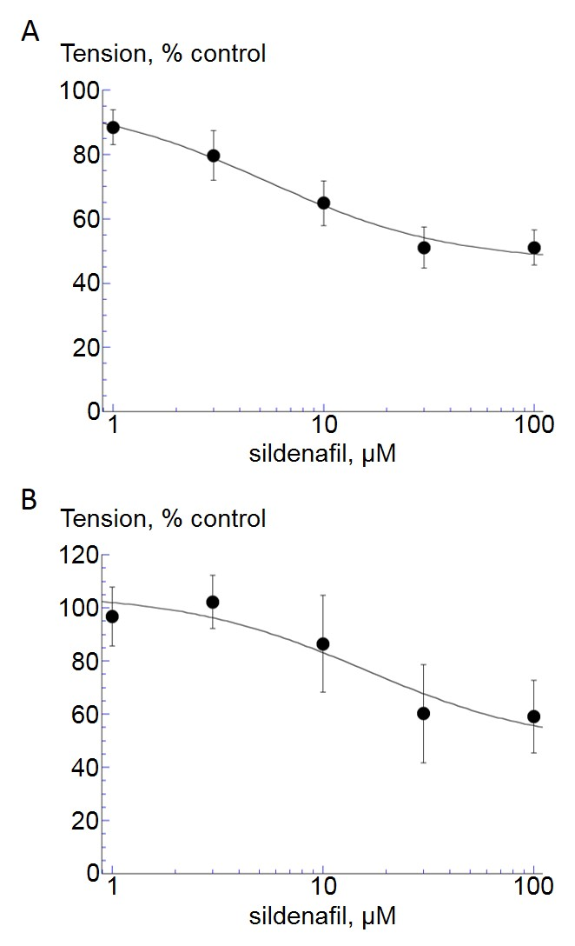

**Figure 1.**

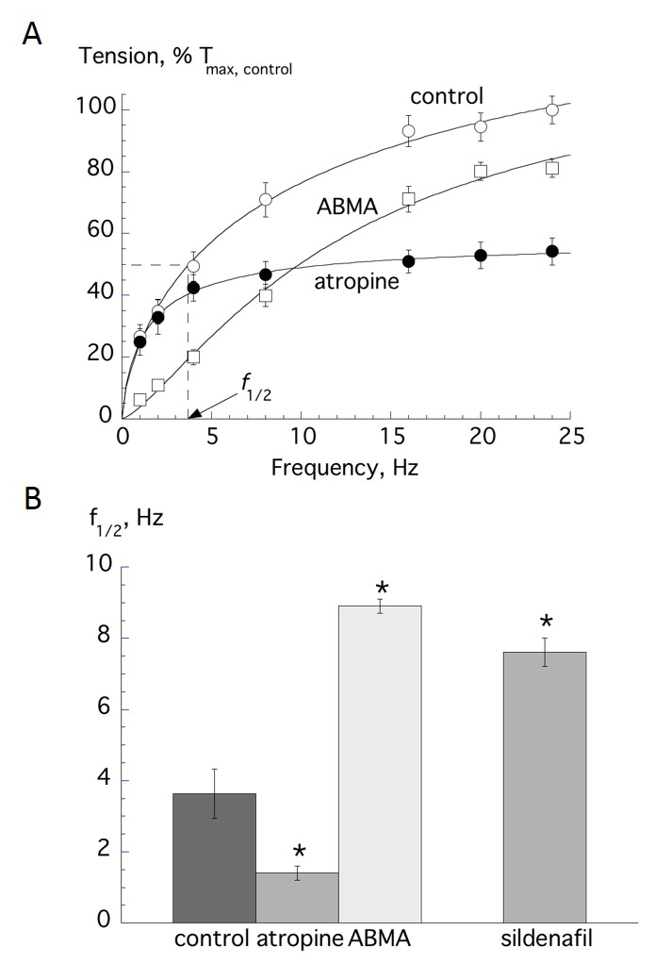

**Figure 2.**

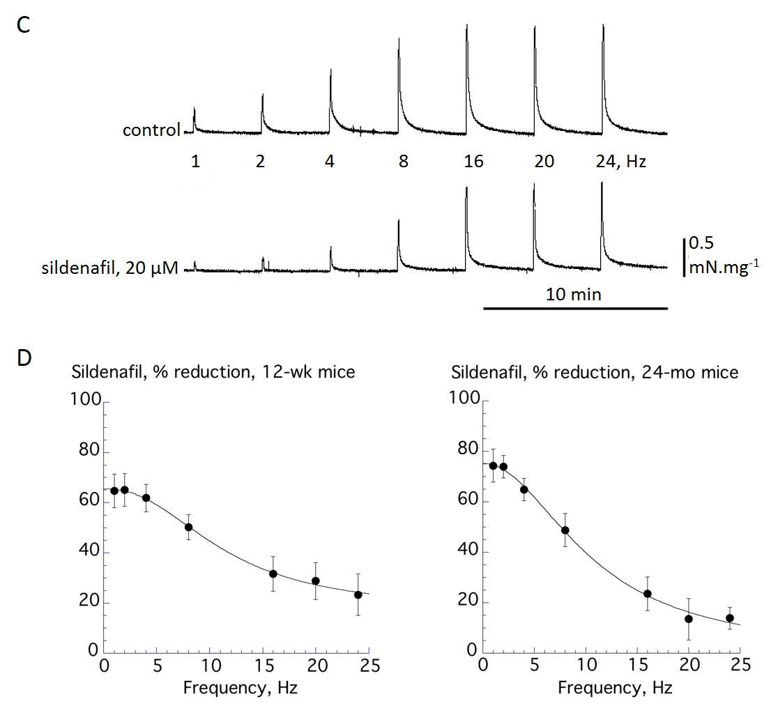

**Figure 3.**

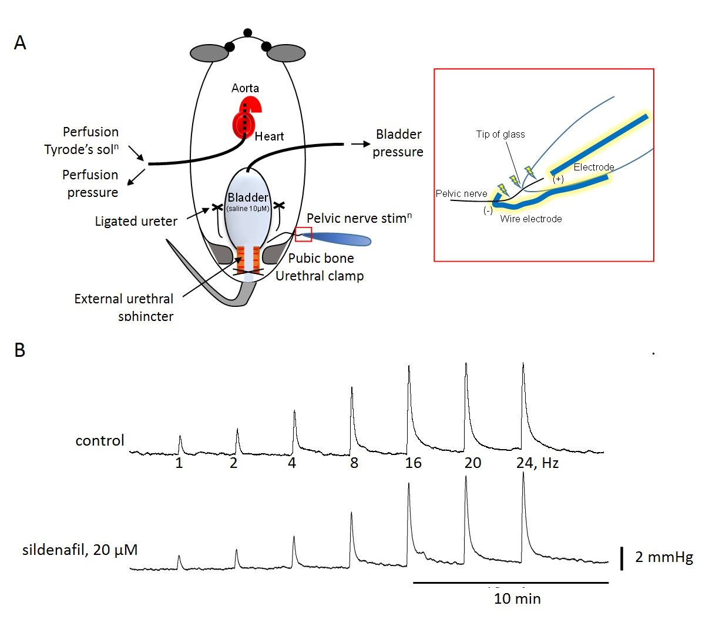

**Figure 4.**

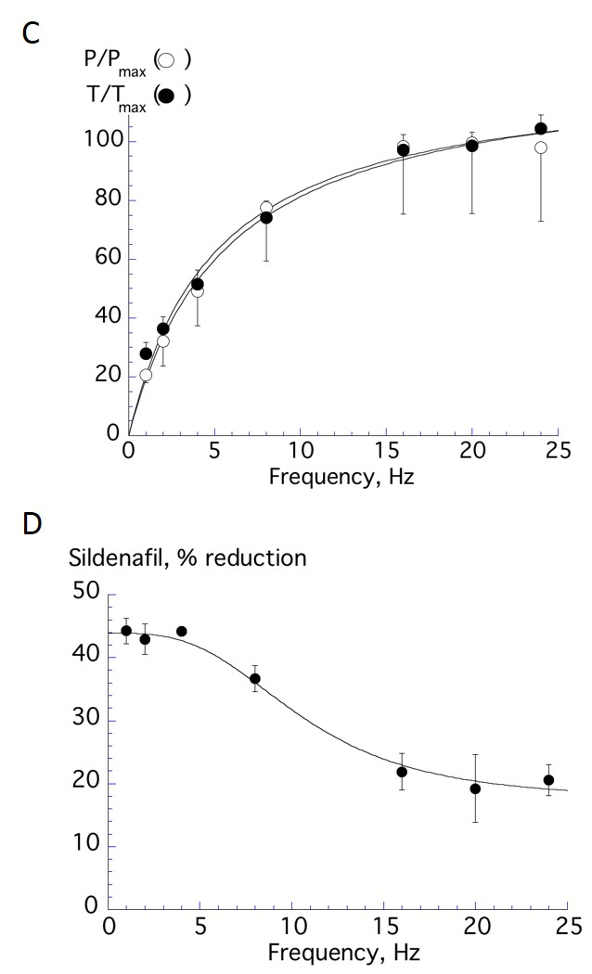

**Figure 4.**

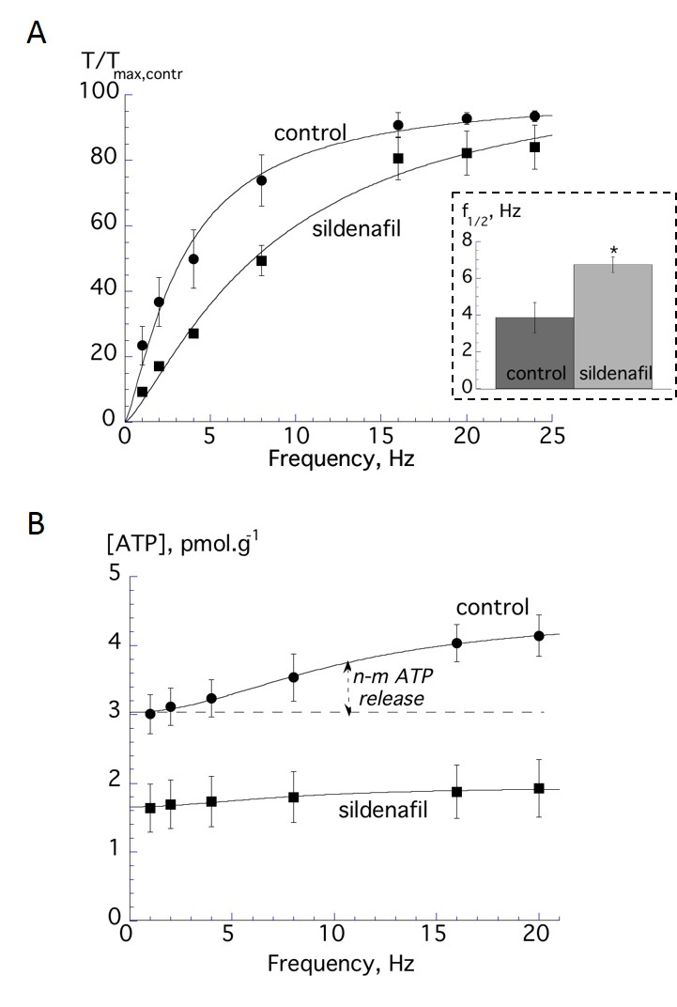

**Figure 5.**