Sharing Economy and the Lodging Websites: Antecedents and Mediators of Accommodation Purchase Intentions
Abstract

Purpose: The aim of this research is to understand the main determinants that affect accommodation purchase intentions through lodging websites in sharing economy context. This industry differs from the hotel industry because it is a community marketplace with a growing community of users where renters can monetize their extra space and list their properties to an audience of millions while travelers can find unique accommodation at any price point.
Methodology: We examine factors such as perceived lodging value, perceived lodging price, lodging information, online lodging reviews, trust with the host, website usability and perceived privacy/security of the website and measure their relationships with purchase intentions. Based on an online survey data, the structural model test outcomes explain the direct effect of the exogenous variables on purchase intentions and the mediating effect of perceived lodging value between perceived lodging price and purchase intentions.
Findings: The study demonstrates that the six latent factors and proposed associations have positive effects on purchase intentions. Thus, enterprises operating in the online lodging industry should consider these elements as key antecedents of lodging purchase intentions.
Originality/Value: Lodging websites operate in a highly competitive market where they have to compete with hotel operators, hostels, bed and breakfasts and hotel comparison websites in current sharing economy. In addition, consumers usually spend a great deal of time and effort on online pre-purchase evaluation because of the ease of the information gathering process where consumers can find a wide variety of options online. Therefore, understanding the drivers that convert browsers into renters is a topic of great interest among marketing managers in current sharing economy context.

Keywords: Lodging websites; Sharing economy; Purchase intention; Trust; Privacy/Security; Structural equation model

Introduction

In today’s global environment the internet is playing a major role in the online accommodation industry changing the way travelers search for information and book their accommodation. This shift in consumer behavior is a trend that is set to continue to an even greater degree in the future as the penetration of internet increases and more accommodation bookings are made online (Kim, Chung and Lee, 2011; Kannan and Li, 2017). Moreover, the internet has made the accommodation booking process more accessible and easier for travelers when compared to traditional channels in which the online accommodation market has positively benefited from the fast development where online transactions are leading and creating a new era for the tourism industry (Kim, Chung and Lee, 2011). In part, this is because the internet has increased rapidly at an unprecedented rate since its introduction in term of infrastructure and content, driving innovation, diverse network expansion and user engagement. With reference to the Internet Society Global Internet Report 2016, there were 3,893,587,260 global internet users in 2015. However, by early 2017 this figure was set to increase to 3 billion users (Internet society, 2016).
As a result, this research will focus on the online lodging industry which is referred in this study as a peer-to-peer exchange service for hospitality where travelers can rent out accommodation online through a website that connects hosts (property owners) with travelers. Moreover, the lodging industry is a type of residential accommodation that not only targets holidaymakers but also business travelers in which consumers can rent through the online channel various types of accommodation around the world including the entire property, a private room or even a shared room according to their budgets (Forbes, 2013). This unique type of accommodation includes private homes, apartments, flats, studios, rooms, villas, houseboats and even castles where travelers can stay one night, a week or rent accommodation for more than one month. This industry differs from the hotel industry because it is a community marketplace with a growing number of users where renters can monetize their extra space while travelers can find unique accommodation at any price point (Forbes, 2013). Some of the most popular lodging websites are airbnb.com, housetrip.com, holidaylettings.com, homeaway.com, loadgingapartments.com, vrbo.com, wimdu.co.uk, 9flats.com and wimdu.com. This is a new industry which is part of the sharing economy and little research has been done before (Forbes, 2015).
Therefore, this study aims to understand the determinants that affect accommodation purchase intentions by considering the lodging websites that facilitate online transactions, the accommodation itself and trust with the host. The trust construct (Liu & Tang, 2018) has been incorporated in the research because the sharing economy is growing rapidly as more and more users take part in this industry. One of the main barriers that could slow down this fast-growing sector is trust. In the online lodging context, trust with the host enables users to rent a room in a property from an unfamiliar person that they have never met before which is one of the most prevalent fears of utilizing sharing economy facilities (Forbes, 2015). Moreover, the idea of staying in a stranger's property over the internet for some internet shoppers is risky or dangerous pointing to trust as a fundamental factor in the future of this industry (Forbes, 2015). In addition, consumers usually spend a great deal of time and effort on online pre-purchase evaluation because of the ease of the information gathering element where consumers are gaining more power due to an increasing number of accommodation choices that can be found online. Also, this industry operates in a highly competitive market and even though the sector has grown rapidly since its introduction they have to compete with hotel operators, Bed and Breakfasts and hotel comparison websites (Fast Company and Inc, 2015). For all the reasons mentioned above, it is very relevant to understand the main drivers of purchase intentions in the online lodging context and the key elements that convert browsers into renters. In essence, the aim of this research is to develop a theoretical framework to study the relationships among key antecedents and mediators of purchase intentions in the online lodging industry by considering different factors that potentially affect purchase intentions (such as perceived lodging value, perceived lodging price, lodging information, online lodging reviews, trust with the host, website usability, perceived privacy/security of the website) and measure their bonds with purchase intentions.
For example, referring to previous research purchase intentions is regarded as a predictor of the actual purchase; and according to prior literature perceived value has been proven to influence purchase intentions as customers favor products that offer maximum value and when their perceptions of the product/service are high, this construct is directly linked with willingness to buy (Chang and Wildt, 1994). Furthermore, perceived price is widely known for affecting purchase intentions and reasonable price has a positive influence on purchase intentions particularly if price falls into the acceptable price range (Lien, et al., 2015). However, it is also said that perceived lodging price influences perceived lodging value which in turn leads to purchase intentions (Lien, et al., 2015). Consequently, the construct of perceived lodging price in our study will also include the acceptable price range concept including the perception of participants whether the lodging price is inexpensive, reasonable, affordable, price comparison and if consumers get what they pay for. Our study contributes to this steam of the literature by developing our understanding of consumers’ perceptions of the above factors and the associative causal effects that can increase lodging purchase intentions. Prior literature mainly established associations between some of these factors, whereas our study also proved the associative causal effects. To assess the hypothesized relationships with purchase intentions and according to the values and the path coefficients, we used structural equation modeling approach (Dion, 2008). In this sense, we fill an important research gap in the literature by creating and testing a complete theoretical model on consumer perceptions of the factors that increase lodging purchase intentions. Our research also has practical implications for marketing managers who are aiming to increase lodging purchase intentions through lodging websites. Managers can focus on the issues of perceived lodging value, perceived lodging price, lodging information, online lodging reviews, trust with the host, and perceived privacy/security as these factors have been proven to positively influence lodging purchase intention. Our results further show in the online lodging industry perceived lodging value is necessary to achieve purchase intentions. Thus, organizations in this sector must adopt a comprehensive view of perceived lodging value by also considering emotional aspects. Besides, perceived lodging value partially mediates perceived lodging price and purchase intentions. Purchase intentions is a consequence of perceived lodging price in the lodging context and lodging websites should take into account all the important characteristics of setting reasonable and competitive prices that fall into the acceptable price range for the various accommodation options.
The study includes the following sections: Section 2 examines the factors that influence purchase intentions in the lodging context and specifies each factor and postulates relationships among constructs. Section 3 comprises the research methodology design, data collection procedures and analytical techniques for the study. Section 4 provides statistical test results and discussion of the outcomes. Section 5 describes the overall research findings, implications, limitations and further research.

Literature Review

The online lodging industry is referred to peer-to-peer exchange service for hospitality around the world in which hosts and guests exchange housing for money. During the application process guests can find information about the host and reviews about the lodging in order to build trust in the marketplace. Moreover, the pioneer and most popular website in this industry is Airbnb whose revenue in 2013 was $250 million and has seen a rapid growth since its launch in 2008 with over 1,500,000 listings worldwide (Forbes, 2015). However, there are other well-known websites such as housetrip.com, holidaylettings.com, wimdu.com among others that follow Airbnb’s steps in this industry. Moreover, these types of websites are part of the sharing economy which is becoming very popular as more and more people are realizing that it is cheaper to share resources than to purchase them and the fact that sharing could save time and money (Forbes, 2015).

Sharing economy and the online lodging industry

The sharing economy is affecting traditional rental industries as conventional sectors mature and deteriorate which are being replaced by innovative companies (PwC Analysis, 2015). Moreover, according to the analysis conducted by PwC sharing economy businesses are more inclined to grow more rapidly than conventional rental sectors and peer-to-peer accommodation is estimated to grow 31% by 2025. Conversely, Bed and Breakfasts and hostels are projected to grow 4% during this period of time (PwC Analysis, 2015). In the online lodging industry similarly to other industries much of the purchase efforts have to be made before the actual buying decision. Thus, it is important for this sector to examine the main antecedents and mediators of purchase intentions in order to gain a better understanding of how to positively influence online shoppers in the pre-purchase phase (Lien et.al, 2015). Moreover, managers and academic researchers rely on purchase intentions as they expect that these intentions will convert into actual buying decisions being a predictor of subsequent purchases (Morwitz et al, 2007). Purchase intention refers to the likelihood that a customer will purchase a product or service being a key predictor of actual buying behaviour. On the other hand, in the online lodging industry, purchase intentions represent consumers’ desire or willingness to rent out accommodation through lodging websites (Lien et.al, 2015).

Relationships among perceived price, perceived value and purchase intentions

Online shoppers often prefer to buy products that offer maximum value and previous research has proven that the perceived value of a product has an impact on purchase intention and in the e-commerce environment these relationships have been confirmed (Ponte, Trujillo and Rodríguez, 2015). As a result, perceived value has been gaining ground and researchers attentions because it is thought to be an important construct that plays an important role in predicting purchase intentions, high perceived value is expected to lead to willingness to buy which is a fundamental variable that influences choice (Chang and Wildt, 1994). Also, perceived value is understood to influence online shoppers being an influential predictor of purchase intention (Chen and Dubinsky, 2003). Chen and Chen (2010) argued that perceived value can be seen as a pivotal determinant of behavioral intentions and in the online context perceived value has a positive effect on online purchase intentions. Moreover, in the lodging industry, perceived price leads to a greater perceived accommodation value boosting consumers’ purchase intentions (Zielke, 2010). Thus, it is thought that an acceptable price range that generates a positive perceived price may results in higher perceived value that leads to a greater intention to purchase (Lien et.al, 2015). Conversely, if the price is unacceptable it is assumed that the product offered lacks perceived value in which the perception of value has a direct impact on willingness to buy (Dodds, Monroe and Grewal 1991). What is more, in the online lodging context reasonable price has a favorable impact on consumers’ purchase intentions (Lien et.al, 2015). In the light of these findings, the information supports the theoretical framework for the formulation of hypotheses in terms of direct and mediating effect and consequently the researcher proposes the following hypotheses.

H1: There is a positive relationship between perceived lodging value and purchase intentions.

H2: There is a positive relationship between perceived lodging price and purchase intentions.

H3: Perceived lodging price has a positive impact on purchase intentions through perceived lodging value.

Lodging information and purchase intentions

Lodging information helps potential customers to obtain information about the accommodation offered (Gursoya and McCleary, 2004). Then, depending on their perceptions about the completeness, relevance and accuracy of the information online shoppers may consider the site appropriate for making the online transaction. In this respect, consumers evaluate different lodging information and then select the website through which they will make the purchase paying attention to the information provided by the site (Ponte, Trujillo and Rodríguez, 2015). Therefore, the more relevant information the site offers about the lodging, the more likely users are to rent the accommodation (Ponte, Trujillo and Rodríguez, 2015). Moreover, it is thought that the ease to search for price and quality information increases satisfaction not only with the online experience and the service purchased but also enhances purchase intentions (Chen and Dubinsky, 2003). Based on previous literature there is a positive relationship between lodging information and purchase intentions and consequently in the current study it is hypothesized that lodging information is positively associated with purchase intentions in the online lodging industry and the following hypothesis is formulated:

H4: Lodging information has a positive effect on purchase intentions

Online lodging reviews

Online product reviews enable consumers to easily create and distribute comments not only through lodging websites but also via product review sites (Sparks and Browning, 2011; Fang, 2014). However, it is also said that online reviews bring new challenges for consumers due to the evaluation of online reviews when it comes to trustworthiness and the need to differentiate credible and helpful reviews (Jiménez and Mendoza, 2013; Wang et al, 2015). Preceding research suggests that consumers face this challenge by evaluating the level of detail in a review and the level of reviewer agreement. The level of detail influence the credibility of reviews whereas reviewer agreement has an effect on the credibility of experience products (Jiménez and Mendoza, 2013). This is particularly visible due to the large quantity of online reviews available on the internet where consumers have to go through a large quantity of online reviews. Secondly, the legitimacy of online product reviews is sometimes dubious because in some cases online marketers deceive consumers by writing online reviews that appear to be written by consumers or independent reviewers, which in fact are self-catering reviews. Consequently, online shoppers are more sceptical of online review and question the credibility of such reviews (Jiménez and Mendoza, 2013).
Conversely, previous researchers have regarded the credibility of online reviews as a cognitive organism and a key predictor of online review adoption (response) in which different stimuli such as online review ratings and online argument strength may drive credibility (Fang, 2014). Moreover, the nomological structure of electronic WOM communication model has stressed the prevailing cognitive process between stimuli and response where the cognitive stimuli responds to the conventional cognitive assessment whose evidential status is high. As a consequence and suggested by prior literature on information adoption, cognitive cues such as online review ratings and online argument strength drive credibility of online review when evaluating options and will be incorporated in this construct (Fang, 2014). The impact of online product reviews is widely recognized as the vast majority of online buyers take into account online product reviews in order to make purchase decisions (Fang, 2014). As a result, online reviews can positively or negatively influence customers’ purchase intentions. In part, this is because the information content of online reviews is a sign that aids consumers to make decisions (Sparks and Browning, 2011). However, users evaluate the credibility of online product reviews when guiding their purchase decisions in which credible reviews tend to result in higher purchase intentions (Jiménez and Mendoza, 2013). Also, online reviews influence the formation of consideration sets and purchase intentions (Park and Nicolau, 2015). Thus, drawing upon previous research there is a relationship between online lodging reviews and purchase intentions and the following hypothesis is formulated.

H5: Online lodging Reviews have an effect on purchase intentions

Trust with the host and purchase intentions

Trust can be defined as feeling of security and belief that the e-commerce site will be responsible and behave adequately fulfilling the expectations of consumers without affecting their vulnerability (Pavlou, 2003). Due to the lack of proven guarantees that the web retailer will not behave in a harmful and opportunistic manner, trust has become a crucial elements of e-commerce. Also, Chen (2006) categorized trust in two forms: the first definition of trust as a belief, confidence, attitude or expectation about another party’s trustworthiness; and the second definition of trust as a behavioral intention involving vulnerability and uncertainty. This is because uncertainty is a requirement for trust to exist. McCole (2002) outlined ten dimensions of trust based on literature, these dimensions are availability, competence, consistency, discreteness, fairness, integrity, loyalty, openness, promise, and fulfilment. Therefore, trust with the host in the online lodging industry is a key element due to consumers’ expectations that the accommodation provider delivers services as promised and these expectations can vary according to the level of trust (Kim, Chung and Lee, 2011). Furthermore, numerous researchers have highlighted the importance of trust and suggested trust as a primary construct in the B2C e-commerce context due to the uncertain environment that takes place in most on-line transactions (Pavlou, 2003). What is more, Reichheld and Schefter (2000) argued that “Price does not rule the web; trust does” (Gefen, Karahanna and Straub, 2003). Hence, the conceptualization of trust involves users’ disposition to accept vulnerability expecting and having confidence that they can depend on the other party (Bart et al., 2005). This definition is in line with the construct of trust as a salient belief consisting of goodwill trust (benevolence) and credibility (honesty, reliability and integrity) (Pavlou, 2003). In this study due to the business model of lodging websites that connect property owners with renters, the trust construct primarily involves trust with the host that rent the accommodation through the lodging site. Trust is continuously seen as a key construct where the importance of trust is considered to be more impactful in e-commerce channels than traditional channels particularly in the online lodging industry in which consumers are unable to experience the quality of the service before the consumption (Lee and Turban, 2001). As a result, trust with the host in the online lodging context is a fundamental determinant that decisively affects the industry and positively influences purchase intentions (Lee and Turban, 2001). Hence, it is hypothesized in the current study that trust with the host has a positive effect on purchase intentions.

H6: Trust with the host has a positive effect on purchasing intentions

Website usability

The quality of a website is highly driven by usability and technological factors. Technological factors refer to the quality of the website that enables online transactions (Chen, Hsu and Lin, 2010). Preceding research indicates that well-developed websites with high quality, customized and informative content together with useful functions are likely to increase customer satisfaction that may result in an increase in return rate (Chen, Hsu and Lin, 2010). It is said that a task that needs more cognitive efforts to assess can result in a more negative affect (Chen and Dubinsky, 2003). Due to the fact that information processing involves cognitive efforts, particularly in the case when the information presented is not readily comprehensible, a website design that doesn’t enable easy information processing could drive negative affect. Moreover, unfriendly online shopping interfaces may make consumers feel that they have lost control of their online interactions and consequently create negative feelings about the online shopping experience. These negative feelings may lead them to drop off the site, abandon the purchase process or simply look for other online options affecting purchase intentions (Chen and Dubinsky, 2003). By contrast, positive web interactions might result in favorable outcomes such as good mood, longer staying time, more exploratory behavior producing an increased intention to purchase. Further research also suggests that the use of the technology involved in sites can drive users’ intentions and attitudes towards visiting or revisit the site (Hausman and Siekpe, 2009). Based on previous literature, there is a positive relationship between website usability and purchase intentions and the following hypothesis is formulated.

H7: Website usability has a positive effect on purchase intentions.

Perceived privacy and security

Privacy and security are primary evaluative criteria in online services and these two elements are related factors that include protecting website users’ personal information and secure transactions. The higher the perception of privacy and security in users’ minds, the lower the risk consumers perceive when making online transactions (Geyskens, Benedict and Steenkamp 2006). Previous researchers have defined privacy as the ability of an individual to be able to control, manage and selectively reveal personal information (Chen, Hsu and Lin, 2010). Privacy comprises the adoption and implementation of a privacy policy, notice, disclosure, and consent of the website visitors (Bart et al., 2005). It is also said that the protection of privacy is extremely important for online transactions. Similarly, perceived security is another important aspect of e-commerce sites, information security can be considered as the confidentiality, integrity, authentication and nonrepudiation of the online transaction and online data. Perceived security can be regarded as the subjective probability in the customer’s eye that their personal or financial information will not be exposed, saved, or stolen by outside parties during the online interaction process. Moreover, security is known to include protecting users from the risk of fraud and financial loss (Zeithaml et al., 2002). Prior literature indicates that security measures such as personal account with ID and password can ease customers’ security fears. Displaying confirmation screens after completing transaction together with authenticated policies of security such as encryption and use of seals of approval can aid in ensuring transaction accuracy reducing the perceived transaction risk (Chen, Hsu and Lin, 2010). In addition, when potential customers want to purchase product or services online, perceived security is one of the most challenging problems because users fear that the information collected by the e-commerce site could be misused for some unwanted purposes making them more anxious and aware of how the information is used. As the internet is growing at an unprecedented rate, the concept of perceived privacy and security are increasingly important. Previous research has pointed out the importance of security and privacy claiming that purchase intentions is most influenced by these elements (Dinev and Hart, 2005). Therefore, based on previous research in the current study the model includes the positive relationship between perceived security/privacy and purchase intentions and the following hypothesis is formulated:

H8: Perceived privacy and security have a positive effect on purchase intentions.

The proposed framework identifies key factors that influence purchase intentions in the online lodging context. The hypotheses are incorporated into a conceptual structure as Figure 1 indicates. The blue ovals represent each construct and blue single-headed arrows denote the direction of casual impacts between two construct.

[Insert Figure 1 about here]

This theoretical framework has been validated by our empirical findings. For example, lodging information is positively associated with purchase intentions; the more relevant information the site offers about the lodging the more likely users are to rent the accommodation. With respect to online reviews, it is thought that online reviews influence purchase intentions, but the credibility of online reviews is still in question among internet users. However, creditability of online reviews is found to influence purchase intentions. Trust with the host is an important construct especially in the online lodging industry which is part of the sharing economy in which trust is a major concern among consumers. A component of trust is proven to be necessary in all the online interactions further demonstrating that trust nourishes purchase intentions. In terms of the online channel, privacy/security is widely recognized as an essential element for transactions to take place impacting purchase intentions directly; previous research has claimed that purchase intentions is largely influenced by these two elements (Dinev and Hart, 2005).

Methodology

To evaluate postulation associations, an online survey questionnaire is created in order to gather primary data and empirically investigate the relational connections among perceived lodging value, perceived lodging price, lodging information, online lodging reviews, trust with the host, website usability, perceived privacy/security and purchase intentions. The questionnaire design is divided into 3 parts: first part, participants are asked whether or not they use lodging websites, if participants respond “No” they finish the questionnaire. After this, a factor measurement section is created which is followed by questions related to participants’ lodging usage, influential factors and then demographic information. In terms of the measurement section, it consists of 8 categories that represent the 8 main constructs. Five manifest variables are in each factor except for perceived lodging value which is made up of 6 items and purchase intentions that has 4 items. Moreover, the third part of the questionnaire aims to collect data regarding lodging usage, influential factors and demographic information. Demographic data provide background information of overall sample characteristics.
With regard to the measurement section, eight constructs have been reviewed and adopted as Table 1 indicates. Purchase intention consists of four items (PI1 TO PI4) and was obtained from Lien et al. (2015); Pavlou (2003); Wen (2012) in order to measure the likelihood of renting out accommodation through lodging websites. Then, perceived lodging value consists of 6 items (PV1 to PV6) are selected from Moliner et al. (2007), Sanchez et al. (2006) and Lien et al. (2015) evaluating whether users perceive the purchase of accommodation as good value for the price paid, if lodging features match their expectations, If they like and feel comfortable with the lodging purchased as well as social approval of the purchase. Perceived Lodging Price construct is made up of 5 items (PP1 to PP5). These items are selected from Lien et al. (2015), Kaura et al. (2013) and Zielke (2010), estimating customers’ perception of lodging prices whether the price is inexpensive, reasonable, affordable, appropriate and cheaper than other travel websites.
Lodging Information construct consists of 5 items (LI1 TO LI5) and assess whether photos for the lodging at the site are helpful, if the sites provide sufficient lodging and host information, if the information is useful and understandable. Online lodging review 5 Items (OR1 to OR5) are obtained from Fang (2014); Li et al.(2013) and Baum and Spann (2014) estimating whether online lodging reviews are credible, persuasive, convincing, helpful in evaluating lodging options. Trust factor consists of 5 items, (T1 to T5) adopted from Kim, Chung and Lee (2011) and Pavlou (2003) assessing whether online shoppers believe that hosts that rent accommodation through lodging websites have integrity, reliability, trustworthiness, deliver on promises and keep customers' interests in mind. Moreover, website usability (WU1 TO WU5) are selected from Bart et al. (2005); Chen, Hsu and Lin, 2010; Kim, Chung and Lee (2011) and Zeithaml et al., (2002); estimating whether lodging websites are easy to use, professional and visually appealing, help functions, level of technology and fast and accurate search capabilities. Perceived privacy/security of the website 5 items (PS1 to PS5) obtained from Bart et al. (2005); Suh and Han (2003); Steenkamp and Geyskens (2006); Ponte, Trujillo and Rodríguez (2015), investigating whether the privacy policy is easy to find, privacy of personal information, trust seals, protection against fraud and payment security. Additionally, the purpose of the third section is to gather information regarding lodging usage, influential factors for choosing accommodation, reasons for renting lodging, travel frequency, lodging budget and demographic information.
For this research the main target audience are individuals that have used lodging websites before such as airbnb.com, housetrip.com and holidaylettings.com. Unengaged responses were examined by calculating the standard deviation for the Likert scale variables to make sure the dataset do not contain unengaged responses. The cut-off for the standard deviation is 0.3, respondents with standard deviation below 0.3 could indicate that they were unengaged and responded almost the same answer in the questionnaire. After this, the analysis of descriptive statistics is conducted to better understand respondents’ background characteristics. Furthermore, the data analysis manners includes confirmatory factor analysis (CFA), structural equation modelling (SEM), structural parameter estimates, and mediating effect evaluation and hypothesis tests (Fox, 2006). In the survey, 436 people answered the questionnaire, however, 56 respondents ended the questionnaire after the first question because they have never used lodging websites in the past. The detection of missing data was conducted in order to determine the percentage of missing values. With respect to the measurement process for analyzing missing values, the most direct method of evaluating the incompleteness of the data is by identifying the percentage of missing data for each participant. Therefore, the sample for the analysis will consist of 380 valid cases for further analysis.
Kolmogorov-Smirnov test and Shapiro-Wilk test are used to evaluate the normality of all individual measurement items in the sample (Kline, 2011). The outcomes of the test demonstrates that all the items are statistically significant at the 0.05 level. As a result, the null hypothesis of normality is rejected. Yet, the central limit theorem highlights that a dataset can be presumed to be normally distributed if the sample size is at least greater than 30 cases (Hair, et al., 2014). Thus, the sample size in the current study is 380 and the data are assumed to be normally distributed. We have also checked collinearity, which was not a problem in our data/analysis.

Descriptive statistics

The characteristics of 380 valid cases are illustrated as follows: 83.9% of participants rent out accommodation through lodging websites for holidays while only 16.1% rent short-term accommodation. As for travel frequency, 27.8% of participants travel 3 times per year, which was followed by 2 times (26.7%). The most common lodging budget was between €50 and €100 per day accounting for 52.8% of the data. 48.3 per cent of participants in this study live in the United Kingdom representing the highest percentage. Meanwhile, 56.1% of participants are women while 43.9% are men. Respondents aged between 30 and 39 years old represent the most prominent age group accounting for 51.7%. The second most prominent age group is people aged between 18 and 29 years old (33.9%). 51.1% of participants possess College/University Degrees while 40.6% of participants own a Master degree. With respect to personal income groups, 54.4 per cent of participants describe themselves as having a medium personal income which was followed by high personal income representing 19.3% while low and very low personal income stand for 26.3%. Table 2 outlines the descriptive statistics for the sample characteristics in this study.

[Insert Table 2 about here]

Analysis

Our research included eight latent factors: perceived lodging value, perceived lodging price, online lodging reviews, lodging information, trust with the host, website usability, perceived privacy/security of the website and purchase intentions. Each latent construct is made up of five manifest variables except for perceived lodging value and purchase intentions that consist of 6 and 4 items respectively. A path diagram can be used to visualize the initial measurement model by using the “semPlot” package (Figure 2). Latent factors are shown by ovals and measured items are displayed by using squares. Double-headed arrows illustrate correlations among latent factors and errors of items/constructs.

[Insert Figure 2 about here]

In order to assess the measurement model Confirmatory factor analysis (CFA) is used. Model indices from the initial CFA are illustrated as follows: the overall model chi-square of the measurement model (Χ²) is 1018.22, degree if freedom (df) 712 and p-value (p) is 0.000. Tucker-Lewis Index (TLI) is 0.90, the goodness-of-fit- index (GFI) is 0.79, adjusted goodness-of-fit index (AGFI) is 0.76 and normed chi-square (Χ² /df) is 1.43 (<3). Root mean square residual index (RMSEA) is 0.05 and standardized root mean residual (SRMR) is 0.062 (≤ 0.08). Bentler-Bonett normed fit index (NFI) is 0.76, Tucker-Lewis non-normed fit index (NNFI) is 0.90 and Bentler comparative fit index (CFI) is 0.90.
The confirmatory factor analysis results suggest that the overall measurement structure is not satisfactory and offers a poor fit with a chi-square index statistically significant 0.000. As a result, the test indicates that the proposed model explains the empirical data poorly. Furthermore, only five out of the eight indices meet the desired criterion. Normed chi-square (Χ²/df= 1.43 <3), root mean square residual index (RMSEA=0.05 ≤ 0.08), standardized root mean residual (SRMR= 0.06 ≤ 0.08), tucker-Lewis non-normed fit index (NNFI= 0.90 ≥0.9) and bentler comparative fit index (CFI= 0.91 ≥0.9). Moreover, AIC= 9643.685 and BIC= 9988.525. Consequently, the initial measurement model will be diagnosed in order to improve the model fit.

Measurement model diagnosing

A valid measurement model is the basic foundation for further structural model analysis. To cope with an unfit measurement structure, standardized factor loadings, R-square for endogenous variables and modification indices are examined in order to improve the initial overall fit. First of all, the CFA result suggests that all the measurement items are statistically significant at the 0.05 level. Secondly, standardized factor loadings estimate correlations between the indicator and its factor. However, website usability fails to meet the strict standard criterion of standardized factor loadings above 0.7 and consequently this construct is removed from the model due to the lack of explanation of the variance of each indicator. Thus, the model has been re-specified omitting website usability and model indices are re-examined.
The re-examined model (Measurement model 2) indices remained almost unchanged when compared to the initial measurement model with 5 out of the eight indices meeting the standard criterion. Normed chi-square (Χ2/df) increased slightly from 1.43 to 1.54, P-value (Chi-square) is 0.000, Tucker-Lewis Index (TLI) remained the same at 0.900. However, AIC and BIC decreased by 1106.239 and 1160.52 respectively. Moreover, all the measurement items are statistically significant at the 0.001 level. With reference to the standardized factors loadings as discussed before they are all statistically significant at the 0.001 level. In addition, the loadings range from 0.36 to 0.92. A standard strict criterion is used to determine the items that will remain in the model and standardized factor loading below 0.7 are removed. As a result, three items are deleted from perceived lodging value (PV2, PV5 and PV6), two items are eliminated from perceived lodging price (PP1 and PP5), two items are extracted from lodging information (L1 and L5), one item is deleted from trust with the host (HT5), two variables are eliminated from website’s perceived privacy and security (PS2 and PS5) and one indicator is removed from purchase intention (PI4). Furthermore, modification indices are inspected because they offer useful information in order to recommend unspecified relationships among constructs and measurement items. It is also said that model fit improvement can be conducted by freezing the paths that have modification indices greater than 4.0 (Malhotra, 2010). Modification index estimates the amount by which the overall model chi-square statistic would decrease if a particular fixed-to-zero parameter were freely assessed and indices with values higher than 0.4 are considered to be good selections for modifications. The two largest drivers of increasing model fit is the association between OR4 and OR5 along with OR1 and OR2 suggesting that the measurement items are correlated in one construct. With respect to the concept of unidimensionality, this definition refers to the presence of a group of measurement items that reflect purely one latent construct and cross-loadings have to be zero for any variable (Malhotra, 2010). Thus, OR4 and OR1 are removed from the online lodging review construct. Then, R-square for endogenous variables is a criterion that has to be considered for assessing manifest variables among a latent construct. With reference to Hooper et al. (2008) items with R-square values smaller than 2.0 should be deleted from the model as they are likely to cause higher explanation errors. As we find, none of the R-square values are below 0.2 and the lowest figure is attributable to LI2 (0.495). However, all the items are retained in the model because at least three items are required in order to measure a construct.
The decision of removing items has been based on the three criteria discussed above. First, standardized factor loadings, then modification indices and lastly R-square for endogenous variables. As a consequence, 13 variables are removed from the measurement model PV1, PV5, PV6, PP1, PP5, L1, L5, PS1, PS5, HT5, PI3, OR4 and OR1.

Adjusted measurement model evaluation

An amended measurement model is produced after deleting 13 manifest variables. On the other hand, each latent factor includes three items except for trust with the host which is made up of four measurement items. All the details of the adjusted measurement model is shown in and the path graph is presented in Figure 3. The adjusted measurement model chi-square (Χ²) is 248.412, degree of freedom (df) is 188 and p-value (p) is 0.002 (< 0.001). Furthermore, the remaining indices are as follows: GFI = 0.9 (≥0.9), AGFI = 0.9 (≥0.9), RMSEA = 0.04 (≤0.08), SRMR = 0.05 (≤0.08), NFI = 0.90 (≥0.9), NNFI = 0.97 (≥0.9), CFI = 0.97 (≥0.9), and normed chi-square (Χ²/df) is 1.32 (<3). All the indices in the model reach the desired criteria showing positive signs of a satisfactory measurement model and the chi-square p-value is statistically insignificant at the 0.001 level. Also, the amended measurement model has significantly improved when compared to the measurement model 2 after the evaluation of the standardized factor loadings, modification indices and R-square. Moreover, the AIC and BIC for the adjusted measurement model are 4970.908 and 5178.450 respectively. These figures have decreased by 3566.538 and 3649.555 accordingly when compared to the previous measurement model. Even though both models have similar characteristics, the fit indices, the AIC and BIC comparison suggests that the adjusted measurement frame is a superior model. Lastly, Tucker-Lewis Index is 0.967 (TLI ≥ 0.95) indicating that the model is effective when compared to a null model indicating a good fit. After the indices comparison the adjusted measurement frame is decided to be a superior model.

[Insert Figure 3 about here]

Composite reliability (CR), average variance extracted (AVE), standardized factor loadings and discriminant validity are four important indices for calculating reliability and validity (Hair, et al., 2014). The result of CR, AVE and standardized factor loadings are displayed in Table 3. Moreover, all the values of CR are greater than 0.7 and AVE numbers are higher than 0.5. Additionally, all the standardized factor loadings are greater than 0.69 and statistically significant at the 0.001 level. Moreover, the outcome of the discriminant validity evaluation are described in Table 4. The result indicates that all the square root of AVE are greater than the construct correlation coefficients (Malhotra, 2010). Thus, model fit indices, reliability and validity assessment outcomes suggest that the adjusted measurement model is acceptable for further structural model analysis.

[Insert Table 3 and 4 about here]

Structural model evaluation

The suggested structural model includes a total of 22 items underlying the 7 latent constructs. Furthermore, standardized factor loadings are statistically significant at the 0.001 level ranging from 0.70 to 0.92. The summary of the structural model fit indices is presented below in Table 5. The model chi-square is 256.299, degree of freedom is 192 and p-value 0.001 (< 0.001). Even though the p-value is not insignificant, the other 8 fit indices meet the recommended criterion. Also, AIC is 4970.795 and BIC is 5165.566; Tucker-Lewis Index (TLI) is 0.966 indicating that the model is effective when compared to a null model. As a consequence, the structural model outcomes suggest a satisfactory structural model. Structural model path diagram is shown in Figure 4.

[Insert Table 5 and Figure 4 about here]

Mediation effect measurement

To further inspect the relationships among perceived lodging price, perceived lodging value and purchase intentions a mediation analysis will be conducted. However, prior to conducting a mediation analysis, it is important to prove statistically significant correlations among the three latent factors. With reference to Table 3, perceived lodging value is positively associated with purchase intentions (φ = 0.50), perceived lodging price with purchase intentions (φ =0.53) and the correlation between perceived lodging price and perceived lodging value is 0.40. Moreover, prior literature suggests that perceived lodging price has a positive effect on purchase intentions. In addition, perceived lodging price also has a positive impact on purchase intentions through perceived lodging value (Zielke, 2010). The mediation analysis attempts to evaluate the intermediary effect of perceived lodging value between perceived lodging price and purchase intentions. However according to Table 6, the direct effect (0.27) of perceived lodging price on purchase intentions is greater than the indirect effect through perceived lodging value (0.22). In other words, the effect of perceived lodging price on purchase intentions is only partially mediated by perceived lodging value and perceived lodging price has some extra effect on purchase intentions that is not mediated by perceived lodging value and even though perceived lodging value is statistically significant explains only a small portion of the total effect of purchase intentions.

To make the results more understandable ratios and proportions as described below.

Proportion of total effect mediated = 0.22/0.49 = 0.45

Ratio of indirect to direct effect = 0.22/0.27 = 0.81

Ratio of total to direct effect = 0.49/0.27 = 1.81

The results indicate that the proportion of the total effect that is mediated is 0.45. The ratio of the indirect effect to the direct effect is 0.81 and the total effect is 1.81 times the direct effect.

[Insert Table 6 about here]

Structural model assessment without the mediator effect

Structural equation model with only direct effects was conducted and compared with the model with the mediating effect. The test outcomes can be found in Table 7 (also Figure 5) and the model fit indices remained almost unchanged. The model chi-square p-value is 0.002 (<0.001). Moreover, the model chi-square (Χ²) is 248.412, degree of freedom 188 and the normed chi-square (Χ²/df) slightly decreased from 1.33 to 1.32 (<3). Also, AIC and BIC remained almost the same. However, the chi-square difference statistic is statistically insignificant providing evidences for the validation of the model with mediating effects.

[Insert Table 7 and Figure 5 about here]

Postulation test

Perceived lodging value, perceived lodging price, lodging information, online lodging reviews, trust with the host, perceived privacy/security and purchase intentions are seven latent constructs for evaluating theoretical associations. Firstly, all the constructs mentioned above have associations with purchase intentions, however some connections are stronger and more significant than others. The primary criterion to test different hypotheses is the path parameter estimation. Moreover, each path coefficient has to be statistically significant to verify the postulation. Additionally, the R-square for the endogenous constructs can assist in interpreting the casual relationships (Malhotra, 2010). In line with the measurement model (CFA), a correlation examination between exogenous constructs and the endogenous construct is conducted individually. The outcome suggests that the exogenous factors have a positive relationship with purchase intentions accordingly (Table 7). Perceived lodging price displays the strongest correlation with purchase intentions (φ = 0.53), which is followed by perceived lodging value (φ =50) and perceived privacy/security (φ =0.44), then lodging information, trust with the host and online lodging reviews correlate with purchase intentions 0.38, 0.34 and 0.31 respectively.
The postulation association are illustrated in Table 8 and Figure 6. In total, the seven hypothesized relationships were supported by the data and they are statistically significant at the 0.05 level. The level of significance for each hypothesis is specified by using asterisks (*) and all the path parameters show positive effects. The standardized coefficient for perceived lodging value to purchase intentions is 0.31 (H1). The results indicate that when the perceived lodging value factor increases by one unit then purchase intentions improves 0.31 unit. Also, the standardized path coefficient of perceived lodging price to purchase intentions is 0.27 (H2) indicating that one unit increase on perceived lodging price predicts 0.27 unit rise of the purchase intention factor. Then, the standardized coefficient of perceived privacy and security is 0.22 (H8). This indicates a unit increase in perceived privacy and security produces a 0.22 positive change in purchase intentions. The coefficient of lodging information to purchase intentions is 0.18 (H4) indicating that a unit change in lodging information leads to 0.18 unit increase in purchase intentions. Moreover, the standardized path coefficient of trust with the host is 0.15 (H6) showing that a unit rise on the trust construct will raise 0.15 unit of the purchase intention construct. Likewise, the standardized coefficient of online lodging reviews is 0.13; one unit change in online reviews leads to 0.13 unit increase in purchase intentions. In all the results, it applies controlling other factors are fixed.
Furthermore, the coefficient of perceived lodging price to perceived lodging is 0.71 (H3). This association explains that one unit increase in perceived lodging price will predict a 0.22 increase in purchase intentions through perceived lodging value. Additionally, the overall strength of the path associations within the constructs are given by R² and R-square for endogenous factors is a key indicator for supporting the casual hypotheses. In this study, 51% of the variance in perceived lodging value was explained by perceived lodging price while the predictor constructs explain 81% of the purchase intentions construct.

[Insert Table 8 about here]

Conclusion and Implications

Even though the online lodging industry has become a potential threat to hotel companies and hotel comparison websites, this sector operates in a very competitive environment in which they have to compete with traditional hotel operators, bed and breakfasts and hotel comparison websites such as booking.com, TripAdvisor and Lastminute.com. However, one of the benefits of the online lodging industry is its low headcount when compared to traditional hotels making the business model more competitive as they commonly offer lower prices (Fast Company and Inc, 2015). On the other hand, hotel chains argue that even though the lodging industry is growing at a fast pace, hotel operators as a whole offer more security, high level of service, more regulated control and an end-to-end customer experience (Wired, 2015). As a results of this competitive online environment, it is important to better understand the main drivers of purchase intentions in the online lodging industry and how to convert browsers into renters (Chen and Dubinsky, 2003). Moreover, in this industry a great deal of effort has to be made before the actual buying decision and understanding how to positively influence online renters in the pre-purchase phase is important (Lien et.al, 2015).
In this research, it is attempted to demonstrate how perceived lodging value, perceived lodging price, lodging information, online lodging reviews, trust with the host and perceived privacy and security of the website influence lodging purchase intentions and the mediating effect of perceived value between perceived lodging price and purchase intentions. We develop our understanding of consumers’ perceptions of these factors as well as the associative causal effects that can increase lodging purchase intentions. Therefore, in order to assess the hypothesized relationships with purchase intentions and according to the values and the path coefficients, structural equation modeling method was used. Subsequently, the study empirically depicts that perceived lodging value, perceived lodging price, product information, online lodging reviews, trust with the host and perceived privacy/security of the website are all positively associated with purchase intentions individually and to different degrees. Furthermore, perceived lodging value is the most influential determinant of purchase intentions in the online lodging industry when compared to the other constructs in the model; which is followed by perceived lodging price. Besides, perceived lodging price partially influences purchase intentions mediating through perceived lodging value. Perceived privacy/security influences purchase intentions which is followed by lodging information, trust with the host and lastly online lodging reviews. The outcome revels that the six proposed constructs have positive associations with purchase intention in the online lodging context, further developing the literature in this particular research stream (e.g., Lien, et al., 2015; Ponte, Trujillo and Rodriguez, 2015; Jiménez and Mendoza, 2013; Pavlou, 2003; Dinev and Hart, 2005).
As the test outcomes support the importance of perceived lodging value, enterprises can enhance customers’ perceived lodging value by considering the multidimensional approach including the functional, emotional and social dimensions of perceived value rather than having a sole focus on the economic utility of comparing benefits and sacrifices (Ponte, Trujillo and Rodriguez, 2015; Jiménez and Mendoza, 2013). Also, lodging listings should produce the perception that the accommodation is a good value for the price paid, liking and create positive feelings prior, during and after the consumption emphasizing the importance of the role played by the feelings (Lien et al.,2015; Moliner et al., 2007; Sanchez et al, 2006). Perceived lodging price is the second most influential determinant of purchase intentions in this research and delivering the perception that the lodging price is appropriate in relation to what they get for their money as well as reasonable and affordable prices can create the impression that the price falls into the acceptable price range and influence purchase intentions positively (Lien et al., 2015; Kaura et al., 2013; Zielke, 2010). This result is not surprising because the majority of participants have a medium personal income (54.4%) while very low and low personal income represent 26.3%. These personal income groups are usually price sensitive. The third most influential factor is perceived privacy and security and a positive perception of security/privacy among consumers can increase purchase intentions easing customers’ security and privacy fears (Bart et al, 2005; Suh and Han 2003; Steenkamp and Geyskens 2006; Ponte, Trujillo and Rodríguez, 2015). Then, lodging information is very relevant during the information search stage and influence purchase intentions. The result is consistent with Ponte, Trujillo and Rodriguez (2015) who stress that the more relevant information the site offers about the lodging the more likely users are to rent accommodation. Lodging hosts can cultivate trust with their customers by showing integrity, reliability, trustworthiness and deliver on their promises keeping customers’ best interests in mind. This result further confirms the findings of Kim, Chung and Lee (2011) and Pavlou (2003). Companies should also consider that credibility of online reviews is taken into account and online reviews make it easier for users to choose the right accommodation. However, online reviews with cognitive cues such as online reviews with strong argument and ratings drive more credibility (Fang 2014; Li et al.2013; Baum and Spann 2014).
To sum up, the test outcomes revel that the constructs included in the model are important elements which are positively associated with purchase intentions and can favorably affect purchase intentions in the online lodging industry. Thus, marketing managers who are aiming to increase lodging purchase intentions through lodging websites should focus on the issues of perceived lodging value, perceived lodging price, lodging information, online lodging reviews, trust with the host, and perceived privacy/security as these factors have been proven to positively influence lodging purchase intention in this study. Finally, perceived lodging value has been demonstrated to be the greatest driver of purchase intentions whose positive relationship with purchase intention is slightly higher than perceived lodging price; however the other constructs also have positive associations with purchase intentions and the factor with the smallest effect is online lodgings reviews. According to previous research perceived price influences perceived value and an acceptable price range may produce a positive perceived value which in turn leads to a higher intention to purchase (Lien, et al., 2015). However, in this study the relationship between perceived lodging price and purchase intentions is only partially mediated by perceived lodging value and perceived lodging price has some extra effect on purchase intentions that is not mediated by perceived lodging value explaining only 45% of the total effect of purchase intentions. Also, the direct effect of perceived lodging price on purchase intentions is greater than the indirect effect through perceived lodging value. In addition, online lodging reviews is the factor with the smallest effect and one possible reason to explain this is the fact that the credibility of online reviews is still in question among internet users and not all the online reviews include cognitive clues as a way of reassuring credibility. This suggests that this and the two other preceding findings need to be further investigated to develop a more comprehensive picture of the assumed relationships. Moreover, lodging websites must pay attention to the importance of lodging information and special care should be given to the relevancy, accuracy and completeness of the information as well as visual content. Consideration to negative online lodging reviews should be given particularly to those highly rated reviews with strong arguments that seem credible; being an antecedent of purchase intentions. A component of trust is necessary in all online interactions in which reassurance of trust with the host can significantly impact purchase intentions and the service given by the host combined with integrity, reliability and trustworthiness can directly impact purchase intentions. Finally, privacy and security of the website has been proven to be a decisive factor affecting purchase intentions. Lodging websites must create the sensation of confidence and security that the website is capable of protecting customers’ interests in terms of privacy and online transaction security.
In this research, there are three important limitations. Firstly, the hypothesized positive relationship between website usability and purchase intentions was not tested and there is scope for further research in order to understand the causal associations between these two factors. Secondly, people aged between 30 and 39 years old might be over-represented in this research as this age category accounted for 51.7% of the total sample. As a result, the analysis outcome may primarily reveal this age group perspective of purchase intentions through lodging websites. Thirdly, there are other important possible drivers of purchase intention in the online lodging context that were not inspected such as satisfaction and brand image. Taking into consideration these limitations for future research can balance the representativeness of the sample and enrich the understanding of consumers’ purchase intentions in this industry.

References

Bart, Y., Shankar, V., Flores , S. and Urban, G. (2005). Are the Drivers and Role of Online Trust the Same for All Web Sites and Consumers? A Large-Scale Exploratory Empirical Study. Journal of Marketing, 69, 133–152.
Baum, D. and Spann , M. (2014). The Interplay Between Online Consumer Reviews and Recommender Systems: An Experimental Analysis. International Journal of Electronic Commerce, 19(1), 129-162.
Chang, T-Z. and Wildt, A. R. (1994). Price, product information, and purchase intention: An empirical study. Journal of the Academy of Marketing Science, 22(1), 16-27.
Chen, C. (2006). Identifying significant factors influencing consumer trust in an online travel site. Information Technology & Tourism, 8(3-4), 197-214.
Chen, C. F., & Chen, F. S. (2010). Experience quality, perceived value, satisfaction and behavioral intentions for heritage tourists. Tourism management, 31(1), 29-35.
Chen, Z. and Dubinsky, A. (2003). Perceived Customer Value in E-Commerce: A Preliminary Investigation. Psychology and Marketing, 20(4), 323–347.
Chen, Y. H., Hsu, I. C., & Lin, C. C. (2010). Website attributes that increase consumer purchase intention: A conjoint analysis. Journal of business research, 63(9-10), 1007-1014.
Dinev, T. and Hart, P. (2005). Internet Privacy Concerns and Social Awareness as Determinants of Intention to Transact. International Journal of Electronic Commerce, 10(2), 7-29.
Dion, P. A. (2008). Interpreting Structural Equation Modeling Results: A Reply to Martin and Cullen. Journal of Business Ethics, Volume 83, 365–368.
Dodds, W., Monroe, K. and Grewal, D. (1991). Effects of Price, Brand, and Store Information on Buyers' Product Evaluations. Journal of Marketing Research, 28(3), 307-319.
Fang, Y. (2014). Beyond the Credibility of Electronic Word of Mouth: Exploring eWOM Adoption on Social Networking Sites from Affective and Curiosity Perspectives. International Journal of Electronic Commerce, 18(3), 67-102.
Fast Company and Inc (2015). What hotel operators really think of airbnb. Available at: http://www.fastcompany.com/3027976/what-hotel-operators-really-think-of-airbnb[Accessed 25 Jan 2019].
Forbes (2013). Airbnb And The Unstoppable Rise Of The Share Economy. Available at: http://www.forbes.com/sites/tomiogeron/2013/01/23/airbnb-and-the-unstoppable-rise-of-the-share-economy/[Accessed 25 Jan 2019].
Forbes (2015). The future of the sharing economy depends on trust. Available at: https://www.forbes.com/sites/theyec/2015/02/10/the-future-of-the-sharing-economy-depends-on-trust/#48a33bc34717 [Accessed 25 Jan 2019].
Fox J. (2006) Structural equation modelling with the sem package in R. Structural Equation Modelling, 13(3), 465-486.
Gefen, D., Karahanna, E. and Straub, D. (2003). Trust and TAM in online shopping: An integrated model, MIS Quarterly, 27(1), 51-90.
Geyskens, J., Benedict , E. and Steenkamp , E. (2006). How Country Characteristics Affect the Perceived Value of Web Sites. Journal of Marketing, 70(3), 136-150.
Gursoya, D. and McCleary, K. (2004). An integrative model of tourists’ information search behavior. Annals of Tourism Research, 3(2), 353–373.
Hair, J., Black, W. and Babin, B. (2014). Multivariate Data Analysis. 7th ed. London: Pearson New International Edition.
Hausman, A. and Siekpe, J.(2009). The effect of web interface features on consumer online purchase intentions. Journal of Business Research, 5(13), 62.
Hooper, D., Coughlan, J. and Mullen, M. (2008). Structural Equation Modelling: Guidelines for Determining Model Fit. Electronic Journal of Business Research Methods, 6(1), 53-60.
Internet Society (2016). Internet Society Global Internet Report 2016. Available at: https://www.internetsociety.org/globalinternetreport/2016/ [Accessed 25 Jan 2019].
Jiménez, F. R. and Mendoza, N. A. (2013). Too popular to ignore: The influence of online reviews on purchase intentions of search and experience products. Journal of Interactive Marketing, 27(4), 226–235.
Kannan, P. K. and Li, H. A. (2017). Digital marketing: A framework, review and research agenda, International Journal of Research in Marketing, 34(1), 22-45.
Kaura, V., Chalasani , D. and Sharma, S.(2013). Customer perception of service quality and perceived price and fairness: a comparison between public and new private sector banks. Journal of Strategic Marketing, 21(6), 513–528.
Kim, M., Chung, N. and Lee, C. (2011). The effect of perceived trust on electronic commerce: Shopping online for tourism products and services in South Korea. Tourism Management, Volume 32, 256–265.
Kline, R. B. (2011). Principles and Practice of Structural Equation Modeling. 3rd ed. ed. New York; London : Guilford Press.
Lee, M. and Turban, E. (2001). A Trust Model for Consumer Internet Shopping. International Journal of Electronic Commerce, 6(1), 75-91.
Lien, C., Wen, M., Huang, L. and Lu, K. (2015). Online hotel booking: The effects of brand image, price, trust and value on purchase intentions. Asia Pacific Management Review, 1-9.
Li, M., Huang, L., Tan, C. and Wei , K. (2013). Helpfulness of Online Product Reviews as Seen by Consumers: Source and Content Features. International Journal of Electronic Commerce, 17(4), 101-136.
Liu, Y., & Tang, X. (2018). The effects of online trust-building mechanisms on trust and repurchase intentions: An empirical study on eBay. Information Technology & People, 31(3), 666-687.
Malhotra, N. K. (2010). Marketing Research: An Applied Orientation. 6 ed. London: Person.
McCole, P. (2002). The role of trust for electronic commerce in services. International Journal of Contemporary Hospitality Management, 14(2), 81-87.
Moliner, J., Sánchez, R., Callarisa, M. and Rodríguez-Artola , R. (2007). "Perceived relationship quality and post-purchase perceived value". European Journal of Marketing, 41(11), 1392 – 1422.
Morwitz, V., Steckela, H. and Gupta, A. (2007). When do purchase intentions predict sales? International Journal of Forecasting, 23(3), 347–364.
Park, S. and. Nicolau, J. (2015). Asymmetric effects of online consumer reviews.Annals of Tourism Research, Volume 50, 67–83.
Pavlou, PA. (2003). Consumer Acceptance of Electronic Commerce: Integrating Trust and Risk with the Technology Acceptance Model. International Journal of Electronic Commerce, 7(3), 101-134 .
Ponte, E., Trujillo, E. and Rodríguez, T. (2015). Influence of trust and perceived value on the intention to purchase travel online: Integrating the effects of assurance on trust antecedents. Tourism Management, 286-302.
PwC Analysis (2015). Sharing economy and traditional rental growth. Available at: http://www.pwc.co.uk/issues/megatrends/collisions/sharingeconomy/the-sharing-economy-sizing-the-revenue-opportunity.jhtml [Accessed 2 July 2017].
Reichheld, F. F., & Schefter, P. (2000). E-loyalty: your secret weapon on the web. Harvard business review, 78(4), 105-113.
Sanchez, J., Callarisa, L., Rodrıguez, R. and Moliner, M. (2006). Perceived value of the purchase of a tourism product. Tourism Management, 27, 394–409.
Sparks, B. and Browning, V. (2011). The impact of online reviews on hotel booking intentions and perception of trust. Journal of Tourism Management, 32(6), 1310-1323.
Steenkamp, J. B. E., & Geyskens, I. (2006). How country characteristics affect the perceived value of web sites. Journal of marketing, 70(3), 136-150.
Suh, B. and Han, I. (2003). The Impact of Customer Trust and Perception of Security Control on the Acceptance of Electronic Commerce. International Journal of Electronic Commerce, 7(3), 135-161.
Wang, M., Lu, Q., Chi, R. and Shi, W. (2015). How word-of-mouth moderates room price and hotel stars for online hotel booking an empirical investigation with Expedia data, Journal of Electronic Commerce Research, 16(1), 72-80.
Wen, I. (2012). An Empirical Study of an Online Travel Purchase Intention Model.
Journal of Travel and Tourism Marketing, 29(1), 18-39.
Wired (2015). Airbnb and Hotels: What to Do About the Sharing Economy? Available at: http://www.wired.com/insights/2014/11/hotels-sharing-economy/ [Accessed 8 July 2017].
Zeithaml, VA., Parasuraman, A.; Malhotra, A (2002). Service Quality Delivery through Web Sites: A Critical Review of Extant Knowledge. Journal of the Academy of Marketing Science, (30) 4, 362-375.
Zielke, S. (2010). "How price image dimensions influence shopping intentions for different storenformats". European Journal of Marketing, 44 (6), 748 - 770.

Figure 1: Proposed Conceptual Framework

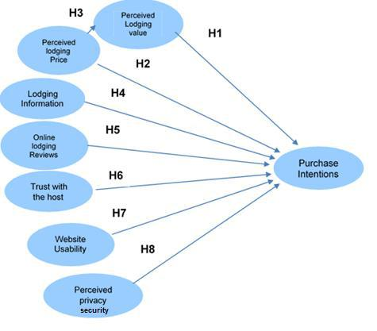

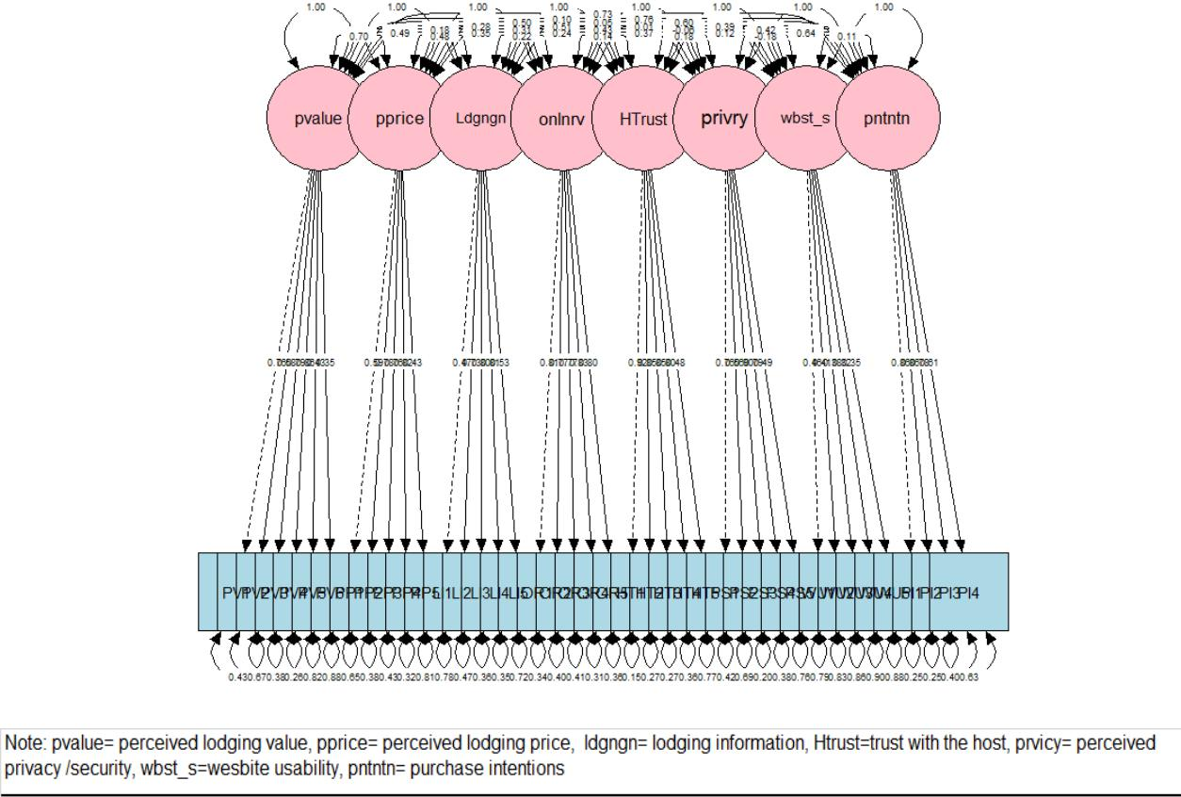
Figure 2 Measurement Model Path Diagram

Figure 3 Adjusted Measurement Model Path Diagram

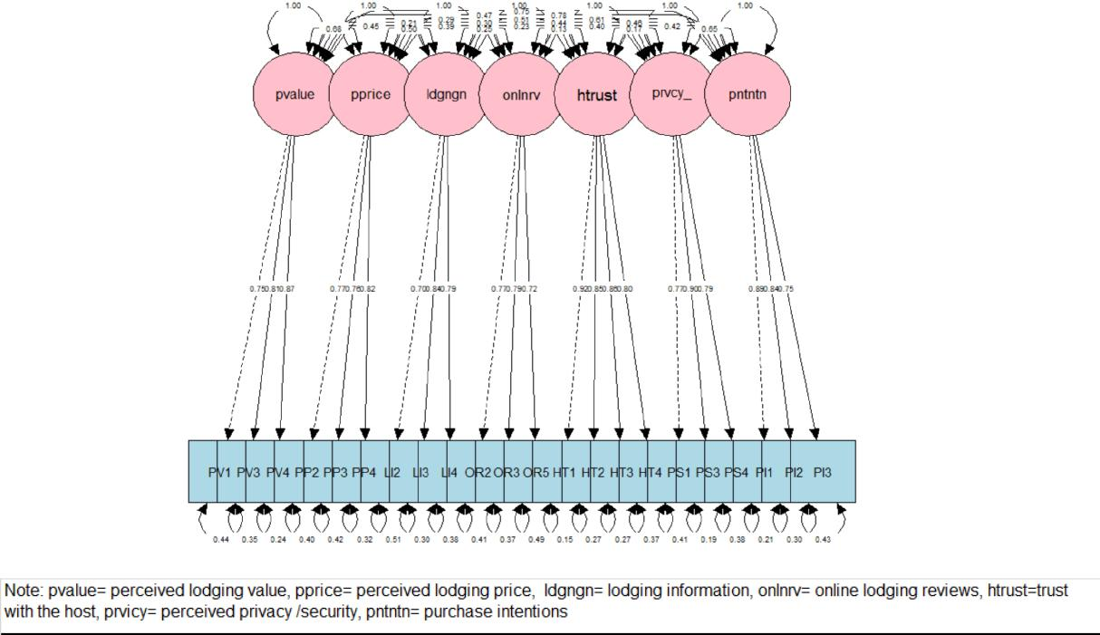
Figure 4 Structural Model Path Diagram
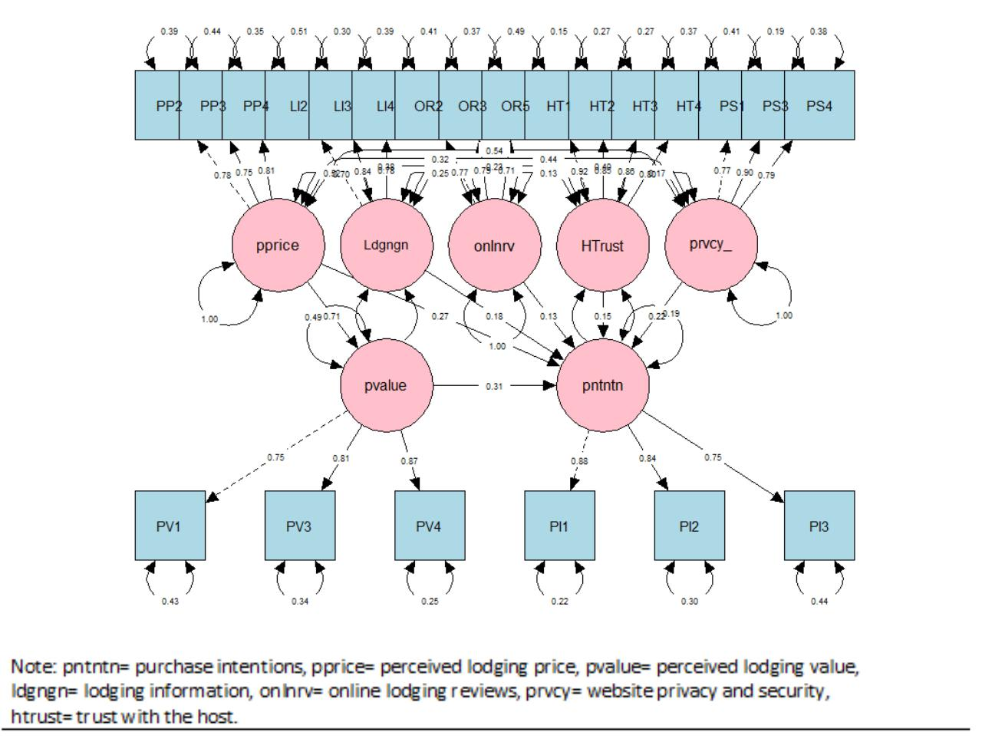

Figure 5 Structural Model Path Diagram
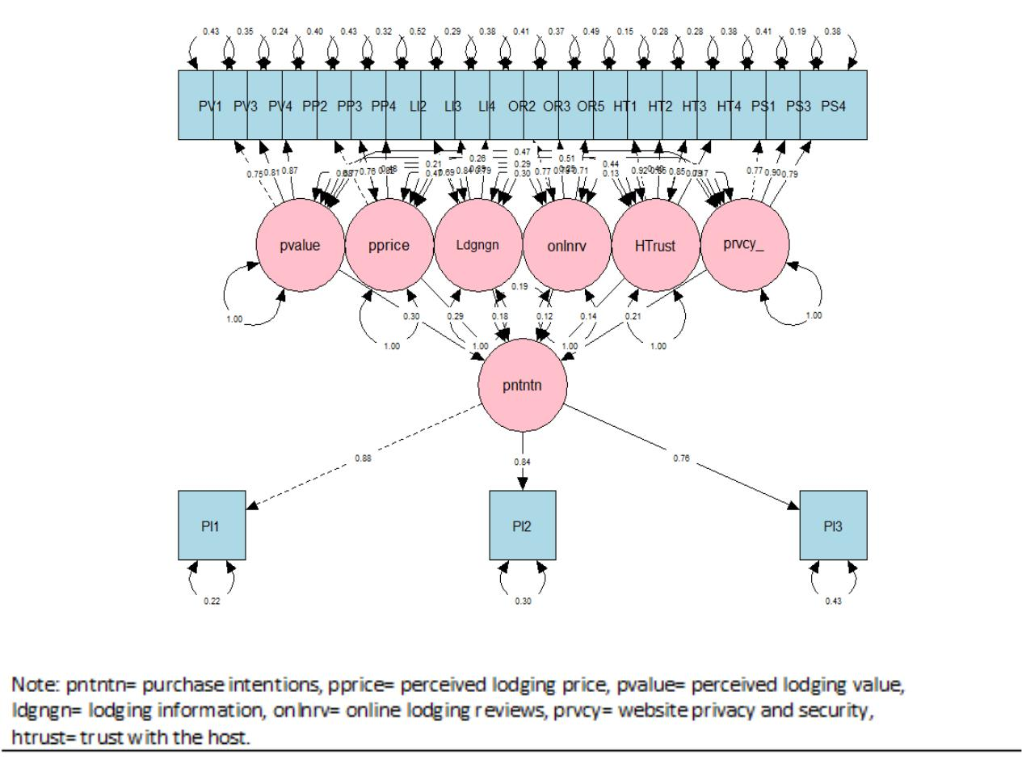

Table 1: Measurement of constructs and indicators
Constructs | Indicators | Literatures
Purchase Intentions | PI1: The probability that I would consider renting accommodation through loading websites is high.  PI2: My willingness to rent accommodation through loading websites is high.  PI3: It is likely that, I will rent accommodation through loading websites in the near future.  PI4: I think of loading website as more beneficial for purchasing accommodation. | Lien et al. (2015); Pavlou (2003); Wen (2012)
Perceived Loading Value | PV1: The loading offers good value for the price paid.  PV2: Loading features match my expectations.  PV3: I like the loading I rent.  PV4: I feel comfortable with the loading purchased.  PV5: These types of loading are booked by many people that value them  PV6: People who take these types of loading obtain social approval. | Lien et al. (2015); Moliner et al. (2007); Sanchez et al. (2006).
Perceived Loading price | PP1: The price listed by the loading in expensive.  PP2: The loading price is reasonable.  PP3: The loading price is affordable.  PP4: The loading price is appropriate in relation to what I got for my money.  PP5: The loading price are cheaper than in other types of travel websites. | Lien et al. (2015); Karura et l. (2013); Zielke (2010).
Loading Information | LI1: The photos for the loading at the site are helpful in making a purchase decision.  LI2: The site provides me with sufficient information about the loading(e.g., amenities, space, price, availability).  LI3: The site offers sufficient information about the profile of the property owner (Host).  LI4: The information offered by loading websites is complete.  LI5: Useful recommendations are made based on my personal information and preferences. | Bart et al. (2005).
Online Loading Reviews | OR1: 1. Online loading are credible.  OR2: Arguments of online loading reviews are persuasive.  OR3: Highly rated online loading reviews are more convincing.  OR4: Online loading reviews help me evaluate accommodation options.  OR5: using online loading reviews make it easier to choose the right accommodation. | Fang (2014); Li et al. (2013); Baum & Spann (2014).
Trust | HT1: Loading hosts have integrity.  HT2: Loading hosts are reliable.  HT3: Loading hosts are trustworthy  HT4: Loading hosts deliver what they promises.  HT5: I trust Loading hosts because they keep my best interests in mind. | Kim, Chung & Lee (2011); Pavlou (2003).
Website Usability | WU1: The site is easy to use.  WU2: The appearance of the site is professional and visually appealing.  WU3: Help functions are useful.  WU4: Fast and accurate search capability.  WU5: The high level of technology online. | Zeithaml et al. (2002); Bart et al. (2005); Chen, Hsu and Lin (2010); Kim, Chung & Lee (2015).
Perceived Privacy/ Security | PS1: The general privacy police is easy to find.  PS2: The site will not use my personal information for any purpose unless I authorize it to do so.  PS3: There were trust seals present.  PS4: The site has good protection against fraud.  PS5: I feel secure about the electronic payment system and using credit cards. | Bart et al. (2005); Suh & Han (2003); Steenkamp & Geyskens ( 2006); Ponte, Trujillo & Rodriguez (2015)
When I rent accommodation through loading websites, I noticed

Table 2: | Descriptive for sample characteristics
Variable N=380 | Percent (%)
Purpose  Holidays  Short-term accommodation | 84.9%  16.1%
Travel Frequency  1  2  3  4  5  6  7  8 | 13.9%  26.7%  27.8%  14.4%  12.2%  2.8%  1.1%  1.1%
Daily Loading Budget  $0 - $50  $50 - $100  $100 - $150  $150 - $200  $400 - $600 | 11.7%  52.8%  25.0%  9.4%  1.1%
Living Country  United Kingdom  Netherlands  El Salvador  United States  Germany  Belgium  Italy  Denmark  Australia | 48.3%  15.6%  11.1%  8.9%  6.1%  5.0%  2.2%  2.2%  0.6%
Gender  Female  Male | 56.1%  43.9%
Age  18-29  30-39  40-49  50-59  Over 60 | 33.9%  51.7%  8.9%  4.4%  1.1%
Education Level  Some College  College/University Degree  Master’s Degree  Doctoral Degree | 5.0%  51.1%  40%  3.3%
Income Level  Very Low  Low  Medium  High | 7.8%  18.5%  54.4%  19.3%

Table 3: Amended measurement model reliability and validity
Constructs/ Indicators | Standardised Item | Error Variance | CR(≥0.7) | AVE(≥0.5)
Perceived loading value  PV1  PV3  PV4 | 0.75  0.81  0.87 | 0.43  0.34  0.24 | 0.85 | 0.66
Perceived loading Price  PP2  PP3  PP4 | 0.77  0.76  0.82 | 0.41  0.43  0.32 | 0.83 | 0.62
Loading Information  LI2  LI3  LI4 | 0.70  0.84  0.79 | 0.51  0.30  0.32 | 0.82 | 0.60
Online Loading Reviews  OR2  OR3  OR5 | 0.77  0.76  0.82 | 0.41  0.43  0.32 | 0.80 | 0.58
Host Trust  HT1  HT2  HT3  HT4 | 0.92  0.85  0.86  0.80 | 0.16  0.28  0.26  0.36 | 0.92 | 0.73
Website privacy/ Security  PS1  PS3  PS4 | 0.77  0.90  0.79 | 0.41  0.19  0.38 | 0.86 | 0.68
Purchase Intentions  PI1  PI2  PI3 | 0.89  0.84  0.75 | 0.22  0.30  0.43 | 0.87 | 0.68
Note: CR= Composite reliability, AVE = Average Variance Extracted
Standardised Item loading are all significant at P-value <0.001 level

Table 4: Adjusted measurement model discriminant validity
Correlation coefficient matrix; square root of AVE= diagonal values
Constructs | PV PP LI OR HT PS PI
Perceived loading value  Perceived loading Price  Loading Information  Online Loading Reviews  Host Trust  Website privacy/ Security  Purchase Intentions | 0.81  0.40 0.79  0.24 0.27 0.77  0.12 0.23 0.14 0.76  0.20 0.21 0.15 0.09 0.85  0.27 0.30 0.24 0.23 0.12 0.82  0.50 0.53 0.38 0.31 0.34 0.44 0.82

Table 5: Summary of structural model fit indices
Indices | GFI AGFI X2/DF RMSEA SRMR NFI NNFI CFI
Criterion  SM value  Result | ≥0.9 ≥0.9 <3 ≤0.08 ≤0.08 ≥ 0.9 ≥ 0.9 ≥ 0.9  0.9 0.9 1.33 0.04 0.05 0.90 0.97 0.97  O O O O O O O O
Note: SM= Structural Model
X2 = 256.299, df= 192p-value=0.001 (<0.001)
O= fit, ∆ = unfit

Table 6: Mediation effect assessment
Specified Path (ß) Path Coefficient
Direct Effect
Perceived loading price Purchase Intentions 0.27**

Indirect Effect 0.22 (=0.71*0.31)
Perceived loading value Purchase Intentions 0.71***
Perceived loading price Perceived loading value 0.31***

Total Effect
Direct Effect + Indirect Effect 0.49
Note: all structural relationships are statistically significant at 0.01 level
p<0.001***, p<0.01**, p<0.05*
Path Coefficient are all standardized values in the table

Table 7: Summary of structural model fit indices
Indices | GFI AGFI X2/DF RMSEA SRMR NFI NNFI CFI
Criterion  SM1 value  Result | ≥0.9 ≥0.9 <3 ≤0.08 ≤0.08 ≥ 0.9 ≥ 0.9 ≥ 0.9  0.9 0.9 1.33 0.04 0.05 0.90 0.97 0.97  O O O O O O O O
Note: SM1= Final Structural Model
X2 = 248.412, df= 188 p-value=0.002 (<0.001)
O= fit, ∆ = unfit

Model Comparison
Df AIC BIC Chisq diff Df diff Pr(>Chisq)
Direct Effects 188 4970.9 5178.4 248.41
Mediating Effect 192 4970.8 5165.6 256.30 7.8876 4 0.09578

Table 8 : Results of testing the research hypotheses
Structural Path Path coefficients Hypothesis testing
H1 Perceived loading value → Purchase Intentions 0.31*** supported
H2 Perceived loading Price → Purchase Intentions 0.27** supported
H3 Perceived loading Price → Perceived loading value 0.71*** supported
H4 Loading Information → Purchase Intentions 0.18** supported
H5 Online Loading Reviews → Purchase Intentions 0.13* supported
H6 Host Trust → Purchase Intentions 0.15** supported
H8 Website privacy/ Security → Purchase Intentions 0.22*** supported
‘*’ 0.05, ‘**’ 0.01, ‘***’0.001
All are standardized path coefficients

