Economical Impact of RFID Implementation in Remanufacturing:
A Chaos-based Interactive Artificial Bee Colony Approach

Vishwa V. Kumar^{1*}, F. W. Liou¹, S. N. Balakrishnan², Vikas Kumar³
¹Department of Manufacturing Engineering, Missouri University of Science & Technology, Rolla, MO-65409, USA.
²Department of Mechanical and Aerospace Engineering, Missouri University of Science & Technology, Rolla, MO-65409, USA.
³Department of Management, Dublin City University Business School, Dublin, Ireland
Abstract: In the modern manufacturing arena, environmental and economical concerns draw considerable attention from both practitioners and researchers towards remanufacturing practices. The success of remanufacturing firms depends on how efficiently the recovery process is executed. Radio Frequency Identification (RFID) technology holds immense potential to enhance the recovery process. The deployment of RFID technology at reverse echelons has the advantage of having a real time system with reduced inventory shrinkage, reduced processing time, reduced labor cost, process accuracy, and other directly measurable benefits. In spite of these expected benefits, the heavy financial investment required in implementing the RFID system is a big threat for remanufacturing companies. This paper examines the economical impact of RFID adoption to remanufacturing. The aim of the research is to compare the basic and RFID-diffused reverse logistics model, and to quantitatively decide whether RFID implementation is economically viable. In order to meet these objectives, we have proposed a Chaos-based Interactive Artificial Bee Colony (CI-ABC) algorithm. Numerical results from using the CI-ABC for optimal performance are presented and analyzed. Comparison between the canonical Artificial Bee Colony and the Particle Swarm Optimization reveals the superiority of the CI-ABC for this application.
Keywords: Remanufacturing, RFID, Artificial Bee colony, Particle Swarm Optimization.
* Corresponding author: Email: E-mail: vishwavijaykumar@gmail.com

- INTRODUCTION
An unprecedented increase in every field of human daily requirements has a direct effect on the burgeoning demand for consumer goods in the last decade. In addition, the customer expects trouble-free use of products over a certain period of time. Consequently, the manufacturers need to produce superior products; this expectation also leads to scientific and technological innovations. Fast emerging manufacturing paradigms have resulted in frequent dumping of products due to technological obsolescence of any components that still have a significant value. The shortening of the product’s life cycle not only puts an extra demand of raw materials to manufacture a new product but also increases the threat to the environment as an inevitable by-product of this process. A growing concern about environment (pollution, global warming and traffic congestion, etc.) has led to a number of take-back legislation and European Union (EU) directives such as: End-of-Life Vehicle (ELV), Closed Substance Cycle and Waste Management Act, and Waste Electrical and Electronic Equipment (WEEE) to collect End-Of-Life (EOL) products and to properly dispose of the hazardous materials (Schultmann et al., 2006; Jung and Hwang, 2011). The economical value of EOL products has generated some interest in manufacturers and needs a better handling approach. A manufacturer can retrieve some components from an EOL product having the same utility as it was in the virgin state, at a much lower cost compared to a new one. For example, manufacturers of toner cartridges (Xerox), single-use cameras (Eastman Kodak and Fuji Film) and photocopiers (Fuji and Xerox), washing machines (ENVIE), computers (IBM) and mobile phones (ReCellular, and Greener Solutions) have profited by a huge amount through reusing durable components (Franke et al., 2006). Thus, various factors such as economical, environmental, legislative, and depletion of natural resources have led to the emergence of a promising field of research termed “remanufacturing”.
Remanufacturing is a process of recapturing parts of value and proper disposal of the hazardous components from a used product. This process is performed in a cost-effective and environmentally friendly manner from the point of consumption to the point of origin of reverse logistics. There are several steps to be followed which can be executed in different order or some steps could even be ignored, depending on the product type, remanufacturing volume etc. Frequently used reverse logistics steps reported in previous studies are termed as: collection, sorting, inspection, cleaning, disassembling, repairing, refurbishing, and disposing (Charter and Gray, 2008). First, inspection operation is performed at the collection centre to justify whether the returned product is directly reusable or needs disassembling to sort out its worn-out parts. At the disassembly centre, the product is disassembled to subassembly and further to the individual part level. The good and moderate quality components are shipped to refurbishing centres to execute cleaning, repairing and replacing operations on any defective or worn out parts, whereas the unendurable ones are sent to landfills at the disposal centre.
Quantitative studies in remanufacturing addresses the various existing complexities such as; Network design (Charter and Gray, 2008; Lee and Dong, 2009), product recovery and distribution planning (Jayaraman, 2006; Pineyro and Viera, 2010), scheduling and shop floor management (Franke et al., 2006; Stanfield et al., 2006), inventory control (Konstantaras and Papachristos, 2007; and Pan et al., 2009), resource allocation (Wang and Yang 2007), routing (Blanc et al., 2006), and third party logistics (Ko and Evans, 2007; Lee et al., 2008). In addition to these, some researchers have highlighted issues related to uncertainty in demand and return rate. Hong et al. (2006) presents a scenario-based robust optimization model, “Reverse Production Systems” (RPS) that employs some electronic goods e-scraps under uncertainty. They implement an RPS model to a case study based in Georgia and linked a relation between RPS processing strategic decisions and RPS collection decisions. Salema et al. (2006) studies a design of reverse logistics network with uncertainty in demand and return, and capacity limits. They developed a mixed integer model to resolve these multi product management issues. Uncertainty in the return rate of an EOL product due to various environmental factors such as law, government policies, and environmental protection issues is considered in Bu and Xu (2008). They formulated an expiration based on above factors and have drawn a mathematical relation between return rate and environmental factors. Recently, Naeem et al. (2013) incorporated both deterministic and stochastic model to determine the optimal quantities that have to controlled for both inventories; recoverable and serviceable in remanufacturing environment. They developed a dynamic programming based model to minimize the total cost, including production cost, holding cost for returns and finished goods, and backlog cost at each period.
Utilisation of state-of-the-art Radio Frequency Identification (RFID) is experiencing an increasing popularity in logistics systems. Addressing the forward logistics problems, many researchers such as Prater et al. (2005), Chow et al. (2006), Nagi et al. (2007), and Pigni and Ugazio (2009) emphasise the adaptation of RFID technology at different echelons viz. manufacturer production sites, warehouses, distribution centres, retail stores, etc. These researchers have developed network models and discussed several benefits of RFID dissemination mainly for real time information, stock-out reduction, process accuracy, and for increasing labour efficiency. However, the cost associated with the RFID adaptation over the traditional shop floor facilities has been ignored by most of the researchers. Only a few recent papers deal with the economical impact of RFID technology on logistics. Veeramani et al. (2008), presents a framework and models for assessing the value of RFID utilization by tier-one suppliers to major retailers. Their paper argues that the RFID implementation is profitable on 5 upper echelons of the supply chain in the context of a real-life application to Wal-Mart’s top 100 suppliers. Bottani and Razzi (2008) evaluate the economical impact of RFID tools on three echelons of fast-moving consumer goods in a supply chain: manufacturers, distributors, and retailers. Their assessment is made by analysing two different scenarios: non-integrated and integrated, which shows that RFID diffusion is not profitable for all scenarios. A cost analysis of an RFID integrated three-echelon supply chain is investigated by Ustundag and Tanyas (2009). They conclude that the total supply chain cost savings are increased by RFID integration.
Although resource allocation and inventory management at forward logistics echelons are similar to the reverse one, they are not exactly the same. Recycling activities differ from production procedure in time and manner such as quantity, category, cycle time, stock keeping unit, and distribution paths. Consequently, the remanufacturing process requires extra care in implementing the RFID technology than the forward supply chain. Moreover, unlike the forward logistics which has been adequately studied, the reverse logistics have not been well studied for the suitability of RFID adoption. Researchers have recently proposed the utilization of RFID in remanufacturing most of them have overlooked its cost in their mathematical models (Lee and Chan, 2009; Yoo and Park, 2009; Dowlatshahi, 2012; etc.). In order to fill this gap, this study focuses on the design of a generic framework of a remanufacturing system which provides a way to measure the economical impact of RFID adoption at various reverse facility centres viz. collection, disassembling, and refurbishing.
It has already been proven that the remanufacturing network design problem belong to the class of NP-hard problems (Doh and Lee, 2010). Hence, random search optimization techniques and their variants have been widely accepted as a more efficient optimization tool over conventional enumeration based optimization techniques; such as genetic algorithm (GA), artificial immune system (AIS), particle swarm optimization (PSO), and their variants (Chan et al., 2011; Kumar et al., 2009; Yadav et al., 2008; etc.). In addition, Artificial Bee Colony (ABC) meta-heuristic has gained adequate favour in this area of research in recent past (Lazzús, 2013; Tsai et al., 2009; Prakash et al., 2008; Kumar et al., 2004; Soleymanpour et al., 2003; etc.). Inspired by successful applications of ABC, in this paper, a new variant of the Artificial Bee Colony algorithm (ABC) called the Chaos-based Interactive Artificial Bee Colony (CI-ABC) Algorithm is used to handle a realistically sized remanufacturing problem. The proposed CI-ABC assimilates the attributes of chaotic systems by introducing stochastic and ergodic properties in searching for the optimal or near optimal solution. Moreover, a new primitive component is combined to update the position of component for enhancing the interaction between employed and unemployed bees. The computational results indicate that the proposed CI-ABC outperforms the canonical ABC and PSO metaheuristics.
The rest of this paper is organized as follows: In section 2, modelling of a suitable objective function for a reverse logistics problem that includes the RFID cost is discussed. Section 3 presents the steps involved in implementing the CI-ABC over the illustrative examples which are discussed in section 4. The results obtained by implementing the aforementioned algorithms are discussed in detail in section 5. Finally, section 6 provides the conclusions from the study and provides directions for further research.

- THE MODEL DEVELOPMENT
This section develops a model to systematically examine the impact of RFID technology on reverse logistics cost factors. In this sense, a general and an RFID-integrated reverse logistics model are illustrated in the subsequent sub-sections.
  - Reverse Logistics Model
Figure 1 depicts a generic reverse logistics network of the system under study. This system starts with returned products including EOL products from customers. First, the returned products are collected at a collection centre where they are sorted. Reusable products are sent back to the manufacturer after the required treatment and the rest of them are transported to the disassembly centre. At the disassembly centre, the product is disassembled to subassembly and further to the individual part level. The components of good and moderate quality are shipped to refurbishing centres for cleaning, repairing, and replacing any defective or worn parts. The unendurable ones are sent to a land fill at the disposal centre. At all three echelons (collection, disassembly, and refurbishing centres), the product/parts are processed through two warehouse processes: inbound moves and outbound moves. The inbound moves include unloading, receiving, and put-away operations during the receiving of the returned products, while outbound moves consist of two operations: picking and loading when the products are shipped to next the echelon. Table 1 summarises the warehouse operations considered in this study.
<< Insert figure 1 about here>>
<< Insert table 1 about here>>
In this study, the manufacturer produces a certain number of products in a certain time period by assembling the virgin and used parts which are in good condition to remanufacture. Virgin parts are purchased from external suppliers while used parts are acquired by disassembling and retrieving the valuable parts from EOL products. Thus, the model is aimed at determining the optimal revival of the used parts in an economical way. In order to articulate this concept into mathematical terms, an objective function (J) is formulated below, followed by a list of all model parameters and decision variables used in this research, which is shown in Table 2.
<< Insert table 2 about here>>

2.1.1. Objective function
The objective function, J, is formulated as follows;
Min (J) = Min (J_{cost} + J_{time}) (1)
In (1), the operation cost (J_{cost}) is defined as:
(2)
This equation reflects the total manufacturing cost that consists of the cost of virgin product and the cost incurred in retrieving potential product/parts from EOL products. The first term shows the cost associated with the purchase of virgin parts to fulfil the customer demand in a time period; the second term considers the cost of collecting the end-of-use product from the final users. The collection cost of a product depends on its type and geographical region from which it was collected and aggregated on return rate ‘r’ of EOL. The third term stands for the cost charged for cleaning or repairing operations of all directly reusable products sorted out at the collection centre. The next three terms consider operating costs of the disassembly, disposal, and refurbishing centres respectively. The operations like landfill of uneconomical and hazardous parts at a disposal centre, breaking of joints to recover reusable parts at a disassembly centre, and repainting of potential parts at a refurbishing centre correspond to operation costs. The seventh, eighth, and ninth terms represent the set-up costs of collection, disassembly, and refurbishing echelons. The last three terms indicate the idle cost of reverse facilities.
The second term in (1), J_{time} represents the operational time cost and is defined as:
(3)
This term counts the time involved in warehouse operations viz. inbound moves (Unloading, Receiving, and Put-away) and outbound moves (Picking and Loading) at echelons; collection, disassembly, and refurbishing centres. Note that the length of operational time depends on the number of items ready for movement between the two consecutive centres.
Normalisation for assimilation
Since the time and cost functions cannot be added directly, they are normalised in the range [0, 1]. The motive of normalization is to make them compatible with each other and to formulate a comprehensive objective function J. The normalised functions for J_{cost} and J_{time} can be defined as:
(4)

(5)
where LB_{cost} and LB_{time} are the lower bounds of J_{cost} and J_{time} respectively, and UB_{cost} and UB_{time}, are the upper bounds.
Based on the normalized objective of cost and time J is reformulated as:
(6)
=Priority weight associated with cost objective.
= Priority weight associated with time objective.
The weight priorities associated with integrated objectives are given by crisp values which are assessed by decision’s maker based on relative importance of cost and time objectives. In case of more priority assigned to cost objective is always greater than and vice versa.

Constraints
The total number of parts of type ‘a’ obtained after disassembling the products at a disassembly centre at time period‘t’ depends on the Bill-Of-Materials (BOM) of the products type, is represented by equation 7.
(7)
The total disassembled parts of type ‘a’ at time period‘t’ are further sorted into disposal and refurbished parts at the disassembly centre, is represented by equation 8.
(8)
The maximum inventory level of product can be equal to the upper capacity limit of the collection centre. Thus the sum of total number of sorted for disassembling and direct reusable purpose is equal to the processing capacity of collection centre of product type ‘p’ at time period ‘t’.
(9)
The maximum inventory level of product can be equal to the upper capacity limit of the disassembly centre:
(10)
The maximum inventory level of parts of type ‘a’ at time-period ‘t’ can be equal to the upper capacity limit of the refurbishing centre:
(11)

The numbers of product ‘p’/part ‘a’ received at echelon ‘e’ in time period ‘t’ have to be satisfy sset-up constraint of different echelons. Here, M is a large predetermined positive number.
(12)
(13)
(14)
A parameter referring to the lower bond of disposal rate of part type ‘a’ is set to DR_{a} in time period ‘t’ that instruct that a fraction of disassembled parts are assumed to be hazardous for that time period ‘t’. Thus, for the whole time horizon it is expressed as:
(15)
Non-negativity and binary constraints are represented by equation 16 and 17 respectively:
(16)
(17)

  - RFID integrated Reverse Logistics Model
RFID system is a wireless technology which enables auto-identification (auto-ID) and traceability of items by transmitting radio waves between an RFID tag and a reader. A tag, which contains a microchip that stores the data, is attached on objects and broadcasts part data such as: manufacturing site, production lot, date of manufacture, expiry date, product and component type, etc. The reader receives this information and converts it into digital data to a computer system. The capability to obtain real-time information about the location and properties of tagged objects influenced various industries to deploy the RFID tool for enhancing the efficiency of their logistics processes. A large number of forward logistics players such as Wal-Mart, The U.S. Defence Department, Metro groups, and Tesco utilise RFID technology and are high profit examples. In reverse logistics, the adaptation of RFID has not been studied much; however, there is significant opportunity in the use of this process to improve operational efficiencies which is being considered in this study. The diffusion of RFID technology at reverse echelons (collection, disassembly, and refurbishing centres) enables increased inbound and outbound operational efficiency through auto-counting and precise instructions. The information and physical flow of the EOL items are presented in figure 1. Moreover, Table 3 summarises advantages of an RFID system in warehouse operations over traditional processes.
<< Insert table 3 about here>>
Based on the information provided in Table 3 the cost and time objective for the RFID adopted reverse logistics model, and is defined as:
(18)
Here, cost factors,, and are the RFID set-up costs at collection, disassembly, and refurbishing centres respectively. Excluding tag cost (), the RFID set-up cost associates all hardware and software costs defined in Section 4. The model equally imposes the RFID set-up cost to all ‘T’ time scenarios. The last term of the equation represents the cost involved in pasting RFID-tags onto all optimally assigned products at collection centres and to the parts at disassembly centres after being disassembled. The RFID tagging is not required at the refurbishing centre as they were already tagged at disassembly centre.
Now,
(19)
The equation calibrates time involved in inbound and outbound moves of warehouse operations. The expressions used in Equation (19) are described below.
(20)
(21)
(22)
(23)
(24)

Again, in order to formulate a compatible overall objective function, (), and are normalised in the range of 0 to 1.
(25)

(26)
where and are the lower bounds of and , and and are the upper bounds.
Thus, the aim of this research is to
Min () (27)
where
=Priority factor associated with cost objective.
= Priority factor associated with time objective.
Constraints
Apart from Constrains 7 to 17, a non-negativity constraint 28 which cannot exceed the value of one numerically is assumed in this study.. That is,
(28)

- SOLUTION METHODOLOGY
The determination of an optimal solution in the reverse logistics problems is a computationally complex process since it requires vast exploration and exploitation of search space. Since this problem is NP-hard, artificial intelligence-based random search techniques have gained favour in this area of research (Kim et al., 2008). Inspired by successful applications of the Artificial Bee Colony meta-heuristic over a closed loop logistics model by Kumar et al. (2010), an improved version of Artificial Bee Colony (ABC) algorithm, known as Chaos-based Interactive Artificial Bee Colony (CI-ABC) algorithm, is used in this study. The following subsections present the proposed methodology in brief.
3.1. An Overview of Artificial Bee Colony
The ABC algorithm is a recently developed (Karaboga, 2005) swarm intelligence technique based on the natural food searching behaviour of bees. In a D-dimensional search space, each solution (S_{xy}) is represented as;
(29)
Here, x = 1,…, SP is the index for solutions of a population and y = 1,.., D is the optimization parameters index.
The probability value which is based on the individuals’ fitness value to summation of fitness values of all food sources and decides whether a particular food source has potential to get status of a new food source is determined as;
(30)
Where, f_{g} and P_{g} are the fitness and probability of the food source ‘g’ respectively.
After sharing the nectar information between the existing onlookers and employed bees, in case of higher fitness than that of the previous one, the position of the new food source is calculated as following:
(31)
where z =1, 2,.., SP is a randomly selected index and has to be different from x. is the food source position at n^{th} iteration, whereas is its modified position in (n+1)^{th} iteration. is a random number in the range of [-1, 1]. The parameter is set to meet the acceptable value and is modified as;
(32)
In this equation, and are the maximum and minimum y^{th} parameter values.
Although the employed and scout bees nicely exploit and explore the solution space, the original design of the onlooker bee’s movement only considers the relation between the employed bee food source, which is decided by the roulette wheel selection, and a food source having been selected randomly (Tsai et al., 2009). This consideration reduces the exploration capacity and thus induces premature convergence. In addition, the position updating factor utilises a random number generator which shows a tendency to generate a higher order bit more random than a lower order bit (Kumar et al., 2010).

3.2. Chaos-based Interactive Artificial Bee Colony Algorithm
In order to avoid the aforesaid shortcomings and enhance the searching capacity of the canonical form of the ABC, a new variant called the Chaos-based Interactive Artificial Bee Colony (CI-ABC) algorithm, has been proposed.
This algorithm is described next.
3.2.1. Basic of chaotic systems
A non-linear system is said to be chaotic if its evolution is very sensitive to the initial conditions and has an infinite number of different periodic responses (Yuan et al., 2002). The ability to generate unbiased random numbers increases the use of chaotic sequences over random number generators in recent years. There are considerable numbers of chaotic operators possessing ergodic and stochastic properties and are reported in literature (Luo and Shen, 2000; Yang and Chen, 2002). In this paper, a “Logistics” (Parker and Chua, 1989) chaotic system is used to replace the random function in the equation (33), which is formulated as:
; (0, 1); n =1,…, N (33)
where is the value of the chaotic variable at n^{th} iteration and is the bifurcation parameter of the system. Figure 2 shows the chaotic graph of the logistic map. This graph has been plotted for 300 iterations with initial values of C₀ = 0.01 and = 4.
<<Include figure 2 about here>>

3.2.2. Proposed CI-ABC
In order to enhance the exploration capacity of foraging bees, the equation for updating new position (equation 31) has been modified by adding a new factor which incorporates more perturbation on the food source position S_{xy}.
The concepts can be mathematically represented as;
(34)
where C_{n}[-1, 1] stands for the chaotic value obtained from equation (33) at n^{th} iteration. w{1,...,W}, an index refers to the bee having the largest nectar amount. It is the best global position found by any employed bee so far. The index w may be to x or z, depending on whether the x or z index referred bees achieved best position in the population.
The newly added term brings diversification in the search and facilitates each bee to interact with a higher number of neighbourhoods. Another advantage of this term is to help get better convergence toward the goal of the bees. For easy comprehension, a flow chat of the proposed algorithm (CI-ABC) has been detailed in Figure 3.
<< Insert figure 3 about here>>
- ILLUSTRATIVE EXAMPLES
This section presents a numerical example to check the efficacy and scalability of the proposed algorithm. The dimension of the test cases has been varied irregularly with a view to show flexibility in an underlying model. The planning horizon for demand and supply of products considered is taken in six time periods (T=6). Table 4 summarises the numbers of product that are to be manufactured according to their own production plan under 6 time periods. The test beds conceived in this paper have to manufacture 8 different numbers of product-types. Table 5 shows Bill-Of-Material (BOM) of each product by which part-types are assembled to a product. The BOM can have a maximum of 9 different part-types for each individual product.
<<Include table 4 and 5 about here>>
The unit purchasing cost from external supplies is set to be 20, 25, 22, 32, 25, 33, 68, 25, and 35 dollars for part-type 1 to 9 respectively. Furthermore, the idle costs of the echelons; collection, disassembly, and refurbishing centres are fixed at 2900, 2500, and 2700 dollars respectively.
The return rate ‘r’ is limited by the environmental factors which have a maximum of 0.90 for any scenario. The test case set an upper fraction of EOL products going to be directly reusable is 0.25 (DR_{p}= 0.25; ‘p’) and the lower bound for the disposal rate for all part types in each time period is 0.30 (RR_{p}= 0.30; ‘p’). The set-up costs for each product/Part-type are set as: collection centre (SCC_{p}=$0.2; ‘p’), disassembly centre (SCD_{p}=$0.4; ‘p’), and refurbishing centre (SCR_{a}=$0.25; ‘a’). Furthermore, the upper limit of product-types and part-types to be operated at three centres is listed in table 6. Table 7 summarises the operating costs on these echelons. Owing to integrity with time objectives of the paper, the parameters related to implementing RFID at different reverse logistics echelons are outlined in Table 8. The costs of RFID adoption encompass hardware and software costs. For the RFID-hardware set-up, different technical devices such as tags, RFID mobile reader, shock-proof shielding gates, and RFID printer are taken into account. Unitary costs have been derived from Bottani and Rizzi (2008) and are listed in Table 9. The proposed procedure is used in conjunction with the above data on different cases.
<<Include table 6, 7, 8, and 9 about here>>
The next section describes the numerical results from the proposed CI-ABC on the reverse logistics problems.
- RESULTS AND DISCUSSION
This section is devoted to report and analyze the effect of different values of CI-ABC approach parameters on its performance. In order to check the efficacy of the proposed algorithm, canonical ABC and PSO algorithms are also tested on the illustrative example. The algorithms have been coded in C++ and executed on an Intel® core™ i5 CPU M @ 2.4 GHz and 4GB of RAM.
5.1. Parameters Settings
Extensive experimental tests were carried out to see the effect of different values of the parameters on the performance of all three algorithms. The population size has been varied in the range of 10-100 in steps of 10, and it was observed that the CI-ABC algorithm obtains best results with a population size of 70. It was also observed that although lesser population size reduces the computational time, it fails to achieve an optimal solution, and vice versa, in the case of higher population size. Thus, the population size of 60 was facilitated to obtain optimal solutions in a reasonable computational time. Similarly, the parameters value that assisted in finding optimal or near optimal solutions in case of PSO, and ABC, are presented in Table 10.
<< Insert table 10 about here>>
For the evaluation of the objective function, experiments have been performed for 50 runs, and the lower and upper bounds of set cost and time objectives are calculated. Since the operation time changes with varied integration of RFID technology to reverse logistics, the cost and time limits for each case comes out to be different, as shown in table 11.
<< Include table 11 about here>>

5.2. The Encoding Schema
Integer coding is followed for the string representation so that each echelon and external supplies centre is assigned the value of a unique positive integer. A set of solution candidates equal to the number of the employed bees are generated. Each string segment denotes an individual reverse facility centre (collection, disassembly, refurbishing, and disposal) and external supplier. In order to assign the value of return rate in different scenarios, a separate string is followed which comprises integer values. For example, in the following 5-tuple string representation, <213; 189; 985; 24; 94>, integers represents the number of products/parts assigned to collection, disassembly, refurbishing, disposal, and external supplier centre in a certain time period respectively.
5.3. Performance Compression
The proposed algorithm has been applied to the illustrative example underlined in the previous section. Equal priority has been assigned to both time and cost objectives. First, the results obtained from the basic reverse logistics model (equation 6) are given in Table 12. Also, for an easy appraisal, normality values of time (N_J_{time}) and cost (N_J_{cost}) have been outlined in Table 12. On the basis of the results marked in Table 12, it is evident that, although CI-ABC produced the same quantitative results as ABC and PSO, it significantly outperforms the both when compared in terms of computational time and the number of function evaluation. In front of 192th function evaluation for the CI-ABC, PSO terminates at 398th. Figure 4 illustrates the convergence rate of solution with the number of function evaluations when algorithms are applied in the illustrated example. The following inference can be drawn from Figure 4: CI-ABC has the fastest convergence rate. However, PSO terminates better than CI-ABC in the middle, but with the increase in number of iterations, its convergence rate becomes almost constant.CI-ABC and ABC both initially converge with the same rate, and CI-ABC, in the long run, yields better solutions over others.
<< Insert table 12 about here>>
<< Insert figure 4 about here>>
In the process of getting the optimal objective value, the assigned numbers of parts/products to reverse facility centres are listed in Tables 13-15. Table 13 represents the reusable product to go to the manufacturer directly after minor cleaning operation. Table 14 summarizes the product quantities needed to disassemble for sorting into recoverable and disposable parts. Furthermore, the rest of the required parts purchased from external suppliers to fulfil the customer’s demands are listed in Table 15.
<< Insert table 13, 14, and 15 about here>>
5.4 Impact of RFID Technology
In order to analyse the impact of RFID diffusion in reverse echelons, the proposed algorithm is implemented on the RFID integrated reverse logistics model (equation 27). In contrast to the objective value (0.7275) of the basic reverse logistics model, the minimal objective value is evaluated by the CI-ABC as 0.7859. The figure reveals that the RFID-enabled scenario is uneconomical under the given data in Section 4. The result, however, reflects improvement in operational time performance by reducing the time objective by 53.3 %; it increases the overall cost objective by 34.6%. The “hiking in cost” objective is primarily due to huge investments in software and hardware equipment at different echelons of reverse logistics. Consequently, the cost of RFID tags put heavy economical load in tagging the returned parts/product. It can be concluded that, €0.15/unit tag is still too high to enable the diffusion of RFID in reverse logistics. Nevertheless, such costs are widely compensated by time saving in inbound and outbound moves. The benefit of time saving in unloading, receiving, put-away, picking, and loading operations are achieved from a dramatic shortening of time required to perform replenishment cycle and inventory counts.
The above finding of RFID-based reverse logistics model depended on a number of parameters that we assumed to be constant in the illustrative example. However, in corporate reality, the different quality of RFID hardware and software that is utilised, significantly affects the installation cost of RFID technology in reverse logistics. For this reason, sensitivity analysis is performed for RFID equipments, capacity of reverse echelons, and the parameter related to chaotic generator.
5.4.1 RFID equipment costs
It can be examined from the objective values of basic reverse logistics model and RFID-based reverse logistics model, that the latter is uneconomical due to the high cost of adoption of an RFID project. At present, the cost of RFID implementation comprises the major investment in hardware, application software, middleware, tags, and the cost of integrating the RFID system with the legacy systems. Tag costs represent a major cost factor as they have to be supplied in high quantities. In market, the costs of these tags vary significantly which refer bulk or small orders of tags purchased. As the research aim is to utilise high quantities of tags at collection, disassembly, and refurbishing centres, an analysis is performed by varying the investment cost of all hardware and software defined in Table 9 for the successful diffusion of RFID technology. Since the tags are utilized in high quantities, we investigate the impact of RFID equipment at two different stages. Firstly, excluding the tags, Figure 5 gives the sensitivity of all hardware and software costs an objective value. Furthermore, the impact of RFID tags is depicted in Figure 6.
<< Insert figure 5 about here>>
<< Insert figure 6 about here>>
As expected, Figures 5 and 6 shows that the price depreciation of RFID hardware and software creates great influence on remanufacturing. Though the implementation of RFID technology is uneconomical at present equipment prices, it will create a favourable environment for remanufacturers in the near future. It is easily noticed from the figures that a 55 % decrement tag’s price and a 25% decrement in other RFID equipment, produce same the objective of the basic reverse logistics model. In this scenario, the hike in objective value arises due to RFID-equipment costs is easily compensated by the operational time reduced after RFID installation.
5.4.2 Capacity of reverse echelons
The successful implementation of any new technology relies on how effectively it is utilised by the system on which it is applied. In this research, the adoption of RFID has been proposed at reverse echelons that encompass RFID equipment, such as tags, readers, fixed and mobile devices, and related software. As mentioned above, the RFID tags only variable parameter is a quantity that depends on the optimal assignment of parts/products to the echelons. Thus, the capacity of reverse echelons is an important influential factor in the proposed model.
In order to investigate the effect of operational capacity over solution quality, the upper capacity limit of three echelons viz. collection, disassembly, and refurbishing centres varies by an even percentage amount. The result has been drawn in Figure 7.
<< Insert figure 7 about here>>
From Figures 7, it is analysed that the objective value decreases with the increase in capacity up to a certain level. Above this level the value became constant and the manufacturer is not getting any additional profit for extension of the centres. Such a result reveals that RFID implementation is favourable at the centres having a very high capacity limit. In this case, only RFID tags put additional costs, while the other equipment costs are the same for the echelons having lower operational capacity.
5.5. Effort Analysis for RFID Adoption.
The variation in demand of a new product and the returning of a used one are considered on seasonal basis in six time-horizons (T=6). The duration of an individual time period can be assumed in an hour, day, or month depending on the flow of the products. However, the maximum limit of operating products on the reverse echelons is not only controlled by such consideration, but also by the capacity of the corresponding echelon. A centre can only allow the maximum number of products to be operated which is minimum from the maximum capacity limit and maximum flow of EOL products in a time period.
As the underlying model consists of cost and time objectives for different activities, a trade-off analysis of both is difficult to execute with the constraints discussed above. In order to examine a correlation, the inventory level defined in the equations 9, 10, and 11 are eliminated from the model. Moreover, the time periods are considered as order numbers (T=1 is order number 1 and so on), so that the product-types/ parts-type of any order can be operated just after the previous one. The result shows that the saving in time for in-bound and out-bound moves is 15.6%, 20.3%, 17.2%, 11.3%, 21.7%, and 15.3% for order numbers 1 to 6 respectively. Similarly, the extra burden on cost objectives are 8.6%, 7.7%, 8.1%, 11.3%, 6.8%, and 8.1%. A correlation that can be set from here is that the adoption of RFID technology is economically viable in the long run for remanufacturers. Since there is no inventory limit at the echelons, a sufficient number of refurbished products/parts are ready for re-use at low cost, which will reduce the burden on new parts from the external supplier.
5.6. Impact of Chaos Parameter on the Solution
In the proposed CI-ABC, the bifurcation parameter is used with the numerical value 3.5 to generate chaotic variables using equation (33). The computational experiments are performed by varying the value of between 2 and 4 in Figure 8, and establishing that the solution quality increases with the increase in the value of. It can also be seen from Figure 8 that, as attains value of 3, this comes in the region of the chaotic regime. Actually, this is the location of the first bifurcation and the logistic equation becomes super stable at this point. As the growth rate exceeds 4, all orbits zoom to infinity and the modelling aspects of this function become useless. Hence, this is the reason why the value of stops at 4 and for this value the chaotic system performs best.
<< Insert figure 8 about here>>
5.7. Limitation of proposed CI-ABC
The following aspects are relevant to the performance of the algorithm.
- Problem implementation: A decision maker is required only to evaluate the generated seed solutions and compare the estimated objective values. Thus, the cognitive load is not very arduous and it is not too complex to use CI-ABC in solving real problems. However, evaluation of the generated solutions and determining their preference values is a key issue.
- Parameter effect: The algorithm moves towards the global best position by adjusting the trajectory of each bee towards its own best position and the nectars’ best position. The determination of the employed and unemployed (Onlooker, and Scout) bees and probability function are critical factors. Also, the chaotic function requires careful estimation.
- Convergence: The decision maker’s preference model guides the search to explore the discrete Pareto front of seed solutions. Albeit, the algorithm performed very well to converge to the near optimal solutions. In each of the cases that use Linear value, Quadratic value, L-4 metric value, and the Tchebycheff value functions the percentage scaled deviation remains about 1 % to 2%.

6. CONCLUSION AND FUTURE REMARKS
Implementing RFID technology in remanufacturing is more likely to bring about change, like the abandonment of outdated recovery processes. It can contribute to real-time quality information and increased efficiency in reverse logistics. Through this research, the authors have demonstrated that the RFID technology can effectively improve inventory control, operational efficiency, and data visibility at reverse echelons, i.e., at collection, disassembly, and refurbishing centres. However, the present price of RFID equipment (hardware and software) is still one of the main cost factors when implementing RFID. We studied an illustrative example on a basic and a RFID-based reverse logistics model to quantitatively decide whether RFID technology is feasible and economically viable. In order to execute this task, the paper proposes a new variant of artificial bee colony algorithm, namely the Chaos-based Artificial Bee Colony (CI-ABC) approach. The analysis showed that the RFID-enabled scenario is uneconomical at present equipment prices but it has a potential to create a favourable environment for remanufacturers in the near future. For the comparative analysis of the proposed CI-ABC algorithm it was compared with ABC, and PSO algorithms, over a problem instances. The comparison shows that the proposed algorithm outperforms others in terms of computational time and rate of convergence.
The paper put forwards a number of future research directions for interested researchers. Future research can be aimed at: (i) Checking the improvement in process accuracy; (ii) Sensitivity analysis of various cost factors such as operational, disposal, and inspection can be considered; (iii) Application of the proposed model to a real remanufacturing corporation; and (iv) Utilising the multi-objective techniques for solving the problems.

REFERENCES
- Blanc I. L., Krieken M. V., Krikke H., and Fleuren H., 2006, Vehicle routing concepts in the closed-loop container network of ARN a case study, OR Spectrum, 28, 53-71.
- Bottani E., and Rizzi A., (2008), Economical assessment of the impact of RFID technology and EPC system on the fast-moving consumer goods supply chain, Int. J. Production Economics, 112, 548–569.
- Bu X. and Xu S., 2008, The profit model in reverse logistics under the different environmental factors, IEEE Int. conference on service operations and logistics, Beijing, China, 1215-1220.
- Charter M. and Gray C., 2008, Remanufacturing and product design. Int. J. Product Development, 6(3/4), 375-392.
- Doh H-H and Lee D-H, 2010, Generic production planning model for remanufacturing systems. Proc. IMechE Part B: J. Engineering Manufacture, 224(1), 159-168.
- Dowlatshahi S.. 2012, A framework for the role of warehousing in Reverse Logistics. International Journal of Production Research, 50(5), 1265–1277.
- Franke C., Basdere B., Ciupek V., and Seliger S., 2006, Remanufacturing of mobile phones-capacity, program and facility adaptation planning. The international journal of management science, 34, 562 – 570.
- Hong I H., Assavapokee T., Ammons J., Boelkins C., Gilliam K., Oudit D., Realff M. J., Vannícola J. M., and Wongthatsanekorn W., 2006, Planning the e-Scrap Reverse Production System Under Uncertainty in the State of Georgia: A Case Study. IEEE Transactions on Electronics Packaging Manufacturing, 29 (3).
- Jayaraman V., 2006, Production planning for closed-loop supply chains with product recovery and reuse: an analytical approach. International Journal of Production Research, 44(5), 981–998.
- Jung K. S., Hwang H.. 2011, Competition and cooperation in a remanufacturing system with take-back requirement. Journal of Intelligence Manufacturing, 22:427–433.
- Karaboga D., 2005, An idea based on honey bee swarm for numerical optimization. Technical Report-TR06, Erciyes University, Engineering Faculty, Computer Engineering Department.
- Karaboga D. and Basturk B., 2007, A powerful and efficient algorithm for numerical function optimization: artificial bee colony (ABC) algorithm. J Glob Optim., 39, 459–471.
- Kim M-C., Kim C. O., Hong S. R., Kwon I. H., 2008, Forward–backward analysis of RFID-enabled supply chain using fuzzy cognitive map and genetic algorithm, Expert Systems with Applications, 35, 1166–1176.
- Ko H. J. and Evans G. W., 2007, A genetic algorithm-based heuristic for the dynamic integrated forward/reverse logistics network for 3PLs, Computers & Operations Research, 34 (2), 346–366.
- Konstantaras I. and Papachristos S., 2007, Optimal policy and holding cost stability regions in a periodic review inventory system with manufacturing and remanufacturing options. European Journal of Operational Research, 178, 433-448.
- Kumar V. V., Chan F. T. S., Mishra N., and Kumar V., 2010, Environmental Integrated Closed loop Logistics Model: An Artificial Bee Colony Approach, 8th International conference on SCMIS, 6-8 October 2010, Hong Kong.
- Kumar V. V., Pandey M. K., Tiwari M. K., and Ben-Arieh D., 2010, Simultaneous optimization of parts and operations sequences in SSMS: a chaos embedded Taguchi particle swarm optimization approach, Journal of Intelligent Manufacturing, 21(4), 335-353.
- Kumar, V.V., Tripathi M., Pandey M. K., Tiwari M. K., 2009. Physical programming and conjoint analysis-based redundancy allocation in multistate systems: a Taguchi embedded algorithm selection and control (TAS&C) approach. In: Proceedings of the Institution of Mechanical Engineers, Part O: Journal of Risk and Reliability, 223 (3), 215–232.
- Kumar R., Tiwari M. K., and Shankar R.. 2003, Scheduling of Flexible Manufacturing Systems: An Ant Colony optimization Approach, Proc. IMechE: Part B: Journal of Engineering Manufacture, 217(10), 1443-1453.
- Lazzús J.A.. 2013. Hybrid particle swarm-ant colony algorithm to describe the phase equilibrium of systems containing supercritical fluids with ionic liquids. Communications in Computational Physics, 14 (1), 107-125.
- Lee D. H., Bian W., Dong M., 2008, Multiproduct Distribution Network Design of Third-Party Logistics Providers with Reverse Logistics Operations. Journal of the Transportation Research Board, 26-33.
- Lee C.K.M., Chan T.M., 2009, Development of RFID-based Reverse Logistics System. Expert Systems with Applications, 36, 9299–9307.
- Lee D. H. and Dong M., 2009, Dynamic network design for reverse logistics operations under uncertainty. Transportation Research Part E, 45, 61–71.
- Luo C. Z., Shao H. H., 2000, Evolutionary algorithms with chaotic perturbations. Control Decision, 15, 557–560.
- Naeem M. A., Dias D. J., Tibrewal R., Chang P. C., Tiwari M. K.. 2013, Production planning optimization for manufacturing and remanufacturing system in stochastic environment. Journal Intelligence Manufacturing, 24, 717-728.
- Ngai E.W.T., Cheng T.C.E., Au S., and Lai K.H., 2007, Mobile commerce integrated with RFID technology in a container depot, Decision Support Systems 43 (1), 62–76.
- Neslihan O. D., and Hadi G., 2008, A mixed integer programming model for remanufacturing in reverse logistics environment. Int J Adv Manuf Technol, 39, 1197–1206.
- Pan Z., Tang J., Ou L., 2009, capacitated dynamic lot sizing problems in closed-loop supply chain. European Journal of Operational Research, 198, 810–821.
- Parker T. S., and Chua L. O., 1989, Practical numerical algorithms for chaotic system. Berlin, Germany: Springer-Verlag.
- Pigni, F., Ugazio, E., (2009), Measuring RFId Benefits in Supply Chains. In: Proceedings of the Fifteenth Americas Conference on Information Systems, San Francisco, California.
- Pineyro P. and Viera O., 2010, The economic lot-sizing problem with remanufacturing and one-way substitution, Int. J. Production Economics. 124, 482–488.
- Prakash A., Tiwari M. K., and Shankar R.. 2008, Optimal job sequence determination and operation machine allocation in flexible manufacturing systems: an approach using adaptive hierarchical ant colony algorithm, Journal of Intelligent Manufacturing, 19 (2), 161-173.
- Salema M. I. G., Barbosa-Povoa A. P. and Novais A. Q. (2006), An optimization model for the design of a capacitated multi-product reverse logistics network with uncertainty, European Journal of Operation Research, 179 (3), 1063-1077.
- Schultmann F., Zumkeller M. and Rentz O. (2006), Modeling reverse logistic tasks within closed-loop supply chains: An example from the automotive industry, European Journal of Operational Research, 171 (3), 1033–1050.
- Soleymanpour D.M., Vrat P., and Shankar R.., Ant colony optimization algorithm to the inter-cell layout problem in cellular, manufacturing, European Journal of Operational Research, 157(3), 592-606.
- Stanfield P. M., King R. E., and Hodgson T. J., 2006, Determining sequence and ready times in a remanufacturing system. IIE Transactions. 38, 597–607.
- Tsai P.W., Pan J.-S., Liao B.-Y., and Chu S.-C., 2009, Enhanced artificial bee colony optimization,” International Journal of Innovative Computing, Information and Control, 5(12).
- Ustundag A., and Tanyas M., 2009, The impacts of radio frequency identification (RFID) technology on supply chain costs, Transportation Research Part E: Logistics and Transportation Review, 45 (1), 29–38.
- Veeramani D., Tang J., & Gutierrez A., 2008, A framework for assessing the value of RFID implementation by tier-one suppliers to major retailers. J. Theor. Appl. Electron. Commer, Res., 3(1), 55-70.
- Wang I. L. and Yang W. C, 2007, Fast Heuristics for Designing Integrated E-Waste Reverse Logistics Networks. IEEE Transactions on Electronics Packaging Manufacturing, 30(2), 147-154.
- Yadav S. R., Dashora Y., Shankar R., Chan Felix T.S, and Tiwari M.K., 2008, An interactive particle swarm optimization technique for selecting a product family and designing its supply, International Journal of Intelligent Systems Technologies and Applications, 31 (3-4), 168-186.
- Yang L., Chen T., 2002, Application of Chaos in Genetic Algorithms, Communication Theoretical Physics, 38, 168–72.
- Yuan X. H., Yuan Y. B. and Zhang Y. C., 2002, A hybrid chaotic genetic algorithm for short-term hydro system scheduling. Mathematical Compu. Simulation, 59, 319–327.

TABLES AND FIGURES

Manufacturer
Customers
Figure 1: Reverse logistics network
Disposal Centre
Collection Centre

Refurbishing Centre

Disassembly Centre

Forward logistics
External Suppliers

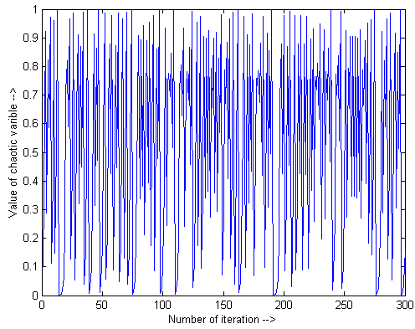
Figure 2: Logistic mapping

iter = iter+1
End
Randomly generate solution space (a set of food source location)
New solution for Onlooker bees
Is termination criteria met?
True
False
iter =1
Evaluate the fitness value (Nectar amount)
Update position (eqn. 34)
Produce new Solution space by adoption the Selection process of higher probability value
Compute chaotic system (eqn. 33)
Figure 3: Flowchart of the proposed CI-ABC algorithm
Produce new solutions from neighbourhood search or previous iteration
Evaluate probability value of each food source (equation 30)

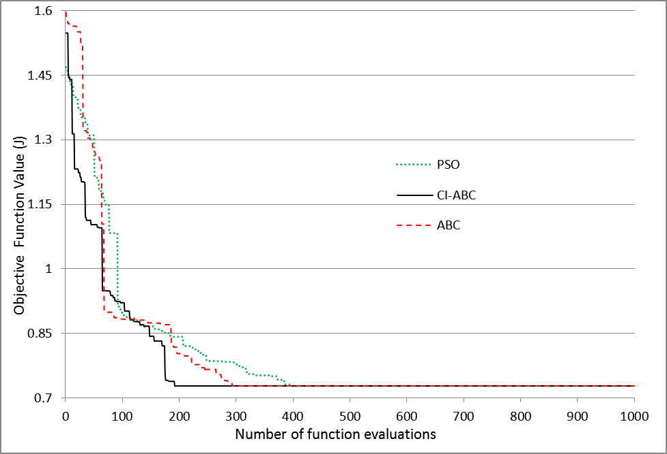
Figure 4: Solution convergence rate

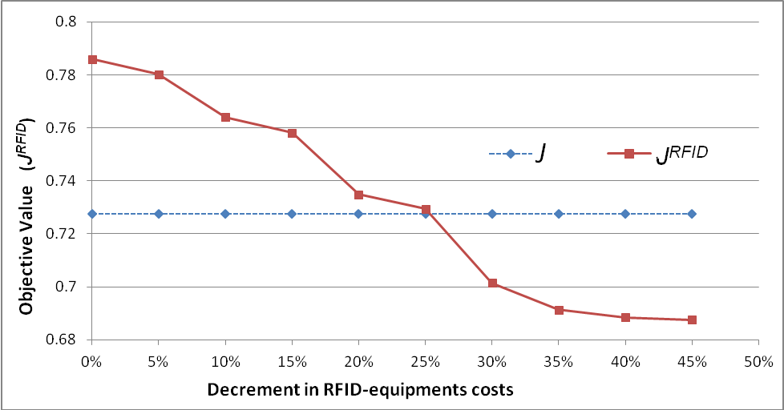
Figure 5: Sensitivity analysis of the RFID-equipments

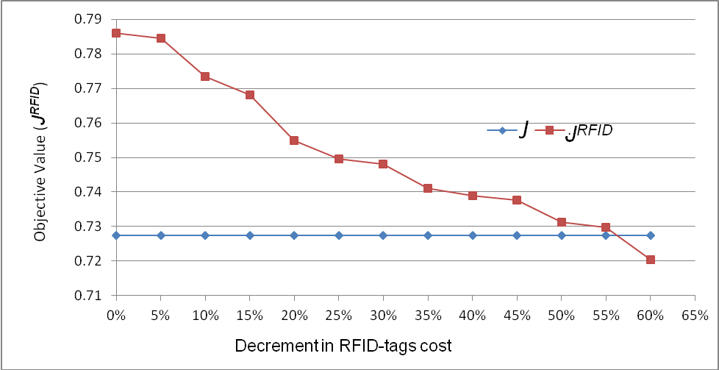

Figure 6: Sensitivity analysis of the RFID-tags

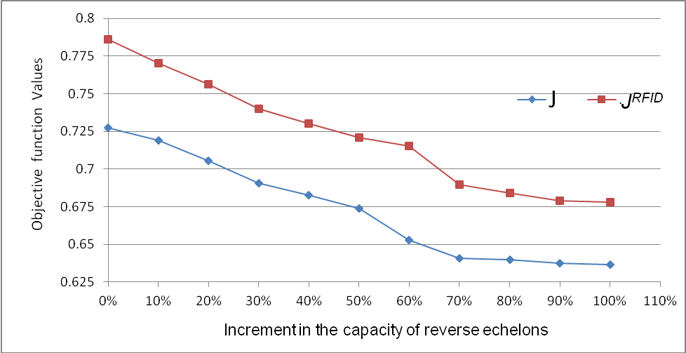
Figure 7: Sensitivity analysis of the reverse echelons capacity

Figure 8: Impact of bifurcation parameter on objective value

Table 1: Main Warehouse Operations
Movement type | Operations
Inbound Moves | Unloading | Receiving |  | Put-Away
Outbound Moves | Picking |  | Loading

Table 2: List of indices, notations, and decision variables
Indices
p= 1, 2,…,P |  | Index for Product-type
a = 1, 2,…,A |  | Index for Part-type
e=1, 2,.., K |  | Index for echelons; (collection centre (e=1), disassembly centre (e=2), refurbishing centre (e=3), and disposal centre (e=4))
t = 1, 2,…,T |  | Index for time Period
Notations
N_{at} | The total number of part ’a’ required by the manufacturer in time the period ‘t’
S_{pt} | The total number of product type ‘p’ supplied by the manufacturer in the time period ‘t’
PCC_{p} | The processing capacity of collection centre of product type ‘p’.
PCD_{p} | The processing capacity of disassembly centre of product type ‘p’
PCR_{a} | The processing capacity of refurbishing centre of part ‘a’
DP_{at} | The total number of part ‘a’ obtains after disassembling at disassembly centre in the time period ‘t’
RR_{p} | A parameter referring to the upper bond rate of directly reusable product ‘p’ sorted at collection centre.
DR_{a} | A parameter referring to the lower bond of disposal rate of part ‘a’
CC_{p} | The collection cost per unit of returned product type ‘p’
OCR_{p} | The operating cost of reusable product ‘p’
OCD_{p} | The operating cost for disassembling per unit of product ‘p’
OCR_{a} | The operation cost for refurbishing per unit of part ‘j’
DC_{a} | The disposal cost per unit of disposable Part ‘a”
SCC_{p} | The set-up cost for return product ‘p’ at collection centre.
SCD_{p} | The set-up cost for disassembling collected product ‘p’
SCR_{a} | The set-up cost for refurbishing disassembled part ‘a’
PCES_{a} | The purchasing cost per unit of part ‘a’ from supplier at time ‘t’
ICC | The idle cost of the collection centre
ICD | The idle cost of the disassembly centre
ICR | The idle cost of the refurbishing centre
UT_{e,p/a} | The unloading time per unit product ‘p’/part ‘a’ at echelon ‘e’
RT_{e,p/a} | The receiving time per unit product ‘p’/part ‘a’ at echelon ‘e’
AT_{e,p/a} | The put-away time per unit product ‘p’/part ‘a’ at echelon ‘e’
LT_{e,p/a} | The loading time per unit product ‘p’/part ‘a’ at echelon ‘e’
PT_{e,p/a} | The picking time per unit product ‘p’/part ‘a’ at echelon ‘e’
NU_{et} | The numbers of product ‘p’/part ‘a’ unloaded at echelon ‘e’ in time period ‘t’
NR_{et} | The numbers of product ‘p’/part ‘a’ received at echelon ‘e’ in time period ‘t’
NA_{et} | The numbers of product ‘p’/part ‘a’ put away at echelon ‘e’ in time period ‘t’
NL_{et} | The numbers of product ‘p’/part ‘a’ loaded at echelon ‘e’ in time period ‘t’
NP_{et} | The numbers of product ‘p’/part ‘a’ picked at echelon ‘e’ in time period ‘t’
EUT_{e,p/a} | The percentage efficiency increscent in unloading time per unit product ‘p’/part ‘a’ at echelon ‘e’
ERT_{e,p/a} | The percentage efficiency increscent in receiving time per unit product ‘p’/part ‘a’ at echelon ‘e’
EAT_{e,p/a} | The percentage efficiency increscent in put-away time per unit product ‘p’/part ‘a’ at echelon ‘e’
ELT_{e,p/a} | The percentage efficiency increscent in loading time per unit product ‘p’/part ‘a’ at echelon ‘e’
EPT_{e,p/a} | The percentage efficiency increscent in picking time per unit product ‘p’/part ‘a’ at echelon ‘e’
UT’_{e,p/a} | The unloading time per unit product ‘p’/part ‘a’ after diffusion of RFID at echelon ‘e’
RT’_{e,p/a} | The receiving time per unit product ‘p’/part ‘a’ after diffusion of RFID at echelon ‘e’
AT’_{e,p/a} | The put-away time per unit product ‘p’/part ‘a’ after diffusion of RFID at echelon ‘e’
LT’_{e,p/a} | The loading time per unit product ‘p’/part ‘a’ after diffusion of RFID at echelon ‘e’
PT’_{e,p/a} | The picking time per unit product ‘p’/part ‘a’ after diffusion of RFID at echelon ‘e’
Decision variables
NDP_{pt} | The number of disassembled product ‘p’ at time ‘t’
NR_{at} | The number of refurbishing part ‘a’ at time ‘t’
NH_{at} | The number of disposable part ‘a’ at time ‘t’
NP_{at} | The number of purchased part ‘a’ from external supplier at time ‘t’
VR_{at} | The binary variable for set-up of refurbishing part ‘a’ at time ‘t’
VD_{pt} | The binary variable for set-up of disassembly product ‘p’ at time ‘t’
VC_{pt} | The binary variable for set-up of collected product ‘p’ at time ‘t’

Table 3: Benefits from implementing RFID technology
Inbound Moves | Benefits
Unloading | - Reduction in waiting time before unloading  - Increased visibility of incoming product  - Real time monitoring and control  - Automated services
Receiving | - Pallet labels cost  - Manpower cost for labeling of pallets  - Manpower cost for checking of received pallets and updating the information to control room  - Manpower cost for amending data errors
Put Away | - Manpower cost for paper works  - Cost of shrinkage; misplacement, spoilage, shoplifting, and organized shop floor crime  - Manpower cost for general and replacement inventory counts  - Manpower cost to identify pallets and locations and update the information to control room.
Outbound Moves
Picking and Sorting | - Optimal picking routes  - Reduction in bin location exception management  - Cost of pallets labels  - Manpower cost for amending data errors  - Manpower cost to identify pallets and locations and update the information to control room.  - Cost of shrinkage of picking inventory
Loading | - Improvement in loading time  - Reduction in waiting time before loading  - Increased data accuracy and reduction of errors in counting

Table 4: Manufacturing plan of product in different scenarios
 | p=1 | p=2 | p=3 | p=4 | p=5 | p=6 | p=7 | p=8
t=1 | 13759 | 13823 | 16702 | 12271 | 8721 | 13023 | 3289 | 9917
t=2 | 14562 | 12026 | 11011 | 16388 | 11902 | 10060 | 8871 | 8794
t=3 | 8401 | 5988 | 9429 | 9832 | 9862 | 4821 | 14024 | 14290
t=4 | 12452 | 14200 | 7793 | 11012 | 2291 | 6428 | 11191 | 12375
t=5 | 9372 | 13063 | 10503 | 2310 | 13027 | 5826 | 7728 | 9943
t=6 | 10067 | 8823 | 12985 | 8621 | 14738 | 12221 | 7998 | 10727

Table 5: BOM; number of part-types for assembling
 | p=1 | p=2 | p=3 | p=4 | p=5 | p=6 | p=7 | p=8
a=1 | 5 | 1 | 10 | 4 | 5 | 3 | 6 | 3
a=2 | 6 | 0 | 0 | 6 | 3 | 9 | 6 | 6
a=3 | 1 | 10 | 0 | 2 | 4 | 5 | 3 | 7
a=4 | 4 | 2 | 9 | 8 | 9 | 8 | 8 | 2
a=5 | 6 | 8 | 9 | 10 | 7 | 8 | 10 | 7
a=6 | 9 | 8 | 4 | 1 | 3 | 2 | 7 | 8
a=7 | 2 | 6 | 8 | 6 | 6 | 9 | 2 | 9
a=8 | 0 | 9 | 9 | 2 | 0 | 7 | 6 | 3
a=9 | 7 | 3 | 0 | 6 | 8 | 4 | 6 | 8

Table 6: Processing capacity of reverse echelons
Product-type(p)/Part-type (a) | 1 | 2 | 3 | 4 | 5 | 6 | 7 | 8 | 9
Collection Centre (PCC_{p}) | 15000 | 15000 | 15000 | 15000 | 15000 | 15000 | 15000 | 15000
Disassembly Centre (PCD_{p}) | 10000 | 8500 | 9000 | 7000 | 7500 | 7500 | 8000 | 8000
Refurbishing Centre (PCR_{a}) | 195000 | 178000 | 169000 | 177000 | 187000 | 157500 | 105000 | 105000 | 181000

Table 7: Operating costs of Product-types and part-types at reverse echelons (in $)
Product-type(p)/Part-type (a) | 1 | 2 | 3 | 4 | 5 | 6 | 7 | 8 | 9
Collection cost (CC_{p}) | 7 | 7 | 11 | 8 | 6 | 3 | 5 | 7
Cleaning (OCR_{p}) | 3.0 | 1.5 | 1.5 | 3.5 | 4.5 | 1.5 | 1.2 | 2.5
Disassembling (OCD_{p}) | 2.0 | 0.5 | 0.75 | 1.5 | 1.8 | 2.2 | 3.2 | 0.75
Refurbishing (OCR_{a}) | 1.4 | 0.75 | 0.3 | 0.75 | 0.9 | 1.2 | 2.5 | 1.8 | 0.75

Table 8: Inbound and Outbound moves time for product and part-types (in Min.)
 | Unloading (UT_{e,p/a}) | Retrieving  (RT_{e,p/a}) | Put-away  (AT_{e,p/a}) | Loading  (LT_{e,p/a}) | Picking  (PT_{e,p/a})
Processing time | 2.2 | 1.5 | 1.8 | 2.5 | 1.75
Percentage efficiency increment after adopting RFID
 | EUT_{e,p/a} | ERT_{e,p/a} | EAT_{e,p/a} | ELT_{e,p/a} | EPT_{e,p/a}
% increment | 0.75 | 0.75 | 0.50 | 0.85 | 0.65

Table 9: Costs of RFID equipment (1€=1.3$)
Hardware and software equipments | Costs (€)
RFID tag (€/tag) | 0.15
label (€/label) | 0.035
Printer of logistics (€/time period) | 400.00
RFID reader (€/time period) | 300.00
RFID gate (€/time period) | 425.00
Equipments of a RFID truck (€/time period) | 800.00
Software and implementation projects (€/time period) | 30,000.00

Table 10: Optimal tuning parameters
Parameters | PSO | ABC | CI-ABC
Random number generator | [0, 1] | [-1,1] | Logistics system
Size of solution space | 40 | 60 | 60
Acceleration coefficients | 2.0 | - | -
Chaotic parameter () | - | 3.0 | 3.0

Table 11: Lower and Upper bounds of cost and time objectives
Upper bounds |  | Lower bounds
 | 2.89*10¹⁹ |  | 7.83*10⁸
 | 1.07*10⁷ |  | 8.41*10⁴
 | 6.98*10²⁵ |  | 5.19*10¹⁰
 | 4.48*10⁴ |  | 9.12*10²

Table 12: Results on reverse logistics model
 | PSO | ABC | CI-ABC
Objective function value () | 0.7275 | 0.7275 | 0.7275
Normalised Cost () | 0.4013 | 0.3822 | 0.3778
Normalised Time () | 0.3262 | 0.3253 | 0.3507

Table 13: The number of Product to go to direct reuse
 | p=1 | p=2 | p=3 | p=4 | p=5 | p=6 | p=7 | p=8
t=1 | 972 | 1238 | 1337 | 627 | 126 | 1526 | 1521 | 1087
t=2 | 1091 | 1224 | 1421 | 771 | 273 | 1421 | 1471 | 1201
t=3 | 1273 | 1379 | 1554 | 509 | 93 | 979 | 1009 | 997
t=4 | 928 | 1127 | 1328 | 512 | 145 | 1437 | 1406 | 1213
t=5 | 975 | 1325 | 1378 | 476 | 76 | 1584 | 1213 | 1203
t=6 | 1013 | 1243 | 1287 | 518 | 205 | 1174 | 1313 | 1078

Table 14: The number of disassembled product
 | p=1 | p=2 | p=3 | p=4 | p=5 | p=6 | p=7 | p=8
t=1 | 6224 | 8031 | 1016 | 6127 | 5221 | 7117 | 1101 | 6124
t=2 | 7079 | 8500 | 7723 | 6724 | 7334 | 6101 | 4017 | 5778
t=3 | 5441 | 7023 | 5747 | 5981 | 5281 | 2814 | 4121 | 6908
t=4 | 8108 | 6092 | 5391 | 6123 | 1019 | 3421 | 3789 | 7001
t=5 | 7719 | 8500 | 5378 | 1223 | 7493 | 3871 | 2121 | 6193
t=6 | 6873 | 7179 | 7273 | 5211 | 7197 | 6884 | 2298 | 6276

Table 15: The number of parts to be purchased from external supplies
 | a=1 | a=2 | a=3 | a=4 | a=5 | a=6 | a=7 | a=8 | a=9
t=1 | 12223 | 10270 | 7521 | 6541 | 4215 | 4216 | 103 | 4013 | 1267
t=2 | 13107 | 11177 | 8795 | 5719 | 5073 | 5217 | 219 | 4271 | 1547
t=3 | 9287 | 9271 | 6281 | 5929 | 4587 | 4791 | 3 | 5978 | 1987
t=4 | 10018 | 8439 | 6547 | 5786 | 4991 | 6289 | 0 | 4774 | 678
t=5 | 9129 | 88271 | 5489 | 6020 | 5298 | 5665 | 78 | 1719 | 910
t=6 | 1174 | 7541 | 5545 | 5627 | 5303 | 5217 | 21 | 2191 | 1103

