24,25-Dihydroxyvitamin D3 cooperates with a stable, fluoromethylene LPA receptor agonist to secure human (MG63) osteoblast maturation
Sarah Tamar Lancaster¹, Julia Blackburn¹, Ashley Blom¹, Makoto Makishima², Michiyasu Ishizawa², Jason Peter Mansell³*
¹ Musculoskeletal Research Unit, Avon Orthopaedic Centre, Southmead Hospital, Bristol, BS10 5NB, UK.
² Division of Biochemistry, Department of Biomedical Sciences, Nihon University School of Medicine, 30-1 Oyaguchi-kamicho, Itabashi-ku, Tokyo 173-8610, Japan.
³Department of Biological, Biomedical & Analytical Sciences, University of the West of England, Frenchay Campus, Coldharbour Lane, Bristol, BS16 1QY.

*Corresponding author
Dr. Jason Peter Mansell
Senior Lecturer
Department of Biological, Biomedical & Analytical Sciences
University of the West of England
Frenchay Campus
Coldharbour Lane
Bristol
BS16 1QY, UK.

Tel: +44 117 323 5966
Email: j.p.mansell@bris.ac.uk

Abstract
Vitamin D receptor (VDR) agonists supporting human osteoblast (hOB) differentiation in the absence of bone resorption are attractive agents in a bone regenerative setting. One potential candidate fulfilling these roles is 24,25-dihydroxy vitamin D3 (24,25D). Over forty years ago it was reported that supraphysiological levels of 24,25D could stimulate intestinal calcium uptake and aid bone repair without causing bone calcium mobilisation. VDR agonists co-operate with certain growth factors to enhance hOB differentiation but whether 24,25D might act similarly in promoting cellular maturation has not been described. Given our discovery that lysophosphatidic acid (LPA) co-operated with VDR agonists to enhance hOB maturation, we co-treated MG63 hOBs with 24,25D and a phosphatase-resistant LPA analog. In isolation 24,25D inhibited proliferation and stimulated osteocalcin expression. When co-administered with the LPA analog there were synergistic increases in alkaline phosphatase (ALP). These are encouraging findings which may help realise the future application of 24,25D in promoting osseous repair.

Key words: Human osteoblasts; 24,25-dihydroxy vitamin D3; Lysophosphatidic acid; Differentiation; Alkaline phosphatase; Osteocalcin.

Introduction
Cytochrome p450-dependent 24R-hydroxylase (CYP24 or CYP24A1) converts renal 25-hydroxyvitamin D3 into 24R,25-dihydroxyvitamin D3 (24R,25D, . There is a widely held view that 24-hydroxylation of vitamin D3 marks the initial step towards metabolite excretion as calcitroic acid and that 24R,25D should be thought of as a biologically inactive catabolite . In stark contrast are the multitude of reports indicating that 24R,25D does indeed exhibit biological activity, findings which could include a role for this particular metabolite in bone .
With a circulating concentration of approximately 6nM , 24R,25D is the most abundant dihydroxylated vitamin D3 metabolite. Whilst it is widely recognised that the other renal vitamin D3 metabolite, 1,25-dihydroxyvitamin D3 (1,25D), has a vital role to play in skeletal development and mineral homeostasis the actual importance of 24R,25D in bone biology has yet to be defined. Although shrouded in controversy as to whether 24R,25D has a bone fide role to play in skeletal physiology there are varied and compelling reports detailing how this particular vitamin D3 metabolite contributes to mammalian bone metabolism . It is beyond the bounds of this particular report to look at each of these studies in the detail with which they deserve but a table (Table 1) summarising the historical developments pertaining to 24R,25D action for human bone forming osteoblasts is provided.
Despite the wealth of literature reporting on the effects of 1,25D for human osteoblasts (hOBs) only a handful of studies which describe the actions of 24R,25D for these cells have been forthcoming . What remains to be determined is whether 24R,25D can promote hOB maturation when co-administered with agents known to synergistically co-operate with 1,25D; it is becoming clear that 1,25D often needs to interact with other factors to prosecute the desired response in target cells . In our hands we consistently find that hOBs do not mobilise alkaline phosphatase (ALP) when treated with 1,25D in a serum-free in vitro setting and will only do so when the cells are in receipt of both 1,25D and certain growth factors such as epidermal growth factor , lysophosphatidic acid (LPA) or certain LPA receptor selective agonists . Whilst a significant body of work is emerging on the role of LPA in osteoblast, and indeed skeletal biology in general, we will not expand on those areas here. Instead we refer the reader to the following choice reviews . In addition to the compelling co-operation between LPA and 1,25D on the process of hOB maturation there is also good evidence to indicate that total ALP levels are synergistically up-regulated when MG63 hOBs are co-stimulated with 1,25D and transforming growth factor beta . The significance of ALP in bone matrix calcification is well established and subjects who lack ALP present with hypophosphatasia, a condition characterised by inadequately mineralised bone collagen . Given that LPA and 1,25D act in concert to secure hOB formation and maturation , we wished to ascertain whether 24R,25D might act in a similar manner.
Herein we describe the maturation response of human osteoblast-like cells (MG63) to co-treatment with 24R,25D and (3S) 1-fluoro-3-hydroxy-4-(oleoyloxy)butyl-1-phosphonate (FHBP, Fig. 1). Our focus for using FHBP stems from its development as a phosphatase-resistant, α-fluoromethylene LPA analog with selective agonistic activity for the LPA3 receptor . Of relevance to hOB fate, we recently reported that much lower concentrations of this compound, relative to LPA, co-operate with 1,25D in driving hOB maturation . Importantly hOBs and human bone marrow stem cells express LPA3 receptors and so the application of LPA3 agonists is entirely appropriate when examining their interaction with non-calcaemic VDR ligands. Since our programme of research extends to delivering small bioactive agents around osseous implant materials, the use of a more stable LPA analog known to heighten hOB maturation is particularly appealing. Our findings provide further evidence that 24R,25D exhibits biological activity and that it is clearly not an inactive metabolite as many might think. It is conceivable therefore that this particular vitamin D3 metabolite might find an application in a bone regenerative context by promoting hOB differentiation at bone biomaterial surfaces.

Materials & Methods

General
Unless stated otherwise, all reagents were of analytical grade from Sigma-Aldrich (Poole, UK). Stocks of LPA (Enzo Life Sciences, Exeter, UK) and FHBP (Tebu-bio, Peterborough, UK), a phosphatase-resistant LPA analog, were prepared in 1:1 ethanol:tissue culture grade water to a final concentration of 10 mM and stored at -20 °C. Likewise, stocks of 1,25D, 24R,25D, 24S,25D (100 μM) and actinomycin D (ActD, 2mg/ml) were prepared in ethanol and stored at -20 °C. The vitamin D receptor (VDR) antagonist, ZK159222, was kindly provided by Bayer Pharma AG, (Berlin, Germany) and prepared as a 10mM stock in ethanol and stored at -20 °C. The compound was used at a 100-fold molar excess of the VDR agonists for the in vitro studies as indicated . All-trans-retinoic acid (ATRA) was prepared as a 1mM stock in ethanol and stored at -20 °C. Likewise ketoconazole (Tocris, Bristol, UK) was prepared as a 5mM stock in ethanol and stored at -20°C. The LPA1/3 receptor antagonist, Ki16425 , was a very generous gift from the Kirin Brewery Company Ltd. (Tokyo, Japan) and was reconstituted at 10mM in DMSO. The preferential LPA3 receptor antagonist, diacylglycerol pyrophosphate as the dioctanoyl form (DGPP 8:0, INstruchemie BV, Zwet 26, The Netherlands), was reconstituted in chloroform to a stock concentration of 25mg/ml and stored at -20°C. Within minutes of intended use the DGPP 8:0 was diluted in ethanol to a working stock concentration of 1mM.

Vitamin D receptor binding studies
The methodology employed was essentially as detailed previously by Kobayashi and colleagues . Briefly, the rat recombinant VDR ligand-binding domain (amino acids 115–423) was expressed as an amino- terminal His-tagged protein in E. Coli. Recovery of the protein was achieved by sonicating the cells. The supernatants were diluted approximately 1000 times in 50 mM Tris buffer (100 mM KCl, 5 mM DTT, and 0.5% CHAPS, pH 7.5) containing bovine serum albumin (100 μg/ml) and the solution dispensed into glass tubes. A solution containing an increasing concentration of 1,25D or 24R,25D (1nm – 1μM) in 15 μl ethanol was added to the receptor solution in each tube and the mixture vortexed 2–3 times. Samples were incubated for an hour at room temperature. [³H]-1,25D in 15 μl ethanol was added (achieving a final [³H]-1,25D concentration of 20pM) , vortexed 2–3 times, and the whole mixture was then allowed to stand at 4°C for 18 h. This extended incubation procedure was performed in order to ensure VDR stabilisation and equilibration between the different VDR ligands. At the end of this second incubation, 200 μl of dextran-coated charcoal suspension was added to remove free ligands and the sample vortexed. After 30 min at 4°C, bound and free [³H]-1,25D were separated by centrifugation at 3000 rpm for 15 min at 4°C. Aliquots (500 μl) of the supernatant were mixed with 9.5 ml of scintillation fluid for radioactivity counting. Each assay was performed at least twice in triplicate.

Human osteoblasts
Human osteoblast-like cells (MG63) were cultured in conventional tissue culture flasks (250 mL, Greiner, Frickenhausen, Germany) in a humidified atmosphere at 37 °C and 5 % CO2. Although osteosarcoma-derived , MG63 cells exhibit features in common with human osteoblast precursors or poorly differentiated osteoblasts. Specifically, these cells produce type I collagen with no or low basal osteocalcin (OC) and ALP. However, when MG63s are treated with 1,25D, both OC and ALP increase which are features of the osteoblast phenotype . Consequently, the application of these cells to assess the potential pro-maturation effects of selected factors is entirely appropriate. Cells were grown to confluence in Dulbecco’s modified Eagle medium (DMEM)/F12 nutrient mix (Gibco, Paisley, Scotland) supplemented with sodium pyruvate (1 mM final concentration), L-glutamine (4 mM), streptomycin (100 ng/mL), penicillin (0.1 units/mL) and 10 % v/v foetal calf serum (Gibco, Paisley, Scotland). The growth media (500 mL final volume) was also supplemented with 5 mL of a 100x stock of non-essential amino acids. Once confluent, MG63s were subsequently dispensed into blank 24-well plates (Greiner, Frickenhausen, Germany). In each case, wells were seeded with 1 mL of a 4 x 10⁴ cells/mL suspension (as assessed by haemocytometry). Cells were then cultured for 3 days, the media removed and replaced with serum-free DMEM/F12 (SFCM) to starve the cells overnight. Osteoblasts were subsequently treated with 24R,25D (10-100nM), FHBP (250nM) or a combination of these factors in the presence and absence of selected inhibitory compounds. Unless stated otherwise all investigations for 24R,25D were compared with 1,25D. For these experiments cells were treated with phenol red-free serum free culture medium to eliminate any interference with the assays described below. After the desired time point (24-72hr) the conditioned media were processed for OC quantification (see below) and the remaining monolayers processed for cell number and total ALP activity to ascertain the extent of cellular maturation.

Osteocalcin quantification in conditioned media
The quantification of OC in cell culture media was performed using a proprietary ELISA (Life technologies Ltd. Paisley, UK) in accordance with the manufacturer’s instructions. Briefly, samples of media, standards and controls (25μl) were dispensed into wells already coated with an anti-OC antibody. Once dispensed each well was treated with 100μl of an anti-OC antibody conjugated to horse radish peroxidase (HRP) and the plate left to incubate at room temperature for 2 hours. Wells were subsequently aspirated and washed three times before treating with 100μl of HRP substrate. After 30 minutes the reaction was terminated and the absorbances read at 450nm. The data are expressed as the mean pg of OC per ± the standard deviation per 100k cells.

Cell number
An assessment of cell number was performed using a combination of the tetrazolium compound 3-(4,5-dimethylthiazol-2-yl)-5-(3-carboxymethoxy-phenyl)-2-(4-sulfophenyl)-2H-tetrazolium, innersalt (MTS, Promega, UK) and the electron-coupling reagent phenazine methosulphate (PMS). Each compound was prepared separately in pre-warmed (37 °C) phenol red-free DMEM/F12, allowed to dissolve, and then combined so that 1 mL of a 1 mg/mL solution of PMS was combined to 19 mL of a 2 mg/mL solution of MTS. A stock suspension of MG63s (1 x 10⁶ cells/mL) was serially diluted in growth medium to give a series of known cell concentrations down to 25 x 10³ cells/mL. Each sample (0.5 mL in a microcentrifuge tube) was spiked with 0.1 mL of the MTS/PMS reagent mixture and left for 45 min within a tissue culture cabinet. Once incubated, the samples were centrifuged at 900 rpm to pellet the cells and 0.1 mL of the supernatants dispensed onto a 96-well microtitre plate and the absorbances read at 492 nm using a multiplate reader. Plotting the absorbances against known cell number, as assessed initially using haemocytometry, enabled extrapolation of cell numbers for the experiments described herein.

Total ALP activity
An assessment of ALP activity is reliably measured by the generation of p-nitrophenol (p-NP) from p-nitrophenylphosphate (p-NPP) under alkaline conditions. The treatment of cells to quantify ALP activity was similar to that described by us recently . Briefly, the MTS/PMS reagent was removed and the monolayers incubated for a further 15 min in fresh phenol red-free DMEM/ F12 to remove the residual formazan. Following this incubation period, the medium was removed and the monolayers lysed with 0.1 mL of 25 mM sodium carbonate (pH 10.3), 0.1 % (v/v) Triton X-100. After 2 min, each well was treated with 0.2 mL of 15 mM p-NPP (di-Tris salt, Sigma, UK) in 250 mM sodium carbonate (pH 10.3), 1 mM MgCl₂. Lysates were then left under conventional cell culturing conditions for 1 h. After the incubation period, 0.1 mL aliquots were transferred to 96-well microtitre plates and the absorbance read at 405 nm. An ascending series of p-NP (25-500 μM) prepared in the incubation buffer enabled quantification of product formation. Unless stated otherwise, total ALP activity is expressed as the mean micromolar concentration of p-NP per 100,000 cells, as extrapolated from the MTS/PMS assay described above.

ELISA quantification of human 25-hydroxyvitamin D-1 alpha hydroxylase (CYP27B1)
The quantification of CYP27B1 from cell lysates was performed using a proprietary ELISA (MyBioSource (item code: MBS937445) as supplied by EMELCA Bioscience, Breda, The Netherlands) in accordance with the manufacturer’s instructions. MG63 cells were recovered from tissue culture flasks using trypsin-EDTA. Recovered cells were subsequently centrifuged in the presence of a protease inhibitor cocktail (Calbiochem, item code: 539124, distributed by Millipore UK Ltd, Watford) and the cells rinsed a further two times in serum-free culture medium supplemented with the cocktail in accordance with the manufacturer’s instructions. Pellets of MG63 cells were lysed and shredded via centrifugation through “spin columns” (NucleoSpin®, Machery-Nagel, Düren, Germany). Lysate volumes were adjusted using the sample diluent as provided in the ELISA kit. This diluent in turn was spiked with the protease inhibitor cocktail. Once prepared, the cell lysates were dispensed into the wells of the ELISA plate alongside standards and controls and the assay run exactly as instructed by the manufacturer.

Statistical analysis
Unless stated otherwise, all the cell culture experiments described above were performed three times and all data were subject to a one-way analysis of variance (ANOVA) to test for statistical significance as we have reported previously . When a p value of < 0.05 was found, a Tukey multiple comparisons post-test was performed between all groups. All data are expressed as the mean together with the standard deviation.

Results

The non-calcaemic VDR agonist 24,25D synergistically co-operates with the LPA receptor agonist, FHBP, to enhance MG63 maturation.
Time (24, 48 and 72hr) and dose (0.1nM-100nM) response studies were conducted for 24R,25D to examine its ability to evoke a maturation response in human MG63 osteoblasts, either alone or in combination with 250nM FHBP. The findings presented clearly indicate that 24R,25D acts synergistically with FHBP to promote statistically significant time and dose-dependent increases in p-NP and therefore ALP activity in MG63 cells (Fig. 2A). Next, we examined the ability of varying concentrations of FHBP (25-250nM) to co-operate with 100nM 24R,25D in securing MG63 maturation after 72hr of culture. The data depicted (Fig. 2B) support evidence of osteoblast maturation when the cells are co-stimulated with FHBP and 24R,25D. Interestingly the effect of these agents on MG63’s is already maximal for the lowest concentration (25nM) of FHBP. The epimer, 24S,25D, also co-operated with FHBP to synergistically enhance total ALP expression (Figs. 2C & 2D). Similarly, the co-stimulation of MG63 cells with 1,25D and FHBP enhanced cellular maturation as indicated by the stark increase in total ALP activity (Figs. 2E & 2F). For the sake of clarity some of the groups` data were pooled for each of the individual time points (all data for 0.1-100nM VDR agonist alone and 25-250nM FHBP alone) as they were essentially similar. The application of 8:0 DGPP (1μM) and Ki16425 (10μM) indicated that FHBP (250nM) was most likely acting via LPA1 (Fig. 3).
As anticipated for a VDR agonist, all three metabolites (100nM) inhibited cell growth and displayed evidence of attenuating the pro-mitogenic effects of FHBP (Fig.4). We found no evidence for increased MG63 proliferation when using each of the VDR agonists at 100pM (data not shown). The 24R,25D metabolite also increased OC expression in a time and-dose dependent manner (Table 2), similarly 24S,25D (100nM) stimulated OC expression in MG63 cells although their ability to induce protein mobilisation was significantly less (*p<0.001) than that for equimolar 1,25D (Fig. 5).

24R,25D binds to the VDR but with substantially less affinity than 1,25D
To ascertain whether 24R,25D might bind to the VDR a competitive binding assay was employed in which a rat recombinant vitamin D receptor ligand-binding domain (amino acids 115–423) was incubated with increasing concentrations (1nM – 1μM) of 24R,25D followed by treatment with [³H]-1,25D. The application of increasing concentrations (1nM – 1μM) of 1,25D served as a positive control. Although 24R,25D binds to the VDR the affinity of this ligand versus 1,25D is markedly less by about 1000-fold (Fig. 6). In addition the data presented reveal that the epimer, 24S,25D, was unable to displace labelled 1,25D.

The ability of 24R,25D to enhance MG63 maturation is prevented using either all-trans-retinoic acid, the VDR antagonist, ZK159222 or a transcriptional inhibitor.
All-trans-retinoic acid (ATRA, 1μM) completely abolished (inhibited) the co-operative effect of 24R,25D and FHBP in stimulating MG63 maturation, as indicated by the significant decline (*p<0.001) in total ALP activity compared to the 24R,25D-FHBP co-treated group (Fig. 7A). Similarly the application of ZK159222 (ZK159, 5μΜ) also led to a marked inhibition (*p<0.001) of cellular maturation on comparison with the co-stimulated control (Fig. 7B). Similar results were obtained when using 24S,25D for ATRA (Fig. 7C) and ZK159 (Fig. 7D). Likewise, ATRA and ZK159 inhibited the ability of 1,25D and FHBP to secure MG63 maturation (data not shown). The transcriptional inhibitor, actinomycin D (ActD, 2μg/ml), also prevented the ability of each VDR agonist to co-operate with FHBP in stimulating total ALP expression (Fig. 8). Collectively the data support a VDR-initiated transcriptional (i.e., genomic) event for the findings presented.

Ketoconazole attenuates the actions of 1,25D as well as 24R,25D.
The biological responses observed for 24R,25D in this study may be a consequence of 1-hydroxylation to 1,24R,25D via the actions of CYP27B1. To test this possibility MG63 cells were exposed to ketoconazole (5μM) throughout the duration of co-treatment with 24R,25D and FHBP. In a parallel, control experiment, osteoblasts were given ketoconazole, 1,25D and FHBP. The data presented (Fig. 9) reveal that ketoconazole blunts the effect of both vitamin D3 metabolites, findings which indicate that the antifungal has other targets besides CYP27B1.

MG63 osteoblasts do not express CYP27B1.
To establish whether MG63 cells might express CYP27B1 protein, cells were lysed and samples processed for CYP27B1 using a proprietary ELISA. Even at a cell concentration of 50 million/ml we were unable to detect expression. Importantly the cell lysates were compatible with the ELISA as samples spiked with CYP27B1 (as provided in the kit) could be detected as predicted. Furthermore the standard CYP27B1 survived the centrifugation shredding step using the spin devices indicating trivial/no losses of protein through adsorption.

Discussion
Whilst it is clear that 1,25D has a vital role to play in mineral homeostasis and skeletal health there is a prevailing perception that the other hydroxylated vitamin D metabolites are of little or no significance to bone. This view has likely arisen from research presented decades ago which found that in stark contrast to 1,25D, 24R,25D was without influence on osteoclastic bone resorption. It would seem therefore that to be a bone fide VDR agonist the ligand in question should prosecute a variety of functions that includes the stimulation of bone calcium mobilisation. Consequently this metabolite has, in essence, been largely ignored and even regarded as merely an intermediate of vitamin D catabolism. Indeed at the time of this particular study we learnt of a paper by Dai and colleagues which introduces 24R,25D as an “inactive metabolite”. Collectively these views may have led to the paucity of studies aimed at determining the biological efficacy of 24R,25D upon hOBs (Table 1). Herein this particular study provides further evidence that 24R,25D does indeed stimulate hOB maturation and that this process is substantially bolstered when 24R,25D is co-administered with the LPA3 receptor agonist FHBP.
We initially examined the ability of 24R,25D to enhance FHBP-induced maturation in light of our earlier discovery that LPA co-operated with 1,25D in promoting synergistic increases in total ALP activity . The enzyme, which is essential for the synthesis of a mineralised collagen matrix , is expressed in greater abundance as hOBs pass from an immature to a more differentiated phenotype. The pattern of ALP expression was both time and dose-dependent for cells co-stimulated with 24R,25D and FHBP. Having found that 24R,25D acted in concert with FHBP to promote ALP we explored whether the 24S,25D epimer might also stimulate MG63 differentiation. The results clearly indicate that 24S,25D (100nM) also co-operated with FHBP (250nM) to induce a synergistic increase in total ALP. The stark rise in ALP could be blocked by actinomycin D thereby supporting a mechanism driving ALP gene transcription. At present we are unable to explain how FHBP and VDR agonists cooperate in stimulating synergistic increases in ALP. However we previously hypothesised that one possible mechanism might involve two or more transcription factors acting at different loci within the ALP promoter . In this regard ligand-bound VDR could act alongside activator protein-1 (AP-1). It is well known that the AP-1 family of transcription factors plays an important role in the development and maturation of osteoblasts . Interestingly one of the components of AP-1 is Fra-2, which, if down-regulated, reduces hOB differentiation . LPA has been found to stimulate expression of Fra-2, albeit for rodent fibroblasts, consequent to MEK activation . In our hands we consistently find that the synergistic increase in ALP following co-stimulation with VDR agonists and other factors is always MEK dependent .
In addition to it binding to the VDR and initiating nuclear signalling are the reports that 24R,25D can influence cellular activity via membrane receptors given the reported short-term effects on renal and intestinal cells in culture . To ascertain whether the observed increase in total ALP activity was a consequence of nuclear initiated signalling via the classical genomic pathway, we took two complimentary approaches. In the first instance we co-treated cells with FHBP and 24R,25D in the presence of ATRA. As predicted the treatment of hOBs with a combination of 24R,25D and FHBP precipitated a synergistic increase in total ALP; the inclusion of ATRA inhibited this response. The application of ATRA would have effectively diminished the available pool of the retinoid X receptor (RXR) for heterodimerisation with the VDR. Suffice it to say reducing the extent of RXR-VDR heterodimerisation by using ATRA would effectively blunt the ability of the VDR agonist to stimulate a VDR-initiated genomic response. We previously exploited this property in describing the biological actions of lithocholic acid (LCA) and some LCA derivatives for hOBs .
To further substantiate that 24R,25D was driving increased ALP via the classical genomic route we exposed cells to the VDR antagonist, ZK159222, a 25-carboxylic ester analog of 1,25D which prevents the VDR from interacting with its coactivators . The application of ZK159222 was able to prevent the large increase in ALP for FHBP and 24R,25D co-treated cells. Our findings therefore provide further evidence in support of a biological action of 24R,25D via the nuclear VDR, evidence echoing the earlier findings by van Driel and colleagues for human foetal osteoblasts in that ZK159222 was able to neutralise the effects of 24R,25D for these cells. These findings share significant overlap with 1,25D and LCA and are also in agreement with the research described by others that the additional, hydroxylated, vitamin D3 metabolites can evoke VDR-mediated responses in target cells. However, it is important to note, that in agreement with the findings from Wesley Pike’s team , 24R,25D binds to the VDR with far less affinity than that of 1,25D; indeed in our hands we too find that around a 1000-fold molar excess of this metabolite is needed to displace radiolabelled 1,25D from its receptor. Nevertheless, 24R,25D is with biological effect and in view of the reports that 24R,25D is without a calcaemic action it may yet be an attractive agent for encouraging bone matrix formation through its controlled release around osseous implant materials including, for example, bone graft substitutes. Research from the 1970’s lends credence to this possibility wherein 24R,25D was reported to prevent rachitic bone lesions, albeit in the chick, findings that prompted the first postulation that 24R,25D acted alongside 1,25D to support adequate bone matrix production . Using male White Leghorn chicks Anthony Norman’s team learnt that fracture precipitated increased renal production of 24R,25D and that this steroid was “indispensable” for the fracture healing process .
Although there are clear indications that 24R,25D can influence hOB function (Table 1) its ability to promote bone repair (without causing bone resorption) in the rachitic chick forty years ago was thought to be a consequence of 24,25D conversion to 1,24,25D [41]. This postulation was likely founded on the still prevailing notion that 1-hydroxylation is required for biological function. To ascertain whether 24,25D might be converted to 1,24,25D we took advantage of ketoconazole, an antifungal recognised as inhibiting the actions of CYP27B1, the hydroxylase required for 1,24,25D synthesis. Indeed the inhibitory constant of ketoconazole for CYP27B1 is rather low at 50nM . However, when ketoconazole (5μM) was applied to cells co-treated with FHBP and 24,25D, the attenuation of the differentiation response (i.e., enhanced total ALP expression) was essentially similar for cells exposed to the antifungal, 1,25D and FHBP (Fig 9). The indication from our studies therefore is that ketoconazole has other targets, which, upon interaction, clearly compromise VDR agonist action.
The very similar, modest attenuation for ALP activity for both models might be explained by ketoconazole targeting the pregnane X-receptor (PXR, which in turn might blunt 24,25D/1,25D mediated effects via subsequent interactions with the RXR. Although we cannot say with certainty that this could indeed be the case, the application of rifampicilin (5μM), a widely recognised reference molecule for PXR binding , was also capable of eliciting a very similar response to that afforded by ketoconazole (data not shown).
We next considered whether MG63 cells might express CYP27B1. Although the kidney is the primary source of this hydroxylase there are reports that osteoblasts, including MG63 cells, might also express CYP27B1 . To this end we processed MG63 cells for CYP27B1 ELISA but we were unable to detect protein expression even when using cell lysate equivalents at 50 million cells per ml. It is most likely that the results we have found for 24,25D are a consequence of this steroid acting directly rather than via conversion of 24,25D to 1,24,25D within MG63 cells.
We also examined the ability of 24R,25D to induce the expression of OC, an abundant non-collagenous protein found in bone matrix and, as with ALP, expressed by hOBs of a more differentiated phenotype. In accordance with the widespread reports of 1,25D-induced OC expression we have found that 24R,25D also induces OC mobilisation from MG63 cells in a time and dose-dependent fashion. Cells were also receptive to 24S,25D and the expression of OC to an equimolar concentration (100nM) of 24R,25D was comparable. However, the most potent mediator of OC mobilisation was 1,25D by approximately 1.5 fold. Interestingly FHBP also stimulated OC, albeit modestly and this was only evident after 3 days of culture. Although OC is a bone fide marker of the osteoblast phenotype there has been an emerging body of evidence implicating OC in whole body energy metabolism rather than participating in skeletal calcification. Recent reviews by eminent bone biologists now propose a bone-pancreas endocrine loop to help explain the biological action of OC in insulin sensitivity, action and energy metabolism . Of additional interest are the compelling studies placing OC as a stimulus for testiculogenesis and Leydig cell testosterone secretion, findings which fuel the notion for OC as a hormone implicated in extraskeletal biological processes . Suffice it to say, OC ablation does not result in a skeletal phenotype whereas a loss-of-function mutation in the TNSALP gene encoding for ALP results in hypophosphatasia, a condition characterised by inadequately mineralised bone . Since ALP is tightly linked to bone matrix ossification, any factors promoting its expression have the potential to favour competent bone formation, including, for example, at implant surfaces.
An attractive feature of 24R,25D which could help realise its clinical application are the reports that it is without a hypercalcaemic effect; in vivo evidence would indicate that 24R,25D is without influence on bone calcium mobilisation and there are in vitro studies that either describe an antagonistic action of 24R,25D on 1,25D-induced osteoclast development and activity or, at best, a trivial, direct, stimulation of resorptive function . Despite the efforts of industry to develop less calcaemic 1,25D surrogates, e.g., Seocalcitol (EB1089, , these molecules still exhibit a toxic hypercalcaemic action during the treatment, for example, of inoperable pancreatic carcinoma . Since 24R,25D would not appear to share the pro-catabolic actions of 1,25D we are exploring the potential of this molecule to stimulate bone matrix accrual in association, for example, with bone graft substitutes as used for revision arthroplasty.
In conclusion we have provided evidence for both a direct biological effect of 24R,25D on hOB OC expression and a clear, co-operative, influence with an LPA analogue on total ALP production. Research could now be effectively directed towards evaluating the efficacy of this non-calcaemic renal metabolite in a bone regenerative setting.

Acknowledgements
The authors hereby acknowledge support from the North Bristol NHS Trust (UK) Small Grant Scheme Award (RD2783) for their research funding. The vitamin D receptor antagonist, ZK159222, was kindly provided by Ulrich Zügel (ulrich.zuegel@bayer.com), Bayer Pharma AG, (Berlin, Germany). We wish to express our gratitude to Professor Abby Parrill (University of Memphis) and Professor Gabor Tigyi (University of Tennessee) for their advice regarding the application of DGPP 8:0 in this study. The authors report no conflict of interest.

References
1. Henry, H.L., Regulation of vitamin D metabolism. Best Pract Res Clin Endocrinol Metab, 2011. 25(4): p. 531-41.
2. St-Arnaud, R. and F.H. Glorieux, Editorial: 24,25-Dihydroxyvitamin D - Active Metabolite or Inactive Catabolite? Endocrinology, 1998. 139(8): p. 3371-3374.
3. Van Leeuwen, J.P., et al., 24,25-Dihydroxyvitamin D3 and bone metabolism. Steroids, 2001. 66: p. 375-380.
4. Khanal, R. and I. Nemere, Membrane Receptors for Vitamin D Metabolites. Critical Reviews in Eukaryotic Gene Expression, 2007. 17(1): p. 31-47.
5. Schoenmakers, I., et al., Interrelation of parathyroid hormone and vitamin D metabolites in adolescents from the UK and The Gambia. J Steroid Biochem Mol Biol, 2010. 121(1-2): p. 217-20.
6. Bikle, D.D., Vitamin D and bone. Curr Osteoporos Rep, 2012. 10(2): p. 151-9.
7. Fang, M., et al., The role of phospholipase D in osteoblast response to titanium surface microstructure. J Biomed Mater Res A, 2010. 93(3): p. 897-909.
8. Franceschi, R. and J. Young, Regulation of alkaline phosphatase by 1,25-dihydroxyvitamin D3 and ascorbic acid in bone-derived cells. J Bone Miner Res, 1990. 5: p. 1157-1167.
9. Oyajobi, B., R.G.G. Russell, and A. Caswell, Modulation of ecto-nucleoside triphosphate pyrophosphatase activity of human osteoblast-like bone cells by 1 alpha,25-dihydroxyvitamin D3, 24R,25-dihydroxyvitamin D3, parathyroid hormone, and dexamethasone. Journal of Bone and Mineral Research, 1994. 9(8): p. 1259-1266.
10. Skjodt, H., et al., Vitamin D metabolites regulate osteocalcin synthesis and proliferation of human bone cells in vitro. Journal of Endocrinology, 1985. 105: p. 391-396.
11. Somjen, D., et al., Vitamin D metabolites and analogs induce lipoxygenase mRNA expression and activity as well as reactive oxygen species (ROS) production in human bone cell line. J Steroid Biochem Mol Biol, 2011. 123(1-2): p. 85-9.
12. van Driel, M., et al., Evidence that both 1alpha,25-dihydroxyvitamin D3 and 24-hydroxylated D3 enhance human osteoblast differentiation and mineralization. J Cell Biochem, 2006. 99(3): p. 922-35.
13. Van Driel, M., H.A. Pols, and J.P. Van Leeuwen, Osteoblast differentiation and control by vitamin D and vitamin D metabolites. Current Pharmaceutical Design, 2004. 10: p. 2535-2555.
14. Yarram, S.J., et al., Epidermal growth factor and calcitriol synergistically induce osteoblast maturation. Molecular and Cellular Endocrinology, 2004. 220(1-2): p. 9-20.
15. Gidley, J., et al., Lysophosphatidic acid cooperates with 1α,25(OH)2D3 in stimulating human MG63 osteoblast maturation. Prostaglandins & Other Lipid Mediators, 2006. 80(1-2): p. 46-61.
16. Mansell, J.P., et al., The synergistic effects of lysophosphatidic acid receptor agonists and calcitriol on MG63 osteoblast maturation at titanium and hydroxyapatite surfaces. Biomaterials, 2010. 31(2): p. 199-206.
17. Mansell, J.P., et al., Lysophosphatidic acid-functionalised titanium as a superior surface for supporting human osteoblast (MG63) maturation. European Cells and Materials, 2012. 23: p. 348-361.
18. Mansell, J.P., et al., Cytoskeletal reorganisation, 1alpha,25-dihydroxy vitamin D3 and human MG63 osteoblast maturation. Mol Cell Endocrinol, 2009. 305(1-2): p. 38-46.
19. Blackburn, J. and J.P. Mansell, The emerging role of lysophosphatidic acid (LPA) in skeletal biology. Bone, 2012. 50(3): p. 756-62.
20. Mansell, J.P. and J. Blackburn, Lysophosphatidic acid, human osteoblast formation, maturation and the role of 1alpha,25-Dihydroxyvitamin D3 (calcitriol). Biochim Biophys Acta, 2013. 1831(1): p. 105-8.
21. Lancaster, S. and J.P. Mansell, The role of lysophosphatidic acid on human osteoblast formation, maturation and the implications for bone health and disease. Clinical Lipidology, 2013. 8(1): p. 123-135.
22. Bonewald, L., et al., Effects of combining transforming growth factor beta and 1,25-dihydroxyvitamin D3 on differentiation of a human osteosarcoma (MG-63). The Journal of Biological Chemistry, 1992. 267(13): p. 8943-8949.
23. Wergedal, J.E., T. Matsuyama, and D.D. Strong, Differentiation of normal human bone cells by transforming growth factor-β and 1,25(OH)2 vitamin D3. Metabolism, 1992. 41(1): p. 42-48.
24. Whyte, M.P., Physiological role of alkaline phosphatase explored in hypophosphatasia. Ann N Y Acad Sci, 2010. 1192: p. 190-200.
25. Mansell, J.P., et al., Lysophosphatidic acid and calcitriol co-operate to promote human osteoblastogenesis: Requirement of albumin-bound LPA. Prostaglandins & Other Lipid Mediators, 2011. 95(1-4): p. 45-52.
26. Xu, Y., L. Qian, and G.D. Prestwich, Synthesis of Monofluorinated Analogues of Lysophosphatidic Acid. The Journal of Organic Chemistry, 2003. 68: p. 5320-5330.
27. Xu, Y., et al., Structure-Activity Relationships of Fluorinated Lysophosphatidic Acid Analogues. Journal of Medicinal Chemistry, 2005. 48: p. 3319-3327.
28. Herdick, M., A. Steinmeyer, and C. Carlberg, Antagonistic action of a 25-carboxylic ester analogue of 1alpha, 25-dihydroxyvitamin D3 is mediated by a lack of ligand-induced vitamin D receptor interaction with coactivators. J Biol Chem, 2000. 275(22): p. 16506-12.
29. Ohta, H., et al., Ki16425, a Subtype-Selective Antagonist for EDG-Family Lysophosphatidic Acid Receptors. Molecular Pharmacology, 2003. 64(4): p. 994-1005.
30. Williams, J.R., et al., Unique ligand selectivity of the GPR92/LPA5 lysophosphatidate receptor indicates role in human platelet activation. J Biol Chem, 2009. 284(25): p. 17304-19.
31. Kobayashi, E., et al., Structure-activity relationships of 19-norvitamin D analogs having a fluoroethylidene group at the C-2 position. Bioorg Med Chem, 2007. 15(3): p. 1475-82.
32. Heremans, H., et al., In vitro cultivation of human tumour tissues II. Morphological and virological characterisation of three cell lines. Oncology, 1978. 35: p. 246-252.
33. Clover, J. and M. Gowen, Are MG-63 and HOS TE85 human osteosarcoma cell lines representative models of the osteoblastic phenotype? Bone, 1994. 15(6): p. 585-591.
34. Dai, B., et al., Assessment of 24,25(OH)(2)D levels does not support FGF23-mediated catabolism of vitamin D metabolites. Kidney Int, 2012. 82(10): p. 1061-70.
35. Wagner, E.F., Functions of AP1 (Fos/Jun) in bone development. Ann Rheum Dis, 2002. 61(Suppl II): p. ii40-ii42.
36. Marie, P.J., Transcription factors controlling osteoblastogenesis. Arch Biochem Biophys, 2008. 473(2): p. 98-105.
37. Bozec, A., et al., Fra-2/AP-1 controls bone formation by regulating osteoblast differentiation and collagen production. J Cell Biol, 2010. 190(6): p. 1093-106.
38. Cook, S.J., N. Aziz, and M. McMahon, The repertoire of Fos and Jun proteins expressed during the G1 phase of the cell cycle is determined by the duration of mitogen-activated protein kinase activation. Molecular and Cellular Biology, 1999. 19: p. 330-341.
39. Mansell, J.P., et al., Lithocholate--a promising non-calcaemic calcitriol surrogate for promoting human osteoblast maturation upon biomaterials. Steroids, 2009. 74(12): p. 963-70.
40. Uchida, M., K. Ozonco, and J.W. Pike, In Vitro Binding of Vitamin D Receptor Occupied by 24R,25-dihydroxyvitamin D3 to Vitamin D Responsive Element of Human Osteocalcin Gene. The Journal of Steroid Biochemistry and Molecular Biology, 1997. 60(3-4): p. 181-187.
41. Boyle, I., et al., The Biological Activity and Metabolism of 24,25-Dihydroxyvitamin D3. The Journal of Biological Chemistry, 1973. 248(12): p. 4174-4180.
42. Lam, H.-Y., et al., 24,25-Dihydroxyvitamin D3. Synthesis and Biological Activity. Biochemistry, 1973. 12(24): p. 4851-4855.
43. Nakamura, T., T. Kurokawa, and H. Orimo, Increase of Bone Volume in Vitamin D-Repleted Rats by Massive Administration of 24R,25(OH)2D3. Calcif Tissue Int, 1988. 43(4): p. 235-243.
44. Ornoy, A., et al., 24,25-Dihydroxyvitamin D is a metabolite of vitamin D essential for bone formation. Nature, 1978. 276: p. 517-519.
45. Seo, E.-G. and A.W. Norman, Three-Fold Induction of Renal 25-Hydroxyvitamin D3-24-Hydroxylase Activity and Increased Serum 24,25-Dihydroxyvitamin D3 Levels Are Correlated with the Healing Process After Chick Tibial Fracture. Journal of Bone and Mineral Research, 1997. 12(4): p. 598-606.
46. Seo, E.-G., T. Einhorn, and A.W. Norman, 24R,25-Dihydroxyvitamin D3: An Essential Vitamin D3 Metabolite for Both Normal Bone Integrity and Healing of Tibial Fracture in Chicks. Endocrinology, 1997. 138(9): p. 3864-3872.
47. Chiellini, G., et al., Synthesis and biological activities of vitamin D-like inhibitors of CYP24 hydroxylase. Steroids, 2012. 77(3): p. 212-23.
48. Das, B.C., et al., Synthesis of novel ketoconazole derivatives as inhibitors of the human Pregnane X Receptor (PXR; NR1I2; also termed SXR, PAR). Bioorg Med Chem Lett, 2008. 18(14): p. 3974-7.
49. Lemaire, G., et al., Identification of new human pregnane X receptor ligands among pesticides using a stable reporter cell system. Toxicol Sci, 2006. 91(2): p. 501-9.
50. Ghazarian, J.G., et al., Mitochondrial Cytochrome P450 A Component of chick kidney 25-hydroxycholecalciferol-1alpha-hydroxylase. The Journal of Biological Chemistry, 1974. 249(10): p. 3026-3033.
51. Norman, A.W., The history of the discovery of vitamin D and its daughter steroid hormone. Ann Nutr Metab, 2012. 61(3): p. 199-206.
52. Howard, G.A., et al., Human bone cells in culture metabolize 25-hydroxyvitamin D3 to 1,25-dihydroxyvitamin D3 and 24,25-dihydroxyvitamin D3. The Journal of Biological Chemistry, 1981. 256(15): p. 7738-7740.
53. Turner, R.T., et al., Calvarial cells synthesize 1alpha,25-dihydroxyvitamin D3 from 25-hydroxyvitamin D3. Biochemistry, 1983. 22: p. 1073-1076.
54. van Driel, M., et al., Evidence for auto/paracrine actions of vitamin D in bone: 1alpha-hydroxylase expression and activity in human bone cells. FASEB J, 2006. 20(13): p. 2417-9.
55. Clemens, T.L. and G. Karsenty, The osteoblast: An insulin target cell controlling glucose homeostasis. Journal of Bone and Mineral Research, 2011. 26(4): p. 677-680.
56. Ducy, P., The role of osteocalcin in the endocrine cross-talk between bone remodelling and energy metabolism. Diabetologia, 2011. 54(6): p. 1291-7.
57. Oury, F., A crosstalk between bone and gonads. Ann N Y Acad Sci, 2012. 1260: p. 1-7.
58. Mahgoub, A., Interaction Between 24R,25-Dihydroxycholecalciferol and 1,25-Dihyroxycholecalciferol on 45Ca Release from Bone in Vitro. Calcif Tissue Int, 1981. 33: p. 663-666.
59. Yamato, H., et al., Effect of 24R,25-Dihydroxyvitamin D3 on the Formation and Function of Osteoclastic Cells. Calcif Tissue Int, 1993. 52: p. 255-260.
60. Schwartz, Z., et al., A direct effect of 24,25-(OH)2D3 and 1,25-(OH)2D3 on the modeling of fetal mice long bones in vitro. Journal of Bone and Mineral Research, 1989. 4(2): p. 157-163.
61. Hansen, C., et al., Seocalcitol (EB 1089): a vitamin D analogue of anti-cancer potential. Background, design, synthesis, pre-clinical and clinical evaluation. Current Pharmaceutical Design, 2000. 6(7): p. 803-828.
62. Evans, T., et al., A phase II trial of the vitamin D analogue Seocalcitol (ED1089) in patients with inoperable pancreatic cancer. British Journal of Cancer, 2002. 86: p. 680-685.

Table & figure legends
Table 1. Reported findings of 24R,25D action upon human osteoblasts.
Table 2. 24R,25D stimulates MG63 osteocalcin synthesis in a time and dose-dependent manner. For each of the different concentrations of 24R,25D there is a clear indication that this vitamin D3 metabolite can induce the expression of osteocalcin, a known VDR agonist-inducible protein expressed by osteoblasts as they progress to a more mature phenotype. For 10 and 25nM 24R,25D there is a significant increase in OC expression between 24 and 48hrs of treatment (*p<0.005). The extent of OC expression is greater still for the higher concentrations of 24R,25D over the same time period (**p<0.001). Over the next 24 hours OC expression continues to increase significantly for each of the different concentrations of the metabolite (§p<0.005, ‡p<0.03). Interestingly the co-treatment of MG63 cells with FHBP and either 10 or 100nM 24R,25D results in a modest, yet statistically significant (^{Ѳ}P<0.001) attenuation in OC expression. All data are expressed as the mean (picograms of OC per 100k cells) ± SD. In each instance the data were obtained from 4 replicates and are representative of three independent experiments. ND: not detectable.
Figure 1. Structures of (3S) 1-fluoro-3-hydroxy-4-(oleoyloxy)butyl-1-phosphonate (FHBP), a phosphatase-resistant LPA receptor agonist and the renal vitamin D3 metabolites, 1,25D and 24,25D.
Figure 2. Dihydroxylated vitamin D3 metabolites and FHBP co-operate in supporting human osteoblast (MG63) differentiation – a time and dose-response evaluation. Alkaline phosphatase (ALP) is expressed in greater abundance as osteoblasts progress from an immature to a more differentiated phenotype. Enzyme activity is reliably monitored via the hydrolysis of p-nitrophenyl phosphate to p-nitrophenol (p-NP). (A) The co-stimulation of MG63 cells with 0.1nM 24R,25D and FHBP yielded significant increases in total ALP activity by 72hrs (*p<0.001 versus agents in isolation) with the greatest change observed for cells co-treated with 100nM 24R,25D and FHBP (**p= 0.02 versus 10nM 24R,25D with FHBP).(B) In a parallel experiment MG63’s were exposed to a fixed concentration of 24R,25D (100nM) in combination with varying amounts of FHBP (25-250nM) for 72hrs. The findings presented indicate that each of the FHBP concentrations similarly co-operate with 24R,25D in promoting a maturation response (*p<0.001 versus 24R,25D alone). (C) The epimer, 24S,25D, also co-operated with FHBP to secure MG63 maturation, with significant increases in ALP activity after 72hr with both 10nM (*p<0.001 versus agents in isolation) and 100nM (**p<0.001 versus agents in isolation) ligand. (D) When cells were subjected to 100nM 24S,25D with 25nM FHBP, there is evidence of a clear, co-operative increase in ALP activity (*p<0.001 versus agents in isolation). Increasing the concentration of FHBP resulted in further, modest increases in ALP activity, reaching a maximum at around 100nM (**p=0.001 versus 25nM FHBP with 24S,25D). (E) Combining 1,25D and FHBP culminated in a stark, synergistic increase in ALP expression, with maximal activity evident at 72hrs (*p<0.001 versus 0.1-100nM 1,25D alone). (F) Co-treating MG63 cells with 1,25D and the lowest concentration of FHBP (25nM) led to a significant increase (*p<0.001 versus 1,25D alone) in ALP activity. Increasing the concentration of FHBP led to significant (p<0.01), step-wise increases in ALP activity with maximal expression at 250nM (**p<0.001 versus 100nM FHBP with 1,25D). All data represent the mean and standard deviation values from four replicates and are representative from three independent experiments.

Figure 3. Differential effects of LPA receptor antagonists on the maturation response of human osteoblasts to FHBP and 1,25D. (A) MG63 cells were treated with 1μM diacylglycerol pyrophosphate (8:0 DGPP), an LPA3 selective antagonist, and an assessment of cellular maturation in response to FHBP (250nM) and 1,25D (100nM) determined after 48hrs. The findings depicted demonstrate that 8:0 DGPP is without influence on the ability of FHBP and 1,25D to evoke cellular maturation. (B) In contrast the LPA1/3 antagonist, Ki16425 (10μM), clearly blocked the ability of FHBP and 1,25D (*p<0.001 versus FHBP in combination with 1,25D) to support MG63 maturation.
Figure 4. The pro-mitogenic effect of FHBP is attenuated by vitamin D3 metabolites. In keeping with an antiproliferative role, each of the D3 metabolites examined inhibited MG63 cell growth at the end of the culture period (in each instance *p < 0.005 versus Vehicle (Veh)). In marked contrast, FHBP stimulated cell growth. However, when MG63 cells were co-treated with FHBP and 1,25D, the ability of the former molecule to stimulate cell growth was significantly attenuated at 24 hours (^{Ѳ}p < 0.002 versus the co-treated group), 48 hours (**p < 0.001) and 72 hours (§p < 0.001). Similar results were obtained for 24R,25D, with clear inhibition at 48 hours (**p < 0.001 versus the co-treated group) and 72 hours (§p < 0.001). The epimer, 24S,25D, also blunted the ability of FHBP to enhance cell growth, with modest, yet statistically significant reductions in cell number at 48 hours (**p < 0.001 versus the co-treated group) and 72 hours (§p < 0.001). All data (A-C) are expressed as the mean cell number (from 4 replicates) ± standard deviation.

Figure 5. Both epimers of 24,25D stimulate osteocalcin expression. MG63 osteoblasts were exposed to the three dihydroxylated vitamin D3 metabolites (100nM) and the cells left under serum-free conditions for 72 hours. The conditioned media was analysed for OC by ELISA. Each of the metabolites clearly evokes increased expression of OC with 1,25D being the most efficacious (*p<0.001 versus 24S,25D). The data represent the mean OC concentration plus the standard deviation and are a representative of two independent experiments.
Figure 6. 24R,25D displaces 1,25D from the Vitamin D receptor (VDR) with greater potency than 24S,25D. Glutathione S-transferase-VDR fusion proteins were incubated with [³H]-1,25D in the presence of nonradioactive 1,25D or 24R,25D. In control experiments (CNT, X ), glutathione S-transferase proteins without VDR were incubated with [³H]-1,25D in the presence of nonradioactive 1,25D. As expected 1,25D binds to the VDR, displacing labeled ligand in the picomolar range. Although 24R,25D can bind to VDR, a substantially greater concentration of this particular metabolite is required to displace labeled 1,25D. With regard to 24S,25D the findings would indicate a metabolite requiring micromolar concentrations to displace 1,25D. The data (mean of three replicates) are a representative of three independent experiments and are in keeping with previously reported findings [40].
Figure 7. All-trans retinoic acid and the VDR antagonist, ZK159222, inhibit the ability of 24,25D to enhance MG63 differentiation. (A) As anticipated a combination of FHBP and 24R,25D resulted in a demonstrable, synergistic increase in ALP activity as supported by the significant increase in p-NP relative to cell number. This clear pro-differentiating response was markedly attenuated (*p<0.001 versus FHBP & 24R,25D) when cells were exposed to all-trans retinoic acid (ATRA) during the 72hr treatment period. (B) Similarly ZK159222, an antagonist of the VDR, completely inhibited (*p<0.001 versus FHBP & 24R,25D) a combination of FHBP and 24R,25D to launch a maturation response in MG63 cells. When MG63 cells were co-treated with FHBP and 24S,25D (C & D) , the increase in ALP activity could be significantly attenuated using both RA (*p<0.001 versus FHBP & 24S,25D) and ZK159222 (*p<0.001 versus FHBP & 24S,25D). Collectively the findings provide pharmacological evidence for the involvement of the VDR in the differentiation response of osteoblasts to both epimers of 24,25D.
Figure 8. The ability of 24,25D to co-operate with FHBP in stimulating osteoblast ALP expression is prevented using actinomycin D. Co-treating human (MG63) osteoblasts with the LPA3 selective agonist, FHBP, and 24,25D, culminates in synergistic increases in total ALP activity. To ascertain whether this observation is a consequence of a transcriptional event, osteoblasts were co-stimulated with FHBP and each of the active vitamin D3 metabolites in the presence or absence of 2μg/ml actinomycin D (ActD) and the cells left to incubate for three days. The findings depicted clearly indicate that ActD markedly inhibits the ability of FHBP and 1,25D (*p<0.001 versus the pairing alone) to induce increases in ALP activity. Similar responses are also evident for cells co-treated with FHBP and 24R,25D (**p<0.001 versus the pairing alone) and FHBP with 24S,25D (§p<0.001 versus the pairing alone). Collectively the findings indicate increased ALP consequent to heightened gene transcription as would be anticipated for a VDR-mediated response. The data represent the mean (from four replicates) plus the standard deviation and are a representative of two independent experiments.
Figure 9. Ketoconazole attenuates MG63 maturation in response to co-stimulation with 1,25D and FHBP or co-treatment with 24R,25D and FHBP. The application of the antifungal ketoconazole (keto, 5μM) was utilised to address whether the pro-differentiating effect of 24R,25D (100nM) might be attributed to intracellular hydroxylation to 1,24R,25D. Although modest, there is a statistically significant (*p<0.02) attenuation (~ 11%) in ALP activity, as observed by reduced para-nitrophenol (p-NP), when osteoblasts are treated with keto, 24R,25D and FHBP. However a comparable attenuation (**p<0.01, ~15%) is also evident for cells exposed to keto, 1,25D and FHBP.

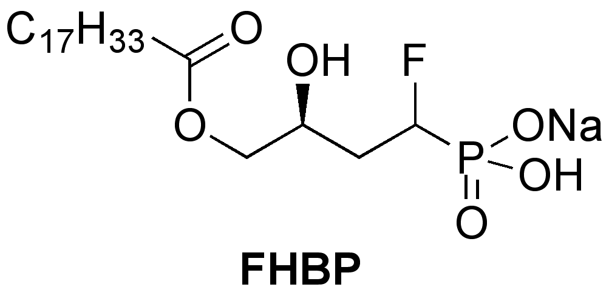
Figure 1

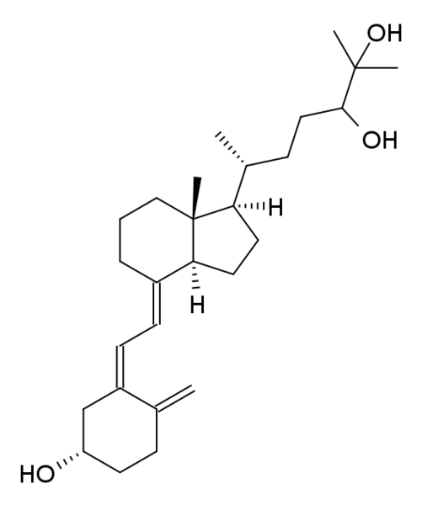

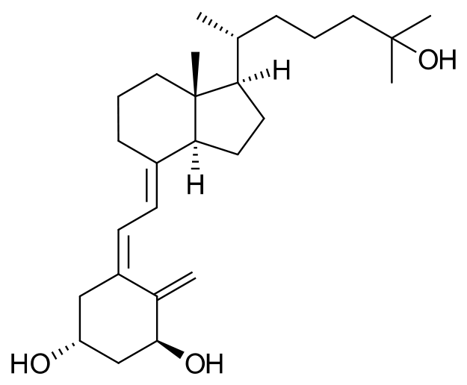

1,25D 24,25D

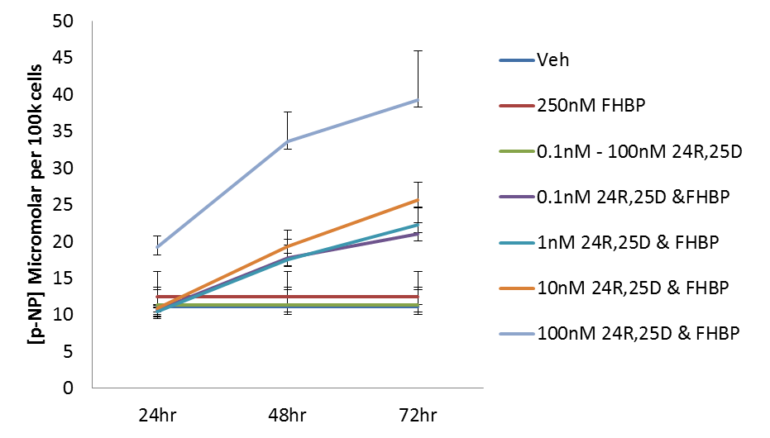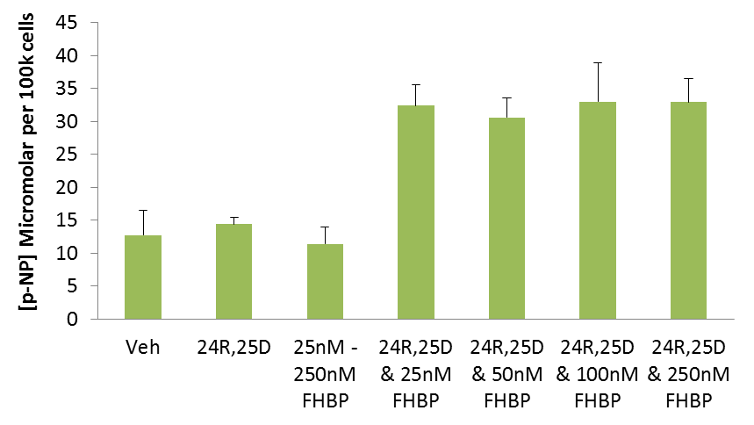
*
**
*
Figure 2
A
B

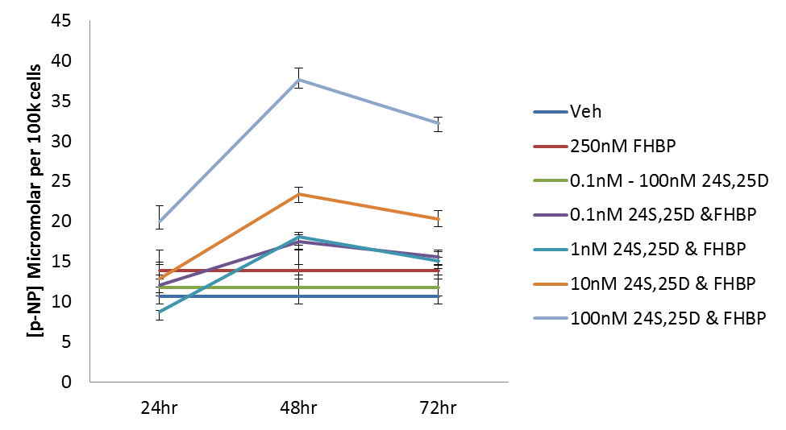
Figure 2
C
**
*
D
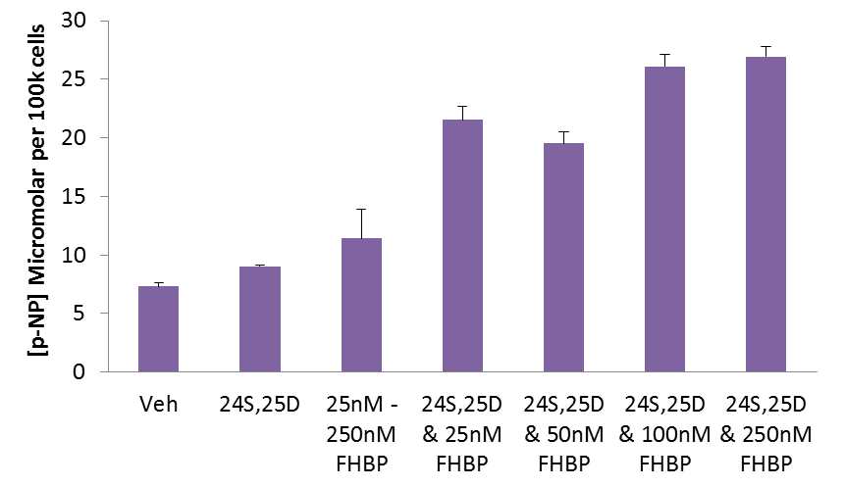
*
**

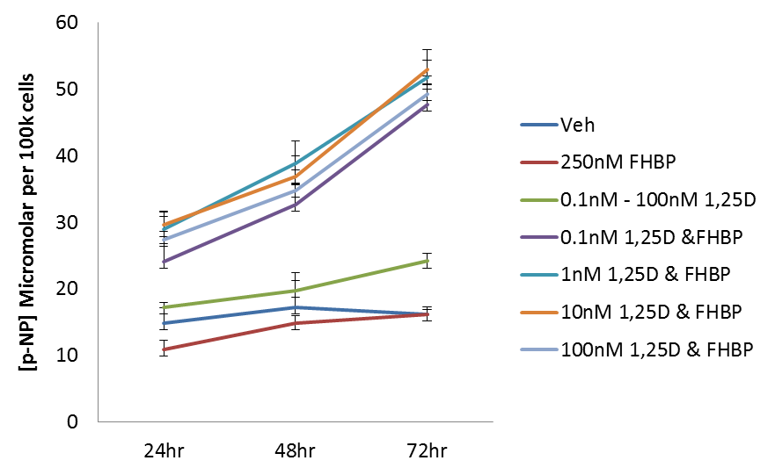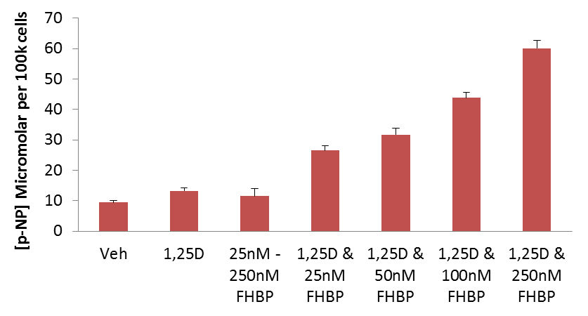
Figure 2
E
F
*
*
**

Figure 3
A
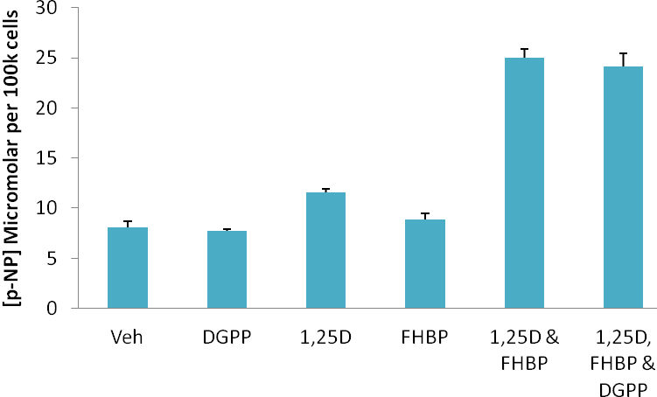
B
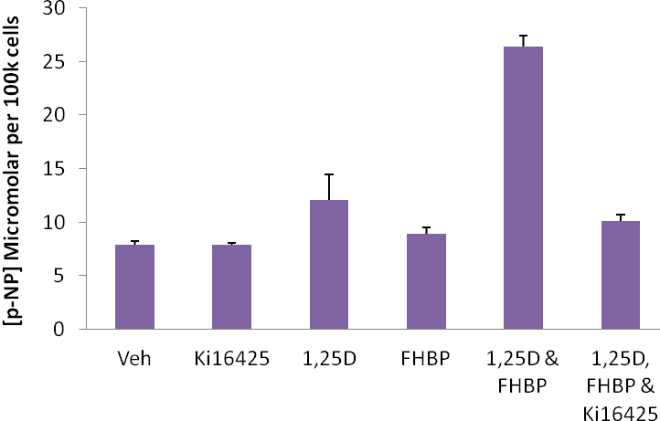
*

Figure 4
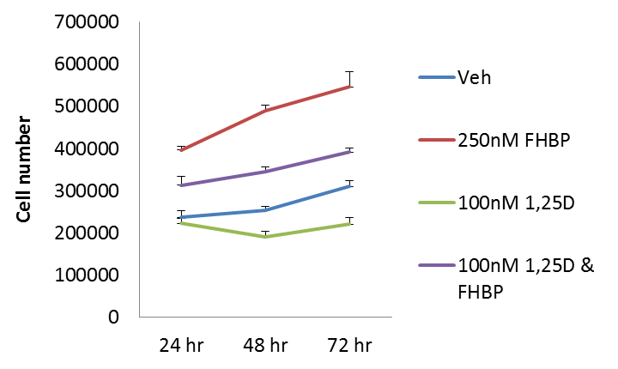
ø
§
A
B
*
**

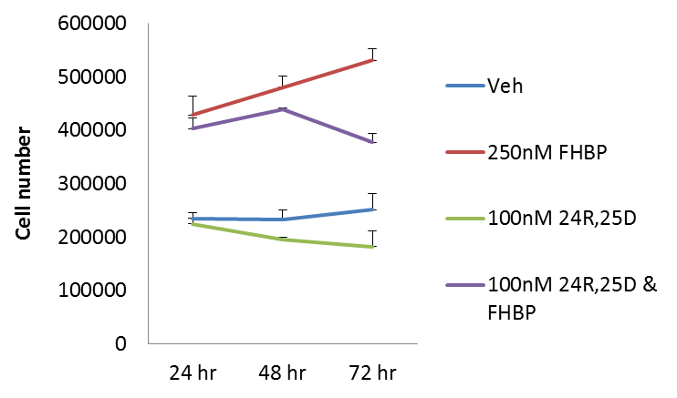
**
§
*

C
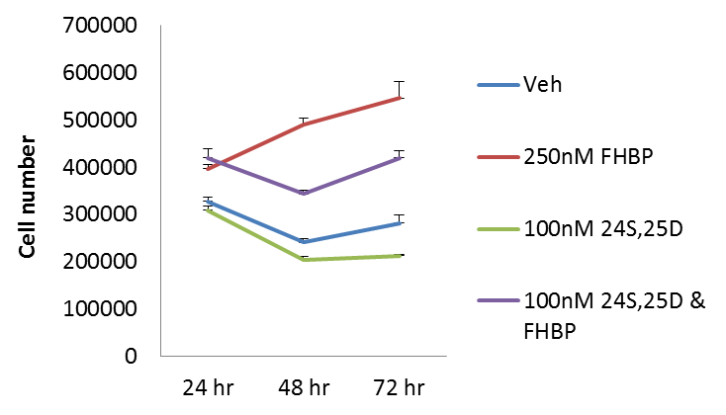
**
§
*

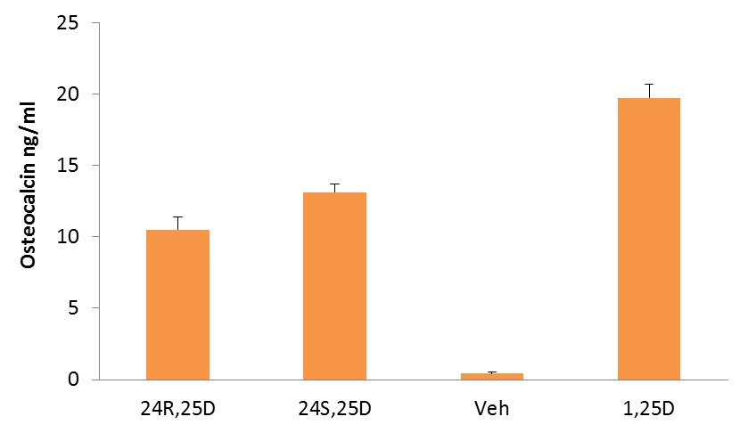
Figure 5
*

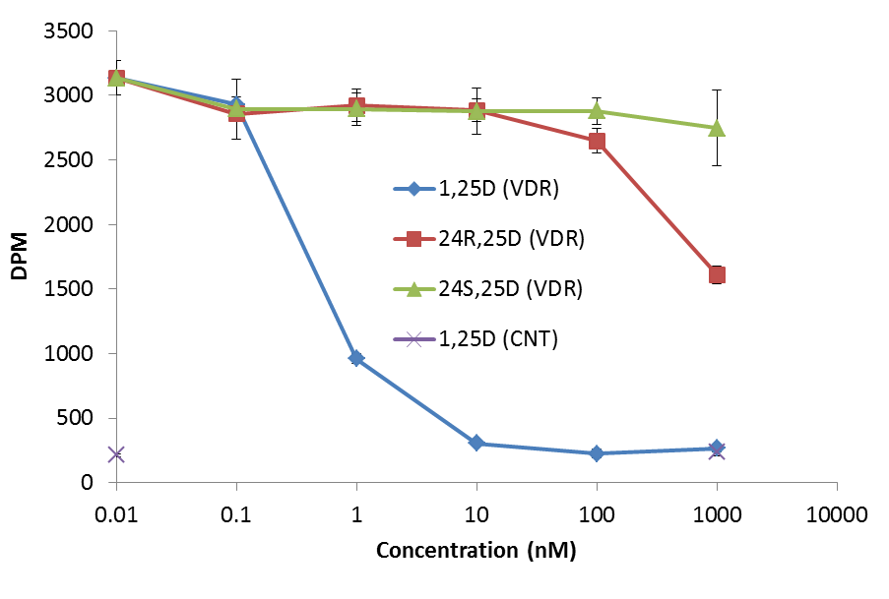
Figure 6

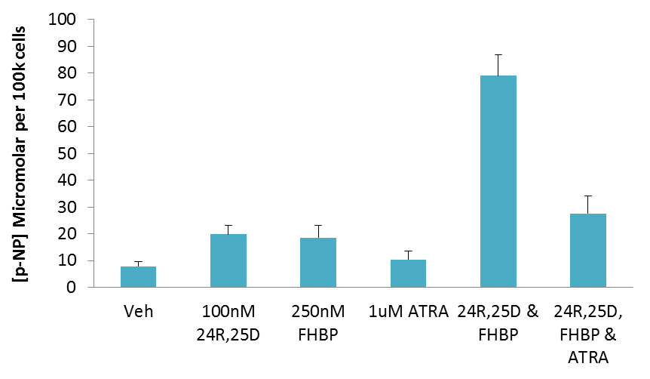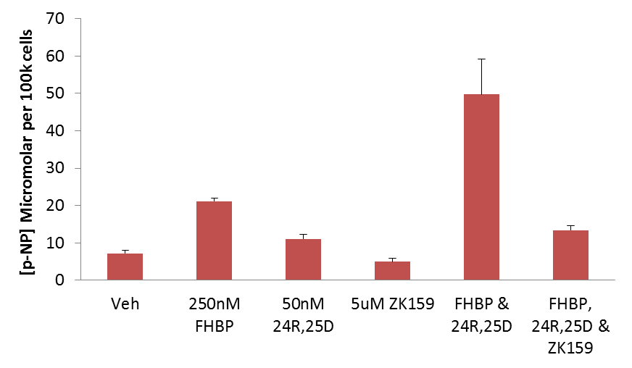
Figure 7
A
B
*
*

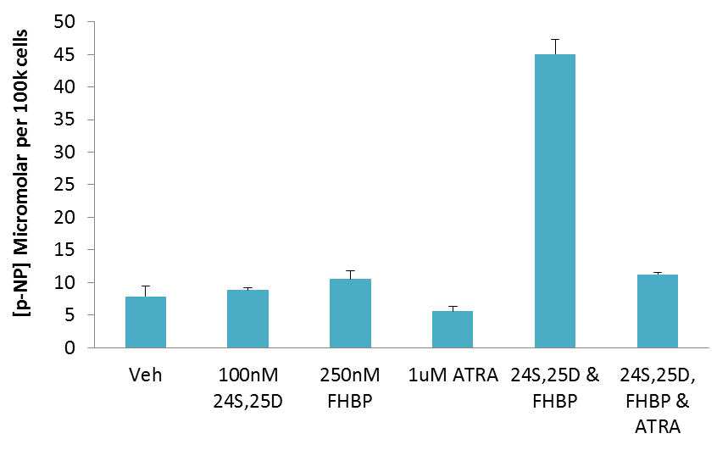
Figure 7
C
D
*
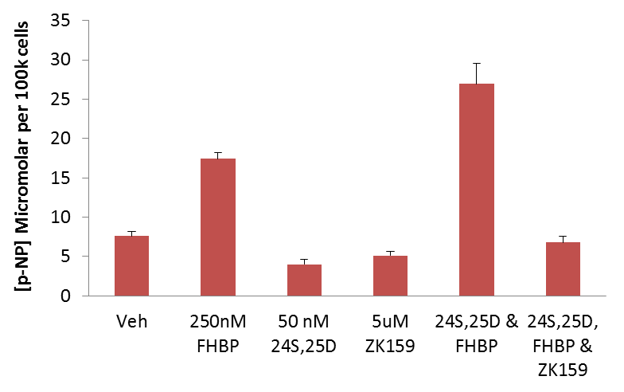
*

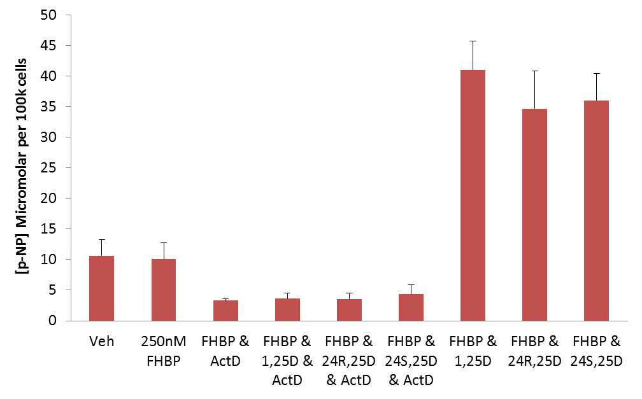
Figure 8
*
**
§

Figure 9
**
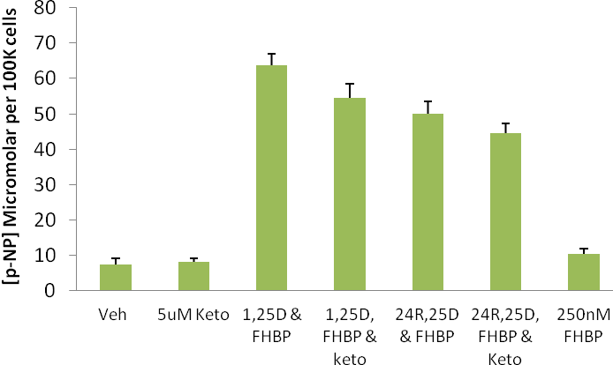
*

Table 1
Reference | Cell type | Main findings
Skjodt et al. 1984 | Primary human osteoblasts | Trivial effect on osteocalcin (OC) expression (~10-fold less than equimolar (5nM) 1,25D). Like 1,25D, 24R,25D at low end of physiological range promoted growth but inhibited proliferation at the high end of the physiological range.
Beresford et al. 1986 | Primary human osteoblasts | Unlike 1,25D, 24R,25D did not stimulate alkaline phosphatase (ALP), OC or collagen synthesis.
Franceschi & Young 1990 | MG63 | 24R,25D stimulation of ALP although approximately 2 orders of magnitude less potent than 1,25D.
Oyajobi et al. 1994 | Primary human osteoblasts | Increased ecto-nucleoside triphosphate pyrophosphatase but not as potent as 1,25D. It is the enzyme responsible for generating inorganic pyrophosphate central to bone matrix mineralisation.
Yamamoto et al. 1998 | Primary human osteoblasts | Co-operation between 1,25D and 24,25D on OC expression. 24R,25D led to increased accumulation of cGMP.
van Driel et al. 2006 | Human foetal osteoblasts (SV-HFO) | 24R,25D promoted cellular maturation, an event blocked by the VDR antagonist ZK159222.
Fang et al. 2010 | MG63 | 24R,25D increased phospholipase D activity, an enzyme linked to osteoblast maturation.
Somjen et al. 2011 | Saos-2 | 12-Lipoxygenase mRNA increased in response to 24R,25D. Also increased were reactive oxygen species.
Table 2

Time point | 24hr | 48hr | 72hr
Vehicle | ND | ND | ND
10nM 24R,25D | 364.7 ± 45.1 | 1446.2 ± 237.9* | 2184.6 ± 160.4§
25nM 24R,25D | 398.4 ± 58 | 1788.4 ± 355.7* | 2824.8 ± 250.2§
50nM 24R,25D | 473.5 ± 133.3 | 2555.3 ± 361.9** | 3379.9 ± 399.6‡
100nM 24R,25D | 451.4 ± 33.9 | 2621.3 ± 238.3** | 4231.0 ± 370.5§
10nM 24R,25D & 250nM FHBP |  |  | 1028.5 ± 133.2^{Ѳ}
100nM 24R,25D & 250nM FHBP |  |  | 2298.8 ± 251.1 ^{Ѳ}
250nM FHBP | ND | ND | 132.8 ± 9.7

