**Drawing on Topolski : an exploration of the relationship between reportage drawing and documentary filmmaking.**

Alistair Oldham

University of the West of England, Bristol. England

**Abstract**

*I am in the process of making a short documentary film called “Drawing on Topolski”, which follows the story of a residency programme for young illustrators that has been inspired by the memory of the renowned Polish emigre artist Feliks Topolski. The young artists I have been following use a style of documentary drawing called reportage, where they work in a quick, observational style to capture the essence of the reality in front of them. Their project “Chronicle” is based on months of drawing around the streets of London (at markets, commercial centres, the Houses of Parliament, the law courts, abandoned council estates, food banks and anti fracking protests) and is directly based on Topolski’s own Chronicles, where he printed his own reportage drawings on brown butcher’s paper every month throughout the sixties, seventies and eighties. This paper will summarise the project, particularly exploring the comparison between the modes of observational documentary film and the theory of the camera stylo, and the far less mediated practice of reportage drawing. The paper will also look at some of the multiplatform outcomes of the project (crossing film, drawing, social media and gallery exhibitions) particularly in their relation to interdisciplinary practice and the principles of Practice as Research.*

**Keywords :** Documentary, Practice, Reportage, Topolski, Drawing

**Introduction**

I am making a short documentary film,“Drawing on Topolski”, which will follow the story of a reportage drawing project inspired by the legacy of the Polish émigré artist Feliks Topoloski. This paper will trace the evolution of the film to date, particularly exploring the relationship between the process of documentary film and reportage drawing, which in its depiction of real life, is surely also a form of documentary.

I would like to frame the paper within the context of Practice as Research. I have been given approximately one month’s research leave from my work to complete the film. This has been an important step forward within our department as it gives new credibility to film making practice as research, rather than a previous emphasis on just theoretical interpretation. I’d like to state from the outset that I am approaching this paper very much as a filmmaker. The essence of Practice as Research is encapsulated in the three short statements, ‘a process of investigation’,’leading to new insights’, that are ‘effectively shared’ (REF 2011, p.48) and it is this essential paradigm that I will be pursuing here.

The selection of subject matter is a critical part of any creative process, whatever medium one is working in, so I will briefly describe the project’s starting point, as the seed or catalyst to everything that has followed. I work in an arts faculty, where I am in daily contact with practitioners from a diverse range of creative practices : graphic designers, animators, photographers, artists, fashion designers and so on. In a casual conversation my colleague Gary Embury from the Illustration department, mentioned that he had just returned from a trip to London where he had made an unscheduled visit to the Topolski Studios at Waterloo, in central London. Gary described how he had waited expectantly outside the entrance of the Studio for twenty minutes before the door was finally opened by Andrea Marie, the Studio’s project worker.

He explained that Feliks Topolski (1907-1989) was an artist who had been a huge inspiration for him personally, who has effectively been neglected in the public memory, but who became one of the foremost illustrators of his day.Topolski arrived in London from Poland in 1935, was on most war fronts in the second half of the twentieth century, was the first war artist into Bergen-Belsen, had done portraits of Mick Jagger, Andy Warhol and Bob Dylan, and had painted a six hundred foot mural underneath the arches of Waterloo Station, titled Memoir of the Twentieth Century. He also explained how every month Topolski had hand printed a monthly chronicle or bulletin of his latest work on brown butcher’s paper, as a way of distributing his work to a wider audience.

Gary’s impromptu visit eventually resulted in the establishment of the Topolski Residency Programme, bringing together six young unemployed artists for a three month course of master classes, workshops and expeditions, that would culminate in a printed broadsheet of their own as well as an exhibition, which was originally intended to be held at the Frontline Club, the war artists social club in London.

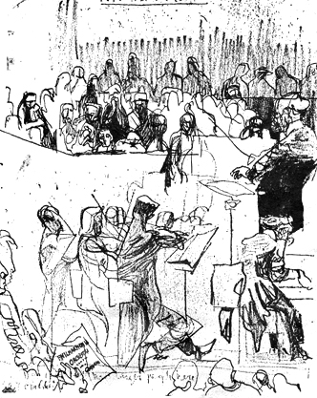 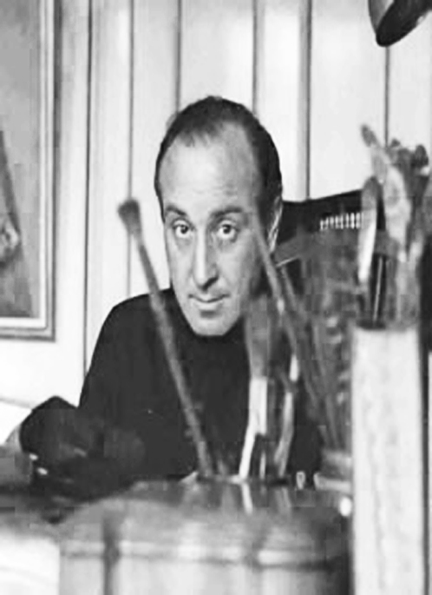 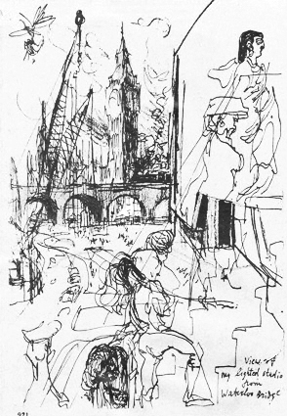

Image 1- Topolski Chronicle Image 2 – Feliks Topolski Image 3 - Topolski Chronicle

Number 100 Walter Hanlon (1954) Number 100

For Gary, this project also has a far larger significance as an engagement with the Reportage Drawing movement, of which he himself is a leading exponent, particularly through his own illustration practice and also through his founding role in the Reportager website (www.reportager.uwe.ac.uk), which he curates and edits. Reportage drawing is illustration’s equivalent of documentary filmmaking. Broadly, it can be defined as drawing in the field, on location, observing the actuality of life as it happens in the moment. And like documentary, the artist is free to turn their attention to whatever subject matter they choose, often gravitating towards the social, the political, or the journalistic as a means of engaging meaningfully with the world around them : what I often describe to documentary filmmaking students as the creative interpretation of reality. David Driver, former head of design at the Times newspaper, describes its practice like this :

“Reportage is the most difficult form of illustration, because it involves everything : observing, being able to draw people, working with moving figures, focusing on particular incidents, having a strong graphic sense, and being able to tell a story.” (Driver, p9)

The Residency Programme started much earlier than I expected, and coincided with the start of the academic year, so while the residents had already started doing masterclasses, and had been on drawing expeditions to fracking protests, the races, dance studios and abandoned council estates in and around London, I was frustratingly left in Bristol to struggle with timetables, module briefs and swarms of needy undergraduate students. When I finally began to disentangle myself from all of that, I rushed up to London to meet Gary and the Residents at the Millennium Dome, to film a day’s drawing, first of all on the river Thames and then opposite the Houses of Parliament. I mention this because it forced me to work in a far less prepared way than I would normally : rather than preparing for production through a continual process of research and creative development,I was literally tipped into action and forced to think on my feet,taking a far more improvised and sketch like approach to the filmmaking process.

As we pulled away from the jetty at Greenwich Pier in our high speed tourist leisure boat, I realized that I had been issued with the wrong microphone mount, that the boat was travelling ridiculously fast, and that Gary, having made a perfectly innocent request to the boat’s crew to do a bit of drawing, had proceeded to unfurl a twenty foot piece of tracing paper on the boat’s deck, which he was busily taping to the floor when the ticket inspector arrived to tell him this was against regulations and to also inform me that I needed permission from head office to film. I was already getting a sense of some of some of the common ground between reportage drawing and documentary filming, with all of the permissions and access that it requires.

Once I had got through to head office, the artists were all busy drawing a rapidly receding London Bridge; I had no choice but to start filming as best I could under the circumstances. They were drawing the passing riverscape at high speed, and in a necessarily fleeting and impressionistic manner, and I was filming them drawing, working as quickly and methodically as I could. Already, in the first moments of filming, synergies were beginning to emerge, as we all tried to capture the constant motion of the fleeting reality that was unfurling all around us. The drawings were fast, skilful and transient, but each belied a clear sense of selection, framing and perspective. Similarly, although the camerawork was fast, and very much done on the fly, I knew that I too was building on a structure, of the classic documentary sequence : in this case, making sure that I had a wide, a midshot, a close up of the drawing process, a close up of the artist’s concentration, and a shot of the view that they were drawing; filming fast, thinking on one’s feet, but always with one eye on how this would all cut together in the edit suite.

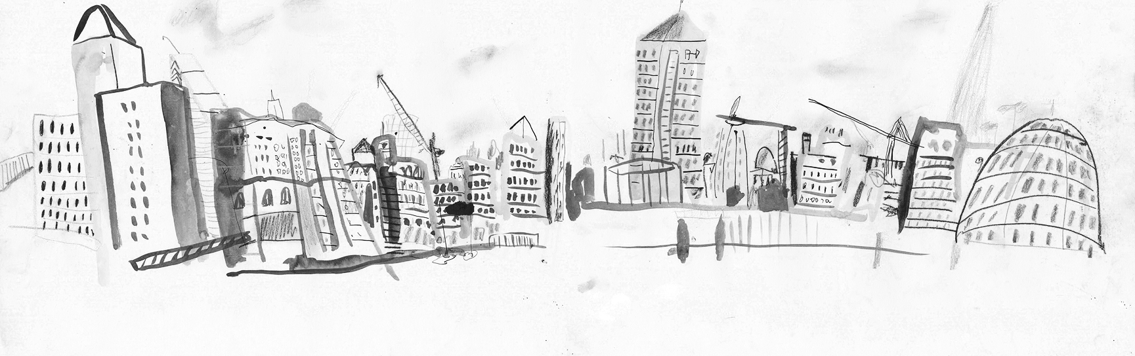

Image 4 – Thames River Cityscape

Matt Booker (2014)

In the afternoon the group went to draw on the South Bank, overlooking the River Thames, right opposite the Houses of Parliament, where Gary again set about unfurling his twenty foot sheet of tracing paper, quickly taping it down to the pavement. There had been a ferocious storm the night before and the light was now crisp and luminous, with a lot of leaves and fallen branches lying around on the paving stones. Gary instructed the group that they were all to draw on the piece of paper together, taking them away from the hermetic tendency of illustrators to hunch up into the private world of their own sketchpads. The wind was still blowing and the air was distinctly fresh, it was a public space with lots of pedestrians walking past where we might be stopped at any moment by security.

The residents rose to the challenge by taping bits of charcoal to fallen branches and even to the end of an umbrella and just started drawing. As I circled around them, framing, reframing, changing angle and refocusing (again just trying to imagine a sequence that would somehow cut together in the edit suite), I could feel their drawing loosening up, becoming more expressive. Drawing with twigs and branches and umbrellas created wavering and blurred lines that worked beautifully in their lack of control. A police helicopter hovered overhead and curious passers by stopped to watch the illustrators at work, bringing out their smartphones and i-pads to photograph what must have seemed rather a curious piece of impromptu street performance, a kind of pop up free drawing event.

In my own filmmaking practice I always write a production diary as a kind of reflective commentary as I go, and all sorts of colliding thoughts were prompted in what I wrote down after that first day’s filming.I was reminded of Alexandre Astruc’s notion of the ‘camera-stylo’, or ‘camera pen’,that the director might wield their camera like a writer might use their pen (Astruc,1948). Astruc was talking more specifically about the idea of the filmmaker as auteur, as a modern replacement of the author or artist, but the idea of the camera-stylo as a means of inscribing the reality around you seemed to hold particular resonance, particularly in this close harmony between the quick observational drawings of the young artists and the necessarily fast filming style that I had to adopt earlier in the day. A mutual curiosity was already emerging between the potentialities of the language of filmmaking and the far less mediated interpretation of reportage drawing.

That footage from the first day also became the basis of a roughly edited piece of montage, that we subsequently used for two gallery exhibitions of the illustrators’ work, as well as at an opening of a reportage drawing conference called ‘Witness’ chaired by Gary Embury at the University of Falmouth in Cornwall (March,2014). We cut the mute filmed sequences to a sample of music called Miles Davis Sketch by James Lucas from The Bristol Bike Project. This edited footage has worked well as a projected sequence that creates a very different ambience to the hushed spaces of the gallery and the conference hall, the Miles Davis inspired soundtrack adding a layer of musical jazz sketching to what was already becoming an interesting crossover between different mediums, spaces and forms of artistic expression.

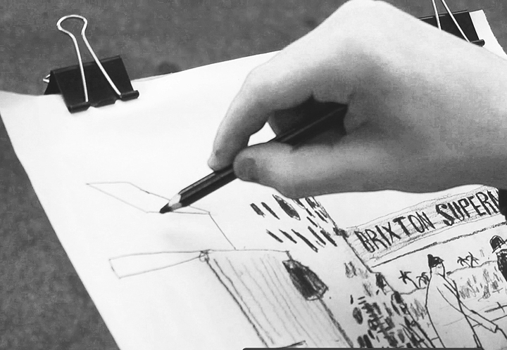 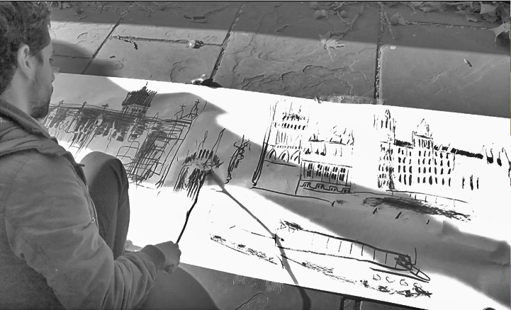

Image 5 – film still Image 6 – film still

A fundamental stage of any documentary process is research, from which you creatively develop ideas into proposals, narrative outlines and treatments, which can then form the basis for production and postproduction. So It was important for me to visit the Topolski Studios to meet Andrea Marie, the project worker there, and to at least get a sense of Feliks Topolski from the environment in which he once worked. The Studios are in a remarkable location, on the South Bank of London, adjacent to the River Thames and the London Eye. Topolski eventually moved from here to another larger nearby archway closer to Waterloo Station, which has now become a themed restaurant called Topolskis, which was also the location of his six hundred foot underground mural, “Memoir of the Twentieth Century”. The current Studio space is cavernous and filled with light, and contains more giant panels of the dismantled six hundred foot mural, as well as a complete archive of all the original issues of Toplski’s Chronicles, the broadsheet he printed on brown butcher’s paper. Even now, you are constantly reminded that the Studio really is just an archway, as the trains coming to and from Waterloo Station rumble overhead.

It is important at this stage to acknowledge Topolski as a great documentarian in his own right. As an artist he is part of the same historical canon as Hogarth, Daumier and Goya, a draughtsman, satirist and chronicler of his time. Andrea showed me dust covered parcels of the chronicles, a forgotten and neglected archive of Topolski’s take on London street scenes, political figures, Indo-China, Harlem Street Riots, Pittsbugh steel mills, Teddy Boys, the races, court room scenes, royal processions, visits to Nigeria and Varanasi, all rendered in his signature style of complex black swirling lines that could only have been drawn quickly and on the spot in their unflinchingly sharp observation. Art critic Jeffrey Dennis, has described how these remarkable Chronicles acted almost like a modern day visual blog, a constant stream of visual observation and commentary, and how the six hundred foot mural, Memoir of the Twentieth Century, in many ways preempted the modern day walkaround art installation. (Dennis.J, 2009).

Much of Topolski’s work was accomplished during the fifties and sixties, the heyday of Free Cinema, Direct Cinema, and Cinema Verite, where new technologies, particularly in lighter shoulder mounted cameras and portable sound recording equipment, were revolutionizing both the style and subject matter of contemporary documentary filmmaking in an attempt “to record the poetry of the everyday…. to get ordinary,uncelebrated life on the screen” (Anderson.L,1985). As filmmakers like Karel Reisz, Tony Richardson and Lindsay Anderson were broaching access to new subject matter and social attitudes in films like “O Dreamland” (1953), “Momma Don’t Allow” (1956) and “We are the Lambeth Boys”(1959),so Topolski was observing everyday life on the streets of London through the eyes of an illustrator.

This touches upon an important element of the research project, weaving as it does between the work of Topolski, the residency programme of young artists, the wider reportage drawing movement and of course the film itself. Each of these different elements engages at some level with the broad principles of documentary, each creatively interpreting the reality that surrounds them with whatever technology they choose to employ, whether it be an HD video camera, a piece of charcoal, a printing press or a pencil. The history of documentary film is in some respects a chronological response to different recording technologies : the medium and language of the form has evolved as a constant set of fluctuations in response to changing technology. But of course this history has also been a dance with audience and social and cultural change, so documentary forms and is informed by the socio-political realities that surround it. In many ways the history of documentary film, just like the Memoirs and Chronicles of Topolski, can also be read as an alternative chronicle of the twentieth century.

Topolski clearly also engaged with this idea of the chronicle as a documentation of the zeitgeist of a particular era, and the Residency Programme has also focused on this broad brushstroke approach to the documentary chronicle, very much in the spirit of Ruttman’s ‘Berlin : Symphony for a City’ (1927),Vertov’s ‘Man with a Movie Camera’ (1929), and Kevin Macdonald’s ‘Life in a Day’ (2011) . In this respect the project seems to correlate thematically to a familiar genre or substrata of the broader documentary project, by drawing on a wide range of subject matter that could hopefully capture the feeling and raw pulse of one of the most iconic cities in the world.

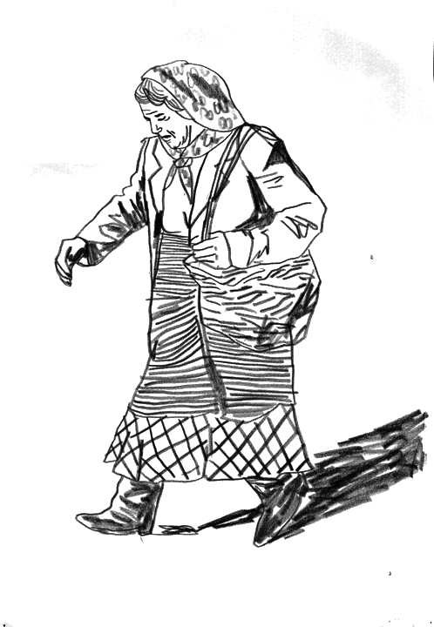 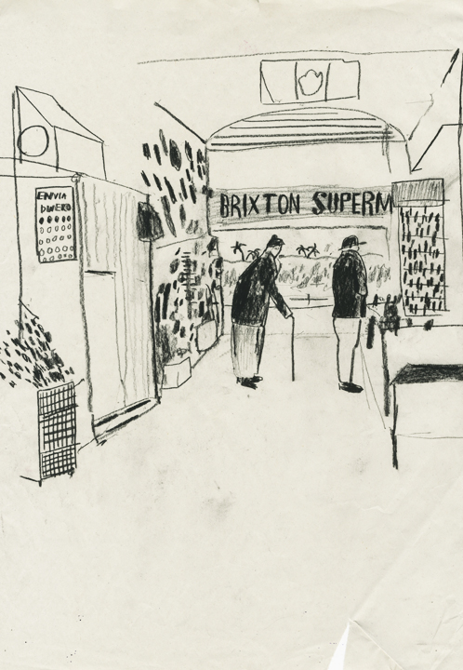 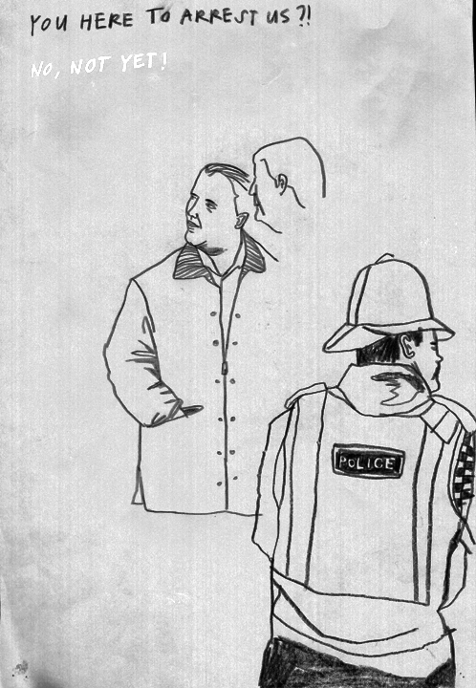

Image 7- Chloe Parke (2014) Image 8 –Matt Booker (2014) Image 9-Chloe Parke (2014)

Returning to the Residency Programme itself, the group would continue to meet twice weekly at the Topolski Studios to set off on more drawing excursions: to the House of Commons or the Law Courts (where all their sketchbooks were confiscated by the judge), to shopping centres and markets and boot sales and Remembrance Day ceremonies. The work began to gather and accumulate and through it you began to see this sense of the broad sweep of everyday life, within institutions but also as it is lived out in the streets and commercial highways and byways of the city at large. This wasn’t a single narrative or story that was being told, but rather a multitude of fragmented observations, and in that respect there is a distinction to be made from the current conventions of documentary filmmaking, which largely through the pressures of commercial television, tends to resort to the character driven story as the predominant narrative form.

As the collective work of the Residency programme took shape and grew, I became concerned that it might not be capturing the real zeitgeist of the city in all of its frenzied post modern anxiety. Maybe this was me looking at the project with the slightly more overt intention of the documentary filmmaker, always on the lookout to make things more meaningful. I had envisioned the frenzied activity of Oxford Street and its mindless consumerism, hordes of witless fashionistas plugged into their i-Pods against the backdrop of giant billboards encouraging them what to buy next. In a deliberate intervention into the reality of their own process as illustrators, I persuaded Gary that we should go on a walk through Central London and stop off for a series of quick drawing exercises ; though to be honest, I really just wanted some good footage for my film, a classic case of the documentary producer shaping a real situation to their own ends.

We took the residents on a walk from the Studios at Waterloo on a freezing cold day in late December, across the Hungerford Bridge, to Trafalgar Square, Chinatown, Picadilly Circus, ending up at Oxford Circus. It was an interesting day for all sorts of reasons. In my production diary, the walk prompted the idea of the illustrators as flaneurs (Baudelaire.C,1995) as observers of the streets, resting back on their notepads and drawing boards, almost unnoticed in the margins of the busy scenes that unfolded in front of them. As before I concentrated on getting the essential coverage of each scene, the wide shot of them each drawing on location, the mid shot, the close up of their drawing and the point of view of the scene that they were drawing, so that these multiple perspectives would cut together to best tell the story. It would be tempting to describe this as observational filming, in the traditional documentary devotion to the direct cinema of the sixties, but I think it is much more constructed than that. It isn’t just filming life in the raw, as it happens in the moment, but rather a developed language of filming that always has one eye on the edit.

This time Gary had left his twenty foot sheet of tracing paper behind, but instead brought a big roll of gaffer tape, and when we were in Chinatown he got each of the residents to tie their pens and pencils to their shoes and to draw with their feet. Again, some of the most expressive drawing was done when control was relinquished, so the illustrators were now drawing instinctively as the distance between their vision and their drawing extended all the way to their feet. Lines became looser, more expressive, less determined and again this drew a small crowd of curious passersby, who once more started to snap away with their cameraphones and i-pads. There was something very ironic about this situation, of the pervasive obsession with snapping bits of recorded reality with the latest portable technologies, as though they knew they were witnessing something far more authentic, an actual artist with a sketchpad drawing the unmediated reality in front of them. As Walter Benjamin noted presciently many years ago in his much quoted essay, The Work of Art in the Age of Mechanical Reproduction, “the sight of immediate reality has become an orchid in the land of technology”. (Benjamin.W,1936)

Also on that day I employed Gary’s son, Josh Emburey, as a sound recordist, and specifically instructed him to be an audio flaneur, to listen to overheard conversations and to the everyday sounds of the streets, so that we could then lay some of these audio sketches over the edited film in postproduction. For example at Oxford Circus, there was a robotic announcement exhorting the shoppers to buy more, there were close ups of all of the shoppers feet, the pulse of the green light of the traffic signals and so on. I also asked him to record the sound of the illustrators’ mark making, their scribbling and cross hatching, although of course this can also be added in later as foley, another device of the documentary filmmaker’s toolkit to recreate the reality that they see before them.

Although Oxford Circus didn’t quite live up to my Bladerunner imaginings, it highlighted another distinct feature of the reportage project. As hordes of Christmas shoppers crushed by, it was impossible for any of the illustrators to draw exactly what they were seeing, even if they had wanted to, because the scene in front them was literally changing by the second. My camera could obviously catch all of this in time in motion, whereas a reportage artist can only capture the semblance or impression of that time to then be represented on to a two dimensional image. I would edit my footage later, whereas they are necessarily employing a subliminal editing process in every mark and line that they commit to paper, putting things down, leaving things out, as the reality before them unfolds at such a frenetic pace that they cannot possibly hope to truthfully record : although of course, in many ways they can capture it more truthfully, and more expressively, through the more organic mediation of their own consciousness and perception.

Gary put an interesting inflection on this in an interview I recorded with him later that week, in response to a question asking him to make a comparison between reportage drawing and photography :

“drawing can be quite spontaneous, there is an element of time, so it's not just capturing the decisive moment - in effect you could argue it's the indecisive moment where you're capturing a number of instances, a number of activities or episodes in one drawing. They are almost like multiple drawings, they are like multiple frames or multiple images overlaid. In effect they are in effect a little bit like animation, so I think you get more of a sense of time-based media with the drawing rather than a single frozen moment in time.”

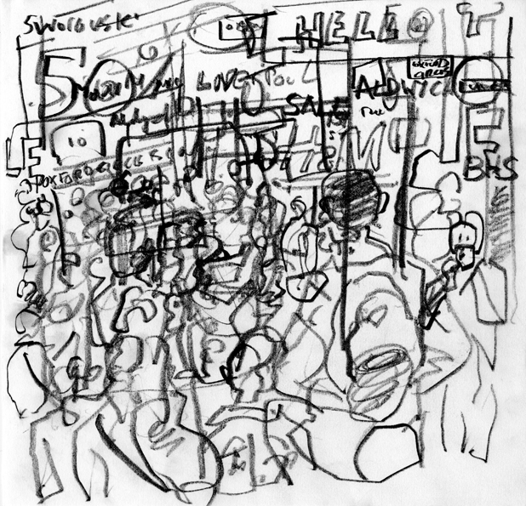 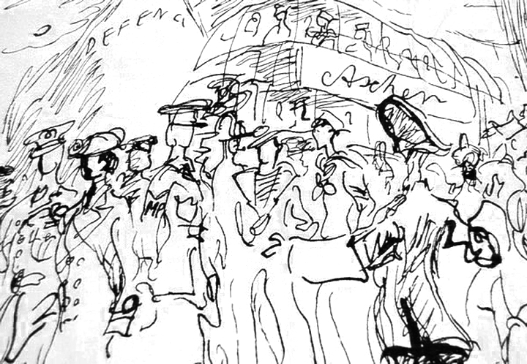

Image 10-Oxford Circus Image 11- Shopping at Aschers

Gary Embury (2014) Feliks Topolski (1956)

Another aim of the project was for the residents to produce their own printed broadsheet, very much in the style of Topolski’s own Chronicles. In order to do this, a sixties German printing machine was brought to the Studios from Brighton University, so as to print off a complete edition of a new Chronicle. Initially this entailed a day long process of reviewing all of the work drawn over the preceding two months of the programme, much in the same way as a documentary filmmaker must review, log and transcribe all of the filmed rushes before going into the edit.

Of course, the idea of the residents printing off their own Chronicle was a crucial part of the story, which had to be filmed. So again I made sure that I had coverage of the residents going back thorough their portfolios, selecting and rejecting their own work, much as I might sit poring through the rushes that I have shot. For me this is a crucial part of the process, as it will tell you how successful you have been in capturing the story of your film, including what gaps there might be that you still need to shoot : not necessarily the most beautiful or aesthetically pleasing shots, but rather the shots that will edit together to take the audience on the journey that you want to take them.

For example, I have reconstructed a shot of Gary standing outside the Studio, as though he is waiting for the door to be answered at the beginning of the film. I have filmed each of the drawing events as sequences which will cut together, almost as small individual narratives in their own right. And I have also filmed the printing process, from inking the plates to the rolling mechanisms of the mechanical press, another small story within the overall narrative arc of the film. As it happens the machine kept on breaking down, mechanical parts were missing, there was endless standing around. One of the most exciting parts of the design of the programme was in reality quite tedious, but the nature of dramatic storytelling will allow me to edit this together so that it all looks dynamic and exciting, including the magic moment when a proof rolls off the press as a finished document.

At the time of writing (April,2014) this is more or less exactly the point where I am at with the film, where I now have around twenty hours of footage that must be compressed and cut down to approximately twenty minutes for the finished piece. In filmmaking terms, that final twenty minutes will always be about finding the best narrative structure possible in order to engage an audience through the journey of the film. This will be shaped around a simple story, using many of the traditions and conventions of dramatic narrative structure. That notion of compression, of using the editing process as a means of gathering together, selecting and emphasizing particular sequences within an overall narrative arc , to create a residual overview of the project, is perhaps the real territory or governance of the documentary film.

The next step of the Residency Programme after the printing of the Chronicle was the Chronicle exhibition at the Vibe Gallery and at the Bower Ashton campus at the University of the West of England, which in many respects seemed to be a more lively and dynamic outcome of the project than the printed Chronicle. So now all of the work was being edited and selected for public exhibition, resulting in hundreds of pieces of work being mounted on the walls of a white gallery space. The work ranged from large A2 cartridge paper to small thumbnail sketches on PostIt notes, and everything in between, including a number of original Topolski drawings and printed Chronicles.

To one side of the gallery there was the video projection of the footage edited from the drawing outside the Houses of Parliament, set to a random loop of music designed by James Lucas. This last proved to be an intruiging legacy of the collaboration between documentary film and drawn reportage, as the projected footage and soundtrack worked to draw a young and diverse crowd into the gallery space. Fortunately they didn’t just gawp at the film and then walk away, but rather it seemed to prompt them to walk into the multitude of drawn images that had been gathered together and displayed around the walls of the gallery.

It was here that the notion of the Chronicle truly took place; as a gallery viewer you were invited to walk round a drawn representation of a cross section of society, going from food banks, to parliament, to the law courts, fairgrounds, shopping malls, council estates, markets, boot sales, fracking protests, city scapes and so on, inviting you to become your own flaneur on a tour of momentary glimpses, fleeting glances and overheard snippets of conversation that somehow managed to capture this strange zeitgeist that we inhabit. So much of what we take to be the zeitgeist is an obsession with the digital, the virtual and the online, but here was real life carrying on regardless on the streets all around us. And amongst all of these sketches and drawings were strategically positioned Topolskis, echoing a similar set of sentiments and observations from fifty years ago, which were neatly bridged across the decades by the echoing improvised soundtrack in the style of Miles Davis,designed by James Lucas, breaking down the sometimes too hushed atmosphere of the gallery space.

Maybe this also helped to describe some of the project’s real potentialities, in the way that an interdisciplinary approach to documentary, in this case between drawing and film, can help create a dialectical space where old forms are broken and new spaces can begin to emerge. In the same way that Topolski broke free from just being a talented draughtsman, he turned his attention to printing his Chronicles and to painting the six hundred foot mural, Memoir of the Twentieth Century, which now seem like quite bold, visionary practices (although to this day largely unacknowledged by the British art establishment).

The Residency Programme that was very much part of his legacy, has similarly begun to extend itself from reportage drawing, into film, gallery exhibition, lithograph printing, sound recording and sound design, and now also finds its expression through a website, and conference papers, both in spoken and written form. The film, when it is finished, will hopefully gain some screenings at various conferences, events, educational situations and film festivals, and will then be put online, where I can monitor audience viewing data as a globalised demographic for years to come, another huge advantage of the film medium in the modern age, which should hopefully serve the reportage illustration project well in its much wider audience reach.

As I am approaching the end of writing this paper, it seems that the Chronicle exhibition will be displayed again in June 2014, this time at the exhibition space in the Bargehouse on the London South Bank, just a few minutes walk away from the Topolski Studios. Plans are also being cemented to run another Residency Programme over the Summer and there is also the possibility that the Programme might then be franchised to overseas universities to further extend the Programme’s commercial feasibility, as a reportage drawing project that might be appropriated to any other major city in the world : the project is beginning to take on a momentum of its own.

Finally, I would like to add a disclaimer, that as a documentary filmmaker, a much vaunted guardian of the truth or claimer of the real, I have of course tampered with the reality in quite a few places (both in the film and I have to say in this paper as well). As we well know, real life, played out in real time, can be a ponderous affair. So I have taken the liberty of moving bits around, I have selected and emphasized and omitted various elements of what actually happened to suit my own purposes of telling the story in the best way possible : and if you as the reader have got this far, then hopefully I might have engaged you as an audience to get to the end of another narrative journey, hopefully creating a text that will prompt more questions than it will provide answers, but which ultimately is presented to you for you to respond in whatever way you choose. It is only a representation of what actually happened,after all.

**Bibliography :**

1. UK Research Excellence Framework 02.2011 :

‘Assessment framework and guidance on submissions’

2. http://reportager.uwe.ac.uk

“Reportager exists in order to support, initiate, and showcase projects involving drawing as reportage, visual journalism, documentary drawing and illustration as visual essay. We are interested in projects, which use the made image to interrogate a diverse range of themes. The website works as an editorial space for the dissemination of good practice in this area.”

3. Driver.D. quoted in “Reportage Illustration in a Contemporary Context” by Wendy Coates-Smith, in “Witness, The Reportage and Documentary Forum*”*, Atlantic Press 2014.

4. Alexandre Astruc “Birth of a New Vanguard -- The Camera-Stylo” in “L’Ecran Francais”,1948.

5. Dennis.J, 2009. “Pictures from the Pole : Feliks Topolski’s User Guide to the Twentieth Century” in Turps Magazine, Issue no.6, 2009.

6. Lindsay Anderson in the documentary “Free Cinema : An essay on film by Lindsay Anderson” Thames Television,1985.

7. Baudelaire.C, ”The painter of Modern Life and other Essays”, Phaidon Press,1995.

(first published1863).

“To be away from home and yet to feel oneself everywhere at home; to see the world, to be at the centre of the world, and yet to remain hidden from the world—impartial natures which the tongue can but clumsily define. The spectator is a prince who everywhere rejoices in his incognito.”

8. Benjamin.W, “The Work of Art in the Age of Mechanical Reproduction”, Penguin Books, 2008.

(first published 1936).