**Airbnb – another argument for a revised, not compromised, spatial management approach**

Adam Sheppard, Harry West, Stroma Cole, Deepak Gopinath and Mojca Sonjak outline the findings of research on the extent, distribution and impact of Airbnb short-term letting in Bristol, and on whether regulatory intervention is required

The planning system in England has received significant media coverage in recent months, most notably because of the White Paper, Planning for the Future, but also because of the further expansion in the use of permitted development and prior approval provisions for a wider range of new developments. Alongside these significant changes and propositions has come one that has received less attention but is likely to be just as impactful: the creation of Class E in the Use Classes Order.

This new ‘Commercial, business, and service’ use class will combine the former Class A1, A2, A3, B1 and certain D1 and D2 uses in England, with the associated reclassification of other uses from A4, A4, D1 and D2 uses into either sui generis designation or new F1 ‘Learning and non-residential institutions’/ F2 ‘Local community’ use classes. The implications of this are potentially as significant as any other aspect of planned change in planning in England, and continue the current trend towards a market-led, laissez-faire planning approach, removing local authority oversight and spatial management abilities.

We can have some degree of foresight of the challenges associated with a use classes system that lacks the ability to manage place through experiences gained through the Airbnb phenomenon. The growth in ‘short-term letting’ (STL) in recent years is notable, and although other ‘sharing economy’ platforms exist, it is Airbnb that leads the market. The implications of this growth in activity have received high-profile media coverage in recent years, too, and Bristol is just one city where there is debate over the impact and consequences of the proliferation of STL uses.

Funded via an internal research grant, a team from UWE Bristol (the University of the West of England, Bristol) undertook a small research project to investigate STL in Bristol, with a specific focus upon Airbnb. A mixed-methods approach was employed – drawing upon a literature review, discussion workshops, a series of interviews, and a GIS mapping exercise – to determine the location and extent of the phenomenon, and also the suggested implications of STL occurrence. The research points to an acceptance of the value of STL, but also identifies a need for levelling-up with regard to regulatory controls and financial obligations to ensure the ability to manage STL’s implications.

**The Airbnb phenomenon**

Airbnb is an enabler of STL. It is, in essence, an online platform that brings together property owners and people looking for places to stay. The properties on offer are very diverse, ranging from single rooms made available while the owner is still present, through to entire properties with a temporarily, or permanently, absent owner. The extent to which the property is offered as an STL over the course of a calendar year is equally variable. The host receives payment for lets, and Airbnb generates income through charging commission on rentals. The growth in the Airbnb phenomenon has been accompanied by a high-profile discourse within academia, stakeholders/professions, media and the public on the implications of this very particular manifestation of STL.

Airbnb and similar companies have revolutionised the short-term accommodation market over the last 10 years. Founded in 2008, Airbnb, the San Francisco based home-sharing online marketplace, has listings (of which 70% are entire homes, 27% are private rooms, and 3% are shared rooms) totalling more than 4 million and which are offered in 191 countries (1,2). This is more than the listings of the world’s three largest hotel chains (IHG, Marriott, and Hilton), with a combined figure of 2.58 million (3). In the UK context, there are over 75,000 listings in London, generating a typical earning of £3,000 per host per year (4).

There are two models of hosting that are available through Airbnb (5,6) with different implications. One is ‘remote hospitality’, whereby the host offers only a space for the guest but is not physically present at the property. The second is ‘on-site hospitality’, in which the host occupies a part of the property and lets out the rest to the guest – a spare room, for example. In relation to the latter model, there are arguments that Airbnb facilitates an important interface between visitors and the local community, creating an ‘authentic experience of place’ (7). There is some evidence that both models of hosting have potential to strengthen community resilience (8). In this regard, cities offer a useful lens to capture the tensions between housing and hospitality, as Airbnb and other peer-to-peer home-sharing online platforms start to position themselves in the short-term letting housing market (7).

These models also help us to understand what some claim to be a shift in the value system underpinning the Airbnb model, from its initial focus on ‘sharing’, and social dimensions of wellbeing, to more recent emphasis on ‘profit maximisation’ (9,10).

There are also claims that Airbnb spreads the benefits of tourism to local people, spreads tourism spend beyond the central business district/hotel zone, and helps poorer people to stay in their homes by providing occasional income. Counter-claims are made that Airbnb is putting traditional bed and breakfast offerings out of business, is pushing up property prices, and is reducing the supply of long-term rental spaces for local residents. Questions arise about if Airbnb tourism is contributing to or reducing inequality (11).

The implications of Airbnb activities are enormously diverse and variable, depending upon a range of factors, including the concentration level in the geographical area, the form of the STL activity (i.e. the duration of letting activity over the course of the calendar year and the presence, or not, of the host within the property), and the characteristics of the geographical area within which the STL property usage is occurring. Broadly, however, it can be said that Airbnb offers both opportunity and challenge.

Existing academic and wider literature identifies a range of positives from Airbnb for the host, for the area within which the property is located, and for the guest. For the host the use of their property, whether they remain present or not, represents a valuable income stream. For both host and guest there is also the value of social interactions when owner and visitor are both present together. For guests, Airbnb creates diversity in the choice of accommodation available – in type, location, and cost. And for the area there may be potential opportunities derived from visitor spend.

Notwithstanding some of the positives, the challenges of Airbnb are notable. Existing research points towards challenges in some instances concerning social cohesion, adverse impacts upon residential amenity, limited financial gain from visitor spend, loss of housing stock, impacts upon housing costs, and an absence of controls concerning health and safety matters. The adverse impacts of Airbnb have, in some countries, driven the development of regulatory responses.

**Regulating the phenomenon globally**

Although there is some variation in the implications of Airbnb globally, many of the impacts discussed above are commonplace.

Within England and Wales STL controls are limited, although London is a notable exception. In fact, London has relatively long-standing controls concerning STL, pre-dating Airbnb and not designed in response to this phenomenon. Originally associated with the Greater London Council (General Powers) Act 1973 and the restriction of temporary sleeping accommodation (identified as a material change of use for which planning permission is required), the Deregulation Act 2015 provides that, where a premise is used as temporary sleeping accommodation for more than 90 days in a year, a material change of use has occurred.

Elsewhere in the UK, Northern Ireland takes a different approach, requiring certification from the tourism body, Tourism Northern Ireland, for anyone providing or offering to provide tourist accommodation as a business – such activity is otherwise prohibited. In January 2020 the Scottish Government confirmed the ability of local authorities to introduce licensing for STL from spring 2021, and the Planning (Scotland) Act 2019 has introduced the ability for planning authorities to designate areas as short-term let control areas (STLCAs). Within these areas, using premises entirely as a short-term let (i.e. ‘buy-to-short-term let’) will constitute a material change of use. Elsewhere in the UK, though, provisions are limited.

Around the world a diversity of approaches can be found. As within the UK, the extent of regulation and the approach vary significantly, but the use of licensing is typical. In many instances a finite number of days is prescribed in which STL can take place, after which some form of licensing/registration/permit is required. The duration beyond which ‘permission’ is required varies notably – for example, in Paris it is 120 days, compared with Barcelona (31 days) and Amsterdam (30 days). In addition to duration, other controls/limitations can be found. For example, in Los Angeles hosts are allowed to rent out only their primary residences, defined as the place where they live for more than six months of the year, hosting only 120 days a year. Comparably, in San Francisco Airbnb hosts must be permanent residents, live in the unit for at least 275 nights a year, and be present during the stay. Hosts cannot have more than one listing or rent out for more than 90 days.

Regulatory responses appear to be just that: responses. In response to a relatively new phenomenon the regulatory constructs are being adapted to enable the possibility of its management, with research suggesting variety in form, scope, extensiveness, and effectiveness globally.

Conversation concerning regulation in England continues; this small research project asked the question as to whether there is a need for some form of regulatory response in Bristol.

**The Bristol case study**

The research team secured contributions from various stakeholders within the accommodation industry, as well as local government. The interactions took the form of roundtable discussions (with visitor accommodation providers) and a number of face-to-face interviews (accommodation and visitor industry representatives and local government). The discussions were semi-structured and explored the nature and impact of Airbnb accommodation in Bristol, and asked open questions with regard to the need for, and forms of, regulatory and other forms of response to the phenomenon, where considered justified. Additionally, a literature review provided context and wider understanding, with a data gathering and mapping exercise also undertaken to present the scale, location and pricing characteristics of Airbnb in Bristol.

***Findings***

The spatial analysis of Airbnb listings for Bristol, by ward, identifies a particular concentration in the city centre and attractive city periphery areas such as Clifton, reflecting the desirability of these areas in the context of the location of key tourism and industry areas of focus (see Fig. 1, on the preceding page).

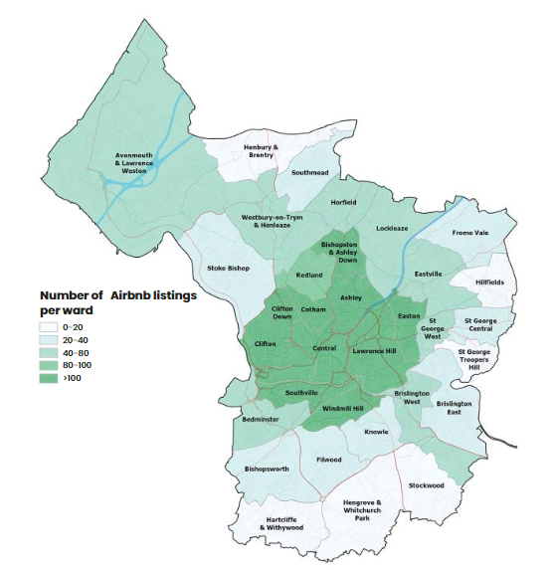

Fig. 1 Airbnb concentration levels in Bristol as found by the study. Data sourced from Inside Airbnb available under a Creative Commons CC0 1.0 Universal (CC0 1.0) Public Domain Dedication license: http://insideairbnb. com/get-the-data.html. Data correct as of Spring 2020.

The distribution of Airbnb merits identification because it reflects the extent of the phenomenon in the city, as well as its concentrations in areas notable as destinations for work, leisure, and tourism activities. More than this, though, the mapping also identifies the sheer scale and extent of Airbnb across Bristol, extending over much the city area with varying degrees of density. Within the data we must also consider the characteristics of the accommodation, mindful in particular of the distinction within existing research of the differing impacts and implications between provision via a single room within a dwelling and a ‘present’ host, and an entire dwelling with an ‘absent’ host (see Fig. 2, above).

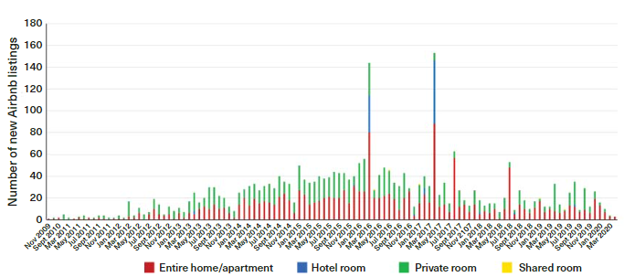

Fig. 2 Characteristics of Airbnb accommodation in Bristol as found by the study.

The gathered and presented data shows that a very significant proportion of the Airbnb listings in Bristol have been entire homes. The wider findings of this research project would suggest that this is significant due to the particular implications identified in association with whole-property STL usage.

The key findings of this research, exploring the views of key stakeholders within Bristol and derived from the primary research data collected, can be summarised as set out in Box 1, on the next page.

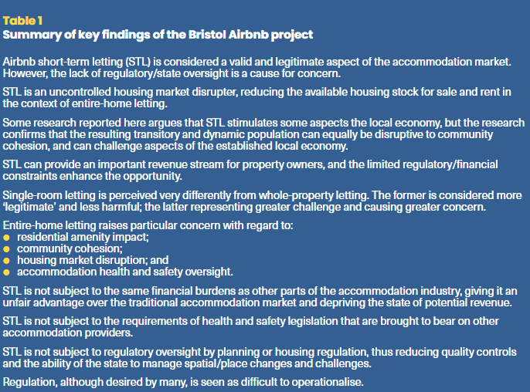

The respondents notably agreed that STL is a valid and legitimate entrant into the accommodation marketplace, and further that it can bring financial benefit to individuals (hosts and guests) and communities/places; but respondents were equally in majority agreement that the lack of regulatory control was problematic and demanded redress.

Support for the idea of a ‘level playing field’ was a common view expressed in the primary research undertaken, mindful particularly of the desirability of managing the impact of whole-property lets and/or over-concentrations of STL in residential areas; and of ensuring parity with other forms of accommodation with regard to health and safety, environmental health/residential amenity, and financial obligations. Of particular significance was the emphasis upon entire-dwelling STL usage – such activity was considered particularly challenging and, in some respects, harmful in the context of the identified challenges.

There was broad agreement among respondents that some form of regulatory oversight was required, but that operationalising this would, in some respects, be problematic. Requiring adherence to the same health and safety requirements as apply to other accommodation providers, and increasing/ensuring tax/financial obligations, was considered appropriate by respondents in creating a ‘level playing field’ between STL and other accommodation providers, but it was agreed that the identification of STL can be problematic if it is not actively declared.

Furthermore, it was considered that in many respects it was desirable to differentiate between single-room and entire-property STL. The former was viewed as less problematic in terms of impact and implication, and more ‘legitimate’; whereas entire-property STL was seen as a more flagrant and impactful challenge to appropriate practice and place management. This would suggest that a nuanced approach is desirable with regard to the introduction of wider state oversight/obligation, and in particular a differentiation between single-room and very occasional entire-property STL activity on the one hand and longer-term entire-property STL activity on the other. The ‘professional Airbnb landlord’ property type was highlighted in this context, and was seen as most problematic.

A particular challenge in operationalising regulatory control concerns wider spatial management of the phenomenon. Both the housing and planning regulatory spaces were highlighted, with planning receiving particular emphasis. Currently there are scenarios in which an STL property could potentially be identified as a C1 (Hotels, etc.) use, but in most instances it would be considered a C3 (Dwellinghouses) use, because this is typically how its occupation is characterised. Controls are therefore limited to areas where additional provisions are in place, such as London, with its ‘90 day’ rule.

For planning to gain control over STL it would therefore be necessary to differentiate the use through, for example, the Use Classes Order. Although this was a popular suggestion, a robust, effective, and clear way of differentiating residential use characteristics would be required, and importantly this would then require monitoring and enforcement. This could create a challenging and resource-demanding obligation on local authority planning teams, and resource allocation would be necessary for this approach to be viable. Furthermore, a clear view here was that national government intervention is required, and certainly this would be the case for any change to the Use Classes Order. There is currently no sign that this is or is likely to be forthcoming.

**Conclusions**

The findings of this research reinforce previous academic and other research work concerning the impact of STL, including an academic research study carried out in 2020 in the Clifton area of Bristol, which included the following concluding comment:

*‘The findings reveal that Airbnb has impacts on the long-term housing market and causes disruption within communities... Overall, the findings clarify that it is recommended that Bristol implements a form of regulatory intervention to control the implications of Airbnb.’ (12).*

There appears to be a clear view among the majority that further state oversight and intervention is required and necessary with regard to STL, and planning is a front-running favourite to operationalise aspects of this control. Implementation of this would likely require a change in position by national government, though, as well as investment in policy, development management, monitoring, and enforcement activities by local government, who would themselves require further resourcing support for this to be realised.

This research supports other work which identifies STL/Airbnb as a genuinely disruptive phenomenon in response to which state intervention is justifiable. The potential for this in England appears to run contrary to the current planning narrative, however: Class E is an indicator of this – a change that will significantly challenge the ability of local authorities to manage place, in particular in areas such as town centres.

With a market-led, permissive, laissez-faire approach to planning in England now so very evident, it is perhaps unlikely that restrictive change concerning STL will come forward. That said, despite the current narrative of reducing state oversight evidenced in permitted development and prior approval expansion and the new Class E, with all of the implications these bring, there is evidence that (reactive) change to certain matters of note can occur. Requiring adequate space and natural light(!) in office-to-residential conversions, and the identification of pubs and fast-food takeaways as sui generis use show that change designed to protect and enhance place can occur.

STL is clearly a phenomenon that brings challenges, and the growing evidence of issues and problems in some instances/circumstances points to a need for additional control. Planning can potentially play a part here, but further and extended pressure will be required for this to manifest itself in a way that is viable, measured, and impactful.

**Notes**

1 T Dogru and O Pekin: ‘What do guests value most in Airbnb accommodations? An application of the hedonic pricing approach’. Boston Hospitality Review, 2017, Vol. 5 (2), 1-131

2 D Gerdeman: The Airbnb Effect: Cheaper Rooms for Travelers, Less Revenue for Hotels. Harvard Business School, Feb. 2018. https://hbswk.hbs.edu/item/the-airbnb-eff ect-cheaper-rooms-for-travelers-less-revenue-for-hotels

3 T Dogru, M Mody and C Suess: ‘Adding evidence to the debate: quantifying Airbnb’s disruptive impact on ten key hotel markets’. Tourism Management, 2019, Vol. 72, Jun., 27-38

4 Airbnb Submission: Draft London Plan. Airbnb, 2017. Available from www.london.gov.uk/sites/default/fi les/Airbnb%20%282301%29.pdf

5 T Ikkala and A Lampinen: ‘Monetizing network hospitality: Hospitality and sociability in the context of Airbnb’. In, CSCW ’15: Proceedings of the 18th ACM Conference on Computer Supported Cooperative Work & Social Computing, Feb. 2015, pp.1033-44

6 C-V Priporas, N Stylos, R Rahimi and L N Vedanthachari: ‘Unraveling the diverse nature of service quality in a sharing economy: A social exchange theory perspective of Airbnb accommodation’. International Journal of Contemporary Hospitality Management, 2017, Vol. 29 (9), 2279-301

7 M Ferreri and R Sanyal: ‘Platform economies and urban planning: Airbnb and regulated deregulation in London’. Urban Studies, 2018, Vol. 55 (15), 3353-68

8 P Hoge: ‘Airbnb to aid disaster response in San Francisco and Portland’. San Francisco Business Times, 29 Jul. 2014

9 C Farronata and A Fradkin: The Welfare Effects of Peer Entry in the Accommodation Market: The Case of Airbnb. NBER Working Paper 24361. National Bureau of Economic Research, Cambridge, MA, USA, 2018. [www.nber.org/system/fi les/working_papers/w24361/w24361.pdf](http://www.nber.org/system/fi%20les/working_papers/w24361/w24361.pdf)

10 Q Ke: ‘Sharing means renting?: An entire-marketplace analysis of Airbnb. In, WebSci ’17, Proceedings of the 2017 ACM on Webscience Conference, Jun. 2017.https://dl.acm.org/doi/10.1145/3091478.3091504

11 G Quattrone, D Proserpio, D Querica, L Capra and M Musolesi: ‘Who benefi ts from the ‘sharing’ economy of Airbnb?’. In, Proceedings of the 25th International Conference on World Wide Web, Montreal, Apr. 2016. pp.1385-94. www.researchgate.net/publication/301874810_Who_Benefi ts_from_the_Sharing_Economy_of_Airbnb

12 G Santarpino: Airbnb and Bristol: Assess the Extent to which the Presence and Impacts of Airbnb within Two Contrasting Wards of Bristol, Inform a Discussion of Whether Regulatory Intervention Is Necessary to Address Such Implications. MSc Thesis, UWE Bristol, 2020