St Pauls Carnival

Economic Impact

Bristol Business School



# Contents

Introduction page 2

Profile of Carnival Attendees page 2

Participation by Carnival Attendees page 5

Expenditure due to the Carnival page 10

Appendix 1: the questionnaire page 14

Appendix 2: Appendix 2: estimating indirect and induced expenditure page 18

# Introduction

A team of economists from Bristol Business School (BBS) was asked to work with the Carnival organisers to investigate the economic impact of the event held in July 2018. The Carnival was the first to be held after a break of a number of years and was attended by some 90,000 people according to police estimates. This report is based on a questionnaire (see Appendix) administered to some 230 Carnival participants by volunteers during the course of the event. It also draws on an earlier study of the structure of the economy of St Pauls carried out by BBS in 2008, referred to below as the St Pauls Workspace Study (see Appendix 2).

This report provides a profile of Carnival attendees, their participation in the activities of the day and their expenditure during their visit. It uses this data to estimate the impact on the economy of the City of Bristol by using local trading patterns taken from the St Pauls Workspace Study.

Profile of Carnival Attendees

Home location

Respondents were asked their home postcode. Although some respondents did not give this information, it was possible to determine where they live from the responses to other questions. The chart below shows the proportions of respondents living in the City, outside the City but in the BS postcode area and elsewhere.

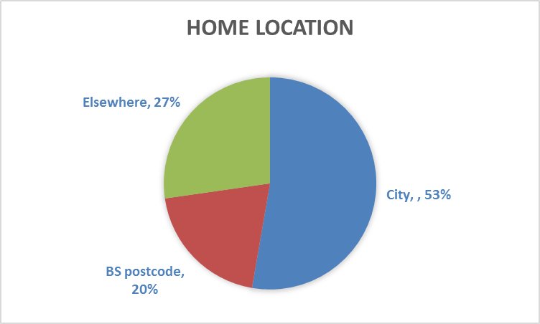

Age

All 228 respondents were happy to divulge their age as shown in the chart below. As might be expected, the age profile of attendees was weighted heavily towards the younger age groups compared with the population as a whole. The over 65s were notably under-represented.

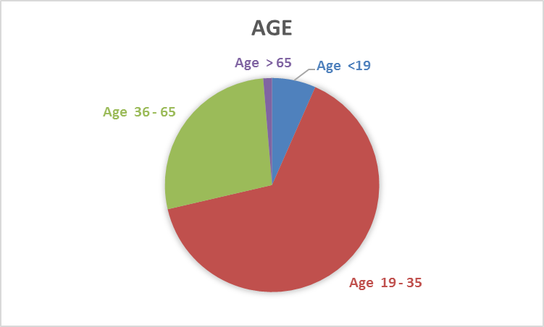

Gender

As can be seen from the chart below, the Carnival attracted a higher proportion of females than in the population as a whole. This may be due to the emphasis given to dance and dressing up in a typical Carribean style carnival.

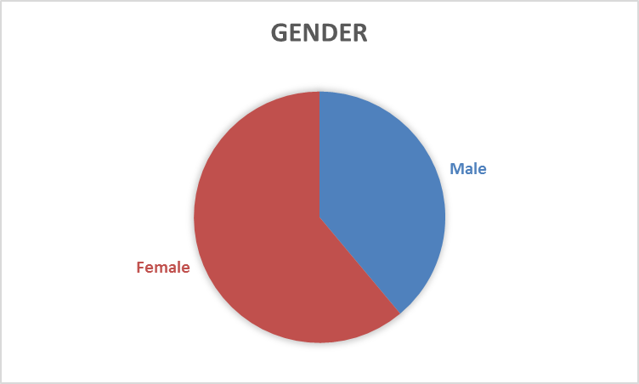

Ethnicity

The responses to the section of the questionnaire on ethnicity are summarised in thre chart below. Many respondents selected both BAME UK and White UK. Interviewers predominantly gave the questionnaire to respondents to complete and this led to possible confusion. These responses where both boxes were marked were taken as White UK. The resulting profile may be biased towards White UK. However the proportion of BAME UK was 13.1%, which compares with 12.4% for Bristol in th 2011 Census, so there may be an insignificant misrepresentation of the actual proportion ofattendees.

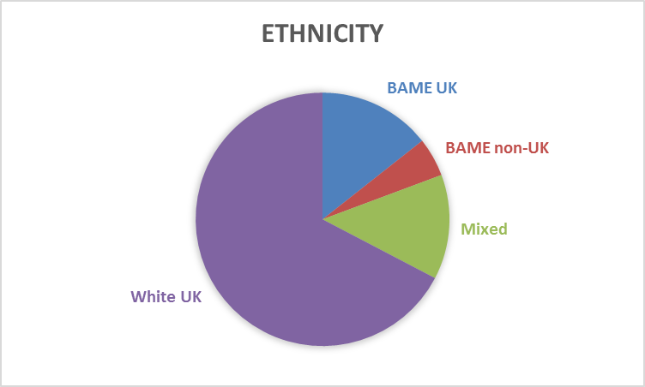

Participation by Carnival Attendees

Reason for being in St Pauls

Some 92 % of respondents were in St Pauls to attend the Carnival. Less than 8% were in the area for some other reason but took advantage of being in Bristol to attend the event. A slightly different question sked whether respondents would be in Bristol were it not for the Carnival. Some 62% stated that they would not. This is significant when addressing the question of the extent to which the Carnival is responsible for attracting spending to Bristol.

Previous attendance at the Carnival

A little over half the respondents (52.4%) reported having attended the Carnival before. Thus a measure of the success of the 2018 Carnival is that it attracted a new group of participants, amounting to over 47% of attendees.

Attending with friends or family?

The respondents were asked whether they came to the Carnival with friends, family, partner, workmates or alone. The responses are summarised in the chart below:

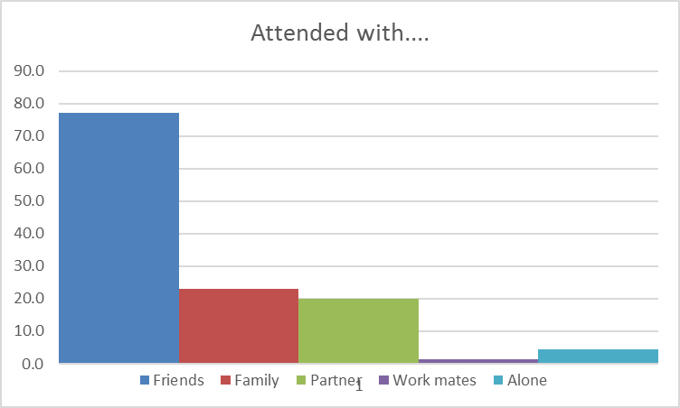

Time spent at the Carnival

The time devoted to enjoying the various activities varied widely although some 75% of respondents spent over 5 hours participating. The percentages of respondents spending various time spans at the Carnival are shown below

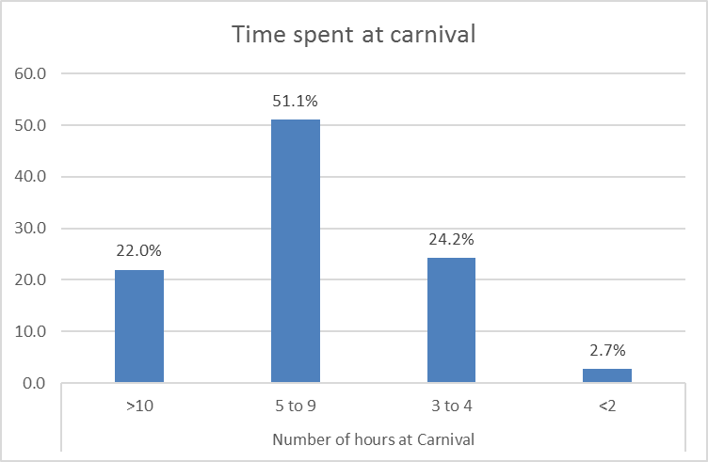

Finding out about the Carnival

The chart below shows how people found out about the Carnival. It appears that networks are mainly responsible for disseminating information about the event. It is perhaps surprising that social media did not play a larger role.

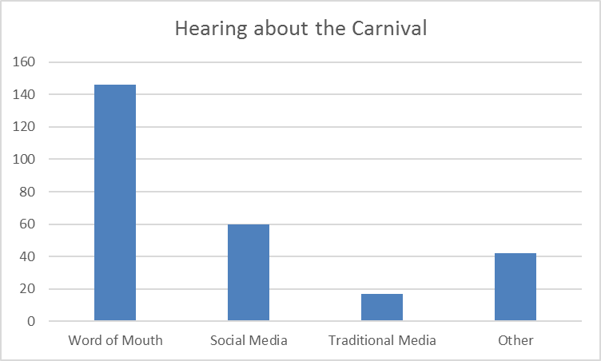

If not for the Carnival….

What would people attending the Carnival be doing if it did not take place? The chart below shows the responses to this question. Those indicating other activities were asked to specify what these might be. Respones included “chilling out”, “seeing friends”, sporting activities and “gardening”. Most would not involve significant spending.

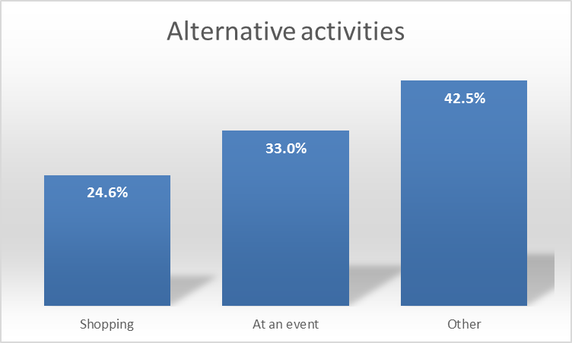

Feeling safe at the Carnival

Respondents were asked to rate how safe and secure they felt at the Carnival

with 1 = very unsafe and 10 = very secure. The responses are summarised in the chart below:

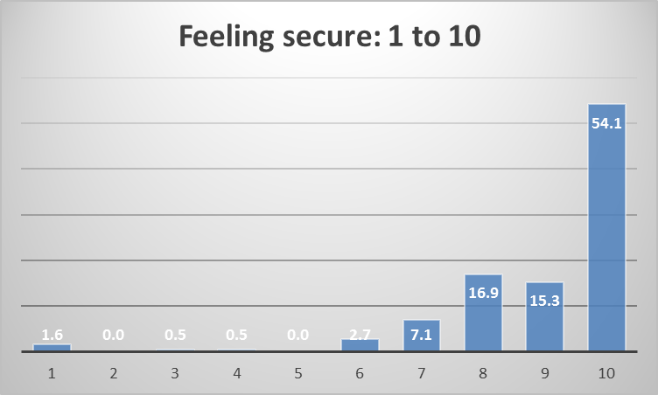

**Supporting the Carnival**

As the Carnival is a not-for-profit organisation that relies on the public for its success, respondents were asked how they planned to support the event. Intentions are summarised below:

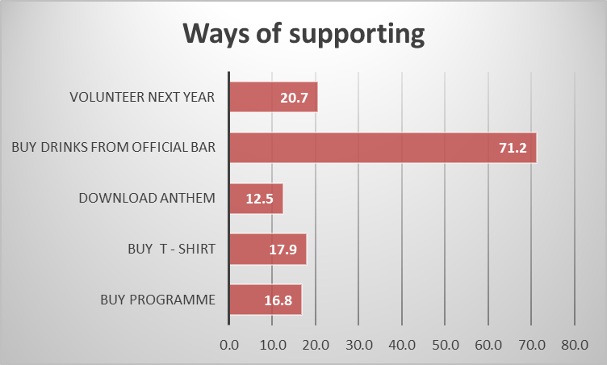

**Willingness to pay for the Carnival**

With future funding of the Carnival being an issue, the survey attempted to guage he extent to which attendees would be willing to pay for tickets. Quite strong resistance was evident from responses and from a number of comments written on the questionnaires. It should be noted that the under £10 category includes those unwilling to pay anything at all.

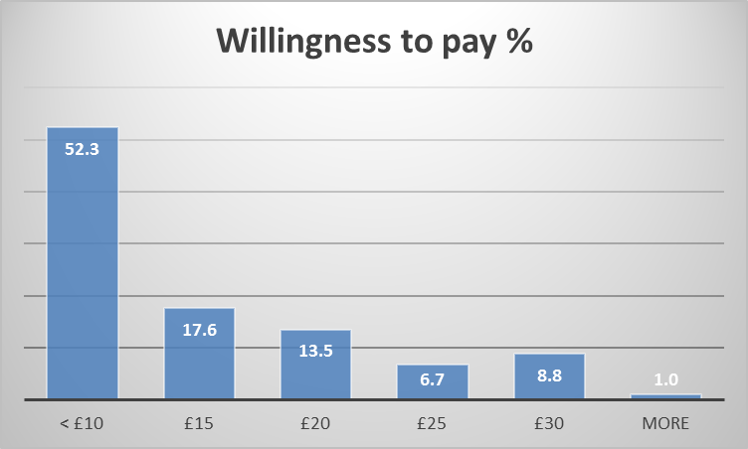

**Intending to attend in future**

An impressive 98.5% of respondents indicated that they would come to the Carnival again next year. Many of the 1.5% who did not reply to this effect wrote “maybe” on the questionnaire. Written comments also showed enormous enthusiasm for the event including one respondent who wrote “Better than Notting Hill!”

**Future activities**

Respondents were asked what aspects of the St Pauls Carnival would they like to see happening more of in the future. The responses across a range of suggestions are shown below:

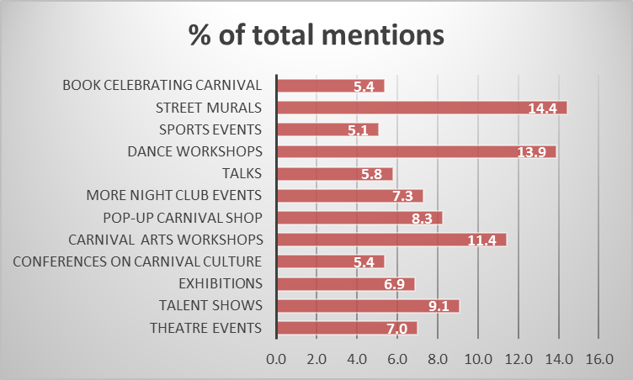

**Expenditure due to the Carnival**

**Spending so far at the carnival**

Respondents were asked what they had spent money on. The responses are summarisd below:

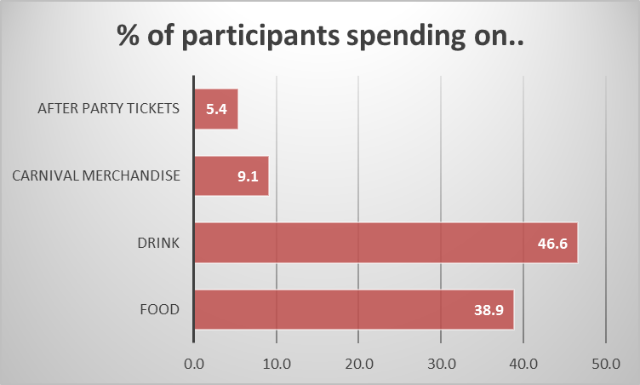

**Total intended spending at the carnival**

The amount participants intended to spend at the carnival is summarised below:

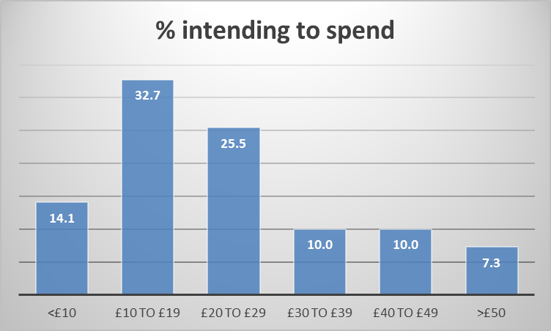

The proportion of respondents spending as indicated above can be used as the basis for an estimation of total likely spending at the Carnival assuming attendance was 90,000. The percentages in each expenditure band is multipled by 90,000 and the result gives the number of people in each band as shown in the first row of the table. An average spend for each band is assumed to lie towards the bottom of the range as shown in the second row of the table. The number of people and the average spend are then multiplied together to give the result in the bottom row, a total estimate of expenditure at the Carnival of £2,012,850. This estimation is summarised in the table below:

**Table 1**



**Reported spending outside the Carnival**

Respondents visiting from outside the city were asked how much they spent outside the carnival while in Bristol. The results are shown in Table 2 below.

**Table 2**



This information can be used to make an estimate of total expenditure of this nature. Once again, the number of people is calculated by multiplying the percentage of people by the total attendance of 90,000. Then the average spend from Table 2 is multiplied by the number of people to give the total expenditure. This sums to a total expenditure of £1,495,920. This is shown in Table 3:

**Table 3**



**Spending on accommodation**

Respondents visiting from outside the city were asked how many nights they stayed in Bristol and how much they paid per night. Many respondents stayed with friends and paid nothing. The average paid per night including those staying free of charge was £18.80. The proportion of residents staying for 1, 2 & 3 nights is shown in Table 4. The total number of nights is calculated applying these proportions to the estimated number attending of 90,000.

This enables the total expenditure on accommodation to be estimated at £822,297 as shown in Table 4 below:

**Table 4**



**Multiplier effects: indirect and induced expenditure**

Multiplier effects as a result of the circulation of expenditure within the local economy. Carnival enterprises benefiting from attendee spending (direct expenditure) will obtain a proportion of their supplies of goods and services from local businesses and this will give a further boost to the local economy. This is referred to as indirect expenditure. Further the Carnival enterprises will pay some of this direct expendinditure out in profits and wages. Local recipients of these wages and profits will spend some in the local economy, giving it a further boost. This is called induced expenditure. Rounds of indirect and induced expenditure can continue indefinitely but diminish with each round because some sources of goods and services are outside the local economy and some recipients of wages and profits spend their incomes on goods and services from the wider regional, national and global economy. In Table 5 below, just two rounds of indirect and induced expenditure are included.

Ideally, surveys would be carried out to determine the proportion of indirect and induced expenditure retained in the local economy. Fortunately, past research into the economies of St. Pauls, Easton and Lawrence Hill gives a good indication of the proportion of indirect expenditure retained. Proportions of induced expenditure are the result of informed guestimates based on known national data.

As sown in Table 5, the total expenditure enjoyed by the Bristol economy as a result of the Carnival was some £5.75 million.

**Table 5**



**Some reservations**

Although the Carnival may have resulted in a total expenditure of some £5.75million, some of those attending the event would have spent some money in Bristol even if it had not taken place. To estimate the expenditure that would have occurred in any event, we can exclude the 62% of attendees that would not have been in Bristol if not for the Carnival. Thus only some 38% of expenditure attributable to those who would have been in Bristol anyway need be considered. Further 42.5% of attendees would have engaged in “other activities” were it not for the Carnival. As discussed above, most of these activities would not have resulted in significant expenditure. We can combine these two factors – 38% of attendees would have been in Bristol, 57.5% of whom would be spending, giving an overall figure of 22% of expenditure might have occurred anyway. Thus the Carnival might be responsible for 78% of £5,733,090 or £4.5m of additional expenditure in Bristol.

**Appendix 1: the questionnaire**

|  |  |  |  |  |  |  |  |  |  |  |  |  |  |  |  |  |  |  |  |  |  |
| --- | --- | --- | --- | --- | --- | --- | --- | --- | --- | --- | --- | --- | --- | --- | --- | --- | --- | --- | --- | --- | --- |
| **Interviewer’s name & time of survey completion** | | | | | | | | | | | | | | |  | | | | | | |
| **As it is our 50th anniversary, the St Pauls Carnival needs your help. Please take just a few minutes to tell us about what you think of the Carnival and about yourself too.**  **Your answers will help us to improve, so thank you for your time!** | | | | | | | | | | | | | | | | | | | | | |
| Your home postcode | | | | | | | | | | | | | | |  | | | | | | |
| Age | | Up to 18 | | | | | 19 to 35 | | | | | | | | 36 to 65 | | | | Over 65 | | |
|  | | | | |  | | | | | | | |  | | | |  | | |
| Gender | | Male | Female | | | | | | | | | Other | | | Prefer not to say | | | | | | |
| Ethnicity | BAME* UK | | | | | | BAME non-UK | | | | | | | | Mixed ethnicity | | | | | | |
| *BAME = Black Asian Minority Ethnicity | | White UK | | | | | White other | | | | | | | | Prefer not to say | | | | | | |
| Main reason you’re in St Paul’s | | Carnival | | | | | | | Other reason | | | | | | | | | | | | |
| Have you been to St Pauls Carnival before? | | | | | | | | | | | | | | | Yes | | No | | | | |
| Who have you come with today? | | Friends | | | Family | | | | | Partner | | | | | Work-mates | | | On my own | | | |
| Number of hours you plan to spend/have spent at Carnival | | 10 or more | | | | | | | | | | | | |  | | | | | | |
| 5 to 9 | | | | | | | | | | | | |  | | | | | | |
| 3 to 4 | | | | | | | | | | | | |  | | | | | | |
| Less than 2 | | | | | | | | | | | | |  | | | | | | |
| What have you spent money on at St Pauls Carnival today? | | Food *Tick all that apply* | | | | | | | | | | | | |  | | | | | | |
| Drink | | | | | | | | | | | | |  | | | | | | |
| Carnival merchandise | | | | | | | | | | | | |  | | | | | | |
| After-party tickets | | | | | | | | | | | | |  | | | | | | |
| Anything else | | | | | | | | | | | | |  | | | | | | |
| How much **in total** do you plan to spend at the Carnival today?  *Guesses/estimates* | | Up to £10 | | | | | | | | | | | | |  | | | | | | |
| £10 to £20 | | | | | | | | | | | | |  | | | | | | |
| £20 to £30 | | | | | | | | | | | | |  | | | | | | |
| £30 to £40 | | | | | | | | | | | | |  | | | | | | |
| £40 to £50 | | | | | | | | | | | | |  | | | | | | |
| Over £50 | | | | | | | | | | | | |  | | | | | | |
|  | | | | | | | | | | | | | | | | | | | |
| Other spending you plan to do while in Bristol *(if you are from out of town)* | | Shopping | | | | | | | | | | | | | £ | | | | | | |
| Food/eating out | | | | | | | | | | | | | £ | | | | | | |
| Club/pub/film/theatre | | | | | | | | | | | | |  | | | | | | |
| Other | | | | | | | | | | | | | £ | | | | | | |
| If you are staying/have stayed overnight | | Number of nights you’re staying  *Circle the number* | | | | | | | | | | | | | 1 2 more than 2 | | | | | | |
| How much have you spent on accommodation per night? | | | | | | | | | | | | |  | | | | | | |
| If not for the Carnival, would you be in St Paul’s/ Bristol today? | | Yes | | | | | | | | | | | | | No | | | | | | |
| What else might you be doing during this time? | | Shopping | | | | | Event | | | | | | | Other – describe  Chilling out | | | | | | | |
| Would you come to Carnival again next year? | | Yes | | | | | | | | | | | | | No | | | | | | |
| How did you hear about Carnival? | | Word of mouth | |  | | Social media | | | | |  | | Press/TV/Radio | | Other | | | | | |  |
| How safe and secure have you felt at this year’s Carnival?  *with 1 = very unsafe and 10 = very secure* | | | | | | | | | | | | | | |  | | | | | | |
| Carnival is a not for profit organisation that relies on the public for support. How do you plan to support Carnival today? | | To buy a commemorative programme | | | | | | | | | | | | |  | | | | | | |
| To buy a Carnival T-shirt | | | | | | | | | | | | |  | | | | | | |
| To download the carnival anthem ‘Unity’ | | | | | | | | | | | | |  | | | | | | |
| To buy drinks from the official carnival bar | | | | | | | | | | | | |  | | | | | | |
| To volunteer to help next year | | | | | | | | | | | | |  | | | | | | |
| Offering 10 hours of entertainment [including 15 sound systems, 4 stages, a procession and more], what do you think St Pauls Carnival is worth? *If you had to pay an admission fee to attend…* | | | | | | | | £5 | | | | | | |  | | | | | | |
| £10 | | | | | | |  | | | | | | |
| £15 | | | | | | |  | | | | | | |
| £20 | | | | | | |  | | | | | | |
| £25 | | | | | | |  | | | | | | |
| £30 | | | | | | |  | | | | | | |
| £ more – please specify | | | | | | |  | | | | | | |
| What aspects of St Pauls Carnival would you like to see happening more of in the future? | | Theatre events | | | | | | | | | | |  | | | More night club events | | | |  | |
| Talent shows | | | | | | | | | | |  | | | Talks | | | |  | |
| Exhibitions | | | | | | | | | | |  | | | Dance workshops | | | |  | |
| Conferences on carnival culture | | | | | | | | | | |  | | | Sports events | | | |  | |
| Carnival arts workshops | | | | | | | | | | |  | | | Street murals | | | |  | |
| A pop-up carnival shop | | | | | | | | | | |  | | | Book celebrating carnival | | | |  | |

**Appendix 2: estimating indirect and induced expenditure**

**Indirect expnditure**

To determine the proportion of Carnival enterprise revenue spent on goods and services, the following assumptions are made. Firstly, from Official Statistics (ONS productivity data), typically businesses spend 50% of revenue on goods and services, 40% on wages and salaries and 10% tax and profits. Thus 50% of revenue is assumed to be paid out for goods and services. Of this, only a portion is paid to suppliers in Bristol. We can make an informed estimate of this portion based on previous research, the St Pauls Workspace Study. The charts below taken from that research suggest that a portion of 55% is reasonable. 55% 0f 50% is 28%, the fiure included in Table 5, Round 1. Round 2 assumes that only 30% of this 28% remains in the Bristol economy, giving the figure 8.25% shown in Table 5.





Source: St Pauls Workspace Study 2008

To calculate induced expenditure, ideally we would survey the spending patterns of those working for Carnival enterprises. This was not possible, but we do have access to information from the St Pauls Workspace Study on where people working in St Pauls live, and thus where they are likely to spend a significant portion of their income. From the chart below, we see that 23% of staff employed by businesse in St. Pauls live in the area. It does not indicate the proportion living in Bristol. Some guidance can be gleaned from data from a similar study carried out in Easton and Lawrence Hill shown below. It shows that 58% of staff live either on the premises or within a 3 mile radius, an area somewhat smaller than city limits. We assume that 60% of staff live in Bristol and that they spend 40% of profits and salaries locally. This gives the overall 12% figure given in Table 5 for Round 1. For the more dispersed induced income derived from general and accommodation expenditure, we assume that only 40% of staff live locally, giving rise to a lower overal figure of 8% in Table 5. In Round 2 both percentages fall to give figures of 3.6% and 1.6% respectively.

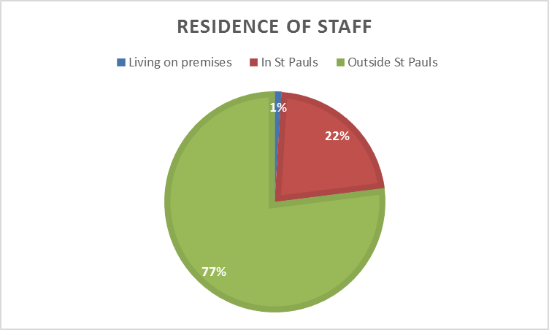

Source: St Pauls Workspace Study 2008



Source: Easton and Lawrence Hill Workplace Needs Asessment 2008