***Stimulus-Organism-Response Model for Understanding***

***Autonomous Vehicle Adoption in the UK***

Michael D. Dzandu 1,*, Buddhi Pathak2 and Stephen R. Gulliver3  
  
1Centre for Digital Business Research, Westminster Business School, University of Westminster, London, UK, email: [dzandum@westminster.ac.uk](mailto:dzandum@westminster.ac.uk)

2Department of International Business and Strategy, Faculty of Law and Business, University of Northampton, Northampton, UK, email: [buddhi.pathak@northampton.ac.uk](mailto:buddhi.pathak@northampton.ac.uk)

3Business Informatics, Systems and Accounting/Informatics Research Centre, University of Reading, Reading, UK email: [s.r.gulliver@henley.ac.uk](mailto:s.r.gulliver@henley.ac.uk)

**\****Corresponding author****:*** *Michael D. Dzandu, Research Fellow, WBS,* [*dzandum@westminster.ac.uk*](mailto:dzandum@westminster.ac.uk)

***Abstract***

*This paper outlines a conceptual model of the factors affecting the adoption of* autonomous vehicles (AV) in the UK based on the stimulus-organism-response (S-O-R) model. *By conducting a critical literature review of literature, 17 factors were identified which were classified based on the concerns of consumers, and the facilitating conditions, of the relevant stakeholders. A preliminary interview with 20 participants in the UK, uncovered three supplementary factors namely company reputation, social policy, and testing of the technology. The S-O-R model, designed to help understand the adoption of AV, is proposed with implications for future research and stakeholders within the AV ecosystem.*

***Keywords:*** *Autonomous Vehicles, S-O-R, concerns, facilitating conditions, technology adoption, stimulus, organism, response.*

## 1.0 Introduction

Increasing waves of disruptive technology are driving societal change (Kroto, 2019; Love et al., 2020; Christensen et al., 2006). The emergence of Industry 4.0, for example, has facilitated a rise in the advancement of digital technologies such as automation, robotics (Bigliardi et al., 2020; Alcácer & Cruz-Machado, 2019), digital twins (Rodič, 2017; Love et al., 2020), etc. Although offering considerable potential to users, the introduction of new technologies has raised some significant challenges, especially in situations where these challenges impact a paradigm shift in both individual and societal behaviour. One such technology is autonomous vehicles (AV). An autonomous vehicle is one that can operate itself with minimal or no intervention from the driver (Manyika and Dobbs, 2013). Although autonomous vehicles are expected to enhance current transportation problems and improve mobility considerably (Mitchell and Brynjolfsson, 2017), these concerns are affecting the potential adoption of AV (Fagnant and Kockelman, 2015; Topham, 2018; Levin, 2018; Solon, 2018; Wolmar, 2018; Yadron and Tynan, 2018). Furthermore, the acceptance of AV focuses more on consumer concerns about the technology (Rosenzweig and Bartl, 2015), and these have implication for stakeholders within the AV ecosystem, i.e. in providing the necessary facilitating conditions to enhance user acceptance of AVs. Despite a growing literature concerning AV technologies, there is a lack of clarity regarding the concerns and facilitating conditions for the potential acceptance of AVs. Although existing studies (e.g. Kyriakidis, Happee and de Winter, 2015; Choi and Ji, 2015; Nees, 2016) are underlined by generic acceptance models (e.g. TAM, UTAT), there is, however, to the best of our knowledge, no study explaining the potential acceptance of AV from an antecedent (stimuli), attitude, and consequent (response) perspectives. The key research question that this study seeks to address is “*What concerns and facilitating conditions are affecting the acceptance of autonomous vehicles in the UK?*

The objective of this study is to identify and assess the stimulus factors (i.e. concerns and facilitating conditions) that impact a user’s attitude concerning AVs and/or the consequent AV acceptance behaviour when AVs are introduced on a large scale in the UK. Currently, AVs are in its acceptance phase. Accordingly, it is critical to understand these factors inhibit or enhance relevant stakeholders attempt, especially government and AV manufacturers, in facilitating a smooth adoption of AV in the UK. To achieve the aim of this study, the authors seek to examine existing literature to identify known factors that may influence user acceptance of AV’s, and then (via interviews) uncover new factors (if any). All factors (from literature and interviews) will then be grouped into concerns and conditions based on a proposed stimulus-organism-response (S-O-R) model (Moqbel 2020; Jacoby, 2002).

In the next sections, we highlight the methods and procedure used to collect and analyse data for the study. This is followed with the results which summarise the key findings on the factors affecting the adoption of AV’s leading to the proposed conceptual model. The paper then draws a conclusion, highlights some limitations and proposes future research directions.

2.0 Methods and procedure

The authors conducted a review of the existing literature to gather factors that influence the user acceptance of autonomous vehicles. The literature review also looked at the theoretical underpinning of the existing acceptance studies to provide a ‘state-of-the-art’ set of factors that potentially impact the acceptance of autonomous vehicles. The theoretical factors were then validated, via a semi-structured interview with 20 participants (in the UK), and analysed qualitatively using thematic analysis (Braun and Clarke, 2006).

3.0 Results

3.1 Factors affecting the adoption of autonomous vehicles

The results of the critical literature review revealed seventeen factors (Table 1) that affect the acceptance/adoption of AVs (e.g. Nielsen and Haustein 2018; Dixon et al. 2018; Choi and Ji, 2015; Kyriakidis, Happee and de Winter, 2015). The factors identified were also confirmed using thematic analysis of semi-structured interview transcripts. Three additional factors, namely reputation of company, social policy and testing of the AV technology, emerged from the interview (Table 1 items number 18, 19 and 20).

The summary results (Table 1) shows that user attitude (organism) to AV is driven by concerns and facilitating conditions (stimulus) in the environment, resulting from users perceived or experiences with AVs, which informs their acceptance and potential adoption (response) of the AV. In line with this, the researchers considered the S-O-R model as appropriate to inform the proposed conceptual framework in future validation. The S-O-R model, originally proposed by Mehrabian and Russell (1974) explores social psychology to explain consumer behaviour as a response to stimuli (Moqbel 2020; Jacoby, 2002).

**Table 1: Summary of factors affecting the adoption of AV, concerns, conditions & impact**

|  |  |  |  |  |
| --- | --- | --- | --- | --- |
|  | **Factors** | **Source** | **Concerns/facilitating conditions & impact** | |
| 1 | Loss of control | Fast and Horvitz (2017), Howard and Dai (2013), Nees (2016), Nordhoff, van Arem and Happee (2016), Choi and Ji (2015) | 1 (-) | |
| 2 | Trust in the technology | Nees (2016), Choi and Ji (2015), Howard and Dai (2013), Huijts, Molin and Steg, (2012) | 1 (-) | |
| 3 | Cost of technology | Nees (2016), Fagnant and Kockelman (2015), Kyriakidis, Happee and de Winter (2015), Venkatesh, Thong and Xu (2012) | 1 (-) | |
| 4 | Knowledge of the technology | Nees (2016), Choi and Ji (2015), Huijts, Molin and Steg (2012) | 1 (-) | |
| 5 | Increased mobility to those unable to drive | Fagnant and Kockelman (2015), Howard and Dai (2013) | 1 (+) | |
| 6 | Pleasure of driving | Nees (2016), Venkatesh, Thong and Xu (2012) | 1 (+) | |
| 7 | Social influence | Venkatesh et al., (2003) | 1 (+) | |
| 8 | Ease of use | Venkatesh et al., (2003), Choi and Ji (2015), Nees (2016), Kyriakidis, Happee and de Winter (2015) | 1 (-) | |
| 9 | Amenities and convenience | Howard and Dai (2013), Venkatesh et al., (2003) | 1 (-) | |
| 10 | Transition period | Schoettle and Sivak (2014) | 2 (-) | |
| 11 | Reduced traffic congestion | Fagnant and Kockelman (2015), Howard and Dai (2013) | 2 (-) | |
| 12 | Environmental impact | Fagnant and Kockelman (2015), Howard and Dai (2013) | 2 (-) | |
| 13 | Safety and security | Choi and Ji (2015), Fagnant and Kockelman (2015), Howard and Dai (2013), Kyriakidis, Happee and de Winter (2015), Schoettle and Sivak (2014), Nees (2016) | 2 (-) | |
| 14 | Ethical issues | Manyika and Dobbs (2013), Kyriakidis, Happee and de Winter (2015), Fast and Horvitz (2017); Holstein et al. (2018) | 2 (-) | |
| 15 | Data privacy | Fagnant and Kockelman (2015), Schoettle and Sivak (2014) | 2 (-) | |
| 16 | Legal liability and safety laws | Schoettle and Sivak (2014), Kyriakidis, Happee and de Winter (2015), Fagnant and Kockelman (2015), Howard and Dai (2013) | 2 (-) | |
| 17 | Impact on the job market | Manyika and Dobbs (2013), Fast and Horvitz (2017); Frey and Osborne (2013) | 2 (-) | |
| Other factors that emerged from preliminary interviews | | | |
| 18 | Company reputation | From interviews | 2 (-) | |
| 19 | Social policy | From interviews | 2 (-) | |
| 20 | Testing of the technology | From interviews | 2 (-) | |

NB: 1 - **Consumer concerns; 2 - facilitating conditions; (+) – positive impact; (-) – negative impact**

This study finds the S-O-R model to be a good fit when explaining the user decisions as to whether to accept and adopt AV’s or not (response), since it manifests their cognitive appraisal of stimuli (concerns and facilitating conditions). The traditional technology acceptance models such as TAM (Davis 1989) and the unified technology acceptance and use theory (UTAUT) and UTAUT2 (Venkatesh et al., 2003; Venkatesh & Davis, 2000; Gefen, et al. 2003), are limited and inadequate in clearly understanding how a stimulus (such as concerns and facilitating conditions of AV) triggers users attitude and intention to adopt a technology (AV). Moreover, since the three factors namely company reputation, social policy and testing of the technology were proposed by the interviewees, these are considered as stimuli, hence the use of the S-O-R model as the most suitable model to understand the adoption of AV in the UK instead of TAM and its variants UTAUT and UTAUT2.

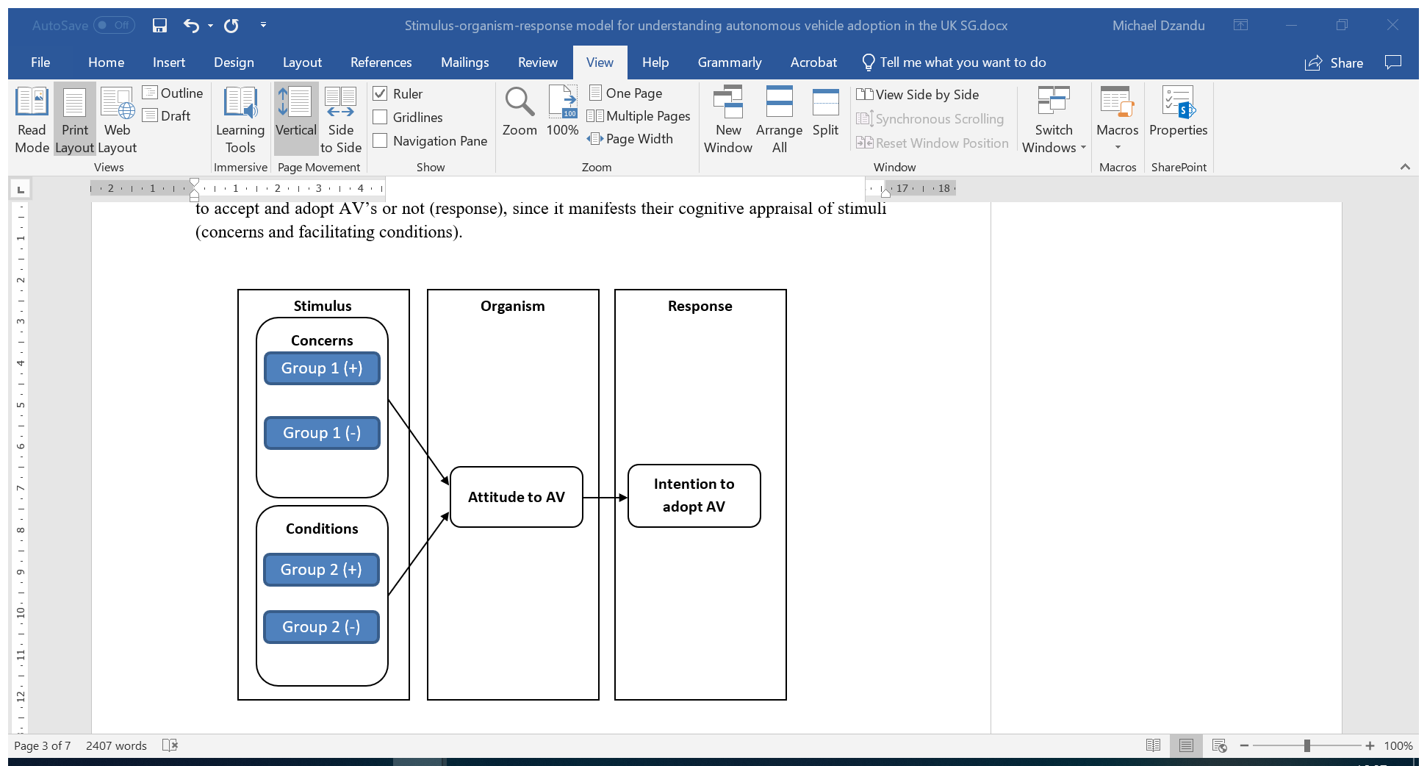

Fig. 1: A S-O-R model for the acceptance and potential adoption of AV

All concerns were coded as belonging to either group 1 or group 2. Group 1 relates to issues that are considered to be more directly linked to individual user and needs. Such issues must be addressed by car manufactures if they are to convince users to accept and adopt AVs. Groups 2 relates to factors that impact on the larger society. Group 2 issues need to be addressed by the government to assure that users to accept and adopt AVs. All concerns were coded as being either positive or negative. Further analysis of the factors and the interview response is required to refine these twenty factors and/or to explicitly model those critical factors, i.e. to inform and define the role of the various stakeholders within the AV’s ecosystem. This is ongoing and will hopefully be reported in a future publication.

The researchers also acknowledge that, whilst the items for the first seventeen factors are well established and validated as constructs in existing acceptance literature, and also confirmed by the responses from the interviews, items 18 to 20 emerged as new constructs from the interviews. Consequently, items for the newly established constructs namely company reputation, social policy and testing of the AV technology would benefit from construct validation. Quantitative questionnaire items are currently being developed and validated, and results of the validation, and the testing of the model, will be reported in a future publication.

**4.0 Conclusion, Limitations and Future research**

Based on current literature, and confirmed using semi-structured interviews, this study considered a wide range of factors affecting the acceptance of AV (in the UK). Three new factors that can influence a person’s attitude to AVs and/or decision to accept and adopt AVs, emerged; namely social policy, company reputation and testing of the AV technology. These previously unidentified factors were incorporated into the proposed S-O-R conceptual model for the acceptance and adoption of AV for validation. The proposed model has wide implications for several future research opportunities, e.g. the quantitative validation of the new constructs that emerged from the interviews (see Fig. 2).

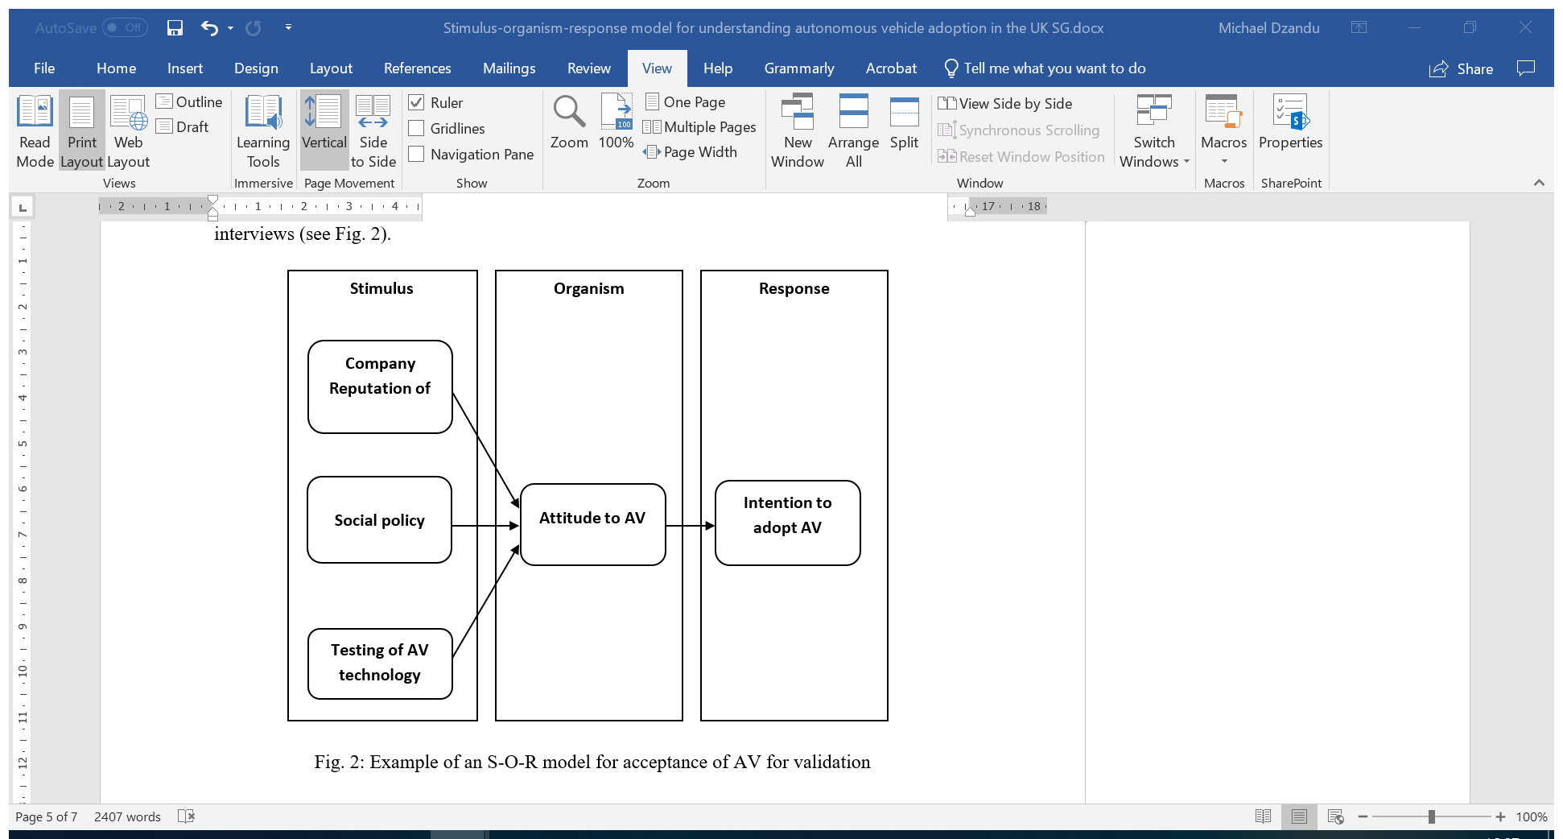

Fig. 2: Example of an S-O-R model for acceptance of AV for validation

One limitation of this study is that we used only qualitative methods, namely a critical review of the literature and semi-structured interviews, which did not yield quantitative data to model the relationships between AV acceptance constructs. Our future research work will use a mixed-methods approach, i.e. to not only generate validating quantitative data for the model testing but also follow-up interviews or focused group discussions, to help understand the reasons behind any observed relationships in the model.

**References**

Alcácer, V., & Cruz-Machado, V. (2019). Scanning the industry 4.0: A literature review on technologies for manufacturing systems. *Engineering Science and Technology, an International Journal*, 22 (3) (2019), pp. 899-919.

Bigliardi, Barbara, Bottani, Eleonora., Casella, Giorgia, (2020), Enabling technologies, application areas and impact of industry 4.0: a bibliographic analysis, *Procedia Manufacturing*, 42, pp. 322-326.

Braun, V., Clarke, V. (2006) “Using thematic analysis in psychology”, *Qualitative Research in Psychology*, 3, 77–101.

Choi, J. and Ji, Y. (2015) “Investigating the importance of trust on adopting an autonomous vehicle”, *International Journal of Human-Computer Interaction*, 31(10), pp.692-702.

Christensen, C.; Baumann, H.; Ruggles, R.; Sadtler, T. (2006) Disruptive innovation for social change. *Harv. Bus. Rev*., 84, 94–191.

Davis, F. D. (1989)“Perceived usefulness, perceived ease of use, and user acceptance of information technology”, *MIS Quarterly*, 13 (3): 319–340.

Dixon, G., Hart, P.S., Clarke, C., O’Donnell, N.H. and Hmielowski, J., (2018) “What drives support for self-driving car technology in the United States?. *Journal of Risk Research*, pp.1-13.

Fagnant, D. and Kockelman, K. (2015) “Preparing a nation for autonomous vehicles: opportunities, barriers and policy recommendations” *Transportation Research Part A: Policy and Practice*, 77, pp.167-181.

Fast, E. and Horvitz, E. (2017) “Long-term trends in the public perception of artificial intelligence”. In: Thirty-First AAAI Conference on Artificial Intelligence. *Association for the Advancement of Artificial Intelligence*, 2017.

Frey, C. and Osborne, M. (2013 ) “The future of employment: how susceptible are jobs to computerisation?, *Technological Forecasting and Social Change*, 114, pp.254-280.

Gefen, D., E. Karahanna, and D. W. Straub (2003) “Trust and TAM in Online Shopping: An Integrated Model” *MIS Quarterly*, 27(1). pp. 51-90.

Holstein, T., Dodig-Crnkovic, G. and Pelliccione, P. (2018) “Ethical and social aspects of self-driving cars”, *arXiv preprint arXiv*:1802.04103.

Howard, D. and Dai, D. (2013) “Public perceptions of self-driving cars: the case of Berkeley”, California. Master. University of California.

Huijts, N., Molin, E. and Steg, L. (2012 ) “Psychological factors influencing sustainable energy technology acceptance: a review-based comprehensive framework”, *Renewable and Sustainable Energy Reviews*, 16(1), pp.525-531.

Jacoby, Jacob. (2002). “Stimulus-Organism-Response Reconsidered: An Evolutionary Step in Modeling (Consumer) Behaviour”, *Journal of Consumer Psychology*, 12, pp. 51-57.

Kyriakidis, M., Happee, R. and de Winter, J. (2015) “Public opinion on automated driving: Results of an international questionnaire among 5000 respondents” *In Transportation Research Part F: Traffic Psychology and Behaviour*, 32, pp.127-140.

Krotov, Vlad (2019), Predicting the future of disruptive technologies: The method of alternative histories, *Business Horizons*, Volume 62, Issue 6, pp. 695-705.

Levin, S. (2018) “Uber self-driving crash that killed woman in Arizona” [online], The Guardian, May 2018.

Love, Peter E.D., Matthews, Jane & Zhou, Jingyang (2020) Is it just too good to be true? Unearthing the benefits of disruptive technology, *International Journal of Information Management*, Volume 52, 102096, https://doi.org/10.1016/j.ijinfomgt.2020.102096.

Manyika, J. and Dobbs, R. (2013) “Disruptive technologies: advances that will transform life, business, and the global economy” *McKinsey Global Institute*.

Mitchell, T. and Brynjolfsson, E. (2017) “Track how technology is transforming work” [online], Nature, May 2017.

Moqbel, Murad. (2020). “Understanding the Relationship between Smartphone Addiction and Well-Being: The Mediation of Mindfulness and Moderation of Hedonic Apps”, *10.24251/HICSS.2020.745.*

National Highway Traffic Safety Administration, (2016) “Federal automated vehicles policy: accelerating the next revolution in roadway safety”.

Nees, M. (2016) “Acceptance of self-driving cars”. *Proceedings of the Human Factors and Ergonomics Society Annual Meeting*, 60(1), pp.1449-1453.

Nielsen, T.A.S. and Haustein, S., (2018). On sceptics and enthusiasts: What are the expectations towards self-driving cars?. *Transport policy,* 66, pp.49-55.

Nordhoff, S., van Arem, B. and Happee, R. (2016) “Conceptual model to explain, predict, and improve user acceptance of driverless vehicles”, Transportation Research Record: *Journal of the Transportation Research Board*, vol. 2602, pp.60-67.

Rodič, B. (2017), Industry 4.0 and the New Simulation Modelling Paradigm,*Organizacija*, 50(3) pp. 193-207.

Rosenzweig, J. and Bartl, M. (2015) “Review and analysis of literature on autonomous driving”, The Making of Innovation.

Schoettle, B. and Sivak, M. (2014) “A survey of public opinion about autonomous and self-driving vehicles in the U.S., the U.K., and Australia”, University of Michigan, Transportation Research Institute.

Solon, O. (2018) “Self-driving cars : who's driving? autonomous cars may be entering the most dangerous phase”, The Guardian.

Topham, G. (2018) “Driverless pods plot new course to overtake humans” [online], The Guardian, May 2018.

Venkatesh, V., M. G. Morris, G. B. Davis, and F. D. Davis (2003) “User Acceptance of Information Technology: Toward a Unified View” *MIS Quarterly*, 27(3), pp. 425-478.

Venkatesh, V., Thong, J. and Xu, X. (2012) “Consumer acceptance and use of information technology: extending the unified theory of acceptance and use of technology” *MIS Quarterly*, 36(1), pp.157-178.

Venkatesh, V., and Davis, F.D. (2000) “A Theoretical Extension of the Technology Acceptance Model: Four Longitudinal Field Studies” *Management Science,* 46(2), pp. 186- 04.

Waymo (2017) “On the road to fully self-driving”, Waymo Safety Report, [online], May 2018.

Wolmar, C. (2018 ) “Driverless cars: on a road to nowhere. 1st ed., London: London Publishing Partnership.

Yadron, D. and Tynan, D. (2018) “Tesla driver dies in first fatal crash while using autopilot mode” [online], The Guardian.

Yeomans, G. (2014) “Autonomous vehicles handing over control: opportunities and risks for insurance”, Lloyd’s.