**The dynamics of procalcitonin in COVID-19 patients admitted to Intensive Care Unit - A multi-centre cohort study in the South West of England, UK.**

Philip Williams, Chris McWilliams, Kamran Soomro, Irasha Harding, Stefan Gurney, Matt Thomas, Maha Albur, O. Martin Williams

Severe COVID-19 infections are characterised by a systemic inflammatory response, and frequently present with pyrexia, raised C-reactive protein (CRP), hypoxia and lung infiltrates. Clinicians have struggled to determine which COVID-19 patients have super-added bacterial infection requiring antibiotic treatment, leading to widespread antibiotic use(1).

Microbiological culture is a relatively insensitive technique, especially during antibiotic treatment. It can be difficult to distinguish infection and colonisation in non-sterile sites, and even in patients with sepsis only 30-50% will have a positive blood culture (2). We cannot therefore rely on positive microbiology alone as an indicator of bacterial infection.

Procalcitonin (PCT) is an inflammatory biomarker that rises in bacterial infection and falls in response to antibiotic treatment, and has greater sensitivity and specificity for bacterial infection than CRP (3, 4). PCT has been used to distinguish between influenza with and without secondary bacterial infection (4) and is of potential value in identifying COVID-19 patients with genuine bacterial infection.

Previous studies have investigated the role of PCT in COVID-19 infection. Williams *et al* (5) described a retrospective analysis of PCT use in COVID-19 patients, concluding that PCT led to a reduction in antibiotic use without impacting on 28 day outcomes.

Van Berkel *et al* (6) measured PCT and CRP in ICU patients with COVID-19, diagnosed with secondary bacterial infection based on a positive culture and the opinion of two ICU physicians. They concluded that low PCT could be used to exclude secondary bacterial infection.

PCT has been identified as marker of poor prognosis in COVID-19 infection (7), and it is unclear if a raised PCT is part of the inflammatory syndrome associated with COVID-19 or primarily reflects bacterial co-infection requiring antibiotic treatment.

We hypothesise PCT raised as an innate part of COVID-19 infection would be unresponsive to antibiotics, while that due to bacterial co-infection would respond to appropriate antibiotic treatment. If PCT is low in many COVID-19 patients and responsive to antibiotic treatment in others, then PCT could provide useful marker of super-added bacterial infection in COVID-19 and in conjunction with the overall clinical picture can guide antibiotic use.

We have undertaken a retrospective observational study describing the dynamics of PCT and CRP, including the response to antibiotic treatment, in adults with severe COVID-19 infection requiring intensive care unit (ICU) admission (n=99) during the first wave of the pandemic. For comparison we selected two better-understood groups of patients from historical data, adult ICU patients with either bacteraemia representing proven bacterial infection (n=113), or influenza representing viral infection at risk of super-added bacterial infection (n=32). Microbiology, inflammatory markers, and antibiotic use, were recorded for the 3 cohorts for 14 days from the first positive blood culture or viral PCR test.

Bacterial co-infection rates in the COVID-19 and the influenza cohorts (7.1% and 18.7%, respectively) were similar to those found in other studies and co-infection rates for both viral infections are higher in ICU patients than in other hospitalised patients (1,8)[.](#_ENREF_18" \t "Shah, 2016 #20)

CRP was initially raised in the COVID-19 cohort and continued to rise during week 1, falling during week 2 (figure-1).

Elevated PCT in the first 48 hours of admission was rare in COVID-19 patients. Where PCT was recorded it was <1.0ng/L in 68.9% of COVID compared to 38% influenza patients.

In an attempt to produce an objective assessment of antibiotic response we have adopted the following definitions “a priori”. We have defined likely bacterial infection group as PCT>1.0 ng/l and have defined a response to antibiotic treatment as a 40% reduction from peak PCT by day 3, or a 60% reduction by day 4 or an 80% reduction by day 5 of treatment or a reduction to below 1.0ng/l. Any PCT reductions up to 24 hours after an antibiotic regime was stopped was included as part of the attributable response.

Patients with insufficient PCT data to determine response where excluded. The remainder were placed in 3 groups; group 1: PCT below 1.0ng/L on days 0 to 13; group 2: PCT raised above 1.0ng/L, but a response to antibiotic treatment was observed; group 3: PCT unresponsive to antibiotic treatment. The characteristic of the 3 groups are summarised in tables 1 and with the inflammatory markers shown in graphical form in appendix 1.

Low PCT is expected in viral infection. In bacterial infection PCT is typically raised, with higher values seen in systemic compared to localised infection, and with more pathogenic organism (9).

In keeping with this only 8.2% of the BSI cohort had low PCT (group 1) while 76.7% showed a good PCT response to antibiotics (group 2), and 15.1% a poor response to antibiotics (group 3), with associated high mortality in this group. In contrast 43% of influenza patients, and 36% COVID-19 patients had a low PCT from admission to day 13 (group 1), with 39.1% of influenza patients, and 29.3% COVID-19 patients having a raised PCT that responded rapidly to antibiotics consistent with super-added bacterial infection (group2).

We found that the CRP of our COVID-19 patients rose over the first 72 hours both in patients with a low PCT (bacterial infection unlikely) and those in group 2 (high PCT that responded to antibiotic treatment (bacterial infection likely). We suggest that static or rising CRP while on antibiotic treatment will not reliably exclude bacterial co-infection in COVID-19 patients in ICU in contrast to the strategy proposed by Mason *et al* (10).

In all cohorts a proportion of patients showed a poor PCT response to antibiotic treatment (BSI=15.1%, influenza=17.4% and COVID-19=34.6%). The higher proportion of COVID-19 patients in groups 3 is likely to be due to late infection with rising CRP and PCT, and positive microbiology common after day 6. A partial response to antibiotic treatment by day 14 was also seen in this group.

The dynamics of PCT in COVID-19 patients are consistent with a response to secondary bacterial infection (and similar to the influenza cohort) and are not consistent with an inflammatory response to COVID-19 alone. In contrast to CRP, PCT appears to be a useful biomarker in identifying COVID-19 patients with super-added bacterial infection.

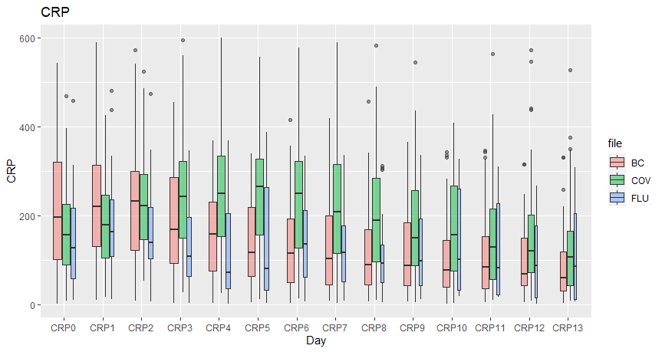 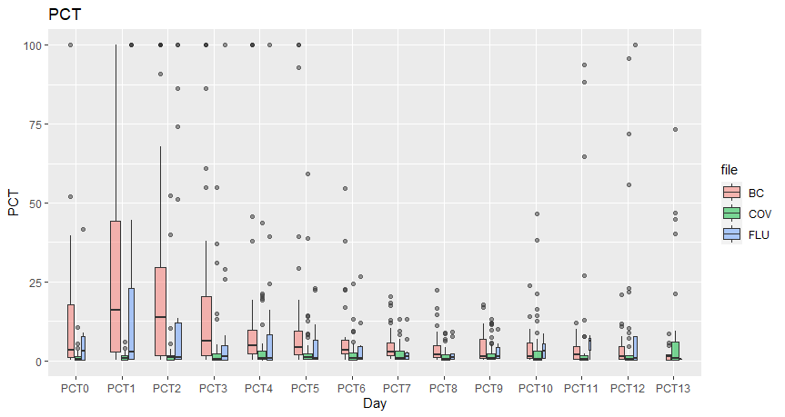

Figure 1. CRP and PCT mean and interquartile range (IQR) by day for the 3 cohorts. BC=BSI cohort; COV=COVID-19 cohort; FLU=influenza cohort.

|  |  |  |  |
| --- | --- | --- | --- |
| **Low PCT group** | **COVID-19 Group 1** | **Influenza Group 1** | **BSI Group 1** |
| Number (n) | 27 (36.0%) | 10 (43.4%) | 6 (8.2%) |
| Age-years (SD) | 56.2 (13.2) | 55.5 (17.2) p=0.89 | 62.8 (8.8) p=0.25 |
| Gender (n (%male)) | 20 (71.4%) | 5 (50%) p=0.16 | 4 (66.6%) p=0.71 |
| Days to ICU discharge (SD) | 13.4 (6.1) | 6 (2.5) p<0.001 | 7.5 (4.8) p<0.001 |
| Mortality <14 days (n (%)) | 1 (3.6%) | 2 (20%) p=0.11 | 1 (16.6%) p=0.23 |
| Mortality <28 days (n (%)) | 4 (14.8%) | 2 (20%) p=0.70 | 1 (16.6%) p=0.90 |
| Co-infection (n (%)) | 2 (7.4%) | 1 (10%) p=0.79 | 2 (33.3%) p<0.078 |
| Early infection (n (%)) | 3 (11.1%) | 0 (0%) p=0.27 | 0 (0%) p=0.39 |
| Late infection (n (%)) | 5 (18.5%) | 0 (0%) p=0.14 | 1 (16.7%) p=0.91 |
|  |  |  |  |
| **PCT responsive Abx** | **COVID-19 Group 2** | **Influenza Group 2** | **BSI Group 2** |
| Number (n) | 22 (29.3%) | 9 (39.1%) | 56 (76.7%) |
| Age-years (SD) | 59.6 (10.6) | 48.4 (19.6) p=0.048 | 63.4 (14.9) p=0.28 |
| Gender (n (%male)) | 15 (68.1%) | 4 (44.4%) p=0.22 | 35 (62.5%) p=0.64 |
| Days to ICU discharge (SD) | 23.0 (15.7) | 14.1 (8.8) p=0.1 | 15.5 (14.2) p=0.01 |
| Mortality <14 days (n (%)) | 3 (13.6%) | 2(22.2%) p=0.55 | 5 (8.9%) p=0.53 |
| Mortality <28 days (n (%)) | 4 (18.1%) | 2(22.2%) p=0.79 | 8 (14.2%) p=0.66 |
| Co-infection (n (%)) | 0 (0%) | 3 (33.3%) p=0.004 | 21 (37.5%) p=0.001 |
| Early infection (n (%)) | 3 (13.6%) | 0 (0%) p=0.22 | 8 (14.3%) p=0.43 |
| Late infection (n (%)) | 4 (18.2%) | 3 (33.3%) p=0.36 | 16 (28.6%) p=0.52 |
|  |  |  |  |
| **PCT not responsive Abx** | **COVID-19 Group 3** | **Influenza Group 3** | **BSI Group 3** |
| Number (n) | 26 (34.6%) | 4 (17.4%) | 11(15.1%) |
| Age-years (SD) | 60.3 (10.4) | 52.2 (15.3) p=0.19 | 63.5 (13.5) p=0.43 |
| Gender (n (%male)) | 21 (80.7%) | 2 (50%) p=0.17 | 9 (81.8%) p=0.94 |
| Days to ICU discharge (SD) | 18.3 (11.2) | 35.7 (35.6) p=0.40 | 10.8 (13.5) p=0.16 |
| Mortality <14 days (n (%)) | 6 (23%) | 1 (25%) p=0.99 | 5 (45.5%) p=0.33 |
| Mortality <28 days (n (%)) | 14 (53.8%) | 1 (25%) p=0.56 | 7 (63.6%) p=0.85 |
| Co-infection (n (%)) | 4 (15.4%) | 1 (25%) p=0.63 | 7 (63.6%) p=0.003 |
| Early infection (n (%)) | 4 (15.4%) | 1 (25%) p=0.63 | 1 (9.1%) p=0.83 |
| Late infection (n (%)) | 9 (34.6%) | 0 (25%) p=0.16 | 1 (9.1%) p=0.11 |

Table 1 . SD=standard deviation; p values relative to the COVID-19 cohort; Abx=antibiotic

References

1. Rawson TM, Moore LSP, Zhu N, Ranganathan N, Skolimowska K, Gilchrist M, et al. Bacterial and fungal co-infection in individuals with coronavirus: A rapid review to support COVID-19 antimicrobial prescribing. Clinical infectious diseases : an official publication of the Infectious Diseases Society of America. 2020.
2. Murray PR, Masur H. Current approaches to the diagnosis of bacterial and fungal bloodstream infections in the intensive care unit. Critical care medicine. 2012;40(12):3277-82.
3. Simon L, Gauvin F, Amre DK, Saint-Louis P, Lacroix J. Serum procalcitonin and C-reactive protein levels as markers of bacterial infection: a systematic review and meta-analysis. Clinical infectious diseases : an official publication of the Infectious Diseases Society of America. 2004;39(2):206-17.
4. Huang DT, Yealy DM, Filbin MR, Brown AM, Chang CH, Doi Y, et al. Procalcitonin-Guided Use of Antibiotics for Lower Respiratory Tract Infection. The New England journal of medicine. 2018;379(3):236-49.
5. Williams EJ, Mair L, de Silva TI, Green DJ, House P, Cawthron K, et al. Routine measurement of serum procalcitonin allows antibiotics to be safely withheld in patients admitted to hospital with SARS-CoV-2 infection. medRxiv. 2020:2020.06.29.20136572.
6. van Berkel M, Kox M, Frenzel T, Pickkers P, Schouten J, group R-C-s. Biomarkers for antimicrobial stewardship: a reappraisal in COVID-19 times? Critical care. 2020;24(1):600.
7. Zhou F, Yu T, Du R, Fan G, Liu Y, Liu Z, et al. Clinical course and risk factors for mortality of adult inpatients with COVID-19 in Wuhan, China: a retrospective cohort study. Lancet. 2020;395(10229):1054-62.
8. Shah NS, Greenberg JA, McNulty MC, Gregg KS, Riddell Jt, Mangino JE, et al. Bacterial and viral co-infections complicating severe influenza: Incidence and impact among 507 U.S. patients, 2013-14. Journal of clinical virology : the official publication of the Pan American Society for Clinical Virology. 2016;80:12-9.
9. Thomas-Ruddel DO, Poidinger B, Kott M, Weiss M, Reinhart K, Bloos F, et al. Influence of pathogen and focus of infection on procalcitonin values in sepsis patients with bacteremia or candidemia. Critical care. 2018;22(1):128.
10. Mason CY, Kanitkar T, Richardson CJ, Lanzman M, Stone Z, Mahungu T, et al. Exclusion of bacterial co-infection in COVID-19 using baseline inflammatory markers and their response to antibiotics. medRxiv. 2020:2020.10.09.20199778.