The Architectural Model as Augmenting a Sensory Ethnography
Elena Marcoª*, Katie Williamsª, Sonja Oliveiraª and Danielle Sinnettª
ªDepartment of Architecture and the Built Environment, University of the West of England, Bristol, UK

*University of the West of England
Frenchay Campus
Coldharbour Lane
Bristol, BS16 1QY
elena.marco@uwe.ac.uk
Professor Marco has worked as an architect in Spain and the UK for over 10 years, where she built a strong profile in sustainable design. Now in academia, she continues to develop her research interests, which focus on the crossover between health, sustainability and architecture.
Professor Williams is an urban theorist, planner and urban designer. She specialises in sustainable urban environments and is known for her work on sustainable neighbourhood design, urban form and land reuse.
Dr Oliveira’s research expertise is built on developing new insights into energy simulation and design practice across scales of analysis from policy level to global reviews.
Dr Sinnett is an environmental scientist with expertise in green infrastructure, primarily as a mechanism to regenerate brownfield and contaminated land.
The Architectural Model as Augmenting a Sensory Ethnography
This study provides an exploration of the effectiveness of the architectural model as a means of implementing a sensory ethnographical research methodology. An architectural model, constructed as part of a wider design research approach, became the visual probe in a site-specific participatory ‘place-event’ with field experts. Using physical objects in sensory ethnography is well established, however, the application of architectural models in this methodological approach has not previously been documented to the authors’ knowledge. The architectural model was shown to be an effective visual probe, a means to implement a sensory ethnography research methodology in the field of architecture. Furthermore, the site-specific nature of the event generated a site-specific conversation that would not have occurred in a more conventional context. The event also made a valuable contribution to the field of architectural research, by demonstrating that a model can challenge the design of a research project from different perspectives, in a similar way to how architectural models challenge the design of buildings. The research described in this paper is part of a wider study, that examines the relationship between material possessions and housing design, and the findings were used to refine the use of visual probes in the later stages of the wider study.
Keywords: architectural design; design research; sensory ethnography; design process

Introduction
In emerging ethnographic research practices, a multisensory approach has been identified as central to understanding people’s lives and experiences in both academic research and practice (Pink, 2007; 2009). The new and more dynamic ethnographic practices currently being explored go beyond traditional observational approaches (Pink, 2007; Pink, 2009; Dicks, 2014). For example, an ethnographic approach with visual material can become an effective tool for generating evidence that other methods, like interviews or surveys, cannot, since they lack the visual materials needed to provoke a specific targeted reaction (Rose, 2012). These multisensory ethnographic approaches are generating new debates and arguments, shaping new empirical studies and practice-led interventions in wide-ranging fields of study (Pink 2004; Pallasmaa, 2005; Tilley, 2006; Edvardsson and Street, 2007) and therefore generating new knowledge.
In the field of architecture in particular, the making of models as visual aids is part of the design process that helps bring together theory and practice (Dunn, 2007; Smith, 2004). Architectural models are often a physical representation of a design (be it a working-, presentation- or conceptual-representation) created as part of the design process (Smith, 2004; Driscoll, 2013; Burry et al., 2007). For centuries, visual materials have been used as part of the design process itself, as well as used to communicate designs to others, such as clients or the wider community (Smith, 2004; Burry et al, 2007; Driscoll, 2013). When presenting their designs to others, architects are being held accountable (Luck, 2004) and the visual materials help challenge the design from different perspectives. As a consequence, changes to the design emerge, that would not otherwise have been considered. This paper argues that visual materials in the form of architecture models also have an important role to play in a research context, helping to frame a design problem from a specific perspective to encourage creativity and innovation.
Participatory events have been used to generate new knowledge, by revealing common themes and stimulating thoughts that at times can be difficult to articulate (Park, 2007; Hemmings et al., 2012). Therefore, this study uses a participatory design event with field experts, using a site-specific setting, in this case the kitchen, to test the effectiveness of implementing a sensory ethnographical research methodology in the field of architecture by using an architectural model as a visual probe. Such events can create a thought-provoking record that can benefit the researcher’s reflection of their own research (Hemmings et al., 2002). In this way, a sensory ethnographical methodology is augmented with an architectural visual probe, constructed using a design research method.
The model was created as part of a wider design research study investigating the evolution of a critical, exploratory and reflective enquiry into the relationship between material possessions and housing design. The architectural model captures the historical changes and present characteristics of today’s domestic space, in both the physical space of the home and in the use and experience of the space itself. The novelty of this study comes from the fact that the architectural model in particular has not yet been tested in the context of a sensory ethnography intervention in architectural research.
This paper begins by situating the model within the architecture design discourse, to explain how the model was created as part of the wider study. This is followed by an explanation of how the specific sensory ethnographic methodology was applied, to test the effectiveness of the model through a site-specific participatory event. Key architectural precedents are also identified, so the approach taken can be understood in context. The background to the development of the methodology is then contextualised. The observations, drawings and recordings of the event are then summarised and thematically analysed, and reported along with the authors’ own critical reflections on the process. The paper concludes that the architectural model was an effective visual probe, a means to implement a sensory ethnography research methodology in the field of architecture. Using a site-specific ‘place-event’ had merit, as the specific location generated site-based conversations that would not have occurred in a more conventional context. Finally, the event made a valuable contribution to the field of architectural research, by demonstrating that a model can challenge the design of a research project from different perspectives, in a similar way to how architectural models challenge the design of buildings.

Situating the model within the architectural discourse
As part of a wider study to capture the historical changes and present characteristics of today’s domestic space, in both the physical space of the home and in the use and experience of the space itself, an architectural model was constructed to bring together past and present qualities of domestic space.
Two historic events, the Smithsons’ ‘Design for the Future Home’ and Andre Jaques’ ‘IKEA Disobedient’, were used as inspirational precedents (Van Den Heuvel and Risselada, 2004; Jaque, 2011; Godfrey, Chimmel and Todoli, 2014). These events have been hugely influential in testing approaches to housing design, and have shown how users of domestic space could be engaged in a discussion about the ideas presented, changing their attitudes and preconceptions. These investigations of the use and experience of domestic space, explored through prototype models with consumers as participant-observers, are the foundations on which the architectural model for this study was constructed. The representation of design thinking as part of the making of architecture is the most important operation that articulates theory and practice (Dunn, 2007). The model is the medium by which ‘certain relevant characteristics of the observed reality’ (Echenique, 1974) are enhanced and abstracted. When creating the model, it was necessary to be highly selective of the information that it contained (Dunn, 2007). It is left to the maker, (in this case the first author), to identify the relevant features for abstraction.
Day (1994) and Peeck (1987) commented on the beneficial role of 3D models to engage participants in participatory events, as they help communicate specific characteristics that keep the participants engaged. Salisbury (1998) cautions against maximising the level of detail that a 3D artefact might have, as well as the quality of its construction, since this can have a negative impact on the event if the object is considered ‘art’. Therefore, the level of detail of the architectural model was chosen with care to communicate effectively without distraction.

Situating the model within a sensory ethnographic methodology
Design Research is considered to be an inquiry, in which design takes a significant role during the research process (EAAE, 2017). Design Research is a reflective practice in which the architect-designers develop complex solutions to a research question (Hauberg, 2011). This reflective practice goes through a process of critical assessment, comparability and evaluation, using sketches, diagrams and models as part of an iterative problem (Thomsen and Tamke, 2009). These visual expressions are representations of cognitive processes that visualise things in a different way to words (Hauberg, 2011). The architectural design process, when used as part of Design Research, ensures that new insights, knowledge and practices that evolve are validated by peer review (Hauberg, 2011).
Sensory Ethnography, on the other hand, is a methodology established as a means to understand people’s lives and experiences (Pink, 2007; 2009; 2011). This methodological approach can benefit architects, as it can give an insight into the priorities of the future inhabitants that they design for (Cranz, 2016).
Visual ethnographic methods generate visual materials (probes) as a way of exploring research questions (Rose, 2014). The researcher becomes central to developing visual material, and in some instances the participants also generate visual material themselves (Pink, 2009; Rose, 2014). The visual material produced needs to be analysed by the researcher and is ‘…used actively in the research process, alongside other sorts of evidence generated usually by interview or ethnographic fieldwork’ (Rose, 2007). Wallace et al. (2013) state that the use of probes is not only a tool for design, but also a tool to explore a specific aspect of design in a targeted but responsive way, which leads to deep reflection and stimuli for design. The visual material can become more emotional when combined with dialogue (Bagnoli, 2009; Rose, 2014), as it can channel a sensory experience of an environment (Banks, 2008; Pink 2009; 2011). The method can be even more effective when combined with interviews or focus groups (Bagnoli, 2009; Rose, 2014), which allow the researcher to explore the things ‘taken for granted’ in the experiences of the participants (Rose, 2013) and can reveal hidden aspects as part of the research inquiry (Knowles and Sweetman, 2004). Scarduzio, Giannini and Geist-Martin (2011) argued that the principles of ethnographic research are similar to an architectural blueprint, in that the ethnographer becomes the architect that joins together the ethnographic ‘attributes’ in order to create their own ‘architectural blueprint’. The ethnographer as the architect continues to reflect through observations, conversations, interviews and drawings, in order to make sense of their enquiry.
In this study, the architectural model, constructed as part of a design research approach, became the means through which an exploration of how a multisensory ethnographic methodology can be implemented to aid design thinking in the field of architecture. Therefore, this paper presents a novel combination of a design research methodology with a supporting sensory ethnography, both explorative and reflexive, as well as iterative and dynamic. The architectural model becomes the central element within both methodological approaches, since they both use visual probes as means of exploring specific aspects of the research. Others have included probes as part of a methodological approach in the past (Boehner, Gaver and Boucher, 2014; Hemmings et al., 2002), using ‘domestic’ or ‘cultural’ probes, but to the authors’ knowledge, an architectural model has not yet been tested in this context. Both methodological strategies involve the researcher-architect in the development of iterative and explorative visual probes (Boehner, Gaver and Boucher, 2014). In this particular study, the visual probe is the architectural model that had been created following a design research methodological approach. The model was then used to enact a reflective dialogue through a site-specific participatory place-event between the researcher–architect and field-experts, creating what the author refers to as a ‘visual ethnography of the design process’.

The making of the architectural model
The architectural model had to articulate the narrative of the past and present qualities of domestic space in relation to the ‘stuff’ that is accumulated and the physical space of the home, as well as the changes to domestic space over time. Titled ‘Undressing UK Housing’, the model captured what lies behind the public face of the house through time. The model used historical and current information from two distinct phases of the wider research study. First, it used the historical information collected as part of the overarching study exploring the major changes in UK housing over the last 200 hundred years (Marco et al., 2013). The study showed a historical dimension to the concept of domestic space and provided an illustration of the change in the priorities and functions of space in the home. The study highlighted the disconnection between storage space provided in our homes and the amount of material possessions that a household contains. Secondly, it used a thematic analysis of the 234 photographs that were collected as part of a participatory design event exhibition at the Architecture Centre, Bristol, UK (Marco and Burgess, 2014). The photographs showed a glimpse, during a particular moment in time, of how possessions were impacting the physical space of the home, giving insights into how inhabitants saw the stuff that occupies their homes.
The model took the form of the four most common terraced-house typologies in the UK: the Regency, Edwardian, Victorian and the Modern house. These encapsulate the times in history when housing demand was at a peak (Muthesius, 1982; Ravetz, 1995). Each period was deconstructed into twelve layers, each made of 5mm thick laser-cut acrylic, and each layer was divided into two halves: left and right (see top-middle and top-right of Figure 1). One half of each layer was carefully laser-etched to represent the past. Looking through the twelve layers together created a three-dimensional effect of how it would have been to live in the house during that period. The repetitive nature of the layers was a reminder of the cyclic nature of the everyday.
The other half was collaged, using images from catalogues and magazines printed onto acetate and glued onto the acrylic, to represent a more contemporary domestic space. These carefully constructed collages (Figure 2) were designed using the findings from the analysis of the photographs collected though the participatory design event exhibition. Six-themes emerged from this analysis: possessions associated with specific rooms and spaces (e. g kitchen, garage, attic, etc.), possessions hidden away or displayed (e.g. collections of mementoes, special significance, etc.), cycles of activities in which possessions were used (e.g. seasonal, daily, long-term, etc.), possessions related to a specific point in the life of inhabitants (e.g. the pram or cot when children are small), possessions related to maintenance and repair (e.g. sewing box, DYI tools, etc.) and archival possessions that might be useful at some point in the future but currently are not (e.g. mobile chargers, old kids swimming pool, boxes unpacked, etc.). The collages showed a layering and juxtaposition of objects, creating a series of fabricated spaces that represent today’s domestic space and its accumulated possessions, by presenting the six-themes identified in the analysis. A key precedent was Richard Hamilton’s photomontages (Godfrey, Chimmel and Todoli, 2014; TATE, 2006; Stonard, 2007; Hamilton, 2004), where he constructed architectural spaces in which material and technological possessions took centre stage.
The past (etching) and the present (collage) cohabited the architectural model to illustrate their influence on today’s domestic spaces. Colourful contemporary collages collided with ghostly etched acrylic to communicate a reality of the everyday at a given point in time. The combined collection of four models, that were to be read as one, gave an overview across both time and space, with the static physical framework of each period home contrasting with the dynamic array of objects and activities they contained.

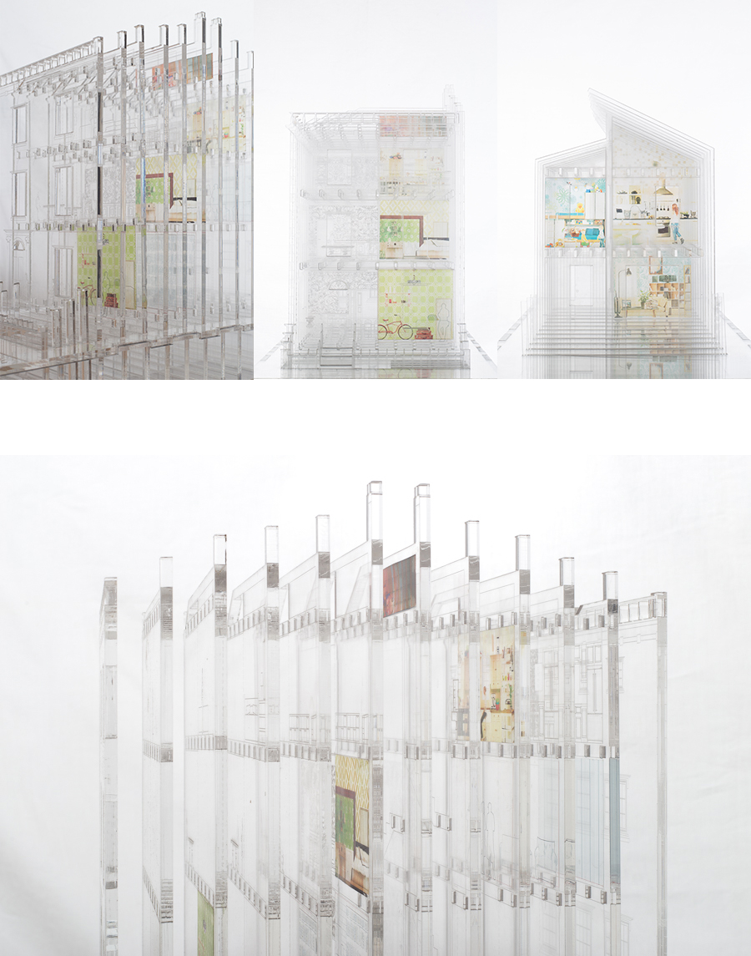
Figure 1. ‘Undressing UK Housing’ architectural model.

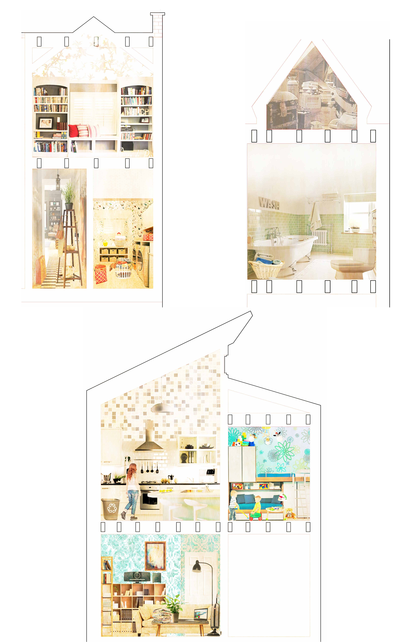
Figure 2. Example of the model collages.

Testing the Model in the Context of the Methodology
Participatory events capture common themes and stimulating material from the experiences of participants and can generate new knowledge (Park, 2007; Hemmings et al., 2012). Their purpose is to changes people’s experiences through an event that reveals hidden aspects of common issues that are difficult to articulate (Park, 2007).
For this study, a design event was created as a reflective participatory event, in order to test the effectiveness of a sensory ethnography methodology using an architectural model. It was important to explore the efficacy of the architectural model as a visual probe.
Therefore, five experts, known to the researcher, were invited to take part in the reflective design event. They were chosen for their expertise in using design research and visual ethnographic methods. Five was seen as the maximum number of participants that could comfortably fit in the chosen physical space, and is in line with the group size recommended by Morgan (1998) when the topic for discussion is complex. Their expertise encompassed the fields of Architecture, Photography, Film and Architectural History. They were asked to engage in a critical discussion of whether the architectural model added to the sensory ethnographic methodology.
Prior to the event, a pack was sent to each participant, containing a written and photographic summary of the study so far, along with information on how the event itself was to be conducted and recorded. The summary covered the project methodology and explained how an architectural model was to be tested in this context. At this stage the participants were asked to reflect on the methodological approach taken. Three blank A5 cards were also included, on which the participants could reflect, record and sketch their thought processes beforehand, based on the briefing.
The experts then came together, led by the researcher to ensure the brief was followed (Figure 3). The model was placed in a specific domestic space, in order to create a ‘place-event’, where the research narrative could be enhanced (Pink, 2009) and to strengthen the dichotomy between the reality of space and its abstraction (Figures 5 and 6). By placing the model (a ‘domestic probe’) inside a physical domestic space (Hemmings, et al.2002), the event was designed to provoke a reflective dialogue amongst the participants, so that the effectiveness of methodological approach could be tested.
The kitchen as a domestic space has been explored in the literature as a place where material possessions and their associated practices come together (Miles, 1998; Pink, 2004; Sutton, 2006; Shove et. al., 2007). The kitchen, within the domestic context of a ‘sensory home’ (Pink, 2004), becomes the intersectional node of human and material activities (Shove et al, 2007). Therefore, for this study, the kitchen was chosen as the ideal place in which to carry out the reflective participatory event.
The reflective discussion started with a thirty-minute briefing, where the background to the project was outlined and questions arising from the briefing pack were addressed. The briefing started as a dinner-table discussion that included the sensory experience of eating and enacting a conversation (Figure 3). It was held in a lounge area, separate from the main place-event kitchen where the model was situated. The construction of the model and its meaning had been introduced as part of the briefing, but at this point the participants had not yet seen the model. The participants were able to ask questions and discuss some of their thinking that had already been captured on the blank A5 cards in the briefing pack. Once the briefing was concluded, the participants moved to the kitchen area, where the model, placed centrally, (Figure 4) was revealed to the participants. At this stage the participants were asked whether the model communicated the use and experience of domestic space over time as intended.
The event lasted two hours from start to finish. The dialogue was recorded and photographed, and written notes were taken by the researcher as participant-observer. The photographic recording of both the event and the model was an important additional means of capturing the dialog beyond the event itself. All this information was then thematically analysed. Figure 5 shows the five stages of the method that was used in the study. First, the participants’ sketches and notes were analysed to identify the efficacy of this methodological approach to deliver innovation in architectural design. The sketches and notes principally focused on the process by which the model was created. This theme was then expanded by analysing the audio-recordings and the first author’s notes, which captured two further themes: the effectiveness of the architectural models augmenting a sensory ethnography and the use of a kitchen as a ‘place event’.

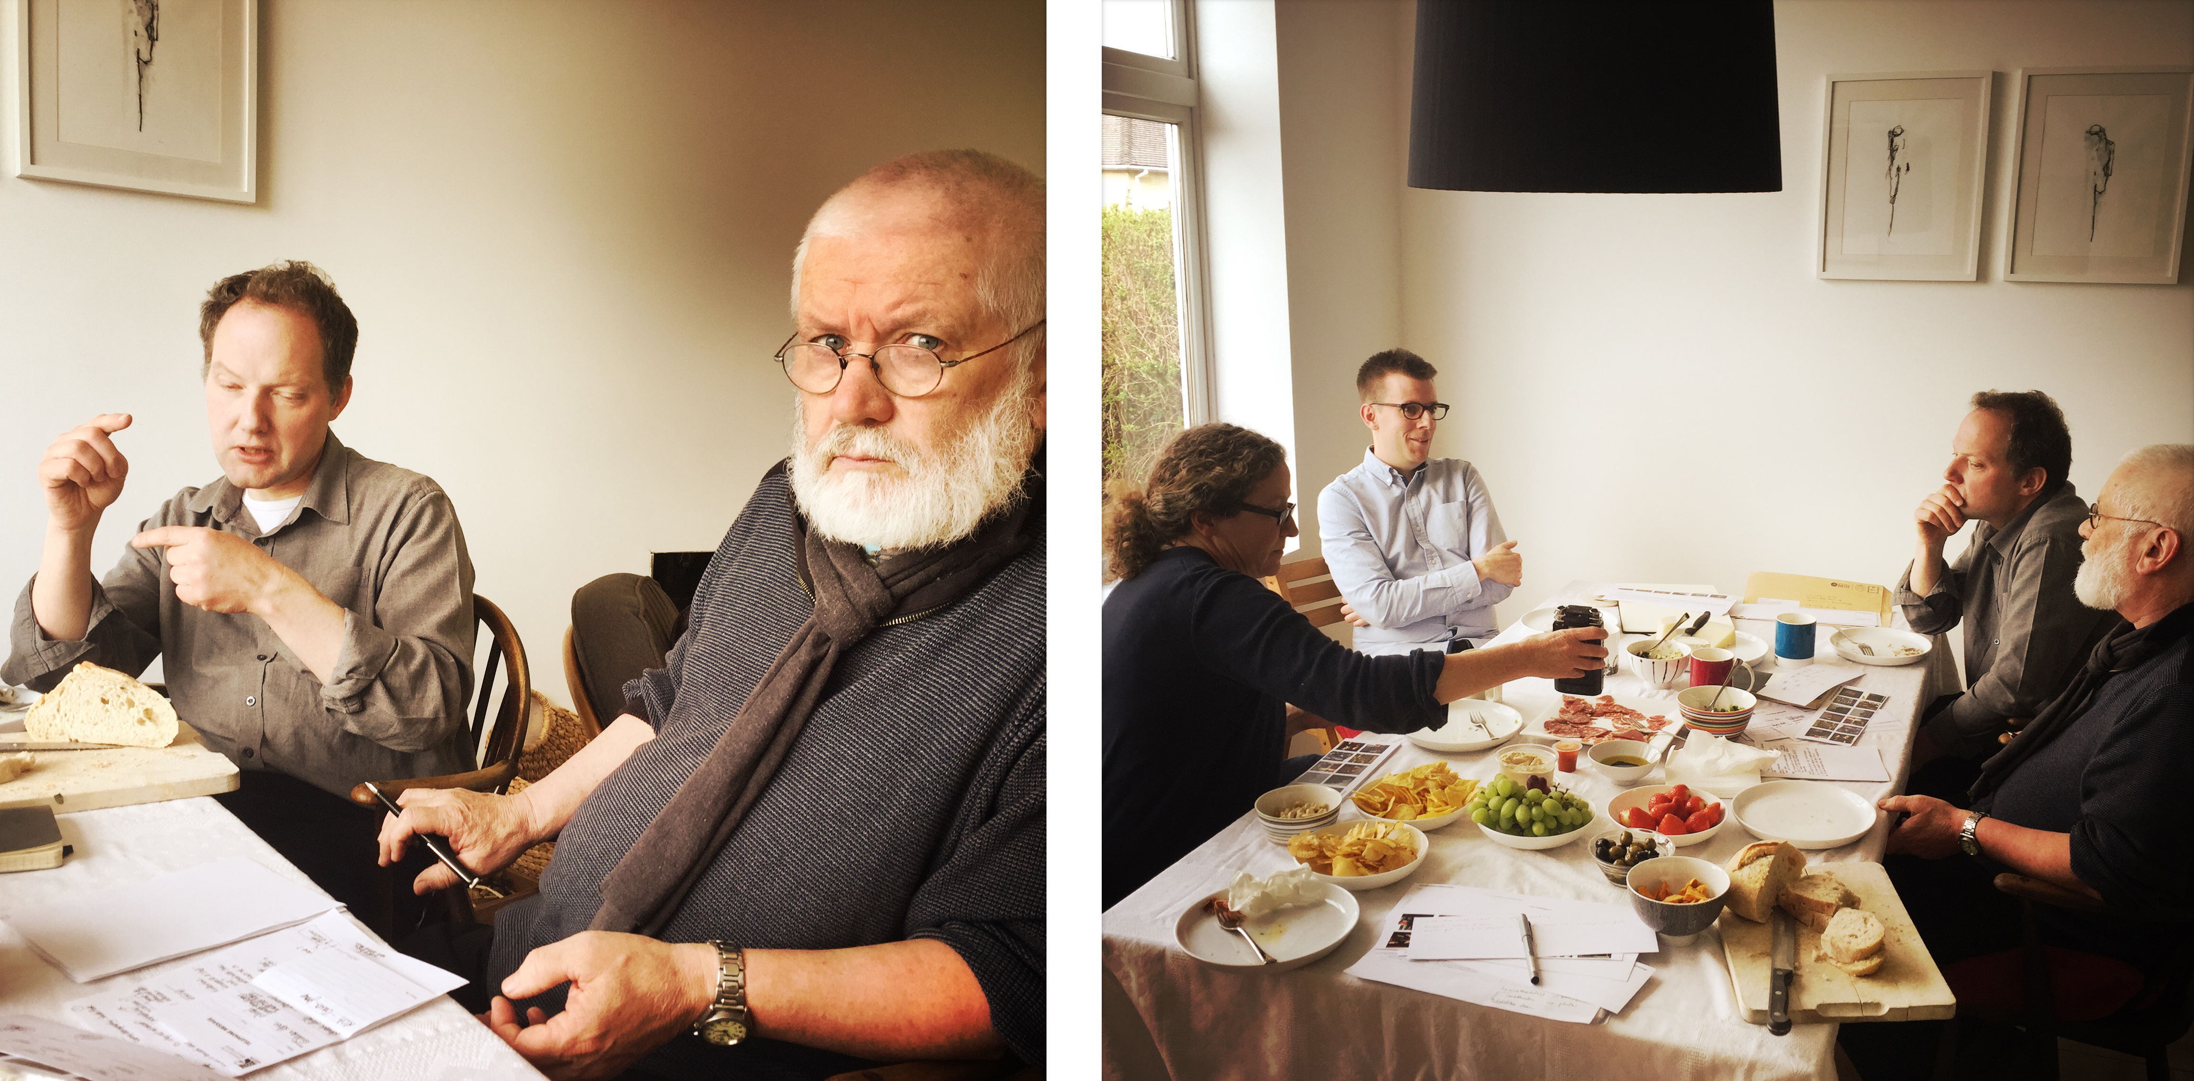
Figure 3. Participants being briefed in the living area as part of the domestic event.

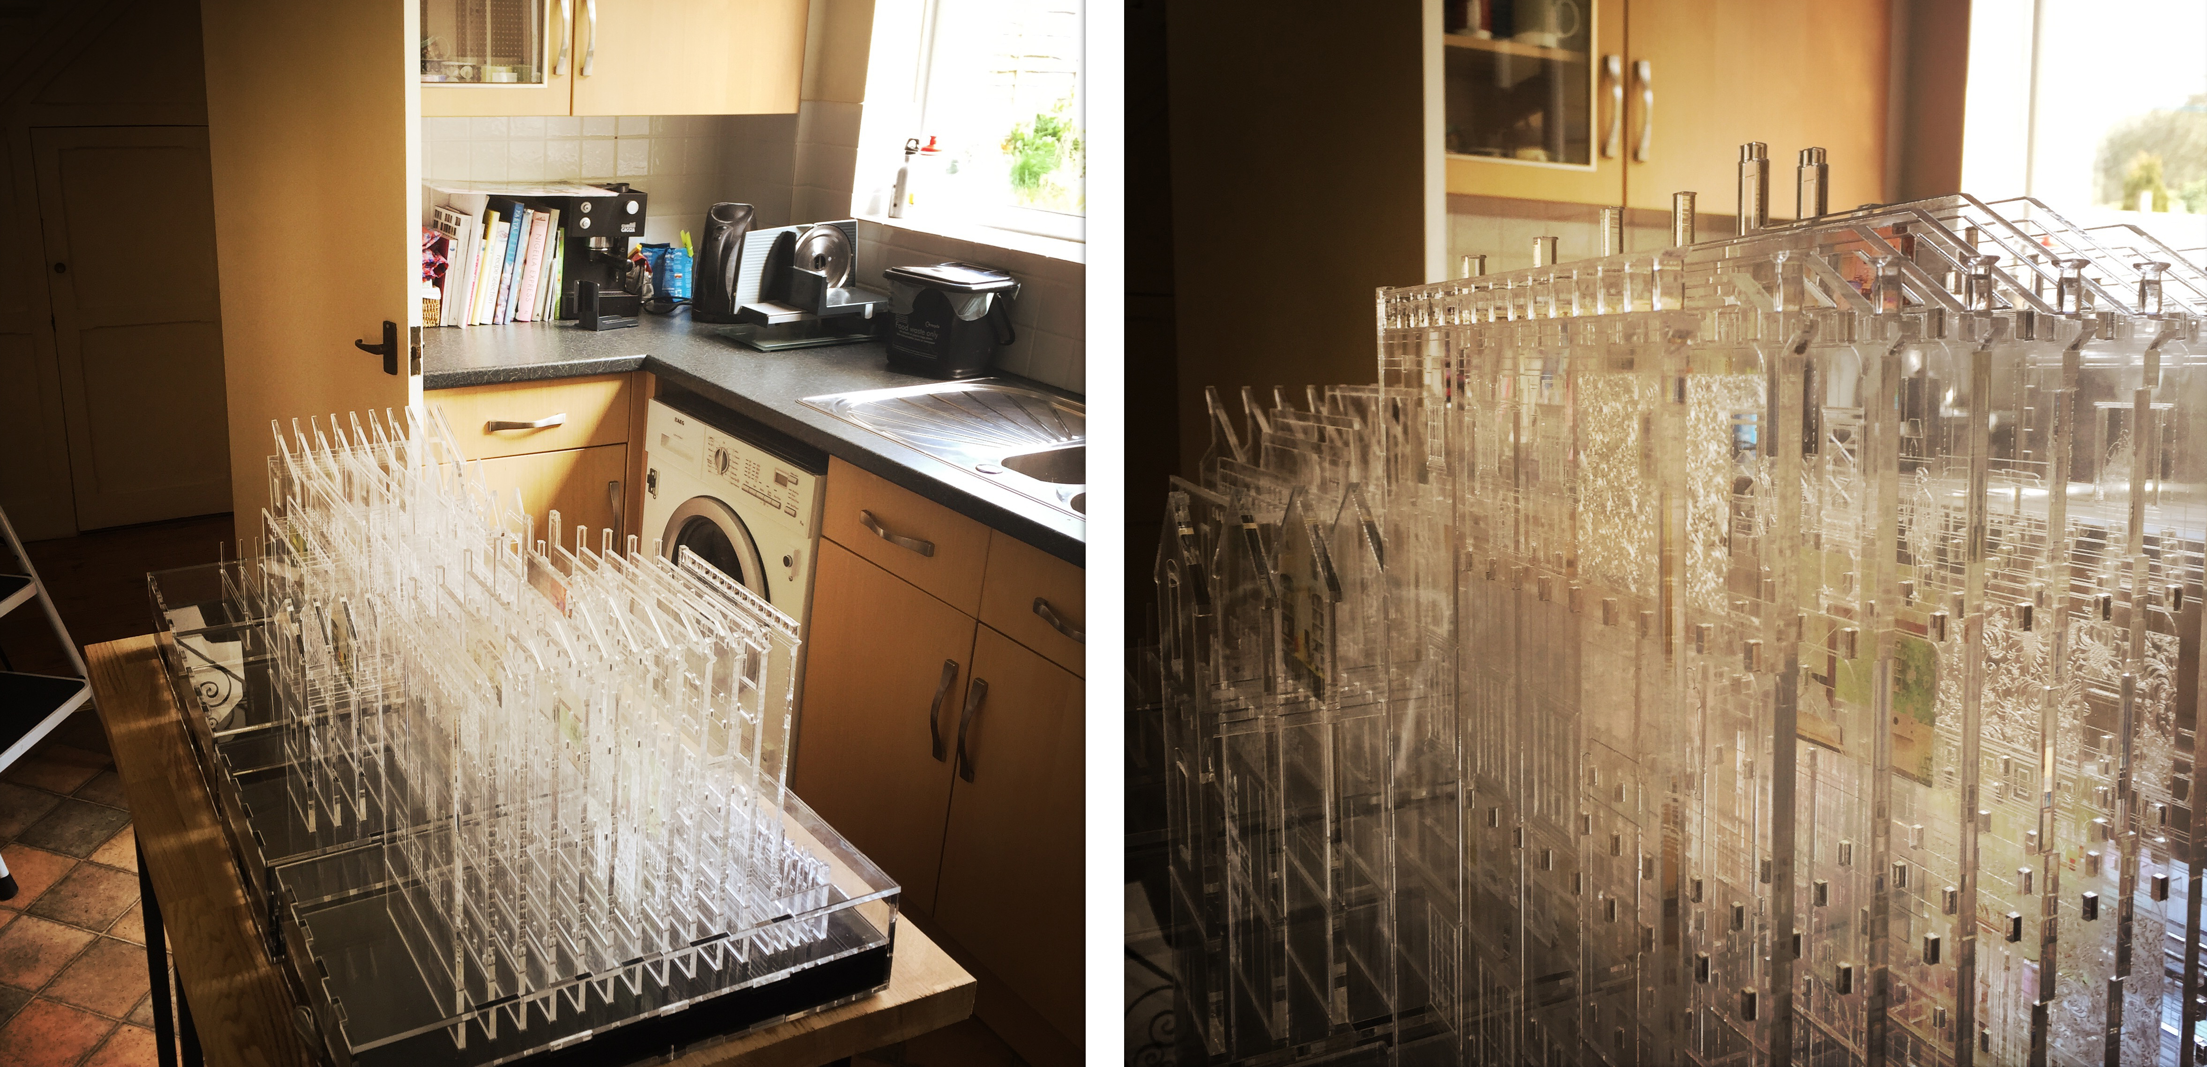
Figure 4. Placing the architectural model in the context of the kitchen.

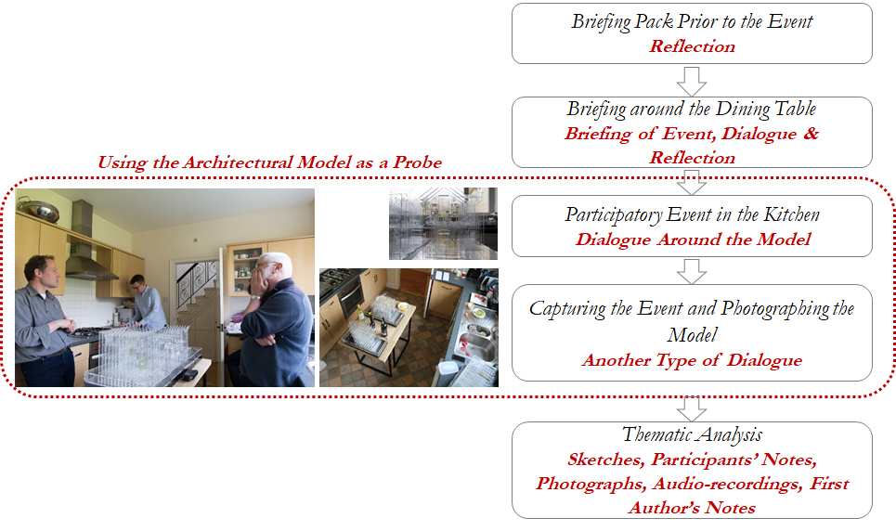
Figure 5. The five stages of the method.

Discussion
The findings presented below have been drawn from the thematic analysis of the reflections from the participants and each theme is discussed in turn.

The architectural model as augmenting a sensory ethnography
The question of whether the architectural model was effective in augmenting a sensory ethnography methodology was explored by the field experts. All field experts were overwhelmingly positive. The architectural model was successful in creating and promoting a critical dialogue amongst the group (Figure 6). The model was observed from different angles and heights during the event, creating a dynamic and engaging dialogue (Figure 6). The model also generated personal moments, where three of the participants in particular discussed where they have lived in the past, as the physical form of the model took them back to their personal experiences.
Based on the range of topics and depth of the discussion that the model generated, the participants agreed that an architectural model could positively contribute to a sensory ethnography. However, the consensus was that, within the wider study, it should ‘not be this model’. They felt that the model examined was too ‘beautiful and structured’ and ‘too crafted’ to contribute to the methodology. They concluded that a different type of model, where the ‘illegitimate’ elements of the research were expressed, would be of more benefit, because people would not be afraid to touch it, move it and even change it as part of the dialogue.
Differences of opinion arose, however, when discussing what type of model would be most suitable for the wider research study. In order to communicate the use and experience of domestic space in relation to material possessions, two possibilities emerged from the discussion. One suggestion was to use a ‘larger-scale, less detailed model of space’, in which participants might 'play' at placing various items of 'clutter'. Another suggestion was to use a ‘digital’ or ‘cinematic’ model that could be morphed with time so as to become temporal, like material possessions are themselves. A theme that kept occurring was the importance of playfulness as a means of engaging the participants that take part in the sensory ethnography.

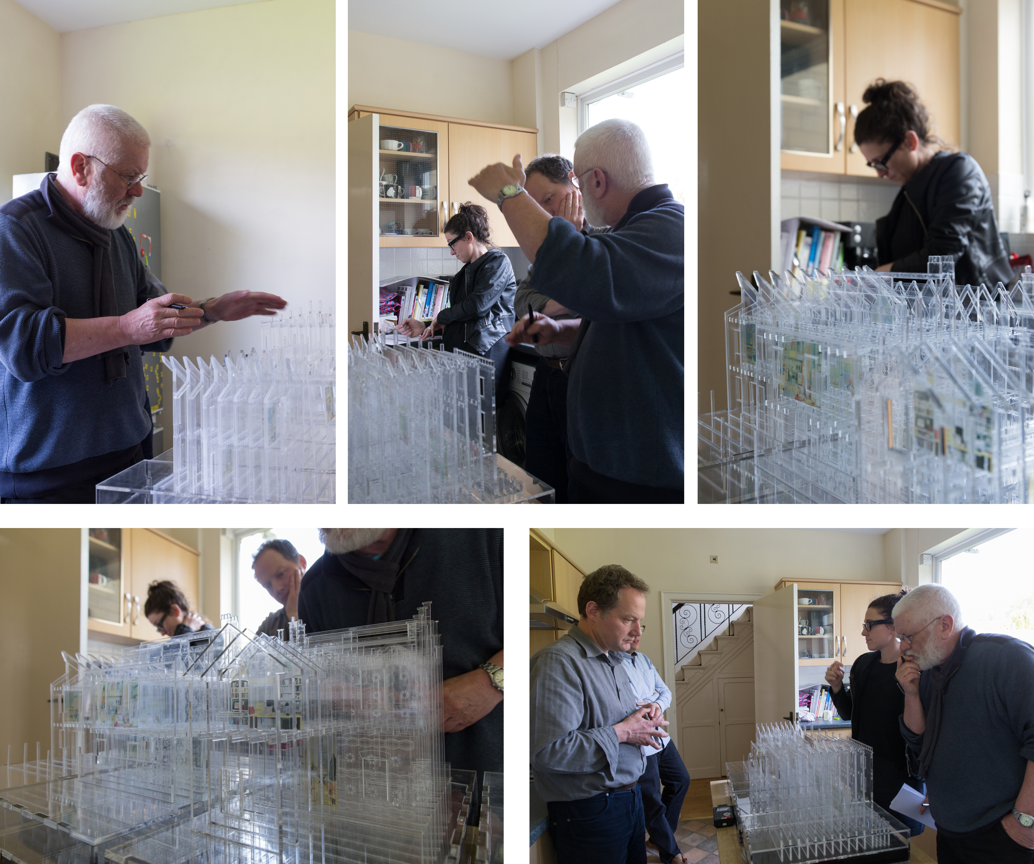
Figure 6. Participants during the domestic event.

‘I don't necessarily agree with [Participant A] that a digital or cinematic representation of space would help. For my part, I would be very interested in seeing you develop a larger-scale, less detailed model of space (we called it a 'cardboard box' model) in which participants might 'play' at placing various items of 'clutter'. This would address what I believe is the very important distinction between 'architectural' space (the spaces represented by architectural photographers, or even the IKEA catalogue) and 'cluttered' space.’
Participant D

‘I am very attracted to the idea of a 'game' in which participants can 'play' at placing clutter within a model.’
Participant A

Once the group agreed that the model had a role within the sensory ethnography, the researcher noticed that participants began to draw and animatedly discuss the design of the ‘other model’ (Figure 7). This raises an interesting question about whether the model should be ‘wrong’ on purpose, in order to stimulate a discussion about what the ‘right’ model should look like.

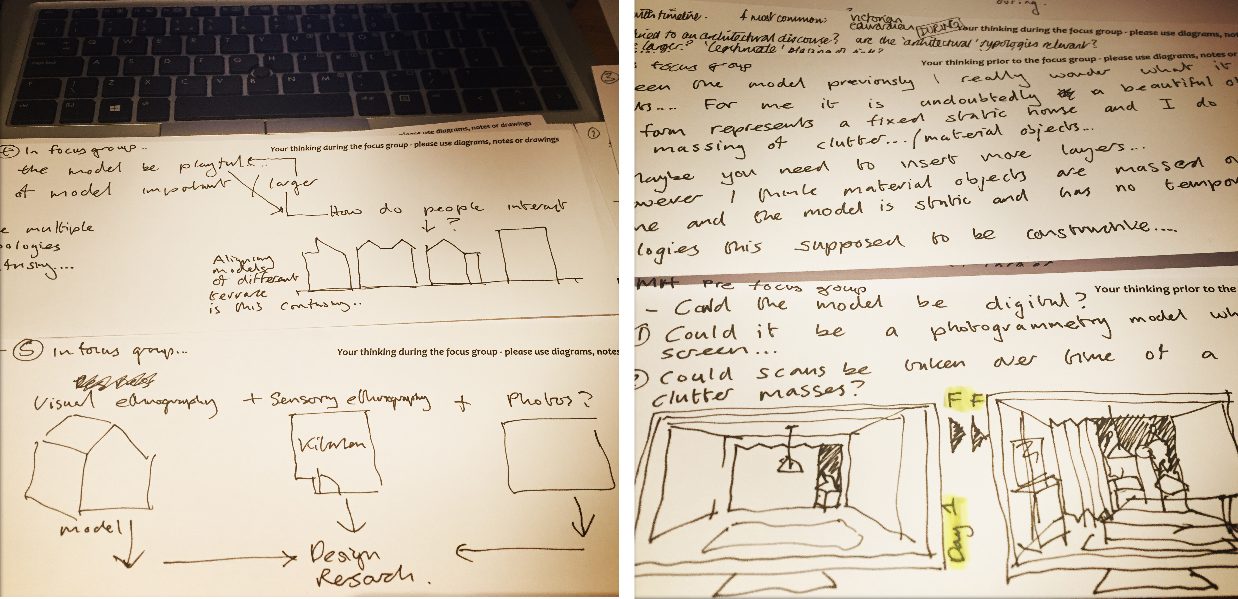
Figure 7. Sketches and notes taken during the event.

There was an agreement that the ‘other model’ should be designed and constructed with the ‘various items of clutter’ derived from the already collected photographs, and that it also needed an element of ‘play’. In order to include the clutter in a methodological manner, the experts felt it was important that the collected photographs led to the creation of a ‘taxonomy of stuff’.

‘When I say 'various items of clutter', I am thinking these might be derived from a detailed analysis and taxonomy of your photos. You say you have a very large sample of these - maybe they could be classified into categories such as 'dirty' or 'clean'; 'useful' or 'symbolic'; 'contained' or 'dumped' etc. etc. You could then use your groups to better understand how these various forms are accommodated within the home.’
Participant E

It is interesting to note that, about half way through the event, the participants came to the realisation that, as a group, they held very specific expertise and their dialogue was ‘very academic’ in relation to the methodology. They questioned whether ‘a much more practical discussion’, involving the inhabitants themselves (non-experts), would lead to different conclusions about the suitability of the model for this methodology. This is an important point, which the researchers will need to consider in more detail as the wider study progresses.

The kitchen as ‘site-specific’
The merit of using a kitchen as the site specific ‘place-event’ in which to hold the discussions was seen as overwhelmingly positive by the participants. During the event, the participants acknowledged that the location generated a different conversation than that which would have taken place in a more academic or architectural practice-based space. The kitchen itself was also used as part of the discussion, and the participants drew parallels between the ‘real’ kitchen and the ‘fabricated’ spaces of the model.
The food that had been shared as part of the briefing process was transported to the kitchen, and the dialog continued to develop into a format that could be compared to a dinner-table conversation. As time went on, the model was changed, touched and moved, despite them suggesting earlier that its crafted nature made them reluctant to do so (Figure 8). Towards the end of the discussion, one participant even found some bottles of alcohol in a kitchen cupboard and moved them amongst the models to bring the them closer to a ‘real’ kitchen context – the authors would like make it clear, however, that no alcohol was consumed during the event.

Figure 8. Photographs of the kitchen after the domestic event finished.
The photographic recording of the model, during and after the event, was also considered an important part of this methodology. The photographic recording was seen as a method of further dialog, something already considered by the Smithsons back in the 1950s (Van Den Heuvel and Risselada, 2004; Godfrey et al., 2014). The model was also photographed by the photography field expert after the event. The photographer tried to stay truthful to its highly aesthetic value, by capturing the essence of the research project and analysis, as well reflecting the discussions that took place during the participatory event. The final photographs of the model after the event became very architectural, flattened 2D representations that captured the depth and 3D nature of the artefact, adding to the recording of the dialog through the photographs themselves (Figure 1).
Pallasmaa (2005) and Tilley (2006) advocate for a multisensory approach to architecture. This study has implemented a multisensory approach in a different context by using an architectural model in a kitchen as a catalyst to provoke a critical debate.

Analysing the process by which the model was created
The value of making as a way of thinking through design was seen by the field experts as beneficial for this study. It was therefore suggested that it would be a good idea to construct different models for different purposes and different audiences, so the multisensory ethnographic methodological approach could be further tested in this context.
One of the weaknesses of the model, from an architectural perspective, was that whilst it was a 3D object, its layers made the information seem flattened, recorded and ‘stored’, and it therefore lost its three-dimensionality. The elaborate crafting of the model was also considered distracting, as the physical fabric of the building was more readable than its ‘stuff’. However, the experts agreed that the model had characteristics that ‘start to work when [the model] describes the [historical] peculiarities of space’ like the high ceilings or original features, and that it shows how the space would be used today through its fabricated collages.
Both the model and the collages were viewed as carefully constructed spaces that record and store the progress of the wider study, showcasing how the project has developed, and trying to abstractedly communicate the research findings so far. One expert argued that the model had done its job within the context of the study and now needed to be archived.
‘I would recommend you to 'archive' or 'park' the models as you presented them, although they are a valuable record of a key stage in your process.’
Participant B
In contrast, two of the other participants saw the model becoming a valuable storage medium for the research and suggested the model should continue to be developed throughout the study in order to archive both the process and the findings, becoming a carefully constructed record of the research process.
‘…. the model is something to read because it is visual….instead of reading a text you read a visual recording of the research’
Participant A
The dichotomy between the ‘perfect architectural model’ and the ‘imperfect reality’ was discussed at length, especially within the architecture and architectural photography contexts. At this point, the participants engaged with the context of the kitchen and its contents by opening cupboards and drawing parallels between the ‘stuff’ in the kitchen and the content of the collages in the model. It was noted that when architecture is photographed, people and stuff are usually removed, ‘but the house is brought to life when you add these things’. The participants debated whether, since the research aims to look at material possessions, this model is ‘too legitimate’, by which they meant too perfect or crafted. They concluded that the research needs an ‘illegitimate model that rebukes architectural space’.
‘Seeing an empty house, devoid of belongings and personal effects, is like seeing a skeleton. The life of a house comes from the presence of people within it, their possessions and the marks they make (wallpaper, paint, etc.)’
Participant C
Therefore, whilst the model was considered beautiful, it was at the same time considered static, almost like a piece of art, albeit one which has value as part of the research process.
The participants agreed that continuing to explore the wider study through the construction of models (legitimate and illegitimate) would be of benefit to the researcher as a way of addressing the dichotomy between the architectural space (legitimate) and the accumulation and storage of material possessions (illegitimate).

Conclusion
The architectural model allowed an exploration of its effectiveness as a means to implement a sensory ethnography research methodology within the field of architecture. The very act of creating the model as part of the design research approach also required the processing and rationalisation of the findings of previous stages of the wider study, through critical reflection. The model gave an overview across both space and time, with the static physical framework of each period home contrasting with the dynamic array of objects and activities they contained. The model helped to synthesise information from disparate sources and provided a visual historical representation of that information. In this study, the model also tested the sensory ethnography methodology, augmented by a design research methodology, through a participatory event, in a kitchen –‘place-event’. This captured new stimulating material to take to the next stage, especially informing the types of models that would benefit future research, and highlighting the importance of creating a ‘taxonomy of stuff’. This brought a contribution to knowledge of how architectural probes should be designed and constructed to test research findings with architects, so these findings can contribute to architecture design thinking. The architectural model was effective as a means of implementing a sensory ethnography, however the construction of the model in itself brought questions about ‘what model’ would be appropriate.
Visual communication through 3D models helps to challenge architectural designs (Smith, 2004; Driscoll, 2013; Burry et al., 2007), and refinements to these designs emerge as a consequence. However, this study builds on this use of visual probes in architecture, by advocating for their use as part of a sensory ethnography methodology as a way of challenging the research process itself. This helps to frame the design of a research project from a specific perspective, encouraging creativity and promoting novel approaches.
Overall, the outcome of the ‘place-event’ was, in the view of the authors, a success. It led to a critical but rich discussion that helped re-think the wider exploratory research study within the context of this particular methodology. According to the participants, siting the model within a real kitchen worked surprisingly well. Despite the array of evidence from the literature (Pink, 2004; 2009; Dick, 2014), there was still initial scepticism from the authors as to whether the informal and cramped nature of a real kitchen would be the right space to promote dialogue and discussion. However, holding the briefing in the dining area instigated a dinner-table type conversation amongst the participants that was rich, fluid, dynamic and reflective. This conversation continued when the event moved into the kitchen. Since the wider study is investigating the use and experience of today’s domestic space in relation to material possessions, holding the event in a domestic space surrounded by material possessions allowed people to draw upon both the kitchen and the model to seek inspiration for their thoughts.
The idea of continually updating and adapting the model as a means to archive the research findings was thought to be inspiring. Since the research is about the accumulation and storage of material possessions in the home, it seems particularly apt to use the model itself as a way of accumulating and storing research findings. Not only will this allow the progression of the research to be recorded, but the very nature of creating the model will require the processing and rationalisation of findings through critical reflection. The model has also since served as a means of communicating the research findings to others through two carefully curated exhibitions.
The discussion on whether the focus of the model should be legitimate or illegitimate made the authors reflect on whether other types of models could be created as part of the wider research. However, it is important to decide whether these probes are just a design tool, or intended to engage participants in a critical dialogue.
The experts themselves did not feel that this particular model was the most appropriate to add to a sensory ethnography. However, the dialogue and engagement it provoked in them, to talk about their own personal and professional experiences of material possessions in domestic space, makes the authors conclude that it has nevertheless added to the sensory ethnographic methodology. This study also identified the need to test out the model with non-experts, the inhabitants of the domestic spaces, to explore what type of dialogue it provokes in them.
In future research, where architectural models are used as part of a sensory ethnography, this study also suggests that it would be beneficial to get feedback from field experts on the design of the models to identify specific attributes that the model needs to have.

Acknowledgements
This research did not receive any specific grant from funding agencies in the public, commercial, or not-for-profit sectors. The authors would like to thank Dr Paul Shepherd and Dr Shawn Sobers, for their help in preparing the manuscript. Additional thanks go to the photographer, Justine Frost, who kindly gave permission for the photographs to be published.

References
Bagnoli, A. (2009). Beyond the Standard Interview: The Use of Graphic Elicitation and Arts-based Methods. Qualitative Research, 9(5), 547-570.

Banks, M., (2008). Using Visual Data in Qualitative Research. London: Sage.

Boehner, K., Gaver, W. and Boucher, A. (2014). Probes. In: Lury, C. and Wakeford, N., Ed, (2014) Inventive Methods: The Happening of the Social. Abinddon: Routledge.

Buckingham, D., (2009). “Creative” Visual Methods in Media Research: Possibilities, Problems and Proposals. Media Culture Society, 31 (4), 633–652.

Burry, M., Ostwald, M., Downton, P. and Mine, A. (2007). The Role of Models in the Architectural Design Process. Sydney: Archadia Press.

Cranz, G. (2016). Ethnography for Designers. New York, NY: Routledge.

Day, J. (1994) Creative Visualization with Children: A Practical Guide. Shaftesbury: Mass. : Element.

Dezeuze, A. (2006). Everyday Life, ‘Relational Aesthetics’ and the ‘Transfiguration of the Commonplace. Journal of Visual Art Practice, 5,(3), 143-152.

Dicks, B. (2014). Action, Experience, Communication: Three Methodological Paradigms for Researching Multimodal and Multisensory Settings. Qualitative Research, 14(6) 656– 674.

Dicks, B., Soyinka, B. and Coffey, A. (2006). Multimodal Ethnography. Qualitative Research, 6(1), 77-96.

Driscoll, M. (2013). Model Making for Architects. Malborough: Crowood Press Ltd.
Dunn, N. (2007) The Ecology of a Model. Oxford: Peter Lang.

EAAE (European Association for Architectural Education) (2017). EAAE Charter on Architectural Research. Available from: http://www.eaae.be/about/statutes-and-charter/eaae-charter-architectural-research/ [Accessed August 2019].

Echenique, M H.(1972). Models a Discussion. In: Martin, L. and March, L., Eds, Urban Space and Structures. Cambridge: Cambridge University Press, 164-174.

Edvardsson, D. and Street, A. (2007) Sense or Non-sense: The Nurse as Embodied Ethnographer. International Journal of Nursing Practice, 13, 24-32.

Fraser, M. (2013). Design Research in Architecture : An Overview. Farnham : Ashgate Publishing.

Frayling, C. (1993). Research in Art and Design. Royal College of Art Research Papers., 1(1), 1-5.

Godfrey, M., Chimmel, P. and Todoli, V. (2014). Richard Hamilton. London: Tate Publishing.

Graver, W. (2001). Cultural Probes – Probing People for Design Inspiration. SIGCHI DK.

Hamilton, R. (2004). ). Just What Is It That Makes Today’s Homes So Different?. [Digital Print on Paper] At: London: TATE.

Harris, S. (1997). Everyday Architecture. In: Harris, S. and Berke, D., Ed., (1997) Architecture of Everyday. New York: Princeton Architectural Press, 1-8.

Hauberg, J. (2011). Research by Design: A Research Strategy. Revista Lusófona de Arquitectura e Educação, 5.

Hemmings, T., Clarke, K., Rancefield, M., Crabtree, A. and Rodden, T. (2002). Probing the Probes: Domestic Probes and the Design Process. In: Participatory Design Conference, Sweden, 23-15 June 2002.

Jaque, A. (2011). IKEA Disobedient [Performance with Ikea Objects ] At: New York: Andre Jaque.

Knowles, C. and Sweetman, P. (2004). Picturing the Social Landscape: Visual Methods and the Sociological Imagination. London: Routledge.

Luck, R. (2012). Kinds of Seeing and Spatial Reasoning: Examining User Participation at an Architectural Design Event. Design Studies, 33, 557-588.

MOMA, (2016) Andrew Jaque: Ikea Disobedients 2011 [Online] 2016. Available from: http://www.moma.org/collection/works/156886 [Accessed 30 March 2016].

Marco, E., Burgess, S., Pilkington, P. and Hall, S. (2013). Housing & Stuff, [Website], www.housingmattersuk.com.

Marco, E., and Burgess, S. (2014). Not-at-present-in-use-maybe-never-again Objects: DEAD STORAGE. [Photography / Participatory Exhibition].

Miles, S. (1998). Consumerism as a Way of Life. London: SAGE.

Morgan, D.L. (1998). Planning Focus Groups. Thousand Oaks, CA: SAGE.

Murray, S. (2013). Design Research: Translating Theory into Practice. In: Fraser, M., Ed., Design Research in Architecture, An Overview (2014) 95-116. Farnham, Surrey, England: Ashgate.

Muthesius, S. (1982). The English Terrace House. New Haven & London: Yale University Press.

Pallasmaa, J. (2005). Lived Space: Embodied Experience and Sensory Thought. Encounters: Architectural Essays. Hameenlinna, Finland: Rakennustieto Oy.

Peeck, J. (1987). The Role of Illustrations in Processing and Remembering Illustrated Text. In: Willows, D.M. and Houghton, H.A. (Eds.), The Psychology of Illustration, Vol I, New York: SpringerVerlag,115 - 151.

Pink, S. (2007). Doing Visual Ethnography. London: SAGE Publications.

Pink, S. (2009). Doing Sensory Ethnography. London: SAGE Publications.

Pink, S. (2011). Amateur Photographic Practice, Collective Representation and the Constitution of Place. Visual Studies. 26(2), 92-101.

Ravetz, A. (2008). The Place of Home, English Domestic Environments 1914-2000. New York: Taylor & Francis.

Rendell, J. (2004). Architectural Research and Disciplinarily. Architectural Research Quarterly. 8(2), 141-147.

Rose, G. (2007). Visual Methodologies: An Introduction to the Interpretation of Visual Materials (Second Edition Ed.). London: SAGE Publications Ltd.

Rose, G. (2014). On the Relation between ‘Visual Research Methods’ and Contemporary Visual Culture. The Sociological Review. 62, 24–46.

Salisbury, F. (1998) Briefing Your Architect. Oxford: Architectural Press (2nd Ed.).

Scarduzio, J. A., Giannini, G. A. and Geist‐Martin, P. (2011). Crafting an Architectural Blueprint: Principles of Design for Ethnographic Research. Symbolic Interaction, 34 (4) 447-470.
Seago, A. and Dunne, A. (1999). New Methodologies in Art and Design Research: The Object as Discourse. Design Issues. 15(2), 11-17.

Smith, A. (2004). Architectural Model as Machine: A New View of Models from Antiquity to the Present Day. Oxford: Routledge (1st Ed).

Smithson, P., Spellman, C. and Unglaub, K. (2005). Peter Smithson: Conversations with Students. New York: Princeton Architectural Press.

Shove, E., Watson, M., Hand, M. and Ingram, J.( 2007). The Design of Everyday Life. Oxford: Berg.

Stonard, J. (2007). Pop in the Age of Boom: Richard Hamilton’s ‘Just What Is It That Makes Today’s Homes So Different, So Appealing? .The Burlington Magazine. 149 (1254), 607-620.

Sutton, D. (2006). Cooking Skills, the Senses and Memory: The Fate of Practical Knowledge. In Edwards, E., Gosden, C. and Phillips, R.B. (Eds) (2006) Sensible Objects. Oxford: Berg.

TATE, (2016) Richard Hamilton: Just What Is It That Makes Today’s Homes So Different? 1992 [Online] June 2007. Available from: http://www.tate.org.uk/art/artworks/hamilton-just-what-is-it-that-makes-todays-homes-so-different-p11358 [Accessed 30 March 2016].

Thomsen, M. R. and Tamke, M. (2009). Narratives of Making: Thinking Practice Led Research in Architecture. Proceedings of the Conference Communicating (by)Design, Brussels.

Tilley, C. (2006). The Sensory Dimensions of Gardening. The Senses and Society, 1(3), 311-330.

Upton, D. (2002). Architecture in Everyday Life. New Literary History. 33(4), 707-723.

Van Den Heuvel, D., and Risselada, M. (2004). Alison and Peter Smithson – From the House of the Future to a House of Today. Rotterdam: 010 Publishers.

Wallace, J., McCarthy, J., Wright, P. and Olivier, P. (2013). Making Design Probes Work. In: CHI 2013: Changing Perspectives. Paris, 27 April – 2 May 2013.

Figure 1. ‘Undressing UK Housing’ architectural model.
Figure 2. Example of the model collages.
Figure 3. Participants being briefed in the living area as part of the domestic event.
Figure 4. Placing the architectural model in the context of the kitchen.
Figure 5. The five stages of the method.
Figure 6. Participants during the domestic event.
Figure 7. Sketches and notes taken during the event.
Figure 8. Photographs of the kitchen after the domestic event finished.

