Evaluation of a linear free energy relationship for the determination of the column void volume in hydrophilic interaction chromatography.

David V. McCalley*

* Corresponding author.

Centre for Research in Biosciences, University of the West of England, Frenchay, Bristol BS16 1QY, UK

Tel. 0044 1173287353

Email [David.Mccalley@uwe.ac.uk](mailto:David.Mccalley@uwe.ac.uk)

Keywords:

HPLC: HILIC: Void volume

**Abstract**

The application of a linear free energy relationship (LFER) to a variety of hydrophilic interaction chromatography columns with different bonded ligands and pore sizes was studied in order to determine their void volume Vm. The method was based on the determination of the elution volume of a series of alkylbenzene standards from C1 (toluene) to C17 (heptadecylbenzene). Results were compared with those obtained by injection of toluene alone, which has traditionally been used as a simple Vm marker. Vm was smaller when derived from the LFER plot than when measured with toluene with differences between the two methods ranging from 2.7 to 12.7 % for the columns studied. This result could be due to the small but appreciable retention of toluene due to its solubility in the water rich layer, which partially constitutes the stationary phase in HILIC. Larger pore size columns showed less difference in Vm between LFER and toluene procedures. This result may be due to size sieving effects of non-excluded solutes in the pores of the stationary phase, or to differences in phase ratio between columns of different pore size.

**1. Introduction.**

Hydrophilic interaction liquid chromatography (HILIC) is increasingly accepted as an alternative to reversed phase chromatography (RP) especially for the analysis of polar and ionised solutes that are insufficently retained by the latter method. The technique is thus widely applicable for the analysis of pharmaceuticals and clinically relevant compounds [1-4]. Nevertheless, some aspects of the technique are poorly understood. For example, the determination of the column void volume (Vm) is a problem that has vexed separation scientists for many years, with regard to its measurement in RP chromatography but also more recently in HILIC. Measurement of Vm allows calculation of the retention factor *k*, which is a more fundamental measure of retention than retention time [5,6]. In practical terms, *k* is more definitive in that it is independent of flow rate and column dimensions e.g. column length (in the absence of secondary effects such as frictional heating). It is also important in kinetic and thermodynamic studies. The hold up volume or “void volume” as defined by IUPAC is the volume of mobile phase required to elute a component, the concentration of which is negligible in the stationary phase compared to that in the mobile phase-i.e. the component is not retained by the stationary phase [7-9]. A popular and simple method for these determinations in RP is the measurement of the elution volume (or time) of a supposedly unretained simple compound, preferably one that shows appreciable absorbance in the UV range, such as thiourea or uracil. An immediate problem is the meaning of Vm, (in simple terms “the volume of mobile phase in the column”), because some (small proportion) of the liquid mobile phase is inevitably associated with the stationary phase. For example in RP, typical organic modifiers such as methanol and acetonitrile (ACN) can become adsorbed onto the hydrophobic surface of the column, whereas in HILIC, water from the mobile phase becomes adsorbed on the polar column surface. An additional problem is that these simple probe compounds may themselves become adsorbed to a small extent on the stationary phase, or its associated solvent. The method of pycnometry, where the column is weighed when completely purged with two solvents of different density and weighed in each, is initially appealing as an alternative for the determination of Vm. However, the value obtained usually represents a maximum volume as similarly, it corresponds not only to the mobile phase volume i.e. the liquid volume contained in the pores and in the inter particle space (the so-called external volume) but also the amount of mobile phase associated with the stationary phase. Estimation of Vm on a series of RP columns was performed [10] by plotting the retention volume of a series of polystyrene standards of varying molecular weight against MW 0.33333. The mobile phase was pure THF. The straight line obtained was extrapolated to zero MW to obtain Vm. A disadvantage of this method especially for HILIC is that Vm is not determined in a mobile phase typically used for analysis. For instance, the void volume is expected to be significantly different in aqueous ACN from that in THF [11]. There are also an extensive number of additional methods (including the minor disturbance procedure [6], which has been recommended for RP). However, despite many years of study, there is still no generally accepted simple procedure for determination of Vm, even in the well-established techniques of RPLC.

HILIC is a newer technique than RP. The neutral compound toluene has been extensively used [12] as a simple probe compound that is presumed to be unretained. The separation mechanism in HILIC is considered to involve partition of the solute between a water-rich layer absorbed on the polar stationary phase and the bulk mobile phase with contributions from hydrogen bonding and adsorption onto the column surface (the latter especially in mobile phases of low water concentration). For charged solutes, ionic interactions can also contribute substantially to retention [13]. Toluene is assumed to be sufficiently hydrophobic to show no retention under typical mobile phase conditions in HILIC (ACN concentration 60-97 %) and that partition overwhelmingly favours distribution of this solute into the mobile phase. Toluene has also been used to measure the extent of the water layer in the pores of the stationary phase [11]. However, recent studies using NMR [14] have shown that toluene is capable of traversing the water layer formed in three HILIC silica-based stationary phases (bonded amino, diol and zwitterionic) and interacting with tightly associated protons. Clearly, errors in Vm could occur from making the measurement with toluene, although the magnitude of such errors was unclear. It was suggested that use of toluene would continue due presumably to its simplicity and convenience, and the lack of a suitable alternative. A useful recommendation of the study was that retention factors based on toluene as a void volume marker should not be used uncritically in thermodynamic studies where exact measurements are required.

Rosés and co-workers [8,15] have suggested using a homologous series of alkylbenzenes or alkylphenones for the determination of Vm in HILIC and RP, using in HILIC aqueous ACN (70-90 % ACN) as the mobile phase. The methodology was based on linear free energy relationships and the solvation model proposed by Abraham [16]. Here, log *k* is linearly related to the phase ratio (c term), solute dispersion (eE term), to dipole interactions (sS); hydrogen bond acidity and basicity (aA and bB) and a volume term (vV) related to the endoergic work required to separate solvent molecules to provide a cavity for the solute molecule and the exoergic solvent-solute dispersive interaction.

log k = c +eE +sS +aA + bB +vV (1)

where the capital letters are solute descriptors and the small letters system constants.

In terms of time:

tR=tM +tM10 c+eE+sS+aA+bB +vV (2)

where tM is the void time and tR is the solute elution time, corrected for extra-column volume. The solute descriptors E, S, A and B for a homologous series hardly differ from one member to another; only the McGowan volumes V increase as the chain lengthens. For example, the values of E, S, A, B and V for toluene are 0.60, 0.52, 0.00, 0.14 and 0.86 respectively and for dodecylbenzene are 0.57, 0.47, 0.00, 0.15 and 2.41 respectively [15]. As long as the stationary and mobile phases remain constant, the system coefficients c, e, s, a, b also remain constant. Thus for a homologous series

tR = tM +r 10 vV (3)

where r and v are constants . V can be obtained from on-line databases. The void time can be obtained as the intercept from a plot of tR against 10vV, where v is obtained by curve fitting to obtain optimum linearity of the relationship. Similar results were obtained both for the alkylphenone and alkylbenzene homologous series in HILIC [8,15].

Rosés and co-workers employed only a single type of column (ZIC-pHILIC) having a zwitterionic ligand bonded on an organic polymeric matrix. This column was deliberately chosen, as with increasing water content in the mobile phase a hydrogel is formed giving an extensive water layer [8]. Thus, Vm was expected to be sensitive to the water content of the mobile phase. The aim of the present work was to further investigate the LFER approach to determination of Vm using a variety of silica based columns of different functionality and pore size, known to adsorb water layers of different thickness. These different columns should give some further evaluation of the applicability of LFER to HILIC. We also wished to quantitate and rationalise the differences in Vm obtained from LFER and simple toluene injections on these different columns, and to measure variations in Vm between mobile phases of different water content.

**2. Experimental**

Experiments were performed using a 1290 ultra-high performance liquid chromatograph (UHPLC, Agilent, Waldbronn, Germany) comprising a binary pump, autosampler and photodiode array UV detector set at 254 nm. The extra column volume was determined to be 0.012 mL, found by replacing the column with a zero dead volume connector, and injecting a solution of toluene. The relative standard deviation of 10 injections made to determine this volume was <1 %. Columns (all 10 cm x 0.21 cm i.d ) were: Halo Silica (shell, various pore sizes, AMT, Wilmington, DE, USA), ZIC-HILIC (totally porous, Merck, Darmstadt, Germany), BEH amide (totally porous, Waters, Milford, MA, USA). The temperature of the oven was set at 30 oC. The mobile phase was aqueous ACN containing 5 mM ammonium formate buffer pH 4.4 at a flow of 0.25 mL/ min. ww pH was measured before addition of the organic solvent. The mobile phase was premixed, prepared by weighing the appropriate quantities of water and ACN according to their densities and delivered by a single pump. Injection volume was 0.5 L. tM from equation (3) was determined from the intercept of the optimised plot of tR vs 10vV using curve fitting and the Solver function in Microsoft Excel. All solutes were obtained from Sigma-Aldrich (Poole, U.K.). ACN (gradient UV grade), ammonium formate and formic acid (MS grade) were from Fisher (Loughborough, U.K.). Solute molecular volumes were estimated using Molinspiration software (Molinspiration cheminformatics, Slovensky Grob, Slovak Republic) and McGowan volume from ACD/I-Lab program (Advanced Chemistry Development Inc., Toronto, ON, Canada). Solute solubilities in water were obtained from the program Marvin Chemsketch, (Chemaxon, Budapest, Hungary).

**3. Results and Discussion**

*3.1 LFER approach for determination of void volume.*

Table 1 shows the McGowan volumes V of the 13 alkylbenzene solutes C1 (toluene) to C17 (heptadecylbenzene) estimated from the ACD program. Fig. 1 shows plots of the elution time tR (corrected for the extra column volume) against V for the alkylbenzenes on all six columns, using a mobile phase of 5 mM ammonium formate pH 4.4 in 95 % ACN at 0.25 mL/min. It is notable that there is a relatively steep decrease in Vm for the smaller pore size columns (Halo 90 Å; Halo 160 Å; BEH amide 130 Å; ZIC-HILIC 100 Å) as the solute volume increases compared with the larger pore size columns (Halo 400Å and Halo 1000Å). Thus for Halo 90Å, the % decrease in tR (and Vm) when measured with C17 benzene compared with toluene is as much as 6.5 %, whereas for Halo 1000 Å it was only 1.3 %. Fig. 2 shows an example plot of tR against 10vV for Halo 90 Å. The curve fitting parameter v was always negative in HILIC (e.g v = -0.176 for Halo 90 Å and v= -0.162) for Halo 1000 Å) in accord with previous results [8,15]. The coefficient of determination (R2) of the plot for Halo 90 Å was 0.9997; values for all the columns and mobile phases are shown in Table 2. The void time and hence the void volume (= void time x flow rate) was obtained from extrapolation of the plot to the intercept on the y axis (Fig. 2). Table 3 summarises the corrected holdup volumes for the 6 columns as calculated from the LFER approach, together with % increases in Vm obtained by use of toluene alone compared with that of LFER. The differences range from 12.7 % for Halo 90 Å column to only 2.7 % for Halo 1000 Å. These % differences are greater than for those between the results for toluene compared with heptadecylbenzene. Clearly, the LFER method predicts that a solute even larger than heptadecylbenzene is required for accurate monitoring of the void volume. The rationale for this prediction is discussed below.

*3.2 Determination of Vm using pycnometry.*

Table 3 shows Vm for each column measured using pycnometry, weighing the column when completely purged with acetonitrile followed by water. The total volume of solvent within the column Vs is given [11] by:

Vs = (W2-W1)/ (2-1) (4)

where W2 is the weight of the column when filled with water of density 2 and W1 the weight when filled with acetonitrile of density 1. Table 3 shows that the void volume for each column determined by pycnometry is greater than that determined by either the retention of toluene alone, or from LFER, as expected considering that it represents a maximum value (see above). The difference between Vm determined by pycnometry and the other two methods is greatest for the ZIC-HILIC column, which is known to trap extensive water layers in the stationary phase [17,18]. Conversely, the difference is least for Halo 1000 Å, which may be largely due to its low surface area (Table 3) and also the lesser inclination of bare silica to adsorb water onto the stationary phase.

*3.3 Rationalisation of variation in void volume with size of the probe.*

The question arises of a physical rationale as to why the profiles of void time of the probes decrease with increase in solute McGowan volume, as demonstrated clearly for the Halo 90, BEH amide and ZIC-HILIC columns in Fig.1. A possible explanation is that in HILIC, smaller and more polar solutes will tend to partition into the stationary phase water layer, while larger, more non-polar solutes will tend to partition into the organic solvent rich mobile phase. In this case, the retention of large solutes would be preferably measured to determine the void volume as their decreased solubility in the water layer would result in negligible HILIC retention. In the LFER approach the void volume is indicated by extrapolation of the value to that of the largest non-polar solute as shown by equation (3). This equation indicates that tR approaches tM when the V is very large, as v is negative. The situation is the opposite of that in RP-LC, where smaller, polar solutes will tend to partition into the mobile phase (and are thus unretained) whereas larger less polar solutes will tend to partition onto the non-polar stationary phase (or in a layer of organic modifier on the surface of the stationary phase). Our results verify that the LFER method was moderately robust [8,15]. Vm calculated from plots of either the six smallest solutes C1 to C6, the six largest solutes C10 to C17, or from the whole range from C1 to C17 alkylbenzenes for Halo 90 Å was 0.181, 0.174 and 0.181 respectively and for Halo 1000 Å 0.222, 0.220 and 0.217 respectively. For the ZIC-HILIC column the corresponding values were 0.188, 0.179 and 0.181 respectively. No general trends could be observed concerning the difference between Vm calculated from the smallest and largest solutes as a function of pore size.

In HILIC, the preference for residence of larger, more non-polar solutes in the mobile phase might be reflected in their increasing insolubility in the aqueous stationary phase layer-thus large solutes would seem more desirable as single Vm markers. The partition coefficient (K) reflecting the relative solubilities of the alkylbenzenes in the stationary and mobile phases should more properly be considered, however, solubility data in aqueous ACN is not available. Nevertheless, the solubility in water (taken as the stationary phase) for toluene to C17 represents a very wide range of 2.2 x 108 :1, thus indicating that this parameter would likely be dominant over mobile phase solubility (Table 1). The appreciable solubility in water especially of toluene (0.0155 mol/L) and to a lesser extent ethyl and propylbenzenes (0.00437 and 0.00126 mol/L) indicates their potential for undesirable interaction with the stationary phase. Solubility decreases rapidly with increasing molecular volume (Table 1). While it does seem likely that solubility considerations do play a part, it seems unlikely that this is the sole explanation for decreasing Vm with molecular volume. The solubility of the larger C10 to C17 alkylbenzenes in water is extremely low (2.51x 10-7 mol/L for C10, and less for those of even higher MW, Table 1) and yet measurable decreases in void time are still shown for this range of probes for the small pore stationary phases Halo 90 Å, BEH amide 130 Å and ZIC HILIC 100Å (Fig. 1). Thus it seems unlikely that the even lower solubility in water of C17 benzene (7.08 x 10-11 mol/L) is responsible for the significant difference in elution times of the C10 and C17 probes on the small pore stationary phases. However, caution is necessary because it has been shown that while a water layer (free of ACN molecules) is maintained close to the silica surface, a gradient of decreasing water and increasing ACN concentration exists at greater distance until the bulk mobile phase composition is reached [19]. Thus the solubility of alkylbenzenes in the stationary phase may be greater than that indicated in Table 1.

The larger pore size phases (Halo 400 Å and 1000 Å) show very shallow negative gradients of the plots of tR vs V in comparison to the small pore size stationary phases (Fig. 1). Table 1 indicates that the C1-17 probes have molecular volumes from 101 to 369 (Å)3. Simple geometry indicates that stationary phases of 90 to 1000 Å pore diameter have volumes of a single pore of 3.8 x 105(Å)3 to 5.2 x 108(Å)3, assuming the pores are spherical in shape. Clearly, even the largest solute (C17) is much too small to suffer true exclusion even on the 90 Å phase, unless there is an extremely wide pore size distribution with a significant number of very small pores [20], which seems unlikely. However, a size sieving (or steric hindrance) effect could still take place, where smaller probe molecules like C1 are able to explore more of the pore volume than larger molecules [11,21-24]. The centre of a solute molecule cannot be closer to the wall of a pore than the solute radius. Thus the solute explores the volume of the pore minus this inaccessible volume. The accessible volume will be smaller for solutes of large size. The pore size of the 400 Å and 1000 Å phases could be too large even for this size sieving to be important, and the shallow plots in Fig, 1 may be governed mainly by the (small) solubility considerations above. For small pore size stationary phases, both size sieving and solubility considerations could contribute to the decrease in void time/volume as the size of the probe increases. Alternatively, the considerable differences in phase ratio between the small and large pore size stationary phase could contribute to the shapes of the curves. Assuming the Halo phases are composed of silica with similar properties, the surface area and thus the volume of (aqueous) stationary phase in the 90, 160 and 1000 Å phases (which have the same shell thickness) decreases substantially in line with the increase in pore size (Table 3). Note that the 400 Å pore size phase has a smaller shell thickness which results in a smaller surface area than that for the 1000 Å phase. The partition coefficient K is related to the retention factor *k* by the relationship:

K= k Vmob/Vstat = k/(5)

where Vmob and Vstatare the volumes of the mobile phase and stationary phase respectively and  is the phase ratio Vstat/Vmob. Thus any retention of the smaller alkylbenzenes due to their solubility in the aqueous layer should be less on large pore size silica phases, resulting in a diminution of the slope of plots or tR vs V as in Fig. 1. The retention range of a series of retained solutes is indeed smaller on the same large pore size (Halo) silica HILIC phases compared with otherwise identical small pore size columns [25]. Some further evidence for the influence of the phase ratio comes from a consideration of equations (2) and (3). r should decrease as the phase ratio decreases with increasing pore size of the silica stationary phase. Table 2 shows this is indeed the case as r for the 90, 160 and 1000 Å phases in 95% ACN-buffer is 0.126, 0.095 and 0.028 respectively.

*3.4 Variation in void volume with water concentration in the mobile phase*.

Table 4 shows Vm as a function of the ACN concentration in the mobile phase for 4 of the columns. For each column and independent of how Vm was measured (from the elution volume of toluene, butylbenzene, dodecylbenzene or the LFER plot), Vm decreases as the ACN concentration decreases. For example, Vm from LFER for the amide column was 0.212, 0.199 and 0.187 mL for 95, 85 and 75 % ACN respectively. For butylbenzene, Vm was 0.226, 0.210 and 0.197 mL respectively. This decrease in Vm recorded by each method can be attributed to the increasing water occupancy of the stationary phase pores as the water concentration in the mobile phase increases. Hydrophobic compounds have very reduced ability to penetrate the pore volume occupied by water. The changes are also considerable for the ZIC-HILIC column; both this and the amide column have polymeric stationary phase ligand structures that can trap considerable amounts of water [18]. In comparison, the Halo 90Å column shows only a small decrease in elution volumes using 95 to 75% ACN (LFER 0.181, 0.180 and 0.179 mL, toluene 0.204, 0.200, 0.198 mL respectively), attributable to the much less extensive water layers on bare silica phases. Greater absolute differences in Vm for silica columns when varying the mobile phase water content can be obtained by using wider and longer columns [11]. Variation in Vm for the 1000 Å silica phase were hardly measurable using this relatively small ID, short length column, attributable in addition to the low surface area of the packing. The greater decrease in Vm from 95-75% ACN shown for BEH Amide and ZIC-HILIC may reflect the greater hydrophilicity of these stationary phases (= greater sensitivity to the % organic solvent) and thus enhancement of small amounts of retention shown by the probes.

Table 4 also shows that for the three smaller pores size columns, appreciable differences exist in Vm dependent on how it is measured in a single mobile phase. Thus ZIC-HILIC gave Vm in 95% ACN-buffer as 0.200, 0.196, 0.190 and 0.181 mL using toluene, C4, C12, and LFER respectively. In 75 % ACN-buffer the differences were somewhat less at 0.178, 0.172, 0.167 and 0.164 respectively. Rosés and co-workers assumed that the best accuracy was obtained using the LFER method, but that the single probe dodecylbenzene afforded a result much closer to that of the LFER method compared with the traditionally used toluene probe. Clearly there are still some differences between Vm measured by dodecyl benzene and LFER. For example, in 95% ACN-buffer a further reduction in Vm of 6.2% for Halo 90 A, 3.2% for BEH amide and for 4.7 % for ZIC-HILIC was shown. In 75 % ACN-buffer the differences are smaller at 3.2 %, 1.1 % and 1.8 % respectively. For the Halo 1000 Å phase, the differences in Vm for the various probes are much smaller. Thus, for example Vm was 0.226, 0.225, 0.223 and 0.220 mL using 95% ACN-buffer for C1, C4, C12 and LFER respectively. Similar results were obtained for the Halo 400 Å phase (results not shown).

**4. Conclusions**

Measurement of the void volume produces a number of conceptual and practical difficulties in HILIC, just as it does in RP. Doubt has been cast on the use of the simple probe compound toluene for this measurement, as for example, it has been shown by NMR to be able to penetrate the water layer on the column surface to some degree, possibly leading to increased values of Vm. A LFER approach was evaluated as an alternative method, based on the elution volumes of a series of alkylbenzene standards from C1 (toluene) to C17 (heptadecylbenzene), using buffered aqueous ACN as the mobile phase. The method assumes that in a homologous series, the solute descriptors for dispersion, hydrogen bonding and dipole interactions remain virtually constant and that only the volume of the solute increases with increasing chain length. Vm can thus be determined by extrapolation of the elution volumes to a non-excluded solute of infinite size. Such a solute is predicted to have the least interaction with the stationary phase water layer, due for example to its large hydrophobicity and its minimal solubility in water. Determination of Vm by this method leads to considerably lower values for small pore size columns (as much as 13%) from those measured with toluene. However, only small decreases were shown for large pore size columns (e.g 2.7 %) from those measured with toluene. The continuing decrease in the elution volumes even for the larger C10-C17 alkylbenzenes does not seem explicable based on the already extremely low and decreasing aqueous solubility of these compounds as their molecular size increases. However, the stationary phase is better described as a water-rich layer which may in part contain some small concentrations of ACN. The solubility of alkylbenzenes is likely to be higher than that in a pure aqueous phase. It is also possible that size sieving effects of these non-excluded compounds in the pores of the stationary phase contribute to this decrease. These additional effects are smaller with very large pore stationary phases. Alternatively, the different phase ratios of phases of different pore size may influence the results. Large pore size columns of the same silica stationary phase have less volume of associated water, giving potentially lower retention of the smaller probes that have appreciable water solubility and thus smaller slopes of plots of tR vs solute volume.

Due to its simplicity, we agree that toluene will continue to be used as an approximate measure of column void volume in HILIC [14]. Practically, a Vm marker could be regarded as a solute that has a lower retention than any other solute that is likely to pass through the column. Toluene satisfies this requirement and can still be used to calculate retention factors of retained solutes, even if this were to result in slightly higher Vm values due to the small solubility of toluene in aqueous solution. Methods like the LFER approach require further study to determine if they are indeed a “gold standard” to validate simpler procedures and for generation of *k* values suited for detailed kinetic or thermodynamic studies; pycnometry certainly does not seem to satisfy this requirement.

**5. Acknowledgements**

The authors thank Agilent Technologies (Waldbronn, Germany) for the loan of the 1290 instrument, and thank Advanced Materials Technology (Wilmington, USA), Merck (Darmstadt, Germany) and Waters (Milford, MA, USA) for the gift of columns used in this work.

**6. Legend to Figures**

Fig. 1 Plots of elution time (corrected for extra-column delay) of C1-C17 alkylbenzenes as a function of the McGowan volume of the solute (V) for 6 different columns (details see Table 3). Mobile phase 5 mM aqueous ammonium formate buffer in 95% ACN, flow rate 0.25 mL/min. Detection UV at 254nm. Column temperature 30 o C.

Fig. 2 Example plot of elution time (corrected for extra column delay) of C1-C17 alkylbenzenes as a function of 10vV where v is a fitting constant determined using the Solver function in Microsoft Excel. Column Halo silica 90 Å. Other conditions as Fig. 1.

**7. References**

1 Y. Guo, Recent progress in the fundamental understanding of hydrophilic interaction chromatography (HILIC), Analyst 140 (2015) 6452-6466, doi.org/10.1039/C5AN00670H.

2 C.B Craven, C.W. Joyce, C.A. Lucy, Effect of nature of electrolytes on retention and selectivity in hydrophilic interaction liquid chromatography, J. Chromatogr. A 1584 (2019) 80-86,doi:10.1016/j.chroma.2018.11.020

3 L. Nováková, Lucie Havlíková, Hana Vlcková, Hydrophilic interaction chromatography of polar and ionizable compounds by UHPLC,TRAC Trends Anal. Chem. 63 (2014) 55-64, doi:10.1016/j.trac.2014.08.004

4 V. D'Atri, S. Fekete, A. Beck, M. Lauber, D. Guillarme, Hydrophilic interaction chromatography hyphenated with mas spectrometry: a powerful analytical tool for the comparison of originator and biosimilar monoclonal antibodies at the middle up level of analysis, Anal. Chem. 89 (2017) 2086-2092 doi:10.1021/acs.analchem.6b04726

5 C. A. Rimmer, C. R. Simmons, J. G. Dorsey, The measurement and meaning of void volumes in reversed-phase liquid chromatography. J. Chromatogr. A 965 (2002) 219-232, doi:10.1016/s0021-9673(02)00730-6.

6 F. Gritti, Y. Kazakevich, G. Guiochon, Measurement of hold-up volumes in reverse-phase liquid chromatography Definition and comparison between static and dynamic methods. J. Chromatogr. A 1161 (2007) 157-169, doi:10.1016/j.chroma.2007.05.102.

7 http:/goldbook.iupac.org (version 2.33.2014-22-04.

doi:org/10.1351/goldbook.

8 X. Subirats, A. Justicia, M. Roses, Chasing the elusive hold-up time from an LFER approach. J. Chromatogr. A 1571 (2018) 176-184, doi:10.1016/j.chroma.2018.08.017.

9 L. Redon, X.Subirats, M. Roses, HILIC characterization: Estimation of phase volumes and composition for a zwitterionic column. J. Chromatogr. A 1130 (2020) 29-48, doi:org/10.1016/j.aca.2020.06.035.

10 Y. Kazakevich , M. Kant, Size-exclusion and the void volume of HPLC column. J. Liqu. Chromatogr. Rel. Tech. 42 (2019) 89-98, doi:10.1080/10826076.2019.1577255.

11 D. V. McCalley , U. D. Neue, Estimation of the extent of the water-rich layer associated with the silica surface in hydrophilic interaction chromatography. J. Chromatogr. A 1192 (2008) 225-229, doi:10.1016/j.chroma.2008.03.049

12 A.J. Alpert, Hydrophilic-interaction liquid chromatography for the separation of peptides, nucleic acids and other polar compounds, J. Chromatogr. 499 (1990) 177-196 , [doi:10.1016/S0021-9673(00)96972-3](https://doi.org/10.1016/S0021-9673(00)96972-3).

13 D.V. McCalley, Study of the selectivity, retention mechanisms and performance of alternative silica-based stationary phases for separation of ionised solutes in hydrophilic interaction chromatography, J. Chromatogr. A 1217 (2010) 3408-3417, doi:10.1016/j.chroma.2010.03.01

14 A. Shamshir, N. P. Dinh, T. Jonsson, T. Sparrman, K. Irgum,

Interaction of toluene with polar stationary phases under conditions typical of hydrophilic interaction chromatography probed by saturation transfer difference nuclear magnetic resonance spectroscopy. J. Chromatogr. A 1588 (2019) 58-67, doi:10.1016/j.chroma.2018.11.028.

15 X. Subirats, M. H. Abraham, M. Roses, Characterization of hydrophilic interaction liquid chromatography retention by a linear free energy relationship. Comparison to reversed- and normal-phase retentions. Anal. Chim. Acta 1092 (2019)132-143, doi:10.1016/j.aca.2019.09.010.

16 M. H. Abraham, Scales of solute hydrogen-bonding: their construction and application to physicochemical and biochemical processes. Chem. Soc. Rev. 22, (1993) 73-83, doi:10.1039/cs9932200073.

17 N. P. Dinh, T. Jonsson, K. Irgum. Probing the interaction mode in hydrophilic interaction chromatography, J. Chromatogr. A 1218 (2011) 5880-5891, doi:10.1016/j.chroma.2011.06.03.

18 N. P. Dinh, T. Jonsson, K. Irgum, Water uptake on polar stationary phases under conditions for hydrophilic interaction chromatography and its relation to solute retention. J Chromatogr A 1320 (2013) 33-47, doi:10.1016/j.chroma.2013.09.061.

19 S.M. Melnikov, A. Holtze, A. Seidel-Morgenstern, U. Tallarek, A molecular dynamics study on the partition mechanism in hydrophilic interaction chromatography, Angew. Chem. Int. Ed. 51 (2012) 6251-6254, doi:10.1002/anie.201201096.

20 L. R. Snyder, J. J. Kirkland, J. W. Dolan, Introduction to modern liquid chromatography. 3rd edn, (Wiley, 2010), doi:10.1002/9780470508183.

21 M. F. Vitha , P. W. Carr. The chemical meaning of the standard free energy of transfer: use of van der Waals' equation of state to unravel the interplay between free volume, volume entropy and the role of standard states, J. Phys. Chem. B 104, (2000) 5343-5349, doi:10.1021/jp993081y.

22 M. F. Vitha , P. W. Carr, Chemical meaning of the standard free energy of transfer. 2. Use of van der Waals' equation of state to evaluate the enthalpic and entropic contributions of free volume and attractive forces to chemical potentials. Ind. Chem. Eng. Res. 42, (2003) 6290-6293, doi:10.1021/ie0207257.

23 F. Gritti , G. Guiochon, Comparison between the loading capacities of columns packed with partially and totally porous fine particles. What is the effective surface area available for adsorption? J. Chromatogr. A 1176 (2007) 107-122, doi:10.1016/j.chroma.2007.10.076.

24 E. F. Casassa, Theoretical models for peak migration in gel permeation chromatography, J. Phys. Chem. 75 (1971) 3929-3929, doi:10.1021/j100695a003.

25 D.V. McCalley, Managing the column equilibration time in hydrophilic interaction chromatography, J. Chromatogr. A, 1612 (2020) 460655, doi:10.1016/j.chroma.2019.460655.

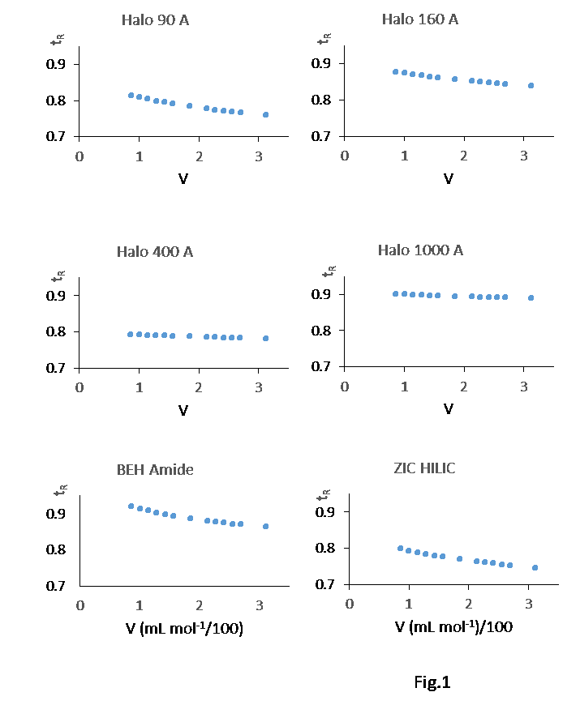

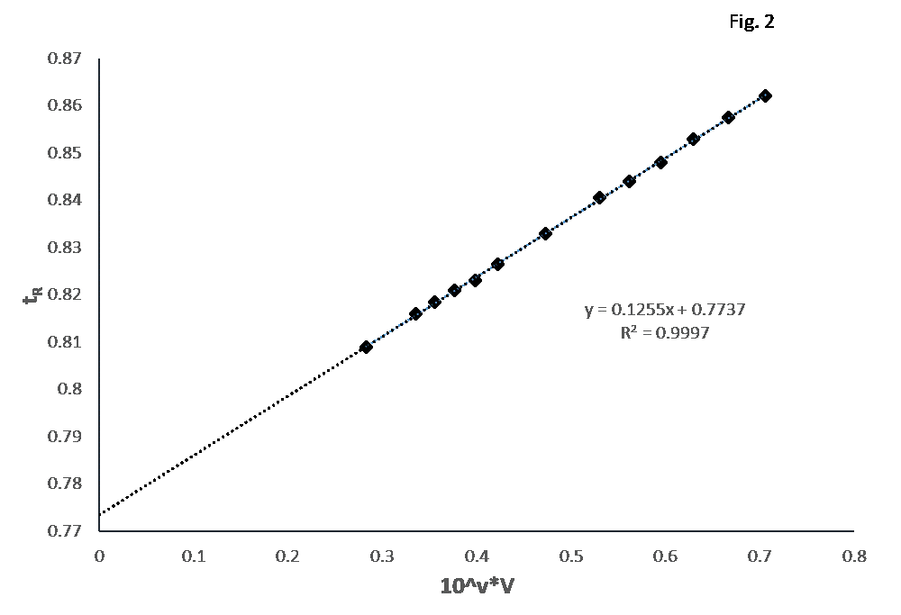

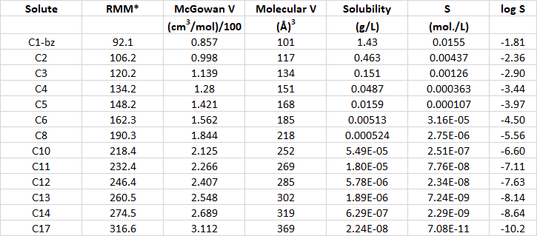

Table 1

