**Why Did UK Governments Cut Road Building in the 1990s and Expand it After 2010?**

Dr Steve Melia*

Centre for Transport and Society  
University of the West of England, Bristol,UK

* Coldharbour Lane, Bristol BS13 1QY. Email: [steve.melia@uwe.ac.uk](mailto:steve.melia@uwe.ac.uk)

**Why Did UK Governments Cut Road Building in the 1990s and Expand it After 2010?**

**Abstract**

Why did a Conservative UK government decide to cut back road building during a time of austerity in the 1990s, whereas a Conservative-led Coalition government decided to substantially increase road building during a time of austerity after 2010? This study aims to answer that question drawing on 32 interviews with ministers, advisors and others, and secondary analysis of media coverage and public opinion. It uses Critical Realist methods in a more specific way than previous studies, representing the key actors, causal mechanisms and changes in underlying social structures in diagrammatic form. It concludes that three mechanisms: a rational response to changing transport circumstances, changing economic ideology prompted by the recession of 2007-9 and public opinion, influenced by the protest movement in the 1990s, explain the contrasting decisions. It identifies key actors who influenced government decisions and explains how a Critical Realist analysis questions the traditional concept in transport studies of causal factors and their relative importance.

**Keywords**: Road building, demand management, UK politics, critical realist methodology

# Introduction and Context

## Aims of the Study

In the late 1990s a Conservative government leading the UK out of a recession, with severe pressures on public spending, decided to substantially cut back its road building programme. In 2013 a Conservative-led coalition leading the UK out of a recession, with severe pressures on public spending, decided to substantially expand its road building programme. Why did those two governments react so differently on those occasions?

That question was the starting point for this study. Much has been written about the changes in road building policy during the 1990s. Less has been written about the later period; this is the first study to compare the two. It also has a methodological aim: to develop a method for applying the concepts of Critical Realism (CR) in a more concretised way than previous studies, responding to a recurring criticism of CR that its broad concepts allow researchers to cherry pick their preferred explanations (e.g. Hodgson, 1999, 2004, Sayer, 1997).

The study draws on 32 interviews, with six former government ministers as well as civil servants, advisors, leaders of NGOs and protest movements. It will also draw on some analysis of public spending, media coverage and public opinion as measured by the British Social Attitudes Survey. A retrospective comparison with more recent events will shed new light (summarised in Section 6.1) on some unresolved controversies in the literature on the influence of the anti-roads protests in the 1990s and whether UK transport policy underwent a paradigm shift.

## Context – UK Policy on Road Building Since the 1990s

The late 1980s was a period of rapid economic growth and rising traffic volumes as shown in Figure 1. Following some intense lobbying from industry groups (Hamer, 1987) in 1989 the Conservative government led by Margaret Thatcher published *Roads for Prosperity* (DTp, 1989), which would more than double the size of the strategic[1] road building programme. It was accompanied by forecasts that traffic would grow by between 83% and 142% by 2025.

Figure 1 Annual changes in GDP and Vehicle Kms 1986 – 2017 (ONS, 2018, DfT, 2018b)

*Trunk Roads England* (DTp, 1990), published just before the start of a recession, added some more schemes, clarified the details of the programme and set out a six-year programme of increasing budgets, as shown in Table 1 below. The road building programme was controversial; many of the new or widened roads would cut through environmentally sensitive areas and/or protected landscapes. Between 1993 and 1997 a mass protest movement used direct action to oppose the programme. The Conservative government led by John Major after November 1990 initially persisted with the programme then cancelled a few of the more controversial schemes during 1993. The budget of November 1994 cut back the programme, as part of an overall reduction in public spending. The budget of 1996 cancelled the rest of the programme apart from existing commitments plus one new bypass.

In 1997 a Labour government was elected, initially committed to a new ‘integrated’ transport policy with less emphasis on road building (DETR, 1998). Although their commitment to integrated transport wavered over the following years, and a few road schemes were approved, spending on road building remained low compared to the periods before and after. Traffic volumes continued to increase until the Global Financial Crisis of 2007, but at a slower rate (see Figure 1).

In 2010 a Conservative-led coalition was elected. They initially confirmed only existing commitments. Then during 2011 (and early 2012 in one case) they unexpectedly approved all bar one of the road schemes submitted to them in a competitive bidding process by local authorities (DfT, 2011, H M Treasury, 2011). In June 2013 they announced a big increase in capital spending on strategic road building from 2015 onwards (and high speed rail over a longer time period: H M Treasury, 2013). DfT (2015) provided more detail in a similar way to DTp (1990); Table 1 compares the six-year budget trajectories contained in the two reports, using the Retail Price Index (RPI) to uprate DTp (1990) to 2015 prices. If the Road Construction Price Index (AECOM, 2018) is used instead of the RPI, the budget for 2020/21 would buy roughly three quarters of the capital works budgeted for 1992/3.

|  |  |  |  |  |  |
| --- | --- | --- | --- | --- | --- |
| Trunk Roads England (DTp, 1990) | | | Road Investment Strategy (DfT, 2015) | | |
| Financial Year | Budget (£bn 2015 prices) | Cumulative  Increase | Financial Year | Budget (£bn 2015 prices) | Cumulative  Increase |
| 1987/88 | 1,245 |  | 2015/16 | 1,064 |  |
| 1988/89 | 1,450 | 16% | 2016/17 | 1,101 | 3% |
| 1989/90 | 1,970 | 58% | 2017/18 | 1,509 | 42% |
| 1990/91 | 2,630 | 111% | 2018/19 | 1,789 | 68% |
| 1991/92 | 2,712 | 118% | 2019/20 | 2,230 | 110% |
| 1992/93 | 2,878 | 131% | 2020/21 | 3,114 | 193% |

Table 1 - Strategic Road Building Programmes Compared, in Constant Prices

In between the two periods shown, spending on road building (Figure 2 below), and transport as a whole, declined rapidly and then recovered. Between 1994/5 and 1999/2000 government spending on transport halved as a proportion of national income (Keynes and Tetlow, 2014).

Table 2 lists some of the key announcements and dates in the two periods compared. This study aims to compare decisions and decision-making rather than the *outcomes* of decisions. However, transport outcomes from the 1990s onwards will be considered amongst the influences on the decisions made by the Coalition Government between May 2010 and May 2015.

|  |  |  |
| --- | --- | --- |
| **Date** | **Publication or Statement** | **Impact on Road Building** |
| May 1989 | Roads for Prosperity | + |
| Feb 1990 | Trunk Roads England | + |
| Nov 1994 | H.M. Treasury Budget Statement | – |
| Nov 1996 | H.M. Treasury Budget Statement | – |
| May 1997 – May 2010 – Labour Government | | |
| Oct 2010 | Comprehensive Spending Review | Neutral |
| Nov 2011 | H.M. Treasury Autumn Statement | + |
| Jun 2013 | Investing in Britain’s Future | + |
| Mar 2015 | Road Investment Strategy | + |

Table 2 - Key Events and Dates in the Two Periods Compared

# Changing UK Government Policy: Analyses and Influences

Subsections 2.1 and 2.2 will briefly review the literature on UK government policy on road building and Subsection 2.3 will discuss the contested evidential issues which have influenced the official discourse about road building. The analysis explored two other areas of literature relating to public opinion and changing economic orthodoxies. To avoid repetition they will be introduced in Section 5.

## Explanations for the Changes in UK Policy on Road Building 1989–97

*Transport, the New Realism* (Goodwin *et al.,* 1991) has provided a starting point for several attempts to explain the shift in UK government policy on road building during the 1990s. It was both a survey of what it described as an ‘emerging consensus’ in the transport professions and a normative attempt to promote that consensus as an alternative to the traditional ‘predict and provide’ approach to road building. It pointed out that even the big increase in road building proposed by *Roads for Prosperity* could never keep pace with the forecast increase in car use; therefore demand management and expansion of alternative modes would be essential to prevent congestion worsening.

Goodwin went on to chair the committee that advised the civil servants writing the first Transport White Paper of the new Labour Government (DETR, 1998). Goodwin (1999) is his semi-insider account of how and why a paradigm shift, reflecting the New Realism, displaced predict and provide. It describes a gradual change in government thinking, motivated by growing environmental concerns, starting earlier than most other accounts with a “key turning point” in 1989. During the 1990s “a string of scientific and research-based reports” notably including SACTRA (1994 on 'induced traffic', discussed below) in which Goodwin was also involved, strengthened the “tentative policy reorientation”, which had begun in 1989 (Goodwin, 1999 p.662). Goodwin’s explanations emphasise the rational response of political leaders to research evidence and changing circumstances; they form the basis of the ***rational response mechanism*** investigated in Section 5.

Dudley and Richardson (1998, 2000) agree with Goodwin that a paradigm shift occurred – a ‘third order policy change’ following Hall (1993). They draw on the concepts of advocacy coalitions (Sabatier, 1988) and policy entrepreneurs (Kingdon, 1995, Mintrom, 1997) in an explanation which also emphasises the importance of environmental ideas and the agency of individuals, particularly Transport Secretaries Brian Mawhinney (1994 – 5) and Sir George Young (1995-7). Sabatier’s framework requires significant changes in external factors to alter the balance of power between competing advocacy coalitions. Dudley and Richardson’s (2000) account of these external changes shares some similarity to Goodwin’s; they emphasise the influence of state-sponsored research reports SACTRA (1994) and RCEP (1994, on air pollution) whilst Dudley and Richardson (1998) focusses on the role of protestors, using ‘arenas without rules’ including direct action to circumvent the hegemony of the advocacy coalition for road building. The squeeze on public spending between 1994 and 1996 created an ‘expedient alliance’ between environmentalists and the Treasury, which sealed the fate of *Roads for Prosperity*.

The influence of the anti-road protests is an issue of disagreement in the literature. Wall (1999) concludes that it did achieve its tactical objectives to stop large-scale road building, though not its aspirations for a more fundamental transformation of policy. Robinson (2000) and Vigar (2001) both question the claims made about the impact of the protest movement (although Vigar, 2002 does appear to ascribe a causal impact – his question may be one of degree). Robinson (2000) argues that external factors made the protest movement appear more influential than it was in reality. Amongst those external factors, Robinson cites the explanations of Goodwin (whom he interviewed) and the small parliamentary majority of the Major government; this amplified the “policy disaster” created by *Roads for Prosperity*, which imposed many unpopular road schemes in Conservative-held constituencies.

Vigar takes issue with Dudley and Richardson’s conclusions, arguing that change “appeared to be of a second order”, a change in the “system of meaning” rather than deeper cultural change (Vigar, 2002, p.184). His study of four local authorities provides some support for the claims in Goodwin *et al.* (1991) of a change of thinking within the transport professions, although this was uneven; in some localities predict and provide had endured. Exogenous change at a national level came from the economy; environmental arguments for cuts in road building are “always more attractive to governments in periods of fiscal crisis” (Glaister et al. 1998 cited in: Vigar, 2002 p.161).

## Explanations for Changing UK Policy on Road Building Since 1997

During the Labour governments of 1997 to 2010 researchers increasingly questioned the claims of a New Realist paradigm shift as the bold objectives of DETR (1998) gave way to “timidity, reactiveness and excess faith in future technologies” (Dudley and Parkhurst, 2008, p.70). The fuel tax protests of 2000, where farmers and hauliers blockaded fuel distribution were one pivotal factor (Lyons and Chatterjee, 2002, Robinson, 2003). The crisis forced the government to abandon the policy it inherited from its predecessors of increasing fuel duty faster than inflation. It also shifted the attitudes of leaders, including Chancellor and future Prime Minister Gordon Brown, against road pricing and congestion charging (David Begg quoted in: Docherty and Shaw, 2011, p.239). With the exception of London (succeeding despite the government, according to White, 2008), the demand management measures essential to the New Realism were weakly and unevenly embraced at local levels (Bulkeley and Rayner, 2003, Vigar, 2000 and 2002), and avoided altogether at national level (Docherty and Shaw, 2011). The multi-modal studies, which were supposed to identify alternatives to road expansion along identified corridors were subjected to “subtle pressure” from ministers, which led instead to proposals for more road building (Shaw *et al.,* 2006).

Despite this apparent reversion to earlier (or default) thinking, the return to road building during the Labour years was limited, as shown in Figure 2 (private finance, not included in the black line, was widely used for public projects but sparingly used for road building). Slower growth in traffic volumes, also illustrated, would have reduced pressures for road building. Traffic growth was considerably slower than any of the DfT’s own forecasts during the Labour and Coalition years, for reasons which are uncertain and contested (Goodwin, In press).

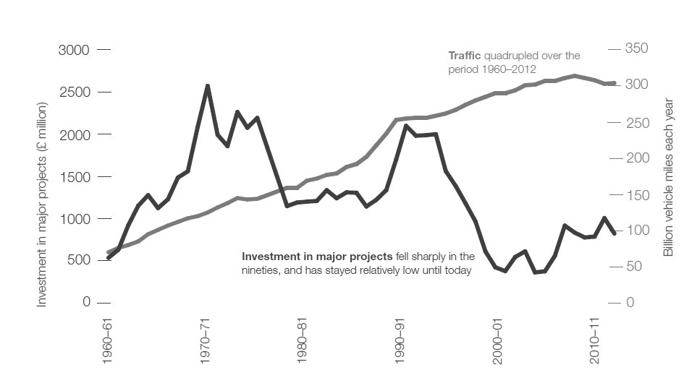

Figure 2 Major Road Scheme Spending Traffic Volumes (HM Treasury, 2013, p.18)[2]

There is, as yet, relatively little academic literature on the transport decision-making of UK governments after 2010. Davis and Tapp (2017) emphasise the influence of the road lobby, citing Hamer (1987) for an earlier period, although they do not provide much evidence for more recent influence. Docherty *et al.* (2018), who interviewed 20 stakeholders identified the strong personal influence of the Chancellor George Osborne (a finding confirmed by this study), who believed that transport infrastructure was essential for international economic competitiveness. The Coalition also believed that Labour’s multi-modal studies had failed; a return to mode-by-mode decision-making was more likely to produce results.

## Causal Beliefs and the Impacts of Road Building

The findings of Docherty *et al.* (2018), like Dudley and Richardson (2000) emphasise the importance of causal beliefs about the impacts of road building – on the economy, traffic and congestion, which accompanied changes in government policy. Whether causal beliefs helped to change government policy, or vice versa, is not entirely clear, however. Sabatier (1988) notes that shared causal beliefs form part of the second (middle) level of the belief systems of policy elites; these beliefs are close to the deep normative core and are unlikely to change unless there is a significant external perturbation; new research evidence alone is unlikely to change them. Confirmation bias is most likely to influence the interpretation of evidence in political situations which are “inherently complex and ambiguous… and in which the cause-effect relationships are obscure” (Nickerson, 1998, p.191). That was true of the causal beliefs around road building during the 1990s and remains true today.

The idea that road expansion might induce more traffic was not new when SACTRA (1994) was published, nor was the inference that it might increase congestion in at least some circumstances (see for example: Downs, 1962 cited in: Arnott and Small, 1994). SACTRA (1994) strengthened the empirical basis for induced traffic. It was written in technical language and was restrained in its policy recommendations. The phrase “we cannot build our way out of congestion”, often attributed to SACTRA, was coined three years earlier by Labour transport spokesperson John Prescott (Hardy, 1991).

The existence of induced traffic has never been seriously disputed but its extent and contextual variations remain contested. The UK Highways Agency (2013) presented some modest estimates for strategic roads built in England; their analysis was challenged by Sloman *et al*. (2017), who reanalysed some of the same data, finding much greater induced traffic. The modelling literature continues to explore Downs’ hypotheses half a century later (e.g. Feng *et al.,* 2018, Wang and Ziedins, 2018) but no writer, and no model, has ever demonstrated a robust context-independent relationship between road capacity, traffic volumes and congestion.

Similar observations may be made about the relationship between road building (or transport infrastructure or public investment in general) and economic growth. SACTRA found a “strong theoretical expectation” that transport investment could boost economic growth but that direct evidence was “weak and disputed” (SACTRA, 1999, p.8). This conclusion was also not new; studies casting doubt on the apparently positive relationships were available earlier in the 1990s (e.g. Whitelegg, 1994). The following years produced many more studies with widely varying findings. Amongst the recent meta-studies, most have found more positive than negative associations; some infer a causal relationship (e.g. Bom and Ligthart, 2014); others carefully avoid the language of causality (e.g. Melo *et al.,* 2013). One recent meta-study found evidence of publication bias weighted towards more positive impacts, concluding that “the estimated effects exhibiting high precision are clustered around zero.” (Holmgren and Merkel, 2017); Melia (2017) concludes that the uncertainties identified by SACTRA (1999) remain unresolved.

## Summary and Research Questions

The explanations summarised in Subsections 2.1 and 2.2 have generally focussed on the actions of individual actors within government or the transport professions and the quasi-autonomous role of evidence and ideas. Most of the writers have mainly sought explanations within the ‘transport world’; wider socio-economic changes are generally presented as exogenous. There are several common explanations but also some differences e.g. the impact of the anti-road protests and the paradigm shift which may have occurred during the 1990s. The rest of this study will seek to contrast and explain the decisions made in the two periods, using CR methods, discussed next.

# The Challenge for Critical Realist Methods

The application of CR to empirical research involves the identification of causal mechanisms, which can explain phenomena at the empirical level and the ‘actual level’ – events or phenomena whether observed or not (Fletcher, 2017). The causal mechanisms can be identified and traced back to underlying social structures through abduction (theoretical redescription) and retroduction (the process of identifying causes and eliminating of alternatives). In describing the process of retroduction, Lawson (1998) emphasises the potential for contrasting situations with apparent inconsistencies (one of which prompted this study) but he acknowledges that the process itself will be context-specific, drawing on the investigator’s perspective and experience. Critics of CR have argued with some justification that the subjectivity of this process has been exploited to confirm preferred explanations, often influenced by political views (e.g. Hodgson, 2004, 1999).

CR offers a useful framework for analysing social or political change but as Fletcher (2017) points out, anyone reviewing contemporary applied CR literature would find it difficult to work out how CR methods led the authors to their findings and conclusions. The relevant changes in social structures and causal mechanisms are rarely made explicit and rarely related in a specific way to decisions by individual actors. Diagrams are often used in CR articles, but usually to make or elaborate a theoretical argument, rarely to illustrate specific mechanisms (Jonsson, 2012 makes a partial attempt at this within a narrative explanation of economic change). Among the few applications of CR to transport Næss (2004, 2006) and Næss and Strand (2012) demonstrate how CR philosophy can help to answer some fundamental questions for transport policy such as: what types of traffic forecast are possible? Those papers focus on high-level questions of principle; Wall (1999) illustrates another possibility, where CR was used as a general guiding principle but with no attempt to relate specific causal mechanisms to changes in social structures.

The challenge for this study is to develop a replicable method, which applies CR principles to empirical questions using diagrams with explanations to illustrate the relationships between: changes in social structure, causal mechanisms, actions of individual actors and ultimate outcomes. As the biases identified in earlier studies may also influence the author of this study, the choices between alternative explanations will be made as transparently as possible, followed by an explicit statement of normative perspective before drawing conclusions.

# Methodology

## Sampling and Interviews

The search for causal mechanisms starts from the assumption that individual actors will have their own explanations for why something occurred. These explanations will contain important elements of the truth but are unlikely to be comprehensive. The next step for this study was therefore to identify key actors amongst the politicians, officials and non-governmental actors involved in the events described in Subsections 1.2 to 2.2. The sampling strategy was purposeful, aiming to cover the whole period from 1989 to 2018 with a particular focus on the Major government from 1990 to 1997 and the Coalition government from 2010 to 2015. 29 of the 32 interviews were face-to-face; all were recorded.

|  |  |  |  |  |
| --- | --- | --- | --- | --- |
|  |  | Experience Relevant to Government: | | |
|  | Total | Major | Labour  G | Coalition |
| Ministers | 6 | 4 | 6 | 6 |
| Advisors | 8 | 3 | 8 | 7 |
| Civil Servants | 5 | 4 | 5 | 5 |
| NGO representatives/lobbyists | 6 | 6 | 6 | 4 |
| Leaders of campaign movements | 4 | 4 | 3 | 3 |
| Civic leaders (elected and officers) | 3 | 2 | 3 | 1 |
| **Total** | **32** | **23** | **31** | **26** |

Table 3 Interviewees Categorised by Principal Activity

Table 3 shows the interviews categorised by their principal activity (several occupied more than one over time) and the period of their relevant experience; 17 of the 32 interviewees had experience spanning both the 1990s and the Coalition years, enabling them to make comparisons. Of the six former ministers three were in office during the 1990s and three during the Coalition. Some of the interviewees focussed on more specific events but most were asked for their own responses to the central question in Subsection 1.1. Those responses, plus the findings from the literature, provided the basis for the rest of the analysis. Section 5 mainly focusses on the explanations from decision-makers within government.

## Abduction and Retroduction

Explanations offered by the interviewees or the literature for the policy change in one period, or comparing both periods, were coded and grouped into broad categories. The juxtaposition of the two periods, created a sifting criterion: could each explanation be logically applied to the events in both? Nearly all explanations contained some merit but some could not be applied as expressed to both periods; the challenge was to adapt and synthesise them into a consistent framework.

To clarify the findings it was decided to represent the social structures, actors, and causal mechanisms in diagrammatic form. This end-product also helped to structure the comparative analysis; causal mechanisms were sought with pathways applicable to both time periods; only the content would differ, as illustrated in Section 5.

In seeking to identify the relevant social structures Sabatier’s (1988) distinction between stable system parameters (e.g. a Capitalist economic system) and external system events (e.g. changes in economic circumstances) is useful. In this study we are mainly concerned with the latter; changes in economic conditions, evidenced by changes in indicators such as GDP, will be relevant. Following the same logic, changes in the **transport social structure** – the ensemble of travel behaviour, conventions and objective circumstances – may be detected through indicators such as total traffic volumes.

# Findings

## Explanations Rejected and Synthesised

Amongst the explanations proffered by interviewees and the literature, several could not be applied in the way they were expressed to the decisions in both periods. The observation of Glaister *et al.* 1998 that environmental arguments against road building are more attractive to governments in fiscal crisis could have applied post-2010 but clearly did not. Similarly, Davis and Tapp’s (2017) argument about the power of the roads lobby cannot explain what happened during the 1990s.

One comparative explanation advanced by two interviewees could not be accepted as expressed but did help to suggest one of the causal mechanisms below. This referred to lower interest rates post-2010 allegedly making it easier for the Coalition government to borrow to finance public investment.

In terms of interest *costs*, this argument could equally have applied to borrowing for *current* spending (e.g. on health or education). In both periods overall public spending was reduced; in the late 1990s the cuts fell more heavily on capital spending (including road building) but capital spending also fell after 2010, as shown in Figure 3.

Figure 3 – Trends in Public Spending and Net Public Investment as a Proportion of GDP 1990 – 1997 and 2010 – 17[3] (1990= 100)

A more precise argument could be made that lower interest rates post-2010 would increase the Net Present Value of future economic benefits from new roads, if such benefits exist at a national level; as discussed in Section 2.3 there is uncertainty around that hypothesis. A belief that road schemes represent better value for money at a time of low interest rates is also relevant to the ***economic ideology*** mechanism below. Having rejected or amended certain explanations, the remaining explanations were synthesised into three mechanisms: rational response, public opinion (including the protest movement in the 1990s) and economic ideology. Figure 4 illustrates all three mechanisms. The analysis that follows will treat each one separately, although all three were interlinked in a variety of ways. The white boxes indicate a group of actors. An arrow pointing towards a box indicates an influence *on* those actors, so in Figure 6 for example, the arrows pointing towards ‘General Public’ represent influences on public opinion. An arrow pointing away from a white box indicates the impacts of decisions and/or actions *of* those actors; in some cases, both occur at the same time, so in Figure 4 actions of the general public influence, and are influenced by, changes in transport social structure.

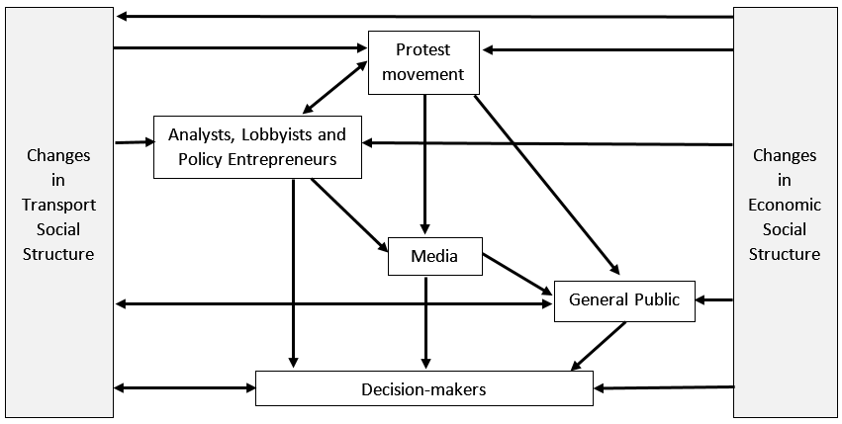

Figure 4 – The Causal Mechanisms Combined

## Causal Mechanisms Under the Major Government (1990-7)

### Rational Response

Figure 5 illustrates the principal causal mechanisms of the rational response postulated by Goodwin (1999, 2008). Changes in the economic structure, particularly cumulative economic growth, amplified by changes in the transport social structure (e.g. deregulation of buses, growth of car-based suburbs) were increasing car ownership and use (shown as economic impacts *on* the public, and impacts *of* the public’s actions on the transport social structure, which create a feedback influence *on* the public). The analysts were drawing the conclusions that this increase could not be accommodated through road building, whilst policy entrepreneurs in the transport profession, NGOs and academics were proposing alternative transport strategies. All of these influenced the decision makers, whose decisions (to expand and then contract the road building programme) impacted on the transport social structure.

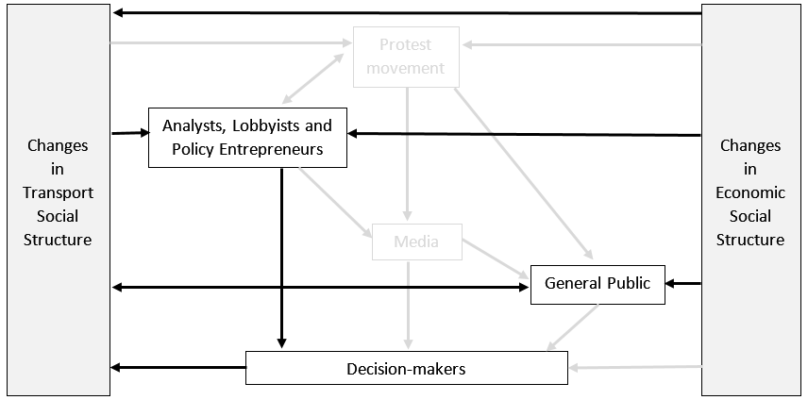

Figure 5 – Rational Response Causal Mechanism

To advance a rational response mechanism as an explanation for political decisions, it is not sufficient to demonstrate that a convincing rational argument was made, nor that its conclusions were implemented; evidence is needed for causal mechanisms that influenced decisions in practice. Amongst the reasons advanced by Goodwin, the interviews did not provide much support for the direct influence of environmental evidence. One minister described the influence of climate change on transport decisions as “almost zero.” The discourse in government changed after 1990, particularly in the Department of the Environment (e.g. DoE, 1990), but any influence on decisions over road building seems to have acted via public opinion (discussed below) rather than a rational response to the evidence.

There was stronger evidence for the impact of SACTRA (1994), the traffic forecasts and the inference from both that attempting to ‘build our way out of congestion’ would be futile. One minister said:

“Everyone began to learn that you couldn’t build [roads] to solve the problem that there were too many cars for roads.”

Another minister referred to abortive plans to build distributor roads around the M25 motorway:

“It came with a health warning that said this would only be good enough for ten years. That sent a very big signal to me that said: ‘this is a ridiculous project’ because presumably in ten years you’re going to be saying to my successor: ‘please can we have another three lanes in each direction?’”

A third minister said he drew the conclusion that demand should be restrained through increasing fuel duty and moderating rises in public transport fares, noting with regret that later governments had done the opposite.

### Public Opinion and Protest Movement

Figure 6 illustrates the protest movement and public opinion causal mechanisms. The relevant changes in the transport social structure include the increase in traffic and also the road programme itself (partly caused by economic factors). These influenced the opinions of the general public, who influenced the decision-makers directly in many cases.

The militant direct-action protestors, as well as the more conventional local groups influenced the general public directly in some cases, and also achieved considerable media impact, which influenced the decision makers directly, and indirectly via the general public. They interacted in multiple ways with the analysts who were making the evidential case against large-scale road building. As the protest movement raised the political profile of road building, academics and other analysts were more likely to gain media coverage, and to influence the general public and decision-makers through that route.

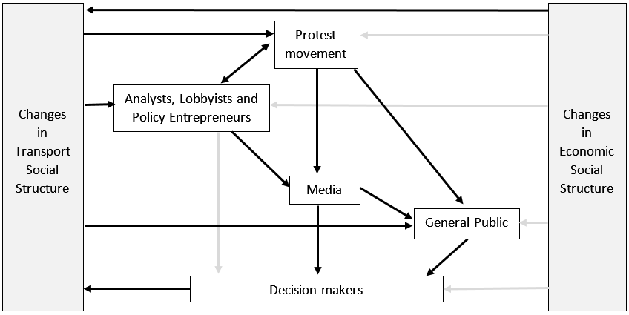

Figure 6 – Public Opinion and Protest Movement Causal Mechanism – 1990s

Public opinion was mentioned by many of the interviewees; a chapter of the transport green paper (DTp, 1996) was devoted to public opinion, noting that public support for road building had declined. One advisor explained how Michael Heseltine, who became Deputy Prime Minister in 1995, had spent much time as a backbencher visiting local Conservative parties and found many members were “quite wound up” about environmental issues, particularly relating to the countryside.

One protest leader explained how the conventional protest groups lobbied MPs to great effect, sending thousands of letters to the same MP in some constituencies. Interviewees from the direct action movement pointed to the widespread local support they enjoyed around different protest sites. Some of the other interviewees were keen to differentiate those views from a more or less silent majority, who they believed to be concerned about congestion and supportive of road building in their area. Ministers and civil servants generally played down the influence of the protestors, whose tactics and appearance antagonised Conservative supporters. Ministers emphasised that decisions were based – or should be based – on reasoned argument. One minister acknowledged that the protests had influenced decision-making: “at the margin, to the extent that it influenced public opinion” adding: “I hope government isn’t over-influenced by direct action.”

A few comments suggested that the protests had made road building a more problematic or “fraught” issue. This perception influenced the incoming Labour government. An advisor under that government said:

“Swampy [a prominent protestor] had a lasting impact. To build a road now is a lot of aggro. You are going to have to get Securicor to protect your site. And to go round bragging about the size of your road programme looks a bit non-PC.”

One Conservative minister in the Coalition government said: “in the early 2000s [Conservative MPs] were still conscious of what had been a substantial anti-roads movement”, adding that they “moved on” whilst in opposition.

A literature search failed to reveal any studies that might provide direct evidence on how the protest movement (or any other relevant factors) influenced public opinion, but some influence may be inferred. Figure 7 based on the British Social Attitudes Survey confirms the observation in DTp (1996) about declining public support for motorway building. This shift occurred between 1993, when the protest movement began, and 1996, when it reached its height with intense media coverage of the Newbury Bypass evictions. Support for unrestricted driving also fell until the change of government in 1997. By the time the Coalition took office in 2010 opinion had shifted back towards unrestricted driving, as discussed in Subsection 5.3.3 (the question on motorway building was not asked after 2010).

Figure 7 – Net (Dis)agreement with Building Motorways to Ease Congestion and Unrestricted Car Use – Even if it Damages the Environment (DfT, 2018a)

For people not directly affected by road building schemes, the media was likely to be the main source of information and influence on their views. Table 4 shows an analysis of newspaper articles about road building for the two years leading up to the 1996 Budget and the publication of H M Treasury (2013). This shows that road building received far more media coverage during the 1990s, and that most of this was critical.

|  |  |  |
| --- | --- | --- |
| Time Period of Search: | 1994-6 | 2011-13 |
|  |  |  |
| Number of articles found in the search: | 165 | 39 |
| Found to be valid | 101 | 29 |
|  |  |  |
| **Article or a quote implies that road building:** |  |  |
|  |  |  |
| Causes environmental damage | 33 | 8 |
| Induces traffic (or fails to reduce congestion) | 16 | 10 |
| (Factual references to anti-road protests) | 15 | 2 |
| Costs would be better spent on alternatives | 14 | 9 |
| Cannot satisfy demand, or restraint is required | 7 | 0 |
| Is unpopular, or cuts are popular | 6 | 0 |
| Offers poor value for money, or too much is spent on it | 3 | 6 |
| Does not bring economic benefits | 3 | 3 |
| Disadvantages the poor | 2 | 0 |
|  |  |  |
| Brings economic benefits | 17 | 13 |
| Improves the environment | 7 | 0 |
| Reduces congestion or saves time | 6 | 8 |
| Should satisfy demand from car-drivers | 2 | 0 |
| Reduces accidents | 2 | 0 |
| Is popular | 2 | 0 |

Table 4 – Analysis of Articles in the UK National and Local Press Using Search Term “Road Building” in the Nexis database

The search term “road building” only picked up a small proportion of the many articles about the anti-road protests; a search on the terms “Newbury Bypass or Twyford Down” produced 846 articles in the earlier period. It may also be noted that several of the critical comments reflect the tenets of the New Realism, suggesting a link between the rational response mechanism and public opinion.

### Economic Ideology

Views within government about the role of public investment and its impact on economic growth changed between the two periods of study. The pathways illustrated in Figure 8 apply to both. Economic changes influenced the ideology of the analysts, lobbyists and policy entrepreneurs, who influence the decision makers directly and via the media.

One minister explained the prevailing attitude within government in the 1990s as follows:

“There was a very long tradition… that infrastructure was basically just money. Rather than it being viewed as an investment improving our social and economic efficiency it was seen as a big lump of money that either had to be borrowed or taxed, neither of which was particularly attractive.”

An advisor commented “we had all completely abandoned Keynes by then”. A Treasury civil servant said:

“The whole atmosphere was one of ‘we must save money’... It was indifferent to whether this was operating spending or capital spending. It’s easier to cut a road scheme than to cut [staffing]… The Treasury was all about markets, competition, regulation, privatisation and private finance – about better ways of delivery” [rather than investing public money in the interests of the wider economy]

Several writers have noted how the International Monetary Fund (IMF) is both a barometer of, and a significant contributor to, changes in international economic orthodoxy (Clift, 2018, Ban and Gallagher, 2015). Although the IMF’s influence is greatest on those countries which borrow directly from it, its staff have privileged access to national finance ministries of other countries; UK Chancellors (finance ministers) have paid frequent attention to its analyses, sometimes citing them in support of their own policies (Clift, 2018). During the 1990s, the IMF put much greater emphasis on fiscal rectitude than any potential for public capital spending to boost flagging economies, although some of their publications did acknowledge the possibility of the latter (IMF, 1996b). The UK chapters of their annual reports for this period support the fiscal contraction policies of the UK government (IMF, 1994, 1996a). IMF (1995) calls for more rapid fiscal contraction; it states that more could be done to retrain the unemployed, but none of the three reports mentions the public capital spending which the UK government was cutting most rapidly.

During this time, business interests continued to lobby for road building or against cuts in the programme but as one minister explained:

“We told them that we agreed with them but we didn’t have any money.”

Figure 8 illustrates the economic ideology causal mechanisms. As those ideologies were well-established by the 1990s, to explain their economic origins would lie beyond the scope of this study; Leeson (2001) and O’Connor (2017) provide two contrasting accounts. A more relevant question for this study is how they came to change.

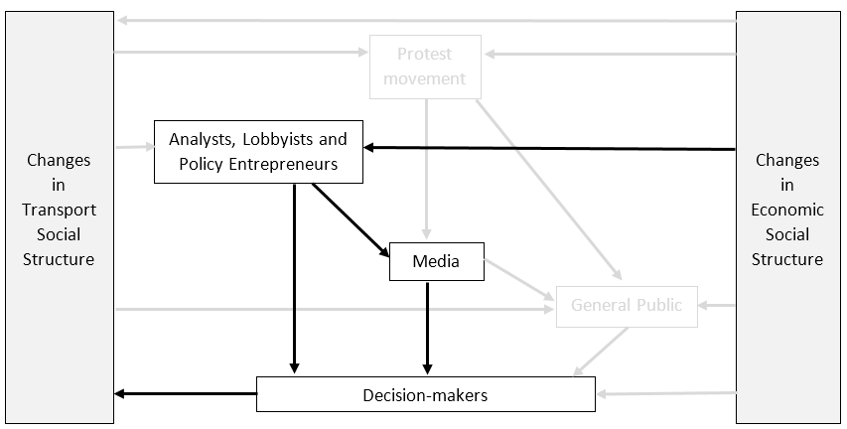

Figure 8 – Economic Ideology Causal Mechanism

## Causal Mechanisms Under the Coalition (2010 – 15)

### Economic Ideology

Figure 8 also applies to this subsection, where the same pathways applied in a different way after 2010. The principal change in the economic social structure was the recession of 2007-9, which was global, unlike the milder UK recession of the early 1990s. The causal mechanism, interpreted by analysts and international bodies was a changed attitude to public investment. Amongst the decision-makers, one actor was particularly important: the Chancellor George Osborne. One minister described Osborne as the “chief executive” controlling the detailed work of government with Prime Minister Cameron overseeing like a “chairman of the board”. As one minister from the Major government, observing from outside government in later years, put it:

“George Osborne rehabilitated infrastructure; he saw infrastructure for what it should be: a means of improving the social and economic health of the nation.”

A minister in the Coalition Government explained the background to the unexpected announcement made by H M Treasury (2011):

“Osborne noticed that [the DfT’s assessment of major schemes submitted by local authorities] was all pro-rail and he decided, without any evidence but based on prejudice, to ‘rebalance it’ as he saw it. He said to the DfT: give me all the road schemes you’ve got in any way worked up and funded the whole lot… It was a personal decision… To be fair to him he had a good political brain; he could see the political sense of doing these things but it completely threw out of the window all the DfT’s careful cost benefit analysis.”

The big increase in strategic road building was also announced by H M Treasury (2013) rather than the DfT. Osborne’s early speeches in government emphasised the need to cut the budget deficit (Osborne, 2011b); later speeches reiterated that view but also emphasised the benefits of public investment, including road building (Osborne, 2013).

Although no one doubted the sincerity of these beliefs, they did not emerge in a vacuum. Osborne had no economic training before becoming Chancellor (Ganesh, 2012). One civil servant explained how the government’s attitudes to infrastructure investment changed rapidly between 2010 and 2011. In 2010 Osborne and two of the four transport ministers both wanted to make a “very public display of hair shirt” on public spending. To reinforce the point one minister said to a civil servant: “you need to understand that we are not postponing these schemes we are cancelling them.”

However, the civil servant continued:

“Between 2011 and 2013 there was a growing swell of opinion [particularly in business organisations] that said: yes government needs to rein back public spending, as any business would, but businesses need to invest. Investment in infrastructure is good because it enables business to operate efficiently; infrastructure is roads and bridges, railways and tunnels. George Osborne listened.”

Lobbying from the business community for road building was not new but following the global recession the ideological context, within the Treasury and internationally, was now more receptive to such arguments. Another civil servant said: “the Treasury were totally sold on the economic role of transport spend,” comparing their *volte face* to a religious conversion, with Osborne as the evangelist.

Clift’s (2018) study of the IMF offers an insight into the deeper mechanisms at work. The global financial crisis caused a shift in thinking within the IMF and opened, or widened, an ideological gap between applied economists and mainstream academic economists, also noted by Keen (2011). The ‘expansionary fiscal contraction’ hypothesis (the belief that cutting deficits can boost economic growth) lost ground to an eclectically neo-Keynsian view, which favoured more active fiscal policy and public infrastructure investment. Between 2011 and 2013 the IMF tried to persuade the UK government to relax its fiscal stance and invest more in public infrastructure. Although the government maintained its public commitment to fiscal rectitude their response to the IMF emphasised their search for “shovel ready” infrastructure projects, including roads. Osborne clearly paid attention to the IMF’s advice, referring to it in several of his speeches (e.g. Osborne, 2011a, 2013) but its main significance here is as an indicator of changing international economic orthodoxy.

### Rational Response

This section will follow the same logic as Subsection 4.2.1 and pathways in Figure 5 to explain the decision to increase road building after 2010. The arrows pointing to and from the general public illustrate their travel decisions, which influenced the transport social structure, and were influenced by it. The arrows to and from the analysts illustrate the rational responses which they proposed to decision makers.

As in the 1990s environmental concerns did not exert much influence on that decision. Although awareness of climate change had increased and was influencing some other areas of government policy, improvements in vehicle technology and appraisal mechanisms (with carbon pricing in the DfT’s WebTAG system) were expected to address those concerns as they applied to road building. One civil servant said these meant that it became:

“possible in polite society to talk about road capacity expansion in a way that just wasn’t possible” before.

Two ministers also mentioned the hostility of George Osborne to environmental arguments that he perceived to be conflicting with economic objectives.

The logic of the New Realism required demand management to constrain traffic growth. Goodwin *et al.* (1991) set out several methods but suggested that without road pricing pressure on road space would continue to build. The implications of that conclusion were embraced by John Prescott, the minister for transport and the environment in DETR (1998) but as one civil servant observed “there was no real buy-in” from the Prime Minister, Chancellor or cabinet colleagues. An advisor added that there was also resistance amongst DfT civil servants who had “built their careers around roads”. Following substantial ‘no’ votes in referenda in Edinburgh and Manchester, urban congestion charging was not pursued outside London. Following an online petition signed by 1.8 million people in 2007 the Labour government abandoned its preparatory work on national road pricing. Following the crisis created by the fuel tax protests, this petition made a deep impression on the perceptions of ministers, advisors, civil servants and local government leaders about the political price of using financial instruments to restrain car use.

Several of the civil servants and advisors explained how Labour’s attempts at demand management were perceived to have failed. One advisor during the Labour years expressed a view that:

“The demand managers were a long distance from where your average transport user was… talking about integrated transport didn’t get much political attention. The integrated strategy was aimed more at interest groups.”

The Multi-modal Studies were mentioned several times, always negatively. One civil servant pointed out that whereas the strategic road proposals could proceed straight to a programme, the public transport schemes had to go through further levels of approval, which made those recommendations less likely to achieve implementation. However, the inferences drawn by most interviewees differed from Shaw *et al.*’s (2006) findings about ministerial interference. The studies were viewed as misconceived, offering no realistic alternative to road capacity expansion. As traffic volumes continued to rise (albeit more slowly) and were forecast to rise more rapidly as the economy recovered, expanding road capacity was increasingly viewed as the only realistic option. One civil servant described the prevailing “mindset” as:

“We might not be able to build our way out of [congestion] entirely but we *can* do *something* about it – surely.”

An advisor explained that the aggregate volume increases (illustrated in Figure 1) disguised rapid increases on inter-urban roads, particularly motorways, partly offset by declines in some urban areas, so there became “a clearer distinction between the right policy for urban and inter-urban roads.” Multi-modalism continued to make sense within urban areas, while inter-urban road capacity would be expanded.

Figure 2 graphically illustrates the official view of the growing pressure on road space. Like their predecessors (DTp, 1989, 1990) H M Treasury (2013) and DfT (2015) make no projections about the impact of the road schemes on national traffic congestion but there is a strong inference that they will alleviate it.

### Public Opinion

Figure 9 illustrates the public opinion causal mechanism post-2010. This differs from Figure 6 for the 1990s; there is no protest mechanism and an additional pathway has been created from changes in economic circumstances to the general public. This represents the influence of the recession on public opinion. The changes in the transport social structure were the increasing traffic volumes, particularly on strategic roads, causing more congestion.

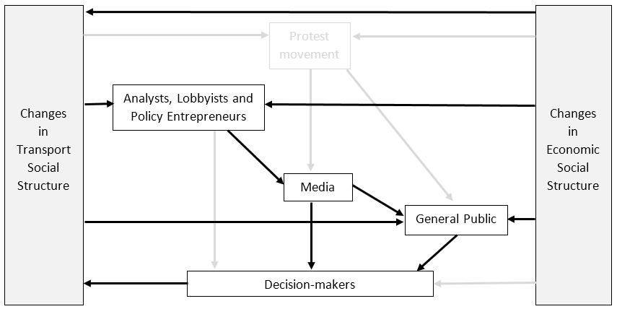

Figure 9 – Public Opinion Causal Mechanism – Post 2010

The impact of the recession on environmental attitudes and UK politics has been well documented. Taylor’s (2012) analysis of the British Social Attitudes Survey (BSA) shows how public attitudes were less sympathetic to the environment in 2010, compared to both 2000 and 1993. Carter and Clements (2015) show how perceptions of that shift influenced the policies of the Coalition government. One of the ministers interviewed for this study said the phrase “get rid of all the green crap” attributed by the media and Carter and Clements (2015) to David Cameron actually originated from George Osborne.

Figure 7 (in Subsection 5.2.2) illustrates how public opinion became less negative towards unrestricted driving “even if this damages the environment” after 2008. Public opinion on motorway building was also less negative in 2010 than during the 1990s, although that question was removed from the BSA after that. Public concern about congestion on motorways rose during the Coalition government from a low point in 2011 (DfT, 2018a).

Table 4 (Subsection 5.2.2) illustrates how road building was rarely mentioned by the media between 2011 and 2013, whilst Figure 10 illustrates how traffic congestion rose up the media’s agenda during the Coalition government.

Figure 10 – Numbers of articles mentioning “congested roads”, “traffic congestion” or “road congestion” in UK national newspapers, from Nexis.

None of the interviewees cited shifting public opinion as a reason for the change in policy on road building but a few expressed a more general view that people tended to favour road schemes in their areas; they also emphasised public resistance to any attempts to restrain traffic growth by charging motorists more.

# Discussion

## Paradigm Shifts and the Impact of the Anti-Roads Protests

Section 5 has shown how changes in social structures triggered causal mechanisms that explain the contrasting decisions taken in the 1990s and post-2010. It has also illuminated the interaction between those mechanisms and the agency of decision-makers, amongst whom George Osborne was the most notable agent for change after 2010. The recession of 2007-9 provided the context for his decisions; it clearly impacted ideology and opinions amongst elites and the general public more profoundly than the shallower recession of 1990-1. To some extent, it prompted a return to earlier beliefs and policies, which could also be viewed as a longer-term default: intra-urban multi-modalism and inter-urban road capacity expansion (with the addition of high speed rail), as described by Vigar (2001). With hindsight it is easy to see that claims of a paradigm shift in the late 1990s were exaggerated. The New Realism may have made a lasting impact on the transport planning profession (as distinct from the highway engineering profession) but its influence on decision-makers was limited and short-lived.

The impact of the 1990s protest movement is more difficult to assess. The language used by some interviewees suggests that it may have been greater than some decision-makers wanted to acknowledge. Descriptions of road building as “fraught”, “non-PC” and not discussed (before 2010) “in polite society” suggest a residual subliminal impact, which gradually diminished during the Labour years. The protests raised the profile of road building, exposing the public to some of the evidence and analysis of the New Realism.

## Methodological Reflection

This study set out to apply CR methods to an empirical policy question in a more specific and transparent way than previous studies; it is the first such attempt in a transport context. It started with an apparent inconsistency, sought evidence from multiple sources including explanations from the actors involved. Those explanations were then assessed for their applicability to both scenarios and traced back to changes in underlying social structures. The concept of economic social structures is well-established; the concept of a transport social structure has also proved useful in this analysis. This framework could be applied or adapted to explain the reasons for changes of policy or practice in many other contexts.

The CR framework provides a different perspective on a question frequently asked in such contexts: which were the most important causes? CR posits an unpredictable relationship between causal mechanisms and human agency. The existence of human agency implies that nothing is predetermined; the same set of circumstances could always have produced a different outcome, which makes it difficult to assess which factors had more influence than others. Indeed, the unpredictability of the outcome challenges the traditional view of causality in transport studies, which often tries to attach numerical probabilities to causal factors. If a change in any factor might have produced a different outcome, is it meaningful to distinguish between ‘more important’ or ‘less important’ causes?

In this study, the three causal mechanisms interacted in different ways e.g. media references to New Realist analysis, linking the rational choice and public opinion mechanisms, and the indirect influence of economic ideology on public opinion. The only clear conclusion is that the impact of each one would have been different without the others or with a different set of actors.

# Conclusions

Why did the Conservative governments of the 1990s and the Coalition government of 2010 – 15 react so differently on road building policy when leading the UK out of recessions? This study suggests that their different reactions can be traced back to underlying changes in social structures, as well as personal interventions of some key actors. Some of those underlying changes were economic but the findings do not support a reductionist interpretation. For example, the economic ideology mechanism post-2010 promoted public capital spending but the decision to treble the size of the strategic road building programme was clearly exceptional; other factors were clearly at work.

The analysis so far should be useful to supporters or opponents of road building. The conclusions that follow start from an environmentalist perspective, recognising that the same evidence could be interpreted differently starting from different perspectives.

Goodwin (2008) explains one implication of the new Realism that without demand management the best that road building can achieve is to make congestion get worse more slowly. Official road building strategies (DTp, 1990, H M Treasury, 2013, DfT, 2015) are consistently coy about the impacts they hope to achieve, possibly for that reason. Many local authorities, who hope to access more government funds for road building, have been more explicit, or more honest, publishing quantitative forecasts that confirm the aspiration of their road building plans to help congestion get worse more slowly (see for example: West of England Authorities, 2017, Table 12.4, Amey, 2016, Figure 4.1). In the absence of effective demand management this may be a rational short-term response, deferring more difficult decisions to future generations. Demand management has not failed in the UK; outside a few urban centres it has never seriously been tried, partly because of public resistance.

In the 1990s a campaign of illegal direct action raised the profile of rational analysis, which decision-makers might otherwise have ignored, as they ignored the open letter from 32 transport professors questioning the rationale for expanding the strategic road network (Marsden *et al.,* 2013). Some of the road schemes in national and sub-regional plans would damage national parks (Highways England, 2018), World Heritage archaeological sites (Parker *et al.,* 2017), ancient woodland and Sites of Special Scientific Interest (West of England Authorities, 2017, Figure 5.1) – the same issues that ignited the anti-road protests of the 1990s. The challenge for any new protest movement would be greater today. Deeper forces have changed the ideological context, and eroded belief in the possibility of an alternative national transport strategy.

At the time of writing a new campaign of illegal direct action motivated by concerns about climate change had recently begun in the UK. Amongst its targets airport expansion has featured more highly than road transport (M. Taylor and Gayle, 2019) but the protestors’ demands would have far-reaching implications for both. Whether this campaign will have similar or different impacts to the anti-roads protestors on public opinion and decision-makers remains to be seen.

References:

AECOM (2018) *Spon's Civil Engineering and Highway Works Price Book 2017* [online]. CRC Press.

Amey, (2016) *Forecasting Report - Maidstone VISUM Transport Model* [online]. Report number: CO04300370/003 Revision 01.[www.maidstone.gov.uk](http://www.maidstone.gov.uk): Kent County Council. [Accessed October 2018].

Arnott, R. and Small, K. (1994) The economics of traffic congestion. *American Scientist*. 82 (5), pp. 446-455.

Ban, C. and Gallagher, K. (2015) Recalibrating Policy Orthodoxy: The IMF Since the Great Recession. *Governance*. 28 (2), pp. 131-146.

Bom, P.R.D. and Ligthart, J.E. (2014) What have we learned from three decades of research on the productivity of public capital? *Journal of Economic Surveys*. 28 (5), pp. 889-916.

Bulkeley, H. and Rayner, T. (2003) New Realism and Local Realities: Local Transport Planning in Leicester and Cambridgeshire. *Urban Studies*. 40 (1), pp. 35-55.

Carter, N. and Clements, B. (2015) From 'greenest government ever' to 'get rid of all the green crap': David Cameron, the Conservatives and the environment. *British Politics*. 10 (2), pp. 204-225.

Clift, B. (2018) *The IMF and the Politics of Austerity in the Wake of the Global Financial Crisis*. Oxford: Oxford University Press.

Davis, A. and Tapp, A. (2017) The UK transport policy menu: Roads, roads, and a dash of multimodalism. *Social Business*. 7 (3-4), pp. 313-332.

DETR (1998) *A New Deal for Transport - Better for Everyone : The Government's White Paper on the Future of Transport*. The Stationary Office Ltd.

DfT, (2018a) *Public Attitudes to Transport - from the British Social Attitudes Survey*. [www.gov.uk](http://www.gov.uk): Department for Transport.

DfT, (2018b) *Road Traffic Statistics Table TRA0201.  Road Traffic (Vehicle Kilometres) by Vehicle Type in Great Britain, Annual from 1949* [online]. [www.gov.uk](http://www.gov.uk): UK Department for Transport. [Accessed September 2018].

DfT, (2015) *Road Investment Strategy: For the 2015/16 – 2019/20 Road Period* [online]. [www.gov.uk](http://www.gov.uk): Department for Transport. [Accessed July 2017].

DfT, (2011) *Investment in Local Transport Major Schemes - Update*. London: Great Britain Department for Transport.

Docherty, I. and Shaw, J. (2011) The Transformation of Transport Policy in Great Britain? ‘New Realism’ and New Labour's Decade of Displacement Activity. *Environ Plan A*. 43 (1), pp. 224-251.

Docherty, I., Shaw, J., Marsden, G. and Anable, J. (2018) The curious death – And life? – Of British transport policy. *Environment and Planning C: Politics and Space*. pp. 2399654418764451.

DoE (1990) *This Common Inheritance*. Great Britain, Department of the Environment.

DTp, (1996) *Transport. the Way Forward. the Government's Response to the Transport Debate*. Report number: CM 3234.London: Department of Transport.

DTp (1990) *Trunk Roads England: Into the 1990s*. London: Great Britain. Department of Transport.;.

DTp (1989) *Roads for Prosperity*. London: Great Britain. Department of Transport.;.

Dudley, G. and Parkhurst, G. (2008) Roads and traffic: from “predict and provide” to “making best use.”. In: Docherty, I. and Shaw, J., eds. (2008) *Traffic Jam : Ten Years of 'Sustainable' Transport in the UK*. Bristol: Policy, pp. 51-74.

Dudley, G. and Richardson, J. (2000) *Why does Policy Change?: Lessons from British Transport Policy, 1945-99*. London: Routledge.

Dudley, G. and Richardson, J. (1998) Arenas without Rules and the Policy Change Process: Outsider Groups and British Roads Policy. *Political Studies*. 46 (4), pp. 727-747.

Feng, S., Shen, X. and Hu, B. (2018) Optimization of traffic demand management policy in China: towards a sustainable mode split. *Transportation Planning and Technology*. 41 (2), pp. 198-210.

Fletcher, A.J. (2017) Applying critical realism in qualitative research: methodology meets method. *International Journal of Social Research Methodology*. 20 (2), pp. 181-194.

Ganesh, J. (2012) *George Osborne : The Austerity Chancellor*. London: Biteback.

Goodwin, P. (In press) Forecasting road traffic and its significance for transport policy. In: Docherty,Iain,Shaw,Jon, ed. (In press) *Transport Matters*. Bristol: Policy Press, pp. Chapter 7.

Goodwin, P. (2008) Traffic jam? Policy debates after 10 years of 'sustainable' transport. In: Docherty, I. and Shaw, J., eds. (2008) *Traffic Jam : Ten Years of 'Sustainable' Transport in the UK*. Bristol: Policy, pp. 231-240.

Goodwin, P. (1999) Transformation of transport policy in Great Britain. *Transportation Research Part A: Policy and Practice*. 33(7), pp. 655-669.

Goodwin, P., Hallett, S., Kenny, F. and Stokes, G. (1991) *Transport, the New Realism*. Transport Studies Unit, Oxford University.

H M Treasury, (2018) *Public Expenditure Statistical Analyses* [online]. [www.gov.uk](http://www.gov.uk): [Accessed October 2018].

H M Treasury, (2013) *Investing in Britain's Future* [online]. [www.gov.uk](http://www.gov.uk): [Accessed December 2013].

H M Treasury, (2011) *Autumn Statement* [online]. [www.gov.uk](http://www.gov.uk): [Accessed October 2018].

Hall, P.A. (1993) Policy Paradigms, Social Learning, and the State: The Case of Economic Policymaking in Britain. *Comparative Politics*. 25 (3), pp. 275-296.

Hamer, M. (1987) *Wheels within Wheels: A Study of the Road Lobby*. London: Routledge & Kegan Paul.

Hardy, J. (1991) Labour Plans Stop on New Roads. *Press Association*. April 17.

Highways Agency, (2013) *Post Opening Project Evaluation of Major Schemes.  Meta-Analysis*.

Highways England (2018) *Arundel Bypass Feedback.* Available from: <https://highwaysengland.citizenspace.com/he/a27-arundel-bypass/> [Accessed October 2018].

Hodgson, G.M. (2004) Some claims made for critical realism in economics: two case studies. *Journal of Economic Methodology*. 11 (1), pp. 53-73.

Hodgson, G.M. (1999) Marching to the Promised Land? Some Doubts on the Policy Affinities of Critical Realism. *Alethia*. 2 (2), pp. 2-10.

Holmgren, J. and Merkel, A. (2017) Much ado about nothing? – A meta-analysis of the relationship between infrastructure and economic growth. *Research in Transportation Economics*. 63(Supplement C), pp. 13-26.

IMF, (1996a) *Annual Report*. Washington DC: International Monetary Fund.

IMF (1996b) *Guidelines for Fiscal Adjustments*. Washington DC: International Monetary Fund.

IMF, (1995) *Annual Report*. Washington DC: International Monetary Fund.

IMF, (1994) *Annual Report*. Washington DC: International Monetary Fund.

Jonsson, I. (2012) Explaining the Crisis of Iceland. *Journal of Critical Realism*. 11 (1), pp. 5-39.

Keen, S. (2011) *Debunking Economics: The Naked Emperor Dethroned?*. Revised and expanded ed. London: Zed.

Keynes, S. and Tetlow, G., (2014) *Survey of Public Spending in the UK* [online]. Report number: BN43.London: Institute for Fiscal Studies.

Kingdon, J.W. (1995) *Agendas, Alternatives, and Public Policies*. 2nd ed. New York: Harper Collins.

Lawson, T. (1998) Economic Science Without Experimentation. In: Bhaskar, R., Archer, M., Collier, A., Lawson, T. and Norrie, A., eds. (1998) *Critical Realism: Essential Readings*. Routledge, pp. 144-186.

Leeson, R. (2001) *The Eclipse of Keynesianism: The Political Economy of the Chicago Counter-Revolution* [online]. Springer.

Lyons, G. and Chatterjee, K. (2002) *Transport Lessons from the Fuel Tax Protests of 2000*. Ashgate.

Marsden, G., Metz, D., Mackie, P., Hull, A., Parkhurst, G., Rye, T., Hess, S., Nelson, J., Docherty, I., Lyons, G., Maher, M., Allsop, R., Potter, S., Shaw, J., Nash, C., Banister, D., Tight, M., Carey, M., Parkin, J., Wilson, R., Saleh, W., Goodwin, P., Preston, J., McDonald, M., Hine, J., Ison, S., Stradling, S., Wardman, M., Bell, M., White, P., Atkins, S., Smyth, A., Buchan, K. and Elliott, T., (2013) *Transport Strategy – Where should we be Heading? Letter to the Secretary of State for Transport* [online]. [www.tps.org.uk](http://www.tps.org.uk): Transport Planning Society. [Accessed October 2015].

Melia, S. (2017) Does Transport Investment Really Boost Economic Growth? *World Transport Policy & Practice*. 23.3&4 pp. 118-128.

Melo, P.C., Graham, D.J. and Brage-Ardao, R. (2013) The productivity of transport infrastructure investment: A meta-analysis of empirical evidence. *Regional Science and Urban Economics*. 43 (5), pp. 695-706.

Mintrom, M. (1997) Policy Entrepreneurs and the Diffusion of Innovation. *American Journal of Political Science*. 41 (3), pp. pp. 738-770.

Næss, P. (2006) Cost-benefit analyses of transportation investments: neither critical nor realistic. *Journal of Critical Realism*. 5 (1), pp. 32-60.

Næss, P. (2004) Prediction, Regressions and Critical Realism. *Journal of Critical Realism*. 3 (1), pp. 133-164.

Næss, P. and Strand, A. (2012) What Kinds of Traffic Forecasts are Possible? *Journal of Critical Realism*. 11 (3), pp. 277-295.

Nickerson, R.S. (1998) Confirmation bias: A ubiquitous phenomenon in many guises. *Review of General Psychology*. 2 (2), pp. 175-220.

O'Connor, J. (2017) *The Fiscal Crisis of the State*. Routledge.

ONS, (2018) *Gross Domestic Product: Chained Volume Measures: Seasonally Adjusted £m* [online]. [www.ons.gov.uk](http://www.ons.gov.uk): UK Office of National Statistics. [Accessed September 2018].

ONS, (2017) *Public Sector Finances, UK: August 2017* [online]. [www.ons.gov.uk](http://www.ons.gov.uk): UK Office of National Statistics. [Accessed October 2018].

Osborne, G. (2013) *Chancellor of the Exchequers Keynote Speech on the Economy.* Available from: <https://www.gov.uk/government/speeches/chancellor-speech-on-the-economy> [Accessed January 2018].

Osborne, G. (2011a) Budget Speech. [online]. [Accessed October 2018].

Osborne, G. (2011b) Speech to Conservative Party Conference. In: Anon. (2011b) . Manchester, October 3rd. New Statesman.

Parker, M., Albarella, U., Allen, M., Bishop, B., Branch, N., Chippindale, C., Craig, O., Field, D., French, C., Gaffney, V., MSc, G., Jacques, D., James, N., Pollard, J., Richards, C., Robinson, D., Rowley-Conwy, P., Ruggles, C., Thomas, J., Tilley, C. and Welham, K., (2017)  *A303 Stonehenge Feedback from a Consortium of Stonehenge Experts* [online]. <http://www.ucl.ac.uk/archaeology/news-events/news/Final_consultation_letter.pdf>: University College London. [Accessed October 2018].

RCEP, (1994) *Transport and the Environment*. Report number: 26.Norwich: Royal Commission on Environmental Pollution, The Stationery Office.

Robinson, N. (2003) Fuel protests: Governing the ungovernable? *Parliamentary Affairs*. 56 (3), pp. 423-440.

Robinson, N. (2000) The politics of the car: the limits of actor-centred models of agenda setting. In: Seel, B., Paterson, M. and Doherty, B., eds. (2000) *Direct Action in British Environmentalism*. London: Routledge, pp. 199-218.

Sabatier, P.A. (1988) An advocacy coalition framework of policy change and the role of policy-oriented learning therein. *Policy Sciences*. 21 (2-4), pp. 129-168.

SACTRA, (1999) *Transport and the Economy*. London: Standing Committee on Trunk Road Assessment.

SACTRA, (1994) *Trunk Roads and the Generation of Traffic*. Report number: 11.London: Department of Transport Standing Advisory Committee on Trunk Roads Assessment.

Sayer, A. (1997) Critical Realism and the Limits to Critical Social Science. *Journal for the Theory of Social Behaviour*. 27 (4), pp. 473-488.

Shaw, J., Hunter, C. and Gray, D. (2006) Disintegrated Transport Policy: The Multimodal Studies Process in England. *Environ Plann C Gov Policy*. 24 (4), pp. 575-596.

Sloman, L., Hopkinson, L. and Taylor, I., (2017) *The Impact of Road Projects in England* [online]. [www.cpre.org.uk](http://www.cpre.org.uk): Campaign to Protect Rural England. [Accessed May 2017].

Taylor, M. and Gayle, D. (2019) Extinction Rebellion targets Heathrow as activists held in jail. *The Guardian*. April 18.

Taylor, E. (2012) Chapter 6 - Environment. In: Park, A., Clery, E., Curtice, J., Phillips, M. and Utting, D., eds. (2012) *British Social Attitudes Survey 28*. London: Sage, .

Vigar, G. (2002) *The Politics of Mobility : Transport, the Environment, and Public Policy*. London: Spon Press.

Vigar, G. (2001) Reappraising UK transport policy 1950-99: the myth of 'mono-modality' and the nature of 'paradigm shifts'. *Planning Perspectives*. 16 (3), pp. 269-291.

Vigar, G. (2000) Local 'Barriers' to Environmentally Sustainable Transport Planning. *Local Environment*. 5 (1), pp. 19-32.

Wall, D. (1999) *Earth First! and the Anti-Roads Movement: Radical Environmentalism and Comparative Social Movements*. London: Routledge.

Wang, A. and Ziedins, I. (2018) Probabilistic selfish routing in parallel batch and single-server queues. *Queueing Systems*. 88 (3), pp. 389-407.

West of England Authorities, (2017) *Joint Transport Study Final Report* [online]. [www.jointplanningwofe.org.uk](http://www.jointplanningwofe.org.uk): [Accessed January 2018].

White, P. (2008) Transport for London: success despite Westminster? In: Docherty, I. and Shaw, J., eds. (2008) *Traffic Jam : Ten Years of 'Sustainable' Transport in the UK*. Bristol: Policy, pp. 183-203.

Whitelegg, J., (1994) *Roads, Jobs and the Economy - a Report for Greenpeace*. Lancaster: Ecologica Ltd.

1. The terminology and classification of some roads have changed over time. ‘Strategic’ is used here to describe roads controlled by central government.
2. Reproduced under [Open Government Licence 3.0](http://nationalarchives.gov.uk/doc/open-government-licence/version/3/)
3. Excluding public sector banks. (ONS, 2017, H M Treasury, 2018). The years shown are the financial years, so 1990 is actually 1990/1