Title: Cruising the Archive: Discovering a Queer Methodology
Dr Steven Paige

Abstract
As an artist researcher I am exploring how I orientate my queer body in an archival space. The focus of this article is how my discursive body negotiates archival relations, conflating ‘cruising’ as a method, seeking through intrigue and desire, making connections and disruptions across archival accounts. I build upon the current dialogues and understanding of ‘queering and queered’ archives and the understanding this offers a recognition of the visceral relationship that forms when finding and meeting the charged archival items. In seeking through a ‘queer/ed’ approach to creative research, I am acknowledging the ‘distinct knowing of self’ that takes place, where an archive yields to me and me to it. In this case I am recognizing and acknowledging potential relations and partnerships with my own curiously, cruising gaze through the artefacts, be they clearly announced or in the gaps and slippages. This self-perpetuating path, as I seek one queer body after another, one encounter after another, is a possible alternative approach to the normative and historized methods of archival research. The locus of this research is centered through time spent in the Robert Rauschenberg Foundation Archive, New York in June 2023. My approach develops a form of community recognition and building, a renewed discovery of a queer/queered network of sympathies, where both the researcher and archive and the creative opportunities become more porous, affected, and meaningful.

Keywords: artist, archives, cruising, body, Rauschenberg.

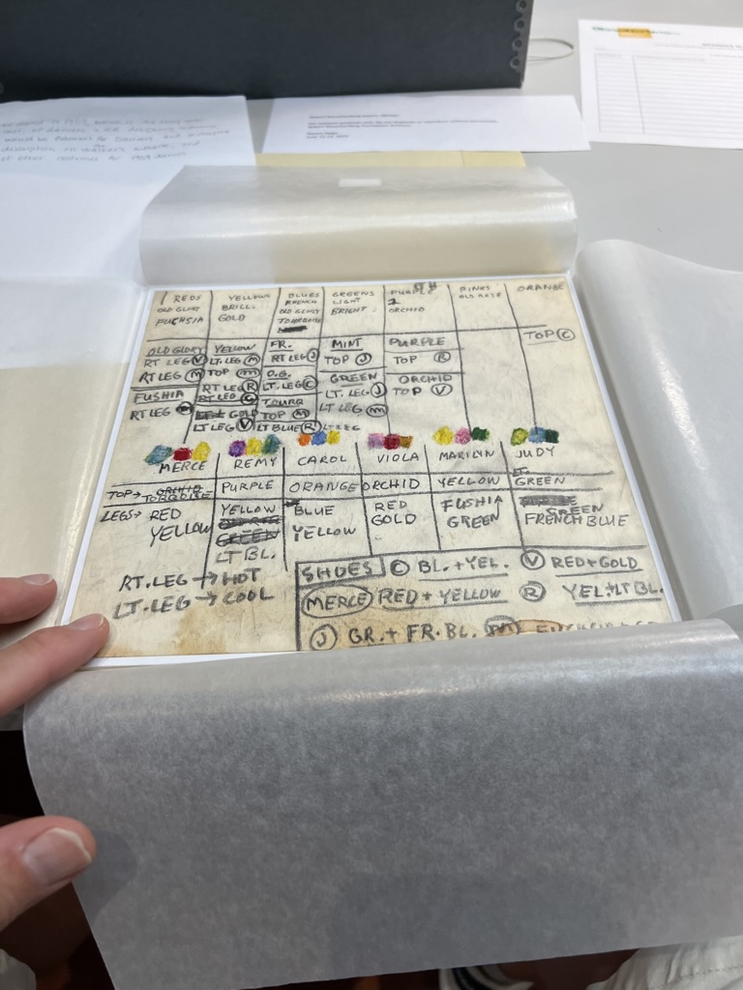
Figure 1: Robert Rauschenberg's notes for a Merce Cunningham dance (1950s), 2023.
Courtesy of Robert Rauschenberg Foundation Archives. Photo: Steven Paige

Archives, and the spaces they inhabit are compelling – with seemingly endless collections, simultaneously at arm’s length and tantalizingly close as a catalogue entry. Time spent engaging with archives fuels my creative practice, in what artist Uriel Orlow describes in Latent Archive, Roving Lens, as an ‘archive thinker’ where artists see the archive for what it represents, its assumed authority and its perceived latent potential. I am drawn to the continuing potential of the archival flux, where ‘the exploration of the archive, is at the intersection of concept and matter’ (2006: 22) in what it offers as a communal space, and how I can make connections across myriad of recorded and collected narratives through my practice.

As a queer man I am preoccupied how this impacts my creative research engaging with an archive, through a queered sense making. This is while being responsive to the rituals and behaviours of archival research, the rules and regulations, and where this might lead what I find access and respond to. I am using queer here to stake out the difference to ‘gay’ as Jack Parlett describes in the Poetics of Cruising as ‘meaning something different to its more recent re-definition as a critical term’ (2022: 13). I am ascribing a political agency to my queer approach, to cruising the archive, simultaneously subjective while being receptive to the dynamic dialogue and connections along historic and contemporary trajectories. Alex Espinoza facilitates this line of reasoning in seeing the act of cruising being more than just momentary gratification,
Cruising has provided a safe outlet for sexual exploration. It is devoid of the power dynamics that plague heterosexual interactions and exists outside of traditional hierarchies. True cruising allows people to set the terms of their desire, and both leave satisfied. It is founded on equality (2019: 32).

The proposition to take an approach to archival research that ‘is devoid of the power dynamics’ of normative relations in how they might be structured is liberating, where the unexpected, missing, or uncommon become compelling. It suggests an alertness to potential intersections where there is a glimmer of a coded record or account, that can be seen through a queer lens. As Espinoza suggest, this liberating space of unstable and evolving relationships validates a nuanced sensibility, that can be both simultaneously critical and longing.

Queer Archive Thinker
Two aspects that are key to my approach to creative research as an artist is the tension in the need for orderly entry into the space and place of archival research which is in part its attraction; a system to test and challenge, but also simultaneously seeking to be open to the musing and creative process as you are making your way through a collections catalogue. You cannot look at everything all at once, be disorderly or roam without a destination, distinct in many ways from digital online research, where you can graze across databases simultaneously. Nor is it possible to avoid the negotiated interactions with the archivists, collections specialists and librarians who become increasingly important gatekeepers the further you delve into the collections. Choices will need to be made as to what you want to look at, to be able to drill down to the individual items, normally accessible one at a time. This approach is cognizant of Michel Foucault’s portrayal of the archive as existing ‘between tradition and oblivion, it reveals the rules of a practice that enables statements both to survive and to undergo regular modification’ (2002: 10). A discursiveness that is important for creative research might then come through a queered process where the incidental, compelling and exciting becomes the guide through the structured space of the archival accounts.

I am interested in developing a communal relationship with the lives found; be they moments captured on a handwritten note or sketch, a photograph or correspondence. The outcomes of the searches are varied, sometimes thrilling, occasionally lackluster. This will not put off the avid archive/artist thinker, there is always more to find, more to search for. This search can be riven with intrigue, surprise, and desire. Discussing possible desirable encounters, Sara Ahmed in Orientations: Toward a Queer Phenomenology notes, ‘we are not only directed towards objects, but those objects also take us in a certain direction’ (2006: 545). These directions are the creative journey, the impulsive direction guided by the finds from the archival research, and I recognize this journey is drawn through me, by my critical focus and also by my desire to recognize and belong with other queer bodies I find.

I have drawn inspiration from archivist and academic Jamie A. Lee’s body of research and writings around the queer and desiring body in the archive. It has been a stimulus for this research in how she situates the queer body, in how it exists and is revealed, as it makes and unmakes itself through archives that are ‘always in motion - forming and re-forming as we constitute and re-member its collection’ (Lee, 2015). These ideas have enabled me to come to terms with the process of exploration as a self-perpetuated route through extant collections, where the process is as much through recognition of self and by association a community, and that selfhood being a lens to finding a sense of belonging in the archive, particularly when it is not explicitly an archive of LGBTQ+ histories. I do not always intentionally seek out ‘queer/ed’ archives, but when this becomes increasingly apparent through the research, I do acknowledge the ‘distinct knowing of self’ that takes place, where the archive yields to me and me to it (Lee, 2016: 37):
Re-thinking the constraints of a dichotomy that divides the professional and the amateur is important to queer/ed archival practices because it moves archivists and their collections beyond the proper, the legitimate, and the normative. This is especially important to those archivists who are interested in the mundane, the ordinary, and the non-normative (Lee, 2016).

I am sensitive to complex and entangled histories, the people, and places in the archive, the ‘non-normative’ and inversely the lack or absence of who or what is missing and how to go about finding them. I allow a meandering, part instinct, part desire and surprise, not too overtly logical or methodical to guide and move through the accounts. I presume that if the queer lives are not shining brighter that those around them, at least to me, then they are simply hidden, or obscured or unmarked. I also draw upon my queered sensibilities where an archive can refract and newly transmit to me possible queer meanings and logics. Accepting that much of the authority constructed by an archive is in its governing rules and regulations and the way they are constructed and enforced, would then beg the question, how complete are they? This governance also reinforces its limitations, how in its striving to be complete and authoritative means gaps and omissions can become apparent. This challenges the researcher to understand how and whether archival fragments are enough to constitute a history. In thinking through the body as the subject and as living being, such as myself and the existences revealed in the archive, Nikki Sullivan discusses possible relations of embodiment where it is,

(trans)formed in and through the discourses and discursive practices that make up systems of power/ knowledge. These systems (ways of knowing, and ways of being) codify and constitute the body-subject, its movements, gestures and so on, in culturally and historically specific ways, and in accordance with hegemonic values and practices (2003: 93).

Being in the archive is experiential, as it is through myself, not separate or objective. I am using my experience as an artist, researcher, and queer man to re-constitute the knowledge I find through this (trans)formed framing.

When I spent time in the Moving Picture Collections, Library of Congress, Washington D.C. in late 2016, I became sensitive to my creative agency as articulated through Orlow’s ‘archive thinker’ (2006: 22). This four-month AHRC placement offered me ways to think about how I orientated my interactions within the collections while being resident within an archive. I continued to explore this in a series of knowledge exchange projects I initiated in early 2022 investigating creative incursion into historic collections, specifically Experiencing the Archive: LGBTQ+ Narratives with archivist Sophie Meyer at The Box, with Arts University Plymouth. The dialogues took stock of the historic queer and often ignored accounts, and how we might begin to renew and enhance LGBTQ+ collections, wherever they reside. However, for this article I will focus on a research residency in the archives at the Robert Rauschenberg Foundation, New York in 2023.

Intrigued by the intimate and boisterous relationships that were so important to Rauschenberg’s artistic practice, I was compelled to spend time in his personal and professional records and accounts. He thrived on the interactions between lovers, friends and collaborators. His work reflected this; layered, complex relationships between images, colour and form. He took creative risks and was highly experimental ‘by fusing and intermingling painting, sculpture, photography, printmaking and performance […] Rauschenberg has been both inventor and explorer‘ (Hopps,1999: 21). His intensive, gregarious, and collaborative creative processes is intrinsically linked to the deep and devoted relationships with friends and lovers, and I wanted this to inform a queer reading of the artist and his practice.

Seeking
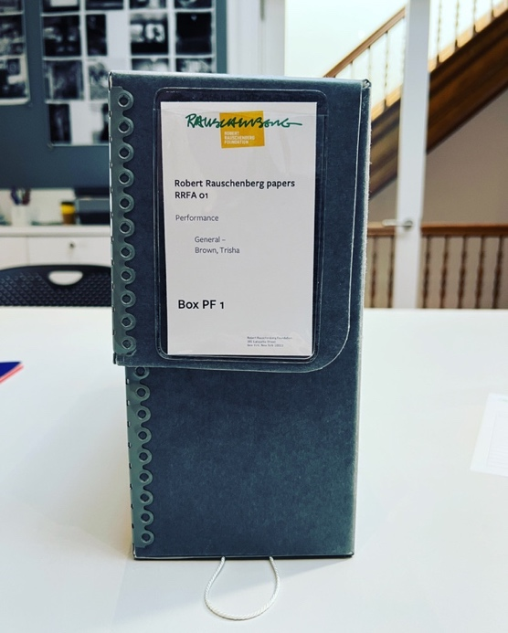
Figure 2: Robert Rauschenberg papers RRFA 01, Performance, Brown, Trisha. Archive manuscript box, 2023. Robert Rauschenberg Foundation Archives. Photo: Steven Paige.

I am open to the creative opportunities offered through an archive where I can research and seek out those items which signal to me and me to them. This alertness is attuned to being open ended, not entirely knowing where this seeking might lead. Doing this through a queered approach helps me to be alert to the oblique, ignored, and forgotten aspects of historic accounts. This alertness to the lopsided nature of seeking absent queer bodies in historic collections is needed to expose where they obliquely reside, for example when documented through punitive legal processes. José Esteban Muñoz in Cruising Utopia clarifies, ‘queerness has an especially vexed relationship to evidence. Historically, evidence of queerness has been used to penalize and discipline queer desires, connections, and acts’ (2019: 65). Norena Shopland in her book A Practical Guide to Searching LGBTQIA Historic Records suggests this is further complicated by when and where you look at the accounts that can lead to very different outcomes and understandings. So that without a lexicon of the descriptive terms for lesbian and gay men in the 18th and 19th centuries (2021: 4-15), contextualising these accounts can become problematic. As salacious or challenging as the historic accounts of gay men and women can be, the echo of the legal accounts points to a life lived, with moments of joy, sadness, pain, and community.

Cruising
Alertness to the potential of the half glanced and peripheral resonates with an appreciation of cruising urban environments with my attempts to bridge the gap between recorded accounts and imagined or lived experiences. It is through this seeking of the particulars of others’ lives as Muñoz suggests, by ephemeral traces; parts that can be constructed to create a whole or at least more complete picture of a queer life. It has the performative potential of seeking the unknown or unexpected, to form a map of sympathies and narratives that elucidate alternative lives and stories that might not surface or reveal themselves otherwise. There are connections to be found in archival collections by being receptive to chance encounters and alert to mis-directions that align with the mechanics and performance of cruising.

I am not attempting to exclude other forms and methods of archival research, queer, queered or otherwise. I am speculating on an approach I have found myself taking when I have been engaging with collections, to see how this connects with ideas around creative research where cruising is part of a methodological approach. I am not seeking to over romanticise engaging with physical collections, it’s from shared positionality, a queer cruising methodology. An archive by its nature and structure has been crafted with indexical pathways that leads the researcher towards what they seek, and what may be found is determined by the state of completeness of the archival document or fragment. This completeness is reliant on a context that is simultaneously part of the archive it exists within, while also harking to its other lived existence (Baron: 110). Not unlike a city map, it will have its highways and byways, clear routes and unexpected turns that can lead to capricious moments of discovery or lonely disappointment. As Hal Foster puts it ‘archival artists seek to make historical information, often lost or displaced, physically present’ (2004: 5). I want to make connections and disruptions across archival accounts, to embolden visceral relationships that form when finding and meeting a charged item or artefact. Disappointments in what you find should not become a disincentive as a researcher or artists will appreciate; cruising in many senses is part of a sifting process to getting one step closer to useful and exciting finds.

Protocols
In Backward Glances Mark Turner looks to Georg Simmel’s 1903 essay The Metropolis and Mental Life, in which he discusses how the fleeting nature of cruising offers the individual a way of making sense of, and a solution to, the consuming cost to the individual by the ceaseless drive of the modern city. It is a process of making connections with other lives that ‘are ways of living amid the violent ruptures of external stimuli that allow one to connect with others and hold alienation temporarily at a distance’ (2003: 58). This rupturing is part of the charge that energizes the connections made in the moment, unrequited or not, drawing our attention.
For Simmel the mutual exchange of the passing glance - that contingent, fleeting, Baudelairean moment - can be a vital point of interaction, an expression of togetherness rather than of alienation, of connection, rather than separation.

The experience, sparked by desire and attraction, a longing optimism and hope in the unrequited moment, that can live on, as Simmel suggests ‘in a different form as fantasy or phantasy’ (2003: 58).

I find a particular purchase in this notion of fantasy that alludes to the searching for and finding a charge from the act of archival cruising, a glance, from my eyes to my hand, to the artefact. I imagine consternation, laughter, or silence through looking, seeing, and reading the notes, photographs, and other archival ephemera. In the context of Robert Rauschenberg’s archive this is a testament to the dynamic creative life he lived, with letters from past lovers and collaborators, where sometimes they are both simultaneously, remain meaningful and redolent. I imagine a spark between my fingers and the expressive and captivating notes and letters that I am finding, holding, and reading.

While I do not want to directly compare the rubrics of cruising with archival research it is useful to draw some comparative associations between the strategies of desiring chase, a commitment to being open to new and unexpected finds and experiences. The impact of my incursion into the recorded accounts in an archive is momentary, an incision across time, where the researcher gets to be with the artefact. In the revelatory moment of discovery, there is the frisson of potential, the excitement of new knowledge, new relations and understanding that blossoms from the encounter. The intense, haptic engagement is fleeting, haunted by its eventual return to the archive. Out of this, springs inspiration for artwork and further research. It is as a state of open mindedness and being alert and sensitive not only to the critical meanings found through archival research but also the subjective yearning for meaning. The place of the archive is part of this sophistic activity, where the archive researcher is operating/cruising with single purpose in plain sight, seeking a fruitful encounter. This is not to say that both archival encounters and cruising are always productive or without risk. The expectancy is part of the frisson, the disappointment part of the cycle of joyful discovery that is sometimes unrewarding. There is no equivalence between the danger that exists in cruising the public spaces of a city, and the slower and mostly less physical pace of archival research. This archival research has emotional implications, the consequence of examining the evidence of lives lived, encountering the affecting network of intimate connections, fraught with personal and intensive accounts. The archival finds linger, not unlike the physical connection with an intimate stranger, where the longing is for the absent unrequited connection found and not entirely made.

Meeting
Making a distinction between locating myself in physical or remote archives is increasingly key to my art practice by investing in meeting and being present in and amongst physical collecitons and its keepers. I would struggle to dissociate the inspirational or important finds from their site of discovery, that become meaningful and redolent through conversations with anecdotes and shared memories from the archive staff. In Jack Parlett’s book The Poetics of Cruising, he describes Walter Benjamin’s note on a ‘Acqua S. Pellegrino notepad’, continuing to muse on ‘aura’, where Parlett highlights place or experience as part of subjective looking, desirous and daring, in his opening chapter Love at First Light:
It is all the more evocative for the tangible sense of place it suggests. The S. Pellegrino tagline at the bottom of the paper - ‘La Migliore Da Tavol’ (The best table water) - recalls the kind of notepaper you might expect to find on a hotel bar or café table in the inside-outside of a Paris arcade, say, a place where you are ‘one who is seen’, where you might answer the looks of passing strangers ‘with a glance’ and afterwards jot down the experience. It is possible to glean from this fragment, then, the very milieu of cruising - a scene of looking, watch-ing, and subsequently, of writing (2022: 24).

The archival encounters are a meeting between the body of the researcher and the artefact, from the archive to my mind, imbued with the moments of meeting, the place of an archive and the charge of findings the endeavors of a life lived ‘with a glance’. It is a particular moment, intense and fleeting, doomed not to last. This is also a socializing experience, between
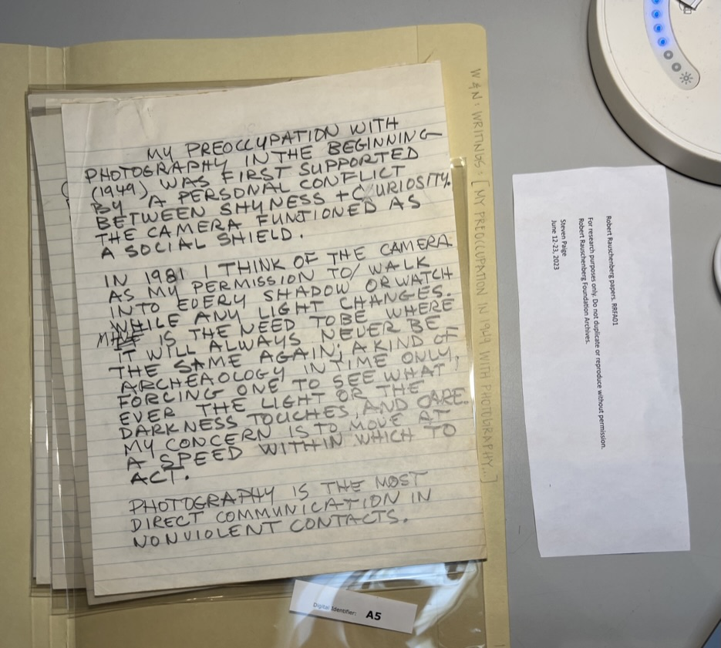
Figure 3: Robert Rauschenberg's draft on My preoccupation with photography (1981), 2023. Courtesy of Robert Rauschenberg Foundation Archives. Photo: Steven Paige.

the artist researcher, the archivist, and the newly revealed histories. The experience is affected and meaningful, as Parlett suggests, through a curiously cruising gaze upon the artefacts, be they clearly announced or in the gaps, slippages and suggestive ‘sutured ephemera’ (Muñoz, 2019) to piece together. This was brought home to me when touching and holding Rauschenberg’s note ‘My preoccupation with photography’ shown in figure 3. The intense writing, the aged paper and the direct connection from his hand to mine was a visceral experience. He describes a developing curiosity and shyness with the world through the photographic lens, using it initially as a social shield, to eventually to be able to ‘walk into every shadow’. I can’t help but feel the frisson of the moment – on seeing Rauschenberg, very real evidence of him being present, and for me to make a connection with him looking out into the world. Returning to Parlett’s book, who in discussing Michel Foucault and Leo Bersani’s theorizing their accounts of cruising in the chapter Passing Strangers ‘suggest that it is a cultural and theoretical battleground, a queer search for self, on the one hand, or for relation, on the other, that incorporates nostalgia, “concessions,” “canon[s] of beauty” and the vexed question of camaraderie’ (2022: 43). I am taking this approach as a form of collective recognition, a renewed discovery of a queer/queered network of sympathies, where both the researcher and archive become more porous, connected, and generative.

Bob & Friends
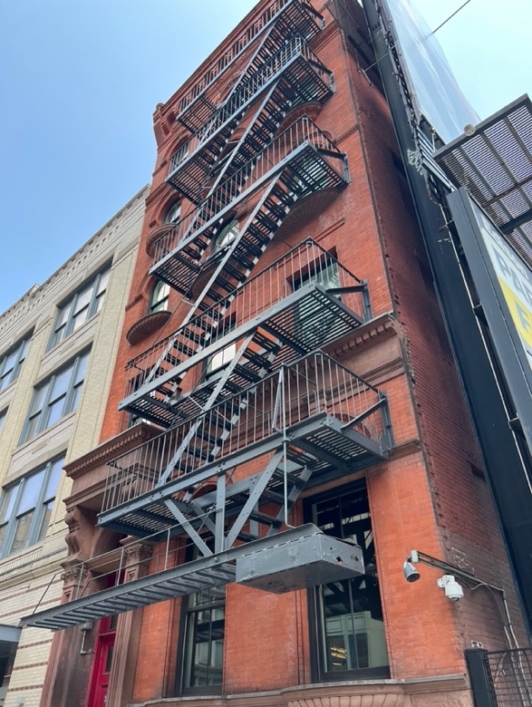
Figure 4: Robert Rauschenberg Foundation Archives. Photo: Steven Paige.

The Robert Rauschenberg Foundation archive is located at 381 Lafayette Street, New York, the site of his studio and city residence from 1965 (see figure 4), before he relocated his practice to his Florida studio in 1970. My approach to this residency was not an attempt at ‘finding Rauschenberg’, but a aspiration to more fully discern the potent, dynamic and instructive relationships that were key to Rauschenberg’s development as a rebellious artist. I wanted to gain an insight into Rauschenberg’s network of sympathies through the archival accounts of his social networks, to see how these resonate and reflect Rauschenberg’s approach to material practice. I sought to understand how the collaborating bodies informed the act of his art making. His dynamic and interdisciplinary working is also suggestive of the intimate, loving, and boisterous relations with friends and lovers and vice versa, a possible queer methodology of making. This research was exploring his collaborative practices as liberating and discursive acts, manifesting what I was beginning to see the role of queer sensibilities and it’s challenges as being part of a positive creative process.

Thinking through Parlett’s musing of Bejamin’s located experiential ‘aura’, I sought to be open to the experience of meeting archival accounts, not to simply find and record the evidence of meaningful relationships and anecdotes. This was palpable when spending time in the Robert Rauschenberg Foundation archives. I wanted to bring to bear a queered relationship with the accounts, acknowledging that this can work both ways, affecting me and in turn prompting new understandings. The following are a selection of my contemporaneous notes, the response to my presence in archive each day, the discoveries and moments of meeting the visceral artefacts of a personal and fulsome creative life.

Robert/Bob’s Archive
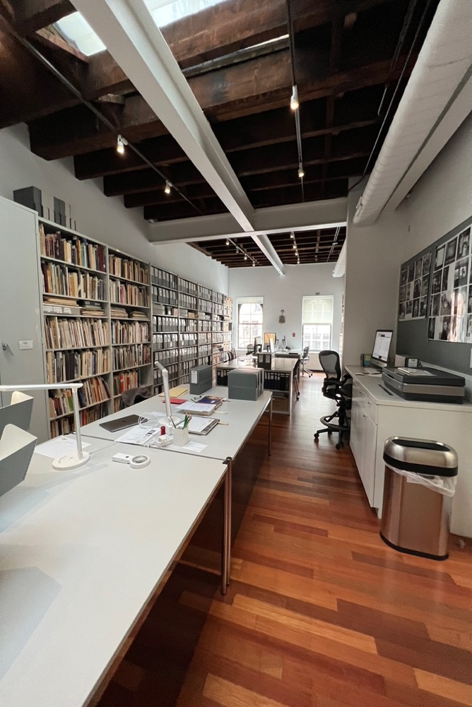
Figure 5 - Robert Rauschenberg Foundation Archive, 2023. Photo: Steven Paige.

Day 1
- Looked through the performance series PF1 – PF5
- Discovered Robert’s notes from his performances, and his collaborations.
- To note – look back at Robert’s pieces? *Elgin *Shot Put
Notes:
I find Robert’s notation of performances compelling, as is his writing, it is startling coming across it in the records (see figure 6). There is something forced but also straight forward in the expression of this – uncomplicated, not cursive, lacking flourish?

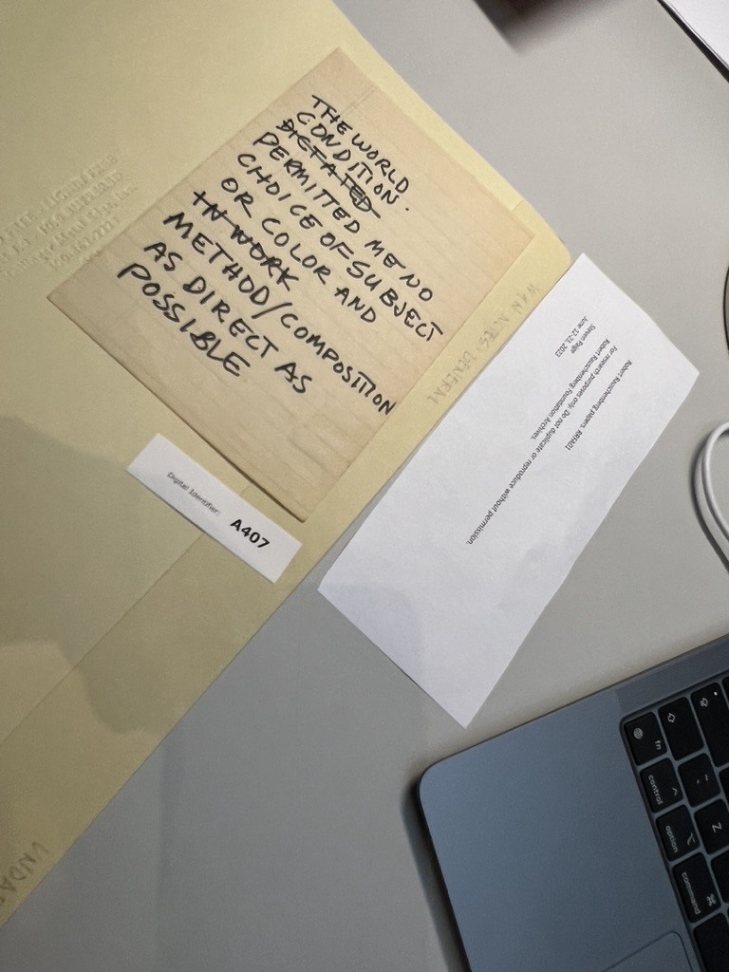
Figure 6: Robert Rauschenberg notes (undated), 2023. Courtesy of Robert Rauschenberg Foundation Archives. Photo: Steven Paige.

Day 2
Notes:
Coming to terms with a particular way of working which would appear as very instinctive – thinking about the example of the white paintings in Black Mountain College (BMC), where he introduced a small star, as he had seen that in galleries where the work was sold.
Having spent time looking through the contact sheets, which supposedly have been reordered from their original state, mixing timelines and subjects, they appear intensely subjective (figure 7, 8 & 10). I think through the connections and visual patterns that seem to make sense between the images, of Merce Cunningham, Steve Paxton, Cy Twombly, Susan Weil and Jasper Johns and what they had meant to him. I recognize the intimate portraits of Johns and Twombly, and Paxton.

Day 3
- Accounts of cathartic moment at Black Mountain College (BMC) with Twombly and Friends in the pond, ‘Black Mood’ - Where Twombly had to talk Robert out of the pond. Connected to Weil leaving BMC, with their child Christopher and later divorcing Robert.
- Lots of comments found in anecdotes about Robert’s ability to collaborate, work together, think differently.

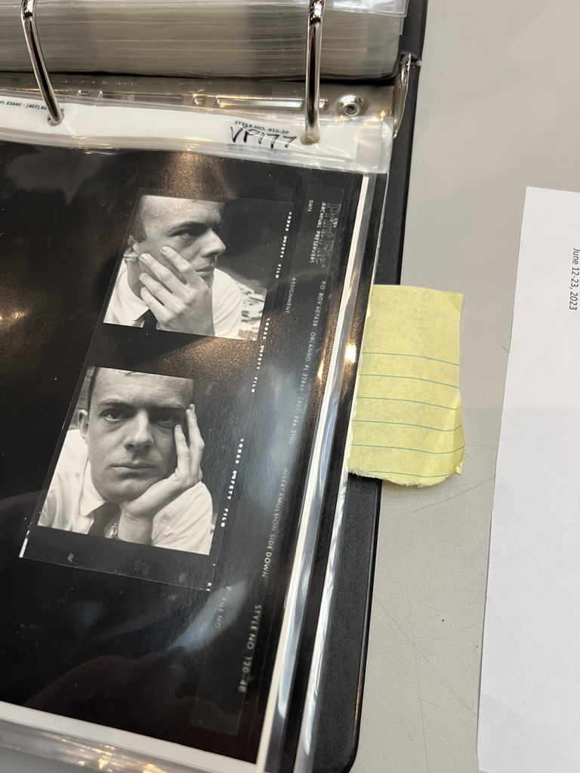
Figure 7: Contact sheets with photographs of Cy Twombly by Robert Rauschenberg (1950s), 2023. Courtesy of Robert Rauschenberg Foundation Archives. Photo: Steven Paige.

Day 4 (researcher’s lunch with Foundation staff)
Notes:
I think of the comments by Donald Staff when describing Robert in China – setting up a studio in Rauschenberg ‘mode’, and the idea of 2-4 heads or 4-8 arms working on the prints that manifested from Gemini G.E.L. His practice was in many ways reconfigured his experience and understanding of the world, through the creative process, where many hands, multiple influences and resources could be made sense of.
David White (senior curator at RRF, working for RR from 1980) – talked about Robert not liking weekends – he did his Sunday drawings, when the staff and assistants were away. He did not like the holidays for the same reasons. He reveled in the skill each person brought to the project.
- He considered himself a photographer.
- Sidney Felson (Gemini G.E.L.) – in a letter negotiating the Japanese Paper Mill project, July 27, 1974.
‘Rauschenberg is an artist who appreciate environments and enjoys very much being around very special people‘ (Box PE 66).
- Publicons, 1978– Gemini G.E.L. scrapbooks – ‘I was all about collaboration’.

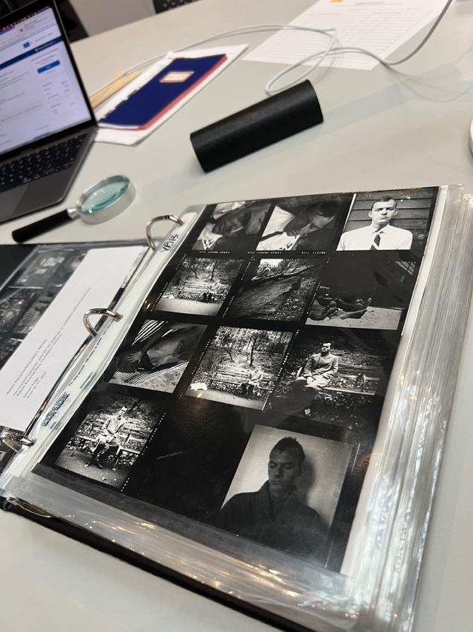
Figure 8: Contact sheets with photographs of Cy Twombly by Robert Rauschenberg (1950s), 2023. Courtesy of Robert Rauschenberg Foundation Archives. Photo: Steven Paige

Day 5
Notes:
I found this quote from Chance and Circumstance by Carolyn Brown when looking through the library in the archive:
By late 1953, Bob had moved away from his all-black paintings to new red paintings. He invited Merce, John, Earle and Carol to his Fulton Street Loft to see the new paintings, ‘He was strangely ill at ease.’
When everyone responded positively – he later stated:
“I didn’t want to lose my friends”. Friends had always been important to Bob; he had very few in those years, and of those few, John Cage, thirteen years Bob’s senior, was perhaps the most valued. (2009: 114-115)

From this point Robert would go to work with Cage and Merce for 10 years until 1964 and at various points after that.

Day 6
Notes:
I find a lot of correspondence that mentions Robert’s philanthropic activities– including letters from Jimmy Carter and the Clintons – both while in the White House and after. The other finds are from his neighbors and friends – with a lot of the addresses to ‘Bob (Rauschenberg) & Bob (Peterson)’. He seemed to be very present in Capitva, Florida, connecting to the area. I also found correspondences from John Cage – which read as heart felt. I develop a sense of my voyeurism reading the private correspondence between Robert and his friends, lovers & colleagues which is not entirely comfortable.
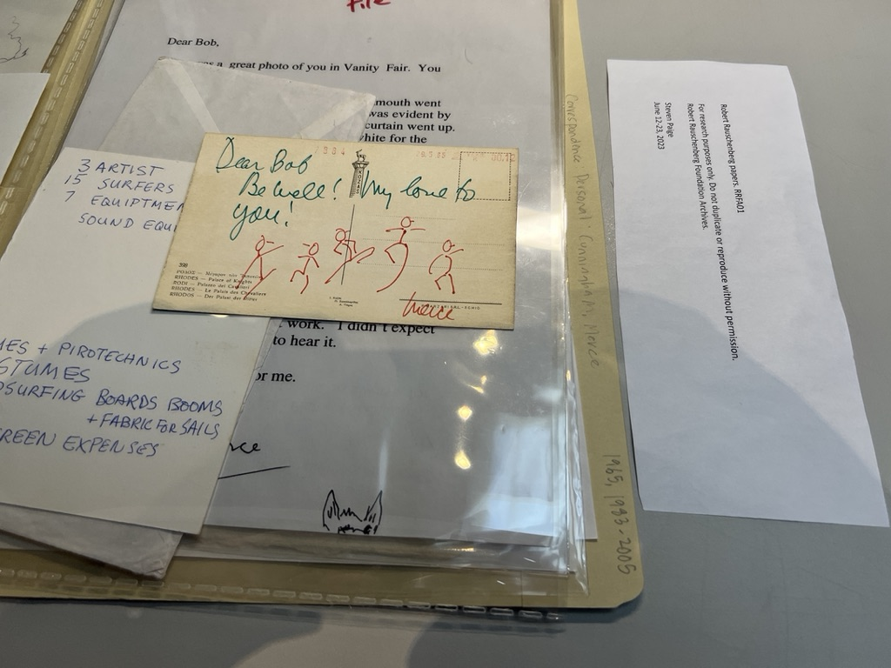
Figure 9: Merce Cunningham correspondence (1965, 1983-2007), 2023.
Courtesy of Robert Rauschenberg Foundation Archives. Photo: Steven Paige

Day 7
- So far I have seen Steve Paxton, Trisha Brown, John Cage and Merce Cunningham. Correspondences (see figure 9).
- All light – familiar and fun.
Notes:
Robert’s mother still called him Milton – with a poignant remark in a later sent postcard as to how proud she was of Robert’s success (1972). Suddenly there was dissonance for me to see the older Robert – after spending so much time with his youthful and vigorous body in the archive.
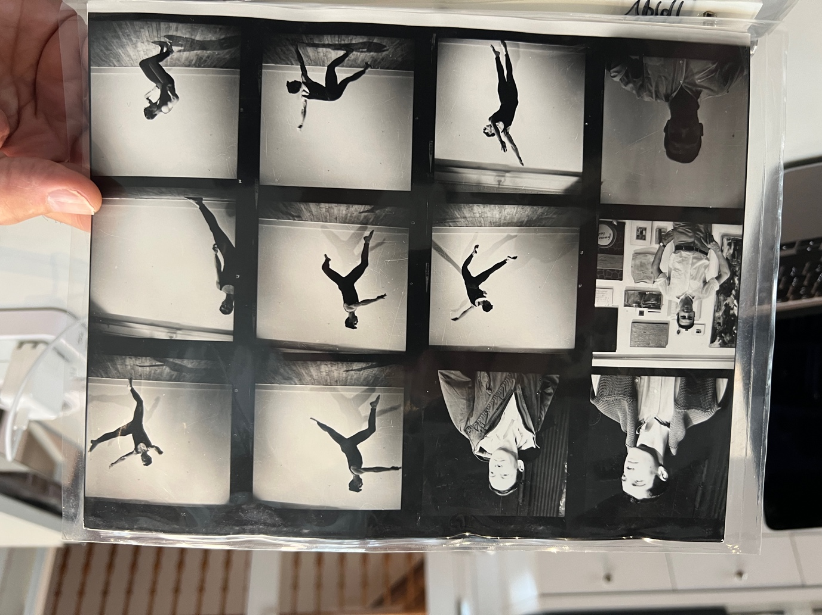
Figure 10: Contact sheets with photographs of Steve Paxton by Robert Rauschenberg (1950s), 2023. Courtesy of Robert Rauschenberg Foundation Archives. Photo: Steven Paige

Day 8
- High speed research!
- Documenting Robert’s correspondence and writings.
- Discovered Alessandro Twombly letters to ‘Uncle Bob’.
- I touch and read Cy Twombly’s letters to Robert, which are beautiful.
- Some Notes from Twombly’s letters:
Nov 1, 1971:
Twombly wants to meet up with Robert, signs off as Rembrandt Jr.
Twombly sends a postcard addressed to Robert and Steven Paxton.
March 14, 1972
Nicoletta thinks I had a romance there [in Captiva Florida], I guess I did.
But as you well know, not a fleshy one. All love to you both.
- Letters from Susan Weil – very loving and caring.
Notes:
One compelling aspect for me exploring Robert’s archive is the intimate, playful, generous, and continuous collaborations, and affairs, sometime both simultaneously. He never stopped making work or interacting with ‘his’ people, and these collaborators and partners seemed to be seared endearingly as friends and companions long after they had separated. His practice, which was extensive and continuous, only ceased when he did, or could no longer physically make any more work. This network of collaborators and partners is increasingly compelling to me.

Endearing
The time spent the Rauschenberg archive was a visceral, moving, and intense period. It was colored by the relations and dialogues with the foundation staff, the generous archivist team, and the generous access I was granted. The building felt a repository, a vibrant space to house the evidence of a lively boisterous life lived and loved. In taking a queered cruising approach to what I encountered in this archive, I was struck by the tentative and delicate relationship I was building with Rauschenberg’s life and works. It was a type of communion with an artist’s life, not only through the accounts in the archive, but also through the interactions with the keepers and space made available that sustains such an account. It was a powerful experience to touch, talk, fixate, and imagine through what I encountered of his archive. I want to return to Jamie A. Lee and her writing, Be/longing in the archival body: eros and the ‘‘Endearing’’ value of material lives, to position these connections,
The bodies and bodies of knowledge that constitute archival collections embody those moments of fixation and are tethered only fleetingly; bodies are connected to archival bodies in distinct and meaningful ways that might, for example, transform understandings of evidential quality from ‘enduring’ to also ‘endearing’ (2016: 35).

I want to celebrate this approach of seeking out elusive moments of ‘endearing’ inspiration and connectivity that takes place in an archive when you have a meaningful encounter with a letter, photograph or item that offers you an emotive charge. This is driven by my optimistic hope that through inquisitive searching, of cruising in the archive and in the city, of the chance of meeting someone or something new, that resonates across my instinctive and artistic sensibilities, that is something unexpected and at the same time increasingly familiar can emerge.

It is in this desiring mode that I am alive to the potential of new possible relations, thoughts and compulsion that are at the same time both intimate and communal. This process of being alert to possibilities that are sometimes critical, feel instinctive, and joyfully resonates with my creative processes. As I described in the diaries notes from my time in the archive, I was able to develop meaningful connections with the archival accounts, in this case Rauschenberg’s dynamic collaborative and loving relations, my body to his body, looking and holding evidence of his life and loves. I followed the dancing, creative and significant characters that surrounded his creative practice, doing this through and across a gregarious and loving trail of letters, conversions and photographs. My cruising through this archive propagated my queer understanding of the relationships and collaborators who were more than simply part of Rauschenberg’s life, but integral to it.

References
Ahmed, Sarah (2006), ‘Orientations: Toward a Queer Phenomenology’, GLQ: A Journal of Lesbian and Gay Studies, 12: 4, pp.543-574.

Baron, Jaimie (2014), The Archive Effect: Found Footage and the Audiovisual Experience of History, Oxon: Routledge.

Brown, Carolyn (2009), Chance and Circumstance: Twenty Years with Cage and Cunningham, Evanston: Northwestern University Press.

Espinoza, Alex (2019), Cruising: An Intimate History of a Radical Pastime, Los Angeles: Unnamed Press.

Lee, Jamie (2016), ‘Beyond Pillars of Evidence: Exploring the Shaky Ground of Queer/ed Archives and Their Methodologies’, in (eds) A. Gilliland, A. Lau, & S. McKemmish, Research in the Archival Multiverse, Melbourne: Monash University Press, pp. 324-351.

Lee, Jamie (2016), ‘Be/longing in the Archival Body: Eros and the “Endearing” Value of Material Lives’, Archival Science, 16:1, pp.33-51.

Foster, Hal (2004), ‘An Archival Impulse’, October 2004, Fall: 110, pp. 3–22.

Foucault, Michel (2002), Archaeology of Knowledge, London: Routledge.

Hopps, Walter & Davidson, Susan (eds) (1999), Robert Rauschenberg, A Retrospective, New York: Guggenheim Museum.

Muñoz, Esteban (2019), Cruising Utopia: The Then and There of Queer Futurity, New York: New York University Press.

Orlow, Uriel (2006), ‘Latent Archive, Roving Lens’ in J. Connarty & J. Lanyon (eds.) Ghosting: The Role of the Archive within Contemporary Artists’ Film and Video, Bristol: Picture This Moving Image.

Parlett, Jack (2022), The Poetics of Cruising: Queer Visual Culture from Whitman to Grindr,
London: University of Minnesota Press.

Shopland, Norena (2021), A Practical Guide to Searching LGBTQIA Historical Records, Oxon: Routledge.

Sullivan, Nikki (2003), ‘Front matter. A Critical Introduction to Queer Theory’, Edinburgh University Press, Jstor, http://www.jstor.org/stable/10.3366/j.ctvxcrwj6.1. Accessed 18 March 2024.

Turner, Mark (2003), Backward Glances: Cruising the Queer Streets of New York and London, London: Reaktion Books.

Arts and Humanities Research Council, UK.
The Library of Congress placement was part of the Kluge Fellowship programme supported by the AHRC Doctoral International Placement Scheme. Experiencing the Archive was funded by the Research England through Arts University Plymouth and hosted at The Box, Plymouth. The Robert Rauschenberg Archive Residency was supported by the Robert Rauschenberg Foundation residency programme.
Robert Rauschenberg liked to be called ‘Bob’ and encouraged those who he met and worked with to so. This was the norm at the Foundation.

