# PACE: Guiding rural tourism development in a fragile area

### Marcus Grant

### Abstract

This paper describes a process designed to assist the sustainable development of tourism and other land use developments in the Somerset Levels in south-west England. The Somerset Levels occupy some 900 sq.km. of land lying just a few meters above sea-level interspersed with higher ridges. Unique in cultural and ecological terms but having problems of social exclusion and few development opportunities, they are typical of many peripheral areas. Recent economic and policy changes are creating pressures for alternative employment including tourism enterprises to replace losses in traditional industries. This fragile cultural and ecological environment requires a responsive mechanism that can be used by all the stakeholders to steer and guide initiatives as and when they occur. The mechanism must allow for social, economic and environmental impacts and also be able to take account of cumulative and inter-project effects. A framework involving Strategic Environmental Assessment, Environmental Impact Assessment and Project Appraisal and Community Evaluation (PACE) has been developed to fulfil these requirements and is shortly due to be tested in pilot form. The work was funded by the Royal Society for the Protection of Birds and English Nature.

Marcus Grant is the principal of Environmental Stewardship. He is a member of the Tourism Research Group at the University of the West of England and of the Green Audit at Kingston University.

**Marcus Grant:**

**Environmental Stewardship**

e-mail:marcus.grant@uwe.ac.uk

# PACE: Guiding rural tourism development in a fragile area

# Introduction

This chapter presents a method for Project Appraisal and Community Evaluation (PACE) which is being piloted in the Avalon Marshes, which lie in the internationally important wetlands of the Somerset Levels and Moors. The Levels and Moors occupy some 900sq.km in the County of Somerset (Southwest England) and contain low lying areas of moor, much of which has been drained for agriculture and urban flood relief. The themes discussed here include:

• how to move from sustainable tourism theory to practice,

• the role of a lead authority as initiator and co-ordinator and,

• mechanisms for facilitating wider access to decisions that will have strategic implications.

*“The two elements, the land and water, shift and exchange, muddle in with each other and then separate as the creeping growth ...... tries to re-establish the solid in this would-be liquid”*

Sutherland & Nicholson, 1986

The ‘Avalon Marshes’ has been chosen as an evocative name which conjures up a picture of this wide bottomed valley in the Somerset Levels as it was in ancient times - a vast expanse of marshland surrounding an island sea, alternately flooded by fresh and salt water. For over five millennia man has wrestled with the forces of water here, in what was for most of this time an area difficult to penetrate. Archaeology has uncovered remains of early trackways linking settlements across the treacherous bogs and marshes. The Avalon Marshes like many of the world’s great wetlands has remained an area of peripherality. The isolated culture that evolved was uniquely moulded to this wetland lifestyle. This culture has been documented in the local museums of the areas, through photography and in prose. The Avalon Marshes also are of international importance in containing statutory protected areas e.g. a National Nature Reserve and several Sites of Special Scientific Interest, with parts also falling into an EU Birds Directive Special Protection Area (SPA) and Ramsar site.

The Avalon Marshes are also typical of many similar peripheral areas, in that they are facing development pressures for increases in employment, for changes in agriculture, for development of tourism and nature conservation; the resolution of which are crucial to their social, environmental and economic future. The nature conservation interests, in particular Bird Life International (known as the Royal Society for the Protection of Birds or RSPB in Britain), are interested in developing and piloting a project appraisal which could be applied to other peripheral areas with important and fragile natural environments.

In the Avalon Marshes, the economic base relied on increasingly in the latter half of this century, in this case large scale peat excavation and EU subsidy supported farming, is in decline; local rural employment is increasingly scarce; higher values are being placed on the area’s contribution to biodiversity. Moreover, through national guidance and the local planning system, the criteria for reclamation of the industrially derelict land and support of farming practices is now geared towards the delivery of biodiversity objectives. It is partly the high quality of the nature conservation resource in the area that has led to pressure for tourism development as local businesses seek new opportunities through nature tourism. Though its assets are not just limited to nature conservation. As a result of the preserving qualities of peat and connections with the myths of King Arthur and Avalon, the area generates international archaeological and historic interest. The Arthurian legends lead to a steady flow of independent youth travellers from Europe, America and the Antipodies. Attractive too is the unique cultural landscape, based on the traditional way of life of relatively low-intensity farming and peat cutting. Also potentially relevant to tourism development are the abundant water supplies and ‘holes in the ground’ (worked out peat pits) making fishing and recreation lakes are relatively cheap to implement.

Somerset County Council, the strategic planning authority, set out the parameters for reclamation of the peat works with a plan for basic zoning which envisaged a nature conservation core and a buffer where wetland compatible recreation would be appropriate (SCC, 1992). Development of any kind needs to be undertaken very carefully in this fragile environment. To provide jobs in tourism, slowly reduce reliance on peat cutting and increase nature conservation value requires certain changes in infrastructure and land management practices. However, both the wetland ecological assemblages and preserved archaeological resource are both vulnerable to water level and water quality. Also the unique cultural landscape is also vulnerable to incremental change and poorly thought out development. The early nineties saw a period of extensive research (an environmental science based base-line report established basic hydrological and ecological parameters [Halcrow-Fox, 1992] this was followed by a multi-disciplinary planning, economic and land-use analysis [LUC, 1994]) resulting in a vision for the area which contained a number of sensitive land use and employment options for consideration by local landowners and the wider community The vision helped to define the concept for the Avalon Marshes. It originally envisaged former peat workings becoming a restored wetland, with lakes and reedbeds primarily for nature conservation, with access and visitor facilities and compatible recreation activities, coupled to appropriate commercial activities (SCC, undated).

The area embodies an example of Getz & Jamal’s (1994) complex tourism ‘domain’, “where no single individual , agency or group can resolve strategic tourism issues by acting alone”. The steering group of the initial options study referred to above consisted of the representatives of some fifteen different organisations or sectional interests, including two local authorities and one strategic planning authority, the statutory bodies for water, agriculture, nature conservation and local interests such as two internal drainage boards, the peat cutters and local land owners associations and otter conservation. This is situation where there is need for a new approach to tourism planning.

Recognising the need for co-operative working early in the nineties, Somerset County Council initiated and leads a consultative and representative process in the whole of the Somerset Levels and Moors called the Levels and Moors Project. The representative body, the Levels and Moors Partnership is a non-statutory body involving representatives of communities, business and farming, nature conservation, water authorities and the planning authorities. A sub-group, the Avalon Mashes Advisory Group, are specifically concerned with the Avalon Marshes, where extensive wetland restoration is already underway (Taylor, 1997). The current project sponsored by English Nature (the government’s nature conservation advisors) and the Royal Society for the Protection of Birds, has sought to provide the Avalon Marshes Advisory Group with a framework for setting strategic goals and reviewing projects and proposals against those goals. Issues considered in the development of this framework included:

• How could the process deliver environmental, social and economic sustainability?

• Could a single mechanism be versatile enough to be rigorous for large proposals but not over cumbersome and too bureaucratic for small scale projects?

• Can a single process include both review of long term programmes and review of specific projects?

• How can all interested parties have access, from parish councils to local and regional councils, from businesses to conservation bodies?

• How can a process meet the specific demands of rural tourism development?

The framework that was designed consists of a tiered approach with three levels of assessment. The assessments are based on environmental assessment (methods and processes used for examining how the existing environmental characteristics of an area are likely to be altered by human activity) but use a wider definition than the one used in the European Directive on Environmental Assessment, and the UK Regulations (EEC, 1985: TCPR,1988).

The three tiers are:

• at the ***strategic level*** relating to policies, plans or programmes - strategic environmental assessment (SEA)

• for *major projects* involving complex processes in sensitive areas - Environmental Impact Analysis (EIA) and,

• for *small-scale projects* ***and proposals*** not requiring formal assessment - Project Appraisal and Community Evaluation (PACE).

### Strategic level assessment (SEA)

Strategic EAs examine the likely effects of policies, plans and programmes on the environment and a new Council Directive covering SEAs has been presented by the European Commission on 4th December 1996 (EU, 1996). There is no formal requirement for SEA in Great Britain but government departments are encouraged to undertake environmental appraisals of new policies, and local authorities are asked to appraise Development plans, using techniques which are closely analogous to SEA. The current project envisages that all of the agencies involved in developing the Avalon Marshes Strategy work together in developing a Strategic Environmental Assessment. The aim will be to ensure that the activities of each agency are designed, wherever possible, to support and reinforce protection and enhancement of the environment.

### Assessment for major projects (EIA)

Large and complex projects which are likely to have significant effects on the environment are subject to formal EA under national regulations (e.g. TCPR, 1988) and the European Council Directive (EEC, 1985). This framework recommends that whether or not formal assessment is actually required, the principles of environmental assessment should be applied to all projects within the Avalon Marshes, and should be introduced at the earliest opportunity which is often the point at which the basic concepts and ideas are being formulated.

### Assessment for small Projects (PACE)

Many small projects have the potential to affect the environment of sensitive areas like the Avalon Marshes through both their direct impacts, but also through the cumulative effects arising from interactions between them. This provides strong grounds for considering the impacts of such proposals even though they are not covered by statutory regulations. Use of EA techniques is also very valuable in improving the quality of the development proposal and enhancing its design.

|  |  |
| --- | --- |
| **Component** | **Role in Avalon Marshes** |
| **Strategic Environmental Assessment**  **(SEA)** | Assessment of Policies, Plans and Programmes arising from the aims of the Avalon Marshes. These are assessed against sustainability goals and against each other |
| **Environmental Impact Assessment**  **(EIA)** | Assessment of (large) Projects as required under EIA legislation |
| **Project Appraisal & Community Evaluation**  **(PACE)** | Assessment of (small) Projects not needing EIA and Proposals at an early stage by the promoter or others to check compliance with the Avalon Marshes aims and sustainability |

The three mechanisms for achieving sustainability in the Avalon Marshes Table 2.1

A simplified form of assessment procedure has been developed, specifically for use within the Avalon Marshes area. We have called this type of assessment ‘**Project Appraisal and Community Evaluation’**, partly to distinguish the method from the formal EA required on large projects, and partly to reflect the concern it shows for the local, social and economic context. Table 1 shows outlines the components of the tiered approach, although the main focus of this paper is PACE it cannot be viewed in isolation from the entire framework.

# The approach in theory

## Sustainability

All projects concerned with sustainability in tourism must also address the honing of the concept sustainable development. It is now ten years since the seminal definition of sustainable development as that ‘which meets the needs of the present without compromising the ability of future generations to meet there own needs’ (WCED, 1987). At first a polarised debate between the environmental and industry lobbies obscured that fact that sustainability also has a social dimension. It is now generally recognised that sustainable development recognises the validity of three interests - the environment, the economy and socio-cultural concerns (Macgillivray & Zadek, 1995). In undertaking this project, Environmental Impact Analysis methodology was adapted being a suitable model which had already been developed to address all three issues (DOE, 1989). In the context of the Avalon Marshes, where the strategic objectives embody biodiversity goals, ‘environmentally sensitive development’ is not enough and the planning model has to actually help deliver biodiversity and/or other goals on the sustainability agenda.

In addition to the current task in hand, it has been suggested that sustainable development has its own self-referring agenda, an educative role, in helping broaden awareness of our place in the environment and so lead to a change in ethics (Hughes, 1995). In other words, the values implicit in sustainable development need to be communicated within the sustainable development project itself (IUCN, 1995). This was felt to be an important consideration in this project.

A review of the literature indicates that, in pursuing a sustainable approach, tourism development should:

• focus on small-scale, environmentally sensitive development (Burr, 1995),

• be integrated into the wider concerns of sustainable development (Hunter, 1995),

• use a sustainable approach for dealing with problems of rural tourism (Lane, 1994).

• involve and empower the local community (Burr, 1995)

## Small scale

Without the right approach small scale can mean piecemeal. From early on in this project, the potential for tourism development on a small scale was seen as a problem and not in itself a solution. Land ownership is very fragmented in the Avalon Marshes, some large blocks of land are under single ownership but the majority of the land is a patchwork of small fields under various ownerships. The least beneficial scenario is that of a plethora of small landowners each using their meagre resources to develop the cheapest reclamation option, say a fishing lake with a small hut and car park. This would lead not only to an unacceptable loss in landscape quality but to fierce market competition which would minimise local economic gains. A previous study had already developed an overall vision and strategy for the area, which following public consultation was increasingly winning support (LUC, 1994). It was decided that to appraise small projects the process had to have:

• a method for testing each tourism proposal against the strategy,

• a method for the early assessment and mitigation of potential cumulative effects.

These two requirements are seen as essential to the process for two reasons. Firstly, they can be used to ensure that projects allowed to proceed actually contribute to achieving the socio/economic, biodiversity and strategic goals of the vision. Secondly, they allow for the assessment of projects in the pipeline or even at preparatory feasibility stages, this in itself can help minimise negative impacts and help promoters prepare a more appropriate project.

In terms of local economic development, recent empirical studies show that the small scale and ‘soft’ options are likely to provide the greatest economic benefits (Slee et al., 1996a). This emphasises the importance of finding a suitable planning and management process for the small scale.

## Integrated studies

### Vertical integration

The need for sustainable tourism to be seen as a sub-set of sustainable development has recently been re-stated (Hunter, 1995). In implementation this means that a sustainable tourism planning and management process must sit within a wider framework for sustainable development. In the Avalon Marshes a vertically integrated process was seen as the only approach. Vertical integration being the term used for linking small local projects into wider project area concerns which in turn are linked with a set of regional objectives. This was needed to encompass the depth of awareness and process management required. To this end, the core of the process, Project Appraisal and Community Evaluation (PACE), which deals with projects and proposals, is embedded within a Strategic Environmental Assessment (SEA), dealing with policies, plans and programmes.

### Horizontal integration

Sustainable development aims to link economic, environmental and social factors into a mutually supporting process. Without a horizontally integrated process, there is the potential for the disparate groups of residents, wildlife interests, businesses and local government all to pursue conflicting agendas. A horizontally integrated process should include all issues, this will help to include all interested parties. For this kind of process to be a success, collaborative relationships needs to be developed between all parties; the quality of these working relationships evolves over time (Getz & Jamal, 1994). This was recognised by the County Council early on in the process and led to the formation of the Levels and Moors Partnership, a forum for collaborative working. Through this, in the case of the Avalon Marshes most of the interested parties had already been involved in some form of joint working. Continuing and consolidating this collaborative working was seen as an important goal in achieving an integrated process when set against the usual formal legal planning process which encourages an adversarial conflict between planning proposers and objectors. Therefore it was determined that to promote success, the PACE process should contain the following;

• components which encourage collaborative working e.g. tasks suitable for joint working,

• processes and tools to encourage consensus by allowing all parties to be heard and to respond to concerns whilst also acknowledging their common ground.

## Rural tourism

Tourism in the Avalon Marshes is an example of ‘rural tourism’ with rurality at its heart. In this context, Lane (1994) suggests that any approach should:

• have management systems to deal with problems relating to tourism penetration, e.g. traffic flows, access control, carrying capacities,

• be able to reconcile the tensions between the forces attempting economic growth to reverse rural decline and the forces of conservation and recognising the importance of involving local business and communities in ownership, decision-making and benefits,

• be able to maintain rurality in landscape and built form.

Lane postulates that a sustainable approach would be capable of fulfilling these requirements. Certainly the tiered approach, outlined above, with the PACE process sitting within a wider SEA process can address the above requirements through having the capacity to monitor and control issues such as cumulative effects and patterns of growth over the longer term and across the whole project area.

## Community tourism

The small scale implicit in community tourism has been dealt with above. However two other community tourism factors are of concern. Firstly, there is the likely style of tourism emerging with many community based tourism providers, this has been referred to as ‘soft’ tourism (Slee et al., 1996b). The term ‘soft’ does not necessarily mean environmentally or socially benign. Therefore the PACE planning process has been designed to be rigorous even in its evaluation of small scale or ‘soft’ proposals.

Secondly, consideration must be given to the mechanism for community involvement in the planning and management of tourism within the locality. In a study looking at the implementation of sustainable planning and design for tourism, ‘citizen participation’ was found to be one of the six dimensions of sustainability (Knowles-Lankford, 1995). Recognised also by the Local Agenda 21 programme, involving local people and listening to local concerns is now seen as having a legitimate role to play in sustainable development. But there are few models of a single planning process which will incorporate local interests (both positive and negative contributions) within a development strategy linked to local authority planning structures and systems. The regional planning process, in the study area, is typical of that found in much of England in that the county authority, in this case Somerset County Council, is responsible for strategic planning of the region through the production of structure plans. Linked to this, the district authorities provide further detail in their local plans. The plans are all produced, with consultation, on a cycle of about ten years. New projects in the area from whatever source are presented as planning proposals and measured, together with any objections, against the adopted plans.

By involving the local and county planning officers in the development of PACE, their approval was sought for seeing its validity as a vehicle for reviewing projects, its usefulness in discussing and formatting objections and its capability for helping achieve strategic goals.

## Community participation in impact assessment

It was quickly seen that the key to obtaining the required levels of community involvement was to ensure that the process recognised and protected the host community’s quality of life. The criteria used for this should as far as possible come from the community and be voiced in their own words. Developing social criteria is essential to such an integrated planning process since host quality of life is integral part of sustainable development (Christensen, 1995). The PACE process requires further work in connection with achieving this objective.

Community level group involvement in impact assessment has an established tradition. Through action at public enquires and protests, communities have often sought to give voice to the local economic, social and environmental consequences of development schemes. In a review of community participation in impact assessment, Runyan (1977) presents a range of tools available and scores them for usefulness in a local group setting. His criteria for usefulness, in community situations, are for tools that:

• are simple to use,

• do not rely on a data base,

• provide new insights and information.

He scores and ranks a number of tools. Several of the tools that are at the top of his table, such as checklists, IMPASSE and the Delbecq technique, play an important part in PACE.

# The approach in practice - Description of PACE

The PACE process has been designed to be used by both promoters of projects and those concerned by their likely effects. It has been developed so that it is easy to use and will assist all interested parties either in preparing their own projects or in responding to new projects and proposals. It is intended that the process be refined and developed, by the lead authority, as experience in its application is gained. An outline of the basic components is given in this paper.

The primary responsibility for assembly of project information, its appraisal and production of a summary of that appraisal rests with a project’s sponsor. Thereafter the information is transferred to a lead authority and, together with the results of parish and other consultations, is used by the lead authority to reach a conclusion and recommendations regarding the project.

The PACE process is worked through step by step for each project appraisal. For each step there are specially designed blank forms on which to collect and organise relevant information, there are also guidance notes. The steps to the complete assessment have been divided into four stages. Stages 1 & 2 (preliminary appraisal and detailed appraisal) are undertaken by the promoter of the proposed project. Stage 3 (evaluation) is carried out by the lead agency. Stage 4 (reaching a recommendation) is undertaken by the decision maker. The process is illustrated in Figure 2.1

At the heart of the appraisal is the testing of the project against environmental, social, economic and strategic issues. These issues have been divided into topic areas which embody both the indicators for sustainable development and the aspirations represented in the Avalon Marshes Strategy.

|  |  |  |  |  |  |
| --- | --- | --- | --- | --- | --- |
| **Promoter** |  |  |  |  |  |
|  | Stage 1 | 1a Statement of Basic Project Information |  |  |  |
|  | **Preliminary Appraisal** | 1b Identification of Components |  | Component Checklists |  |
|  |  | 1c Completion of Interaction Table |  |  |  |
|  |  |  |  |  |  |
|  | Stage 2 | 2a Detailed Appraisal Checklist |  |  |  |
|  | **Detailed Appraisal** | 2b Summary of Key Issues |  |  |  |
|  |  | 2c Project Review Options, Mitigation and Alternatives |  |  |  |
|  |  |  |  |  |  |
|  |  |  |  |  |  |
| **Lead Agency** |  |  |  |  |  |
|  | Stage 3  **Evaluation** | 3a Consultations with Parishes & Interested Parties |  | Community Evaluation |  |
|  |  |  |  |  |  |
|  |  |  |  |  |  |
| **Decision Maker** |  |  |  |  |  |
|  | Stage 4 | 4a Technical Review |  |  |  |
|  | **Reaching a**  **Recommendation** | 4b Recommendation |  |  |  |
|  |  |  |  |  |  |

Figure 2.1 Process for Project Appraisal for the Avalon Marshes

### Stage 1: Preliminary Appraisal

This stage, in three steps, clarifies basic project information, lists project components and identifies if a detailed appraisal is required through review of the primary perceived impacts.

The aim is to establish a clear description of the project though not to gather every available piece of information. Enough information is collected, to clarify:

i) the reasons for promoting the project and choice of location;

ii) the nature of the project (e.g. built-form, scale, operations, lifespan);

iii) the existing land conditions and environmental, economic and social concerns.

This initial stage of project definition indicates likely key issues, the depth of appraisal which is likely to be required and identifies any specialist resources that may be needed to carry out the appraisal. Having defined the basic nature of the project, a more detailed understanding of its key characteristics is built up. The main components of the development (e.g. built structures, infrastructure, business operations) are identified and listed, for both the construction and operational phases. All movements of people, machinery or materials on or off site are noted. The first stage finishes with the completion of an interaction table.

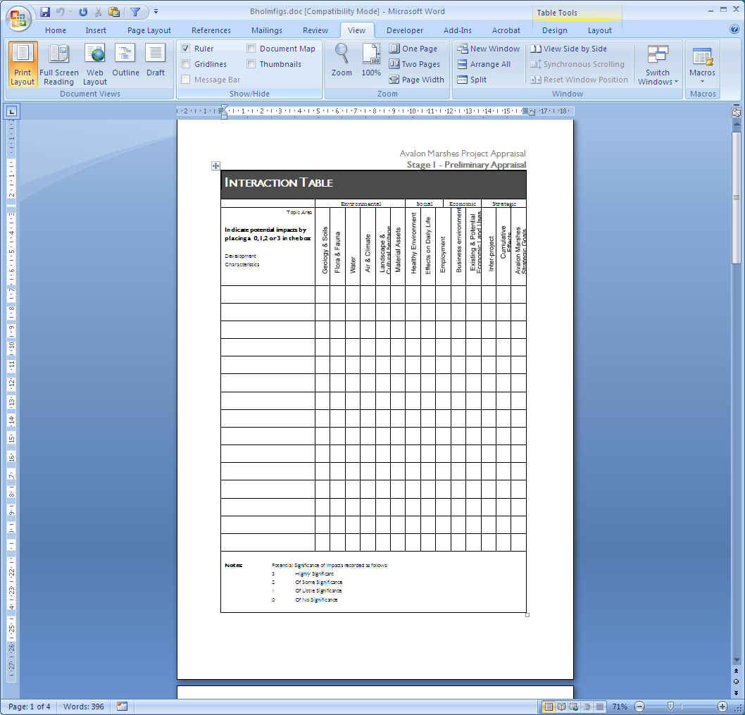

Figure 2.2 An example of an interaction table

The table illuminates relationships between components of the development, and the environmental, socio-economic or strategic topic areas. The vertical axis contains a list of the main project components. The potential impact topic areas have been set out along the horizontal axis. Topic areas have been grouped into sections covering environmental, social, economic and strategic issues.

Ease of use is aimed at by stressing in the guidance notes that the process of compiling the table should be carried out rapidly but systematically. At this level of analysis it is only possible to draw preliminary conclusions about the level of significance, these can be refined in later stages of the appraisal. The results of the Interaction Table will show at a glance what the key issues are likely to be, and will help to determine the level of appraisal which is subsequently required. An example of a completed table can be found in the Figure 2.2.

### Stage 2 - Detailed Appraisal

The three steps in this stage provide a rigorous analysis of the perceived significant impacts at an early stage so allowing for amendment to project design and proposals for mitigation. It also provides information on which external parties will base their judgements.

Having completed the Interaction Table, a detailed appraisal should follow of those areas which are considered to be the most significant. This task is undertaken using the Detailed Appraisal Checklist. Each topic areas is represented at this stage in more detail, as a series of indicators. This stage also calls for a more detailed examination of the levels of significance of impact between project component and the indicator to signify positive or negative effects and whether of major, moderate or minor significance. It is also recorded as to whether the perceived effects of the project are likely to be adverse or beneficial, short-term or long-term, of local or strategic significance, and reversible or irreversible. The detailed checklist also provides space for a description of the nature of the effect, which should quantify values wherever possible and provide qualitative data if quantification is not possible. In some cases, completion of the checklist may identify gaps in information pointing up the need for further research. A single page from the 15 page detailed checklist is reproduced in Figure 2.3.

The information gathered in the detailed checklist needs to be analysed and presented in a way which helps to clarify the relative importance of individual impacts and establishes the key beneficial and adverse effects. This is carried out by ranking the relative importance of the effects that have been identified within the environmental, social, economic and strategic categories producing a summary of key issues. The aim is to decide, for each category, which issues are likely to be of greatest significance to the Avalon Marshes. These are also likely to be the issues where review of project design should be focused.

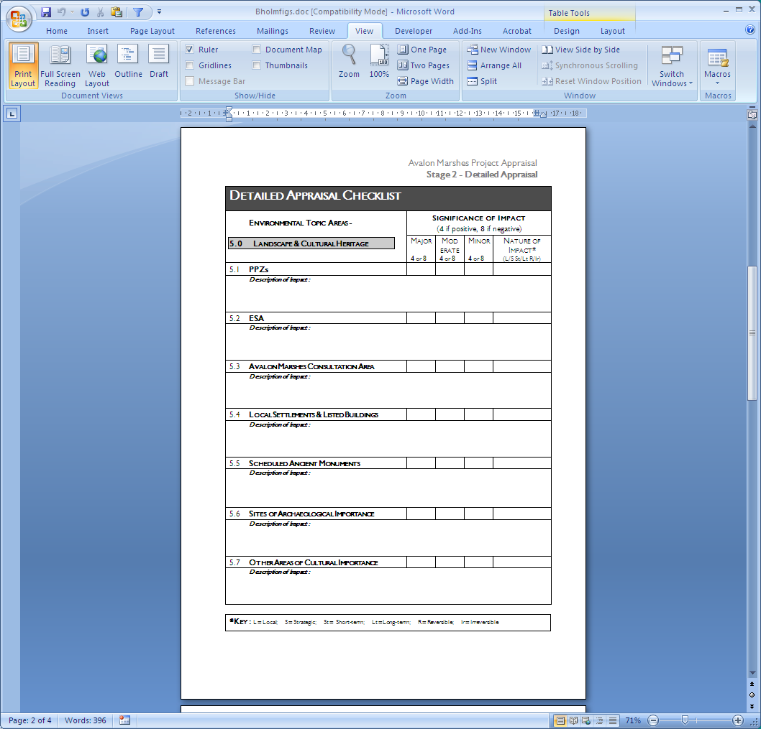

Figure 2.3 An example of a detailed appraisal checklist

Once ranking has been carried out for each category, the key issues for project review need to be distilled. This is the final stage for the promoter before handing the document over to the lead agency. Project review by the promoter provides scope for making adjustments to project design in order to minimise the significant impacts.

Even following successful completion of this type of internal review, there will often be a number of residual impacts still associated with the project. This stage allows the promoter to put forward, for the consideration of the lead agency and other parties, options and proposals for mitigation and monitoring. Following this, the documents generated so far and the whole process is handed over to the lead agency.

### Stage 3: Evaluation

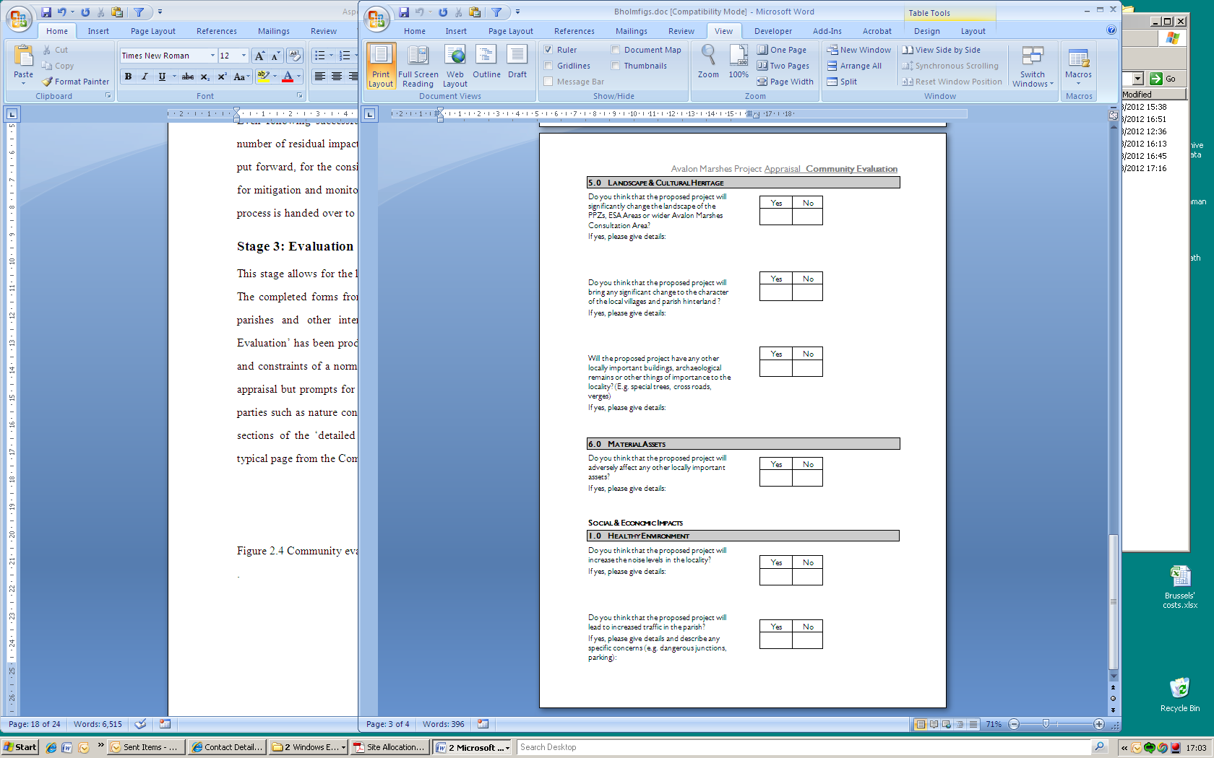

Figure 2.4 Community evaluation form

This stage allows for the lead authority to circulate information and co-ordinate the responses. The completed forms from Stages 1 & 2 are used as a basis of gathering comment from the parishes and other interested parties. A questionnaire styled form titled ‘Community Evaluation’ has been produced to assist the parishes in making responses within the timescale and constraints of a normal parish meeting. The form covers the same ground as the detailed appraisal but prompts for answers associated with locally perceived impacts. Other interested parties such as nature conservation bodies, local business interests or local authorities can use sections of the ‘detailed proposal’ stages of the process to make their own comments. A typical page from the Community Evaluation form is reproduced in the Figure 2.4.

### Stage 4: Reaching a recommendation

The two steps in this final stage allow for the decision maker to review the responses, from both the community and technical sources and reach a recommendation.

On completion of this step, all the available information on which a recommendation by the lead agency will eventually be based should have been assembled. However, this information needs to be collated, analysed and presented in a way which helps to clarify the relative importance of individual impacts and establishes the key beneficial and adverse effects. This step has been called the technical review. The relative importance of the perceived effects are again ranked within the environmental, social and economic categories. This review combines material from the promoter’s summary of key issues together with comments from the Community Evaluation form and forms received from other interested parties. The aim is to decide, for each topic, which issues are likely to be of greatest significance in reaching a decision on whether or not to take the development forward. Once ranking has been carried out for each individual subject, the key issues for making a recommendation are distilled. There is the provision for three outcomes.

i) Approval of the project in the form proposed;

ii) Rejection of the proposal outright;

iii) Conditional approval of the project subject to mitigation, modification, relocation etc.

The reasons for reaching the recommendation can also be recorded on the form, a sample form is included in Figure 2.5.

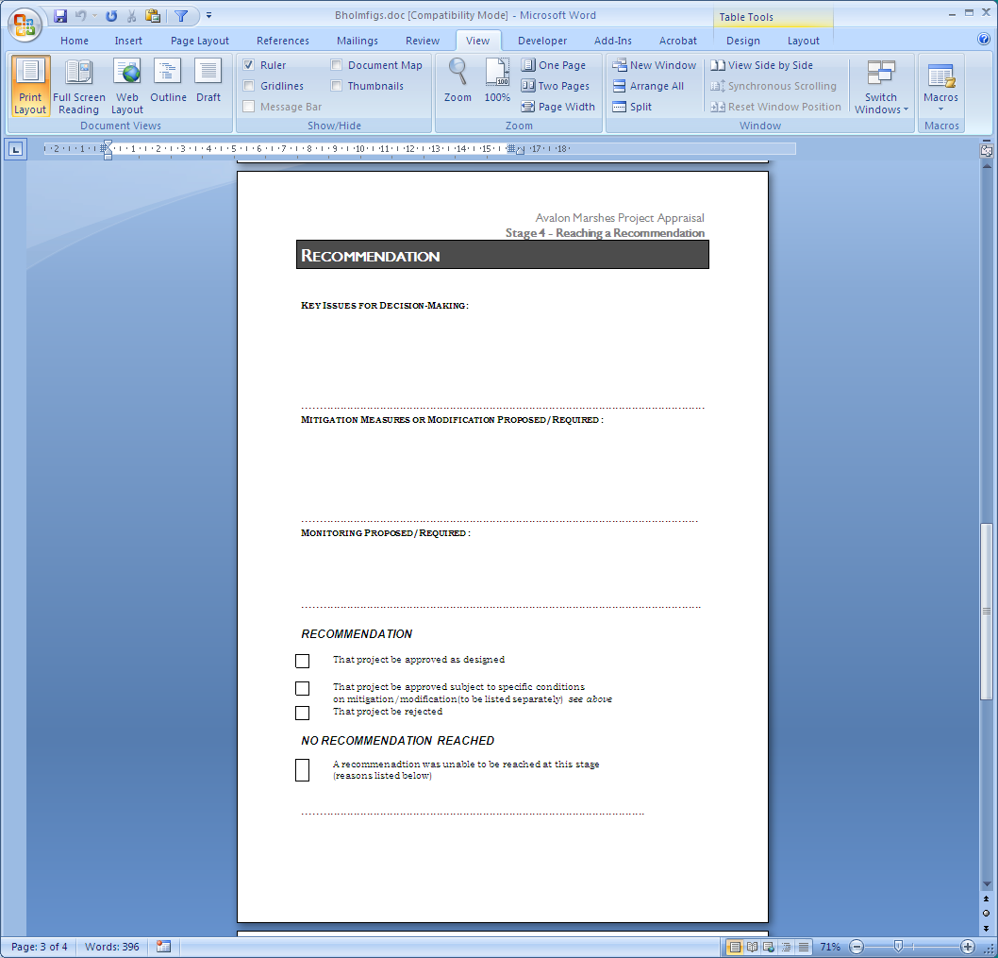

Figure 2.5 Recommendation form

# Critique and review of the framework

Peripheral areas are often rural in character and can be areas with problems of social exclusion. There are often few opportunities for development, whether sustainable or not. In these areas, opportunities that do exist often revolve around the natural environment and because of the beauty and special character of a peripheral area, they may often involve tourism. These are communities which have few other options. In this context, a method such as the PACE, which facilitates development in keeping with the natural, social and local economic assets (i.e. sustainable development) is vital.

Assessment of this approach is at an early stage and the PACE is still being piloted and refined. The Royal Society for the Protection of Birds and English Nature are reviewing its application for appraisal of their nature conservation initiatives in the area and local planning authorities are looking at its adoption as supplementary planning guidance. It has been used in the proposals for wetland enhancement in the Exminster Marshes, Devon and the regional RSPB office has an advocacy programme the objectives of which are to spread awareness and use of this method. At the current time, Autumn 1998, there is too little experience in its application for even a preliminary evaluation in use.

Success will be partly dependent on take-up of the framework by the NGOs, business groups and parishes. Individually, they will benefit by having a systematic method for the assessment of their own projects and those proposed by other parties. If endorsed by the planning authorities it also gives local organisations a powerful method for commenting on the impact of other organisations projects in a recognised format. As stated earlier, community involvement and small scale sensitive development by local businesses are often through to be the key to sustainable rural tourism, however these ingredients are not enough. Communities and businesses require a tool assisting with the language, process and the political keys to dovetail into the local and regional planning systems, PACE has been designed to provide such a tool.

The framework has been also designed to take sustainable tourism theory out into the live development arena which contains many idiosyncrasies. Although the framework is robust, in being able to accept variety in the nature and scale of projects assessed, without wide sponsorship and understanding it could be at the mercy of vested interests, hidden political agenda or planning system inertia. What is required is the investment from a lead authority, through either Somerset County Council, the Levels and Moors Partnership or the Environment Agency, in its continued maintenance, development and promotion. There are a wealth of benefits for the Avalon Marshes Advisory Group members in pursuing their shared vision of the Avalon Mashes. These include secondary benefits coming from easier communication amongst all participants through the use of a common approach for project review and assisting local communities and businesses in developing their concepts and visions of sustainability.

It is hoped that the process will also stimulate higher standards of development projects, as assessed against the Avalon Mashes Strategy objectives, through the possibility for early systematic appraisal and design alteration. This is seen as key by the nature conservation partners, since it guards against the more usual ad-hoc and post-hoc approaches to appraisal, where each project is likely to be assessed as a one-off, late in the day, and the opportunity to use a continual stream of small proposals to achieve long-term biodiversity goals is lost. There will also be benefits from an improved quality of decision-making, through better provision of information and the adoption of a documented method for project appraisal which can then be improved and refined through experience.

Hopefully the link with the local authority planning structures will also be sufficient to provide enough ‘carrot and stick’ to avoid ‘the tragedy of the commons’. Communally there is much to gain from the use of this process, but will the benefits to each individual organisation be sufficient to ensure take-up and so achieve the communal objectives?

**Acknowledgements**

Peter Nelson, a director of Land Use Consultants, led the project that developed PACE as a component within a Strategic Environmental Assessment (SEA). The author wishes to acknowledge his vital role in the development of PACE, the core structure of which was based on Land Use Consultant’s previous work. Land Use Consultants has extensive and continuing involvement both in the subject of environmental assessment and with processes in the Somerset levels. Peter Nelson is closely involved with the training of Environmental Assessors and senior professionals from governments in developing countries*.* Land Use Consultants are Members of the Institute of Environmental Assessment. For details contact Peter Nelson, at Land Use Consultants, 14, Great George Street, Bristol BS1 5RH, England. e-mail: admin@bristol.landuse.co.uk tel:(+44) 0117 929 1997

The development of PACE was funded by the Royal Society for the Protection of Birds and English Nature. For further information and recent developments contact Mark Robins, Senior Conservation Officer, at RSPB South West England Office, Keble Hse, Southernhay Gardens, Exeter, EX1 1NT; e-mail: mark.robins@rspb.org.uk tel:(+44) 01392 432691.

### References

Burr, S. W., 1995, Sustainable tourism development and use: follies, foibles, and practical approaches, In McCool, S. F., Linking tourism, the environment, and sustainability: setting the stage, in US Department of Agriculture Technical Report INT-GTR-323, pp8-13

Christensen, N. A., 1995, Sustainable community based tourism and host quality of life, In McCool, S. F., Linking tourism, the environment, and sustainability: setting the stage, in US Department of Agriculture Technical Report INT-GTR-323, pp63-68

DOE, 1989, Environmental Assessment - A guide to the procedures, HMSO

EEC, 1985, European Council Directive, 85/337/EEC

EU, 1996, Council directive 96/0304(syn)

Getz, D. & Jamal, T. B., 1994, The environment-community symbiosis: a case for collaborative planning, *Journal of Sustainable Tourism,* Vol 2, No 3, pp152-173.

Halcrow-Fox, 1992, Brue Valley Feasibility Study Phase 1, Somerset County Council

Hughes, G., 1995, Cultural construction of sustainable tourism, *Tourism Management,* Vol 16, No 1, pp49-59.

Hunter, C. J., 1995, On the need to re-conceptualise sustainable tourism development, *Journal of Sustainable Tourism,* Vol 3, No 3, pp165, 1995

IUCN, 1995, Assessing rural sustainability - 25 steps, draft booklet, Monitoring and assessing progress towards sustainability project, World Conservation Union

Knowles-Lankford, J. & Lankford, 1995, S. V., Sustainable Practices: Implications for tourism recreation development, In McCool, S. F., Linking tourism, the environment, and sustainability: setting the stage, in US Department of Agriculture Technical Report INT-GTR-323, pp18-22.

Land Use Consultants, 1994, Brue Valley Feasibility Study Phase 2, Avalon Marshes - Discussion of options & topic reports

Lane, B., 1994, What is rural tourism, *Journal of Sustainable Tourism*, Vol 2, Nos. 1&2, pp7-21.

Macgillivray, A. & Zadek, S., 1995, *Accounting for change; indicators for sustainable development,* New Economics Foundation

Sutherland, P. & Nicholson, A., 1996, Wetland - Life in the Somerset Levels

Runyan, D , 1977, Tools for community -managed impact assessment, Journal of American Institute of Planners, Vol43, pp125-134.

SCC, 1992, Peat Local Plan, Somerset, Somerset County Council

SCC, undated, Avalon Mashes, creating a living asset for Somerset, Somerset County Council

Slee, B., Farr, P. & Snowden, P., 1996a, Sustainable tourism and the local economy, Sustainable Tourism; Ethics and the Environment, conference proceedings, Newton Rigg

Slee, B., Farr, P. & Snowden, P., 1996b, Tourism strategies and rural development, *Zemedelska Ekonomika,*  Vol 42, No 1, pp19-28

Taylor , D. 1997 - Avalon’s new wetlands, Enact, Vol.5, No2, pp16-19

TCPR, 1988, Town & Country Planning (Assessment of environmental effects) Regulations 1988, HMSO

WCED, 1987, The Brundtland Report, World Commission on Environment and Development, Oxford:OUP