Residential Building Models for Seismic Risk Assessment at the Historic Downtown of Mexico City

F. Salazar, L. Gerardoª and Tiago Miguel Ferreira^{b}*
ª CONSTRUCT–LESE, Department of Civil Engineering, Faculty of Engineering, University of Porto, Portugal, gsalazar@fe.up.pt; ^{b} ISISE, Institute for Science and Innovation for Bio-Sustainability (IB-S), Department of Civil Engineering University of Minho, Portugal, tmferreira@civil.uminho.pt

Abstract

In recent decades, seismic vulnerability studies in residential Historic Districts have increasingly resorted to simplified assessment methods, which, very often, are grounded on idealized models obtained from the analysis of the most recurring material and geometrical features in a specific area. This paper aims to discuss the procedure to get residential building models appropriate for simplified seismic vulnerability studies at Historic Downtown of Mexico City (HDMC). The models are built based on a comprehensive analysis from post-seismic reports, web-based inspections (i.e. 3D buildings in Google Earth and Street View 2017 panoramic), and existing literature in broad research domains – from history to urbanism, architecture, and conservation studies. From that analysis, it was obtained a set of building models organized into nine material classes (i.e. M1-M9), and four geometric categories (i.e. A, B, C, and D), whose matrix combination enable a final classification of 36 typologies. The neighbourhood of La Merced was selected as a pilot study area to obtain a typological matrix suitable to be applied to other areas of the HDMC.
Keywords: cultural heritage; Mexico City; building typologies; historic downtown; seismic risk.

1. Introduction
In 1987, UNESCO incorporated the Historic Centre of Mexico City to the World Heritage List due to the architectural richness from different historical periods, highlighting its cultural value. The diversity of the downtown encompasses ruins of the Aztec Empire, buildings influenced by 16th-19th Spanish architectural principles, and the modern buildings linked to the late 19th and early 20th centuries. According to a federal declaration emitted in 1980, the geographical extension of the historic centre was delimited through two zones depending on its sprawl evolution: Perimeter A and Perimeter B (see Figure 1). The Perimeter A corresponds to the foundation of the city up to 1830, while the Perimeter B includes the urban portion developed between 1830 and 1900 (i.e. the so-called buffer area) (ACH 2011) and the early 20th century (ACH 2017), mainly composed of art deco and art nouveau buildings.
These boundaries delineate the historical city (i.e. Perimeter A and Perimeter B) which has been part of many transformations due to the evolution of construction techniques, post-disaster actions implemented after the earthquakes of 1985 and 2017, or socioeconomic factors. Thus, this paper aims to depict the systematic procedure to define building models (i.e. typologies) to be used in large-scale seismic vulnerability assessment studies where, due to access and data processing constraints, the analysis must be conducted on a typological basis. After developed, this original procedure was integrated into the seismic risk and vulnerability assessment carried out by Salazar and Ferreira (2020), addressed to the neighbourhood of La Merced. Figure 1 shows the proximate boroughs and the perimeters (i.e. A/B) within the Historic Zone, as well as the study area, namely La Merced.
Since the colonial period, the neighbourhood of La Merced has been one of the most meaningful areas of downtown Mexico City due to its socio-economic and cultural prominence. Despite the high rate of abandonment in the historical centre, the area maintains the liveability of locals (Monterrubio 2011), whose social dynamics derive from commercial activities. Regarding its built heritage, although most of the constructions have a commercial use nowadays, they have initially been mixed-use buildings (i.e. multi-family dwellings and commercial), which makes La Merced an example of architectural diversity and construction richness. Another important aspect for selecting La Merced as a study area lies in the fact that a considerable number of buildings in this neighbourhood, originally in masonry, has been replaced by Reinforced Concrete (RC) structures or refurbished resorting to RC structural elements. According to several authors, see for example Basaglia et al. (2018) and Correia Lopes et al. (2019), these interventions can significantly increase the seismic vulnerability of these buildings due to interaction phenomena between the pre-existing and the new structure, which make the analysis of La Merced neighbourhood even more relevant.
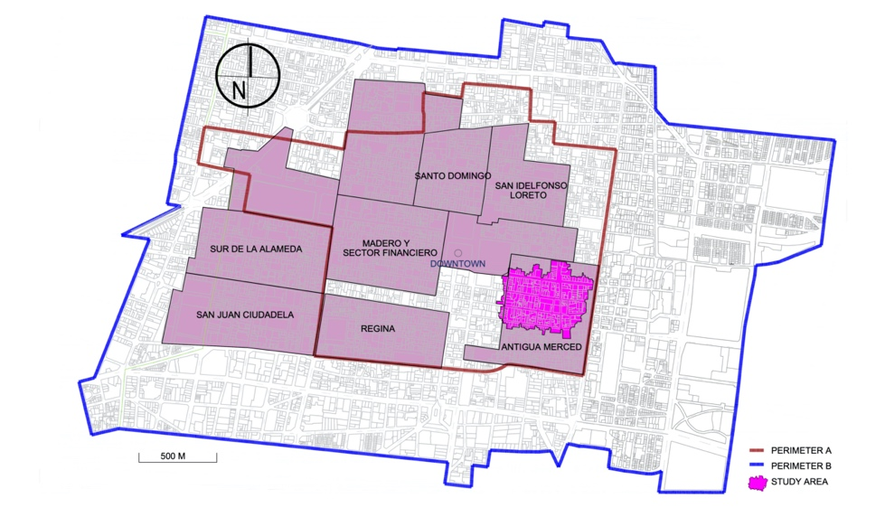
Figure 1. Downtown Mexico City with some current neighbourhoods, delimitation and case study. Source: ACH edited by the authors.

In Latin, the term ‘taxonomy’ refers to the organization of rules where ταξις refers to the organization, and νομια means rules. Commonly, the taxonomy of buildings refers to methods that subcategorize primary classes by establishing specific characteristics. In the case of HAZUS program by FEMA (1999) and NIBS, the assessment entailed the classification of eight post-disaster types and 36 subtypes, of which nine types depended on the construction height for five localized damages (as quoted in Bianchini 2015). Similarly, is the taxonomy SYNER-G (2011) which was the basis to classify the buildings of L’Aquila region in Italy, whose criteria enabled a hierarchical definition of 15 masonry categories aimed to identify and describe a group of systems, subsystems and components (as quoted in Bianchini 2015). In this paper, therefore, the aim is to create a taxonomy of 36 classes that accounting for specific characteristics (i.e. materials and geometries) as simplified typological models (i.e. the taxonomy) for the particular case in Mexico City that could be included in different seismic risk models. According to the National Housing Institute (Instituto Nacional de la Vivienda - INVI) in Mexico (INVI 2015), the houses in the city centre are more vulnerable to natural disasters due to the lack of maintenance or deficient self-construction processes. Therefore, 166 historic residential buildings, listed by the cultural authorities, were classified corresponding to the neighbourhood of La Merced.

2. Materials and Methods

2.1 Methodology
The main purpose is to identify geometric patterns and to establish a relationship with the materials applied to the neighbourhood of La Merced, which has a great diversity of construction technologies and formal shapes. Therefore, the work integrated the following steps:
- Delimitation of the study area within the neighbourhood;
- Data collection of all the available sources regarding the entire Historical Downtown of Mexico City (HDMC) (See Section 2.2);
- Systematic data extraction of relevant information that accounted for the characterization of the historical buildings such as dimensions, materials and socio-demographic aspects (i.e. the number of dwellings per edification and number of commercial properties);
- Determination of the Geometric Model Classification;
- Determination of the Material Model Classification;
- Composition of the Matrix Building Model between geometrical and material characterization;
- Indication of the final typologies within the selected area.

2.2 The Database and information acquired
This work was possible with the investigation of multiple documents and on-site visits. The models presented in this paper were developed based on a comprehensive analysis of a large amount of data collected from both national institution and several historical and socio-urban sources. This task of collecting data, analysing and creating the models took little less than three months to complete, which seems to be a very good cost-benefit given the size of the study area and the number of buildings involved. The available data comprises not only the buildings in La Merced but the whole historic centre because the information acquired from other zones (i.e. materials and geometry of buildings) could illustrate the characteristics of buildings at the selected study area (La Merced). Therefore, the acquisition of data followed the next three strategies:
- Data collection of the zone (i.e. all HDMC) related to past natural disasters, changes in construction policies, historic photos, and post-seismic reports (i.e. the earthquake occurred in September 2017), as well as data linked to the origin of the building (i.e. the year of construction, materials used, etc.) and the available reports of constructive alterations through the time;
- Analyzing the available information (i.e. web-based visual inspection) of Google Earth 2017 and Street View that comprises the geographical boundaries from 19° 26’40’’N 99° 08’28” W to 19° 25’30’’N 99° 07’33” W (from upper left to bottom right) in Mexico City;
- A Rapid Visual Screening of Buildings made by specialists (i.e. professionals in cultural heritage, architects and civil engineers) to 125 constructions of the neighbourhood La Merced.
Concerning data acquisition (strategy 1), the information was obtained through:
  - Historic photos obtained from the National Coordination of Historical Monuments (CNMH), the Secretariat of Historical Studies (DEH) and the National Institute of Anthropology and History (INAH), through the project Memoria de una ciudad of the Central Zone of Mexico City (ZCCM) (Rojas Loa 2012);
  - Reports of rapid visual screening of post-earthquake damage evaluation web-based available by the Secretariat of Urban Development and Housing (SEDUVI), the Secretariat of Construction (SOBSE) and Civil Protection (SPC) whose assessments include constructions of similar age;
  - Data obtained from official surveys provided by the Authority of the Historical Centre (ACH) related to buildings age, constructive systems (i.e. lintels, walls, floors, and roofs), as well as subsequent interventions and overall conditions (i.e. optimal or deficient conservation state);
  - References related to the historical construction technology, urbanism and social practices – from Rene Coulomb (2009, 2017), Jose Antonio Terán Bonilla (2003), Enrique Ayala Alonso (1996, 2001, 2009), Alicia Ziccardi (2017), Victor Delgadillo (2011), Pilar Gonzalbo Aizpuru (2014), Luis González Obregón (1923), Rubén Cantú (2003), Anavel Monterrubio (2011), Carlos Lira (1993), Leopoldo Rodríguez (2011, 2011), and María del Carmen Olvera (2011).
The criteria implemented to the Google Earth and Street View analysis (strategy 2) follows a similar approach performed by Qi W. et al. (2017) called “Internet+”. The bird-eye view, software tools (i.e. Google Earth / Ruler), volumetric information, and 360° street-level shots, acquired in 2016 and 2017, enable simplified geometric characterization considering heights, the number of floors, façade information, number and measurements of doors and windows, footprint areas, and building envelope (i.e. planar and volumetric differences). In the case of on-site surveys (strategy 3), a visual inspection confirmed the preestablished materials. The access was allowed to 125 constructions, thus validating pre-defined constituents of some buildings based on the “Internet +” approach (strategy 2).
Based on these strategies, the identification of 166 eligible historical constructions with a residential house and, or exclusive, commercial land use made possible the seismic risk and vulnerability assessment performed by Salazar and Ferreira (2020). Despite some buildings present similar architectural formal patterns linked to those constructed between 17th and 20th century, these few structures correspond to techniques not appropriate for the analysis when combining reinforced brick masonry wall and RC slabs. Therefore, the first series of structures (i.e. 180), was reduced to 166 buildings in the study area.

3. Study area
The delineation of the study area within La Merced was defined through the position of some relevant monuments located at polar boundaries (i.e. north-south, east-west), and it is characterized by the former water system of ditches documented historical studies of the 18th century (Jiménez Vaca 2014). Figure 2 shows the former urban space which displays the monuments that account for the delimitation of the case study, thus leading the concentration of ancient houses over the urban landscape with the channel aquifer network (Jiménez Vaca 2014).
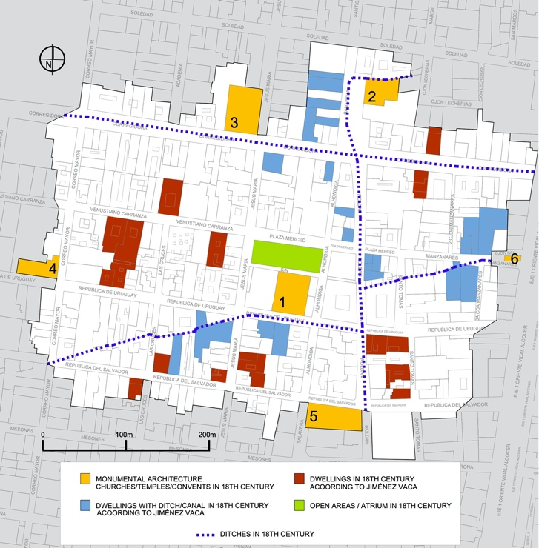
1. EX-CONVENT OF MERCED; 2. ANCIENT ALHÓNDIGA; 3. EX-CONVENT OF JESUS MARÍA; 4. SAN CHARBEL SHRINE; 5. TALAVERA HOUSE; 6. HUMILDAD CHAPEL
(a)
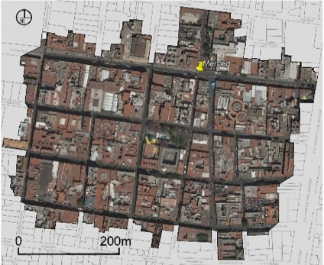 | 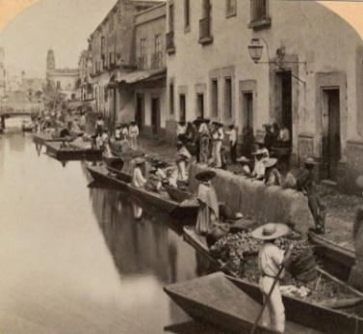
(b) | (c)
Figure 2. (a) Delineation of the study area. Source: Jiménez Vaca (2014) and digitalized by the authors; (b) Study Area of La Merced Neighbourhood in AutoCAD/Google Earth. Source: FCH edited by the authors; (c) Former Ditch of La Viga that today passes through an underground pipe at Alhóndiga Street. Source: Kilburn Brothers.
The area includes 180 buildings integrated into the national monuments catalogue (see Figure 3). However, the edifications with no residential link were discarded from the final classification such as monumental architecture (i.e. churches, temples, convents, among others) or buildings dedicated to industrial activities (i.e. manufacturing and distribution of products). The final selection involves 166 buildings which are listed by two cultural authorities: National Institute of Anthropology and History (INAH) and the National Institute of Beauty Arts (INBA). One-hundred fifty-two constructions belong to INAH buildings list (i.e. built before the 20th century, i.e. historical value) and eleven buildings correspond to the INBA catalogue (i.e. at the beginning of 20th century, i.e. artistic value). In some cases, the historical period is not well-defined due to the urban transformations by listing nineteen buildings in both (i.e. before and after the 20th century).
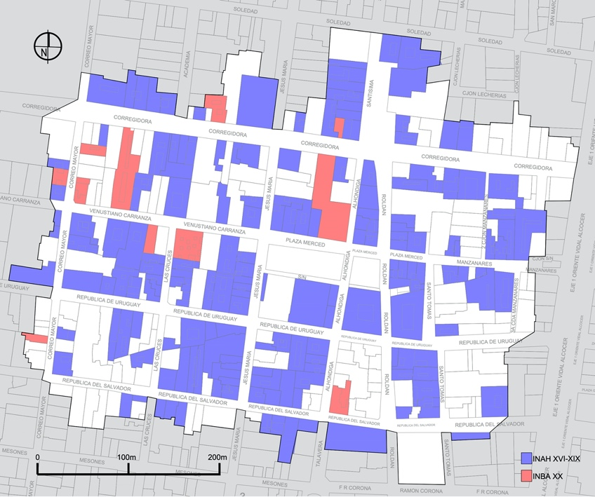
Figure 3. Study area boundaries of La Merced (180 national monuments) indicating the heritage local classification (i.e. INAH or INBA). Source: INAH, ACH edited by the authors.

3.1. Transformation, programs and local policies in residential buildings at downtown
Although the construction period may be associated with specific geometric/structural features as well as material properties, it is also necessary to consider subsequent transformations, linked to socioeconomic changes of the urban district (such as migration, commercial activities, tourism, unspecialized works) or the occurrence of disaster (i.e. earthquakes). In fact, these social transformations may have altered (increased or lowered) the buildings’ seismic response. An example of these transformations is the boroughs of Cuauhtémoc and Miguel Hidalgo, where approximately 211,245 residential buildings have been converted for commercial use (Ziccardi 2017). From 1970 to 2000 more than 25,000 dwellings in the historic downtown were reconstructed or rehabilitated, whose figures represented almost 42% of residential buildings. These actions aimed to increase, substitute or reinforce structural elements for producing better conditions of habitability (CENVI 2005). Nonetheless, this led to secondary effects by reducing the housing areas over the city to 14,920 units (ACH 2011, Coulomb 2017).
After the September 1985 earthquake and the integration of the HDMC into the World Heritage List in 1987, governmental institutions and associations fostered habitational high-impact policies and programmes (i.e. Renovación de Habitación Popular - RHP). The seismic event led to major changes in the urban landscape as a result of the collapse of multiple buildings and the subsequent expropriation of 3,107 buildings through the RHP programme (Esquivel Hernández 2016). Highly damaged heritage structures were identified in the north (e.g. Santo Domingo and San Idelfonso Loreto) and west areas (e.g. Regina and Madero) of the historic downtown (see Figure 1). The low-quality of the connections between the façade and the orthogonal walls is in the origin of most of these damages. There were reported several cases of the partial and global collapse of the buildings, particularly of those with mixed structural systems (i.e., masonry walls and RC slabs), making it clear the poor seismic behaviour of these buildings – and later confirmed during the 2017 earthquake. There were also observed moderate damages, namely diagonal shear and flexural cracking caused by the horizontal expansion of the walls and the uneven settlement of foundations, respectively. About 4,300 buildings (i.e. more than 50,000 dwellings) have been covered by recovering programmes put in place by the government, allowing to recover 300,000 houses in approximately one and a half year (Moreno García 2006). However, this praiseworthy programme came with a price: the low quality of the solutions and materials used in these reconstructions (ACH 2011). From 1985 to 1987, 13,562 families were relocated to 796 buildings from the neighbourhoods of Guerrero, Tepito, La Merced, and Morelos, which still did not prevent the occupancy rate of the area to drop from 80% to 30% (Monterrubio 2011).
From 1990 to 1995, the city centre lost 10,536 inhabitants and 2,320 dwellings units as a result of the already mentioned change of the buildings’ use, from residential to commercial (Cantú 2003). During this period, the RHP programme allowed for the reconstruction or rehabilitation of 3,616 mixed-use buildings, placing on the rental market, only 1998 and 2001, more than 350 new units (Coulomb 2017). These efforts were, however, and once again, insufficient to arrest the population decline in the downtown area (Coulomb 2017).
Despite this, few inhabitants have continued to reside and develop the usual commercial activities (CENVI 2005). Based on the relation of Esquivel Hernández (Esquivel Hernández 2016), the population ratio per dwelling is 3.4 inhabitants, and based on the examination of number dwellings and stores (Rojas Loa 2012), the local inhabitants and users in working hours in La Merced is about 2291. In some cases, property registry of the city centre indicated the occupation of two houses which belong to the same structure, such as the building located at the 16th of Manzanares Street. Figure 4 depicts the current urban distribution of residential and commercial zoning at La Merced, where 105 units are houses with other land use, namely dedicated to other public services, whereas 61 constructions correspond to service commercial areas.

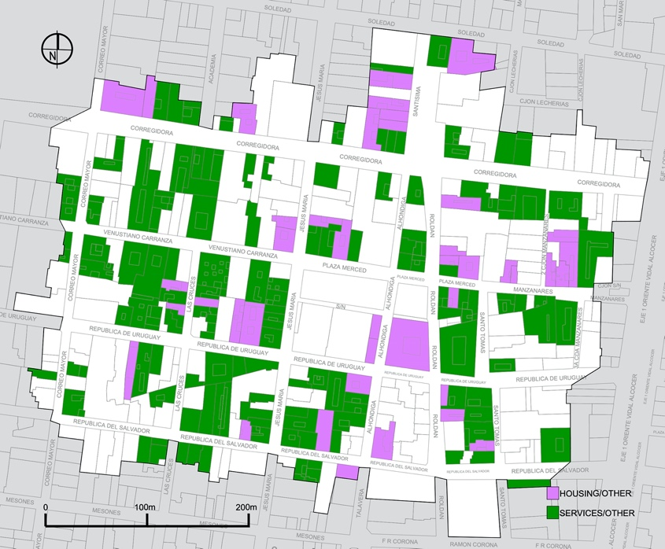
Figure 4. Study area boundaries of La Merced, where 166 buildings are zoned by housing or services/commercial land use. Source: INAH, ACH edited by the authors.

Furthermore, between 1997 and 2011, the ACH carried out the Integral Program for Regeneration of Historic Downtown by stating actions for recovering the residential use in historical constructions. Therefore, the program boosted the rehabilitation of highly damaged structures of the popular sector, as well as the expropriation of derelict or abandoned buildings rehabilitating 132 dwellings (i.e. 12 buildings) (Monterrubio 2011, Coulomb 2009). Due to the lack of restoration principles and reduced consideration of structural limitations, these interventions combined the use of non-historic materials. This situation happens not only in non-monumental buildings (i.e. houses) but also in other significant monuments (i.e. churches, museums, etc.) that were also restored with new materials such as RC. However, low-cost materials and unplanned criteria led to the integration of these materials that commonly produced incompatible and dangerous interventions. This review of programs provided valuable information to define the final determination of material building models.

4. Geometrical Building Models
Based on the systematic analysis of the area, structures from the 16th to the 20th century led to the identification of a possible relation between the building envelope shape and the evolution of construction techniques (i.e. construction period). In the 16th century, the urban landscape was dominated by fortified houses with massive stone walls. During the 17th century, with the horizontality of the city, the buildings gained a more horizontal dimension, with thinner walls, larger openings, and one to two storeys. In contrast, the 18th century was marked by the vertically of the religious buildings that, at that time, spread throughout the city. Although the urban configuration did not represent an apparent social hierarchy, the building envelope plays a significant role in the organization of the city (Ayala Alonso 2001).
Unlike buildings dating from the 16th to the 17th centuries, the central patio did not characterize the habitational spaces from the 19th century. The central area was more common in constructions from the 17th century. Nevertheless, those constructions were modified during the 18th century (e.g. increase a level or patio) which aimed to integrated services into secondary areas (i.e. storage, servants’ rooms) because the main rooms and principal exterior zones corresponded to the reception, living or workshop rooms (Ayala Alonso 2001, Verdugo Reyes 2006). By the end of the 19th century, construction technology evolved to support the integration of iron and tile vaults. These elements led to the construction of higher buildings, maintaining these architectural principles until the beginning of the 20th century. In this way, the trends in architectural design throughout history can denote the volumetric parameters over the HDMC.
Therefore, to establish parametric building models, the analyzed data enabled the creation of four types (i.e. A, B, C and D) associated with the height, the building footprint, area of the property and effective area of the façade wall (i.e. the ratio of the total area on the façade minus the corresponding area of openings). To do so, a series of conditional equations have programmed in Microsoft Excel and used to classify the building into a specific type (e.g. if RESIDENTIAL BUILDING X <12 m, hence: Type B) and to calculate the mean values of the previous parameters associated with the similar volumetric proportions (see Figure 5). In this way, the ratios of all buildings represent an approximation of the geometrical properties following the selected geometric type. The characteristics of each type are explained as follows:
Type A: Regular building with heights usually more than 12 m originated from different associated subsystems which denote volumetric differences in elevation with respect to the main façade. The effective area of the façade wall is around 80.36%, and the constructed area is around 1566.45 m² with a proportional shape of 1: 1: ½ – ¾.
Type B: Regular and flattened building with heights less than 12 m originated from different associated subsystems which denote volumetric differences in elevation with respect to the main façade. The effective area of the façade wall is around 78.06%, and the constructed area is around 615.87 m² with a proportional shape of 1: 1-4: ½ – 2.
Type C: Elongated buildings with heights usually over the 12 m which highlights the verticality over the horizontal plane originated from different associated subsystems which denote volumetric differences in elevation with respect to the main façade. The effective area of the façade wall is around 78.74%, and the constructed area is around 1083.90 m² with a proportional shape of 1: 2-5: 2-5.
Type D: Irregular and flattened structures with heights that overpasses the 8 meters from central exterior areas (sometimes covered by a metallic truss) originated from different associated subsystems with the non-constructed area and volumetric differences in elevation. The effective and ratio area on the façade is approximately 81.36%, and the constructed area is approximately 1177.85 m² with a proportional shape of 1: 1-2: ¼.
According to the aforementioned historical analysis, the types B or D could be associated with the buildings constructed between the 16th and 18th centuries, although some buildings were also constructed with a lower height in the 19th century. The type C may correspond with buildings erected in the late 19th century or early 20th century. The correspondence of type A can lead to any historical period, although this type could be found in building originated between the 17th and the19th century. Figure 5 indicates all the building envelopes found within the historic downtown thus associating to the final geometry classification (i.e. A-D). The effective area of the façade wall and footprint area in Figure 5 are the average values of the analyzed cases in La Merced which are factors commonly considered for simplified assessments of seismic vulnerability in cultural heritage (Mosoarca et al. 2020, Ferreira et al. 2017), measured in percentage and squared meters, respectively. In the case of the effective area of the walls, the volumes in all types illustrate only the proportion (i.e. empty-solid relation) between the openings and the walls.

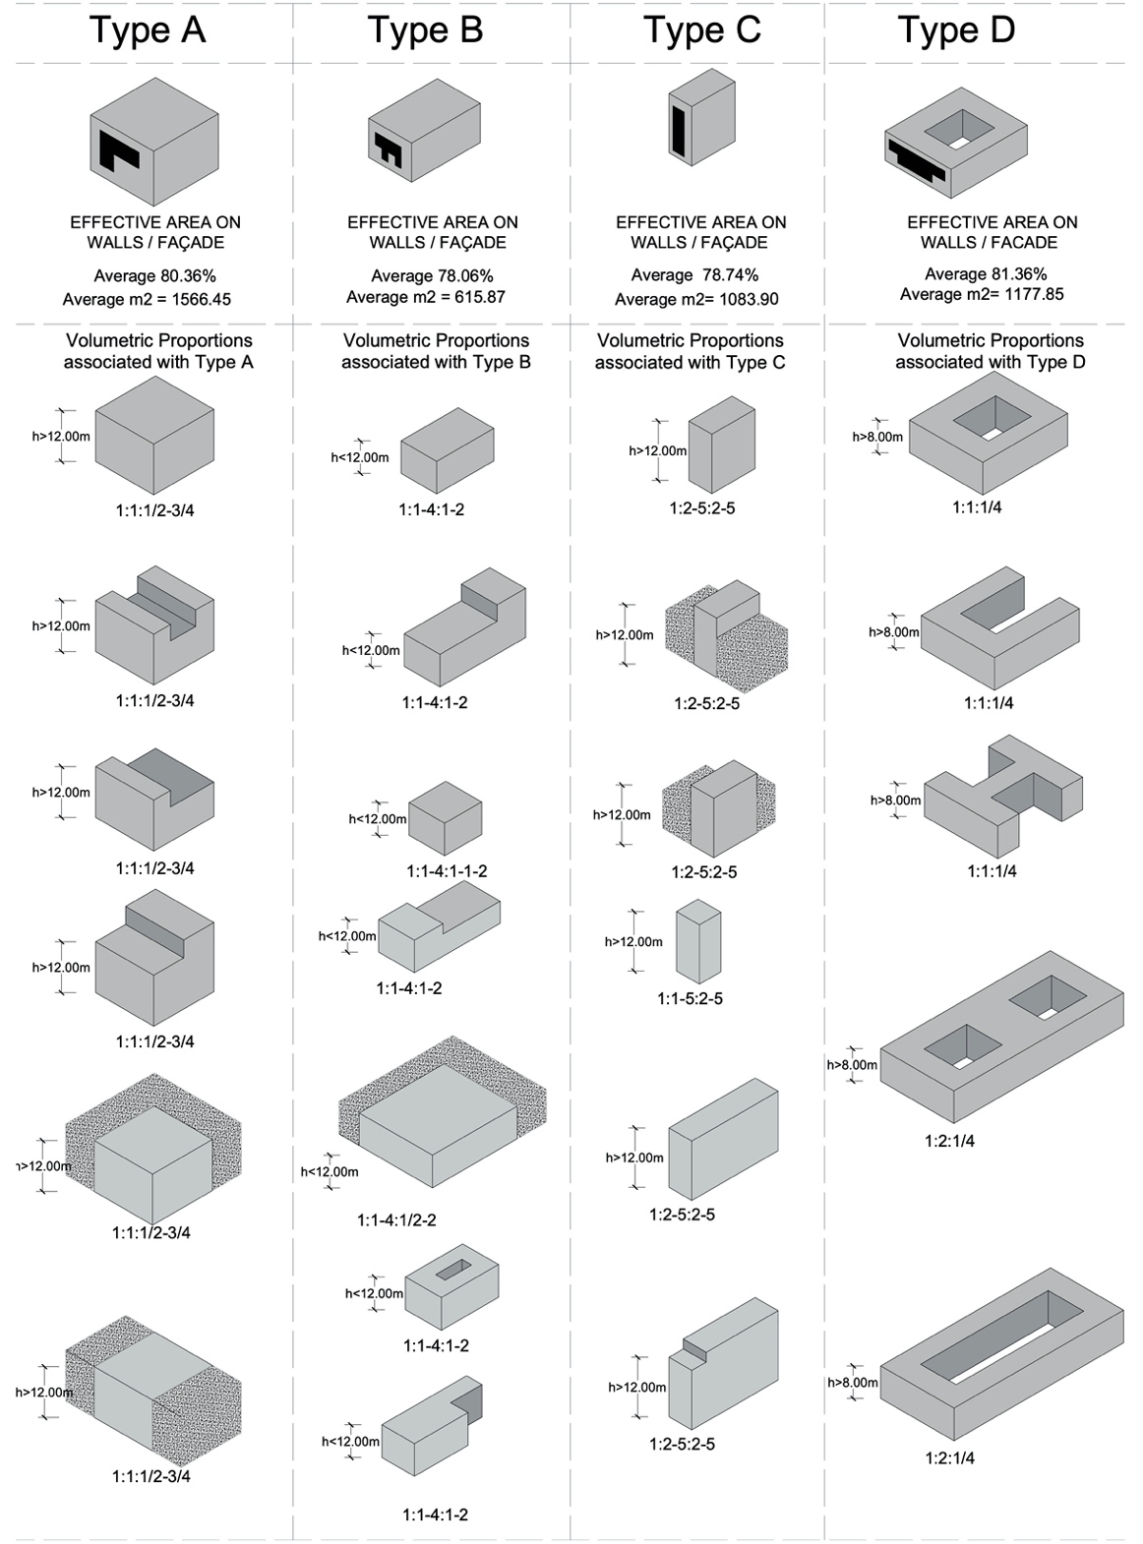
Figure 5. Geometrical Building Models. Source: Salazar and Ferreira (2020) edited by the authors.

Figure 6 depicts the distribution of the 3D geometrical building model mapping related to the selected cases within the study area of La Merced that accounts for the results further depicted in Table 1, with 14 buildings of type A, 68 of type B, 43 of type C, and 41 of type D.

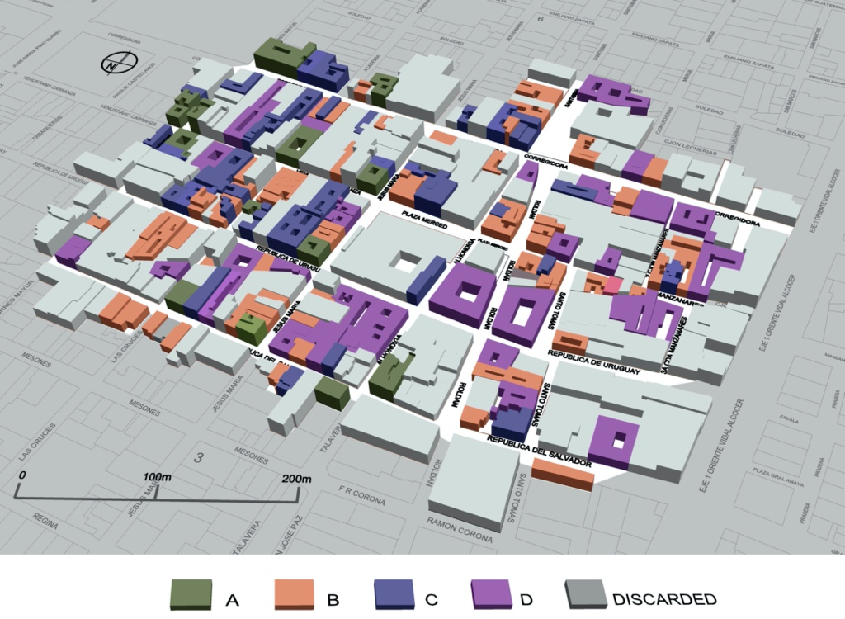

Figure 6. Geometrical Typology.

5. Material Building Models
Since the determination of the models was mainly developed through ‘internet+’ approach, the implementation of complementary actions was necessary to establish nine categories of materials. Therefore, the final classification data was obtained through the systematic review of the literature concerning the conservation of historical and artistic monuments in Mexico City, preliminary post-seismic reports (September – December 2017) (Berrón Ruiz et al. 2018), web-based observations, few data provided by FCH, and on-site visits in buildings with public access (i.e. commercial). In this way, the acquired information surveyed enabled the different levels of the structural definition, by considering vertical and horizontal systems, finishes, and, when possible, the current condition of foundations.
Either the web-based inspection (Google Earth Pro 2017, Google n.d.), historical photos, on-site visits or post-seismic reports accounted for the current materials in the study area, thus validating the criteria-based literature research. Many researchers dedicated to the study of the history of architectural conservation in Mexico, allowing for the characterization of buildings at a specific historical period. For instance, between the 17th and 18th centuries, the Baroque Architecture considered the integration of thicker load-bearing in comparison with the partition walls. According to Ayala Alonso (2009), the load-bearing stone masonry walls were commonly placed on the longitudinal plane whereas the partition walls, regularly constituted by clay brick masonry, adobe or rammed earth, were situated on the transversal plane. This architectural configuration might lead to the reduction of incidental lateral thrusts produced by seismic accelerations.
The vertical building structural system constructed between the 16th and 18th centuries mainly corresponds to walls constituted by irregular masonry stones, usually composed by volcanic rocks called tezontle (dark-red or blackish volcanic stone) with one vara (i.e. about 84 cm) of thickness (Rodríguez Morales 2011). However, these systems often are composed mixed with other structural systems such as adobe (i.e. compressed earth blocks) or clay brick, technique well-known as ‘mestiza’. In terms of the behaviour of concentrated vertical systems, the mechanism of columns or pillars works in combination with stone arches or with large timber beams called gualdras (Ayala Alonso 2001) (see Figure 7a). Furthermore, the façades of the historic centre commonly present jambs and lintels of well-cut chiluca stone or clay bricks. The flooring systems were originally constituted by timber structures (i.e. beams and planks) with the integration of layers of either flattened earth, lime or the combination of both (Ayala Alonso 2001). However, the horizontal structural systems also integrate one or two layers of clay bricks, especially during the colonial period.

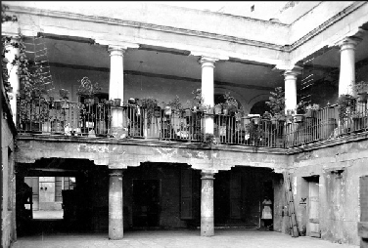 | 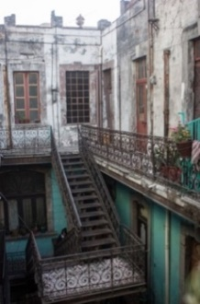 | 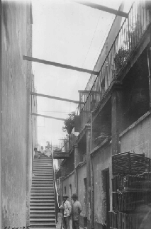
(a) | (b) | (c)
 | 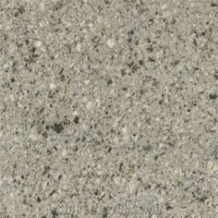
(d) | (e) | (f)
Figure 7. Historic photos of dwellings within the study area: (a) 136 Venustiano Carranza Street Source: INAH; (b) 6 Manzanares Street Source: Unknown – Pinterest; and (c) 26 Manzanares Street Source: INAH. Texture of (d) Tezontle stone (laminates and core); (e) Chiluca Stone; (f) Recinto Stone

The usual finishing during the 18th century was based on panels of cutting porous tezontle (Figure 7d) or chiluca stones (Figure 7e), as well as the implementation of lime-mortar layers. In the case of lintels, jambs or cornices, the predominant material is the chiluca stone. During the 17th century, the finishing led to ornamental patterns composed by lime-mortar called ajaraca, and the recinto stone (Figure 7f) which visualized on the bottom of multiple constructions, as part of the structural load-bearing walls attached to the foundations mostly made by high-strength tezontle stones (Ayala Alonso 2001). In the second half of the 19th century, the neoclassic architecture influenced the construction design which established construction techniques based on mixed materials by using compressed earth, handmade/industrial clay bricks, iron and timber beams (see Figure 7b and Figure 7c) (Rodríguez Morales 2011). In this century, however, the use of tezontle was uncommon due to the shortage and the cost increase (Rodríguez Morales 2011), thus enabling the integration of other construction materials such as the recinto or the chiluca stones. Moreover, at the beginning of the 20th century, Mexico City experienced a lack of timber due to the uncontrolled overexploitation of forest areas near the city (Olvera Calvo 2011). These facts represented a change in the construction lead to the integration of industrial steel or iron, towards the incorporation of art nouveau and art deco into the architecture of the urban landscape.
As discussed in Section 3.1, by the end of the 20th century, local programs and policies enabled the rehabilitation of numerous buildings in the city centre. The creation of new building technology applied to historical constructions may produce adverse impacts whether the rehabilitation neglects the diverse components of the structure. The non-specialized care when using RC in floor slabs (i.e. instead timber floors), and cement in mortars (i.e. instead lime) during the 20th and 21st century could cause future damage on masonry the structures. For instance, in seismic events, partial collapses might occur if the seismic capacity of the vertical members is lower than the seismic demand (i.e. RC slabs with poor connections ‘attached’ to low-resistant masonry walls). Nowadays, RC is part of the materials in many buildings of the HDMC, and the safeness and resistance under lateral forces are still uncertain. These elements are significant to the classification of materials to simplified seismic vulnerability assessments.
Based on the mentioned criteria, the building models linked to the consideration of materials might correspond to the historical development of the city through economic, social and political aspects. The final material typologies considered for this analysis are described as follows:
Material Typology 1 (M1): The load-bearing walls present irregular stones and, in some cases, the clay brick functions as a partition wall. RC elements were identified, such as columns or beams on the façade, especially when the spatial distribution on the ground floor was modified to adapt or increase the commercial activity. The flooring systems present main beams of iron and/or timber, clay bricks and they can also present timber desk with/or a lime-mortar and/or compressed earth layer. It would appear the presence of isolated vertical stone supports either columns or pillars with timber beams (gualdras) and/or stone arches to create the effective spans. The finishing could be lime or cement mortar and the lintels could be of clay bricks or, barely, steel elements on either façade or indoor walls. In all the cases, the original foundations were made of stone. However, in some cases, they have already been intervened with concrete material aiming at increasing the number of dwellings or give some reinforcement to the constructions. This kind of building could be addressed into the construction origin from 16th to the first half of the 19th century with interventions during the second half of the 20th or 21st centuries.
Material Typology 2 (M2): This class presents the same irregular stone load-bearing wall system such as the M1 but, in this case, the addition of recinto stone on the façade wall could appear as a possibility. The partitions walls can be of cement bricks. Sometimes, it will be possible to appreciate RC such as M1 on the façade. The floors could be composed of RC elements. That means the total indoor alterations of the structural system, only conserves the façade as a solely historical and cultural heritage element. The finishing of the walls could be lime or cement mortar and/or ceramic tiles. Lintels include clay bricks or well-cut stone (chiluca). The foundations could be as M1. This material class could date from the 16th to the mid-19th century with additional interventions between the late 20th and early 21st centuries.
Material Typology 3 (M3): Load-bearing walls are similar to M1 (irregular stone and clay brick) although in this case, the intervention added partition walls of cement brick, with the same partial presence of RC. The floors present the same system as M1 but, in M3, they could have a layer of RC between the layers of clay bricks or timber decks. The presence of punctual vertical elements is the same as M1. The finishing of the walls could be of lime mortar and/or volcanic stone tiles (tezontle). Lintels include well-cut stones of large dimensions as monolithic on the façade. Stone material could have in the foundations. This material class could date from the 16th to the mid-19th century with additional interventions between the late 20th and early 21st centuries.
Material Typology 4 (M4): This class constitutes walls made of clay bricks, adobe, well-cut stone (chiluca) and/or recinto stone with the intervention of RC in some spaces. The floor systems have main beams of iron or steel material, timber beams, and the presence of tile vaults with lime mortar or cement and ceramic layers, cement or clay tiles. The increase in floors included the use of RC. The finishing of the walls and the foundations present the same characteristics described for M3. The lintels integrate well-cut stone and clay bricks. These buildings can be part of the 19th century with interventions during the late 20th or early 21st century.
Material Typology 5 (M5): This class discards the presence of RC with a flooring system of tile vault supported by timber and iron or steel beams with a layer of lime and/or sand and/or soil mortar and a finishing of clay or cement tiles. The walls can be made of clay bricks and/or volcanic stone both/either tezontle and/or recinto type with a coating of lime mortar. The lintels could integrate clay bricks well-cut stone or clay bricks. The construction date from the 19th century, without any ‘incompatible’ modification carrying this system as an original building of that time.
Material Typology 6 (M6): This system presents a construction system similar to that of M5 typology. The main difference lies in the walls, which, in this case, are constructed with clay bricks and/or adobe. It presents isolated vertical elements in the same way as M1, but without RC interventions.
Material Typology 7 (M7): In this typology, the walls are made of volcanic stone both tezontle and recinto with the finishing of well-cut volcanic stone tiles or lime mortar. The floors could integrate clay bricks and timber beams with possible layers of lime/sand/soil mortar. The presence of punctual vertical stone elements can be part of the system either of columns or pillars with timber beams (gualdras) or stone arches. There is no intervention with RC and the possible period of construction could go between the 16th and 18th centuries.
Material Typology 8 (M8): This type belongs by the end of the 19th century or at the beginning of the 20th century with floor systems of steel or iron beams, tile vaults, zinc laminates and lime or cement mortar with the collocation of cement or clay tiles. On the walls, the presence of well-cut stone and clay brick is characteristic, with lime or cement mortar or ceramic tiles. The lintels could integrate clay bricks. Besides volcanic rocks on the foundations, there are interventions with RC elements, which denotes intervention works carried out during the late 20th or early 21st century.
Material Typology 9 (M9): The last typology corresponds to the same case as M8, but without RC interventions denoting a possible period of construction from the end of 19th to the beginning of 20th century. From the models of the buildings led to the material characterization, Figure 8 illustrates the details of each construction system.

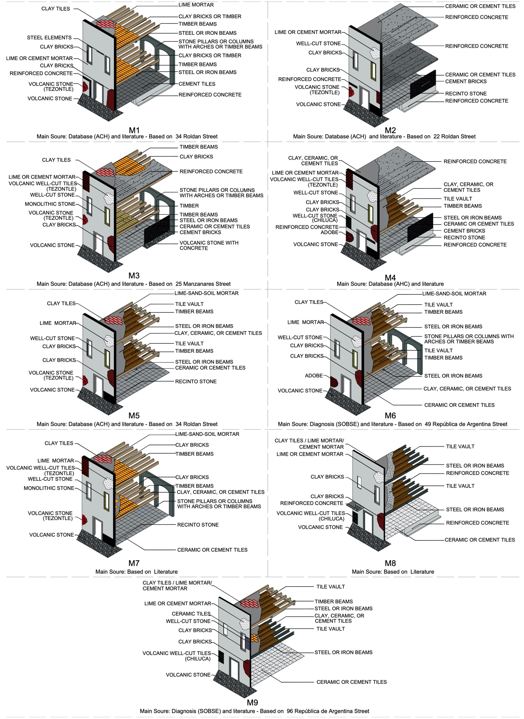
Figure 8. Illustration of the nine material typologies identified. Source: Salazar and Ferreira (2020) edited by the authors.

Figure 9 illustrates the distribution of the 3D material building model mapping related to the selected cases within the study area of La Merced. There are represented 19 buildings of M1, 28 of M2, 30 of M3, 23 of M4, 26 of M5, 8 of M6, 15 of M7, 8 of M8 and 9 of M9, further depicted in Table 1.
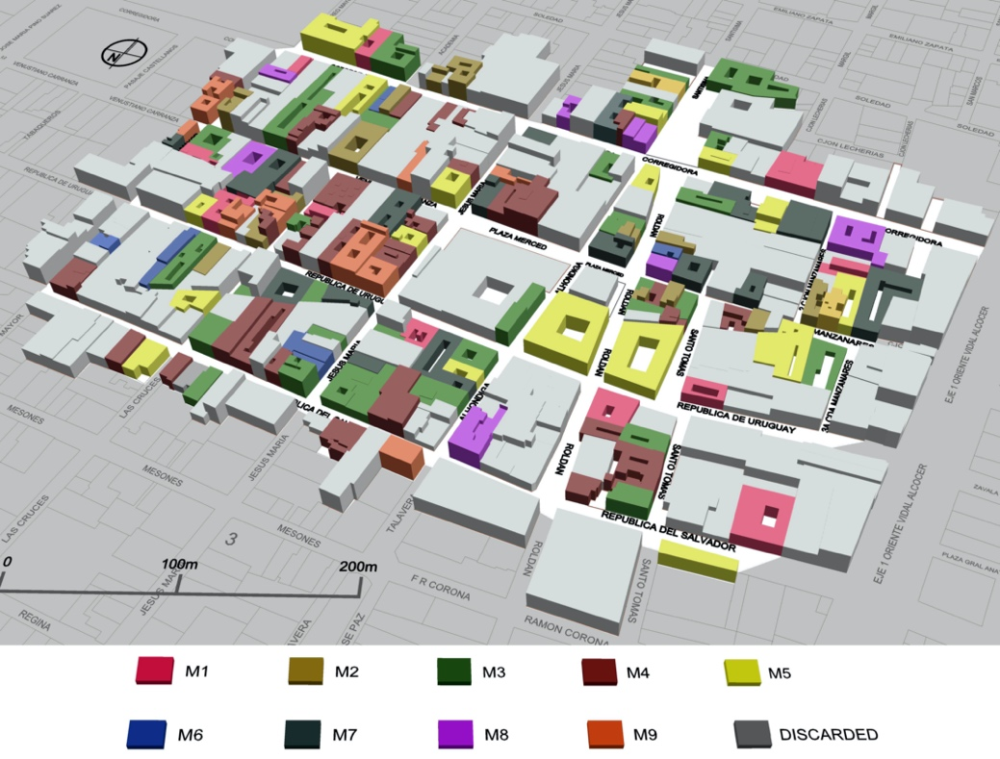
Figure 9. Distribution of the material typologies over the study area.

6. Definition of Building Model Matrix
Finally, with the integration of four possible geometries and nine materials, it was possible to define a set of buildings typologies (T_{n}) from the association of the material typologies (M_{n}) and the different geometries (from A to D). Table 1 shows the number of related buildings and the percentage to regard the study area. The matrix provides 31 different building typologies crossing the coincidence criteria. Hence, five types of 36 are considered as null for this case study (i.e. selected area of La Merced) although they can be used for future works regarding HDMC.
From the analysis of Table 1, the most recurrent geometry type is B, with 68 cases which present on average 615.87 square meters regular and flattened buildings with heights less than 12 m and with effective areas on the façade around 78.06%. It denotes a high amount of buildings between one or two floors. However, by adding type A, C, and D, there are 108 properties with heights more than 8 m, depicting two-storey buildings or superior. The construction materials of the area involve historical and cultural symbolism. However, almost 65% of the buildings have been refurbished resorting to modern material solutions, which are often incompatible with currently accepted conservation principles.
Finally, Figure 10 illustrates the distribution of the building typologies over the study area. The great diversity of material and shapes denotes the complexity of the typological classification.

Table 1. Residential Building Model Matrix, Geometry vs Material used by Salazar and Ferreira (2020).
 |  | Material Type (M)
 |  | M1 | M2 | M3 | M4 | M5 | M6 | M7 | M8 | M9 | ∑(M)
Geometry Type (G) | A | T₁  0 units  0% | T₂  3 units  1.61% | T₃  3 units  1.61% | T₄  0 units  0% | T₅  4 units  2.21% | T₆  0 units  0% | T₇  0 units  0% | T₈  1 unit  0.41% | T₉  3 units  1.61% | 14
 | B | T₁₀  6 units  3.42% | T₁₁  14 units  8.24% | T₁₂  14 units  8.24% | T₁₃  10 units  5.83% | T₁₄  12 units  7.04% | T₁₅  5 units  2.82 % | T₁₆  3 units  1.61% | T₁₇  1 unit  0.41% | T₁₈  3 units  1.61% | 68
 | C | T₁₉  7 units  4.02% | T₂₀  5 units  2.82% | T₂₁  5 units  2.82% | T₂₂  9 units  5.23% | T₂₃  4 units  2.21% | T₂₄  2 units  1.01% | T₂₅  3 units  1.61% | T₂₆  5 units  2.82% | T₂₇  3 units  1.61% | 43
 | D | T₂₈  6 units  3.42% | T₂₉  6 units  3.42% | T₃₀  8 units  4.63% | T₃₁  14 units  8.24% | T₃₂  6 units  3.42% | T₃₃  1 unit  0.41% | T₃₄  9 units  5.23% | T₃₅  1 unit  0.41% | T₃₆  0 units  0% | 41
 | ∑(G) | 19 | 28 | 30 | 23 | 26 | 8 | 15 | 8 | 9 | 166

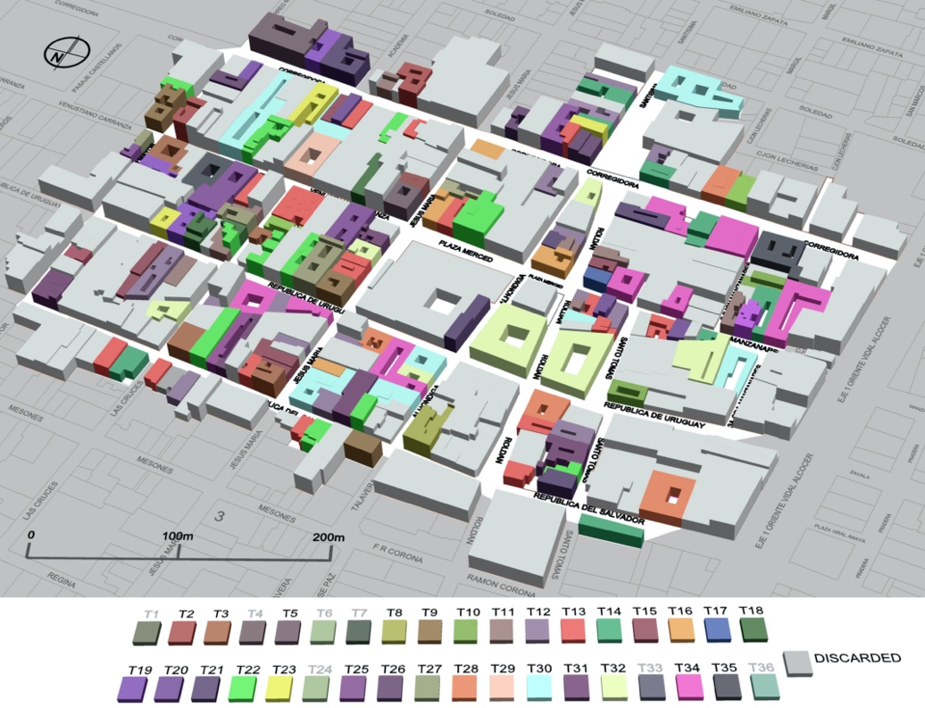
Figure 10. Distribution of the building typologies.

Despite the complexity of this classification, the typologies obtained from this framework can be easily integrated into typological-based large-scale seismic vulnerability and risk assessment analyses; for details on the classification of the seismic vulnerability assessment approaches, please refer to Aguado et al. (2018). In fact, although this Residential Building Model Matrix does not consider specific aspect related to the conservation state of the buildings or the mechanical properties of their materials, provided they are found on robust geometrical and material characterisation, the final building models can be used to identify the most vulnerable building typologies. In this specific case, based only on its geometrical, construction and structural characteristics, it is plausible to assume that the buildings belonging to the typologies T2, T29 and T31 will be among the most vulnerable ones. Since the discussion of the specific aspects related to the seismic vulnerability assessment of the building typologies is behind the scope of this paper, no further discussion is given here. However, additional details on the seismic vulnerability of these building typologies and La Merced Neighborhood can be found in Salazar and Ferreira (2020).

7. Conclusions
This paper presented a framework for the generation of buildings typologies, which, among other uses, can be integrated into typological-based vulnerability and risk assessment analyses. Although they have been obtained from the specific context of La Merced neighbourhood, they can be extended and updated to be used in other urban areas, inside or outside the perimeter of the HDMC. Moreover, this framework can be easily replicated to obtain buildings typologies representative of other historic centres worldwide.
There were generated thirty-six building typologies (i.e. T1-T36) from a matrix of nine material typologies (i.e. M1-M9) and four geometrical building models (i.e. A-D) obtained through a comprehensive analysis of the buildings in the HDMC.
The geometry and material survey was initially possible through ‘internet+’ approach (i.e. Google Earth and Street View), post-seismic reports, extensive literature and historic photos while validated with on-site visits. The acquired and analysed data demonstrated a qualitative correlation between architectural patterns (i.e. geometry and materials) and the origin of the buildings. However, different urban, natural, social and political causes led to the mixed structural systems that commonly present inappropriate technical construction system. Despite the easy access of computational sources, the final residential building model matrix was possible due to the well-documented data provided by historical sources and official institutions in the borough.
The procedure enabled a simplified building modelling of the city centre, by highlighting heights more than 8 m with two-storey buildings or superior, as well as the regular presence of RC in the selected historic area where predominate load-bearing masonry walls. The overall knowledge of the building components and its constituents may enable the appropriate procedures to particular vulnerability assessments. Nevertheless, the principal constraint of this final matrix of residential building models can only lead to simplified large-scale seismic methods with similar characteristics to downtown houses in Mexico City. Thereby, this approach can be considered a step forward for more non-monumental simplified seismic vulnerability studies in historic districts with the highest seismic risk in Latin America. Such outcomes can guide the decisions of stakeholders, civil protection, and cultural heritage authorities for better risk management of urban historical areas.
Acknowledgements
The authors would like to express their sincere gratitude to the ACH (Autoridad del Centro Histórico de la Ciudad de México (2016-2018)), as well as acknowledge Eng. Pilar Espinoza Vázquez, from Instituto Politécnico Nacional Escuela Superior de Ingeniería y Arquitectura Tecamachalco (IPN ESIA), and Dr. Diana L. Flores Salazar, from Universidad Insurgentes (UI) for their contribution to this work by sharing information about some buildings of La Merced neighbourhood. The work presented in this article was supported by the European Union within the framework of the Erasmus Mundus Advanced Master in Structural Analysis of Monuments and Historical Constructions (SAHC) and by the Portuguese Foundation for Science and Technology (FCT) through the postdoctoral fellowship SFRH/BPD/122598/2016.

References
Aguado, J. L. P., Ferreira, T. M., & Lourenço, P. B. (2018). The Use of a Large-Scale Seismic Vulnerability Assessment Approach for Masonry Façade Walls as an Effective Tool for Evaluating, Managing and Mitigating Seismic Risk in Historical Centers. International Journal of Architectural Heritage, 12(7–8), 1259–1275. https://doi.org/10.1080/15583058.2018.1503366
Aizpuru, P. G. 2014. Espacio laboral y vida en familia. Las mujeres en la real fábrica de tabacos de la Ciudad de México. In Espacios En La Historia: Invención Y Transformación De Los Espacios Sociales, 237-258. Mexico City: El Colegio de México (in Spanish).
Autoridad del Centro Histórico de la Ciudad de México. 2017. Plan de Manejo Centro Histórico de la Ciudad de México (2017-2022) [Comprehensive Management Plan for the Historic Downtown of Mexico City (2017-2022)]. Mexico City: UNESCO/PUEC/ACH (in Spanish).
Autoridad del Centro Histórico de la Ciudad de México. 2011. Plan Integral de Manejo del Centro Histórico de la Ciudad de México (2011-2016) [Comprehensive Management Plan for the Historic Downtown of Mexico City (2011-2016)] Mexico City: ACH (in Spanish).
Ayala Alonso, E. 2001. Habitar la Casa Barroca. Una experiencia en la Ciudad de México. In Actas III Congreso Internacional del Barroco Americano. Territorio, Arte, Espacio y Sociedad, ed. J. M. Almansa, A. Aranda, R. Gutiérrez, A. Moreno, F. Ollero, F. Quiles, and G. M. Viñuales, 678-691. Sevilla: Universidad Pablo De Olavide ISBN: 84-688-4049-1 (in Spanish).
Ayala Alonso, E. 1996. La casa de la Ciudad de México. Evolución y transformaciones [The house in Mexico City. Evolution and transformations].1st ed. Ciudad de México: Consejo Nacional para la Cultura y las Artes. ISBN 13: 978-968-298-776-2 (in Spanish).
Ayala Alonso, E. 2009. La idea de habitar. La ciudad de México y sus casas 1750-1900 [The idea of inhabiting. Mexico City and its houses 1750-1900]. México: Universidad Autónoma Metropolitana. ISBN 978-607-477-188-6 (in Spanish).
Basaglia, A., Alessandra A., Enrico S., and Francesco P. 2018. Performance-based Seismic Risk Assessment of Urban Systems. International Journal of Architectural Heritage Conservation, Analysis, and Restoration 12:7-8, 1131-1149 doi:10.1080/15583058.2018.1503371.
Berrón Ruiz, R., C. M. Á. Pacheco Martínez, N. Valencia Guzmán, and P. Aguilar Ortega. 2018. Análisis de las Edificaciones Afectadas en la Ciudad De México por el sismo del 19 de septiembre de 2017 dictaminadas por el Instituto para la Seguridad De Las Construcciones. Paper presented at XXI Congreso Nacional de Ingeniería Estructural. Campeche, Mexico, November 17 (in Spanish).
Bianchini, N. 2015. Dal danno osservato alle curve di vulnerabilità per edifici in muratura: l'esperienza del terremoto de L'Aquila (2009). Tesi di Master del Corso di Studi in Ingegneria Edile-Architettura. Università Degli Studi di Genova, Scuola Politecnica (in Italian).
Cantú, R. 2003. Impacto del medio ambiente sociourbano del centro histórico de la Ciudad de México en la Vivienda [The impact of the socio-urban environment on housing at Historic Downtown in Mexico City]. Scripta Nova. Revista electrónica de geografía y ciencias sociales Vol. VII, 146(072) Barcelona: Universidad de Barcelona, ISSN: 1138-9788. (in Spanish).
Centro de la Vivienda y Estudios Urbanos. 2005. Aprendiendo de la Innovación 9. Programas de Mejoramiento de Vivienda en América Latina y el Caribe. In Foro Iberoaméricano del Caribe sobre Mejores Prácticas Ciudad de México: Centro de Vivienda y Estudios Urbanos (in Spanish).
Coulomb, R. 2017. Estrategias e instrumentos de un proyecto socialmente incluyente para la regeneración habitacional de la ciudad histórica: reflexiones desde la Ciudad de México. In Ciudades y Centro Históricos: habitación, políticas y oportunidades, coord. A. Pineda, M. Velasco, Vol. II, 1st ed, 19-36. Mexico City: Universidad Nacional Autónoma de México ISBN 978-607-02-9749-6 (in Spanish).
Coulomb, R. 2009. Regeneración urbana y habitabilidad en los centros de la ciudad. Lo aprendido en Ciudad de México. Presented at Encuentro Latinoaméricano sobre Centros Históricos. San Salvador, El Salvador, May 5-6 (in Spanish).
Correia Lopes, G., Vicente, R., Ferreira, T. M., & Azenha, M. (2019). Intervened URM buildings with RC elements: typological characterisation and associated challenges. Bulletin of Earthquake Engineering, 17(9), 4987–5019. https://doi.org/10.1007/s10518-019-00651-y
Delgadillo, V. 2011. Patrimonio histórico y tugurios: las políticas habitacionales y de recuperación de los centros históricos de Buenos Aires, Ciudad De México y Quito [Historical heritage and slums: housing and recovery policies of the historical centers of Buenos Aires, Mexico City and Quito]. Mexico City: Universidad Autónoma de la Ciudad de México. ISBN978-607-7798-44-6 (in Spanish).
Esquivel Hernández, M. T. 2016. El Programa de Renovación Habitacional Popular: Habitabilidad y permanencia en áreas centrales de la Ciudad de México [Housing Renovation Program: Habitability and permanence in central areas of Mexico City]. Iztapalapa. Revista de ciencias sociales y humanidades, 37(80):69-99. doi.org/10.28928/revistaiztapalapa/802016/atc3/esquivelhernandezmt (in Spanish).
González Obregon, L. 1923. Las calles de México [The streets of Mexico]. Mexico City: Porrúa (in Spanish).
Google Earth Pro 2017. US: Google LLC.
Google LLC. n.d. Google Maps, Street View Tool. Google LLC. Accessed May 2017. https://www.google.pt/maps.
Federal Emergency Management Agency. 1999. Earthquake Loss Estimation Methodology - Technical and User Manuals. Washington, D.C: FEMA.
﻿﻿Ferreira, T. M., R. Maio, A.A. Costa, A.A. and R. Vicente (2017). Seismic vulnerability assessment of stone masonry façade walls: Calibration using fragility-based results and observed damage. Soil Dynamics and Earthquake Engineering, 103, 21–37. https://doi.org/10.1016/j.soildyn.2017.09.006
Ferreira, T.M., R. Vicente, J. A. R. Mendes da Silva, H. Varum and A. Costa. 2013. Seismic vulnerability assessment of historical urban centres: case study of the old city centre in Seixal, Bull Earthquake Eng, 11: 1753-1773 doi.org/10.1007/s10518-013-9447-2
Instituto de Vivienda del Distrito Federal. 2015. Evaluación Interna Programa: Mejoramiento de Vivienda Ejercicio 2015 [Internal Evaluation Program: Home Improvement Exercise 2015]. Mexico City (in Spanish).
Jiménez Vaca, A. 2014. Las acequias de la ciudad de México y sus repercusiones en la arquitectura habitacional del siglo XVIII [The ditches of México City and implications on residential buildings of the 18th century]. Gremium 01 (02): 5-22. ISSN 2007-8773 (in Spanish).
Lira, C. 1993. Arquitectura mexicana en el siglo XIX. Cuatrocientos años de occidentalización [Nineteenth-century Architecture in Mexico. Four hundred year of occidentalization]. Secuencia (27): 85-100. doi.org/10.18234/secuencia.v0i27.439 (in Spanish).
Monterrubio, A. 2011. Políticas habitacionales y residenciales en el Centro Histórico de la Ciudad de México [Housing and residential policies in the Historic Center of Mexico City]. Argumentos 24 (66): 37-59. ISSN 0187-5795 (in Spanish).
Moreno García, J. R. 2006. La vivienda en los centros históricos. In I Encuentro sobre Arquitectura, Vivienda y Ciudad en Andalucía y América Latina. Hacia Cádiz 2012, 297-307. Cádiz. http://www.flacsoandes.edu.ec/biblio/catalog/resGet.php?resId=19157 (in Spanish).
Mosoarca M., I. Onescu, E. Onescu, and A. Anastasiadis. 2020 Seismic vulnerability assessment methodology for historic masonry buildings in the near-field areas, Engineering Failure Analysis, 115 (104662) doi.org/10.1016/j.engfailanal.2020.104662.
Olvera Calvo, M. del C. 2011. Materiales de construcción en la Ciudad de México durante la época virreinal: Sobre el uso y abuso que se hace de la madera para la construcción [Construction materials in Mexico City during the viceroyalty period: On the use and abuse of wood for construction]. Boletín de Monumentos Históricos Tercera Época (1): 93 https://www.revistas.inah.gob.mx/index.php/boletinmonumentos/article/view/3832. (in Spanish).
Qi, W., G. Su, L. Sun, F. Yang, and Y. Wu. 2017. “Internet+” approach to mapping exposure and seismic vulnerability of buildings in a context of rapid socioeconomic growth: a case study in Tangshan, China.” Nat Hazards 86: 107-139 doi.org/10.1007/s11069-016-2581-9
Rodríguez Morales, L. 2011. La práctica constructiva en la Ciudad de México. El caso del tezontle, siglos XVIII-XIX [Constructive practices in Mexico City. The case of tezontle, 18th-19th centuries]. Boletín de Monumentos Históricos Tercera Época Tercera época (22): 157-180 https://www.revistas.inah.gob.mx/index.php/boletinmonumentos/article/view/2168. (in Spanish).
Rodríguez Morales, L. 2011. Una tabla de materiales de construcción del siglo XIX. Boletín de Monumentos Históricos Tercera época (1): 79-91 https://www.revistas.inah.gob.mx/index.php/boletinmonumentos/article/view/3831. (in Spanish).
Rojas Loa, J. A. 2012. Memoria de una Ciudad Zona Central Ciudad de México 1923-2011. INAH Dirección de Estudios Históricos Coordinación Nacional de Monumentos Históricos. Accessed 06 30, 2020. https://zccm.inah.gob.mx/ (in Spanish).
Salazar, L. G. F., and T. Miguel Ferreira. 2020. Seismic Vulnerability Assessment of Historic Constructions in the Downtown of Mexico City. MDPI 12(3), 1276 doi.org/10.3390/su12031276.
Terán Bonilla, J. A. 2003. La enseñanza de la arquitectura en la Nueva España durante el proceso barroco. España: Universidad de Pablo de Olavide 211-223 (in Spanish).
Verdugo Reyes, M. 2006. Usos y ocupaciones a través del tiempo del conjunto conocido como Ex-Convento de los Padres Camilo (1754-2004). Tesis para obtener el grado de Maestra en Historia. Universidad Iberoamericana (in Spanish).
Ziccardi, A. 2017. Vivienda, gobiernos locales y gestión metropolitana. In Los gobiernos locales y las políticas de vivienda en México y América Latina, 13-30. Mexico City: Universidad Autónoma de México / Centro Cultural de la Cooperación Floreal Gorini / Universidad Nacional de Quilmes / Pensamiento Crítico (in Spanish).

List of Tables

Table 1. Residential Building Model Matrix, Geometry vs Material used by Salazar and Ferreira (2020)

List of Figures

Figure 1. Downtown Mexico City with some current neighbourhoods, delimitation and case study. Source: ACH edited by the authors.
Figure 2. (a) Delineation of the study area. Source: Jiménez Vaca (2014) and digitalized by the authors; (b) Study Area of La Merced Neighbourhood in AutoCAD/Google Earth. Source: FCH edited by the authors; (c) Former Ditch of La Viga that today passes through an underground pipe at Alhóndiga Street. Source: Kilburn Brothers.
Figure 3. Study area boundaries of La Merced (180 national monuments) indicating the heritage local classification (i.e. INAH or INBA). Source: INAH, ACH edited by the authors.
Figure 4. Study area boundaries of La Merced, where 166 buildings are zoned by housing or services/commercial land use. Source: INAH, ACH edited by the authors.
Figure 5. Geometrical Building Models. Source: Salazar and Ferreira (2020) edited by the authors.
Figure 6. Geometrical Typology.
Figure 7. Historic photos of dwellings within the study area: (a) 136 Venustiano Carranza Street Source: INAH; (b) 6 Manzanares Street Source: Unknown – Pinterest; and (c) 26 Manzanares Street Source: INAH. Texture of (d) Tezontle stone (laminates and core); (e) Chiluca Stone; (f) Recinto Stone
Figure 8. Illustration of the nine material typologies identified. Source: Salazar and Ferreira (2020) edited by the authors.
Figure 9. Distribution of the material typologies over the study area.
Figure 10. Distribution of the building typologies.

ORCID iD

L. Gerardo F. Salazar: 0000-0002-8616-1707

Tiago Miguel Ferreira: 0000-0001-6454-7927

CNMH is the acronym in Spanish of Coordinación Nacional de Monumentos Históricos (CNMH); DEH is the acronym in Spanish of Dirección de Estudios Históricos; INAH is the acronym in Spanish of Instituto Nacional de Antropología e Historia; and ZCCM is the acronym in Spanish of Zona Central de la Ciudad de México
SEDUVI is the acronym in Spanish of Secretaría de Desarrollo Urbano y Vivienda ; SOBSE is the acronym in Spanish of Secretaría de Obras ; SPC is the acronym in Spanish of Secretaría de Protección Civil.
ACH is the acronym in Spanish of Autoridad del Centro Histórico
INBA is the acronym in Spanish of Instituto Nacional de Bellas Artes
Housing and Population Operational Centre (Centro Operacional de Vivienda y Poblamiento - COPEVI), Housing Centre of Urban Studies (Centro de la Vivienda y Estudios Urbanos - CENVI), Management Trust of Historical Centre (Fideicomiso del Centro Histórico - FCH), and the Housing National Institution (Instituto Nacional de la Vivienda - INVI)

