In this article the RESPECT team (Racialised Experiences Project: Education, Children and Trust) give an overview of their research about the impact of racism on the mental health and well being of primary school children, and share some examples of their participating children's work in visualising a kinder, anti-racist society.

# Intro

Racism has crucial connections to both kindness and geography that are often not fully understood or acknowledged. The primary geography curriculum’s stated purpose is to ‘inspire in pupils a curiosity and fascination about the world and its people that will remain with them for the rest of their lives’ (Department of Education 2013). For pupils to really make sense of the interactions between diverse places, people and resources they need to understand what part racism plays in these relationships across the globe. On a more local scale, we need to recognise the legacy of these troubled interactions and how they continue to play out in UK society, including in our schools. There is significant discussion about kind behaviour in most schools and many people would see this as an embodiment of some kind of empathy and care towards others. Racism works against such ideas, and the children we worked with on the RESPECT project experienced it as a continuing unkindness towards themselves and their communities. As one child memorably said “It’s as if White people are loved more”.

# Does racism happen in primary schools?

Despite increasing diversity in our schools, there is virtually no research about how primary school children in the UK feel about racism. A Freedom of Information request sent to councils and academy trusts recorded more than 60,000 racist incidents in schools in the past five years[[1]](#footnote-1). However, when such incidents occur in primary schools they are often dismissed by staff who rationalise their approach through the belief that the perpetrators are ‘just children’ and therefore do not understand what they are doing. Classroom staff are often not provided with adequate training or resources to either acknowledge the underpinning issues, or to support children to navigate these situations,[[2]](#footnote-2) and however unintentional or unaware racist behavior might be, children from Black and minoritised ethnic communities are left feeling very vulnerable and increasingly marginalised.

The aim of the RESPECT study was to understand the experiences and impacts of racism on 10 – 11 year olds, and provide recommendations on how schools might better support children and teachers. Our team was made up of education and psychology specialists from the University of the West of England, Bristol, working with an experienced, socially engaged artist. We were aware that racism is a very sensitive issue, and so we designed arts-based research methods through which we could facilitate these delicate conversations. Rather than focusing on whether children making racist comments (for example) actually understand what they are saying, we asked a different question, ‘What impact is that comment having on the child who is on the receiving end of it?’ We prioritised gathering the lived experiences of children from Black and minoritised ethnic communities, and focused on creating an environment that was safe enough for them to say what they really felt.

# What did we do?

We worked with approximately 80 children from three Bristol primary schools, and introduced ourselves saying that we were there to listen to their experiences and perspectives about racism in order to help teachers become better at supporting them. We started by showing the whole class a selection of slides chosen with the aim of prompting discussion about racism occurring at local and national scales, and talked about how external events can have an effect on how we feel inside. We tried to encourage the children to think beyond seemingly isolated interpersonal racist incidents. For example, we asked them to consider if they saw people who looked like them as leading characters in the books they read; or whether they had ever had any teachers from Black or minority ethnic backgrounds. We supported them to include microaggressions and covert examples of racism, which might take the form of a look, being ignored, or a tone of voice. These can be particularly insidious because they are so hard for the people they are aimed at to identify and challenge.

Body mapping was introduced as a way in which the children could show how external events were impacting on them internally, and they were encouraged to use drawing, writing, symbols, emojis and colour coding on their maps. At the end of the session, the children were invited to share their thoughts and feelings with the whole group if they wanted to. 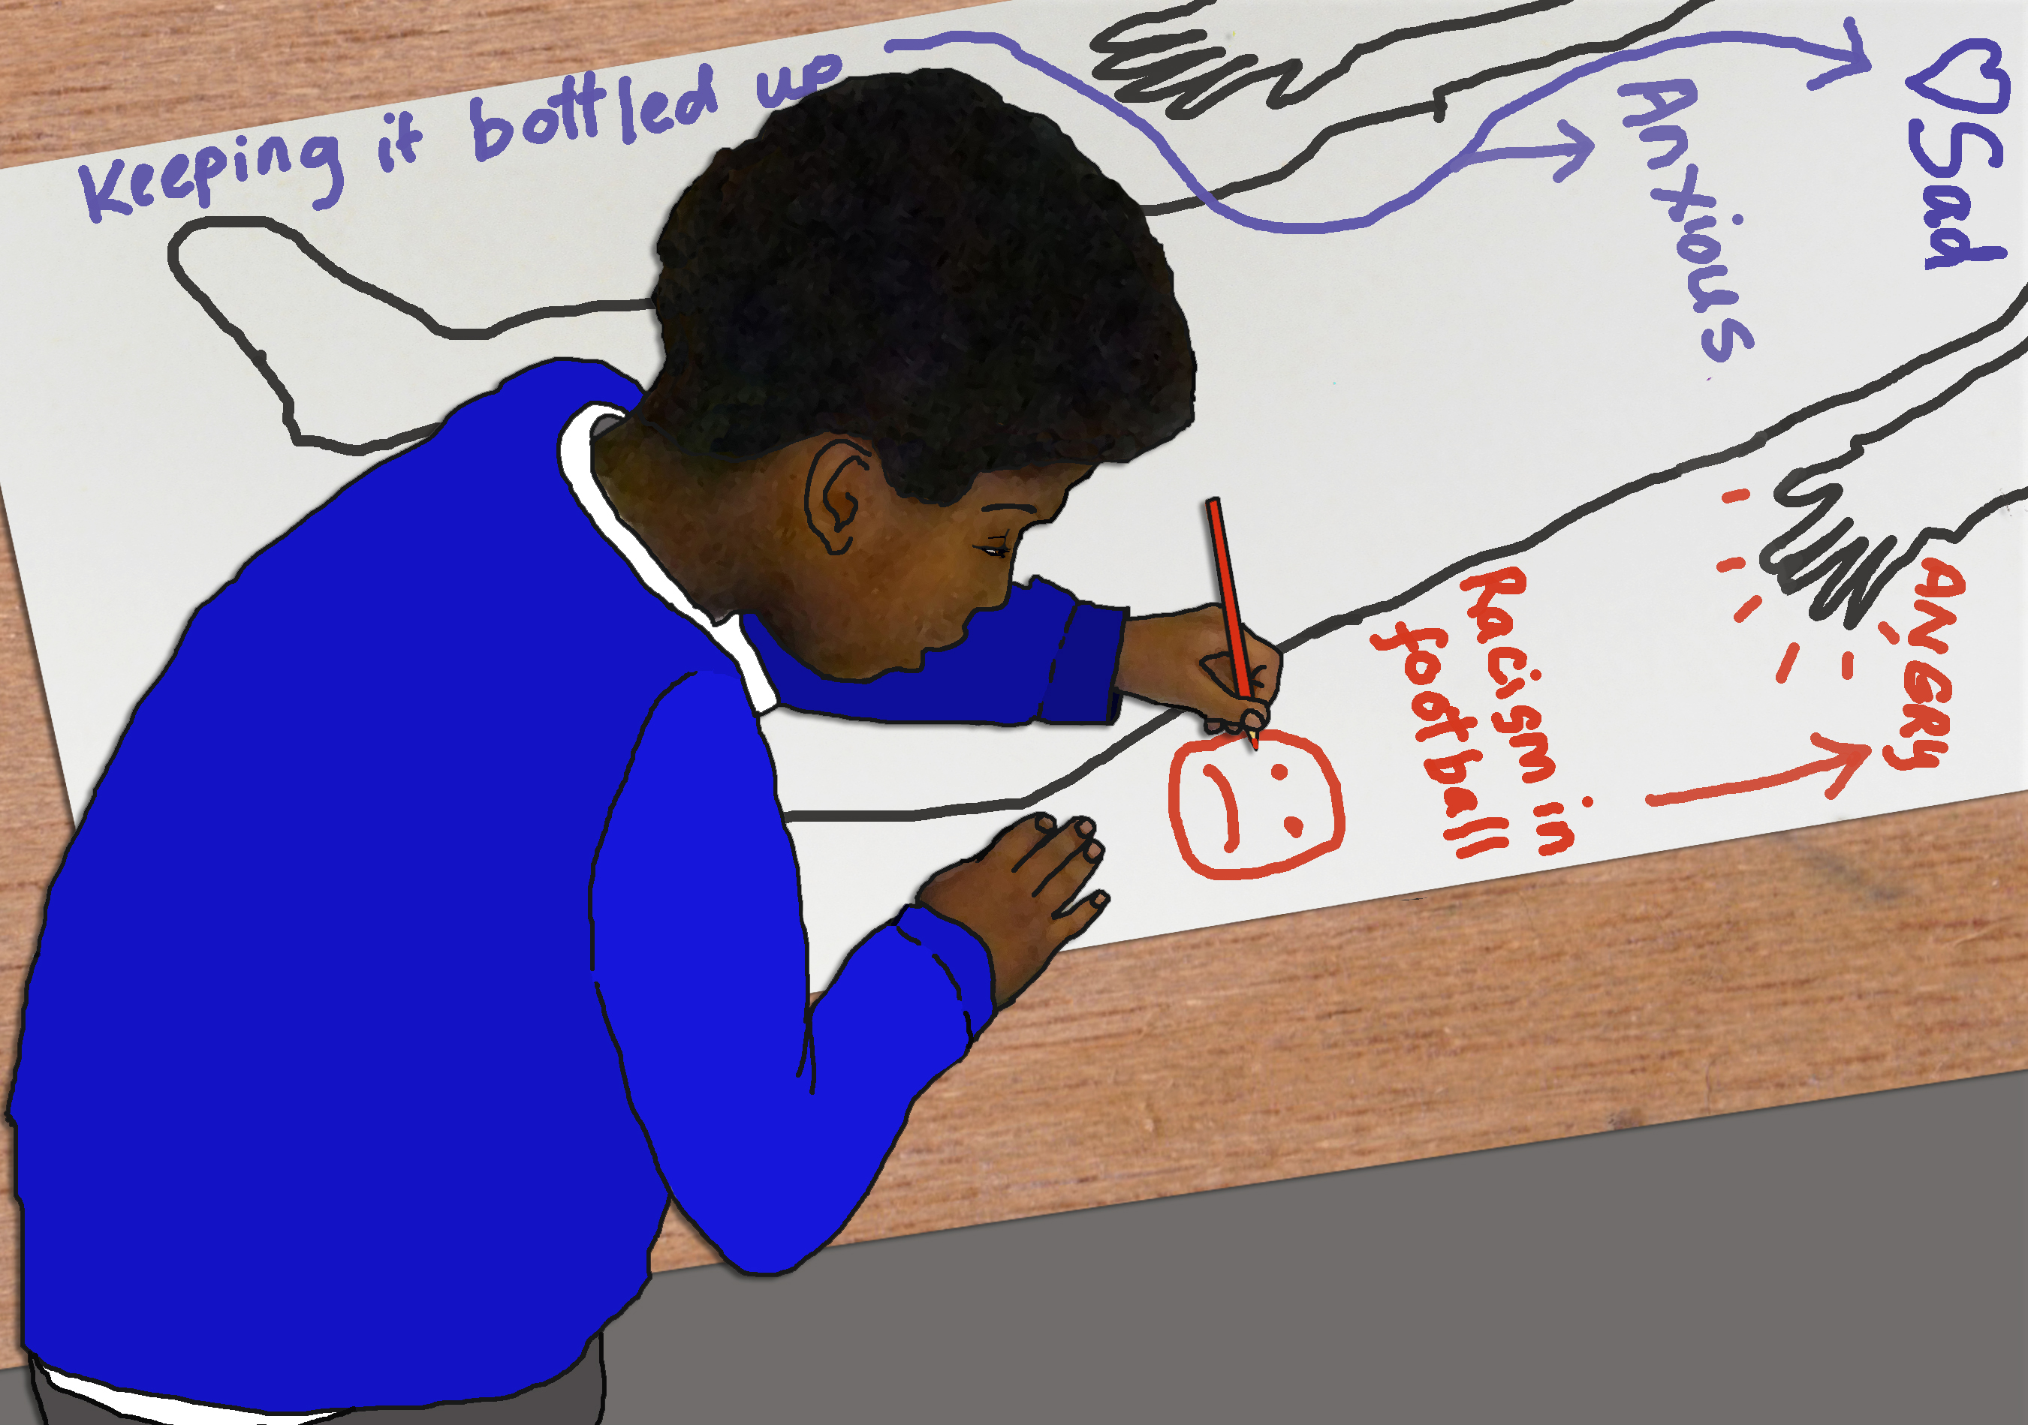

Luci Gorell Barnes, 2022, *Child working on bodymap*

# What children say about racism and unkindness

The children recognized racism as a form of bullying, and told us about experiencing and witnessing it in relation to many things including: skin colour, linguistic differences, food, clothing, hair, headwear, and religion. For example, participants said,

*When I go to my old school I really wanted to wear my turban. But my parents would say don't wear your turban because people might make more fun.*

*A girl in my class said that my skin colour was like mud.*

The children also discussed media coverage of national and international incidents, and reported a range of emotions that included feeling angry, scared, frightened, shamed, unsafe, sad, powerless and frustrated. It became clear that because children are not offered opportunities to discuss racism at school, many of the very complex and distressing feelings that they have about it become internalised. This results in some children living with a range of unexpressed and difficult states: including low self-esteem, resentment, disappointment, anxiety, and negative rumination. Children talked about simultaneously feeling hyper visible and self-conscious whilst seeming invisible and overlooked in spaces such as school, the park and shops.

**Resources to help you explore kindness**

Many of the children said that they welcomed the chance to discuss racism, and their engagement and enthusiasm for the research prompted us to co-produce a book with 17 of our participants. The book is called ‘If Racism Vanished for a Day…’ and is based around some of the themes that emerged from the body mapping sessions. We wanted to create a book that enabled the children to share their visions of a kinder, anti racist society and so we worked with the sentence starter ‘If racism vanished for a day…’ The children welcomed this idea and, working with the themes, they told us ‘If racism vanished for a day…’

* …the police would treat me and my family with kindness and equality
* …in this world there would be love and friendship everywhere. It would be a very better place!
* …people would feel calm and relaxed and relieved
* …I could become friends with white people as well as brown people. We could find the things we have in common. We could be friends and it would be normal
* …people wouldn’t judge me for my hair
* …I would go to the shops and everyone would treat me with kindness.

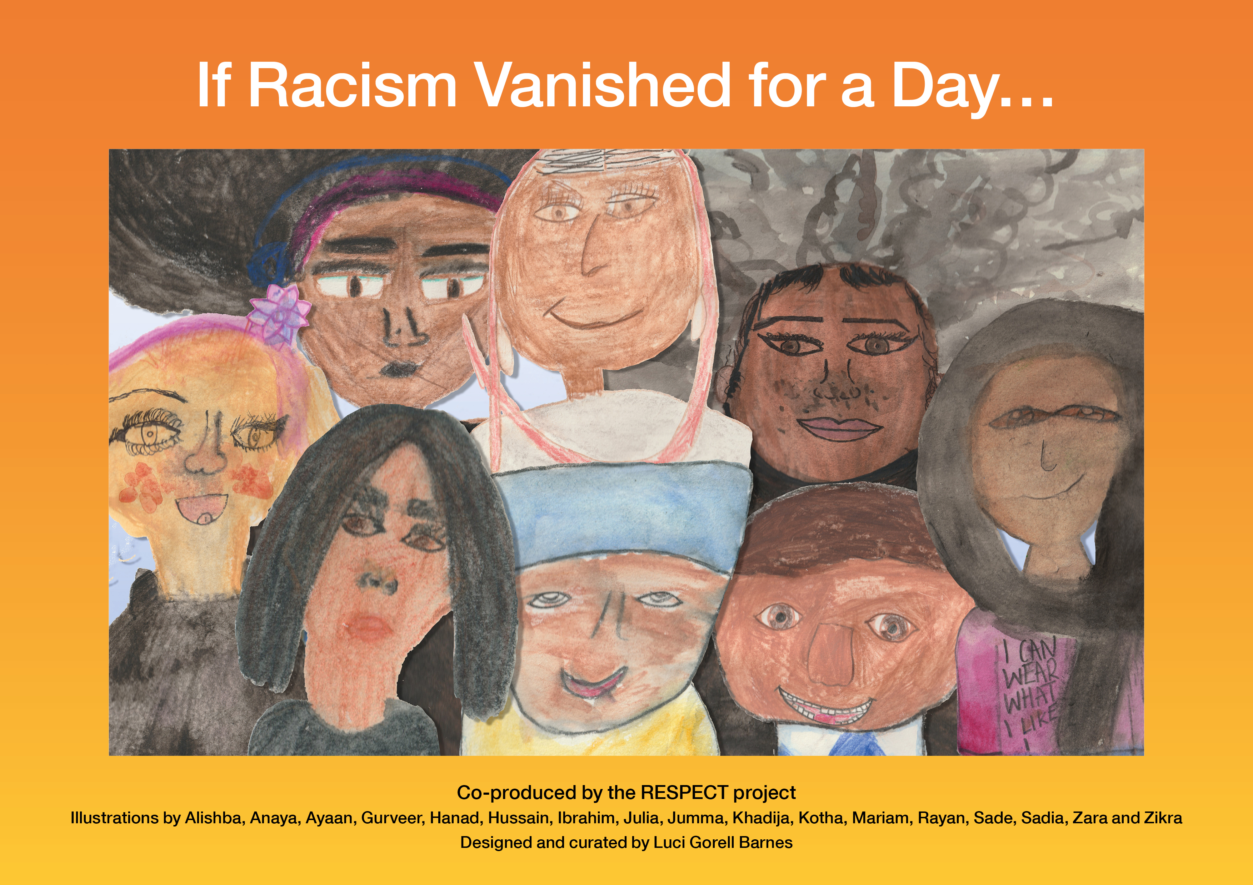

Along with its accompanying guide, these resources are designed to support teachers to have conversations about racism and its impact, with the children in their classrooms. Based on the deeper understandings we gained about the children’s experiences and perspectives, we made recommendations to schools about how they might discuss racism in classroom situations including:

* Consider using the book ‘If Racism Vanished for a Day’ and accompany teacher resources as a starting point for discussion with pupils
* Recognise your own positionality and journey towards allyship
* Acknowledge that despite the sensitive nature of the discussion about racism, this can be very powerful for children, and they welcome it
* Accept that there are multiple experiences of racism at a range of levels and these can be triggered by local, national and international events
* Seek guidance from community members to act as a critical friend
* Ensure children in school have an adult that they can turn to if they have concerns about racism (this is in addition to the school racism policy)
* Revisit the theme of racism regularly through the school year.

# Resources

Both the e-book book and teacher’s guide to *If Racism Vanished for a Day…* are free resources and available online for download from the RESPECT website:

<https://respectprojectbristol.org/>

You can also find the e-book of ‘If Racism Vanished for a Day…’

[https://issuu.com/uwebristol/docs/if\_racism\_vanished\_for\_a\_day](https://issuu.com/uwebristol/docs/if_racism_vanished_for_a_day )

RESPECT was funded by the UKRI’s Emerging Minds Network, UWE, Bristol and Future Quest.

1. Batty, D. & Parveen, N. (2021) ‘Race in education’, The Guardian, accessed online [↑](#footnote-ref-1)
2. [ttps://www.bera.ac.uk/blog/honestly-i-think-its-a-horrendous-knee-jerk-reaction-politeness-superiority-assimilation-and-criticality-student-teachers-views-on-fundamental-british-values](https://www.bera.ac.uk/blog/honestly-i-think-its-a-horrendous-knee-jerk-reaction-politeness-superiority-assimilation-and-criticality-student-teachers-views-on-fundamental-british-values" \t "_blank) [↑](#footnote-ref-2)