Managing sample introduction problems in Hydrophilic Interaction Liquid Chromatography.

Mark Taylora, Jane Kawakamib, David V. McCalleyc*

aPfizer, Discovery Park, Ramsgate Road, Sandwich, CT13 9NJ, U.K.

bPfizer, 280 Shennecossett Rd, Groton, CT 06340, U.S.A.

cCentre for Research in Biosciences, University of the West of England, Frenchay, Bristol BS16 1QY, UK

* Corresponding author

Tel. +44 117 3287353

Email David.Mccalley@uwe.ac.uk

Keywords:

HPLC: HILIC: sample injection

**Abstract**

Sample injection can cause serious problems in hydrophilic interaction liquid chromatography (HILIC) when the injection solvent has higher elution strength than the mobile phase. It can lead to asymmetric peak shapes and poor efficiency. The problem can occur when the mp contains a high proportion of organic e.g. 95% acetonitrile (a weak solvent) whereas the injection solvent contains a higher proportion of water (a strong solvent) that is necessary to dissolve polar samples. We investigated different strategies to overcome this problem. A simple method is pre-column dilution where the injector is programmed to deliver a plug of weak solvent (e.g. pure acetonitrile) along with the sample dissolved in a solvent with higher water content than the mp. Another option is to use alternative organic solvents to acetonitrile in the injection solvent, e.g. isopropanol, acetone or tetrahydrofuran, that may give enhanced sample solubility. The role of the volume of injection solvents was investigated as well as the possible effects of mass overload on the results. The use of small sample volumes is always recommended to reduce mismatch effects.

**1. Introduction.**

Hydrophilic interaction chromatography (HILIC) has become a useful alternative technique to RPLC, especially for the analysis of polar and ionisable compounds which are difficult to retain using the latter technique [1]. The mechanism of separation is considered to be partition of solutes between a water layer held on the polar stationary phase (sp, typically bare silica, amide or zwitterionic) and the bulk mobile phase (mp) which contains at least 60 % ACN and at least 3 % water. Investigations into the detailed mechanism of the technique continue [2-6]. Additional mechanisms can contribute to retention, particularly ionic effects. HILIC has been successfully applied in diverse areas to the analysis of peptides [7], antibiotics [8,9], small molecule pharmaceuticals, liberated glycans /monoclonal antibodies [10-11], sugars and polar metabolites in metabolomic studies [12].

Besides retention of polar and ionised species, HILIC has the advantage of complimentary selectivity to RP for samples amenable to both techniques. This “orthogonality“ to RP can be exploited in two-dimensional separations [7]. Other advantages stem from the use of a low viscosity mp which permits high flow rates or long columns. The high volatility of typical mps also can result in efficient removal of the effluent in evaporative detectors such as electrospray ionisation mass spectrometry (ESI-MS) or charged aerosol detection (CAD), giving greater sensitivity compared with RP [13-15]. Nevertheless, HILIC suffers from some disadvantages such as longer equilibration times that are particularly troublesome in gradient elution. However, strategies that overcome this limitation have been proposed [16-18]. Another problem in HILIC (that occurs also in RP-LC, but perhaps to a lesser extent) is the mismatch between the mp and a stronger injection solvent, containing more water. Such injection solvents may be required to dissolve the sample, which being inherently polar in nature, may not be readily soluble in high concentrations of ACN. The mismatch can cause severe loss of efficiency as the sample may be inadequately focussed on the top of the column [19].

The first aim of this work was to assess the extent of solvent mismatch problems when the sample was injected in various concentrations of ACN in aqueous solution. Pre-column dilution (“Performance Optimising Injection Sequence” or “POISe”) was investigated as a simple remedy to reduce the elution strength of the injection solvent [20]. The method was developed exclusively for RP chromatography and involves automatic dilution of the samples with a weaker solvent in order to achieve a more closely matched overall strength with that of the mp, thus improving the focus effect. This technique involves similar principles to “at-column dilution” which is however, mainly directed towards preparative chromatography and uses a separate pump for the dilution solvent [21,22]. In the present study we explored adapting the technique for HILIC use. Secondly, we investigated the effect of injection volumes on solvent mismatch using only ACN as the (weak) organic solvent. Thirdly, alternative injection solvents to ACN were studied including, tetrahydrofuran (THF), acetone, methanol and water. Isopropanol has been briefly studied previously [23]. We preferred to use mps containing salt buffers rather than simple aqueous-organic mixtures [24]. Salt buffers stabilise and affect the water layer on the sp (important also for neutral solutes) but also stabilise the pH and ionisation of solutes and sp groups. We used isocratic elution throughout, which not only simplifies interpretation of results, but allows simpler quantitative evaluation of peak shape. Furthermore, gradient elution gives more favourable conditions, as there is an additional focusing effect due to low mp strength at the beginning of the run.

Our work concerned small molecules and the assessment of the effect on peak shape of moderate solvent mismatch and moderate injection volumes. However, for peptides and other large molecules, higher sample injection volumes of strong solvent can lead to split peaks or even sample breakthrough [25]. The effect may be attributed to the pronounced effect of small transient increases in mp water concentration, which considerably increase eluotropic strength for these compounds. We have not as yet studied mismatch with these larger solutes.

**2. Experimental**

Experiments were performed using a 1290 ultra-high performance liquid chromatograph (UHPLC, Agilent, Waldbronn, Germany) comprising a binary pump, autosampler and photodiode array UV detector (0.6 L low dispersion flow cell of 10 mm path length) set at 210/260 nm (bandwidth 4 nm) with data collection rate 160 Hz. The instrument was fitted with the ultra-low dispersion needle seat and flow-through needle options. Columns (totally porous) obtained from Waters (Milford, SA) both 10 cm x 0.21 cm I.D. were: BEH Premier amide , average particle diameter (dp) 1.7 m, pore diameter 130 Å, surface area 185 m 2/g, and Atlantis BEH Premier Z-HILIC (zwitterionic), dp 1.7 m, pore diameter 95 Å, surface area 270 m 2/g. The latter has bonded sulfobetaine ligands with -SO3- groups in the distal position. The hardware (including the frits) of both columns was deactivated by vapour phase deposition by the manufacturer. The temperature of the oven was set at 30 oC. The mp was 5 mM ammonium formate (AF) buffer pH 4.4 in 90 % ACN-water, at a flow of 0.40 mL/ min. 5 mM buffer maintains good buffering properties with minimal suppression of MS sensitivity, if using this method of detection. ww pH was measured before addition of the organic solvent. Columns were equilibrated in the mp for at least 1 hour at 0.4 mL/min. Isocratic elution was used throughout. Solutes uridine 3-OH benzoic acid (3-OHbz) and trimethylphenylammonium chloride (TMPAC) were obtained from Sigma-Aldrich (Poole, U.K.). Each solute was prepared at a concentration of 20 mg/ L in various solvents except where otherwise stated; samples were injected in duplicate. Solvents and additives ACN, methanol, THF, IPA (all gradient UV grade), AF, formic acid (FA), (all MS grade) were from Fisher (Loughborough, U.K.). Column efficiency was measured using the half-height procedure. This method gives only approximate values as the peaks in many cases were non-Gaussian in shape. However, the method was found to be precise and gave at least an approximate quantitative and relative indication of performance. More sophisticated algorithms are recommended if further calculations or deductions are made based on column efficiency however, this was not the case in the present study.

**3. Results and Discussion**

*3.1 Pre-column sample dilution.*

The injection process is known to be a significant contributor to band spreading in RP-LC, especially for peaks of small *k* that experience little trapping on the front of the column during isocratic analysis [20]. The POISe technique (Performance optimising injection sequence) involves injection of a defined volume of weak solvent along with the sample. Addition of the weak solvent can be performed automatically by the autosampler in many modern instruments. This technique was developed for RP-LC using typically ACN: water as mp; the weak solvent for injection and mp is water and the strong solvent ACN. The optimal ratio of weak: strong injection solvent was 4:1[20]. Decreases in peak width for POISe of up to 40 % (dependent on the particular instrument) were obtained for acetophenone which had low *k* in the mp (50:50 ACN-water). The effects were identical if the sample was pre-diluted off-line; the authors concluded that this was evidence for efficient mixing in the pre column space. The technique was studied exclusively for RP separations [20]. We now evaluated POISe for suitability in HILIC where the weak solvent was ACN, and the strong solvent water. The instrument was set up to backflush the needle (as is normally the case with a flow-through needle type injector). The sample (1 L ) was introduced followed by a plug of 4 L pure ACN (similar to [20].

The amide column presents a mostly neutral surface, without giving strong ionic interaction which might dominate injection effects [1]. However, the effects of silanol groups in silica or hybrid silica base material can never be fully eliminated; we have included ionogenic solutes for this reason. Uridine is a neutral solute; TMPAC a quaternary compound remaining positively charged throughout these experiments. 3-OH bz is a weak acid: we have not so far identified a suitable strong acid probe. Sulfonic acids tend to have poor retention on silica based HILIC columns (possibly due to repulsion of the fully charged species from ionised column silanols). Phosphates can undergo strong interactions with metals in the system, confounding the results [1,26,27]. The chosen solutes had 0.4 < k <3 which was the retention range recommended to obtain most benefit with POISe in the RP mode [20]. Presumably with longer retention, the influence of the injection solvent on the mp strength diminishes (see below).

Fig. 1 shows the column efficiency (measured at half height, average of duplicate injections) for 20 ppm solutions of uridine, the 3-OHbz and TMPAC, using the amide column, with a buffered mp of 90 % ACN, and injection solvents of buffered 90, 70 and 50% ACN. For each solute and injection solvent, the left-hand bar shows the efficiency for conventional introduction of 1 L of sample whereas the right hand bar shows the efficiency for the pre-column dilution (PCD) or “POISe” method with co-injection of 4 L ACN. PCD improves efficiency for each solute, and each sample injection solvent with the greatest % improvement shown for 50 % ACN-buffer. Of the three solutes TMPAC (k= 1.6) shows the greatest enhancement (~180 %) and uridine (*k*= 2.7) the least (37%) with 3-OH bz (*k*=2.0) at 56%. These enhancements are somewhat greater than reported for RP [20]. While the increases in performance are greatest for the solute of lowest *k,* clearly other factors are involved, especially for ionised solutes. Reversing the injection sequence such that pure ACN was introduced first had relatively little effect (results not shown), although this result may be instrument dependent. Finally, Fig. 1 demonstrates that PCD even improves efficiency for all three solutes when the mp and sample solvent are matched (both 90% ACN: buffer).

Results can be explained in terms of increased focussing effects as the ACN concentration in the injection plug increases. By analogy with RP, there may be also a contribution from band compression effects (see below). Attempts have been made to model these effects in RP on the basis of differences in solute *k* in the injection solvent/mobile phase, although the models sometimes disagree [28-29]. Our results suggest the benefits in HILIC may be even greater than shown for RP [20].

*3.2 Column efficiency for small volume injection of test compounds diluted in a variety of solvents at 90 % v/v.*

This experiment was carried out to determine the extent of efficiency loss when the dilution solvent contained the same concentration (% v/v), but of different organic solvents compared with the standard mp containing 5 mM AF pH 4.4 in 90 % ACN. It was considered that these alternative solvents might provide enhanced sample solubility compared with equal concentration of ACN. Furthermore, it is possible that these alternatives might show more favourable results when sample injection volume was increased, compared with ACN. It was anticipated that greater success would be obtained using solvents with similar or less HILIC elution strength than ACN (see below).

Fig. 2 shows column efficiencies (average of duplicate injections) on the amide column using buffered 90 % ACN (the mp solvent) compared with 90 % acetone, IPA, THF, methanol/ and 100 % water (buffer), with an injection volume of 1 L. While injection in 100 % aqueous solvent predictably gave very poor efficiency (N < 5,000 plates for uridine, 3-OH bz and TMPAC), small volume injection in 90 % of these alternative organic solvents (90 % acetone, IPA or THF) gave acceptable performance in comparison with 90 % ACN. Thus while N for 1 L injection in 90 % ACN was 19,400, 19,000 and 13,100 for uridine, 3-OH bz and TMPAC respectively it was 18,800, 19,400 and 13,300 for 90 % acetone, 16,500, 18,600 and 13, 400 for 90 % IPA, and 16500, 14,800 and 13,600 plates for 90 %THF. 90 % Methanol (13,600, 11,300 and 9,100 plates) gave a more substantial drop in efficiency. Thus, acetone and IPA are possibilities as alternative injection solvents to ACN and warrant further investigation of the effect of using larger volume injections.

*3.3 Injection in various concentrations of ACN. Influence of injected sample volume and sample mass, mobile phase 90 % ACN-buffer.*

While the effect of sample volume alone on peak shape is reasonably well known, it is necessary to measure its influence so it can be subtracted from the total reduction in efficiency to reveal the effects ot solvent mismatch. The same applies to mass overload, which additionally has been relatively little studied in HILC. Fig. 3a, 4a, 5a show first the effect of increasing volumes (1-5 L) in 90 % ACN -buffer i.e. matched injection solvent for uridine, 3-OH bz and TMPAC respectively. For uridine (orange curve Fig. 3a) and TMPAC (orange curve Fig. 5a) the deterioration in plate count is very small. However, for 3-OH bz (Fig. 4a), the drop is much more substantial. Fig. 6 (upper) shows that while the peaks for uridine and TMPC remain symmetrical over the range of volumes injected, 3-OH bz increasingly fronts with increasing sample volume, with the peak apex moving to longer retention times. This result is characteristic of *mass* overload in HILIC [1]. Indeed, Fig. 6 (lower), which shows the peak profiles obtained by injecting 1 L of solutions of increasing concentration (20-100 mg/L). is virtually identical. The mass of solute injected is the same both for increasing volume injections of (constant) 20 mg/L solutions as for the injection of 1 L volumes of solutions of increasing concentration. Table 1 confirms the considerable loss in efficiency for 3-OH bz when 5 L of matched solvent (100 ng solute mass, 11,800 plates) is used instead of 1 L (20 ng, 19,000 plates). It also shows that injection of 1 L of 100 pm solution (12,600 plates) gives almost the same efficiency as 5 l of 20 ppm solution, confirming the mass effect.

Fig. 3a, 4a and 5a indicate the generally detrimental effect on efficiency of increasing the concentration of water in the ACN-rich injection solvent from 10 % to 50 % (90 to 50 % ACN) and increasing the injection volume. Thus 1 L of 20 mg/L uridine (Fig. 3a) gave 19,400, 18,200, 16,500 and 12,300 plates for 90, 80, 70, 50 % ACN as injection solvent but only 17,700, 9,400, 3,500 and 480 plates using 5 L of the same injection solvents. More serious losses still were shown for 5 L injections of 3-OH bz (Fig. 4a) and TMPAC (Fig. 5a) which gave only 1,900 and 100 plates respectively using 70 % ACN. Indeed, the efficiencies for TMPAC injected in 50 % ACN were so low and the peaks so asymmetric that the plate count determination is subject to substantial error. Clearly, the injection volume should be kept as low as possible in cases of mismatch of ACN concentration.

A likely explanation of these results is that injection solvents stronger than the mp (those richer in water) cause a temporary increase in the elution strength of the mp. Higher elution strength will cause a reduction in focussing effects at the front of the column. As the peak moves through the column, its front moves faster than the tail, giving further peak broadening. (In contrast, the different speed of movement of the front and tail can produce useful peak compression in RPLC when the sample solvent is *weaker* than the mp [29]) . Larger sample volume and stronger sample solvent lead to more pronounced effects. Theoretically, peak distortion effect should be greater for less retained analytes which is again demonstrated in Figs. 3a, 4a, 5a (see *k* values above). Care is necessary in relating efficiency loss to *k,* for example due to the contribution of mass overload for 3-OHbz. Furthermore, the retention factors of these test solutes are rather too similar to highlight the effects of *k* on peak shape.

3*.4 Effect of mobile phase strength. Effect of alternative stationary phase.*

Figs. 3d, 4d and 5d show results for the amide column using 95% ACN-buffer as mp instead of 90 % ACN-buffer. 85 and 75 % ACN were chosen as alternate injection solvents because they represent similar proportional reduction to 95 % ACN as do 80 and 70 % to 90% ACN. This change of mp led to considerable increases in retention: *k*= 7.2, 6.8, 3.5 for uridine, 3-OH bz and TMPAC respectively. Comparison of Figs. 3d,4d and 5d with Figs. 3a, 4a, 5a shows generally rather similar patterns of deterioration of efficiency with injected volume for the 3 solutes in the different mps. An exception is for 3-OHbz injected in mp of 95 % ACN-buffer (see Fig. 4d) which gave improved efficiency for larger injection volumes. It is possible that 3-OHbz is less ionised in 95 % ACN which may favourably influence overloading [1]. Some increase in performance may be attributed to the increase in *k* with 95 % ACN, but clearly many factors are involved. These studies indicate that the broad pattern of deterioration in efficiency is followed, but that care is necessary in the prediction of behaviour for individual solutes.

We briefly investigated the effect of changing the sp on solvent mismatch, substituting a zwitterionic for the amide column. Zwitterionic ligands supposedly give an overall neutral charge [1]. The column was also from Waters and uses the same hybrid silica substrate and deactivated hardware. Fig. 7 shows the deterioration in efficiency with increase in injection volume of mismatched acetonitrile based solvents. Comparison of Fig. 7a with Fig. 3a shows similar loss in efficiency on this column as the volume of mismatched injection solvent increased for uridine. Similar results were obtained for TMPAC (compare Fig. 7c with Fig. 5a. However, results for 3-OHbz differed on the zwitterionic (Fig. 7b) and amide columns (Fig. 4a) with relatively little deterioration in efficiency with increasing sample volume for the former when the injection solvent was the same as the mp. This difference is explicable on the basis of reduced mass overload on the zwitterionic column. Recent research has confirmed that these columns have increased water layer thickness, thus greater sample capacity [1, 30,31]. Differences in *k* (5.2, 8.7, 1.7) for uridine, 3-OHbz and TMPAC must also be considered. A difficulty in comparing results was the somewhat reduced efficiency for all solutes on the zwitterionic compared with the amide phase. A contributory factor to the overall efficiency is slow mass transfer through the water layer, especially if thick [27,30]. However, there are clearly many other contributory processes to overall efficiency, so caution is necessary in drawing such conclusions.

*3.5 Effect of different organic injection solvents on efficiency.*

Although some authors have used alternative organic solvents in HILIC, ACN is by far the most widely employed as mp/injection solvent. An aim is to obtain selectivity differences. However, sample solubility issues in ACN have encouraged investigation of alternatives for injection. Studies with various organic solvents [32,33] suggest an eluotropic series in HILIC of :

Methanol> isopropanol> THF> ACN

with ACN as the weakest solvent. The Waters guide to HILIC [34], agrees with this order and includes acetone in the series:

(water)> methanol> isopropanol> THF> ACN> acetone.

Clearly it is difficult to establish such a series as the eluotropic strength may depend also on many factors including the solute and sp. This series is approximately the opposite of that found in RP separations where THF and ACN are the strongest eluting solvents followed by methanol, with water as the weakest. If the injection solvent acts as a temporary extra mp component, it would be expected that loss in efficiency with different organic solvents might parallel the eluotropic series. If ACN or acetone are the weakest eluting organic solvents they should give the best peak shapes (best injection focussing effects) and methanol the worst in HILIC. Fig. 2 apparently confirms this prediction, at least for small volume injections. Acetone and IPA are shown to be the most favourable alternatives to ACN. Methanol and water are the least suitable. Acetone is rarely chosen as a *mp* solvent due to absorbance of light over the UV region, but its use for injection with smaller transient volumes should be possible. Alternatively it is possible that peaks that interfere with those of the solute might be produced. In practice, we found that most of these small peaks appeared before or near the void volume of the column (see below) allowing monitoring of the probe compounds at the usual UV wavelengths.

Figs. 3-5 show the effect on efficiency of injection of uridine (Fig. 3), 3-OH bz (Fig. 4) and TMPAC (Fig. 5) in 70-90 % of ACN, acetone and IPA with the usual mp (90 % ACN-buffer) and the amide column. Fig. 3 shows also uridine injected in 50 % organic solvent but peaks were so asymmetric that the accuracy of efficiency measurements is doubtful, and data is not given for the other solutes at this level. For 5 L injections in 80 % organic-buffer the efficiencies for uridine were 9,400, 5,300 and 2900 plates for ACN, acetone and IPA respectively; for 3OH bz 7,600, 6,500 and 5,000 respectively; for TMPAC 1,900, 13,400 and 11,100 respectively. Thus it appears that particularly acetone is worth examining as an alternative injection solvent to ACN. The markedly higher efficiencies of TMPAC with injection in both acetone and IPA, contrasting with (in general) relative low efficiencies in ACN are difficult to explain. Undoubtedly the retention processes of ionogenic compounds are complicated by mechanisms like ion exchange in addition to partitioning in the water layer. It is possible that strong hydrogen bonding interactions between the solute and column that cause reduced efficiency are momentarily suppressed by injection in these alternative solvents compared with ACN. It is important to note that these efficiency comparisons have been made with 5 L injections and that much smaller losses in efficiency are shown with 1 L injections (Figs. 3-5).

An alternative strategy to the use of aqueous-organic injection solvents is to raise the polarity of the weak solvent (pure ACN) by blending mixtures of ACN with more polar organics such as IPA or methanol (with no added water). As water is the strongest solvent in the eluotropic series, its absence should increase the focussing effect of solutes on the column. Indeed, this method has met with success for certain neutral solutes [24] although it is debatable whether this approach would sufficiently increase the solubility of very polar or ionised analytes. Further experimentation involving comparative solubility studies of such analytes would be necessary to ascertain the value of this approach.

**4. Conclusions.**

Serious loss in efficiency can occur in HILIC (as well as in RP-LC) when the injection solvent has greater elution power than the mp. This mismatch must be tolerated for example if sample solubility in the injection solvent must be increased in HILIC by addition of more water. Methods for remediation of this effect were studied on 10 x 0.21 cm UHPLC amide and zwitterionic columns, using neutral and charged solutes. The simplest way to circumvent problems is to use as small injection volumes as possible commensurate with acceptable sample detection. Another simple remedy was automatic pre-column dilution of sample, first demonstrated in RP-LC but here successfully adapted for HILC, with dilution with ACN as the weak solvent. This technique gave excellent results for sample injection in 50 % aqueous ACN when the mp was 90 % aqueous ACN.

Injection of increasing volumes of matched solvent (1-5 L) produced only minor loss in efficiency except when mass overload occurs at higher sample volumes. However, efficiency was rapidly lost using mismatched concentrations of the same organic solvent (ACN). Thus a 5 L injection in 70 % ACN can result in a column efficiency of less than a third that of its value when the same volume is injected in the mp (90 % ACN). Loss of efficiency was greater as the sample volume and degree of mismatch increased. Reduction in efficiency is caused by excess of the strong solvent (water) producing a temporary increase in the eluotropic strength of the mp, which reduces focussing of the injection. The extent of deterioration in efficiency decreases with increase in solute *k* , as the influence of the injection solvent decreases with time. However, other factors are involved, especially for ionogenic solutes that have a more complex retention mechanism. Similarities, but also some differences were obtained by changing the column and/or mp.

Exchanging the injection solvent to organic solvents other than ACN may be necessary to increase sample solubility, representing more drastic increase in solvent mismatch. For small injection volumes (1 L) of 90 % organic with a 90 % ACN mp, surprisingly little difference in efficiency for neutral and charged solutes was obtained for acetone or IPA as the injection solvent. The deterioration in performance generally increased with increase in the eluotropic strength of the solvent. Thus, acetone and IPA, which are considered to have the most similar elution strength to ACN in HILIC, gave the best results. However, increasing the volume of the sample and the degree of mismatch in the aqueous content of the injection solvent again produced more serious deterioration in performance.

**Declaration of Competing Interest.**

The authors declare that they have no known competing financial interests or personal relationships that could have appeared to influence the work reported in this paper.

**CRediT authorship contribution statement**

**David V. McCalley:** Conceptualisation, Practical work, Methodology, Curation, writing original draft. **Mark R. Taylor**: Securing funding, discussion of practical work, manuscript commenting and editing. **Jane Kawakami**: Manuscript editing.

**Acknowledgement.**

The authors thank Agilent Technologies (Waldbronn, Germany) for the gift of the HPLC instrument, and Waters (Milford, USA) for the gift of the columns used in this work.

**Funding**.

This work was partially funded by Pfizer.

**5 Legend to Figures**.

Fig. 1. Pre-column dilution (PCD) using 1 L of 20 mg/L sample in various concentrations of buffered ACN followed by 4 L pf pure ACN. Solutes urd = uridine, 3-OH = 3-hydroxybenzoic acid, TMPAC = trimethylphenylammonium chloride. RH bar represents efficiency using PCD; LH bar efficiency using simple 1 L injection. Column: premier amide, mp 5 mM ammonium formate pH 4.4 in 90 % ACN at 0.4 mL/min. Detection UV at 210 nm, Temperature 30 o C.

Fig. 2. Efficiency for simple 1 L injection of uridine (blue bar), 3-OH bz acid (red) and TMPAC (green) for various solvents buffered with 5 mM AF pH 4.4. Column, mp and other conditions as Fig. 1.

Fig. 3 Effect of organic solvent concentration (90-50%) on efficiency of 1-5 L sample injections of 20 mg/L uridine into Premier Amide column. Mobile phase 5 mM AF pH 4.4 in 90 % ACN. Injection organic solvent: a) ACN, b) acetone c) IPA. d) same except mobile phase 5 mM AF pH 4.4 in 95% ACN, injection solvent 95, 85,75% ACN-buffer.

Fig. 4 Same as Fig. 3 except solute = 3-OHbz

Fig. 5 Same as Fig. 3 except solute = TMPAC. In b), peaks were too distorted in >2 L injections in 70 % organic solvent to give meaningful measurement of column efficiency.

Fig. 6 (upper) Overlaid chromatograms of 1-5 L 20 mg/L solutions of TMPAC (peak 1), 3-OHbz (peak 2), uridine (peak 3). Injection in mobile phase. (lower) Overlaid chromatograms of 1 L solutions of 20-100 mg/L test compounds. Injection in mobile phase. Other conditions as Fig. 1.

Fig. 7 Effect of ACN concentration on injection of 1-5 L injections onto zwitterionic column for test compounds at 20 mg/L concentration. Mobile phase 5 mM AF pH 4.4 in 90 % ACN. Solutes a) = uridine, b)= 3-OHbz, c) =TMPAC.

References

1 D. V. McCalley. Understanding and manipulating the separation in hydrophilic interaction liquid

chromatography. J Chromatogr. A 1523 (2017) 49-71, doi:10.1016/j.chroma.2017.06.026 ).

2 M. Gilar, K.D. Berthelette, T.H. Walter. Contribution of ionic interactions to stationary phase selectivityin hydrophilic interaction hromatography. J. Sep. Sci. 45 (2022) 3264-3275, doi: 10.1002/jssc.202200165

3 Y. Guo. Recent progress in the fundamental understanding of hydrophilic interaction chromatography (HILIC), Analyst 140 (2015) 6452-6466, doi:10.1039/c5an00670h.

4 Y. Guo, N. Bhalodia, B. Fattal, I. Serris, Evaluating the Adsorbed Water Layer on Polar Stationary Phases for Hydrophilic Interaction Chromatography (HILIC), Separations 6 (2019) 19. doi.org/10.3390/separations6020019.

5 Y. Guo, N. Bhalodia, B. Fattal, Evaluating Relative Retention of Polar Stationary Phases in Hydrophilic Interaction Chromatography, Separations 6 (2019) 42. doi.org/10.3390/separations6030042.

6 D.V. McCalley. Study of the selectivity, retention mechanisms and performance of alternative silica-based stationary phases for separation of ionised solutes in hydrophilic interaction chromatography, J. Chromatography A 1217 (2010) 3408-3417,doi.org/10.1016/j.chroma.2010.03.011.

7 M. Gilar, P. Olivova, A.E. Daly, J.C. Gebler. Orthogonality of separation in two dimensional liquid chromatography, Anal. Chem. 77 (2005) 6426-6434, doi:10.1021/ac050923i.

8 L. Fical, M. Khalikova, H.K. Vlčkova, I. Lhotská, Z. Hadysová , I. Vokřál ,- L. Červený , F. Švec, L. Nováková. Determination of Antiviral Drugs and Their Metabolites Using Micro-Solid Phase Extraction and UHPLC-MS/MS in Reversed-Phase and Hydrophilic Interaction Chromatography Modes. Molecules 26 (2021) 2123, doi:10.3390/molecules26082123.

9 J. C. Heaton, N W. Smith, D.V. McCalley. Retention characteristics of some antibiotic and anti-retroviral compounds in hydrophilic interaction chromatography using isocratic elution, and gradient elution with repeatable partial equilibration. Anal. Chim. Acta 1045 (2019) 141-151, doi.org/10.1016/j.aca.2018.08.051.

10 M.A. Lauber, Y.Q. Yu, D.W Brousmiche, Z. Hua, S.M.Koza, P .Magnelli, E. Guthrie, C. H. Talon, K.J. Fountain. Rapid Preparation of Released N-Glycans for HILIC Analysis Using a Labeling Reagent that Facilitates Sensitive Fluorescence and ESI-MS, Anal. Chem. 2015, 87, 10, 5401–5409. doi.org/10.1021/acs.analchem.5b00758.

11 V. D’Atri, S. Fekete, A. Beck, M. Lauber,D. Guillarme. Hydrophilic Interaction Chromatography Hyphenated with Mass Spectrometry: A Powerful Analytical Tool for the Comparison of Originator and Biosimilar Therapeutic Monoclonal Antibodies at the Middle-up Level of Analysis. Anal. Chem*.* 89 (2017) 2086–2092. doi.org/10.1021/acs.analchem.6b04726

12 D-Q. Tang, L. Zou, X-X. Yin, C.N. Ong. HILIC-MS for metabolomics: An attractive and complementary approach to RPLC-MS. Mass Spec. Rev. 35 (2016) 574-600. https://doi.org/10.1002/mas.21445

13 J.J. Russell, J.C. Heaton, T.Underwood, R. Boughtflower, D.V. McCalley. Performance of charged aerosol detection with hydrophilic interaction chromatography. J. Chromatogr.1405 (2015) 72-84, doi/dx.doi.org/10.1016/j.chroma.2015.05.050.

14 A.Periat I. Kohler, A.Bugey, S.Bieri, F.Versace, C.Staub, D. Guillarme. Hydrophilic interaction chromatography versus reversed phase liquid chromatography coupled to mass spectrometry: Effect of electrospray ionization source geometry on sensitivity. J. Chromatogr. A 1356 (2014)211-220. dx.doi.org/10.1016/j.chroma.2014.06.066

15 A.Periat, J.Boccard, J.L.Veuthey, S.Rudaz, D.Guillarme. Systematic comparison of sensitivity between hydrophilic interaction liquid chromatography and reversed phase liquid chromatography coupled with mass spectrometry. J. Chromatogr. 1312 (2013), 49-57. foi.org/10.1016/j.chroma.2013.08.097.

16 D. V. McCalley. Managing the column equilibration time in hydrophilic interaction chromatography. J. Chromatogr. A 1612 (2020) 460655, doi:10.1016/j.chroma.2019.460655.

17 D. V. McCalley. A study of column equilibration time in hydrophilic interaction chromatography. J Chromatogr. A 1554 (2018) 61-70, doi:10.1016/j.chroma.2018.04.016.

18 D.L. Shollenberger, D.S. Bell. Investigation of reequilibration in hydrophilic interaction liquid chromatography. LCGC Europe 29 (2016) 687-692.

19 J. C. Heaton , D. V. McCalley. Some factors that can lead to poor peak shape in hydrophilic interaction chromatography, and possibilities for their remediation. J. Chromatogr. A 1427 (2016) 37-44, doi:10.1016/j.chroma.2015.10.056.

20 A.C Sanchez, J.A. Anspach, T. Farkas. Performance optimising injection sequence for minimizing injection band broadening contribution in high efficiency liquid chromatographic separations. J. Chromatogr. A 1228 ( 2012 ) 338-348, doi:10.1016/j.chroma.2012.01.038.

21 Anon. At column dilution Application Notes, 71500078010 Revision A, Waters.

22 G. Jaffuel, L. Chappuis, D. Guillarme, T.C.J. Turlings, G. Glauser. Improved separation by at-column dilution in preparative hydrophilic interaction chromatography**.** J. Chromatogr. A 1532 (2018) 136-143. doi.org/10.016/jchroma.2027.11.071

23 J. Ruta, S. Rudaz, D. V. McCalley, J.L Veuthey, D. Guillarme. A systematic investigation of the effect of sample diluent on peak shape in hydrophilic interaction liquid chromatography. J. Chromatogr. A 1217 (2010) 8230–8240. doi:10.1016/j.chroma.2010.10.106.

24 H. Li, C. Liu, L. Zhao, D. Xu, T. Zhang, Q. Wang, D. Cabooter, Z. Jiang. A systematic investigation of the effect of sample solvent on peak shape in nano- and microflow hydrophilic interaction liquid chromatography columns, J. Chromatogr. A 1655 (2021) 462498. doi.org/10.1016/j.chroma.2021.462498.

25 B. Bobaly, V. D’Atri, A. Beck, D. Guillarme, S. Fekete. Analysis of recombinant monoclonal antibodies in hydrophilic interaction chromatography: a generic method development approach. J. Pharm. Biomed. Anal. 145 (2017) 24-32. doi.org/10.1016/j.jpba.2017.06.016

26 D.V. McCalley. Influence of metals in the column or instrument on performance in hydrophilic interaction liquid chromatography. J. Chromatogr. A 1663 (2022) 462751. doi.org/10.106/jchroma.2021.462751

27 M. DeLano, T. H. Walter, M. A. Lauber, M. Gilar, M. C. Jung, J. M. Nguyen, C. Boissel, A.V. Patel, A. Bates-Harrison, K. D. Wyndham. Using hybrid organic-inorganic surface technology to mitigate analyte interactions with metal surfaces in UHPLC. Anal. Chem, 93 (2021) 5773-5781. doi.org/10.1021/acs.analchem.0c05203

28 M. J. Mills, J.Maltas, W.J. Lough. Assessment of injection volume limits when using on-column focusing with micorbore liquid chromatography. J. Chromatogr. A 759 (1997) 1-11

29 S.R. Groskreutz, S. G Weber. Quantitative evaluation of models for solvent-based, on-column focusing in liquid chromatography. J. Chromatogr. A 1409 (2015) 116-124. Dox.doi.org/10.1016/jchroma.2015.07.038

30 F. Gritti, B.A. Alden, J. McLaughlin, T. H. Walter. Retention and mass transfer properties of the series of unbonded, amide-bonded and alkylsulfobetaine-bonded ethylene bridged hybrid hydrophilic interaction liquid chromatography columns. J. Chromatogr. A 1692 (2023) 463828. . doi:10.1016/j.chroma.2023.46382802.069.

31 H. Li, G. Desmet, Z. Jiang, D.Cabooter. On the occurrence of very-low intra-particle diffusion rates in zwitterionic hydrophilic interaction liquid chromatography polymer columns. J. Chromatogr. A 1683 (2022) 463531. doi:10.1016/j.chroma.2022. 463531.

32 Z.G. Hao, B.M. Xiao, N.D. Weng. Impact of column temperature and mobile phase components on selectivity of hydrophilic interaction chromatography (HILIC). J. Sep. Sci. 31 (2008) 1449-1464. DOI 10.1002/jssc.200700624

33 A. E. Karatapanis, Y.C. Flamegos, C.D. Stalikas. A revisit to the retention mechanism of hydrophilic interaction liquid chromatography using model organic compounds. J. Chromatogr. A 1218 (2011) 2871-2879. doi:10.1016/j.chroma.2011.02.069.

34 E.S. Grumbach, K.J. Fountain. Comprehensive guide to HILIC Hydrophilic interaction chromatography. Waters Corporation (Milford, USA) Library of Congress control number 2010929310.

Blue =uridine, red = 3-OH bz, green = TMPAC

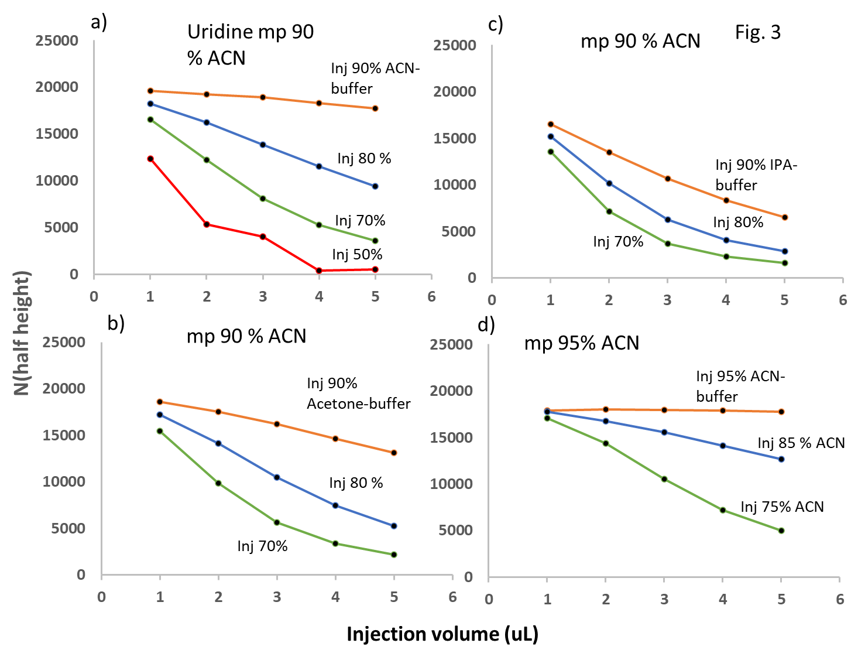

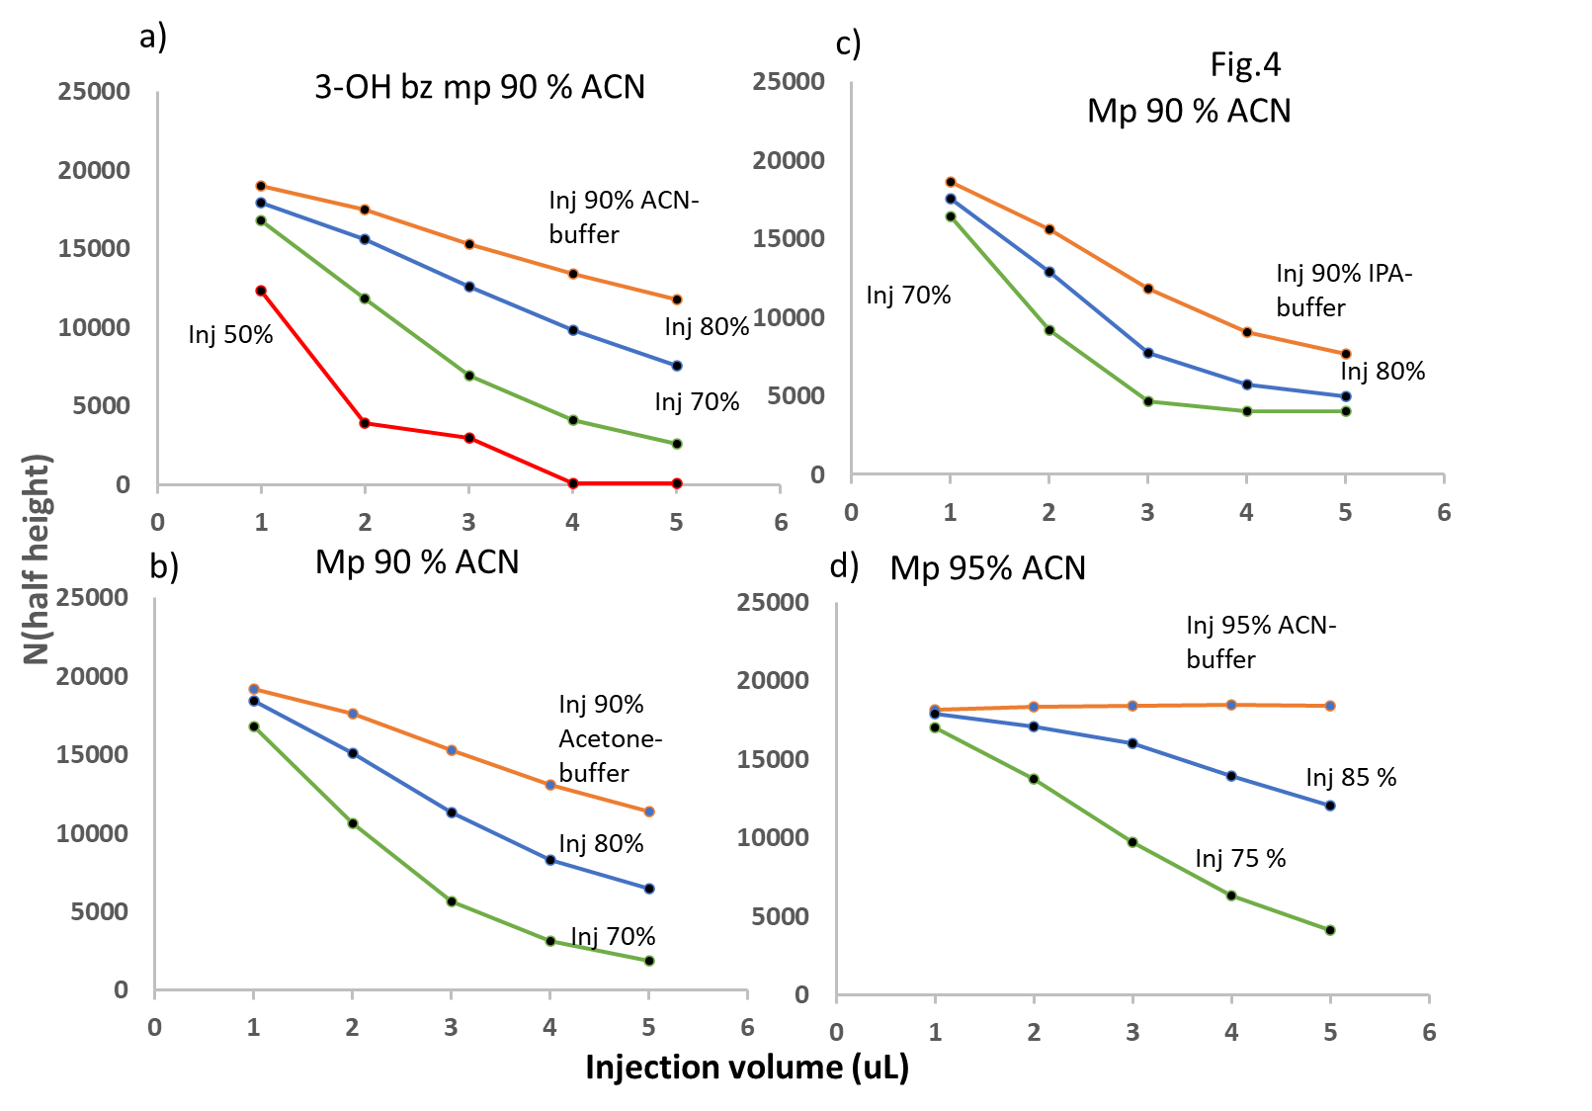

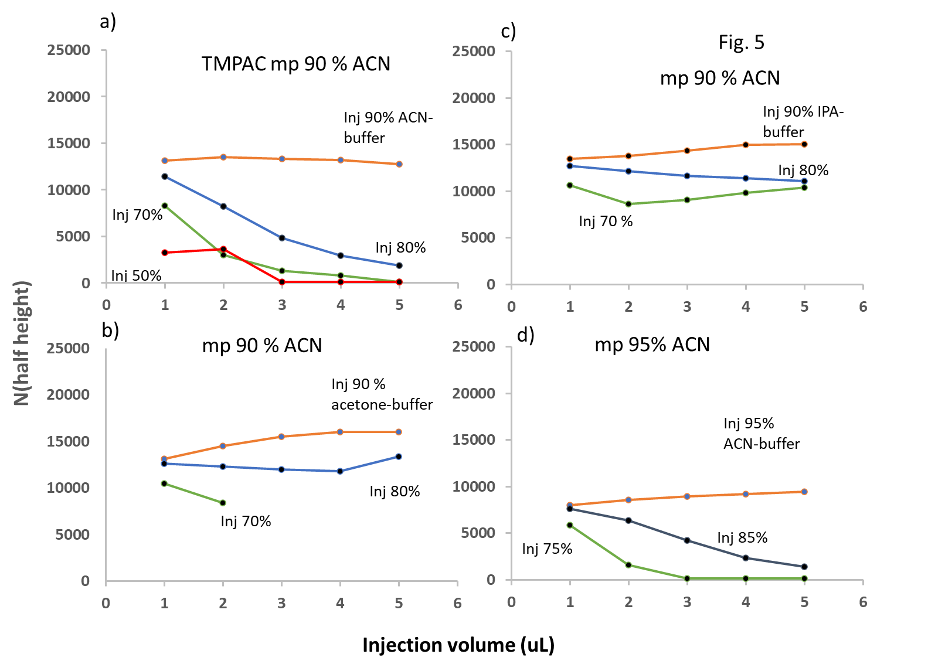

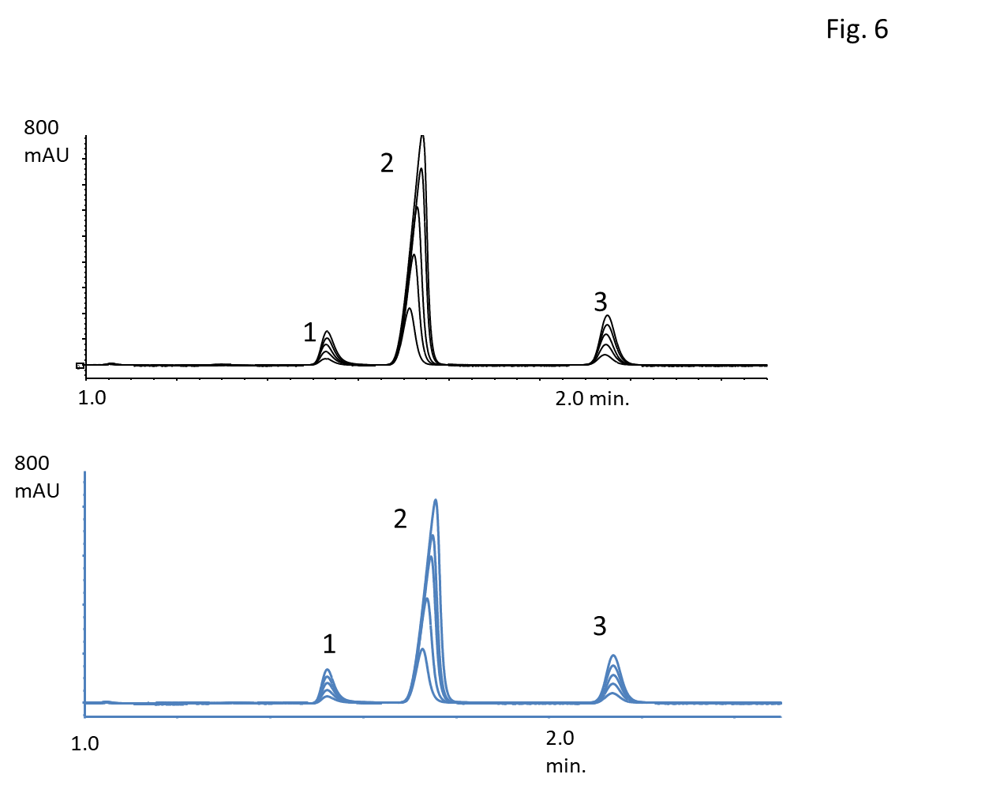

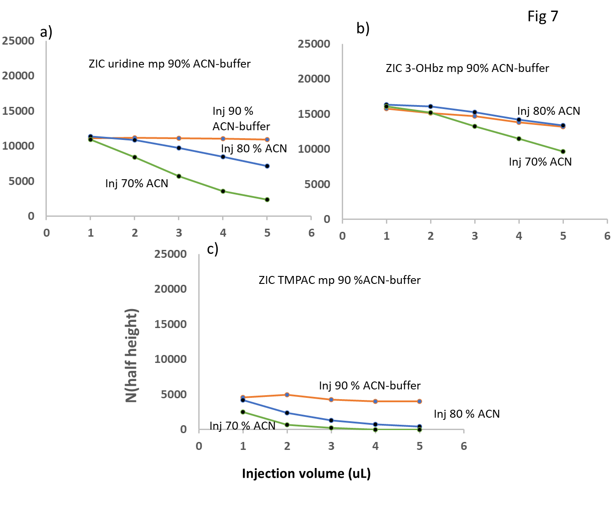

Table 1 Effects of sample volume and mass on column efficiency

|  |  |  |  |  |
| --- | --- | --- | --- | --- |
| **Inj solv 90% ACN** | **Injected mass (ng)** | **TMPAC** | **3-OH benzoic** | **Uridine** |
| 1 uL 20 ppm | 20 | 13,100 | 19,000 | 19,500 |
| 5 uL 20 ppm | 100 | 12,800 | 11,800 | 17,700 |
| 1 uL 100 ppm | 100 | 14,600 | 12,600 | 19,300 |
| **Inj solv 70% ACN** |  |  |  |  |
| 1 uL 20 ppm | 20 | 8,420 | 16,700 | 16,600 |
| 5 uL 20 ppm | 100 | 100 | 2,610 | 3,550 |
| 1 uL 100 ppm | 100 | 8,670 | 11,200 | 16,700 |