**An approach for developing probabilistic models for temperature-dependent properties of construction materials from fire tests and small data**

**G. Karaki1*, M.Z. Naser2,3**

1Assistant Professor, Department of Civil and Environmental Engineering, Birzeit University, Birzeit, Palestine

E-mail: [gkaraki@birzeit.edu](mailto:gkaraki@birzeit.edu)

2Assistant Professor, School of Civil & Environmental Engineering and Earth Sciences (SCEEES), Clemson University, USA

3AI Research Institute for Science and Engineering (AIRISE), Clemson University, Clemson, SC, USA

E-mail: [mznaser@clemson.edu](mailto:mznaser@clemson.edu), Website: [www.mznaser.com](http://www.mznaser.com)

*Corresponding author

**Abstract**

Probabilistic approaches provide a more realistic look into assessing structures under fire conditions and overcome some limitations observed in the more traditional (deterministic) approaches. These approaches have also been introduced to the fire engineering domain, e.g., fire probabilistic risk analysis and probabilistic structural fire engineering. In order to perform probabilistic-based analysis, temperature-dependent probabilistic models for material properties are needed. This paper presents a methodology to develop temperature-dependent probabilistic models for the thermal and mechanical properties for commonly used construction materials, including normal-strength, high-strength, and high-performance concrete and mild, high-strength, and cold-formed steels. The presented approach analyzes a comprehensive list of surveyed experimental data at different temperature groups, tests the goodness of fit for a number of distributions, and derives a continuous function to quantify temperature-dependent parameters of the distribution. In addition, the newly derived models are also compared against those adopted by fire codes, and standards and others derived using machine learning. The newly developed models will complement existing efforts to facilitate probabilistic performance-based structural fire engineering.

*Keywords*: fire, probabilistic models, material properties, approach

**1. Introduction**

The structural assessment for buildings exposed to fire requires knowledge of fire characteristics, building layout, loading conditions, and properties of present construction materials 1. While fire resistance evaluation primarily favors deterministic approaches to assess fire response of structural systems, temperature-dependent material models for properties of the different construction materials are not always available with high confidence. Codes, standards and reports, i.e., ASCE manual on structural fire protection 2, ACI guide 3, Eurocode 2 4 and Eurocode 3 5, Harmathy 6, Bennetts 7, Schneider 8, and Anderberg 9, documented, surveyed, and discussed the mechanical and thermal properties of the different building materials. Models for the thermal and mechanical properties of some building materials at elevated temperatures can be found in ASCE 10, Eurocode 2 4, and Eurocode 3 5. In general, these are developed as a function of temperature in the temperature range of (0 – 1000 oC). It should be noted that most of the codes and standards relationships for the thermal and mechanical properties at elevated temperatures present the averages of surveyed observations 3. Furthermore, the material properties at elevated temperatures data are based on steady-state and transient state tests and sometimes a combination of both 11. Most codes and standards, e.g., Eurocode 2 4, offer no distinction between High-Strength Concrete (HSC) and Normal-Strength Concrete (NSC) in their fire design provisions and no specific information on whether the design rules were specified for concrete under service load 11. Thus, engineers often utilize such material models adopted in fire codes and standards, which are developed using material tests undertaken in the late 1980s-2000s and belonged to varying testing procedures and different geographical regions 12. Practically speaking, such models may prove outdated and could potentially and adversely affect the reliability of the fire structural capacity assessment.

The open literature offers models for temperature-dependent properties of assumed typical construction materials, such as normal-strength concrete and steel 13,14. A limited number of published works (e.g. 12,15–19 proposed temperature-dependent material models for modern materials used in the construction industry, e.g., high-strength concrete and high-strength steel. Much of the reviewed models were arrived at via small-scale material tests – often on a limited number of specimens and confined into a particular testing methodology 20.

More recently, probabilistic approaches have been introduced to fire engineering, e.g., probabilistic fire risk analysis (PRA) and more extended probabilistic structural fire engineering (PSFE) 21. The probabilistic analysis provides a more realistic look into the assessment of structures under fire conditions, and it aims to overcome some of the limitations observed in the more traditional (deterministic) approaches by including uncertainties stemming from the simplifications and assumptions used in systems analysis and design processes. Van Coile et al. 22 provide discussions and clarifications related to probabilistic risk assessment (PRA), which is usually used as a tool for performance-based design in fire safety engineering. Furthermore, the paper presents a hierarchy of the different acceptance concepts. Shrivastava et al. 23 adapted the Performance-Based Earthquake Engineering framework for application to structural fire engineering, which required identifying potential fire severity measures. The developed framework facilitates the evaluation of the damage probability or failure probability of a structure due to a probable fire hazard within the framework of PSFE. Gernay et al. 24 present frameworks for PSFE and development of fragility curves which are essential to evaluate the probabilistic vulnerability of structural members and systems exposed to fire scenarios. The techniques developed in this paper help establish reliability levels used to assess the resilience for the different fire scenarios. The probabilistic modeling and analysis frameworks and techniques require the inclusion of uncertainties. Such uncertainties can broadly be grouped under two categories: model and parameter (variable) uncertainties.

Model uncertainty is related to the mathematical model of the engineering problem, while parameter uncertainty is linked to uncertainty in variable estimates (which is tied to the amount and quality of collected information for the input variables 25. Building on the motivation of this work, this study aims to examine the uncertainty in material models pertaining to material properties (i.e., falls within the category of variable uncertainty). Therefore, to include their uncertainties in assessing the structural capacities of fire-damaged buildings, there is a need to derive temperature-dependent probabilistic models for temperature-dependent material properties.

Some research works have explored the notion of uncertainty within the variables defining thermal and mechanical properties of typical construction materials (i.e., normal-strength concrete and mild steel) and thermal properties of insulating materials, e.g. 24,26–28. However, a smaller number of research works derived temperature-dependent probabilistic models for the construction material properties. In one notable study, Khorasani et al. 29 developed probabilistic models for the mechanical properties of mild steel and the thermal properties for insulating materials using a Bayesian statistical approach. The mechanical properties of mild steel and normal-strength concrete were also examined by Qureshi et al.30. These researchers developed probabilistic temperature-dependent material models using fitted continuous probability distribution functions. Furthermore, probabilistic models for the thermal properties for normal-strength concrete were developed by Jovanović et al. 31 and Karaki et al. 32.

This paper adopts probabilistic approaches as in Qureshi et al. 30 to develop temperature-dependent probabilistic models for material properties. It also provides probabilistic models for the properties of a variety of cementitious and metallic construction materials. These models were developed using a comprehensive list of surveyed experimental data for the thermal and mechanical properties of Normal-Strength Concrete (NSC), High-Strength Concrete (HSC), High-Performance Concrete (HPC), Mild Steel (MS), High-Strength Steel (HSS), and Cold-Formed Steel (CFS). The newly developed models will complement existing efforts to facilitate probabilistic performance-based structural fire engineering.

**2. Data collection of temperature-dependent material properties**

The properties of construction materials are usually tested using small-scale specimens, i.e., concrete cubes/cylinders of metal coupons. The tested specimens are heated uniformly to a specified temperature using furnaces or electric ovens and loaded until failure. The majority of the data surveyed were obtained from steady-state and transient tests[1] and found in the following research works 33,34,43–52,35,53–62,36,63–71,37–42.

After examining the different publications on temperature-dependent material properties, it was observed that researchers were using different specimen sizes, boundary conditions, specified heating and cooling rates, and loading conditions. This reflects the lack of an international and well-established standardized procedure to test cementitious and metallic specimens to evaluate the temperature-dependent material properties 12,20,72,73. A review of the experimental data on the behavior of construction materials can be found in multiple publications, e.g. 12,18,19,74–77.

**3. Methodology for Development of Probabilistic Models:**

Probabilistic material models are continuous models that derive temperature-dependent functions for a set of parameters defining the fitted probability distribution functions. The methodology comprises the following steps:

1. Survey and collect the data from the open literature
2. Choose a set of distribution functions to be tested for the data fitting
3. Check the goodness of fit for the data points considering the selected distribution functions considering all temperature points
4. Develop a regression model for the parameters defining the best-fit distribution function
5. Document the distribution function and use it to create samples of the material property

*Survey and collect experimental data:* for most of the material properties examined, a minimum of eight tests were collected and used to derive the probabilistic material models. Every test surveyed the related material property at target temperature points (i.e., 25, 100, 200… 1000°C). All selected tests were mainly conducted within the last two decades and naturally varied by origin institutes and laboratories. The aforenoted “selection criteria” for the collected tests ensured that data used in deriving the probabilistic models represent current advances in construction material sciences, and reflect materials available in the market. This will yield relevant probabilistic models with a wide range of applications.

*Choose the family of distribution functions:* the compiled data for mechanical and thermal properties contains property values for target (specific) temperatures in the range of 25, 100, 200, 300 … 1000ºC. Every data set was fitted to basic distribution functions that are: 1) commonly used, and 2) require a small number of parameters (with a maximum of two depending on the distribution function). Six distribution functions were tested for every property, namely: Normal, Lognormal, Logistic, Loglogistic, Birnbaum-Saunders, Weibull distributions.

*Check goodness of fit:* generally speaking, the sample size of the available data sets is small (as noted in parallel works 12,18,19); therefore, the goodness of fit would rely on a multi-step assessment procedure where the available statistical tools were combined with the modeler’s judgment on available data. From this perspective, the best model is the one that delivers an acceptable description of the data while using a minimum number of parameters to yield a compact representation. The most popular penalized-likelihood criteria for model selection are the Akaike Information Criterion (AIC) and Bayesian Information Criterion (BIC), 78. Despite the differences in their assumptions and theoretical background, their difference in practice is the size of the penalty on free parameters. BIC penalizes model complexity more than AIC, which means BIC and AIC disagree when AIC chooses a more complex model to describe the data. Furthermore, BIC is more consistent than AIC when data size is large 78,79. As mentioned in the previous step, basic models with equal complexity were selected as candidate models. Building on the fact that the sizes of the surveyed data are small, the AIC criteria were chosen to check the goodness of fit for the candidate models. AIC estimators indicate the model with the lowest expected information loss. Furthermore, to account for the effect of small data sizes on likelihood estimation, a corrected Akaike estimator (*AICc*) is often used, which adds the term $\left(\frac{2V(V+1)}{(n-V-1)}\right)$ to penalize the small data size. *AICc* estimator is expressed in Equation (1),

${AIC}_{c}=-2logL+2V+\frac{2V(V+1)}{(n-V-1)}$ (1)

where *L* is the maximum likelihood for the candidate model, *V* is the number of the model’s parameters, and *n* is the number of samples.

The model with a smaller value of *AICc*is considered the one with the lowest information loss. However, *AICc*values can be transformed to conditional probabilities for each model; these probabilities are referred to as Akaike weights 79, Equation (2).

(2)

where *AICc* is the difference between the *AICc*of the *ith* model and the minimum value of *AICc* for all candidate models, and *K* is the number of all candidate models. Akaike weight (*wi*) represents the probability that the *ith* model has the lowest information loss given the data and the other candidate models examined 79. The models with high values of Akaike weights are considered the best candidates to represent the data sets. The weights were used to select a subset from all model candidates for further examination. The approach aims to develop material properties models at high temperatures. Therefore, the AICc estimators were calculated at every temperature point. An overall AICc measure for the candidate model was then calculated as the sum of AICc estimators at the examined temperatures and used in the model comparison.

*Develop continuous models for the parameters of selected probability distribution functions:* Regression models are then used to derive a relation for the parameters defining the selected distribution functions as a continuous function of temperature. Scatter plots of distribution parameters were the initial tool to check the quality of the regression model and were used to avoid the overfitting of the data (variance). Furthermore, the coefficient of determination R2 was used to check the approximation quality and prevent underfitting the data (bias), Equation (3). Other supplementary metrics (such as R) can also be used as per the modeler’s preference.

$R^{2}=1-\frac{{SS}_{res}}{{SS}_{tot}}$ (3)

${SS}_{res}=\sum_{i=1}^{n}{(y_{i}-f_{i})^{2}}$ (3.a)

${SS}_{tot}=\sum_{i=1}^{n}{(y_{i}-\overline{y})^{2}}$ (3.b)

where *yi* is the data point, $\overline{y}$ is the mean value of data points, and *fi* is the fitted data point.

Generally, and given their simplicity, polynomial functions with first, second, and third orders were tested as candidates for the regression model. Higher-order polynomials were avoided as overfitting was noticed. Furthermore, a general flattening effect was apparent in the scatter plots of the data points for yield strength and modulus of elasticity of the steel, which polynomial functions could not model. Therefore, an exponential function was introduced for their models to even the peaks of the polynomial function.

*Document the probabilistic model:* A subset of the candidates to define the probabilistic models were selected following the goodness of fit for the distribution function and the regression models for distribution parameters. A final check for conditions on the values of the material properties (when required) was performed. For example, the data available for concrete strength is normalized by the strength at ambient temperature; thus, experimental data were positive values. The selected model needed to produce positive values. Furthermore, if the data sets prove to be too small to indicate the best fit for the candidate models, then a normal or lognormal distributions were chosen based on data points. The candidate from the subset with the best-fit estimators with realistic values for the material property was selected, visualized, and documented.

**4. Developed Models**

The methodology is illustrated in detail for the compressive strength of normal-strength concrete and modulus of elasticity of mild steel as dedicated examples. Furthermore, the developed models for the thermal and mechanical material properties for Normal-Strength Concrete (NSC), High-Strength Concrete (HSC), High-Performance Concrete (HPC), Mild Steel (MS), High-Strength Steel (HSS), and Cold-Formed Steel (CFS) are presented in the following subsections.

*4.1 Implementation*

The data points for the material property were fitted at every temperature point to each one of the following distributions; Normal, Lognormal, Logistic, Loglogistic, Birnbaum-Saunders, and Weibull. The *AICc* estimator of prediction error was calculated at every temperature point. An overall *AICc* measure for the candidate model was then calculated as the sum of *AICc* estimators at the examined temperatures, for which the Akaike weight was calculated. Akaike weight presents the conditional probability that the candidate model describes the data with the lowest data loss. Table 1 shows the results for fitting the data for the compressive strength of normal-strength concrete. A subset from candidate models was chosen based on the values of Akaike weights. Every subset contained two to three candidates’ models that had the relatively highest Akaike weights, with an assumed 0.2 weight as a lower limit. Accordingly, from the six distribution functions, a subset of three distributions, i.e., Lognormal, Birnbaum-Saunders, and Loglogistic distributions, were selected to be further examined in the following step: modeling the distribution functions and regenerating the data points using the regression models. The model with the highest weight was tested first. If the regression models for the distribution variables were of relatively good quality and presented the original data, then this distribution and the regression models of its parameters were accepted and documented. Otherwise, the second-best distribution was tested, and so forth.

Table 1. The *AICc* estimators and Akaike weights for the fitted distribution functions of compressive strength for normal-strength concrete

|  |  |  |  |  |  |
| --- | --- | --- | --- | --- | --- |
| Distribution | *AICi* | *wi* | Distribution | *AICi* | *wi* |
| Normal | -207.91 | 0.12 | Loglogistic | -208.89 | **0.20** |
| Lognormal | -209.83 | **0.31** | Weibull | -205.18 | 0.03 |
| Logistic | -206.28 | 0.05 | Birnbaum-Saunders | -209.66 | **0.29** |

Following the above explanation, the lognormal distribution was examined first for the compressive strength of normal-strength concrete. This distribution is defined using two parameters; mean value (**) and standard deviation (**). The distribution parameters-temperature relationship was modeled using different degrees of polynomial functions. The coefficient of determination (R2) and scatter plots were used to assess the quality of the developed regression models. Equation (4) describes the ** and ** values as a function of temperature.

$μ=0.0262-0.5103{∙T}_{std}+1.3704∙T_{std}^{2}-2.7088∙T_{std}^{3}$ (4a)

$σ=0.0650-0.1172{∙T}_{std}+0.6207∙T_{std}^{2}$ (4b)

*Tstd* is the standardized temperature, i.e. $T_{std}={{(T}_{i}-T_{min})}/{{(T}_{max}-T_{min})}$, where *Ti* is the examined temperature point, *Tmin* is the minimum temperature in data set, and *Tmax* is the maximum temperature in the data set. By using the standardized temperatures’, the determination of regression coefficients was more stable. The coefficient of determination for the regression model of ** is 0.99 and of ** is 0.96.

Figure1a and Figure 1b show the distribution parameters with their approximated values, and Figure 1c presents the 5%, 50% and 95% percentiles of the probabilistic models using the fitted distribution function and its modeled parameters.

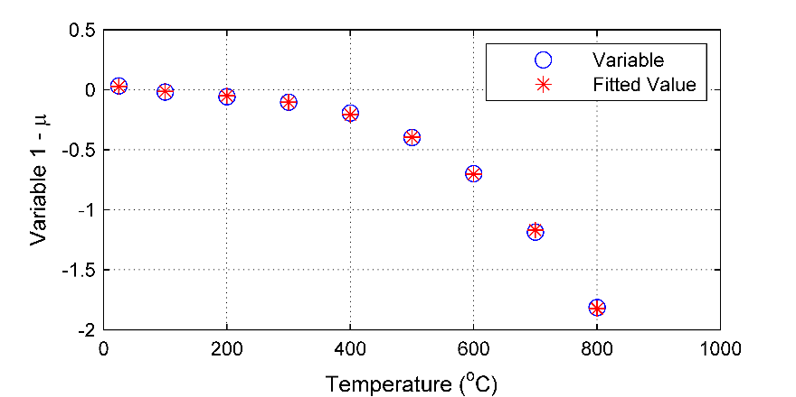

1. Regression model for variable 1 – mean value (

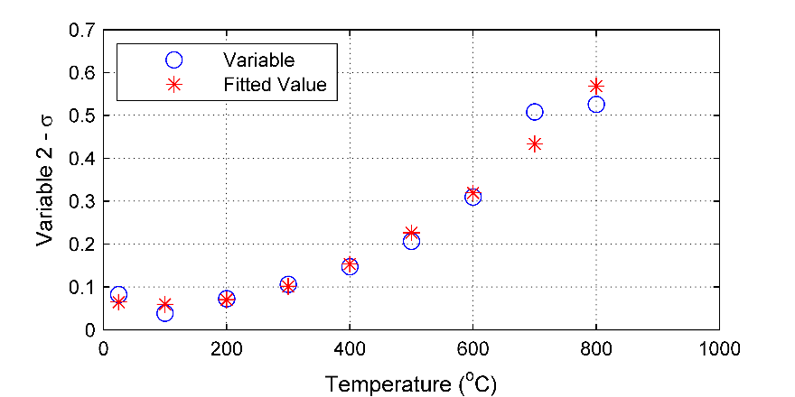

1. Regression model for variable 2 – standard deviation (

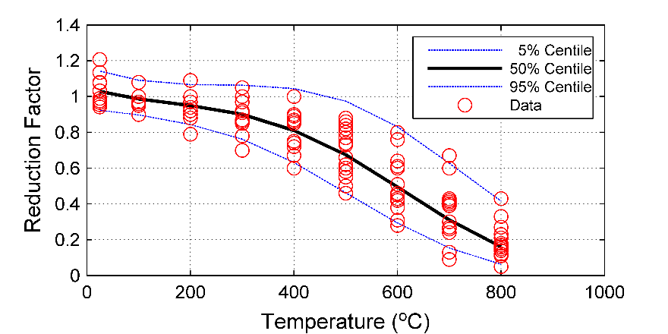

1. Developed probabilistic model using approximated ( and )

Figure 1. Probabilistic models for NSC compressive strength using lognormal distribution fit for experimental data

Another example for applying the methodology is developing a probabilistic model for the modulus of elasticity for mild steel. The *AICc* estimators and Akaike weights were calculated and presented in Table 2.

Table 2. The *AICc* estimators and Akaike weights for the fitted distribution functions of modulus of elasticity for mild steel

|  |  |  |  |  |  |
| --- | --- | --- | --- | --- | --- |
| Distribution | *AICi* | *wi* | Distribution | *AICi* | *wi* |
| Normal | -165.87 | 0.03 | Loglogistic | -163.75 | 0.01 |
| Lognormal | -167.93 | 0.09 | Weibull | -171.02 | **0.54** |
| Logistic | -161.49 | 0.01 | Birnbaum-Saunders | -169.74 | **0.28** |

The two candidate models for modulus of elasticity data were Weibull and Birnbaum-Saunders distributions. A (scale factor) and B (shape factor) are the variables that define Weibull distribution, and they are positive numbers. The best-fit continuous functions for the shape factor, which had a coefficient of determination of 0.59, produced negative or very small values, Figure 2b, at temperatures 600oC, 700oC, 800oC, 900oC.

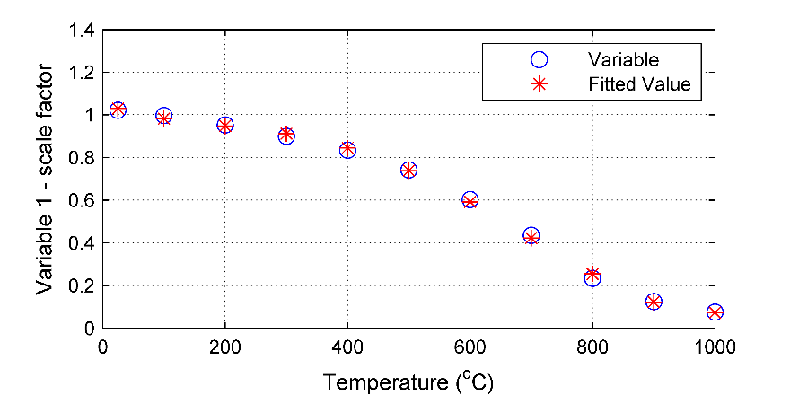

1. Regression model for variable 1 - scale factor (A)

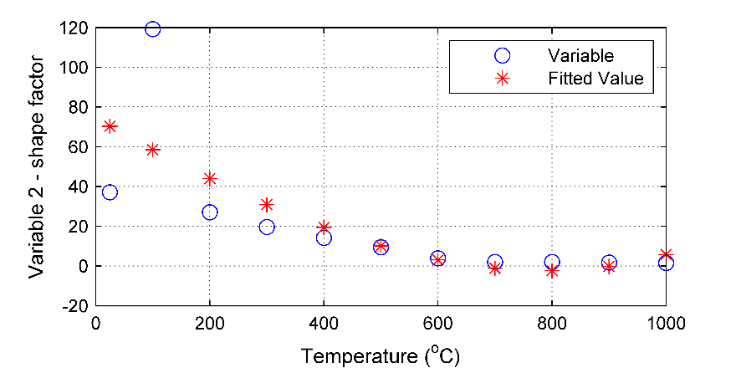

1. Regression model for variable 2 - shape factor (B)

Figure 2. Models to predict A (variable 1) with (R2 = 0.99) and B (variable 2) with (R2 = 0.59) for the Weibull distribution fit for the data of modulus of elasticity of mild steel

Therefore, the probabilistic model in Figure 3a for the modulus of elasticity assuming that the data followed a Weibull distribution and using the developed models for its parameters failed to present the material property at these temperatures (i.e., 600oC, 700oC, 800oC, 900oC).

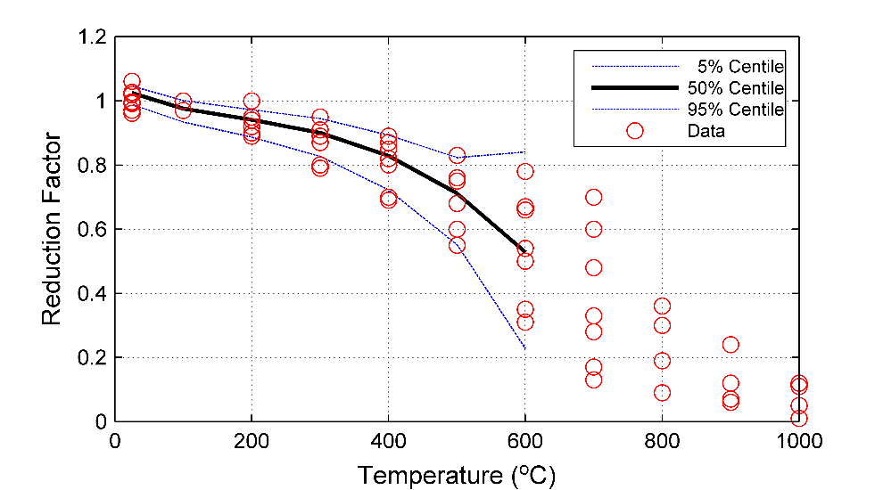

1. assuming that data points follow Weibull distribution

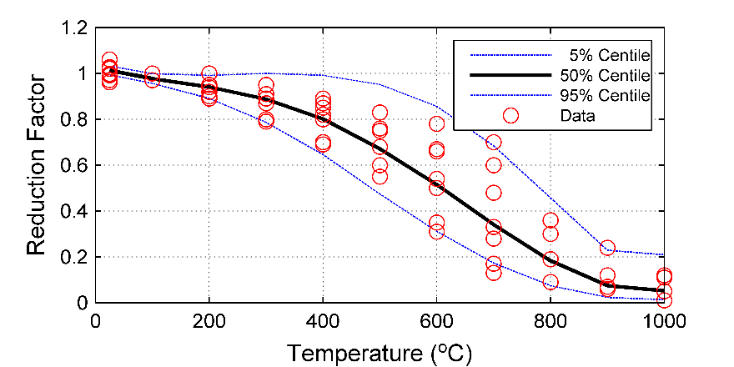

1. assuming that data points follow Birnbaum-Saunders distribution

Figure 3. Probabilistic model for modulus of elasticity for the mild steel

Based on this, the second-best candidate, Birnbaum-Saunders distribution, was examined and accepted to model the modulus of elasticity. Equation 5 documents the fit of the distribution parameters ** (scale factor) and ** shape factor  for Birnbaum-Saunders distribution, and Figure 3b shows the (5%, 50%, and 95%) percentiles of the probabilistic model.

$β=-152.3789+153.3916∙e^{T_{std}}+152.8007{∙T}_{std}-74.4257∙T_{std}^{2}+17.6276∙T_{std}^{3}$ (5a)

$γ=0.0116-0.0527{∙T}_{std}+0.9434∙T_{std}^{2}$ (5b)

The aforenoted methodology was applied to develop probabilistic models for the thermal and mechanical properties for a collection of construction materials. The followings are the developed models presented by the examined property.

*4.1.1 Compressive strength of concrete:*

Table 3. Models for the variables defining the probabilistic models for the compressive strength of concrete

|  |  |  |  |
| --- | --- | --- | --- |
| Type | Dist. | Model | R2 |
| NSC | LogNorm. | $$μ=0.0262-0.5103{∙T}_{std}+1.3704∙T_{std}^{2}-2.7088∙T_{std}^{3}$$ $$σ=0.0650-0.1172{∙T}_{std}+0.6207∙T_{std}^{2}$$ | 0.99  0.96 |
| HSC | Weibull | $$A=1.000+0.0789{∙T}_{std}-1.4130∙T_{std}^{2}+0.4507∙T_{std}^{3}$$ $$B=13.0241-29.5246{∙T}_{std}+18.7818∙T_{std}^{2}$$ | 0.99  0.79 |
| HPC | LogNorm. | $$μ=-0.0846+0.3258{∙T}_{std}-1.8333∙T_{std}^{2}$$ $$σ=0.0931+0.2613{∙T}_{std}+0.4448∙T_{std}^{2}$$ | 0.98  0.99 |

The developed probabilistic models are presented in Table 3, and Figure 4 depicts the attained reduction factor for compressive strength. This factor is defined as the compressive strength at a target temperature normalized by the compressive strength at ambient temperature. The surveyed experimental data provides this factor at different temperatures. The variation of data points at ambient temperature was obtained from the probabilistic models offered by 80. The median and the 5% and 95% percentiles of reduction factors are shown in Figure 4. The data and the developed model suggest that the compressive strength of normal-strength concrete has a lower rate of strength loss when compared with high-strength concrete up to the temperatures 400-500oC. However, the strength loss rate was similar at higher temperatures (T>400oC). The leading cause of strength loss above 400oC is the loss of bond between aggregate and cement paste and physio-chemical degradation induced by a rise in temperature, which is similar for both concrete 81. In general, high-performance concrete shows the same behavior as high-strength concrete. However, a lower rate of strength loss above 400oC was observed; this may depend on the mixture characteristics used to enhance the performance of the concrete.



1. for NSC

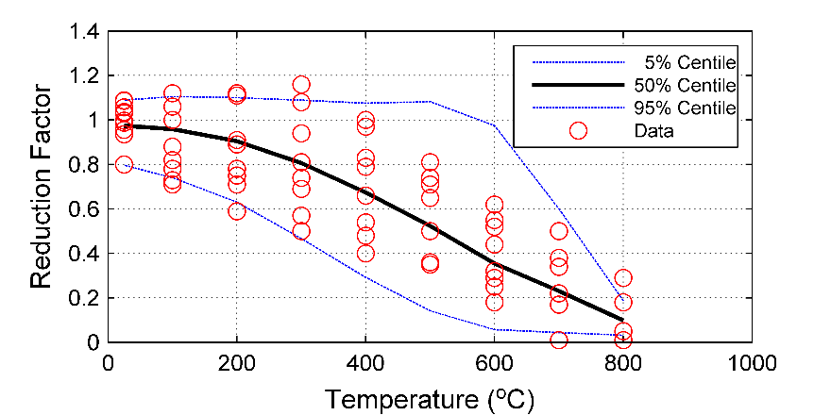

1. for HSC

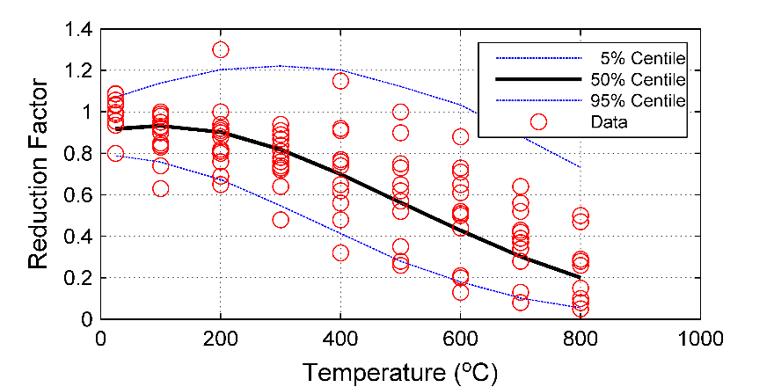

(c) for HPC

Figure 4. Probabilistic models for the compressive strength of concrete

*4.1.2 Modulus of elasticity of concrete*

The available data for the concrete modulus of elasticity is presented as a reduction factor. This reduction factor is the modulus of elasticity normalized by the modulus of elasticity at ambient temperature. The variation of data points at ambient temperature was obtained from the probabilistic models offered by 80. The developed probabilistic models following the explained methodology are documented in Table 4 and Figure 5.

Table 4. Models for the variables defining the probabilistic models for the modulus of elasticity of concrete

|  |  |  |  |
| --- | --- | --- | --- |
| Type | Dist. | Model | R2 |
| NSC | Weibull | $$A=1.0464-0.4376{∙T}_{std}-1.6226∙T_{std}^{2}+1.1464∙T_{std}^{3}$$ $$B=9.2155+12.0703{∙T}_{std}-57.4990∙T_{std}^{2}+38.0620∙T_{std}^{3}$$ | 0.99  0.78 |
| HSC | LogNorm. | $$μ=-0.0235-0.2987{∙T}_{std}-2.5918∙T_{std}^{2}+0.7048∙T_{std}^{3}$$ $$σ=0.1624+0.3306{∙T}_{std}+0.2889∙T_{std}^{2}$$ | 0.99  0.72 |
| HPC | Weibull | $$A=1.0726-0.8216{∙T}_{std}-0.1858∙T_{std}^{2}$$ $$B=10.2334-17.9296{∙T}_{std}+8.6871∙T_{std}^{2}$$ | 0.99  0.74 |

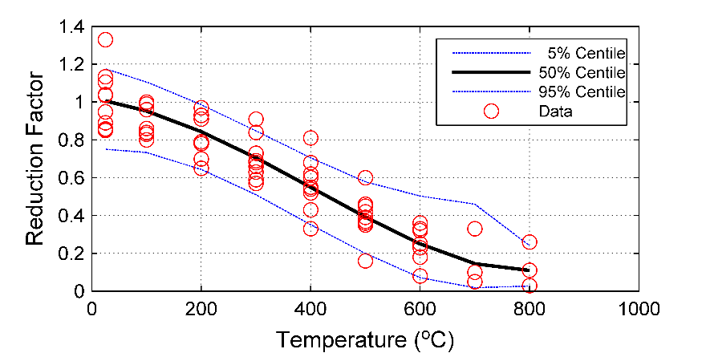

1. for NSC

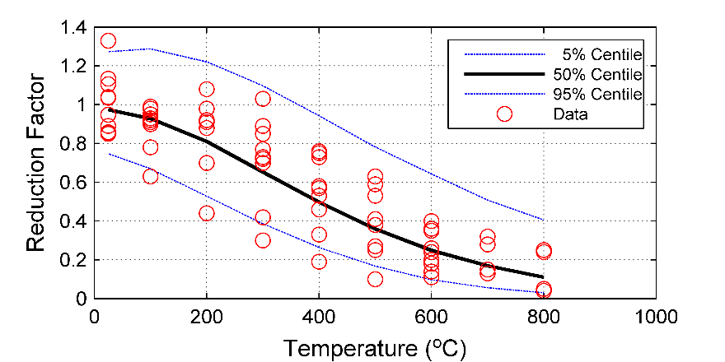

1. for HSC

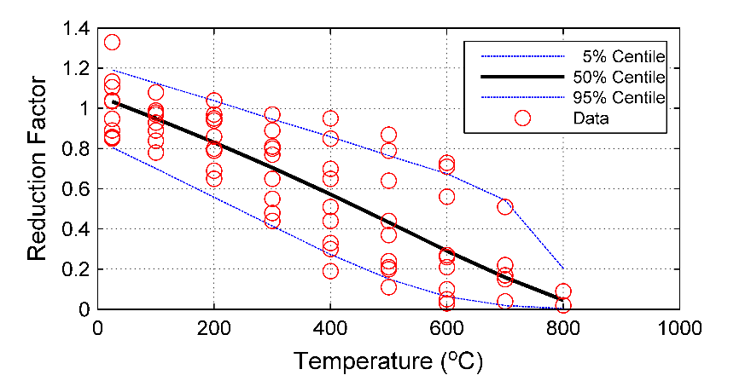

1. for HPC

Figure 5. Probabilistic models for the modulus of elasticity of concrete

After examining the data and developed models in Figure 5, the degradation of the modulus was noticed to occur beyond the temperature of 100oC for normal and high-strength concrete. However, normal-strength concrete retains its modulus better than high-strength concrete at temperatures lower than 400oC. It was observed, from the data, a higher variation of modulus values in high-strength and high-performance concrete within the temperature range [400oC - 600oC]. Furthermore, high-performance concrete showed a constant degradation rate in the modulus values. In general, the strength of concrete did not significantly affect modulus-temperature response.

*4.1.3 Thermal conductivity of concrete:*

Overall, the scatter in the data points of the thermal conductivity is higher for normal-strength concrete, and this affected the quality of the regression model for one of the parameters defining the probabilistic model for the conductivity of normal-strength concrete, Table 5, and Figure 6.

Table 5. Models for the variables defining the probabilistic models for thermal conductivity of concrete

|  |  |  |  |
| --- | --- | --- | --- |
| Type | Dist. | Model | R2 |
| NSC | Weibull | $$A=1.7106-1.5246{∙T}_{std}+0.5222∙T_{std}^{2}$$ $$B=4.8809+3.6512{∙T}_{std}-6.8362∙T_{std}^{2}$$ | 0.98  0.65 |
| HSC | Normal | $$μ=2.9885-6.5231{∙T}_{std}+9.5980∙T_{std}^{2}-5.3069∙T_{std}^{3}$$ $$σ=0.3689-0.5716{∙T}_{std}+0.4185∙T_{std}^{2}$$ | 0.98  0.88 |

The lower the mix water content and the denser the microstructure, the higher the conductivity of the hardened concrete; therefore, the conductivity at ambient temperature is higher for high-strength concrete, Figure 6. In addition, the experimental data showed that the decrease of the thermal conductivity with temperature was higher for high-strength concrete than normal-strength concrete. These observations had been captured by the developed models, as shown in Figure 6.

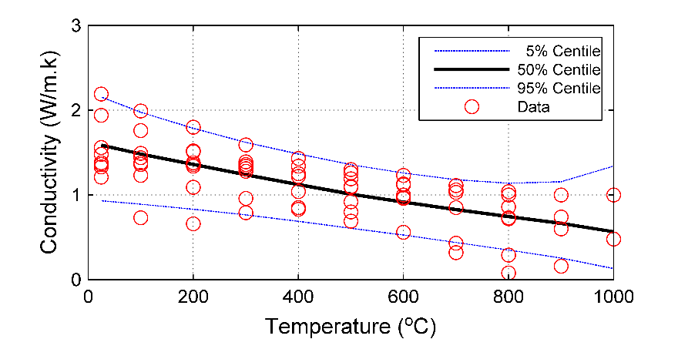

1. for NSC

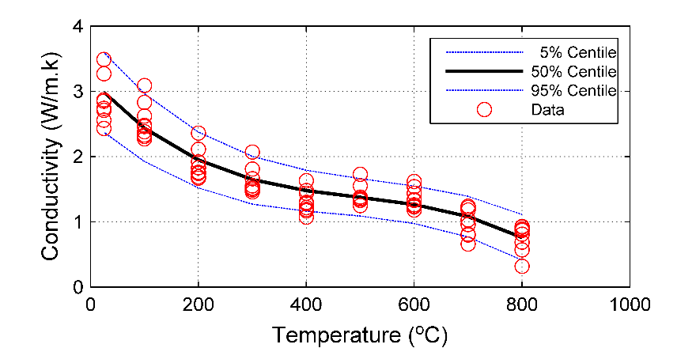

1. for HSC

Figure 6. Probabilistic models for the thermal conductivity of concrete

*4.1.4 Specific heat of concrete:*

The developed probabilistic models for the specific heat of concrete are presented in Table 6. The coefficient of determination for the standard deviation of lognormal distribution used in the probabilistic model for the specific heat of normal-strength concrete was low. This is due to the sudden sharp increase in the specific heat at 700oC stemming from exothermic reactions at the microstructure level often captured by some material models. The developed model predicts a slight rise at 700oC and captures a decrease in specific heat above this temperature. However, fire codes such as Eurocode 2 and the probabilistic model do not capture this sudden increase (see Figure 7).

Table 6. Models for the variables defining the probabilistic models for the specific heat of concrete

|  |  |  |  |
| --- | --- | --- | --- |
| Type | Dist. | Model | R2 |
| NSC | LogNorm. | $$μ=6.0345+1.1756{∙T}_{std}-0.2906∙T_{std}^{2}$$ $$σ=0.3894+0.5245{∙T}_{std}-0.6485∙T_{std}^{2}$$ | 0.93  0.15 |
| HSC | LogNorm. | $$μ=3.4580-15.7711{∙T}_{std}+25.9841∙T_{std}^{2}-13.1054∙T_{std}^{3}$$ $$σ=0.1087-0.3441{∙T}_{std}+0.5616∙T_{std}^{2}$$ | 0.85  0.95 |

In general, the experimental data for normal-strength concrete and high-strength concrete showed that the specific heat increases as temperature increases. For normal-strength concrete, a sharp rise was observed at 700oC as explained earlier; and for high-strength concrete rises and drops were observed at multiple temperatures; a rise was noticed at 100oC, a drop was seen at 400oC (decrease), and a sharp rise was noticed at 700oC (see Figure 7). Naus (2010) 81 reviewed concrete behavior and documented that the vaporization of free water happens at about 100oC, the dissociation of Ca(OH)2 happens at about 400oC - 500oC, and the alpha-beta quartz transformation in some aggregates happens at high temperatures. These may explain these rises and drops in the specific heat values. The behavior, in general, was depicted in the developed probabilistic models, as noted in Figure 7.

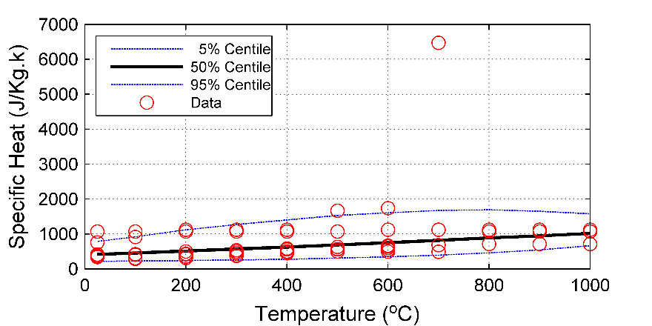

1. for NSC

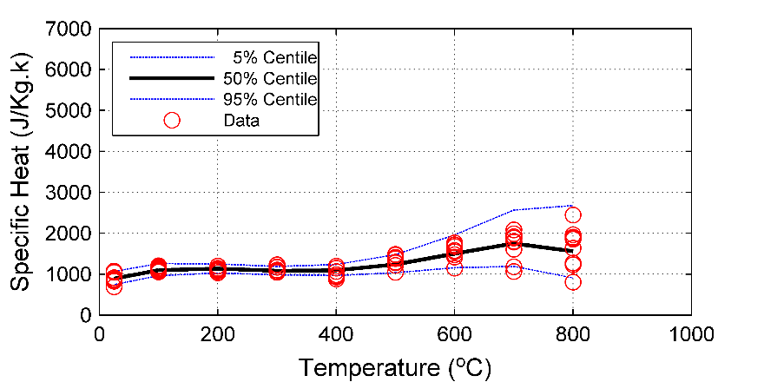

1. HSC

Figure 7. Probabilistic models for the specific heat of concrete

*4.1.5 Yield strength of steel:*

The experimental data for the yield strength was obtained as reduction factors. The variability in the data points at ambient temperature was obtained from 82. In general, the variation in the steel data is less than that of the concrete, reflecting the homogenous nature of steel as opposed to concrete. Following the data for mild steel (MS) and high-strength steel, the yield strength’s apparent loss starts at temperatures exceeding 300oC, Figure 8, which the model described in Table 7 depicts.

Table 7. Models for the variables defining the probabilistic models for the yield strength of steel

|  |  |  |  |
| --- | --- | --- | --- |
| Type | Dist. | Model | R2 |
| MS | Weibull | $$A=-313.6871+314.7100∙e^{T_{std}}+313.7510{∙T}_{std}-151.1840∙T_{std}^{2}+35.4004∙T_{std}^{3}$$ $$B=28.8804-65.9409{∙T}_{std}+40.8658∙T_{std}^{2}$$ | 0.99  0.87 |
| HSS | Weibull | $$A=-261.9452+262.9604∙e^{T_{std}}+262.4889{∙T}_{std}-127.8017∙T_{std}^{2}+30.5845∙T_{std}^{3}$$ $$B=27.2539-85.5850{∙T}_{std}+93.7015∙T_{std}^{2}-33.0861∙T_{std}^{3}$$ | 0.99  0.95 |
| CFS | Weibull | $$A=-83.0998+84.0975∙e^{T_{std}}+84.2817{∙T}_{std}-43.8306∙T_{std}^{2}+11.7404∙T_{std}^{3}$$ $$B=-6.7527∙{10}^{3}+6.8234∙{10}^{3}∙e^{T_{std}}+6.4732∙{10}^{3}{∙T}_{std}-2.7265∙{10}^{3}∙T_{std}^{2}+498.9117∙T_{std}^{3}$$ | 0.99  0.94 |

Based on the models in Figure 8, MS had a reduction factor of 0.91, 0.48, 0.08 at 300oC, 600oC, and 800oC, respectively. HSS had a reduction factor of 0.90, 0.42, 0.06 at the same temperatures, whereas CFS had reduction factors of 0.85, 0.34, 0.06. Therefore, the yield strength slightly depends on the type of material. Furthermore, high-strength and cold-formed steel had higher loss rates than mild steel.

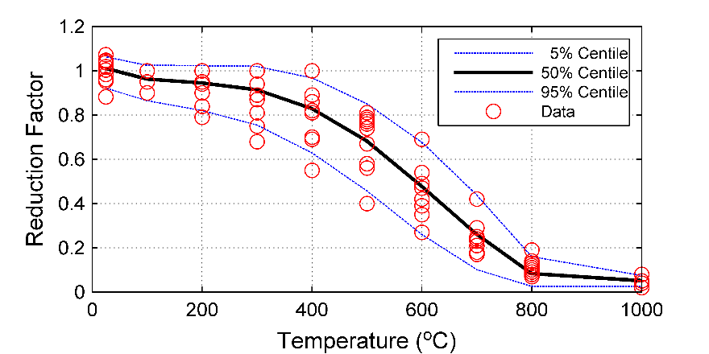

1. For MS

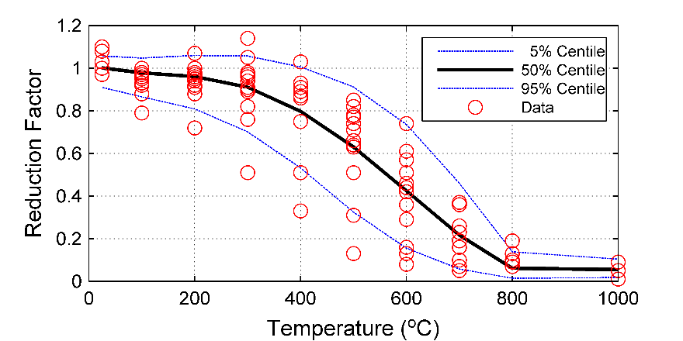

1. HSS

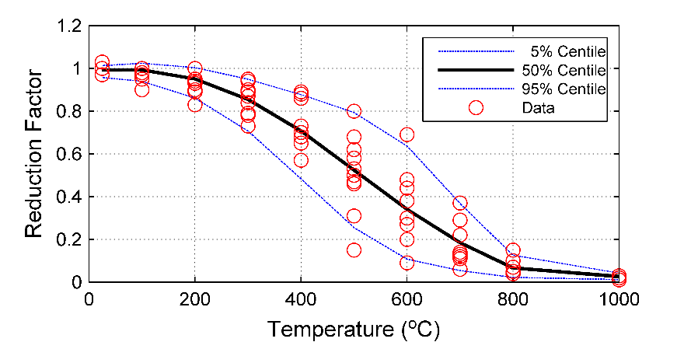

1. CFS

Figure 8. Probabilistic models for the yield strength of steel

*4.1.6 Modulus of elasticity of steel:*

After examining the data for the reduction factor of yield strength and modulus of elasticity, as can be seen in Figure 8 and Figure 9, it can be noticed that the variation in the data points is more significant at temperatures 400oC, 500oC, and 600oC. Furthermore, the variability in the data points at ambient temperature was obtained from 82. The developed probabilistic models are described in Table 8, and they capture this variation dependency on the temperature.

Table 8. Models for the variables defining the probabilistic models for the modulus of elasticity of steel

|  |  |  |  |
| --- | --- | --- | --- |
| Type | Dist. | Model | R2 |
| MS | Birnbaum-Saunders | $$β=-152.3789+153.3916∙e^{T_{std}}+152.8007{∙T}_{std}-74.4257∙T_{std}^{2}+17.6276∙T_{std}^{3}$$ $$γ=0.0116-0.0527{∙T}_{std}+0.9434∙T_{std}^{2}$$ | 0.99  0.92 |
| HSS | Weibull | $$A=-127.4544+128.4695∙e^{T_{std}}+128.3550{∙T}_{std}-63.9892∙T_{std}^{2}+15.8965∙T_{std}^{3}$$ $$B=36.8780-132.8149{∙T}_{std}+161.8747∙T_{std}^{2}-61.2240∙T_{std}^{3}$$ | 0.99  0.98 |
| CFS | LogNorm. | $$μ=3.6773-3.6953∙e^{T_{std}}-2.9402{∙T}_{std}-3.7561∙T_{std}^{2}+0.9260∙T_{std}^{3}$$ $$σ=0.0225+0.2367{∙T}_{std}+0.3619∙T_{std}^{2}$$ | 0.99  0.57 |

As one examines Figure 9, the modulus of elasticity for mild steel undergoes a lower loss than high-strength steel and cold-formed steel.



1. for MS

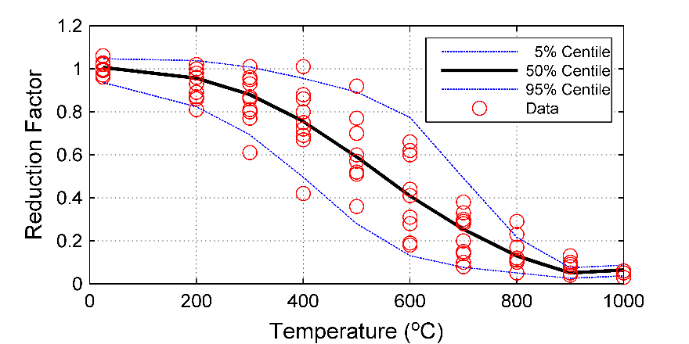

1. for HSS

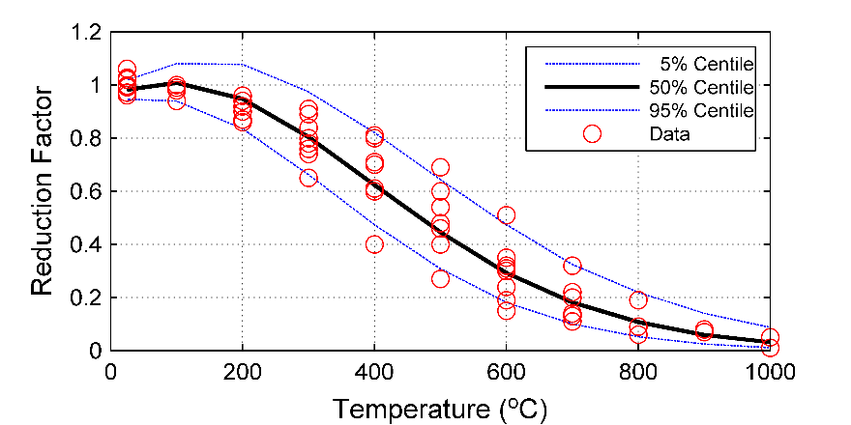

1. for CFS

Figure 9. Probabilistic models for the modulus of elasticity of steel

*4.1.7 Thermal conductivity of steel:*

The probabilistic models for the thermal conductivity of steel are described in Table 9 and depicted in Figure 10. The number of data points is small for high-strength steel, which affects the choice of the distribution function used in the probabilistic model. Normal distribution was chosen, and consequently, the quality of the fit was affected by this choice and the limited number of data points. It can be seen from Figure 10 that thermal conductivity decreases with temperature for the mild steel and high-strength steel. Furthermore, the decrease is higher in mild steel, but one must keep in mind that the data of high-strength steel is much-limited opposite to mild steel.

Table 9. Models for the variables defining the probabilistic models for thermal conductivity of steel

|  |  |  |  |
| --- | --- | --- | --- |
| Type | Dist. | Model | R2 |
| MS | LogNorm. | $$μ=3.9373-0.6906{∙T}_{std}+0.1568∙T_{std}^{2}$$ $$σ=0.0408+0.1664{∙T}_{std}-0.0182∙T_{std}^{2}$$ | 0.99  0.91 |
| HSS | Norm | $$μ=34.5748-1.9970{∙T}_{std}-0.8403∙T_{std}^{2}$$ $$σ=3.0993+0.3630{∙T}_{std}$$ | 0.72  -- |

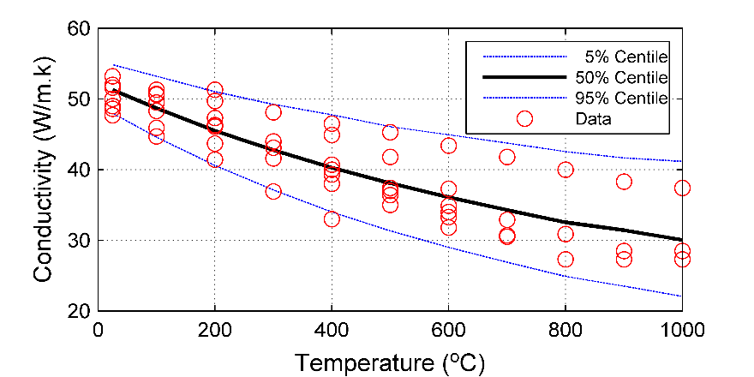

1. for MS

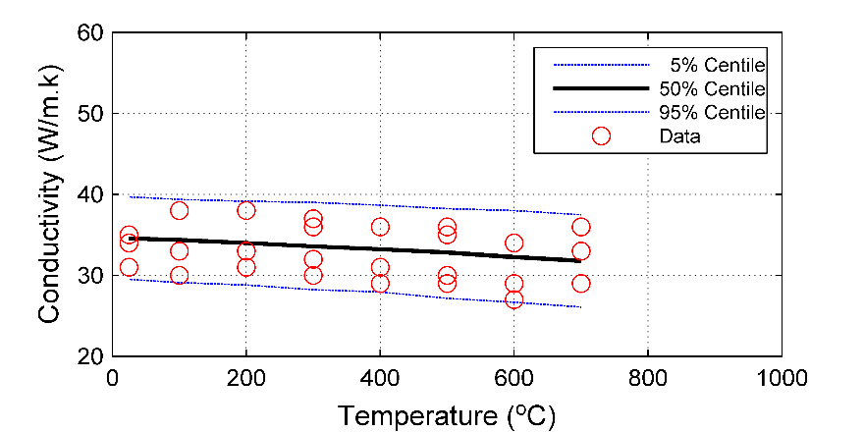

1. for HSS

Figure 10. Probabilistic models for thermal conductivity of steel

*4.1.8 Specific heat of steel:*

The data points for mild and high-strength steel’s specific heat were examined. The number of data points for high-strength steel is also small, affecting the distribution function's choice. A lognormal distribution is chosen for the probabilistic model for high-strength steel. Table 10 presents the probabilistic model for the specific heat, and the models are depicted in Figure 11.

Table 10. Models for the variables defining the probabilistic models for the specific heat of steel

|  |  |  |  |
| --- | --- | --- | --- |
| Type | Dist. | Model | R2 |
| MS | LogNorm. | $$μ=6.1412+0.0199{∙T}_{std}+3.1816∙T_{std}^{2}-2.9890∙T_{std}^{3}$$ $$σ=0.0602+0.0336{∙T}_{std}+0.4454∙T_{std}^{2}-0.4799∙T_{std}^{3}$$ | 0.83  0.87 |
| HSS | LogNorm. | $$μ=5.9713+1.9821{∙T}_{std}-8.9057∙T_{std}^{2}+16.5952∙T_{std}^{3}-8.7918∙T_{std}^{4}$$ $$σ=0.0713+0.1769{∙T}_{std}-0.1645∙T_{std}^{2}$$ | 0.97  -- |

Figure 11 depicts that specific heat increases with temperature. Following the data of mild steel, a peak is noticed at 700oC. The same observation is noticed for high-strength steel. The probabilistic model predicts this behavior for mild- and high-strength steel. However, only two data points were available for high-strength steel to model its behavior above 700oC.

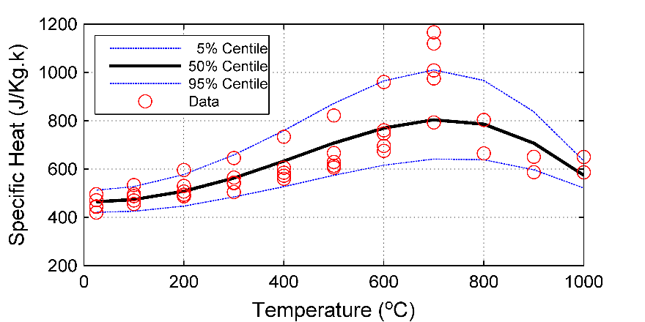

1. for MS

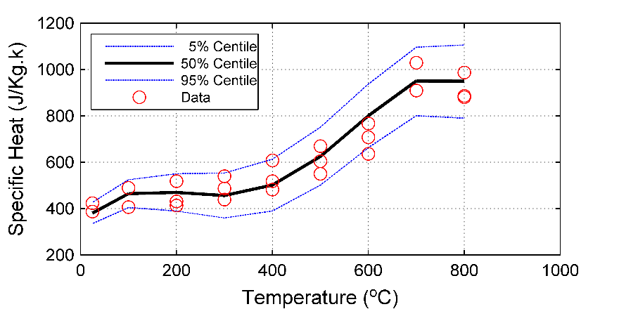

1. for HSS

Figure 11. Probabilistic models for specific heat of steel

*4.2 Practical Applications of Developed Models*

Closed-form equations are determined for the distribution parameters of material properties as a function of temperature. During the probabilistic analysis, the temperature-dependent distribution parameters are evaluated, and probability distribution functions are created. A user-input percentile is used to obtain a point on the created probability distribution function and used in the thermo-mechanical analysis of the structural element. The derived relationships for the material properties at elevated temperatures are valid in the temperature ranges covered by the surveyed experimental data. Furthermore, their development framework is flexible in that new test data can be added, and the validity of the developed material models can be constantly extended. Interested researchers are invited to further create and finetune models for material degradation.

*4.3 Model Comparisons*

The models developed in this paper are compared with models developed by 18,19. The methodology in 18,19 used artificial neural networks to describe the data, whereas, in this study, the data is fitted using a probabilistic approach, as explained earlier. Figure 12 presents the 50% percentile of the developed probabilistic models (Prop. Model) and the Artificial Neural Network-based models (ANN model) for NSC and HSC; Figure 13 presents the 50% percentile of the developed probabilistic models (Prop. Model) and the Artificial Neural Network-based models (ANN model) for MS and HSS. The material types that had enough data points to develop temperature-dependent material models for all the considered thermal and mechanical properties are used in this comparison. Furthermore, the material models of ASCE, 1992 10, Eurocode 2, 2004 4, and Eurocode 3, 2005 5 with the mean value of the experimental data are presented in Figure 12 and Figure 13. Since most material models in the fire standards are based on averages of experimental data for NSC and MS, it can be seen that there is a general agreement between the different models for most NSC and MS material properties, Figure 12 and Figure 13.

It should be noted that the approach to derive Prop. model examines different probability distribution functions for the data modeling, and both Prob. and ANN models are developed using more recent experimental data sets than standards and codes. There is an agreement between Prob. and ANN models, which validate the developed models as two different approaches concluded with similar models. However, Prob. models can be more straightforward in their development and deployment (as opposed to ANN, which, at the moment, may require coding). Furthermore, the prob. approach models the variability in materials properties and this variability may be used to run uncertainty and reliability analyses in structural fire engineering, especially for members constructed using new materials for which the standards do not provide material models. In hindsight, the presented results seem to favor the outcome of simple ANNs – especially when compared to the rigor of Prob. models. For completion, the authors believe that further testing is required, presumably with a much larger dataset, to further examine the merits of Prob. models vs. ANN models. Future researchers are invited to further explore this front as the data and code are attached for all interested readers. Furthermore, the models of Qureshi et al.30 for the NSC and MS are added to the model comparison in Figure 12a and Figure 13a, the developed Prob. Models and ANN models seem to be centered within the other presented models; however, Qureshi et al. models seem to be closer to the sides of the comparison. The centralized behavior of the developed models in this paper may be due to the comprehensiveness of the collected dataset.

Moreover, it is noticed from the experimental data and the derived models that the strength of the material has a significant effect on the material properties, i.e., strength/yield, conductivity, and specific heat. For example, the compact microstructure of HSC does not allow moisture to escape. This causes a buildup in the pore pressure, which accelerates the development of microcracks and, consequently, causes the loss of strength. This faster deterioration of strength in HSC is depicted in the derived models, Figure 12a. Furthermore, the thermal conductivity of HSC is expected to be higher than that of NSC due to the different types of binders used in HSC and its low water-to-cement ratio, and this behavior is captured in the developed models in Figure 12c. High-strength steels are made by adding different types of alloys that affect the fire resistance property of steel 53; the experimental data and developed models in Figure 13 indicate such changes in material behavior at elevated temperatures. The observations above support the need to derive generalized and probabilistic material models for the more modern construction materials that vary in strength and type.

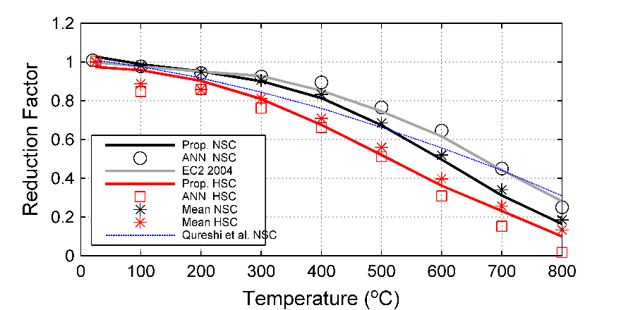

1. Reduction factor for compressive strength

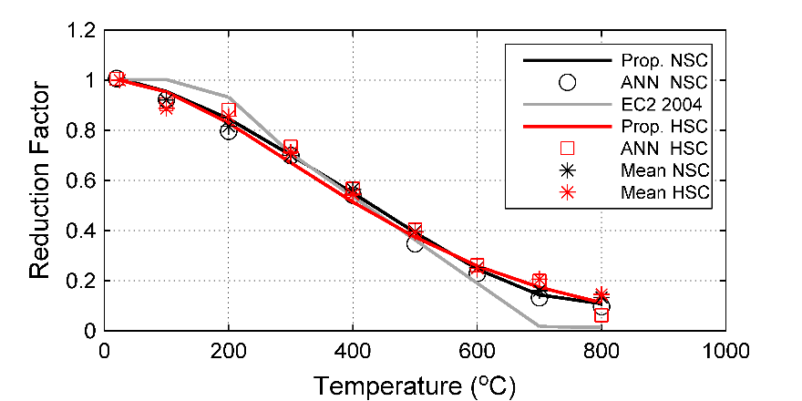

1. Reduction factor for modulus of elasticity

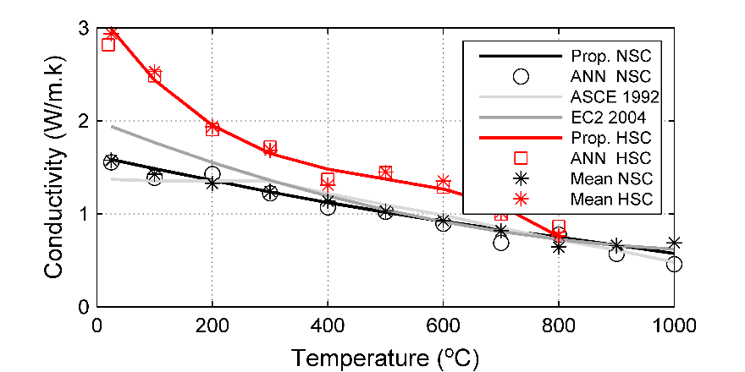

1. Thermal conductivity

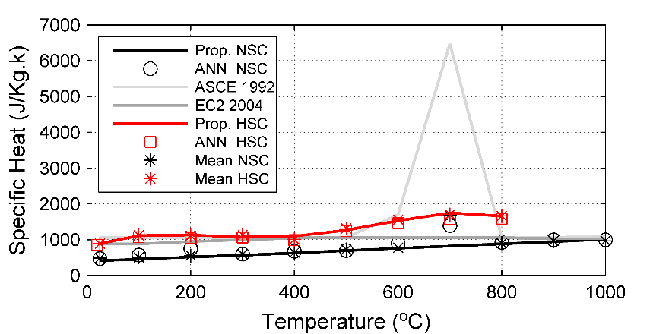

1. Specific Heat

Figure 12: Model comparison for the thermal and mechanical properties of concrete

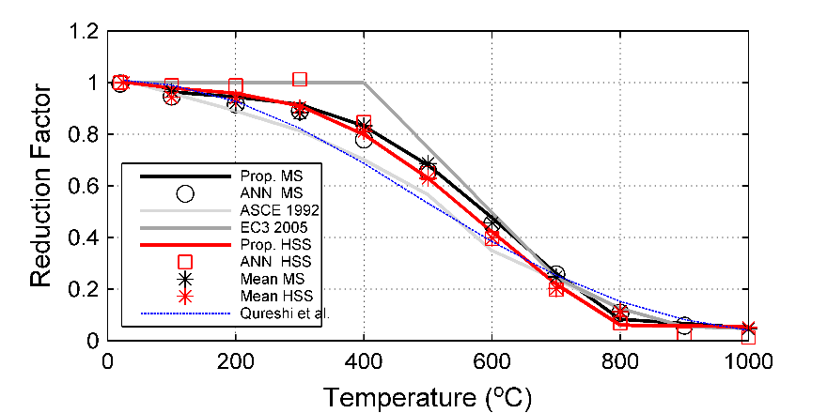

1. Reduction factor for yield strength

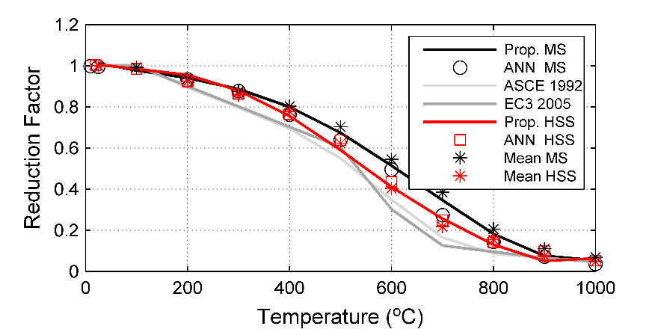

1. Reduction factor for modulus of elasticity

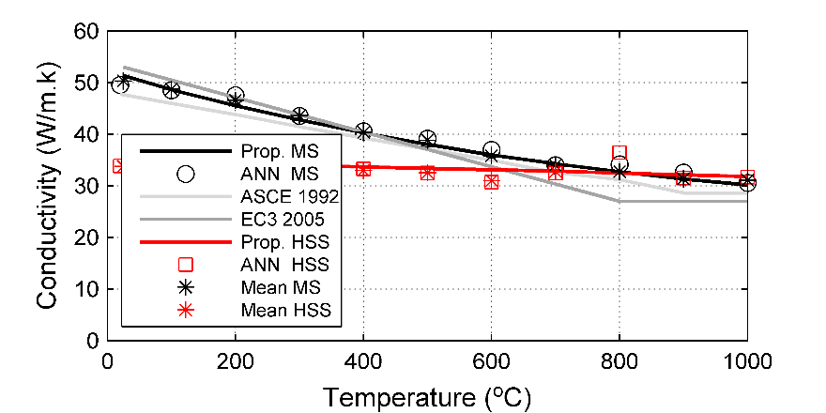

1. Thermal conductivity

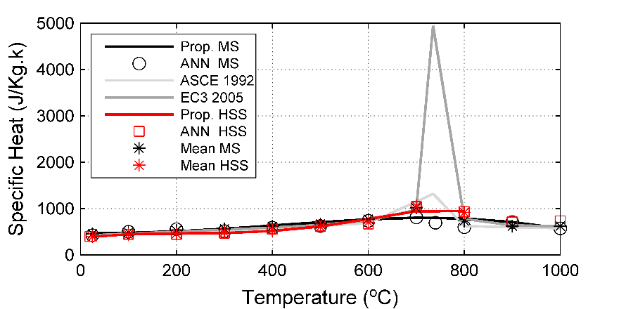

1. Specific heat

Figure 13: Model comparison for the thermal and mechanical properties of steel

**5. Conclusions**

The examined material properties are temperature-dependent, and the experimental data show a large variability for their values. Therefore, there is a need for probabilistic models to quantify the observed scatter in data at elevated temperatures. The availability of probabilistic material models in structural fire engineering facilitates probabilistic performance-based fire engineering and allows a detailed evaluation of structural fire reliability. This study presents a methodology to develop temperature-dependent probabilistic material models. The approach analyzes a comprehensive list of surveyed experimental data at different temperature groups, tests the goodness of fit for a number of distributions, and derives continuous functions to quantify temperature-dependent parameters of the fitted distribution functions. The paper provides probabilistic models for the thermal and mechanical properties for normal-strength, high-strength, and high-performance concrete and mild, high-strength, and cold-formed steels. Furthermore, the 50% percentile of developed probabilistic models were compared with ANN developed models for the concrete and steel temperature-dependent material properties; both models showed a general agreement. The proposed models to quantify uncertainties in concrete and steel temperature-dependent material properties can be used to complete the reliability analysis, derive safety factors and perform sensitivity analysis for the fire design of buildings. Furthermore, the methodology can be extended to develop probabilistic models informed by the experimental data sets for other engineering applications*.*

**Appendix**

The code in MATLAB to create the data points for the material properties using the developed probabilistic models.

% Creation of material property data points for a probabilistic study

% Sample code Matlab

%% candidate distributions

Distributions={'Birnbaumsaunders' 'loglogistic' 'logistic' ...

'lognormal' 'Normal' 'Weibull'};

DistVar1={'pd.beta' 'pd.mu' 'pd.mu' ...

'pd.mu' 'pd.mu' 'pd.A'};

DistVar2={'pd.gamma' 'pd.sigma' 'pd.sigma'...

'pd.sigma' 'pd.sigma' 'pd.B'};

%% Example: create probabilistic model for compressive strength of normal strength concrete

j=4; % follwoing the output of the study - best fit is the lognormal distribution

%% Regression models

% a are regression coefficients provided in the study for the first variable defining distribution function

% b are regression coefficients provided in the study for the second variable defining distribution function

a=[0.0262 -0.5103 1.3704 -2.7088]';

b=[0.065 -0.1172 0.6207]';

% Regression terms, these changes following terms given in the study

% T is the array of examined temperatures

T=[25 100 200 300 400 500 600 700 800];

Tstd = (T - min(T))/(max(T)-min(T));

Xa = [ones(size(Tstd))' (Tstd.^1)' (Tstd.^2)' (Tstd.^3)'];

Xb = [ones(size(Tstd))' (Tstd.^1)' (Tstd.^2)' ];

% Approximated distribution parameters for examined temperatures

var1=Xa*a; var2=Xb*b;

%% Realization of samples of the examined property using the derived model

NumSamples=10000;

for i=1:size(T,2)

PropData(:,i)= random(Distributions{j},var1(i),var2(i),NumSamples,1);

end

PropData50=quantile(PropData,0.5,1);

# Data Availability

Data, models, or code that support the findings of this study are available from the corresponding author upon reasonable request.

**References**

1. Kodur VKR, Agrawal A. An approach for evaluating residual capacity of reinforced concrete beams exposed to fire. *Eng Struct*. 2016;110:293-306. doi:10.1016/j.engstruct.2015.11.047

2. ASCE. *Structural Fire Protection: Manual of Practice*.; 1993.

3. ACI. *Guide for Determining the Fire Endurance of Concrete Elements, ACI-216–89*.; 1989.

4. Eurocode2. *Design of Concrete Structures, Part1-2: General Rules-Structural Fire Design*.; 2004.

5. Eurocode3. *EN 1993-1-2:Design of Steel Structures. Part 1-2: General Rules-Structural Fire Design*.; 2005.

6. Harmathy TZ. *Fire Safety Design and Concrete*. Longman Scientific and Technical; 1993.

7. Bennetts ID. *Report No. MRL/PS23/81/001*.; 1981.

8. Schneider U. *Properties of Materials at High Temperatures—Concrete*.; 1985.

9. Anderberg Y. *Properties of Materials at High Temperatures—Steel*.; 1983.

10. ASCE. *Structural Fire Protection - ASCE Manuals and Reports on Engineering*.; 1992.

11. T. PL. High-strength concrete at high temperature—an overview. In: *6th International Symposium on Utilization of High Strength/High Performance Concrete*. ; 2002:501–518.

12. Naser MZ, Uppala VA. Properties and material models for construction materials post exposure to elevated temperatures. *Mech Mater*. 2020;142(September 2019). doi:10.1016/j.mechmat.2019.103293

13. ACI216.1. *Standard Method for Determining Fire Resistance of Concrete and Masonry Construction Assemblies*.; 2014.

14. ECS. *EN 1993-1-2: Design of Steel Structures. Part 1-2: General Rules-Structural Fire Design*. Vol 2.; 2005.

15. Khaliq W. *Performance Characterization of High Performance Concretes under Fire Conditions*. Michigan State University; 2012.

16. Bai GL, Du NJ, Xu YZ, Qin CG. Study on the Thermal Properties of Hollow Shale Blocks as Self-Insulating Wall Materials. *Adv Mater Sci Eng*. Published online 2017. doi:10.1155/2017/9432145

17. Hertz KD. Reinforcement data for fire safety design. *Mag Concr Res*. Published online 2004.

18. Naser MZ. Properties and material models for modern construction materials at elevated temperatures. *Comput Mater Sci*. 2019;160(December 2018):16-29. doi:10.1016/j.commatsci.2018.12.055

19. Naser MZ. Properties and material models for common construction materials at elevated temperatures. *Constr Build Mater*. 2019;215:192-206. doi:10.1016/j.conbuildmat.2019.04.182

20. Bingöl AF, Gül R. Effect of elevated temperatures and cooling regimes on normal strength concrete. *Fire Mater*. 2009;33(2):79-88. doi:10.1002/fam.987

21. Van Coile R, Hopkin D, Lange D. Guest Editorial: Probabilistic Methods in Fire Safety Engineering. *Fire Technol*. 2019;55(4):1107-1109. doi:10.1007/s10694-019-00874-0

22. Van Coile R, Hopkin D, Lange D, Jomaas G, Bisby L. The Need for Hierarchies of Acceptance Criteria for Probabilistic Risk Assessments in Fire Engineering. *Fire Technol*. 2019;55(4):1111-1146. doi:10.1007/s10694-018-0746-7

23. Shrivastava M, Abu AK, Dhakal RP, Moss PJ. Severity Measures and Stripe Analysis for Probabilistic Structural Fire Engineering. *Fire Technol*. 2019;55(4):1147-1173. doi:10.1007/s10694-018-0799-7

24. Gernay T, Khorasani NE, Garlock M. Fire Fragility Functions for Steel Frame Buildings: Sensitivity Analysis and Reliability Framework. *Fire Technol*. 2019;55(4):1175-1210. doi:10.1007/s10694-018-0764-5

25. Kiureghian A Der, Ditlevsen O. Aleatory or epistemic? Does it matter? *Struct Saf*. 2009;31(2):105-112. doi:10.1016/j.strusafe.2008.06.020

26. Gernay T, Elhami Khorasani N, Garlock M. Fire fragility curves for steel buildings in a community context: A methodology. *Eng Struct*. 2016;113:259-276. doi:10.1016/j.engstruct.2016.01.043

27. Guo Q, Jeffers AE. Finite-Element Reliability Analysis of Structures Subjected to Fire. *J Struct Eng*. 2015;141(4):04014129. doi:10.1061/(asce)st.1943-541x.0001082

28. Heidari M, Robert F, Lange D, Rein G. Probabilistic Study of the Resistance of a Simply-Supported Reinforced Concrete Slab According to Eurocode Parametric Fire. *Fire Technol*. 2019;55(4):1377-1404. doi:10.1007/s10694-018-0704-4

29. Khorasani NE, Gardoni P, Garlock M. Probabilistic Fire Analysis: Material Models and Evaluation of Steel Structural Members. *J Struct Eng*. 2015;141(12):04015050. doi:10.1061/(asce)st.1943-541x.0001285

30. Qureshi R, Ni S, Elhami Khorasani N, Van Coile R, Hopkin D, Gernay T. Probabilistic Models for Temperature-Dependent Strength of Steel and Concrete. *J Struct Eng*. 2020;146(6):04020102. doi:10.1061/(asce)st.1943-541x.0002621

31. Jovanović B, Khorasani NE, Thienpont T, Chaudhary RK, Van Coile R. Probabilistic models for thermal properties of concrete. In: *Proceedings of the 11th International Conference on Structures in Fire (SiF2020)*. The University of Queensland; 2020. doi:10.14264/363ff91

32. Karaki G, Hawileh RA, Kodur VKR. Probabilistic-Based Approach for Evaluating the Thermal Response of Concrete Slabs under Fire Loading. *J Struct Eng*. 2021;147(7):(ASCE)ST.1943-541X.0003039. doi:10.1061/(ASCE)ST.1943-541X.0003039

33. Shin KY, Kim SB, Kim JH, Chung M, Jung PS. Thermo-physical properties and transient heat transfer of concrete at elevated temperatures. *Nucl Eng Des*. 2002;212(1-3):233-241. doi:10.1016/S0029-5493(01)00487-3

34. Bentz D, Prasad K. *Thermal Performance of Fire Resistive Materials I. Characterization with Respect to Thermal Performance Models*.; 2007.

35. Rempe JL, Knudson DL. High temperature thermal properties for metals used in LWR vessels. *J Nucl Mater*. 2008;372(2-3):350-357. doi:10.1016/j.jnucmat.2007.03.268

36. Ranawaka T, Mahendran M. Experimental study of the mechanical properties of light gauge cold-formed steels at elevated temperatures. *Fire Saf J*. 2009;44(2):219-229. doi:10.1016/j.firesaf.2008.06.006

37. Heva YB. *Behaviour and Design of Cold-Formed Steel Compression Members at Elevated Temperatures*. Queensland University of Technology; 2009.

38. Mäkeläinen P, Outinen J, Kesti J. Fire design model for structural steel S420M based upon transient-state tensile test results. *J Constr Steel Res*. 1998;48(1):47-57. doi:10.1016/S0143-974X(98)00005-4

39. Chen J, Young B. Experimental investigation of cold-formed steel material at elevated temperatures. *Thin-Walled Struct*. 2007;45(1):96-110. doi:10.1016/j.tws.2006.11.003

40. Hertz KD. Limits of spalling of fire-exposed concrete. *Fire Saf J*. 2003;38(2):103-116. doi:10.1016/S0379-7112(02)00051-6

41. Bastami M, Aslani F, Omran M. High-temperature mechanical properties of concrete. *Int J Civ Eng*. 2010;8:337-351.

42. Savva A, Manita P, Sideris KK. Influence of elevated temperatures on the mechanical properties of blended cement concretes prepared with limestone and siliceous aggregates. *Cem Concr Compos*. 2005;27(2):239-248. doi:10.1016/j.cemconcomp.2004.02.013

43. Li GQ, Jiang SC, Yin YZ, Chen K, Li MF. Experimental Studies on the Properties of Constructional Steel at Elevated Temperatures. *J Struct Eng*. 2003;129(12):1717-1721. doi:10.1061/(ASCE)0733-9445(2003)129:12(1717)

44. Outinen J, Mäkeläinen P. Mechanical properties of structural steel at elevated temperatures and after cooling down. *Fire Mater*. 2004;28(24):237-251. doi:10.1002/fam.849

45. Bazant ZP, Kaplan MF. *Concrete at High Temperatures: Material Properties and Mathematical Models*. Prentice Hall; 1996.

46. Mecozzi E, Zhao B. Development of stress–strain relationships of cold-formed lightweight steel at elevated temperatures. In: *4th European Conference on Steel and Composite Structures-Eurosteel*. ; 2005:41-49.

47. Khaliq W, Kodur V. Thermal and mechanical properties of fiber reinforced high performance self-consolidating concrete at elevated temperatures. *Cem Concr Res*. 2011;41(11):1112-1122. doi:10.1016/j.cemconres.2011.06.012

48. Kodur VKR, Sultan MA. Effect of Temperature on Thermal Properties of High-Strength Concrete. *J Mater Civ Eng*. 2003;15(2):101-107. doi:10.1061/(ASCE)0899-1561(2003)15:2(101)

49. Lie TT, Kodur VK. Thermal and mecanical properties of steel-fibre-reinforced concrete at elevated temperatures. *Can J Civ Eng*. 1996;23(2):511-517.

50. Xiao J, Xie Q, Xie W. Study on high-performance concrete at high temperatures in China (2004–2016) - An updated overview. *Fire Saf J*. 2018;95:11-24. doi:10.1016/j.firesaf.2017.10.007

51. Xiao J, Li Z. Back-analysis and variability of the thermal conductivity of high strength concrete under high temperatures. *J Archit Civ Eng*. 2014;31(01):44-49 in Chinese.

52. Choi IR, Chung KS, Kim DH. Thermal and mechanical properties of high-strength structural steel HSA800 at elevated temperatures. *Mater Des*. 2014;63:544-551. doi:10.1016/j.matdes.2014.06.035

53. Kodur VKR, Harmathy TZ. Properties of Building Materials. In: *SFPE Handbook of Fire Protection Engineering*. Springer New York; 2016:277-324. doi:10.1007/978-1-4939-2565-0_9

54. Xiong MX, Liew JYR. Mechanical behaviour of ultra-high strength concrete at elevated temperatures and fire resistance of ultra-high strength concrete filled steel tubes. *Mater Des*. 2016;104:414-427. doi:10.1016/j.matdes.2016.05.050

55. Phan LT. High-strength concrete at high temperature-an overview. In: *6th International Symposiumon Utilization of High Strength/High Performance Concrete*. ; 2002:501-518.

56. Chen GM, He YH, Yang H, Chen JF, Guo YC. Compressive behavior of steel fiber reinforced recycled aggregate concrete after exposure to elevated temperatures. *Constr Build Mater*. 2014;71:1-15. doi:10.1016/j.conbuildmat.2014.08.012

57. Way RT, Wille K. Effect of Heat-Induced Chemical Degradation on the Residual Mechanical Properties of Ultrahigh-Performance Fiber-Reinforced Concrete. *J Mater Civ Eng*. 2016;28(4):04015164. doi:10.1061/(ASCE)MT.1943-5533.0001402

58. Behloul M, Chanvillard G, Casaova P, Orange G. No Title. In: *1st FIB Congress-Concrete Structures in the 21st Century*. ; 2002:105-122.

59. De Chefdebien A, Robert F, Colligon C. Performance of ultra high strength concrete subjected to fire. In: *CONSEC 07: Concrete under Severe Conditions: Environment and Loading*. ; 2007.

60. Meda A, Gambarova PG, Bonomi M. High-performance concrete in fire-exposed reinforced concrete sections. *Struct Eng*. 2002;99(3):277-287.

61. Husem M. The effects of high temperature on compressive and flexural strengths of ordinary and high-performance concrete. *Fire Saf J*. 2006;41(2):155-163. doi:10.1016/j.firesaf.2005.12.002

62. Bamonte P, Gambarova PG. Thermal and Mechanical Properties at High Temperature of a Very High-Strength Durable Concrete. *J Mater Civ Eng*. 2010;22(6):545-555. doi:10.1061/(ASCE)MT.1943-5533.0000058

63. Poon CS, Shui ZH, Lam L. Compressive behavior of fiber reinforced high-performance concrete subjected to elevated temperatures. *Cem Concr Res*. 2004;34(12):2215-2222. doi:10.1016/j.cemconres.2004.02.011

64. Chiew SP, Zhao MS, Lee CK. Mechanical properties of heat-treated high strength steel under fire/post-fire conditions. *J Constr Steel Res*. 2014;98:12-19. doi:10.1016/j.jcsr.2014.02.003

65. Qiang X, Jiang X, Bijlaard FSK, Kolstein H. Mechanical properties and design recommendations of very high strength steel S960 in fire. *Eng Struct*. 2016;112:60-70. doi:10.1016/j.engstruct.2016.01.008

66. Lange J, Wohlfeil N. Examination of the mechanical properties of the microalloyed grain refined steel S 460 at elevated temperatures. *Bautechnik*. 2007;84(10):711-720.

67. Maraveas C, Fasoulakis ZC, Tsavdaridis KD. Mechanical properties of High and Very High Steel at elevated temperatures and after cooling down. *Fire Sci Rev*. 2017;6(1). doi:10.1186/s40038-017-0017-6

68. Heidarpour A, Tofts NS, Korayem AH, Zhao XL, Hutchinson CR. Mechanical properties of very high strength steel at elevated temperatures. *Fire Saf J*. 2014;64:27-35. doi:10.1016/j.firesaf.2014.01.006

69. Phan LT, Carino NJ. Review of Mechanical Properties of HSC at Elevated Temperature. *J Mater Civ Eng*. 1998;10(1):58-65. doi:10.1061/(ASCE)0899-1561(1998)10:1(58)

70. Zheng W, Li H, Wang Y. Compressive stress–strain relationship of steel fiber-reinforced reactive powder concrete after exposure to elevated temperatures. *Constr Build Mater*. 2012;35:931-940. doi:10.1016/j.conbuildmat.2012.05.031

71. Persson B. Fire resistance of self-compacting concrete, SCC. *Mater Struct*. 2004;37(9):575-584. doi:10.1007/BF02483286

72. Buchanan A, Abu A. *Structural Design for Fire Safety*.; 2017.

73. Kodur V, Naser M. *Structural Fire Engineering*. 1st ed. McGraw Hill Professional; 2020.

74. Craveiro HD, Rodrigues JPC, Santiago A, Laím L. Review of the high temperature mechanical and thermal properties of the steels used in cold formed steel structures - The case of the S280 Gd+Z steel. *Thin-Walled Struct*. 2016;98:154-168. doi:10.1016/j.tws.2015.06.002

75. Kodur V. Properties of Concrete at Elevated Temperatures. *ISRN Civ Eng*. 2014;2014:1-15. doi:10.1155/2014/468510

76. Ma Q, Guo R, Zhao Z, Lin Z, He K. Mechanical properties of concrete at high temperature-A review. *Constr Build Mater*. 2015;93:371-383. doi:10.1016/j.conbuildmat.2015.05.131

77. Maraveas C, Fasoulakis ZC, Tsavdaridis KD. Mechanical properties of High and Very High Steel at elevated temperatures and after cooling down. *Fire Sci Rev*. 2017;6(1):3. doi:10.1186/s40038-017-0017-6

78. Stoica P, Selen Y. Model-order selection. *IEEE Signal Process Mag*. 2004;21(4):36-47. doi:10.1109/MSP.2004.1311138

79. Wagenmakers EJ, Farrell S. AIC model selection using Akaike weights. *Psychon Bull Rev*. 2004;11(1):192-196. doi:10.3758/BF03206482

80. JCSS. *JCSS Probabilistic Model Code: Section 3.01*.; 2002.

81. Naus D. *A Compilation of Elevated Temperature Concrete Material Property Data and Information for Use in Assessments of Nuclear Power Plant Reinforced Concrete Structures*.; 2010.

82. JCSS. *JCSS Probabilistic Model Code: Section 3.02*.; 2001.

1. Noting that fire is a complex phenomenon that may not follow a pure steady state or transient nature, we opt to combine steady state and transient tests into one database. Future works can still apply our methodology toward exploring the influence of testing procedure on the developed material models. Additional details on our approach can be found in the Methodology section.