A health map for urban planners
Towards a conceptual model for healthy, sustainable settlements
Published in Built Environment Volume 31, No 4, 2005

HUGH BARTON

Synopsis
The environment in which we live is a significant determinant of health. Yet in some ways we are literally building unhealthy conditions into the fabric of our cities, and the profession charged with planning the urban environment currently lacks a conceptual framework for integrating health into spatial planning decisions .Taking sustainable development as its starting point, this paper examines the logic of adopting a human ecology perspective on settlements. It argues that the human dimension of such theories (and related practice) is underplayed,. and proposes a new conceptual model of settlements that puts human health and well-being at its heart. The model combines an eco-system analysis which expresses the relationship between people and their environment with a public health approach which identifies the relevant social / environmental determinants of well-being. The paper shows how this ’ecosystem health map’ can assist with the theory and practice of urban planning.

Introduction

The purpose of this paper is to integrate an explicit concern for human health into planning for sustainable settlements - to create a health map for urban planners. The irony, of course (noted in the overall introduction to this set of papers), is that modern planning was born out of concern for the unhealthy and overcrowded cities of the nineteenth century. The subsequent divorce of planning and health has helped to undermine the social credentials of planning. Urban planning stands accused of exacerbating social and environmental conditions, such as social exclusion, poor accessibility and car dependence, which are causal factors of disease (Marmot and Wilkinson 1999, Duhl 2000). The problem has been made particularly intractable, in many countries, by the institutional separation of planning and health. In the UK, for example, health authorities have the remit of providing health services while planning authorities have (traditionally) the prime concern for local economic development and environmental protection. Conscious strategies for achieving health-promoting urban environments can easily get lost between the two.

However, in the years since the 1992 Rio ‘Earth Summit’ the official view of urban planning has shifted radically. Policy objectives have been changing from straightforward market support and environmental quality to the much more challenging, multi-faceted principle of sustainable development (DETR 1998, ODPM 2004). As part of this, settlements are being seen not simply as physical or aesthetic constructs, or manifestations of economic forces, but as providing the human habitat, and ecosystems in their own right (Hough 1995, EU Expert Group 1995, Barton et al 1995). In this context, healthy environments are back on the agenda. Human well-being is held up some as a good proxy for ‘social sustainability’(Price and Dube 1997, Barton et al 2003). At the same Local Agenda 21, and now, in the UK, community strategies and ‘spatial plans’, are putting municipalities under an obligation to build bridges across the organizational chasms that segment governance. New tools, such as SEA / SA (strategic environmental assessment and sustainability assessment) encourage holistic, systematic plan appraisal. Within some circles (e.g. the Healthy Cities movement) there is a move to integrate health impact assessment with environmental and social impact assessment, thus creating an integrated regime for project appraisal. All these changes are so profound as to constitute a paradigm shift, a new collective mind set, a revitalized vision of what is appropriate and possible in settlement planning.

In the context of this almost seismic shift in awareness, some facets of planning theory remain trapped in a time-warp. Urban planning theories come in two forms: those concerned with the way planning decisions are (or should be) taken, and those concerned with the way towns, cities and regions work. Faludi (1973) called these two forms theories of planning and theories for planning. Since the 1970s most of the emphasis in planning theory has been on the former – theories of planning, leaving the field of theories for planning almost entirely to the ‘ingredient ‘ disciplines of economics, sociology, ecology, geography, psychology and urban design (Taylor 1998). There are two key points to be made about this, which set the scene for this paper. The first is that despite planning concern for the ‘quality of life’, study of the determinants of quality of life, health and well-being does not feature in this list. The second is that there has been a conspicuous lack of integration of these disciplines in relation to settlement planning. Planning students, for example, study the various disciplines in the absence of any integrating theory which could provide a consistent basis for analysis. The only real attempt at integration, albeit partial, was systems theory, which lost credibility in the 70s. It will be examined anon.

Planning practice and urban policy-making reflect these limitations. One recent survey of chief planners from cities participating in the European Healthy cities movement showed an alarming lack of co-operation between health and planning agencies. The chief planners, perhaps surprisingly given their position, considered that many planning policies were actually incompatible with health. Some cited rigid standards of location, zoning and layout as anti-health. They also highlighted health problems in relation to transport and traffic policies and social segregation. Some held that the planning focus on the private profit of market interests was at the expense of the everyday needs of citizens (Barton and Tsourou 2000).

The lack of a coherent approach is evident between professions. There remains a gulf of understanding between the strategic transport planners (with their reliance on econometric tests and sophisticated mathematical models) and the land use planners. There is sometimes a gulf, too, between social and environmental policy: the Social Exclusion Unit’s “National Strategy for Neighbourhood Renewal”, for example, is remarkable for its lack of attention to the environmental sustainability and spatial planning agendas of the DETR/ODPM (see SEU 2001 cf. DETR 1998,). The reasons for these varied perspectives are no doubt part political, part institutional, part professional. But substantive planning theory is doing little or nothing to inform debate and break down the barriers. And both planning theory and current practice are largely health-blind.

It is in this context that I want to take a step towards an integrated conceptual framework for the matter (as opposed to the manner) of town planning – i.e. a way of understanding the communities and settlements that spatial policy affects. The revival of theories for planning could offer a number of things:
- A means of meshing the different theoretical perspectives (ecological, economic, aesthetic, etc) on settlements so that so that they are are in perspective
- A basis for shared inter-professional understanding of the way in which settlements work, in the context of agreed(?) goals of health and sustainable development
- A means of articulating what healthy, sustainable settlements might be like, and providing an agenda for the discussion of objectives, criteria and indicators
- A framework for rational debate and evidence-gathering, in the context of SEA, SA and integrated impact analysis.

There are of course historic attempts at synoptic planning framework (e.g. Webber 1964, Chapin 1965), but here I will focus on the approach that has gained many advocates in the post-Rio era: that is that settlements be viewed as eco-systems. The first part of the paper examines this approach, and notes both its strengths and weaknesses – the latter specifically in relation to social and economic issues. The second part then argues that theories about the determinants of health, neatly overcome the limitations, and help bridge the conceptual gap between health and planning. The third part attempts to integrate the two sets of ideas – from human ecology and health – in a simple conceptual model. It tries to show how such a model could be useful aid for developing a coherent view of the theory and practice of settlement planning.

Settlements as eco-systems

In his book ‘Good City Form’ (1981) the urban designer Kevin Lynch examines the relationships between human values and the physical form of the city. He evaluates some of the favoured concepts of the day: the city as a machine for living in, the city as an organism. He eventually rejects both of these as inadequate, concerned more with image and metaphor than actuality. His solution is the theory of the eco-system. This theory, applied to human settlements, recognises the complexity of an open system with living and non-living elements, cyclic processes and complicated networks of relationships. It is not a metaphor; it provides a useful means of describing settlements and has both explanatory and normative power.

The development of settlement eco-system theory has, however, been rather halting and disparate. The idea had early exponents. Plato, observing the unsustainable economic practices of 5th Century BC Greece, eloquently expressed the dependence of settlements on their resource base of soil, water and flora (in the Critias). He even grasped the implications of land use practices for climate change. Much more recently there have been a number or attempts to link the science of ecology with the metabolism of cities, some of them very productive. First in the field were the "social ecologists", represented by the Chicago School (Park, Burgess, Hoyt etc), who analysed the process of city change and development, attempting to establish how social and economic forces affected urban form. They observed the way "natural" market forces created evolving patterns of class and use differentiation, with progressive 'invasion' and 'succession' between zones (Park and Burgess 1925). However, while these social ecologists used the language of ecology, they did not see settlements as ecological systems. Rather they used the metaphor of ecological processes to help understand urban social and spatial dynamics.

It has been argued that the precise patterns and mechanisms proposed by the early urban ecologists are partial and even misleading, based on particular cities in a particular spatial –temporal-cultural setting. (e.g. Timms 1971). But from the viewpoint of settlement planning there are some valuable insights. The archetypal concentric, sector and multi-nodal models still offer useful and easily-comprehended descriptive tools. The concepts of symbiosis, ecological niche, dominance, invasion, etc can articulate complex dynamics (see Barton et al 2003), and help understanding of the trajectory of change and renewal. Theories of residential differentiation, location, land economics and urban form have been built on this foundation (Hall 2001).

A second influential stream of intellectual development linking cities and eco-systems started mid-century in the form of systems theory. The idea of human settlements as systems was evolved, initially in America, in the intellectual ferment of the 1960s. Chapin (1965) defined activity systems as "behaviour patterns of individuals, families, institutions and firms which occur in spatial patterns that have meaning for the planning of land use", and parallel the movement systems that are the focus of transportation planning. Chapin held that hitherto planners had concentrated on land use patterns almost as ends in themselves, rather than as expression and facilitators of human activity. They had failed to study spatial or location behaviour itself (Foley 1964). Mcloughlin, in a powerful analysis, linked systems theory expressly with human ecology and the concept of eco-systems (Mcloughlin 1968, chapter 1). While sadly this logic was not followed through in the rest of his book, it is nevertheless important to note the basic structure of systems thinking. In the terms used by Mcloughlin and Chadwick (1972) systems theory requires a proper understanding of four interacting elements:
- activities (some of which, like going to the pub, or an industrial production process, are spatially specific while others, like using the laptop, may be spatially fluid)
- communications (both the physical movements of people/goods and telecommunications)
- spaces (most of which are adapted for particular activities, in the form of dwellings, pubs, factories, playing fields etc, but may be changed)
- channels (streets, railways, sewers, cables, airwaves etc)

The essential insight of systems theory is that these elements are mutually interactive and dependant, with activities and communications within and between settlements largely the result of choices by very many households and businesses, contained or encouraged by the capacity, quality and location of adapted spaces and channels.

The systems approach did for a while hold sway in the field of strategic planning in the 1970s. In the field of transport planning it continues to provide some of the bedrock logic for land use/transport modelling, and thus provides the theoretical underpinning for major transport investment decisions. However, in planning (as opposed to transport) practice and theory, the systems view was compromised by concerns about its technocratic approach and lack of realism (Taylor 1998). In the context of this paper there are three weaknesses of the systems view of settlements, which any new theory would need to address. One is its failure - ironic in the light of Mcloughlin's (1968) eco-system approach - to see settlements properly in their ecological context or examine sustainable resource use. Another is the failure to see people except in terms of their activities and movements: social issues of health, equity, community and quality of life are implicitly sidelined. The third criticism is that aspatial aspects of urban systems such as economic processes, institutional frameworks and the cultural context are not reflected in the model.

I should emphasise that these criticisms do not imply that systems theory is worthless. On the contrary, the strong logic of its central thesis - that settlement planning can be assisted by careful analysis of the urban system in terms of the relationship between human activities and the built environment - is persuasive. But systems theory is clearly not enough.

Both the social ecologists and the systems theorists were inspired by ecological principles. But neither group actually saw human settlements as eco-systems. Both used natural ecology as a metaphor for urban processes, and down-played the significance of the natural resource base. The science of human ecology, by contrast, is not about metaphorical parallels but actual relationships. It may be defined as “the study of the interactions of man and human society with the environment” (the Commonwealth Human Ecology Council, quoted in Hancock 1985). Applied to settlements the focus is on human activity as a part of natural metabolic systems. Towns and cities are seen as constructed ecosystems providing the local human habitat. They are just as dependent (in the last resort) on the stock and flow of air, water, food, energy and materials as is an ant heap.

Some of the impacts are local (eg. in relation to ground water levels and water supply); some are regional or global (acid rain or greenhouse gas emissions). Within settlements, humans live symbiotically with many other species – partly by accident but often by intention, designing urban landscapes to enhance enjoyment.

The idea of an ecological landscape gives a sharper edge. Landscape ecologists see landscape as a mosaic of interlocking eco-systems (from natural to artificial) – complex patterns of spatial heterogenecity that may be imbued with cultural and perceptual as well as use values by human beings (Forman and Godron 1986; Hersperger 1994). Landscape ecology is a discipline that sees human activity as part of eco-systems at different scales, and is concerned both with ecosystem-sustainability and cultural development (Grant et al 1996 p.333). It is therefore a science that is entirely compatible with the principle of sustainable development. Michael Hough, in his seminal work Cities and Natural Processes (1995, adopted from his earlier “City Form and Natural Processes”) was clear about the priorities:

“Our primary concern is how the city can be made environmentally and socially healthier; how it can become a civilizing place in which to live” (p.31).

This anthropogenic perspective on sustainable development (consistent with the Brundtland definition) is echoed by others who have promoted an ecological perspective on settlements (Houghton and Hunter 1994 p.27; Girardet 1999 p.13; Barton et al 1995 p.12). But despite this stance people are not really the main focus. The focus to varying degrees is the interaction of people with nature. In other words those writing from an ecological viewpoint quite naturally are concerned with environmental sustainability. Social sustainability is effectively sidelined.

To a significant extent practice has paralleled theory. A series of tools has been developed which are based on the insight that settlements are ecosystems (EU Expert Group 1995). These include environmental impact analysis, energy and water budgets, economical footprint studies, state-of-the-environment reports, carrying capacity and environmental capacity studies. At the same time ecological policy and design conventions have gained in sophistication and effectiveness (witness SUDS – sustainable drainage system; habitat creation; energy-efficient buildings etc). There are, it is apparent, technical processes and physical design concepts which can analyse and, to a certain extent, address the ecological issues.

All this is admirable. But the problem is it is unbalanced. The literature of human ecology has been much stronger on the ecology than the human. Equivalently the theory and practice of sustainable development is more developed on the environmental and economic agendas of sustainability than the social (Selman 1996). Only recently has the social dimensions begun to be articulated (e.g. Barton 2000, Burton 2002, Cave et al 2004).

Health and well-being

If we are to put people at the heart of the conceptual model of sustainable settlements then we need a theory of human well-being. This theory should have explanatory power in relation to the impact of the environment on people in the same way that human ecology has explanatory power in the other direction. Health theories provide just the right kind of logic. Health in this context does not mean simply the absence of disease but “a state of complete physical, mental and social well-being …. The enjoyment of the highest attainable standard of health is one of the fundamental rights of every human being, without distinction of race, religion, political belief or economic and social circumstances.”

This definition of health, formulated in the charter of the World Health Organisation (1946), challenges the conventional assumption that public health is a matter only for health professionals. On the contrary, it makes clear that health should be a central concern of the many professions which impinge on the physical, social and economic factors affecting health, including town planners. Yet it is only in the last generation that the traditional research focus on “pathogenesis” (the causes of disease) was integrated with research into “saluto-genesis” (discovering the causes of health and acting in order to strengthen them), and the change in consciousness is not yet consolidated in research or practice.

The interrelationship between urban planning and health is multi-faceted and profound. The following model of the relationship between health and the physical/social/economic environment is widely cited, and particularly germane to the present enquiry:-

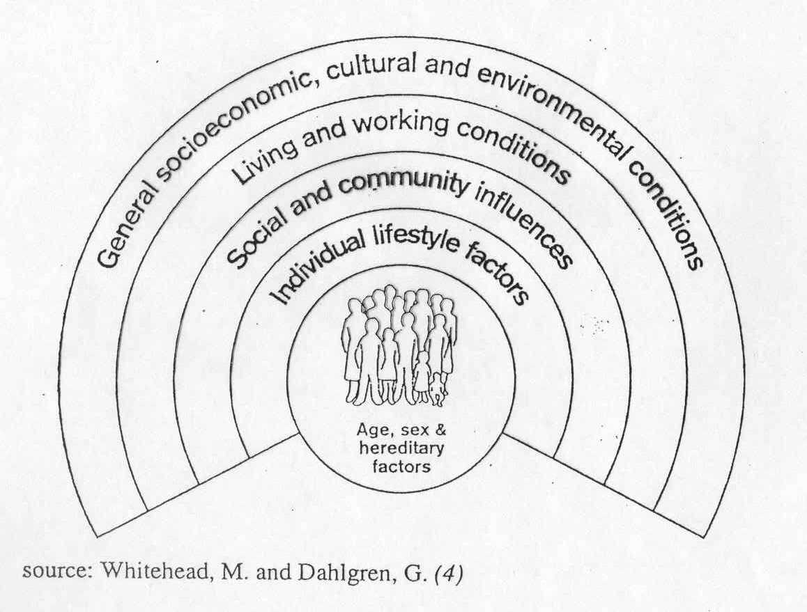
Figure 1 source: Whitehead, M. and Dahlgren, G. (4)
Barton and Tsourou (2000) point out, in relation to this diagram, that at each level of external influence on the individual there are factors that are amenable to planning policy. Individual behaviour and life-style is affected by the availability, safety and quality of routes and facilities, by the density and shape of towns, by the distances which have to be travelled to reach places. Regular exercise protects against heart disease, diabetes and promotes a sense of well-being (Wilkinson and Marmot 1998). Social and community influences include the impact of urban development and renewal on the social networks that are important - especially for the less mobile groups - for avoiding depression and reducing chronic disease (Ibid). Local living and working conditions can be critical to health in terms of the availability of housing, work and essential services, alleviating the poverty and social exclusion which leads to poor health. Broader environmental conditions, including air/water/soil quality and climate, are affected by planning policy and can in some contexts be critical to health.

The degree of impact of settlement planning on lifestyles, social capital, equity and access remains a contested issue: policies for social mix, neighbourhoods and "designing-out-crime", for example, received a bad press in the 1960s for presuming a high level of physical determinism (Dennis 1968, Gans 1968). The wheel has come full circle and these policies are again being advocated, and there remains the danger of exaggerating their social impact. But recent health literature is not equivocal: whilst recognising that individual circumstances (heredity, income, up-bringing) are the most critical determinants of health, there is no doubt that the environment is also profoundly important (see, for example Halpern 1995, Marmot and Wilkinson 1999, Duhl 2000). Indeed, official health policy now demands an effective response from built environment professions (DHSS 1999), and health impact assessments – undertaken mainly by health professionals – highlight the major health impacts of traffic, poor accessibility, street danger and poor housing. The impact of spatial variables on the strength of local community networks (with the links to mental well-being) is also highlighted by recent literature (Halpern 1995, Barton 2000).

So … taking stock of the argument so far: the eco-system theory of settlements gives a sound basis for normative analysis of the human habitat from the viewpoint of environmental sustainability. The danger of an ecological analysis, however, is that it may sideline the social and economic priorities which are inherent in the broader concept of sustainable development. An express concern for human health and well-being, drawing on the theories of health determinants, could provide a more integrated view. The next section therefore puts forward a conceptual model that knits the eco-system and the health perspectives together, and can be applied to the planning of settlements.

A conceptual model of a healthy settlement

The conceptual model presented below aims to provide a satisfactory mental image of a healthy, sustainable settlement that contextualises different disciplines, processes analytical power and provides a useful map for spatial policy makers. The settlement is viewed holistically, being not simply the physical place but the people that live there, their activities, their social networks, the economy they depend on, and the broader base of environmental capital that supports them. It is the settlement as a living, breathing, changing thing – a local ecosystem within the global eco-system.

The Shaping Neighbourhoods model

One version of the model was put forward in Shaping Neighbourhoods: for health, sustainability and vitality (Barton et al 2003). This is a practical planning and design guide for local stakeholders, sponsored by the WHO Healthy Cities campaign in Europe. The model was kept as simple as possible to aid understanding. It identifies five nesting spheres of reality for the neighbourhood or town: people, community, human activities, the built environment and the natural environment (see figure 2).

The model is structured visually so as to emphasise that settlements are the local human habitat. People are placed at the heart, as the prime focus and purpose of the settlement. The natural environment, including the resource base, is round the outside – the context for settlement but also, in some situations, putting environmental limits on its healthy development, Thus both anthropocentric and eco-centric perspectives on sustainable development are represented. The model itself does not take sides.

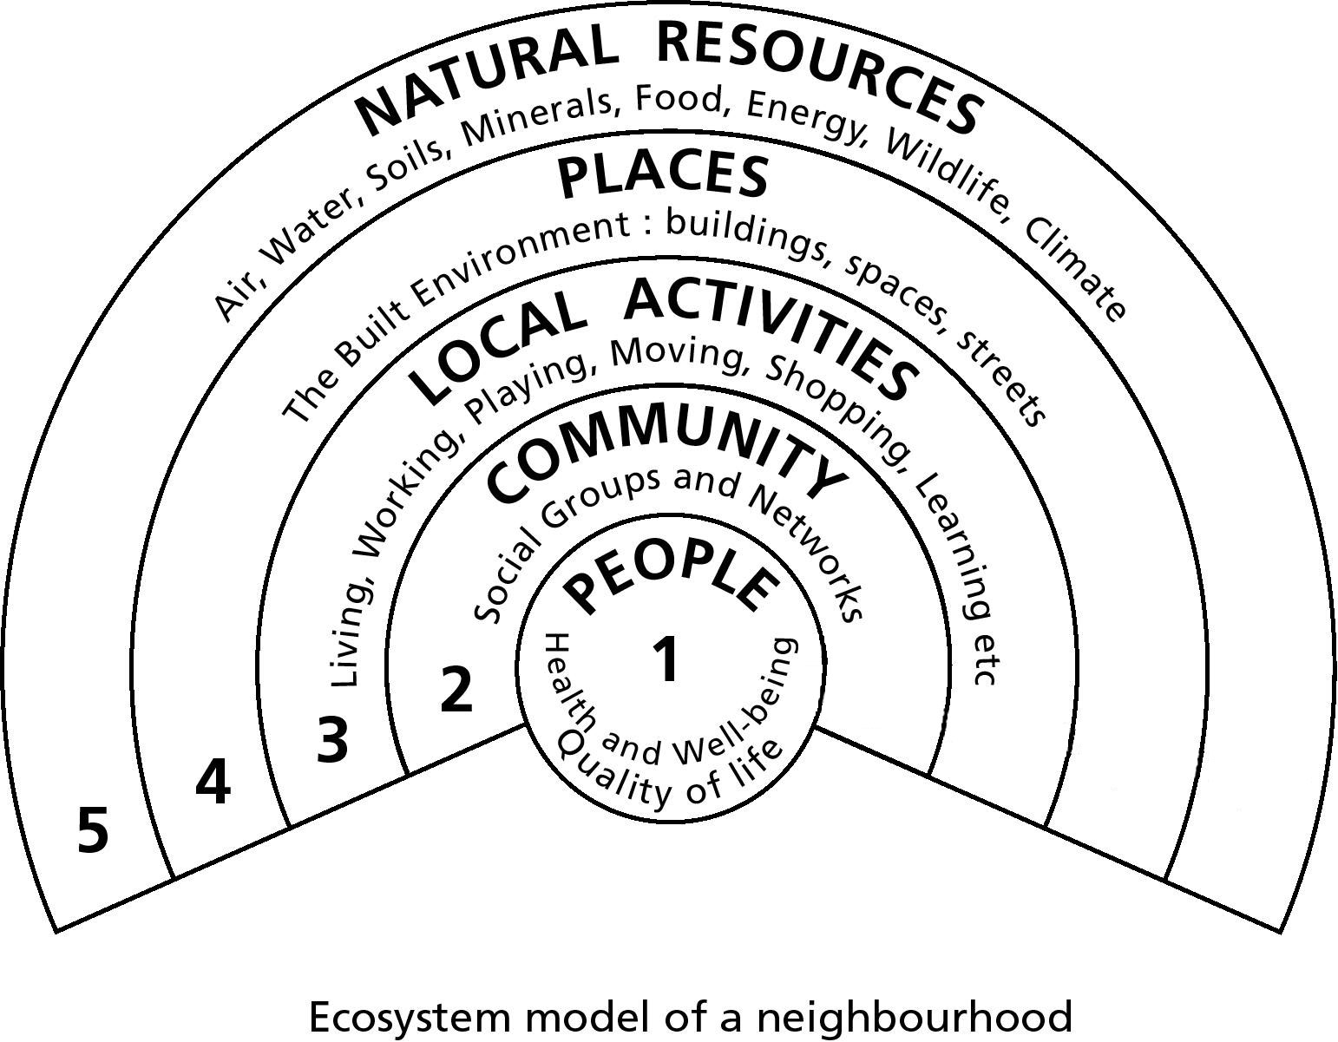
Figure 2 Ecosystem model of a neighbourhood

The direct impact of town planners, designers and the development industry is experienced in the fourth sphere: the built environment (defining that in its broadest sense). Impacts on the other spheres occur mainly indirectly. For example, urban air pollution (which is reflected in the outer sphere and has health implications) is for the most part the result of the activities (particularly vehicle movement) that are facilitated by the built structures, not the direct result of the structures themselves; equivalently, the amount of recreational activity (in sphere three) is clearly affected buy the possibilities opened up or closed down by the level and quality of open space provision, but the prevailing community culture.

The health impacts can be sequential: consider, for example mental well-being. There are well attested correlations between characteristics of the built environment and mental health (Halpern 1995), but the relationships are far from straightforward. While certain aspects of the environment do have a direct psychological or physiological effect (see the article by Brown and Grant in this issue), the key external influences on mental well-being are relationships – the quality of supportive social networks. Mental illness is strongly related to the degree of isolation, with restricted social networks (Halpern 1995). How far and in what ways the built environment influences these networks (particularly for groups which are most vulnerable to depression and neurosis) is not entirely clear, but probably depends on the degree to which it fosters local shared activities – from shopping to work opportunities – and offers a perceived safe environment in the immediate vicinity of the home (Barton 2000). The model represents the main sequential effects graphically: the physical environment affects the activities; the activities are generators of interest-based networks or communities; the social networks influence mental well-being.

The virtue of the diagram, used dynamically in this way to examine the interplay of spheres, is that it puts the influence of the physical environmental determinism that can be levelled at the urban system approach, or for that matter the converse, where environmental factors are downplayed as of marginal significance in the face of heredity, social and economic forces.

However, the Shaping Neighbourhoods model elides certain facets of settlements which it would be useful to distinguish. First: the whole sphere of economic activity, which drives the process of development and through income levels and work opportunities is an important health determinant, is subsumed within the activities domain. It would be clearer to separate it. Second: local regional and global environmental concerns all squeeze into one sphere: if the local biosphere were separated out, them analysis of local resource loops and the degree of settlement autonomy could be more easily represented by the model, while at then same time global issues of climate change and biodiversity are clearly recognised. Third: there remains a danger that the model exaggerates in users’ minds the functional independence of the city, town or neighbourhood under consideration – so it would be appropriate to represent neighbourhood settlements and the wider region in an explicit way.

The expanded model

The diagram presented below responds to these points. At the risk of excessive the model separates out the local economy and the local natural environment as distinct spheres, and identifies other settlements and regions on a different plane. The global eco-system rings the entire thing to visually re-emphasise the critical dependence of the human habitat on the stability of the biosphere. I have called it a “settlement eco-system health map”.
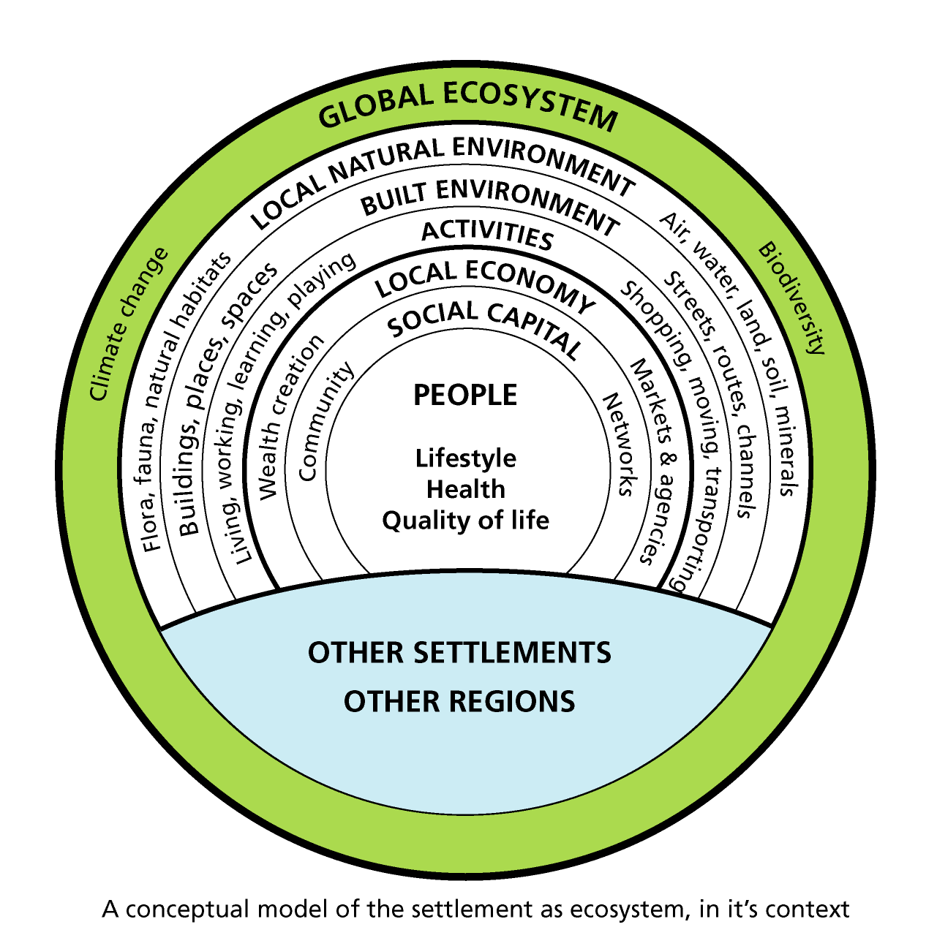
Figure 3 A conceptual model of the settlement as ecosystem, in it’s context
Settlement ecosystem health map

First here are some general points about the structure and use of the model:
- The diagram represents the eco-system of a human settlement. The seven spheres (the number is perhaps only accidentally related to Mediaeval cosmography!) are different elements of stock or capital – social, economic and environmental. Note, however, that each sphere represents as much a process as a state. Its quality may be measured at any particular moment but it is in fact continually evolving and affecting the other spheres.
- The model can be applied at different spatial levels: village, neighbourhood, town, city, urban region. While such settlements are not often functionally separate from each other, the discourse of sustainable development emphasizes the importance of enhancing local autonomy, landscape ecology ties settlements to their immediate environment, and local cultural / political identity is given due recognition.
to be of value the diagram has to be used dynamically not statically. It is to be used to analyse the potential impacts of, for example, physical change on the sustainability and the health of the settlement. And in doing such analysis a key issue is always the degree to which the settlement is or is not autonomous – the way it is interconnected with adjacent settlements, the region and the world.

Each of the seven spheres of the map are examined below in terms of their nature, significance, theoretical context and analytical value, starting at the centre.

1. PEOPLE: their lifestyles, health and quality of life
The central sphere is concerned with individual life-styles as well as healthy status and quality of life. It thus elides together, for the sake of simplicity in the diagram, aspects of individual behavioural choice on the one hand and health/Quality-of-life outcomes on the other. It does not include heredity factors since the focus is on the social and environmental determinants of health.

Old and young, rich and poor, black and white, able and disabled, experience their living environment in different ways, with different health outcomes. So the key question is: how equitable is the settlement in its impact on health and quality of life? Are low status groups, or those living in particular areas, disadvantaged? Overall is the settlement becoming healthier, and do people feel their quality of life is improving?

Theories of the determinants of health provide insight into the relationship between people’s well-being and the planning of settlements (Aicher 1998, Marmott and Wilkinson 1999). A World Health Organisation study identifies twelve health objectives for planning, relating to equity, exercise, social cohesion, housing, work, accessibility, food, safety, air quality, water, earth and climate (Barton and Tsourou 2000, p12-22). These can provide an agenda for analysing health impacts.

Concerns about obesity and health put the spotlight on individual lifestyle choices, particularly the amount of regular exercise taken (Cooper 2003, Smart Growth 2004). Along with good diet, exercise is probably the most vital ingredient of health in “advanced” societies. But the impact of spatial planning on exercise is far from straightforward.
Family and cultural values predominate. Planning through its effect on the distribution and accessibility of activities and the quality of place helps to determine whether walking and cycling are viable and enjoyable options – or whether they are inconvenient, unpleasant and unsafe. Understanding of the reasons why people behave in particular ways is vital for effective design and planning. Theories of travel behaviour and environmental psychology can assist, though strangely they are not always evident in planning and urban design courses.

2. SOCIAL CAPITAL: community groups and networks
This sphere includes not only social networks and “community” but also the level of social inclusion in terms of environmental equity and empowerment. In an era if high motorisation and social groups based on shared interests rather than propinquity, communities are likely to exist in richly variegated patterns across the “non-place urban realm” (Webber 1964). Yet the importance of local community is emphasised by government (e.g. in the National Strategy for Neighbourhood Renewal – SEU 2001) as vital for social inclusion, and is part of the strategy against climate change (DETR 1998). For poorer and less mobile groups it is also vital for mental health and well-being (Barton 2000). The level of influence of physical planning on supportive social networks is an under-researched area. Halpern (1995) shows how it links to issues of land use and social mix, traffic and public space. It seems likely that the most important channel of impact is via the provision of space for specific activities – such as schooling, shopping, pubbing, playing, meeting etc – that themselves generate social groups.

Studies of sociology, more particularly community development, provide insight into these processes. The debate over social capital is providing a new momentum and recognition of the significance of social cohesion for individual and societal well-being.

3. LOCAL ECONOMY: wealth creation, markets and agencies
Income is probably the biggest determinant of health, accountable for a huge proportion of the variation between different groups (Marmot 2004). So the general structure and dynamic of the local economy, the degree to which it creates employment opportunities for different population sectors, are important for health.

The local economy – in this context broadly defined to include private, public, voluntary and informal sectors – is also the driver of physical change and the way in which activities mesh (or fail to mesh) with constricted space. Understanding local economic activity – especially land markets, housing and commercial markets, development processes – is essential for aspiring settlement planners. Equivalently an understanding of the wider implications for health and environment of their investment decisions is vital for responsible investors. This applies to all sectors, and is a major justification for “spatial planning” (as promoted by the new UK planning act 2004), community strategies and Local Agenda 21. Conspicuous examples of organisations failing to live up to their “public interest” responsibilities include the Post Office and Health Authorities, closing local branches or hospitals in the interest of operational efficiency without adequate consideration of the financial and health costs they may be forcing on client groups.

4. ACTIVITIES: activity systems and movement
While the first three spheres, dealing with people, society and economy, are described largely in spatial terms, sphere four is spatially specific. It is largely concerned with the human activities, and related service activities, that occupy space. There are four main categories: the activities such as residing, working, schooling, shopping, playing, socialising etc, that have space needs of a particular scale and character; the movement of people, for purpose or pleasure, between places by a variety of modes; support services such as sewage treatment or energy generation; and the flows of goods and utilities. A fifth category of “virtual” movement by telecommunications, which may substitute for or generate “real” movement, could be added.

These activities and flows are the lifeblood of the settlement. Health is affected very directly by, for example, the availability of water and food. Individual well-being, social cohesion and economic development depend on activities’ quality, accessibility and viability.

This is all home ground for planners and designers. Systems theory can help to integrate topic-based analysis of needs and demands for housing, business, retailing, schooling, open space, transport.

Ensuring that there is space to satisfy needs, and that the settlement functions smoothly to permit people to pursue their activities in a healthy and sustainable manner, is the central concern of town planning.

5. BUILT ENVIRONMENT: adapted spaces and channels
The focus of this sphere is the constructed urban environment: the buildings, places and spaces where activities happen; the routes and channels which provide for flows. There are important direct impacts or health: the availability and quality of housing, school buildings and the physical safety of streets for example. However, many impacts are indirect.

It is a healthy corrective against inflated self-importance to see this sphere, over which planners and designers have influence, in the context of the other six that go to make up the living settlement. The diagram illustrates the integrated nature of the settlement, and therefore the key responsibility of those charged with guiding its physical evolution. The impacts of renewal and development processes touch every layer. Unlike the restricted remit of EIA (Environmental Impact Analysis), health and sustainability appraisal of a development project should deal with all those layers – working from the outside in:-
- Impacts on energy use and emissions, which impact on global climate and biosphere stability
- impacts on local natural environmental capital: use of resources in construction and use, likely pollution effects, impacts on natural ecology, water systems etc.
- quality of built environment: the buildings, spaces and channels; aesthetic impacts, sensitivity to local heritage and culture
- fit for purpose: matching needs in terms of location, siting and design; maximising accessibility for potential user groups; slotting sensibly into the overall land use/movement system
- impacts on economic capital: direct costs, short/long term job and wealth creation and organisational capacity, knock on effects on renewal processes
- impacts on social capital: capacity building through participatory processes, direct or indirect affects on potential for social networks/cohesion/inclusion
- life-style impacts: promotion of healthy exercise not car dependence; likely health and well-being impacts.

Thus the model suggests a format for integrating social and health impact analysis with economic and environmental impact analysis. This agenda would be equally appropriate to plan or programme appraisal as project appraisal.

6. BIOSPHERE: local natural environmental capital
The town or city sits in a landscape of which it is part. To a greater or lesser extent it relies on that landscape for essential resources of clean air, land, water, construction materials, for and energy. Local people are value the landscape for its innate quality, its cultural associations, its wildlife habitats and so on. The dividing line between constructed and natural environment (spheres 5 and 6) is of course blurred, for example in relation to farmland and managed woodland, but a pragmatic distinction can be drawn.

The ideal of a sustainable settlement if that it achieves a high level of local self-sufficiency in resource use – ie. it flows not exploit its natural environmental capital beyond its capacity to revive (Barton et al 1995). The eco-footprint technique can help to assess this. But there is also a health agenda to do with are, water and soil quality and the avoidance of pollution.

The diagram helps to emphasise that it is not the number of people per se that might contaminate their landscape and local biosphere, but the way the intervening decisions about economic development, activities and the built environment are handled. Population levels are not necessarily a proxy for ecological impact.

7. THE GLOBAL ECOSYSTEM
The impact of local settlement planning on global issues of climate change is a central issue. The release of CO₂, the main greenhouse gas, occurs primarily through the burning of fossil fuels for industry and business activity, buildings generally (both capital and operational energy use) and transport. In terms of this model this is the effect of spheres four and five on sphere seven. Climate change is recognised as a threat to health by the WHO Healthy Cities movement (Barton and Tsourou 2000).

It will be obvious that the model as presented represents a process of dynamic change and interaction between the spheres. Using the eco-system approach, it incorporated the normative goals of maximising health while minimising environmental degradation. It encourages the analysts to asses how far the settlement in question is self-sustaining – not only in resource terms but also in terms of human activity – commuting and service-dependence – and the local economy. In an increasingly mobile and globalised society local self-sufficiency is a difficult-to-achieve if not impossible aspiration. The final part of the model, other settlements, other regions, allows for this. It provides a diagrammatic stimulus to input/output analysis which could encompass immigration/outmigration; cultural/lifestyle change; the spatial extent of social networks; the job ratio, in and our commuting, retail/leisure catchments; economic impact/output, the migration of firms, internal/external control of firms and organisations; the ecological footprint for energy, water, building materials, wastes, carbon etc; the relative growth or decay of species/habitats.

Potential value of the Settlement Ecosystem Health Map

Earlier I suggested that there is a need to provide a more integrated theory of settlements and settlement planning that can inform both planning education and decision-making processes. The Ecosystem Health Map is intended to contribute to these aims. So the questions arise: how well does it mesh together different theoretical perspectives on settlements so as to provide a basis for shared inter-professional understanding? How adequately does it articulate what healthy, sustainable settlements might be like? How far foes it provide a framework for rational, inclusion decision-making, usefully contextualising existing planning tools?

First, consider the theoretical perspectives. The place of each of the main areas of theory is clear. The inner three spheres relate broadly to the social sciences: psychology, sociology and economics. The middle two spheres, human activities and the built environment, encompass urban systems theory. The outer two spheres are the realm of natural ecology. Human ecology provide a more integrated approach, linking across the spheres from the local economic activity out to the global eco-system. Landscape ecology overlaps with that, reaching from social capital (the cultural aspects of landscape) through the nature and impacts on the local environmental determinants of health stretch from the core of the model people, out to at least the local biosphere, and perhaps the global.
More specific areas of theory inform specific relationships between spheres. For example urban economics (location theories, land market analysis) link the local economy, activities and the evaluation of the built environment, and underpin both urban systems theories and land use transport studies. Environmental psychology examines the response of people to their physical environment. Seeing each body of theory in the context of the map can help theorists and students of planning to understand its significance.
An omission from the list of disciplines above is politics. Clearly there are relationships between political theory and the model – for example in relation to empowerment and social inclusion in sphere two. Bu the main emphasis of the model, as discussed earlier, is not way in which decisions are taken and by whom, which is the stuff of politics but the way settlements function as places to live.
Figure 4 sets the map in the context of specific tools and conceptual frameworks for monitoring the quality and sustainability of settlements under the aegis of the “quality of life capital” approach (see CA et al 2001 and DETR et al 2000). This is related in the figure to the social and environmental determinants of health. The notional range of concern of a number of important planning techniques is graphically demonstrated. In project appraisal it helps make the case for integrating health impact assessment with environmental impact assessment under the umbrella of sustainability impact assessment, rather than treating each as if it was concerned with different things (WHO 2005).

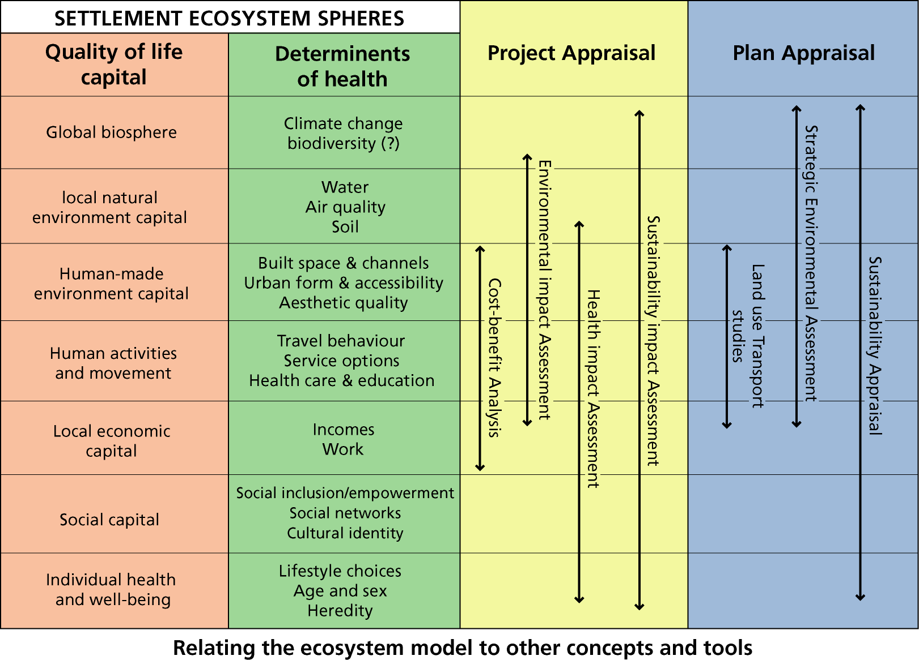
Figure 4: Relating the ecosystem to other concepts and tools

In both theoretical and practical arenas the map helps to avoid sins of omission. But it acts as more than a checklist. It assists conceptualisation of the complex dynamics of human settlements. As with the mental health example earlier, it encourages recognition of the interaction between layers of reality, including sequential impacts. It shows planners, and other actors in the play of spatial development, how they fit into an overall pattern. In this context the role of planners and designers is to be experts in the way the physical fabric of settlements evolves and effects other variables.

If current planning courses, and the skills/knowledge of trained planners, are evaluated against the model in this way, they may well fall short of adequacy. The scientific evidential underpinning of policy is particularly weak. In the long run there is the opportunity (and need) to construct an integrated theoretical and empirical base for spatial planning.

Conclusions

It has been argued in this paper that substantive planning theory has been stranded in an intellectual backwater for too long. The result is that our understanding and analysis of how settlements work tends to be seen through a number of distorting lenses (the disciplines and skills that are relevant). There is no coherence or focus to the image. What is needed is an integrated theory of settlements that locates and contextualises the different perspectives, putting people firmly at the centre, so that students, researchers and practising planners can orientate themselves effectively. As a step in this direction, the paper puts forward a human ecology model of settlements that integrates an eco-system approach with an analysis of the determinants of health and well-being. Although this marriage has not previously been consummated (to my knowledge) in any systematic way, it appears that the two theories – ecological and health – are well matched and offer, potentially, a powerful, logical tool for urban planning.

In line with the anthropogenic UN definition of sustainable development people are put at the heart of the model – specifically the people living, working, learning, playing etc in the settlement. It is their needs and opportunities, their health and well-being, their inclusion or exclusion, the quality of life and environment that they experience, that are the prime concern. The people generate (and depend on) activities – some of which are concerned with wealth-creation – which may or may not be contained within the settlement. The activities range from the casual to the formal and relate closely to the interest communities and other networks of mutual support which are critical to mental well-being. The activities may be analysed in terms of flows (e.g. traffic levels, retail turnover) or stock (e.g. social capital, employment levels).

The activities use space. The physical settlement may be described in terms of buildings, streets, greenspace and infrastructure. The functional form of the settlement, the network of internal and external links and the aesthetic character of the area affect the capacity for, and quality of activities, and themselves respond to economic pressures, adapting to changing need. The planning authorities act as gate-keepers to physical change and thus act to facilitate (of frustrate) activity, affecting thereby the quality of people's lives.

The economic and social activities of the inhabitants, as mediated by the physical fabric of the settlement, demand certain levels of resource use and affect natural environmental capital (earth/minerals, air, water and fire/life/biology). If the impact is unsustainable then eventually health and well being are threatened. The settlement is seen as integral with, and limited by the capacity of, its bioregion. For some impacts, such as climate change, the bioregion is the whole Earth.

On a different plane there are broad cultural, social, economic and technological conditions which shape the processes at work within the settlement and between settlements. Cultural beliefs, values and norms limit the behavioural range and to a significant extent determine the social milien of individuals. Economic structures and government policies affect life chances, wealth and services available. These societal variables have not been the prime subject of this paper, which is focussed at the settlement level, but of source are critical to what goes on in the settlement.

The conceptual model, it is argued, gives a health map for town planners, a means of organising and structuring debate, a framework for the development of techniques such as plan and project appraisal. It also gives a focus: planners exert direct influence on the sixth sphere – the adapted spaces and channels – and this affects all the others to varying degrees. Other actors and agencies shape elements of the built environment. But the planner has a specific and indispensable role in trying to ensure the healthy and sustainable spatial evolution of neighbourhoods, towns, cities and regions as a whole. No-one else takes that integrated spatial overview. It is the planners job to understand and communicate accurately the significance of physical change for social, economic and environmental variables that affect quality of life, now and in the future.

Planning theory currently offers no synthesis of theories for planning. The absence of such synthesis is inhibiting effective planning practice and perpetuating the myth that planners' role is purely one of mediation and procedure, with no substantive agenda beyond the expressed interests of stakeholders. Theory is falling behind the needs of practice and acting as a brake on insight and innovation. The ideas presented here are only at the formative stage. But I hope they will trigger thoughts and actions by others.

REFERENCES

Aicher, J. (1998) Designing Healthy Cities. Florida, Kreiger Publishing Company
Barton, H. et al, (2000) Sustainable Communities, Earthscan, London
Barton, H. and Tsourou (2000) Healthy Urban Planning. WHO Copenhagen and Spon, London
Barton, H., Davis, G. and Guise, R. (1995) Sustainable Settlements: a Guide for Planners, Designers and Developers. UWE, Bristol and LGMB
Barton, H., Davis, G. and Guise, R. (2003) Shaping Neighbourhoods. Spon, London
Burton, E. (2002) Sustainable urban form and issues of equity
Chadwick, G. (1972) A Systems View of Planning. Pergamon Press, Oxford
Cave B, Molyneux P and Coutts A (2004) Healthy sustainable communities: what works? Report for the NHS Milton Keynes /South Midlands Sub-region by BCA, Brighton
Chapin, F. (1965) Urban Land Use Planning. University of Illinois Press, Chicago
Cooper, A. (2003) “Why walk to School? Active commuting and children’s health” in Urban Design Quarterly
Countryside Agency, English Heritage, English Nature and the Environment Agency (2001) Overview report: Quality of Life Capital. CA, EH, EN, EA
Dennis, N. (1968) "The Popularity of the Neighbourhood Community Idea" in Pahl, R. Readings in Urban Sociology. Pergamon Press, Oxford
DETR (1998) Planning for Sustainable Development. HMSO, London
DETR, LGA, I&DeA (2000) Local Quality of Life Counts. London, DETR
DHSS (1999) Our Healthier Nation: a Contract for Health. HMSO, London
Duhl, L. (2000) Public Health and Urban Planning – unpublished draft
E.U. Expert Group on the Urban Environment (1995) European Sustainable Cities Part II. ESDG XI, Brussels
Faludi, A. (1973) Planning Theory, Pergamon, Oxford
Foley, D. (1964) An approach to Metropolitan Spatial Structure in Webber, M. et al (eds) “Explorations into Urban Structure”, University of Pennsylvania Press, Philadelphia
Foreman, R. and Godran, M. (1986) Landscape Ecology. New York, Wiley
Gans, H. (1972) People and plans. Penguin, Harmondsworth
Girardet, H. (1992) Creating Sustainable Cities. Green Books, London
Grant, J., Manuel, P. and Joudrey, D. (1996) “A Framework for planning sustainable residential landscapes” in Journal of the American Planning Association Vol 62, No.3
Hall, T. (2001) Urban Geography: Second Edition. Taylor and Francis, London
Halpern, D. (1995) Mental Health and the Built Environment, Taylor and Francis, London
Hancock, T. (1985) The mandela of health: a model of the human ecosystem Family and community health November 1985
Hersperger, A. (1994) Landscape Ecology and its Potential Application to Planning. Journal of Planning Literature 9.1: 14-29
Hough, M. (1995) Cities and Natural Processes, Routledge, London
Houghton, G. and Hunter, C. (1994) Sustainable Cities. Regional Studies Association/Jessica Kingsley Publishers, London
Lawrence, R. (2002) ‘Human Ecology and its applications’ in Landscape and Urban Planning. 987 pp1-10
Lynch, K. (1981) A Theory of Good City Form. MIT Press, Cambridge, Mass
Marmot, M. (2004) The status syndrome: how social standing affects our health and longevity Times Books, London
Marmot, M. and Wilkinson, G. ED (1999) Social Determinants of Health. OUP, Oxford
Mcloughlin, B. (1968) Urban and Regional Planning: a Systems Approach. Faber and Faber, London
ODPM (2004) PPS 1 Delivering sustainable development ODPM London
Park, R., Burgess, E. and McKenzie, R. (1925) The City, University of Chicago Press, Chicago
Price, C. and Dubé, P. (1997) Sustainable Development and Health: concepts, principles and framework for action for European cities and towns WHO Regional Office for Europe, Copenhagen.
Selman, P. (1996) Local sustainability: managing and planning ecologically sound places. Paul Chapman, London
Smart Growth International Conference (2004)
Social Exclusion Unit (2001) The National Strategy for Neighbourhood Renewal. HMSO, London
Taylor, N. (1998) Urban Planning Theory, Sage, London
Timms, D. (1971) The urban mosaic: towards a theory of residential differentiation. Cambridge, CUP
Tjallingii, S. (1995) Ecopolis: Strategies for Ecologically Sound Development. Backhays Publishers, Leiden
Tomalty, R. (1994) "An Eco-System Approach to Growth Management" Environments. Vol.22, No.3, Canada
Webber, M. (1964) ‘The Urban Place and Non-place Urban Realm’ in Webber, M. et al Explorations into Urban Structure. UPP, Philadelphia
Whitehead, M. and Dahlgren, C. (1991) "What can we do about inequalities in health". The Lancet. 338: 1059-1063
WHO (2005) Phase IV (2003-07) WHO Healthy Cities Network: Report on a WHO Business Meeting, Udine, Italy, October 2004, Copenhagen, WHO
Wilkinson, R. and Marmot, M. (ed.) (1998) The solid facts: social determinants of health. Copenhagen, WHO Regional Office for Europe

H:RO/Centres/Healthy/2004/A health map for urban planners

