

Southville Home Zone
An Independent Evaluation

Final Report of Evaluation Study Conducted for
Bristol City Council
Prepared by
The Centre for Transport & Society
University of the West of England, Bristol

October 2006



UWE project team:
Ms Henrietta Sherwin, Lead Researcher
Dr Graham Parkhurst, Project Manager
Dr Kiron Chatterjee, Expert Advisor

For any queries or correspondence regarding this Study or Report, please contact the UWE Project Manager

Dr Graham Parkhurst
Centre for Transport & Society
Faculty of the Built Environment
University of the West of England, Bristol
Frenchay Campus
Coldharbour Lane
Bristol
BS16 1QY

E-mail: graham.parkhurst@uwe.ac.uk
Tel: +44 (0) 117 32 82133
Fax: +44 (0) 117 32 83002
Executive Summary
Background
- In September 2001 Bristol City Council (BCC) began the four-and-a-half year process of implementing the Southville Home Zone (HZ) focussed around a bid to the national Home Zone Challenge fund made available by the UK Government Department for Transport (DfT). The overarching aim of a HZ is to rebalance the priorities in residential streets away from motor traffic, in favour of ‘streets as living spaces’; enabling social activity such as play, and non-motorised movement. BCC has been a pioneering local authority in the introduction of HZs in the UK.
- Five streets in the Southville area entered into discussions with BCC about the potential for redesigning the streetscape. Of these, one entire street and sections of two other streets eventually received HZ treatment, whilst works in the other streets did not proceed for various reasons. Simultaneously, the wider area was involved in consultations for a ‘20 mph zone’. The implementation process for the latter is ongoing.
- In November 2005, the University of the West of England, Bristol (UWE) was commissioned to conduct an independent evaluation of the implementation process of the Southville HZ project and its outcomes, the findings of which are presented in the following report.
Methodology
- The evaluation has involved:
- questionnaire surveys distributed to 170 households (52 in streets with HZ features and 128 in nearby streets), enabling comparison of some questionnaire elements with a ‘before’ survey of the same streets conducted by BCC in 2003,
- additional qualitative research including individual interviews with community representatives and the key professionals who had been closely involved in the implementation and focus groups discussions with groups of residents,
- inspection and evaluation of the consultation materials with additional specialist assistance by staff from the UWE Construction and Property Research Centre,
- informal observation of the use of the streetscape by residents and travellers, and
- an opportunity to comment by post or email offered by letter to a further 230 households in the streets surrounding the HZ.
- Response rates to the questionnaire survey were high, with 34 returns from HZ streets and 71 from nearby streets (equivalent to around two-thirds of households overall), whilst around 20 percent of households in the wider area submitted comments. The qualitative data collection was in general effective, resulting in a broad range of high quality data.
- Detailed analysis of household composition did, however, indicate that many of the individuals responding to the 2006 survey were different from the 2003 survey, due to differences between which properties participated and due to changes of property ownership. This confirms both that the Southville community evolved through the process and that there are constraints on the comparability of all longitudinal surveys.
Consultation
- Consultation for the HZ was thorough and extensive, with both BCC officers and many Southville residents investing substantial professional and personal resources in the process. It was, however, complicated by a number of factors, leading to negative emotions and beliefs amongst all involved at times, including
- the length of the process and the intermittent nature of activity, given the phases of the project and other responsibilities of the BCC officers,
- the presence of an external timetable created by the HZC, and
- problems in the transition from ‘visionary’ conceptual planning to detailed design, which introduced important constraints on residents’ aspirations.
- Although particular critics of the consultation process remain, and those critics have valid individual perspectives, a clear majority of the survey respondents agreed that the process had included them, and a majority felt their involvement had had influence.
- The consultation process used a number of planning tools, including visual simulations of the future streetscapes and ‘planning for real’ exercises. A significant minority of respondents did not express an opinion about these tools, but the majority of respondents agreed that they had been useful. Qualitative evidence yielded specific examples linking use of the tools to residents’ views and requests to BCC having changed.
The expert assessment of the visualisation tools by UWE did, however, identify ways in which their use by BCC could be enhanced in future, including:
- ensuring a consistently high level of detail and realism is included (using stills over video where cost is a limiting factor),
- avoiding perspectives from the ‘roof-line’ which almost never concur with residents’ subsequent experience, and
- greater consideration of the potential for interactive visual simulation tools.
Implementation
- The implementation process in Southville was affected by construction and financial issues that are partly beyond the scope of the present evaluation. Some of the circumstances are now particular historical facts which are unlikely to be repeated. A general lesson is that given the uncertainties about what underlies Victorian-era streets then something akin to the optimism bias that exists for national capital schemes be appropriate in the cost estimations for retrofit HZs.
- A particular positive of the implementation process was the involvement of local design and craft skills, particularly useful in the design and provision of street furniture and decoration. This process could have been more formal, through a skills audit, and it is recommended that this is undertaken earlier in respect of future similar projects, so that the use of local skills maximised.
- Whilst the completed streets are almost universally considered to be completed to a high specification and quality, some issues emerged relating to post-implementation management, including:
- how operating practices agreed amongst the specific residents of the streets at the time of implementation, for example concerning the informal rules about parking or watering the planters, are communicated to future residents, not party to the original agreement, and
- whether such informal agreements are sufficient to avoid conflict.
Outcomes: Perceptions of the HZ and quality of life
- Residents in 2006 were asked to assess six quality of life variables. HZ street residents identified concerns at a lower rate overall than those living nearby. This may reflect actual improvements in the quality of life, or changes in perception due to living in a HZ street, or a combination of the two.
- The ratings by all residents of five of these six variables showed improvement in 2006 over similar questions put to them in 2003. The largest improvements were for ‘traffic speed’ and pedestrian safety as judged by residents in HZ streets (with those nearby indicating less improvement). The factor showing a (small) increase in concern levels was ‘parking’. This had been arguably the most concerning and divisive issue raised in the consultation process by residents, and had an important influence on the consensus designs (or decisions not to proceed).
- Responses were also sought in relation to four specific streetscape issues. None of these attracted very strong identification as concerns, with ‘lack of community spirit’ in particular not being identified as a problem before or after implementation. HZ residents indicated much less concern with street lighting in 2006, which had been changed as part of the project. There were also changes in the perception of litter as a problem, which may relate to litter being more obvious on the new, higher-quality streetscapes with lighter coloured surfaces and no gutters to trap litter.
- Questions relating to overall quality of life following HZ development were also asked to all residents in 2006. Nearly all HZ residents thought the HZ had ‘improved the street’ and two-thirds of those living in nearby streets who expressed a clear view thought HZs were ‘a good thing for Southville’. There was also strong support for the view that ‘overall living in Southville was better’ amongst HZ residents (a question not put directly to those nearby).
Outcomes: Reported change in behaviour
- HZ residents firmly reported spending more time outside in the street, engaging more in both informal interaction and organised street activities. Children were also reported as playing more in the street, and it was similarly felt that the streets were safer for play.
- The above developments were generally seen as positive, although some residents identified negative aspects, including greater noise, possible damage to property from games, and the risk of exclusion.
- Residents living near-HZs, who had experienced the interaction of the consultation process but not redesigned streets, gave contrasting responses in respect of verbal interaction with neighbours: a majority disagreed that they talked to neighbours more.
- HZ residents reported they were driving more carefully following implementation. Respondents in nearby streets also reported a similar but smaller change. A before and after speed survey of the ‘focal point’ element of the scheme in Stackpool Road, which has an important traffic calming role, showed a 50 percent reduction in the 85th percentile speeds of vehicles travelling through the feature to less than 20 mph, and a very large reduction in extreme speeding. The sampled residents strongly recognised the benefits of the focal point in terms of slower traffic and easier crossing of the street, and most also agreed it created a useable, pleasant public space. However, despite more than one remodelling, there was evidence that some residents are not happy with the traffic management arrangements at the focal point, with concerns about forward visibility for drivers and aggressive driving. Such concerns may reflect the difference in road safety philosophy: segregation of flows versus the sharing of space with uncertain priorities.
- The majority of all respondents felt they were not more likely to consider alternatives to car use as a result of the HZ process, although HZ residents were somewhat less strong in their views. Arguably, the relatively high existing use of alternatives (with many cars being left at home in the working day) may have limited the extent to which the overall sample could increase its walking and cycling. However, the HZ street respondents did feel strongly that pedestrians and cyclists were now safer, at least within the HZ and some specifically reported using cycles or walking more, suggesting a small positive actual change in the HZs themselves.
- The respondents were somewhat negative in their responses regarding parking, believing it was harder to find a convenient space. By a small majority, HZ residents felt that the rules about where you could park in the streets were unclear. There was modest rather than strong overall support for a residents’ permit scheme, with support somewhat higher outside the HZ streets.
Recommendations in respect of consultation and implementation
- The following Recommendations for enhancing the provision of HZs:
- Clarify objectives in the beginning with a realistic sense of what can be delivered given practical constraints: carefully manage expectations. Be clear that there will be compromises and trade offs particularly in terms of reduced parking.
- Consultation should emphasise frequent provision of information as well as detailed information, if only to confirm that a decision has not yet been taken.
- Conduct a skills audit to be sure that local (often free) resource inputs, adding to a multi-disciplinary team, and compensating for the limitations of public resources.
- Seek community advice about what should be regarded as a consensus behind implementation. Engage as many people as possible, and particularly those who have concerns, otherwise they will leave the process and become objectors later on, and be disenfranchised in the post-implementation period. However, in consulting minorities, be clear that the process remains public, and do not allow individuals to unreasonably influence the process at the expense of the majority.
- Make sure the contracts are more detailed, and include time penalty clauses.
- Have a clear ‘handover’ strategy to the community, indicating who is responsible for which aspects of the scheme’s management.
Value for public money and issues of equity
- The issues of cost and equity were raised during the qualitative data collection, by both the professionals and residents. It is expected that the final cost of the HZ and associated 20 mph zone will exceed £850,000. Although there have been clear environmental regeneration benefits in particular streets, and some wider social and safety benefits, Southville was not an urban regeneration community; indeed it performs well against the usual indices of multiple deprivation.
- It is noted that gentrification is likely to result from the HZ scheme, and that local estate agents foresee house prices increasing in the region of £5,000 per property, and suggest the properties will have greater saleability. Part of the investment by national and local government has therefore benefited current property owners. This does not automatically mean that the benefits of HZs are poor value for money, but does emphasise the careful targeting of such public investment to needy communities.
- Given the identified benefits of HZs apparently have a market value, greater consideration should be given locally and nationally to the role of private funding for HZs (by developers, sponsors, or even residents themselves).
- There are equity considerations raised by the existence of minorities in proposed ‘retrofit’ HZs who do not welcome the change. The adoption of a specific percentage figure as indicative of consensus is particularly controversial when the outcome affects the enjoyment of particular homes and lifestyles, sometimes significantly. A more accountable, public and justified basis for determining consensus at the neighbourhood level is required.
Overall conclusion
- Southville was relatively unusual as a retrofit HZ project in that the area was not in need of urban regeneration on grounds of social policy objectives. Nonetheless the Southville scheme is recognised as having brought identifiable environmental, social and behavioural benefits by the majority, but arriving at those outcomes is seen as a complex, difficult and expensive process.
- The consultation and implementation process was complex and troubled in some, but not all, streets. However, once problems arose, the implementation team worked intensively to seek consensus solutions, and these were generally reached (in some cases resulting in the HZ process not continuing in a particular street). In the final evaluation, both the consultation process and its outcome were rated positively by a clear majority of residents. Indeed, given the high costs of the scheme, this creates a paradox that the demand for similar treatment by other neighbourhoods is likely to rise as a result of the demonstration project, but national funding will not be available on the same basis.
- It is observed that many of the difficulties experienced and high costs in the case of Southville (existing community with a range of expectations leading to complex consultation; existing, aged street infrastructure; constrained carriageway width) relate to the fact the project was a retrofit HZ. It is hence recommended that BCC’s policy development in respect of HZs emphasises:
- any future BCC investment being targeted towards neighbourhoods in need of urban regeneration where public investment is likely to result in greater social benefit per pound invested, and
- the achievement of the highest standards of HZ principles in the design of new-build private-sector and social housing.
Contents
1. Introduction 12
1.1 Overview and Report Structure 12
1.2 Home Zones in the UK 12
1.3 Home Zones in Bristol 14
1.4 Ethos of the Southville Home Zone 16
1.5 Complementary initiatives 19
2. Process and Implementation 21
2.1 Overview of Consultation Process 21
2.2 Outcomes from Street-by-Street Consultation 26
2.3 Out-turn Physical Changes in the Streets 27
3. Methodology and data collection 35
3.1 Methodology 35
3.2 Methodological challenges and constraints 38
3.3 Response rates 38
3.4 Sample Characteristics 40
4. Results and interpretation 44
4.1 Consultation Exercise 44
4.2 ‘Before and After’ Concerns About Life in Southville 50
4.3 Satisfaction with the Home Zones 58
4.4 Influence on Reported Behaviour 62
4.5 Parking 69
4.6 The Stackpool Road Focal Point 71
4.7 Wider commentary on the scheme from the ‘20 mph zone’ 78
5. Discussion 81
5.1 Quality of the Consultation Process 81
5.2 Inputs into the Implementation Process 83
5.3 Goodness of Fit with the HZ concept 87
5.4 Value for Money and Future Direction for Home Zones 91
6. Conclusions and Recommendations 92
6.1 Southville Home Zone Process and Outcome 92
6.2 Conclusions for National Policy on Home Zones 93
References 95
Appendix A: Consultation Process in Howard Road 96
Appendix B: Results from Tracking of Respondents through 2003 and 2006 Surveys 98
Appendix C: Further HZ Residents’ Comments about the Consultation Exercise 106
Appendix D: Questionnaire Instruments 107
D1. 2006 Questionnaire to HZ Streets 107
D2. 2006 Questionnaire to Near-HZ Streets 115
D3. 2006 Letter to residents of wider area 122
D4. 2003 Questionnaire to all streets 123

List of tables
1.1 | Interim Budget Details for Southville HZ | 17
2.1 | Number of meetings held for different streets’ HZ workshops | 25
3.1 | Response rates in 2006 in ‘Questionnaire 1 HZ streets | 40
3.2 | Response rates in 2006 in ‘Questionnaire 2 near HZ streets’ | 40
3.3 | 2003 and 2006 response rates for HZ streets compared | 40
3.4 | 2003 and 2006 response rates for near-HZ streets compared | 40
3.5 | Response rate to letter drop | 41
4.1 | Westbound (7-day) traffic and speed counts before and after implementation | 74
4.2 | Eastbound (7-day) traffic and speed counts before and after implementation | 74
List of MAPS
1.1 | Southville Environmental Cell | 19
2.1 | Home Zone Scheme as proposed in November 2003 | 22
2.2 | Overview of Southville Home Zone as built | 34
List of PLATES
1.1 | Stackpool Rd Cul-de-Sac HZ as constructed | 20
2.1 | 3-D Simulation of ‘echelon’ option for cul-de-sac | 25
2.2 | 3-D Simulation of ‘centre parking’ option for Cul-de-Sac (not progressed) | 26
2.3 | Gateway to Stackpool Rd Cul-de-sac with planters and cycle parking | 28
2.4 | Echelon Parking in Stackpool Rd Cul-de-Sac | 29
2.5 | Heritage materials reused in Milford St | 30
2.6 | Milford Street – feature planters designed by local architect | 31
2.7 | Tiles produced by residents for Stackpool Rd Cul-de-Sac | 32
2.8 | Milford Street prior to HZ | 35
2.9 | Milford Street with HZ | 35
4.1 | Design overview of focal point | 73
4.2 | Stackpool Road – Looking west with vehicle turning from Beauley Road | 75
4.3 | Stackpool Road Focal Point looking east | 76
4.4 | Additional space for community activity outside the church | 78
List of PLATES
3.1 | Demographic Structure of HZ Sample Households | 42
3.2 | Demographic Structure of Near-HZ Sample Households | 42
3.3 | HZ Streets Vehicle Ownership | 43
3.4 | Near HZ Street Vehicle Ownership | 43
4.1 | Hz Street views’ on the consultation process | 46
4.2 | HZ Residents views on usefulness of the consultation tools | 47
4.3 | Near-HZ Residents views on useful of the consultation tools | 48
4.4 | HZ households concerns before and after implementation | 52
4.5 | Near-HZ households concerns before and after implementation | 53
4.5 | Frequency of issues being identified as a concern in HZ streets | 54
4.7 | Frequency of issues being identified as a concern in near-HZ streets | 54
4.8 | Issues HZ residents ranked as primary concerns | 55
4.9 | Issues near-HZ residents ranked as primary concerns | 56
4.10 | HZ respondents’ recognition of street issues | 57
4.11 | Near-HZ respondents’ recognition of street issues | 57
4.12 | Changing concerns about poor lighting | 58
4.13 | Stability of views concerning community spirit | 58
4.14 | HZ Residents’ views of HZ socio-environmental benefits | 59
4.15 | HZ residents’ beliefs about whether HZs had been an improvement | 60
4.16 | Near-HZ residents’ support for the general principle of HZs | 62
4.17 | Near-HZ residents’ views of HZ socio-environmental benefits | 63
4.18 | Reported increase in street activities | 64
4.19 | Propensity of all respondents to speak to their neighbours more | 64
4.20 | Perceptions of Children’s Safety | 65
4.21 | HZs Residents’ views on other drivers’ behaviour | 66
4.22 | Propensity to drive more carefully | 67
4.23 | Propensity to consider alternatives | 68
4.24 | HZ residents’ views about pedestrian and cyclist safety | 69
4.25 | HZ residents’ views about parking post-HZ | 71
4.26 | Near-HZ residents’ views about parking post-HZ | 71
4.27 | All respondents views about the benefits of the focal point | 77

“The Home Zone I feel has made a better street. I am really pleased with it, obviously there are things that could have been improved upon, but seeing as we were one of the first Home Zones then I guess that was bound to happen. I think that in the summer the street really comes alive with children. My three-year old is out there on his bike and I feel he is safe now, I don’t think I would have done before”
Resident, Milford Street

Acknowledgements
We would like to thank the Bristol City Council Home Zone Team for providing us with their data and information and also being generous with their time; the many people in Southville who were willing to give their time either for interview, filling in questionnaires or attending a focus group; the Southville Community Centre for allowing us to use their facilities; Prof Lamine Mahdjoubi and John Counsell for their expert advice on visual planning aids; Heidi Andrews who helped with the focus groups as part of her Masters Degree in Public Health at UWE and Matt Whale who helped with the gathering of data as part of his undergraduate degree in the Faculty of the Built Environment UWE.

1. Introduction
1.1 Overview and Report Structure
The object of the present report is to provide an independent evaluation of the Southville Home Zone (HZ), implemented in the south of Bristol in 2004-5. It was commissioned by Bristol City Council (BCC), the agency responsible for the implementation. A key reason for seeking an independent evaluation is to identify the extent to which the completed project has achieved both the aspirations of the project, and realised the objectives set out in a successful bid to the UK Government Department for Transport’s ‘Home Zone Challenge’ (HZC) funding instrument. To this end, the report examines the implementation of the project from the consultation phase right through to the delivery of the physical change in the streets and the reactions of residents to that change.
The measures supported by the HZC funds were implemented by 31st March 2005 although the Bristol City Council match funding enabled completion of the final Home Zone element by 5th March 2006. The evaluation was carried out during the later part of 2005 and early 2006. The analysis draws on records kept by BCC and survey data collected by the council prior to the implementation of the scheme which have provided an invaluable source of baseline data. The UWE team also acknowledges the information provided by the professionals and community representatives who had been personally involved in the implementation, and above all the patience and resilience of the Southville community, who have in large numbers provided a breadth and depth of information and insight, throughout both the implementation and evaluation processes.
- Section 1 describes the development of the HZ concept in the UK, The HZ Challenge Fund, HZs in Bristol and Southville in particular.
- Section 2 outlines the process and describes the measures used in Southville to create the HZs.
- Section 3 describes the methodology and data collection.
- Section 4 presents, and provides interpretation of, the results.
- Section 5 discusses the consultation and implementation process, the goodness of fit with the HZ concept, value for money and future directions for HZs.
- Section 6 summarises the evaluation and concludes with recommendations for the future implementation of HZs.
1.2 Home Zones in the UK
A HZ is a residential area where the street is designed to change the way the street is used to improve the quality of life of residents so that they can talk to their neighbours, play, walk and cycle safely in the streets. The aim is to change the balance between the car dominance of streets and the use of streets for living (DfT, 2001).
The term ‘HZ’ is the English language expression for what originally became known as woonerf (living yard) in the Netherlands where the design of the physical space favours the residential function over provision for traffic. Minimum design standards for ‘Woonerf’ were published by the Netherlands Ministry of Transport and Public Works as early as 1976 and the booklet Woonerf outlines the elements required for a successful HZ (Royal Dutch Touring Club, Road Safety Directorate 1980). The HZ concept is also familiar in other European states, notable Germany, where such streets are called Verkehrsberuhigung.
A HZ could be described as an ‘outdoor’ room which is perhaps delineated by ‘gateways’, a change in physical design that signals to drivers that road conditions are about to change. “HZs are based on a change in the way that people perceive the street. Motorists should feel that they have left the normal highway and have entered an area where they can expect to find people who are using the whole of the street. In essence, the HZ should make motorists feel they are guests in a pedestrian environment, and should drive accordingly.” (HZ Design Guidelines 2002)
Biddulph (2003) cites the work of the academic and road safety campaigner Barbara Preston who originally coined the term ‘Home Zone’ in the early 1990s in response to the high level of pedestrian casualties in residential streets. Barbara Preston proposed changing the law so that in certain HZ streets drivers would bear the burden of proof for any crashes involving pedestrians, which is an established principle in the Netherlands.
The rise in the numbers of cars was making the reality of many residential streets unpleasant as they were clogged with traffic and parked vehicles. HZs were beginning to be seen as a way of addressing some of these quality of life issues for urban streets. One of the key promoters of the HZ concept in the UK has been the Children’s Play Council (CPC) with the idea that streets represent an important opportunity to provide a safe space for children to play. Resident groups, Transport 2000 and Sustrans have also been involved in promoting the concept.
It was recognised that there were some inherent institutional and cultural barriers to achieving clean, safe and attractive streets. The Commission for Architecture and the Built Environment (CABE) highlighted some of them in ‘Paving the Way – how we achieve clean, safe and attractive Streets’ (CABE 2002) as:
- the prevailing bias in favour of motorists’ interests in government highway and design guidance,
- the consequent exclusion of other street users’ interest in government guidance and in the way streets are managed,
- a lack of clear focus within local authorities for the design and management of streets,
- a shortage of design expertise in the various professions who have responsibility for streets, and
- the failure of utility companies to acknowledge their responsibilities in maintaining quality streetscapes.
In 1998 the Transport White Paper – A New Deal for Transport was published which initiated the government working with local authorities in England and Wales to set up the first nine pilot HZ projects in August 1999.
The Transport Act 2000 makes provisions for HZs in England and Wales which gives local authorities the power to designate HZs in their area and the Department for Transport has published Traffic Advisory Leaflets 10/01 Home Zones – Planning and Design (Dec 2001) and 8/02 Home Zones – Public Participation (Dec 2002). These were followed by the Institute of Highway Incorporated Engineers Home Zone Design Guidelines (2002).
In April 2001 the Prime Minister announced a £30 million HZ Challenge (HZC) Fund to encourage the development of new HZ schemes to build on the experience of the original pilots by generating a rapid growth in the number of HZs to act as:
- pilots, generating information about implementation, in particular “how best to actively involve local community interests” (DfT, 2001: Para 3)
- and as demonstration projects, actively assisting in disseminating the relevance and practicality of the concept for other areas.
The 61 selected schemes were completed by 2005 and a good practice guide Home Zones - Challenging the future of our streets (DFT 2005) draws on the experience of these schemes. It states “There is no blueprint for a HZ. While individual schemes may use similar elements, each scheme needs to reflect the community’s aspirations”.
Though each HZ is unique to that location there are common features which enable the use of the street to change and slow traffic: traffic calming; shared surfaces (no delineation of a pavement); echelon parking; bollards; trees and planters; benches; play areas; street lighting and ‘gateways’ to announce that you are entering a different streetscape.
Evidence is increasing on the impacts of HZs in UK contexts. TRL has to this date published detailed evaluations of seven of the nine pilot Home Zones. For example, the evaluation of the Methleys HZ scheme in Leeds (TRL, 2003) found that traffic flows and speeds were reduced, and residents had positive perceptions of the implemented scheme, but no effects on mode share and time spent outdoors by children were apparent. Transport 2000/Sustrans (2000) have summarised lessons from the early pilots and emphasised the need for sustained involvement of a local authority project manager and strong input from an independent facilitator and/or resident/tenant group or organisation. There remains, however, a need for greater evidence on the impacts of HZs, and the present evaluation contributes to that base of knowledge. It is hoped that this evaluation study will shed new light by exploring issues not previously investigated (e.g. views of neighbouring residents to HZ streets).
1.3 Home Zones in Bristol
HZs have been developed in both in existing residential areas of Bristol (‘retrofit’) and in newly constructed residential areas (‘new build’). Two retrofit HZs that are already established are the Great George Street HZ (central Bristol) which was constructed during 1995/96 and the Victory HZ (Bedminster) which was completed in 2002. These were established before much of the current legislation and guidance had been developed.
In 2002 the Bristol City Council Environment, Transport and Leisure Scrutiny Commission looked at the progress and status of HZs city within the city and made various recommendations which set the direction of HZs in Bristol. Bristol City Council published a leaflet titled Making Streets Safer outlining their approach. The aim “to reclaim residential streets by improving the places where people live and children play”.
It states “HZs will benefit the whole community. They will improve the quality of life for local residents, create safer and healthier neighbourhoods and promote environmentally sustainable communities. They can help towards traffic reduction and ‘softening’ residential areas, encouraging cycling and walking”.
BCC published New Build HZ Design Guidelines (November 2003) to advise developers of the steps they need to take to create effective new build HZs that meet the aspirations of the Council. A new HZ development on the old BT site off Wessex Avenue in Horfield is near completion by Linden Homes and Bovis Homes in partnership with BCC.
When the Government announced the HZ Challenge Fund, Bristol City Council looked at possible streets that might be suitable to form the basis of a bid. From a list they narrowed it down to six from which they chose three - St Werburghs, the Dings and Southville - which were put forward to the DfT. Southville was successful and the Dings secured funding from Europe through VIVALDI (Visionary and Vibrant Actions through Local Transport Demonstration Initiatives) a European Union co-financed project under the CIVITAS initiative.
The Dings HZ is to the east of the city centre within walking distance of Bristol Temple Meads Station. A cycle path through it will link to both Bristol Temple Meads Station and the Bristol to Bath cycle path. It is a small residential area of 7 residential streets with about 120 households and 12 small businesses surrounded by light industry and brownfield. The HZ is part of the regeneration of that area where Barratt Homes is in the process of building a large residential development which was granted planning permission on the basis that the new streets would integrate with the HZ established in the Dings. Notably, Barratt’s marketing information identified the HZ concept as a particular selling point of the properties, including through identifying the development in publicity as ‘The Zone’.
The particular problems identified by the community in the Dings were unsafe and nuisance parking primarily by commuters blocking access roads and residential addresses. There was poor access for delivery and emergency vehicles and problems of antisocial behaviour primarily children and teenagers. The ‘Dings’ is one of Bristol’s most deprived wards (19th nationally). The Dings HZ includes three streets where a Sustainable Urban Drainage System (SUDS) has been used which is a permeable paving which manages rainwater and reduces the risk of flooding.
The Ashley Vale Action Group (AVAG) that had put forward the proposal in St Werburghs carried on with their proposal themselves but found that a full HZ with shared paved surfaces was too costly so in 2003 they started work on a low cost alternative to address speeding vehicles and parking problems. They arrived at a layout which included a change from undesignated parallel parking to perpendicular parking bays, the narrowing of the running track to a single car width, the widening of one of the pavements, and the construction of large planters, build-outs and traffic islands. It was constructed as part of the planning requirements for the AVAG self-build scheme and has been paid for by the AVAG and the self-builders and cost £12,500. The scheme has also been supported by Sustrans. Local residents have contributed materials, labour and plants.
1.4 Ethos of the Southville Home Zone
Southville was one of 61 schemes nationally supported by the HZ Challenge Fund with a financial award of £458,800 over three years. The principal budget cost heads for the project are shown in Table 1.1
Table 1.1: Interim Budget Details for Southville HZ
Main Project Activities | Budgeted spend
Consultation | £141,000
Detailed Design and Contract Management | £168,000
Construction works, planting, public utility plant alterations | £514,000
Evaluation work including traffic surveys | £21,000
Total | £844,000

The balance of the project funding was contributed by BCC to allow for the signing and physical measures for a 20 mph zone to complement the HZ, covering around 400 homes.
HZs have been described as
“…a tool for neighbourhood regeneration and ultimately traffic reduction, through a series of linked measures including promotion of walking and cycling, scope for travel blending and development of car clubs.”
Southville is not a deprived area, having a largely professionally-employed community, with the majority of the housing being privately owned (70.8%). The remainder is mainly rented privately (21%); both figures are higher than respective Bristol or UK averages. HZ implementation was seen as a way of regenerating the Victorian-era street environment and infrastructure and contributing to the Local Transport Plan objective of stabilising growth in car traffic by 2005 and seeking traffic reduction thereafter.
Southville is arguably sufficiently close to the City Centre to allow people to reduce their car dependence. According to the 1991 census data, Southville car availability figures were similar to the Bristol and National figures, although only 16% of households had a second car available (compared with 20% in Bristol and 23% in Great Britain as a whole), this relatively low figure perhaps reflecting both location and the availability of parking. Car use was reported for 46% of journeys to work in the same census, with 27.9% then being made on foot. These figures show significantly less car dependence than average when compared with the national modal split for journeys to work of 60% by car and 11.8% walking.
In the overview section of original bid for the Southville HZ Bristol City Council outlined how a HZ was a component of its integrated transport strategy which also meshed with a number of other policy aims set out in its Corporate and Best Value Plan Serving Bristol Better. Of particular importance are the following aims:
- Investment for a sustainable environment
- Promoting Health and well being
- Strengthening local communities
It was also felt that the scope for community empowerment and community development that the HZ process offers would support other initiatives including local strategic partnerships and local neighbourhood partnerships.
In terms of the specific HZ measures to be implemented, Southville was identified as an area that lent itself well to the ‘core cell’ treatment, with two complete streets and three portions of streets around a centre comprising a community centre, primary school and church to be treated. It is also an area with a strong local involvement co-ordinated through the Southville Community Centre and with a number of locally-generated environmental initiatives (see below). It was suggested that the HZ Project would complement a number of existing local initiatives as well as create a ‘village centre’.
The map (Map 1.1) below identifies the extent of the Southville ‘environmental cell’ as outlined in the original bid document. The City Centre lies to the immediate north of the cell.
Map 1.1: Southville environmental cell
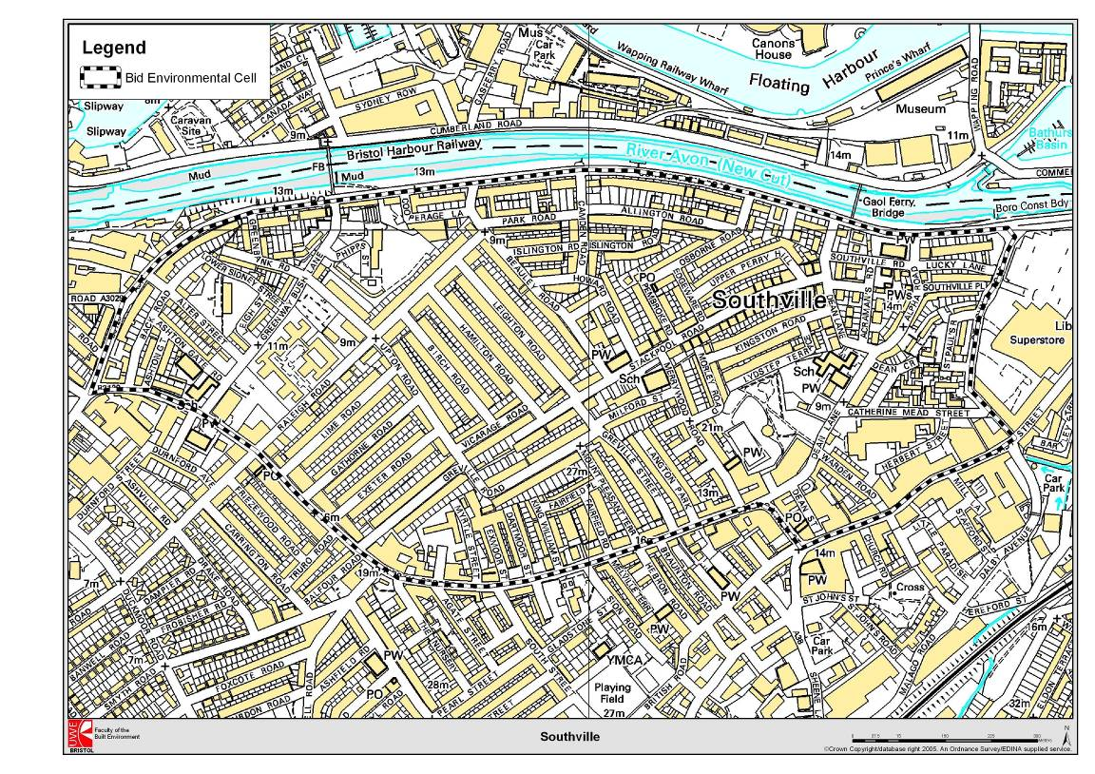

A survey and local community meeting at the short-listing stage generated a very strong and positive response with over 90% of the 70% responding wishing to support the HZ Bid. The local community identified the following scheme objectives:-
- Reduce traffic speeds and volume
- Encourage play in local streets
- Green local streets through planting
- Reduce the isolation of older people by improving the perceived safety of the walking environment
- Use the local streets more for social space
- Improve safety of walking journeys to school
- Reduce traffic access ambiguity at the end of Stackpool Road
It was suggested that to harness community involvement and achieve overall consensus it envisaged a minimum of 12 months for the consultation phase.
The first meeting took place on the 11th December 2002 and physical work started in August 2004. In June 2005 the ongoing scheme objectives were publicised as
“to reduce traffic speed and rat running via the implementation of a 20 mph zone, the narrowing of streets, the planting of trees/shrubs and the creation of safe crossing places to improve and encourage walking. The Council would also like to see the streets used for more social space and play areas for children will be created. Parking will be echelon style. Street furniture and play areas will slow traffic on entering the HZ”.
Plate 1.1 shows one of the two main HZ elements as constructed.
Plate 1.1: Stackpool Rd Cul-de-Sac HZ as Constructed
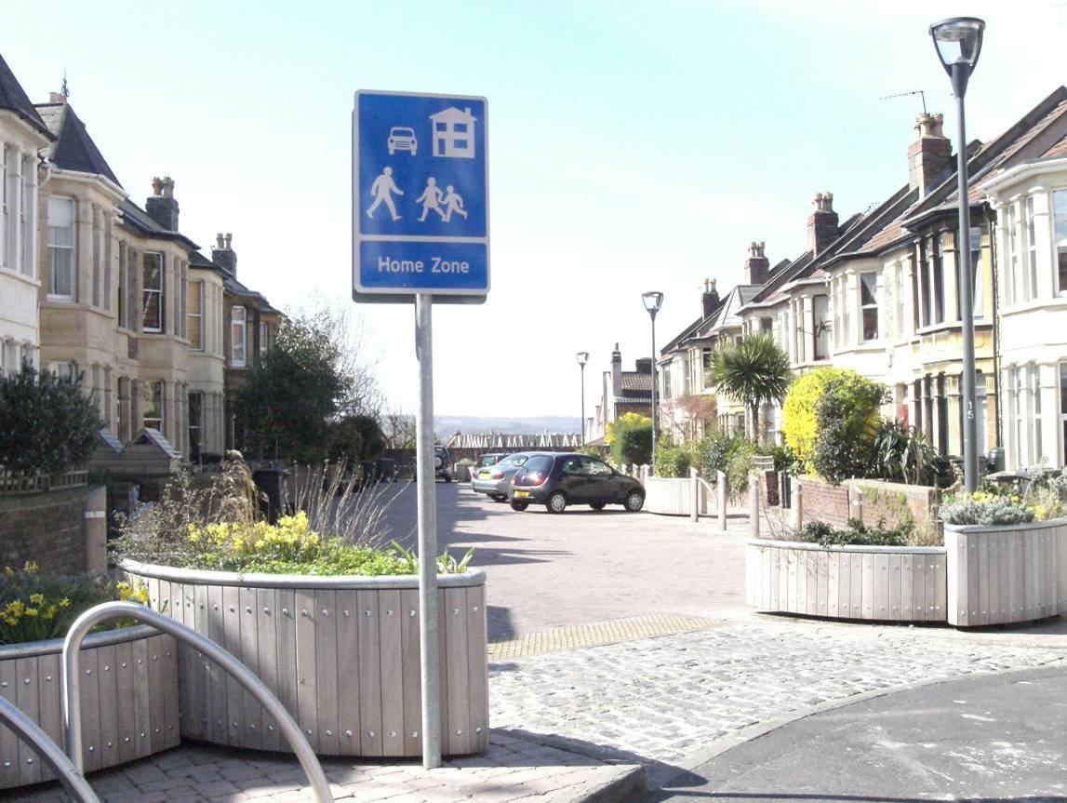

1.5 Complementary initiatives
As mentioned above, the HZ bid was seen as part of an overall strategy of traffic reduction. The Southville Community Centre was involved in a Sustainable Southville Project which included a transport element, including a bike pool and actively promoting the car club. Health walks and community cycle rides around the area were also organized, along with bike maintenance training workshops and production of walking and cycling maps of the area.
The car club was running in Southville prior to HZ implementation, with parking at the Southville Centre on Beauley Road. Southville is one of the most popular localities within the Bristol scheme, with a high level of utilisation and a large number of members joining. It has been possible for the CityCarClub to expand its scale locally to 2 cars partly as a result of HZ development: a BCC officer who lives in the area saw a planning application for two houses in Milford Street, and this was a catalyst for setting a planning condition for two on-street parking spaces for car club vehicles.
However, in the fourth HZ newsletter sent out by BCC a leaflet about the car club was included, offering a free six-month trial which the Council would fund as part of the HZ scheme. No-one took up this offer directly. Richard Drew, Manager of the CityCarClub expressed some surprise that the offer was not taken up, but noted that experience has shown that people need to gain confidence by word of mouth before reducing their personal car ownership.
Another initiative in Southville implemented in parallel with the HZ was TravelSmart another strand of the EU-funded Vivaldi project which has supported HZ development elsewhere in Bristol. TravelSmart, implemented by Sustrans, applied individualized travel marketing (ITM) with the objective of changing people’s personal travel behaviour so that they walk, cycle and use public transport more often. The process involves travel planners working with individual households on a one-to-one basis, offering tailor-made information, support, and where requested special offers such as free trial bus tickets.
The TravelSmart programme, conducted in the Southville, Bedminster and Windmill Hill areas of Bristol during 2004-05, was successful in achieving a significant shift towards use of more sustainable travel modes among the target population of more than 2,200 households. According to the report (Socialdata, Sustrans 2004) on that project the campaign resulted in increases amongst participants in their walking trips by 7%, cycling trips by 22% and public transport trips by 18%. Comparing the changes in Southville with behavioural patterns in the previous two TravelSmart projects in Bristol suggested that the net effect of the Southville Individualized Travel Marketing Campaign intervention was to reduce car trips by around 10%, in the short-to-medium run.
Finally, schools are increasingly an important conduit for promoting sustainable mobility. Southville Primary School is the nearest school for most Southville children under 11, and is located in one of the streets involved in the HZ implementation, next to the focal point. The school has a Travel Plan in place (with support from BCC), which is aimed at the promotion of walking and cycling. The school was the winner of the 2004 Schools Challenge as part of Bristol's Biggest Bike Ride with 34 children having participated in the event.
BCC does a travel-to-school survey every year for all schools and the result for Southville primary in 2005 were that 167 children reported that they walked to school and 17 said they arrived by car.
2. Process and Implementation
The challenge bid was prepared in September 2001 and the award was announced in January 2002. A HZ Manager was appointed in November 2002 after the completion and opening of the Victory HZ in Bedminster. The team was supplemented with additional staff, a traffic engineer (April 2003) and transport planner (July 2003). This team was also working on the Dings HZ and several HZ schemes in new-build developments. The team started the process of consultation in the Autumn of 2003, but with the time lapse some of the people involved in the original bid had moved on. This meant from the perspective of those who had worked on the original bid things lay dormant for a long time and then once the consultation process started there was a feeling of time pressure, as the money had to be spent by a certain time.
2.1 Overview of Consultation Process
The HZ consultation was clearly extensive with BCC using a number of different methods to ensure that people understood what the changes would mean for their street or the area.
Map 2.1: Home Zone Scheme as proposed in November 2003
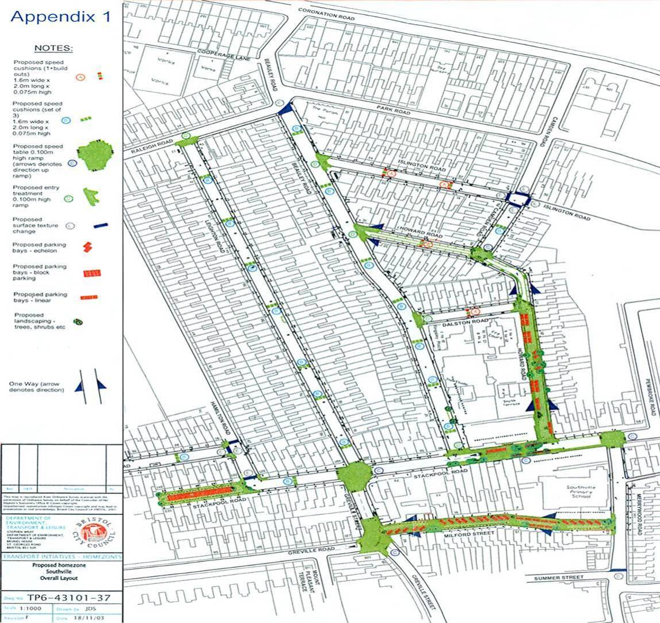
Map 2.1 below was produced in November 2003 at the beginning of the process and is one of approximately 170 drawings made throughout the process as discussions and amendments progressed. These drawings were very often put in a more accessible format, and later 3D pictures were made to show what the streets might look like and also ‘drive thru’ videos.
BCC produced its first Newsletter in November 2002, which was followed by further newsletters in February 2003, November 2003, December 2003 (street by street consultation leaflet), February 2004, June 2004 (general information sheet), September 2004, and March 2005. There was also a HZ noticeboard at the Southville Community Centre and regular updates on the HZ Challenge Website (www.homezonenews.org.uk).
A doorstep interview questionnaire was conducted between December 2002 and February 2003 to establish people’s concerns and perceived problems with their streets as well as their understanding of the HZ concept and attitudes towards it. A request was also made for volunteers interested in becoming street representatives to provide a link between the HZ Team and residents. Parking Surveys were conducted in early 2003 and the results fed back through the street representatives.
Concerns identified by local residents included traffic speed, parking, environmental issues and road safety, particularly in the vicinity of the primary school. Further details of the extent of these concerns are considered in the ‘before and after’ analysis reported in Section 4.
At the core of the consultation process were the 14 meetings that took place in Southville for the Southville HZ and 20 mph zone to which street representatives were invited plus others within the community: the Vicar of the Methodist Church, representatives of the Southville Primary School governing body, local councillors and the Director of the Community Centre. The street representatives were mainly people involved in the original bid or who had shown interest in traffic safety issues and the HZ idea. Some of the original street representatives continued to serve throughout the process, while others joined the implementation team later following the request for more street representatives in the doorstep questionnaire and newsletters noted above. Their role was very important and they took on a considerable burden in terms of communicating what was happening and making sure that the views of their street were fully understood by the HZ Team.
Between the meetings of the Southville HZ and 20 mph Zone it was up to the street representatives to communicate information to their neighbours but at the same time BCC continued to send out newsletters. For example, in December 2003 a consultation leaflet of draft proposals was sent to all householders inviting comments and observations followed up with two information bus (‘Ibus’) visits, one on a weekday and one on a weekend to allow residents to view the proposals, meet the HZ team and raise further issues. At the end of the first phase of consultation in May 2004 there was an exhibition at the Southville Centre outlining the proposals.
It was made clear that they were street representatives for the streets identified in the original bid as HZs and those for streets identified as part of the 20 mph zone. They were all given the results of the doorstep survey of their street along with a summary of all streets, plans of their specific streets with photos including aerial photos. The HZ street representatives got a copy of HZ News, the Traffic Advisory Leaflet on HZs and street furniture product specifications.
At these meetings the HZ team explained the process, reported on progress and concerns were aired. The meetings were held between December 11th 2002 and May 2004 at which point they were split into HZ Workshop Meetings for the different streets to work out the detailed design characteristics for their zone.
During this process street representatives and the HZ team used and facilitated:
- a number of newsletters, often delivered directly to people’s doors,
- 3D simulations and ‘drive thru’ videos,
- the Council’s electric publicity minibus (the very visible ‘Ibus’) was present on at least two occasions,
- events on the streets including the ‘Planning for Real’ exercises and information on notice boards,
- events at the School, and
- planting events at the completed HZs and an official opening by a Government Minister.
As well as providing information and consultation, the activities were intended to develop a feeling of community ownership towards the HZs.
Each formal design discussion and change of plan was minuted, with technical drawings revised and further discussed. Plates 2.1 and 2.2 below show examples of two 3D simulation stills of different options to facilitate the consultation on the Stackpool Road Cul-de-Sac.
Plate 2.1: 3-D Simulation of ‘echelon’ option for Cul-de-Sac
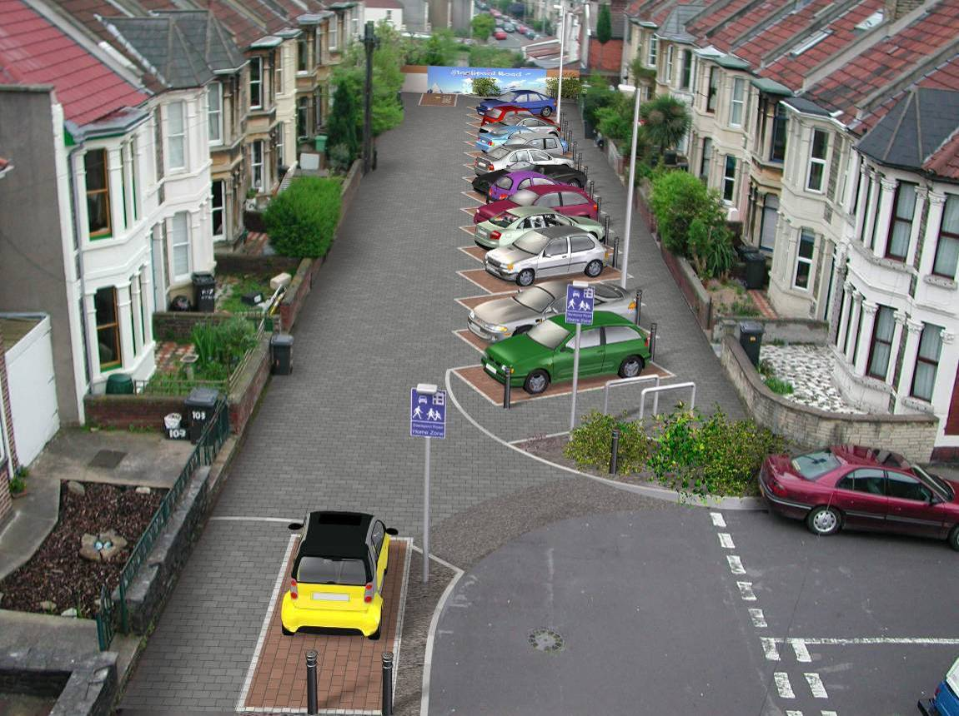
Many of the discussions at these meetings dwelt on the issue of parking; it was a trade off between space for parking and reclaiming the street space for other uses.
One possible solution presented to Stackpool Road Residents was turning the street space ‘inside-out’, with parking in the centre, as shown in Plate 2.2, but residents did not feel it would work well in practice and it was not progressed.
Plate 2.2: 3-D Simulation of ‘centre parking’ option for Cul-de-Sac (not progressed)
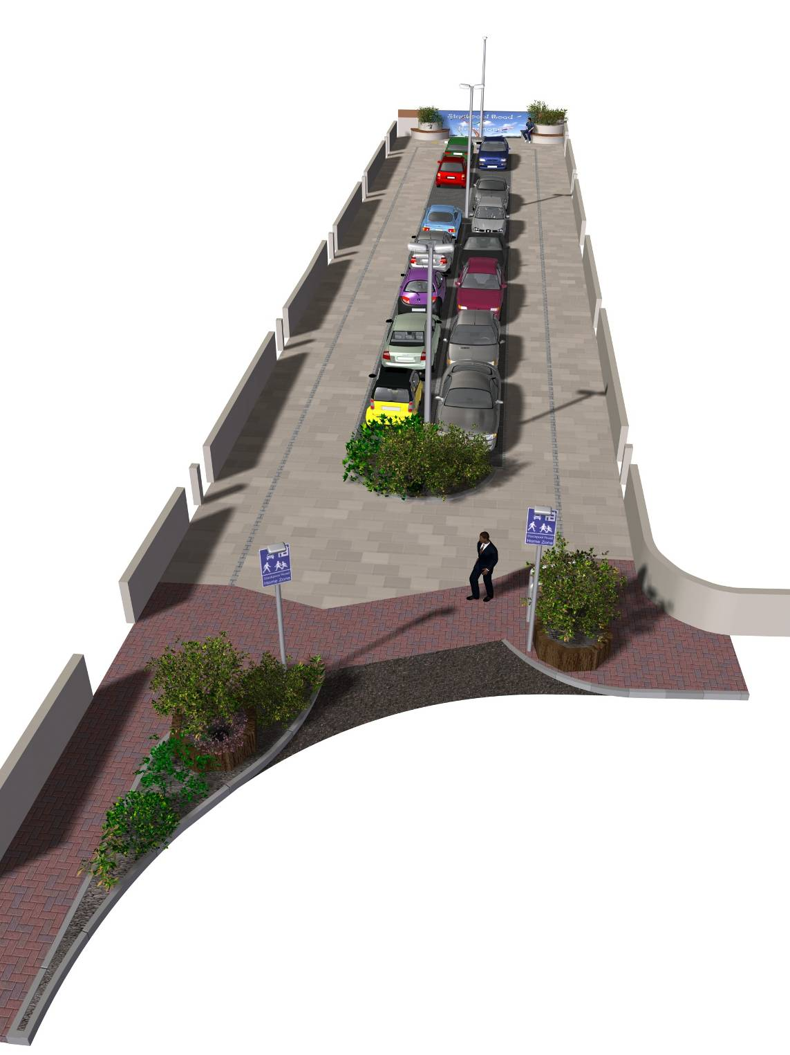

In parallel with the consultation with the residents, other stakeholders were also informed of what was going on the Methodist Church, the police, ambulance, fire services, public transport providers and Southville Primary school.
Southville Primary School experienced a change of Headship during the implementation process, which affected the extent of formal involvement of the school. However, two councillors involved in the process were also school governors so involvement was maintained via this and other links. In June 2004 the Southville HZ information sheet went out to all students at the Primary School informing them of future events to be held in their playground, particularly for pupils and parents. Later that year, in September, two representatives from Jarvis Highways- the contractors for Milford St and the Stackpool Road Focal Point - gave an assembly presentation called Stay Safe to prevent accidents while the work was being carried out. In cooperation with Jarvis Highways, the HZ Team produced activity and sticker books for pupils to reinforce site safety issues. BCC’s Road Safety Officer also visited school assemblies twice to highlight safety issues around the school prior to the HZ and after the HZ. A road safety art competition was organised, with the three winning pictures being made into banners for lighting columns at the Stackpool Road Focal Point.
2.2 Outcomes from Street-by-Street Consultation
Table 2.1 indicates the meetings held for the specific streets considered for HZ treatment. Merrywood Road is not included in the table as, though the residents were also initially offered a HZ, it was determined very early on that they did not want one. Subsequently the northern part of Howard Road also decided it did not wish to progress a HZ, and so the meetings for Howard Road towards the end of the period were for the southern end only.
Table 2.1: Number of meetings held for different streets’ HZ workshops
Street | Number of meetings held
Milford Street | 3
Stackpool Road Cul-de-Sac | 4
Stackpool Road Focal Point Workshop | 1
Howard Road | 8

In Milford Street, agreement amongst the residents was sufficient that they did not feel a ‘Planning for Real’ exercise was necessary. After three meetings they had settled on their design.
Stackpool Road Cul-de-Sac, with only 20 households, had greater difficulty reaching agreement to the point that discussions between residents and the BCC officers became deadlocked and a facilitator was called in for the final workshop. The eventual design was supported by a majority. Concerns were raised by a minority who remained in opposition (see discussion section 5.1 – definition of a consensus).
The experience of Howard Road was complicated. The last four workshops were also held with a facilitator. Although the southern end of Howard Road was in favour of full HZ, reaching agreement over a scheme that satisfied all residents desires and both BCC and DfT objectives and criteria was not straightforward, and was also constrained by funding issues. A compromise of a HZ treatment just at the top of Howard Rd, a natural extension of the Focal Point, was finally agreed, but implemented somewhat later than the other HZ elements.
2.3 Out-turn Physical Changes in the Streets
As explained in the first chapter, much of the design in the street is intended to change the way people use the street and particularly to require drivers to reduce their speed. The HZ Challenge Guidance to prospective bidders expected the following:-
- Modification to street design, traffic calming and other speed reduction measures to support low speeds appropriate to HZs
- Prescribed and /or approved signing
- Amenity features, such as public spaces, play areas, rearrangements of street furniture and the introduction of trees, to support any new uses of streets in the community
- Good design, both in the hard and soft elements which accompany HZs
- Restrictions on parking.
Key features in the Stackpool Road Cul-de-Sac and Milford Street were shared surfacing using paving, echelon parking, tree planting, wooden planters, bollards, seating, cycle parking (Plate 2.3) and plaques and tiles.
Plate 2.3: Gateway to Stackpool Rd Cul-de-Sac with planters and cycle parking
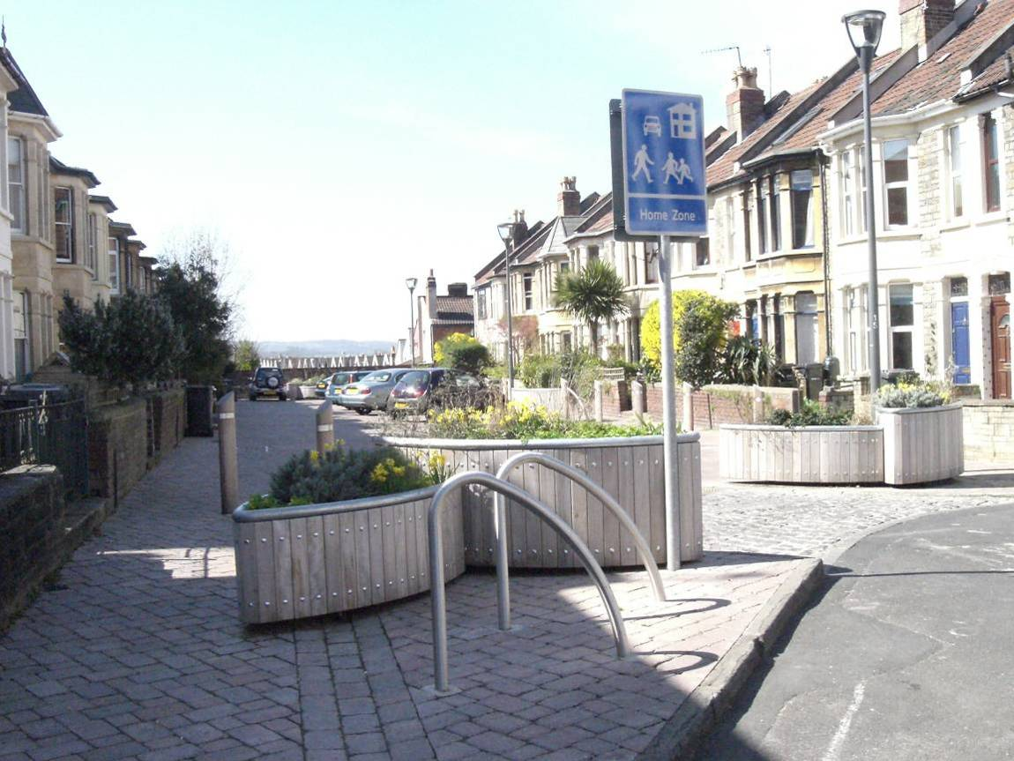
The HZ team proposed different colour paving to mark parking bays but the residents rejected this, on the basis that when a car was not parked there it left a ‘shadow’, in a sense still letting the car dominate the landscape. There are no markings at Milford Street but on Stackpool Road Cul-de-Sac spaces are marked by a subtle change of paving making a corner at the back of the parking space with posts to define the limit of parking at the front also with a change in paving. Several bike racks have been installed in Stackpool Road Cul-de-Sac (Plate 2.4).
Plate 2.4: Echelon parking in Stackpool Rd Cul-de-Sac
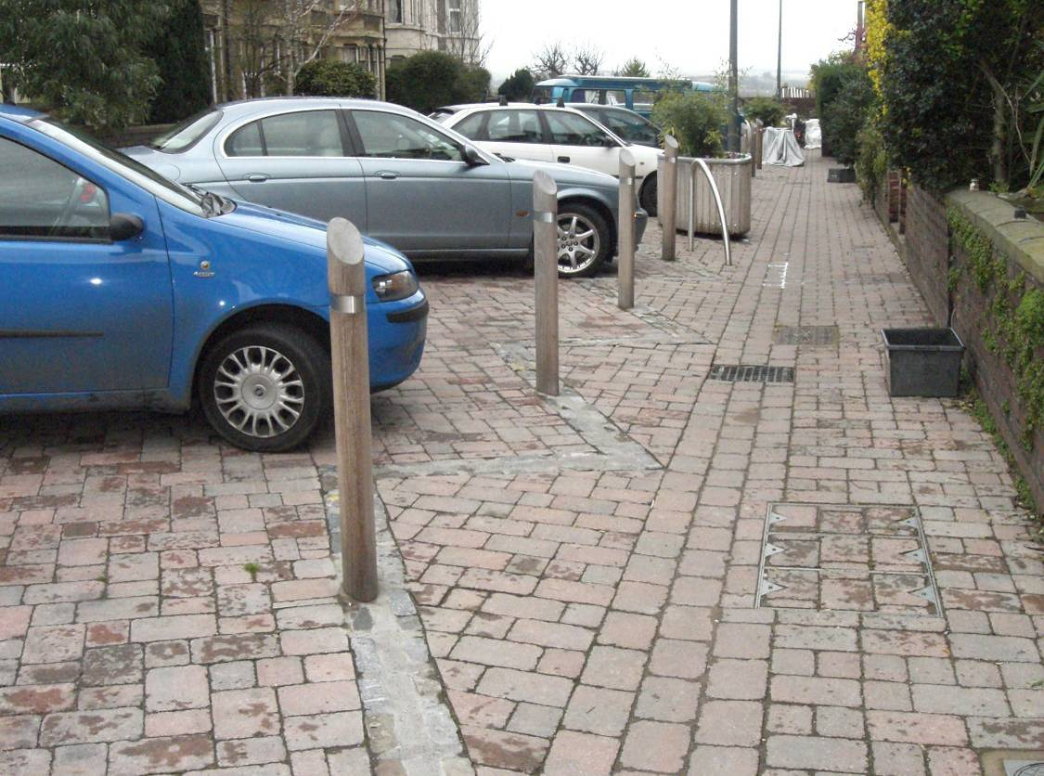

Granite sets from the original streets were retained as ‘heritage materials’ and placed along the edge of the shared surface in Milford Street to form an edge abutting a redbrick garden wall, as shown in Plate 2.5.
Plate 2.5: Heritage materials reused in Milford St
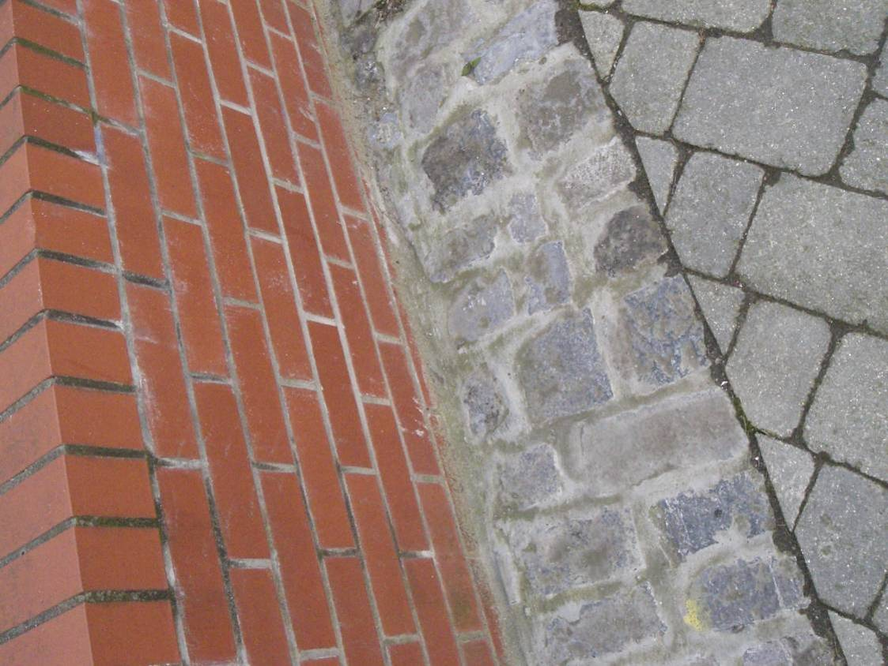

One of the underlying objectives of the consultation and design exercise was to encourage residents to take ownership of the new streets. An architect living on one of the streets came up with the design for the planters, some of which have an inbuilt bench, which were made by Street Design (Plate 2.6).
Plate 2.6: Milford Street - feature planters designed by local architect
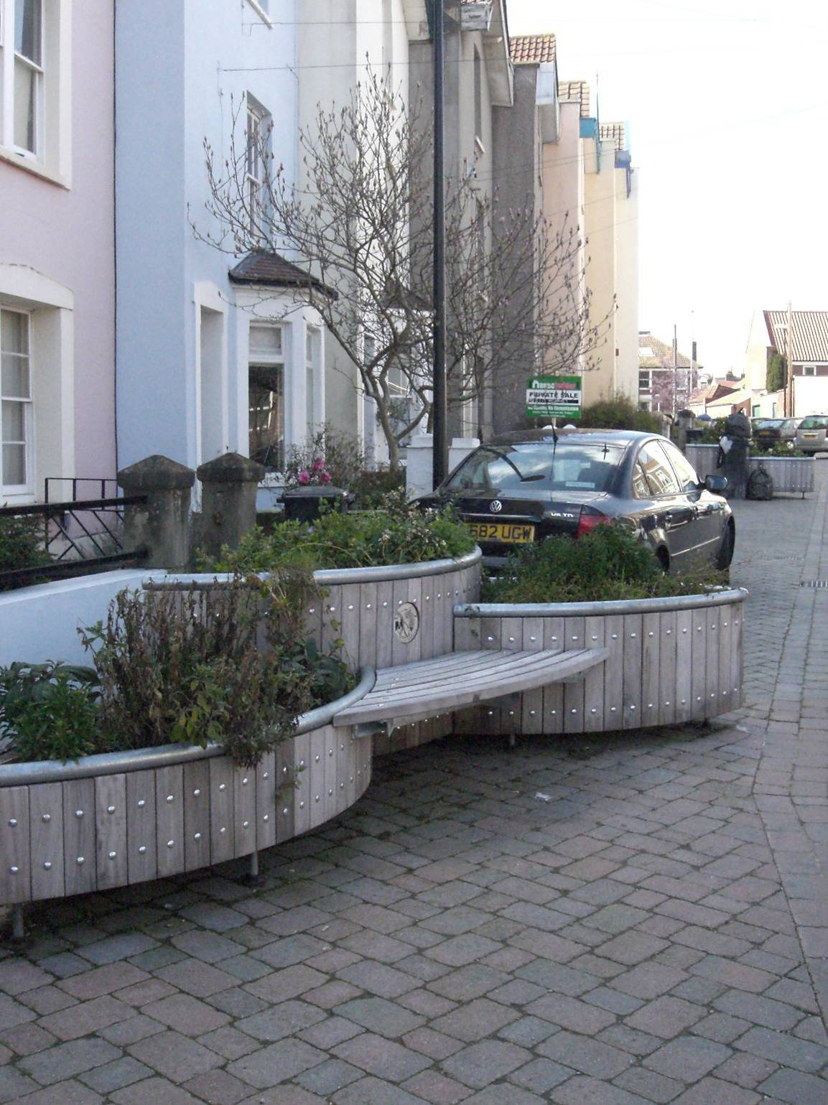

Plaques were also designed with residents. A road safety art competition was organised with the school which produced the banners on the Focal point light columns and a potter who was resident in the Stackpool Road Cul-de-Sac involved many people in the Cul-de-Sac making tiles for the wall at the end of the road (Plate 2.7)
Plate 2.7: Tiles produced by residents for Stackpool Rd Cul-de-Sac
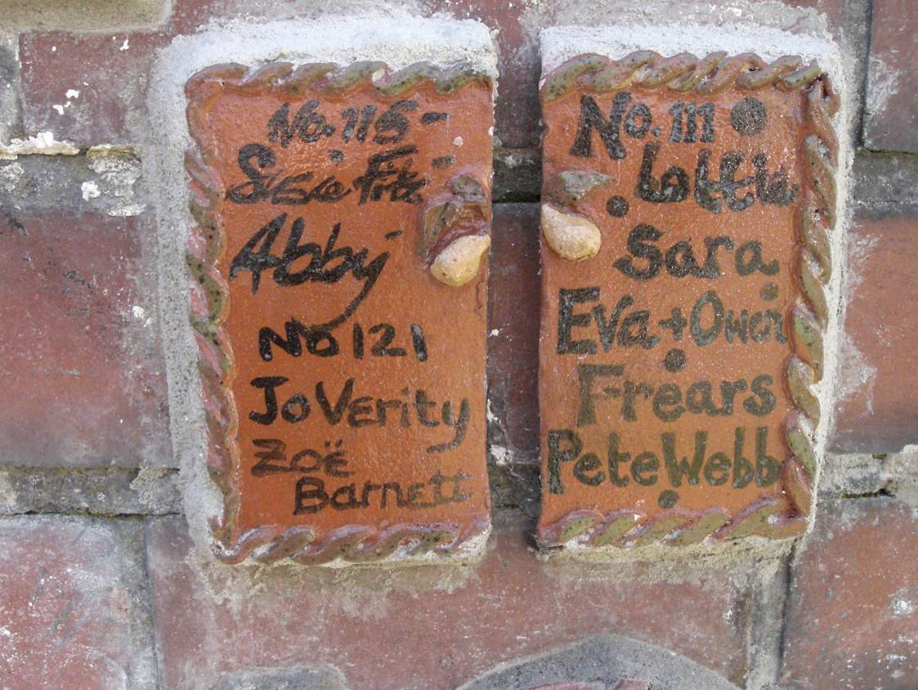

The original aim was for a 20 mph zone to surround the three HZ streets with the idea of reducing speeds to 20 mph before people entered the HZ where the hope was that people would travel at a average speed of 10 mph. Formal Consultation on the traffic orders necessary for the 20 mph zone began in October 2003 with the notices going up in December 2003. At the January 2004 meeting it was reported that there were 20 objections with five letters of support to the Traffic Regulation Orders with 400 households consulted. The delay in the process meant that work on the HZs started before the implementation of a 20 mph zone because the Challenge Fund money was due to be spent by 28th February 2005 and because the work for the 20 mph zone would have hindered the work on the HZs.
The final built scheme differs considerably from the original bid, partly as a result of the consultation but also as a result of difficulties with construction cost over-runs.
In August 2004 Carillion started on the Stackpool Road Cul-de-Sac and Jarvis Highways started work on the Focal point. Both were completed later than planned in December 2005.
The Milford Street HZ was started by Jarvis Highways a few weeks later and also finished by December 2005. Howard Road was started in January 2006 by the contractors A B Johnson Construction, Yate and was finished in March 2006.
The original design for both Milford Street and the Stackpool Road was to overlay the existing carriageway but site staff and the contractor advised the HZ team that it was not possible, so the road had to be dug up and reconstructed. It was expected that this would incur about a 20-25% increase in the contract costs. The contractor for Milford St and the Stackpool Road Focal Point – Jarvis Highways. Its parent company Jarvis plc was experiencing financial difficulties which resulted in uncertainty and delay. Jarvis Highways also made additional financial claims to the Council related to design changes and public utility requirements which became apparent after the construction began. The delays and financial difficulties from having to resolve claims and buy-in additional resources led to the downsizing of the original intentions with the final works of speed cushions in Leighton Road and Beauley Rd still to be implemented.
Howard Rd has a much smaller scheme than originally planned, which could be more properly described as a continuation of the Focal Point between the Church and the School. As a result of an article that appeared in the Surveyor Magazine in June 2005 describing the Bristol’s experience of implementing HZ’s in Southville entitled the ‘Community’s in charge’, sponsorship of £6,000 worth of paving for Howard Road was given by an Interpave member company, Marshalls who manufactured the paving for the Milford St and Stackpool Road Cul-de-Sac.
Speed tables at three junctions were not completed, the junctions of Stackpool Road and Greville Road/Leighton Road and also Milford Street/Greville Road and Greville Street. (shown in Map 2.2) This has meant that the scheme is more fragmented than originally proposed. The original proposal was for the entire length of Howard Road to receive HZ treatment but both the northern end of Howard Road dropped out early and Merrywood Road. The map below shows what has been implemented.
Map 2.2: Overview of Southville Home Zones as built
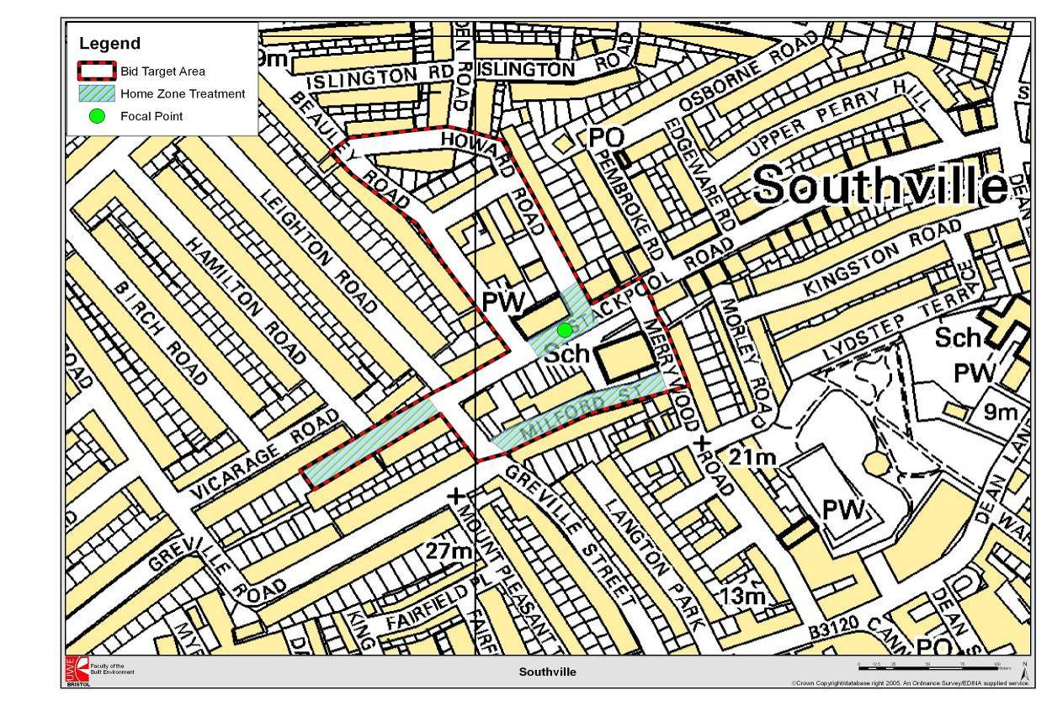

On September 20th 2005, Derek Twigg, Parliamentary Under Secretary of State for Transport, officially opened the HZ streets in Southville: the Focal Point, Stackpool Road Cul-de-Sac and Milford Street. Plates 2.8 and Plate 2.9 compare Milford Street from a similar perspective, before and after the intervention.
Plate 2.8: Milford Street prior to HZ
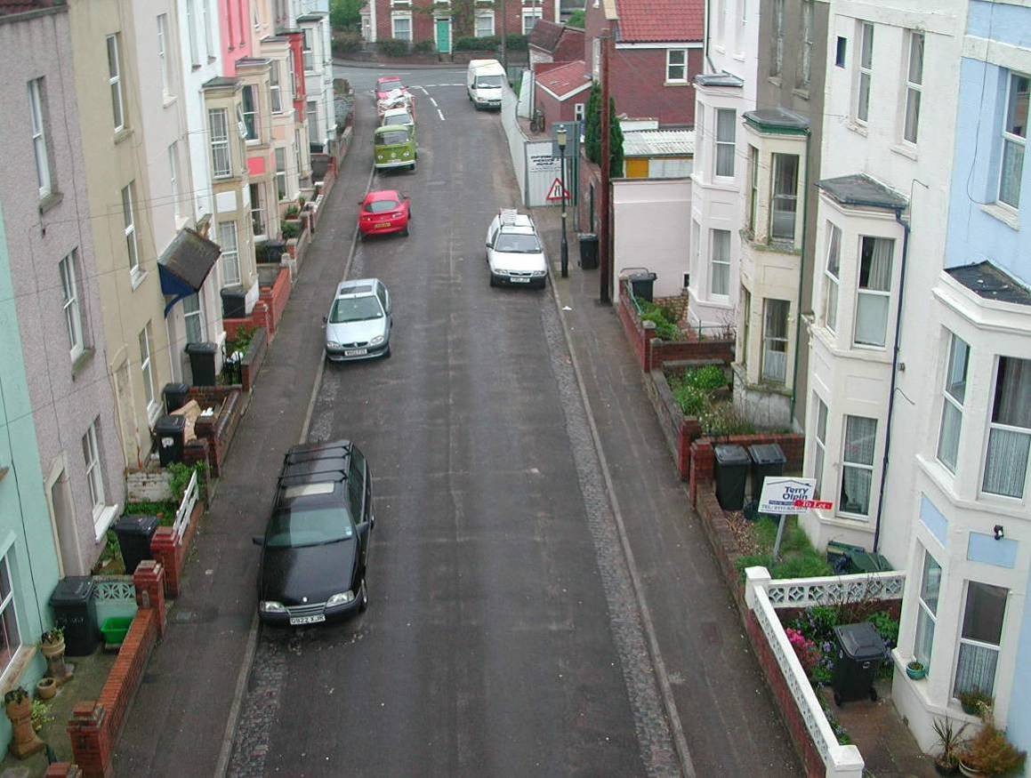
Plate 2.9: Milford Street with HZ
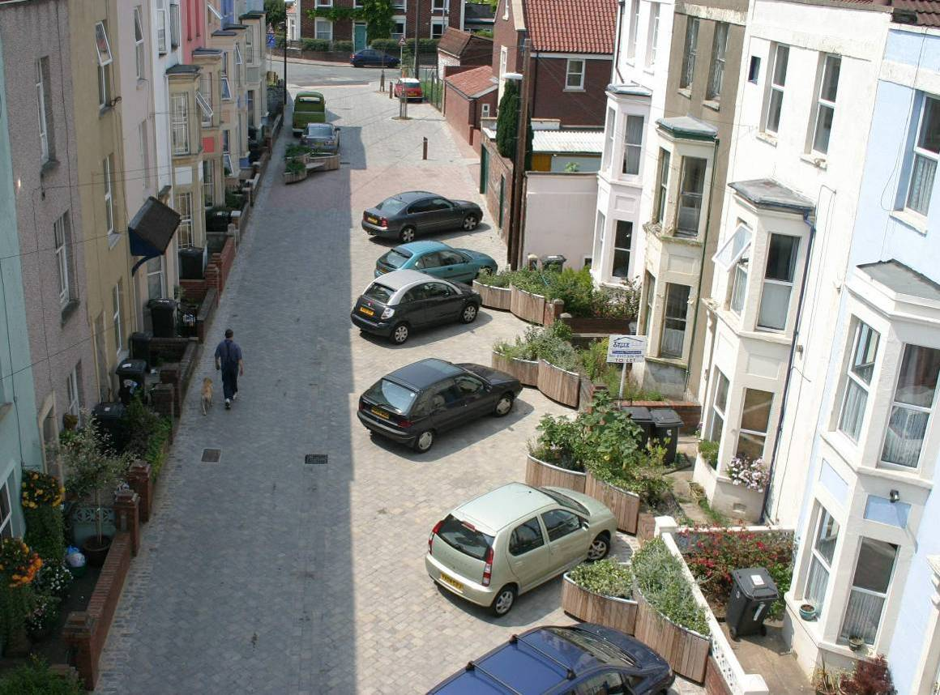
3. Methodology and data collection
The evaluation conducted by the UWE team built on monitoring work and data collection by BCC prior and during implementation in Southville. It also drew on work done in Bristol on other HZs by the VIVALDI project partners (BCC, UWE, Sustrans).
3.1 Methodology
The main stages of the post-implementation evaluation were:
- Review of documentation and data relating to the history of the Southville project, and comprehension of points in common and difference with the other Bristol HZs;
- Detailed analysis of consultation procedures, materials, and tools;
- After implementation data collection and analysis;
- Integration of analyses and preparation of final report.
Particularly within Stages 2 and 3 a range of quantitative and qualitative methodologies were applied. Further, systematic analysis of the consultation tools was assisted by expert professional assistance from within UWE. The main data-collection activities are described below.
In-depth qualitative interviews
Detailed, open-ended discussion interviews were conducted with professionals who had been involved in the consultation and implementation process, to consider how decisions were taken and the effectiveness of the actions subsequently arising. Similar interviews were held with the street representatives nominated for the process, and who represented a key link between the professionals and the residents of individual streets. Obstacles and opportunities encountered during the process were documented, together with the roles and contribution of the different parties. These fifteen interviews were conducted in late November and early December and informed the design of the questionnaires.
Fixed-response questionnaires
The evaluation built on data streams collected by BCC prior to implementation, enabling a before and after comparison or both quantitative rating data and supporting qualitative and contextual data. In December 2002 and February 2003 BCC conducted a doorstep interview questionnaire with all the households affected by the proposed HZ and 20 mph zone; about 400 households in total.
Given the facts that the 20 mph zone had not been implemented, that some streets had decided not to proceed with the HZ treatment, and that limited treatment in Howard Street was pending, the Southville scheme as built was smaller scale and more fragmented than originally conceived. As a result, it would not have been methodologically valid to apply the same methodology and instruments to all 400 households; for example, it would not have been appropriate to ask residents not living in a HZ if their streets were now more attractive. Hence, it was decided for the purposes of this evaluation to divide the residents into those living in a:
HZ ‘proper’, which we refer to variously as the ‘HZ streets’, ‘HZ residents’, or ‘HZ sample’, i.e., the:
- Stackpool Road Cul-de-Sac and
- Milford Street,
and those who had gone through the consultation process for a HZ, but for a range of reasons the consultation had not resulted in a HZ being constructed, i.e.:
- Howard Road,
- Stackpool Road,
- Merrywood Road and
- Dalston Rd.
The latter group is referred to in the report as the ‘near-HZ’ streets, residents, or sample. The existence of this second – in effect expert lay group opened up the possibility to consider their views in two interesting ways. First, it was possible to see if their views had changed over the three-year period following involvement in the process, with subsequent experience of what a HZ product is like from observing nearby streets, and perhaps travelling through them, or even using them as social spaces. For example, we were able to ask this group what they thought of the finished HZs as ‘outside’ observers, and of the Stackpool Road Focal Point. This feature, sited between the Church and the School is not fronted by any residences, and some of near-HZ residents in fact live closer to it than the HZ residents. However, in any case, it cannot be said to be ‘owned’ by a particular street of residents, but more by the activities that go on nearby, involving many Southville residents. It should be noted though that ‘near-HZ’ residents’ views might reflect adverse knock-on impacts of the HZs on their streets (e.g. increased through traffic or parked cars) and this might affect their views.
Second, it was possible to compare the responses of HZ and near-HZ residents to see if there were differences between the two groups in terms of their responses, for example to the extent they thought their travel behaviour had changed. Hence, the near-HZ group provided something approaching an experimental control for the HZ sample, in the sense that they had experienced a similar level of publicity and engagement with various sustainable mobility issues, including the HZ development. Clearly, the analogy of the control group should not be taken in its full reductionist, determinist meaning; there are other differences between the two samples, in terms of property size, choice of a residential location in a cul-de-sac for some households and level of cycle ownership, which may well have influenced favourability towards HZ implementation, creating a circular logic linking favourability towards HZs, willingness to receive the treatment, and attributions towards the completed schemes and reported changes in behaviour. Nonetheless, these limitations notwithstanding, some useful and interesting outcomes can be observed in the data.
To this end, UWE designed two questionnaires which contained some questions repeated from the 2002-3 BCC doorstep questionnaire, and new questions, which were omitted or varied according to whether the household was in a HZ or near-HZ location. Questionnaire 1 was delivered to all households within the two completed HZ streets Stackpool Road Cul-de-Sac and Milford Street. These included questions about their experience of the consultation process as well as their views on how living in a HZ had affected their daily lives. Questionnaire 2 was delivered to all streets who took part in the consultation exercise and had at one stage had the opportunity for a HZ or, in the case of Stackpool Road (apart from the Cul-de-Sac end) were the nearest neighbours of the Focal Point. Questionnaire 2 was delivered to residents of Merrywood Road, Dalston Road, Howard Road and Stackpool Road excluding the Cul-de-Sac. Both Questionnaires had a series of questions relating to the Focal Point on Stackpool Road between the Church and School.
The questionnaire was delivered with a prepaid return envelope. Researchers called at each house to encourage people to return their questionnaires and if they were not at home a reminder was left. A £100 free prize draw was offered to people who returned their questionnaires.
The implementation of these two questionnaires did not, however, include those residents in the wider Southville area, who are stakeholders to the extent that the HZ influences the overall appeal and appearance of Southville. The HZ may also influence social and travel activities in the area particularly in respect of accessing the religious, educational, and social focus of the community around the Stackpool Road Focal Point. More practically, the wider residents had been involved in consultation for the 20 mph zone (and the boundaries of this consultation and that of the HZs were not always distinct) creating some expectations about future implementation in their own streets, and a desire in some cases to provide an input into the evaluation. For these and similar reasons, a letter was sent to all of the 400 households who had received the original BCC doorstep interview questionnaire but not received one of the two 2006 questionnaires. The letter informed them that UWE was conducting an evaluation specifically of the HZ streets and solicited their views by email or in the prepaid envelope provided. Some bullet point ideas of possible topics we would be interested to hear about was provided as a guide, but no other guidance was provided on how this response might be structured.
All three instruments were delivered in the first week of January 2006. Examples are shown in the Appendix D
Supplementary information was gathered at two focus groups held at the Southville Community Centre in late February 2006 with residents of Milford Street and Stackpool Road Cul-de-Sac. Participants were recruited via a filter question on the Questionnaire 1 described above, although an additional filter was applied by the team to ensure only members of the community without involvement as a professional with responsibility in the implementation process or as a community representative were included. Those not eliminated by the above criteria and indicating willingness to take part were then contacted to arrange attendance. Three participants attended the first group and eight the second. Two facilitators from UWE were present at each.
These data sources were then combined in analysis to enable the experiences, lessons learnt, barriers and drivers to the success of the project to be discussed.
3.2 Methodological challenges and constraints
The evaluation study began in November 2005, whilst there was still minor construction activity being completed. Specifically, the data were collected during the latter part of 2005 and early in 2006, before the Howard Road element had been constructed and whilst the traffic calming in Leighton Road and Beauley Road was still to be implemented, along with the signing of the 20 mph zone. However, no actual construction was taking place at the time of the main data collection with the public, in January 2006.
The evaluation overall was intended to cover attributions towards the process in the period immediately following implementation. Responses in the longer-term could be different; one reason for this being the turnover of resident population. In the medium-to-long term, say beyond five years after construction, the population of Southville may be substantially different, due to relative in and out migration. Positive attributions to the HZs are likely to result in the selective retention of some residents and the attraction of outsiders who welcome the HZ ambience. Conversely, negative attributions to HZs would encourage – at the margin – the relocation of some residents, and deter immigration of certain potential residents. Taken together, it can be expected that, other things being equal, attitudes towards the HZ should become more favourable over time. Such changes are beyond the scope of the current evaluation, although might be an interesting topic for future study.
Even in the case of a short-run evaluation, it would ideally be desirable to have allowed a longer ‘settling-in’ period in order to avoid confounding data intended to reflect short-to-medium term responses with very short-term attitudinal and behavioural responses to a new scheme. Perhaps more important than whether minor ‘fitting’ issues were being addressed in the HZ streets proper, was the fact that local residents would have been aware that some of the wider-area measures relating to the 20 mph zone and HZ construction in Howard Street had not taken place. Some may have been aware that implementation of a small element of HZ in Howard Street was imminent. Overall, however, it is not felt that the timing of the surveys with respect to construction had a major, systematic effect on responses to the surveys in practice.
It must also be recognised that the evidence relating to changes in behaviour has been collected by self-report, rather than direct observation. Self-reports may be unreliable, although no collection method is without its bias; it would not have been realistic or resource-effective to deploy video cameras, whilst ethical and legal considerations would have required their presence to be publicised, which itself may have influenced behaviour.
Other sources of systematic bias and influence were not identified during the project, such as major changes in the level of crime. A separate survey into attitudes towards a possible residents parking zone was implemented in late 2005, but neither this, nor the extensive involvement in consultations in the previous years seems to have influenced response rates, as evidenced by the rates reported in the following section.
3.3 Response rates
Tables 3.1 and 3.2 indicate that 104 of the 180 questionnaires were returned. Response rates from both groups of streets were fairly high, ranging from 48-75% of households for particular streets, but around two-thirds being returned in the two HZ streets overall.
Table 3.1: Response rates in 2006 in ‘Questionnaire 1 HZ streets’
 | Distributed | Returns | Rate of return (%)
Stackpool Rd CdS | 21 | 13 | 62
Milford St | 31 | 21 | 68

Table 3.2: Response rates in 2006 in ‘Questionnaire 2 near HZ streets’
 | Distributed | Returns | Rate of return (%)
Stackpool Rd | 54 | 26 | 48
Howard Rd | 46 | 23 | 50
Merrywood Rd | 16 | 12 | 75
Dalston Rd | 12 | 9 | 75

Tables 3.3 and 3.4 compare the number of returns obtained by the BCC team in 2003 from each street with the number obtained by the UWE team in 2006 for each street. The numbers and rates were also similar, overall, for the two survey dates, although somewhat lower for the non-HZ areas of Stackpool Rd and Howard Rd in 2006 over 2003.The tables also indicate the number of respondents who took part in both surveys, which ranged widely: from 27 to 70 percent of the 2003 respondents, but overall less than half appeared in both. Further details about the respondents that took part in both surveys are included in Appendix A.
Table 3.3: 2003 and 2006 response rates for HZ streets compared
 | 2003 returns | 2006 returns | Number responding to both surveys | % of 2003 sample responding in 2006
Stackpool Rd CdS | 15 | 13 | 7 | 47
Milford St | 18 | 21 | 7 | 39

Table 3.4: 2003 and 2006 response rates for near-HZ streets compared
 | 2003 returns | 2006 returns | Number responding to both surveys | % of 2003 sample responding in 2006
Stackpool Rd | 33 | 26 | 9 | 27
Howard Rd | 34 | 23 | 13 | 38
Merrywood Rd | 13 | 12 | 7 | 54
Dalston Rd | 10 | 9 | 7 | 70

Given that response rates were similar from the two groups of streets, but the population in terms of number of households in near-HZ streets approximately double that of HZ-streets, in some cases in the report the near-HZ responses have been weighted, to give an equivalent proportional response to that of the HZ streets.
Response rates to the 220-household letter drop made in the ‘wider area’ streets are shown in Table 3.5 below. Overall the response rate was around 23 percent, without any follow up, suggesting that the HZ and 20 mph zone issues remain of public salience.
Table 3.5: Response rate to letter drop
Street receiving letter drop | Responses received
Beauley Road | 10
Camden Road | 2
Islington Road | 4
Leighton Road | 26
Vicarage Road | 7
All | 49

3.4 Sample Characteristics
The age and gender characteristics of both samples were similar, except that the proportion of people over 64 in the HZ street sample was particularly low. Based on the researchers’ information about non-responding residents, this is not a sampling error. It is explained in part by there being a low number of pensioner households in this part of Southville in general and in part by the presence of a greater number of smaller-size housing units in the near-HZ streets, and in Merrywood Road in particular.
In general, the households responding were constituted by adult couples of working age either with or without children; young and teenage children being fairly evenly represented. In Figures 3.1 and 3.2 the age and gender characteristics are presented of all members of the households responding to the 2006 survey.
Figure 3.1: Demographic Structure of HZ Sample Households
Figure 3.2: Demographic Structure of Near-HZ Sample Households
The length of establishment of the sample households was somewhat lower than the national average, at a mean of 10 years. Within this average there was a broad range, from 3 months to 55 years. The median length of establishment of around 6 reflects the average being influenced by relatively few very long-standing residents.
The near-HZ households were somewhat longer-established than the HZ households (mean 13 years, median 9 years) but had a similar range of lengths of residence (2 months to 50 years).
Figures 3.3 and 3.4 indicate that the HZ sample owned an average of 1.2 cars per household, equivalent to 0.7 cars per adult, with only two households out of 34 having no car. The figures for the near HZ Streets were very similar, at 1.23 cars per household and four households out of 70 without cars. Virtually all the cars owned are parked on the street.
Figure 3.3: HZ Streets Vehicle Ownership
Figure 3.4: Near HZ Street Vehicle Ownership
As a similar number of cycles were owned by the households as cars, but can usually only carry one adult, perhaps with child passenger(s), actual overall availability of cycles was not high. Furthermore, there were also large differences in availability between households, with some having four and some none.
Interestingly, cycle ownership was somewhat higher in the HZ streets, and some households were willing to park them on the street (where bicycle parking has been provided by the scheme). It may be, at the margin, that greater ownership of cycles, if an indicator of greater use, made the HZ sample more amenable to supporting the introduction of HZs.

4. Results and interpretation
Section 4 presents the results beginning with the consultation process, drawing on both residents’ and independent professional opinion. It then turns to consider the main concerns with streets before and after implementation, and presents the overall level of satisfaction with the HZ elements as completed. The latter stages of the section then consider reported changes in behaviour and the wider reported experience of the Stackpool Road focal point.
A copy of the questionnaires is provided in the Appendix D, in case the reader wishes to refer to the original questions.
4.1 Consultation Exercise
As noted in Section 2, Milford Street residents reached agreement over their HZ most easily, and emerged in the data presented below as most satisfied. In Stackpool Road Cul-de-Sac, findings are mixed, due to a majority/minority split for and against the changes, with the latter believing its views were not being taken into account. Relations between some neighbours have remained troubled since implementation, and the views of the minority remain negative. In Howard Road it is not clear from data collection the extent to which there was a genuine disagreement amongst residents or whether it was to do with different expectations of the process, miscommunication between the residents and the HZ team, misunderstandings about what the design might mean in practice and the fact that some residents ‘dipped in and out’ of the process.
The issues identified below seek to summarise the various views relating to Southville HZ development, whilst considering how best practice might increase the likelihood of positive consultation experiences in the future.
Inclusiveness and effectiveness of process
As reported in Section 3, consultation was a long process started in December 2002 and ongoing after implementation started in August 2004. Residents of HZ streets were asked if they agreed or disagreed with a number of statements concerning the consultation process (Figure 4.1).
Figure 4.1: HZ street views’ on the consultation process
It should be noted that few participated in all the meetings, whilst some may not have seen all the information or taken part in all the activities within the consultation to which the questionnaire referred. This situation explains some of the ‘don’t know’ responses, although respondents may have also sought to rate elements with which they had limited experience.
Nonetheless, for three of the measures, there is widespread agreement that the consultation process was inclusive, and effective. Notably, there is less agreement with the fourth measure, concerning whether ‘views were taken into account’, which may reflect specific concerns that were not addressed in full. It may of course be very difficult to take all people’s views into account, particularly where views conflict, and a compromise may not be recognised by anyone as an effective consultation.
A minority clearly felt their views were not listened to, with the following being a range of comments received
“they didn’t want to hear if you disagreed – mob rule” Home Zone St Resident
“Plenty of opportunity to get involved and express views but it was token and the results were already decided and my questions never answered” Home Zone St Resident
“I actually thought the consultation was pretty good, although I know that people on the receiving end didn’t think so, consultation is an absolute nightmare, it could take you forever and you still don’t get consensus and the trouble is that people think that consultation is getting what they asked for and of course it can’t mean that because everybody is asking for something different. It is very difficult to do consultation and let everyone feel satisfied” Implementation Team
“There was a process of trying to incorporate people’s views, people who didn’t like things didn’t all not like the same things, it was different things and it was always shifting. There comes a point then the majority says…we have to go for this” Street Representative
Further comments on the consultation process provided by HZ residents are included in Appendix C.
Consultation tools
The survey of the consultation process also addressed three types of tool used in consultation: the basic provision of information, the use of a ‘planning for real’ exercise in which individuals got an opportunity to manipulate mock-ups of a street layout to understand for themselves the constraints and trade-offs, and visualisations, in the form of static photographs and some ‘drive-through’ videos which simulated travel through computer-generated streets.
Figure 4.2 below shows the views of HZ residents about how useful these three types of tool were.
Figure 4.2: HZ Residents views on usefulness of the consultation tools
It is clear that a number of respondents were uncertain about whether the various tools had ‘helped clarify what a HZ would look like and how it would function’, with this being most obvious in the case of the planning for real exercises. It is likely that some of the uncertain responses reflect the fact that not all respondents had participated in the activities or receive the information.
A further concern about these responses, though, is that despite Milford Street residents having not taken up the opportunity for a planning for real exercise, as they did not feel it was necessary, thirteen respondents from that street nonetheless expressed some kind of opinion. As there was no specific planning for real exercise for them to comment on, we can surmise that they either did not understand the terminology had a specific technical meaning, and thought the question referred to the planning activities in general, or else they did know what such an exercise entailed, and thought they would be useful in general.
In the additional comments it was clear that three respondents indicated that they felt the process had been too long but also that once the scheme had started they felt the communication was poor. Two also commented that the expectations were raised too high and that it would have been better to be more realistic about what was possible in the beginning.
Comments also supported the general finding that it is difficult for the public to visualise change in the environment, for example, a resident in Stackpool Road Cul-de-Sac were surprised at how much room echelon parking actually takes up. In this context, the implementation team identified the tools as useful, if not perfect:
“There is an issue of conveying to people what you are actually trying to do with the street. As an engineer we traditionally work in two-dimensional drawings which don’t convey images in 3D. A lot of people just don’t understand drawings so they are not the best medium to use. There were some quite useful photo montages that were done from an elevated perspective. ‘Planning for Real’ could actually relate what we had on the drawing to what it would mean on the street and the penny dropped… things became more ‘real’; hence the title”. Implementation Team
“….compared to what we had available…no point in putting up slides of Holland, it was the best tool available at the time. It did help the ‘buy-in’ for some streets, it is a lot easier to understand than a plan. To go out there with cardboard models would have taken probably a lot more resource in terms of the management of the event which we didn’t have with two and a half members in the team” Implementation Team.
As near-HZ samples had experienced use of the tools, it also made sense to ask them about their opinions (Figure 4.3).
Figure 4.3: Near-HZ Residents views on usefulness of the consultation tools
Comparison of Figures 4.2 and 4.3 shows that more people in the near-HZs group disagreed with the statement ‘The Planning for Real Exercise helped clarify what a HZ would look like and how it would function’ compared with the HZ group. In this group only Howard Road had a Planning for Real Exercise and it was at this point in the consultation process that some serious disagreements emerged. In other words it would seem people were not clear what it would mean but this exercise either suddenly ‘engaged’ them in the process to object or indeed make them realize it was not something they wanted.
“The availability of 3D images and the planning for real exercise started to crystallize people’s thoughts about the HZ, either for or against. Don’t really want people to realize what has actually happened once you’ve built it…useful in that respect.” Implementation Team

Professional Evaluation of visual simulations used for Southville HZ public consultation
To facilitate evaluation of this aspect of the consultation, a report was commissioned by the study team from expert colleagues working in the field of environmental simulation. They sought to establish the validity and ‘fit for purpose’ of the visual simulations used in Southville, assessing the quality of the visual simulations and representativeness of the context, including observation of the HZ elements in practice as built.
The criteria applied by the simulation experts to the materials were:
- Representativeness, the degree to which simulations represent typical views of the project;
- Accuracy, the degree of similarity in appearance between the ‘simulated’ and the ‘real’ scene;
- Visual clarity, the degree to which detail, parts, and overall content of the simulation can be easily understood and recognised;
- Interest, the degree to which simulations hold the interest of the audience;
- Legitimacy, the extent to which the correctness of the simulation can be demonstrated and justified.
- Timeliness, i.e., communicated in time for its purpose to be used.
- Contains the right level of detail, i.e., only the appropriate level of detail included in the simulation in accordance with the decision-making context.
It must be noted that the experts were conducting a post hoc analysis of the materials, seeking to assess the use of the materials after the event, without the benefit of observing how they were used in practice, which might have indicated the extent to which particular visual aids of greater or lesser suitability had been important in the process.
Hence, the following comments are made by the study team only, but drawing on those expert opinions, and also informed by additional knowledge available about how they were used in the consultation process. The analysis considers Milford Street, Stackpool Road Cul-de-Sac and Focal Point only, which were the streets for which a comparison of simulation and constructed scheme is possible.
In general terms, it is to be welcomed that 3D representations were included, as
“Technical drawings require training to read - as with map reading this is a taught skill that some never acquire. 2D plans are interpreted in 3D form by different viewers in different ways that do not always accord. These interpretations are therefore unreliable when a communal judgement is being sought. In this respect they do not reach the necessary standards of representativeness, accuracy, visual clarity or legitimacy.” Independent Academic Adviser
The frontage visual simulation for Milford Street was assessed as “fairly representative” of the street level frontage, although whilst a high level of detail was provided for traffic engineering elements and issues, there was insufficient detail in the depiction of the house frontages, and the difference in perspective of pedestrians and cyclists from motorists was not recognised. The simulations were not, however, found to reflect the as-built experience. The key issue here was that the elevated views did not provide typical views of the street, as it would be generally experienced by residents, either before or after implementation.
A video showing the scheme at a low level of detail lacked visual clarity and did not contain the right level of detail to give a good sense of ‘presence’ in the street. The video took the ‘motorist’s eye’ reflecting the importance of parking layouts and the efforts to reduce the forward visibility to encourage lower speeds but this had the effect of underplaying the key social objectives of the HZ approach and the safety of pedestrians and cyclists. As the present evaluation is entirely post hoc, it was not possible to observe how the videos were used in the consultation process directly.
In the case of the video of Stackpool Road Cul-de-Sac it provided a highly detailed representation of one option where the parking was parallel in the middle of the street rather than at the side of the street, although it also took the motorist’s perspective only. As the scheme option simulated was not eventually built, whether it was a good representation of what that scheme would have been like as-built cannot be assessed.
In general, Stackpool Road Cul-de-Sac was, like Milford Street, represented from an aerial view, which did not provide realistic, typical views of the street, as it would be experienced by the users. Only one visual provided a view taken from an eye-level. However, as a result of the position of the viewer, this view did not provide sufficient information on the street. A ‘storyboard’ sequence of stills would have provided a better representation and would have enabled a more meaningful assessment of the proposals by the public.
The still images provided a reasonable portrayal of the street, with some images in particular providing a good similarity between the simulated and the built project. Some details could have been more accurate, however, such as the match between colours and textures of bricks and tiles of the simulation and scheme as built. In addition, the size of planters depicted is important, as their volume constrains the size of plants that can be introduced in practice.
The range of materials available for the Stackpool Road Focal Point, and the extent of the associated consultation were both more limited. However, the 3D static simulations were found to be “reasonably accurate” of the final built form, with the main differences being in terms of textures and surface treatments, and these differences not being so significant as to undermine the value of the representation as a reliable indicator of the proposed changes. As in the other cases, though, fully ‘peopled’ street-level views were not available.
In summary, the evaluation suggests that some of the simulations would have been useful, and they do seem to have been influential in the case of the Cul-de-Sac residents turning down the centre parking option (shown in Plate 2.2 in Section 2). However, their quality did vary, and some materials contained - to varying degrees - factors which could have led to misrepresentation or under-representation. In particular, key recommendations are that
- aerial views taken from ‘cherry picker’ devices should be avoided as simulation aids - although convenient ways of summarising the view, they have little correspondence with everyday experience, and
- there should be greater depiction of people and street activities in the representations and greater use of perspectives other than the ‘from the driving seat view’.
It is likely that an interactive simulation model, which could have been interrogated from a variety of perspectives on demand, might have represented a better investment than the specific stills and videos.
4.2 ‘Before and After’ Concerns About Life in Southville
Households in both HZ and near-HZ streets were asked about whether they were concerned, not concerned, or undecided about a number of potential ‘quality of life’ factors in 2003 and 2006, some related to the HZ objectives, others not. These enable an understanding of how far issues the HZ intended to influence were of relative importance in each survey. The topics covered were traffic speed, ease of parking, crime, pedestrian safety, noise and vandalism. Residents could also indicate if they had other concerns, not prompted. Subsequent questions sought information about which of the concerns that had been acknowledged was most important.
Acknowledgement of prompted concerns
Figure 4.4 shows the results for HZ streets in 2003 and 2006. The main objective of a HZ is to change the physical environment to the point where the balance between car traffic and other uses for the street changes. The figure shows that fast traffic has reduced as a reported concern, particularly in Milford Street which is a through-route, and so had more of a problem than the Cul-de-Sac. The success in addressing traffic speeds is highlighted by the fact that none of the 14 residents surveyed on both occasions were concerned about fast traffic in 2006, whereas seven had been in 2003. In 2006 also fewer people were worried about pedestrian safety. Changes in other factors were smaller in magnitude, and mostly indicated less concern, except in the case of indiscriminate parking, where there was a slight increase in the already high number of people concerned (about half of residents).
Figure 4.4: HZ households concerns before and after implementation
The data above indicate where an issue was identified as a concern. The findings were generally mirrored by the sample indicating complementary changes in the extent to which they identified a specific issue as a ‘non-concern’ (i.e. a small number of people identifying ‘fast traffic’ as a concern was broadly matched by relatively large number of people explicitly identifying it as not being a concern). Hence the sample showed a high degree of consensus its views, rather than being polarised between contrasting views.
However, during the process interviews and discussion groups a different angle on this apparent consensus was obtained. It became clear that a significant minority was concerned about aspects of the HZ scheme, particularly in the Cul-de-Sac. Such views are represented here by some of the comments made in response to the prompt to indicate ‘other’ concerns to those discussed above. They can perhaps be best summarised as community disagreements about how the street should be used:
“cars been vandalized” (with implication that perpetrated by fellow HZ resident(s))
“indiscriminate parking at entrance to Cul-de-Sac”
“stealing from front gardens”
“cars backing out, destroy gardens”
“lights too bright – easyjets might land in our street!”
“exacerbated historic enmities between old and new residents”
“parking not properly dealt with in planning therefore arguments continue now”.
In Milford Street, instead, these volunteered concerns mainly identified parking issues:
“parking at angle causes less parking spaces”
“parking by people long term for boats camper vans” (with implication that unfair and unnecessary)
“visitors and new residents don’t understand ‘bays’, unfinished signage”
“don’t like metallic telegraph pole at school end”
“still domination of vehicles parked in street”.
Figure 4.5 presents the results for the near-HZ streets. The results show no change or a reduction in the extent of concern for all prompted factors, but the overall amount of change is small, and lower than in the HZ streets. Residents were most likely to agree that parking was a problem. Notably, the biggest changes do concern fast traffic and pedestrian safety, which might reflect positive attributions towards the HZ, and the focal point in particular, or simply the fact that residents had gone through the HZ consultation process, which may have increased the sense that traffic issues were being addressed.
Figure 4.5: Near-HZ households concerns before and after implementation
One anomaly here, however, is that the level of concern for pedestrian safety amongst Stackpool Rd was higher in 2006 then 2003, despite these residents being nearer the Focal Point, which is generally regarded by Southville residents as having been beneficial to pedestrian safety. Given the relatively small number of respondents which comprise the difference, this may be a sampling effect due to the different sample of residents responding in the two surveys (only 9 of the 26 respondents in 2006 also responded in 2003).
It is also interesting to note that concern about pedestrian safety on Merrywood Road in 2006 is almost absent. This may again be a sampling effect, or a real effect reflecting Milford Street becoming a one-way traffic street the opposite way to the main ‘rat run’ traffic with the knock on effect of cutting down the volume of traffic on Merrywood Road.
As in the case of the HZ streets, the non-HZ streets responses about those prompted factors they identified as not being a concern generally mirrored their responses about factors that were a concern. However, the non-HZ sample was more polarised in its opinions and more concerned than the HZ sample, which tended to identify more issues as not being a concern in 2006(Figures 4.6 and 4.7).
Figure 4.6: Frequency of issues being identified as a concern in HZ streets
Figure 4.7: Frequency of issues being identified as a concern in near-HZ streets
Highest priority prompted concerns
When residents were asked to rank their highest priority concern it was indicated that both HZ streets were more concerned about fast traffic and pedestrian safety in 2003, whilst post the construction of the HZ only one household in Milford Street ranked fast traffic or pedestrian safety as its primary concern. These data are based on a few people’s perceptions, but support the view that the HZ had achieved its purpose of slowing traffic and creating safer conditions for pedestrians. However, more people ranked parking as a primary concern in 2006 than in 2003, and this was clearly the most important concern amongst those prompted issues (Figure 4.8).
Figure 4.8: Issues HZ residents ranked as primary concerns
In Figure 4.9 below it is clear that in the near-HZ streets, there is also less concern about fast traffic in 2006 but the reduction in concern is less pronounced as in the HZ streets and is probably mostly accounted for by people living in Stackpool Road where the focal point has reduced traffic speeds. Parking remained the greatest acknowledged concern of those prompted in 2006. Inspection of the data identified that more respondents from Stackpool Road were concerned about parking in 2006 than in 2003 and fewer on Howard Road. Again, this could be an example of differences in the sample of respondents on the two occasions affecting the responses at the street level, or that the Focal Point has reduced parking or is felt to have made a significant difference, but it remains unclear as to why parking should be less of an issue on Howard road.

Figure 4.9: Issues near-HZ residents ranked as primary concerns

Additional concerns about street infrastructure and use
Both HZ and near-HZ householders had been asked another series of questions in 2003 to identify whether their street had a problem with poorly maintained road/pavement surfaces, litter, poor lighting or lack of community spirit. These questions were repeated in 2006 to give a comparative measure (Figures 4.10 and 4.11).
The only issues attracting large changes in recognition were that
- HZ residents no longer identified street lighting as a problem (which had been the largest single issue in 2003).
- Near-HZ residents did not identify nearly as many ‘other’ unprompted issues as they had done in 2006.
Of the other changes, most were minor in magnitude, but there were moderate effects concerning litter: greater concern in the HZ streets, and reduced concern in the non-HZ streets. It can be hypothesised that the improved appearance of the HZ streets, in particular the provision of shared surfaces without traditional gutters, means litter is more visible. This does not explain the reduction in the near-HZ streets, unless the HZ process has itself increased community responsibility towards minimising litter. There is no evidence to support either supposition directly, however.
Figure 4.10: HZ respondents’ recognition of street issues
Figure 4.11: Near-HZ respondents’ recognition of street issues
The key issue of lighting is examined in further detail in Figure 4.12 below. The households on Milford St in particular had been concerned about poor lighting in 2003, which has apparently now been rectified by the implementation of the HZ. Lighting had also been a concern for some in the Cul-de-Sac in 2003; this had though been a less prominent concern, which in part explains why the reduction in concern is less obvious in 2006. It may also be that the new lighting does not address the specific concerns in this street.
Figure 4.12: Changing concerns about poor lighting
Another issue explored in the 2006 questionnaire of particular note for the lack of change on 2003 was that of ‘community spirit’. It is notable (Figure 4.13) that in neither HZ street were residents concerned about a lack of community spirit in 2003 and that had not changed in 2006 at the aggregate level, although one household in the Cul-de- Sac revealed through qualitative data the perception that it had got worse as a result of the process and the scheme as built.
Figure 4.13: Stability of views concerning community spirit
4.3 Satisfaction with the Home Zones
The view from within the HZ streets
HZ residents were asked their reaction to the statement
- ‘Overall living in Southville is better now’.
Elsewhere in the survey, householders were also asked to comment on the statements that
- ‘The appearance of Milford Street and Stackpool Road Cul-de-Sac have improved now the HZ is completed’ and
- ‘Along with the focal point (outside Church) in Stackpool Rd they have improved the Southville area as a whole’.
A clear majority agreed – or agreed strongly – with all three statements (Figure 4.14).
Figure 4.14: HZ residents’ views of HZ socio-environmental benefits
The results shown above support the overwhelming positive answer to a general question about whether HZ development had ‘improved my street’ – which offered more restricted response options, to encourage respondents to indicate basic support for the concept, or otherwise (Figure 4.15).
Figure 4.15: HZ residents’ beliefs about whether HZs had been an improvement
Notably, of the 34 responding households, only three households were uncertain (just one in Milford Street) and only one person thought the statement was untrue, (from the Cul-de-Sac). These are some of the comments that householders made about why the HZ had improved their street:
“looks nice, lost traditional Victorian look, lost parking a problem, street lamps to bright, more street activities, better community spirit (but not all included/want to be included)”
“looks better, more pedestrian and cycle friendly, more suited to community events”
“better, relaxed environment and better community interaction, more life on street”
“looks better, safer, designated place for children to play, more interaction, plants an asset, residents have improved their own front gardens”
“more attractive, colour of paving, no cars my side, 2 attractive seats, no curbs, good space for parties and kids games”
“nicer environment, looks better, nice seats by planters better space for children to play”
“shared space, aesthetically pleasing”
“appearance improved, especially planters, community spirit even better”
“aesthetics enhanced, parking systematized, community enhanced, focal point created”
“space more flexible and attractive”
“more attractive, better lit, less traffic/noise, virtually a pedestrian street without through traffic”
“better use of space, better lit, more pleasant outlook”
“more attractive, less traffic and more sociable”
“emphasis on living part rather than traffic part”
“not a rat run, one way, traffic has slowed considerably and it is more sociable kids play in street”
“vastly improved safety brought street together I love the seating areas”
“children can play safely, improved community spirit, no longer rat run, improved appearance”
“looks nice, safer, and has brought the people in the street together”
“looks nicer, street is quieter, safer for residents and children playing, improved community spirit”
“quieter traffic wise, only residents tend to use for parking, looks lovely, children can play safely, brought community together”
“no longer rat run, much quieter, children play on street”
“quieter, slower traffic, more child friendly, looks more attractive, more socializing amongst neighbours”
“children play outside though concern about visibility to traffic, less traffic, availability of parking the same, doesn't match our expectations”
“more pleasant, safer, family orientated living environment”
“look and feel of street is better, cars slower, children can play”
“safe for children to play, less through traffic, always car parking”
“children can play, nice atmosphere”
“one way, slow movement of vehicles, better environment for all”
“one way has cut out casual traffic”
There were comments made by householders who were uncertain or who did not think it was an improvement
“bullying; fake community spirit bullies determined to involve everybody whether want to get involve or not; considerable parking space reduction”
“lamps too bright, less three parking spaces, no real tree at end of Cul-de-Sac”
“much worse to live here, aggressive individuals who treat it as theirs, problem before but worse now”
“nobody sure where to park”
Reaction to the Home Zone from near-HZ Streets
Nationally, many people are aware, or might guess, what the HZ concept means in practice, but there are relatively few households like those in the near-HZ Southville streets who live in close proximity to a HZ and have been through a HZ consultation exercise, but don’t actually live in one as a result. These households have a relatively informed opinion, but are not subject to the same psychological biases such as cognitive dissonance, which might lead to over-positive attributions to the HZs. Indeed, they might be expected to have an over-negative view, having been offered a zone and either rejected the opportunity, or sought one and then not received it. They may also have experienced adverse knock-on effects of the HZs in terms of increased traffic and parking on their streets. Hence they were asked whether from their knowledge of HZs, they were thought to be a ‘good thing for that part of Southville’. The results are shown in Figure 4.16.
Figure 4.16: Near-HZ residents’ support for the general principle of HZs
About half felt HZs were a good idea for Southville making similar comments to those above from those living in HZs but the other half felt they weren’t a good idea or were uncertain. Several ticked both ‘Yes’ and ‘No’, making comments about displaced parking and the equity issue – why some streets have HZ Treatment and not others - and issues around the Stackpool and Beauley Road junction. The point about equity suggests this sample show low levels of dissonance; rather than playing down the benefits of a HZ as a result of not living in one, they instead, have a rational logic; having seen what a HZ is like and having understood the process necessary to acquire one, they still believe living in a HZ is desirable and would like one in the future.
Figure 4.17 features two of the three questions from Figure 4.14 above; those which could also be validly put to near-HZ households. Notably, near-HZ residents gave favourable responses. They responded positively to the specific statement
- ‘The appearance of those two streets has improved now the HZ is completed’.
And more agreed than disagreed with the statement:
- ‘Along with the focal point (outside Church) in Stackpool Rd they have improved the Southville area as whole’.
Figure 4.17: Near-HZ residents’ views of HZ socio-environmental benefits
4.4 Influence on Reported Behaviour
The 2006 questionnaire sought to explore beyond attitudes to examine whether the HZ has had an impact on the way that people live:
- the time they spend outside,
- the time they spend interacting with their neighbours
- the time children spend playing in the street
- changes in travel and driver behaviour.
Use of the street for non-travel activities
HZ Householders were asked if they agreed or disagreed with this statement ‘I now spend more time outside my house’. Nearly two thirds agreed with the statement. Even more agreed that ‘there have been more activities and/events in the street’. Nearly all HZ households agreed with the statement that ‘People interact more now in the Street’ (Figure 4.18).
Figure 4.18: Reported increase in street activities
Elsewhere in the surveys, both samples were asked whether they were speaking with their neighbours more since the HZ process. The results are compared in Figure 4.19 below, with near-HZ responses weighted to enable comparison with the HZ results. The implication is that living in a completed HZ street rather than a street which had only gone through the necessary consultation has resulted in substantially more people agreeing that they speak to their neighbours more.
Figure 4.19: Propensity of all respondents to speak to neighbours more
Reported changes in children’s behaviour in the street
27 households agreed with the statement ‘The Street is now safer for pedestrians and cyclists’ and 30 thought ‘The street is now safer for children to play in the street’. Residents were asked if they agreed or disagreed with the statement ‘children now play more in the streets’ and 30 out of the 34 households agreed that they did. See below Figure 4.20.
Figure 4.20: Perceptions of Children’s Safety
Twenty-six HZ households out of the 34 which responded agreed that the focal point between the Methodist Church and the School has ‘made crossing the road easier’.
Parents who take children to school regularly were asked whether they’d made any changes in how they make their journey to school. Only 6 households responded specifically about the journey to school.
I take the children to school every day, haven’t changed how we make the journey. I am disappointed in the design of this part of the HZ. It hasn’t slowed traffic and made things safer. I think there is an opportunity left to provide more space outside the school gate and church which would break the sight line.
No we have always walked to school
Yes it is safer – though school or the community centre need to ‘adopt’ planting. Ambience is better and speed more under control – needs to be considered for Raleigh Road.
Easier less stressful trip because there is less worry of children running into the road on Milford Street and Stackpool Road
As a volunteer parent crosser for Southville Primary I have found Stackpool Road considerably easier to cross and the traffic much more considerate towards children crossing.
The same question was asked of parents in the near HZ and 46 out of the 70 respondents agreed that ‘It has made crossing the road easier’ Many parents commented that they had not made changes to their journey to school.
Part of the scheme that was abandoned was the junction tables which would have had a further impact on the journey to school particularly the junction of Greville Road, Greville Street and Milford Street where there is currently a Parent-Assisted Crossing.
Changes in driver behaviour
The analysis of reported changes in driver behaviour includes information from:
- drivers themselves and
- provided by residents observing vehicles passing in their streets.
Figure 4.21 indicates a clear majority of HZ street respondents believe that ‘drivers are now more careful when using the street’.
Figure 4.21: HZs Residents’ views on other drivers’ behaviour
Similarly, Figure 4.22 indicates positive beliefs about the effect of HZ development on drivers’ own behaviour, with most reporting they were driving ‘more safely in Southville’. Notably, once adjusted for the larger sample size, near-HZ residents were less likely to agree, and less likely to agree strongly, although the majority nonetheless reported a change, perhaps as a result of an information and education acquisition process resulting from the consultation exercises, which made them more aware of the problems caused by fast driving.
Figure 4.22 Propensity to drive more carefully

Catalyst for more sustainable travel?
The original bid presented the HZ as part of the overall traffic reduction strategy for Bristol. Notably four of the seven respondents in Milford Street participating in the surveys in 2003 and 2006 had reduced their car ownership by one (from 2 to 1 cars, or 3 to 2 cars). It is not known when this occurred in the period between the two surveys. In two cases the number of adults in the households had also reduced by one, which may explain the reductions in car ownership. The other reductions may be related to the range of ‘sustainable mobility’ initiatives in the area (perhaps including the HZ, but more obviously relating to the car club) or changes in lifestyle.
Figure 4.23 shows the extent to which residents agreed with the statement ‘The process has made me consider using alternative forms of transport to the car’. The majority in both HZ Streets and near HZ streets disagreed that this kind of change had occurred, but it can be seen that those living in HZ streets were slightly more likely to agree than those living near a HZ.
Figure 4.23: Propensity to consider alternatives
Of the HZ respondents who reported a change, five respondents agreed they walked more, eight agreed they cycled more and seven agreed they used their cars less.
The HZ process does seem to have been a catalyst for some people to change their behaviour but to bicycle more people need to feel safe beyond their street so that this small island of safety can only make a small difference. The majority of respondents living in the HZ streets agree with the statement ‘The street is now safer for pedestrians and cyclists’ which reinforces the other results showing that the perception of the HZ Street safety has changed (Figure 4.24).
Figure 4.24: HZ residents’ views about pedestrian and cyclist safety
Despite the fact that households felt the ‘street is now safer for pedestrians and cyclists’ only 8 said they were actually cycling more. Car ownership is very similar for the HZ and near-HZ streets in terms of cars per household, cars per adult and cars per person. The only difference was that cycle ownership is 0.8 per adult in the HZ streets and only 0.5 per adult in the near-HZ streets. Only a third of households in HZ streets have no cycles but more than half (38/70) don’t have one in the near HZ streets.
Situations such as relatively high cycle use and low car ownership and use will clearly render a street population more likely to accept a HZ where parking constraints are a potential problem. One factor here is that an individual who owns a car but uses it infrequently will tend to experience inconvenience in not finding a convenient parking space on fewer occasions, as the fewer trips are made the less likely it is that a neighbour or visitor will ‘take’ a preferred spot adjacent to the motorist’s residence. The issue of parking is addressed by the following section.
4.5 Parking
The evaluation was concerned with the extent that the HZ development had altered the demand for, and ease of, parking in and around the HZs. It has to be noted, however, that isolating parking matters directly related to HZ development and the wider issue of parking constraints in Southville in general is not an exact science, as residents and other motorists are currently largely able to park along the kerbside throughout the suburb on a first-come-first served basis, and without charge, but demand for that space remains generally high.
Reported use of on-street parking facilities
Data about the level of car ownership have been reported in Section 3, in outlining the characteristics of the sample. Householders were also asked in the questionnaires whether they or anyone else in their household parked cars on the street during the working day, 59% responded that they did at least on some days during the working week.
Some people voiced their resentment at cars apparently left idle for days on end while others expressed resentment at houses with two or three cars. Others were concerned about inconsiderate, haphazard and dangerous parking, commuter parking and overspill from the Southville Centre.
Attitudes to parking
Both samples were asked whether convenient parking was easier following HZ implementation, and whether finding a space was harder. They were also both asked whether a residents’ parking zone was desirable. In addition, residents in the HZ streets were asked whether they agreed with the statement ‘It is not clear what the rules are – where to park etc.’. The results to these questions are shown in Figures 4.25 and 4.26 below.
Figure 4.25: HZ residents’ views about parking post-HZ
Figure 4.26: Near-HZ residents’ views about parking post-HZ
Taking into account both the responses to this question and also data collected in other ways, parking was the number one overall concern for all residents. Notably, residents in the HZs had somewhat more negative beliefs about parking conditions post-implementation than near HZ areas.
In all streets residents had mixed views as to whether a residents’ parking permit scheme would improve the parking situation in the streets.
Concerning the question to HZ streets about whether the semi-formal rules about where to park where being respected, not all comments referred exclusively to parking, although it was clearly an important particular issue.
One householder commented
“People regularly park in places that were not on the plan which helps with the parking but detracts from the visual amenity”
and this is perhaps the crux of the matter: there is a trade off between space for parking and other uses. As there was constant pressure from residents to maximise the number of parking spaces, it may be that in the end the compromise did not allow for a HZ which fully respected the mixed-use principle.
Additional views on this topic included:
“most arguments related to parking-always been safe to play in the cul-de-sac as cars moved slowly, now it is harder to park as toys left around the shared space”
“parking rules, some people choose to ignore”
“sometimes parking makes it difficult for emergency access”
“parking haphazard, can’t get a buggy out of the house if someone has parked to close to the front door, clear parking bays would help this”
“like the fact there are no parking bays”
“cars parked in places not according to plan detracts from the visual improvement”.
A feeling also emerged from the qualitative data that the HZs are now ‘private space’, just for the houses situated in those streets, and so perhaps people from outside are less inclined to park there, due to a deterrent factor created by their physical features.
4.6 The Stackpool Road Focal Point
The Focal Point differs from the HZ streets in that it does not have residential accommodation fronting it, but a school and a church. The objectives of providing it were also subtly different: to increase public space for entire community (Plate 4.1), providing a symbolic central point for Southville, with the added practical benefit of slowing traffic outside the school.
Plate 4.1: Design overview of focal point
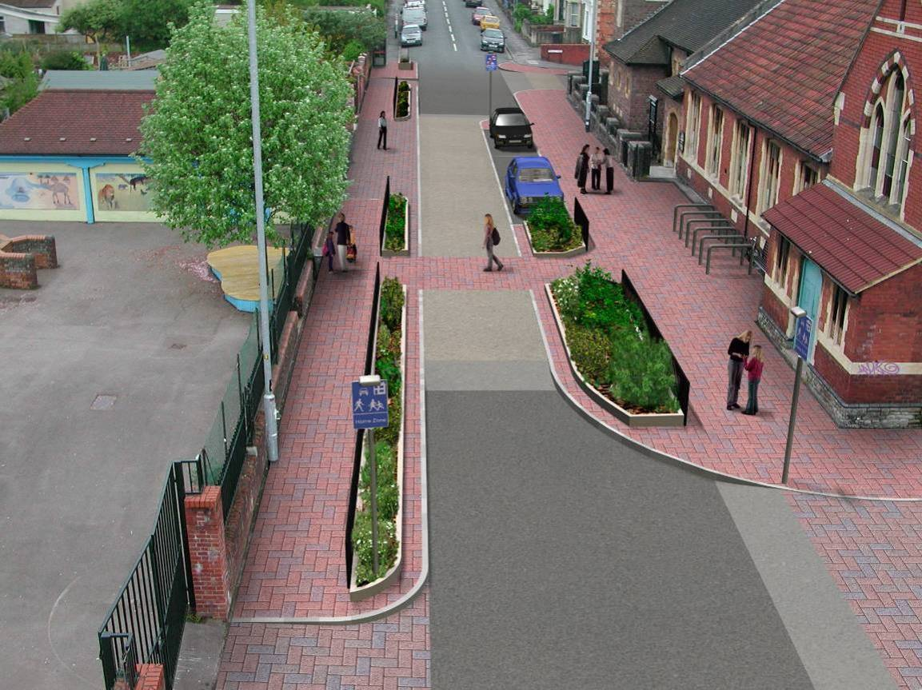

Effectiveness of design in reducing vehicle speeds
The junction of the Focal Point with Beauley Road has caused problems and as a result it is now in its third manifestation.
When the focal point was built the junction just beyond it between Stackpool Road and Beauley Road remained as it was with Stackpool Road having the priority.
When the focal point was opened this arrangement seemed to increase vehicle speeds in front of the school especially driving west. The HZ team looked at different options and settled for giving Beauley Road priority creating a give way for vehicles approaching the junction from Stackpool Road from the east. This should have also meant vehicles going in an easterly direction along Stackpool Road should stop to cross the centre line as they would have restricted visibility of the vehicles with the priority coming southwards along Beauley Road.
As demonstrated in Tables 4.1 and 4.2, this did reduce vehicle speeds.
Table 4.1: Westbound (7-day) traffic and speed counts before and after implementation
 | Count (Vehicles) | 85th %ile speed (MPH) | Speeds >31 MPH |  | Speeds >61 MPH
 | Count (Vehicles) | 85th %ile speed (MPH) | Vehicles | % | Vehicles | %
Before | 768 | 29.4 | 70 | 9.1 | 11 | 1.4
Option A (initial design) | 735 | 18.7 | 9* | 1.2 | 9 | 1.2
Current scheme | 703 | 20.3 | 4** | 0.6 | 4 | 0.6
*Notably, these vehicles were in fact recorded as travelling in excess of 61 MPH, and were the only vehicles travelling in excess of 26 MPH. In fact only 43 vehicles were travelling in excess 21mph.
**Similar findings to initial scheme, with only 8 vehicles travelling in excess of 26mph (four of which travelling 26-31mph).
Table 4.2 Eastbound (7-day) traffic and speed counts before and after implementation
 | Count (Vehicles) | 85th %ile speed (MPH) | Speeds >31 MPH |  | Speeds >61 MPH
 | Count (Vehicles) | 85th %ile speed (MPH) | Vehicles | % | Vehicles | %
Before | 1220 | 27.3 | 48 | 3.9 | 2 | 0.2
Option A (initial design) | 1045 | 18.7 | 0* | 0 | 0 | 0
Current scheme | 1196 | 18.7 | 0** | 0 | 0 | 0
*Highest recorded speed 26mph. 62 vehicles travelling 21-25 mph.
**highest recorded speeds: two vehicles 26-31mph 52 travelling 21-25 mph.
Although the reductions in both average and extreme speeds, particularly following the revision of the scheme, are significant, it has been subject to further review resulting in a revision to junction priorities. Observation of driver behaviour showed vehicles travelling in an easterly direction along Stackpool Road were crossing the centreline and potentially cutting across vehicles travelling southbound on Beauley Road. Giving Beauley Road priority reduced this problem, but meant vehicles on Beauley Road no longer had to stop at this junction which meant residents had also informed us that they felt this junction more difficult to cross as pedestrians than originally experienced.
Hence, a third configuration was introduced, resulting in ‘give ways’ on all junctions, with no one having priority, so relying on some uncertainty to control vehicle speeds. This has been used elsewhere in Bristol and the UK. (Plate 4.2)
Plate 4.2: Stackpool Road – Looking west with vehicle turning from Beauley Road
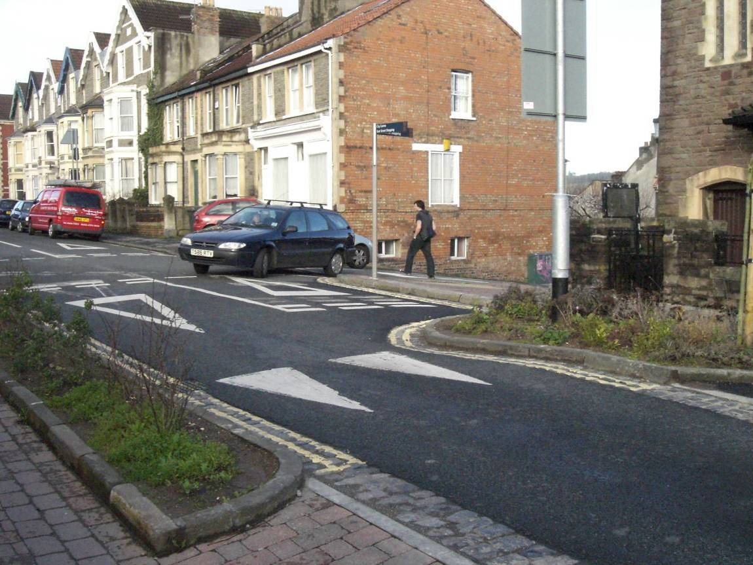

No speed counts had been taken at the time of writing since the latest changes to the Beauley Road/Stackpool Road junction and focal point scheme, although the above analysis suggests the reductions shown in the tables will continue to be realised, leading to only slow-speed manoeuvres outside the school and church; a particularly sensitive and important context.
Finally, it should be noted that the focal point is essentially a stand-alone traffic-calming element, and it can be expected that upstream and downstream vehicle speeds and driver behaviour may not be greatly affected, beyond 1-200 metres or so either side of the feature.
Driver perceptions of safety
Residents have reported a visibility problem when travelling eastbound into the focal point, resulting from the provision of three parking bays outside the Church (Plate 4.3), which it is felt make it harder to see oncoming cars. However, the ‘uncertainty principle’ in traffic calming works by reducing motorists’ perceived safety margins, resulting in adjustments in driving style, so this observation does not imply that the scheme is unsafe.
Plate 4.3: Stackpool Road Focal Point looking East
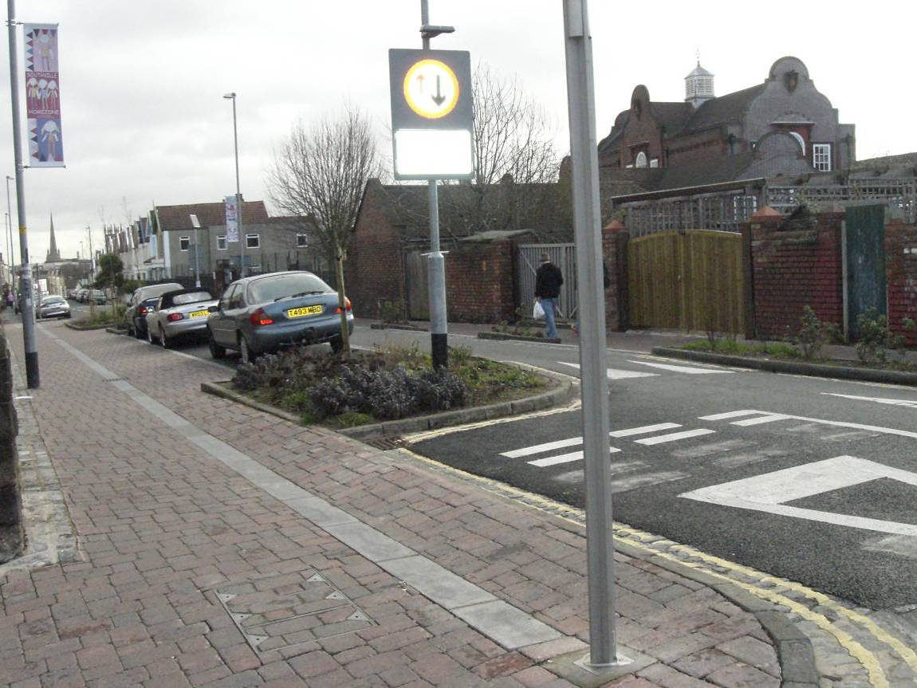

Reported satisfaction with focal point
Both samples responding to data collection were able to comment from approximately similar circumstances about the extent to which the focal point provided practical and symbolic benefits. Three specific questions were put in the quantitative surveys asking whether it had:
- made crossing the road easier,
- slowed traffic,
- created a pleasant useable public space at the centre of Southville.
Figure 4.27 shows the responses from both samples, combined.
Figure 4.27: All respondents views about benefits of the focal point
The overwhelming majority of residents in both the HZ streets and near HZ streets agreed that the focal point has slowed traffic and has made crossing easier, so as a traffic calming measure it appears to have achieved its goals, but it is not so clear as to whether it has achieved the additional goals of changing the way people use that part of the street.
There was less certainty about its status as a public space. A clear majority agreed about the benefits, but around a quarter of respondents neither disagreed or agreed with that statement. Relatively few, however, said they ‘didn’t know’, which suggests this quarter had complex views which were hard to summarise in a quantitative survey. In other words they could be saying it has not made a significant enough change to be a pleasant and useable space, but is a useful contribution.
These findings were supported by the qualitative evidence. Whilst the Minister of the church expressed strong satisfaction with the increased pavement space (Plate 4.4), noting that it had enabled events to be held outside the church, there was some concern from others about the interaction between vehicles and people:
“I think the crossing is really dangerous, it is very narrow, cars speed over it and small children (mine included) sometimes run right to the edge of the pedestrian bit which is flush with the road - only inches away from any passing car - one trip and that is it. It really scares me.” (Resident)
Notably, the extended paved area is wider on the Church side rather than the school side. This can present a problem in the mornings when families are jostling to get into the school gate as there is limited room for a parent with two children and a buggy.
Plate 4.4: Additional space for community activity outside the church
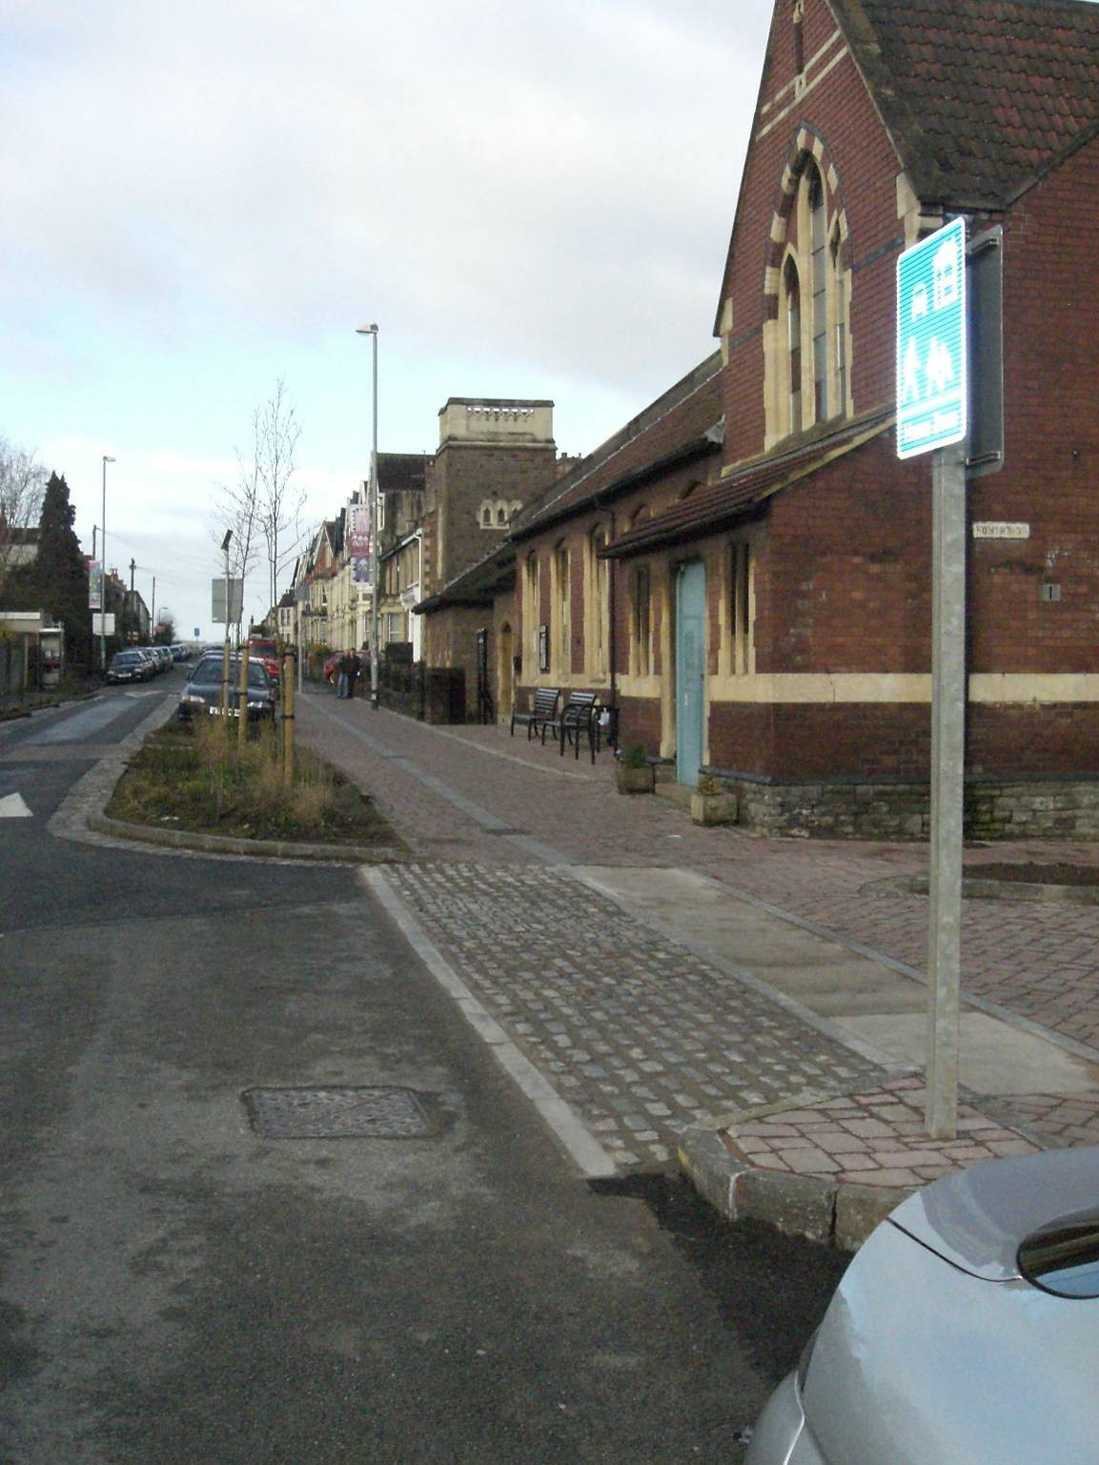

Though there was one Stackpool Road Focal Point workshop meeting to discuss the design it was a different level of ownership compared with the other HZ streets and this may be reflected in changes in the physical features. It has now been extended around the corner into Howard Road which will perhaps give it more of a feeling of a public space than a traffic calming pinch point. There is also an issue about who will maintain the planting. It would in general terms be prudent for BCC to continue to monitor the operation of the current focal point design and nearby junction arrangements with diligence.
4.7 Wider commentary on the scheme from the ‘20 mph zone’
A letter was sent to all remaining households who had received the original BCC doorstep interview questionnaire to inform them that the University of the West of England was conducting an evaluation and soliciting views in an unstructured way by email or in the prepaid envelope provided. In the letter examples of issues they might wish to comment on were included:-
- Whether HZ development was a good idea for Southville generally;
- Whether the way in which pedestrians and motorists use your street has changed in recent months;
- Whether you find it easier or more pleasant to travel around Southville on foot or using a vehicle since the development of the HZ or perhaps harder and less pleasant;
- Whether you prefer the appearance of those parts of Stackpool Rd and Milford Street that have been converted to HZ Streets to how they were before.
Both Leighton Road and Beauley Road are part of the 20 mph zone and will be getting some sort of traffic management but at the time of writing none had been implemented. They are both relatively straight roads with traffic speed a problem but as Beauley Road has the junction with the Focal Point at the top, cars are using Leighton Road as an easier route therefore they are dealing with some displaced traffic.
The issues raised were broadly similar across all streets but the difference in length, location and speed of traffic affected the emphasis.
- Broad agreement that the HZ streets themselves were an improvement in appearance and function but few felt the impact spread much beyond those streets. Several mentioned the issue of equity, why had some streets had this kind of treatment and not theirs? Others raised the even wider issue of poorer neighbourhoods than Southville being more worthy recipients. It has benefited the few rather than the wider neighbourhood. Within these comments was the underlying issue of value for money, could the money spent have been better spent elsewhere. One respondent commented why not spend the money on North Street which is a more communal area and would benefit more people.
- Confusion and safety of the Beauley Road/Stackpool Road Junction
- Several mentioned the improvement in safety at the Focal Point between the school and church though others felt it was less safe
- Parking, displaced parking and cars badly parked
- Conflict of cars and bikes using the Stackpool Road Focal Point
Leighton Road
For Leigton Road the considerable response reflected the increase in traffic with respondents mentioning they had witnessed more road rage incidents. Many made positive comments about the HZ streets and the focal point. The two other issues that were consistently raised were the difficulty and confusion over the Stackpool Road/Beauley Road junction and the issue of equity - Why do Milford Street and Stackpool Road Cul-de-Sac have a HZ and not our street? There was general agreement that the appearance of the HZ streets had improved which had brought improvement to the area as a whole though not all agreed. One respondent felt there had been a loss of the Victorian Character. Several mentioned the safety improvement brought by the Stackpool Focal Point though one respondent felt it was worse for safety encouraging people to speed to get through the give way and another found it more difficult crossing the road with children. Nearly a third mentioned the difficulty of parking and some perceived it as displaced parking from the HZ streets. One issue that had not been raised before was the difficulty of cycling through the focal point or pinch point as there is not enough room for a bicycle and car to pass at the same time causing conflict.
“Having been very anti HZ especially around Southville School it has worked much better than anticipated. The school crossing is great and Milford Street is very quiet in terms of traffic. However I live in Leighton Road and this is definitely busier and faster”
“‘Initially I was concerned about the effect on traffic flow and loss of parking in an already congested area. However my child is at Southville Primary and I feel that the homezone helps to slow down traffic near the school and deters parents from parking near to the school. I now consider myself a supporter of the scheme, having initially been against.”
“‘The HZ initiative is a wonderful project. Our neighbourhood has benefited greatly by the work which has been done so far. More Please!”
“The appearance of Milford Street and Stackpool Road is great but why do I have to suffer as the same taxpayer etc. what do I get from the HZ areas? The cost of building the HZs must be considerable – could this money have been better spend on other roads in the area – so that we all could have benefited rathan than the few who now have “posh” streets! My children deserve a ‘safe’ street as well you know!”
“Junction of Beauley Road/Stackpool Road an absolute mess with poor visibility turning from Beauley into Stackpool”’
“The HZ has effectively turned Stackpool Road Cul-de-Sac and Milford Street into private roads funded by public money, no doubt the residents have found HZ living most conducive, but the effect for us has been to make things more difficult and at times more dangerous. I am convinced that the money could have been better spent either improving traffic management for the whole of Southville or gone towards a more deserving case”’
“Obviously, this scheme has greatly benefited those who live on the streets concerned but I feel it is a misuse of public money when there is such a great need elsewhere, Harcliffe, Barton Hill etc.”
Beauley Road
The comments of the 10 residents in Beauley Road who responded are similar to those on Leighton Road but without the concern about increased traffic and ‘road rage’.
“I think that the HZ is a brilliant idea. It looks pleasant and is pedestrian friendly. I hope Beauley Road is next. Keep up the good work”
“Milford St is an excellent example. The layout is excellent and it benefits not only the residents but also all the people whose children attend Southville school. It has slowed traffic considerably stopping cars racing through and using it as a short-cut…However other parts of the HZ are less successful. I see no benefit at all in creating a HZ at the Stackpool Road cul-de-sac, apart from increasing the house prices for those residents as it has improved the appearance of that part of the road. It is a cul-de-sac so why does it need to be turned into a HZ when there is no through traffic at all. I cannot understand how this can be justified”’
“I am disappointed that the build-outs promised at the stop of Greville Street to allow kids to cross hasn’t happened, it was in the plans.”
“I would like to have had the road wider at the focal point to allow a car and a bike to pass, now people are confused and this can lead to conflict as some cars don’t seem to be willing to stop to take account of the vulnerability of cyclists to their wing mirrors”
Vicarage Road
Vicarage Road runs parallel to the Stackpool Road cul-de-sac. Out of the 7 respondents, four were reasonably positive about the actual HZ streets.
“The cul-de-sac end of stackpool road is often rather a nightmare to drive past – cars trying to get into and out of the cul-de-sac making it impossible to pass. Due to cars parked everywhere someone needs to reverse quite a long way!”
“Cars are parked all over the place in Milford Street. Often the exit end is blocked by badly placed cars”
“complete and utter waste of money – pedestrianised areas just a facility for people to park cars on very expensive paying – dropping oil etc. The traffic restrictions in Stackpool Road now a hazard for cars, completely unnecessary in view of the parked cars always dictating slow speed up and down the road”
Camden Road
Both respondents mention the difficulties of the Beauley Road and Stackpool Road and the focal point. One mentions the difficulties of parking but does not know if it is related to the HZ scheme or and increase in commuters.
Islington Road
One respondent finds the HZ streets attractive and pleasant to walk in and appreciates the extra cycle parking areas and would like their street to be developed in this way, partly as a way of deterring computer parking.
“I think HZs are not much more than a sticking plaster on a much bigger problem – that is, the alarming level of car use amongst the residents of Bristol. Everyone who drives a car has a thousand reasons (or excuses) as to why they simply must have their car. The school run, work, shopping, childminding, convenience etc. But until these people start to explore, or have confidence in, alternatives to car usage, then the streets of Southville and other areas will continue to be choked with parked cars and moving vehicles’ Realistically of course. There’s little or no chance of people giving up their beloved cars. This effectively means that HZs are little more than tinkering”
5. Discussion
“We have got something that we wouldn’t have had without the HZ challenge, which shows that you can do different things with your street and other people can see it.” Stackpool Road Cul-de-Sac Resident
The present section draws on the results from surveys with residents presented in Section 4, and also the interviews with professionals and the focus groups.
It needs to be recalled throughout reading this report, but particularly in the present section, that it evaluates a demonstration project, which was supported with national funding precisely because there is limited UK experience in implementing HZs, and relatively few completed examples. All who took part in the Southville project would probably agree it was a learning experience, and this section puts the results outlined in the earlier sections into that context.
5.1 Quality of the Consultation Process
Three key issues emerge from evaluation of the consultation process:
- The length, consistency and intensity of the process,
- The role of the street representatives
- The level of public support which is taken to be a consensus.
Length, depth and consistency
A very extensive consultation exercise took place over a considerable period of time, which started relatively late in the three-year implementation schedule due to the time taken to appoint the HZ implementation team, so there was some time pressure. Nonetheless, even the accelerated process was seen as long and onerous by some respondents, and in particular for the volunteer street representatives was a considerable burden.
With such a lengthy period of consultation the issue of the continuity of the participants involved is important, and can in itself cause misunderstanding and ill feeling. For example, at the first HZ workshop for the Cul-de-Sac there were 10 households present out of 20 possible, but at a Howard Road meeting only 3 residents turned up from a street of 43 households. Hence, things may move on quickly at one meeting, someone not present at that particular meeting then raises objections at the next.
There is a certain unpredictability and inevitability here: some residents will have limited time to commit and there is of course no obligation to attend, some may be away when a key decision is taken, or not get ‘interested’ until they realise change will affect them. Hence, quite late in the implementation process, and despite the wide range of dissemination discussed in Section 2, some residents would question decisions at a surprisingly late stage.
Clearly, the detailed discussions on the redesign of specific streets needed to be largely limited to the immediate residents, but the shift in focus from the wider area to specific streets might have been handled better: those who had participated in the combined meetings as representatives discussing the introduction of the 20 mph zone reported feeling left uninvolved and uninformed as the street-by-street HZ workshops evolved. At the time of data collection they were still unclear as to whether a 20 mph zone and wider-area traffic calming were to be put in place. This has left a certain amount of resentment.
With the HZ streets themselves, too, though, there were gaps in information at crucial moments which lead to friction. The difficulties with the contractors, exacerbated by the financial difficulties of the parent company of Jarvis Highways, put considerable financial doubt over the whole project and it was difficult for the HZ Team to know what to communicate. There was more uncertainty than is typical for local road engineering projects, which to some extent can be put down to a particular set of unusual events, and in part reflects the novelty of HZ schemes in particular and the experience of the relevant professions with HZ development.
Role of street representatives
“…no election of street reps…became a problem later on, I don’t think the street representatives would have been different but [position weakened] because there hadn’t been an election…should have been done democratically at the time” Resident Stackpool Road Cul-de-Sac
The street representatives were the intermediaries between the groups of residents and the Council; not always a comfortable position. Who became a street representative was to a large extent a question of who was willing to step forward and take on a considerable commitment. Their position might have been strengthened if there had been a more democratic process to identify them. However, given the difficulty of getting people to attend meetings consistently, it would have been difficult to have a free and fair election of street representatives.
Definition of a consensus
Not only is there the issue of who do you communicate with during the consultation in this case it was through street representatives but at what level of ‘buy-in’ do you go ahead. The HZ Team were working on the basis of 75% agreement which was the case in Stackpool Cul-de-Sac, but this left about a quarter of households feeling sufficiently marginalized by the HZ process and outcome that they have approached their local MP for assistance. These households suggest they have been bullied and intimidated by those householders who wanted the HZ and that the consultation was handled in an undemocratic way. They feel the views of a number of residents were ignored, voices unheard, questions unanswered and point to the fact that the street representative was not elected.
It is also true that in Howard Road there are people who feel the process has divided the community rather than improved neighbourly relations, as this commentator from another street observed.
“If you want a HZ to work then everybody has to buy into it. I think that’s where the whole process from the start was …oh we have got 70% approval we will go ahead and expect other people to fall in line – well they obviously don’t and so I think it can be divisive” Resident Milford Street
It may be that a different process could have reached a greater consensus, but it would be wrong to over-emphasise the power and responsibility of the professionals; in the case of Stackpool Cul-de-Sac, some commentators felt the process just exacerbated tensions that were already in existence, with the HZ presenting a convenient hook onto which people could hang ‘nuisance neighbour’ issues. Some argue the HZ has just allowed inconsiderate neighbours to extend their domain outside their front doors.
Further, just as the minority feel they weren’t listened to, others felt the HZ team took too much notice of their views, and there was a feeling that they opted out of the process and circumvented the public process without the rest of the community knowing:
“It seemed to me that we would have community meetings to which some people very rarely came, where things would be agreed and then I had a sense that some of the HZ team were getting irate phone calls and emails and this vociferous minority was ‘caved into’ repeatedly” Resident Stackpool Road Cul-de-Sac
In the final analysis, the issue of what level of support is taken as a ‘consensus’ will remain an important constraint on the success of HZs. In contrast to the case of other controversial transport schemes, such as major city centre traffic management changes, any inconvenience experienced tends to be during a visit to a shared, public, locality, and there maybe an option to visit another similar location which is found to be more convenient, such as another town or out-of-town shopping centre, whereas if a HZ is found to be inconvenient, the ultimate recourse of the dissatisfied resident is much more drastic – to move home – which suggests a high social cost, even if only a small number of people are affected.
However, these issues not withstanding, the fact that the outcome varied between the streets offered a HZ, despite the HZ Team being the same and applying a similar consultation methodology, suggests the process was robust and effective. The views of particular residents’ groups containing different individuals will naturally vary and in the Southville case did have an important influence on the outcomes. One example was the ‘planning for real’ exercise in Howard Road being instrumental in enabling residents to understand what was involved and that it was not universally welcomed.
5.2 Inputs into the Implementation Process
“It needs to be clear what the objective is, I can see the point of the Dings, anything is better than what they have, people are happier to see something done that would improve their area, I couldn’t quite grasp what problem we were trying to solve in Southville. It just seemed like an experiment and these people were guinea pigs” Implementation Team
Whilst the previous subsection on consultation has examined the effectiveness of public involvement, the focus here is on the delivery led by the public sector, including the deliverability of the HZ concept.
Clarity of project aims
“At least with road safety schemes, you know why you are building it, there is a target, you are addressing a safety issue. With HZs you are selling an ethos and there are different interpretations of that ethos and I think that is one of the problems we’ve got” Implementation Team
This issue of expectations versus the reality came up again many times in the interviews and discussions. Some residents felt that the HZs were the output of restrictive engineering procedures, rather than imaginative, bespoke designs. Others, almost in contrast, felt that what they ended up with was as a result of the resident’s enthusiasms rather than facilitation by the council. This was reflected in the Focal Point where
“there weren’t local residents with the enthusiasm and input and therefore the focal point to me was a nothingness and it should have been the most important bit” Resident Focus Group
At the beginning of this project the HZ concept was relatively new in the UK. Section 1 has outlined the limited (nine) national pilot schemes that represented existing practice (although some of these were still under construction or evaluation), and the limited associated written guidance, certainly before the IHIE document of June 2002. Given that it was fundamental to define clearly from the beginning of the project what the regulatory and funding boundaries were and to communicate it clearly to all those involved to avoid unrealistic expectations, the limited knowledge base was a problem (although a somewhat inevitable one in the case of a pilot project itself intended to increase the available evidence).
On top of the practical constraints on effective ‘management of expectations’, though, it seems likely that a certain amount of unrealistic ‘visioning’ was encouraged by the professionals at the beginning of the process, in order to engage and enthuse people from the community to make the bid, which resulted in some residents developing undeliverable remodelling scenarios for their streets. Subsequently, once the HZ team was assembled, it then had to present the community with the realities of time and budget constraints and the fact that less obvious street ‘activities’ such as the position of services under the street surface had to be taken into account, along with national guidance and regulation. This placed the HZ Team in the position of being the limiters of possibilities, which naturally led to negative association.
“The Lampposts we all decided we really liked and would look nice, we were told you can’t have those because the council won’t maintain them. So you either have ones that look like this or that and everyone kind of goes , well they are awful and that was it. So we had gone from being promised lots of choice to actually finding our choices were very limited” Resident Stackpool Road cul-de-sac.
Moreover, the HZ Team unexpected resistance and obstacles when trying to meet the aspirations of the residents:
“It was an absolute eye opener to find out what level of regulation there is for traffic, lighting and signage, it is a complete maze, there are so many things you can’t do” Implementation Team.
As an example, residents universally wanted more trees, but the water utitlity companies raised obstacles which limited the design options.
The Team also had to push the boundaries within the Council itself. The instinct is sometimes not to change; for example highway maintenance engineers would perhaps prefer the simplicity and economy of wall-to-wall asphalt rather than a complex multi-material shared surface.
Skills brought to the implementation process
The complexity of implementing a retro-fit HZ requires technical, social and design skills: a multi-disciplinary team. In the case of Southville the area has an articulate and professional resident population, well skilled in the strategies and tactics of obtaining personal objectives from interactions with institutions. The HZ team comprised two engineers and a transport planner, to run a process which is very much an exercise in politics and negotiation, as well as engineering. Notably, in the nearby case of The Dings, Sustrans acted as the ‘external facilitator’ but in Southville there was no such intermediary at the outset.
“A facilitating organisation is really crucial to working with residents and bringing them in and getting them on board to defuse tensions” Resident Stackpool Road Cul-de-Sac
“In a HZ Team you need someone who is really good at people skills and then you need someone who is good on the technical side as they are going to know what you can and can’t do” Street Representative
Hence, the Implementation Team was handed a challenging brief which arguably required additional skills, drawing on community planning and facilitation from the beginning, rather than from when the particular processes became deadlocked, as the Team itself acknowledges:
“I suppose one thing I’ve learnt is that you’ve got to be aware of your limitations as a civil engineer, highways engineers: we can’t manage the softer issues of a scheme like this which is actually about people management, there is a suspicion of what you are doing and where you are coming from if you are the Council – it is difficult to overcome that…we’d say things and people wouldn’t necessarily believe us. You’d keep saying it and try saying it in different ways. They’d test you to see if you were spinning a line…natural suspicion people seemed to have…which was barrier…as trust is very important when you are trying to deliver something like this you need mutual trust” Implementation Team
On the positive side, however, Southville residents had a lot of skills which the HZ team were able to use to improve the overall scheme, and they undoubtedly contributed to the outcome.
“We were helped by the fact that there were professionals in both streets who had architectural skills who had views and were trusted by the majority of residents…and they were quite key in moving things forward…could present people with. We were fortunate that there were people in these streets who were willing to prepared to take up the issue and knew what was required and by and large I think the rest of the street trusted their judgement”. Implementation Team
In summary, a combination of skills is needed and they will rarely be found in one individual. The skills needed to implement the physical changes are very different from those needed to negotiate a consensus. Different disciplines have different approaches and might solve a problem in a different way. It is also important to audit and involve the skills available in the local community.
Management of construction
“ [We] didn’t have a detailed enough plan and programme to build a HZ. With hindsight we would have brought in additional resources early on to design out the risk” Implementation Team
Provision of the agreed schemes was an ambitious task with serious time pressure constraints, and which became complicated by difficulties experienced by the contractors, external to the HZ. The constraints meant that the two largest elements, Milford Street and the Stackpool Road Cul-de-Sac had to be constructed in parallel rather than consecutively, which meant an opportunity to apply lessons learn in one street to the other was lost.
Mistakes were made in the specification of the contracts and designs were perhaps not detailed enough to prevent one contractor submitting bills for ‘extras’ not outlined in the official order. Hence, the HZ Team found itself vulnerable to claims which cast a shadow of uncertainty over the budget. Furthermore, the original design envisaged paving over the existing street but it was not possible to construct according to the contract due to the condition of the carriageway. This meant the street had to be dug up, at extra expense.
Notably, though the consultation process for Howard Road was particularly challenging, the physical construction went very smoothly compared to the other two streets largely because the Team was able to benefit from earlier experiences.
Ongoing Maintenance and Design Issues
There is a need for management into the future, which is arguably greater than exists with a conventional street. It is not clear how far a management plan is in place.
‘HZ rules’ will need to be passed on to newcomers, requiring at least a mechanism for communication within the streets, possibility along the lines of an individual taking on a role similar to a neighbourhood watch coordinator, or the authority being vested in a residents’ committee. There is no clear precedent as to how the new ‘cultural norms’ should be passed on to avoid conflict, and in the absence of a mechanism, conflicts will arise.
“People will take advantage if there is doubt about rules to create their own rules that aren’t very considerate on all sides” Street Representative
For example, in the Stackpool Road Cul-de-Sac the angle of the echelon parking makes it impossible to do a three-point turn to exit the street travelling forwards, so space is left at the far end to enable turning movements. However, up to three vehicles can be parked there in contravention of the ‘rules’ and these spaces are usually taken up by cars, so residents have to reverse their cars out of the Cul-de-Sac, which would appear to create a particular danger in a street intended to allow for play (although others feel it is a small price to pay for an improved street and three more informal parking spaces).
This is not so much an issue of capacity, as there will always be a limit beyond which residents will have to consider parking elsewhere, or a lower level of car ownership, but it creates particular management problems, of a nature which cannot be effectively enforced by parking attendants: it remains unclear what constitutes legal parking in a HZ. Moreover, does a ‘future’ community in the street remain bound by what was agreed in the past, or is it subject to review (and if so how often and through what mechanism)?
Another specific issue concerns the planters. Residents have ‘adopted’ planters and bought extra plants for them, but there is still confusion about responsibility. In hot weather they need very regular watering and the planters on one end of Milford Street are very far from anyone’s home. It is not clear whether the residents can or should take charge of watering. It was felt there should be a stand pipe. There are also issues about more significant maintenance to the planters.
Further, residents in Milford Street decided they did not want parking spaces clearly marked out, which has meant that people park in places that in the designs were not meant for parking and also leads to inaccurate parking, making it difficult to open car doors if cars are too close, which can cause problems for elderly residents, and equally, difficult to exit from properties with luggage or prams if cars are parking too close to front doors.
Finally, the tight timescale of the HZ construction in Milford Street highlighted the issues around co-ordinating different facets of a street. The lead piping in the street is due for renewal, but not for a couple of years. The HZ could not be delayed and the work on the pipes could apparently not be brought forward, so there is a likelihood that at least parts of the expensive new surfacing will have to be excavated relatively soon by a utility company.
5.3 Goodness of Fit with the HZ concept
The evidence presented in Section 4 shows how the streetscape can be physically changed to the broad satisfaction of the majority of residents. In 2003 several residents were concerned about fast traffic, even in the Cul-de-sac, but after the implementation of the HZ there were no residents concerned about fast traffic. The traffic-calming effect of the focal point has reduced the 85th percentile speed of vehicles measured as they pass through the feature by 50 percent, and greatly reduced the incidence of extreme speeding. The after-implementation sample was also less concerned about pedestrian safety than that in 2003. They also answered that they drove more carefully in Southville and perceived that others were driving more carefully in their street. A few had changed their behaviour and were walking and/or cycling more. 30 out of the 34 households agreed that ‘children play more in the streets’. The HZs have brought changes but this, in itself, does not confirm goodness of fit with the HZ concept, which has some more demanding objectives in terms of the scale of the implementation and the potential for interaction and play, as outlined in Section 1.
There is still an intention by BCC to complete the physical context to the HZs by signing the area and putting in traffic calming on Beauley Road and Leighton Road, but this work had not been undertaken by May 2006 in time for the present evaluation, whilst the junction tables originally proposed (see section 2 Map 2.1) will not be pursued for budget reasons. Arguably, further works will help to integrate all the physical changes within a more coherent ‘safety zone’.
In assessing the balance of the outcomes from consultation and implementation, it is instructive to go back to one of the texts on which the HZ idea was based: Woonerf, a new approach to environmental management in residential areas and related traffic regulation (1980) states that “the design and layout of a ‘woonerf’ must express the fact that traffic is subordinate to pedestrians” and describes the sort of features that might be included. This is not dissimilar to the HZ guidance but interestingly the Dutch text argues ‘play areas for children from which cars are banned are a must. In addition, constrictions should be created in the roadway wherever children often play to make it safer’.
Minimum design standards for ‘Woonerf’ were published by the Netherlands Ministry of Transport and Public Works as early as 1976. Article 13 dealt with play areas. “Where possible, play areas should be physically separated from those parts of the highway used by vehicles. Bollards, chains, fences and benches can all be used to identify and separate play areas, but the definition of play areas should never be allowed to create the impression that children cannot play elsewhere on the street within the ‘woonerf’”.
The approach of the above texts concerning the needs of children is somewhat in contrast to the Southville experience in which
- the needs of adults wishing to park cars have sometimes dominated, and
- some residents have rejected the broad philosophy behind HZs: the legitimacy of ‘streets as living spaces’.
Streets as living and play spaces?
Many parents in Southville were concerned about the shared surfacing and needed persuading that it was a good idea. Different sections of society may want different things from a HZ, but even within a group with a common interest which might be expected to have similar views there were differences in parents’ expectations about a safe street. The focal point in particular attracted polar opposite viewpoints given: the majority felt it was safer, a few felt it was less safe, depending on whether they preferred segregation of cars, or deliberate blurring of priorities to create uncertainty.
Another more fundamental philosophical objection to the HZ approach relates to the extent of play which is encouraged. Some residents feel that the level of play creates too much noise and results in damage to cars and garden plants, particularly by ball games.
“there are maybe half a dozen households in our street, where in the summer months they are living half inside and half outside – half in the garden and half in the street and the kids are running about and the parents are sitting in their front garden or in the street watching them and it is very sociable. I personally think it is lovely but I know that there are people in the street who disagree – they don’t like the noise” Resident Stackpool Road Cul-de-Sac
The counter-argument to street play is that a park lies within a 7-minute walk and is a more appropriate venue for play. There had been disagreements about these issues in the Cul-de-Sac before the HZ but the HZ has possibly exacerbated the situation by in a sense ‘validating’ children playing in the street.
More generally, some might see HZ development as a way of increasing their house prices, other might have a more idealist viewpoint, and other people just don’t want things to change.
Amongst the ‘social idealists’ the HZ consultation process itself could be seen as a positive: a way for people to get to know their neighbours and increase the social capital’ of the area:
“I used to get up and got to work… I don’t have a family, so I found it nice all meeting we have to actually see who all the other people were. And since we have carried on saying hello. In some ways I actually miss those meetings and meeting around the table” Resident Milford Street
“It was very good for us because we moved in as this process was starting and it was an excellent way for us to get to know our neighbours” Resident Stackpool Road Cul-de-Sac
In summary, aside of the merits of HZ development, it has to be accepted that the process is as much about social engineering – promoting a particular kind of lifestyle. People naturally see different opportunities and threats. Equally there are some people who just did not want change; they want to be left alone to live their life in a certain way which they feel is their choice and why should they interact more with the neighbours and no amount of consultation will probably change their minds.
And in practical terms, car ownership was significantly lower in the western industrialised states at that time of the pioneering Dutch interventions, whilst there are higher levels of walking and cycling in the Netherlands, Germany and Denmark, the three countries with most HZ experience. This suggests there is a greater emphasis on the needs of motorists when redesigning streets in the UK, and full HZ status may be harder to achieve in British towns.
Parking: A particular constraint
A lot of the highway in Southville is about 10 metres wide with fairly narrow pavements so there was not much space to re-allocate. In addition the house frontages are narrow with the potential for blocking gateways. The most efficient way of parking was often found to be the traditional street layout. For example if the houses are narrow and two cars are parked per frontage in echelon fashion, this may result in the gateways being obstructed. A few more metres of available highway could have enabled a wider range of layout choices in Southville to try and satisfy the parking demand while meeting other HZ requirements. In practice, considerable design constraints arose, leading to conflict in consultation. Parking was the most contentious issue throughout the process and for those living in the HZ streets it probably still causes friction.
“For some people the parking is the only thing that matters to them and that I didn’t expect, that kind of fierceness about parking it became such an issue. Parking is so difficult around here anyway and my view was well it is difficult and a few cars won’t make a difference” Street Representative
“The one issue that ignited everyone was that they must have somewhere to park their car…sometimes all three. I think when people started talking about homezones they thought it was perhaps a solution to that problem, it turns out it isn’t a solution to that problem it has had almost no impact on the problem one way or another.” Community Worker
In Southville it seems likely there was a small reduction in the amount of parking as a result of the HZ streets and Focal Point, exactly how many spaces and the significance of the reduction is open to debate. In the questionnaire responses some residents from the nearby streets blamed their parking problems on displaced parking from the HZ streets, but the reality is that the difficulty of parking in Southville is due to a number of factors, including the size of vehicle, the physical constraints of the street, how carefully people park, levels of car ownership, levels of commuter parking, single family houses converting to multiple dwellings and an active community centre which brings people to the area who need to park. Bristol has one of the highest car ownership levels in the country and rising.
Southville was not unique amongst the Challenge schemes in experiencing parking as a major issue, even in the cases in which car ownership was relatively low (DfT 2005). In most areas existing parking spaces were at a premium and residents strongly resisted any reduction. Local authorities have therefore sought to maintain or increase parking provision, even though this would appear to be in conflict with the principle of creating more space for activities other than car use.
Indeed, in the guidelines for Woonerf it is made clear that the designation of a street will normally lead to a reduction in the parking capacity, and that whenever there is a significant excess in the demand for parking which cannot be met by the provision of special parking facilities in the immediate vicinity, it is preferable not to develop a ‘woonerf’ since the cars will be parked regardless of parking regulations and thus destroy many of the concepts integral to the ‘woonerf’.
It is not suggested that the situation in Southville was so extreme as to be inappropriate for HZ development, but it is surprising that some authorities are seeking to increase parking by HZ treatment, apparently with support from the IHIE guidance:
“Parking Capacity problems can be addressed through the design, as HZs tend to increase the efficiency of on-street parking. Parking spaces can be arranged in blocks, in echelon (angled) or at 90 degrees to buildings; and the whole width of the street, including former footways, can be brought into use.” (Section 3.6.10)
Although Section 3.6.8 of the same guidelines do point out the number of on-street spaces may be affected, it does not go as far as articulating that car parking is likely to be reduced within a HZ - this was the major point of tension in the implementation in Southville, that a reduction in parking might displace cars onto surrounding streets. The HZ team was hence left seeking a balance between those that found it difficult to accept the idea of reducing parking and those who really wanted to ‘reclaim the streets’ from parked vehicles.
In the original bid there was little evidence of the trade-offs regarding parking provision. This seems to be an important specific example of the argument about clarity developed in Section 5.2.
5.4 Value for Money and Future Direction for Home Zones
The response from the wider community showed that such a demonstration project can be divisive in that people want the same treatment for their street, wondering “why should children in neighbouring streets be safer than ours?” Others even raised the issue as to “why Southville?”, noting that it isn’t a regeneration neighbourhood, and hence not particularly deserving of high levels of public funding.
There are around 55 households sited in the two main HZ areas and immediately adjacent to the Howard Street HZ element. The interim public cost of the Southville scheme was £838,000. If it is assumed that around one-third of the total expenditure to date has been allocated to the Focal Point design and implementation and design and preparatory work for the 20 mph zone, then a crude approximate cost of implementation per property directly benefiting was in excess of £10,000. Providing similar schemes for other suburbs in Bristol would run into tens of millions of pounds, and such a policy would still be open to the criticism that only a few residents in each HZ benefit directly.
The above analysis ignores any benefits (and costs) accrued to households outside of the HZ streets, and in practice there may well be cost reductions achieved in the future as this was a pilot scheme, but given the magnitude of these costs and of local authority transport budgets, it will always be difficult to achieve equitable provision of HZ infrastructure, if the supply is essentially rationed by the queue principle. Notably, the original Dutch experiment in Delft in the early 1970s involved a woonerf implemented in a fairly low-density suburb of single-storey housing with around 100 residents per hectare. Due to high implementation costs, when the Dutch approach was subsequently ‘transplanted’ to Germany and Denmark then it was expressed in the form of lower-cost traffic calming methods (Richards, 1990).
Residents clearly perceive benefits and further gentrification of the immediate area is likely to result. It is not clear whether individual households would perceive benefits from HZs to the extent that they would be prepared to put significant (or in some cases any) funding towards them on a voluntary basis. That any would seems unlikely. Nonetheless, the general improvement to the streetscapes suggests there is, a valuable benefit – indeed one explicitly valued by potential residents – perhaps equivalent to around half of the value of public investment. This is expressed in terms of increased property value: a limited number of discussions with four estate agents covering the Southville area suggested that there may be either a
- saleability premium, with HZ houses selling faster than non-HZ houses and
- a value premium, possibly worth up to £5,000 for a Victorian house.
A caveat here is whilst those in the housing market in general might value HZ properties more highly, specific purchasers may not: some purchasers are very concerned about parking and may perceive that it will be more constrained within a HZ. To the extent that a premium is realised it is unlikely to be captured from the current council tax regime, based on fairly crude property banding. It represents, then, a financial distribution from the public sector to property owners living in (and possibly to some extent near) HZ streets. Most of these property owners will be relatively wealthy private home-owners and landlords, so the investment arguably represents a negative redistribution of wealth.
6. Conclusions and Recommendations
6.1 Southville Home Zone Process and Outcome
It is concluded that the Southville HZ implementation has met many of the residents’ original objectives outlined in the bid to the DfT. The consultation was considerable and allowed residents to be part of the process and influence outcomes, with different streets choosing quite different outcomes, including not to progress HZs. As a demonstration project it has also generated useful lessons.
In terms of BCC’s specific objectives, the evaluation has demonstrated that in the two significant HZ construction areas, along with the Focal Point (and latterly probably also the Howard Road extension), have a very different appearance from conventional streets acknowledged by the public. The vast majority of people living in the streets and also in surrounding streets think they are an improvement on the traditional streetscape. The change in the physical nature of the streets has succeeded in cutting traffic speeds which has allowed the streets to be used in a different way and to some extent seems to have changed people’s attitudes and behaviour, although with the caveat in the latter case that many of the data are self-reports. To a lesser extent, it appears that even participation in the process has also changed people’s driving behaviour.
However, in encouraging community ownership, the process perhaps raised expectations beyond the realities of budget, physical constraints, government guidance and regulation.
Furthermore, BCC had not managed to implement the 20-mph zone expected to surround the HZ elements by Spring 2006, and this is an important part of the overall HZ ethos. Hence, there is a risk of the scheme being seen as fragmented pockets of change that are not ‘joined up’ in the way that was originally conceived, with the risk that improved safety will exist in isolated pockets rather than extend throughout the area. As it stands, the high cost of the scheme has brought direct benefit to a small number of households but with the complete scheme more households would benefit.
Recommendations for enhancing the provision of HZs
- Clarify objectives in the beginning with a realistic sense of what can be delivered given practical constraints: carefully manage expectations. Be clear that there will be compromises and trade offs particularly in terms of reduced parking.
- Consultation should emphasise frequent provision of information as well as detailed information, if only to confirm that a decision has not yet been taken.
- Conduct a skills audit to be sure that local (often free) resource inputs, adding to a multi-disciplinary team, and compensating for the limitations of public resources.
- Seek community advice about what should be regarded as a consensus behind implementation. Engage as many people as possible, and particularly those who have concerns, otherwise they will leave the process but become objectors later on, and be disenfranchised in the post-implementation period. However, in consulting minorities, be clear that the process remains public.
- Devise transparent, consistent and effective processes for reconciling the legitimate aspirations of minority groups of consultees with those of any majority.
- Make sure the contracts are more detailed, and include time penalty clauses.
- Have a clear ‘handover’ strategy to the community, indicating who is responsible for which aspects of the scheme’s management.
6.2 Conclusions for National Policy on Home Zones
There are difficulties inherent in using a national bidding system to innovate something as ambitious and local as a HZ. Consultation prior to a bid by necessity can only be relatively shallow, and needs to be public opinion-leading, with a risk that it creates unrealistic expectations. Once a bid has been won, however, there is a momentum ‘imposed’ from outside, and it becomes a rush to achieve the extensive consultation necessary and construct a scheme within the budget ‘spend-by’ date.
Overall, the process of HZ implementation in a Victorian suburb has been shown to be complex and resource-intensive. A number of factors contribute to this situation, including
- the need to recreate streets from an ageing stock of existing built environment,
- the presence of existing residents with differing lifestyles and aspirations, and
- fairly high-density housing, combined with an affluent community, which creates high demand for parking.
Clearly, the case of introducing HZs to high-density UK Victorian suburbs in the 2000s, with intensive car ownership and use, is a challenging objective. As a result, the high cost per household, the difficulty of achieving consensus where parking is a scarce resource, and the need for significant re-engineering of streets suggest that the case for public funding in terms of costs and benefits would be weak when compared with other alternative allocations of the resources.
One clear conclusion is that the case for public investment in HZs can only really be justified where there is a clear accident problem, and even then the case for the full HZ treatment over lower-cost traffic-calming needs to be made. Other exceptions might be in the case that the public sector – in some form – is the landlord, so any property value benefits are retained by the public sector, or there are clear social inclusion objectives, such as the case of a deprived community needing public investment for environmental regeneration reasons (and here too it is likely that at least part of the property market benefits will be retained within the public sector).
Otherwise, the onus should be on encouraging high-quality HZ type investment by the private sector as part of the planning process, achieving safety and quality of life benefits which are in part funded by a premium on the property value and in part a ‘developer contribution’ in order to achieve wider public policy objectives in the transport, health, and social policy fields.
Strategic Recommendations
The present study has confirmed that ‘retrofit’ HZ development is generally welcomed by resident groups who engage with the process and agree a near- consensus scheme. Non-residents also observe the schemes, and often identify them as desirable. This potentially creates a problem for policy, as even modest demand for the schemes is unlikely to be met by current funding arrangements. It is hence recommended that:
- A greater emphasis is placed on the costs of provision – and their justification – as well as the benefits, including a clearer understanding that beyond the HZ Challenge funding, there will normally be an opportunity cost to HZ development.
- Planning guidance should firmly seek obtaining high-quality HZ provision where new-build and refurbished housing is provided, where there will be important cost savings through providing in tandem with other infrastructure.
- Public sector funding to be focussed on schemes where social inclusion objectives can be clearly demonstrated or the public sector is responsible for the majority of the housing provision as landlord.
- New sources of funding from residents’ themselves are considered for the relatively few cases in which a complete consensus can be achieved, including through the council tax, resident’s permit parking schemes, or other mechanisms.
- Other forms of funding are also considered, such as through planning gain, and private sector sponsorship.
References
Biddulph, Mike, 2003. Towards Successful HZs in the UK. Journal of Urban Design, 8 (3), pp 217-241
Bristol City Council (2003) New Build HZ Design Guidelines Bristol: Bristol City Council Available from: http://www.bristol-city.gov.uk/ccm/content/Transport-Streets/Road-Safety/home-zones.en
CABE (2002) Paving the way – how we achieve clean, safe and attractive Streets London: CABE www.cabe.org.uk
Davis, C. J, (1994). Traffic in Townscape; Ideas from Europe London: Civic Trust, English Historic Towns Forum
Department for Transport (2001) Traffic Advisory leaflet 10/01, HZs Planning and Design London: DfT
Department for Transport (2002) Traffic Advisory Leaflet 8/02, HZs – Public Participation London:DfT
Department for Transport (2001). HZ Challenge: Guidance to Prospective Bidders. DfT, London.
Department for Transport, 2005, HZs: Challenging the Future of Our Streets . London:Department for Transport (accessed 20 March 2006)
Hamilton-Baillie, B., 2002 HZs – Reconciling People, Places and Transport London: Winston Churchill Memorial Trust
Institute of Highway Incorporated Engineers (IHIE) (2002) HZs Design Guidelines London: IHIE Available From: http://www.homezones.org.uk/public/guidance/index.cfm or www.ihie.org.uk
Richards, B., (1990). Transport in Cities. Architecture Design & Technology Press, London.
Royal Dutch Touring Club, Road Safety Directorate, (1980 ). Woonerf, a new approach to environmental management in residential areas and the related legislation. The Hague
Socialdata and Sustrans, (2004) Travelsmart Bristol (Southville, Bedminster, Windmill Hill) a report on Bristol’s third Vivaldi individualised travel marketing project Bristol:Sustrans
Transport 2000 (undated). Streets for People briefing: Tips for a successful HZ. http://www.transport2000.org.uk/communityaction/HomeZoneTipsBriefing.htm
TRL (2003). Pilot HZ schemes: evaluation of the Methleys, Leeds. TRL Report 586, TRL Limited

Appendix A: Consultation Process in Howard Road
In March 2006 the construction of the extension of the Focal point on Howard Road was completed. It has no homes directly adjacent and might be more properly described as an extension of the Focal Point rather than a HZ per se.
Fairly early in the lengthy consultation process, the northern end of Howard Road decided it did not want a HZ. The residents were interested in obtaining certain aspects of a HZ but wanted to retain the traditional carriageway structure, with vertical delineation of the pavements, and were concerned about the loss of parking. As the carriageway changes are such a fundamental part of the HZ concept, it would not have been possible to spend HZC funding on a scheme which would have met these residents’ objectives.
The Southern end continued with the process, with a Planning for Real Exercise taking place on Sunday 23rd May 2004 which resulted in residents commenting on the plan and coming up with an amended, preferred layout. At the next crucial meeting in June only three households turned up.
The HZ team felt that this new design, which the majority of residents had endorsed, was too much of a compromise to be designated a HZ, and would be a poor example of a HZ. As Southville was a demonstration project this design was sent to the funders, the DfT, for approval. Their response was that it would not be a best practice HZ but to some extent it was up to BCC to make a decision. Arguably, for BCC to go against the DfT advice was probably not in the Council’s overall interest in maintaining public and DfT confidence in the process.
From the point of view of the residents who wanted a HZ and had struggled through all the meetings during this time they felt there was a break in communication and they heard nothing for a couple of months. When they were told their design had been rejected they felt let down and that they had not been given good advice from the professionals, the HZ Team. Some felt that at this crucial point where the compromise design was put forward to the DfT the BCC team did not engage sufficiently to change it so that it was acceptable.
At this point BCC went back to the residents with three options and asked them to vote (votes in Brackets) including a ‘previous but amended’ layout (3), no home zone (4) or come to a new workshop to discuss options (3). There was no obvious consensus and the street representative at that point felt he could not continue in his role.
There were complaints to the Council with some residents expressing that they felt the options they were presented with bore little relation to their ‘designs, ideas or wishes’ which had been discussed previously, at length. They felt it was a flawed consultation process. However, the counter argument to this is that there is a limit to how many more meetings and how many more designs can be produced at public expense. In the background was also the fact that the HZ Challenge Fund money was due to be spent by a certain time and some of the funds that might have gone to Howard Road had been spent as a result of cost overruns on the other streets.
The group manager of transport initiatives with BCC became involved and after several more meetings the design for the extension of the focal point on Howard Road was agreed.
It appears that the response to the extension of the focal point on Howard Road has been positive, although the information available was qualitative and anecdotal, as the data collection for this questionnaire was prior to its completion.
Appendix B: Results from Tracking of Respondents through 2003 and 2006 Surveys
Commentary
Direct comparisons have been made between the responses made by households to the before and after questionnaire surveys (where they participated in both cases) for a selection of the analyses reported in Section 4 above. These additional analyses focus in on those households who contributed to both the surveys in 2003 and 2006, as summarised in Table A1.
Table A1: Number of residents completing both before and after questionnaires
Street | Before | After | Both
Milford Street | 17 | 20 | 7
Stackpool Road cul-de-sac | 15 | 13 | 7
Howard Road | 23 | 23 | 13
Merrywood Road | 13 | 12 | 7
Stackpool Road | 31 | 26 | 9
Dalston Road | 9 | 9 | 7

Comparisons were only possible for items of information that were common to both questionnaires, and comparisons are only reported here where the results were of particular interest. Hence, results are presented for:
- The overall opinion of Home Zones,
- concern for fast traffic,
- concern for indiscriminate parking and
- number of cars owned.
Where comments are made on Home Zones in 2006 which relate to comments made also in 2003 these are also presented. The results are provided separately for the six different street sections covered by the after questionnaire.
Summary of changes between surveys: HZ streets
In Milford Street all seven respondents thought the street was improved in 2006 with six of these thinking it was a good idea in 2003 and one not sure. One respondent had hoped the scheme would raise consideration of broader issues relating to car ownership and was disappointed in 2006 that this had not happened. In 2006 none of the seven respondents were concerned with fast traffic (four had been in 2003). Five respondents had been concerned with indiscriminate parking and remained so. Four of the seven respondents had decreased their car ownership by one with the others stable.
In the Stackpool Road cul-de-sac four respondents thought the street was improved in 2006 and had thought it was a good idea in 2003. Two were not sure whether street was improved with one thinking it a good idea in 2003 and another thinking it not a good idea. One respondent had not been sure whether it was a good idea in 2003 and felt the street was not improved. One respondent had said a Home Zone was not essential for street in 2003 but considered the street more attractive in 2006. In 2006 none of the seven respondents were concerned with fast traffic (three had been in 2003). One respondent not concerned with indiscriminate parking in 2003 had become concerned in 2006 and another remained concerned in both 2003 and 2006. One of the seven respondents had increased their car ownership by one with the others stable.
Summary of changes between surveys: non-HZ streets
It needs to be recognised for non-Home Zone streets that responses given are not always given with respect to prospect of Home Zone in street where respondent lives but might be given with respect to the impact on the streets where Home Zones was introduced, to the knock-on impacts of the introduced Home Zones (and focal point) on surrounding streets (particularly with respect to traffic levels and parking) or to the perceived success of the overall Home Zone initiative for Southville. This is borne out by the comments presented on the following pages.
In Howard Road four respondents who had thought a Home Zone a good idea in 2003 had changed their view in 2006 with two disagreeing it was a good idea and two not sure. The most notable change to concerns about fast traffic and parking was four respondents becoming concerned with indiscriminate parking where they had not been so in 2006.
In Merrywood Road two respondents who had thought a Home Zone a good idea in 2003 had changed their view in 2006 and two who had not been sure a Home Zone was a good idea in 2003 had become favourable in 2006. For both fast traffic and parking there was one respondents becoming concerned where they had not been so in 2006.
In Stackpool Road (non cul-de-sac) three respondents who had thought a Home Zone a good idea in 2003 did not do so in 2006 and two who had not agreed a Home Zone was a good idea in 2003 had become favourable in 2006. Responses on fast traffic and parking were fairly stable between 2003 and 2006.
In Dalston Road three respondents had not been sure a Home Zone was a good idea in 2003 with one thinking it was a good idea in 2006 and two not. One respondent had thought a Home Zone was a good idea in 2003 and was not sure in 2006. For fast traffic there were two respondents becoming concerned where they had not been so in 2006 and for indiscriminate parking there were three respondents becoming concerned where they had not been so in 2003. One respondent had been undecided about parking in 2003 and felt it was not a concern in 2006. In both surveys in 2003 and 2006 each of the seven respondents had one car.
Street-by-street analysis of changes
Milford Street (7 tracked subjects)
Length of residency as of Jan 2006 (rounded down to nearest year): 3, 3, 5, 8, 13, 23, 40
Home Zone overall opinion
Improved my street (2006)  Good idea (2003) | Yes | Not sure | No | No response
Yes | 6
Not sure | 1
No
No response
Comments (where 2006 comments relate to what was said in 2003)
 | 2003 | 2006
M122 | Encourage Council to think of problems caused by car owners | Still dominated by parked vehicles.  No-one seemed interested in the broader issues
M124 | School  Helps parking | Kids play in street.  Parking eased (at first) but now crowded due to shared housing
M111/M111b | Control of parking | Inconsiderate parking in non-designated spaces

Concerns about fast traffic
2006  2003 | Concerned | Undecided | Not concerned | No response
Concerned |  |  | 4
Undecided
Not concerned |  |  | 3
No response

Concerns about indiscriminate parking
2006  2003 | Concerned | Undecided | Not concerned | No response
Concerned | 4 |  | 1
Undecided
Not concerned |  |  | 2
No response

Have you got a car?
2006  2003 | 0 | 1 | 2 | 3
0
1 |  | 1
2 |  | 3 | 2
3 |  |  | 1

Stackpool cul-de-sac (7 tracked subjects)
Length of residency as of Jan 2006 (rounded down to nearest year): 4, 8, 9, 15, 18, 19, 19.
Home Zone overall opinion
Improved my street (2006)  Good idea (2003) | Yes | Not sure | No | No response
Yes | 4 | 1
Not sure |  |  | 1
No |  | 1
No response

Comments (where 2006 comments relate to what was said in 2003)
 | 2003 | 2006
SC119 | Big concern about parking space | Parking space reduction
SC114 | Not essential in this area | More attractive
SC111 | Safer for children | More street activities
SC102 | More pedestrian friendly | More pedestrian and cycle friendly
SC107 | Enhance community | Community enhanced
SC109 | Pedestrian friendly | Shared space

Concerns about fast traffic
2006  2003 | Concerned | Undecided | Not concerned | No response
Concerned |  |  | 3
Undecided |  | 1
Not concerned |  |  | 3
No response

Concerns about indiscriminate parking
2006  2003 | Concerned | Undecided | Not concerned | No response
Concerned | 1
Undecided |  | 1
Not concerned | 1 |  | 3
No response |  |  | 1

Have you got a car?
2006  2003 | 0 | 1 | 2 | 3
0
1 |  | 5 | 1
2 |  |  | 1
3

Howard Road (13 tracked subjects)
Length of residency as of Jan 2006 (rounded down to nearest year): 5, 6, 7, 7, 8, 8, 12, 15, 16, 18, 18, 20, 30
Home Zone overall opinion
Good idea (2006)  Good idea (2003) | Yes | Not sure | No | No response
Yes | 6 | 2 | 2
Not sure | 1 | 1
No |  |  | 2
No response
Note: 2006 response is sometimes based on opinion of impact on treated street, sometimes impact on street where live and sometimes on impact on area.
…and comments (where 2006 comments relate to what was said in 2003)
 | 2003 | 2006
HR302 | People based spaces | More attractive, better community spirit
HR127 | Enhance community and environment | Environment much improved looks better
HR100 | Improve environment, safety for kids | People are lucky to live within Home Zone

Concerns about fast traffic
2006  2003 | Concerned | Undecided | Not concerned | No response
Concerned | 5 |  | 2
Undecided | 1
Not concerned | 1 |  | 3
No response |  |  | 1

Concerns about indiscriminate parking
2006  2003 | Concerned | Undecided | Not concerned | No response
Concerned | 5
Undecided | 1
Not concerned | 3 |  | 3
No response |  |  | 1

Have you got a car?
2006  2003 | 0 | 1 | 2 | 3
0 | 2 | 1
1 |  | 7
2 |  | 1 | 2
3

Merrywood Road (6 tracked subjects)
Length of residency as of Jan 2006 (rounded down to nearest year): 4, 5, 9, 13, 20, 50
Home Zone overall opinion
Good idea (2006)  Good idea (2003) | Yes | Not sure | No | No response
Yes | 1 | 1 | 1
Not sure | 2 | 1
No
No response
Note: 2006 response is sometimes based on opinion of impact on treated street, sometimes impact on street where live and sometimes on impact on area

& comments (where 2006 comments relate to what was said in 2003)
 | 2003 | 2006
MR110 | Safer for children, improve appearance | Improved for safety and looks (roads near school)
MR109 | Slower traffic help pedestrians to linger | Good for areas which benefited
MR108 | In favour of slowing traffic, not loss of parking | Certainly calmed traffic. Milford Street pleasant to walk along.
MR102 | OK if parking not reduced | Lost car parking space in Merrywood Road

Concerns about fast traffic
2006  2003 | Concerned | Undecided | Not concerned | No response
Concerned | 3
Undecided
Not concerned | 1 |  | 1 | 1
No response

Concerns about indiscriminate parking
2006  2003 | Concerned | Undecided | Not concerned | No response
Concerned | 3 |  |  | 1
Undecided |  |  | 1
Not concerned | 1
No response

Have you got a car?
2006  2003 | 0 | 1 | 2 | 3
0
1 |  | 5
2 |  | 1
3

Stackpool Road (non cul-de-sac) (9 tracked subjects)
Length of residency as of Jan 2006 (rounded down to nearest year): 8, 8, 9, 18, 18, 28, 38, 40, 43.
Home Zone overall opinion
Good idea (2006)  Good idea (2003) | Yes | Not sure | No | No response
Yes | 2 |  | 1 | 2
Not sure | 1 |  | 2
No | 1
No response
Note: 2006 response is sometimes based on opinion of impact on treated street, sometimes impact on street where live and sometimes on impact on area.
…and comments (where 2006 comments relate to what was said in 2003)
 | 2003 | 2006
SR103 | Slow down traffic, community spirit | Traffic calming and improved safety for children
SR136 | No need | Smartens it up

Concerns about fast traffic
2006  2003 | Concerned | Undecided | Not concerned | No response
Concerned | 2 |  | 1 | 2
Undecided |  | 1
Not concerned | 1 |  | 2
No response

Concerns about indiscriminate parking
2006  2003 | Concerned | Undecided | Not concerned | No response
Concerned | 7 |  | 1
Undecided |  |  | 1
Not concerned
No response

Have you got a car?
2006  2003 | 0 | 1 | 2 | 3
0
1 |  | 4
2 |  | 1 | 3 | 1
3

Dalston Road (7 tracked subjects)
Length of residency as of Jan 2006 (rounded down to nearest year): 12, 13, 20, 20, 29, 43, 46.
Home Zone overall opinion
Good idea (2006)  Good idea (2003) | Yes | Not sure | No | No response
Yes | 2 | 1
Not sure | 1 |  | 2
No |  |  | 1
No response
Note: 2006 response is sometimes based on opinion of impact on treated street, sometimes impact on street where live and sometimes on impact on area.

…and comments (where 2006 comments relate to what was said in 2003)
 | 2003 | 2006
DR106 | Safer, child friendly | Safer for children, Milford Street looks nice
DR105 | Reduced parking where would people park | Traffic uses Dalston more
DR102 | Loss of parking | Taken valuable parking

Concerns about fast traffic
2006  2003 | Concerned | Undecided | Not concerned | No response
Concerned | 2
Undecided | 1
Not concerned | 1 |  | 2
No response |  |  |  | 1

Concerns about indiscriminate parking
2006  2003 | Concerned | Undecided | Not concerned | No response
Concerned | 3
Undecided | 1 |  | 1
Not concerned | 1
No response | 1

Have you got a car?
2006  2003 | 0 | 1 | 2 | 3
0
1 |  | 7
2
3

Appendix C: Further HZ Residents’ Comments about the Consultation Exercise
“lots of meetings but at inconvenient times; shouted down by street coordinators; keep out of it now”
“plenty of opportunity to get involved and express views but token outcomes already decided, my questions were never answered”
“not enough info on budget, processes of decision making HZ team trying to implement their views”
“HZ could have been more, didn't achieve full potential due to management of process, too many cars, lack of imagination”
“minimal expertise HZ team, good result only achieved by drive of residents”
“went to bus didn't want to hear if you disagreed - mob rule”
“project well managed good contractors”
“process facilitated cooperation between neighbours - but not all residents” concur
“minimum of residents who went direct to council rather than communicating with their neighbours wanting more parking”
“not given enough info. Re constraints ended up still dominated by cars - improvements pushed to the side by small minority”
“once work started total lack of communication from BCC re progress”
“felt managing expectations at the beginning would have been better”
“took too long”
“don’t think Milford St completed”
“very poor communication once scheme approved and delay in starting work 4 months behind schedule”
“expectations raised too high in beginning then when manager appointed consultation disappointing- predetermined and hz team”
“didn't have much experience, lack on info on progress, work still unfinished”
“didn't participate in all but what I did was professional only negative was time scale involved which was a lot longer than originally outlined”
“whatever levels of consultation with hindsight had an agenda in the beginning which was altered little”
Appendix D: Questionnaire Instruments
D1. 2006 Questionnaire to HZ Streets

SOUTHVILLE HOME ZONE EVALUATION Questionnaire 1

Please return by 20/01/06!
1. Your Home Zone

Home Zones have now been established in Milford Street and parts of Stackpool Road (outside the Church and in the cul-de-sac) Now that you are living in a Home Zone, do you think:

Yes it has improved my street because:

…………………………………………………………………………………………………………………

…………………………………………………………………………………………………………………

Not sure

No it has not improved my street because:

…………………………………………………………………………………………………………………..

…………………………………………………………………………………………………………………..

2. Your Street

2a What concerns do you have about your street?

1. | Fast traffic? | Concerned |  | Not concerned |  | Undecided
2. | Indiscriminate parking? | Concerned |  | Not concerned |  | Undecided
3. | Fear of crime? | Concerned |  | Not concerned |  | Undecided
4. | Pedestrian safety? | Concerned |  | Not concerned |  | Undecided
5. | Traffic noise? | Concerned |  | Not concerned |  | Undecided
6. | Vandalism? | Concerned |  | Not concerned |  | Undecided

7. Other ……………………………………………………………………………………………………………

…………………………………………………………………………………………………………………

2b Which three of the problems you identified above concern you the most?

Please write the numbers of the problems in the boxes below, starting with the one that concerns you most e.g. if crime is your biggest concern write ‘3’ in the 1st box.

1st |  | 2nd |  | 3rd

2c Does you street have any of these problems?

1. | Poorly maintained road/ pavement surfaces? | Yes |  | No |  | Undecided
2. | Litter? | Yes |  | No |  | Undecided
3. | Poor lighting? | Yes |  | No |  | Undecided
4. | Lack of community spirit? | Yes |  | No |  | Undecided

5. Other? ………………………………………………………………………………………………………

…………………………………………………………………………………………………………………..

……………………………………………………………………………………………………………………

2d Which three of the problems you identified above concern you the most?

Please write the numbers of the problems in the boxes below, starting with the one that concerns you most e.g. if litter is your biggest concern write ‘2’ in the 1st box

1st |  | 2nd |  | 3rd

3. Your views on Public consultation

Please indicate whether you agree or disagree with the following statements.
(Tick one box only for each statement)
 | Strongly agree | Agree | Neither agree or disagree | Disagree | Strongly disagree | Don’t know/not applicable
Local residents were given the opportunity to get involved in a consultation process for a home zone
 | Strongly agree | Agree | Neither agree or disagree | Disagree | Strongly disagree | Don’t know/not applicable
Adequate opportunity existed to express my views on the developing Home Zone proposal
I received the right level of information (taking into account newsletters, visit by infobus, official notices and meetings etc)
The Planning for Real exercise helped clarify what a Home Zone would look like and how it would function
The 3D images and ‘Drive Thrus’ provided by Bristol City Council were helpful in visualising what the Home Zone would look like and how it would function.
My views were taken into account
The completed home zones in Milford Street and Stackpool cul-de-sac are similar to what I expected from the public consultation process for our street
The appearance of those two streets has improved now the Home Zone is completed
Along with the focal point (outside Church) in Stackpool Rd they have improved the Southville area as a whole

Please provide any comments on the public consultation and implementation of the Home Zone.

…..……….………………………………………………………………..…………………………………..

………….………………………………………………………………………………………………………

……………………………………………………………………………………………..…………………..

4. Your Own Behaviour

Please indicate how far you agree or disagree with the following statements.
(Tick one box only for each statement)

 | Strongly agree | Agree | Neither agree or disagree | Disagree | Strongly disagree | Don’t know
I now spend more time outside my house.
I speak to my neighbours more
The process has made me consider using alternative forms of transport to the car
I walk more now
I cycle more now
I use my car less now
I drive more carefully in Southville
Overall living in Southville is better now

Please provide any additional comments you may have about ways in which the consultation may have influenced how you choose to travel or your involvement with the community.

…..……….………………………………………………………………..……………………………………

………….………………………………………………………………………………………………………

5. Your Views on Driving and Parking in Your Street

Please indicate whether you agree or disagree with the following statements.
(Tick one box only for each statement)

 | Strongly agree | Agree | Neither agree or disagree | Disagree | Strongly disagree | Don’t know, not applicable
Drivers are now more careful when using the street
The street is now safer for pedestrians and cyclists
The street is now safer for children to play in the street
It is now more difficult to find a parking space
It is easier to park my car (if I have one) at a location convenient to me
A residents’ parking permit scheme would improve the parking situation in the street

Please provide any comments on driver behaviour and parking.

…..……….………………………………………………………………..……………………………………

………….………………………………………………………………………………………………………

……………………………………………………………………………………………..……………………

6. Street Activity and Management

Please indicate whether you agree or disagree with the following statements.
(Tick one box only for each statement)

 | Strongly agree | Agree | Neither agree or disagree | Disagree | Strongly disagree | Don’t know
People interact more now in the street
Children now play more in the street
 | Strongly agree | Agree | Neither agree or disagree | Disagree | Strongly disagree | Don’t know
There have been more activities/events in the street
It is not clear what the rules are - where to park etc.

Please provide any comments on street activity and management.

…..……….………………………………………………………………..……………………………………

………….………………………………………………………………………………………………………

……………………………………………………………………………………………..……………………

7. Stackpool Road ‘Focal Point’ (between Church and School)

Please indicate how far you agree or disagree with the following statements.
(Tick one box only for each statement)

 | Strongly agree | Agree | Neither agree or disagree | Disagree | Strongly disagree | Don’t know
It has created a pleasant useable public space at the centre of Southville
It has slowed traffic
It has made crossing the road easier

7a If you regularly take children to school, have you made any changes in how you make that journey? (Please ignore this question if you do not take children to school but comment if you do)

…………………………………………………………………………………………………………………

…………………………………………………………………………………………………………………

…………………………………………………………………………………………………………………

8. Your Household

How many people are living in your household and how old are they?
(Please write the number of males and females in each of the age boxes as appropriate)
Age | Male | Female
<12
12-18
19-64
64+

9. Vehicle Ownership

Please write the number of each of the following types of vehicles you have in the box (e.g. 0, 1, 2, 3 etc.) In each case, please delete as appropriate to indicate whether you park the vehicles in the street or off street.

Does your household have one or more
Cars? |  | Usually parked on the street? | Yes/No
Motorcycles? |  | Usually parked on the street? | Yes/No
Bicycles? |  | Usually parked on the street? | Yes/No
Other vehicles? |  | Usually parked on the street? | Yes/No

Do you or any member of your household park a car on the street during the working day Mon-Friday? Please write the number of cars that remain parked in the street during the working day in the box (e.g. 0,1,2,3 etc)

10. Your Details

Name ……………………………………. Address ……………………………………………………………………………

…………………………………………………………………………………………………………………………………

Please indicate how long you have lived here: Years …….. Months…………

And Finally
Would you be interested in attending a meeting in February at the Southville Community Centre to discuss transport issues in Southville generally and Home Zones in particular?
Yes No

THANK YOU VERY MUCH FOR COMPLETING THIS QUESTIONNAIRE

D2. 2006 Questionnaire to Near-HZ Streets

SOUTHVILLE HOME ZONE EVALUATION Questionnaire 2

Please return by 20/01/06!
1. Your Street

1a What concerns do you have about your street?

1. | Fast traffic? | Concerned |  | Not concerned |  | Undecided
2. | Indiscriminate parking? | Concerned |  | Not concerned |  | Undecided
3. | Fear of crime? | Concerned |  | Not concerned |  | Undecided
4. | Pedestrian safety? | Concerned |  | Not concerned |  | Undecided
5. | Traffic noise? | Concerned |  | Not concerned |  | Undecided
6. | Vandalism? | Concerned |  | Not concerned |  | Undecided

7. Other ………………………………………………………………………………………………………

…………………………………………………………………………………………………………………

1b Which three of the problems you identified above concern you the most?

Please write the numbers of the problems in the boxes below, starting with the one that concerns you most e.g. if crime is your biggest concern write ‘3’ in the 1st box.

1st |  | 2nd |  | 3rd

1c Does you street have any of these problems?

1. | Poorly maintained road/ pavement surfaces? | Yes |  | No |  | Undecided
2. | Litter? | Yes |  | No |  | Undecided
3. | Poor lighting? | Yes |  | No |  | Undecided
4. | Lack of community spirit? | Yes |  | No |  | Undecided

5. Other? ………………………………………………………………………………………………………..

…………………………………………………………………………………………………………………
1d Which three of the problems you identified above concern you the most?

Please write the numbers of the problems in the boxes below, starting with the one that concerns you most e.g. if litter is your biggest concern write ‘2’ in the 1st box

1st |  | 2nd |  | 3rd

2. Your Views on Driving and Parking in Your Street .

Please indicate how far you agree or disagree with the following statements.

Tick one box only for each statement

 | Strongly agree | Agree | Neither agree or disagree | Disagree | Strongly disagree | Don’t know, not applicable
Drivers are careful when using the street
The street is safe for pedestrians and cyclists
The street is safe for children to play in the street
It is difficult to find a parking space
It is easy to park my car (if I have one) at a location convenient to me
A residents’ parking permit scheme would improve the parking situation in the street

Please provide any comments you would like to make on how people drive and park in your street.

……………………………………………..…………………………………………………………………..

………….……………………………………………………………………………………………………….

……………………………………………………………………………………………..……………………

3. Home Zones

Home Zones have now been established in Milford Street and parts of Stackpool Road (outside the Church and in the cul-de-sac).

3a From what you know about Home Zones, do you think:

Yes it was a good idea for Southville because:

……………………………………………………………………………………………………………………

……………………………………………………………………………………………………………………

Not sure

No it was not a good idea because:

…………………………………………………………………………………………………………………..

…………………………………………………………………………………………………………………..

4. Your views on Public consultation

Please indicate whether you agree or disagree with the following statements.
(Tick one box only for each statement)
 | Strongly agree | Agree | Neither agree or disagree | Disagree | Strongly disagree | Don’t know/not applicable
Local residents were given the opportunity to get involved in a consultation process for a home zone
Adequate opportunity existed to express my views on the developing Home Zone proposal
I received the right level of information (taking into account newsletters, visit by infobus, official notices and meetings etc)
The Planning for Real exercise helped clarify what a Home Zone would look like and how it would function
The 3D images and ‘Drive Thrus’ provided by Bristol City Council were helpful in visualising what the Home Zone would like and how it would function
My views were taken into account
The completed home zones in Milford Street and Stackpool cul- de-sac are similar to what I expected from the public consultation process for our street
The appearance of those two streets has improved now the Home Zone is completed
Along with the focal point (outside Church) in Stackpool Rd they have improved the Southville area as a whole

Please provide any comments on the public consultation.

…..……….………………………………………………………………..……………………………………

………….………………………………………………………………………………………………………

……………………………………………………………………………………………..……………………

5. Involvement in the Home Zone Process

Please indicate how far you agree or disagree with the following statements.
(Tick one box only for each statement)
 | Strongly agree | Agree | Neither agree or disagree | Disagree | Strongly disagree | Don’t know
I speak to my neighbours more
The process has made me consider using alternative forms of transport to the car
 | Strongly agree | Agree | Neither agree or disagree | Disagree | Strongly disagree | Don’t know
I drive more carefully in Southville

Please provide any additional comments you may have about ways in which the consultation may have influenced how you choose to travel or your involvement with the community.

…..……….………………………………………………………………..……………………………………

………….………………………………………………………………………………………………………

……………………………………………………………………………………………..……………………

6. Stackpool Road ‘Focal Point’ (between Church and School)

Please indicate how far you agree or disagree with the following statements.
(Tick one box only for each statement)

 | Strongly agree | Agree | Neither agree or disagree | Disagree | Strongly disagree | Don’t know
It has created a pleasant useable public space at the centre of Southville
It has slowed traffic
It has made crossing the road easier

6a If you regularly take children to school, have you made any changes in how you make that journey? (Please ignore this question if you do not take children to school but comment if you do)

………………………………………………………………………………………………………………

………………………………………………………………………………………………………………

……………………………………………………………………………………………………………..

7. Your Household

How many people are living in your household and how old are they?
(Please write the number of males and females in each of the age boxes as appropriate)
Age | Male | Female
<12
12-18
19-64
64+

8. Vehicle Ownership

Please write the number of each of the following types of vehicles you have in the box (e.g. 0, 1, 2, 3 etc.) In each case, please delete as appropriate to indicate whether you park the vehicles in the street or off street.

Does your household have one or more
Cars? |  | Usually parked on the street? | Yes/No
Motorcycles? |  | Usually parked on the street? | Yes/No
Bicycles? |  | Usually parked on the street? | Yes/No
Other vehicles? |  | Usually parked on the street? | Yes/No

Do you or any member of your household park a car on the street during the working day Mon-Friday? Please write the number of cars that remain parked in the street during the working day in the box (e.g. 0,1,2,3 etc)

9. Your Details

Name …………………………….Address……………………………………………………………………

…………………… …………………………………………………………………… ……………………………………………………………….

Please indicate how long you have lived here: Years …….. Months…………

And Finally
Would you be interested in attending a meeting in February at the Southville Community Centre to discuss transport issues in Southville generally and Home Zones in particular?
Yes No

THANK YOU VERY MUCH FOR COMPLETING THIS QUESTIONNAIRE

D3. 2006 Letter to residents of wider area

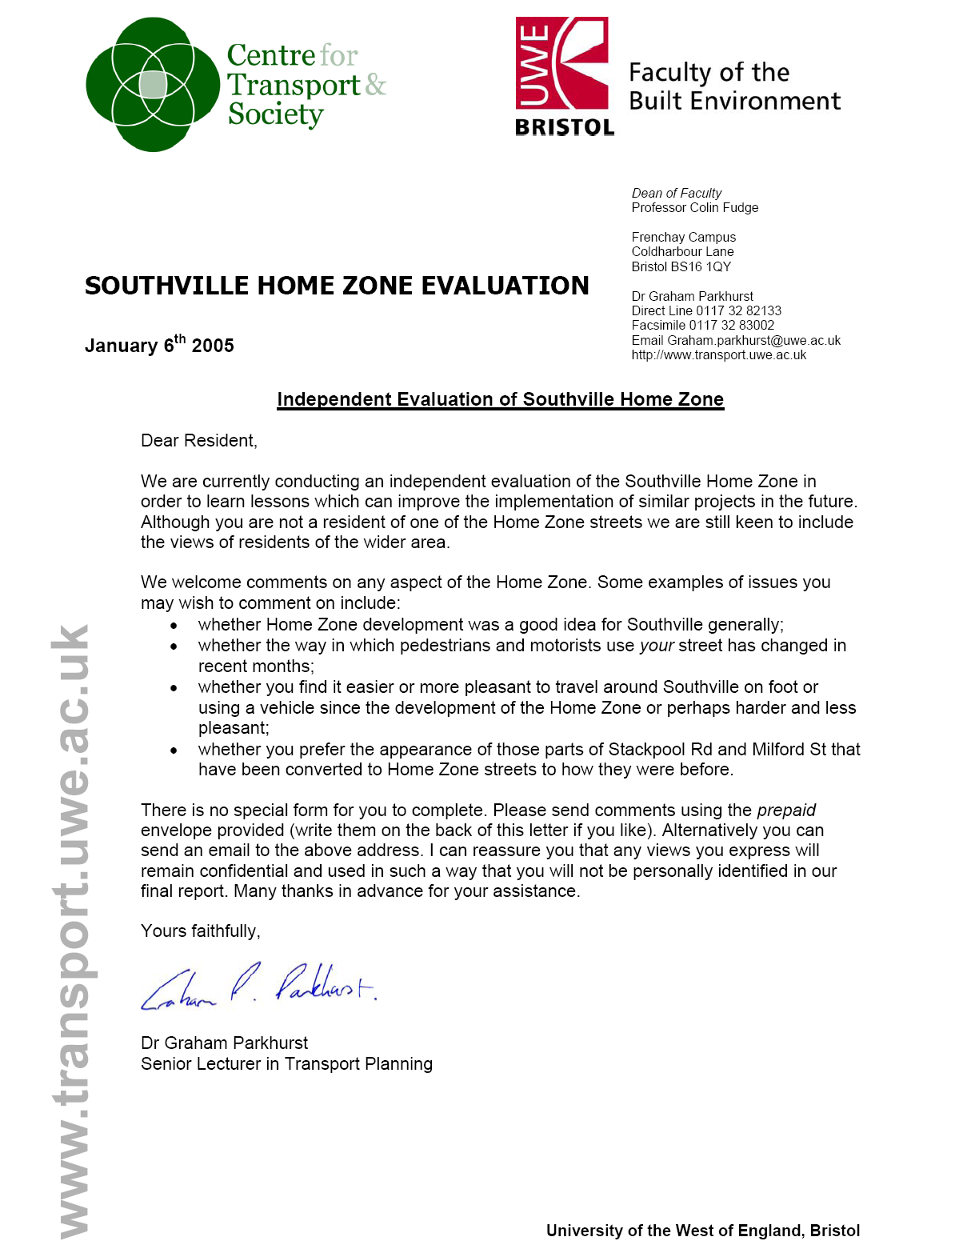

D4. 2003 Questionnaire to all streets
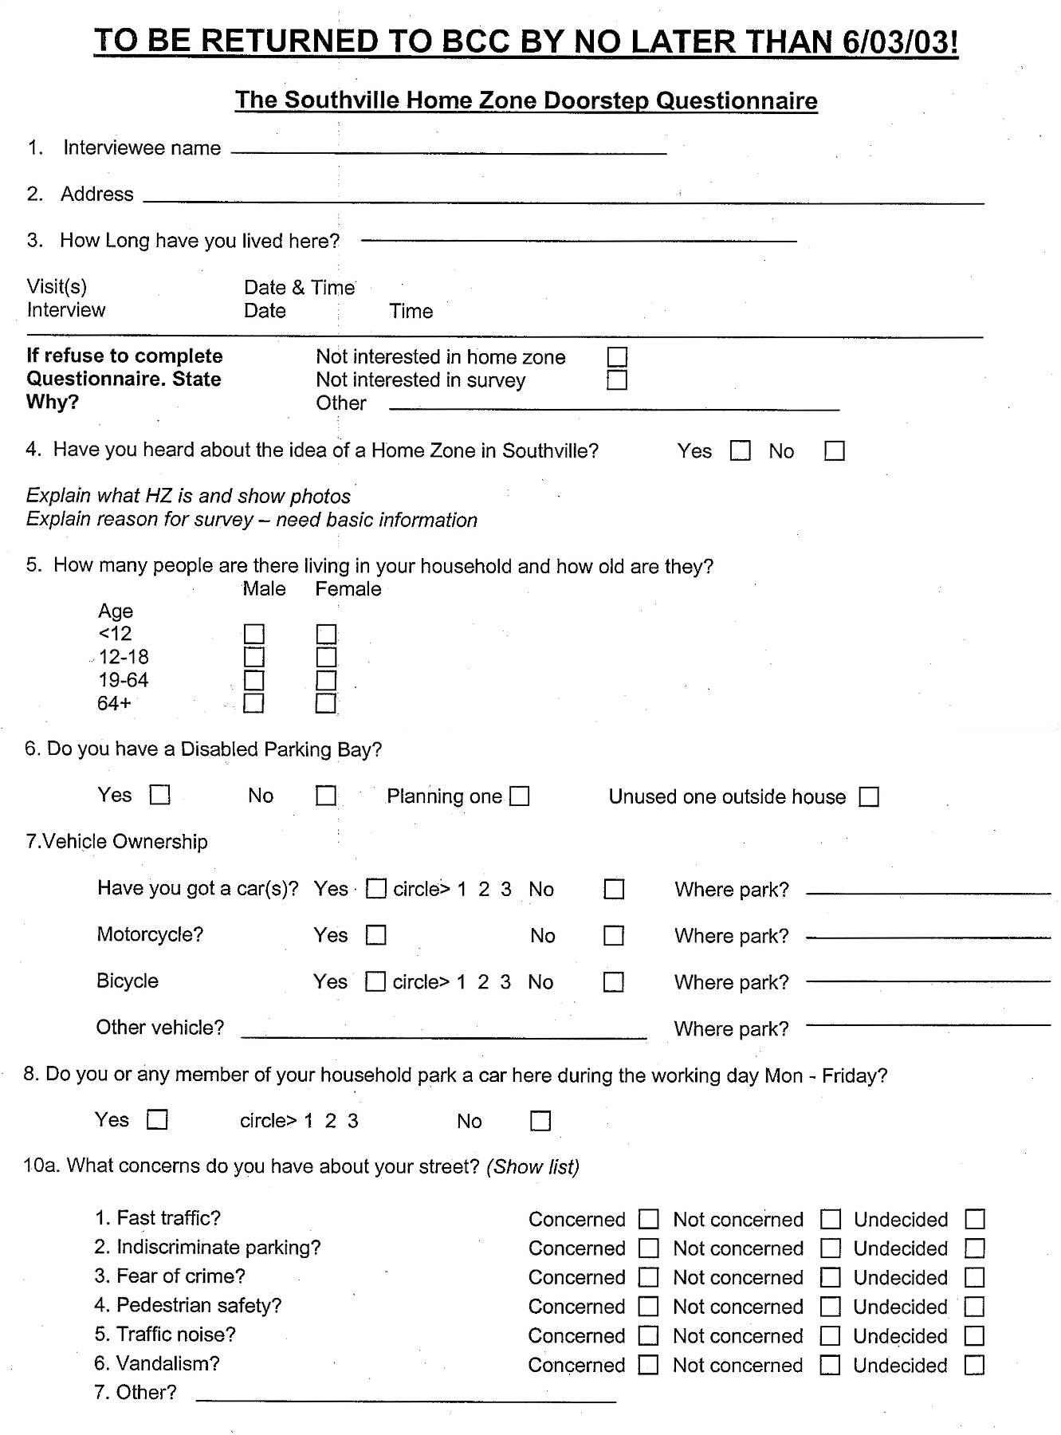
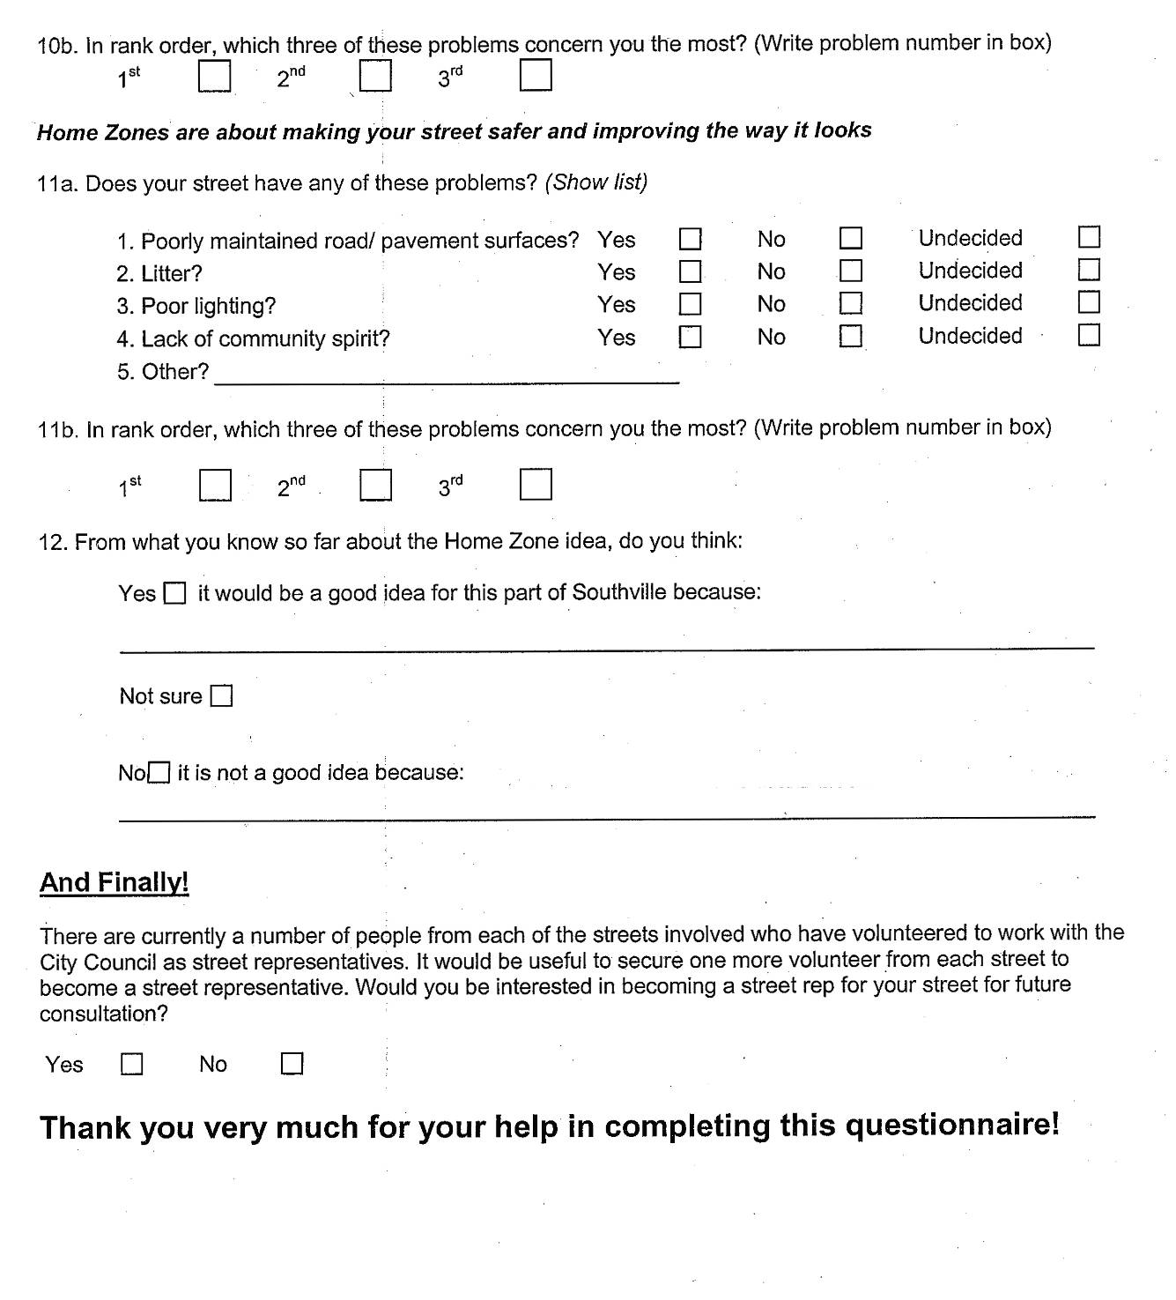

The Southville HZ is one the 61 schemes funded by the £30 million HZ Challenge Fund announced by the Prime Minister in 2001 to encourage the development of new HZ schemes.
http://www.vivaldiproject.org and http://www.civitas-initiative.org/civitas/home.cfm
http://www.barratthomes.co.uk/thezone/index.cfm accessed 060506.
Final construction costs for 3 elements of work had yet to be submitted by the contractor and/or agreed for payment at the time of preparing the final report.
This includes the HZ element in Howard Road which cost in the region of £50,000 including £6,000 obtained from private sponsorship for paving.
HZ Challenge Bid Overview.
HZ Challenge Website, Southville page, accessed 06/06/2005, but no longer available in that electronic form.
An interesting example in the Cul-de-Sac involved 12 out of the 20 households in making tiles around a ‘fruit’ theme, to mark the centenary of an orchard that had been nearby. Notably there was a potter resident on the street who was willing to give her time free.
The withdrawal of these two groups of residents theoretically released funds which appeared to give Dalston Road the possibility of a HZ, a principle which the DfT approved, though it was not subsequently taken further as only half the residents agreed and funding proved more stretched than originally expected.
A more detailed account of these events is included in Appendix A.
Some of the proposed traffic calming measures had also been cut from the scheme, including speed tables at three junctions between Stackpool Road and Greville street/Leighton Rd and also Milford Street/Greville Rd/Greville Street and Merrywood Rd/Stackpool Rd and Camden Road/Howard Rd
The treatment of a small section of Howard Road which in effect extends the Stackpool Road Focal Point was completed in March 2006, post the survey. No households directly front this HZ element.
Although Stackpool Road has the focal point it is not a Home Zone in the full sense of a ‘living yard’.
In 2003, twenty residents had identified ‘other’ concerns as including; dog fouling, lack of greenery, graffiti, back alley security, pavement issues and parking loss.
Households living in Howard Road, Stackpool Road, Merrywood Road and Dalston Road live near streets with a HZ and Stackpool Road also has the focal point.
Essentially, the adjustment of beliefs to match one’s behaviour, or the situation one is in, as having conflicts between beliefs or with behaviour patterns causes psychological discomfort, and adjusting the beliefs is often easier than adjusting the behaviour or situation. Hence, someone who lives in a HZ might share the logic that ‘HZs must be a good thing, otherwise the Council wouldn’t want to spend the money, and residents wouldn’t have accepted the idea’. Conversely, near-HZ residents might rationalise that ‘if HZs are so great, we would all have one by now; as we don’t have one, they can’t be so great’. In practice, such rationalisations will be more personal and complex, and the arguments may not be constructed in the self-conscious part of the mind.
One example concerned a planting event in Howard Road; a resident came up to one of the HZ Team and said “When did you get permission for this?” despite the doorstep newsletter, surveys, and meetings.
Waste water utility company requires an obstacle free way leave of 3 metres either side of their sewers. Also the water supply company requires clearance for its main claiming that they have a right to maintain access to maintain their pipe network as laid out in the Water Act. This limits the number of trees that can be planted.
There were unsuccessful efforts to recruit additional resources and skills to the HZ team to assist with the workload associated with the development of several new-build and retrofit schemes simultaneously.
The IHIE design guidance 3.6.11 says ‘Individual parking spaces should be clearly indicated’ the residents felt this detracted from the HZ by leaving car ‘shadows’.
Whilst important in terms of symbolism and community identity, however, it is recognised that for all practical purposes, most of the streets to be affected already exhibit 85th percentile speeds within around 20 mph. Exceptions here, however, are Beauley Rd and Leighton Rd, which in a July 2004 survey demonstrated 85th percentile speeds of 29-30mph and mean speeds of around 23 mph.
One issue here is that a consensus view over the basic data about the level and source of demand for parking has not been achieved. Though parking surveys were conducted by BCC, resources meant that they were fairly crude. For example, residents had to remember to put a card in their car windows on the morning of the counts, but may not have all remembered or complied.
http://www.homezones.org.uk/public/guidance/index.cfm

