Features of the transposed seasonality of the 2021 RSV epidemic in the UK and Ireland:
analysis of the first 10,000 patients

Authors: Roland D^{1,2}, Williams T³, Lyttle D. M^{4,5}, Marlow R⁵, Hardelid P⁶, Sinha I^{7,8}, Swann O^{3,9},
Maxwell-Hodkinson A⁷, Cunningham S^{10,11} on behalf of the REspiratory Syncytial virus
Consortium in EUrope (RESCEU) investigators and the Paediatric Emergency Research United
Kingdom and Ireland (PERUKI) network.

1. Paediatric Emergency Medicine Leicester Academic (PEMLA) Group, Leicester Royal Infirmary

2. Sapphire Group, Health Sciences, Leicester University, University of Leicester, UK
3. Child Life and Health, University of Edinburgh, UK
4. Faculty of Health and Applied Sciences, University of the West of England

5. Emergency Department, Bristol Royal Hospital for Children, Bristol, UK

6. Great Ormond Street Institute of Child Health, University College London, UK

7. University of Liverpool, Liverpool, UK

8. Alder Hey Children’s Hospital, Liverpool, UK

9. Department of Paediatric Infectious Diseases and Immunology, Royal Hospital for Children,
Glasgow, UK

10. Centre for Inflammation Research, University of Edinburgh
11. Department of Paediatric Respiratory and Sleep Medicine, Royal Hospital for Children and
Young People, Edinburgh, UK

Corresponding Author:
Damian Roland
SAPPHIRE Group, Health Sciences, Leicester University, Leicester, UK

Paediatric Emergency Medicine Leicester Academic (PEMLA) Group, Children’s Emergency
Department, Leicester Royal Infirmary, Leicester, UK
dr98@leicester.ac.uk

Contributions

Thomas C. Williams: Conceptualization, Methodology, Writing – Original Draft Preparation,
Writing – Review & Editing
Mark D. Lyttle: Conceptualization, Methodology, Project Administration, Software, Writing –
Original Draft Preparation, Writing – Review & Editing
Steve Cunningham: Conceptualization, Methodology, Project Administration, Writing – Original
Draft Preparation, Writing – Review & Editing
Ian Sinha: Conceptualization, Methodology, Writing – Original Draft Preparation, Writing – Review

& Editing
Olivia V. Swann: Conceptualization, Methodology, Writing – Original Draft Preparation, Writing –
Review & Editing
Abigail Maxwell-Hodkinson: Conceptualization, Methodology, Writing – Review & Editing

1

Pia Hardelid: Methodology, Writing – Review and Editing
Robin Marlow: Methodology, Data Management

Damian Roland: Conceptualization, Methodology, Project Administration, Writing – Original Draft
Preparation, Writing – Review & Editing

Collaborators

A list of collaborators can be found in table one.

Competing Interests
No competing interests were disclosed.

Funding Information

This study received financial and administrative support from the Respiratory Syncytial Virus
Consortium in Europe (RESCEU) and Paediatric Emergency Research United Kingdom and
Ireland (PERUKI). RESCEU has received funding from the Innovative Medicines Initiative 2 Joint
Undertaking under grant agreement No 116019. This Joint Undertaking receives support from
the European Union’s Horizon 2020 research and innovation programme and EFPIA. The results
reported herein reflect only the authors’ view, and not of the European commission. As such,
the EC is not responsible for any use that may be made of the information contained in this
publication.

Acknowledgements

We thank Khalil Abudahab, Anthony Underwood, and David Aanenson at Microreact for

support increating the dashboard, and Linda Wijlaars for assistance in data extraction. We
thank Mai Baquedano for technical support in the launch of the REDCap survey tool and
ongoing data management, and Darren Goble for information management and
technology support, including maintenance of the server and development of a data flow
pipeline for the BronchStart outputs. We thank Elizabeth Whittaker for input at the
project planning stage. We thank the RESCEU investigators for their support.

Data availability

Data from the BronchStart Study has been made openly available on a dashboard created
byMicroreact (https://tinyurl.com/Bronch-Start).

Ethics

This study has been registered with the NIHR (Research Ethics Committee number
21/HRA/1844)and clinicaltrials.gov (Identifier NCT04959734).

Word Count: 509

2

Main text

Non-pharmaceutical interventions (NPIs) introduced globally to limit the spread of severe

acute respiratory syndrome coronavirus 2 (SARS-CoV-2) led to disruption of the typical RSV

seasonality[1]. Studies examining the resurgence of RSV have been limited by sample size, and

lack of information on secondary care episodes and clinical features. The BronchStart study is

a prospective multi-centre cohort study. Paediatric emergency departments (PED) within

PERUKI (Paediatric Emergency Research in the UK and Ireland) submited data on all children

under 2 years of age who visit a PED with symptoms of an acute lower respiratory tract

infection (diagnosed as bronchiolitis, lower respiratory tract infection, or first episode of acute

wheeze). Follow-up information is submitted 7 days later, and study data is made available on

a live online dashboard hosted by Microreact [2].

We present initial data for 10,347 infants and children from 44 study sites for the period 1st

June to 5th December 2021. The 2021 RSV epidemic in the UK has finished with infections

having peaked in August (Figure 1A). Comparing the age distribution of hospitalised infants

<12 months to previous years at two large paediatric centres participating in BronchStart

(Leicester Children’s Hospital and Bristol Royal Hospital for Children), we observed a similar

age distribution (Figure 1B). This suggests either reduced community exposure to RSV during

the 15 months preceding the start of the season did not result in a clinically significant lack of

protective maternal antibody transfer to those <3 months of age, or the NPIs introduced didn’t

prevent low level transmission.

Unlike New Zealand, the overall hospital burden of bronchiolitis admissions in the UK and
3

Ireland in 2021 was lower than previous seasons [3]. Disease severe enough to require

intensive care was 2.5% in our cohort (infants 6 weeks to one year), comparable to 4.2%

reported in the BIDS trial [4] (odds ratio using Fisher’s exact test 0.59, 95% confidence interval

0.31-1.18, p = 0.09). We noted a low probability of a SARS-CoV-2-positive RT-PCR test

(83/4,328 children tested,1.9%; of which 39 were co-infections with another virus) in children

presenting with acute lower respiratory tract infection.

We observed a frequent number of PED visits and admissions for RSV-positive 12-23 month

old children in BronchStart: 362 out of 1,468 (24.7%) admissions. This age group, when infants,

would have had lack of RSV exposure as a result of the delayed seasonal epidemic. Maternal

RSV vaccination may have a similar effect in future and this observation, if corroborated,

would support the future long-term follow-up of those children born to mothers who receive a

future RSV vaccination.

Our initial findings indicate that the 2021 summer infection peak in the UK and Ireland

predominantly affected younger age groups as in previous years. The trend for a lower burden

of disease in 2021 (as demonstrated by ICU admissions) suggests incomplete infection by RSV

of its usual susceptible population, potentially the result from some ongoing NPIs (such as

mask wearing and hand washing) over the study period. Incomplete penetrance raises the

possibility of a further wave of infection in the coming months; this has not yet occurred.

4

References

1. Foley DA, Yeoh DK, Minney-Smith CA, Martin AC, Mace AO, Sikazwe CT, Le H, Levy A, Moore

HC, Blyth CC. The Interseasonal Resurgence of Respiratory Syncytial Virus in Australian

Children Following the Reduction of Coronavirus Disease 2019-Related Public Health

Measures. Clin Infect Dis. 2021 Nov 2;73(9):e2829-e2830. doi: 10.1093/cid/ciaa1906. PMID:

33594407; PMCID: PMC7929151.

2. BronchStart Dashboard. https://tinyurl.com/Bronch-Start. Website last accessed 12th

January 2022.

3. Weekly Hospital Admission Rates of RSV positive cases. United Kingdom Health and Security

Agency Joint Modelling Team. Week 51 National Influenza and COVID-19 report.

https://assets.publishing.service.gov.uk/government/uploads/system/uploads/attachment_data/file/1

087111/Weekly_Flu_and_COVID-19_report_w26.pdf Website last accessed 13th July 2022.

4. Cunningham S, Rodriguez A, Adams T, Boyd KA, Butcher I, Enderby B, MacLean M,

McCormick J, Paton JY, Wee F, Thomas H, Riding K, Turner SW, Williams C, McIntosh E, Lewis

SC; Bronchiolitis of Infancy Discharge Study (BIDS) group. Oxygen saturation targets in infants

with bronchiolitis (BIDS): a double-blind, randomised, equivalence trial. Lancet. 2015 Sep

12;386(9998):1041-8. doi: 10.1016/S0140-6736(15)00163-4. PMID: 26382998; PMCID:

PMC467

5

Table 1 List of Contributors

Alder Hey Children's Hospital NHS Foundation Trust England Liverpool Meriel Tolhurst-Cleaver

Site Country City Site lead Co-lead

Birmingham Children's Hospital England Birmingham Stuart Hartshorn
Bolton NHS Foundation Trust England Bolton Jessica Watson

Bristol Royal Hospital for Children England Bristol Roisin Begley
Chelsea and Westminster NHS Foundation Trust
England
London
Sakura Hingley
Manali Dutta,
Gemma Ramsden

Children's Health Ireland at Crumlin Ireland Dublin Eleanor Ryan
Children's Health Ireland at Tallaght Ireland Dublin Sheena Durnin Stanley Koe

Countess of Chester NHS Foundation Trust England Chester Steve Brearey
Croydon University Hospital England Croydon Darren Ranasinghe

East Cheshire NHS Trust England Macclesfield Mudiyur Gopi
Frimley Park Hospital England London Patrick Aldridge Vicky Owens
Hull Royal Infirmary England Hull Simon Richardson
Ipswich Hospital England Ipswich David Hartin

John Radcliffe Hospital England Oxford Jiske Steensma Sahana Rao
Leicester Royal Infirmary England Leicester Damian Roland

Leighton Hospital England Crewe Jo Tillett Simon Dowson
Medway Hospital NHS Foundation Trust England Gillingham Adebayo Da Costa Alfred Sime
Newham University Hospital England Newham Claire Kirby
North Middlesex Hospital England London Adam Lawton

Nottingham University Hospitals NHS Trust England Nottingham Ruth Wear Christopher Gough
Ormskirk & District General Hospital England Ormskirk Sharryn Gardner Craig Rimmer

Poole Hospital England Poole Heather Deall
Queen Elizabeth Hospital, Woolwich England London Sharon Hall
Royal Aberdeen Children's Hospital Scotland Aberdeen Catriona Middleton
Royal Alexandra Children's Hospital
England
Brighton
Emily Walton
Friyana Dastur
Mackenzie

Royal Berkshire NHS Foundation Trust England Reading Manish Thakker
Royal Derby Hospital England Derby Gisela Robinson Graham Johnson

6

Royal Hospital for Children, Glasgow Scotland Glasgow Steve Foster
Royal Hospital for Children & Young People, Edinburgh Scotland Edinburgh Jen Browning Lynsey Rooney

Royal Wolverhampton NHS Trust England Wolverhampton Lorna Bagshaw
Salisbury NHS Foundation Trust England Salisbury Seb Gray
Sheffield Children's NHS Foundation Trust England Sheffield Sally Gibbs
South Tyneside & Sunderland NHS Foundation Trust England Sunderland Niall Mullen

Southampton Children's Hospital England Southampton Jane Bayreuther
St George's Hospital, London England London Heather Jarman

St Helens & Knowsley NHS Trust England Rainhill Clare O'Leary
The Royal London England London Raine Astin-Chamberlain
University Hospital Crosshouse Scotland Kilmarnock Lawrence Armstrong Joanne Mulligan
University Hospital Lewisham England London Sophie Keers

Watford General Hospital (West Herts NHS Trust) England Watford Richard Burridge
Wexham Park Hospital England Slough Sarah Wilson

Whipps Cross Hospital England London Amutha Anpananthar
Wirral University NHSFT England Birkenhead David Lacy

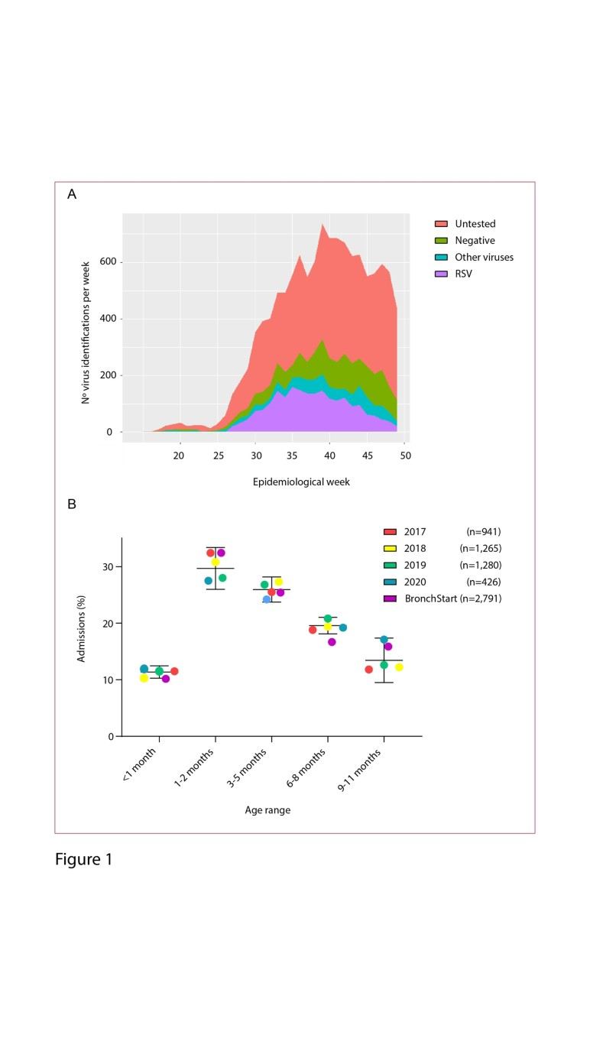

Review Only

Figure 1 - Virus Indentifications over time

190x338mm (300 x 300 DPI)

