**Fluorophosphonate-functionalised titanium via a pre-adsorbed alkane phosphonic acid: a novel dual action surface finish for bone regenerative applications.**

**Wayne Nishio Ayrea, Tom Scottb, Keith Hallamb, Ashley W. Blomc, Stephen Denyerd, Heather K. Bonee, Jason P. Mansellf\***

a School of Dentistry, Cardiff University, Cardiff CF14 4XY, UK

b Interface Analysis Centre, School of Physics, University of Bristol, Bristol BS8 1TL, UK

c Musculoskeletal Research Unit, University of Bristol, Southmead Hospital, Bristol BS10 5NB, UK

d Pro-Vice-Chancellor, University of Brighton, Mithras House, Brighton BN2 4AT, UK

e CATIM, University of the West of England, Frenchay Campus, Bristol BS16 1QY, UK

f*Corresponding author

Dr. Jason Peter Mansell

Senior Lecturer in Bone Biology

Department of Biological, Biomedical & Analytical Sciences

University of the West of England

Coldharbour Lane

Bristol, BS16 1QY, UK.

Tel: +44 117 328 3573

Email: [jason.mansell@uwe.ac.uk](mailto:jason.mansell@uwe.ac.uk)

**Abstract**

Enhancing vitamin D-induced human osteoblast (hOB) maturation at bone biomaterial surfaces is likely to improve prosthesis integration with resultant reductions in the need for revision arthroplasty consequent to aseptic loosening. Biomaterials that are less appealing to microorganisms implicated in implant failures through infection are also highly desirable. However, finding surfaces that enhance hOB maturation to active vitamin D yet deter bacteria remain elusive. In addressing this, we have sought to bio-functionalise titanium (Ti) with lysophosphatidic acid (LPA) and related, phosphatase-resistant, LPA analogues. The impetus for this follows our discovery that LPA co-operates with active vitamin D3 metabolites to secure hOB maturation *in vitro* including cells grown upon Ti. LPA has also been found, by others, to inhibit virulence factor production and biofilm formation of the human opportunistic pathogen *Pseudomonas aeruginosa*. Collectively, selected LPA species might offer potential dual-action surface finishes for contemporary bone biomaterials. In attaching a phosphatase-resistant LPA analogue to Ti we took advantage of the affinity of alkane phosphonic acids (APAs) for TiO2. Herein, we provide evidence for the facile development of a dual-action Ti surface for potential orthopaedic and dental applications. Successful conjugation of FHBP to the Ti surface was supported through physiochemical characterisationusing x-ray photoelectron spectroscopy and secondary ion mass spectrometry. Human osteoblast maturation to active vitamin D3 was enhanced for cells grown on FHBP-Ti whilst these same surfaces exhibited clear antiadherent properties towards a clinical isolate of *Staphylococcus aureus.*

**1. Introduction**

Developing novel surface finishes to encourage osteoblastogenesis is a continuing theme of contemporary bone biomaterials research. Enhancing human osteoblast (hOB) formation and maturation at prosthetic surfaces is predicted to secure superior implant integration and longevity. Finding ways of fabricating unique substrates includes coating bone biomaterials with small biological agents. Importantly, the selected molecules should target hOBs and their bone marrow-derived stromal cell (BMSC) precursors. Particularly attractive are agents that participate in signalling co-operation or “cross-coupling” with key molecules central to bone formation, health and homeostasis. Candidate factors fulfilling these criteria are the simple bioactive lysophosphatidic acids (LPAs) and/or their more stable, phosphatase-resistant analogues [1].

Skeletal cells, including hOBs and BMSCs, are targets for LPA [2]. Of particular relevance to bone formation is the discovery that LPA co-operates with active metabolites of vitamin D3 to secure hOB maturation [3-5], an event associated with the provision of a mechanically robust, mineralised matrix. The signalling cross-coupling that occurs between LPA and active vitamin D3 metabolites culminates in synergistic increases in alkaline phosphatase (ALP), an enzyme essential for bone matrix calcification [6]. These features of LPA, its small size and ability to co-operate with vitamin D3, make it an especially desirable molecule for the functionalisation of titanium (Ti) and hydroxyapatite (HA), two widely used bone biomaterials. The only other molecules reported to co-operate with 1,25-dihydroxy vitamin D3 (1,25D) in stimulating hOB maturation are TGF-β [7] and epidermal growth factor [8]. Their larger size and greater cost make them less desirable contenders for biomaterial conjugation and they are less likely to withstand conventional sterilisation protocols compared to the simpler LPAs.

In addition to its reported effects on hOBs, monopalmitoyl LPA (16:0 LPA) has been reported to inhibit virulence factor production and biofilm formation of the human opportunistic pathogen *Pseudomonas aeruginosa* [9]. 16:0 LPA, along with several other phospholipids, e.g. dipalmitoyl phosphatidyl serine, dipalmitoyl phosphatidic acid and monomyristoyl phosphatidic acid, has been shown to sensitise otherwise resistant *P. aeruginosa* isolates to the actions of betalactams [10]. Krogfelt and colleagues also reported that 16:0 LPA and monopalmitoyl phosphatidyl choline were antimicrobial against a range of Gram negative and Gram positive bacteria including *Staphylococcus aureus*, a species often associated with bone implant failures through sepsis [11]. Collectively, LPA-functionalised devices could be beneficial in two important ways; firstly, the enhancement of early osseointegration by promoting hOB maturation at the surface; and, secondly, deterring the initial attachment and spread of bacteria known to precipitate implant failures through sepsis.

Biological coating of contemporary bone biomaterials can be particularly challenging, often requiring time consuming, complex and costly procedures. Constraints pertaining to device storage, stability and sterilisation means that only a small selection of biological agents are amenable to biomaterial conjugation. One particularly attractive method for functionalising Ti devices for the subsequent attachment of suitable factors is the use of alkane phosphonic acids (APAs). The application of APAs in modifying a variety of metal supports is an expanding and exciting development in contemporary biomaterials research, primarily founded on the facile ability of APAs to bind with high affinity to metal oxide surfaces, including titania (TiO2), the natural oxide coating of Ti. The bonds formed between TiO2 and APAs are robust and covalent in nature and include mono-, bi- and tri-dentate phosphonate units as self-assembled monolayers. These metal-OP bonds are superior in stability to those formed between metal and OSi when using silanes [12,13]. The application of an APA to enhance Ti surface wettability of a dental implant device (SurfLink®) has recently shown promise as a successful APA-functionalised surface [14]. There is another appealing feature of APAs; they can serve as tethering points for the attachment of suitable biologicals at titanium surfaces. Obvious choices are cell signalling LPAs which would be predicted to interact with pre-bound APAs in a manner resembling the self-assembly of (lyso)phospholipids in biological membranes and micelles. Such a partnership provides for a unique opportunity towards a simple bio-functionalisation procedure for orthopaedic and dental implants.

Herein, we report the facile functionalisation of Ti using octadecylphosphonic acid (ODPA) for the subsequent attachment of (3S)1-fluoro-3-hydroxy-4-(oleoyloxy)butyl-1-phosphonate (FHBP), a phosphatase-resistant LPA analogue [15-17], which we have found to be a potent pairing with 1,25D in promoting hOB maturation [5,18]. The alignment/configuration of Ti‑tethered ODPA to FHBP is most likely akin to the self-assembly of phospholipids. These modified surfaces were evaluated for their ability to support 1,25D-induced hOB maturation. In parallel, the same surfaces were exposed to *S. aureus* to ascertain if these functionalised materials encouraged or deterred bacterial attachment and growth.

**2. Materials and Methods**

*2.1Titanium surface functionalisations*

Solid Ti discs (12.7 mm diameter and 2.5 mm thickness were a generous gift from Corin (Cirencester, UK). Unless stated otherwise, all reagents were of analytical grade from Sigma-Aldrich (Poole, UK). The alkane phosphonic acid, octadecylphosphonic acid (ODPA), was prepared as a 1 mM solution in anhydrous tetrahydrofuran (THF) in glass. Stocks of FHBP (Tebu-bio, Peterborough, UK) were prepared in 1:1 ethanol:tissue culture grade water to a final concentration of 10 mM and stored at ‑20 °C in a glass vial. The first step in Ti-functionalisation involved baking samples at 180 °C for 3 days to encourage further TiO2 formation; once cooled, specimens were steeped in the ODPA solution (five discs in 10 ml using glass universal tubes) for 24 hours. Recovered samples were dried at ambient temperature before being baked at 180 °C for 24 hours to convert ODPA to the phosphonate [19]. After this baking step a rinsing solution comprising 5 ml 1.5 M K2CO3 in 10 ml ethanol (sufficient for 20 Ti discs) was used to displace unbound/loosely bound ODPA [19] by shaking (300 rpm) at ambient temperature for 20 minutes. The solution was discarded and the samples rinsed three times in molecular biology grade water (MBW). These Ti samples were then placed into sterile 24‑well tissue culture plates for exposure to either 0.8 ml MBW or FHBP (2, 5 and 10 μM in MBW). After 24 hours the discs were turned over and left for a further 24 hours at ambient temperature. Once incubated, the sample discs were transferred to clean 24-well plates and given a single rinse with MBW (1 ml per disc) before being rinsed twice in phenol red-free Dulbecco’s modified Eagle medium/F12 nutrient mix (PRF-DMEM/F12, Gibco, Paisley, UK). These control and modified Ti specimens were then ready for immediate osteoblast seeding. In some instances after the MBW rinse, Ti samples were rinsed twice in 70 % ethanol, allowed to dry in a tissue culture cabinet and subsequently shipped out for microbiological and physiochemical evaluation.

*2.2 Physicochemical characterisation of FHBP-functionalised Ti*

A Thermo Fisher Scientific (East Grinstead, UK) Escascope was used for x-ray photoelectron spectroscopy (XPS) analysis. Following the acquisition of survey spectra over a wide binding energy range, spectral regions were scanned such that valence state determinations could be made for each element. Data analysis was carried out using ‘Pisces’ software (Dayta Systems, Bristol, UK) with binding energy values referenced to the adventitious hydrocarbon C1s peak at 284.8 eV [20]. Uncoated and ODPA+FHBP coated Ti surfaces were analysed in their as-received state. Samples were then cleaned with potable water using a battery-powered toothbrush (soft-bristled; Colgate-Palmolive, New York, USA) and rinsed with deionised water before being analysed again. Equivalent samples from the same batches were also analysed using Auger electron spectroscopy (AES), in a Jeol JAMP-30 microprobe (Tokyo, Japan). Secondary ion mass spectrometry (SIMS; in-house instrument comprising an FEI SD gallium LMIS EVA focusing column and a Vacuum Generators model 7035 double focusing magnetic sector mass analyser) was carried out on the as-received (unwashed) samples only. Additional XPS spectra were recorded from one sample, exposed only to FHBP, for comparison with the ODPA+FHBP specimens.

To determine changes in surface roughness and surface energy, unmodified Ti discs and Ti discs modified with 1 mM ODPA followed by 0.1, 0.5, 1, 2, 5 and 10 μM of FHBP were prepared as previously outlined. Surface roughness was determined using a Surftest SV-2000 (Mitutoya, Hampshire, UK). Three sample surfaces were tested for each group in triplicate and surface roughness determined as the average roughness coefficient, in μm. Surface free energy was determined according to the BS EN 828:2013 standard using the sessile drop method with water, ethylene glycol, glycerol and hexadecane on the surface of the samples.

*2.3 Responses of human (MG63) osteoblast-like cells to phosphonate-functionalised Ti*

Human osteoblast-like cells (MG63) were cultured in conventional tissue culture flasks (250 mL, Greiner, Frickenhausen, Germany) in a humidified atmosphere at 37 °C and 5 % CO2. Although osteosarcoma-derived, MG63 cells exhibit features in common with human osteoblast precursors or poorly differentiated osteoblasts. Specifically, these cells produce type I collagen with no or low basal osteocalcin (OC) and alkaline phosphatase (ALP). However, when MG63s are treated with 1,25D, OC expression increases [21] and, when the same cells are co-treated with 1,25D and selected growth factors, e.g. LPA, the levels of ALP markedly increase [3], a feature of the mature osteoblast phenotype. Consequently, the application of these cells to assess the potential pro-maturation effects of novel materials is entirely appropriate. Further, the MG63 continues to be a widely used cell line in biomaterials research [22]. Cells were maintained in DMEM/F12 supplemented with sodium pyruvate (1 mM final concentration), L-glutamine (4 mM), non-essential amino acids (1x final concentration) and 10 % v/v foetal calf serum (Gibco, Paisley, UK). The MG63s were subsequently dispensed into blank 24-well plates (Greiner, Frickenhausen, Germany) or plates containing either control (ODPA treated) or ODPA/FHBP-modified Ti discs. In each case, wells were seeded with 1 mL of a 4 x 104 cells/mL suspension (as assessed by haemocytometry) in phenol red-free (PRF), serum-free DMEM, spiked with 1,25D (from a 100 μM stock in ethanol) to a final concentration of 100 nM. Serum was excluded from the culture medium as it is a rich source (micromolar) of LPA, as bound to the albumin fraction [2]. Cells were then cultured for 3 days, the media removed and the cells processed for total ALP activity to ascertain the extent of cellular maturation.

In a separate study, the potential of recycling the lipid-functionalised Ti was explored to ascertain whether the modified metal was still able to support an osteoblast maturation response. Briefly, discs that had already been seeded with cells and processed for total ALP activity were recovered, rinsed under running tap water and scrubbed with a toothbrush to remove any remaining cellular debris. Once rinsed, the samples were immersed in 70 % aqueous ethanol and left for 2-3 min before being rinsed several times with sterile PBS. Washed discs were then placed into clean, multi-well plates, rinsed with DMEM/F12 nutrient mix and subsequently seeded with MG63 cells as described above. A second repeat of this step was performed to explore how three independent uses of the same functionalised discs could support the maturation of MG63 osteoblasts to 1,25D.

To ascertain the robustness of the surface modification to autoclaving sample discs were autoclaved under standard operating conditions using an Astell bench top unit run at 121°C for 15 minutes. Recovered specimens were subsequently seeded with osteoblasts as identified above.

*2.4 Total ALP activity*

An assessment of ALP activity is reliably measured by the generation of p-nitrophenol (p-NP) from p-nitrophenylphosphate (p-NPP) under alkaline conditions. The treatment of cells to quantify ALP activity was similar to that described by us recently [5]. To ensure that the ALP activity was only associated for cells attached to Ti and not to the surrounding plastic, the sample discs were transferred to fresh 24 well tray and the monolayers lysed with 0.1 mL of 25 mM sodium carbonate (pH 10.3), 0.1 % (v/v) Triton X-100. After 2 min, each well was treated with 0.2 mL of 15 mM p-NPP (di-Tris salt, Sigma-Aldrich, Poole, UK) in 250 mM sodium carbonate (pH 10.3), 1 mM MgCl2. Lysates were then left under conventional cell culturing conditions for 1 h. After the incubation period, 0.1 mL aliquots were transferred to 96-well microtitre plates and the absorbance read at 405 nm. An ascending series of p-NP (25-500 μM) solutions prepared in the incubation buffer enabled quantification of product formation.

*2.5 Attachment and growth of a clinical S. aureus isolate to ODPA and FHBP-modified Ti*

Joint aspirates and excised soft tissue were obtained from revision surgeries of infected knee replacements. Swabs of these samples were taken and cultured on blood agar under aerobic (5 % CO2) conditions at 37 °C. *S. aureus* isolates were identified as Gram positive clustered cocci, γ-haemolysis, catalase and coagulase positive, oxidase negative, non-lactose fermenting and with a yellow/gold colony appearance. After 24 hours culture, *S. aureus* colonies were isolated from the agar and stored either at -80 °C or at 4 °C on Tryptone Soya Agar (TSA) slopes for later use. The clinical *S. aureus* isolate used was cultured in 20 mL of Tryptone Soya Broth (TSB) at 37 °C, 5 % CO2 for 24 hours. The suspension was centrifuged at 3000 rpm for 5 minutes and the pellet was resuspended in 20 mL phosphate buffered saline (PBS). The pellet was centrifuged again at 3000 rpm for 5 minutes and resuspended in PBS to give an absorbance at 600nm of 0.08 to 0.1 (approximately 1 x 107 CFU/mL).

To determine rates of bacterial attachment, uncoated Ti discs, Ti discs treated with 1 mM ODPA and Ti discs treated with 1 mM ODPA followed by 0.1, 0.5, 1, 2, 5 and 10 μM of FHBP were prepared as previously outlined. The discs were placed on a 24-well plate and 1 mL of a 1x107 CFU/mL bacterial suspension in PBS pipetted onto the surface of the discs. After 1, 2, 6, 12 and 24 hours incubation at 37 °C, 5 % CO2, the discs were transferred onto a sterile 24-well plate and gently washed with 1 mL solution of 0.85 % NaCl to remove non-adherent bacteria. 1 μL of syto9 and 1 μL of propidium iodide were added to 1 mL of sterile water (LIVE/DEAD® BacLight™ Bacterial Viability stain, Life Technologies, Paisley, UK) and 20 μL of this solution added to the surface of the discs, covered with a sterile glass coverslip and left at room temperature for 5 minutes. Five random images of the disc surface were taken using a fluorescent microscope at x10 magnification at emission/excitation wavelengths of 485/530-630 nm respectively. Bacterial coverage was quantified using a macro written in ImageJ that calculates the percentage of the image occupied by fluorescence. The experiment was repeated to establish bacterial viability; at each time point the samples were vortex-mixed in 1 mL of PBS for 30 seconds to remove adherent bacteria. The suspensions were serially diluted and spiral plated on TSA for colony counting.

*2.6 Biofilm formation by S.aureus at ODPA and FHBP-modified Ti*

To assess biofilm formation, an overnight culture of *S. aureus* was prepared in TSB and adjusted to an absorbance at 600 nm of 0.08 to 0.1. The suspension was serially diluted to produce a suspension of 1x103 CFU/mL in TSB. Treated and untreated Ti discs were placed in a 24-well plate and 1 mL of the diluted suspension added to each well following incubation at 37 °C, 5 % CO2 for 24, 48, 72 and 96 hours, with broth changes every 24 hours. At each time point the broth was carefully removed, ensuring the biofilm was not disrupted, and the disc washed gently with PBS twice to remove any non-adherent bacteria. 2 mL of methanol was added for 15 minutes to fix the biofilm followed by 2 mL of a 0.1 % crystal violet solution for a further 15 minutes prior to two washes in PBS. 2 mL of 30 % acetic acid solution was added to each well for 15 minutes to dissolve the biofilm and the absorbance of the solution measured at 580 nm. The experiment was repeated to establish bacterial viability; at each time point the samples were vortex-mixed in 1 mL of PBS for 30 seconds to detach the biofilm and the suspensions serially diluted and spiral plated on TSA for colony counting.

*2.8 Statistical analysis*

Unless stated otherwise, all the cell culture experiments described above were performed three times and all data were subject to a one-way analysis of variance (ANOVA) to test for statistical significance. When a p value of < 0.05 was found, a Tukey multiple comparisons post-test was performed between all groups. All data are expressed as the mean together with the standard deviation. Investigations of adhesion of *S.aureus* to Ti discs were also analysed with a one-way ANOVA using Dunnett’s multiple comparison post-test between control and treatment groups (i.e., functionalised Ti discs) for p values < 0.05.

**3. Results**

*3.1 Physicochemical characterisation of FHBP-functionalised Ti*

The Ti disc samples revealed themselves to have surface films of TiO2 on top of the bulk alloy. The uncoated discs had a layer of adventitious hydrocarbon contamination on their surfaces. Confirmation of the presence of the desired functionalising organics on ODPA+FHBP and Ti-FHBP specimen surfaces was seen in the form of greater surface carbon concentrations (XPS and AES), phosphorus being present (XPS and AES) and the appearance of fluorine (XPS and SIMS). AES demonstrated the presence of numerous surface deposits on the ODPA+FHBP specimen surfaces while few were present on the uncoated specimens. Phosphorus detected on the coated specimens was mostly concentrated in these surface deposits.

Though fluorine was seen in the XPS spectra of ODPA+FHBP samples (with the concentration reducing with washing), no fluorine signals were evident in any of the AES spectra. It was for this reason that SIMS analysis was first performed. SIMS clearly identified much higher levels of fluorine on the surface of ODPA+FHBP than on equivalent uncoated, control material indicating that FHBP adsorption had occurred. A stylised summary as to how we envisage this to occur is presented (Fig. 1).

Both XPS and AES saw the surface phosphorus concentration on the ODPA+FHBP specimens decrease - but not disappear completely - after washing. Washing was shown to increase the surface carbon concentration, for both uncoated and coated samples, again by both XPS and AES, with AES observing a much greater increase on the ODPA+FHBP discs. XPS and AES similarly observed the presence of calcium on the surfaces of the potable water washed samples, both uncoated and coated, as an introduced contaminant.

In summary, evidence for successful deposition of FHBP onto sample surfaces and retention of this with washing/brushing was seen for ODPA+FHBP Ti samples and Ti-FHBP (Fig. 2).

The roughness of the Ti surfaces was not significantly altered as a result of FHBP‑modification (Fig. 3A). Although a slight reduction in surface free energy was observed due to FHBP-modification of the Ti discs; this was only significant (p<0.05 versus controls) for samples treated with 1 μM FHBP (Fig. 3B).

*3.2 FHBP-functionalised Ti enhances 1,25D-induced MG63 osteoblast maturation*

Control Ti and FHBP-functionalised Ti specimens were seeded with MG63 osteoblasts in a serum-free culture medium supplemented with 100 nM 1,25D. After a 72 hour culture period the metal discs were recovered, transferred to clean multi-well plates and processed for total ALP activity to determine the extent of cellular maturation. This marked the initial analysis (Fig. 4A). The findings presented indicate that Ti specimens initially steeped in either 5 μM or 2 μM FHBP produce a surface finish that is better than control surfaces (p<0.01) at enhancing 1,25D-induced MG63 maturation. The ability of the modification to support 1,25D-induced MG63 differentiation was most pronounced for the 2 μM FHBP-steeped samples. Having performed the ALP assay all discs were scrubbed under running tap water, rinsed in 70 % (v/v) ethanol and subsequently stored in this solution for 2 weeks (ambient temperature) prior to reseeding them with MG63 cells. Once again the samples were left for 3 days in the presence of 100 nM 1,25D under conventional cell culturing conditions. This represents a first recycle or reuse experiment to ascertain whether the Ti specimens retain appreciable bioactivity (Fig. 4B). Suffice it to say that each of the different FHBP‑functionalised samples supported a greater extent of MG63 maturation compared to control surfaces (p≤0.015). These same discs were cleaned and stored in 70 % (v/v) ethanol as before for a further 2 months, recovered and prepared ready for a second recycle or reuse experiment (Fig. 4C). Despite each surface being seeded with cells for a third time each of the different FHBP-modified specimens co-operated with 1,25D in promoting cellular maturation compared to unmodified samples (p≤0.001).

*3.3 FHBP-functionalised Ti withstands autoclaving*

In realising the potential application of our Ti surface modification for bone regenerative applications it is key that the surface modification is compatible with routine washing and sterilisation procedures. In the preceding results section we provide evidence of a surface coating that can withstand multiple water washings and storage in aqueous ethanol for more than 2 months. We next considered whether our FHBP‑functionalised Ti would withstand the rigours of an autoclave cycle. The findings presented (Fig. 5) support FHBP stability to autoclaving as the extent of cellular maturation was similar for cells grown upon functionalised non-autoclaved surfaces. Significantly greater (**p<0.001) total ALP activity was evident for both functionalised surfaces compared to unmodified, control Ti.

We have also found that LPA, as a solid kept in a darkened glass vial, retains approximately 60 % bioactivity after being subjected to 35 kGy of γ-irradiation as would be administered for implantable devices (data not shown).

*3.4 Attachment and growth of a clinical S. aureus isolate to ODPA and FHBP-modified Ti*

*S. aureus* attachment to the surface of untreated (control) and ODPA-modified Ti discs (Fig. 6A and B respectively) was found to be greater than on ODPA+FHBP-modified discs (Fig. 6C). The surface modifications, however, were not bactericidal towards the clinical strainof *S. aureus* employed. When analysing the area covered by bacteria using ImageJ [23], there were significant reductions in bacterial load as a result of FHBP-modification, particularly at concentrations of 1, 2, 5 and 10 μM (Fig. 6D). ODPA, however, had no effect on bacterial load when compared to the untreated Ti discs. The results of this analysis are in agreement with the results from the colony counts (Fig. 6E). A parabolic relationship between FHBP concentration and bacterial attachment was observed, whereby 1, 2 and 5 μM FHBP concentrations were most effective at inhibiting bacterial attachment. The rate of attachment increased for all samples throughout the 24 hour culture period, demonstrating the initial rate of attachment of *S. aureus* to be inhibited at the surface of the FHBP‑modified Ti. Subsequent attachment would increase as a result of cell-cell attachment and interactions.

*3.5 Influence of FHBP-functionalised Ti on biofilm formation*

Biofilm formation on treated and untreated discs was determined as a function of crystal violet staining (Fig. 7A) and colony counts (Fig. 7B). Similar to the attachment results, ODPA-modification did not significantly alter biofilm formation when compared to untreated Ti. FHBP-modified Ti, however, was found to hinder biofilm formation for all time points when staining with crystal violet (Fig. 7A). This effect was significant for 2 and 5 μM FHBP concentrations for all time points. A similar parabolic trend was observed with the colony counts (Fig. 7B). However, the reductions in biofilm formation were only significant for 1, 2 and 5 μM FHBP concentrations at 48 hours and 1 μM FHBP at 72 hours.

**4. Discussion**

Biomaterials that have the capacity to enhance hOB formation and maturation are particularly appealing in a bone regenerative context. One way of improving host cell responses to existing materials, such as titanium, includes attaching small, robust biological agents known to target hBMSCs and hOBs. If the biomaterial modification can also hinder the initial attachment of bacteria then they are more likely to reduce the infection risk of implantable devices. Such dual-action biomaterials for either orthopaedic or dental applications have not been forthcoming. In this particular study we coated orthopaedic-grade titanium with FHBP, a phosphatase-resistant LPA analogue which we now report as exhibiting this desirable dual-action.

When hOBs were exposed to FHBP-functionalised titanium their maturation response to 1,25D was enhanced. As hOBs mature they mobilise greater quantities of ALP, an enzyme we know to be absolutely necessary for the formation of a mechanically sound, calcified bone matrix [6]. Stimulating hOB maturation at the biomaterial surface will be conducive to securing superior early osseointegration by encouraging bone matrix formation and mineralisation. In our hands we find that the greatest extent of hOB maturation occurs on those surfaces steeped in 2 µM FHBP. At present we are unable to explain why this FHBP concentration yields a titanium surface that is optimal for supporting 1,25D-induced hOB maturation. Whether the steeping concentration of FHBP will have to change depending on the surface area to be treated will require further investigation. The coating itself displays evidence of stability to storage under ambient conditions, albeit for approximately four months. This is particularly significant as titanium implants are stored this way to keep costs to a minimum. Furthermore, when FHBP‑modified samples were “recycled” by seeding hOBs on to them for a second and third time they were still able to support better hOB maturation compared to control, unmodified metal. These findings indicate the persistence of sufficiently high enough FHBP at the titanium surface despite having been re-seeded with cells, washed and placed under 70 % ethanol for weeks at a time. Another noteworthy feature of our FHBP-functionalised titanium is its ability to withstand autoclaving.

In parallel with the hOB studies we examined the attachment and colonisation of a clinical strain of *S. aureus*, a pathogen frequently implicated in bone implant sepsis. Surface modification with FHBP was effective at significantly reducing *S. aureus* attachment when compared to unmodified titanium. Interestingly, the initial modification of titanium with ODPA was not sufficient to deter bacterial attachment, demonstrating that the fluorinated analogue of LPA (FHBP) was responsible for reducing bacterial adherence. Furthermore, results from surface roughness and surface energy measurements highlight that the reduction in bacterial load was not due to changes in roughness or surface energy, but rather as a result of biochemical or stereo-chemical interactions between the FHBP molecule and *S. aureus*. It is important to stress that antimicrobial testing of the FHBP-modified titanium discs demonstrated that ODPA and FHBP molecules, at the concentrations employed, were not biocidal towards *S. aureus*, rather that the modification imparts an anti-adherent property.

The efficacy of the FHBP-functionalisation was found to be concentration dependant and a parabolic relationship was observed, whereby the optimum concentration of FHBP to reduce bacterial attachment was in the range of 1 to 5 μM. It is thought that too low a concentration of FHBP (100 to 500 nM) will not sufficiently coat the entirety of the ODPA‑functionalised Ti surface, whilst over saturation of FHBP molecules (>10 μM) may induce multiple layers of FHBP and, therefore, alter the orientation of the lipid on the surface. Similar results were obtained when culturing biofilms on the Ti surfaces. FHBP functionalisation at optimum concentrations of 1 to 5 μM was found to reduce biofilm mass, composed of extracellular DNA, proteins and polysaccharide. This is of particular importance in preventing septic implant failure as biofilms act as a reservoir for chronic infection and are not easily eradicated by antimicrobials. Although bacterial attachment and biofilm formation at each time point were significantly lower when compared to unmodified Ti, the overall increase in attachment and biomass between time points was similar. Functionalisation with FHBP is a surface modification and, therefore, only initial bacterial attachment to the surface is inhibited. Once the surface is preconditioned, through physiochemical modification (e.g. hydrophobic interactions, electrostatic interactions, Van der Waals forces) or protein coating (e.g. fibrinogen, vitronectin, Von Willebrand factor, platelets/thrombin), and bacteria are able to adhere to this surface, subsequent attachment will propagate as a result of cell-cell adhesion and proliferation, allowing the formation of a mature biofilm [24]. *In vivo*, adherence may also be mediated by bacterial surface proteins known as MSCRAMMs (microbial surface components recognising adhesive matrix molecules [25].

Previous studies have demonstrated the antimicrobial effect of certain lysophospholipids, confirming the results observed in this study. Monopalmitoyl LPA (16:0 LPA) has been shown to inhibit virulence factor production[9]in *Pseudomonas aeruginosa* strains and increase the sensitivity of resistant *P. aeruginosa* isolates to ampicillin [10]. Monopalmitoyl LPA was found to act as a chelator, removing Ca2+ and Mg2+ from lipopolysaccharide found in the cell wall, consequently destabilising the outer membrane. Membrane disruption would permit leaching of low molecular weight proteins from the bacteria and studies have demonstrated fatty acids to achieve this against strains of *S. aureus* [26] and a range of Gram positive and negative bacteria [27]. In both these studies, chain length, level of saturation and functional group were key variables for achieving antimicrobial effects. The anti-adherent mechanisms of action and effects of LPA analogues against bacterial species are of particular interest and its ability to enhance susceptibility to antimicrobials will form the basis of future investigations.

**5. Conclusions**

In this study we report the facile bio-functionalisation of Ti with a phosphatase-resistant analogue of LPA, FHBP. This surface finish enhanced 1,25D-induced hOB maturation, as indicated by increased expression of ALP, a reliable marker of osteoblast differentiation. Of further significance are the findings of an anti-adherent property of FHBP-Ti towards *S. aureus*, a clinically relevant bacterial species associated with sepsis-induced implant failures. These are especially desirable features of implantable bone biomaterials that could be realised in tackling the issue of revision arthroplasty in the future.

**Acknowledgements**

The authors acknowledge the generous support of Professor Lars Sundstrom and colleagues of the Severnside Alliance for Translational Research (SARTRE, University of Bristol, UK) for their research funding. JPM would like to thank Xavier Bell, Research, Business & Innovation, University of the West of England, for his hard work in securing a patent application for the technology we describe herein; P119087GB was filed at the UK Intellectual Property Office, Newport, UK (patent application number 1509693.6) on the 4th June 2015.

**References**

[1] Mansell JP. Convergence of vitamin D and lysophosphatidic acid signalling in stimulating human osteoblast maturation. Front Physiol. 2014;5: article 263.

[2] Blackburn J, Mansell JP. The emerging role of lysophosphatidic acid (LPA) in skeletal biology. Bone. 2012; 50: 756-62.

[3] Gidley J, Openshaw S, Pring ET, Sale S, Mansell JP. Lysophosphatidic acid cooperates with 1alpha, 25 (OH) 2D3 in stimulating human MG63 osteoblast maturation. Prost Other Lipid Med. 2006; 80: 46-61.

[4] Mansell JP, Blackburn J. Lysophosphatidic acid, human osteoblast formation, maturation and the role of 1, 25-Dihydroxyvitamin D3 (calcitriol). BBA Mol Cell Biol Lipids 1. 2013; 105-8.

[5] Lancaster ST, Blackburn J, Blom A, Makishima M, Ishizawa M, Mansell JP. 24,25-Dihydroxyvitamin D3 cooperates with a stable, fluoromethylene LPA receptor agonist to secure human (MG63) osteoblast maturation. Steroids. 2014; 83: 52-61.

[6] Whyte MP. Physiological role of alkaline phosphatase explored in hypophosphatasia. Ann. NY Acad. Sci. 2010; 1192: 190-200.

[7] Bonewald LF, Kester MB, Schwartz Z, Swain LD, Kharen A, et al. Effects of combining transforming growth factor β and 1,25-dihydroxyvitamin DS on differentiation of a human osteosarcoma (MG-63). J Biol Chem. 1992; 267: 8943-8949.

[8] Yarram SJ, Tasman C, Gidley J, Clare M, Sandy JR, Mansell JP. Epidermal growth factor and calcitriol synergistically induce osteoblast maturation. Mol Cell Endo. 2004; 220: 9-20.

[9] Laux DC, Corson JM, Givskov M, Hentzer M, Moller A, Wosencroft KA et al. Lysophosphatidic acid inhibition of the accumulation of Pseudomonas aeruginosa PAO1 alginate, pyoverdin, elastase and LasA. Microbiology. 2002; 148: 1709-23.

[10] Krogfelt KA, Utley M, Krivan HC, Laux DC, Cohen PS. Specific phospholipids enhance the activity of beta-lactam antibiotics against Pseudomonas aeruginosa. J Antimicro Chemo. 2000; 3: 377-84.

[11] Brause BD. Infections with prostheses in bones and joints. In: Mandell GL, Bennett JE, Dolin R. eds. 6th. Principles and Practice of Infectious Diseases, Washington, DC: WB Saunders (2005) 1330.

[12] Paz Y. Self-assembled monolayers and titanium dioxide: From surface patterning to potential applications. Beilstein J Nanotechnol. 2011; 2: 845-61.

[13] Queffélec C, Petit M, Janvier P, Knight DA, Bujoli B. Surface modification using phosphonic acids and esters. Chem Reviews. 2012; 112: 3777-807.

[14] von Salis-Soglio M, Stübinger S, Sidler M, Klein K, Ferguson SJ, Kämpf K, et al. A Novel Multi-Phosphonate Surface Treatment of Titanium Implants: A Study in Sheep. J Funct Biomater. 2014; 5: 135-57.

[15] Xu Y, Qian L, Prestwich GD. Synthesis of monofluorinated analogues of lysophosphatidic acid. J Org Chem. 2003; 68: 5320-30.

[16] Xu Y, Aoki J, Shimizu K, Umezu-Goto M, Hama K, Takanezawa Y. Structure-activity relationships of fluorinated lysophosphatidic acid analogue. J Med Chem. 2005; 48: 3319-27.

[17] Prestwich GD, Gajewiak J, Zhang H, Xu X, Yang G, Serban M. Phosphatase-resistant analogues of lysophosphatidic acid: Agonists promote healing, antagonists and autotaxin inhibitors treat cancer. Biochim et Biophys Acta. 2008; 1781: 588-94.

[18] Mansell JP, Brown J, Knapp JG, Faul CF, Blom AW. Lysophosphatidic acid‑functionalised titanium as a superior surface for supporting human osteoblast (MG63) maturation. Eur Cells & Mater. 2012; 23: 348-61.

[19] Hanson EL, Schwartz J, Nickel B, Koch N, Danisman MF. Bonding self-assembled, compact organophosphonate monolayers to the native oxide surface of silicon. J Am Chem Soc. 2003; 125: 16074-80.

[20] Moulder JF, Stickle WF, Sobol PE, Bomben KD. Handbook of x-ray photoelectron spectroscopy, Perkin-Elmer Corporation. (1992).

[21] Clover J, Gowen M. Are MG-63 and HOS TE85 human osteosarcoma cell lines representative models of the osteoblastic phenotype? Bone. 1994; 15: 585-91.

[22] Bachle M, Kohal RJ. A systematic review of the influence of different titanium surfaces on proliferation, differentiation and protein synthesis of osteoblast-like MG63 cells. Clin Oral Imp Res. 2000; 15: 683-92.

[23] Rasband WS. ImageJ, U. S. National Institutes of Health, Bethesda, Maryland, USA, http://imagej.nih.gov/ij/, 1997-2014.

[24] Katsikogianni M, Missirlis YF. Concise review of mechanisms of bacterial adhesion to biomaterials and of techniques used in estimating bacteria-material interactions. Eur. Cells & Mater. 2004; 8: 37-57.

[25] Foster TJ, Geoghegan JA, Ganesh VK, Höök M. Adhesion, invasion and evasion: The many functions of the surface proteins of Staphylococcus aureus. Nature Rev. Micro. 2014; 12: 49-62.

[26] Parsons JB, Yao J, Frank MW, Jackson P, Rock CO. Membrane disruption by antimicrobial fatty acids releases low-molecular-weight proteins from Staphylococcus aureus. J. Bacteriol. 2012; 194: 5294-304.

[27] Kabara JJ, Swieczkowski DM, Conley AJ, Truant JP.​  Fatty acids and derivatives as antimicrobial agents.​  Antimicrob. Agents Chemother. 1972; 2: 23-28.

**Figure legends**

**Figure 1 - A stylised summary of titanium surface modification using an alkane phosphonic acid and an analogue of lysophosphatidic acid. A.** Titanium (Ti) surfaces are initially steeped in a 1mM solution of octadecylphosphonic acid (ODP). **B.** The polar head group of the phosphonic acids react with available hydroxyl residues at the metal surfaces forming robust Ti-O-P bonds leaving acyl chain extensions perpendicular to the metal surface. These fatty acyl chains provide sites for further surface modifications. **C.** ODP-preconditioned surfaces are then bathed in an aqueous solution of the LPA analogue, FHBP, and the molecules allowed to integrate with fixed ODP residues at the Ti surface. **D.** Depicted how the surface may appear with bioavailable FHBP tucked into fixed ODP in a manner resembling the formation of phospholipid membranes commonly found in nature.

**Figure 2 - Evidence for the successful functionalisation of titanium with octadecylphosphonic acid (ODPA) and (3S)1-fluoro-3-hydroxy-4-(oleoyloxy)butyl-1-phosphonate (FHBP).** Solid titanium (Ti) discs were initially steeped in 1mM ODPA in anhydrous tetrahydrofuran (THF). Samples were subsequently recovered, rinsed in THF, baked at 180°C for 24 hours to convert ODPA to the phosphonate and then immersed in 2M aqueous FHBP. The application of x-ray photoelectron spectroscopy indicated the attachment of (**A**) fluorine from the bound FHBP and (**B**) phosphorous from the pre-adsorbed ODPA. Brushing modified (ODPA+FHBP) Ti surfaces under running tap water results in both fluorine and phosphorous loss. The differential extent of these elemental losses is likely attributed to iono-covalent binding of ODPA to TiO2 versus non-covalent interaction of the FHBP fraction. The non-monochromated x-ray source led to an analysis area of ~4 mm x 3 mm on each specimen over which the data were summed.

**Figure 3 – Titanium surface free energy and roughness following octadecylphosphonic acid (ODPA) and (3S)1-fluoro-3-hydroxy-4-(oleoyloxy)butyl-1-phosphonate (FHBP) functionalisation.** Solid titanium (Ti) discs were initially steeped in 1mM ODPA in anhydrous tetrahydrofuran (THF). Samples were subsequently recovered, rinsed in THF, baked at 180°C for 24 hours to convert ODPA to the phosphonate and then immersed in aqueous FHBP (0.1-10 μM). **A.** Surface roughness was determined as the average roughness coefficient, in μm. **B.** Surface free energy was determined according to the BS EN 828:2013 standard using the sessile drop method with water, ethylene glycol, glycerol and hexadecane on the surface of the samples. Ti samples exposed to 1 μM FHBP appear to exhibit a lower surface free energy compared to control Ti samples (*p<0.05) there are no statistically significant differences in surface free energy between the different samples tested. For both parameters three sample surfaces were tested per group, in triplicate, and the data expressed as the mean ±SD.

**Figure 4 – Human MG63 osteoblast maturation at FHBP-functionalised Ti.** Solid titanium (Ti) discs were initially steeped in 1mM ODPA in anhydrous tetrahydrofuran (THF). Samples were subsequently recovered, rinsed in THF, baked at 180°C for 24 hours to convert ODPA to the phosphonate and then immersed in aqueous FHBP (2, 5 & 10 μM). Control (baked only) and functionalised surfaces were seeded with MG63 cells in a serum free culture medium supplemented with 1,25D (100nM). **A.** After a 72 hour culture period each of the Ti samples were transferred to clean 24-well plates and processed for total alkaline phosphatase (ALP) activity via quantification of p-nitrophenol (p-NP) from p-NP phosphate. FHBP-modified Ti samples are associated with greater ALP activity with 2 μM FHBP (**p<0.001 versus control) exhibiting the most activity followed by 5 μM FHBP-treated surfaces (*p<0.01 versus control). **B.** Ti surfaces as analysed in **A** were cleaned, stored in 70% ethanol for 2 weeks, rinsed and then re-seeded with MG63 cells as before. Each of these FHBP recycled surfaces are associated with greater total ALP activity compared to control Ti sample discs (*p=0.015, **p<0.005). **C.** Samples as analysed in **B** were cleaned and stored for a further 2 months in 70% ethanol under ambient conditions. When osteoblasts were re-seeded on to these double recycled surfaces they continued to express greater total ALP activity compared to cells seeded on control Ti specimens (*p=0.01, **p<0.001). In each instance the data, which are a representative from two independent experiments, are expressed as the mean μM concentration of p-NP plus the standard deviation from 4 replicates.

**Figure 5 – FHBP-functionalised Ti withstands autoclaving.** Orthopaedic-grade solid titanium (Ti) discs were initially exposed to 1mM ODPA in anhydrous tetrahydrofuran (THF). Samples were subsequently recovered, rinsed in THF followed by baking at 180°C for 24 hours to convert ODPA to the phosphonate. A portion of these ODPA-Ti samples were then immersed in 3 μM aqueous FHBP. Functionalised ODPA-FHBP Ti samples were split; half were left in their current state and the remainder autoclaved (121° C for 15 minutes). Each of the different Ti specimens were subsequently seeded with MG63 osteoblasts in a serum free culture medium supplemented with 100nM 1,25D. After a 72 hour culture period each of the Ti samples were transferred to clean 24-well plates and processed for total alkaline phosphatase (ALP) activity via quantification of p-nitrophenol (p-NP) from p-NP phosphate. As anticipated FHBP-functionalised Ti samples were associated with greater total ALP activity compared to Ti controls (*p<0.001). Ti-FHBP specimens that had been autoclaved retained their ability to support MG63 maturation as supported by the greater concentration of p-NP (**p<0.001) compared to Ti controls. In each instance the data, which are a representative from two independent experiments, are expressed as the mean μM concentration of p-NP plus the standard deviation from 4 replicates.

**Figure 6: Bacterial attachment on FHBP-functionalised Ti.** A clinically isolated strain of *S. aureus* from an infected joint replacement was suspended in PBS, which permits bacterial attachment but inhibits growth, at 1x107 CFU/mL. Plain titanium discs, ODPA treated discs and 100nM, 500nM, 1uM, 2uM, 5uM and 10uM FHBP-functionalised discs were incubated with this bacterial suspension and at 1, 2, 6, 12 and 24 hours the bacteria stained with syto9/propidium iodide for fluorescent microscopy. Fluorescent microscopy images are shown for bacteria after 24 hours incubation on (a) Ti, (b) ODPA treated and (c) 10μM FHBP-functionalised Ti discs. Live bacteria stain green, whilst dead bacteria stain red. It is clear that titanium discs treated with 10μM FHBP demonstrated lower levels of bacterial attachment. (d) Image analysis investigating the percentage area covered by bacteria highlights an optimum FHBP concentration range (1uM to 5uM) for anti-adherent activity against *S. aureus*. (e) Colony counts of the attached bacteria on tryptone soya agar confirm the results from image analysis (* - p<0.05, ** - p<0.01 and *** - p<0.001).

**Figure 7: Biofilm formation on** **FHBP-functionalised Ti.** To assess the effect of FHBP concentrations on biofilm formation, a 1x103 CFU/mL *S. aureus* suspension in tryptone soya broth was incubated on plain titanium discs, ODPA treated discs and 100nM, 500nM, 1uM, 2uM, 5uM and 10uM FHBP-functionalised Ti discs for 24, 48, 72 and 96 hours. Biofilms were fixed with methanol, stained with crystal violet solution and subsequently resuspended in acetic acid. (a) Absorbance values at 580nm demonstrate a significant reduction in biomass for all time points tested for 1uM, 2uM and 5uM FHBP-functionalised discs. (b) Biofilms were also removed from the titanium discs by extensive vortex mixing and colonies counted on tryptone soya agar. At 48 hours similar results to the crystal violet staining were observed and at 72 hours 500nM FHBP resulted in significantly lower colony counts. At 24 and 48 hours however no significant differences were observed (* - p<0.05).

**Figure 1**

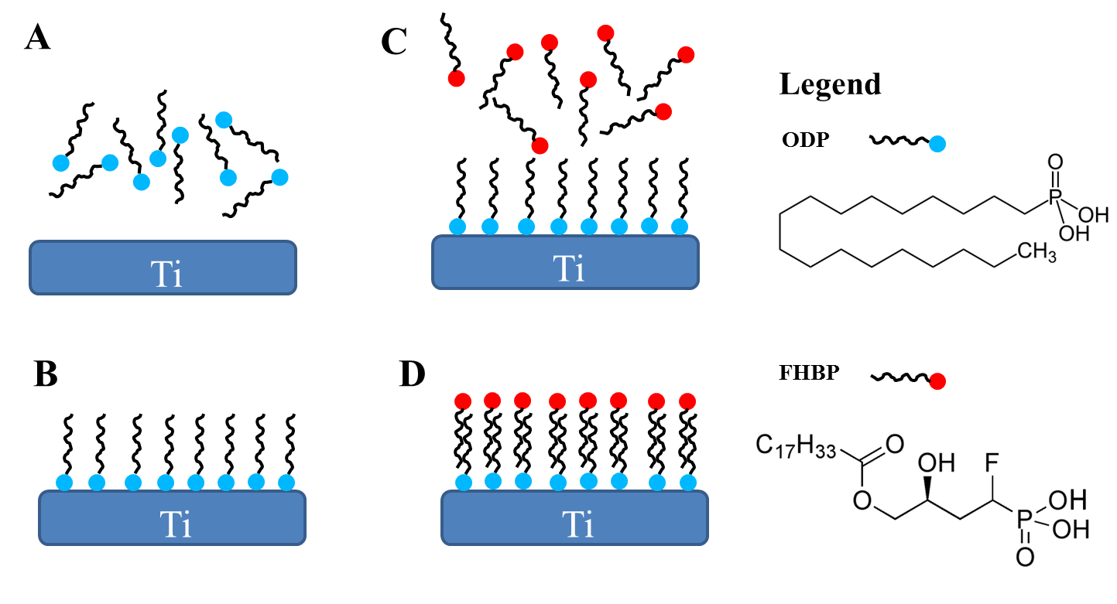

**Figure 2**

**A**

**B**

**Figure 3**

**A**

**B**

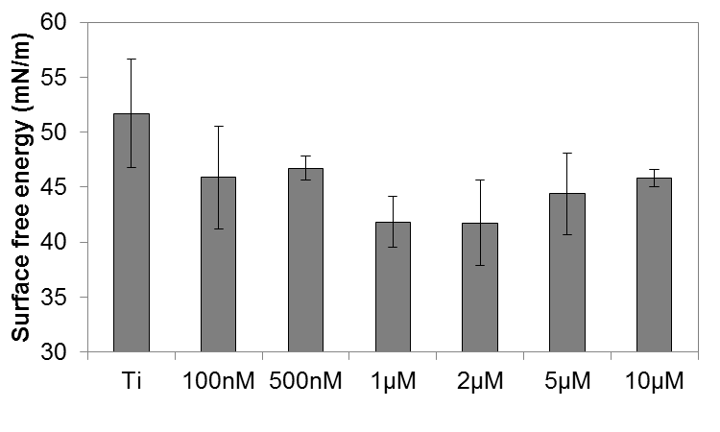

*

**Figure 4**

**A**

**

*

**B**

**

**

*

**C**

**

**

*

**Figure 5**

*

**

**Figure 6**

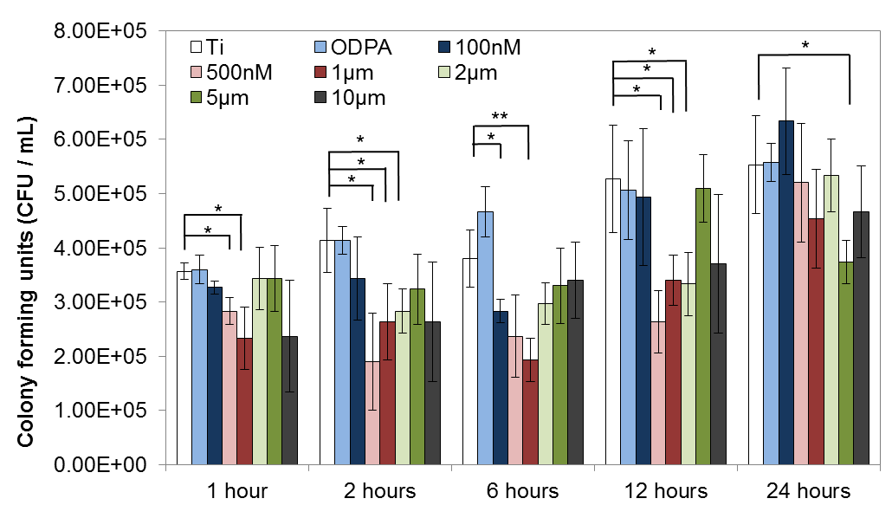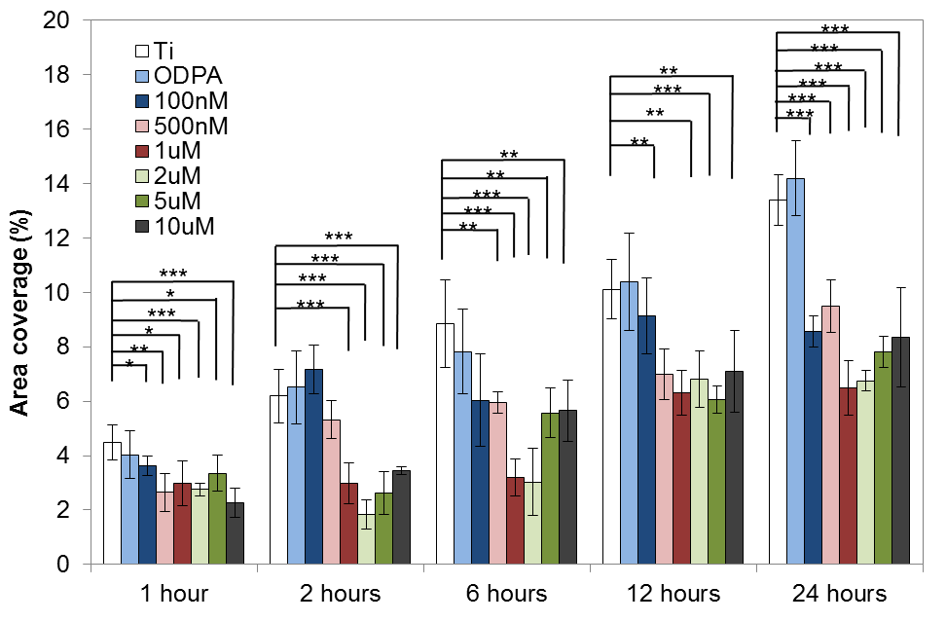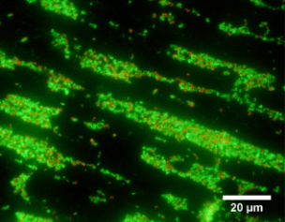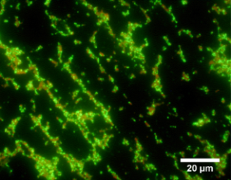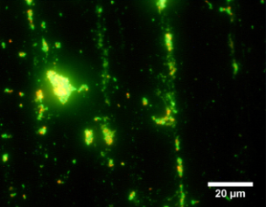

**A**

**B**

**C**

**D**

**E**

**Figure 7**

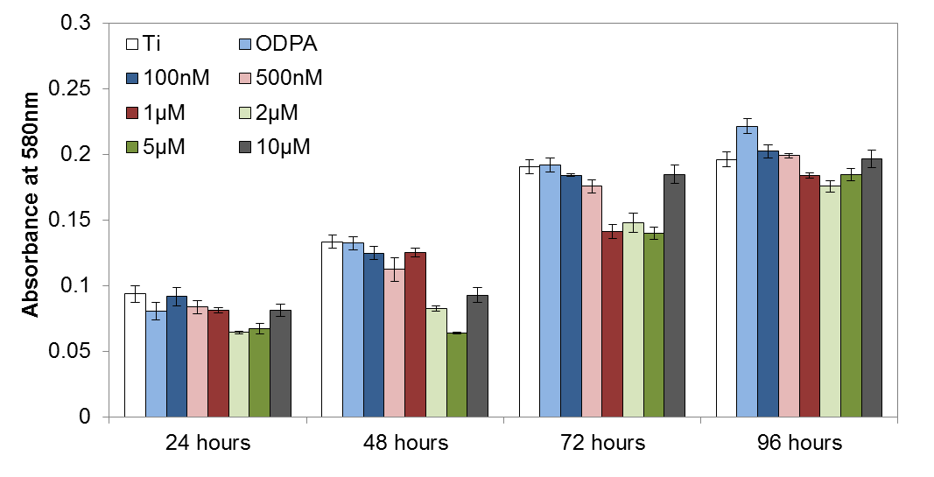

*

**

**

*

***

***

***

*

**

***

**

*

*

***

**A**

**B**

