Article for RSA Comment published online on 7 November 2016

**PLACE-BASED LEADERSHIP**

*Written by Robin Hambleton FRSA*

*Local leaders across the world are changing our understanding of how to develop and implement effective public policy, says Robin Hambleton FRSA.*

The recent interim report from the RSA *Inclusive Growth Commission* is to be welcomed, not least because it gives the idea of strengthening place-based leadership in the UK a significant boost.

The context for this study is that current approaches to economic growth are on the wrong track. It is now widely recognised that a commitment to ‘trickle down economics’, involving the spurious claim that a rising national economic tide lifts all the boats, is misguided. The evidence shows that current policies are, in fact, widening wealth, health, social and geographical divisions in British society.

The Commission’s starting point is that if you want to bring economic and social objectives together in practice, it can only happen locally. It follows that bringing about a significant devolution of power to local areas across the country is essential.

While researching my new book on how to create inclusive cities I discovered seventeen examples of inspirational civic leadership drawn from cities across the world. A key feature of these innovation stories is that many place-based leaders have been successful in developing and implementing strategies that are guided by locally determined social and economic priorities. Based on this research I offer two suggestions on how to improve devolution policy in England and elsewhere.

**Seeing like a state or a city?**

First, and in line with the argument put forward by Matthew Taylor in his annual RSA lecture in September, we need to bring a much more critical eye to current approaches to public policy making. I have found the analysis presented by James C. Scott in his 1998 book, *Seeing Like a State*, to be particularly insightful. He shows how national governments, with their functional, single-purpose departments, have some of the qualities of sensory-deprivation tanks.

Ministers and civil servants, while they may be animated by a desire to improve the human condition, simply cannot visualise what needs to be done because their ways of seeing the world are inevitably distorted. Scott argues that the very way that briefing systems, information, knowledge and power are structured undermines central government effectiveness.

Warren Magnusson, a Canadian political theorist, builds on Scott’s analysis and, in his 2011 book, *Politics of Urbanism: Seeing Like a City*, shows that the problems run deeper than the well-known patterns of silo-thinking associated with departmental government structures. He reveals how, over the years, the social sciences have undervalued interdisciplinary studies.

A consequence is that many fine scholars, because they are devoted to particular disciplines, can also come to ‘see like a state’. An inadvertent consequence is that much knowledge creation in universities and elsewhere is fractured. His radical argument is that to ‘see like a city’ holds out many benefits and, in particular, it involves positioning ourselves as inhabitants, not governors.

Successive Prime Ministers, and their ministerial colleagues, do, of course, mouth their enthusiasm for listening to citizen voices, strengthening local economies and bolstering local democratic processes. But they do not practice what they preach.

The recent trajectory of devolution policy in England illustrates this double think all too well. Ministers, on the basis of their own unpublished preferences, are, right now, deciding which localities are to benefit from secretive ‘devolution deals’. The process involves a super-centralisation of government power.

Ministers decide the criteria, Ministers decide the contents of each ‘deal’, Ministers decide what funding will flow to the selected areas, and Ministers have even decided to insist on a particular form of governance for city regions. Directly elected mayors are being imposed on localities that do not want them.

This is an evidence-free approach. My recent international research for the Local Government Association provides solid evidence showing that non-mayoral models of city region governance perform just as well as mayoral models – see: <http://www.local.gov.uk/devolution/publications>

**Expanding the power of place-based leadership**

Second, we should work to develop a more sophisticated understanding of the nature of effective place-based leadership. Alongside advocating a rebalancing of local/central power the RSA’s *Inclusive Growth Commission* interim report is surely right to suggest that local leadership capacity needs to be developed.

The strategic role of local government can be strengthened, and it is clear that elected local councillors can play a key leadership role in working with civil society organisations, individuals, communities and businesses, so that all can play their part in achieving inclusive growth.

What conceptual frameworks are available to help us imagine the new kinds of civic leadership that are needed? In my work with cities and communities in different countries I have found the notion of realms of place-based leadership to be helpful in developing new ways of collaborating at the local level. The conceptual framework set out belowrecognises that different kinds of people, with different backgrounds, roles and experiences, can all play a decisive role in effective place-based leadership.

The diagram does, of course, simplify the complexity of local political dynamics, but it can provide a way of visualising and organising local civic drive. In particular, it shows that all the realms connect with all the other realms and it highlights the role of local leaders in stimulating and facilitating public service innovation.

The diagramsuggests that in any given locality there are likely to be five realms of place-based leadership reflecting different sources of legitimacy:

* **Political leadership** – referring to the work of those people elected to leadership positions by the citizenry
* **Public managerial/professional leadership** – referring to the work of public servants, appointed by local authorities, governments and third sector organisations to plan and manage public services, and promote community wellbeing
* **Community leadership** – referring to the many civic-minded people, voluntary organisations and other local agencies who give their time and energy to local leadership activities in a wide variety of ways
* **Business leadership** – referring to the contribution made by local business leaders and social entrepreneurs, who have a clear stake in the long-term prosperity of the locality
* **Trade union leadership** – referring to the efforts of trade union leaders striving to improve the pay and working conditions of employees

**The realms of place-based leadership**

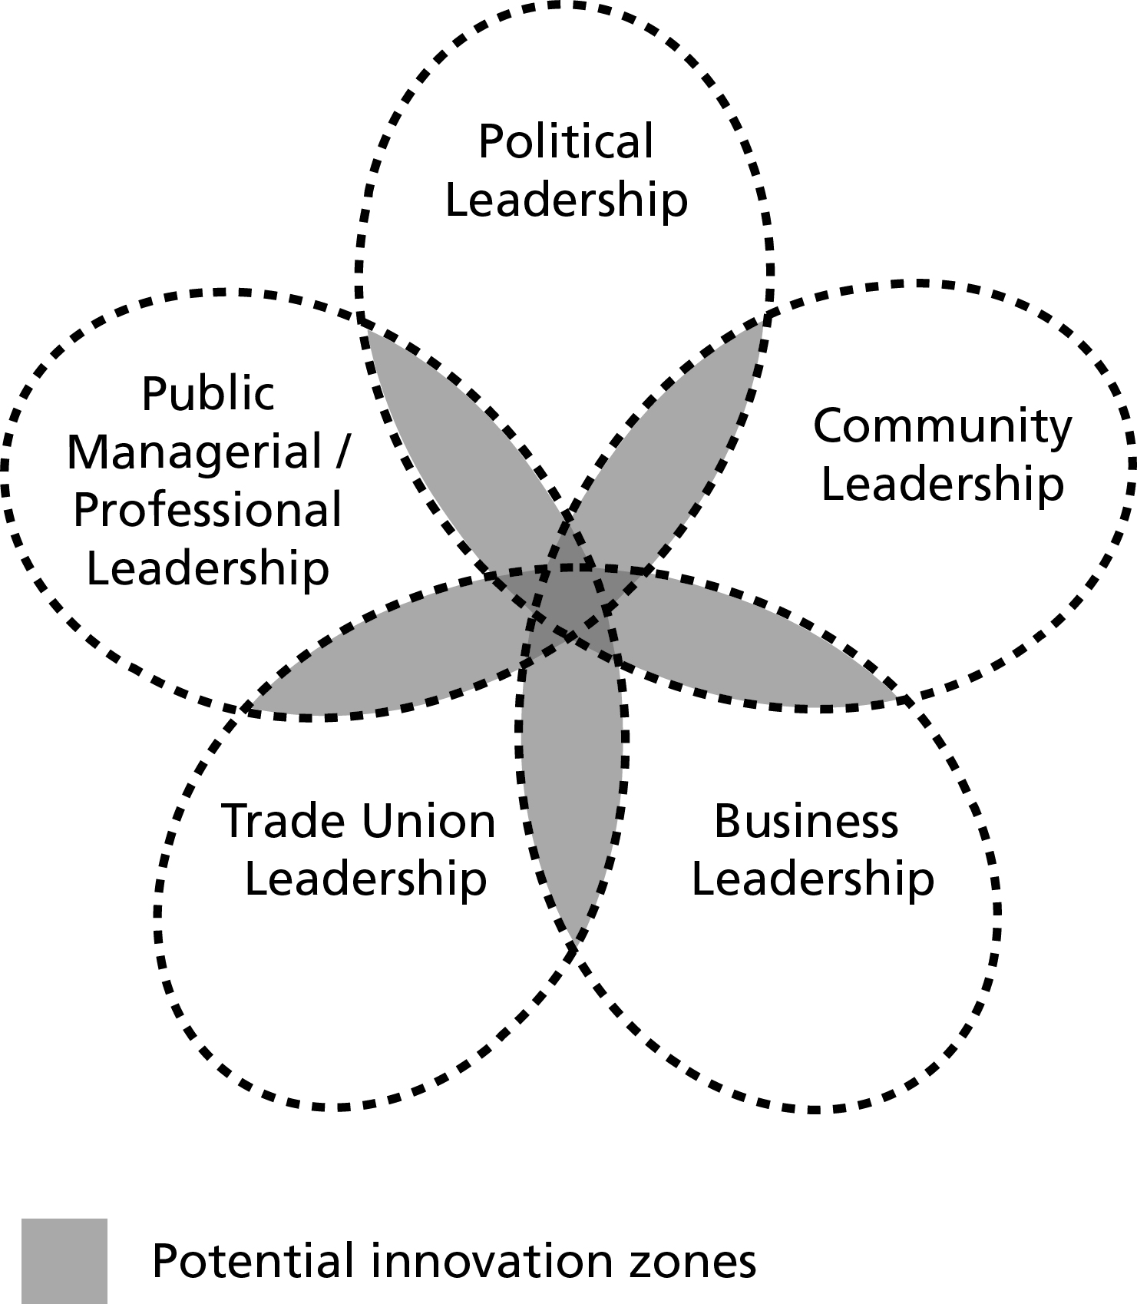

The evidence from my research is that civic leadership is critical in ensuring that the innovation zones – the areas of overlap between the realms of leadership - are critical to progressive change. But leadership is necessary to orchestrate behaviour in these zones - behaviour that promotes a culture of listening that can, in turn, lead to innovation. Civic leaders are, of course, not just ‘those at the top’. All kinds of people can exercise civic leadership and they may be inside or outside the state. The framework can, perhaps, help local leaders comprehend and map their local power structure and explore new possibilities.

Globalisation has many benefits. But place-less power has grown too much. By place-less I mean the power exercised by people who are not expected to care about the consequences of their decisions for particular places and communities.

If communities are to prosper, place-based power must be expanded dramatically in England. It is to be hoped that the final report of the RSA’s *Inclusive Growth Commission* will recommend precisely this.

*Robin Hambleton, is emeritus professor of city leadership, University of the West of England, Bristol and Director of Urban Answers. His latest book is ‘Leading the Inclusive City’ published by Policy Press:*

<http://policypress.co.uk/leading-the-inclusive-city-1>