The role of structural change in
European regional productivity growth

Eoin O’Leary¹ and Don J. Webber²

¹ Institute for Business Development and Competitiveness, School of Economics, University College, Cork, Ireland. Email: eoin.oleary@ucc.ie
² Department of Accounting, Economics and Finance, University of the West of England, Bristol, BS16 1QY, UK. Email: Don.Webber@uwe.ac.uk

Abstract

Recent literature suggests that inter-sectoral structural change has a negligible impact on aggregate productivity growth. Through the application of dynamic shift-share methods, this paper presents a re-examination of this perspective using data for 181 European regions from 1980 to 2007. Results suggest that the effect of the inter-sectoral component is far from negligible and is substantially stronger for those regions towards the higher deciles of the distribution. Moreover, its effects appear to be particularly growth enhancing when the region is either ‘high and improving’ or ‘low and deteriorating.’ These results rehabilitate the importance of structural change for growth and convergence.

Keywords: Regional Productivity; Shift-Share; Structural Change; Growth; Convergence

JEL Classifications: R11; O47

1. Introduction

One of the outcomes of the convergence debate has been that regional convergence is seen as conditional on initial regional differences in institutions, economic structures and tastes, while ‘club’ convergence is observed to occur among regions with similar structural and related conditions (Corrado et al., 2005). The importance of structural differences has been shown to have weakened over the last few decades as convergence of productive structures has occurred (Cuadrado-Roura et al., 1999; Gil et al., 2002; Le Gallo and Dall’Erba, 2008) and related to this is a strong consensus that the effects of inter-sectoral structural change on aggregate regional productivity growth and convergence are negligible (Esteban, 2000; Ezcurra et al., 2005; Villaverde and Maza, 2008; Le Gallo and Kamarianakis, 2011).
This paper challenges the conventional view that the effects of inter-sectoral structural change on regional productivity growth and convergence are negligible by conducting a detailed econometric investigation of the effect of structural change on labour productivity among EU regions. In doing so it is cognizant of the importance now attached in the emerging debate on regional resilience, of structural or sectoral variety (Simmie and Martin, 2010) and of effecting more significant structural change (Bristow, 2010) in shaping greater resilience.
Early theoretical contributions on the effects of structural change on growth and convergence expected it to be positive on both counts. The beneficial effects on growth come through a reallocation of surplus labour from agriculture to industry and services (Lewis, 1954) and have been referred to by Temple (2001) as the growth bonus. These shifts from the primary to the secondary and tertiary sectors may cause convergence, assuming poor regions have relatively more labour in low-productivity sectors such as agriculture (Abramovitz, 1986). However, in principle, the movement of labour between sectors in search of higher wages may not be confined to poor regions. Rich regions may also grow faster and diverge from other regions through labour re-allocation generated between and within sectors. Shifts could occur between low productivity sectors such as textiles and high-productivity sectors such as electronics, owing for example to increasing returns from technological progress in the latter.
It is an empirical question as to whether, and the extent to which, structural change has been important for growth and convergence/divergence, and whether this is country- and/or region-specific. The main purpose of this paper is to measure the effects of structural change between 15 sectors, including 7 manufacturing and 6 market services sectors, on the growth and convergence/divergence performance of 181 EU regions between 1980 and 2007.
This paper builds on the work of O’Leary (2003a, b) and shows that, while structural change, measured as the inter-sectoral contribution, has a smaller growth effect, it becomes progressively more important for the upper deciles of the distribution and is especially important for regions that are ‘high and improving’ and ‘low and deteriorating.’
Policies to stimulate either regional growth or convergence through structural change must be founded, at least in part, on empirical evidence. It is important to know whether, and to what extent, policies that, either by design or through indirect effects reallocate employment from relatively low to relatively high productivity sectors, have an effect on the growth and resilience of regions. Moreover, if it does have an effect on growth, will it contribute to convergence or divergence? If poor regions benefit more, then national and EU policies targeted at facilitating structural change may promote the long-standing policy objective of balanced development. However, if rich regions gain more from structural change then the policy debate may need to pay attention to a hitherto overlooked source of divergence.
The next section outlines the debate about convergence and structural change. Sections 3 and 4 describe the data and specify the methodology to be used. Section 5 provides a discussion of the results and Section 6 draws conclusions and policy implications.

2. Regional convergence and structural change

Among EU regions, Gardiner et al. (2004) have shown that regional convergence has been remarkably slow and that the persistence of regional productivity disparities is a key issue for researchers and policy makers. This paper investigates one factor that has effectively been disregarded in terms of its importance for understanding productivity disparities: inter-sectoral structural change. Structural change is a process involving the re-allocation of labour from relatively low to relatively high productivity sectors, thus boosting aggregate regional or national productivity growth. Lewis (1954) hypothesized that increased growth could be attributable to structural change through surplus labour in agriculture being re-allocated to other industries and services. In the convergence debate, Abramovitz suggests that structural change might have a convergent effect:

If countries at relatively low levels of industrialization contain large numbers of redundant workers in farming and petty trade, as is normally the case, there is also an opportunity for productivity growth by improving the allocation of labour (1986: 387).

Thus, convergence is the outcome when poor regions with relatively more labour in low-productivity sectors, such as agriculture, exhibit faster productivity growth as a result of reallocating labour.
However, it is too restrictive to assume that structural change necessarily results in convergence. Rich regions may also benefit as labour is re-allocated from industry to services or, indeed, within these sectors. This could occur if, in the context of increasing international competition, particular sectors in regions benefit more than others from localized increasing returns from technology spillovers (Martin and Sunley, 1998) or agglomeration effects (Krugman, 1991). In a world characterized by endogenous growth or new economic geography models, it is plausible to expect that the ‘petty trades’ referred to by Abramovitz (1986) could be present in rich regions in relatively low productivity manufacturing or service industries. Hence, structural change might lead to regional divergence if rich regions grow faster as a result of labour re-allocation from relatively low to relatively high productivity sectors. The possibilities that (i) rich as well as poor regions and (ii) diverging as well as converging regions might be influenced by structural change are investigated in the empirical part of the paper.
Structural change is neglected in the neoclassical approach to convergence. Paci and Pigliari (1997) show that, in the neoclassical framework, there is no room for structural change since marginal productivity is assumed to be equal across sectors (see also Gil et al., 2002). Although the standard conditional β convergence method includes the initial agricultural employment share as an independent variable, the purpose is not to estimate the effects of structural change, but instead to control for the effect of aggregate shocks on regional productivity growth (see, for example, Button and Pentecost, 1995, and Hoffer and Worgotter, 1997).
Paci and Pigliaru (1997) extended this standard method, by controlling for the sectoral reallocation effect. They argued that aggregate convergence among Italian regions was largely due to this effect, which is calculated using the shift-share method. Cuadrado-Roura et al. (1999) showed that the overall convergence of Spanish regions between 1955 and 1995 was not due to convergence among sectors, and instead argued that convergence was attributable to the homogenization of regional productive structures.
In a study of Irish regions, O’Leary (2003a, b) used the shift-share method with the σ convergence measure and found that structural change from the primary sector had a convergent effect. The approach used in this paper is an extension of this method to 15 sectors and 181 EU regions. It involves decomposing aggregate productivity growth for each region between time periods (years) t and t+1 into three components, as follows:

Intra-sectoral productivity growth ratio in region j = $\frac{\sum_{1}^{N}{(P_{i,j,t+1}S_{i,j,t})}}{\sum_{1}^{N}{(P_{i,j,t}S_{i,j,t})}}$ (1)

where i refers to 15 sectors and j 181 regions, P is sectoral labour productivity defined as regional gross value added (GVA) per work-hour, S is the sectoral employment share of each region, based on the total number of work-hours, and N is the number of sectors. This intra-sectoral growth measure captures annual aggregate growth due to sectoral productivity growth, and the growth ratio in equation (1) may be used to calculate annual growth rates.
The next component is the inter-sectoral structural growth ratio. This captures the effect of structural change through inter-sectoral labour re-allocation as follows:

Inter-sectoral structural growth ratio in region j = $\frac{\sum_{1}^{N}{(P_{i,j,t}S_{i,j,t+1})}}{\sum_{1}^{N}{(P_{i,j,t}S_{i,j,t})}}$ (2)

The final component is the residual, which is usually small and is the interaction between the intra-sectoral and inter-sectoral components, such that:

Residual productivity growth ratio in region j = $\frac{\sum_{1}^{N}{(P_{i,j,t+1}−P_{i,j,t})}(S_{i,j,t+1}−S_{i,j,t})}{\sum_{1}^{N}{(P_{i,j,t}S_{i,j,t})}}$ (3)

It should be clarified that structural change is captured exclusively in inter-sectoral component (2). However, structural change also contributes to the residual component, which is an interaction term. For completeness, the overall contribution of structural change is also calculated as the difference between aggregate productivity growth and intra-sectoral productivity growth which, in effect, refers to the combination of both inter-sectoral and residual components, and represents an upper-bound on its contribution.
While the shift-share technique has limitations, especially in the area of forecasting (Stevens and Moore, 1980), it is in widespread use in the analysis of labour re-allocation and growth in the regional literature (see, for example, Le Gallo and Kamarianakis, 2011; Oosterhaven and Broersma, 2007; Ezcurra et al., 2005). The proposed measures avoid the use of initial year’s weights of S_{i,j}, which have been widely used and can lead to an under-estimation of the contribution of structural change over time (Broadberry, 1998). This problem is overcome by taking previous year values, so that the proposed method can be characterized as dynamic shift-share, although it retains the underlying assumption that each economy is treated as a closed economic system.
Esteban (2000) uses a similar shift-share method and finds that most of the observed inter-regional variance in aggregate productivity among EU regions is attributable to regional productivity differentials. This suggests that inter-sectoral structural change has had a negligible effect on growth. However, this finding may partly be due to Esteban’s study being confined to a very small number of years (1986 and 1989).
Ezcurra et al. (2005) adopted a similar method to Esteban (2000) and overcame the problem of a severely limited time period by investigating EU regions over the 1977−99 period using Cambridge Econometrics data. Their regional differential component is defined as the productivity gap between each region and the EU average, while the structural component refers to the difference between the region’s industry mix and the EU average. After first regressing each component on the aggregate regional productivity gap relative to the EU average over time, Ezcurra et al. (2005) showed that the regional component had the greatest explanatory power, with a minor role for the structural component. They then conducted a variance decomposition of regional productivity and concluded that the strongest impact came from the regional component. This led to their suggestion that structural change was unimportant and that a one-sector growth model is more relevant for analysing regional disparities. More recently, Le Gallo and Kamarianakis (2011) employed a similar methodology, and obtained similar results.
While the present paper employs a similar methodology, there are some noteworthy differences. In particular, Ezcurra et al. (2005) and Le Gallo and Kamarianakis (2011) computed the regional and structural components at a point in time with reference to the EU average, which is of course endogenous. This amounts to attributing the difference between aggregate regional growth and the EU average to each region’s industry mix and differential components relative to that average. However, Equations (1) and (2) above show that these components may be computed based on the historical evolution of each region over time, and not with reference to an arbitrary average. In addition, this paper also provides more detailed econometric testing of the effects of structural change on growth.
To develop the argument, the paper continues by estimating the effect of intra-sectoral productivity growth and structural change, as measured above, on overall productivity growth. The first step is to investigate the relationship between aggregate productivity growth and aggregate intra-sectoral productivity growth, as follows:

$\frac{(P_{i,\text{agg},t+1}−P_{i,\text{agg},t})}{P_{i,\text{agg},t}}=α+β\left[\frac{\sum_{1}^{N}{(P_{i,j,t+1}S_{i,j,t})}−\sum_{1}^{N}{(P_{i,j,t}S_{i,j,t})}}{\sum_{1}^{N}{(P_{i,j,t}S_{i,j,t})}}\right]+ε_{i,j,t}$ (4)

where P_{i,agg} is aggregate regional productivity, defined as total regional GVA per work-hour. It is hypothesized that β is positive and close to unity, which would corroborate the results of Ezcurra et al. (2005).
The next stage is to analyse the relationship between aggregate productivity growth and the different measures of structural change. These are productivity growth equations focusing on inter-sectoral (Equation (5)), the residual component (Equation (6)) and the inter-sectoral combined with the residual component (Equation (7)), such that:

$\frac{(P_{i,\text{agg},t+1}−P_{i,\text{agg},t})}{P_{i,\text{agg},t}}=α+β\left[\frac{\sum_{1}^{N}{(P_{i,j,t}S_{i,j,t+1})}−\sum_{1}^{N}{(P_{i,j,t}S_{i,j,t})}}{\sum_{1}^{N}{(P_{i,j,t}S_{i,j,t})}}\right]+ε_{i,j,t}$ (5)

$\frac{(P_{i,\text{agg},t+1}−P_{i,\text{agg},t})}{P_{i,\text{agg},t}}=α+β\left[\frac{\sum_{1}^{N}{(P_{i,j,t+1}P_{i,j,t})}(S_{i,j,t+1}S_{i,j,t})}{\sum_{1}^{N}{(P_{i,j,t}S_{i,j,t})}}\right]+ε_{i,j,t}$ (6)

$\frac{(P_{i,\text{agg},t+1}−P_{i,\text{agg},t})}{P_{i,\text{agg},t}}=α+β\left[\frac{(P_{i,\text{agg},t+1}P_{i,\text{agg},t})}{P_{i,\text{agg},t}}−\left[\frac{\sum_{1}^{N}{(P_{i,j,t+1}S_{i,j,t})}−\sum_{1}^{N}{(P_{i,j,t}S_{i,j,t})}}{\sum_{1}^{N}{(P_{i,j,t}S_{i,j,t})}}\right]\right]+ε_{i,j,t}$ (7)

Again in line with the findings of Ezcurra et al. (2005), it is hypothesized that the values of β, especially in Equations (5) and (7), which represent the lower and upper bound, respectively, of the contribution of structural change, are close to zero.
In estimating these equations, it is normally assumed that the effects are identical across the whole distribution. This would involve estimating the effects of both intra- and inter-sectoral change on productivity levels, while controlling for the region’s productivity relative to average EU regional productivity (denoted by P_{EU,agg,t}), to capture convergence towards the mean, such that:

$P_{i,\text{agg},t+1}=α+β_{1}\left(\frac{P_{i,\text{agg},t}}{P_{\text{EU},\text{agg},t}}\right)+β_{2}\left(\frac{\sum_{1}^{N}{(P_{i,j,t+1}S_{i,j,t})}−\sum_{1}^{N}{(P_{i,j,t}S_{i,j,t})}}{\sum_{1}^{N}{(P_{i,j,t}S_{i,j,t})}}\right)+β_{3}\left(\frac{\sum_{1}^{N}{(P_{i,j,t}S_{i,j,t+1})}−\sum_{1}^{N}{(P_{i,j,t}S_{i,j,t})}}{\sum_{1}^{N}{(P_{i,j,t}S_{i,j,t})}}\right)+ε_{i,j,t}$ (8)

It is hypothesized that the values of β₂ and β₃ will vary across the distribution, with β_{3,} the coefficient on inter-sectoral change, being positive and significant at the top of the distribution (i.e. for relatively rich regions) and at the bottom of the distribution (i.e. for relatively poor regions). A key contribution of this paper is to move away from the restrictive assumption that the effects are the same across the distribution and instead employ quantile regression techniques to identify whether this is an inappropriate and unnecessarily restrictive assumption.

3. Data description

The empirical analyses use data corresponding to 181 EU regions for the period 1980− 2007 that has been extracted from the Cambridge Econometrics (2009) database. This source was also used by Ezcurra et al. (2005), Villaverde and Maza (2008) and Le Gallo and Kamarianakis (2011). The advantages of the Cambridge Econometrics dataset are that it provides a balanced panel of data containing sectoral gross value added (GVA) at constant prices and purchasing power parities and labour input for a large number of NUTS 2 regions between 1980 and 2007. Labour input is measured as total hours worked, computed as employment multiplied by average weekly hours worked. Gardner et al. (2004) argued for the superiority of this measure of labour input. A significant benefit of the dataset is that a high degree of sectoral disaggregation is provided, with 15 sectors being available. GVA is in constant €2000 basic prices and purchasing power standards. Cambridge Econometrics employs national sector specific price deflators, which assumes that, for any sector, price movements are the same across all regions in a country. The Cambridge Econometrics (2009) dataset draws data from REGIO, which is the official source of EU regional data (Eurostat, 2004).
Table 1 summarizes the number of NUTS 2 regions investigated for each of 13 EU countries, all of which were members of the original EU 15. While NUTS 2 administrative regions are not ideal measures of functional regions (Magrini, 1999), they are frequently used. For Belgium, two regions are excluded owing to irregularities with the sectoral data. For Germany, only the 30 former West German regions are included owing to their data being available from 1980. Groningen in the Netherlands and North-Eastern Scotland in the UK are excluded because of the influence of North-Sea oil (see Neven and Guoyette, 1995). In addition, Flevoland in the Netherlands is excluded as it only came into existence in 1986. All 13 regions of Greece are excluded, owing to irregularities with the sectoral data, while Luxembourg is excluded as it is an outlier. With these exclusions, we are left with a balanced set of 181 regions across 13 EU countries for 27 years.

{Insert Table 1 about here}

4. Econometric approach

To identify stability and consistency in the results, three separate time-series-cross-section estimators were applied. First, the models were estimated initially using random effects and fixed effects with robust variances. Applications of the Hausman test indicated throughout that models using random effects were preferable to those assuming fixed effects.
The application of the above regression approaches implicitly assumes that the disturbance term is identically and independently distributed, yet this may not be the case if the errors are correlated over time. As a result, the model was re-estimated by using a time-series-cross-section estimator with a first-order autoregressive disturbance term (see Baltagi and Wu, 1999).
The above regression approaches, which are extensions of those used by Ezcurra et al. (2005), were applied to data over the entire time period and across the whole sample. However, there is the possibility that intra- and inter-sectoral changes have different effects on labour productivity, depending on whether the region is above or below the sample average, and whether the region is converging or diverging from that sample average. To investigate these propositions further, we re-estimated the above models for these four categories.
Application of these regression methods is based on the implicit assumption that the effects of explanatory variables on productivity do not vary with the relative values of regions. This assumption is relaxed through the application of quantile regressions (our fourth econometric approach), which permits an exploration into the differing effects that intra- and inter-sectoral structural change may have on labour productivity over time, depending on where regions lie within the productivity distribution.
Given that regional productivity is not likely to be randomly distributed across space, it is necessary to consider whether spatial heterogeneity is present in the data. In this context there are potential benefits of applying exploratory spatial data analysis techniques. These are presented and point the reader towards the need to identify theory which could lead to the future construction of appropriate spatial weights matrices and methodological improvements for which there is currently severely limited help in the literature. All the regression models presented above were estimated with time-invariant country-level dummy variables. While these country dummies may account for some spatial effects, they are second best measures in that they could equally capture factors such as idiosyncratic country-level policies.

5. Results

This section initially presents estimates of the time-series-cross-section estimations of the effects of intra- and inter-sectoral change on labour productivity growth.

i) Aggregate productivity growth and the intra-sector measure

To identify the importance of intra-sectoral change on aggregate productivity growth we estimated Equation (4). The results presented in Panel A of Table 2 indicate that intra-sectoral change had a statistically significant and enhancing effect on aggregate productivity growth. Because of omitted variables, the consistently high R² values may overstate the importance of intra-sectoral change per se; nevertheless, this result illustrates the importance of intra-sectoral change for productivity growth at the NUTS 2 regional level and corroborates the findings of Ezcurra et al. (2005).

{Insert Table 2 about here}

ii) Aggregate productivity growth and the inter-sector measure

To identify the importance of inter-sectoral change on aggregate productivity growth we estimated Equation (5). Here the results presented in Panel B of Table 2 are uniformly insignificant. This suggests that inter-sectoral change is not a major driving force behind productivity growth, a finding that is similar to that of Ezcurra et al. (2005).

iii) Aggregate productivity growth and the residual component

For completeness, the above methods are applied to the residual measure. Panel C of Table 2 presents the results for Equation (6). Strikingly, the R² values are very small, suggesting that the explanatory power of the residual measure on productivity growth is small. This is to be expected as the residual component is usually very small.

iv) Aggregate productivity growth and the combined inter-sectoral and residual components

Application of the econometric methods to the estimation of Equation (7) yields the results presented in Panel D of Table 2. These results suggest that the combined inter-sectoral and residual components had a statistically significant and negative association with productivity growth, although the explanatory power is invariably extremely low.

v) Quantile regression

Taken together, the results presented above confirm the findings of authors such as Ezcurra et al. (2005), by suggesting that a region’s rate of productivity growth is mostly explained by intra-sectoral change and that inter-sectoral change and the residual have relatively minor contributory effects. One potential disadvantage of the econometric approaches applied above, which are conventional in the literature, is the implicit underlying assumption that the effects are identical across the whole distribution of regions. This implicit assumption is neither theoretically justifiable nor in line with the work of, for example, Lewis (1954) and Abramovitz (1986), who focus on the benefits of labour reallocation falling more on poorer regions. In addition regression approaches are based on the presumption that the statistic of interest is the conditional mean and that the distribution is of limited interest.
In order to identify whether this implicit assumption is justifiable, we investigated the effects of intra-sectoral and structural change on labour productivity growth through the application of quantile regressions. Given the findings in panels C and D of Table 2, which reveal that the effects of the residual component on growth are weak, we focus solely on the inter-sectoral component as the measure of structural change. Estimation of Equation (8), which takes into consideration the relative position of the region in the distribution at time t, as well as the separate intra- and inter-sectoral change effects, yielded the results presented in Table 3. These new results cast doubt on the stability and validity of our earlier findings for each and every decile in the distribution. The β₁ coefficient, which captures the initial position of a region within the distribution, suggests that a region above (below) the mean will grow slightly faster (slower) than the mean; note that they are not statistically significantly different from unity for the 6th decile. These results suggest that there is divergence in the sample after account has been taken of the effects of measures of structural change. Also notable are that the models have greater explanatory power as one ascends the distribution. For convenience, the structural change coefficients are graphed in Figure 1, which emphasises the non-linear effects, especially of inter-sectoral change, on productivity.

{Insert Table 3 and Figure 1 about here}

Figure 1 reveals that the effects of intra- and inter-sectoral change on a region’s productivity depend on where it is in the distribution. It shows that the effect of intra-sectoral change on a region’s productivity is invariably strongly positive, rising consistently from 0.73 for the first decile to 0.91 for the last. It is noticeable that standard errors for the estimated coefficients are substantially smaller at the top of the distribution than at the bottom.
Although the results to date emphasise that the effect of inter-sectoral change on productivity is always less than that for the intra-sectoral component, it is also evident that the effect of inter-sectoral change is far from being negligible. Indeed, the inter-sectoral effect depends on where the region is located in the distribution, as it rises from 0.06 at the bottom to 0.69 at the top. Furthermore, the error boundary around the estimate is substantially larger in the first decile, where the true estimate could be as high as 0.20, than at the top of the distribution.
This finding contradicts the proposition that poorer regions are likely to benefit most from structural change, as a result of having large pools of relatively low-productivity agricultural workers (see, for example, Temple (2001) and O’Leary (2003a, b)). It supports the possibility that rich regions might benefit from structural change. By conducting the analysis at a greater level of sectoral disaggregation, this paper has uncovered a significant source of benefit to richer regions from structural change.

vi) Above or below the average, improving or deteriorating

Academics and policy makers who read this literature tend to be interested in whether a region is above or below an average and whether its performance is on an upward or downward relative trajectory. Accordingly, it may be practical and valuable to investigate the effects of structural changes on productivity relative to the sample mean for four groups of regions based on a categorisation of productivity performance over the entire time period: (i) those regions that are relatively rich and becoming more so, (ii) those regions that are relatively rich but are deteriorating, (iii) those regions that are relatively poor but improving and (iv) those regions that are relatively poor and are deteriorating. The results of these estimations are presented in Appendix 2 and replicated in Figure 2 (Appendix 3 tabulates the regions in each category).
The effect of intra-sectoral change is consistently strong across the across the four groups, rising from 0.48 for the regions that are ‘low and deteriorating’ to 0.72 for ‘high and improving’ regions. It is noticeable that the error boundaries for regions in the middle two categories, regions that are ‘low and improving’ and those that are ‘high and deteriorating’, are considerably tighter. However, it is also noticeable that the effect of inter-sectoral change on productivity growth differs depending on how a region is performing. Its effect on growth appears to be particularly strong if the region is ‘low and deteriorating’ and ‘high and improving’. Conversely, the effect is much smaller if the region is ‘low and improving’ and ‘high and deteriorating’. This suggests that structural change may be a strong contributory factor in diverging regions, which again runs counter to the expectations of Abramovitz (1986) that structural change has a convergent effect. The results further reinforce the view that structural change should feature in policy recommendations, as regions cope with negative and positive shocks.

{Insert Figure 2 about here}

vii) Shift-share and relative location

The shift-share econometric approach is based on a number of restrictive assumptions. One key assumption here is that each region is treated as a closed economic system. Research into regional productivity patterns should consider the relative location of regions, but to proceed forward and modify this literature would require a strong theoretical rationale for selecting and employing a particular spatial weights matrix in the shift-share analysis. Currently, there are no strong theoretical justifications for modifying the shift-share method through the inclusion of, for example, a specific spatial weights matrix. Moreover, Harris and Kravtsova (2009) warn against the standard approach in the spatial econometrics literature of imposing spatial weights matrices that use contiguous or distance-related measures to weight observations because it imposes a structure of spatial interactions that is untested and potentially misspecified.
In our regional-level productivity case, capturing economic distance, which varies enormously in importance across goods, infrastructures and markets, is extremely problematic because i) we do not have any prior assumptions about the form of spatial dependence and ii) the imposition of a spatial weights matrix collapses all spatial interactions into a single weighted variable, rather than directly testing which regions interact with each other (and the strengths of interactions). Of course, it would be possible to adjust spatial weight matrices here to capture a particular structure of spatial interaction but this would be atheoretical, would be untested and potentially would lead to misspecification. Indeed, Fingleton (2003, p 205) asks “what is the theoretical and empirical basis of assumptions about the spatial reach of externalities, and how can this be enhanced?”
In order to proceed forward on this front, we investigated whether our model has systematically over- or under-estimated by undertaking an exploratory spatial data analysis on the residuals of the quantile regressions. The estimation of a Moran’s I scatterplot and accompanying statistic provides a visual and quantitative indication of how important relative location is in these models and whether new developments of shift-share econometrics are needed in order to take full account of the potential spatial autocorrelation that may be affecting the results.
For simplicity, and because there is no strong literature to guide here, a first-order queen-contiguity spatial weights matrix was selected. Figure 3 presents the Moran’s I scatterplot with standardised residuals presented on the x-axis and standardised queen-spatially-lagged residual values on the y-axis. Although the points are well spread around line of best fit, the Moran’s I statistic of 0.348 is statistically significant at the 1% level based on 999 permutations, suggesting that a region’s residual value is positively associated with the residual values of its (queen-) contiguous regions. These results suggest that shift-share methods should be augmented to include the spatial dimension, although this may be a momentous shift due to the removal of a steadfast underlying assumption.

{Insert Figure 3 about here}

Future research could seek to establish the extent to which regions benefit in terms of productivity growth from labour re-allocation between geographically proximate regions. The results of Le Gallo and Kamarianakis (2011), which point to the importance of geographical clustering, suggest that this might be a fruitful extension of this line on inquiry. Indeed, this could involve the application and extension of methods proposed by Mayer and Lopez (2008) to introduce spatial dependence in a shift-share model.

6. Conclusions

This paper presents a set of empirical tests of the effects of structural change on EU regional productivity growth. The empirical approach saw the application of a dynamic shift-share approach to a 15 sector measure of GVA per work-hour for 181 EU regions from 1980 to 2007. The paper is distinctly different from others, such as Ezcurra (2005), principally because of its more detailed econometric testing of the effects of structural change on growth and the fact that its computation of the contribution of structural change to the change in productivity is based on the historical evolution of each region over time.
The main findings are that:
- intra-sectoral change was positively related to regional productivity growth, with inter-sectoral change having much smaller effects;
- for deciles of the distribution, the effect of the inter-sectoral component is far from negligible, and is substantially stronger for those regions towards the top of the distribution;
- the effect of inter-sectoral change appears to be particularly growth enhancing if the region is ‘low and deteriorating’ and ‘high and improving’.

These results rehabilitate the importance of structural change for growth and convergence. They cast doubt on the current convention that the intra-sectoral contribution is the dominant and perhaps only source of productivity growth, and that inter-sectoral structural change has a negligible impact (Ezcurra et al., 2005; Villaverde and Maza, 2008; Le Gallo and Kamarianakis, 2011). This implies that in addition to the stock of physical capital and research and development expenditure, which have been shown to be key drivers of intra-sectoral productivity growth (Ezcurra et al., 2005), factors linked to structural change such as the mobility of labour between sectors may also play a role in driving aggregate productivity. Further research is required in order to identify the relative importance of these factors.
This paper has important policy implications. First, the finding that structural change can make a significant contribution to aggregate productivity growth in richer regions suggests that policies should also be targeted at facilitating growth in these regions through education, training and infrastructure measures directed at improving labour mobility, both within and across sectors and regions. Such measures may have contradictory effects on regional convergence/divergence, depending on whether these regions are deteriorating or improving in relative terms. For poor regions that are falling behind average growth, the results suggest that adopting such policies could contribute to either convergence or divergence, again depending on their growth trajectory. Indeed, the finding that structural change may be a driver of poor regions that are deteriorating relative to the average, which was found to be a feature of 16 regions in the sample (including 6 from Spain, 5 from the UK, 2 from Denmark, 2 from Finland and 1 from Sweden; see Appendix 2) is worthy of more detailed investigation by policymakers.

The result that inter-sectoral structural change is important for growth of regional productivity is the most important contribution of this paper. This hypothesis could be tested for data sets with larger numbers of sectors, regions and countries and for longer time periods. The possibility that structural change might affect regional resilience might also be tested empirically.

Although we recognise that our results should be treated with caution as labour productivity is not randomly distributed across space, it is problematic to explicitly integrate relative location into a shift-share approach because it treats each region as a closed economic system and because there is a lack of theoretical reasoning behind the selection of a particular spatial weights matrix. Estimation of a Moran’s I statistic using the quantile regression residuals revealed significant global spatial autocorrelation; further research could be directed to develop shift-share methods to account for these spatial components.

Acknowledgments: The authors are grateful for helpful comments from Tony Flegg, and seminar participants at the Regional Science Association International (British and Irish Section) Annual Conferences in Stratford on Avon, 2005, Jersey, 2006, and Cardiff, 2011, and anonymous referees. Thanks to Jon Stenning, Cambridge Econometrics, for helpful discussions around and provision of the data. All errors remain the authors’ responsibility.
References

Abramovitz, M. (1986). Catching Up, Forging Ahead and Falling Behind, Journal of Economic History. 46(2): pp 385-406.
Arellano, M. and Bond, S. (1991) Some Tests of Specification for Panel Data: Monte Carlo Evidence and an Application to Employment, Review of Economic Studies 58(2), pp. 277-297
Baltagi, B. and P. Wu. 1999. Unequally spaced panel data regressions with AR(1) disturbances, Econometric Theory 15, pp 814-823 u/l case?
Broadberry, S.N. (1998). How Did the United States and Germany Overtake Britain? A Sectoral Analysis of Comparative Productivity Levels, 1870-1990. The Journal of Economic History, 58(2): pp 375-407.
Bristow G (2010). Resilient regions: re-‘place’ing regional competitiveness. Cambridge Journal of Regions, Economy and Society, 3: pp 153-167.
Button K. J. and Pentecost E. J. (1995). Testing for Convergence of the EU Regional Economies. Economic Inquiry. XXXIII: pp 664-671
Cambridge Econometrics (2009). European Regional Data: 1980-2007. Cambridge Econometrics, UK. [Available on request – see http://www.camecon.co.uk]
Carluer F and G Gaulier (2005). The Impact of Convergence in the Industrial Mix on Regional Comparative Growth: Empirical Evidence from the French Case. Annals of Regional Science. 39: pp 85-105.
Corrado, L, R Martin and M Weeks (2005). Identifying and Interpreting Regional Clusters Across Europe. Economic Journal, 115: pp133-160.Cuadrado-Roura J.R., Garcia Greciano B and Raymond J.L. (1999). Regional Convergence in Productivity and Productive Structure: the Spanish Case. International Regional Science Review 22: pp 35-53.
Esteban J (2000). Regional Convergence in Europe and the Industry Mix: A Shift-Share Analysis. Regional Science and Urban Economics. 30(3): pp 353-364.
Eurostat (2004). European Regional Statistics: REGIO, Eurostat, Luxembourg, July 4th.
Ezcurra R, Gil C, Pascual P and Rapun M (2005). Regional Inequality in the European Union: Does Industry Mix Matter? Regional Studies. 39(6): pp 679-698.
Fingleton, B. (2003) “Externalities, economic geography and spatial econometrics: conceptual and modelling developments,” International Regional Science Review 26(2), 197-207
Gardiner B, Martin R and Tyler P (2004). Competitiveness, Productivity and Economic Growth across the European Regions. Regional Studies. 38(9): pp 1045-1068.
Gil Caneleta C., P. Pascual Arzoz and M. Rapun Garate (2002). Structural Change, Infrastructure and Convergence in the Regions of the European Union. European Urban and Regional Studies. 9(2): pp 115-135.
Harris, R. and Kravtsova, V. (2009) “In search of ‘W’,” SERC discussion paper, 17.
Hoffer H and Worgotter A (1997). Regional Per Capita Income Convergence in Austria. Regional Studies. 31(1): pp 1-12.
Krugman P (1991). Increasing Returns and Economic Geography. Journal of Political Economy, 99: pp 483-99.
Le Gallo J. and Dall’Erba S. (2008) Spatial and sectoral productivity convergence between European
regions, 1975–2000, Papers in Regional Science. 87, 505–525.
Le Gallo J and Kamarianakis Y. (2011). The Evolution of Regional Productivity Disparities in the European Union from 1975 to 2002: A Combination of Shift-Share and Spatial Econometrics. Regional Studies, 45(1): pp 123-139.
Lewis A. (1954). Development with Unlimited Supplies of Labour, The Manchester School XXII: pp 139-191, May.
Magrini S. (1999). The evolution of income disparities among the regions of the European Union. Regional Science and Urban Economics, 29: pp257–281.
Simmie J and R.L. Martin (2010). The Economic Resilience of Regions: towards an evolutionary approach, Cambridge Journal of Regions, Economy and Society, 3: pp 27–43.
Martin R. L. and Sunley P. J. (1998) Slow convergence? The new endogenous growth theory and regional development, Economic Geography 74, pp 201–227.
Mayer, M. and A.J. Lopez (2008). Spatial Shift Share Analysis versus Spatial Filtering: An Application to Spanish Employment Data. Empirical Economics, 34: pp123-142.
Neven D and Guoyette C (1995). Regional Convergence in the European Community. Journal of Common Market Studies. 33 (1): pp 47-65.
O’Leary E (2003a). Aggregate and Sectoral Convergence Among Irish Regions: The Role of Structural Change: 1960-96. International Regional Science Review. 26 (4): pp 483-501.
O’Leary E (2003b). Sources of Regional Divergence in the Celtic Tiger: Policy Responses. Journal of the Statistical and Social Inquiry Society of Ireland. XXXII: pp 1-32.
Oosterhaven J and L. Broersma (2007). Sector Structure and Cluster Economies: A Decomposition of Regional Labour Productivity. Regional Studies, 41(5): pp 639-659.
Paci R and Pigliaru F (1997). Structural Change and Convergence: An Italian Regional Perspective. Structural Change and Economic Dynamics. 8: pp 297-318.
Quah D. (1996). Empirics for Economic Growth and Convergence. European Economic Review. 40 (6): pp 1353-76.
Stevens B.H. and Moore C.L. (1980). A Critical Review of the Literature on Shift-Share as a Forecasting Technique. Journal of Regional Science, 20(4): 419-437.
Temple J. (2001). Structural Change and Europe’s Golden Age, Centre for Economic Policy Research, Discussion Paper No. 2861, June.
Villaverde J. and A. Maza (2008). Regional Convergence in the European Regions, 1980-2003: A Sectoral and Spatial Approach. Applied Economics. (40): 1299-1313.

Figure 1: Quantile regression estimates
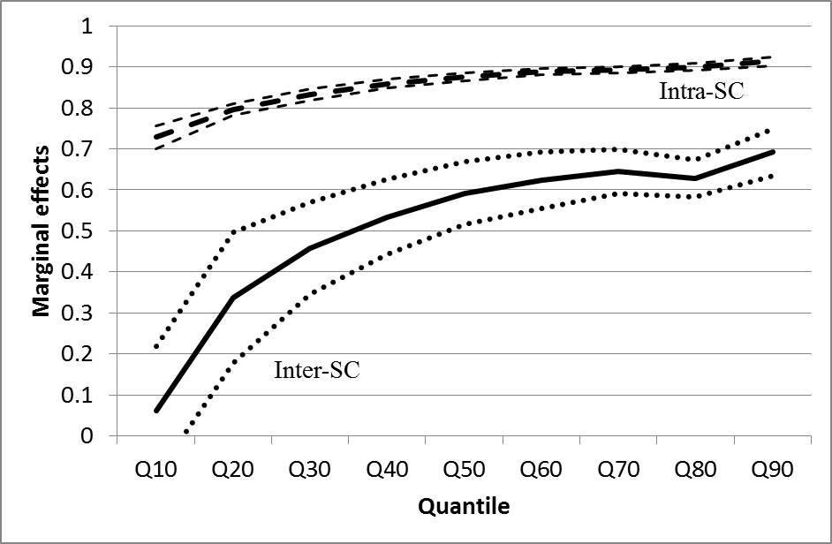
Note: The dotted lines represent standard errors.
Figure 2: Marginal effects by category, based on random effects estimator

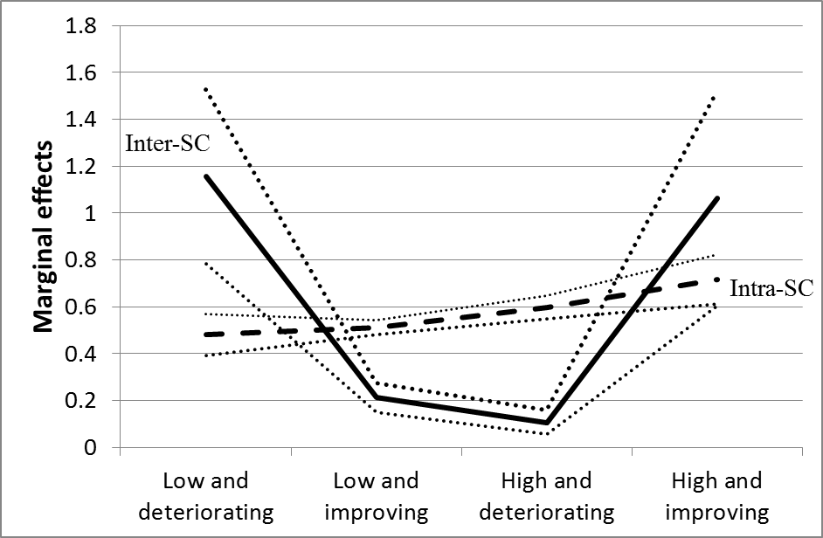

Note: The dotted lines represent standard errors.

Figure 3: Moran’s I

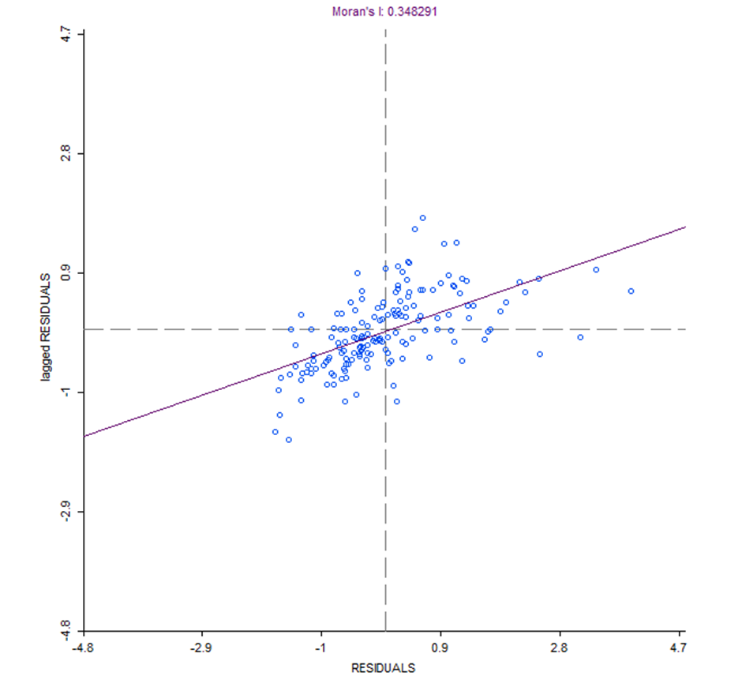

Table 1: Number of EU NUTS 2 regions
Country | NUTS 2 Regions
Belgium¹ | 9
Denmark | 5
Germany² | 30
Spain | 19
France | 22
Italy | 21
The Netherlands³ | 10
Austria | 9
Portugal⁴ | 5
Finland | 5
Sweden | 8
Ireland | 2
UK⁵ | 36
Total⁶ | 181
Source: Cambridge Econometrics (2009).
Notes 1: Excluding the region West Brabant and Brabant Wallon.
2: Includes only the former West German regions.
3. Groningen and Flevoland excluded.
4: Excluding Azores and Madeira.
5: North-East Scotland excluded
6: All 13 regions of Greece excluded.

Table 2: Shift-share regression results
 | α | Intra-structural change | Inter- structural change | Residual component | Inter- structural change and Residual Combined | R²s  [Within]  {Between}  Overall
Panel A: Equation (4): Intra-sectoral component of productivity growth
Random effects GLS | 0.000  (0.000) | 0.918  (0.003)*** | – | – | – | [0.944]  {0.884}  0.942
Random effects GLS regression with AR(1) disturbances | 0.000  (0.000) | 0.918  (0.003)*** | – | – | – | [0.944]  {0.884}  0.942
Panel B: Equation (5): Inter-sectoral component of productivity growth
Random effects GLS | 0.021  (0.001)*** | – | 0.003  (0.019) | – | – | [0.000]  {0.703}  0.020
Random effects GLS regression with AR(1) disturbances | 0.021  (0.001)*** | – | 0.002  (0.019) | – | – | [0.000]  {0703}  0.020
Panel C: Equation (6): Growth and the residual component of productivity growth
Random effects GLS | 0.021  (0.001)*** | – | – | -0.048  (0.021)** | – | [0.001]  {0.702}  0.021
Random effects GLS regression with AR(1) disturbances | 0.021  (0.001)*** | – | – | -0.048  (0.021)** | – | [0.001]  {0.702}  0.021
Panel D: Equation (7): Inter-sectoral and residual components combined of productivity growth
Random effects GLS | 0.021  (0.001)*** | – | – | – | -0.281  (0.053)*** | [0.008]  {0.649}  0.026
Random effects GLS regression with AR(1) disturbances | 0.021  (0.001)*** | – | – | – | -0.286  (0.053)*** | [0.008]  {0.648}  0.026
Notes: standard errors in parentheses. ***, ** and * signify statistical significance at the 1%, 5% and 10% levels, respectively. Also included in these regressions are country-level fixed effects. In all regressions, the number of regions equals 181 and all Wald tests show significant at the 1% level.

Table 3: Estimation of Equation (8): Quantile regressions

Quantile | α | (β₁) Initial  position | (β₂) Intra-SC | (β₃) Inter-SC | R² | Test  H_{o}: β₁=1
Q90 | -0.013 (0.004)*** | 1.007 (0.002)*** | 0.914 (0.011)*** | 0.692 (0.057)*** | 0.951 | 13.14***
Q80 | -0.011 (0.003)*** | 1.005 (0.002)*** | 0.900 (0.009)*** | 0.627 (0.045)*** | 0.947 | 7.24***
Q70 | -0.014 (0.003)*** | 1.003 (0.001)*** | 0.893 (0.007)*** | 0.645  (0.054)*** | 0.945 | 9.2***
Q60 | -0.014 (0.002)*** | 1.000 (0.002)*** | 0.888 (0.008)*** | 0.624 (0.069)*** | 0.941 | 0.0
Q50 | -0.014 (0.002)*** | 0.997 (0.001)*** | 0.876 (0.010)*** | 0.592 (0.076)*** | 0.937 | 4.59**
Q40 | -0.011 (0.002)*** | 0.992 (0.002)*** | 0.859 (0.011)*** | 0.534 (0.092)*** | 0.932 | 26.47***
Q30 | -0.007  (0.005) | 0.987 (0.001)*** | 0.832 (0.014)*** | 0.458 (0.112)*** | 0.924 | 75.5***
Q20 | -0.014  (0.008)* | 0.980 (0.002)*** | 0.795 (0.014)*** | 0.337 (0.160)** | 0.914 | 92.8***
Q10 | -0.018 (0.009)** | 0.969 (0.005)*** | 0.728 (0.027)*** | 0.061  (0.157) | 0.897 | 34.6***
Notes: standard errors in parentheses. ***, ** and * signify statistical significance at the 1%, 5% and 10% levels, respectively. Also included in these regressions are country-level fixed effects. In all regressions, the number of regions equals 181 and all Wald tests show significant at the 1% level. These coefficients can be interpreted as marginal effects. Also included in these regressions are country-level fixed effects. Estimations are based on 1,000 bootstraps.
Appendix 1: Table A1: 15 Sectoral classification (NACE Rev 1)
Agriculture, Forestry and Fishing
Mining and Energy
Food, Beverages and Tobacco
Textiles and Clothing
Fuels, Chemicals, Rubber and Plastic Products
Electronics
Transport Equipment
Other Manufacturing
Construction
Wholesale and Retail
Hotels and Restaurants
Transport and Communication
Financial Services
Other Market Services
Non-Market Services

Appendix 2: Categories, random effects estimator
Method | α | Initial  position | Intra-SC | Inter-SC | R²s  [Within]  {Between}  Overall
High and improving (n=18) | 0.846  (0.031)*** | 1.62-05  (9.88e-07)*** | 0.718  (0.105)*** | 1.062  (0.459)** | [0.283]  {0.991}  0.438
High and deteriorating (n=66) | 0.683  (0.018)*** | 1.75e-05  (5.84e-07)*** | 0.598  (0.050)*** | 0.107  (0.051)** | [0.229]  {0.794}  0.527
Low and improving (n=81) | 0.552  (0.008)*** | 1.78e-05  (4.53e-07)*** | 0.512  (0.032)*** | 0.213  (0.062)*** | [0.353]  {0.870}  0.722
Low and deteriorating (n=16) | 0.677  (0.024)*** | 9.09e-06  (1.37e-06)*** | 0.480  (0.089)*** | 1.155  (0.373)*** | [0.065]  {0.668}  0.383
Whole sample (n=181) | 0.482  (0.007)*** | 2.18e-05  (3.48e-07)*** | 0.617  (0.030)*** | 0.195  (0.043)*** | [0.251]  {0.888}  0.733
Notes: standard errors in parentheses. ***, ** and * signify statistical significance at the 1%, 5% and 10% levels respectively. Also included in these regressions are country-level fixed effects. In all regressions, the Wald tests show significant at the 1% level.

Appendix 3: Group memberships in Figure 2.

Low and Deteriorating (N=16):
Syddanmark (dk03), Midtjylland (dk04), Cantabria (es13), Castilla y León (es41), Castilla-la Mancha (es42), Extremadura (es43), Andalucia (es61), Región de Murcia (es62), Åland (fi2), Puglia (itf4), Småland med öarna (se21), Merseyside (ukd5), South Yorkshire (uke3), Devon (ukk4), West Wales and The Valleys (ukl1) and South Western Scotland (ukm3).

Low and improving (N=81):
Burgenland (at11), Niederösterreich (at12), Kärnten (at21), Steiermark (at22), Freiburg (de13), Niederbayern (de22), Oberpfalz (de23), Oberfranken (de24), Unterfranken (de26), Hannover (de92), Lüneburg (de93), Weser-Ems (de94), Münster (dea3), Detmold (dea4), Koblenz (deb1), Trier (deb2), Saarland (dec), Sjælland (dk02), Nordjylland (dk05), Galicia (es11), Principado de Asturias (es12), La Rioja (es23), Aragón (es24), Comunidad Valenciana (es52), Ciudad Autónoma de Ceuta (es63), Ciudad Autónoma de Melilla (es64), Canarias (es7), Itä-Suomi (fi13), Länsi-Suomi (fi19), Pohjois-Suomi (fi1a), Basse-Normandie (fr25), Pays de la Loire (fr51), Bretagne (fr52), Poitou-Charentes (fr53), Limousin (fr63), Auvergne (fr72), Corse (fr83), Border, Midlands and Western (ie01), Abruzzo (itf1), Molise (itf2), Campania (itf3), Basilicata (itf5), Calabria (itf6), Sardegna (itg2), Norte (pt11), Algarve (pt15), Centro (pt16), Lisboa (pt17), Alentejo (pt18), Östra Mellansverige (se12), Sydsverige (se22), Västsverige (se23), Tees Valley and Durham (ukc1), Northumberland, Tyne and Wear (ukc2), Cumbria (ukd1), Greater Manchester (ukd3), Lancashire (ukd4), East Yorkshire and Northern Lincolnshire (uke1), North Yorkshire (uke2), West Yorkshire (uke4), Derbyshire and Nottinghamshire (ukf1), Leicestershire, Rutland and Northants (ukf2), Lincolnshire (ukf3), Herefordshire, Worcestershire and Warks (ukg1), Shropshire and Staffordshire (ukg2), West Midlands (ukg3), East Anglia (ukh1), Bedfordshire and Hertfordshire (ukh2), Essex (ukh3), Outer London (uki2), Berkshire, Bucks and Oxfordshire (ukj1), Surrey, East and West Sussex (ukj2), Hampshire and Isle of Wight (ukj3), Kent (ukj4), Gloucestershire, Wiltshire and Bristol/Bath area (ukk1), Dorset and Somerset (ukk2), Cornwall and Isles of Scilly (ukk3), East Wales (ukl2), Eastern Scotland (ukm2) and Highlands and Islands (ukm6) and Northern Ireland (ukn).

High and deteriorating (N=66):
Oberösterreich (at31), Salzburg (at32), Tirol (at33), Vorarlberg (at34), Région de Bruxelles-Capitale/Brussels Hoofdstedelijk Gewest (be1), Prov. Antwerpen (be21), Prov. Oost-Vlaanderen (be23), Prov. West-Vlaanderen (be25), Prov. Hainaut (be32), Prov. Liège (be33), Prov. Luxembourg (be34), Prov. Namur (be35), Stuttgart (de11), Karlsruhe (de12), Tübingen (de14), Oberbayern (de21), Mittelfranken (de25), Schwaben (de27), Bremen (de5), Darmstadt (de71), Gießen (de72), Kassel (de73), Braunschweig (de91), Düsseldorf (dea1), Köln (dea2), Arnsberg (dea5), Rheinhessen-Pfalz (deb3), Schleswig-Holstein (def), Pais Vasco (es21), Comunidad Foral de Navarra (es22), Comunidad de Madrid (es3), Cataluña (es51), Illes Balears (es53), Etelä-Suomi (fi18), Picardie (fr22), Bourgogne (fr26), Lorraine (fr41), Alsace (fr42), Franche-Comté (fr43), Midi-Pyrénées (fr62), Languedoc-Roussillon (fr81), Southern and Eastern (ie02), Piemonte (itc1), Valle d'Aosta/Vallée d'Aoste (itc2), Liguria (itc3), Lombardia (itc4), Provincia Autonoma Bolzano-Bozen (itd1), Provincia Autonoma Trento (itd2), Veneto (itd3), Friuli-Venezia Giulia (itd4), Emilia-Romagna (itd5), Toscana (ite1), Umbria (ite2), Marche (ite3), Lazio (ite4), Sicilia (itg1), Friesland (nl12), Drenthe (nl13), Gelderland (nl22), Zeeland (nl34), Stockholm (se11), Norra Mellansverige (se31), Mellersta Norrland (se32), Övre Norrland (se33), Cheshire (ukd2) and Inner London (uki1).

High and improving (N=18):
Wien (at13), Prov. Limburg (be22), Hamburg (de6), Hovedstaden (dk01), Île de France (fr1), Champagne-Ardenne (fr21), Haute-Normandie (fr23), Centre (fr24), Nord - Pas-de-Calais (fr3), Aquitaine (fr61), Rhône-Alpes (fr71), Provence-Alpes-Côte d'Azur (fr82), Overijssel (nl21), Utrecht (nl31), Noord-Holland (nl32), Zuid-Holland (nl33), Noord-Brabant (nl41) and Limburg (nl42).

Endnotes

Not all evidence supports this perspective; Paci and Pigliaru (1997) for Italy, O’Leary (2003a, b) for Ireland, Carluer and Gaulier (2005) for France and Gil et al. (2002) for the EU find that inter-sectoral structural change is stronger in poorer regions and has a convergent effect.
This is the difference between (ΣP_{i,j,t+1}S_{i,j,t+1})/(ΣP_{i,j,t}S_{i,j,t}) and Equation (1).
Using this paper’s notation, Ezcurra et al. (2005) define the regional differential as (ΣP_{i,j}S_{i,})-(ΣP_{i}S_{i}) and the industry mix as (ΣP_{i,}S_{i,j})-(ΣP_{i}S_{i}). An interaction or allocative component is also analysed, equal to (Σ(P_{i,j}-P_{i})(S_{i,j}-S_{i})). P_{i} and S_{i} refer, respectively, to average EU sectoral productivity levels and sectoral employment shares for a given year while j refers to regions.
See Appendix 1 for the sectoral definitions.
National purchasing power parities are applied to each sector. This is the best alternative to the industry-of-origin approach based on ex-factory prices for each sector. However, these data are unavailable.
REGIO is incomplete, with full series not available for all EU countries, especially during the early 1980s and at the detailed sectoral level. For this reason Cambridge Econometrics has opted to supplement REGIO data with alternative national statistics and interpolation methods. Gardner et al. (2004), Villaverde and Maza (2008), Le Gallo and Dall’Erba (2008) and Le Gallo and Kamariandis (2011) use this dataset in investigations of convergence in regional productivities.
The effects of structural change on regions towards the bottom of the distribution may be smaller because of other factors that have not been accounted for in our modelling process; these factors may correspond to the communication infrastructure (roads, broadband, etc.), the quality of the labour force, outmigration of skilled labour, etc.
We checked the stability of these results by undertaking a sensitivity analysis with the time period split before and after the 1991 recession. The results continue to suggest that the effects of inter-sectoral change increases with the deciles of the distribution and that the effect of intra-sectoral change is larger in magnitude than the effect of inter-sectoral change.
Other standard spatial weights matrices were used interchangeably and the following results were found to be stable across this substitution.

