SMALL-SCALE MICROBIAL FUEL CELLS UTILISING URIC SALTS

J. Youª, J. Greenman^{a,b}, C. Melhuishª, I. Ieropoulos^{a,b,*}
ªBristol Robotics Laboratory, University of the West of England, Bristol, UK
^{b}School of Life Science, University of the West of England, Bristol, UK

*Corresponding author: Tel.: +44 117 32 86318, 86322; Fax: +44 117 32 83960
E-mail address: ioannis.ieropoulos@brl.ac.uk (I. Ieropoulos)
Bristol Robotics Laboratory, T-Building, Frenchay Campus, Bristol, BS16 1QY, UK

HIGHLIGHTS
• Uric salts were tested for the first time as fuel for electricity generation in MFCs.
• When uric salts were added to other substrates, power generation and longevity improved.
• Small-scale MFCs produced a comparable amount of power output to that produced by larger MFCs.

Abstract

With exhausting fossil fuels and increasing greenhouse gas emissions, numerous attempts, to overcome future energy challenges, are being pursued. In this study, small-scale microbial fuel cells (MFCs, 0.7mL anodic chamber volume) were built to investigate their electrical performance with uric salts as fuel for power generation. When uric salts were added to other substrates such as urine or sewage sludge, results showed improved power generation and longevity. The small-scale MFCs produced a comparable amount of power output (P_{MAX}: 11.09 mW/m²; 44.36 W/m³) to that produced by larger MFCs, which suggests that MFC miniaturisation and multiplication is a sound approach for scale-up and practical implementation.

Keywords: uric salts, uric sludge, energy from waste, small-scale MFCs, urine

Introduction
Organic waste is an abundant source of energy, which if fully utilised, could help alleviate some of the global energy problems. At present, treatment and disposal of organic waste and wastewater comes at a high cost, and it therefore becomes very important to explore and promote technologies that can utilise organic matter for the production of useful energy. Taking wastewater as a good example for the North East England, it has been reported that the calorific value of this waste product is 7.6 kJ/L [1]. In this respect microbial fuel cells (MFCs), that generate electricity directly by the breakdown of this energiferous organic fuel, have a great potential for future energy challenges.
One of the main advantages of MFCs is their environmentally friendly nature and operation. Instead of using refined expensive fuel, MFCs can utilise a wide range of substrates, and produce useful amounts of energy without the need for high-cost catalysts or special operational conditions. Their primary disadvantage, however, is the relatively low power output compared to chemical fuel cells. In order to obtain a sufficient amount of power for practical applications, scale-up of MFC systems, through connecting individual small-scale cells in series or parallel (or both) as a stack, has been suggested [2]. When the size of a MFC device is enlarged, the system tends to lose power due to a higher internal resistance [2]. Therefore it appears that one viable method for scale-up is the miniaturisation of individual units and their multiplication in stacks.
Various substrates – including urine – have been reported as efficient fuels in MFCs for electricity generation [3-10]. Urine is an abundant waste product and the main source of nitrogen and phosphorous in wastewater [11], which are difficult and expensive to remove in treatment systems. Previous work has already suggested that the early break down of urine for electricity generation can help remove and lock-away, (in the form of new biomass), some of the nitrogen, phosphorous and potassium content in urine, thus having a positive impact on wastewater treatment [9]. However, urine tends to accumulate in the form of uric salts (uric sludge) especially in communal drainage systems, requiring frequent removal and maintenance. Usually strong alkaline solutions are used to remove the uric salts, which are not environmentally friendly and bring further problems such as drainage corrosion. With this in mind, this study investigated the feasibility of utilising uric salts mixed with urine or sludge in MFCs for direct electricity generation.
The specific aims of this study were; (i) to investigate whether uric salts can be utilised for power generation by MFCs; (ii) to demonstrate whether useful levels of electricity can be produced from miniature MFCs fed with uric salts.

Methods
  - Type I (Batch mode medium-scale MFCs)
The Type I MFCs comprised single 25mL anodic chambers. The open side of the chamber was sealed with a cation exchange membrane (VWR, Leicestershire, UK). Cathodes were attached onto the membrane by a plastic paraffin film and one side of them was exposed to air (open-to-air type). They were made of acrylic material with dimensions h = 6cm, w = 5cm, l = 1cm and a membrane window with 30cm² surface area. Carbon fibre veil electrodes (PRF Composite Materials Poole, Dorset, UK) with a total surface area of 270cm² were folded several times along the length and width before being placed in the chambers and used as the anode and cathode electrodes. Nickel-chrome wire (thickness: 0.45mm, length: 6cm) was used to connect the electrodes to the external circuit and data logging equipment. After inoculation and maturing using activated sewage sludge (Wessex Water, Cam Valley Works, UK) for at least 3 weeks, 5mL of neat (unprocessed) urine (pH 5.56) or uric salts (pH 8.45, 100 times diluted with deionised water) was fed into MFCs for the purpose of substrate comparison. The resultant pH of the anolyte, especially after 48 hours of operation, was between 8.78-8.81. Tap water (7.5mL) was used for hydrating cathodes on a daily basis.

  - Type II (Re-circulating medium-scale MFCs)
The Type II MFCs consisted of 25mL anode and cathode chambers (50mL in total) separated by the same membrane and having the same electrode type, size and conformation, as above. Unlike the open-to-air cathodes of the type I MFCs, cathodes were placed in the closed cathode chambers on one side of the membrane. Maturing of these MFCs was as described above. Neat urine stored in 1L bottles was recirculated through MFCs by single channel peristaltic pump (WELCO Co. Ltd, Japan) with a flow rate of 4mL/min. In order to test uric salts in MFCs as a substrate, 5mL of diluted uric salts (in deionised water) was added directly into the anodes of these MFCs. Tap water (700 mL) was recirculated at a rate of 30mL/min using a single channel diaphragm pump (KNF Neuberger, Germany). Anolyte in the reservoirs was replaced with fresh urine when the power output of the MFCs reached the pre-set baseline, which was 50mV.

  - Type III (Re-circulating small-scale MFCs)
Type III MFCs consisted of two 0.7mL hemispherical chambers, anode and cathode chambers, and they were 3D printed in Nanocure® resin material. Each chamber had an inlet and outlet (d = 2mm) for continuous feeding. Between the two chambers, a circular cation exchange membrane with 15mm diameter was placed. The same carbon veil folded electrode as described above was used, but with a total surface area of 28cm² (w = 7cm, l = 4cm). Subsequent to inoculation and maturing, (as described above) MFCs were fed with uric salts mixed with activated sludge in batch mode for the first 9 days, in order to let microbial consortia settle and colonise the anode, and then 500 mL of uric salts and sludge mix was re-circulated. Uric salts were mixed with sludge at a 1:100 ratio (pH 9.27) and then this mixture was diluted with tap water with different ratios of 1:9, 1:4 and 1:1 (10, 20 and 50% in percentage volume respectively). Tap water was recirculated with a flow rate of 0.5 mL/min as a catholyte and replaced on a daily basis.

Initially all three types of MFC were inoculated with activated sludge, collected from the Cam Valley wastewater treatment plants, Wessex Water. Design and operational conditions of the three different types of MFCs are shown below in Table 1. The initial resistor loads used in the experiments were 2.7kΩ for MFC Type I and II, and 12kΩ for the Type III MFCs. These were chosen to match the initial internal resistances of the different MFC types, and were determined by periodic monitoring of the open-circuit voltage.

Table 1 Design and operational condition of three different types of MFCs
 | Type I  Medium-scale MFCs | Type II  Medium-scale MFCs | Type III  Small-scale MFCs
Anode volume (ml) | 25 | 25 | 0.7
Cathode volume (ml) | 0 (open-to-air) | 25 | 0.7
MFC material | Acrylic | Acrylic | Nanocure
Anolyte supply | Batch | Continuous  (re-circulation) | Continuous  (re-circulation)
Substrate | Neat urine or uric salts | Neat urine and uric salts mix | Activated sludge and uric salts mix
Catholyte composition | Batch; water or algal water | Water circulation | Water circulation

  - Composition of uric salts
Typically urine consists of 96% of water and 4% of various solutes [12]. When urine is saturated as a result of evaporation or microbial urea degradation occurring in urinary systems, these solutes precipitate and build up in the systems. This is insoluble thus often causes maintenance problems such as bad odours and blockages. Uric salts consist of mainly calcium carbonate (CaCO₃), hydroxyapatite (HAP, Ca₅(PO₄)₃(OH)) and struvite (MgNH₄PO₄·6H₂O) [13]. Uric salts used in this study were provided by WhiffAway Ltd, Slough, UK. Since the samples were provided from an operating communal urinal facility, they naturally consisted of a mixture of uric salts and sludge, which would have been high in impurities and organic carbon.

  - Data capture and calculation of power output
The MFC output was recorded in real time in millivolts (mV) using an ADC-24 A/D converter computer interface (Pico Technology Ltd., Cambridgeshire, UK). The current (I) in amperes (A) was determined using Ohm’s law, I = V/R, where V is the measured voltage in volts (V) and R is the external load resistance value in ohms (Ω). Power (P) in watts (W) was calculated by multiplying voltage with current; P = I×V. Power density (P_{D}) was calculated in terms of electrode total macro surface area; P_{D} = P/α, where α is the total anode electrode surface area in square-meters (m²) before folding the electrode to fit inside the MFC chambers. Type I and II MFCs employed 270 cm² of electrode, whereas the Type III MFCs employed 28cm² of the same carbon veil electrode. The internal resistance of each type of cells was calculated according to the Physics method of measuring internal resistance in any physical power supply, i.e. R_{int} = (V_{o/c}/I_{load})-R_{load}.

Results and Discussion
  - Feasibility of uric salts as a substrate
Figure 1 shows the temporal profile of power production from the Type I MFCs. When MFCs were fed with urine, the power output reached up to 0.5mW/m², and then continuously decreased as urine was depleted. After approximately 12 days, the MFCs produced only 0.03mW/m², which was the pre-set baseline. At this point, the uric salts solution was injected into the anodes and the power output increased by 0.39mW/m² before beginning to decrease over the next 3 days. Unlike after the urine feed, this decline did not continue as the power output reached a plateau and remained constant at approximately 0.2mW/m² for the next 9 days. This suggests that uric salts improved the longevity of continuous power generation, although the peak power was lower than that with urine.

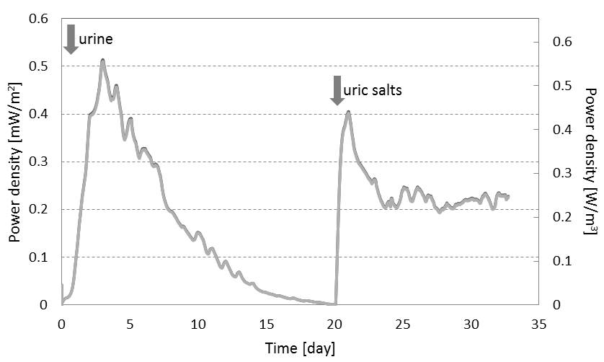
Figure 1. Temporal profile of power production from the Type I MFCs when they were fed with urine and uric salts; arrows indicate when urine (left) or uric salts (right) were fed into the MFCs.

Adding uric salts to the Type II MFC, which were being fed with urine from reservoirs, has shown an even more marked improvement in terms of power generation (Figure 2). When the uric salts substrate was added to the MFC anode directly, the power output increased significantly. The average power output of the MFC after being fed with uric salts and urine was 1.92mW/m², which is approximately 51.2% higher than the average power output of the same MFC when it was fed only with urine (1.27mW/m²), and as in the previous case, the power output remained constant at the elevated level for 3.5 days (5,000min). The power output in terms of area under curve (AUC) analysis was 100% as a result of simply adding 5mL of diluted uric salts to urine (Figure 2 inset).

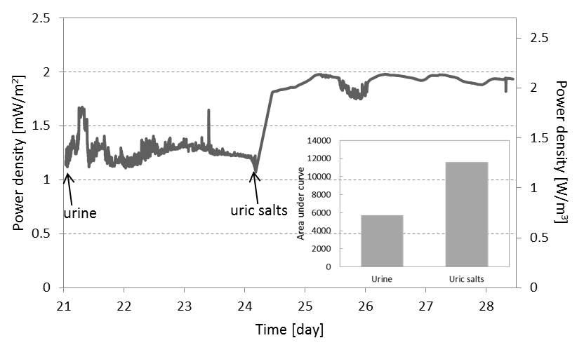
Figure 2. Temporal profile of power production from the Type II MFC when uric salts were added to the anode; arrows indicate when urine (left) and uric salts (right) were provided to the MFCs.

These findings suggest that uric salts can be used as a substrate for direct electricity production by MFCs. Moreover uric salts could improve both the level of power and the longevity when added to other substrates (in this case, urine). This is probably due to the increased organic content from the composition of uric salts and sludge mixture, the decreased ohmic resistance of the anolyte due to the high concentration in inorganic salts, as well the higher pH, which would have buffered any level shifts towards acid levels.

  - Response to uric salts concentration

From the data shown in Fig.3, when the Type III MFCs were fed with 10% sludge and uric salts mix (sludge:uric salts=100:1, volume ratio) diluted with tap water, the average power generated for 7 days was 0.03mW/m². The average power output increased to 0.16mW/m² (5-fold increase) and 0.89mW/m² (28-fold increase) respectively, when 20% and 50% diluted sludge and uric salts mix (sludge:uric salts=100:1, volume ratio) was provided. As can be seen in Figure 3, the average amount of power produced was proportional to the amount of uric salts mix added. Also when the different concentrations of the uric salts mixture were provide to the Type III small MFCs, the output response was rapid (within 30 min in all cases). It is therefore shown that the Type III small MFCs were more sensitive to the increasing concentration of substrate.
Although no performance decline was observed for the entire period of the experiment, the possibility of uric salts deposition on the membrane needs to be considered when a high concentration of uric salts mix is introduced into the system. The deposition can limit the MFC performance especially in the longer term.

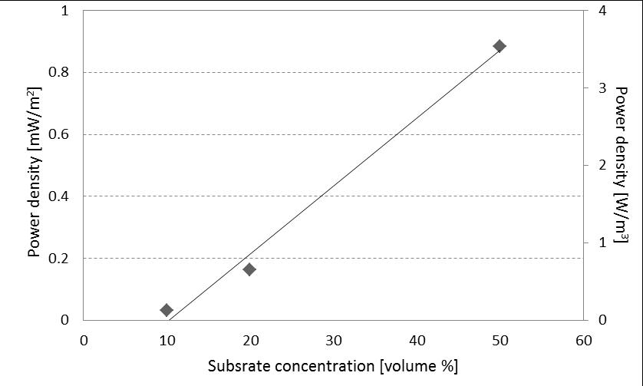
Figure 3. Dose response curve from the Type III MFCs, as a result of substrate concentration.

Once again, addition of uric salts to other substrates (in this case, sewage sludge) led to an increase in anolyte pH from pH 8.74 (fresh sludge) to pH 9.27 (uric salts and sludge mix). High pH increases solubility of organic matter in sludge and therefore allows for more substrate to be readily available for uptake. This result is in agreement with previous studies reporting that artificial alkaline treatment of sewage sludge resulted in improved electricity production by MFCs [14, 15]. In the current study the buffering towards the alkaline level is performed naturally by uric salts and this emphasises yet another great advantage of the MFC technology.

  - Power generating performance of small-scale (0.7 mL) MFCs
As can be seen in Figure 4, when the Type III small-scale MFCs were fed with 50% diluted uric salts mix, the maximum power output (P_{MAX}) was 11.09mW/m² (absolute power was 31.05µW; power density normalised to the total anodic volume, 44.36W/m³) and the internal resistance was 1kΩ. Although P_{MAX} is highly dependent on the type and concentration of substrate, these data show that the small-scale MFC could produce a comparable amount of power output to those produced by the larger MFCs. No significant pH change of anolyte (less than 0.4 pH unit) was observed over 7 days of a single feeding cycle, and the MFC performance did not seem to be affected by the cathode, since no significant output changes were recorded as a result of catholyte replenishment (data not shown).

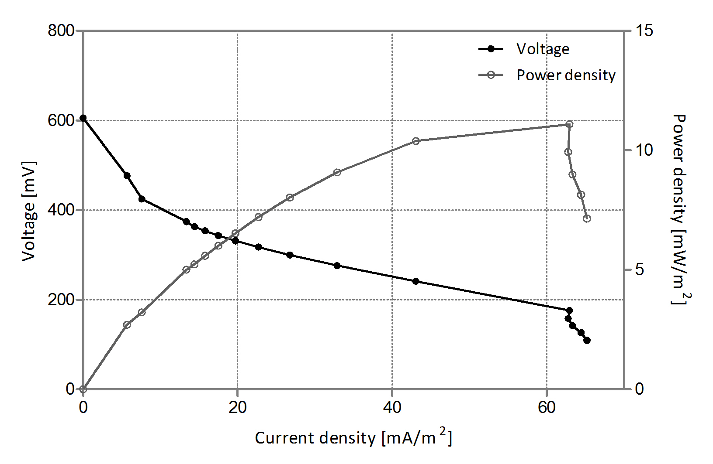
Figure 4. Polarisation and power curves of the Type III MFC.

The Type II MFCs were fed on uric salts and neat urine mix whereas the Type III MFCs on uric salts and sludge (50% diluted with tap water) mix. Despite this difference in feedstock (taking into account that sludge consists of urine) and of course the difference in size (objective of the experiment), everything else was identical in terms of electrode material, membrane, and continuous flow of anolyte/catholyte, and therefore normalisation of the outputs could be performed. In terms of power density per anode electrode surface area, the Type II MFCs (medium-scale) produced 1.92mW/m² and the Type III MFCs (small-scale) 0.89mW/m². However in terms of power density normalised per anodic volume, the Type III MFCs produced 70% higher output (3.56W/m³) compared to that of the Type II MFCs (2.07W/m³).

Conclusions
In the present study, it was shown that uric salts as well as urine can be successfully utilised by MFCs. This is the first demonstration showing the potential of uric salts as a fuel for MFCs and perhaps suggests that it would be possible to obtain useful electrical energy from MFCs directly fitted in urinary systems in the future. Moreover it was demonstrated that the small-scale MFCs could produce comparable power levels to those produced by larger MFCs. This is important in the development of MFC stack systems for practical applications. The demonstration of good levels of power outputs from such small-scale MFCs strengthens the case for miniaturisation & multiplication as a means of scale-up.

Acknowledgements
This work has been funded by the UK Engineering & Physical Sciences Research Council (EPSRC) grant no. EP/I004653/1 project and by the Bill & Melinda Gates Foundation grant no. OPP1044458.

References
[1] E.S. Heidrich, T.P. Curtis, J. Dolfing, Determination of the internal chemical energy of wastewater. Environ. Sci. Technol. 45 (2011) 827-832.
[2] I. Ieropoulos, J. Greenman, C. Melhuish, Microbial fuel cells based on carbon veil electrodes: Stack configuration and scalability. Int. J. Energ. Res. 32 (2008) 1228-1240.
[3] B. Min, J. Kim, S. Oh, J.M. Regan, B.E. Logan, Electricity generation from swine wastewater using microbial fuel cells. Water Res. 39 (2005) 4961-4968.
[4] C. Melhuish, I. Ieropoulos, J. Greenman, I. Horsfield, Energetically autonomous robots: Food for thought. Auton. Robots. 21 (2006) 187-198.
[5] M.M. Ghangrekar, V.B. Shinde, Performance of membrane-less microbial fuel cell treating wastewater and effect of electrode distance and area on electricity production. Bioresour. Technol. 98 (2007) 2879-2885.
[6] X. Wang, Y.J. Feng, H. Lee, Electricity production from beer brewery wastewater using single chamber microbial fuel cell. Water Sci. Technol. 57 (2008) 1117-1121.
[7] X. Wang, Y. Feng, N. Ren, H. Wang, H. Lee, N. Li, Q. Zhao, Accelerated start-up of two-chambered microbial fuel cells: Effect of anodic positive poised potential. Electrochim. Acta 54 (2009) 1109-1114.
[8] J. Greenman, A. Gálvez, L. Giusti, I. Ieropoulos, Electricity from landﬁll leachate using microbial fuel cells: Comparison with a biological aerated ﬁlter. Enzyme. Microb. Tech. 44 (2009) 112–119.
[9] I. Ieropoulos, J. Greenman, C. Melhuish, Urine utilisation by microbial fuel cells; energy fuel for the future. Phys. Chem. Chem. Phys. 14 (2012) 94-98.
[10] P. Kuntke, K.M. Smiech, H. Bruning, G. Zeeman, M. Saakes, T.H.J.A. Sleutels, H.V.M. Hamelers, C.J.N. Buisman, Ammonium recovery and energy production from urine by a microbial fuel cell. Waster Res. 46 (2012) 2627-2636.
[11] T.A. Larsen, W. Gujer, Separate management of anthropogenic nutrient solutions (human urine). Water Sci. Technol. 34 (1996) 87-94.
[12] G.F. Yeo, A manual of physiology. 4th ed. the University of California: Blakiston; 1889.
[13] K.M. Udert, T.A. Larsen, W. Gujer, Biologically induced precipitation in urine-collecting systems. Water Sci. Technol. 3 (2003) 71-78.
[14] H. Yuan, Y. Chen, H. Zhang, S. Jiang, Q. Zhou, G. Gu, Improved bioproduction of short-chain fatty acids (SCFAs) from excess sludge under alkaline conditions. Environ. Sci. Technol. 4 (2006) 2025-2029.
[15] Y. Yuan, Q. Chen, S. Zhou, L. Zhuang, P. Hu, Improved electricity production from sewage sludge under alkaline conditions in an insert-type air-cathode microbial fuel cell. J. Chem. Technol. Biotechnol. 87 (2012) 80-86.

Carrying energy

