Paper

A prospective comparison of invasive and non-invasive blood pressure in children undergoing cardiac catheterization

TITLE PAGE:

Authors:

Dr Richard Beringer
Consultant Anaesthetist
Bristol Royal Hospital for Children

Dr Alastair Keith
Consultant Anaesthetist
Bristol Royal Hospital for Children

Dr Elin Jones
Consultant Anaesthetist
Birmingham Children’s Hospital

Dr Tim Murphy
Consultant Anaesthetist
Bristol Royal Hospital for Children

Professor Paul White
Statistician
University of the West of England

Corresponding Author:

Dr Richard Beringer
Consultant Anaesthetist
Post: E519, Bristol Royal Hospital for Children, Upper Maudlin Street, Bristol, BS2 8BJ, UK.
Email: richard.beringer@uhbw.nhs.uk
Tel: +44 117 342 7008

Mesh terms:

Blood pressure determination; child; hypotension; blood pressure; cardiac catheterisation

Clinical Implications:
a. What is already known about the topic

There are insufficient and conflicting data on whether there is acceptable agreement between invasive and non-invasive blood pressure readings for children, particularly during anesthesia.

b. What new information this study adds (indicate the salient research results)

There is poor agreement between invasive and non-invasive blood pressure measurements in children undergoing cardiac catheterization, particularly during periods of hypotension.

Abstract

Background

Blood pressure measurement is a standard of monitoring during general anesthesia. Invasive measurement is considered the gold standard but is less commonly used than non-invasive. Automated oscillometric blood pressure devices measure the mean arterial pressure (MAP) and use an algorithm to determine the systolic and diastolic pressures. Few devices have been validated in children, particularly during anesthesia. Few studies have assessed the agreement between invasive and non-invasive blood pressure measurements in children.

Methods

This was a multi-centre prospective observational study of children under 16 years undergoing cardiac catheterisation with general anesthesia. Paired invasive and non-invasive blood pressure measurements were recorded for each patient during stable periods of the procedure. Correlation within and between sites was assessed with Pearson’s correlation coefficient and agreement was examined using Bland-Altman methodology to determine bias. Agreement during episodes of hypotension and for age and weight was also determined. Bias greater than 5 mmHg and standard deviation greater than 8 mmHg was considered clinically significant. The primary end point was agreement of MAP measurements.

Results

683 paired blood pressure values were collected from 254 children in three paediatric hospitals. Median [IQR] age and weight were 3 [1-7] years and 13.9 [8 – 23] Kg. The overall bias (SD) for mean arterial pressure values was 7.2 (11.4) mmHg. During hypotension (190 readings) the bias (SD) was 15 (11.0) mmHg. The non-invasive MAP was frequently higher than invasive MAP during infancy, and lower in older children.

Conclusion

Automated oscillometric blood pressure measurement is unreliable in anesthetized children during cardiac catheterization. Invasive pressure measurement should be considered for high-risk cases.

Introduction

Blood pressure measurement during anesthesia is a standard of monitoring in many countries. It is used as an indicator of cardiovascular status, especially for patients at risk of organ hypoperfusion such as those with cerebrovascular or ischaemic heart disease. Most children tolerate hypotension if cardiac output and oxygen delivery are maintained. However, a subgroup of children present a significant risk of perioperative cardiac arrest from compromised coronary perfusion, for example those with coronary abnormalities or left ventricular outflow tract obstruction. ^{1–3}

Accuracy of blood pressure monitoring is therefore important. Invasive blood pressure measurement remains the gold standard but is usually reserved for complex cases, because of the additional time, complex equipment, and associated morbidity, such as arterial thrombosis or aneurysm formation. Automated non-invasive oscillometric monitors are therefore more commonly used during anesthesia, so it is vital that anesthetists understand the function and limitations of these devices.

Oscillometric monitors work by measuring pressure fluctuations within an air-filled cuff as it compresses an underlying artery. The maximum amplitude of oscillation occurs at mean arterial pressure (MAP) and is the only value actually measured by these devices.^{4,5} Systolic and diastolic blood pressure (SBP and DBP) are derived using a proprietary algorithm.

Validation of blood pressure measurement devices is usually performed in awake subjects using comparisons to mercury sphygmomanometry. Geographical differences in validation technique have made it difficult to develop a standardised international protocol.⁶ The limited data available for children is mostly for awake children aged three and above⁷ and there is little published data on the validation of oscillometric devices in children undergoing general anesthesia.

The largest study of anesthetised adults to date, using retrospective data, found significant differences in pressures measured invasively or non-invasively.⁸ Two studies of anesthetized children, published since commencement of the current study, report acceptable agreement in most cases, however both studied a relatively small number of patients.^{9,10}

The primary aim of this study was to assess the agreement for MAP measured invasively and by non-invasive oscillometry in anesthetised children. Secondary aims were to assess agreement: for SBP and DBP; at different ages and weights; and during periods of hypotension.

There are three reasons for using MAP as the primary endpoint: MAP remains constant as the pressure wave passes along the arterial system, despite changes to the waveform morphology and pulse pressure¹¹; MAP is less affected by problems of damping within the invasive monitoring circuit; MAP is the only value measured by oscillometry.

Methods

Prospective observational data were collected at three sites: Bristol Royal Hospital for Children (BRHC), Birmingham Children’s Hospital (BCH) and Great Ormond Street Hospital for Children (GOSH). The study was approved by the National Research Ethics Service as well as the research ethics committee for each site.

There was no change to the clinical management of these complex children. Patient identifiable information was not recorded. As such, written informed consent was deemed unnecessary.

Following Lu et al¹², we sought to sample at least 200 patients in order to meet reliability scenarios likely to arise in practice (range of ages and incidence of hypotension) with the aim of at least 50 patients from each site.

Children from birth to 16 years old undergoing cardiac catheterisation where invasive arterial blood pressure measurement was planned during the procedure were eligible to participate. Data from children with anatomical reasons for differing BP readings (such as coarctation of the aorta or Blalock-Taussig shunt) were excluded from the analysis.

The following data were recorded by the responsible anesthetist: age, weight, diagnosis, up to three paired BP readings (SBP, DBP and MAP) taken at least five minutes apart during periods of cardiovascular stability (avoiding periods of catheter manipulation where ectopy and splinting of cardiac valves may interfere with haemodynamics). NIBP was measured from a cuff on the upper arm with the appropriate cuff size confirmed by the anesthetist who also recorded whether the arms were up by the side of the head (flexed, abducted shoulder and elbow) or down by the patient’s side. Arterial pressure was measured through a sheath in the femoral artery inserted as a routine part of the procedure by the cardiologist. The pressure transducer was zeroed at the level of the heart and managed by the cardiac physiologists. The arterial pressure was recorded at the precise moment that the NIBP reading was displayed.

NIBP was measured using Philips Intellivue monitors in all sites. Arterial pressure was measured with the Siemens Sensis Combi system in BRHC and GOSH and with GE Mac Lab system in BCH.

Statistical analysis

Data are presented as range, median and interquartile range. Correlation within and between sites was assessed with Pearson’s correlation coefficient.

Agreement was examined using Bland-Altman methodology to determine bias, standard deviation and 95% levels of agreement. Agreement during episodes of hypotension was also determined. Hypotension was retrospectively judged to be present when the invasive MAP was greater than one standard deviation below the mean from a published nomogram of blood pressure in anesthetized children¹³.

The relationship between agreement and age or weight was also examined using regression analyses. As it is likely that MAP may vary with weight but not necessarily in a simple additive effect, we sought to explore the relationship between MAP and weight using the natural logarithm of weight as a predictor variable for each of NIBP and IBP.

To determine whether measuring NIBP with the arms up or down was a significant factor, the absolute differences in measured values were compared using a linear mixed model controlling for weight.

A clinically significant difference in MAP is commonly said to be above 5 mmHg. This corresponds with the accepted level of agreement in the validation protocol from the International Organization for Standardization (ISO) and the Association for the Advancement of Medical Instrumentation (AAMI) which considers acceptable agreement to be a bias lower than 5 mmHg and standard deviation lower than 8 mmHg.¹⁴ These limits were therefore used to determine acceptable agreement in the present study.

Results

Data were collected between 2016 and 2018. A total of 683 paired blood pressure values were collected from 254 children (174 from BRHC, 50 from GOSH and 30 from BCH). Fewer patients were recruited from BCH because concurrent measurement of invasive BP was not as common in this unit. 629 pressures were measured with the arms by the side of the head and 54 with the arms by the side. 155 readings were hypotensive. Patient demographics are shown in Table 1.

Table 1. Demographics

 | Site | Range | Median | IQR
Age (years)* | BRHC | 0.01 - 16 | 2.7 | 0.8 – 6.0
 | BCH | 0.01 – 16 | 3.0 | 1.0 – 9.0
 | GOSH | 0.06 - 16 | 4.0 | 2.0 – 10.0
 | Overall | 0.01 - 16 | 3.0 | 1.0 – 7.0
Weight (Kg) | BRHC | 1.5 – 80 | 13.1 | 7.5 – 20.0
 | BCH | 2.6 - 82 | 12.8 | 8.6 – 20.0
 | GOSH | 2.3 - 65 | 15.8 | 9.8 – 29.0
 | Overall | 1.5 - 82 | 13.9 | 8.0 – 23.0

*lowest age: BRHC seven days; BCH six days; GOSH three weeks

Data for eight patients were excluded from the analysis because of a potential anatomical reason for poor agreement (five patients with aortic coarctation and three with a Blalock-Taussig shunt).

Pearson correlation coefficients and Bland-Altman analyses (bias, standard deviation (SD) and limits of agreement) for each site are presented in Table 2. (Note the 95% confidence intervals for bias, SD and Bland-Altman limits for each centre overlap, showing that centres do not significantly differ, thus allowing combination of data for analysis).

Table 2. Results for each centre and combined showing correlation of invasive BP with NIBP, Bland Altman output (bias, SD and Limits of Agreement) and 95 percent confidence intervals for bias, SD and limits of agreement.

Site  (no. of pts) | Pressure | Pearson  Correlation | p | Agreement bias | SD | Limits of Agreement
All  (n=254) | MAP | .253  (.132, .367) | <.001 | -7.22  (-8.63, -5.81) | 11.43  (10.50, 12.49) | -29.62, 15.18  (-32.03, 17.59)
 | SBP | .489  (.387, .579) | <.001 | -0.60  (-2.10, 0.90) | 12.20  (11.20, 13.34) | -24.51, 23.31  (-27.08, 25.88)
 | DBP | .098  (-.028, .221) | .119 | -2.91  (-4.38, -1.44) | 11.97  (10.99, 13.08) | -26.37, 20.55  (-28.89, 23.07)
BRHC  (n=174) | MAP | .191  (.040, .333) | .011 | -4.75  (-6.49, -3.01) | 11.70  (10.56, 13.04) | -27.68, 18.18  (-30.66, 21.16)
 | SBP | .494  (.370, .601) | <.001 | 1.99  (0.19, 3.79) | 12.13  (10.95, 13.51) | -21.93, 25.90  (-24.88, 28.85)
 | DBP | .071  (-.082, .220) | .352 | -0.01  (-1.78, 1.77) | 11.95  (10.78, 13.31) | -23.43, 23.41  (-26.47, 26.45)
GOSH  (n=50) | MAP | .716  (.542, .831) | <.001 | -16.24  (-18.22, -14.26) | 7.16  (5.93, 8.81) | -30.27, -2.21  (-33.69, 1.21)
 | SBP | .675  (.484, .805) | <.001 | -10.88  (-13.45, -8.31) | 9.27  (7.68, 11.41) | -29.05, 7.29  (-33.47, 11.71)
 | DBP | .635  (.428, .778) | <.001 | -13.17  (-15.25, -11.09) | 7.49  (6.20, 9.22) | -27.85, 1.51  (-31.42, 5.08)
BCH  (n=30) | MAP | .587  (.280, .785) | <.001 | -9.11  (-11.79, -6.43) | 7.49  (5.97, 10.07) | -23.79, 5.57  (-28.42, 10.20)
 | SBP | .716  (.473, .858) | <.001 | -1.24  (-4.15, 1.67) | 8.14  (6.48, 10.94) | -17.19, 14.71  (-22.23, 19.75)
 | DBP | .271  (-.107, .580) | .149 | -5.40  (-8.42, -2.37) | 8.46  (6.74, 11.37) | -21.98, 11.18  (-27.21, 16.41)

The findings for the 155 paired readings defined as hypotensive (invasive MAP >1 SD below reference range) are presented in Table 3.

Table 3. Results for hypotensive subgroup for each centre and combined showing correlation of invasive BP with NIBP and Bland Altman output (bias, SD and Limits of Agreement)

Site  (no. of patients) | Pressure | Pearson  Correlation | p | Agreement bias | SD | Limits of Agreement
All  (n=155) | MAP | .321 | <.001 | -14.89 | 10.51 | -35.49, 5.71
BRHC  (n=115) | MAP | .114 | .218 | -13.42 | 12.47 | -37.86, 11.02
GOSH  (n=20) | MAP | .775 | <.001 | -19.26 | 5.00 | -29.06, -9.46
BCH  (n=16) | MAP | .661 | .004 | -11.19 | 7.90 | -26.67, 4.29

Bland-Altman plots are shown in Figures 1-3. Figure 1 displays the primary outcome (agreement in MAP for all patients) with hypotensive readings shown in blue. Figure 2 displays the results for individual centres. Figure 3 displays the results for systolic BP and diastolic BP. Figure 4 illustrates the relationship between agreement and age. Figure 5 illustrates the relationship between agreement and weight, including the results of regression analysis.

Analysis of the absolute difference between NIBP and invasive BP with the arms up or down using a linear mixed model controlling for weight showed no difference in the mean absolute difference for MAP (p = 0.178), systolic BP (p = 0.528) or diastolic BP (p = 0.815).

Figure 1. Bland Altman plot showing difference in MAP for all patients. Hypotensive readings in blue.

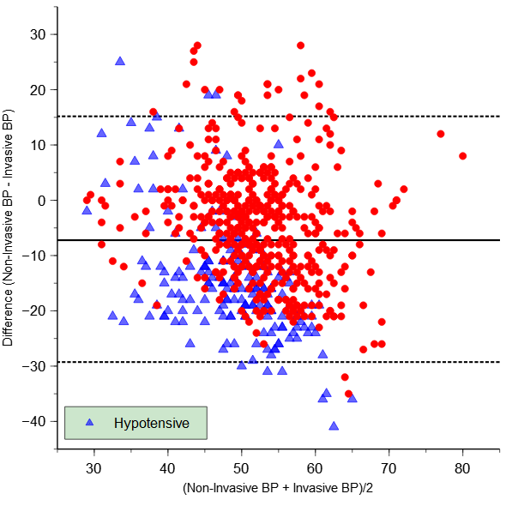

Figure 2. Bland Altman plots showing difference in MAP for individual sites.

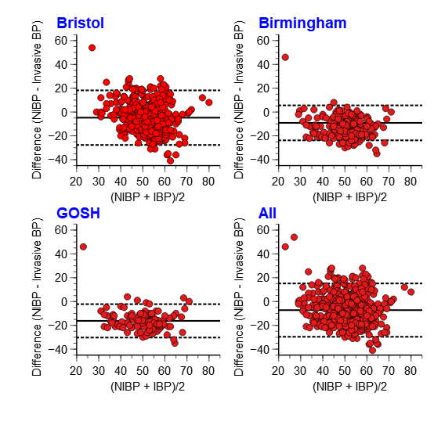

Figure 3. Bland Altman plots showing difference in diastolic (Panel A) and systolic (Panel B) BP for all patients.

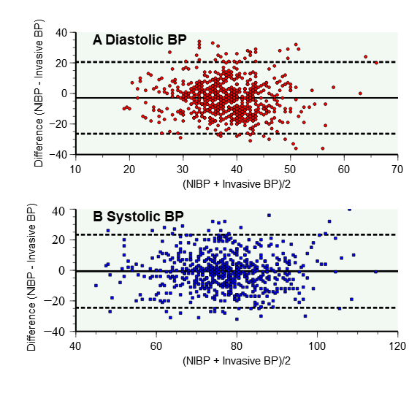

Figure 4. Blood pressure differences with age for all patients

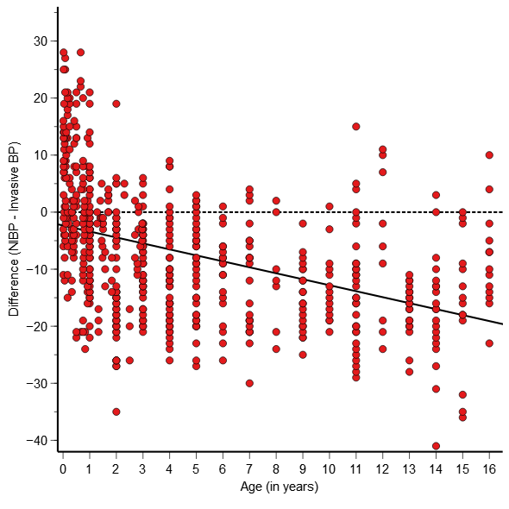

Figure 5. Relationship of MAP to weight for all patients including results of regression analysis: upper left panel for NIBP; upper right panel for invasive BP; lower left panel for agreement; lower right panel for the ratio of NIBP / invasive BP.

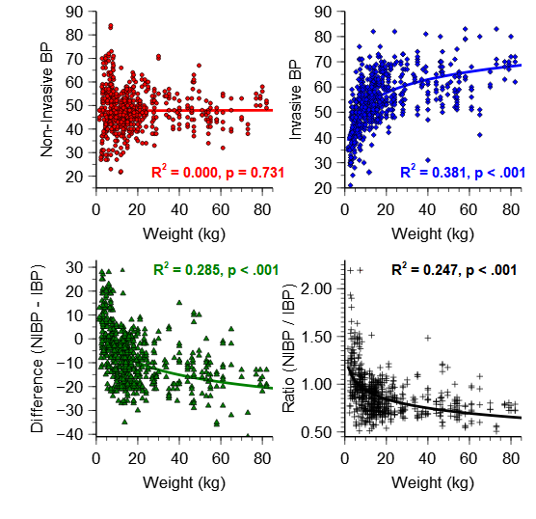

Discussion

These results may be concerning for clinicians caring for children during anesthesia or critical care. Many would agree that an overall bias for MAP of 7.2 mmHg is clinically significant and that a standard deviation of 11.4 demonstrates extremely poor agreement.

There is no agreed standard for validating blood pressure measurement devices during anesthesia, but for awake subjects the AAMI/ISO stipulate the mean (SD) bias for test vs reference BP differences to be less than 5 (8) mm Hg.¹⁴ This target was not achieved in any of the three centres in the current study.

Analysis of the data during periods of hypotension demonstrates even weaker agreement. The bias was greater in each centre, with an overall bias (SD) of 15 (11) mmHg. Non-invasive blood pressure readings are therefore even less reliable when the patient is hypotensive.

Poor agreement was also shown for SBP and DBP, with limits of agreement even wider than for MAP.

The difference in agreement with age presented in Figure 4 demonstrates that NIBP generally over-estimates MAP in infants under a year of age and under-estimates MAP in older children. Over-estimation of blood pressure in infants using NIBP has been previously reported.¹⁵

Figure 5 illustrates that NIBP is not correlated with weight, whereas invasive BP is correlated with the natural logarithm of weight. The difference (NIBP – invasive BP) and the ratio (NIBP / invasive BP) are also related to the natural logarithm of weight. Only invasive blood pressure measurements reflect the expected increase in MAP with increasing body mass.

Previous studies comparing invasive and oscillometric NIBP measurements report conflicting results. Comparison is hampered by the difficulty in interpreting the findings of studies done before Bland and Altman developed the favoured method of analysing these data.¹⁶

In the largest adult study to date, Wax et al described significant differences between NIBP and invasive blood pressure readings for 24 225 anesthetized adults, worse at extremes of pressure.⁸ A retrospective study of 872 children with severe burns reported significant discrepancy in measured values with bias (SD) of 5.8 (8.7) mmHg.¹⁷

Two recent studies of anesthetized children reported acceptable agreement for mean arterial pressure: a retrospective analysis of 67 anesthetised term neonates by Fujii et al found a bias (SD) of 1.3 (5.8) mmHg⁹; a prospective observational study by Meidert et al of 25 children aged under three years also showed reasonable agreement, with bias (SD) of 3 (7) mmHg, although agreement was poor during episodes of hypotension (bias -9 (5) mmHg).¹⁰

A systematic review and meta-analysis of studies from neonatal intensive care identified 18 studies utilizing Bland-Altman analyses. Although most studies reported a mean difference within 5 mmHg, only four studies met the study’s criteria for acceptable level of agreement (SD less than 5 mmHg).¹⁵ Of note, all studies in the first few days of life showed NIBP values to be higher than invasive.

It is striking that even studies reporting acceptable agreement demonstrate such wide confidence intervals. A standard deviation of 8 mmHg indicates that 95 percent of true blood pressure readings are expected to be within 16 mmHg of the measured MAP. This degree of ‘acceptable’ variation may be alarming for clinicians.

It is important to note that even if measurement of NIBP were reliable, interpretation of the measured value is not straightforward - blood pressure is a flawed surrogate for cardiac output and does not correlate with oxygen delivery.⁴ Furthermore, the safe range of blood pressure required to prevent organ damage is unknown, particularly for children.¹⁸ Anesthetists must consider these limitations when deciding how best to manipulate a patient’s haemodynamics.

Study limitations

The study population of children with congenital heart disease may not be representative of all children, so care must be taken in generalising these findings. Although prospective data collection overcomes many of the disadvantages of retrospective analysis, it does introduce the possibility of observer bias. For safety reasons, the study was designed to avoid any change from standard clinical care - this made standardisation of measurements difficult. Although the site of invasive BP monitoring does not significantly affect the MAP, the change in pulse wave morphology does affect SBP and DBP, making these data less reliable. The arms were by the side of the head in most, but not all paired readings – it is possible this may affect the NIBP reading and bias, although retrospective analysis did not show this to be significant. All three sites in this study used Philips Intellivue monitoring for NIBP, so it may not be appropriate to extrapolate these findings to all devices. It may be prudent for clinicians to determine agreement within their own institutions.

Conclusion

Automated oscillometric measurement of blood pressure in anesthetized children during cardiac catheterization is not reliable. Clinicians must understand the limitations of these devices when planning care and consider using invasive arterial pressure measurement for cases where accurate blood pressure measurement is essential.

Conflict of Interest Statement

The authors have no conflicts of interest to declare.

Acknowledgements

Many thanks to Dr Hannah Gill for assistance in preparing the manuscript.

References

1. Latham, G. J. et al. Perioperative morbidity in children with elastin arteriopathy. Paediatr Anaesth 26, 926–935 (2016).
2. Odegard, K. C. et al. The frequency of cardiac arrests in patients with congenital heart disease undergoing cardiac catheterization. Anesth Analg 118, 175–182 (2014).
3. Ramamoorthy, C. et al. Anesthesia-related cardiac arrest in children with heart disease: data from the Pediatric Perioperative Cardiac Arrest (POCA) registry. Anesth Analg 110, 1376–1382 (2010).
4. Bartels, K., Esper, S. A. & Thiele, R. H. Blood pressure monitoring for the anesthesiologist: A practical review. Anesth Analg 122, 1866–1879 (2016).
5. Kuck, K. & Baker, P. D. Perioperative noninvasive blood pressure monitoring. Anesthesia and Analgesia vol. 127 408–411 Preprint at https://doi.org/10.1213/ANE.0000000000002619 (2017).
6. Stergiou, G. S. et al. A universal standard for the validation of blood pressure measuring devices: Association for the Advancement of Medical Instrumentation/European Society of Hypertension/International Organization for Standardization (AAMI/ESH/ISO) Collaboration Statement. Hypertension 71, 368–374 (2018).
7. Stergiou, G. S., Boubouchairopoulou, N. & Kollias, A. Accuracy of Automated Blood Pressure Measurement in Children Evidence, Issues, and Perspectives. Hypertension vol. 69 1000–1006 Preprint at https://doi.org/10.1161/HYPERTENSIONAHA.116.08553 (2017).
8. Wax, D. B., Lin, H.-M. & Leibowitz, A. B. Invasive and Concomitant Noninvasive Intraoperative Blood Pressure Monitoring Observed Differences in Measurements and Associated Therapeutic Interventions. (2011).
9. Fujii, T. & Nishiwaki, K. Comparing oscillometric noninvasive and invasive intra-arterial blood pressure monitoring in term neonates under general anesthesia: A retrospective study. Paediatr Anaesth 30, 1396–1401 (2020).
10. Meidert, A. S. et al. Accuracy of oscillometric noninvasive blood pressure compared with intra-arterial blood pressure in infants and small children during neurosurgical procedures: An observational study. Eur J Anaesthesiol 36, 400–405 (2019).
11. Chowienczyk, P. Pulse wave analysis: What do the numbers mean? Hypertension 57, 1051–1052 (2011).
12. Lu, M. J. et al. Sample Size for Assessing Agreement between Two Methods of Measurement by Bland-Altman Method. International Journal of Biostatistics 12, (2016).
13. de Graaff, J. C. et al. Reference Values for Noninvasive Blood Pressure in Children during Anesthesia: A Multicentered Retrospective Observational Cohort Study. Anesthesiology 125, 904–913 (2016).
14. ISO 81060-2:2018(en), Non-invasive sphygmomanometers — Part 2: Clinical investigation of intermittent automated measurement type. https://www.iso.org/obp/ui/#iso:std:iso:81060:-2:ed-3:v1:en.
15. Dionne, J. M. et al. Method of Blood Pressure Measurement in Neonates and Infants: A Systematic Review and Analysis. J Pediatr 221, 23-31.e5 (2020).
16. Martin Bland, J. & Altman, D. G. STATISTICAL METHODS FOR ASSESSING AGREEMENT BETWEEN TWO METHODS OF CLINICAL MEASUREMENT. The Lancet 327, 307–310 (1986).
17. Cambiaso-Daniel, J. et al. Correlation between invasive and noninvasive blood pressure measurements in severely burned children. Burns 44, 1787–1791 (2018).
18. Karlsson, J. & Lönnqvist, P. A. Blood pressure and flow in pediatric anesthesia: An educational review. Paediatric Anaesthesia vol. 32 10–16 Preprint at https://doi.org/10.1111/pan.14328 (2022).

