Chinese Interprovincial Income Disparity via Regional Mobility Dynamics

Archana Kumari and Ian Smith

Archana Kumariis at the Gloucestershire Business School, University of Gloucestershire, United Kingdom. Ian Smithis at Bristol Business School, University of the West of England, United Kingdom.

***Abstract***: The growth paths in China diverge widely between the rich coastal and poor inland provinces. As a result, the impact of institutional effects on reducing provincial disparity in terms of the “Go West” policies implemented in the early-2000s appears to be based on the biased cultural attitudes of elites. In this study, the provincial disparity is studied from the perspective of regional mobility dynamics from 1993 to 2016 employing the X-convergence technique. With regards to findings, the study reveals the predominance of divergence among thirty-one provinces from 1993 until 2005 and convergence during 2005–2014. However, within the low-income group of provinces, the convergence started predominating after 2008. This suggests that some of the poorest of the poor provinces began to grow faster to catch up with the rest only from 2008, and therefore, the decline in regional disparity truly happened from 2008 which could be the result of “Go West” policy implementation in the early-2000s. Another important finding of this study is the prevalence of persistence between the income groups indicating rich provinces remain rich and poor remain poor. The implications of this study are particularly important for regional decision making in planning for economic cohesion.

***Keywords:*** provincial disparity, culture-based development, neo-Weberian approach, introvertive perspective, regional mobility dynamics

***JEL Codes:*** D60, D63, D69

The issue of regional disparity becomes important when the disparity persists and hinders the overall regional integration process. The persistence of economic disparities has been explained with the help of a number of factors such as physical capital, human capital, technology, etc. Other factors such as cultural legacies of institutions, values, norms, etc. explaining the regional income inequality have gained attention in the last decade (Tubadji and Nijkamp 2018; Tubadji 2020; Lynn 2008; Pollitt 2008). Accordingly, a common reason behind inequality is considered to be the repetitive “institutional corrosive effect” as explained by Leonard Seabrooke (2002). In this regard, concentrated wealth and income generated concentrated power at the top which in turn influenced the institutional decision making that advocated the betterment of the elites and the cycle continues. This implies that the disparity persists or widens between rich and poor.

The cultural embeddedness in geographical development behavior has been explained by Culture-Based Development (CBD) literature (Tubadji 2020). The literature highlights the significance of culture in local/rural and regional economic systems for the overall development of the national economy, which is an introversive take on the neo-Weberian approach (Xue, Hong, and Xu 2020). In other words, CBD results in individual and group cultural biases on economic choices that influence local economic development (Tubadji and Nijkamp 2018). One of the ideas of the neo-Weberian approach encompasses the CBD approach to understand the influence of cultural decision making on regional development.

The regional disparity in China highlights the problem of a wide economic gap between coastal and inland regions (Lemoine et al. 2014). The coastal provinces have been more open to the rest of the world through seaport and merchant trading (Lemoine et al. 2014). These provinces initiated a regime of modernization through the presence of foreign powers, colonial penetration, etc. Coastal regions have modern textile and food industries, commerce, banks, etc. and, therefore, they were more developed than inland. The modernity in the society was reflected in the cultural behavior of elites who influenced institutional decision making for their own development. Reportedly, the gap between provinces’ per capita output was very high during the 1990s.

Furthermore, Branko Milanovic (2014) argued that income inequality in China is stimulated by corruption at all levels of government that inhibit policy implementations that could benefit the poor. Likewise, Leonid Grinin, Sergey Tsirel, and Andrey Korotayev (2015) argued that limited resources and demographic problems would limit the Chinese economy from growing too fast. The evidence shows that the cultural implications of regional biased behavior aggravate the regional disparity highlighting the importance of the institutional corrosive effect and political concentration (Malesky, Abrami, Zheng 2011). Thus, institutional intervention in terms of policy implementation to reduce the regional income disparity is deemed important as it happened during the early-2000s when the Chinese government implemented the “Go West” policies. This accentuated the importance of regional administration and governance in policy implementation. The successful policy implementation that helped in reducing disparity could be deemed as an effect of neo-Weberian reforms (Byrkjeflot, Gay, Greve 2018; Lynn 2008; Sanderson 1988).

In this study, Chinese provincial disparity is discussed from a different perspective. The study highlights the importance of the regional mobility perspective to assess the change in rank order positions of the provincial income. This mobility assessment makes a thorough investigation of provinces that have overtaken, lagged behind, or stagnated compared to others. The methodology that is employed in the study is a pairwise comparative assessment using the X-convergence technique (Webber and White 2003; 2009). First, the provinces will be grouped into high- and low-income groups using a grouping algorithm technique called group-based trajectory method proposed by Daniel S. Nagin (1999).

The pairwise assessment will give a thorough outlook on the change in rank order position of provinces. The aim is to examine the implications of the “Go West” policies on provincial income convergence and divergence while understanding their mobility behavior. Regional policies were implemented to attract investment in the western poor provinces in China.

Mobility dynamics has been studied in China in terms of social mobility for individuals moving from one social stratum to another based on their income, education, health, and nutrition, among others (Cheong and Wu 2018; Chen and Cowell 2017; Cowell and Flachaire 2018; Khor and Pencavel 2011; Corak, 2013; Sun, Lu, and Bai 2007). However, the use of mobility dynamics has been ignored in the study of regional growth mobility. Chao Wu et al. (2019) emphasized the need to understand the relative behaviors of regions with regards to regional growth mobility. Just like the gradual social mobility of individuals (either in one generation or multiple generations) from low to high income strata in society is important, the mobility of regions from low to high income group is important for their economic growth and development.

With regard to the methodology, a novel technique called X-convergence, proposed by Don Webber and Paul White (2003; 2009) and Don Webber, Paul White, and David Allen (2005), can easily interpret the findings on the dynamic behavior of regions in pairwise settings. This technique has been employed and acknowledged by many researchers (Liobikienė and Mandravickaitė 2013; Novotný 2011; Aparicio, Carrasco, and Gómez 2014). One of the advantages of this technique is that it can unravel many regional dynamics simultaneously. For instance, in addition to convergence and divergence, the X-convergence technique has the potential to reveal the mobility behavior of regions by identifying regions that are overtaking, lagging behind, and stagnating. If the regions are not switching places between high- and low-income groups, then it implies persistence between the income groups (i.e., rich are still rich and poor are still poor).

Therefore, investigation of the evolution of regional dynamics of convergence, mobility, and persistence can reveal the subtleties of regional disparity that has not been studied in detail. The effects of the implementation of the “Go West” policies via changing income per capita or understanding regional dynamics in detail could provide valuable insights on regional disparity. The mobility assessment between groups of high- and low-income provinces will reveal whether the income groups are persistent or not. Persistence demonstrates path dependency which could be the result of culturally biased decision making by the institutions. Hence the X-convergence method would be appropriate to compare the subtleties of regional disparity pre- and post-implementation of the “Go West” policies. The investigation of regional dynamics of mobility and persistence is not explored in widely studied regional inequality studies in China. Realizing the gap in the literature on understanding the evolution of regional dynamics to identify the provincial disparity, this article employs the X-convergence technique to assess the inequality trend for thirty-one provinces from 1991 to 2015.

Regional Inequality in China

One of the sustainable development goals of the United Nations is to promote balanced growth within a nation, (United Nations, 2020).[1] Rising inequality poses a threat to the long-term sustainable growth of a country through economic, social, and political risks (Kanbur and Lustig 2000). The divide between rich and poor provinces in China can be illustrated with the gap between the richest and poorest provinces. In 2016, the highest income was for Beijing at 118,198 yuan/person which was around four times Gansu’s income at 27,643 yuan/person (see figure 1). In 2016, out of the ten top income provinces, eight were coastal. The divide between coastal and inland provinces are studied by many researchers (Tian et al. 2016; Yang 2002). For instance, Xu Tian et al. (2016) used Peter C. B. Phillips and Donggyu Sul’s (2007) method to identify clubs of thirty-one provinces using GDP per capita data from 1978 to 2013. The study identified two clubs including Shanghai, Tianjin, Jiangsu, Zhejiang, Guangdong, Shandong, Fujian (eastern coastal provinces), and Inner Mongolia converge into a high-income club, and the remaining provinces converge into a low-income club.

Figure 1. GRP per Capita of Thirty-Onee Provinces in 1993 and 2016

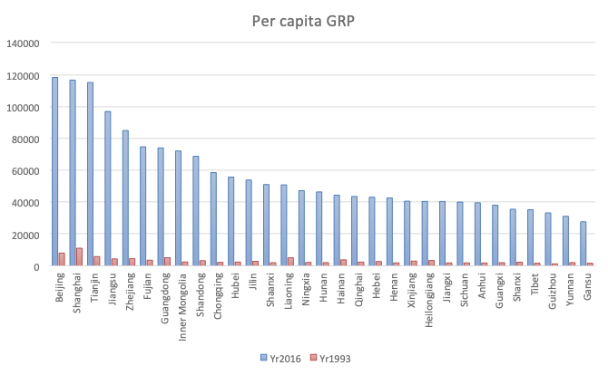

Source: National Bureau of Statistics China

The Chinese reforms of 1978 marked the beginning of fiscal and economic decentralization in China. Due to decentralization, autonomous power was delegated to regional local governments and they were incentivized to stimulate economic growth (Lin and Liu 2000; Yang 2002; Jian, Sachs, Warner 1996). Because of the decentralization, China’s economy grew at a fast rate; however, at the same time, it promoted competition among economies to become rich (Li and Haynes 2011). Government fund transfers directed to poor regions were easily manipulated by the rich provincial and municipal governments (Li and Wu 2012). Therefore, the economic divide between coastal and inland provinces appear to be the result of the unprecedented growth of coastal provinces, partially due to the nature of government policies and programs designed to achieve further economic growth.

Regional income convergence and inequality in China have been studied by many researchers such as Ravi Kanbur and Nora Lustig (2000), Sonali Jain-Chandra et al. (2018), Xu Tian et al. (2016), and Dennis Tao Yang (2002). Trends on regional inequality reveal that China has been showing evidence of conditional convergence, after controlling for factors such as physical and human capital, investment, employment, etc. (Cai, Wang, Du 2002; Weeks and Yao 2003; Chen and Fleisher 1996; Raiser 1998; Zhang, Z., Liu, Yao 2001; Tian et al. 2016. According to the conditional convergence hypothesis of neoclassical theory, economies experience conditional convergence depending on the similarity of their structural characteristics, such as preferences, technologies, and savings rate (Galor 1996; Islam 2003). Jian Chen and Belton M. Fleisher (1996), using beta and sigma convergence, provided the evidence of conditional convergence among twenty-five Chinese provinces between 1978 and 1993 by controlling for coastal location, physical and human capital, employment growth, and foreign direct investment. However, at the same time, evidence of unconditional (absolute) convergence has been provided by Erich Gundlach (1997) by employing beta and sigma convergence for regional income per worker in twenty-nine provinces from 1978 to 1989. Please note that unconditional (absolute) convergence suggests that convergence between capital rich and poor economies occurs because capital poor economies experience higher growth over time than capital rich economies due to factor mobility and factor price equalization.

Exploring the reasons behind the coastal and inland regional inequality, Tianlun Jian, Jeffrey Sachs, and Andrew Warner (1996) observed that the convergence from 1978 was the result of rural areas of coastal provinces growing faster and not the rural areas of inland provinces. Later, Martin Raiser (1998) further investigated the convergence phenomena of Chinese provinces from 1978 to 1992 and found a weakening of convergence from 1985 mainly because the rich coastal areas were growing at a faster rate due to redirection of capital toward rich coastal provinces rather than poor inland regions. Simialrly, Yingqi Wei and Xiaming Liu (2004) investigated the provincial income for the period from 1980 to 2001 and, using the Gini Coefficient, found increasing regional disparity from the 1990s. Increasing regional disparity during the 1990s is in line with studies such as Fang Cai, Dewen Wang, and Yang Du (2002), Sylvie Demurger et al. (2002), Max Lu and Enru Wang (2002), among others.

The rural economic system plays an important role in rural development and they are influenced by differences in cultural backgrounds (Xue et al. 2020). This can be explained with the help of corrosive institutional effects as explained by Seabrooke (2002). In China, there has been a concentration of economic activities near the coastal provinces that helped them prosper. This led to the concentration of wealth and power in certain areas, which in turn increased the possibility of public institutions being lobbied/captured by private elites. The government funding was easily manipulated and transferred to the already rich and powerful regions that undermined the autonomy of local/rural regions. The ongoing social and economic norms got imbibed by the regional/rural development cultural biasedness in China that aggravated the regional income disparity. The local and regional institutional autonomy constitutes an important part of neo-Weberian literature (Seabrooke 2002; Byrkjeflot, Gay, Greve 2018; Lynn 2008; Sanderson 1988).

The Chinese economic reforms starting in 1978 have been important factors that led to a drastic change in the economic growth of the country. Similarly, in the early-2000s, realizing the increasing income gap between provinces, the government started to implement “Go West” strategies for the development of western/inland regions—Chongqing, Sichuan, Guizhou, Yunnan, Tibet, Shaanxi, Gansu, Ningxia, Xinjiang, Inner Mongolia, Guangxi, and Qinghai (Singh 2002; Goodman and Edmonds 2004; Lin and Chen 2004). The government started to implement policies to make regions conducive to foreign investments by investing in infrastructure, educational facilities, reskilling labors, etc. (Lemoine et al. 2014; The State Council 2016). The government tried to bridge the gap among provinces through policies and administration and enhance regional integration.

However, every effort to strengthen regional growth has been initially overcast by the culture of local politics, bureaucracy, and chaos (Li and Wu 2012). As a result, it took some time to reflect the benefits of the policies in the provincial income in China. The studies suggest that these initiatives started showing signs of improvement for regional inequality and inequality reversed during the period from 2005 to 2010 when inland provinces started to converge with the coastal provinces (Fan and Sun 2008; Liao and Wei 2016; Ma and Summers 2009). Zhengyun Sun (2013), using the coefficient of variation, Gini, and Theil index, showed declining interprovincial inequality around 2005.

The reduction in regional inequality was reflected in the reduction of household inequality as well. In 2010, China became the first developing country to achieve the World Bank’s Millennium Development Goals (MDGs) before the target year. In this regard, research shows that the absolute income gap has reduced but the relative gap still needs attention (Wang et al. 2020; Yu et al. 2019). For instance, Jain-Chandra et al. (2018) outlined that a moderate decline in Gini coefficient from 2008 has been driven by a decline in the income share of the top twenty and gains in the middle of the income distribution, instead of an increase in the income share of the bottom group. Therefore, it appears that an improvement in the middle-class segment led to a reduction in income inequality rather than the poor class. This inference is also applicable to the most backward regions that still need support to show growth improvements (Ma and Summers 2009; *The Economist* 2019).

The neo-Weberian institutional approach highlights the capacity of local and regional institutions in reducing income disparity (Lottholz and Lemay-Hébert 2016). In the context of China, the institutional intervention has proved important for enhancing regional economic growth. It is also evident that the local government decision making is culturally biased in promoting the already developed regions. In this regard, the article will empirically assess the regional dynamics of convergence, mobility and persistence to understand the nuances of provincial disparity in China. The implementation of “Go West” policies have changed the rank order positions of inland provinces by changing the cultural attitudes of local economic systems. Therefore, this article will provide empirical evidence of change in the economic disparity trend for thirty-one provinces considering the mobility and persistence dynamics due to institutional intervention, which is an introvertive take for China. The mobility assessment of economies in China from an introvertive perspective has limited evidence in the literature.

Methodology

The article argues that convergence as a relative measure is better than as an aggregate measure. That is, measuring convergence between two regions in a pairwise setting provides more details when examining convergence patterns between regions. Moreover, the quantification of actual movement of economies by identifying economies that are overtaking, stagnating, or lagging behind in relative terms could help policymakers to appropriately focus resources to regions that need them the most.

Even after recognition of the importance of mobility dynamics to investigate growth and inequality among economies, there remains a lack of sufficient measures to investigate distributional dynamics issues in detail (Novotný 2011; Castro 2003; Gluschenko 2012; Monfort 2008). To fill this gap, Webber and White (2003; 2009) and Webber, White, and Allen (2005) have proposed the X-convergence technique that examines important regional dynamics of convergence, divergence, switching, persistence, polarization, and mobility of economies, all at the same time. The simultaneous assessment of major regional dynamics is a feature that makes Webber and White’s (2003; 2009) measure distinct from other measures of inequality. Since the technique assesses the change in income for two provinces between two time periods in a pairwise setting, it helps precisely quantify and compare the mobility of economies within a distribution.

The studies in the domain show limited evidence of the dynamic behavior of income distribution in terms of changing rank order positions in a comprehensive pairwise setting (Novotný 2011). The dynamic behavior of economies between two time periods has been assessed by the changing rank order positions of economies by researchers such as Danny Quah (1993; 1997) and G. E. Boyle and T. G. McCarthy (1997; 1999). By examining the changing rank positions, Webber, White, and Allen (2005) showed various possibilities of emerging distributional dynamics as shown in figure 2.

Another distinctive feature of the X-convergence method proposed by Webber and White (2003; 2009) is that it facilitates an in-depth study of two regions between two time periods to assess the exact frequency of convergence or switching. This allows the researchers to take account of the repercussions of any small change that happens during a particular time period. The method has been employed to understand various forms of inequalities in a number of subsequent studies—the living standard inequality dynamics by Josef Novotný (2011), changes in household consumption expenditure regarding environmental impact by Genovaitė Liobikienė and Justina Mandravickaitė (2013), and convergence of public expenditure by Jesus Ferreiro, Carlos Alberto Carrasco, and Carmen Gómez (2014), among others. It is evident that the X-convergence technique has been used by researchers to get insights on the convergence of different variables. X-convergence could provide important insights for understanding inter-regional growth convergence and inequality.

Figure 2. Different Possibilities of Emerging Distribution Dynamics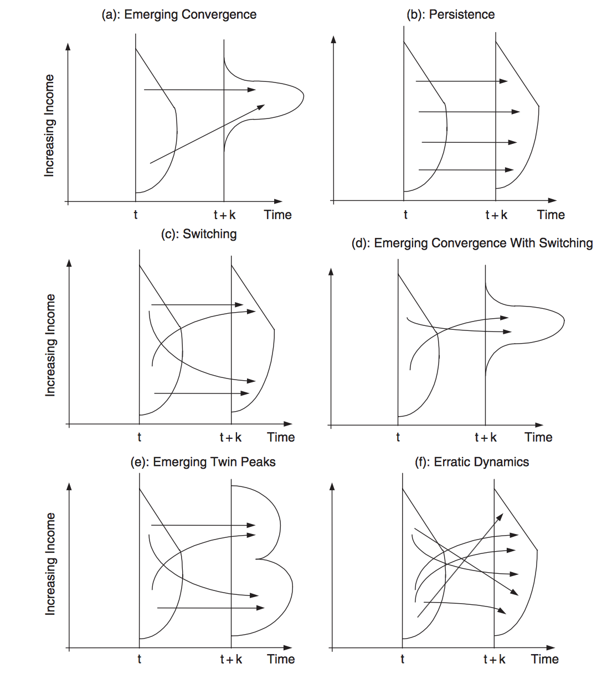

Source: Webber, White, and Allen (2005)

The X-convergence statistic calculates convergence and divergence indicators in terms of relative ratios of differences in per capita income between two economies between two time periods. Averaging the estimated frequencies of per capita income differentials for each pair provides a measure of converging pairs and diverging pairs of economies. The method is much more comprehensive than the earlier cited indicators of convergence and divergence because this method interprets outcomes based on every pair of economies. If the comparison is based on “n” economies, total indicators of n(n–1)/2 pairs are investigated. This provides an overview of differentials in per capita GDP in relative ratios terms.

Inspired by the neoclassical growth predictions of convergence that a poor economy grows at a higher speed to catch up with a rich economy, Webber and White’s (2003; 2009) model outlines that convergence could be referred to as a gradual decrease in the magnitude of difference between rich country’s (*i*) and poor country’s (*j*) output per capita (si and sj) between periods t and t+T.

That is, if si,t > sj,t and (si,t – sj,t) > (si,t+T – sj,t+T), then this is “convergence without switching.” Note that rich country *i*’s growth rate will be lower than the poor country *j*’s growth rate in *t+T*. In other words, convergence without switching based on ratios of per capita GDP happens when (si,t/ sj,t) > (si,t+T/ si,t+T) > 1.

Following Webber and White (2009):

(si,t/ sj,t)Xi,j= (si,t+T/ si,t+T) (1)

si > sj > 0

By defining Xij as a solution for 1) and taking logarithms on both sides gives:

$X_{i,j}= \frac{{log⁡(s}_{i,t+T })-log⁡(s_{j,t+T})}{\log\left(s_{i,t}\right)-\log\left(s_{j,t}\right)}$ (2)

If, Xi,j > 1 then countries i and j exhibit divergence in ratios without switching,

Type I[2], where a relatively high-income region (A) grows at a faster rate rather than low-income region (B) as shown below in figure 3:

Figure 3. Type I Behavior

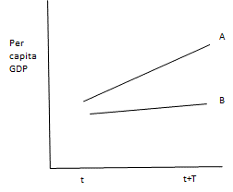

If 0 < Xi,j < 1 then countries i and j exhibit convergence in ratios without switching which is called Type II and where a relatively low-income region (B) grows faster rate than the relatively high-income region (A) which stagnate as shown below in figure 4:

Figure 4. Type II behavior

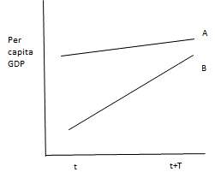

When –1 < Xi,j < 0 occurs then countries i and j exhibit convergence in ratios with switching, which is called Type III and where a relatively high-income region (A) lags behind the relatively low-income region in terms of growth, as shown below in figure 5.

Figure 5. Type III Behavior

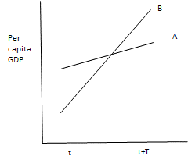

When –1 > Xi,j then countries i and j exhibit divergence in ratios with switching, which is called Type IV and where a relatively low-income region (B) overtakes high-income region (A), as shown in figure 6.

Figure 6. Type IV Behavior

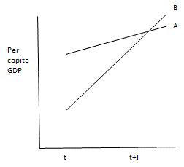

When Xi,j = 0 then the countries have already merged and there cannot be any further convergence, which is called Type V, as shown in figure 7.

Figure 7. Type V Behavior

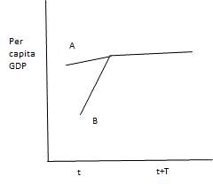

The typologies are based on the corollary of the neoclassical hypothesis of convergence (i.e., where poor regions grow at a faster rate to converge with the richer ones). The total convergence among regions is determined by adding Type II and Type III percentages and the total amount of divergence is determined by adding together Type I + Type IV. Type V instances of full convergence were not noted in the analysis, and that is why it is omitted from the analysis.

Moreover, the X-convergence measure is based on changes in income per capita of two regions between two time periods. The indicators could be interpreted based on the estimates obtained by the formula. The statistical estimates simply describe the data and do not allow predictions; hence, the measure is descriptive and not inferential.

Data

Per capita Gross Regional Product data (yuan/person) was obtained for thirty-one provinces from 1993 to 2016 from the National Bureau of Statistics China. The time period justifies the aim to evaluate the evolution of regional convergence and disparity issues as the literature suggests that the mid-1990s experienced a widening between the growth paths of rich and poor provinces in China. The evidence of culturally biased attitudes in the redistribution of income is assessed in a casual manner in Chinese literature. This study attempts to provide an understanding of the regional dynamics change due to institutional intervention in terms of policy implementation in the early-2000s.

Findings

To show some basic characteristics of per capita Gross Regional Product (GRP), table 1 provides the descriptive statistics for four periods—1993, 2000, 2007 and 2016. The mean per capita GRP is increasing thereby revealing an increase in the average income of provinces in China. The standard deviation is continuously increasing since 1993 indicating that the values are spreading out from the mean. Figure 8 shows the minimum and maximum values for per capita GRP over these years. The minimum value depicts the minimum per capita GRP for the low-income provinces such as Guizhou, Gansu, Yunnan, etc. Whereas, the maximum value depicts the maximum per capita GRP for the respective years. Shanghai was the richest province until 2011 and, thereafter, Beijing secured the top position. The maximum value reflects Shanghai’s per capita GRP in 1993, 2000, and 2007 and Beijing’s in 2016. The minimum and maximum values have an increasing trend showing increasing incomes for low- and high-income provinces, however, the big difference between the two values indicate a large income differential between the richest and the poorest provinces over the years.

Examination of the difference between the minimum and maximum values in 1993 and 2016 reveals a disproportionate share of income between rich and poor provinces. Comparison of income in relative ratios becomes significant in the case of China because there is a big gap between the richest and the poorest province.

Table 1. Descriptive Statistics

|  |  |  |  |  |  |  |
| --- | --- | --- | --- | --- | --- | --- |
| **Variable** |  | **Obs** | **Mean** | **Std. Dev.** | **Min** | **Max** |
| 1993 |  | 31 | 3211.871 | 2077.605 | 1234 | 11061 |
| 2000 |  | 31 | 8520.129 | 5938.547 | 2759 | 29671 |
| 2007 |  | 31 | 22189.81 | 13672.5 | 7878 | 62041 |
| 2016 |  | 31 | 56766.23 | 25721.24 | 27643 | 118198 |

Figure 8. Minimum and Maximum per Capita GRP Values Trend

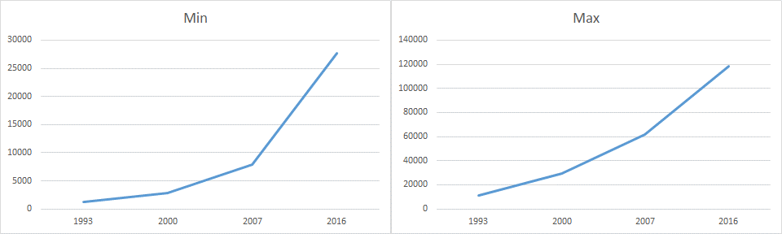

X-Convergence

This section discusses the findings obtained by employing the X-convergence technique. It starts by investigating the aggregate trend on convergence among thirty-one provinces and then it divides the provinces into groups of high- and low-income provinces using group-based trajectory modelling. Furthermore, it analyzes the convergence trend within and between high- and low-income groups of provinces.

Figure 9 shows the percentage occurrence of convergence and divergence in relative ratios for thirty-one provinces compared in pairs. Between 1993–2005, barring a few exceptions, Type I behavior is predominant throughout. This finding suggests that high percentages of pairs of provinces demonstrated divergence without switching. This could mean two things, first, that high-income provinces are growing at a very fast speed and diverging away, secondly, low-income province is growing at a very slow rate creating a gap with their counterparts. In the case of Chinese provinces, the rich coastal provinces were growing at faster rates during the 1990s and diverging away with the rest as demonstrated below in table 2. Table 2 shows that during 1993–2003, except for the year 1995–1996, all the ten coastal provinces were demonstrating higher percentages of Type I behavior with the rest of the provinces. This underlines an increase in provincial income disparity led by higher growth rates experienced by relatively high-income provinces during the 1990s.

On the other hand, table 3 shows the Type I and II behaviors demonstrated by twenty-one inland provinces with the rest of the provinces from 2005 to 2013. It shows higher instances of Type II behavior which is convergence without switching with others. This implies that low-income inland provinces have attained higher growth to converge with the rest as explained by the neoclassical convergence hypothesis. In other words, the low-income provinces grew at a faster rate compared to the rest of the provinces that helped in catching up of these provinces with the rest. This could be the effect of “Go West” policies implemented in the early-2000s. The insights on high- and low-income groups of provinces are demonstrated in subsequent sections.

Figure 9. Percentage of Instances of Types of Behavior Exhibited by Provinces

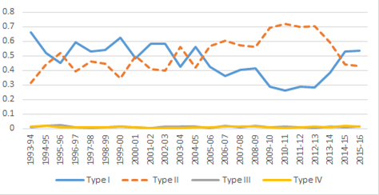

Type I = Divergence without switching, Type II = Convergence without switching, Type III = Convergence with switching, Type IV = Divergence with switching.

Table 2. Percentages of Type I and II Behavior Demonstrated by Ten Coastal Provinces with the Rest during 1993–2007

|  |  |  |
| --- | --- | --- |
|  | Type I | Type II |
| 1993-94 | 0.657 | 0.33 |
| 1994-95 | 0.537 | 0.44 |
| 1995-96 | 0.447 | 0.55 |
| 1996-97 | 0.61 | 0.373 |
| 1997-98 | 0.64 | 0.36 |
| 1998-99 | 0.693 | 0.307 |
| 1999-00 | 0.617 | 0.383 |
| 2000-01 | 0.55 | 0.443 |
| 2001-02 | 0.647 | 0.353 |
| 2002-03 | 0.58 | 0.413 |
| 2003-04 | 0.447 | 0.54 |
| 2004-05 | 0.467 | 0.51 |
| 2005-06 | 0.387 | 0.61 |
| 2006-07 | 0.263 | 0.723 |

Table 3. Percentages of Type I and II Behavior Demonstrated by Twenty-One Inland Provinces with the Rest during 2005–2013

|  |  |  |
| --- | --- | --- |
|  | Type I | Type II |
| 2005-06 | 0.444 | 0.544 |
| 2006-07 | 0.408 | 0.551 |
| 2007-08 | 0.478 | 0.494 |
| 2008-09 | 0.468 | 0.489 |
| 2009-10 | 0.341 | 0.635 |
| 2010-11 | 0.332 | 0.654 |
| 2011-12 | 0.324 | 0.662 |
| 2012-13 | 0.281 | 0.702 |

The findings of the prevalence of divergence during the 1990s and convergence during the mid-2000s are supported by the literature (Lu and Deng 2011; Fan and Sun 2008; Liao and Wei 2016). These findings also confirm the outcomes of standard measures of convergence that reveal a prevalence of convergence during 2000s. The trend seems to reverse from 2014–2015 when the instances of divergence have surpassed the instances of convergence. This indicates a slowdown in the economy for the inland provinces; for instance, Gansu experienced an increase in GRP per capita from 26,433 to 27,643 yuan/person in 2014 and 2016. Similarly, Guangxi experienced an increase in per capita income from 33,090 to 38,027 yuan/person only. On the other hand, Beijing and Shanghai experienced increases in income from 99,995 to 118,198 and from 97,370 to 111,652, respectively.

Examining the Type III and Type IV behavior in figure 10, the proportion of pairs of provinces switching is very low compared to those without switching. The highest switching behavior is observed for Type IV behavior which is divergence with switching for the period 2014–2015. Provinces have switched places at ten instances. Provinces that changed positions mostly are Xinjiang, Anhui, Jiangxi, Fujian, Hainan, Shanxi, Liaoning, Guangdong, Heilongjiang, Yunnan, Guizhou, Hebei, Hunan, Qinghai. Most of these provinces are low-income inland provinces. The low instances of Type III and IV behaviors for the high-income coastal provinces indicate that they are mostly permanently placed in their rank positions. The evidence suggests that there is a persistence in the income groups of the provinces.

Figure 10. Percentage of Instances of Types of Behavior Exhibited by Provinces

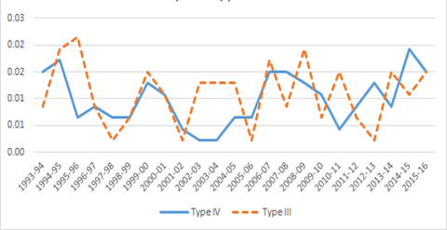

Type III = Convergence with switching, Type IV = Divergence with switching.

The X-convergence technique suggests the prevalence of higher instances of convergence from the mid-2000s and not before. The next section identifies the groups of high- and low-income provinces and then analyze in detail the change in regional dynamics within and between groups to understand their mobility behaviors.

Group Analysis

Two groups of provinces were identified using Nagin’s (1999) group-based trajectory modelling approach. The Bayesian information criterion (BIC) is highest at –2172.79 for two groups with linear growth paths for group members. The other deciding factor for group determination is the p-value for every parameter. Table 4 shows a significant p-value for every parameter. The group membership for the first group indicates that 32.25 percent of total provinces lie in group 1. This turns out to be ten provinces (0.3225X31 provinces) in group 1. Similarly, there are twenty-one provinces (0.6774X31 provinces) in group 2. Table 5 provides a list of provinces in group 1 and group 2.

The high-income group consists of ten provinces and the low-income group consists of twenty-one provinces as shown in table 4. The high-income group consists of eight coastal provinces in addition to Inner Mongolia and Liaoning. Liaoning relies on the steel industry and has a higher income per capita than Inner Mongolia in 1993 but Inner Mongolia surpassed Liaoning’s income per capita in 2007. Inner Mongolia, rich in rare earth mineral resources, has experienced sustained and stable flourishing in regional industries, including dairy, clean energy, processing, and rare earth industry. The increasing regional investment in fixed assets with sustained regional industries helped Inner Mongolia show significant improvement in economic growth. The growth supports Inner Mongolia to surpass some coastal provinces’ output growth.

Table 4. Group Membership Based on Group-Based Trajectory Modelling Approach

|  |  |  |  |  |
| --- | --- | --- | --- | --- |
| Group | Parameter | Estimate | Prob > |T| |  |
|  |  |  |  |  |
| 1 | Intercept | 1.8419 | 0 |  |
|  | Linear | 0.00001 | 0 |  |
|  |  |  |  |  |
| 2 | Intercept | 1.87837 | 0 |  |
|  | Linear | 0.00003 | 0 |  |
|  |  |  |  |  |
| Group | membership |  |  |  |
| 1 | (%) | 32.25811 | 0.0001 |  |
| 2 | (%) | 67.74189 | 0 |  |
|  |  |  |  |  |

The high-income group consists of ten provinces and the low-income group consists of twenty-one provinces as shown in table 5. The high-income group consists of eight coastal provinces in addition to Inner Mongolia and Liaoning. Liaoning relies on the steel industry and has a higher income per capita than Inner Mongolia in 1993 but Inner Mongolia surpassed Liaoning’s income per capita in 2007. Inner Mongolia, rich in rare earth mineral resources, has experienced sustained and stable flourishing in regional industries including dairy, clean energy, processing, and rare earth industry. The increasing regional investment in fixed assets with sustained regional industries helped Inner Mongolia show significant improvement in economic growth. The growth supports Inner Mongolia to surpass some coastal provinces’ output growth.

Table 5. Names of High-Income and Low-Income Provinces

|  |  |
| --- | --- |
| High-income group | Beijing Tianjin, Inner Mongolia, Liaoning, Shanghai, Jiangsu, Zhejiang, Fujian, Shandong, Guangdong |
| Low-income group | Hebei, Shanxi, Jilin, Heilongjiang, Anhui, Jiangxi, Henan, Hubei, Hunan, Guangxi, Hainan, Chongqing, Sichuan, Guizhou, Yunnan, Tibet, Shaanxi, Gansu, Qinghai, Ningxia, Xinjiang |

Between High-Income and Low-Income Provinces

The between group analysis of high and low-income group as shown in figure 11 reveals that the percentage of instances of Type I behavior was higher during the 1990s than in the 2000s and Type II behavior was higher after the mid-2000s. The findings suggests that the low-income provinces were growing at a faster rate than the richer provinces from 2005 and catching up with the high-income provinces. This is consistent with the literature that reveals that inequality reduced after the mid-2000s (Fan and Sun 2008).

Figure 11. Percentage of Instances of Types of Behavior Exhibited by Provinces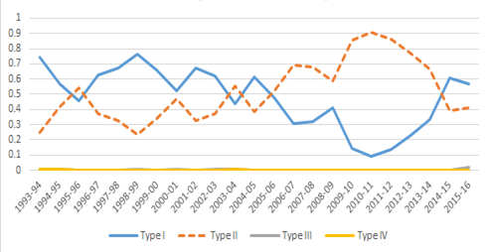

Type I = Divergence without switching, Type II = Convergence without switching, Type III = Convergence with switching, Type IV = Divergence with switching.

The instances of switching places as shown by Type III and IV behaviors between high-income provinces and low-income provinces during 2000–2016 are shown in table 6:

Table 6. High-Income Provinces Switching Rank Order Positions with Low-Income Provinces during 1993–2016

|  |  |
| --- | --- |
| **Coastal province** | **Switching places with inland provinces** |
| Beijing | No Switch |
| Shanghai | No Switch |
| Tianjin | No Switch |
| Jiangsu | No Switch |
| Zhejiang | No Switch |
| Fujian | No Switch |
| Shandong | No Switch |
| Guangdong | No Switch |
| Liaoning | No Switch |
| Inner Mongolia | Jilin, Xinjiang, Heilongjiang, Hubei |

Table 6 suggests that except Inner Mongolia, no other high-income province has changed positions with any low-income province. Instead, there is evidence of stratification and persistence between high-income and low-income provinces. In other words, the rich provinces were still rich and poor were still poor throughout the period of analysis.

Within High-Income Group

As shown in figure 12, the high-income provinces show higher instances of Type II behavior of convergence within themselves roughly from 2002 to 2014.

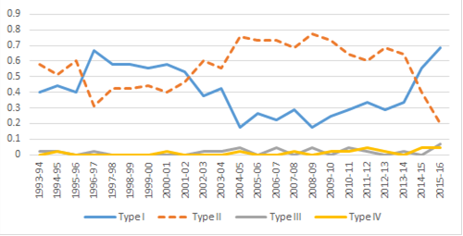Figure 12. Percentage of Instances of Types of Behavior Exhibited by Provinces.

Type I = Divergence without switching, Type II = Convergence without switching, Type III = Convergence with switching, Type IV = Divergence with switching.

The prevalence of convergence is evident for a greater number of years than divergence for high-income provinces (1993–1996 and 2003–2014) indicating a decline in inequality among these provinces. Coastal provinces are mostly converging with each other which is in line with the literature (Fujita and Hu 2001; Démurger et al. 2002; Jian et al. 1996). The preferential government policies and transfers, and industrial agglomeration have helped coastal areas to integrate into the international economy (Raiser 1998). These factors, to a large extent, helped coastal provinces to converge their growth paths with each other.

For the nation as a whole, convergence trend shown in figure 9 and within coastal provinces shown in figure 12, the percentage of Type I behavior is surpassing the Type II behavior from 2014. This indicates the phase of income disparity starting to come back during these years.

In terms of mobility, figure 13 suggests limited evidence of Type III and Type IV behavior exhibited by provinces. Consequently, the rank order positions of provinces have not altered very much, thereby indicating persistence within the rich group with the top three rich positions taken by Beijing, Shanghai, and Tianjin throughout.

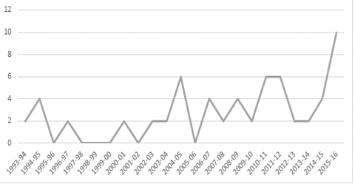Figure 13. Frequency of Type III and IV Behaviors within High-Income Group during 1993–2016

The frequencies of Type III and IV behaviors are very low for within high-income provinces. One pair (two instances) in 1993–1994 and five pairs (ten instances) in 2015–2016 have shown switching behavior. This implies that the switching of places is very low within high-income provinces.

Within Low-Income Group

The within low-income provincial convergence/divergence pattern is very different from what is shown in figure 9 for the whole sample. As shown in figure 14, until 2009 the patterns of convergence/divergence for low-income inland provinces are irregular and after 2009 there is a presence of higher instances of Type II behavior of convergence without switching. Thus, the presence of convergence for the whole sample (figure 9) after 2005 is mostly driven by high-income provinces’ higher instances of convergence (figure 12) and not inland provinces. This indicates that the reduction in disparity among provinces in China after 2005 is mostly due to a reduction in disparity within high-income provinces and not low-income provinces.

The divergence within inland provinces poses higher risks for already poor inland regions because it could be the case that the poorest of the poor regions did not receive much attention to evolve and perform better, which led to a widening of the gap between rich and poor provinces. This seems to have gone unnoticed as literature only talks about the declining disparity between rich coastal and poor inland provinces from the mid-2000s. Between 2000 and 2008, the low-income provinces mostly show higher instances of divergence which indicate that some of the poorest of the poor regions have not performed well in terms of economic growth.

In the light of mobility dynamics, there has been a reasonable amount of switching places between the low-income provinces as shown in figure 15. This indicates that low-income provinces are showing attributes of intra-distributional mobility. Type III, which is convergence with switching indicates relatively high-income regions lag behind the relatively low-income region within the distribution. Type IV, which is divergence with switching, indicates some relatively low-income regions overtaking some relatively high-income regions within the distribution. Delving deeper into identifying the provinces that have demonstrated these two types of behavior would indicate which region is lagging behind and which one is overtaking within the distribution. To shed more insights on identifying provinces lagging behind and overtaking, table 7 provides details on the names of provinces that showed Type III and IV behaviors between 2004–2005 and 2015–2016. This period was chosen because during this period the whole sample analysis shows the prevalence of convergence. The table shows the frequency of pairs of provinces that exchanged places with other provinces during a time period. For instance, during 2006-2007, Chongqing showed Type III behavior with one province and Type IV behavior with another province, indicating that this province has converged and diverged with two different provinces by exchanging positions with them.

Figure 14. Percentage of Instances of Types of Behavior Exhibited by Provinces

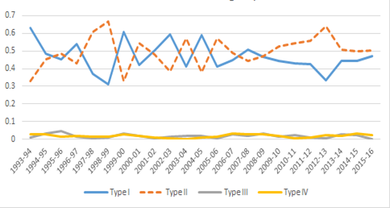

Type I = Divergence without switching, Type II = Convergence without switching, Type III = Convergence with switching, Type IV = Divergence with switching.

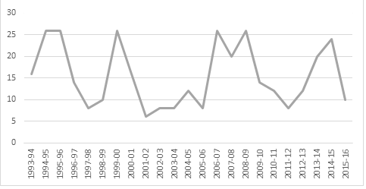Figure 15. Frequency of Type III and IV Behaviors within Low-Income Group during 1993–2016

Table 7 indicates that recently, between 2013–2014 and 2014–2015, Hebei has shown Type III behavior indicating that it has lagged behind some provinces during these years. For the years between 2012 and 2016, the study did a detailed analysis on a few provinces listed below to identify which provinces lagged behind and overtook based on the instances of Type III and IV behaviors.

Hebei lagged behind Hainan from 2014 and Hunan from 2014. Shanxi overtook Henan in 2012 but lagged behind Henan since 2014. Anhui, Guangxi, Sichuan, and Jiangxi overtook Shanxi from 2015. Hunan overtook Shanxi from 2013. Therefore, comparing these five provinces, Shanxi has lagged behind all of these provinces—Henan, Anhui, Jiangxi, Guangxi, Sichuan, and Hunan in 2015. Thus, comprehensive details on lagging behind and stagnating regions is a strength of the X-convergence estimates.

Table 7. Names of Provinces Changing Rank Order Positions within Group

|  |  |  |
| --- | --- | --- |
| 2004–2005 | Type III | Guangxi, Hainan, Chongqing, Anhui, Henan |
|  | Type IV | Tibet, Ningxia, Jiangxi, Hunan |
| 2005–2006 | Type III | Qinghai, Shaanxi |
|  | Type IV | Henan, Hubei, Chongqing, Hainan, Tibet, Sichuan |
| 2006–2007 | Type III | Xinjiang, Chongqing, Shaanxi, Ningxia, Henan, Hubei, Gansu, Hainan, Yunnan |
|  | Type IV | Jilin, Heilongjiang, Henan, Hubei, Shaanxi, Ningxia, Tibet, Chongqing, Hainan, Guangxi, Hunan |
| 2007–2008 | Type III | Shaanxi, Ningxia, Xinjiang, Qinghai, Henan, Hunan, Hubei |
|  | Type IV | Jilin, Hebei, Tibet, Hainan, Hunan, Qinghai, Xinjiang, Gansu, Anhui, Yunnan, Hainan, Chongqing |
| 2008–2009 | Type III | Hubei, Shaanxi, Ningxia, Hubei, Chongqing, Sichuan, Shaanxi, Heilongjiang, Xinjiang, Heilongjiang, Jiangxi, Shaanxi, Hunan |
|  | Type IV | Chongqing, Guangxi, Xinjiang, Qinghai, Anhui, Shaanxi, Xinjiang, Hunan, Henan, Ningxia |
| 2009–2010 | Type III | Shaanxi, Xinjiang, Heilongjiang, Hunan, Henan |
|  | Type IV | Sichuan, Hunan, Chongqing, Henan, Hubei, Jiangxi, Gansu, Yunnan |
| 2010–1201 | Type III | Hubei, Chongqing, Ningxia, Hainan, Hebei, Hubei, Henan, Heilongjiang |
|  | Type IV | Qinghai, Henan |
| 2011–2012 | Type III | Xinjiang, Gansu, Yunnan, Shaanxi |
|  | Type IV | Shaanxi, Sichuan, Jiangxi, Hebei |
| 2012–2013 | Type III | Hainan, Shanxi |
|  | Type IV | Ningxia, Hunan, Qinghai, Jiangxi, Anhui, Shaanxi, Shanxi, Hubei, Hebei |
| 2013–2014 | Type III | Hunan, Xinjiang, Sichuan, Qinghai, Shaanxi, Shanxi, Hubei, Hebei, Gansu, Guizhou, Heilongjiang |
|  | Type IV | Henan, Hunan, Xinjiang, Jiangxi, Anhui, Shanxi, Heilongjiang |
| 2014–2015 | Type III | Hainan, Xinjiang, Guangxi, Chongqing, Shanxi, Hebei, Xinjiang, Jilin, Hebei, Hainan |
|  | Type IV | Qinghai, Anhui, Jiangxi, Hainan, Shanxi, Shaanxi, Xinjiang, Heilongjiang, Yunnan, Guizhou, Hebei, Xinjiang, Hunan, Qinghai |
| 2015–2016 | Type III | No evidence |
|  | Type IV | Henan, Hubei, Sichuan, Heilongjiang, Xinjiang, Jilin, Qinghai, Jiangxi, Hainan |

Discussion

Regional Convergence and Disparity Trend

The findings indicate that during the 1990s, divergent growth paths were prominent between the provinces. The fast growth rate assisted capital-rich provinces to diverge away from the rest of the provinces via increasing returns to capital, innovative ideas, accumulation economies, knowledge diffusion, etc. One of the important determinants of growth that helped rich coastal areas grow faster during the 1990s is capital assets. Raiser (1998) investigated the convergence phenomena of Chinese provinces and found a slowing of convergence after 1985 mainly because the rich coastal areas were growing at a faster rate due to a redirection of capital towards rich coastal provinces rather than the poor inland regions. Since the early 1980s, government attention has been drawn to the development of infrastructure, telecommunication services, and the energy sector as a part of fixed capital assets investment based on the priority investment program for priority regions (Démurger 2001). Efforts have been made to increase road and railway networks to open up mineral-rich areas and make them easily accessible. For instance, the development of networks was intended to connect the resource-rich (coal and steel) regions of Shanxi with the rest of China. Likewise, the construction of transportation facilities was located next to coastal provinces or to strategic locations with rich mineral resources. Therefore, investment in capital assets helped coastal areas grow faster; however, at the same time widened the gap between coastal areas and the remote areas of Xinjiang and Ningxia provinces.

The findings of convergence from the mid-2000s have been supported by C. Cindy Fan and Mingjie Sun (2008). This was the period that saw increased growth rates experienced by the low-income inland provinces. To help the inland provinces catch up with the coastal ones, China launched a strategy of “Go West” in the early 2000s to promote the economic development of twelve inland provinces—Chongqing, Sichuan, Guizhou, Yunnan, Tibet, Shaanxi, Gansu, Ningxia, Xinjiang, Inner Mongolia, Guangxi, and Qinghai (Lemoine et al. 2014). The government built infrastructure, promoted educational facilities, helped to attract foreign investment, etc. to support these regions to perform better. The government invested 6.35 trillion yuan on the “Go West” strategy from 2000–2016 (The State Council 2016). Efforts to promote indigenous industries in medicine and handy craft were enhanced, at the same time, the advanced manufacturing sector was developed too. As a result, the inland regions were in the best period of development. The evidence supports the introvertive perspective of neo-Weberian reforms in reducing inequality in China.

Felix Haifeng Liao and Yehua Dennis Wei (2016) indicated that a reduction in the interprovincial disparity after 2005 was the result of both development policies for western regions as well as negative impacts of the global financial crisis on trade/export activities of coastal provinces. Hence, it was not only the high growth of inland provinces but it was also the reduced growth of coastal provinces that contributed to the decreased interprovincial disparity after 2005. Highlighting the poor condition of the most backward regions of China, Doris Ma and Tim Summers (2009) argue that the policy support to develop west and combat the 2008 global financial crisis assisted the western provinces to boost the economy but the challenge of developing the most backward regions of China still needed to be addressed.

Although the government funds were among the factors that helped to accelerate the development of regions, Tao Huang (2016) reported that the local government borrowing debt was largely uncontrollable. There has been criticism of the government’s poorly managed investment on unproductive projects that were debt-financed (Tsui 2011; Pan et al. 2017; Ansar et al. 2016). Many studies have highlighted the problem of lack of clear criteria to transfer funds between central and local governments that made the regional disparity worse (Kanamori 2004; Kim 2002; Lu and Sun 2013). The problem of lack of criteria has led to a favorable funds transfer situation for the high-income coastal provinces that widened the gap between high- and low-income provinces and the income gap persists between the groups. This highlights the repetitive “institutional corrosive effect” explained by Seabrooke (2002).

Mobility and Persistence

Measuring regional income mobility becomes important for understanding the changing dynamics of the income distribution (Wu et al. 2019). This helps to identify regions that move slowly or stagnate for a long time. In the context of China, measuring regional income mobility becomes important because the per capita income distribution is changing at a rapid pace and generating an increasing regional gap. Getting more insight on the details of regions changing rank order positions could help to acquire more clarity on income disparity. This becomes key with regard to the within- and between-group analysis that helps in understanding the economic behavior of the richest of the rich and poorest of the poor provinces—whether the poorest of the poor province is converging with peers or not. The reduction in disparity in the true sense will occur when the poorest region converges with others. Owing to the limited studies in this domain, Wu et al. (2019) highlighted the need to examine regional income mobility based on individual incomes.

In this article, regional mobility dynamics are defined to track regions’ change in rank order positions based on income growth within the distribution over time. The change in rank order positions is captured by Type III and Type IV behaviors of X-convergence. Figures 13 and 15 show the mobility behaviors within high-income and low-income groups. The high-income group showed very limited switching of places with similar provinces. Compared to the high-income group, the low-income group showed a higher number of instances of switching behavior among themselves. This could be because the low-income group has regions that have similar income per capita and a slight change in income increases the possibility of crossing growth paths within the group. These provinces demonstrate the ability to overtake, lag behind or stagnate within the distribution. For instance, in light of the findings, Shanxi which is a part of low-income group lagged behind Henan, Anhui, Jiangxi, Guangxi, Sichuan, and Hunan in 2015.

Development of capital, labor, industries, etc. in the low-income group change the income distribution constantly and makes it necessary to understand the changing behavior of provinces. By analyzing the changing behavior of regions in terms of mobility assessment using the X-convergence technique, it becomes easy to identify regions that are stagnating or lagging behind. Identifying these problem areas helps by highlighting problem areas that require productivity attention and will help to balance regional growth disparities that China has been trying to achieve since 2000.

The findings on persistence in income groups of rich coastal and poor inland Chinese regions have been supported by the literature (Zhang and Zou 2012; Aziz and Duenwald 2001; Bin 2015). Table 6 shows that no coastal province has ever changed ranks or switched places with any inland province during 1993–2016. Only one high-income province changed places with some low-income inland provinces, namely Inner Mongolia. Inner Mongolia follows the trajectory of high-income provinces according to the grouping technique used in the study, but it is not a coastal province. So switching places with Inner Mongolia would not influence the persistence of the divide between coastal and inland provinces in China. Therefore, the tendency for rich provinces to remain rich and poor provinces to remain poor was high in China. This is explained by the literature on club convergence.

Conclusion

This article provides an overview of China’s regional convergence and disparity patterns between 1993 and 2016 from an introvertive perspective. China’s economy is growing at a fast rate but at the same time struggling to bridge the divide between rich and poor provinces. The country’s bureaucratic and administrative complexities, lack of transparency, corruption, and weak intellectual property rights protection make investors skeptical to invest in the interior parts of China. These factors together with the preferential policies biased by the cultural attitudes of the local economic systems to provide funds to provinces that are earning higher incomes contributed to the growing disparity between rich and poor provinces. The institutional corrosive decision making is an important cause of provincial disparity in China where government decisions are influenced by the elites. Realizing the increasing disparity between high- and low-income provinces, the “Go West” policies were implemented in the early 2000s to invest in the western poor provinces in China. The findings in this article suggest that the “Go West” policies came into effect in the late-2000s in bringing prosperity to the poorest of the poor regions.

Analyzing the convergence trend for the whole sample of thirty-one provinces, the evidence shows the presence of convergence between 2005–2014, thereby indicating a reduction in provincial inequality. Moreover, assessing the convergence trend within high-income group shows a prevalence of convergence after 2005 but within low-income provinces group shows the prevalence of convergence trend from 2008–2009. This could be the result of the “Go West” policies implemented to invest in the western poorer provinces. This implies that when the national disparity was reducing from 2005, some of the poor inland provinces were still struggling to catch up with the rest. In addition, the between group analysis shows less mobility between coastal and inland provinces suggesting persistence in their positions as high-income and low-income groups of provinces. This implies that the rich remain rich and the poor remain poor during the analysis period. Lastly, the study found that the regional income mobility was prominent within the low-income group provinces, i.e., this group has more evidence of provinces stagnating, overtaking, and lagging behind others. These important insights could be found only by conducting a separate study for within and between group effects with the help of X–convergence technique.

There are two limitations cited in the study. First, data inaccuracy. Even though the data set used in the study is procured from the national agency of China, it does not guarantee a credible source. It has been reported that some Chinese provinces inflated their GDP figures in the past. For instance, Liaoning inflated its gross regional product from 2011–2014 (Huang 2017). Some studies highlight the issues on data quality and credibility for Chinese regions in detail (Xiao and Womack 2014; Fischer and Fromlet 2015). Despite data manipulation and backward corrections, reports highlight that ignoring one or two data points is still valuable to do a comparative study. From the academic research perspective, the study on regional data will make a significant contribution to the literature on regional disparity and growth. In addition, the study will motivate future researchers to seek a robust data set to challenge the existing findings.

A second limitation is the need to take account of spatial dependence. Literature suggests the use of spatial weights to assess spatial dependency and heterogeneity. This gap can be filled in future work and could help to understand the spillover effect between neighboring provinces on output growth.

References

Ansar Atif, Bent Flyvbjerg, Alexander Budzier, and Daniel Lunn. 2016. “Does Infrastructure Investment Lead to Economic Growth or Economic Fragility? Evidence from China.” *Oxford Review of Economic Policy* 32 (3): 360–390.

Aparicio, Jesús Ferreiro, Carlos Alberto Carrasco, and Carmen Gómez. 2014. “Convergence of Public Expenditures and Implementation of a Single Model of Public Finances in the European Union.” *Revista de Economía Mundial* 37: 75–102.

Aziz, Jahangir, and Christoph Duenwald. 2001. “China's Provincial Growth Dynamics.” Working paper No. 01/3 International Monetary Fund.

Bin, Peng. 2015. “Regional Disparity and Dynamic Development of China: A Multidimensional Index.” Technical Report Working Paper 2015-1, School of International Studies. University Library of Munich, Germany.

Boyle, G. E., and T. G. McCarthy. 1997. “A Simple Measure of β‐Convergence. “*Oxford Bulletin of Economics and Statistics* 59 (2): 257–264.

Boyle, G. E., and T. G. McCarthy. 1999. “Simple Measures of Convergence in Per Capita GDP: A Note on Some Further International Evidence.” *Applied Economics Letters* 6 (6): 343–347.

Byrkjeflot, Haldor, Paul du Gay, and Carsten Greve. 2018. “What is the ‘Neo-Weberian State’ as a Regime of Public Administration?” In *The Palgrave Handbook of Public Administration and Management in Europe* edited by Edoardo Ongaro, and Sandra Van Thiel, 991–1009. London: Palgrave Macmillan,.

Cai, Fang, Wang, D., and Du, Y. (2002). Regional Disparity and Economic Growth in China: The Impact of Labor Market Distortions. *China Economic Review* 13 (2–3):197–212.

Castro, José Villaverde. 2003. “Regional Convergence, Polarisation and Mobility in the European Union, 1980– 1996.” *Journal of European Integration* 25 (1): 73–86.

Chen, Jian, and Belton M. Fleisher. 1996. “Regional Income Inequality and Economic Growth in China.” *Journal of Comparative Economics* 22 (2): 141–164.

Chen, Yi, and Frank A. Cowell. 2017. “Mobility in China.” *Review of Income and Wealth* 63 (2): 203–218.

Cheong, Tsun Se, and Yanrui Wu. 2018. “Convergence and Transitional Dynamics of China's Industrial Output: A County-Level Study Using a New Framework of Distribution Dynamics Analysis.” *China Economic Review* 48: 125–138.

Corak, Miles. 2013. “Income Inequality, Equality of Opportunity, and Intergenerational Mobility.” *Journal of Economic Perspectives* 27 (3): 79–102.

Cowell, Frank A., and Emmanuel Flachaire. 2018. “Measuring Mobility.” *Quantitative Economics* 9 (2): 865–901.

Démurger, Sylvie. 2001. “Infrastructure Development and Economic Growth: An Explanation for Regional Disparities in China?” *Journal of Comparative Economics* 29 (1): 95–117.

Demurger, Sylvie, Jeffrey D. Sachs, Wing Thye Woo, B. A. O. Shuming, and Gene Chang. 2002. “The Relative Contributions of Location and Preferential Policies in China's Regional Development: Being in the Right Place and Having the Right Incentives.” *China Economic Review* 13 (4): 444–465.

*Economist (The*). 2019. “Once Again, China’s Richest Region is Pulling Ahead of the Others.” February 28, 2020. Available at <https://www.economist.com/china/2019/06/08/once-again-chinas-richest-region-is-pulling-ahead-of-the-others>. Accessed on February 28, 2020.

Fan, C. Cindy, and Mingjie Sun. 2008. “Regional inequality in China, 1978–2006.” *Eurasian Geography and Economics* 49 (1): 1–18.

Fischer, Doris, and Hubert Fromlet. 2015. “China's Strive for Quality of Growth and Growth Data-Challenges for Economic Analyses and The European/Global Corporate Sector.” In *17th Annual Conference on European Integration-Swedish Network for European Studies in Economics and Business* (SNEE), Mölle, Sweden.

Fujita, Masahisa, and Dapeng Hu. 2001. “Regional Disparity in China 1985–1994: The Effects of Globalization and Economic Liberalization.” *The Annals of Regional Science* 35 (1): 3–37.

Galor, Oded. 1996. “Convergence? Inferences from Theoretical Models.” *The Economic Journal* 106 (437): 1056–1069.

Gluschenko, Konstantin. 2012. “Myths about Beta-Convergence.” Ann Arbor, MI: University of Michigan. William Davidson Institute Working Paper Series 1040.

Goodman, David SG, and Richard Edmonds, eds. 2004. ”China's Campaign to ‘Open up the West:’ National, Provincial and Local Perspectives.” *The China Quarterly* 178 (June): 317–334

Grinin, Leonid, Sergey Tsirel, and Andrey Korotayev. 2015. “Will the Explosive Growth of China Continue?” *Technological Forecasting and Social Change* 95: 294–308.

Gundlach, Erich. 1997. “Regional Convergence of Output per Worker in China: A Neoclassical Interpretation.” *Asian Economic Journal* 11 (4): 423–442.

Huang, Tao. 2016. “Legal Transformation of China's Local Government Debt: A Central-Local Relations Perspective.” *Legal Science* 3: 1.

Huang, Zheping. 2017. “The Chinese Government Finally Admitted that its Economic Data was Made Up.” *Quartz*.. Available at <https://qz.com/887709/chinas-liaoning-province-admitted-that-it-inflated-gdp-figures-from-2011-to-2014>. Accessed on October 23, 2022.

Islam, Nazrul. 2003. “What Have We Learnt from the Convergence Debate?” *Journal of Economic Surveys* 17 (3): 309–362.

Jain-Chandra, Sonali, Niny Khor, Rui Mano, Johanna Schauer, Philippe Wingender, and Juzhong Zhuang. 2018. “Inequality in China–Trends, Drivers and Policy Remedies.” Working Paper No. 18/127 International Monetary Fund.

Jian, Tianlun, Jeffrey D. Sachs, and Andrew M. Warner. 1996. “Trends in Regional Inequality in China.” *China Economic Review* 7 (1): 1-21.

Kanamori, Toshiki. 2004. “Fiscal Reform in the People's Republic of China: Current Issues and Future Agenda.” Asian Development Bank Institute. Available at <https://think-asia.org/bitstream/handle/11540/4160/2004.03.rp055.fiscal.reform.pdf?sequence=1>. Accessed on September 2, 2018.

Kanbur, Ravi, and Nora Lustig. 1999. “Why is Inequality Back on the Agenda?” Working Paper No. 642-2016-44137. Department of Applied Economics and Management. Cornell University.

Khor, Niny, and John Pencavel. 2011. “*Evolution of Income Mobility: People’s Republic of China*.” In *Poverty, Inequality, and Inclusive Growth in Asia: Measurement, Policy Issues, and Country Studies*, edited by Juzhong Zhuang, 387–408. Cambridge: Cambridge University Press.

Kim, Myoung-Shik. 2002. “Fiscal Reforms and the Relationship of Central-Local Governments in China.” Masters Thesis, University of Tennessee–Knoxville. Available at <https://trace.tennessee.edu/cgi/viewcontent.cgi?article=3442&context=utk_gradthes>. Accessed on September 2, 2018.

Lemoine, Françoise, Grégoire Mayo, Sandra Poncet, and Deniz Ünal. 2014. “The Geographic Pattern of China's Growth and Convergence within Industry.” Working paper No. 2014-04. CEPII.

Li, Huaqun, and Kingsley E. Haynes. 2011. “Economic Structure and Regional Disparity in China: Beyond the Kuznets Transition.” *International Regional Science Review* 34 (2): 157–190.

Li, Yi, and Fulong Wu. 2012. “The Transformation of Regional Governance in China: The Rescaling of Statehood.” *Progress in Planning* 78 (2): 55–99.

Liao, Felix Haifeng, and Yehua Dennis Wei. 2016. “Sixty Years of Regional Inequality in China: Trends, Scales and Mechanisms.” *Technical Report*. Territorial Cohesion for Development Working Group.

Lin, Justin Yifu, and Zhiqiang Liu. 2000. “Fiscal Decentralization and Economic Growth in China.” *Economic Development and Cultural Change* 49 (1): 1–21.

Lin, Wuu‐Long, and Thomas P. Chen. 2004. “China's Widening Economic Disparities and its ‘Go West Program.’” *Journal of Contemporary China* 13 (41): 663–686.

Liobikienė, Genovaitė, and Justina Mandravickaitė. 2013. “Convergence of New Members of the EU: Changes in Household Consumption Expenditure Structure Regarding Environmental Impact during the Prosperous Period.” *Environment, Development and Sustainability* 15 (2): 407–427.

Lottholz, Philipp, and Nicolas Lemay-Hébert. 2016. “Re-Reading Weber, Re-Conceptualizing State-Building: From Neo-Weberian to Post-Weberian Approaches to State, Legitimacy and State-Building.” *Cambridge Review of International Affairs* 29 (4): 1467–1485.

Lu, Max, and Enru Wang. 2002. “Forging Ahead and Falling Behind: Changing Regional Inequalities in post‐Reform China.” *Growth and Change* 33 (1): 42–71.

Lu, Yinqiu, and Tao Sun. 2013. *Local Government Financing Platforms in China: A Fortune or Misfortune?* International Monetary Fund. Working paper no. 13-243.

Lynn, Laurence. 2008. “What is a Neo-Weberian State? Reflections on a concept and its implications.” *NISPAcee Journal of Public Administration and Policy* 1 (2): 17–30.

Ma, Doris, and Tim Summers. 2009. “Is China’s Growth Moving Inland? A Decade of ‘Develop the West.’” *Chatham House Asia Program Paper* 2.

Malesky, Edmund, Regina Abrami, and Yu Zheng. 2011. “Institutions and inequality in single-party regimes: A comparative analysis of Vietnam and China.” *Comparative Politics* 43 (4): 409–427.

Milanovic, Branko. 2014. “Inequality in the United States and China.” *Harvard Business Review*. Available at https://hbr.org/2014/01/inequality-in-the-united-states-and-china. Accessed on March 5, 2020.

Monfort, Philippe. 2008. “Convergence of EU regions: Measures and Evolution.” Brussels: European Commission, Regional Policy.

Nagin, Daniel S. 1999. “Analyzing Developmental Trajectories: A Semiparametric, Group-Based Approach.” *Psychological Methods* 4 (2): 139.

Novotný, Josef. 2011. “Convergence and Divergence in Living Standards among Regions of the Enlarged European Union (1992–2006).” Munich Personal RePEc Archive, No. 34145. Avvailable at <https://core.ac.uk/download/pdf/213930937.pdf>. Accessed on September, 28. 2020,

Pan, Fenghua, Fengmei Zhang, Shengjun Zhu, and Dariusz Wójcik. 2017. “Developing by Borrowing? Inter-Jurisdictional Competition, Land Finance and Local Debt Accumulation in China.” *Urban Studies* 54 (4): 897–916.

Phillips, Peter C. B., and Donggyu Sul. 2007. “Transition Modelling and Econometric Convergence Tests.” *Econometrica* 75 (6): 1771–1855.

Pollitt, Christopher. 2008. “An Overview of the Papers and Propositions of the First Trans-European Dialogue (TED1).” *NISPAcee Journal of Public Administration and Policy* 1 (2): 9–16.

Quah, Danny. 1992. “Empirical Cross-Section Dynamics in Economic Growth.” *European Economic Review* 37 (2/3): 426–434.

Quah, Danny T. 1997. “Empirics for Growth and Distribution: Stratification, Polarization, and Convergence Clubs.” *Journal of Economic Growth* 2 (1): 27–59.

Raiser, Martin. 1998. “Subsidising Inequality: Economic Reforms, Fiscal Transfers and Convergence across Chinese Provinces.” *The Journal of Development Studies* 34 (3): 1–26.

Sanderson, Stephen K. 1988. “The Neo-Weberian Revolution: A Theoretical Balance Sheet.” *Sociological Forum*, Eastern Sociological Society: 307–314.

Seabrooke, Leonard. 2002. “Bringing Legitimacy Back in to Neo-Weberian State Theory and International Relations.” Canberra: Department of International Relations, Australian National University.

Singh, Arvinder. 2002. “Understanding China's' Go-West' Campaign.” *China Report* 38 (1): 121–127.

*State Council (The*), The People’s Republic of China. 2016. “New Five-Year Plan Brings Hope to China’s West.” Available at <http://english.gov.cn/premier/news/2016/12/27/content_281475526349906.htm>. Accessed on August 6, 2018.

Sun, Wenkai, Jiangyong Lu, and Chongen Bai. 2007. “An Analysis of Income Mobility in Rural China.” *Economic Research Journal* 42 (8): 43–57.

Sun, Zhengyun. 2013. “Explaining Regional Disparities of China’s Economic Growth: Geography, Policy and Infrastructure.” Berkeley, CA: University of California.

Tian, Xu, Xiaoheng Zhang, Yingheng Zhou, and Xiaohua Yu. 2016. “Regional Income Inequality in China Revisited: A perspective from club convergence.” *Economic Modelling* 56: 50–58.

Tsui, Kai Yuen. 2011. “China's Infrastructure Investment Boom and Local Debt Crisis.” *Eurasian Geography and Economics* 52 (5): 686–711.

Tubadji, Annie. 2020. “Value-Free Analysis of Values: A Culture-Based Development Approach.” *Sustainability* 12 (22): 9492.

Tubadji, Annie, and Peter Nijkamp. 2018. “Cultural Corridors: An Analysis of Persistence in Impacts on Local Development—A Neo-Weberian Perspective on South-East Europe.” *Journal of Economic Issues* 52 (1): 173–204.

United Nations. 2020. “Social Development for Sustainable Development.” United Nations Department of Economic and Social Affairs: Social Inclusion. Available at <https://www.un.org/development/desa/dspd/2030agenda-sdgs.html>. Accessed on October 23, 2020.

Wang, Hanjie, Qiran Zhao, Yunli Bai, Linxiu Zhang, and Xiaohua Yu. 2020. “Poverty and Subjective Poverty in Rural China.” *Social Indicators Research* 150 (1): 219–242.

Webber, Don, and Paul White. 2003. “Regional Factor Price Convergence Across Four Major European Countries.” *Regional Studies* 37 (8): 773–782.

Webber, Don J., and Paul White. 2009. “An Alternative Test to Check the Validity of Convergence Results.” *Applied Economics Letters* 16 (18): 1825–1829.

Webber, Don J., Paul White, and David O. Allen. 2005. “Income Convergence across US States: An Analysis Using Measures of Concordance and Discordance.” *Journal of Regional Science* 45 (3): 565–589.

Weeks, Melvyn, and James Yudong Yao. 2003. “Provincial Conditional Income Convergence in China, 1953–1997: A Panel Data Approach.” *Econometric Reviews* 22 (1): 59–77.

Wei, Yingqi, and Xiaming Liu. 2004. “Convergence or Divergence? Debate on China's Regional Development.” *Economic Research Journal* 7: 70–81.

Wu, Chao, Fu Ren, Xinyue Ye, Xiaojin Liang, and Qingyun Du. 2019. “Spatiotemporal Analysis of Multiscale Income Mobility in China.” *Applied Geography* 111: 102060.

Xiao, Kezhou, and Brantly Womack. 2014. “Distortion and Credibility within China's internal Information System.” *Journal of Contemporary China* 23 (88): 680–697.

Xue, Bing, Liangping Hong, and Kexin Xu. 2020. “Research on the Sustainable Development of Villages in China’s Minority Regions Promoted by Cultural Factors—A Case Study of Changyang Tujia Autonomous County in China.” *American Journal of Industrial and Business Management* 10 (5): 944.

Yang, Dennis Tao. 2002. “What has Caused Regional Inequality in China?” *China Economic Review* 13 (4): 331–334.

Yu, Kaizhi, Yun Zhang, Hong Zou, and Chenchen Wang. 2019. “Absolute Income, Income Inequality and the Subjective Well-Being of Migrant Workers in China: Toward an Understanding of the Relationship and its Psychological Mechanisms.” *International Journal of Environmental Research and Public Health* 16 (14): 2597.

Zhang, Qinghua, and Heng-fu Zou. 2012. “Regional Inequality in Contemporary China.” *Annals of Economics and Finance* 13 (1): 113–137.

Zhang, Zongyi, Aying Liu, and Shujie Yao. 2001. “Convergence of China's Regional Incomes: 1952–1997.” *China Economic Review* 12 (2–3): 243–258.



1. https://www.un.org/development/desa/dspd/2030agenda-sdgs.html
2. The types of behavior demonstrated in the article is a simple illustration of convergence and divergence with/without switching to make easy interpretations. This could be interpreted in many different ways.