## Abstract

The use of online multimedia content in nurse education is still in its infancy with limited research about its role and acceptance by students and staff within nursing courses.

This paper describes the development of interactive web based delivery for the European Union Directive (77/453/EEC) for maternity, child care and mental health within adult nursing education. An evaluative study carried out by an online questionnaire with students, using both structured questions and free text, and a focus group with staff whilst identifying areas for further development found general acceptance of this approach.

The study has provided important insights into both the content and delivery of the packs, and the format of the material. The use of IT, with multimedia elements, was seen as being beneficial by both students and staff. The findings will be useful in improving and developing the packs for future cohorts.

## Introduction

This paper discusses the use of a multimedia delivery method of the “EU requirements” in a large health and social care school of an English University, with over 400 pre-registration adult nursing students commencing the programme per annum.

In order for adult nursing students to fulfill Nursing and Midwifery Council (NMC, 2004) requirements for registration they need to provide evidence of meeting learning outcomes in relation to the European Directive (77/453/EEC) :

1. Maternity Care
2. Child Care
3. Mental Health and Psychiatry

Whilst the NMC in their circular 36/2006 (NMC 2006) acknowledge the growing trend towards theoretical approaches to meeting this directive it continues to be debated in the nursing press (**Mallaber and Turner**, 2006: Zabalegui et al, 2006: Spitzer and Perrenoud 2006a: Spitzer and Perrenoud 2006b). In 2004 within our Faculty it was proposed to move from paper resource to support the achievement of the learning outcomes to an online delivery and therefore increase the level of interaction through the use of multimedia learning resources and student activities. It was felt that an online approach may be a valuable way for students to obtain the information and insights they require in these areas whilst applying this to practice through the interactive activities provided within the online pack.

Figure Interactive “drag and drop” exercise in which students have to label stages of the menstrual cycle and then receive feedback on how many they have right, before moving on to another screen with another set of labels.

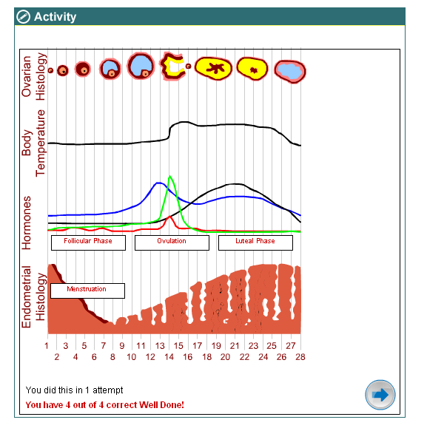

A range of activities are included within the learning materials to enhance interaction and student learning. The activities range from drag and drop type activities (Figure 1) created by faculty staff using “Macromedia Flash” to videos (Figure 2) some of which have been created within the faculty and others used under license from Film & Sound Online (<http://www.filmandsound.ac.uk/>) and Lifesign (<http://www.lifesign.ac.uk/>). The issues surrounding the licensing of externally made videos, was one of the major challenges within the development phase of the project. Apart from the Lifesign videos, which can only be accessed on campus, all materials can be accessed from any point at which the students have internet access.

Figure Video clip within the application used with the permission of “Film and Sound Online”

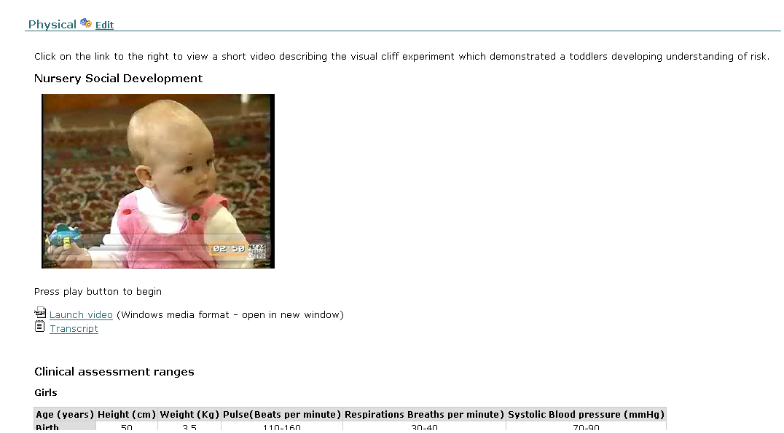

The completed online pack was introduced with the September 2006 Adult nursing students and has subsequently been used with all cohorts within the first semester of their programme including conversion students (nurses undertaking a course to develop their qualifications from enrolled to registered nurse). Therefore by February 2008 over 800 students were using the online packs and this is expected to reach over 1000 once the first students reach the third year of their course.

## Evaluation study

In 2006 an evaluation study was proposed which examined the online delivery of the online oacks for pre-registration adult nursing students, with the secondary aims of ensuring that the online delivery of EU requirements was fit for purpose.

### Methods

The use of a collective case study involving purposive sampling of all personal tutors supporting students with the online pack for a focus group and sending all students within the September 2006 cohort an online questionnaire. were used to ensure confidence in the representation of the sample.. Ethics approval was obtained and secured prior to data collection from the University’s Research Ethics Committee. All participants were provided with research information sheets detailing the aims of the project and involvement.

Questionnaire/Survey Design

Due to the quantitative design of the study the majority of the questions within the questionnaire were forced choices rating scales in order to generate a frequency of responses that will produce data that is open to statistical analysis (Cohen *et al* 2000). Within the forced choice rating scale a limited number of possible responses were included to ensure that respondents have to choose one of the available responses.

To allow for the further combination of quantitative measurement and qualitative observations open ended questions were also included. These asked students if they had any further comments or suggestions concerning the online pack, this was done to allow for free responses when asking the students to evaluate the online resource. The final section contained further closed questions to gain demographic data such as the respondent’s age and gender, along with a section exploring the when, where and how students were accessing the online resource.

The questionnaire was piloted in 2006 through a convenience sample of academics from with the school of Adult Nursing who were not personal tutors for the September 2006 cohort. The resulting questionnaire following minor corrections was incorporated into the SNAPv8 online survey software creating a Hyper Text Mark-up Language HTML page of the survey that could be used within an email.

Questionnaire Distribution

Whilst the study was completed online, note was taken of the literature suggesting that pre-contact information can improve a study’s response rates (Cavusgil and Elvey-Kirk 1998; Cook et al 2000), therefore paper copies of the initial contact information containing a covering letter and the participant information sheet were sent to the student group prior to release of the questionnaire.

This multi model approach was taken to prevent an unsolicited email containing the hyperlink to the study arriving in the respondent’s email inbox which may have resulted in automatic deletion. This information was also attached in a Portable Document Format (PDF) to the email containing the hyper link to the survey to ensure that staff and student’s who had not received the paper version still had access to all the information contained within these documents. None of the correspondence to participants used personalized greeting. This was in response to findings that suggest that although this approach is likely to increase response rates (Joinson et al 2007) it can compromise the respondents’ perceptions of anonymity (Riggle et al 2005).

Questionnaire Data Collection Methods

Data collection was achieved through the importing of these emails from within the SNAPv8 software program. This process allowed for the pre-coded data to be exported into the Statistical Package for the Social Sciences (SPSS) in preparation for data analysis.

Questionnaire Response Rate

The emerging evidence examining the differences and variables that can affect response rates within online surveys were appraised (Bosnjak and Tuten 2001; Duffy 2002; Fricker and Schonlau 2002; Morris et al 2004), in order to inform the approach used within this study. However despite this the response rate from the 277 distributed questionnaires was disappointing at 12% (n =31) as such a low response rate may not offer a true representative illustration from the chosen sample as those respondents who did not take part in the survey may have reported different opinions and attitudes to those who did (Sapsfords 1999). However such a high number of non-response ‘wouldn’t matter’ if the research team are confident that the complete sample are similar and therefore would have answered the survey similarly had they taken part (Muijs 2004). Taking Sapford’s (1999) and Muijs’s (2004) opinions into consideration we believe that the sample, albeit small, allows for descriptive exploration of the data.

Focus Groups

The focus groups were held nine months after the personal tutors had first begun to use the packs. Of the six personal tutors who had agreed to take part in the study only three were available on the day of the focus group. The availability of personal tutors for the focus group due to constraints of timetabling and workload has to be acknowledged as a limitation within the study however as Krueger and Casey (2000) suggest such a mini focus group did create a comfortable environment for the participants involved.

An independent researcher undertook the focus group to prevent the potential for bias within the focus group, with one of the research team acting as observer and scribe. Following completion of the focus group the discussions were transcribed ensuring anonymity by the independent researcher and then reviewed by the research team in order to interpret the data for emerging themes and topics

### Results

Student questionnaires

When are students accessing the resource?

When asking the student when and where they accessed the resource some surprising finding emerged. Whilst it is predicted that two thirds of households within the UK have internet access at home, with students amongst one of the highest users (Dutton and Helsper 2007), 94% (*n=29*) of the students reported that they had accessed the site from a home computer. With a further 23% (*n=7*) of the students stating that they used the university computers labs, demonstrating that some of the students had used both access methods. This finding is reflected in the free text comments within the questionnaire and can be seen to explain the apparent use of both university and home computers

*my home computer could not cope with the video so I had to do that in the university Student 3*

*we need more access to videos for students who live outside campus as I cant get into uni easily living 1hr and half away and do eu packs on a weekend Student 20*

Figure 1 demonstrates the varied times that students were engaging with the resource when asked what times they accessed the site. The results are similar to previous research within the faculty (Ward and Moule, 2007) and wider evidence (Haywood et al, 2004).



The ease of use

When asking the students what was there overall impression of the entire site Figure 2, shows that 55% (*n=17*) of the students reported a positive response (good or very good) with 29% (*n=9*) giving a neutral response and 16% (*n=5*) giving a negative response.

____



45% (*n=14*) of Students reported that the speed of login was very good and 32% (*n=10*) reported that the speed of login was good (Figure 3) however this could also be attributed to the high speed internet connections that the majority of students were using

__



__

Child Health, Maternity and Mental Health Sections

Whilst the child section had the least positive response when asking students to give their overall impression of each of the sections. When asking the students to rate each section for its contribution to their learning the child section had the highest percentage of positive responses (65%) in comparison to the maternity section (61%) and the mental health section (55%). This may reflect the students perceptions of the relevance of the material to their course. Figure 8, 9 and 10 fully detail the student’s response to this question for each of the three sections.

__



__



When discussing the three sections students also reported in the free text responses that they were uncertain as to what was expected from them within each of the sections

*There is not enough guidance on how to access information, and the amount of information required. Student 29*

The final question asked the students if they had any comments that they wished the project team to be aware of. This open free text question resulted in mixed responses from the 11 students who used this opportunity. Within these responses the following themes were identified:

Reduced perception of effort due to the online formation

*I like the ease of doing the packs on-line but do think I don’t put enough into it as I might if it was paper based. I find that if I have a lot of reading on the computer I soon lose interest and find it hard to concentrate fully. Its nice not to have to carry all the work around in a folder though and in general do prefer to do the packs this way. Its good to be able to watch the videos and go right on with the work so you don’t lose the thread. Student 4*

*I feel that the online EU packs are much easier to follow than the previous paper EU packs (I have seen friends paper EU packs). I like the use of the video clips, as I am a visual learner I feel that these have helped me greatly in my understanding. I have completed all year one EU packs and am looking forward to completing the year two and three EU packs in due course. Student 14*

Computer fatigue

*i would prefer a workbook as it is easier to work through, when you are online doing eu packs it becomes quite trying to access online resources at the same time, also having a workbook does make you do it as you don't forget about it. Student 16*

*There is a lot of good information on all of the areas and it helps to have website links. Being online does save a lot on paper work but it can sometimes be annoying having to sit at a computer for ages. Student 26*

The need for further guidance and structure within the pack

*Although being online the eu packs are easy to access, I think if they were on paper I would be more inclined to put more into them and get them done a lot sooner. It is very easy to forget that they need to be done. Maybe there should be more deadlines for them, i.e. one section has to be done every 3 months or so? Student 9*

*All colleagues and staff that I have spoken to are unclear on how much information is actually needed to answer the activities. I feel it is subjective to the tutors marking. Once e-mailed to the tutor we then receive no feedback about them and don't know if they have been received by our tutors unless we contact them specifically to ask, or if the content is ok and whether they will pass. Some items seem completely irrelevant for adult nursing and is difficult to obtain Student 29*

*i really think there should be set dead lines for each section as i know people haven’t even started theres yet and this could lead to problems further down the line. Student 23*

*The style of some of the activities can be quite confusing, it is unclear if the work has been saved and also what is expected to be written, for example how in-depth answers are required to be. Student 36*

Tutors focus group

Analysis was carried out after the tape from the focus group was transcribed by the focus groups facilitator, following transcription the anonymised transcript was reviewed by a member of the research team in order to identify any emerging themes, this resulted in the identification of the following themes,

Use of packs

The focus group commenced with the question, “had the participants used the Online EU packs on Midwifery, Children’s and Mental Health practice.”

The participants clearly felt that they had used the packs and one stated that the email alert that the student had submitted something was good. “*so we know when a student has submitted so we are alerted to the fact*” tutor 1 .Although another participant suggests that this did cause some stress as they had “*about 12 ‘e’ ones that I know I have got to look at*” tutor 2 .

A further issue was the role of the specialists tutor and the need to sample work for NMC verification. Improving ease of access would seem relevant here as well. *“was aware of a report that suggested that the specialists were disappointed in the feedback given and this participant felt that ease of access to the system would improve this and ease tracking for the specialists***.”** Tutor 1. The use of a sign off button by the specialist was raised so that an audit trail can be established and perhaps the need to do this on a yearly basis so that a larger sample is seen.

One of the other advantages of the packs online discussed was the fact that change to the documents can be done at a central point so it is a lot easier to mange the evolution of the packs when learning outcomes are upgraded.

Variations in tutor use and attitudes.

Another aspect to come out of this discussion was the requirement to give feedback to the students. One participant felt the sample answers written by the subject specialists were a good feature of the online system in that tutors can give similar feedback based on these. But the need to give each student feedback outside the system via email was found be time consuming.

“*The feedback is a very poor feature of this system, very time consuming* “ tutor 1

**“***Feedback is taking half an hour minimum for every submission***”** tutor 1

Given the demands on a tutor’s time it would appear that this needs to be addressed but, as Waller suggests, the work can be programmed but it remains time consuming because it is based on the handling of the paper based copies (Waller, 2002). This led to the discussion of access to the questions that the students were answering.

The technical skill to access and use the system appeared to vary amongst with all three taking a paper copy to use either with the student’s answers on screen or as a printed copy. **“***I have got a copy of the template answers but I do look on the screen*” tutor 2

When asked “is having it online making it harder or easier” tutor 2 replied **“***that its something to do with me and computers***”** which supports earlier work which suggests that the tutors attitude and skills towards IT systems affects the way they use it (Simpson 2000).

This led to a discussion on the amount of feedback and the purpose of the system and its validity as it falls outside the modular system and the universities assessment regulations. *Tutor 2*  highlighted that it is a NMC requirement so it needs to be addressed and *tutort 1* suggested that in terms of the packs and where they sit in the curriculum there is no difference.

Perception of use by students

When asked how they felt students perceived the system they felt that the students benefited “*as they did not copy direct from text books”*  tutor 3and had thought about their answers. There were mixed messages around the amount of engagement and the amount of work to be done by the students but overall they felt that the online packs were probably better than the paper issues. Also they were enhancing there confidence in computer skills and email.

A concern was raised over whether students could cut and paste from each others work if working in groups. The need to have a system to look at plagiarism detection was raised by all three participants.

General comments from the participants was that students would benefit from

* The use of an e portfolio for them to save there work
* A set of frequently asked questions was needed as this was thought to be of value in reducing personal tutors work load and giving the students the answers when they required.
* The giving of students general guidelines within the packs was felt to be a useful addition for the future.
* The need to clarify specialist issues was seen as important in supporting these students It was suggested that the limitations of personal tutors in a specialist area could be addressed with an email facility to the specialists concerned.

Personal tutor’s approaches to the EU requirements and the management of the online packs would appear to vary from the discussion in the group but as a small group it is not possible to draw conclusions on whether this has improved at the end of the first year of implementation compared with the paper packs. The predictive value of the students who are not engaged in the process and there academic ability was briefly commented on and highlighted as an area for further research.

## Discussion

One of the aims within the study was the methodological exploration of online data collection through the use of an online questionnaire/survey design. With hindsight there are some aspects within both the research design and the operationalization of the study where we would suggest changes.

A limitation within the study’s design that may have affected the response rate was the inability to target non-responders due to the anonymity of all responses. Whilst the response rate was poor for this study, the speed and accuracy surrounding the inputting of the raw data must be considered as one of the benefits to this emerging research design. As a research design online surveys and questionnaires remain within their infancy with the literature informing this research method remaining predominately from the subject area of marketing. Since we completed this study, the use of online surveys and questionnaires appears to be becoming the preferred choice of both neophyte and experienced researchers with limited discussion of the need to improve response rates within the method of data collection.

The study has provided a range of important insights into both the content of the packs, the format of the material and the delivery mechanism. Particular issues with the use of diagrams and interactive elements were highlighted although access barriers such as those identified in Glen and Moule (2006) were not as prevalent as may have been expected. The use of IT, with multimedia elements, was seen as being beneficial by both students and staff. For staff the way in which students submitted their material and more particularly the way in which feedback to students is handled were big issues. These related not just to the use of technology but to time management and workload issues. The findings will be useful in improving and developing the packs for future cohorts. The team have also developed useful insights and some expertise in the use of online questionnaires.

Examining both the student and the staff feedback it was evident that each of the packs needed to be further reviewed to ensure that the information is both clear and accessible. This process is ongoing but the evaluation study has been very useful in highlighting areas in which the packs could be improved.

## Conclusion

The use of online multimedia within courses for pre registration students nurses is still in the early stages of development. The opportunities for flexible learning which this provides are generally appreciated by students, however some were apprehensive about using the software materials.

The evaluation study demonstrated that appropriate preparation was needed for both the students and staff who were to be using the software, however when this had been provided the materials were found to be useful for students. The personal tutors identified more issues with feedback to students and time management.

This study has demonstrated the efficacy of using an online multimedia approach. Further research is needed to see whether the results would be replicated in another Higher Education Institution.

## References

Bosnjak, M. and Tuten, T.L., (2001) Classifying Response Behaviors in Web-based Surveys. [Online] *Journal of Computer Mediated Communication*, 6(3), Available: http://jcmc.indiana.edu/vol6/issue3/boznjak.html Accessed 24.08.06.

Cavusgil, S. T. and Elvey-Kirk, L. A. (1998). Mail survey response behavior a conceptualization of motivating factors and an empirical study. *European Journal of Marketing*, 32 (11/12), pp 939-1192,

Cohen.L., Manoin. L and Morrison. K. (2000). *Research Methods in Education 5th Edition*. London. Routledge-Falmer.

Cook, C., Heath, F. and Thompson. R.L. (2000). A Meta-Analysis of Response Rates in Web- or Internet-Based Surveys. *Educational and Psychological Measurement.* 60(6), pp. 821-836.

Duffy, M.E. (2002). Methodological Issues In Web-based Research. *Journal of Nursing Scholarship,* 34(1), pp. 83-88.

Dutton, W. H and Helsper, E.J. (2007). *The internet in Britain.* [Online] The Oxford Internet Survey 2007 Available http://www.oii.ox.ac.uk/microsites/oxis/ Accessed 23.09.07

Fricker, R.D. and Schonlau, M., (2002). Advantages and Disadvantages of Internet Research Surveys: Evidence from the Literature. *Field Methods,* 14(4), pp. 347-365.

Glen, S, and Moule, P. (2006) *E-learning in Nursing*, Palgrave, London

Haywood, J., Macleod, H., Haywood, D., Mogey, N., Alexander, W. (2004) Student Views of E-Learning: A Survey of University of Edinburgh WebCT Users 2004 [online] <http://homepages.ed.ac.uk/jhaywood/papers/surveyresults2004.pdf> [accessed 25.03.08]

Joinson, A.N., Woodley, A. and Reips, U. (2007). Personalization, authentication and self-disclosure in self-administered Internet surveys. *Computers in Human Behavior,* 23(1), pp 275-285.

Krueger, R.A. and Casey, M.A. (2000) *Focus Groups: A practical guide for applied research.* 3rd Ed . Sage publications. London.

**Mallaber, C. & Turner**, P. (2006) Competency versus hours: An examination of a current dilemma in nurse education *Nurse Education Today* 26(2), 110-114

Morris, D.L., Fenton, M.V. and Mercer, Z.B. (2004). Identification of national trends in nursing education through the use of an online survey. *Nursing Outlook*, 52(5), pp. 248-254.

Muijs. D. (2004) *Doing quantitative research in education with SPSS.* London: Sage.

NMC, (2004) *Standards of proficiency for pre-registration Nursing Education.* Nursing & Midwifery Council, London.

NMC, (2006) *NMC Circular 36/2006 Guidelines for meeting the EU Directives for general care required for nurses from overseas and EU countries seeking admission to the NMC register in the field of adult nursing.* Nursing and Midwifery Council. Available <http://www.nmc-uk.org/aDisplayDocument.aspx?DocumentID=2329> accessed 23.03.08

Riggle, E.D.B., Rostosky, S.S. and Reedy, C.S., (2005). Online Surveys for BGLT research: Issues and techniques. *Journal of Homosexualty,* 49(2), pp. 1-21.

Sapsford, R. (1999). *Survey Research.* London: Sage Publications.

Simpson, O. (2000), Supporting Students in Open and Distance Learning, Kogan Page, London,

Spitzer, A and Perrenoud, B (2006a) Reforms in nursing education across Western Europe: From agenda to practice. *Journal of Professional Nursing,* 22(3), pp 150-161.

Spitzer, A and Perrenoud, B (2006b) Reforms in nursing education across Western Europe: Implementation processes and current status. *Journal of Professional Nursing,* 22(3), pp 162-171.

Waller, M. (2002*) Delivering Learning on the Net: The Why, What and How of Online Education*. Routledge Falmer, London

Ward, R. and Moule, P. (2007) Supporting pre-registration students in practice: A review of current ICT use. *Nurse Education Today* 27(1) 60-67

Zabalegui, A., Macia, L. Marquez, J. Ricoma, R. Nuin, C. Mariscal, I, Pedraz, A., German, C. and Moncho, J. (2006) Changes in Nursing Education in the European Union. *Journal of Nursing Scholarship* 38(2) p 114–118